EDGAR® Release 8.10
OnlineForms Filer Manual

Volume III


February 2005
Notice
Use this EDGAR® Filer Manual when making electronic filings with the United States Securities and Exchange Commission (SEC or "Commission"). See Rule 301 of Regulation S-T.
The EDGAR Filer Manual consists of three volumes: EDGARLink Filer Manual (Volume I) discusses the requirements for submitting EDGAR filings. N-SAR Supplement Filer Manual (Volume II) discusses the N-SAR application. OnlineForms Filer Manual (Volume III) discusses the requirements for submitting online filings.
The EDGAR® Release 8.10 OnlineForms Filer Manual (Volume III) is effective on:
February 7, 2005
________________________________________________________
For up-to-date information regarding filing-related topics, consult our EDGAR Database website (http://www.sec.gov), the OnlineForms website (https://www.onlineforms.edgarfiling.sec.gov), and the EDGAR Company Database (http://www.edgarcompany.sec.gov).
________________________________________________________
EDGAR® and EDGARLink® are registered trademarks of the Securities and Exchange Commission. All other product brand names mentioned in this Filer Manual are trademarks or registered trademarks of their respective holders.

Preface
Welcome to the Electronic Data Gathering, Analysis, and Retrieval (EDGAR) system of the U.S. Securities and Exchange Commission (SEC). EDGAR provides an electronic filing process for filers and filing agents submitting documents under the Securities Act of 1933, the Securities Exchange Act of 1934, the Public Utility Holding Company Act of 1935, the Trust Indenture Act of 1939, and the Investment Company Act of 1940 (collectively, "Acts"). This manual explains how you can file electronically with the SEC.
This Volume of the File Manual explains the process for creating and submitting documents over the Internet using the OnlineForms website. The OnlineForms website will verify filer identification, check that required information is present, and allow filers or their agents, to transmit online submissions to EDGAR for dissemination to the public. You may view electronically submitted filings on EDGAR workstations in the SEC's public reference room in Washington D.C., through commercial dissemination services, or using the SEC's website on the World Wide Web (http://www.sec.gov).
What Filings are on EDGAR?
You will find almost all filings by domestic and foreign companies and third party schedules such as Schedules 13D, on EDGAR. Companies can submit certain filings (e.g., Forms 11-K, and Forms 144) either electronically or on paper.
Rules Governing Forms and Filing Information
EDGAR provides you with an electronic way to submit information to us. It does not change the content of what you submit. Regulation S-T mandates electronic submissions of filings by all domestic and foreign registrants. Regulation S-T also provides the general requirements and procedures for electronic filing. You may find copies of Regulation S-T in the Federal Register and the Code of Federal Regulations (17 CFR Part 232) in our Public Reference Rooms. You will also find Regulation S-T under the Division of Corporation Finance area on the SEC's website (www.sec.gov) under Forms and Associated Regulations, EDGAR.
We have identified the following other laws and releases that affect online submissions and electronic filing. You may obtain copies of this material from our SEC website (www.sec.gov).
- Securities and Exchange Commission Authorization Act of 1987 — Public Law 100-181 (December 4, 1987). (Section 35A of Securities Exchange Act of 1934.)
- Releases:

33-8496 | XBRL Voluntary Financial Reporting Program on the EDGAR System
Issued 9/27/04
Effective (Proposed Rule)
(69 FR 59094)
34-50486 | Proposed Rule Changes of Self-Regulatory Organizations
Issued 10/04/04
Effective 11/08/04
(69 FR 60287)
33-8410 | Mandated Electronic Filing for Form ID
Issued 4/21/04
Effective 4/26/04
(69 FR 22704)
33-8401 | Rulemaking for EDGAR System
Issued 3/16/04 | (proposal for identification of investment company series and
Effective TBD | classes (contracts); additional mandatory electronic filings for
(69 FR 13690) | investment companies; and technical amendments)
33-8230 | Mandated Electronic Filing and Website Posting for Forms 3, 4, and 5
Issued 5/7/03
Effective 6/30/03
(68 FR 25787)
33-8170 | Mandated Electronic Filing and Website Posting for Forms 3, 4, and 5
34-47069
35-27627
Issued 12/10/02
33-8177 | Rules for additional disclosure and certification requirements.
24-47235
Issued 1/23/03
Effective 30 days after publication in the Federal Register
33-8009 | Mandated EDGAR Filing for Foreign Issuers.
Issued 5/14/02
Effective 5/24/02
and 11/4/02
(67 FR 36677)
33-8007 | Updated version of the EDGARLink software.
Issued 9/17/01
(66 FR 49829)
33-7999 | Next stage of EDGAR Modernization.
Issued 7/30/01
(66 FR 42941)
33-7933 | Next stage of EDGAR Modernization.
Issued 1/16/01
Effective 2/02/01
(66 FR 8764)
33-7855 | Rules for the next stage of EDGAR Modernization.
Issued 4/24/00
Effective 5/30/00
Effective 7/10/00 | Diskette submissions not accepted.
Effective 1/1/01 | Financial Data Schedule requirement removed.
(65 FR 24788)
33-7789 | Adopted updated filing form types in Filer Manual.
Issued 1/20/00
Effective 1/24/00
(65 FR 3123)
33-7755 | CompuServe discontinued electronic mail service.
Issued 10/07/99
Effective 10/16/99
(64 FR 56430)
33-7684 | Rules for the first stage of EDGAR modernization adopted.
Issued 5/17/99
Effective 6/28/99
(64 FR 27888)
34-40934 | Electronic filing of Form 13F made mandatory.
Issued 1/12/99
Compliance date 4/1/99
(64 FR 2834)
33-7472 | Commission will no longer accept, in paper, filings required to be submitted electronically, except in a hardship situation.
Issued 10/24/97
Effective 1/1/98
(62 FR 58647)
33-7427 | Minor and technical rule amendments, including the elimination of transition rules applicable to the phase-in period.
Issued 7/1/97
(62 FR 36450)
33-7122 | Rules and phase-in schedule made final. Final phase-in lists published. Minor rule amendments adopted
Issued 12/19/94
(59 FR 67752)
33-6977 | Interim rules applicable to electronic filing in general, and specifically to the Division of Corporation Finance filers.
Issued 2/23/93
(58 FR 14628)
IC-19284 | Interim rules specific to investment companies.
Issued 2/23/93
(58 FR 14848)
35-25746 | Interim rules specific to public utility holding companies.
Issued 2/23/93
(58 FR 14999)
33-6980 | Rules relating to payment of filing fees to the SEC's lockbox in Pittsburgh, Pennsylvania.
Issued 2/23/93
(58 FR 15009)

Table of Contents
1. Introduction to the ONLINEFORMS Filer Manual and EDGAR 1-1
1.1 Organization of this Manual 1-1
1.1.1 Conventions Used in the Filer Manual 1-2
1.2 The EDGAR OnlineForms Website Updates 1-2
1.2.1 Release 8.10 OnlineForms Website Updates 1-2
1.2.2 EDGAR OnlineForms Website 1-3
1.2.3 Web Browser 1-3
1.2.4 Filing Transmission Methods 1-3
1.2.5 Viewing Submission Status 1-3
1.2.6 Changing Company Information 1-4
1.2.7 Downloading Return Copies 1-4
1.3 Preparing to Become an EDGAR Filer 1-4
1.3.1 Filing a Form ID with the SEC to Get Your Access Codes 1-4
1.3.2 EDGAR Hardware and Software Requirements 1-8
1.3.3 Receiving E-Mail Status of Filings from the SEC 1-9
1.3.4 Properly Prepare and Maintain Documents 1-10
1.4 How to Obtain the EDGAR OnlineForms Filer Manual 1-10
1.4.1 Hours of Operation 1-11
1.4.2 Filing Date of Electronically Transmitted Submissions 1-11
1.4.3 Where to Send Paper Filings 1-11
1.5 Getting Help with EDGAR 1-11
1.5.1 Getting Help with the Content of Filings or Exemptions/Adjustments 1-11
1.5.2 Frequently Asked Questions 1-12
2. Getting Started Using ONLINEFORMS WEBSITE 2-1
2.1 Introduction to Web Browsers 2-1
2.1.1 Browser Differences 2-1
2.2 Accessing OnlineForms Website 2-2
2.2.1 Logging into OnlineForms Website 2-2
2.3 Navigating EDGAR 2-4
2.3.1 Information Exchange 2-5
2.3.2 Support 2-6
3. Preparing and Transmitting Online Submissions to EDGAR 3-1
3.1 Online Ownership Processing 3-1
3.1.1 Legacy Ownership Processing 3-1
3.1.2 Modernized Section 16 Ownership Processing 3-1
3.1.3 OnlineForms Data Gathering Model 3-1
3.1.4 Creating an Online Section 16 Ownership Submission 3-2
4. REDUCED-CONTENT XML SUBMISSIONS 4-1
4.1 Preparing Reduced-Content XML Submissions 4-1
4.1.1 Test and Live Submissions 4-1
4.2 Transmitting Reduced-Content XML Submissions 4-1
4.2.1 Transmit Reduced-Content XML as a Test Submission 4-2
4.2.2 Transmit Reduced-Content XML as a Live Submission 4-3
4.2.3 Transmission Status 4-5
5. Additional ONLINE Features 5-1
5.1 Accessing Submission and Company Information 5-1
5.2 Submission Information 5-2
5.2.1 Retrieving Submission Notification 5-2
5.3 Retrieve Company Information 5-5
5.3.1 Edit Company Information 5-7
5.4 Return Copy Support 5-10
5.4.1 Retrieve Return Copies 5-10
5.5 Change Login Password or CCC 5-12
5.5.1 Changing Your Password 5-13
5.5.2 Changing Your CCC (CIK Confirmation Code) 5-14
5.6 Logging in with (Enter) Another CIK/CCC 5-16
6. PREPARING SUPPLEMENTAL EDGAR DOCUMENTS 6-1
6.1 Introduction 6-1
6.2 Terminology 6-1
6.3 ASCII 6-4
6.3.1 Character Code Requirements Differ by Submission Medium 6-4
6.3.2 EDGAR Recognizes a Limited Set of Keyboard Characters 6-4
6.3.3 Why the EDGAR System Recognizes Only Standard Character Sets 6-5
6.3.4 How the Requirement for ASCII Affects Word Processing 6-5
6.3.5 About HTML 6-6
6.3.6 Common Symbols that EDGAR Does Not Recognize 6-6
6.3.7 System Inserts "^" For Unrecognized Characters 6-7
6.4 Description of ASCII/SGML Tags 6-7
6.5 Tag Construction 6-7
6.6 How Tags are Used 6-7
6.6.1 Field Values are Filer-Supplied Information 6-8
6.7 Tags Used Within a Document 6-9
6.8 Non-Public and Confidential Information 6-11
6.9 How To Create a Correspondence Document 6-11
6.10 Formatting Tables Wider than 80 Characters 6-11
6.10.1 Guidelines for Presentation of Tables 6-11
6.10.2 Table Tags 6-12
6.10.3 Formatting Examples of Wide Tables 6-13
6.11 Statutory Signatures 6-16
6.12 Powers of Attorney and Consents of Experts 6-16
7. Instructions for Attaching HTML Documents to Electronic Submissions 7-1
7.1 Overview 7-1
7.2 Acceptable HTML Document Tags 7-3
7.3 Acceptable HTML Tags within a Document Body 7-4
7.4 HTML Tags that are NOT Supported by EDGAR 7-6
7.5 Acceptable Attributes for EDGAR HTML Tags 7-6
7.6 Extended Character Sets Within HTML Documents 7-8
7.7 Template for an Attached HTML Document 7-10
7.8 ASCII or SGML Functionality to be Preserved within HTML Documents 7-10
7.9 ASCII or SGML Functionality Not Supported within HTML Documents 7-11
7.10 SEC Recommendations on Preparing Submissions with HTML Documents 7-12
A. Online Submission Types Accepted for Electronic Filing A-1
B. Messages Reported by EDGAR B-1
C. Forms for Electronic Filing C-1
D. Glossary of Commonly Used Terms, Acronyms, and Abbreviations D-1
E. Applying for Access to EDGAR E-1

Introduction to the ONLINEFORMS Filer Manual and EDGAR

Organization of this Manual
This volume is divided into chapters and appendices. The paragraphs and subparagraphs are numbered for easy reference (e.g., 1.2, 2.6.1). When necessary, chapters have been further divided into Sections (e.g., 4-A).
The chapters of this volume primarily refer to the preparation of EDGAR submissions. Chapter 7 describes the characteristics and limitations of Hypertext Markup Language (HTML) documents.
The following outline shows you where to find information in this volume. An index is also provided at the end of this document.
CHAPTER 1 -- Introduction to the OnlineForms Filer Manual and EDGAR
CHAPTER 2 -- Getting Started Using OnlineForms Website
CHAPTER 3 -- Preparing and Transmitting Online Submissions to EDGAR
CHAPTER 4 -- Reduced-Content XML Submissions
CHAPTER 5 -- Additional Online Features
CHAPTER 6 -- Preparing Supplemental EDGAR Documents
CHAPTER 7 -- Instructions for Attaching HTML Documents to Electronic Submissions
APPENDICES:
A Online Submission Types Accepted for Electronic Filing
This appendix provides a description of all the EDGAR submission types that are available for online filing.
B Messages Reported by EDGAR
This appendix provides information on acceptance, suspension, and EDGAR error messages, including all HTML/PDF error messages.
C Forms for Electronic Filing
Form ID Uniform Application for Access Codes to File on EDGAR
Form SE Form for Submission of Paper Format Exhibits by Electronic Filers
D Glossary of Commonly Used Terms, Acronyms, and Abbreviations
This glossary contains terms acronyms, and abbreviations used in the Filer Manual and the OnlineForms website.
E Applying for EDGAR Access (Electronic Form ID)
This appendix provides information to help you obtain password and access codes for the EDGAR system.

Conventions Used in the Filer Manual
As you read this volume you should notice attributes assigned to certain types of text:
- Instructions to press a key on a keyboard or click a button on the screen appear in square brackets and in title case:
- Press [Enter]
- Click [Module/Segment]
- Titles of check, dialog, and list boxes, fields, functions, options, processes, queries, reports, pages, tables and windows appear in title case:
- Submission Type list box
- Name field
- Company Information query
- Return Copy check box
- Menus, menu options, radio buttons, and statuses appear in title case and have double quotation marks around them:
- “Test Filing” radio button
- from the “Edit” menu, select “Copy”
- “Busy” status
- Directories and file names appear bolded:
- the C:\temp directory
- power_of_attny.txt
- Keystroke combinations appear between less-than and greater-than brackets and in upper case:
- <ALT-TAB>
- <CTRL-C>
- Internet Hyperlinks appear underlined:
- Home

The EDGAR OnlineForms Website Updates
This section highlights the OnlineForms website changes for the various releases since the OnlineForms website was established.

Release 8.10 OnlineForms Website Updates
In February 2005, EDGAR Release 8.10 introduces the following changes:
- New 25-NSE XML submissions and 25-NSE/A XML amended submissions can be transmitted using the Transmit Reduced-Content XML Submission command.

Note: Changes for Submission types 25-NSE and 25-NSE/A are to be used only in the event the SEC adopts the rule on mandatory electronic filing of the forms by issuers. The implementation date will be provided within the adopting release. (See Release No. 34-49858 (June 15, 2004) [69 FR 34860])

EDGAR OnlineForms Website
The OnlineForms website is no different than most other websites that you now visit. It uses the same browser-based application software and transmission methods as the other sites and you probably will be able to submit filings to EDGAR from the website with [few] or no changes in your hardware or software configurations. You can access the OnlineForms website using a Universal Resource Locator (URL) code (https://www.onlineforms.edgarfiling.sec.gov).
Note: Please remember to enter https. You will not be able to access the OnlineForms website without the "s" designation.
We require that your browser support Java script.

Web Browser
The OnlineForms website only works with the two industry standard web browsers. We recommend you use Netscape version 4.0 or later, or Internet Explorer version 5.0. The use of browsers is discussed in Chapter 3.
Note: The OnlineForms website is incompatible with Netscape version 6.0.

Filing Transmission Methods
The only transmission method to access EDGAR via the OnlineForms website is through the Internet. It is your decision as to the best means to access the Internet. EDGAR accepts transmissions from any Internet source, so you can decide which Internet Service Provider (ISP) best suits your needs.

Viewing Submission Status
Filers may access the OnlineForms website to check on the status of their submissions. For details on checking your submission status please refer to Chapter 5, Submission Information. You will only be permitted to view the status of submissions that you have submitted. You may also choose to use E-Mail for your submission confirmation.

Changing Company Information
It is the obligation of the registrant to keep their information on EDGAR current and valid. You can update your company information by entering your company information on the Edit Company Information page of the OnlineForms website. All changes to your company information are made immediately except for changes to your company's name. Our Filer Support staff needs to review any change to your company's name. For details on changing your company information, please refer to Chapter 5, Edit Company Information.
You can also change your CIK Confirmation Code (CCC) and password using the OnlineForms website. For details on changing your password, please refer to Chapter 5, Changing your Password. For details on changing your CCC, please refer to Chapter 5, Changing your CCC.

Downloading Return Copies
Requested Return Copies can be downloaded from the OnlineForms website. For details on downloading Return Copies, please refer to Chapter 5, Return Copy Support.

Preparing to Become an EDGAR Filer
To become an EDGAR filer, you must:
- Obtain EDGAR-compatible hardware (computer equipment) and software.
- Secure an ISP for access to the Internet.
- Submit an electronic Form ID application and accompanying notarized authenticating documentation to the SEC (refer to Appendix E of this document for more information). You cannot access the OnlineForms website until the SEC accepts your Form ID application.
- Generate EDGAR access codes (refer to Appendix E of this document for more information). You cannot access the OnlineForms website without EDGAR access codes.

Filing a Form ID with the SEC to Get Your Access Codes
Before you can use the EDGAR system, you must submit a Form ID application to be accepted as an EDGAR filer (refer to Appendix E for more information). An EDGAR filer can be a registrant, a third-party non-registrant filer, a third-party agent filing for another individual or entity, or a training agent. EDGAR filers may send submissions on their own behalf or use a filing agent. Training agents may only send test submissions. A duly authorized person, such as a partner, president, treasurer, corporate secretary, officer, or director, must sign the Form ID. Section 16 filers may have someone with their power of attorney sign the Form ID. Filing agents such as financial printers cannot sign this Form on behalf of the issuer unless they are specifically authorized to do so in writing. The written documentation should accompany the Form ID.
As an applicant for EDGAR access codes, you must indicate whether you are a filer, filing agent, or training agent as defined in Part I of the Form ID General Instructions. If you plan to file on EDGAR in more than one capacity, a separate Form ID must be completed and submitted for each capacity. For example, if you want to make EDGAR submissions as a registrant, and as a filing agent, and as a training agent, you must submit a separate Form ID for each filing capacity. You will receive three separate sets of CIKs and access codes.
You must file your Form ID application via the EDGAR Filer Management website, and you must fax the accompanying notarized authenticating documentation to the SEC. Appendix E of this volume contains instructions on how to do this. Appendix C of this volume contains a copy of the paper Form ID, but it is for reference only. You cannot submit a paper Form ID. You can print various related EDGAR forms (e.g., Form TH, Form SE) from the www.sec.gov website. You can also request additional copies from the SEC’s Publications Office by calling (202) 942-4040, or by making a written request to the following address:
ATTN: Publications Branch
US Securities and Exchange Commission
Mail Stop 3C40
450 5th Street, NW
Washington, DC 20549
You must fax the notarized authenticating documentation associated with your electronic Form ID to the following office:
US Securities and Exchange Commission
ATTN: Filer Support
(202) 504-2474
or
(703) 914-4240
You may contact Filer Support (202) 942-8900 if you require additional information.
After we accept your Form ID application, you will receive the following five access codes:
- CIK -- Central Index Key:
The CIK is a number that we assign to each entity that submits filings to us. Use of the CIK allows us to differentiate between filing entities with similar names. A CIK is used to identify all filers, both EDGAR and non-EDGAR. Individuals should use their own CIK number and password each time they file with EDGAR, even if their filings relate to different registrants.
- Using the CIK to Login and Identify Submitter Registrants:
The CIK is the one EDGAR access code that is available to the public. In EDGAR, the CIK is used with a password for login identification (sometimes referred to as a login CIK). This identifies the submitter, which could be a registrant, a non-registrant, a filing agent, or a training agent. The CIK is also used with the CCC in submission headers to identify the registrant. The CIK is a permanent identifier; you may not change it. You can login to EDGAR using any valid CIK-password combination. The login CIK will be part of the accession number for the submission.
- CCC -- CIK Confirmation Code:
The CCC is a code of eight characters having at least one number (0-9) and at least one special character (@, #, $, *). The CCC is case-sensitive and you must use it exactly as created, either in upper or lower case. Because the CCC is case-sensitive, if you use lower case letters when the CCC is created or changed, you must use lower case letters when entering the CCC in submission headers. To avoid confusion, we do not use the number 1 (one), the lower-case letter “l” (el), the number 0 (zero), or the capital letter O (oh) in assigning codes. We suggest that you also avoid using these numbers and letters when changing your CCC. You will need both a CIK and its corresponding CCC to submit a filing.
- Releasing the CCC To Filing Agents and Financial Printers:
If you use a filing agent, you may release the CCC to your agent because you must include a CCC in your submission. When a third-party agent submits a filing for you, the agent uses its own login CIK and password to establish authorization to make a submission. However, the agent must use your CIK and CCC in your submission in order to identify you as the entity for which the submission is being made.
- Changing Your CCC:
Although we initially assign a CCC to you, there will be times when you should change it. To ensure only you know your CCC, you should change your CCC (1) before you use EDGAR the first time, and (2) after a third-party filing agent has used it for a submission on your behalf. You will find procedures for changing the CCC in Chapter 5.
- Password:
The password is a code of eight characters having at least one number (0-9) and at least one special character (@, #, $, *). The password is case-sensitive and you must use it exactly as created, either in upper or lower case. You use it in combination with a CIK to identify the entity making a submission. Since a CIK is public information, a second, confidential code is necessary to ensure that whoever is sending a submission to EDGAR is authorized to do so. You must enter both a CIK and a password to access EDGAR. The CIK is public and you may give it and the CCC to your agent to make submissions on your behalf, but you should hold the password in strictest confidence.
- Changing Your Password:
Although we will assign a password to you, you should change that password before beginning to use the system. You will find procedures for changing a password in Chapter 5. To change a password, you must use a Password Modification Authorization Code (PMAC). You should change your password periodically. Your password will expire 12 months after it was created or last changed. If you are locked out of EDGAR because your password has expired, you may generate a new set of legacy EDGAR access codes (PMAC, password, CCC) via the EDGAR Filer Management website using your passphrase. If you’ve also forgotten your passphrase, you must request a new passphrase (also via the EDGAR Filer Management website) before you can generate a new password. A request for a new passphrase must be accompanied by authenticating documentation, and it must be accepted by the SEC, so be sure you keep your password up to date (refer to Appendix E for instructions on how to generate a new set of EDGAR access codes and how to request a new passphrase).
- PMAC -- Password Modification Authorization Code:
You must use the PMAC to authorize a change of password. The PMAC is a code of eight characters having at least one number (0-9) and at least one special character (@, #, $, *). The PMAC is case-sensitive and you must enter it exactly as created, in lower case. We create the PMAC in lower case only. It is a very private code that we assign and then send to you, and only one or two persons in an organization should know this code. To request a new PMAC, you must submit an amended Form ID marked “Request for New PMAC.” We will process your request and fax or E-Mail the PMAC to you. The CIK is public and you may give it and the CCC to your agent to make submissions on your behalf, but you should hold the PMAC in strictest confidence.
Part of the process of submitting an electronic Form ID application is to specify an EDGAR passphrase:
- Passphrase:
The passphrase is used to generate a set of legacy EDGAR access codes (PMAC, password, CCC). The passphrase follows the PMAC formatting and usage rules (see above). Because it can be used to generate the legacy EDGAR access codes, the passphrase is a very sensitive code that should be strictly controlled. Access to it within your organization should be extremely limited. As mentioned previously, requesting a new passphrase must be done via the EDGAR Filer Management website, it must be accompanied by notarized authenticating documentation, and it must be accepted by the SEC (refer to Appendix E for instructions on how to generate a new set of EDGAR access codes and how to request a new passphrase).
The SEC does not keep these codes on file. It is the responsibility of the individual designated in Part III on the Form ID to provide these codes to the EDGAR filing parties, and to keep the codes secure. Section 16 filers must provide their EDGAR codes to their EDGAR contact at each of the companies for which they are insiders. Only ONE set of EDGAR codes will be valid for each individual, so it is essential that all relevant companies be given the codes. Only one Form ID should be submitted for a registrant.

Keep Assigned Access Codes Private
To protect the integrity and security of the data you send, you must limit the number of people who know your CCC, password, and PMAC.

EDGAR Hardware and Software Requirements
You will need certain hardware and software to use the OnlineForms website to prepare and transmit online submissions to EDGAR. You can only transmit an online submission using the Internet. The following list states the recommended system requirements:
- Windows compatible PC
- Monitor (color recommended, but not required)
- Printer
- Internet browser: Netscape Navigator version 4.0 or higher or Internet Explorer version 5.0 or higher and supporting 128-bit cipher strength. Java should be enabled in the browser. EDGARLink and the OnlineForms website do not support Netscape 6.0
- Word processing or spreadsheet applications having the option to save documents as standard ASCII or HTML text
- Internet access
- Adobe Acrobat Reader version 4.0 or higher

Software Requirements
To run a standard Web browser and the Modernized EDGARLink application, you will need to use a 32-bit version of the Windows Operating System. Windows ‘95 version B or higher, ‘98, NT, or 2000 meets this 32-bit standard. If your operating system is something other than Windows, you may be able to access EDGAR using the Windows emulator.
For more information about using the Web browser, see Chapter 2.

Operating Requirements
You will need space for storing the text of submission documents.

Internet Communication to OnlineForms Website
To access the OnlineForms website, you must first setup a connection through an Internet Service Provider (ISP). You should be aware that using the Internet is not without risk. Since many filers use the Internet on a day-to-day basis, they may assume that this filing path is always available. This is not always the case. Because the Internet consists of interconnecting communications equipment owned by many different companies and each essential to the delivery of your communications, the SEC cannot guarantee your Internet connection.
The SEC has designed the EDGAR system to provide redundancy. If there are problems with the SEC’s Internet connection we will reroute traffic through other available routes. The newer your browser and operating system, the more effective your platform may be in sensing those route changes and responding to them. We recommend upgrading your browser and operating system to configurations that take advantage of more modern Internet technologies. We have tested the following configurations:
- Windows 2000 with Internet Explorer 5.0 and 5.01
- Windows NT 4.0 (Service Pack Six) with Internet Explorer 5.003
If your filing is critical, allow for potential Internet system outages by making your filing early. If this is not possible, then a backup transmission plan is essential. Consider having lines from more than one Internet Service Provider or multiple path lines from a single service provider.
Use your Internet browser, Netscape, or Internet Explorer, to access EDGAR by entering the OnlineForms website URL: https://www.onlineforms.edgarfiling.sec.gov in the address location field or in the Open Location window.
When you log into the OnlineForms website you can assemble and transmit submissions, transmit reduced-content submissions, or use any of the other additional online features.

Receiving E-Mail Status of Filings from the SEC
You cannot be sure EDGAR has accepted your submission unless you receive an acceptance message. You have not made an official filing unless your acceptance message includes a filing date. You can have EDGAR send acceptance or suspense messages to your Internet electronic mail (E-Mail) address.

How EDGAR Uses the Internet for E-Mail
EDGAR will forward acceptance and suspense messages to all filing entities with valid E-Mail addresses. As an EDGAR filer, you are entirely responsible for setting up a valid Internet address through an ISP. Internet access rates vary per ISP.
Please note the following information about the EDGAR Internet services:
- With an Internet address, you can receive timely information regarding the acceptance or suspension of your filing
- All Internet addresses have a maximum length of 80 characters. Only valid EDGAR characters are accepted for Internet addresses. We also recommend that you do not use the double quote (") character in an Internet address

How to Order Internet Service
Contact a local ISP for information on obtaining Internet access for general and EDGAR use. We do not recommend or prefer any individual ISP.

How Mail Is Addressed to the Internet Address
EDGAR sends acceptance and suspense messages to the following:
- The Login CIK contact E-Mail address when you submit a filing
- The E-Mail address that you list in the Submission Contact Information
- Each additional Notification E-Mail address you list in the submission information
- Each Reporting Owner company contact E-Mail address
If you wish to permanently change the E-Mail address, then edit the Company Contact Information form on the OnlineForms website. For more details, please refer to Chapter 5, Edit Company Information.
Note: Requested Return Copies are not sent via E-Mail address. You can only download requested Return Copies via the OnlineForms website.

Properly Prepare and Maintain Documents
When you prepare an ASCII document for your submission, you must limit line width to 80 characters for text and 132 characters for tabular material (between table tags). For details on preparing EDGAR documents please refer to Chapter 6, Preparing Supplemental EDGAR Documents.
Keep a manually signed signature page (or equivalent document) on file for five years. For details on signatures please refer to Chapter 6, Signatures for Electronic Filings.

How to Obtain the EDGAR OnlineForms Filer Manual
You can download the latest version of the OnlineForms Filer Manual from our website (www.sec.gov). The Filer Manual is also available in HTML format on the OnlineForms website.
Warning: When you login to the OnlineForms website, please read the Welcome Page. It contains information about EDGAR filing requirements, activities, and updates to the website.

Hours of Operation
EDGAR accepts direct transmissions of electronic submissions each business day, Monday through Friday, from 6:00 a.m. to 10:00 p.m., Eastern Time. Transmissions started but not completed by 10:00 p.m. Eastern Time may be canceled, and you may have to re-submit on the next business day.

Filing Date of Electronically Transmitted Submissions
Accepted live ownership filings will receive a filing date and time identical to its EDGAR receipt date and time if the filing receipt time is between 6:00 a.m. and 10:00 p.m. Eastern time on a normal business day.
Note: Remember that submission transmission does not begin until EDGAR receives the first byte of a transmission. When you make a time-sensitive submission, allow time for setup of your Internet connection, completing and verifying the submission, and the start of the transmission.

Where to Send Paper Filings
Temporary hardship exemptions in paper are not accepted for Section 16 Ownership filings or for Form ID applications/requests. We will return temporary hardship exemptions for Section 16 Ownership filings and Form ID applications/requests. Official filings made in paper as a result of a continuing hardship exemption should be mailed to the following address:
Headquarters Location
ATTN: Filing Desk
US Securities and Exchange Commission
Mail Stop 1-4, Room 1004
450 5th Street, NW
Washington, DC 20549

Getting Help with EDGAR
For general filing and technical information or help with the OnlineForms website, contact our Filer Support Staff in the Office of Filings and Information Services.
Filer Support Staff can help you each business day from 7:00 a.m. to 7:00 p.m., Eastern time. You may reach them at (202) 942-8900 for help.

Getting Help with the Content of Filings or Exemptions/Adjustments
For non-technical filing questions including filing content, hardship exemption requests, and filing date adjustments, contact the EDGAR Support Staff in the Divisions of Corporation Finance or Investment Management during normal business hours 9:00 a.m. to 5:30 p.m., Eastern time.
If you need help with Corporation Finance filings, contact the Office of EDGAR and Information Analysis in the Division of Corporation Finance at (202) 942-2940.
If you need help with investment company filings, contact the Division of Investment Management at (202) 942-0978.
If you need help with Public Utility Holding Company Act filings, contact the Office of Public Utility Regulation, Division of Investment Management at (202) 942-0558.

Frequently Asked Questions
Since we opened the Operational EDGAR system for testing on May 1, 1991, EDGAR filers have called Filer Support with a variety of questions about EDGAR. Below are some of the more frequently asked questions and answers.
Questions | Answers
How do I reach the OnlineForms website? | You can reach this site by using the OnlineForms website URL, which is https://www.onlineforms.edgarfiling.sec.gov. Please bookmark this site the next time you visit it.
How do I reach the EDGAR Filer Management website | You can reach this site by using the EDGAR Filer Management website URL, which is https://www.filermanagement.edgarfiling.sec.gov. Please bookmark this site the next time you visit it.
Which Web browser shall I use? | We recommend using one of the industry standard Web browsers, either Microsoft Internet Explorer 5.0 or later, or Netscape 4.0x - 4.7x. EDGAR does not support other browsers, such as Netscape 6.0 and AOL, at this time.
Why may filing agents have more than one CIK? | Filing agents may have several CIKs for accounting and management purposes. For example, a filing agent may use a different CIK for each operating office, each industry group, or for certain categories of filers on whose behalf they make an SEC filing(s). However, the filing agent must use a separate and distinct CIK for any filing(s) they make on their own behalf.
What happens if I submit a filing by mistake? | This could be a very serious problem if the filing does not contain errors that would cause EDGAR to suspend the filing. Once EDGAR accepts a public filing, it is immediately disseminated. We cannot intercept a filing after its acceptance and prevent its dissemination, nor can we retrieve the filing.
How quickly can I determine whether my filing was accepted? | The quickest way for you to find out if your filing was accepted or suspended is to use the OnlineForms website. You can also read the messages EDGAR will send to your Internet E-Mail address.
How do I change my password? | You may change your password within 10 days of the expiration date using the OnlineForms website. If both the password and the grace period have expired, you may generate a new set of EDGAR access codes (including the password) using the EDGAR Filer Management website and your passphrase. If you have forgotten your passphrase, you must request a new one before you can generate and new set of EDGAR access codes (refer to Appendix E for more information on the EDGAR Filer Management website capabilities).
How do I change my CCC? | You may change your CCC using the OnlineForms website. Login to EDGAR using the OnlineForms website, click on Retrieve/Edit Data, then click on Change Login Password or CCC. Please note that CCCs do not expire.
Can I change an expired password via the OnlineForms website? | Yes, if you change it within 10 days of the expiration date. If both the password and the grace period have expired, you must apply for a new password on Form ID.
How do I change company information? | You may update company information using the OnlineForms website by entering company information on the Change Company Information page and submitting the changes to us. You must provide the CIK and CCC for that company before you can change any information.
How do I name my attached documents for filings sent via the OnlineForms website? | All document file names must be in lower case and no longer than 32 characters in length. The names must start with a (a-z) character and may contain (a-z) characters and (0-9) characters. File names may contain one '.', one '-', and one '_' character. File names must end with *.htm, *.txt, *.fil, *.jpg, or *.gif extensions.
How do I check the status of a submission? | You can check the status of filings using the OnlineForms website. Once you have logged into EDGAR and accessed the Company and Submission Information Retrieval page, you can access submission information for your CIK. You must provide the CCC before you can access any submission information.
Can I submit my filing in PDF format? | No, online filings do not allow any attachments in PDF format.
How do I view an assembled submission or individual document prior to transmitting it to the SEC? | You may view your submission as a PDF document prior to transmitting it. However, there is no way to view any of the attachments once they are uploaded. You should view your attachments prior to uploading them.
Why does my browser connection fail during large file transfers to the OnlineForms website? | The browser may not allocate enough cache for the current transmission. You may need to make more cache available to the browser (the recommended minimum is 20MB) before transmitting large filings to EDGAR.
Can I download my Return Copy more than once? | Return Copies are available for seven (7) business days. During that time, you can download Return Copies as many times as you want.
What order shall I attach documents when assembling a submission using the OnlineForms website? | It does not matter.
Why do I get an "Accepted" status after submitting company updates via the OnlineForms website? | The "Accepted" status means that EDGAR has successfully routed the submission to the appropriate internal and external destination(s). Only public filings are sent out through the Public Dissemination System. Company updates (COUPDAT) with a status of "ACCEPTED", as well as attached cover letter documents, are considered private. All private submissions and documents are available internally to the SEC only and are not disseminated to the public.
How will I know if you have changed the OnlineForms website or the OnlineForms Filer Manual? | The OnlineForms website will notify you of updates to the website. We will post a current version of the OnlineForms Filer Manual on the SEC website (http://www.sec.gov/info/edgar.shtml). Because we provide the updated OnlineForms Filer Manual in electronic format on the website, you can download the complete document and print the entire manual or specific chapters. We will also provide OnlineForms Filer Manual updates through the Public Reference Rooms. Please note that there may be an associated fee for updates retrieved through the Public Reference Rooms.
Where do I find the Form ID? | Use the following URL to find the paper Form ID: www.sec.gov/divisions/corpfin/forms/id.htm. However, a paper Form ID will not be accepted. You must apply for EDGAR access electronically using the EDGAR Filer Management website at the following URL: https://www.filermanagement.edgarfiling.sec.gov.

Getting Started Using ONLINEFORMS WEBSITE
This section will cover the basics about using a browser, accessing the OnlineForms website, and how to assemble, and verify a submission.

Introduction to Web Browsers
We created the OnlineForms website to make submitting filings easier by using Web-based technology. Web browsers read code called Hypertext Mark-up Language (HTML). Many people have become familiar with HTML as they have used the Internet. We are now using a browser as an integral part of EDGAR, providing our interface to the OnlineForms website.

Browser Differences
There are two industry standard browsers currently in use today: Netscape Navigator and Microsoft Internet Explorer (IE). The OnlineForms website does not support Netscape version 6.0. Both comply with Secure Socket Layer (SSL) communications that you will use to reach the OnlineForms website, and are easy to obtain. Which browser you use is a personal preference. This section contains some functions that are innate to browsers, how your browser should be set up, and the differences between Netscape and IE. For the screen shots in this manual, we use Netscape version 4.08. You should be aware that there might be subtle differences if you are using IE or other versions of Netscape.
Netscape Menu Bar
Internet Explorer Menu Bar
Figure 2-1: Browser Menu Bars
Both browsers have very similar navigation functions: [Back], [Forward], [Stop], and [Reload] buttons, Current Address Location fields; as well as performing other functions such as printing and saving. The largest difference between the two browsers is button appearances and where to find the preference settings. For detailed information on your browser; see your browser’s user manual or help function.
The browser window works similarly to all windows, in that it can be maximized, minimized, and sized. The default menu bar contains buttons that help you navigate the Internet; however, these buttons don’t necessarily help you navigate EDGAR. For the purposes of logging into EDGAR, submitting filings and company queries, or updating company information, these buttons do not apply. Some of the functions you can use are Bookmark, to mark the EDGAR OnlineForms Login page for easy accessibility; Back, to correct, add, or remove criteria from a query; and Security, to turn on or off your security functions.

Accessing OnlineForms Website
Only valid EDGAR users can log into the OnlineForms website. If you are not currently a valid EDGAR user please see Chapter 1, Preparing to Become an EDGAR Filer.

Logging into OnlineForms Website
To access any of the OnlineForms functions, you will need to log into OnlineForms website:
- Connect to the Internet.
- Go to the EDGAR OnlineForms Login page:
https://www.onlineforms.edgarfiling.sec.gov
You must use https to access the EDGAR Login page.
- Click in the CIK field and enter your CIK.
- Press [Tab] and enter your password.
This is your login password, not your CCC, or PMAC. Your password is case-sensitive. See the Notes at the end of this section for more information about passwords.
- Click the [Login to EDGAR] button.
See the Notes at the end of this section for more information about possible login errors.
- The Create Passphrase page appears if your CIK and password are valid and you do not have a passphrase. If your CIK and password are valid and you have a passphrase, the Welcome page appears.
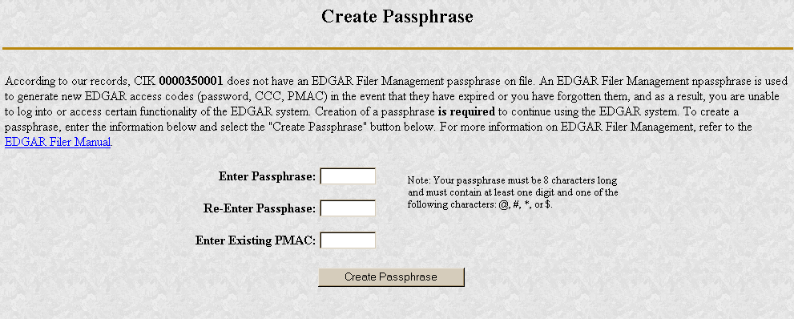
Figure 2-2: The EDGAR Create Passphrase Page
To define a passphrase, type it in the data entry fields provided (the passphrase is not displayed in clear and it is an important security code: typing it twice ensures that no typographical errors occur during entry).
Enter your existing PMAC (doing so verifies that you have the right to define a passphrase). If you’ve forgotten your PMAC, contact our Filer Support Staff at (202) 942-8900 for help.
Click the [Create Passphrase] button. If your new passphrase is in the correct format (it must be in the same format as the PMAC) and the PMAC is valid for the CIK, the Create Passphrase Results page is displayed (you will be informed of any errors in the data entered and will be required to fix it before you can proceed).
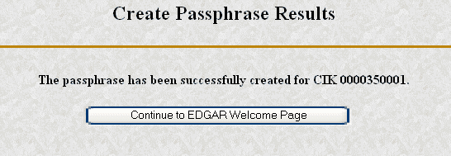
Figure 2-3: The EDGAR Create Passphrase Results Page
Click the [Continue to EDGAR Welcome] button. The Welcome page appears.
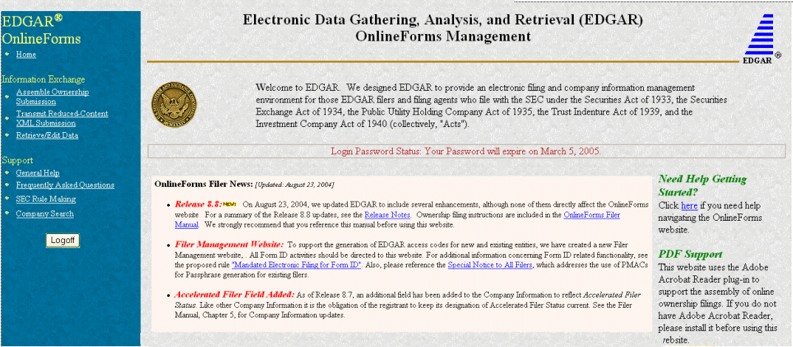
Sample
The contents of this page may change for every release.
Figure 2-4: The EDGAR OnlineForms Welcome Page (Top)

Notes:
- If you mistype your password, EDGAR considers it an invalid password and access to EDGAR is denied.
- If you accidentally mistype the CIK or password, you can press the [Back] button to return to the Login page, and try again.
- If your CIK and password do not match those saved in the database, you will see an Invalid Login page. If you find you are getting the Invalid Login page and your CIK and password are entered correctly, please contact Filer Support.
- Additional error messages you may see are Password Login Expiration messages. There are two different types of messages: Login Password to Expire Soon or Login Password Expired. If your password expires soon or if your password has expired within the last 10 days, EDGAR allows you to create a new password using your PMAC. For more details, please refer to Section 5. If you have a passphrase (see the Electronic Form ID Appendix for more information), you can get a new set of EDGAR access codes (including a password) using the EDGAR Filer Management Website – even if your password has been expired for more than 10 days. If you need assistance, contact our Filer Support Staff at (202) 942-8900 for help.
- The passphrase is a security code that is new with the electronic Form ID capability in Release 8.7. It is used to generate EDGAR access codes (refer to the Electronic Form ID Appendix for more information). You must define a passphrase before you can access any of the EDGAR capabilities.

Navigating EDGAR
Once you log into EDGAR, an option menu appears on the left-hand side of the browser window. This menu allows you to navigate easily through EDGAR without having to return to a menu page. This menu is broken down into two different sections:
- Information Exchange
- Support
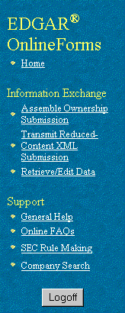
Figure 2-5: EDGAR Menu
Two additional functions will help you use the OnlineForms website. The [Logoff] button ends your EDGAR session. Clicking Home brings you to the EDGAR OnlineForms Welcome page. From this menu you can move back and forth between pages, find news, download software or template updates, or get additional assistance.

Information Exchange
In the Information Exchange section there are three links:
- Assemble Ownership Submission
- Transmit Reduced-Content XML Submission
- Retrieve/Edit Data
By clicking on Assemble Ownership Submission, you can prepare, assemble, validate, and transmit online ownership submissions to EDGAR for processing. For more details, please refer to Section 3.1.4, Creating An Online Ownership Submission.
By clicking on Transmit Reduced-Content XML Submission, you can transmit any reduced-content submissions to EDGAR for processing. For more details, please refer to Chapter 4, Reduced-Content XML Submissions.
By clicking on Retrieve/Edit Data, you can query company, or filing information, retrieve your Return Copies or change your password or CCC. For more details, please refer to Chapter 5, Additional Online Features.

Support
In the Support section there are four links:
- General Help
- Online FAQs
- SEC Rule Making
- Company Search

General Web Help
If you need help while using the OnlineForms website on the Internet, click on General Help from the menu to bring up the General Support Menu page that displays a list of help topics. When you click on a topic, you are shown information or additional links to specify the type of assistance you need.
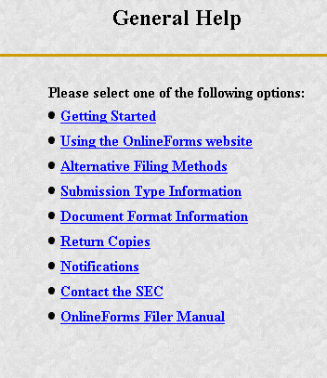
Figure 2-6: General Help Page

Frequently Asked Questions
Click on Online FAQs to open the EDGAR OnlineForms Frequently Asked Questions (FAQ) page. The FAQ page includes different questions that have been asked most often. You may find the answers helpful while using the OnlineForms website. Click on the hyperlink topic to display the answer in the lower portion of the window.

SEC Rule Making
Click on the SEC Rule Making link to go to the SEC website that gives you up-to-date rule information. You will get information about rules that have been proposed or adopted, as well as other bulletins and notices.

Company Search
The OnlineForms website restricts you to retrieving company information only for your CIK. To search for information about other companies, click on the Company Search link to redirect your browser to the EDGAR Company website (www.edgarcompany.sec.gov). From this website you can perform company searches through the EDGAR database that is updated daily.

Preparing and Transmitting Online Submissions to EDGAR
The OnlineForms website allows you to prepare and transmit form type submissions online.

Online Ownership Processing
This section walks you through the process of preparing your submission of ownership reports (Forms 3, 4, and 5) using the OnlineForms website.

Legacy Ownership Processing
If you prepared Section 16 ownership submissions for EDGAR in the past you know that it involved preparing a HTML or SGML ASCII primary ownership document. Next, you used EDGARLink to prepare the submission header and to attach the ownership primary document along with other attachments such as cover letters and power of attorney exhibits. Once the submission was prepared using EDGARLink, you then logged into the EDGAR Filing website using your CIK/password and transmitted the submission to EDGAR for processing. This allowed the SEC to notify investors about various insider transactions as soon as EDGAR processed them. One major disadvantage with this process was that the detailed information was buried in the HTML or SGML ASCII primary ownership document text.

Modernized Section 16 Ownership Processing
In order to make it easier for filers and their agents to submit ownership and other required electronic filings, the SEC decided to establish an OnlineForms website. The ownership submission form types 3, 3/A, 4, 4/A, 5, and 5/A are the first set of EDGAR submission form types to be available for online preparation. The OnlineForms website software will use the filer-provided information to prepare an XML tagged ownership primary document that can be verified and printed by the filer and then transmitted to EDGAR for processing. Once EDGAR has accepted the submission it will disseminate the header in tagged SGML and the primary document in tagged XML.
Note: You may only create and submit one Form submission at a time. If you are filing on behalf of a company's officers and directors you must create a separate form for EACH officer and director.

OnlineForms Data Gathering Model
All online submissions will follow the same basic model. The OnlineForms website will:
- Allow you to choose the type of submission to prepare, (i.e., Assemble Ownership Submission)
- Allow you to select the specific ownership form type that you want to assemble and submit to the SEC, (e.g., Form 3, Form 4, Form 5)
- Allow you to provide general submission information (i.e., contact name, phone number, E-Mail address, and Return Copy information)
- Allow you to provide additional E-Mail addresses to receive Filer Notification messages
- Allow you to provide all of the necessary information required by the SEC rules on an appropriate data gathering form
- Allow you to provide your signature and signature date
- Allow you to verify the information on the form
- Allow you to edit reporting owner address on the form where necessary
- Allow you to upload attachments (i.e., cover letters, exhibits, or correspondence)
- Allow you to review and confirm your information in the context of the form you are filing and then print the submission for your records
- Allow you to transmit the reviewed submission to EDGAR for processing
The following are important notes to consider when preparing a submission using the OnlineForms website:
- There is no capability to save work in progress so it is important for you to have all of the information necessary to complete the form before you begin to assemble your submission online
- You can exit the window at any time to discard your work in progress and start over
- All filings that you prepare and submit online are considered to be live EDGAR submissions; once you transmit an online prepared submission it will be automatically processed by EDGAR and, if accepted by EDGAR, immediately disseminated to the public
- The maximum size of your submission must not exceed 100 MB

Creating an Online Section 16 Ownership Submission
This section outlines the general process for preparing a Section 16 ownership submission using the OnlineForms website and then transmitting the submission to EDGAR for processing.
Before beginning, gather the following information:
- Determine the proper submission form type you need to file
- Note: To determine which form type you need to submit, go to http://www.sec.gov/rules/final/34-46421.htm, which is the SEC's Ownership Reports and Trading by Officers, Directors, and Principal Security Holders Rules section.
- Have your CIK, password, and CCC handy
- Determine the Issuer CIK and the ticker symbol of the transactions you need to report. You can use the company database for assistance, http://www.edgarcompany.sec.gov.
- Make sure you have the CIK and CCC for each reporting owner to be included in the submission
- Make sure you have the proper address for each reporting owner to be included in the submission
- Make sure you have the E-Mail address for each additional addressee to receive filer notification messages
- Make sure you have all necessary transaction and holding details
- Prepare any attachments, such as a Cover Letter or Exhibit, save them in the correct format, and have the file names identified.

Select Ownership Submission Form Type
The first step for preparing an ownership submission using the OnlineForms website is to select the proper ownership submission form type by:
- Logging in to the OnlineForms website, https://www.onlineforms.edgarfiling.sec.gov.
- Click on Assemble Ownership Submission in the menu bar.
- The Select Ownership Form Type page will appear:

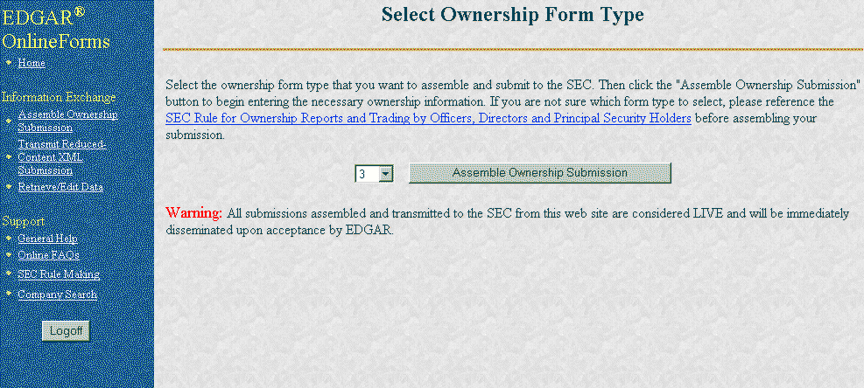
Figure 3-5: Select Ownership Form Type Page
- Using the pull down bar, select the form type you wish to prepare, and click on the [Assemble Ownership Submission] button.
- A new browser window will open and the data entry page for the select submission form type should appear. For example, see the Ownership Form Type 3 page below.
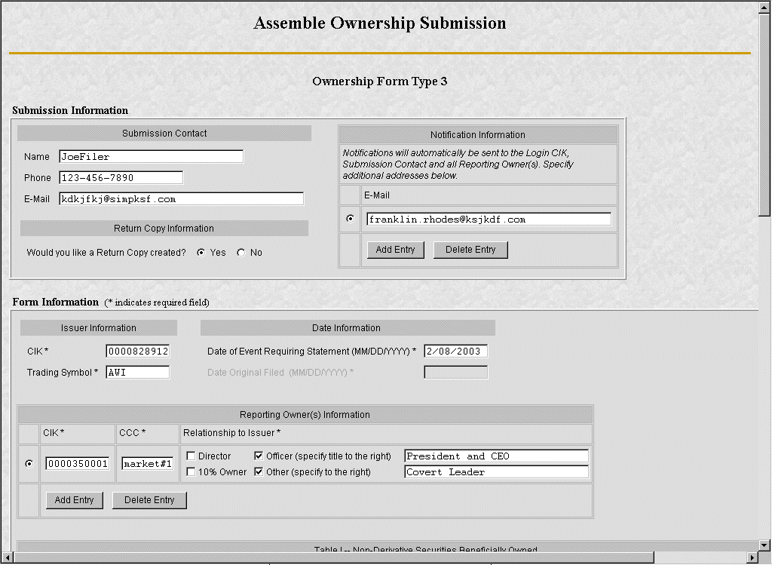
Figure 3-6: Ownership Form Type 3 Page

Assemble Ownership Submission – Top of Form
The following are some basic OnlineForms data entry conventions:
- In Internet Explorer, disabled fields are made read-only and are colored gray. In Netscape, we can make the field read-only but cannot color it gray
- Required fields are indicated by an asterisk to the right of the label name (for example, CIK* and Date* are some of the required fields)
- Certain fields are indicated by a double asterisk to the right of the label name to indicate that a footnote is required if you are unable to provide the required data in the space provided (for example: Date Exercisable** and Conversion or Exercise Price of Derivative Security** are fields that require a footnote if the field is left blank)
- Press the [Tab] key to move from field to field
- Field level help is available by clicking on the label
- The [Exit Window] button will close the current data entry session and return to the Select Ownership Form Type Page. Any data entered or attachments uploaded will be discarded.

Once the Assemble Ownership Submission data entry screen is displayed, you can begin completing your ownership submission for each of the entry sections:

Submission Contact
  - Provide a point of contact for the submission in the name, phone, and E-Mail address fields.
Return Copy Information
  - Indicate if you want a Return Copy of your submission generated by EDGAR.
Notification Information
  - Enter additional E-Mail addresses to receive filer notification messages.
Issuer Information
  - Enter the CIK and trading symbol for the Issuer company.
Date Information
  - Enter the date of the event that triggered this submission, such as the earliest transaction date to be reported in a Form 4.
  - The Date Original Filed is only available for amendments and refers to the date when the original submission that is being amended was filed.
Reporting Owner Information
  - Enter the CIK, CCC, and relationship fields for each reporting owner.
  - Click on the [Add Entry] button to add additional reporting owners.
  - To remove a reporting owner, select the radio button to the left of the reporting owner and click on the [Delete Entry] button.

Assemble Ownership Submission – Middle of Form
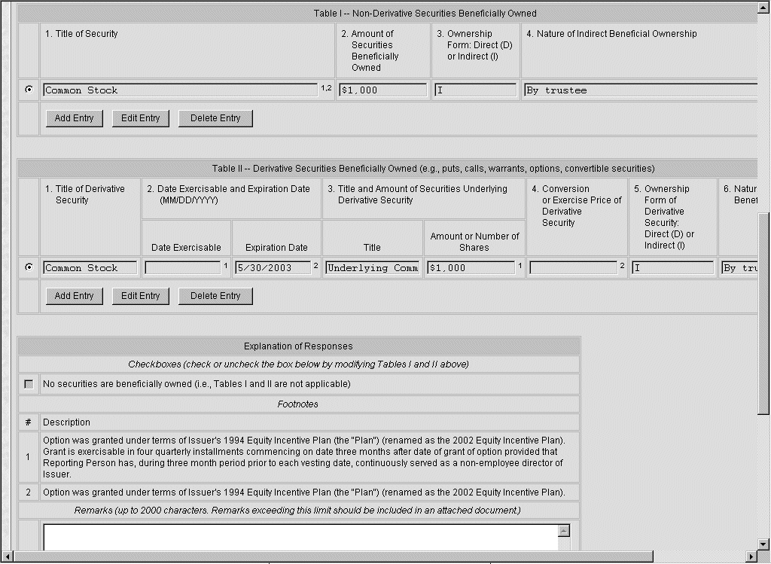
Figure 3-7: Assemble Ownership Submission – Middle of Form
The middle part of the Assemble Ownership Submission data entry form indicates where Table I and Table II data are displayed. The following are some additional data entry conventions for the Assemble Ownership Submission data entry form:
- Fields in Table I and II appear as read-only. You can enter data by clicking on the [Add Entry] button. The example above shows how Table I and II appear once entries have been added.
- To modify a row, select the radio button to the left of the entry you wish to modify and click on the [Edit Entry] button.
- To delete a row, select the radio button to the left of the entry you wish to delete and click on [Delete Entry] button.
- Footnote references are represented by a superscript to the right of the field. The referenced footnote appears at the bottom of the page.
- Date format is MM/DD/YYYY.
The following sections illustrate how to enter the required information for Table I and Table II and provide footnotes where necessary.

Add Holding (Form 3 Non-Derivative Security)
The Add Holding page appears when the [Add Entry] button is clicked in Form 3 Table I. You use this data entry form to enter all of your Form 3 non-derivative securities that appear in Table I. You must provide the title of the security, the amount of securities beneficially owned, and indicate if the security is owned directly or indirectly. If the security is owned indirectly, you must indicate the nature of indirect beneficial ownership.
The following are some data entry conventions for this page:
- Default unit for Amount of Securities Owned is Shares
- Default setting for Ownership Form is Direct
- Footnotes can be added on a per field basis by clicking on the corresponding [Footnote] button
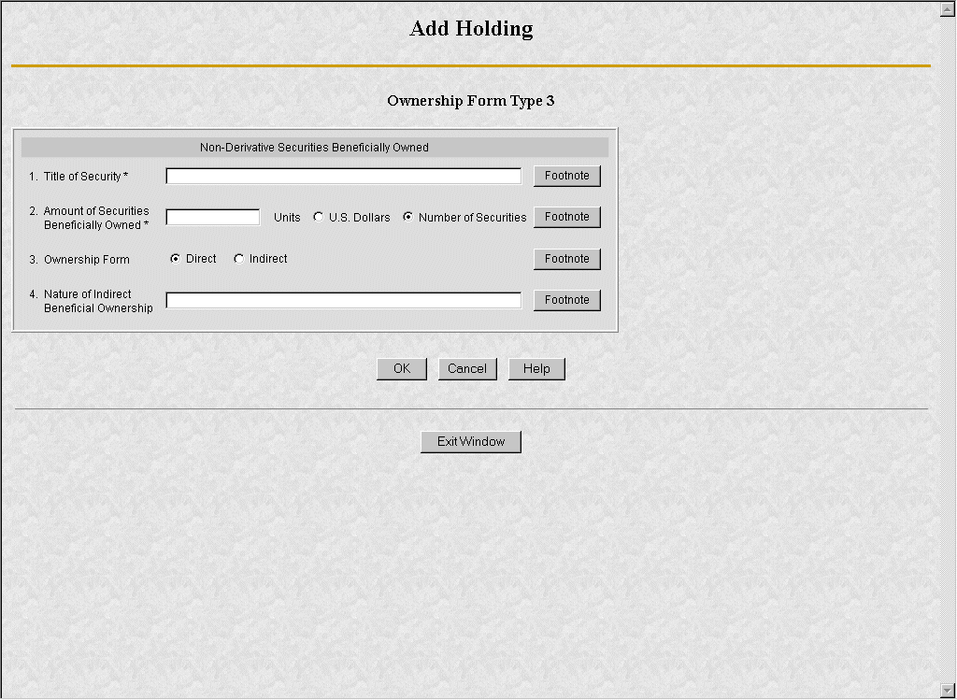
Figure 3-8: Add Holding Page (Non-Derivative Security)

Edit Holding (Form 3 Non-Derivative Security)
The Edit Holding page appears when the [Edit Entry] button is clicked for Form 3 Table I. The Edit Holding page is similar to the Add Holding page in Table I and has the same data entry conventions.

Add Holding (Form 3 Derivative Security)
The Add Holding (Form 3 Derivative Security) page appears when the [Add Entry] button is clicked for Table II. You use this data entry form to enter all of your Form 3 derivative securities that appear in Table II. You must provide the title of the security, date exercisable, expiration date, title of securities underlying derivative security, amount or number of shares of securities underlying the derivative security, conversion or exercise price of the derivative security, and mark whether the security is owned directly or indirectly. If the security is owned indirectly, you must indicate the nature of indirect beneficial ownership. If you are unable to provide any of the following information in the space provided you must provide an explanation footnote for each situation:
- a date for the Date Exercisable
- a date for the Expiration Date
- the Amount or Number of Shares of Underlying Derivative Securities
- the Conversion or Exercise Price of Derivative Security
The following are some data entry conventions for this page:
- Default unit for Amount of Securities Owned is Shares
Default setting for Ownership Form is Direct
- Footnotes can be added on a per field basis
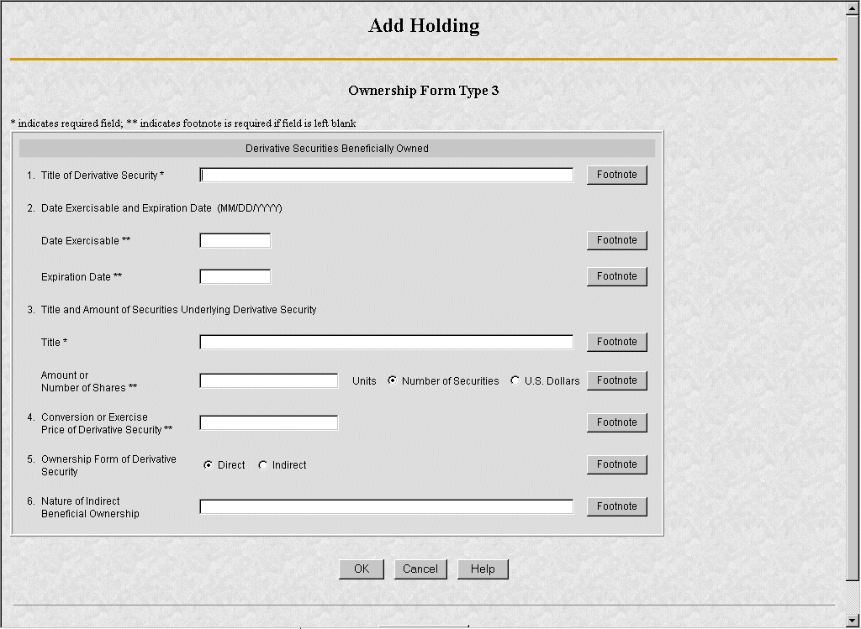
Figure 3-9: Add Holding Page (Derivative Security)

Edit Holding (Form 3 Derivative Security)
The Edit Holding page appears when the [Edit Entry] button is clicked for Table II. The Edit Holding page is similar to the Add Holding page for Table II and has the same data entry conventions.

Footnotes
The Footnotes page appears when you click on the [Footnote] button from Table I or Table II entry page. You use this page to add, edit, or delete footnotes associated with your submission. In addition, you use this page to associate selected footnotes with a specific data entry field from Table I and Table II.
The following are some data entry conventions for this page:
- This page contains the master list of all of the footnotes for this submission.
- To apply a footnote to a field, select the “Apply To Field” checkbox for that footnote.
- To add a new footnote, click on the [Add Footnote] button.
- To modify a footnote, select the radio button to the left of the entry you wish to modify and click on the [Edit Footnote] button.
- To delete a footnote, select the radio button to the left of the entry you wish to delete and click on the [Delete Entry] button.

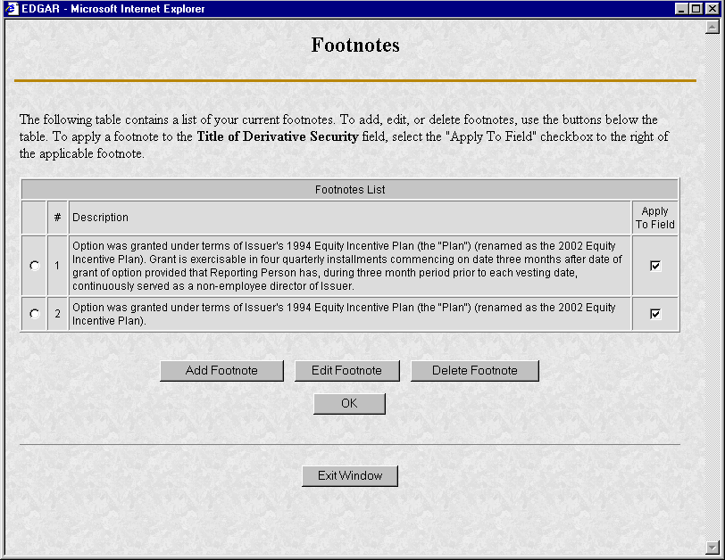
Figure 3-10: Footnotes Page

Add Footnote
The Add Footnote page appears when the [Add Footnote] button is clicked.
The following are some data entry conventions for this page:
- You can enter up to 1000 characters for a footnote. If you need to add more than 1000 characters, split your footnote in multiple pieces and associate the pieces with the appropriate fields using the Footnote page.
- EDGAR will automatically create the footnote number.
- Click on the [OK] button to save the footnote entry.
- Click on the [Cancel] button to cancel the footnote entry.

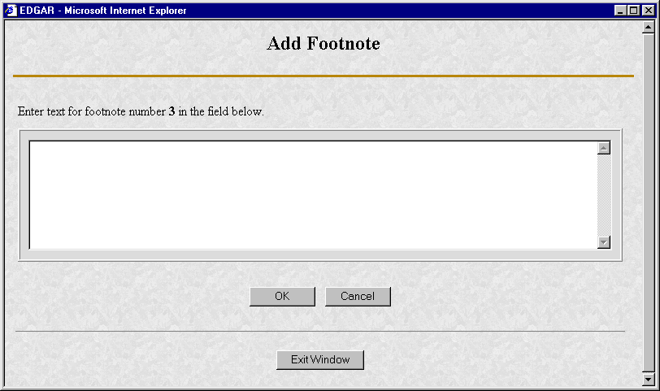
Figure 3-11: Add Footnote Page

Edit Footnote
The Edit Footnote page appears when the [Edit Footnote] button is clicked. You can modify the existing text of the footnote.
The following are some data entry conventions for this page:
- Click on the [OK] button to save the footnote changes.
- Click on the [Cancel] button to cancel the footnote changes.
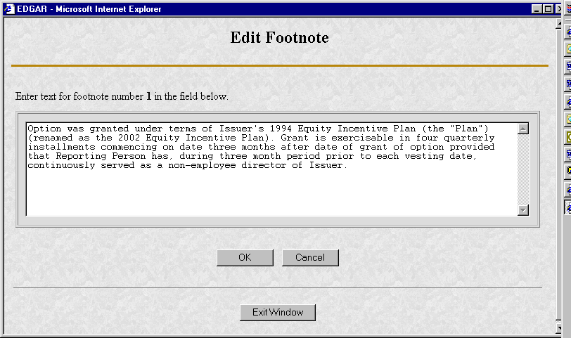
Figure 3-12: Edit Footnote Page

Assemble Ownership Submission – Bottom of Form
The bottom part of the Assemble Ownership Submission data entry form illustrates where the Explanation of Responses and Signature data is displayed.
The following are some additional data entry conventions for this page:
Explanation of Responses
- Each form type has some specific responses that are indicated by checking the box. Some of these checkboxes are automatically filled in based on your responses in Table I and Table II, while others you must complete if appropriate. For example, on Form 3 there is a response “No securities are beneficially owned” along with a checkbox that is auto-filled. When the page first appears, it will be checked. If you add an entry to Table I or Table II, the checkmark will be removed.
- Footnotes are listed here as read-only. You can enter additional footnotes or modify an existing footnote by returning to the Table I or Table II entry portion of the form.
- Remarks can be used to supply additional commentary on the submission. This field also should be used to provide a list of exhibits and other attachments, if any. Remarks exceeding the 2000 character limit should be included in an attached document.
Signature Data
- Enter the name of each reporting person in the signature field along with the date signed. Click on the [Add Entry] button to add more signature entry lines.
- To delete a signature, select the radio button to the left of the entry you wish to delete and click on the [Delete Entry] button.
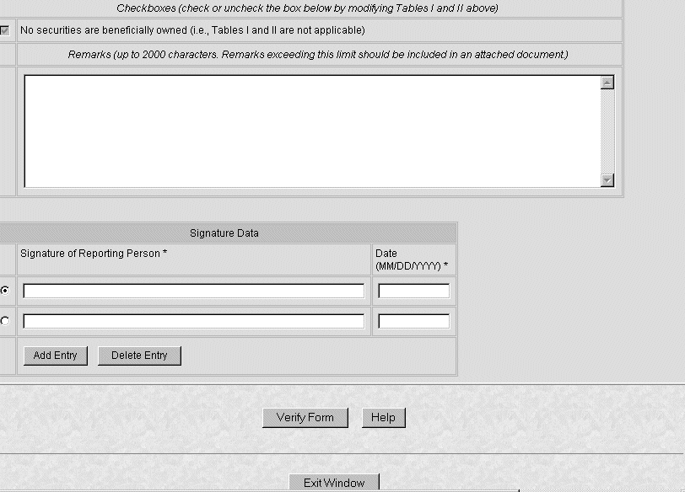
Figure 3-13: Assemble Ownership Submission – Bottom of Form

Verify Form
Once you have completed all of the information for the submission, you need to verify the form information. Either the Assemble Ownership Error Screen or the Insider Confirmation/Correction page will appear when the [Verify Form] button is clicked.

Assemble Ownership Errors
If there were any errors on the form, the form will be redisplayed with the error fields marked. You should follow the instructions on the page to correct the errors.
For example, Figure 3-10 marked the following errors:

- Submission contact E-Mail is formatted incorrectly; it needs an "@" to be valid
- Issuer CIK is formatted incorrectly; it can only be all numeric
- Date is formatted incorrectly; it should be MM/DD/YYYY
- CCC provided is not valid for the Reporting Owner CIK provided
Note: EDGAR will validate ONLY the format and syntax of the information provided, and that the Issuer CIK and Reporting Owner CIK and CCC combination are valid. YOU ARE RESPONSIBILE for confirming the accuracy of all transactional and ownership information submitted in the Form.
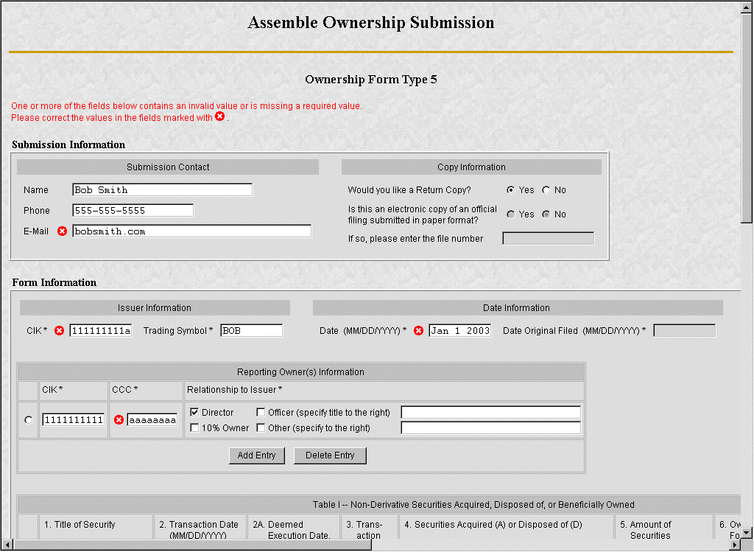
Figure 3-14: Assemble Ownership Form With Errors (Form Type 5)
If there are errors in Table I or Table II you need to select the field entry or field value that needs to be revised, and click on the [Edit Entry] button. The detailed form will appear with the fields in error marked, as shown in the example below.
For example, Figure 3-11 marked the following errors:
- Transaction Date is formatted incorrectly; it should be MM/DD/YYYY
- Price of securities acquired of disposed of is formatted incorrectly; it has two decimal places in the number
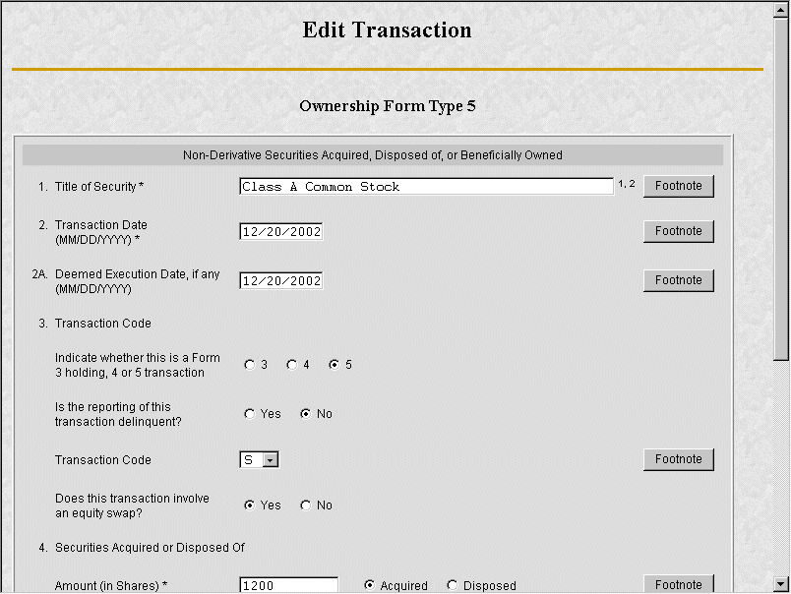
Figure 3-15: Edit Transaction With Errors (Form Type 5, Non-Derivative Security)

Insider Confirmation/Correction
If your submission was successfully verified, the Insider Confirmation/Correction page will appear. As part of verification, EDGAR retrieves the company name for the Issuer CIK and the name and address information for each reporting owner you entered. Before continuing, you need to confirm that the name and address information that was retrieved from EDGAR based on the issuer CIK and reporting owner CIK and CCCs are correct and update where necessary.
The following are some data entry conventions for this page:
- If you need to modify a reporting owner's mailing address, select the desired reporting owner row and click on the [Edit Mailing Address] button.
Note: These address changes apply only to the addresses contained within this form and do not update the CIK's address of record. To update the address of record, you must use the "Retrieve/Edit Data" link in the main EDGAR OnlineForms window.
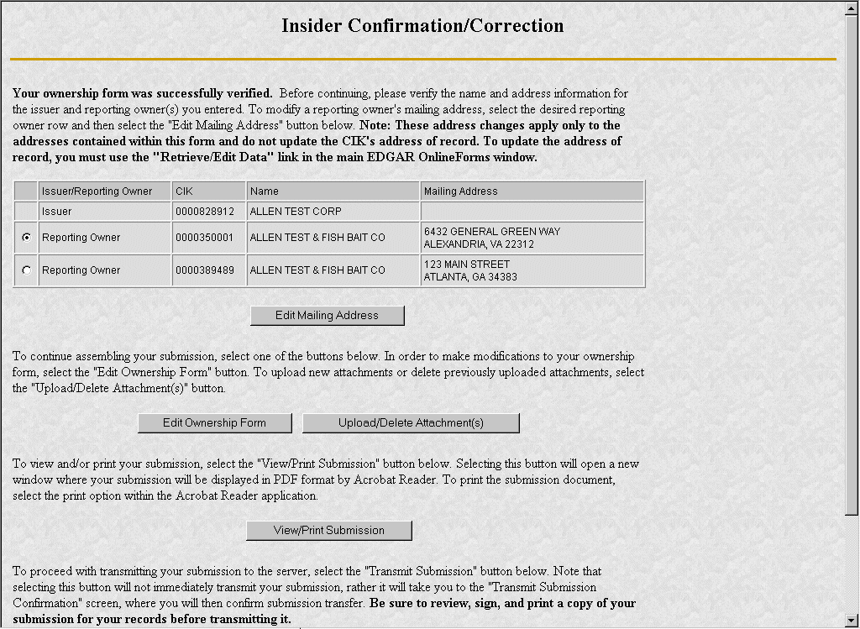
Figure 3-16: Insider Confirmation/Correction

Edit Mailing Address
The Edit Mailing Address page appears when the [Edit Mailing Address] button is clicked. This screen allows you to modify the mailing address for addresses contained within this form and do not update the CIK's address of record. To update the address of record, you must use the "Retrieve/Edit Data" link in the main EDGAR OnlineForms window.
The following are some data entry conventions for this page:
- Click on the [OK] button to change the information for this submission
- Click on the [Cancel] button to return to the Insider Confirmation/Correction screen without making changes.
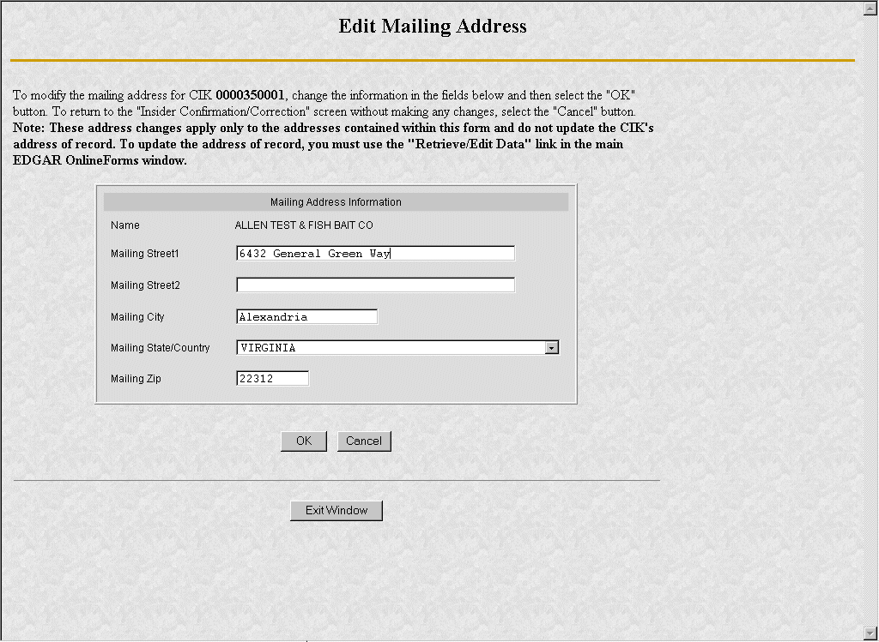
Figure 3-17: Edit Mailing Address

Upload/Delete Attachment(s)
The Upload/Delete Attachment(s) page appears when the [Upload/Delete Attachment(s)] button is clicked. This page allows you to manage the attachments associated with your submission.
The following are some data entry conventions for this page:
- Click on the [Upload Attachment] button to upload an attachment.
- If you need to delete an attachment, select the radio button to the left of the attachment you wish to delete and click on the [Delete Attachment] button.
- Click on the [Edit Ownership Form] button to return to the Assemble Ownership Submission data entry form.
- Click on the [Transmit Submission] button to proceed to transmit your submission to the server.
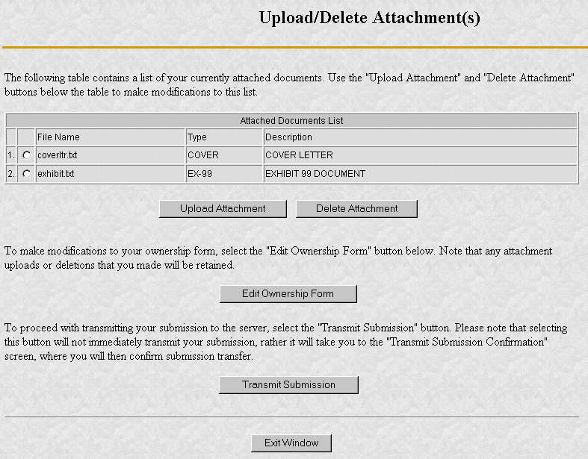
Figure 3-18: Upload/Delete Attachment(s)

Upload Attachment
The Upload Attachment page appears when the [Upload Attachment] button is clicked.
Note: Any attachments you plan to include should already have been prepared and saved in the appropriate format prior to assembling your online submission.
The following are some data entry conventions for this page:
- To upload an attachment to the server, enter the attachment information in the fields, and then click on the [Upload] button.
- To return to the Upload/Delete Attachment(s) screen without uploading an attachment, click on the [Cancel] button.

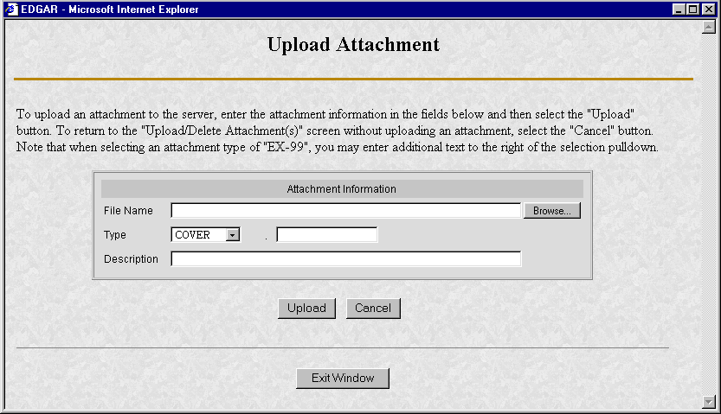
Figure 3-19: Upload Attachment

Transmit Submission Confirmation
The Transmit Submission Confirmation page appears when the [Transmit Submission] button is clicked.

The following are some data entry conventions for this page:
- Click on the [Cancel Transmission] button to return to the Assemble Ownership Submission data entry form.
- Click on the [View/Print Submission] button to view the submission document in PDF format.
- Click on the [Transmit Submission] button to proceed to transmit the submission to EDGAR for processing.
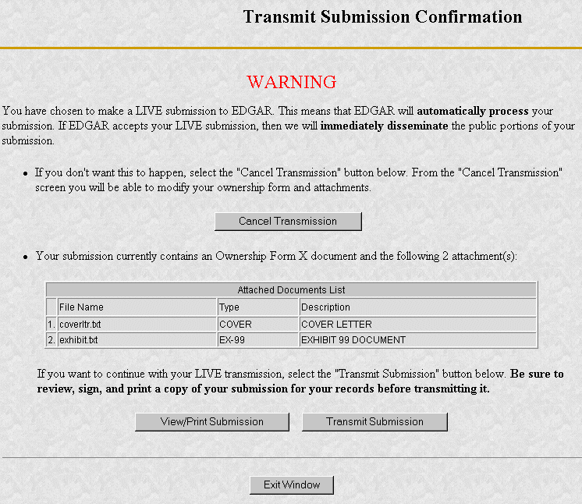
Figure 3-20: Transmit Submission Confirmation

View/Print Submission
The View/Print Submission page appears when the [View/Print Submission] button is clicked. Use this to print a copy of your form for your records.
The following are some data entry conventions for this page:
- To view your submission as an Adobe PDF document, click on the [Continue] button. This will display your submission via the Adobe Acrobat Reader as shown in the example below. From the Acrobat Reader, you can print your document by selecting the printer icon.
- To close this window and continue your submission processing, click on the [Close] button.
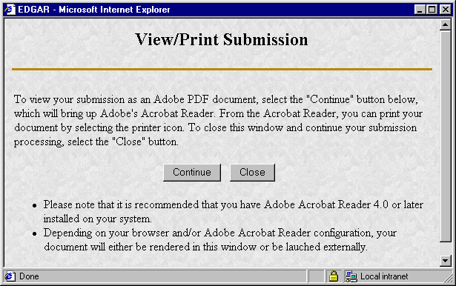
Figure 3-21: View/Print Submission Page
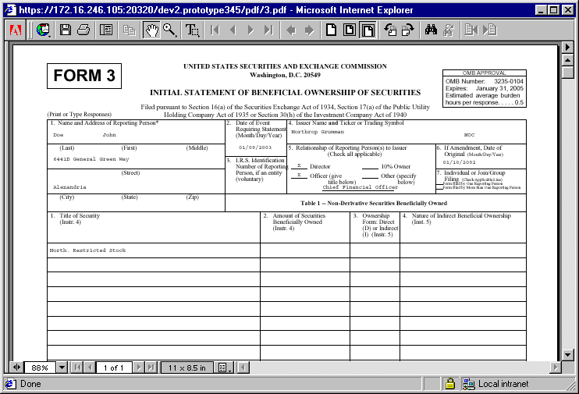
Figure 3-22: PDF Document

Transmit Submission Acknowledgement
The Transmit Submission Acknowledgment page appears when the [Transmit Submission] is clicked from the Transmit Submission Confirmation page. This page provides acknowledgement of the transmission, along with the submission accession number.
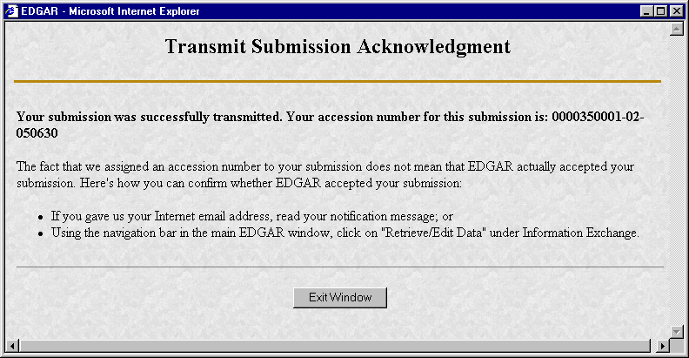
Figure 3-23: Transmit Submission Acknowledgement
Record your accession number so you can later identify your submission and retrieve the acceptance messages and Return Copy from the website.

Transmit Submission Cancelled
The Transmit Submission Cancelled page appears when the [Cancel Transmission] button is clicked.
The following are some data entry conventions for this page:
- Click on the [Edit Ownership Form] button to return to the Assemble Ownership Submission data entry form.
- Click on the [Upload/Delete Attachment(s)] button to return to the Upload/Delete Attachment(s) page.

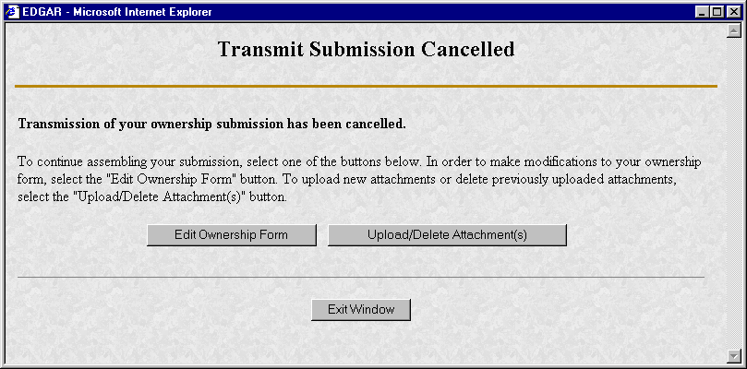
Figure 3-24: Transmit Submission Cancelled

REDUCED-CONTENT XML SUBMISSIONS

Preparing Reduced-Content XML Submissions
Preparing a submission without using the OnlineForms website requires a working knowledge of XML. The OnlineForms website automatically assembles all your information into an EDGAR-compatible XML ownership submission. XML forms are accepted by EDGAR, processed, and indexed into our databases. If you want to prepare your submission without using the OnlineForms website, you must use our Reduced-Content XML Filing Specification document. You can find additional information about this document and download it from our website: http://www.sec.gov/info/edgar/ednews.shtml. Reduced-Content XML submissions must be transmitted to EDGAR via the Transmit Reduced-Content XML Submissions link on the OnlineForms website.
Note: Reduced-Content XML Submissions are only accepted through the OnlineForms website.

Test and Live Submissions
You cannot create test submissions online using the OnlineForms website. However, if you choose to prepare your own XML submission using the Reduced-Content XML Filing Specification, we allow you to transmit the submission as a test submission to verify that your XML is correct. EDGAR treats all submissions transmitted this way as "test" and they will not be disseminated.

Transmitting Reduced-Content XML Submissions
Prior to transmitting, prepare your Reduced-Content XML Ownership Submission file. You can then transmit your ownership Reduced-Content XML Submission using the OnlineForms website, (https://www.onlineforms.edgarfiling.sec.gov) by:
- Logging into the OnlineForms website (see Section 2.2.1).
- Click on Transmit Reduced-Content XML Submission in the menu bar.
- The Transmit Reduced-Content XML Submission page appears and asks you to specify whether to transmit the Reduced-Content XML submission as a TEST submission or as a LIVE submission.
Note: If you are not ready to make a LIVE submission, choose "test" submission. If you make a "LIVE" submission, we will automatically disseminate the public portions of your submission(s). Please use caution when transmitting LIVE submissions to EDGAR. Also, the maximum size of your submission must not exceed 100 MB.

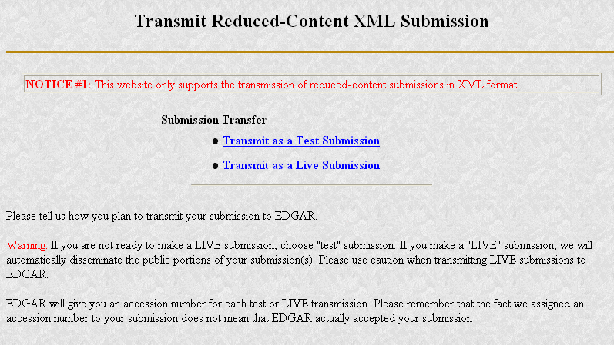
Figure 4-1: Transmit Reduced-Content XML Submission Page

Transmit Reduced-Content XML as a Test Submission
Once you have logged into OnlineForms website and accessed the Transmit Reduced-Content XML Submission page, you can transmit your Reduced-Content XML Submission as a test submission:
- Click on Transmit as a Test Submission.
- The Transmit Test Submission page appears.
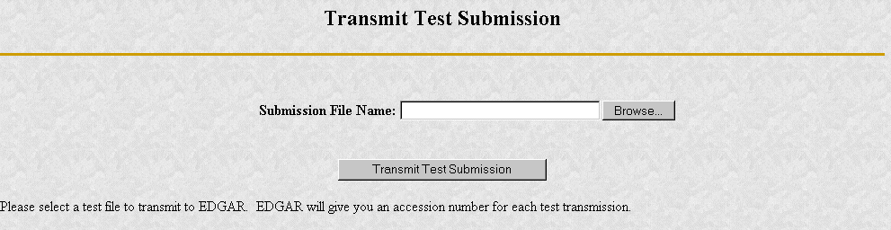
Figure 4-2: Transmit Test Submission Page
- Click on the [Browse...] button. The Choose File window appears.
- Open the location of your submission in the Look In: field.
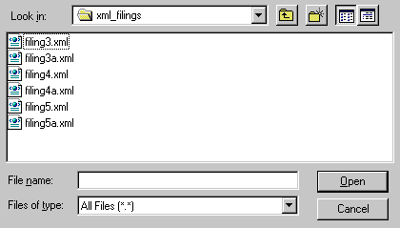
Figure 4-3: Transmit Test Submission File Upload Window
Note: If your XML submission does not appear immediately, change the Files of Type to All Files (*.*).
- Click on your XML submission.
- Click on the [Open] button.
The Submission File Name field fills with the location and name of your submission. When you are ready to transmit a TEST filing:
- Click on the [Transmit TEST Submission] button.
Once you click this button, EDGAR will process your submission.

Transmit Reduced-Content XML as a Live Submission
Once you have logged into OnlineForms website and accessed the Transmit Reduced-Content XML Submission page, you can transmit your Reduced-Content XML Submission as a live submission by:
- Click on Transmit as a Live Submission.
- The Transmit Live Submission page appears.
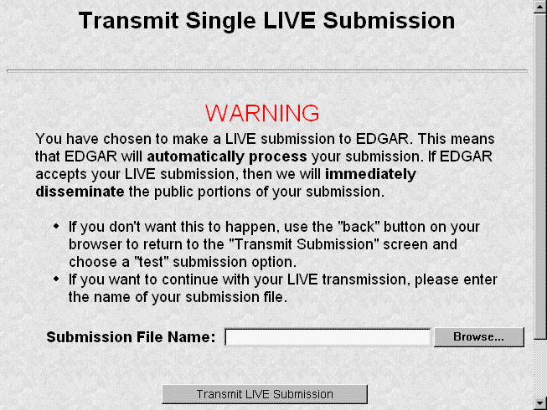
Figure 4-4: Transmit Live Submission Page
- Click on the [Browse...] button. The Choose File window appears.
- Open the location of your submission in the Look In: field.
Figure 4-5: Transmit Live Submission File Upload Window
Note: If your XML submission does not appear immediately, change the Files of Type to All Files (*.*).
- Click on your XML submission.
- Click on the [Open] button.
The Submission File Name field fills with the location and name of your submission. When you are ready to transmit a LIVE filing:
- Click on the [Transmit LIVE Submission] button.
Once you click this button, EDGAR will process your submission.

Transmission Status
OnlineForms has a transmitting indicator that appears in the bottom pane of your browser window. While your submission is being transmitted to EDGAR, the words "Transmitting Files" scrolls from right to left. The scrolling text stops and the Transmit Submission Results page appears when the transmission is complete.
An accession number appears on the Transmit Submission Results page.
Note: This does not mean your submission has been accepted. It means your submission has been transmitted. You can find the status of your submission one of two ways:
- Through E-Mail
- By performing a Submission query on the OnlineForms website. For more details please refer to Section 5.2, Submission Information.

Additional ONLINE Features
The previous chapters discussed preparing, compiling, and transmitting submissions. The OnlineForms website provides the following additional features.

Accessing Submission and Company Information
You can access submission and company information using the OnlineForms website, (https://www.onlineforms.edgarfiling.sec.gov):
- Log into the OnlineForms website (see Section 2.2.1).
- Click on the [Retrieve/Edit Data] button.
- The Retrieve/Edit Data page appears and prompts you for your CIK and CCC information:
- Enter your CIK in the CIK field and press [Tab].
- Enter your CCC in the CCC field.
- Click on the [Continue] button.
This page verifies that you have access to retrieve or edit information on the EDGAR system.
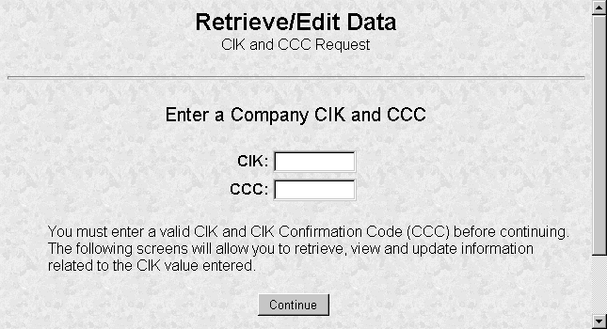
Figure 5-25: Retrieve/Edit Data Page
The next page is the Retrieve/Edit Company and Submission Data page, which is shown in Figure 5-2. You can access the following functions from this page:
- Retrieve Submission Information
- Retrieve Company Information
- Retrieve Return Copies
- Change Login Password or CCC
- Enter Another CIK/CCC
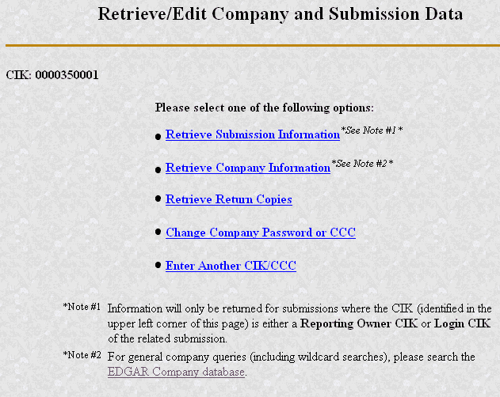
Figure 5-26: Retrieve/Edit Company and Submission Data Page

Submission Information
Retrieve Submission Information allows you to verify and retrieve information about any submission in EDGAR that is associated with the login CIK you entered. Information will only be returned for submissions where the CIK (identified in the upper left corner of the Retrieve/Edit Company and Submission Data page) is either the Filer CIK or Login CIK of the related submission.
Access to submission status information depends upon some time variables. In general, test filing information will only be available for two business days. Suspended filing information will be available for six business days. Accepted live filing information will be available for thirty business days.

Retrieving Submission Notification
Once you have logged into EDGAR and accessed the Company and Submission Information Retrieval page, you can access submission notifications for your CIK:
- Click on Retrieve Submission Information.
- The Retrieve Submission Information page appears.
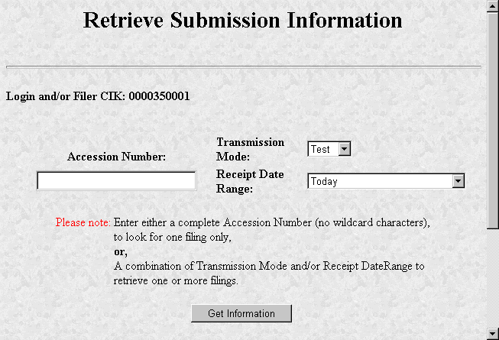
Figure 5-27: Retrieve Submission Information Page
- Enter query parameters for any or all of these three fields:
- Enter the accession number of the filing you are looking for in the Accession Number field. This query page does not accept wild card characters. To retrieve all submissions, leave the Accession Number field blank.
- Choose the type of submission you are looking for: Test, Live, or Both from the Submission Type field.
- Choose the date range of when the submission was transmitted: Today, Within 5, 10, or 30 Days from the Receipt Date Range field.
- Click on the [Get Information] button.
EDGAR retrieves a list of submissions associated with your CIK using the criteria you entered above.
Note: If the information you enter does not retrieve any submissions, you can click on the [Back] button and enter different information.
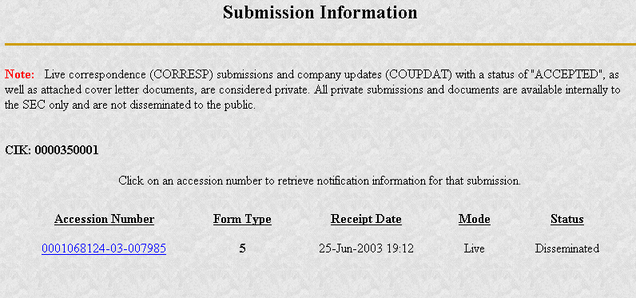
Figure 5-28: Submission Information Page
When the Submission Information page appears, a list of filings displays. Click on the accession number hyperlink to retrieve the Submission Notification page for that filing. This page displays the E-Mail notification that the E-Mail recipients received. You can print this page for future reference using your browser’s printing function.
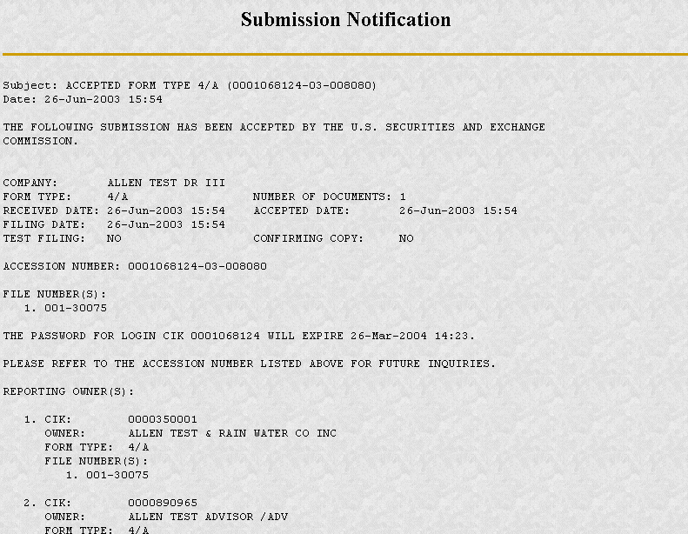
Figure 5-29: Submission Notification Page

Retrieve Company Information
Another feature in EDGAR is the ability to retrieve and update your company information from the OnlineForms website. (From EDGAR's perspective, every CIK belongs to a filing entity generally referred to as “company.” In this case, each reporting owner is a “company.”) Once you have logged into EDGAR and accessed the Company and Submission Information Retrieval page, you can retrieve your company information:
- Click on Retrieve Company Information. The Company Information page appears.

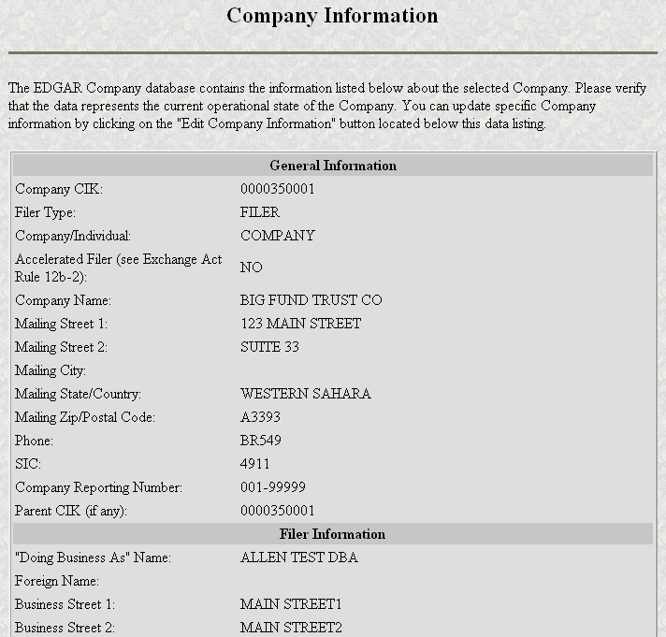
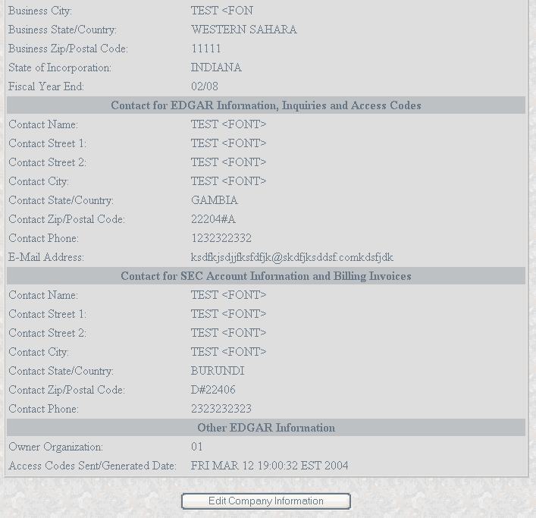
Figure 5-30: Company Information Page
Scroll down this page to review the company information EDGAR has stored. If any of this information is incorrect, you can change it by using the [Edit Company Information] button at the bottom. Note that only the information pertinent to you based upon your filer attributes (Filer Type, Company/Individual indicator, and Foreign/Domestic indicator) will be displayed. For example, if you are a “Filing Agent” or “Training Agent” the Filer Information section will not be displayed.
Note: You cannot change your CIK.
You can also print this page using your browser’s print function for future reference.
For general company queries (including wildcard searches), please search the EDGAR Company database (http://www.edgarcompany.sec.gov).

Edit Company Information
Once you have logged into EDGAR and accessed the Company and Submission Information Retrieval page, you can edit your company information:
- Click on the Retrieve Company Information. The Company Information page appears.
- Scroll to the bottom and click on the [Edit Company Information] button. The Edit Company Information page appears.
- Note that only the information pertinent to you based upon your filer attributes (Filer Type, Company/Individual indicator, and Foreign/Domestic indicator) will be displayed. For example, if you are a “Filing Agent” or “Training Agent” the Filer Information section will not be displayed.
- On this screen, required fields are indicated by an asterisk (*). If you do not fill in all required fields, you will be prompted with an error upon submission.

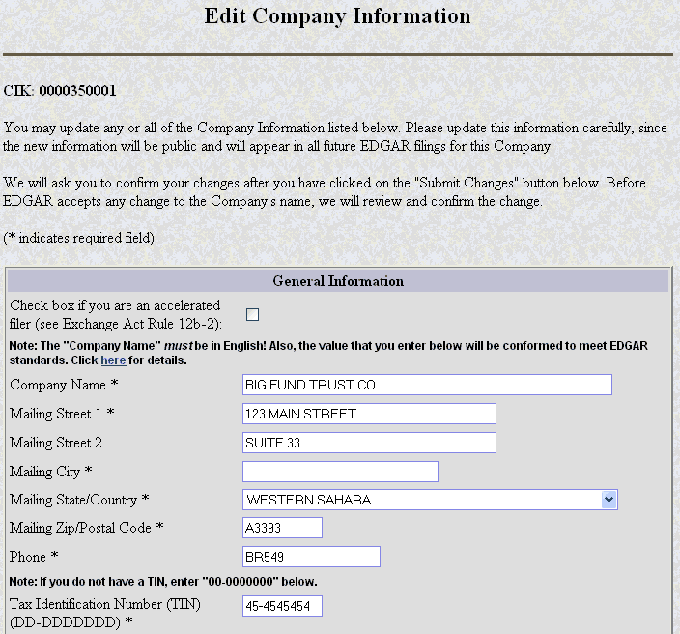
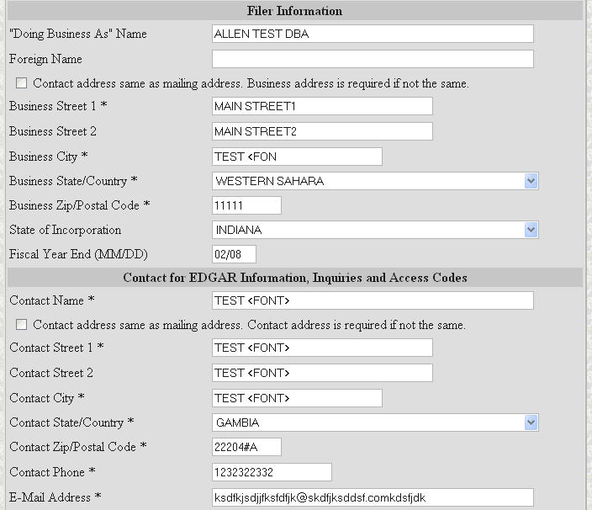
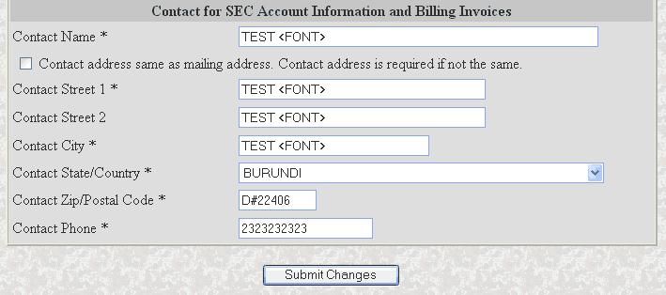
Figure 5-31: Edit Company Information Page (Top)
- Click in the field you want to edit and change the information.
- If you want to change your Company Name, the company name may be modified by the software to meet the EDGAR conformance standards. These standards can be accessed by clicking on the link in the note above the Company Name field. Note that you will be prompted with these changes before you actually submit them.
- If you want to change one of your addresses to be the same as your Mailing Address, select the “same as” checkbox next to the appropriate address section. This will clear out the address currently in that section and make it the same as your mailing address upon submission.
- If you are a Filer/Company and select “Foreign” as your Domestic/Foreign indicator, you may add a foreign company name in the “Foreign Name” field in the Filer Information section.
- When finished, click on the [Submit Changes] button.
- Your changes appear on the Edit Company Information Confirmation page. If your company name is conformed, a pop-up dialog indicating your entered company name and the EDGAR conformed company name will appear as a warning.
- Confirm the changes by clicking on the [Confirm Company Changes] button at the bottom of the page.
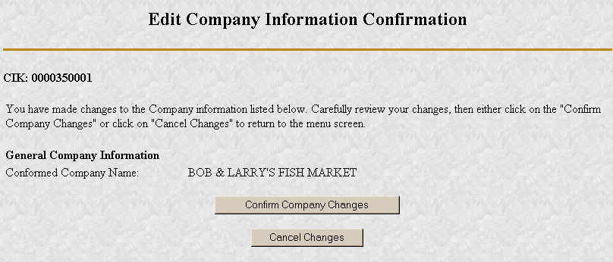
Figure 5-32: Edit Company Information Confirmation Page
- If you want to cancel the changes, click on the [Cancel Changes] button or click on the browser's [Back] button.
- The Edit Company Information Acknowledgment page appears and confirms your changes. All changes to your company information are made immediately except for changes to your company's name. Our Filer Support staff needs to review any change to your company's name. Filer Support can reject any name change if it is deemed unacceptable. If your proposed name change is rejected you will receive a suspense notification message, otherwise you will receive an acceptance notification message.
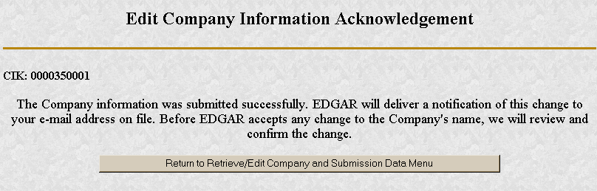
Figure 5-33: Edit Company Information Acknowledgment Page
If you want to return to the Retrieve/Edit Company and Submission data page, click on the [Return to Retrieve/Edit Company and Submission Data Menu] button at the bottom of the Edit Company Information Acknowledgment page.

Return Copy Support
When you complete an online submission you can choose to request a Return Copy of that submission. EDGAR will post a copy of your accepted submission on the OnlineForms website. If you transmit a Test submission to EDGAR, only the Login-CIK can access both Accepted or Suspended submission requested Return Copies.
If you transmit a Live submission to EDGAR, each reporting owner can access the accepted requested Return Copy. Suspended Live submission requested Return Copies are not available to anyone.

Retrieve Return Copies
Once you have logged into EDGAR and accessed the Company and Submission Information Retrieval page, you can retrieve Return Copies for your CIK:
- Click on Retrieve Return Copies. The Return Copy Information page appears with a list of submissions associated with your CIK.
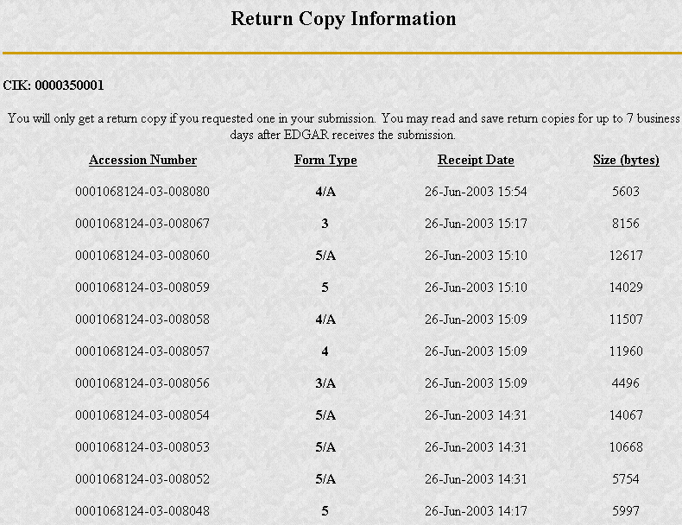
Figure 5-34: Return Copy Information Page
- To view a requested Return Copy, click on the [Yes] button at the bottom of the page.
- The Return Copy Download page displays the list of accession numbers. Select an accession number and click the [Download Return Copy] button.
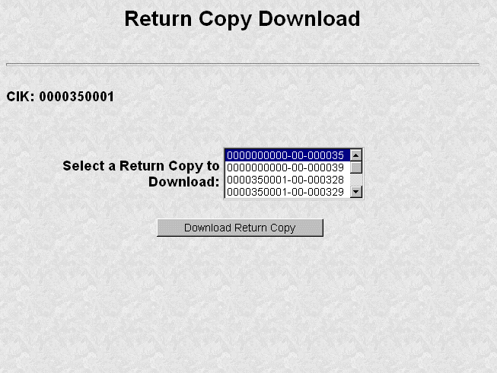
Figure 5-35: Return Copy Download Page
The Requested Return Copy Download Confirmation page confirms the submission you want to download and advises you of the approximate amount of time it takes to download the information.
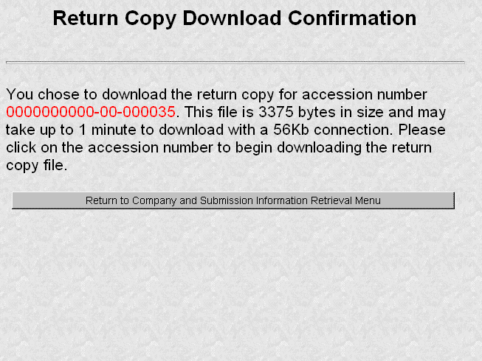
Figure 5-36: Return Copy Download Confirmation Page
- Click on the Accession Number to continue.
- The Return Copy page appears and displays a requested Return Copy of your submission.
Note: Requested Return Copies are stored on the OnlineForms website for seven business days.
Use your browser’s print feature to print the Return Copy for future reference. You can also use your browser’s save feature to save the Return Copy as a HTML or text file.

Change Login Password or CCC
The Change Login Password or CCC option has a page for you to select either of two options as shown in Figure 5-13Figure 5-37:
- Change Password
- Change CCC (CIK Confirmation Code)
Click on the Change Login Password or CCC option on the Retrieve/Edit Data page, and this page will appear.
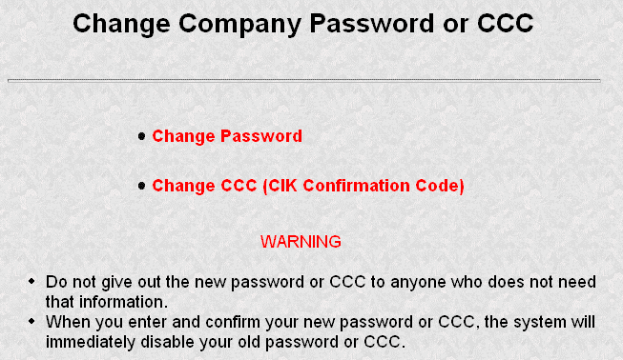
Figure 5-37: Change Company Password or CCC Page
Your EDGAR password is good for only twelve (12) months. Be sure you change your password on the Filing website before it expires.

Changing Your Password
- Login to EDGAR and access the Change Company Password or CCC page.
- Click on the [Change Password] button.
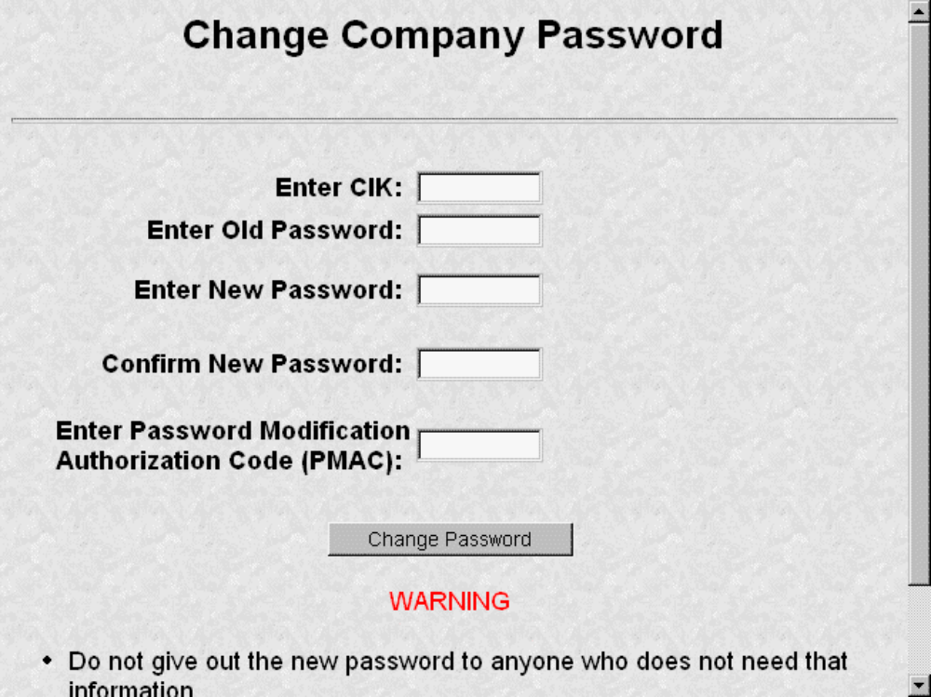
Figure 5-38: Change Company Password
Note: Your password must contain eight characters with at least one letter, one number, and one special character.
- When the Change Password page appears, enter the company’s CIK, Old Password, New Password, Confirm the New Password, and Password Modification Access Code (PMAC).
- Click on the [Change Password] button.
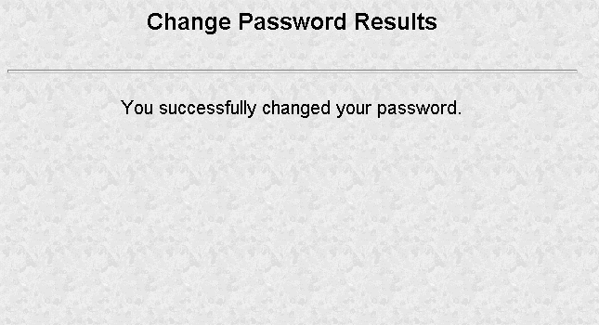
Figure 5-39: Change Password Results Page
Note: All CCCs and passwords are case-sensitive and must be entered correctly.

Changing Your CCC (CIK Confirmation Code)
You can change your CCC at anytime.
To change your CCC:
- Enter your CIK, Password, new CCC, and Confirm New CCC.
- Click on the [Change CCC] button.
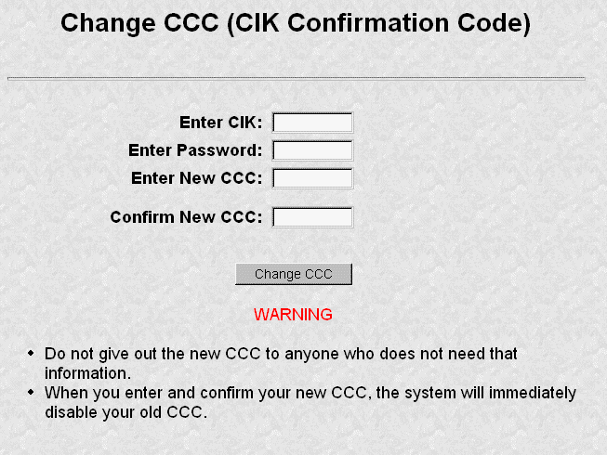
Figure 5-40: Change CCC (CIK Confirmation Code) Page
Note: Your CCC must contain eight characters with at least one letter, one number, and one special character.
The Change CCC Results page appears, confirming your CCC change. This change is effected immediately on the Filing website. If you exit the site and try to login again, you must use the new CCC.
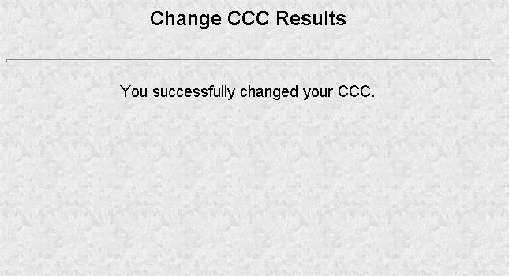
Figure 5-41: Change CCC Results Page
If you mistype your CIK or CCC, you may see the Invalid CIK/CCC error screen. Click the [Back] button on your browser and enter it again. If you are still having problems, please call Filer Support.

Logging in with (Enter) Another CIK/CCC
As you navigate through the Submission and Company Information page, the information you retrieve is limited to your login CIK. If you have more than one CIK you can change to an alternative CIK:
- From the Retrieve/Edit Company and Submission Data page, click on Enter Another CIK/CCC. The Retrieve/Edit Data login page appears.
- Enter your CIK, CCC, and click on the [Continue] button.
You can then access or edit all information associated with that CIK.

PREPARING SUPPLEMENTAL EDGAR DOCUMENTS

Introduction
This chapter includes the specifics of preparing a supplemental attached document, such as a power of attorney attachment or a cover letter. This chapter is divided into the following sections:
Section: Page Number:
Section A -- Creating Documents 6-1
Section B -- Tags Used Within Documents 6-9
Section C -- Special Handling for Certain Documents 6-11
Section D -- Signatures for Electronic Filings 6-16
SECTION A -- Creating Documents
Your successful creation of electronic submissions requires that:
- Both the sending and receiving computers must "speak" the same language.
For EDGAR to read what it receives, you must prepare your documents in American Standard Code for Information Interchange (ASCII) or HTML, version 3.2. In this section, you will find a discussion of ASCII and a listing of the characters recognized by EDGAR.

Terminology
You need to be aware that certain terms have special meaning when used in electronic filing procedures. Common filing terms are defined in Table 6-1.
Table 6-1: Terms Used During Electronic Filing
Term | Meaning
Accession Number | A unique number generated by EDGAR for each electronic submission. EDGAR reports accession numbers in acceptance/suspense messages to you. The accession number consists of three elements: the filer's login CIK (10 digits), the year (2 digits), and a sequence number (six digits, left-padded by zeroes, to a maximum of 999,998) For example: 0000350001-99-000256. Accession numbers are automatically displayed when you send a submission to EDGAR electronically, whether or not EDGAR ultimately accepts the submission.
ASCII | This abbreviation stands for the American Standard Code for Information Interchange. It is a binary code used by the computer to represent characters.
ASCII/SGML | This is our term for SGML documents in ASCII format, which differ from the new HTML document format that EDGAR also supports.
Document | A discrete unit of text or graphic. One or more documents (one primary document with optional supporting documents) comprise an electronic submission. Examples of documents include a Form 3, a cover letter, or an exhibit. Exhibits (only) are included in EDGAR documents beginning with the value "EX". See Appendix C.
Electronic Filer | A person or entity that submits filings electronically pursuant to Regulation S-T.
Electronic Filing | A document or group of associated documents filed by an electronic filer under the federal securities laws that is transmitted or submitted to the Commission in electronic format.
Electronic Submission | A form type header and all associated documents representing one or more filings that are transmitted to the Commission in electronic format. An electronic submission may also contain correspondence material.
Form Type | A distinct type of document that is required to be filed pursuant to the federal securities laws, e.g., Form 3 or 4. Ownership form types may have several variants (e.g., an initial ownership filing and an amendment). For EDGAR, each variant is recognized by a specific name, referred to as a submission type. The ownership form types and their applicable submission types are identified in Appendix A.
Grouped Tags | Tags (fields) that must appear together. The tags that must follow the lead tags are shown with the same number plus an alpha designation (e.g., 4, 4a, etc.). When you use grouped tags, all of the possible grouped tags may not apply to your filing. You should only use applicable tags. See Tag in this list of terms.  Note: The OnlineForms website automatically groups and places the XML tags in the submission together when you assemble your submission.
Header | The basic information required to supplement each electronic submission and document submitted through EDGAR. Submission headers provide identifying information about the filing (e.g., the submission type of the principal document, the identity of the electronic filer, and any fee data). Document headers identify each document in an electronic submission.  Note: In the OnlineForms website, XML tags are automatically placed in the submission by the online data entry and assembly forms provided.
HTML | This abbreviation stands for the HyperText Mark-up Language. It is a mark-up language used to create documents that are portable from one platform type to another. HTML documents are ASCII documents with generic tags that are appropriate for representing information from a wide range of applications. EDGAR accepts a subset of the tags from the HTML 3.2 standard, as recommended by the World Wide Web Consortium (W3C). See Chapter 7 for more information.
Issuer | A company, partnership, investment trust, mutual fund, or similar entity that has filed a Securities Act registration statement and has issued ownership securities to reporting owner entities.
Registrant | A company, partnership, investment trust, mutual fund, or similar entity that files a Securities Act registration statement, or that has a continuing reporting obligation under the Securities Exchange Act, Investment Company Act, or Public Utility Holding Company Act.
Reporting Owner | An individual or group that files a Securities Act ownership statement, or who has a continuing ownership reporting obligation under the Securities Exchange Act, Investment Company Act, or Public Utility Holding Company Act.
SGML | This abbreviation stands for the Standard Generalized Mark-up Language. It is an accepted standard, set forth by International Standard ISO 8879 that allows entities to define tagging constructs that convey and capture specific information.
Submission Medium | Submission Medium: One of the two methods that you may use to submit ownership filings to EDGAR: Internet, or Online. Direct dial transmission (PPP), and Leased Line are not acceptable submission media for ownership submissions.
Submission Type | The specific name by which EDGAR recognizes the variants of filings with the SEC (e.g., for Form Type 3, the initial statement of beneficial ownership of securities, EDGAR recognizes the submission type 3/A.)
Tag | The OnlineForms website automatically creates XML header tags as you fill in the online web forms provided. Some tags will still be used within documents. A tag is an identifier that labels specific information to EDGAR. You must place an angle bracket (< >) on either side of a term to designate it as a “begin” tag. An “end” tag also has angle brackets but is distinguished by use of the "/" (virgule/slash) immediately following the opening angle bracket (</). For example, the beginning and end of a table are signified by <TABLE> and </TABLE>, respectively. See Section 6.7 for a listing of ASCII/SGML tags.
Transmission | A set of one or more submissions sent electronically to EDGAR during an on-line session.
Value | Information supplied by you and inserted in a field or after a tag (i.e., for the tag <NAME>, insert the name of a module included in the submission).
XFDL | This abbreviation stands for Extensible Form Description Language. A way of structuring forms so that they may be used on an Web-based medium.
XML | This abbreviation stands for Extensible Markup Language. A universal format for structured documents and data on the Web. It is derived from and appears like HTML or SGML tags; however, XML is not restricted to a specific list of tags.

ASCII
This section discusses the character types allowed and not allowed inside your submission documents.

Character Code Requirements Differ by Submission Medium
All documents attached to online submissions must be in ASCII.

EDGAR Recognizes a Limited Set of Keyboard Characters
EDGAR recognizes a subset of standard ASCII characters. You should use only the list of characters listed in Table 6-2 in your filing. If you use characters or commands outside of this set in your EDGAR submission, EDGAR may suspend the filing.
Table 6-2: Characters Allowable within a Filing
Character | Description
0-9 | numeric characters
A-Z | upper case alphabet
a-z | lower case alphabet
` | grave accent
~ | Tilde
! | exclamation point
@ | at sign
# | number (pound) sign
$ | dollar sign
% | percent sign
& | Ampersand
* | asterisk (star)
( | left parenthesis
) | right parenthesis
. | Period
- | Hyphen
+ | plus sign
[space bar] | space bar key
{ | left brace
} | right brace
[ | left bracket
] | right bracket
| | vertical line
\ | back slash (reverse virgule)
: | Colon
; | semi-colon
“ | quotation mark  Note: Not a valid character in a header tag value. It is valid within the text of a document.
‘ | single quote/apostrophe
< | less-than (left angle bracket)
> | greater-than (right angle bracket)
, | Comma
_ | underline (may be used on a separate line or between characters, but not to underline a character)
? | question mark
/ | slash (virgule)
= | equal sign
EDGAR also recognizes the following control characters:
- Horizontal tab (will not cause the filing to be suspended; however, EDGAR will not display the effect in the filing)
- Line feed
- Carriage return
- Form feed (page break)

Why the EDGAR System Recognizes Only Standard Character Sets
We selected the standard computing character set to facilitate the use of a wide variety of equipment and software.

How the Requirement for ASCII Affects Word Processing
Note: The following section applies only to ASCII/SGML, but not to HTML documents. For information on HTML documents; see Chapter 7.
You can use many popular word processing and spreadsheet applications to save a document as an ASCII text file. The process for saving to ASCII varies from one software package to another, and it may be called "MS-DOS text with line breaks," "save as text only file," "MS-DOS text with layout," or "save as ASCII DOS text".
Word processing software includes various control codes that are used to indicate document style and format (e.g., bold face, underlining, italics, special characters or symbols, automatic pagination, headers/footers, and print fonts). Because these codes are not part of the standard ASCII character set, and EDGAR does not recognize them, you must remove them from all files that you submit to EDGAR. If you save a document prepared with word processing software as an ASCII text file, most word processing control codes will be removed.
You should remember the following about ASCII conversions:
- Advanced word processing features such as footnoting often do not properly convert to ASCII. There are some exceptions when special procedures are used; consult your word processing manual. You may have to manually construct footnotes and other document elements the way you would if you were using a typewriter.
- You should turn Auto-hyphenation off when preparing EDGAR documents.
- If you are submitting Reduced-Content XML Submissions, we encourage you to verify that your word processing software package creates accurate ASCII document output by submitting a test filing.
- You may have problems if you convert tabular or columnar material to ASCII. If you use tabs with proportional type fonts, their positions may not be kept in the same position when you convert to ASCII. Even when you use non-proportional fonts in the word processing, the number of spaces inserted in ASCII to replace tabs may not be consistent with the original text. We encourage you to check the ASCII version of your tabular material before transmitting to us and put in manual spaces (using your space key) as placeholders instead of tabs or columns.

About HTML
Chapter 7 contains detailed information about creating and submitting HTML documents.

Common Symbols that EDGAR Does Not Recognize
There are a few common symbols frequently available in word processing software that EDGAR does not recognize. The most common of these symbols are listed below in Table 6-3. Where appropriate, please spell out the name of these symbols.
The following unrecognizable symbols also apply to HTML 3.2 formatted submissions; however, within HTML you can represent these symbol characters using a W3C-approved “extended reference set” of characters. See Chapter 7 for more detailed information.
Table 6-3: Unrecognized Symbols in EDGAR
Character | Description
¢ | cent
£ | pound sterling
¥ | yen
• | bullet
† | dagger
‡ | double dagger trademark
¶ | paragraph
§ | section
© | copyright
® | registered
™ | trademark

System Inserts "^" For Unrecognized Characters
When EDGAR encounters characters that it does not recognize, it inserts a circumflex (^) and usually suspends the submission. In some cases, EDGAR can accept the filing with a limited number of unrecognized characters.

Description of ASCII/SGML Tags
Some tags are used within documents. ASCII/SGML tags identify data that follow formatting instructions, or signal EDGAR regarding a particular aspect of the filing. For all non-primary supplemental documents within ownership submission, you continue to include document specific tags, such as the <TABLE> tags or graphic file references in HTML documents. In Section B of this chapter, we include a list of document specific tags that are still valid in EDGAR.

Tag Construction
You have to construct all tags within a non-primary submission document manually. Construct tags within your submission documents by typing key words inside of right and left angle brackets ("less than" and "greater than" symbols). You may type tags using either upper- or lower-case letters within the angle brackets (i.e., <table> or <TABLE>).
Caution: You cannot use blank spaces within the left and right angle brackets in tags. Hyphens must separate multiple words within a tag.

How Tags are Used
Some ASCII/SGML document tags are followed immediately by information (a value) typed outside of the left and right angle brackets (e.g., <F1> footnote text). Other tags stand alone (e.g., <PAGE>). Some tags indicate start and stop conditions within a document (e.g., the beginning of a table <TABLE>, and the ending of a table </TABLE>). When certain tags must appear together as a group, they are referred to as “nested” tags. The lists in Section B of this chapter show these nested tags, which are marked by their lead tag first. The lead tags are numbered with a single number (e.g., 1, 5, 10, 25, etc.) and their nested tags are numbered the same as their lead tag, plus a numerical designation (e.g., 5.1, 5.2, etc.).

Field Values are Filer-Supplied Information
In this manual, the term "value" refers to the information that you need to supply. When EDGAR encounters a field, it determines if you have supplied the required information. In some cases, no value is required; however, in most cases, values are required.
For EDGAR to process values, you must enter them in a specified format. For example, when the Submission Contact Phone Number field is used, the value should contain at least ten digits (e.g., 123-456-7890).
SECTION B -- Tags Used Within Documents

Tags Used Within a Document
We identify tags you should use within the body of documents in the following two lists. For your convenience, each tag is numbered consecutively.
There are two types of tags included in this section:
- Internal text tags (for other than wide tables), Table 6-4
Note: Most of these tags can be used within HTML documents; exceptions are noted.
- Wide table tags (over 80 characters wide), Table 6-5
Note: These tags cannot be used within HTML documents.
For information on formatting tables wider than 80 characters, see Section 6.10.
Table 6-4: Internal Text Tags (For Other Than Wide Tables)
Tag  # | Tag | Example Of Value To Be Inserted | Definition (Limits of Field)
1 | <F1>  .  .  .  .  <F99> | No value required. | Creates a searchable marker for notes about text. May be used in pairs (e.g., <F1> in the text and a corresponding <F1> at the applicable foot or end note; any number from 1 through 99 is acceptable).  Note: This tag cannot be used within an HTML document.
2 | <R> | No value required. | Indicates the beginning of redlined (revised) information.
3 | </R> | No value required. | Indicates end of redlined information. <R> and </R> are used to "surround" revised information. To indicate deleted information, use <R> </R> together.  Note: When you are required to redline information, you should insert the tag <R> before and </R> following a paragraph which contains changes. HTML documents may be marked to show changed materials within paragraphs. You need not redline changes to financial statements and notes.
4 | <PAGE> | No value required. | Indicates where a new page should begin in a document, if you wish to force a specific page break.

Table 6-5: Wide Table Tags (Over 80 Characters Wide)
Note: The following information is not applicable to HTML documents.
Tag  # | Tag | Example of Value to be Inserted | Definition (Limits of Field)
1 | <TABLE> | No value required. | Marks the beginning of information wider than 80 characters per line but not wider than 132 characters per line. Two <S> or two <C> tags, or one of each, are required with each use of the <TABLE> tag or EDGAR will suspend the submission.
1.1 | <CAPTION> | No value required. | Marks the start of text that will serve as headings for columns.
1.2 | <S> | No value required. | Marks the start of a stub (the left angle bracket is aligned with start of the stub).
1.3 | <C> | No value required. | Marks the start of a column of data (the left angle bracket is aligned with the farthest left character of the column of data). Multiple columns require multiple tags.
1.4 | <FN> | No value required. | Denotes (and separates) the numerical data in a table from its footnotes.
1.5 | </TABLE> | No value required. | Marks the end of a table, and return to lines no wider than 80 characters.
Caution: If lines of text exceed 80 characters in width in ASCII documents, you must use the <TABLE>, <S>, <C>, and </TABLE> tags. We encourage you to also use the tags in tables less than 80 characters wide. The <S> and <C> tags must appear on a separate line between the column headings and the data. If you use the <FN> tag, it must appear on a separate line between the last line of data and the footnote or table description.
For more information on using tags for tables; see Section 6.10.
SECTION C -- Special Handling for Certain Documents

Non-Public and Confidential Information
EDGAR is designed to separate non-public from public information and disseminate only the public information. In some cases, the value for the Submission Type field provides sufficient instruction for EDGAR to handle filings correctly (i.e., when the value CORRESP is entered into the Submission Type field, EDGAR does not disseminate the information outside the SEC).
Similarly, when the Submission Type field is public information, the Type field in the Upload Attachment page determines whether or not the document is public, thereby assuring that EDGAR treats cover letters submitted under Document Type COVER or correspondence submitted under Document Type CORRESP as non-public. EDGAR does not disseminate non-public submission document information.
Notes: EDGAR disseminates graphic files associated with non-public documents (Graphics on a COVER letter for a Form 3 filing), although it will not disseminate the document itself.
Non-public material is different from confidential material. You should continue to submit all confidential material in paper form.

How To Create a Correspondence Document
To create a correspondence document, use a word processing application that supports ASCII or HTML. Attach it to the submission using the Attached Documents List page. You may also include a PDF copy in a correspondence document.

Formatting Tables Wider than 80 Characters
The following table format information does not apply to HTML documents. See Chapter 7 for tables within HTML documents.

Guidelines for Presentation of Tables
Our specifications for formatting electronic filings require that lines of text in ASCII/SGML documents not exceed 80 characters. The only exception to this limitation is information submitted in a table or column format, which must comply with the following guidelines:
- You must include information wider than 80 characters between the tags <TABLE> (begin table tag) and </TABLE> (end table tag);
- You can use no more than 132 characters per line (row);
- You may introduce column headers by a line having the optional tag <CAPTION> appearing on the otherwise blank line (row) preceding column headings (see the examples in the next section);
- The row preceding columnar information must consist of tags designating where columns of information will begin (where tabs are set in word processing programs or where columns begin in a spreadsheet program):
-- use the <S> tag to designate the leading (left) edge of the "stub" (sometimes referred to as the legend or key), or columns of non-numeric information (see examples in the next section);
-- use the <C> tag to designate the leading (left) edge of each column of information (at least one column to the left of the < (left angle bracket) of the tag <C> must be blank in all rows of the table up to the next presentation tag, e.g., <CAPTION>, <FN>, or </TABLE>);
-- you must use at least two <S> or <C> tags, or one of each, with each use of the <TABLE> tag or EDGAR will suspend the submission
- The row preceding any explanatory or footnote material should include the tag <FN> (see Example I in the next section).
Refer to the following examples for guidance on using table tags in a variety of table styles.

Table Tags
The following list contains the tags that apply for inserting a table in your EDGAR filing, module, or segment document:
List of tags used in the following example:

<TABLE> | Tag is placed before the wide text of the table.
<CAPTION> | Tag is placed following the wide text and preceding first line of columnar captions.
<S> | Tag is placed at leading edge (left margin) of stub information.
<C> | Tag placed at leading edge (left margin) of each column. The column at the immediate left of the < must be free of any characters between the < and the preceding column on all rows.
<FN> | Tag preceding the footnote tag <F#>.
<F1>, <F2>, etc. | Tag preceding the footnote information.
</FN> | Tag following the last line of footnote information.
</TABLE> | Tag following the last line of wide information, including footnotes where they apply.

Formatting Examples of Wide Tables
If you downloaded this manual from the SEC website, print the following examples at 132 characters per line, or print using condensed type. These examples, and the tags within them, do not apply to HTML documents. See Chapter 7 for examples and information regarding HTML documents and tags.
Example I --Table Appearing within Textual Discussion (wide text included as part of textual presentation):
<TABLE>
Selected Financial Data
<CAPTION>
Six Months Ended
Fiscal Year Ended June 30, December 31,
----------------------------------- -----------------
1998 1999 1995 1996 1997 1996 1997
(in thousands, except per share data)
<S> <C> <C> <C> <C> <C> <C> <C>
Financial Condition:
Total Assets 1,754 1,124<F1> 766 756 5,029 1,165 5,431
Long-Term Debt 200 200 268 207 303 125 174

Results of Operations:
Net Sales 0 0 0 0 1,347 0 898
Income (Loss) from 1,053) (935) (892) (613) (339) (367) (244)
Continuing Operations Income (Loss) Per (.03) (.03) (.02) (.01) .00 .00 .00
Share from
Continuing Operations
Cash Dividends 0 0 0 0 0 0 0
Per Share
<FN>
<F1>
This footnote refers to a particular item that has been tagged in the table. It must, however, follow the footnote tag as shown.
</FN>
</TABLE>

Example II -- Table With Tabular Data-Series Market and Trading Information
<TABLE>
xyy's common stock and series A and B preferred stock are quoted on the NASDAQ/NMS. The following tables show for the periods indicated the high and low closing sales prices for such securities.
<CAPTION>
Common Stock
19xx 19xx 19xx
Quarter High Low High Low High Low
_____ ______ ______ ______ ______ ______
<S> <C> <C> <C> <C> <C> <C>
First 22 1/2 6 3/4 22 1/4 23 1/2 26 1/8 23 5/8
Second 12 5/8 6 1/2 25 5/8 24 1/2 25 5/8 24 1/2
Third 11 2 25 1/4 24 1/8 25 5/8 24 5/8
Fourth 25 21 1/4 25 1/2 25 1/2 23 1/2
<CAPTION>
Series A Preferred Stock
19xx 19xx 19xx
Quarter High Low High Low High Low
______ ______ _____ _____ _____ _____
<S> <C> <C> <C> <C> <C> <C>
First 33 1/2 17 3/4 7 1/4 33 1/2 26 1/8 23 5/8
Second 32 5/8 15 1/2 34 5/8 32 1/2 25 5/8 24 1/2
Third 22 12 31 1/4 34 1/2 25 1/2 23 1/2
Fourth 29 25 31 1/4 34 1/2 25 1/2 23 1/2
<CAPTION>
Series B Preferred Stock
19xx 19xx 19xx
Quarter High Low High Low High Low
______ ______ ______ _____ ______ ______
<S> <C> <C> <C> <C> <C> <C>
First 53 1/2 34 3/4 57 1/2 53 1/2 46 1/8 43 5/8
Second 52 5/8 35 1/2 54 5/8 52 1/2 45 5/8 44 1/2
Third 42 32 50 1/4 51 1/8 45 5/8 44 5/8
Fourth 49 45 51 1/4 54 1/2 45 1/2 43 1/2
</TABLE>
Note: The <CAPTION>, <S>, and <C> tags are repeated to indicate insertion of new captions.

SECTION D -- Signatures for Electronic Filings

Statutory Signatures
The document level signature requirements described in this section have not changed from the Legacy EDGAR document signature requirements.
In many cases, the securities laws require filed documents to be signed. You must type your signature for an electronic filing to meet this requirement. See Rule 302 of Regulation S-T. Rule 302 of Regulation S-T requires you to retain a manually signed signature page or other document that authenticates, acknowledges, or otherwise adopts the signature that appears in typed form within an electronic filing. You must retain this signature page for five years.
An example of a signature as it would appear in an electronic filing is:
HERBERT JONES
HERBERT JONES
OR
HERBERT JONES
HERBERT JONES
CHIEF FINANCIAL OFFICER
OR (For Investment Management Filers)
HERBERT JONES

Powers of Attorney and Consents of Experts
If you are submitting signatures for powers of attorney, consents of experts, or any other required signature, you must submit them in the typed form specified in Section 6.11.

Instructions for Attaching HTML Documents to Electronic Submissions

Overview
The following instructions tell how you can prepare EDGAR-acceptable electronic submissions documents formatted in Hyper-Text Markup Language (HTML) versions 3.2 or 4.0. For additional help with the preparation of electronic submissions, contact Filer Support at (202) 942-8900.
HTML is a markup language you can use to create documents that are portable from one platform to another. It is a powerful data representation method that enhances the way you can represent public information, and the way our analysts and other end-users digest information throughout EDGAR.
The “tagging” language of HTML 3.2 and 4.0 was adopted and maintained by the World Wide Web Consortium (W3C). Even though HTML 4.0 is accepted worldwide, HTML 3.2 is the only “standardized” version of HTML. In general, HTML documents are SGML documents with generic semantics that are appropriate for representing platform-independent information from a wide range of applications. Please see the following W3C web page for a complete tag and attribute specification and document type definition (DTD) for HTML 3.2:
(http://www.w3.org/TR/REC-html32)
EDGAR supports the attachment of HTML documents with locally-referenced JPEG and GIF graphics via the <IMG SRC=> tag. HTML documents may also contain <A HREF=> references to other local HTML and ASCII/SGML documents within the submission. In addition, <A HREF=> tags may reference previously-filed submissions on the “(http://www.sec.gov/Archives/edgar/data/)...” repository from within HTML documents attached to the submission.
HTML 3.2/4.0 document format is another official option you may use to create your documents. HTML documents, like their ASCII/SGML text counterparts, are attached to submissions and submitted as part of a submission via the Internet.
You can use HTML editors (e.g., MS FrontPage, etc.) and/or versions of word processors (e.g., MS Word 97, Word Perfect 7.0, MS Excel 97, etc.) that support a “Save as HTML” option.
Note: These tools may not save your document in SEC-acceptable HTML 3.2/4.0 format.
EDGAR only accepts documents that you have formatted using a subset of the HTML 3.2 semantics (tags) and some HTML 4.0 attributes, as recommended and standardized by the W3C. Due to the SEC’s limited support of HTML, EDGAR enforces the following restrictions relative to all HTML documents that are included in an EDGAR submission:
- No Active Content (i.e., <APPLET>, <OBJECT>, <SCRIPT>, etc.)
- No External References, except for <A HREF=> links to previously-filed submissions on the http://www.sec.gov website. (i.e., <A HREF=“http://www.sec.gov/Archives/edgar/data/***”)
Note: If your HTML document contains any active content, or unsupported external references, your entire submission will be suspended.
- Local references to other files within the submission via the <A HREF="....."> tagging construct are allowed. All links within the submission must be resolved locally for us to accept your submission
Exception: Links to private documents, i.e., cover or correspondence, are not allowed.
- No reference to Type 1 modules or segments
- No nested <TABLE> tags
- JPEG and GIF graphic files, and no other formats, may be attached to submissions and referenced from within HTML documents via the <IMG SRC=“...”> tag. All graphic links within the submission must be resolved
- N-SAR, EX-27, and 13F documents are not accepted in HTML format [Not Applicable to ownership filings]
- HTML documents are identified by the *.htm filename extension, which will follow any pre-<HTML> comment tags (i.e., <!DOCTYPE >). The <HTML> tag is considered an optional tag within *.htm documents.
- In order to properly link documents within a submission, all linked documents must be named exactly as they are linked.
Note: You must provide a filename in the following format:
[Maximum 32 characters (including suffix); use “a-z“ characters (lower case, only), 0-9 (but NOT for the first character), no spaces or special characters, at most one ‘.’, ‘-’, or ‘_’ char, and the extension must be *.htm, *.txt, *.fil, *.gif, *.jpg]
Warning: Except for CORRESP submissions, graphic files associated with non-public HTML documents (i.e., cover) will be disseminated even though the non-public document will not.
- You may also use the EDGARLink Error Check to verify your documents (see Filer manual, Volume 1), but if an error is found you must use your HTML authoring tool to edit your documents.

- Note: Ownership forms (except for Form 144) do not use EDGARLink, but this tool may be used to verify the format of any attached document.

- Always review your HTML document separately through a browser before you attach them to your submission and transmit it to EDGAR.
EDGAR will NOT accept any TEST or LIVE submissions that have attached HTML documents with unacceptable content, as described above. Each HTML document within an EDGAR submission must be "resolvable", that is all links (if any) must be to other HTML, Graphics, ASCII, or SGML within the same submission (with the single exception being <A HREF=> references to the “(http://www.sec.gov/Archives/edgar/data/)..” website).
Graphics will be attached as documents (like PDF documents). All documents with acceptable content will be disseminated with a <FILENAME> tag and value (up to 32 characters) in order to identify the document properly for internal references (if any).
We recommend that you assemble your HTML and other documents in a single directory and test view them in a browser before you attach them to your submission. All HTML documents should be compatible with an Microsoft Internet Explorer (MSIE) 3.0+ or Netscape 3.0+ browser. As part of our receipt and acceptance process, we will be extracting all of your attached documents and graphics to a single directory and check all references for inconsistencies and errors. We estimate that submissions with HTML document and graphic content will increase the average submission size by about 70-150 percent, depending on your use of HTML 3.2/4.0 formatting techniques.
EDGARLink (Volume 1) and the OnlineForms website (Volume 3) attach HTML documents and graphics to a submission in the same manner as they attach an ASCII/SGML document. See Chapters 4 and 5 (in their respective volumes) for instructions on how to assemble submissions using EDGARLink and the OnlineForms website.

Acceptable HTML Document Tags
Due to the EDGAR restrictions described previously, EDGAR will only accept a subset of the HTML 3.2/4.0 tagging standard. The following table lists the set of acceptable HTML document header tags available to you.
Note: All HTML attributes are supported for each HTML tag listed, unless otherwise specified.
Document Tags | Definition
<HTML> | Identifies text as an HTML document
<!--> or <! DOCTYPE> | Comment -- does not appear in the browser, only in the HTML source code  <!DOCTYPE> tag is used to identify which HTML standard is used by the HTML text.  Note: These tags may appear in-between the <TEXT> and <HTML> tags.
<BODY> | Signifies the body of the HTML document  Note: The BACKGROUND attribute is not supported for this tag.
<HEAD> | Signifies header information for an HTML document
<ISINDEX> | Signifies that the document is an index for a search engine
<META> | Extended information to be included in the document header  Note: The HTTP-EQUIV attribute is not supported for this tag.
<TITLE> | Title of document displayed at the top of the browser

Acceptable HTML Tags within a Document Body
Due to the EDGAR restrictions described previously, EDGAR will only accept a subset of the HTML 3.2/4.0 tagging standard. The following table lists the set of acceptable HTML document “body” tags (tags that change the appearance of the text when displayed by a browser) that are available to you.
Note: All HTML attributes are supported for each HTML tag listed, unless otherwise specified.
Document Body Tags | Definition
&#... | Escape Sequences – Used to display characters normally reserved (such as “<”) as plain text in the HTML document
<A> | Anchor/Hyperlink  [Note: For the attribute HREF, the following references are supported:  - References to other PUBLIC HTML, ASCII/SGML or PDF documents within the submission (i.e., <A HREF="ex-99.htm">)  - References to submissions stored at http://www.sec.gov/.... locations (i.e., <A HREF="http://www.sec.gov/Archives/edgar/data/...">)  - Bookmark (internal) references will be supported]  - (i.e., <A NAME=“linkanchor”> and <A HREF=#linkanchor>)]  All other uses of the HREF attribute are not supported and illegal, including non-local references, the use of the “TARGET” attribute, and the “mailto:” and “ftp:” designations.
<ADDRESS> | Address – usually italicized
<B> | Bold
<BIG> | Big Text -- increases font size
<BLOCKQUOTE> | Block Quote -- usually indented
<BR> | Line Break
<CAPTION> | Caption -- can only be used with tables
<CENTER> | Centers elements between tags
<CITE> | Citation
<CODE> | Code
<DD> | Definition
<DFN> | Definition – same as using <I>
<DIR> | Directory List
<DIV> | Division -- helps separate a document into parts
<DL> | Definition List -- used with <DT> and <DD>
<DT> | Definition Term
<EM> | Emphasized -- similar to using Bold
<FONT> | Allows alteration of font contained within tags
<H1> | Heading 1 -- largest heading size
<H2> | Heading 2
<H3> | Heading 3
<H4> | Heading 4
<H5> | Heading 5
<H6> | Heading 6 -- smallest heading size
<HR> | Horizontal Rule -- displays a thin line across the page for separation of text
<I> | Italics
<IMG SRC=> | Image reference  [Note: Only local JPEG and GIF graphic files may be referenced (i.e., <IMG SRC="graph10q.gif"> or  <IMG SRC="graph10q.jpg">)]  The attributes DYNSRC, LOOP, LOOPDELAY, START, and CONTROLS are not supported for this tag.
<KBD> | Keyboard – pre-formatted text
<LI> | List Item -- used by <DIR>, <MENU>, <OL>, and <UL>
<LISTING> | Listing -- same as using <PRE>
<MENU> | Menu List
<OL> | Ordered List -- includes numbers
<P> | Paragraph
<PLAINTEXT> | Plain Text
<PRE> | Pre-formatted Text
<SAMP> | Sample -- uses a fixed-width font and is same as using <PRE>
<SMALL> | Small Text -- decreases font size
<STRIKE> | Strikethrough
<STRONG> | Strong -- similar to using Bold
<SUB> | Subscript
<SUP> | Superscript
<TABLE> | Table  Note: EDGAR will not accept or disseminate HTML documents with nested <TABLE> tags.
<TD> | Table Data or Cell
<TH> | Table Header -- displayed in bold
<TR> | Table Row  Note: The WIDTH attribute supports percentage (%) values as well as pixel values.
<TT> | Teletype -- uses a fixed-width font and is same as using <PRE>
<U> | Underlined
<UL> | Un-ordered List -- bullets only
<VAR> | Variable -- uses a fixed-width font and is same as using <PRE>
<XMP> | Example -- same as using <PRE>
Please see Appendix B for a listing of various errors and warnings associated with the processing of HTML documents within EDGAR.
Note: The <CAPTION> and <TABLE> tags are currently used within ASCII/SGML EDGAR documents and also used in HTML documents but they are “visually” interpreted differently.

HTML Tags that are NOT Supported by EDGAR
EDGAR will suspend and not disseminate submissions with the following HTML tags:
<ACRONYM> | <APPLET> | <AREA>
<BASE> | <BASEFONT> | <BDO>
<BUTTON> | <COL> | <COLGROUP>
<DEL> | <FIELDSET> | <FORM>
<FRAME> | <FRAMESET> | <IFRAME>
<INPUT> | <INS> | <LABEL>
<LEGEND> | <MAP> | <META HTTP_EQUIV…>
<NOFRAMES> | <NOSCRIPT> | <OBJECT>
<OPTION> | <PARAM> | <Q>
<S> | <SCRIPT> | <SELECT>
<SPAN> | <STYLE> | <TBODY>
<TEXTAREA> | <TFOOT> | <THEAD>

*All other tags not represented in Section 7.3.

Acceptable Attributes for EDGAR HTML Tags
Due to the EDGAR restrictions described previously, only a subset of the HTML 3.2/4.0 tag attributes are accepted by EDGAR. The following table lists the set of acceptable HTML tag attributes that you can use.
Note: Many of the following attributes are only supported passively, since their primary function may be to support actions that are restricted by EDGAR. Refer to any HTML 3.2 reference book for actual values available for these attributes.
Attribute | Description | Parent Tag(s)
align | Align text | <H1>-<H6>, <HR>, <P>, <CAPTION>, <DIV>, <TABLE>, <TD>, <TH>, <TR>
alink | Highlight color when hypertext links are used | <BODY>
bgcolor | Background color of the document body | <BODY>, <TABLE>
border | Thickness of the table border | <TABLE>
cellpadding | Sets the spacing between the border and the content of the table cells | <TABLE>
cellspacing | Sets the spacing between the cells in a table | <TABLE>
class | Space-separated list of classes | MANY
clear | Moves down past floating images on either margin | <BR>
color | Sets the color of the text | <FONT>
colspan | Causes the cell to span a number of columns | <TD>, <TH>
compact | Render lists in a more compact style | <DIR>, <DL>, <MENU>, <OL>, <UL>
content | Associated information | <META>
dir | Direction of text | MANY
height | The height of a cell in pixels or percentage of screen height | <TD>, <TH>
href | Link to another document | <A>
id | Document-wide unique id | MANY
lang | Language specification | MANY
link | Color used to stroke the text for unvisited hypertext links. | <BODY>
name | Meta-information name or link name | <META> or <A>
noshade | Display as a solid rule | <HR>
nowrap | Prevents word-wrapping within a cell | <TD>, <TH>
prompt | Specifies a prompt string for an input field | <ISINDEX>
rel | Forward link types | <LINK>, <A>
rev | Reverse link types | <LINK>, <A>
rowspan | Causes the cell to span a number of rows | <TD>, <TH>
size | Amount of space assigned for an input field | <HR>, <FONT>
src | Graphic reference | <IMG>
start | Starting sequence number | <OL>
style | Associated Style info | MANY
text | Color used to stroke the document’s text | <BODY>
title | Advisory title string | <LINK>
type | Style of bullet | <LI>, <OL>, <UL>
valign | Sets the vertical alignment of the content within a cell | <TD>, <TH>, <TR>
vlink | Color used to stroke the text for visited hypertext links. | <BODY>
width | Width of a column in pixels or percentage of screen width | <HR>, <TABLE>, <TD>, <TH>

Extended Character Sets Within HTML Documents
Within HTML documents, extended-ASCII characters (i.e., the British Pound Sterling symbol, £,and the Japanese Yen symbol, ¥) can be represented by their ISO-8859-1 (Latin 1) decimal character reference specification. The Pound Sterling symbol (£) can be represented by the following character string: &#163. The Yen symbol (¥) can be represented by the following character string: &#165. Many W3C-certified web sites contain complete ISO-8859-1 extended character reference listings, like the sample from http://www.htmlhelp.com/reference/charset below.
Note: EDGAR will suspend a submission that contains an extended ASCII character. EDGAR will only support extended character references.
A partial listing of Relevant ISO-8859-1 Extended Character References for SEC HTML documents includes:
Description | Hex | Character Reference (Dec) | Entity Name | Symbol
small italic f, function of, f florin | 83 | &#131; | &fnof; | ƒ
low horizontal ellipsis | 85 | &#133; | &hellip; &ldots; | …
dagger mark | 86 | &#134; | &dagger; | †
double dagger mark | 87 | &#135; | &Dagger; | ‡
letter modifying circumflex | 88 | &#136; |  | ¹
per thousand (mille) sign | 89 | &#137; | &permil; | ‰
capital S caron or hacek | 8A | &#138; | &Scaron; | Š
left single angle quote mark (guillemet) | 8B | &#139; | &lsaquo; | ‹
capital OE ligature | 8C | &#140; | &OElig; | Œ
round filled bullet | 95 | &#149; | &bull;
trademark sign | 99 | &#153; | &trade; | ™
small s caron or hacek | 9A | &#154; | &scaron; | š
right single angle quote mark (guillemet) | 9B | &#155; | &rsaquo; | ›
small oe ligature | 9C | &#156; | &oelig; | œ
capital Y dieresis or umlaut | 9F | &#159; | &Yuml; | Ÿ
non-breaking space | A0 | &#160; | &nbsp;
inverted exclamation mark | A1 | &#161; | &iexcl; | ¡
cent sign | A2 | &#162; | &cent; | ¢
pound sterling sign | A3 | &#163; | &pound; | £
general currency sign | A4 | &#164; | &curren; | ¤
yen sign | A5 | &#165; | &yen; | ¥
section sign | A7 | &#167; | &sect; | §
spacing dieresis or umlaut | A8 | &#168; | &uml; &die; | ¨
copyright sign | A9 | &#169; | &copy; | ©
feminine ordinal indicator | AA | &#170; | &ordf; | ª
left (double) angle quote (guillemet) | AB | &#171; | &laquo; | «
registered trademark sign | AE | &#174; | &reg; | ®
spacing macron (long) accent, | AF | &#175; | &macr; | ¯
degree sign | B0 | &#176; | &deg; | °
plus-or-minus sign | B1 | &#177; | &plusmn; | ±
superscript 2 | B2 | &#178; | &sup2; | ²
superscript 3 | B3 | &#179; | &sup3; | ³
spacing acute accent | B4 | &#180; | &acute; | ´
micro sign | B5 | &#181; | &micro; | µ
middle dot, centered dot | B7 | &#183; | &middot; | ·
spacing cedilla | B8 | &#184; | &cedil; | ¸
superscript 1 | B9 | &#185; | &sup1; | ¹
masculine ordinal indicator | BA | &#186; | &ordm; | º
right (double) angle quote (guillemet) | BB | &#187; | &raquo; | »
fraction ¼ | BC | &#188; | &frac14; | ¼
fraction ½ | BD | &#189; | &frac12; &half; | ½
fraction ¾ | BE | &#190; | &frac34; | ¾
inverted question mark | BF | &#191; | &iquest; | ¿
Your HTML editor may use the "Entity-Name" (i.e., &yen) of the character you wish to reference rather than the standard character reference. Either technique may be used within an HTML document that is attached to an SEC submission.
To represent ASCII/SGML tagging phrases within an HTML document, use the following identifiers for the reserved characters “<” and “>”: &lt for “<,” and &gt for “>.” This will prevent the browser from misinterpreting the characters for display purposes.
Note: The <R> tag can be represented either directly as <R> or indirectly as &ltR&gt. For all other uses of the reserved "< >" characters, you can also use their ISO-8859-1 representation.

Template for an Attached HTML Document
The following is an acceptable template for an attached HTML document.
Note: All documents are attached to page two of the submission template.
<HTML>
<HEAD>
{Head tags and text }
</HEAD>
<BODY>
{HTML body tags and text............}
</BODY>
</HTML>

ASCII or SGML Functionality to be Preserved within HTML Documents
EDGAR allows you to use several ASCII or SGML tags within HTML documents, primarily to preserve existing functionality. The following functions are preserved in HTML documents:
- Paging
EDGAR allows the ASCII or SGML <PAGE> tag within HTML documents, even though this tag is not supported by common browsers and HTML 3.2. You may need to use this tag to differentiate pages to end-users.
- Redlining
HTML documents may be marked to show changed materials within paragraphs; however, only one set of redline tags (the begin and end redline) may be on a text line. Press Enter or Return after each ending redline tag (</R>). In addition, do not use font tags within a set of redline tags.
EDGAR allows you to use the ASCII or SGML <R> and </R> tags within HTML documents, even though this tag is not supported by common browsers and HTML 3.2. You may want to use this tag set to highlight sections of text for us. Sections of your submission text that you mark with these redlining tags will be highlighted for our staff in BOLD Magenta color in order to differentiate that section of text from other non-redlined sections.
The <R> and </R> tags can also be represented as &ltR&gt and &lt/R&gt, respectively. Either format will signify a redline request to EDGAR . The redline tags within the HTML document are not disseminated to the public. Each redline tag character will be replaced by a blank character (‘ ‘) before the submission is disseminated. The blanks will not be visible from the browser but will be visible in the HTML source code.
Important: If you do not form your redline tags correctly, the tags can appear in your disseminated filing.
Sample HTML document with Redline tags:
<HTML>
...
...
<p align="center"><strong>TESTFILE COMPANY </strong></p>
<p align="center"><strong>NOTES TO FINANCIAL STATEMENTS </strong></p>
<p align="center"><strong>September 30, 1999</strong></p>
<p>&nbsp;</p>
&ltR&gt
<p>Note 1. Summary of Significant Accounting Policies</p>
&lt/R&gt
...
...
</HTML>
Note: For non-ownership submissions only: You may wish to submit HTML documents, or parts of HTML documents, before you file your submission or master segment. EDGAR allows only Type 2 (full document) modules and segments in HTML format. You may create them exactly as you would create ASCII/SGML modules and segments. See Chapter 5 for more information on modules and segments. You would attach your Type 2 module or segment to your "Master" submission template by selecting the Module/Segment Reference page.

ASCII or SGML Functionality Not Supported within HTML Documents
EDGAR will NOT support the following ASCII or SGML document tags within an HTML document that is submitted to EDGAR as part of a Live or Test submission:
<S>
<C>
Since tables are interpreted differently in HTML, the <S> and <C> tags are NOT accepted.
Warning: The presence of an <S> or <C> tag in an HTML document will cause EDGAR to suspend the submission.
EDGAR will also NOT support the following ASCII or SGML footnote tags within an HTML document that is submitted to EDGAR as part of a Live or Test submission.
<FN>
<F1>
<F2>, etc.
Warning: The presence of a footnote tag in an HTML document will cause EDGAR to suspend the submission.
You can simulate a footnote using the <SUP> and <SUB> tags with an internal <A href=#xxxx > hyperlink. This technique allows browser users to easily reference any footnote information at a click of a mouse button.

SEC Recommendations on Preparing Submissions with HTML Documents
The following are specific SEC recommendations concerning the creation of SEC-approved HTML documents:
- We strongly recommend that you prepare your HTML documents so that they are easily understood and viewable on a 15” monitor with 800x600 resolution. Since browsers can adjust HTML documents according to monitor size, we strongly encourage you to adhere to this recommendation in order to avoid unwanted variance in your HTML document presentation to the end-user. Please use color combinations for background and text in your submission documents, which will enable us to successfully print them in black-and-white once we have received them in-house. Also, EDGAR will not verify proper HTML tag ordering. Improper tag nesting (except for the <TABLE> tag) and interleaving will not cause EDGAR to suspend your submission.
- Your submission, including all attached documents, must not exceed 100 MB. Files containing HTML material may be large and can take considerable time to electronically transmit. These files can also consume relatively large amounts of storage space. Please consult your HTML editor manuals when you create your HTML documents in order to efficiently present their content.
- No “Active Content” that may compromise the integrity of submissions with us may be present (or referenced from) within any HTML document submitted to us. The use of the following web technologies are not allowed within EDGAR documents: embedded Java applications, Java applets, JavaScript (ECMAScript), VBScript, Perl scripts, PostScript, PDF application links, binary executable files, Shockwave and ActiveX. Since this technology is evolving rapidly, no list can include all excluded technologies. EDGAR will suspend all submissions containing HTML documents with Active Content.
- EDGAR support for HTML documents allows you to enhance the appearance of your submissions through the use of locally-referenced graphical image files in *.gif, and *.jpg formats only.

- Note: Only GIF and JPG graphic files are supported. EDGAR will suspend any submission that contains a non-GIF/JPG <IMG> reference. This external reference support is expected to significantly enhance and clarify the presentation of information in EDGAR submissions. When adding graphics we recommend the following actions to limit the size:
- Make image dimensions as small as possible
- Use thumbnail versions of images
- Save GIFs with natural color gradients as JPEGs
- Increase the amount of JPEG compression
- Use fewer bits per pixel to store the image
- Adjust image contrast
- Suppress dithering
- EDGAR does not provide functionality to scan submissions for “extraneous” information included manually, or by HTML authoring or other tools. Sometimes an authoring tool can insert a tag sequence that can actually cause EDGAR to suspend your submission. For instance, MS Word 97 may insert the <META HTTP-EQUIV=“xxxxxxx”> tag into your document when you select the “Save as HTML” option. You should review your submissions and remove any extraneous content prior to submission. Information inserted in HTML files by various HTML authoring tools may include, but is not limited to:
- The name and version of the tool
- The identification of the user of the authoring tool
- The company to whom the tool is registered
- The dates of file creation and modification
- Change tracking markup and edited/deleted text, references, etc.
- Editorial comments
- Since you may be using an authoring tool that includes unacceptable HTML 3.2/4.0 tags or attributes, you may also need to run your submission through an HTML 3.2 validator. Be aware that you may need to edit the HTML source, if necessary. We do not provide an HTML 3.2 validator, and we suggest that you check the W3C Web page for the location and availability of these validators.

APPENDIX A

Online Submission Types Accepted for Electronic Filing
This Appendix provides tables listing all online submission form types accepted by EDGAR.
A.1 How Tables are Organized
The tables are organized by the Act under which they are used. Each table has three headings: Filing Type; Description; and Submission Type.
A.1.1 Filing Type
The Filing Type column lists the names of the forms, rules, or schedules as they appear in the Code of Federal Regulations (CFR).
A.1.2 Description
The Description column explains the purpose of the form.
A.1.3 Submission Type
The Submission Type column lists the names of the submission types that correspond to the filing type.
APPENDIX A
Online Submission Types Accepted for Electronic Filing
Table of Contents
Table Page
TABLE 1 Securities Exchange Act - Registration and Report Submission Types A-2
Accepted by EDGAR

Table A-1. Securities Exchange Act - Online Submission Types Accepted by EDGAR
Filing  Type | Description | Submission Type
Form 3 | Initial statement of beneficial ownership of securities  Initial filing  Amendments | 3  3/A
Form 4 | Statement of changes in beneficial ownership of securities  Initial filing  Amendments | 4  4/A
Form 5 | Annual statement of changes in beneficial ownership of securities  Initial filing  Amendments | 5  5/A
Form 25 | Notification filed by National Security Exchange to report the removal from listing and registration of matured, redeemed or retired securities  Initial Filing  Amendments  Note: Changes for Submission types 25-NSE and 25-NSE/A are to be used only in the event the SEC adopts the rule on mandatory electronic filing of the forms by issuers. The implementation date will be provided within the adopting release. (See Release No. 34-49858 (June 15, 2004) [69 FR 34860]) | 25-NSE  25-NSE/A

Special Processing of Certain OnlineForms Submission Types
Issuers are advised that filings with the submission types listed below will receive a "Filing Date" identical to the EDGAR "Received Date" even if received after 5:30 p.m. Eastern time which is different than normal filings. In addition these filings will be disseminated until 10:00 p.m. Eastern time. Normally filings received after 5:30 p.m. Eastern time will receive a filing date of the next business day and will not be disseminated until the next business day.
The following submission types will receive a filing date identical to the EDGAR "Received Date" and will be disseminated until 10:00 p.m. Eastern time:
3 3/A 4 4/A 5 5/A
APPENDIX B

Messages Reported by EDGAR
B.1 Introduction
EDGAR generates and sends either acceptance or suspense messages to you after your submission has been received. Either type of message may contain notices of discrepancies or inconsistencies in the submission. Those notices are reported as warnings or errors. Errors cause a submission to be suspended, but warnings do not.
After EDGAR generates a suspense message, you must correct and/or resubmit the submission before we can accept it.
Notes:
(1) In some cases, EDGAR may replace an unrecognizable character in your submission with a circumflex (^).
(2) Some discrepancies may generate either a warning or an error message depending upon the tag or value involved.
(3) If you use the submission or document validation option to check a filing before submitting it to us, you will receive the same similar messages as those received from EDGAR.
(4) The term “tag” actually means “field”.
This Appendix contains the following:
- Examples of acceptance and suspense messages.
- Examples of errors and warnings reported in acceptance and suspense messages, and the accompanying messages that are generated.
- An alphabetical listing of error/warning messages, with explanations and suggested solutions.
B.2 Example of Acceptance Message for Official Filings Returned via the Internet:

FROM: EDGAR POSTMASTER [EDGARPOST1]
TO: jsmith@xyz.com
DATE: 10-Jan-2003 10:48
SUBJECT: ACCEPTED FORM TYPE 10-K (1010101010-99-010051)
MSG ID: 97349-56392
THE FOLLOWING SUBMISSION HAS BEEN ACCEPTED BY THE U.S. SECURITIES AND EXCHANGE COMMISSION:

COMPANY: HI TECH PHARMACAL CO INC
FORM TYPE: 4 NUMBER OF DOCUMENTS: 3
RECEIVED DATE: 10-Jan-2003 10:48 ACCEPTED DATE: 10-Jan-2003 10:48
FILING DATE: 10-Jan-2003 10:48
TEST FILING: NO CONFIRMING COPY: NO

ACCESSION NUMBER: 1010101010-03-010051
FILE NUMBER(S):
1. 000-20424

THE PASSWORD FOR LOGIN CIK 1010101010 WILL EXPIRE 31-DEC-2003
PLEASE REFER TO THE ACCESSION NUMBER LISTED ABOVE FOR FUTURE INQUIRIES.

REPORTING-OWNER(S):

1. CIK: 0000887497
OWNER: BLACK, JOE
FORM TYPE: 4
FILE NUMBER(S):
1. 000-20424

ISSUER:

2. CIK: 0001186838
COMPANY: HI TECH PHARMACAL CO INC
------------------------------ NOTICE ---------------------------------

{Adhoc Notification message}

B.3 Example of Suspense Message:

FROM: EDGAR POSTMASTER [EDGARPOST1]
TO: TESTER01
DATE: 8-JAN-2003 10:54
SUBJECT: SUSPENDED FORM TYPE 4 (0000950136-03-000028)
MSG ID: 13359-36894
THE FOLLOWING SUBMISSION HAS BEEN SUSPENDED BY THE U.S. SECURITIES AND EXCHANGE COMMISSION:

FORM TYPE: 4 NUMBER OF DOCUMENTS: 1
RECEIVED DATE:8-JAN 2003 10:18 SUSPENDED DATE: 8-JAN-2003 10:19
TEST FILING: NO CONFIRMING COPY: NO
ACCESSION NUMBER: 0000950136-03-000028
FILE NUMBER(S):
1. NONE.
THE PASSWORD FOR LOGIN CIK 0000123567 WILL EXPIRE 01-FEB-2003 00:00.
THIS SUBMISSION MUST BE RE-TRANSMITTED IN ITS ENTIRETY.

ERR: | TAG_VALUE_MISSING_OR_INVALID
MSG: | Value for IssuerCIK is missing or invalid 0101010101.
LOC: | LINE NUMBER: 0

------------------------------ NOTICE ---------------------------------

{Adhoc Notification message}
B.4 Explanation of Error Messages
EDGAR will list each error in the order in which it was encountered in processing. Some error conditions may generate more than one error.
You will receive an error message, via the Internet address you have provided, in the following format:
ERR: | DUPLICATE_FILER
 | (This is EDGAR’s internal error message name for the error condition.)
MSG: | FILER_CIK (VALUE) IS DUPLICATED
 | (This message describes the error.)
Note: If the same error occurs repeatedly in a filing, not all of the errors will be reported. For example, if the filing has exceeded the reporting limit for the number of invalid characters in a filing, only the first 10 occurrences will be reported.
LOC: | This portion of the message helps you identify the line number associated with the error. The position of the error (character count) helps you move directly to the error location so that you may easily repair the error.
For example, the LOC section of the error message could be:
LINE NUMBER: 30
This Appendix lists the Error Message names in alphabetical order.
The "ERR" or "WRN" and "MSG" sections of an error-check message are repeated in the List of Errors. We have included the following two additional information categories in this list:
DESCRIPTION OF ERROR: | This is a more detailed description of the problem that caused the error and may explain why the filing was not accepted.
SOLUTION: | This section of the message makes some suggestions for correcting the error.
Note: Some error messages can be used for more than one tag field or error. In each error message that can apply to multiple tags, the term <tag> or field is used. The error message, which is in EDGARLink and received from the Internet indicates the actual tag which caused the error.
An example of an error message that could be used for more than one tag could be:
ERR: | REQUIRED_TAG_MISSING
MSG: | Required <CIK> tag is missing.
When you find "REQUIRED_TAG_MISSING" in the List of Errors, the message reads:
MSG: Required <value> tag is missing.
Since many tags are required for acceptance, not every possible message is listed here. The EDGARLink or Internet message specifies exactly which required tag is missing.
Similarly, a tag’s value may be noted in the error message received from the Internet or EDGARLink. In the listing of errors in the manual, however, the message will have the tag value in parentheses (value). The Internet error message will show the actual value that was inserted. For example, if the correct CIK is 0000456789 and you entered 0000466789 after the <CIK> tag, the error message will read:
ERR: INCONSISTENT_TAG_VALUE
MSG: <CCC> value is inconsistent with <CIK> (0000466789).
For the previous error, the message in this appendix will be:
MSG: <TAG> value is inconsistent <CIK> (value).
Although EDGARLink and EDGAR have been designed to find as many errors as possible, certain types of submission errors will halt processing so that subsequent errors cannot be detected. For example, when the system does not recognize a submission type, the filing requirements cannot be checked. Under such conditions, you will receive the message, "May contain other errors."
B.6 List of Errors and Warnings
Note: Errors [ERR] will cause a filing to be suspended; warnings [WRN] will not.
WRN: |  | ACCEPT_WITH_ERROR
MSG: |  | Previous error(s) ignored for continued processing. Submission has been accepted with the listed errors.
DESCRIPTION OF WARNING: |  | This warning is associated with our processing of the filing.
SOLUTION: |  | This warning will not cause suspension of your submission. No action is required.
ERR: |  | ACTIVE_CONTENT_NOT_ALLOWED
MSG: |  | Active content found within HTML document (DOCUMENT_TYPE): (value).
DESCRIPTION OF ERROR: |  | A script, or other active content, was embedded in an HTML document that was attached to the EDGAR filing.
SOLUTION: |  | Remove any scripts from HTML document(s) before submitting the filing to EDGAR.
WRN: |  | BAD_MAILING_ADDRESS
MSG: |  | The mailing address for CIK (value) is incomplete or invalid.
DESCRIPTION OF WARNING: |  | The mailing address for the CIK is either missing key data (street1, city, state, or zip) or has all the key data but the address is invalid.
SOLUTION: |  | This WARNING will not prevent the submission from processing successfully. However, you should update the mailing address for the reported CIK.
ERR: |  | BEGIN_TAG_MISSING
MSG: |  | In (value): the (value) end tag has no corresponding begin tag.
DESCRIPTION OF ERROR: |  | Your submission document has a beginning tag missing, i.e., <MODULE> or <HTML>.
SOLUTION: |  | Insert the missing tag, re-enclose the document, and retransmit your submission.
ERR: |  | CANNOT_VALIDATE_DOCUMENT
MSG: |  | Document (value) has a (value) of (value), so it will not be validated.
DESCRIPTION OF ERROR: |  | Your submission document cannot be validated because it is a graphic.
SOLUTION: |  | Turn off the Validation check box in EDGARLink and retransmit your submission.
ERR: |  | DOC_NAME_TYPE_MISMATCH
MSG: |  | Document (value) cannot have a type of (value).
DESCRIPTION OF ERROR: |  | One of the documents in your submission has a missing file name type, incorrect extension, invalid Type 1 module or segment, or incorrect file type.
SOLUTION: |  | Correct the submission document and retransmit.
WRN: |  | DOCUMENT_DELETED
MSG: |  | The PDF document (value) was removed from the submission since it contains invalid content.
DESCRIPTION  OF WARNING: |  | The unofficial PDF document contains an invalid tag and was removed from the submission.
SOLUTION: |  | The submission will not be suspended if this is the only error.
ERR: |  | DUPLICATE_FOOTNOTE_ID
MSG: |  | Footnote ID of "(value)" is used to identify more than one footnote in the <footnotes> section.
DESCRIPTION OF ERROR: |  | Attempted to create more than one footnote with the same ID.
SOLUTION: |  | Remove the duplicate ID and resubmit.
ERR: |  | DUPLICATE_FOOTNOTE_REFERENCE
MSG: |  | The (value) references footnote (value) more than once.
DESCRIPTION OF ERROR: |  | An entry in either the Derivative or Non-Derivative table references the same footnote ID more than once.
SOLUTION: |  | Remove the duplicate reference and resubmit.
ERR or WRN: |  | EMPTY_DOCUMENT
MSG: |  | Document (value) in Submission of type (value) is empty.
DESCRIPTION |  | The document indicated contains only white space.
SOLUTION: |  | Open the template that was submitted and view the attached documents.
ERR: |  | END_TAG_MISSING
MSG: |  | In (value): the (value) begin tag has no corresponding end tag.
DESCRIPTION OF ERROR: |  | Your submission document has an end tag missing, i.e., </MODULE> or </HTML>.
SOLUTION: |  | Insert the missing tag, re-enclose the document, and retransmit your submission.
ERR: |  | ILLEGAL_LINK_TO_PRIVATE_DOCUMENT
MSG: |  | In (value): contains an illegal link to the private document (value).
DESCRIPTION OF ERROR: |  | You have a Private document that has a link from a Public HTML document. All link references from within an HTML document must match the designated Filenames of the referenced documents. Private documents may not be linked. Any link within an HTML document that does not meet this standard will cause EDGAR to issue this error.
SOLUTION: |  | Please name all of your attached documents that are referenced by links within an HTML document. Do not link to Private documents. You must use only SEC-approved Filenames for your referenced documents
ERR: |  | ILLEGAL_MODSEG_REFERENCE
MSG: |  | In (value): Submission Type (value) does not support the inclusion of a Type 1 (value) reference within an ASCII document. This document references a (value) named (value).
DESCRIPTION OF ERROR: |  | Your submission references a module or segment that doesn't exist, or the module or segment name doesn't conform, or the submission type does not permit the use of modules and segments.
SOLUTION: |  | Verify that the submission type allows module or segment references. If it does, correct the reference and resubmit. If not, remove the references and resubmit.
ERR: |  | INCONSISTENT_TAG_VALUE
MSG: |  | The (value) is inconsistent with (value) (value).
DESCRIPTION OF ERROR: |  | Either the CIK or the CCC is invalid.
SOLUTION: |  | Check your records and correct the inconsistent value.
ERR: |  | INVALID_ASCII_TAG
MSG: |  | In (value): found an invalid ASCII tag (value).
DESCRIPTION OF ERROR: |  | Your submission document contains invalid ASCII characters.
SOLUTION: |  | Remove the invalid character, re-enclose, and retransmit your submission.
ERR: |  | INVALID_CHARACTER
MSG: |  | In (value): found an invalid ASCII code (value).
DESCRIPTION OF ERROR: |  | Your submission contains an invalid ASCII character.
SOLUTION: |  | If you receive many messages regarding invalid characters, you may have submitted a word processing document that you did not first convert to ASCII or HTML. In this case, convert the filing to ASCII or HTML and submit the ASCII or HTML version. If you receive such messages after having submitted an ASCII or HTML graphic version of the filing, your word processing software may have made an incomplete translation to ASCII or HTML. You must remove the additional codes individually. The software's "search and replace" feature may help you to locate errors. If you receive only a few such messages, remove the invalid character(s) individually and re-submit the filing. If you cannot "see" the error, it may be a code that cannot be displayed on your PC screen. You may be able to correct the filing by deleting and inserting a space at the location indicated. If you receive only a few such messages and correction of this document would represent an unreasonable burden, call Filer Support to explore whether replacement of the invalid characters with a circumflex (^) destroys the readability of the document.
ERR: |  | INVALID_EXTERNAL_REFERENCE
MSG: |  | In (value): improper external reference (value).
DESCRIPTION OF ERROR: |  | An invalid external reference was embedded in an HTML document that was attached to your EDGAR filing. You may only reference documents that are also contained within your submission or you may reference a previously-submitted filing on the http://www.sec.gov/Archives website. Module and Segment documents cannot contain HTML external (graphic) references. Also, attached documents cannot have duplicate names.
SOLUTION: |  | Remove or correct any external graphic references from the HTML document(s) before submitting your filing to EDGAR.
ERR: |  | INVALID_FOOTNOTE_ID
MSG: |  | Footnote ID of "(value)" in (value) is invalid. Correct format is an "F" followed by an integer from 1 to 99.
DESCRIPTION OF ERROR: |  | A provided footnote ID does not conform to the proper format.
SOLUTION: |  | Correct the footnote ID and resubmit.
ERR: |  | INVALID_FOOTNOTE_REFERENCE
MSG: |  | The (value) references Footnote (value), which does not exist.
DESCRIPTION OF ERROR: |  | An element references a non-existent footnote.
SOLUTION: |  | Repair the footnote discrepancy and resubmit.
ERR: |  | INVALID_HTML_TAG
MSG: |  | An invalid HTML tag was found within the HTML document (DOCUMENT_TYPE): (VALUE).
DESCRIPTION OF ERROR: |  | All tags within an HTML document must conform to the HTML 3.2 tag subset that is acceptable by EDGAR. Any tag within an HTML document that does not conform to this standard will cause EDGAR to issue this error.
SOLUTION: |  | Within an HTML document, you must use only the SEC-approved set of HTML 3.2 tags.
ERR: |  | INVALID_NESTED_TAG
MSG: |  | In (value): the (value) tag must be nested inside a (value) tag nest.
DESCRIPTION OF ERROR: |  | Your submission document contains nested tags that are not structured correctly, i.e., Type 1 Module nested tags.
SOLUTION: |  | Correct the nested tag structure, re-enclose the document, and retransmit your submission.
ERR: |  | INVALID_OBJECT_COUNT
MSG: |  | Invalid number of correctly specified (value) objects. Provided: (value); Minimum Allowed: (value); Maximum Allowed: (value).
DESCRIPTION OF ERROR: |  | The number of occurrences for a particular XML element is outside its allowable range. For example, you can have from 1 to 10 <reportingOwner> elements. If you have none or more than 10, you will get this error.
SOLUTION: |  | Repair the discrepancy and resubmit.
ERR: |  | INVALID_PDF_TAG
MSG: |  | In (value): found an invalid PDF tag (value).
DESCRIPTION OF ERROR: |  | No PDF tags that support active content, external references, or scripts are allowed in unofficial PDF attachments. EDGAR will remove the unofficial document from the filing before dissemination.
SOLUTION: |  | Remove the non-supported tags and associated content.
ERR: |  | INVALID_UNOFFICIAL_PDF
MSG: |  | An unofficial PDF document (value) must follow an official ASCII or HTML version associated with an official document.
DESCRIPTION OF ERROR: |  | A PDF document is considered unofficial and may only be included as a supplemental, duplicate attachment of another document within the filing. An official ASCII or HTML version of the document must precede the PDF version within the filing. A PDF document cannot be submitted without an official ASCII or HTML version accompanying it.
SOLUTION: |  | You must include an official ASCII version of the document in the submitted filing and attach it before the unofficial PDF version.
ERR: |  | INVALID_SUBMISSION_TYPE
MSG: |  | Receipt Server does not process XML submission of type: (value).
DESCRIPTION OF ERROR: |  | Submission type provided in the XML submission file is not valid.
SOLUTION: |  | Fix the submission type and resubmit.
ERR: |  | MULTIPLE_HTML_TAG_NESTS
MSG: |  | In (value): a single HTML document may not contain multiple <HTML> tags.
DESCRIPTION OF ERROR: |  | Your submission document contains more than one <HTML> </HTML> tag combination.
SOLUTION: |  | Remove the additional HTML tags, re-enclose the document, and retransmit your submission.
ERR: |  | NATIONAL_EXCHANGE_CIK
MSG: |  | Subject Company CIK <CIK> is a National Exchange. This entity is invalid for submission type <25-NSE / 25-NSE/A>.
DESCRIPTION OF ERROR: |  | This error appears for an Form 25-NSE electronic submission if the subject company CIK is one of the national exchange CIKs.
SOLUTION: |  | Use the correct subject company CIK and resubmit.
ERR: |  | NATIONAL_EXCHANGE_CIK
MSG: |  | Filed by CIK <CIK> is not a National Exchange. This entity is invalid for submission type <25-NSE / 25-NSE/A>.
DESCRIPTION OF ERROR: |  | This error appears for an Form 25-NSE electronic submission if the filed by CIK is not one of the national exchange CIKs.
SOLUTION: |  | Use the correct filed by CIK and resubmit.
ERR: |  | NESTED_TABLES_NOT_ALLOWED
MSG: |  | In (value): nested tables are not allowed.
DESCRIPTION OF ERROR: |  | Your HTML submission document contains a nested table.
SOLUTION: |  | Correct the HTML submission document, re-enclose the document, and retransmit your submission.
ERR: |  | NONCONFORMING_XML_FILE
MSG: |  | Receipt Server encountered a nonconforming XML submission file: (value). The XML Parser treats this as a FATAL error. The submission cannot be processed.
DESCRIPTION OF ERROR: |  | The XML submission file contains an error that prevents the XML parser from completing.
SOLUTION: |  | Fix the submission file and resubmit.
ERR: |  | NONCONFORMING_XML_FILE
MSG: |  | Receipt Server encountered a nonconforming XML primary document: (value). The XML Parser treats this as a FATAL error. Processing halted at this point.
DESCRIPTION OF ERROR: |  | The XML primary document contains an error that prevents the XML parser from completing.
SOLUTION: |  | Fix the primary document and resubmit.
ERR: |  | NO_REPORTING_OWNER_RELATIONSHIP
MSG: |  | Reporting Owner (value) must have at least one Relationship value specified.
DESCRIPTION OF ERROR: |  | A Reporting Owner must have at least one Relationship (Director, Officer, 10 percent Owner, or Other) specified.
SOLUTION: |  | Specify at least one relationship for the Reporting Owner and resubmit.
ERR: |  | NO_VALID_DOCUMENT
MSG: |  | (Value) submission does not include a valid document specification.
DESCRIPTION OF ERROR: |  | Your submission is missing a valid document.
SOLUTION: |  | Check submission document's validity and retransmit.
ERR: |  | NO_VALID_PRIMARY_DOCUMENT
MSG: |  | Submission does not have a valid primary document.
DESCRIPTION OF ERROR: |  | The primary submission document is not valid.
SOLUTION: |  | Correct the submission document and retransmit your submission.
ERR: | REGULATED_ENTITY_CIK
MSG: | (value) CIK (value) belongs to a Regulated Entity. This entity cannot file electronically.
DESCRIPTION OF ERROR: | For an electronic submission, the primary filer or a coregistrant is a Regulated Entity. This is not permitted.
SOLUTION: | Resubmit the electronic submission with CIKs that do not belong to Regulated Entities.
ERR OR WRN |  | REQUIRED_TAG_MISSING
MSG: |  | Required <tag> tag is missing.
DESCRIPTION OF ERROR OR WARNING: |  | The indicated tag was not found, but is required for acceptance.
SOLUTION: |  | Add the required tag.
ERR: |  | SUBMISSION_SUSPEND
MSG: |  | The submission has been suspended due to previously encountered errors.
DESCRIPTION OF ERROR: |  | An analyst is suspending this submission from the A&R Workstation.
SOLUTION: |  | N/A.
WRN: |  | TAG_NOT_REPEATABLE
MSG: |  | (Value) tag is duplicated.
DESCRIPTION OF WARNING: |  | The submission file has multiple data values in a field (XFDL tag) that is only permitted to have a single value.
SOLUTION: |  | The submission will not be suspended for this. To correct this, the filer needs to delete all but one value for the field.
ERR or WRN: |  | TAG_VALUE_MISSING_OR_INVALID
MSG: |  | Value for (value) is missing or invalid (value).
DESCRIPTION OF ERROR OR WARNING: |  | The value for the (value) specified is incorrect or missing. Common occurrences of this error include incorrect coding or omitting the value for the <TYPE>, <CIK>, <FILE-NUMBER>, <PERIOD>, or <ACT> tags when these tags are required for the filing. This error will appear as a warning when the value following an optional tag is missing or invalid or when the value following a tag within a document is missing or invalid.
SOLUTION: |  | Insert or correct the tag value. You must re-submit the corrected filing in its entirety.
ERR: |  | TEXT_EXCEEDS_80_CHARACTERS
MSG: |  | In (value): a text line exceeds 80 characters.
DESCRIPTION OF ERROR: |  | Your submission document contains text that is wider than 80 characters.
SOLUTION: |  | Reduce the width of your document, re-enclose, and retransmit your submission.
ERR: |  | TEXT_EXCEEDS_132_CHARACTERS
MSG: |  | In (value): a text line exceeds 132 characters
DESCRIPTION OF ERROR: |  | Your submission document contains a table wider than 132 characters.
SOLUTION: |  | Reduce the width of the table, re-enclose, and retransmit your submission.
ERR: |  | TOO_FEW_S_AND/OR_C_TAGS
MSG: |  | In (value): a TABLE section has less than two <S> and/or <C> tags.
DESCRIPTION OF ERROR: |  | Your HTML submission document has a table that is incorrectly designed.
SOLUTION: |  | Correct the table structure, re-enclose the document, and retransmit your submission.
ERR: |  | TOO_MANY_DOCUMENTS
MSG: |  | (value) submission has (value) (value) documents exceeding the allowable limit of (value).
DESCRIPTION OF ERROR: |  | Submission contains too many documents of a particular type.
SOLUTION: |  | Remove the extra documents from the submission and resubmit.
ERR: |  | TRAINING_CIK
MSG: |  | Value for (value) is assigned to Training Agent (value).
DESCRIPTION OF ERROR: |  | The submission was designated as LIVE but one of the registrants is a Training Agent.
SOLUTION: |  | Change the submission to TEST or remove the Training Agent as a registrant and then resubmit.
ERR: |  | UNREADABLE_SUBMISSION_FILE
MSG: |  | Receipt Server cannot read submission file: (value).
DESCRIPTION OF ERROR: |  | This error is generated for an unprocessable submission.
SOLUTION: |  | Check that you compiled your submission correctly and that you have the latest EDGARLink software and templates.
ERR: |  | UNRECOGNIZED_XML_FILE
MSG: |  | Receipt Server could not determine submission type of XML file: (value).
DESCRIPTION OF ERROR: |  | Submission type element could not be located in the XML file.
SOLUTION: |  | Fix the file and resubmit. This is mostly likely the case of a non-XML file being named with a '.xml' extension.
ERR: |  | UNREFERENCED_FOOTNOTE
MSG: |  | Footnote (value) is never referenced.
DESCRIPTION OF ERROR: |  | An XML document contains a field that references a footnote that is not included in the document.
SOLUTION: |  | Repair the footnote discrepancy and resubmit.
ERR: |  | UNREFERENCED_GRAPHIC_DOCUMENT
MSG: |  | In (value): this graphic document must be referenced by an HTML <IMG> link.
DESCRIPTION OF ERROR: |  | A graphics (.jpg or .gif) document included in the submission as either a document or a referenced module or segment must be referenced via an HTML link.
SOLUTION: |  | Either reference the graphic document via an HTML link or remove the graphics document from the submission and resubmit.
ERR: |  | UNRESOLVED_HTML_LINK
MSG: |  | In (value): contains an unresolved link to (value).
DESCRIPTION OF ERROR: |  | All link references from within an HTML document must match the designated Filenames of the referenced documents. Any link within an HTML document that does not meet this standard will cause EDGAR to issue this error.
SOLUTION: |  | Please name all of your attached documents that are referenced by links within an HTML document. You must use only SEC-approved Filenames for your referenced documents
WRN: |  | UNSUPPORTED_PDF
MSG: |  | Online submission of type (value) does not allow the inclusion of a PDF document. The document (value) was removed from the submission.
DESCRIPTION OF WARNING: |  | The Online submission types do not allow the inclusion of PDF documents.
SOLUTION: |  | Do not include PDF documents in future submissions of Online types.
ERR: |  | XML_SCHEMA_VIOLATION
MSG: |  | Document (value) has an XML Schema Violation: (value).
DESCRIPTION OF ERROR: |  | The XML submission file or primary document does not conform to the applicable XML SCHEMA definition.
SOLUTION: |  | Correct the SCHEMA violation and resubmit.

APPENDIX C

Forms for Electronic Filing
C.1 Form ID Notes
When applying for EDGAR access codes, you must indicate whether you are a filer, filing agent, or training agent, as defined in Part I of the Form ID General Instructions. If you plan to file on EDGAR in more than one capacity, you must complete and submit a separate Form ID for each capacity. For example, if you want to make EDGAR submissions as a filer, a filing agent, and a training agent, you must submit a separate Form ID for each filing capacity. You will then receive three separate sets of CIKs and access codes.
If you are submitting a Form ID application as a registrant, you must have a manual signature of an associated person or an authorized representative of the registrant as required by the form. Acceptable positions or titles of an associated person are: president, partner, treasurer, secretary, director, officer, or attorney.
You may submit filings on your own behalf or use a filing agent. Training agents may only submit test filings.
C.2 Availability of Paper Forms
To obtain additional paper forms for electronic filing, call the SEC's Filer Support staff at (202) 942-8900, or the Publications Branch at (202) 942-4046. You can also download electronic copies of EDGAR-related forms from the (www.sec.gov) website.
Note: Blank pages in this appendix are for paper form continuity, only.

This page is intentionally blank.
OMB APPROVAL
OMB Number: 3235-0328
Expires: January 31, 2005
Estimated average burden
hours per response: . .0.15

United States
Securities and Exchange Commission
Washington, D.C. 20549

FORM ID

UNIFORM APPLICATION FOR ACCESS CODES TO FILE ON EDGAR

PART I — APPLICATION FOR ACCESS CODES TO FILE ON EDGAR

Name of applicant (applicant's name as specified in its charter, except, if individual, last name, first name, middle name, suffix (e.g., “Jr.”)

Mailing Address or Post Office Box No.
City | State or Country | Zip
Telephone number (Include Area and, if Foreign, Country Code) ( )
Applicant is (see definitions in the General Instructions)

 | Filer |  | Filing Agent |  | Training Agent |  | Individual (if you check this box, you must also check either Filer, Filing Agent or Training Agent box)

PART II — FILER INFORMATION (To be completed only by filers that are not individuals)

Filer's Tax Number or Federal Identification Number (Do Not Enter a Social Security Number) | Doing Business As  Foreign Name (if Foreign Issuer Filer and applicable)

Primary Business Address or Post Office Box No. (if different from mailing address)
City | State or Country | Zip

State of Incorporation/Organization | Fiscal Year End (mm/dd)

PART III — CONTACT INFORMATION (To be completed by all applicants)

Person to receive EDGAR Information, Inquiries and Access Codes

Telephone Number (Include Area and, if foreign, Country Code) ( )

Mailing Address or Post Office Box No. (if different from applicant's mailing address)
City | State or Country | Zip
E-Mail Address

PART IV — ACCOUNT INFORMATION (To be completed by filers and filing agents only)

Person to receive SEC Account Information and Billing Invoices | Telephone Number (Include Area and, if Foreign, Country Code)  ( )

Mailing Address or Post Office Box No. (if different from applicant's mailing address)
City | State or Country | Zip

PART V — SIGNATURE (To be Completed by all Applicants)

Signature: | Type or Print Name:
Position or Title: | Date:
Intentional misstatements or omissions of facts constitute federal criminal violations.
See 18 U.S.C. 1001.

Section 19(a) of the Securities Act of 1933 (15 U.S.C. 77s(a)), sections 13(a) and 23(a) of the Securities Exchange Act of 1934 (15 U.S.C. 78m(a) and 78w(a)), section 319 of the Trust Indenture Act of 1939 (15 U.S.C. 77sss), section 20 of the Public Utility Holding Company Act of 1935 (15 U.S.C. 79t) and sections 30 and 38 of the Investment Company Act of 1940 (15 U.S.C. 80a-29 and 80a-37) authorize solicitation of this information. We will use this information to assign system identification to filers, filing agents, and training agents. This will allow the Commission to identify persons sending electronic submissions and grant secure access to the EDGAR system.

SEC 2084 (02-02)  Previous form obsolete | Persons who potentially are to respond to the collection of information contained in this form are not required to respond unless the form displays a currently valid OMB control number.

Form ID

GENERAL INSTRUCTIONS

USING AND PREPARING FORM ID
Form ID must be filed by registrants, third party filers, or their agents, to whom the Commission previously has not assigned a Central Index Key (CIK) code, to request the following access codes to permit filing on EDGAR:
- Central Index Key (CIK) - The CIK uniquely identifies each filer, filing agent, and training agent. We assign the CIK at the time you make an initial application. You may not change this code. The CIK is a public number.
- CIK Confirmation Code (CCC) - You will use the CCC in the header of your filings in conjunction with your CIK to ensure that you authorized the filing.
- Password (PW) - The PW allows you to log onto the EDGAR system, submit filings, and change your CCC.
- Password Modification Authorization Code (PMAC) - The PMAC allows you to change your password.
An applicant must file this Form in electronic format via the Commission’s EDGAR Filer Management website. Please see Regulation S-T (17 CFR Part 232) and the EDGAR Filer Manual for instructions on how to file electronically, including how to use the access codes.
An applicant also must file in paper by fax within two business days before or after filing electronically Form ID the notarized document, manually signed by the applicant over the applicant’s typed signature, required by Regulation S-T Rule 10(b)(2) that includes the information contained in the Form ID filed or to be filed, confirms the authenticity of the Form ID and, if filed after electronically filing the Form ID, includes the accession number assigned to the electronically filed Form ID as a result of its filing. The applicant must fax the authenticating document to the Branch of Filer Support of the Office of Filings and Information Services at (202) 504-2474 or (703) 914-4240. If the fax is not received timely, the application for access codes will not be processed. The applicant will receive an e-mail message at the contact’s e-mail address informing the applicant of the staff’s response to the application and providing further guidance. If the application is not processed, the message will state why. For assistance with technical questions about electronic filing, call the Branch of Filer Support at (202) 942-8900. For assistance with questions about the EDGAR rules, Division of Corporation Finance filers may call the Office of EDGAR and Information Analysis at (202) 942-2940; and Division of Investment Management filers may call the IM EDGAR Inquiry Line at (202) 942-0978.
You must complete all items in any parts that apply to you. If any item in any part does not apply to you, please leave it blank.

PART I - APPLICANT INFORMATION (to be completed by all applicants)

Provide the applicant’s name in English.

Please check one of the boxes to indicate whether you will be sending electronic submissions as a filer, filing agent, or training agent. Mark only one of these boxes per application. If you are an individual, however, also mark the “Individual” box.

- "Filer" - Any individual or entity on whose behalf an electronic filing is made.
- "Filing Agent" - A financial printer, law firm, or other party, which will be using these access codes to send a filing or portion of a filing on behalf of a filer.
- “Training Agent" - Any individual or entity that will be sending only test filings in conjunction with training other persons.
- “Individual” – A natural person.

PART II - FILER INFORMATION (to be completed only by filers that are not individuals)

The filer's tax or federal identification number is the number issued by the Internal Revenue Service. This section does not apply to individuals. Accordingly, do not enter a Social Security number. If an investment company filer is organized as a series company, the investment company may use the tax or federal identification number of any one of its constituent series. Issuers that have applied for but not yet received their tax or federal identification number and foreign issuers that do not have a tax or federal identification number must include all zeroes. A “foreign issuer” is an entity so defined by Securities Act of 1933 (15 U.S.C. 77a et seq.) Rule 405 (17 CFR 230.405) and Securities Exchange Act of 1934 (15 U.S.C. 78a et seq.) Rule 3b-4(b) (17 CFR 240.3b-4(b)). Foreign issuers should include their country of organization.

A foreign issuer filer must provide its “doing business as” name in the language of the name under which it does business and must provide its foreign language name, if any, in the space so marked.

If the filer’s fiscal year does not end on the same date each year (e.g., falls on the last Saturday in December), the filer must enter the date the current fiscal year will end.

PART III - CONTACT INFORMATION (to be completed by all applicants)

In this section, identify the individual who should receive the access codes and other EDGAR-related information. Please include an e-mail address that will become your default notification address for EDGAR filings; it will be stored in the Company Contact Information on the EDGAR Database. EDGAR will send all subsequent filing notifications automatically to that address. You can have one e-mail address in the EDGAR Company Contact Information. For information on including additional e-mail addresses on a per filing basis, refer to Chapter 1 of the EDGAR Filer Manual.

PART IV - ACCOUNT INFORMATION (to be completed by filers and filing agents only)

Identify in this section the individual who should receive account information and/or billing invoices from us. We will use this information to process electronically fee payments and billings. If the address changes, update it via the EDGAR filing website, or your account statements may be returned to us as undeliverable.

PART V - SIGNATURE (to be completed by all applicants)

If the applicant is a corporation, partnership, trust or other entity, state the capacity in which the representative individual, who must be duly authorized, signs the Form on behalf of the applicant.
If the applicant is an individual, the applicant must sign the form.
If another person signs on behalf of the representative individual or the individual applicant, confirm the authority of the other person to sign in writing in an electronic attachment to the Form. The confirming statement need only indicate that the representative individual or individual applicant authorizes and designates the named person or persons to file the Form on behalf of the applicant and state the duration of the authorization.

SEC 2082 (02-02) | Potential persons who are to respond to the collection of information contained in this form are not required to respond unless the form displays a currently valid OMB control number.

OMB APPROVAL
OMB Number: 3235-0327
Expires: January 31, 2005
Estimated average burden hours per response. . . 0.10
UNITED STATES
Securities and Exchange Commission
Washington, D. C. 20549
FORM SE
FORM FOR SUBMISSION OF PAPER FORMAT EXHIBITS BY ELECTRONIC FILERS

_______________________________________  Exact name of registrant as specified in charter | _____________________________________  Registrant CIK Number
_______________________________________  Electronic report, schedule or registration statement of which the documents are a part (give period of report) | _________________________________  SEC file number, if available
____________________________________________________________________________
Name of Person Filing the Document (If other than the Registrant)

SIGNATURES
Filings Made By the Registrant:
The Registrant has duly caused this form to be signed on its behalf by the undersigned, thereunto duly authorized, in the City of ___________________________, State of _______________________________, 20_____.
__________________________________________________
(Registrant)
 | By: | ___________________________________________________  (Name and Title)
Filings Made by Person Other Than the Registrant:
After reasonable inquiry and to the best of my knowledge and belief, I certify on _____________________, 20_____, that the information set forth in this statement is true and complete.
 | By: | __________________________________________________  (Name)
___________________________________________________
(Title)

GENERAL INSTRUCTIONS TO FORM SE
I. | Use of Form SE
 | A. | This form shall be used by an electronic filer for the submission of any required paper format exhibit pursuant to the Securities Act of 1933, the Securities Exchange Act of 1934, the Public Utility Holding Company Act of 1935, the Trust Indenture Act of 1939, or the Investment Company Act of 1940, provided that submission of such exhibit in paper format is permitted pursuant to Rule 201 or Rule 202 of Regulation S-T (§§232.201 and 232.202 of this chapter). It also may be used for the submission of any other paper format document permitted by Rule 311 of Regulation S-T (§232.311 of this chapter).
 | B. | Attention is directed to the General Rules and Regulations under the Securities Act of 1933, the Securities Exchange Act of 1934, the Trust Indenture Act of 1939, the Public Utility Holding Company Act of 1935 and the Investment Company Act of 1940. Requirements applicable to electronic submission are set forth in Regulation S-T (Part 232 of this chapter) and the EDGAR Filer Manual.
II. | Preparation and Filing of the Form
 | A. | Four complete copies of the Form SE and three complete copies of exhibits filed thereunder shall be submitted in paper format.
 | B. | The Form SE shall be submitted in the following manner:
 |  | 1. | If the subject of a temporary hardship exemption is an exhibit only, the exhibit shall be filed under cover of this form no later than one business day after the date on which the exhibit was to be filed electronically.
 |  | 2. | An exhibit filed pursuant to a continuing hardship exemption, or any other document filed in paper under cover of Form SE (other than an exhibit filed pursuant to a temporary hardship exemption), as allowed by Rule 311 of Regulation S-T, may be filed up to six business days prior to, or on the date of filing of, the electronic format document to which it relates but shall not be filed after such filing date. If a paper document is submitted in this manner, requirements that the document be filed with, provided with or accompany the electronic filing shall be satisfied. Any requirements as to delivery or furnishing the information to persons other than the Commission shall not be affected by this Instruction.
 | C. | The registrant, or person other than the registrant, shall identify the documents being filed. Attach any paper format exhibit and an exhibit index as required by Item 601 of Regulation S-K (§229.601 of this chapter).
 | D. | One copy of the form shall be manually signed by each person on whose behalf the form is submitted or by an authorized representative. If the form is signed by the authorized representative of a person (other than an executive officer or general partner), evidence of the authority of the representative to sign on behalf of such person shall be filed with the form, provided, however, that a power of attorney for this purpose that is already on file with the Commission may be incorporated by reference.
 | E. | If the form is submitted in connection with a temporary hardship exemption, signatures may be in typed form rather than manual format.

APPENDIX D

Glossary of Commonly Used Terms, Acronyms, and Abbreviations
ACCEPTANCE MESSAGE | Notification from the SEC that an electronic submission has met the minimum filing requirements and been accepted by EDGAR. If the submitter or filer has an Internet electronic mail (E-Mail) address, the acceptance messages are sent by E-Mail to that account.
ACCEPTANCE REVIEW | Procedural checks performed by EDGAR to determine whether a filing meets certain minimum filing requirements. The requirements may relate to the composition and completeness of the submission package, as well as to the particular type of filing being made.
ACCEPTED | The term that describes a filing that has successfully passed acceptance review. A live filing is deemed public at this point.
ACCESSION NUMBER | A unique number generated by EDGAR for each electronic submission. Accession numbers are reported to submitters and filers in the acceptance and suspense messages. Assignment of an accession number does not mean that EDGAR has accepted your submission.
ASCII | American Standard Code for Information Interchange. The ASCII character code must be used EDGAR submissions.
BROWSER | Commercially available software used in viewing on the Internet. The most popular versions are Netscape and Internet Explorer.
CCC | CIK Confirmation Code - An eight-character code that EDGAR uses in conjunction with the CIK to authenticate a filer.
CENTRAL INDEX KEY (CIK) | A unique number assigned by the SEC, distinguishing the company or individual to which it is assigned. Used by EDGAR to identify either a submitter (LOGIN CIK) or filer.
CIK | Central Index Key
CONFIDENTIAL | Refers to portions of documents omitted from public filings pursuant to SEC rules (e.g., Rule 406 under 1933 Act).
DATA FIELD | An identifier that labels specific information submitted to EDGAR. Data fields are created by placing angle brackets on either side of a term. An end data field is distinguishable from a begin data field by the "/" (virgule/slash) immediately following the opening angle bracket (<). For example, the beginning and end of a table would be signified by <TABLE> and </TABLE>, respectively.
DOCUMENT | Document is a generic term for the various forms, reports, schedules, exhibits, items of correspondence, etc., that comprise filings and other submissions. An electronic document originating with a filer or agent can only be sent as part of a submission. A document is a discrete unit of text. One or more documents comprise an electronic submission. Examples of documents include a power of attorney exhibit or a cover letter. Each exhibit is a separate document within a submission.
EDGAR | The SEC's Electronic Data Gathering, Analysis, and Retrieval system for electronic filing.
ELECTRONIC FILER | A person or entity whose required filings must be submitted electronically.
ELECTRONIC FILING | A document or series of documents submitted in electronic format, at least one of which is required to be filed with the SEC pursuant to the federal securities laws.
FILE NUMBER | A number assigned by the SEC to registrations, applications, and reports.
FILER | A person or entity on whose behalf an electronic filing is made.
FILING AGENT | A financial printer, law firm, or other party that will be sending filings on behalf of a filer.
FORM ID | The form used to apply for access codes needed to use EDGAR, namely the CIK, Password, CCC, and PMAC.
FORM SE | A Form "Separate Exhibit" accompanies all exhibits to an electronic filing that are submitted in paper .
FORM TYPE | A distinct type of submission that must be filed pursuant to the federal securities laws (e.g., Form 3).
HTML | Hypertext Markup Language is a simple markup language you can use to create documents that are portable from one platform to another. It consists of tags that you use to describe data elements within your submission.
ISP | Internet Service Provider.
NESTED | Certain data fields that must appear together are "nested". In the tables beginning with Section 4.6, the lead fields are shown first in nested groupings. The fields that must follow are shown with the same number plus an alpha designation (e.g., 5, 5a, etc.) When you use nested fields, not all of the possible nested fields may apply to your situation. You should only use the fields that apply. Certain nested field sets also require an end field.
NON-PUBLIC | Information that is not disseminated publicly. Correspondence is non-public information.
PASSWORD | A unique, confidential code assigned to EDGAR participants that must be used in conjunction with the CIK number. You must enter these two codes correctly to access EDGAR. You must use the Form ID to apply for a password.
PMAC | Password Modification Authorization Code. An eight-character code that authenticates a request to change a password.
REPORTING OWNER | An individual or group that files a Securities Act ownership statement, or who has a continuing ownership reporting obligation under the Securities Exchange Act, Investment Company Act, or Public Utility Holding Company Act.
RETURN COPY | A copy of an accepted filing posted on the OnlineForms website and available to reporting owners.
SEC | U.S. Securities and Exchange Commission.
SGML | Standard Generalized Mark-up Language.
SUBMISSION | A submission is the fundamental unit of information that is transmitted to EDGAR for receipt, validation, and acceptance. It is the conveyance of a document or series of documents, in electronic format, to the SEC via EDGAR.
SUSPENDED FILING | Filings that have not successfully passed EDGAR’s acceptance review are placed in a suspended status indicating fatal flaws within the submission. Suspended filings are deleted in six business days.
SUSPENSE MESSAGE | Notification from the SEC that an electronic submission has not met the minimum filing requirements and been suspended by EDGAR. If the filer has an Internet address on file, the suspense messages are sent electronically to that Internet address. Suspense messages are also sent to all Internet addresses on the Notification page.
TEST FILING | A submission made to EDGAR to test the ability to create a filing in an EDGAR-acceptable format. Such filings are neither publicly available nor retained on the filing database. EDGAR sends the results of a test filing acceptance review to the filer via acceptance or suspense messages. A test filing cannot be changed to a live filing.
TRAINING AGENT | A person or entity which sends only testing filings in conjunction with training other persons.
URL | Universal Resource Locator, also known as an Internet address.
VALUE | Information that is supplied by the filer and inserted in a data field. For example, the Name data field would indicate the name of the person to be contacted who could answer questions about a particular filing.
XFDL | Extended Forms Definition Language
XML | Extensible Markup Language

APPENDIX E

Applying for Access to EDGAR
To automate the process of submitting a Form ID application, the SEC has developed the new EDGAR Filer Management Website (EFMW) that will allow potential filers to file the Form ID application, generate access codes (new/replacement), update passphrases (new security code), convert from a paper only filer to an electronic filer and to obtain access codes for serial companies.
This Appendix describes the process that a new filer must follow to gain access to EDGAR. It also describes how to access EFMW and the functionality that it provides, including how to create and submit a Form ID application electronically.
E.1 Introduction to Web Browsers
Please refer to the “Web Browser” section in the main body of this Manual for the basics about using a browser with EDGAR: the EFMW functions the same as the EDGAR Filing and OnlineForms websites in this respect.
E.2 Accessing the EDGAR Filer Management Website
Any potential filer can access the EFMW by executing the following procedure:
- Connect to the Internet.
- Go to the EFMW
https://www.filermanagement.edgarfiling.sec.gov
The EFMW Home page appears (Figure E-1).
This page functions as a gateway to the website.
- Click the [Press Here to Begin] button.
The EFMW Welcome page appears (Figure E-2 [top]).
This page provides access to the electronic Form ID application and other capabilities provided by the EFMW.
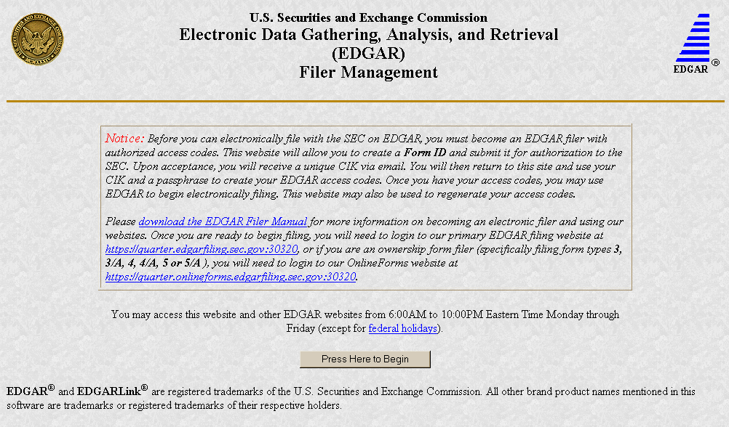
Figure E-1: EDGAR Filer Management Home Page
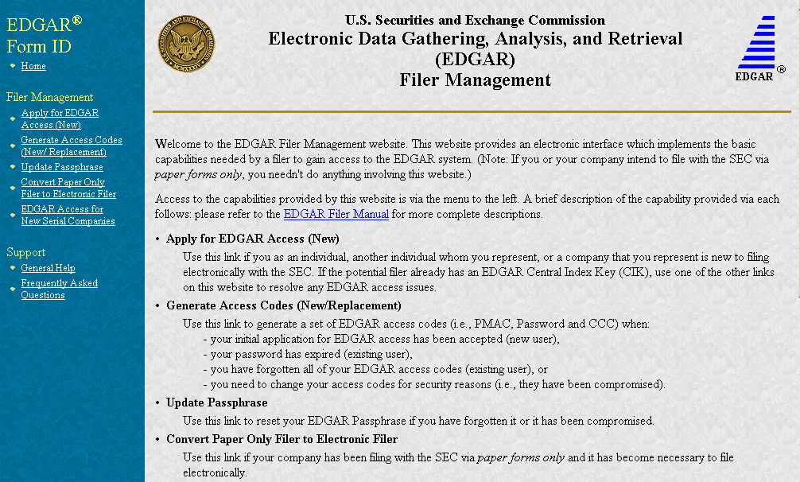

Sample
The contents of this page may change for every release.
Figure E-2: EDGAR Filer Management Home Page Welcome Page (Top)

E.3 Navigating the EFMW
The EFMW Welcome page displays an option menu on the left-hand side of the browser window. This menu allows you to navigate easily through the EFMW without having to return to a menu page. This menu is broken down into two different sections:
- Filer Management
- Support
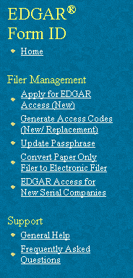
Figure E-3: EFMW Welcome Page Menu
Note that clicking Home merely redisplays the EFMW Welcome page. This menu item exists for consistency with other EDGAR websites (such as the OnlineForms website) and to support future functionality. Please note that the links open pop-up windows, so users should not disable pop-up displays.
E.3.1 Filer Management
In the Filer Management section, there are five links:
- Apply for EDGAR Access (New)
- Generate Access Codes (New/Replacement)
- Update Passphrase
- Convert Paper Only Filer to Electronic Filer
- EDGAR Access for New Serial Companies
By clicking Applying for EDGAR Access, you can create a Form ID application and submit it to the SEC for acceptance. A Form ID application is typically submitted by
- a [potential] filer that has not previously filed with the SEC in any media
or
- a current filer who needs to file in a new capacity
Acceptance of a Form ID application results in the creation of a new Central Index Key (CIK). For more details, please refer to Section E.4, Applying for EDGAR Access (New).
By clicking Generate Access Codes (New/Replacement) and entering your CIK and your passphrase, you are presented with EDGAR access codes (for an existing CIK) that are needed to perform common “filing” activities (these EDGAR access codes are the Password Modification Authorization Code [PMAC], the password and the CIK Confirmation Code [CCC]). For more details, please refer to Section E.6.1, EDGAR Access Codes
By clicking Update Passphrase, you can create a request for a new passphrase and submit it to the SEC for acceptance. This capability allows an existing EDGAR filer who has forgotten or wants to change his or her passphrase to get a new passphrase. With a new passphrase, the filer can regenerate the PMAC, password, and CCC. For more details, please refer to Section E.6.2, EDGAR Passphrase.
By clicking Convert Paper Only Filer to Electronic Filer, paper filers can create a request for EDGAR access and submit it to the SEC for acceptance. This capability allows the filer to file electronically with the SEC in the future. For more details, please refer to Section E.5.1, Current Paper Only Filer.
By clicking EDGAR Access for New Serial Companies, you can create a request for EDGAR access for a new serial company and submit it to the SEC for acceptance. This capability allows a serial company that was previously created via the submittal of a form 424B filing to specify a passphrase for access to EDGAR (after the request has been accepted by the SEC, the serial company can use the passphrase to get the access codes [PMAC, password, and CCC] that are needed to file with EDGAR). For more details, please refer to Section E.5.2, New Serial Company.
E.3.2 Support
In the Support section, there are two links:
- General Help
- Frequently Asked Questions
E.3.2.1 General Help
If you need help while using the EFMW on the Internet, click on General Help from the menu to bring up the General Help page (Figure E-4) that displays a list of help topics. When you click on a topic, you are shown information or additional links to specify the type of assistance you need.
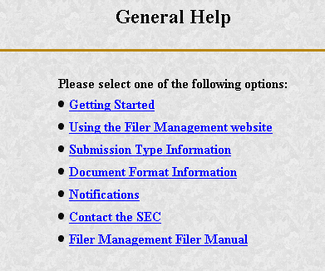
Figure E-4: EFMW General Help Page
E.3.2.2 Frequently Asked Questions
Click on Frequently Asked Questions (FAQ) to open the EFMW Frequently Asked Questions page. The FAQ page answers the questions about the EFMW that have been asked most often. You may find the answers helpful while using the EFMW. Click on the hyperlink topic to display the answer in the lower portion of the window.
E.4 New SEC Filer: Applying for EDGAR Access
This section walks you through the process of applying for access to EDGAR for applicants who are new to filing with the SEC, who need to file with the SEC in a new role or who have previously filed with the SEC but have not been assigned a CIK. Filers who have previously filed with the SEC on paper and who need to begin filing electronically should follow the instructions in Section E.5.1, Current Paper Only Filer. New serial companies that need EDGAR access should follow the instructions in Section E.5.2, New Serial Company.
E.4.1 Overview
The process of applying for access to EDGAR consists of two parts as follows:
- Composing and submitting a Form ID, and
- Submitting Authentication documentation.
Access to EDGAR will not be granted to a potential new filer until both parts have been accomplished. The SEC will not accept a Form ID application until both documents have been received. The Form ID is created and transmitted electronically, it cannot be submitted as a paper form. The Authentication documentation is a notarized hardcopy document that is faxed to the Office of Filings and Information Services, Branch of Filer Support. (Refer to Section E.4.4, Authentication Documentation, for details).
Within the context of a Form ID, the EFMW will:
- Allow you to provide all of the necessary information required by the SEC rules on an appropriate data gathering form (Form ID)
- Allow you to provide your signature and signature date
- Allow you to verify the information on the form
- Allow you to edit information on the form where necessary
- Allow you to upload attachments (i.e., cover letters, exhibits, or correspondence)
- Allow you to review and confirm your information and then print the submission for your records
Remember, the Form ID is a legal document. Consider these important notes when composing your Form ID using the EFMW:
- Intentional misstatements or omissions of facts constitute federal criminal violations. See 18 U.S.C.1001.
- Submission of a Form ID missing required information will not be allowed – all required fields must be completed.
- There is no capability to save work in progress, so it is important for you to have all of the information necessary to complete the form before you begin to assemble your submission online.
- You can exit the window at any time to discard your work in progress and start over.
- Only one applicant per Form ID is allowed (however, a method is provided to make it easier to submit multiple Form ID applications from the same browser window).
E.4.2 Application (Form ID)
This section outlines the process for composing a Form ID application using the EFMW and then transmitting the submission to EDGAR for processing.
Note: The instructions provided for the paper Form ID are pertinent to the information that is entered on the electronic Form ID data entry page. These instructions are available in Appendix C of this document and on the SEC website http://www.sec.gov.
Before beginning, gather all required information. Be especially sure to do the following:
- Determine the correct filer attributes: applicant type and company/individual indicator
- Ensure that you have identified the necessary contacts (for both EDGAR matters and for accounting and billing information)
- Ensure that you have proper and valid postal addresses, telephone numbers and e-mail address at hand
- Prepare any attachments, such as a cover letter or exhibit, save them in the correct format and have the file names identified.
The first step for composing a Form ID application is to bring up the Form ID data entry form. This is accomplished as follows:
- Connect to the EFMW Welcome page (refer to Section E.2, Accessing the EDGAR Filer Management website).
- Click on Apply for EDGAR Access (New) in the menu bar.
- A new browser window opens and the data entry page for the Form ID application appears (Figure E-5, top of form only).
- Enter the Form ID data, described in the following subsections.
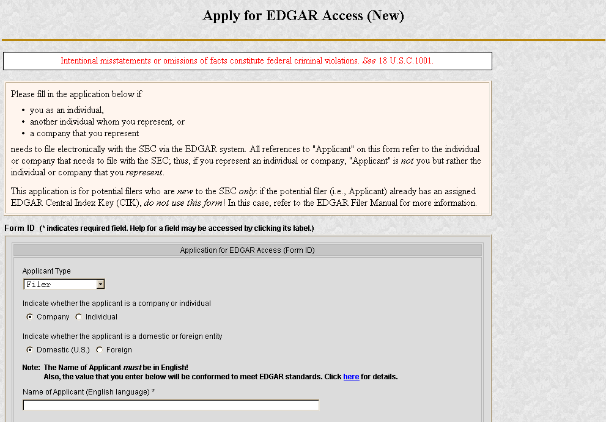
Figure E-5: EDGAR Apply for EDGAR Access (New) Page (Top)
The information on the Form ID data entry page is sectioned for ease of use into five parts:
Applicant Information
Basic information about the applicant, i.e., the company or individual that wishes to file with the SEC.
Filer Information
Additional information about the applicant when the applicant is a company.
Contact for EDGAR Information, Inquiries and Access Codes
Information about the person who is the applicant’s point of contact for EDGAR-related information and queries.
Contact for SEC Account Information and Billing Invoices
Information about the person who is the applicant’s point of contact for “financial” information and queries.
Signature Information
Typed signature of the applicant, the authorized representative of an applicant that is not an individual, or the individual authorized to sign by the individual applicant or authorized representative.
Note that the information to be entered is not the same for all applicants and that the data entry page is customized based upon the values of the filer attributes (Applicant Type and Company/Individual indicator). The “parts” that are required are based upon these filer attributes are specified in Table E-1.
Table E-1: EDGAR Form ID, “Parts”
Applicant Type | “Form Id” Data Entry Block
Applicant Type | Applicant Information  Part I | Filer Information  Part II | Contact Information  Part III | Account Information  Part IV | Signature Information  Part V
Filer (Company) | Yes | Yes | Yes | Yes | Yes
Filer (Individual) | Yes | No | Yes | Yes | Yes
Filing Agent (Company) | Yes | No | Yes | Yes | Yes
Filing Agent (Individual) | Yes | No | Yes | Yes | Yes
Training Agent (Company) | Yes | No | Yes | No | Yes
Training Agent (Individual) | Yes | No | Yes | No | Yes

E.4.2.1 Data Entry Conventions
The following are some basic EFMW data entry conventions:
- In Internet Explorer, disabled fields are read-only and are colored gray. In Netscape, the field is read-only but is not displayed in gray.
- Required fields are indicated by an asterisk to the right of the label name. (For example, “Mailing Street 1 *” is a required field.)
- Press the [Tab] key to move from field to field. (For this purpose, field level help counts as a field.)
- Field level help is available by clicking on the label.
- The [Exit Window] button will close the current data entry session and return to the EFMW Welcome page. Any data entered or attachments uploaded will be discarded.
E.4.2.2 Data Entry Details
Some significant details about the entry of the information on the Form ID application are described in the sections below. There is a section for each data portion that includes a screen shot of the associated portion of the data entry page. Note that the electronic Form ID application is modeled after the paper Form ID (refer to Appendix C) and that any instructions regarding the data to be entered in a field on the paper form are applicable to the electronic form.
E.4.2.2.1 Applicant Information
The Applicant Information section of the Form ID application is the first data entry section that is displayed on the page (equivalent to Part I of the paper form). This information is to be supplied by all applicants. The filer attributes are the first items in this section (before the Name of Applicant/Individual) and are critical to the data entry process as they control the data entry fields that are available on the page. It is recommended that the filer attributes be specified before any other data and that an effort be made to ensure that they are correct: changing them after data has been entered in other fields may result in data being lost. When the page is first displayed, the filer attributes are set to {“Filer” and “Company”}.
The Name of Applicant or Name of Individual is the first data entry field after the filer attributes. The difference between the two is that the Name of Applicant is used for companies only and consists of a single component, while the Name of Individual is used for individuals only and consists of a four components, one each for Last Name, First Name, Middle Name and Suffix. As stated on the web page, the Name will be conformed according to the EDGAR standards. These standards may be viewed online by clicking the link in the Note above the data entry field. The process of automatic name conformance cannot be turned off or otherwise prevented or avoided by the requestor or applicant.
The Mailing Address is required and must be entered for all applicants. However, it may also be used for other addresses on the Form ID application (as described in the appropriate sections).
The TIN is required whenever the applicant is a Company. However, a company that has applied for but has not yet have received a TIN must enter “00-0000000” (zeroes). Remember to update your TIN when it is received. You must use the EDGAR Filing or OnlineForms Website’s Edit Company Information capability to update the TIN in EDGAR. The TIN is not needed for Individuals and cannot be entered (the entry of a Social Security Number [SSN] is not required and is not supported).
Note: The “applicant” is the company or individual who is required to file with the SEC, not necessarily the person who is filling in the form (although it could be). The term “requestor” is used to refer to the person who is filling in the form.
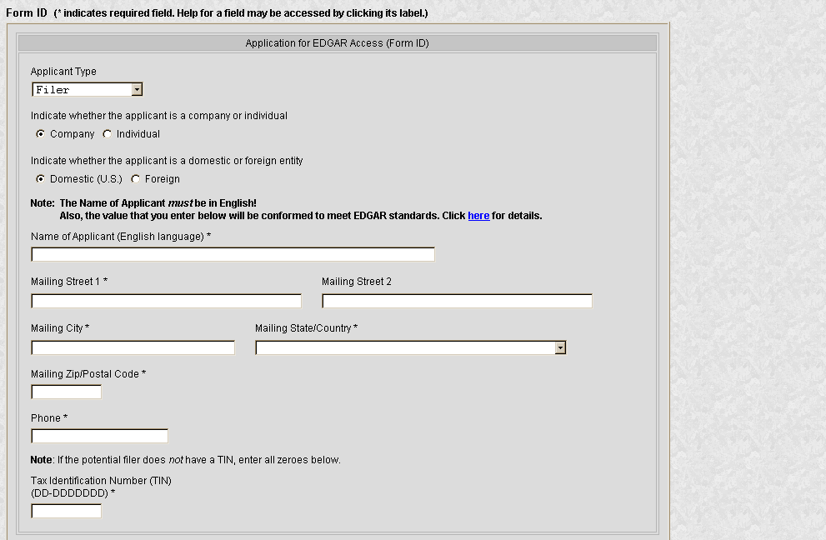
Figure E-6: EDGAR Form ID Page, Applicant Information
E.4.2.2.2 Filer Information
The Filer Information section of the Form ID application is the second data entry section that is displayed on the page (equivalent to Part II of the paper form). This information can be supplied only for applicants that are companies.
The “Doing Business As” Name is optional. If the filer is a foreign filer, an optional Foreign Name data entry field is also available. This name is intended for the name of the company in a non-English language but using only the subset of the standard ASCII (text) character set that is supported by EDGAR.
The requestor must either explicitly enter the information required for the Business Address or check the “Business address same as mailing address” box. If the “Business address same as mailing address” box is checked, EDGAR will copy the Mailing Address information to the Business Address fields before submitting the Form ID application (this action is not immediate). When this box is checked, the Business Address data entry fields are disabled (grayed out with Internet Explorer).
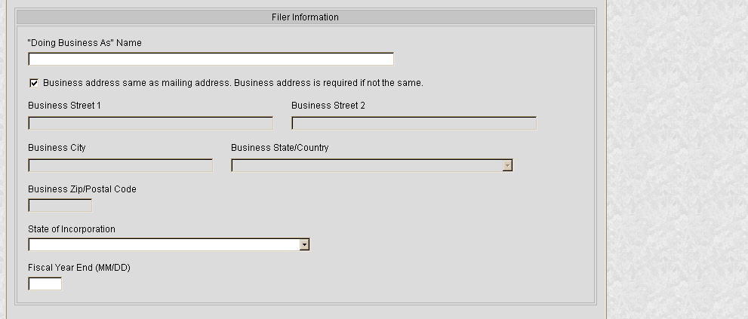
Figure E-7: EDGAR Form ID Page, Filer Information
E.4.2.2.3 Contact for EDGAR Information
The Contact for EDGAR Information, Inquiries and Access Codes section of the Form ID application is the third data entry section that is displayed on the page (equivalent to Part III of the paper form). This information must be supplied for all applicants.
The Contact Address is required if any part of the address is different from the Mailing Address. If the Contact Address is identical to the Mailing Address, the requestor may check the “Contact address same as mailing address” box and EDGAR will copy the Mailing Address information to the Contact Address fields before submitting the Form ID application. When this box is checked, the Contact Address data entry fields are disabled (grayed out with Internet Explorer).
The E-Mail Address is critical to communications between the applicant and EDGAR. This is because notifications (messages) are sent from EDGAR to this e-mail address. For example, an e-mail notification is sent to the applicant after his or her Form ID application is processed by the SEC – if the application is rejected, there is no other way for the applicant to determine this (after the Form ID application is accepted and the applicant has access to EDGAR, subsequent notifications may be retrieved from the EDGAR Filing or OnlineForms websites).
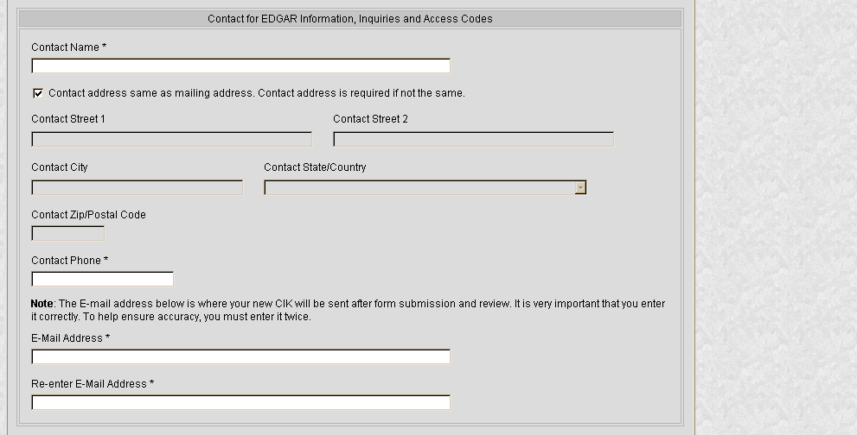
Figure E-8: EDGAR Form ID Page, Contact for EDGAR Information
Note that our rules require that you keep this information updated. After your Form ID application is accepted and you have your EDGAR access codes, you can use the Edit Company Information capability of the EDGAR Filing or OnlineForms websites to update this information as required.
E.4.2.2.4 Contact for SEC Account Information
The Contact for SEC Account Information and Billing Invoices section of the Form ID application is the fourth data entry section that is displayed upon the page (equivalent to Part IV of the paper form). This information is to be supplied for all Filers and Filing Agents.
The Contact Address is required if any part of the address is different from the Mailing Address. If the Contact Address is identical to the Mailing Address, the requestor may check the “Contact address same as mailing address” box and EDGAR will copy the Mailing Address information to the Contact Address fields before submitting the Form ID application. When this box is checked, the Contact Address data entry fields are disabled (grayed out with Internet Explorer).
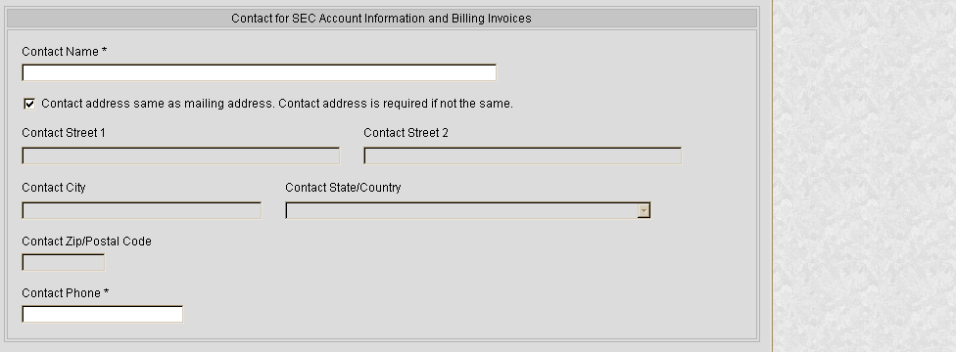
Figure E-9: EDGAR Form ID Page, Contact for SEC Account Information
E.4.2.2.5 Signature
The Signature Information section of the Form ID application is the fifth data entry section that is displayed upon the page (equivalent to Part V of the paper form). This information is to be supplied for all applicants. A duly authorized person, such as a partner, president, treasurer, corporate secretary, officer, or director, must sign the Form ID application. Individuals may have someone with their power of attorney sign the Form ID application. Filing agents such as financial printers cannot sign this Form on behalf of the issuer unless they are specifically authorized to do so in writing. The written documentation should be attached to the Form ID application (refer to Section E.4.3.2, Assembling the Form ID Submission, for information on how to add an attachment).
The Signature that is entered is the text equivalent of the signer’s manual legal signature. For example, if Tobias Alowicious Smith uses “T. A. Smith” as his legal signature, the requestor would enter “T. A. Smith” in this data entry field. Note that the Signature is for the applicant, the authorized representative of an applicant that is not an individual, or the individual authorized to sign by the individual applicant or authorized representative, which is not necessarily the person who is filling in the form (although they could be the same).
The Title/Position is required only when the applicant is a company.
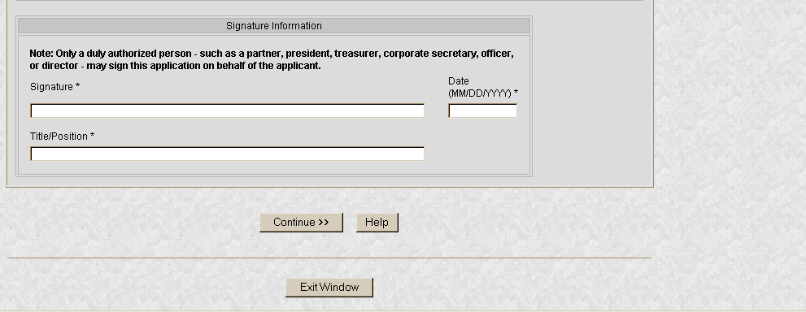
Figure E-10: EDGAR Form ID Page, Signature Information
E.4.3 Assembling and Submitting the Form ID Application
After you have entered all of the required data on the Form ID application, you are ready to complete the process and submit the Form ID application to the SEC for acceptance. You must do the following to finish the process:
- Correct any errors
- Upload any attachments
- Define a passphrase
- Submit the completed Form ID application
E.4.3.1 Verifying the Form ID Application
Note: The figures in this section all contain sample data. Each figure represents the type of data that can be entered on the Form ID application. The figures are provided as examples of what you will see; your data will be different.
The next step in the process is to complete the Form ID data entry phase. This is accomplished as follows:
- Click the [Continue] button (Figure E-10).
EDGAR validates the format and syntax of the information that you provided in the Form ID application (you are responsible for confirming the accuracy of all information submitted in the Form). If there are errors in the information provided (such as missing required fields), your Form ID application with the errors highlighted will be displayed (Figure E-11, top only). Follow the instructions on the screen to correct the errors, then click the [Continue] button. Your updated Form ID application will be revalidated; if errors remain, your updated Form ID application with the remaining and any new errors marked is displayed. You must correct all errors to proceed past this point.
For example, the following errors are marked in Figure E-11:
- Mailing State/Country is missing (required field)
- Phone [Telephone Number] is not in the correct format
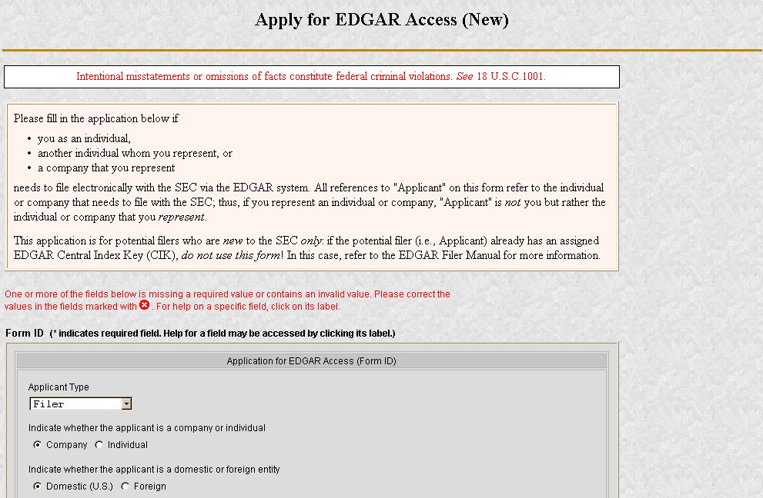
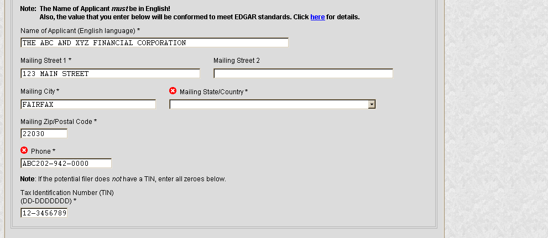
Figure E-11: EDGAR Form ID, Errors (Top)
- If there are no errors in your Form ID application and your Name is changed by the name conformance process, a dialog box appears (Figure E-12).
The dialog box gives you the conformed Name of Applicant that will be used when your Form ID application is submitted. Click the [OK] button in the Conformed Name dialog box after you have reviewed the information.
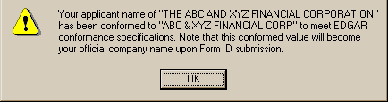
Figure E-12: EDGAR Form ID, Conformed Name Dialog
- The EFMW Form ID Application Confirmation page appears (Figure E-13, top only).
This page allows you to review the information that will be sent to EDGAR after you submit this Form ID application. It also provides a way for you to edit any incorrect information (except for the conformed Name of Applicant), to upload/delete attachments and to define a passphrase.
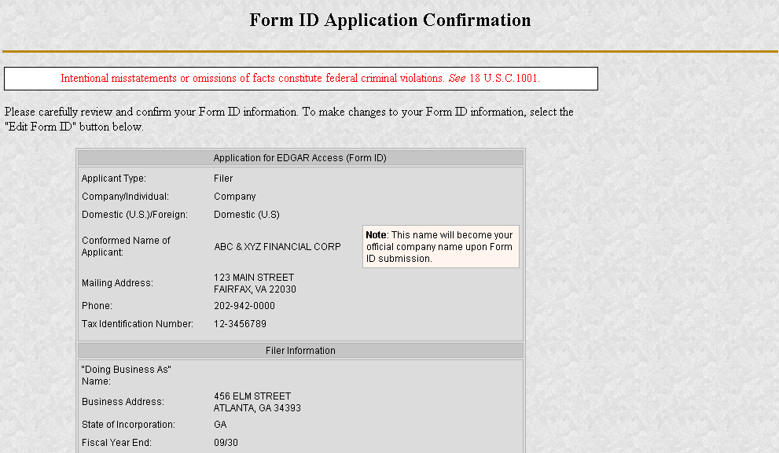
Figure E-13: EDGAR Form ID Application Confirmation Page (Top)
If you want to change any of the data displayed on the EFMW Form ID Application Confirmation page, click the [Edit Form ID] button in the middle of the page (Figure E-14).
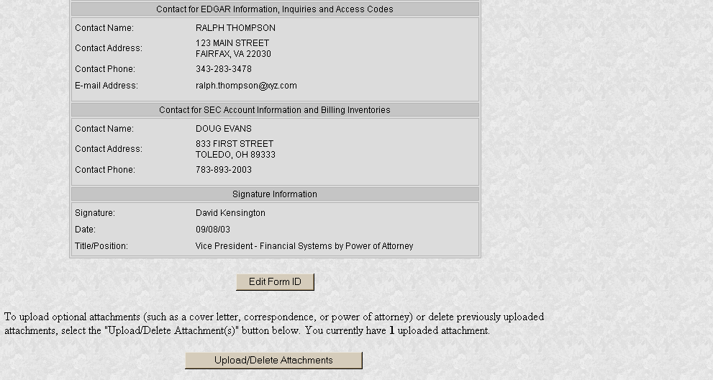
Figure E-14: EDGAR Form ID Application Confirmation Page (Middle)
The EFMW Form ID application page appears (Figure E-15, top only), prefilled with the data from your original Form ID application. Change any of the data that you want, and then click the [Continue] button. Your updated Form ID application will be reverified; if errors remain, your updated Form ID application with the new errors marked is displayed (see above).
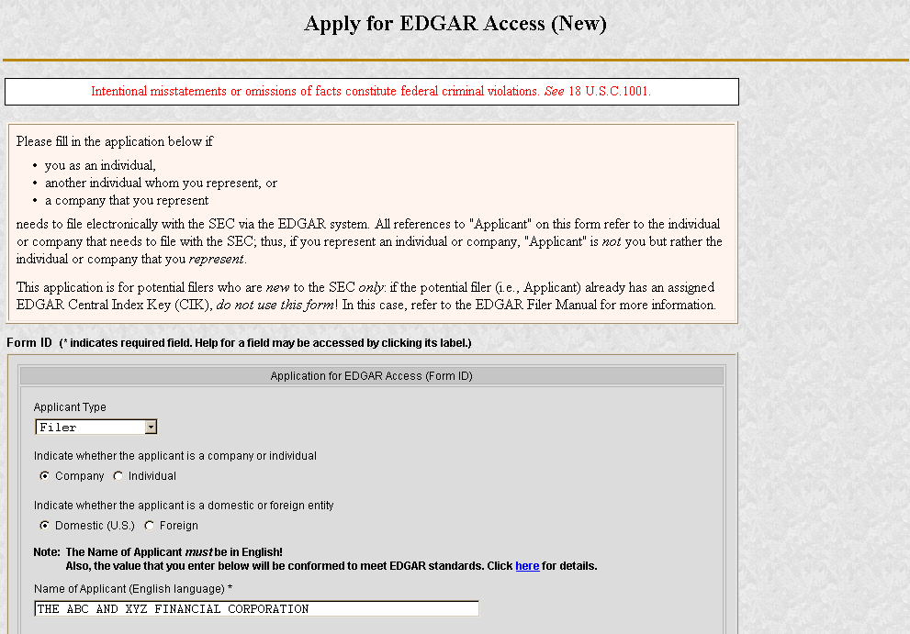
Figure E-15: EDGAR Form ID Application Edit (Top)
E.4.3.2 Assembling the Form ID Submission
The Form ID application may include attachments (such as a Power of Attorney). To assemble the Form ID submission (i.e., associate any attachments with your Form ID application), you must upload them to EDGAR (if you don't need to associate attachments with your Form ID application, skip this step).
- If you want to add or delete an attachment, click the [Upload/Delete Attachments] button in the middle of the page (Figure E-14).
The EFMW Upload/Delete Attachment(s) page appears (Figure E-16). This page displays a table of the uploaded attachments and allows you to manage the attachments associated with your Form ID application.
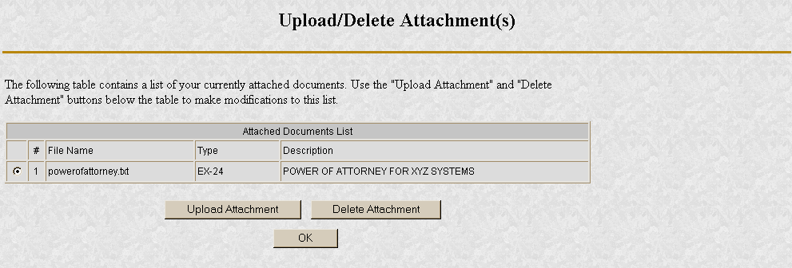
Figure E-16: EDGAR Form ID Upload/Delete Attachment(s) Page
To add an attachment, click the [Upload Attachment] button (any attachments you plan to include should already have been prepared and saved in the appropriate format prior to assembling your Form ID submission. ASCII [*.txt file extension] and HTML [*.htm file extension] are accepted; PDF and graphic formats are not accepted). The Upload Attachment page appears (Figure E-17). Enter the appropriate information in the data entry fields, and then click the [Upload] button (to return to the Upload/Delete Attachment(s) page without uploading an attachment, click on the [Cancel] button). The EFMW Upload/Delete Attachment(s) page appears (Figure E-16) with your new attachment displayed in the table.
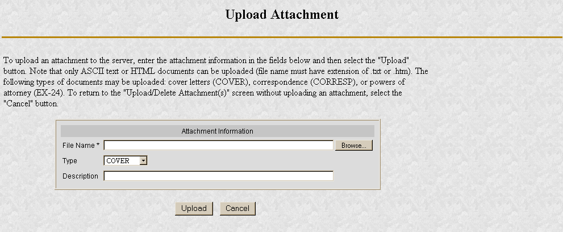
Figure E-17: EDGAR Form ID Upload Attachment Page
To delete an attachment, select the radio button to the left of the attachment you wish to delete and click on the [Delete Attachment] button. The selected attachment will be discarded and its entry in the table on the Upload/Delete Attachment(s) page will be removed.
The EFMW Upload/Delete Attachment(s) page appears (Figure E-16) with your new attachment displayed in the table. Continue to add or delete attachments until you are satisfied, and then click the [OK] button to return to the Form ID Application Confirmation page.
E.4.3.3 Defining a Passphrase
The passphrase is a new EDGAR security code that is used to generate (or regenerate) the EDGAR access codes needed to make filings via EDGAR with the SEC. The passphrase is not used to log on to the EDGAR Filing or OnlineForms websites. The passphrase allows a filer to generate a new set of EDGAR access codes if/when they are forgotten (refer to Section E.6.1, EDGAR Access Codes, for more information).
It is important to remember that the passphrase (and the EDGAR access codes) are not assigned to the requestor of the Form ID, but to the applicant.
The last step, prior to submitting your Form ID application, to the SEC is to specify a passphrase. Please do not forget your passphrase. For security reasons, it cannot be recovered after the Form ID application window has been exited.
Note: Defining a passphrase must be the last step before submitting a Form ID application to the SEC. If you enter a passphrase and then click on the [Edit Form ID] or [Upload/Delete Attachments] button, the passphrase is discarded. This sequence of steps helps ensure the security of the passphrase.
- To specify your passphrase, enter it in the data entry fields near the bottom of the Form ID Application Confirmation page (Figure E-18). For security reasons, your passphrase must be eight characters in length and contain at least one digit and one character from the set {@, #, *, $}.
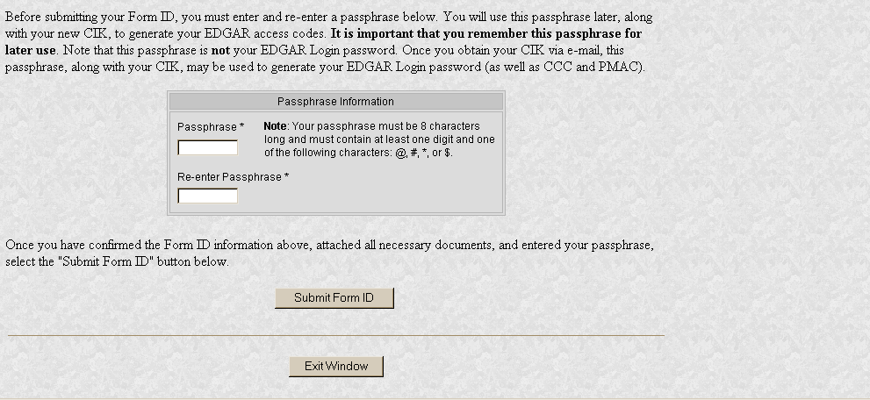
Figure E-18: EDGAR Form ID Application Confirmation Page (Bottom)
E.4.3.4 Submitting a Form ID Application
After completing and editing your Form ID application, adding any attachments and specifying a passphrase, you are ready to submit the Form ID application to the SEC.
Consider this step carefully: You cannot easily retract the Form ID application after it has been submitted. If you decide that you don’t want to submit the Form ID application, close the browser window by clicking the [Exit Window] button at the bottom of the Form ID Application Confirmation page. If you close the window, all of the data that you’ve entered on the Form ID application and any attachments will be discarded.
- To submit your Form ID application, click the [Submit Form ID] button at the bottom of the Form ID Application Confirmation page (Figure E-18).
A dialog box appears (Figure E-19) asking you to confirm that you want to submit the Form ID application. If you do not want to submit it, click the [Cancel] button and the dialog box will disappear; otherwise, click the [OK] button to submit the Form ID application to the SEC.
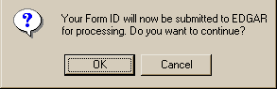
Figure E-19: EDGAR Form ID, Submittal Dialog
Note: After you click the [OK] button, the Form ID application is submitted to the automated submission processing portion of the EDGAR system. This is the start of the acceptance process; your subsequent actions in this browser window will not affect this process. However, the acceptance process cannot be completed until you submit authentication documentation to the Office of Filings and Information Services, Branch of Filer Support. Refer to Section E.4.4, Authentication Documentation, for more information.
The EFMW Form ID Application Acknowledgment page appears (Figure E-20). This page provides the Accession Number for the submission (use this number when referring to this submission) and lists the Form ID information that was submitted.
Note: The Accession Number is a unique code assigned to your Form ID submission. It has a format of: 9999999996-[Year]-[Unique Sequence Number]
Click the [Print Window] button near the bottom of the page to print this page to make a copy for your records.
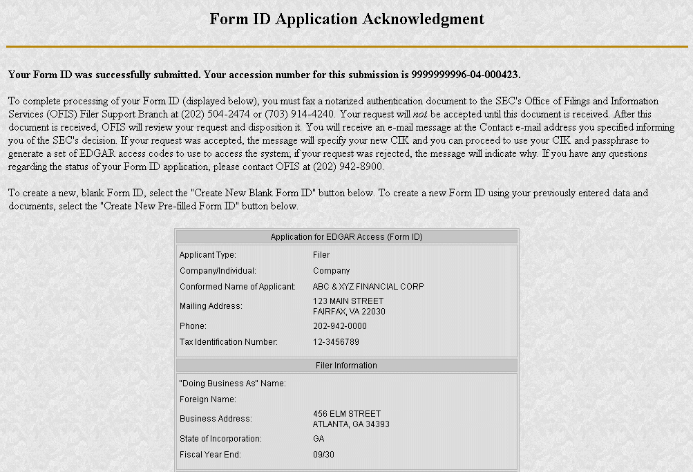
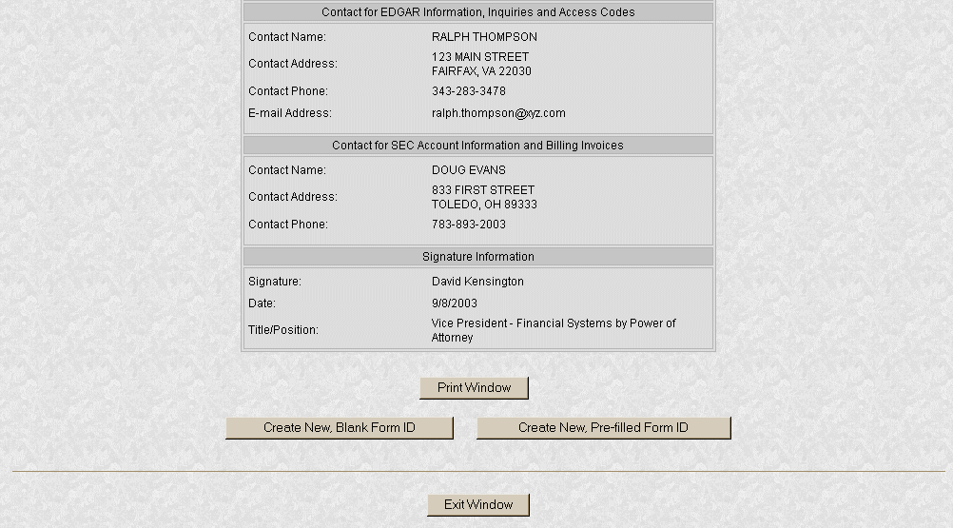
Figure E-20: EDGAR Form ID Application Acknowledgment Page
- Click the [Exit Window] button near the bottom of the Form ID Application Confirmation page to finish the process by closing the browser window.
A dialog box appears (Figure E-21) asking you to confirm that you want to exit the browser window. If you do not want to exit, click the [Cancel] button and the dialog box will disappear; otherwise, click the [OK] button and the browser window will be closed and the previously entered Form ID information and any attachments (documents) will be discarded.
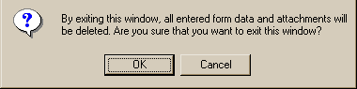
Figure E-21: EDGAR Form ID, Exit Window Dialog
E.4.3.5 Starting Another Form ID Application
If you would like to start another Form ID application, directly from the Form ID Application Acknowledgment page, click one of the buttons provided for this purpose near the bottom of the page (Figure E-20).
E.4.3.5.1 Create New, Blank Form ID
This option returns you to the Form ID Application page (in the same browser window) and deletes all of the data that you had previously entered. Use this capability when you need to submit another Form ID application for a company or person whose information is different from that previously entered.
- Click the [Create New, Blank Form ID] button near the bottom of the Form ID Application Confirmation page.
A dialog box appears (Figure E-22) warning you that the previously entered Form ID information and any attachments (documents) will be cleared if you continue. If this is not your desire, click the [Cancel] button on the dialog box.
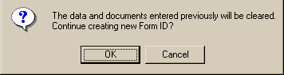
Figure E-22: EDGAR Form ID, New Blank Form Dialog
If you would like to start a new, blank Form ID application, click the [OK] button on the dialog box. The EFMW Apply for EDGAR Access (New) page appears in the same browser window without any of the previously entered data. Follow the previous instructions (Section E.4, New SEC Filer: Applying for EDGAR Access) for composing and submitting this new Form ID application.
E.4.3.5.2 Create New, Pre-filled Form ID
This option returns you to the Form ID Application page (in the same browser window) and prefills all of the data entry fields with the data that you had previously entered, except for the Name of Applicant or Name of Individual (as appropriate). Use this capability when you need to submit another Form ID application for a company or person whose information is materially the same as that previously entered.
- Click the [Create New, Pre-filled Form ID] button near the bottom of the Form ID Application Confirmation page.
A dialog box appears (Figure E-23) warning you that the previously entered Form ID information and any attachments (documents) will be retained if you continue. If this is not your desire, click the [Cancel] button on the dialog box.
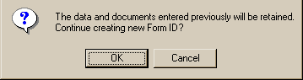
Figure E-23: EDGAR Form ID, New Pre-filled Form Dialog
If you would like to start a new, prefilled Form ID application, click the [OK] button on the dialog box. The EFMW Apply for EDGAR Access (New) page appears in the same browser window with all of the previously entered data except for the Name (which is empty). Follow the previous instructions (Section E.4, New SEC Filer: Applying for EDGAR Access) for composing and submitting this new Form ID application.
E.4.4 Authentication Documentation
The Form ID application must be supplemented with additional verification to help ensure that the application is authentic. Accordingly, the applicant is required to file with the SEC in paper by fax within two business days before or after electronically filing Form ID a notarized document, manually signed by the applicant over its typed signature, that includes the information contained in the Form ID filed or to be filed and confirms the authenticity of the Form ID. If we do not receive the fax within this period, we will reject the application and the applicant will need to reapply.
E.4.5 Application Acceptance and Applicant Notification
After both the electronic Form ID application and the associated authentication documentation are received by the SEC, the SEC will review and accept or reject the information provided on the Form ID. This is a manual process that is not immediate and that may require a day or more to complete.
A notification message stating the SEC’s disposition of the application will be sent to the e-mail address provided in the “Contact for EDGAR Information” part of the Form ID. The disposition will be either “accepted” or “rejected.”
If the application was accepted, the e-mail message will include but will not be limited to the following information:
- Text saying that the Form ID was accepted by the SEC
- The new Central Index Key [CIK]
- Basic directions for how to generate EDGAR access codes
- The URL of the EDGAR Filer Management web site
If the application was rejected, the e-mail message will include but will not be limited to the following information:
- Text saying that the submission was rejected by the SEC
- The reason that the application was rejected
- Basic instructions on how to resolve the issues
Refer to Section E.7, Examples of Notification Messages, to review the notification messages.
E.5 Current SEC Filer: Applying for EDGAR Access
This section explains the process of applying for access to EDGAR for applicants who are currently filing with the SEC, unless they have not been assigned a CIK or seek to file in a different capacity (the capacities being “individual”, “filing agent” and “training agent”). Other filers should follow the instructions in Section E.4, New SEC Filer: Applying for EDGAR Access.
E.5.1 Current Paper Only Filer
Note: The “applicant” is the company or individual who is required to file with the SEC, not necessarily the person who is filling in the form (although it could be). The term “requestor” is used to refer to the person who is filling in the form.
This section outlines the process for composing and submitting an EDGAR access request using the EFMW when the applicant currently makes paper filings (only) with the SEC and wants to start to file electronically. Before beginning, ensure that you know the Central Index Key (CIK) of the applicant. If you don’t know the CIK, you can look up the applicant by name by connecting to the EDGAR Company Database at URL
http://www.edgarcompany.sec.gov
and clicking the [Company Search] button. The CIK is one of the items returned by querying this database.
E.5.1.1 Composing the Convert to Electronic Filer Request
The first step for composing an EDGAR access request is to bring up the EDGAR access request data entry form. This is accomplished as follows:
- Connect to the EFMW Welcome page (refer to Section E.2, Accessing the EDGAR Filer Management website).
- Click on Convert Paper Only Filer to Electronic Filer in the menu bar.
- A new browser window opens and the data entry page for the EDGAR access request appears (Figure E-24).
Refer to Section E.4.2.1, Data Entry Conventions, for the standards used on all of the EFMW pages.
- Enter the required data (CIK, passphrase and e-mail address)
Refer to Section E.4.3.3, Defining a Passphrase, for more detailed description of the passphrase. For security reasons, the passphrase must be eight characters in length and contain at least one digit and one character from the set {@, #, *, $}.
- Click on the [Convert to Electronic] button near the bottom of the page when you are satisfied with the data that you entered.
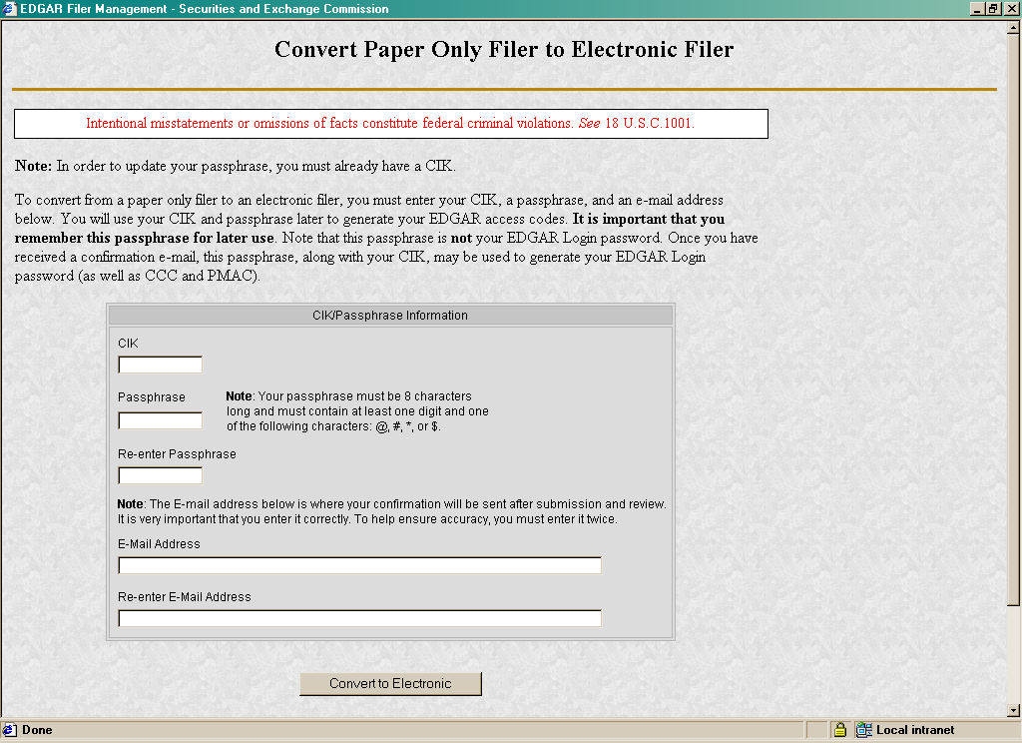
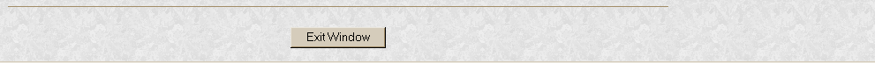
Figure E-24: EDGAR Convert Paper Only Filer to Electronic Filer Page
A dialog box appears (Figure E-25) asking you to confirm that you want to submit the request. If you do not want to submit the request, click the [Cancel] button and the dialog box will disappear; otherwise, click the [OK] button.
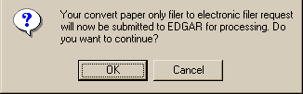
Figure E-25: EDGAR Convert to Electronic Filer, “Continue” Dialog
Note: After you click the [OK] button, the Convert Paper Only Filer to Electronic Filer request is submitted to the automated submission processing portion of the EDGAR system. This is the start of the acceptance process, your subsequent actions in this browser window will not affect this process. However, the acceptance process cannot be completed until you submit Authentication documentation to the SEC – refer to Section E.5.1.2, Authentication Documentation, for more information.
The EFMW Convert Paper Only Filer to Electronic Filer Acknowledgment page appears (Figure E-26). This page provides the Accession Number for the submission (use this number when referring to this submission).
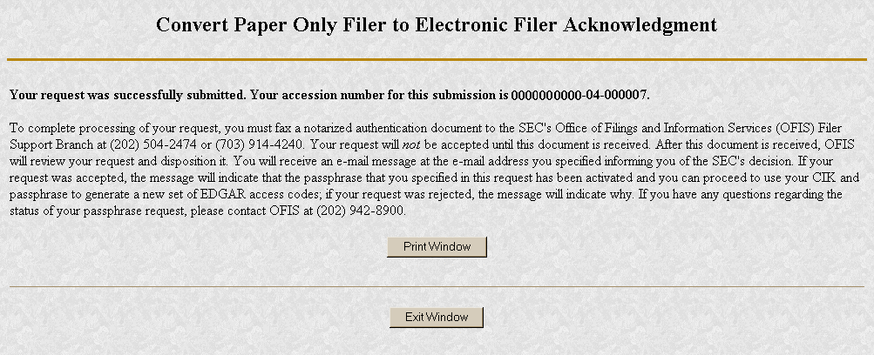
Figure E-26: EDGAR Convert Paper Only Filer to Electronic Filer Acknowledgment Page
Click the [Print Window] button near the bottom of the page to print this page to make a copy for your records.
- Click the [Exit Window] button to complete the process by closing the browser window.
No confirming dialog box is displayed - the browser window is just closed.
E.5.1.2 Authentication Documentation
The Convert Paper Only Filer to Electronic Filer request must be supplemented with additional verification to help ensure that the request is authentic. Accordingly, the filer is required to file with the SEC in paper by fax within two business days after electronically filing the request a notarized document, manually signed by the filer over its typed signature, that includes the information identified below and confirms the authenticity of the request. If we do not receive the fax within this period, we will reject the request and the requestor will need to reapply.
- CIK
- Name associated with that CIK
- Name of the contact person for purposes of this request
- Acknowledgement accession number
- Contact person on database
- Contact telephone number on database
E.5.1.3 Request Acceptance and Applicant Notification
After both the electronic Convert Paper Only Filer to Electronic Filer request and the associated Authentication documentation are received by the SEC, the SEC will authenticate the information provided on the Convert Paper Only Filer to Electronic Filer request. A notification message stating the SEC’s disposition of the request will be sent to the e-mail address provided in the request. The disposition will be either “accepted” or “rejected.”
If the request is accepted, the e-mail message will include but will not be limited to the following information:
- Text saying that the request was accepted by the SEC
- Text stating that the specified passphrase was activated
- Basic directions for how to generate EDGAR access codes
- The URL of the EDGAR Filer Management web site
If the request is rejected, the e-mail message will include but will not be limited to the following information:
- Text saying that the request was rejected by the SEC
- The reason that the request was rejected
- Basic instructions on how to resolve the issue
Refer to Section E.7, Examples of Notification Messages, to review the notification messages.
E.5.2 New Serial Company
Note: The “applicant” is the company or individual who is required to file with the SEC, not necessarily the person who is filling in the form (although it could be). The term “requestor” is used to refer to the person who is filling in the form.
A serial company is created as a result of a “parent” company filing a Form 424B, using a serial tag, with the SEC. When the 424B submission is accepted by the SEC, the serial company is created in EDGAR and a [new] CIK is assigned. However, the act of creating the serial company in EDGAR does not automatically result in EDGAR access for the new company: the new serial company must request access to EDGAR. This section outlines the process for composing and submitting an EDGAR access request using the EFMW when the applicant is a newly-created serial company (note that a new serial company need not apply for EDGAR access if it will be filing with the SEC on paper only [Form 424B6]).
Before beginning, ensure that you know the Central Index Key (CIK) of the applicant (it will be specified in the notification message sent to the parent company by EDGAR after the Form 424B is accepted by the SEC). If you don’t know the CIK, you can look up the serial company by name using the EDGAR Company Database at URL
http://www.edgarcompany.sec.gov
and clicking the [Company Search] button. The CIK is one of the items returned by querying this database.
Note: The EDGAR Company Database is updated nightly so it will be populated with the new serial company’s CIK no earlier than the day after the 424B that created it is accepted.
E.5.2.1 Composing the New Serial Company Access Request
The first step for composing an EDGAR access request is to bring up the EDGAR access request data entry form. This is accomplished as follows:
- Connect to the EFMW Welcome page (refer to Section E.2, Accessing the EDGAR Filer Management website).
- Click on EDGAR Access for New Serial Companies in the menu bar.
- A new browser window opens and the data entry page for the EDGAR access request appears (Figure E-27).
Refer to Section E.4.2.1, Data Entry Conventions, for the standards used on all of the EFMW pages.
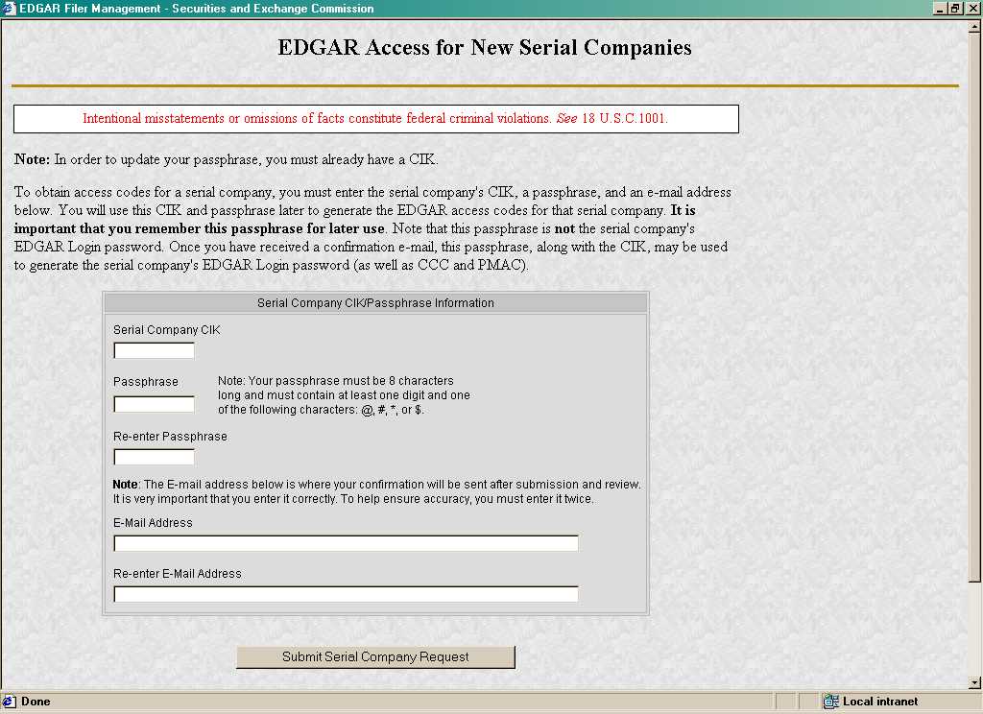
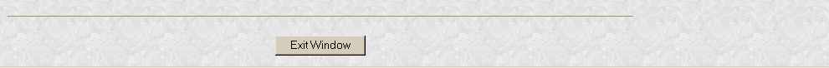
Figure E-27: EDGAR Access for New Serial Companies Page
- Enter the required data (CIK, passphrase and e-mail address)
Refer to Section E.4.3.3, Defining a Passphrase, for a more detailed description of the passphrase. For security reasons, the passphrase must be at least eight characters in length and contain at least one digit and one character from the set {@, #, *, $}.
- Click on the [Submit Serial Company Request] button near the bottom of the page when you are satisfied with the data that you entered.
A dialog box appears (Figure E-28) asking you to confirm that you want to submit the request. If you do not want to submit the request, click the [Cancel] button and the dialog box will disappear; otherwise, click the [OK] button.
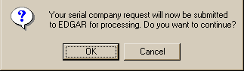
Figure E-28: EDGAR New Serial Company Access, “Continue” Dialog
Note: After you click the [OK] button, the EDGAR Access for New Serial Companies request is submitted to the automated submission processing portion of the EDGAR system. This is the start of the acceptance process; your subsequent actions in this browser window will not affect this process. However, the acceptance process cannot be completed until you submit Authentication documentation to the SEC. Refer to Section E.5.2.2, Authentication Documentation, for more information.
The EFMW EDGAR Access for New Serial Companies Acknowledgment page appears (Figure E-29). This page provides the Accession Number for the submission (use this number in the future when referring to this submission).
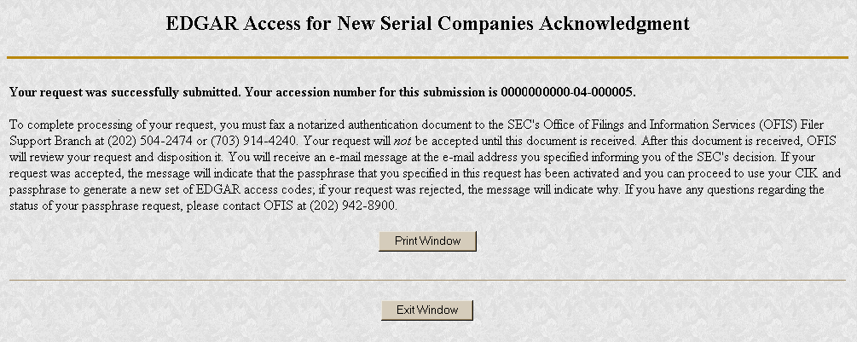
Figure E-29: EDGAR Access for New Serial Companies Acknowledgment Page
Note: The Accession Number is a unique code assigned to your Form ID submission. It has a format of: 9999999996-[Year]-[Unique Sequence Number]
Click the [Print Window] button near the bottom of the page to print this page for your records.
- Click the [Exit Window] button to finish the process by closing the browser window.
No confirming dialog box is displayed - the browser window is just closed.
E.5.2.2 Authentication Documentation
The EDGAR Access for New Serial Companies request must be supplemented with additional verification to help ensure that the request is authentic. Accordingly, the filer is required to file with the SEC in paper by fax within two business days after electronically filing the request a notarized document, manually signed by the filer over its typed signature, that includes the information identified below and confirms the authenticity of the request. If we do not receive the fax within this period, we will reject the request and the requestor will need to reapply.
- CIK
- Name associated with that CIK
- Name of the contact person for purposes of this request
- Acknowledgement accession number
- Contact person of the parent company on database
- Contact telephone number of the parent company on database
- Accession number of the 424B filing that created the serial company
E.5.2.3 Request Acceptance and Applicant Notification
After both the electronic EDGAR Access for New Serial Companies request and the associated Authentication documentation are received by the SEC, the SEC will authenticate the information provided on the EDGAR Access for New Serial Companies request. A notification message stating the SEC’s disposition of the request will be sent to the e-mail address provided in the request. The disposition will be either “accepted” or “rejected.”
If the request is accepted, the e-mail message will include but will not be limited to the following information:
- Text saying that the request was accepted by the SEC
- Text stating that the specified passphrase was activated
- Basic directions for how to generate EDGAR access codes
- The URL of the EDGAR Filer Management web site
If the request is rejected, the e-mail message will include but will not be limited to the following information:
- Text saying that the request was rejected by the SEC
- The reason that the request was rejected
- Basic instructions on how to resolve the issue
Refer to Section E.7, Examples of Notification Messages, for review the notification messages.
E.6 All Filers: Generating EDGAR Access Codes
This section explains the process of generating EDGAR access codes if you have been accepted for EDGAR access by the SEC. If your Form ID application for EDGAR access has not been accepted by the SEC, please refer to Section E.4 (New SEC Filer: Applying for EDGAR Access) or Section E.5 (Current SEC Filer: Applying for EDGAR Access), as appropriate.
E.6.1 EDGAR Access Codes
This section describes how to generate a set of EDGAR access codes (PMAC, password, CCC)
- for a new electronic filer,
- for an electronic filer who has forgotten their EDGAR access codes, or
- for an electronic filer who wants to change EDGAR access codes for security purposes.
The filer must have a currently valid CIK.
You cannot get individual access codes using the EFMW, only a complete set. However, the EDGAR Filing and OnlineForms websites allow you to generate just a new password (if you know the filer’s PMAC) or just a new CCC (if you know the filer’s password). Please refer to Section 5 (Additional Online Features) of this manual for more information.
Note that this capability is not needed as long as a filer’s EDGAR access codes are appropriately protected and kept current. (The password expires yearly; the PMAC and CCC do not expire.)
Before beginning, ensure that you know the Central Index Key (CIK) of the filer (it will be specified in the notification message sent when the filer’s electronic Form ID application was accepted). If you don’t know the CIK, you can look up the filer by name using the EDGAR Company Database at URL
http://www.edgarcompany.sec.gov
and clicking the [Company Search] button. The CIK is one of the items returned by querying this database.
You must also know the filer’s passphrase (the passphrase was specified in connection with the electronic Form ID application, on an Update Passphrase request, on a Convert Paper Only Filer to Electronic Filer request, or on an EDGAR Access for New Serial Companies request).
The first step in generating a set of EDGAR access codes is to bring up the EDGAR Generate Access Codes data entry form. This is accomplished as follows:
- Connect to the EFMW Welcome page (refer to Section E.2, Accessing the EDGAR Filer Management website).
- Click on Generate Access Codes (New/Replacement) in the menu bar.
- A new browser window opens and the Generate Access Codes (New/Replacement) page appears (Figure E-30).
Refer to Section E.4.2.1, Data Entry Conventions, for the standards used on all of the EFMW pages.
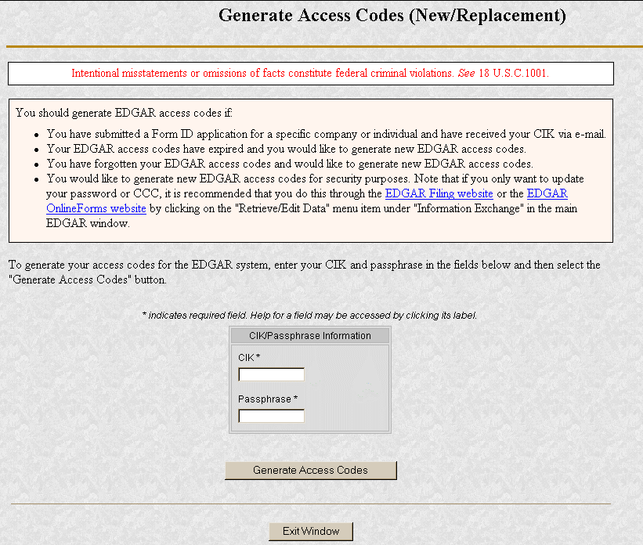
Figure E-30: EDGAR Generate Access Codes (New/Replacement) Page
- Enter the required data (CIK and passphrase).
- Click on the [Generate Access Codes] button near the bottom of the page when you are satisfied with the data that you entered.
A dialog box appears (Figure E-31) asking you to confirm that you want to submit the request. If you do not want to submit the request, click the [Cancel] button and the dialog box will disappear; otherwise, click the [OK] button.
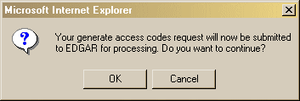
Figure E-31: EDGAR Generate Access Codes, “Continue” Dialog
The EFMW Generate Access Codes Acknowledgment page appears (Figure E-32). This page provides the filer’s CIK and a set of new EDGAR access codes that are associated with that CIK. You should remember these codes, after you close this page there is no way to recover them – if you forget them, you will need to generate a new set.
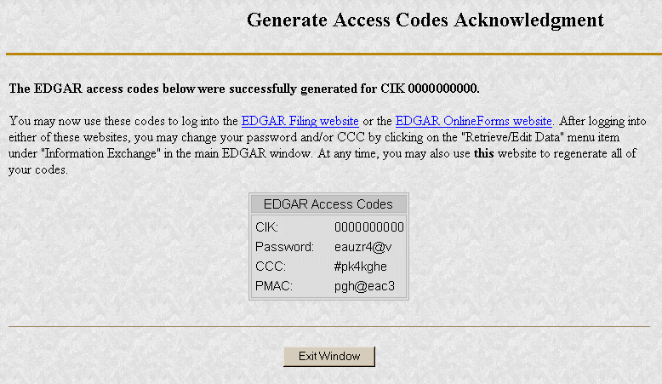
Figure E-32: EDGAR Generate Access Codes Acknowledgment Page
Note: The CIK and EDGAR access codes specified in Figure E-32 are examples only; do not attempt to use these codes with EDGAR!
- Click the [Exit Window] button to finish the process by closing the browser window.
No confirming dialog box is displayed – the browser window is just closed.
E.6.2 EDGAR Passphrase
This section describes how to request a new EDGAR passphrase
- for a filer who has forgotten their passphrase, or
- for a filer who wants to change a passphrase for security purposes.
Note that this capability is not needed as long as a filer’s passphrase and EDGAR access codes are appropriately protected and kept current (the password expires yearly; the passphrase, PMAC and CCC do not expire).
E.6.2.1 Composing the New Passphrase Request
The first step for composing an EDGAR passphrase request is to bring up the EDGAR passphrase request data entry form. This is accomplished as follows:
- Connect to the EFMW Welcome page (refer to Section E.2, Accessing the EDGAR Filer Management website).
- Click on Update Passphrase in the menu bar.
- A new browser window opens and the data entry page for the Update Passphrase page appears (Figure E-33).
Refer to Section E.4.2.1, Data Entry Conventions, for the standards used on all of the EFMW pages, including this one.
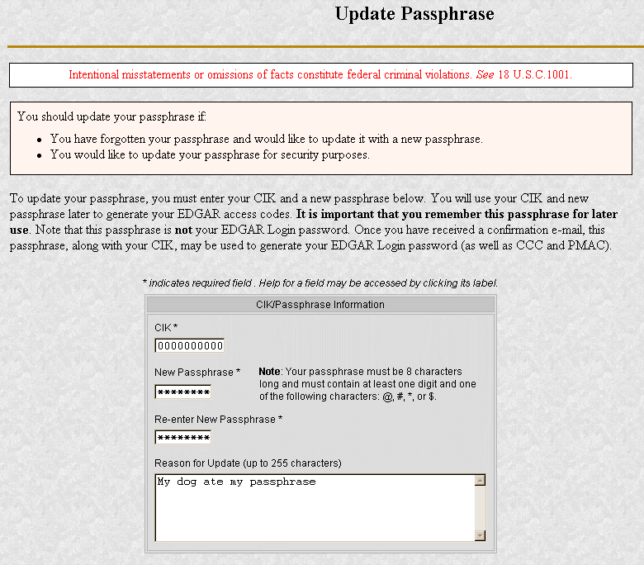

Figure E-33: EDGAR Update Passphrase Page
- Enter the required data (CIK and passphrase) and a reason for making the request (optional).
Refer to Section E.4.3.3, Defining a Passphrase, for a more detailed description of the passphrase. For security reasons, the passphrase must be at least eight characters in length and contain at least one digit and one character from the set {@, #, *, $}.
The Reason for Request data entry field is optional and allows you to enter free-form text explaining why the filer needs a new passphrase. This allows you to provide information that may help the SEC process your request.
- Click on the [Update Passphrase] button near the bottom of the page when you are satisfied with the data that you entered.
A dialog box appears (Figure E-34) asking you to confirm that you want to submit the request. If you do not want to submit the request, click the [Cancel] button and the dialog box will disappear; otherwise, click the [OK] button.
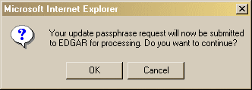
Figure E-34: EDGAR Update Passphrase, “Continue” Dialog
Note: After you click the [OK] button, the EDGAR Update Passphrase request is submitted to the automated submission processing portion of the EDGAR system. This is the start of the acceptance process, your subsequent actions in this browser window will not affect this process. However, the acceptance process cannot be completed until you submit authentication documentation to the SEC – refer to Section E.6.2.2, Authentication Documentation, for more information.
The EFMW EDGAR Update Passphrase Acknowledgment page appears (Figure E-35). This page provides the Accession Number for the submission, which uniquely identifes the submission and is used when referencing the submission.
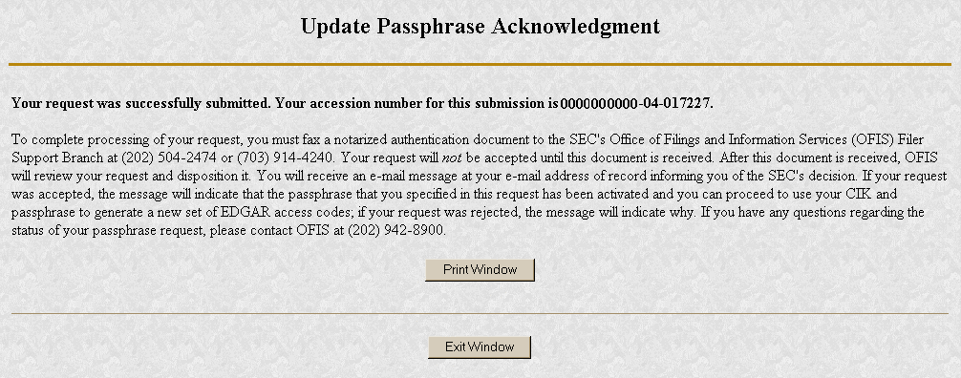
Figure E-35: EDGAR Update Passphrase Acknowledgment Page
Click the [Print Window] button near the bottom of the page to print this page for your records.
- Click the [Exit Window] button to finish the process by closing the browser window.
An “are you sure” dialog box is not displayed, the browser window is just closed.
E.6.2.2 Authentication Documentation
The Update Passphrase request must be supplemented with additional verification to help ensure that the request is authentic. Accordingly, the filer is required to file with the SEC in paper by fax within two business days after electronically filing the request a notarized document, manually signed by the filer over its typed signature, that includes the information identified below and confirms the authenticity of the request. If we do not receive the fax within this period, we will reject the request and the requestor will need to reapply.
- CIK
- Name associated with that CIK
- Name of the contact person for purposes of this request
- Acknowledgement accession number
- Contact person on database
- Contact telephone number on database
E.6.2.3 Request Acceptance and Applicant Notification
After both the electronic EDGAR Update Passphrase request and the associated authentication documentation are received by the SEC, the SEC will authenticate the information provided on the EDGAR Update Passphrase request. A notification message stating the SEC’s disposition of the request will be sent to the e-mail address provided in the request. The disposition will be either “accepted” or “rejected.”
If the request is accepted, the e-mail message will include but will not be limited to the following information:
- Text saying that the request was accepted by the SEC
- Text stating that the specified passphrase was activated
- Basic directions for how to generate EDGAR access codes
- The URL of the EDGAR File Management web site
If the request is rejected, the e-mail message will include but will not be limited to the following information:
- Text saying that the request was rejected by the SEC
- The reason that the request was rejected
- Basic instructions on how to resolve the issue
Refer to Section E.7, Examples of Notification Messages, to review the notification messages.
E.7 Examples of Notification Messages
This section contains examples of the notification messages that EDGAR will send to the applicant/filer in response to a Form ID application, an Update Passphrase request, a Convert Paper Only Filer to Electronic Filer request and an EDGAR Access for New Serial Companies request. For each type of submission, examples of both an acceptance message and a rejection message are provided.
These messages will be sent to the e-mail address specified by the requestor or to the filer’s e-mail address of record. If they are associated with a valid CIK, they will also be posted to the EDGAR Filing and OnlineForms websites (the rejection message for a Form ID application will never be posted to these websites as a CIK does not exist for the applicant).
Note: None of the data contained in these messages is real, it merely represents the type of data that would typically be contained in the message. Do not attempt to use any of this data with the EDGAR system.
E.7.1 Form ID Application Messages
THE FOLLOWING SUBMISSION HAS BEEN ACCEPTED BY THE U.S. SECURITIES AND EXCHANGE COMMISSION.

COMPANY: ALLEN TEST & RAIN WATER CO INC
FORM TYPE: ID-NEWCIK NUMBER OF DOCUMENTS: 1
RECEIVED DATE: 06-Aug-2004 08:53 ACCEPTED DATE: 06-Aug-2004 08:53
TEST FILING: NO CONFIRMING COPY: NO

ACCESSION NUMBER: 9999999996-03-001201

FILE NUMBER(S):
1. None.

PLEASE REFER TO THE ACCESSION NUMBER LISTED ABOVE FOR FUTURE INQUIRIES.

REGISTRANT(S):

1. CIK: 1234567890 new
COMPANY: ALLEN TEST & RAIN WATER CO INC
FORM TYPE: ID-NEWCIK
FILE NUMBER(S):
1. None.

SUMMARY OF CHANGES:

Your application for access to EDGAR has been accepted. Your CIK is 1234567890.
Please connect to the EDGAR Form ID URL
https://www.filermanagement.edgarfiling.sec.gov
to generate EDGAR access codes using your CIK and passphrase.

------------------------------- NOTICE ---------------------------------

URGENT: Verify that all of your addresses on the EDGAR database are
correct. An incorrect address in the EDGAR Accounting Contact Name
and Address information may result in your Fee Account Activity
Statement being returned to the SEC as undeliverable. Please correct
outdated addresses via the EDGAR filing website.

The EDGAR system is available to receive and process filings from
6:00 a.m. to 10:00 p.m. Eastern Time on business days. Filer Support
staff members are available to respond to requests for assistance from
7:00 a.m. to 7:00 p.m. Eastern Time.

We strongly encourage you to visit the Filing Website at
https://www.edgarfiling.sec.gov. You can download our current version
of the EDGARLink/Windows software and templates, the Filer Manual,
receive on-line help, and access Frequently Asked Questions.
Figure E-36: EDGAR Form ID Application Notification, Accepted

THE FOLLOWING SUBMISSION HAS BEEN REJECTED BY THE U.S. SECURITIES AND EXCHANGE COMMISSION.

COMPANY: ALLEN TEST & RAIN WATER CO INC
FORM TYPE: ID-NEWCIK NUMBER OF DOCUMENTS: 1
RECEIVED DATE: 06-Aug-2004 08:53 REJECTED DATE: 06-Aug-2004 08:53
TEST FILING: NO CONFIRMING COPY: NO

ACCESSION NUMBER: 9999999996-03-001201

FILE NUMBER(S):
1. None.

PLEASE REFER TO THE ACCESSION NUMBER LISTED ABOVE FOR FUTURE INQUIRIES.

REGISTRANT(S):

1. CIK: None
COMPANY: ALLEN TEST & RAIN WATER CO INC
FORM TYPE: ID-NEWCIK
FILE NUMBER(S):
1. None.

SUMMARY OF CHANGES:

Your application for access to EDGAR has been rejected by the SEC’s Office of Filer Support for the following reason:
Invalid Contact Data

For further information, contact the SEC’s Office of Filer Support at (202) 555-1234.

------------------------------- NOTICE ---------------------------------

URGENT: Verify that all of your addresses on the EDGAR database are
correct. An incorrect address in the EDGAR Accounting Contact Name
and Address information may result in your Fee Account Activity
Statement being returned to the SEC as undeliverable. Please correct
outdated addresses via the EDGAR filing website.

The EDGAR system is available to receive and process filings from
6:00 a.m. to 10:00 p.m. Eastern Time on business days. Filer Support
staff members are available to respond to requests for assistance from
7:00 a.m. to 7:00 p.m. Eastern Time.

We strongly encourage you to visit the Filing Website at
https://www.edgarfiling.sec.gov. You can download our current version
of the EDGARLink/Windows software and templates, the Filer Manual,
receive on-line help, and access Frequently Asked Questions.
Figure E-37: EDGAR Form ID Application Notification, Rejected

E.7.2 Update Passphrase Request
THE FOLLOWING SUBMISSION HAS BEEN ACCEPTED BY THE U.S. SECURITIES AND EXCHANGE COMMISSION.

COMPANY: ALLEN TEST & RAIN WATER CO INC
FORM TYPE: ID-PASSUPD NUMBER OF DOCUMENTS: 1
RECEIVED DATE: 06-Aug-2004 08:53 ACCEPTED DATE: 06-Aug-2004 08:53
TEST FILING: NO CONFIRMING COPY: NO

ACCESSION NUMBER: 9999999996-03-001201

FILE NUMBER(S):
1. None.

PLEASE REFER TO THE ACCESSION NUMBER LISTED ABOVE FOR FUTURE INQUIRIES.

REGISTRANT(S):

1. CIK: 1234567890 existing
COMPANY: ALLEN TEST & RAIN WATER CO INC
FORM TYPE: ID-PASSUPD
FILE NUMBER(S):
1. None.

SUMMARY OF CHANGES:

Your request for a new EDGAR passphrase has been accepted by the SEC’s Branch of Filer Support. The requested passphrase is now active in the EDGAR system.
Please connect to the EDGAR Form ID URL
https://www.filermanagement.edgarfiling.sec.gov
to generate EDGAR access codes using your CIK and passphrase.

------------------------------- NOTICE ---------------------------------

URGENT: Verify that all of your addresses on the EDGAR database are
correct. An incorrect address in the EDGAR Accounting Contact Name
and Address information may result in your Fee Account Activity
Statement being returned to the SEC as undeliverable. Please correct
outdated addresses via the EDGAR filing website.

The EDGAR system is available to receive and process filings from
6:00 a.m. to 10:00 p.m. Eastern Time on business days. Filer Support
staff members are available to respond to requests for assistance from
7:00 a.m. to 7:00 p.m. Eastern Time.

We strongly encourage you to visit the Filing Website at
https://www.edgarfiling.sec.gov. You can download our current version
of the EDGARLink/Windows software and templates, the Filer Manual,
receive on-line help, and access Frequently Asked Questions.
Figure E-38: EDGAR Update Passphrase Notification, Accepted

THE FOLLOWING SUBMISSION HAS BEEN REJECTED BY THE U.S. SECURITIES AND EXCHANGE COMMISSION.

COMPANY: ALLEN TEST & RAIN WATER CO INC
FORM TYPE: ID-PASSUPD NUMBER OF DOCUMENTS: 1
RECEIVED DATE: 06-Aug-2004 08:53 REJECTED DATE: 06-Aug-2004 08:53
TEST FILING: NO CONFIRMING COPY: NO

ACCESSION NUMBER: 9999999996-03-001201

FILE NUMBER(S):
1. None.

PLEASE REFER TO THE ACCESSION NUMBER LISTED ABOVE FOR FUTURE INQUIRIES.

REGISTRANT(S):

1. CIK: 1234567890 existing
COMPANY: ALLEN TEST & RAIN WATER CO INC
FORM TYPE: ID-PASSUPD
FILE NUMBER(S):
1. None.

SUMMARY OF CHANGES:

Your request for a new EDGAR passphrase has been rejected by the SEC’s Branch of Filer Support for the following reason:
Unable to Contact Requester

For further information, contact the SEC’s Office of Filer Support at (202) 555-1234.

------------------------------- NOTICE ---------------------------------

URGENT: Verify that all of your addresses on the EDGAR database are
correct. An incorrect address in the EDGAR Accounting Contact Name
and Address information may result in your Fee Account Activity
Statement being returned to the SEC as undeliverable. Please correct
outdated addresses via the EDGAR filing website.

The EDGAR system is available to receive and process filings from
6:00 a.m. to 10:00 p.m. Eastern Time on business days. Filer Support
staff members are available to respond to requests for assistance from
7:00 a.m. to 7:00 p.m. Eastern Time.

We strongly encourage you to visit the Filing Website at
https://www.edgarfiling.sec.gov. You can download our current version
of the EDGARLink/Windows software and templates, the Filer Manual,
receive on-line help, and access Frequently Asked Questions.
Figure E-39: EDGAR Update Passphrase Notification, Rejected
E.7.3 Convert Paper Only Filer to Electronic Filer Request
THE FOLLOWING SUBMISSION HAS BEEN ACCEPTED BY THE U.S. SECURITIES AND EXCHANGE COMMISSION.

COMPANY: ALLEN TEST & RAIN WATER CO INC
FORM TYPE: ID-CONVERT NUMBER OF DOCUMENTS: 1
RECEIVED DATE: 06-Aug-2004 08:53 ACCEPTED DATE: 06-Aug-2004 08:53
TEST FILING: NO CONFIRMING COPY: NO

ACCESSION NUMBER: 9999999996-03-001201

FILE NUMBER(S):
1. None.

PLEASE REFER TO THE ACCESSION NUMBER LISTED ABOVE FOR FUTURE INQUIRIES.

REGISTRANT(S):

1. CIK: 1234567890 existing
COMPANY: ALLEN TEST & RAIN WATER CO INC
FORM TYPE: ID-CONVERT
FILE NUMBER(S):
1. None.

SUMMARY OF CHANGES:

Your request for access to EDGAR has been accepted.
Please connect to the EDGAR Form ID URL
https://www.filermanagement.edgarfiling.sec.gov
to generate EDGAR access codes using your CIK and passphrase.

------------------------------- NOTICE ---------------------------------

URGENT: Verify that all of your addresses on the EDGAR database are
correct. An incorrect address in the EDGAR Accounting Contact Name
and Address information may result in your Fee Account Activity
Statement being returned to the SEC as undeliverable. Please correct
outdated addresses via the EDGAR filing website.

The EDGAR system is available to receive and process filings from
6:00 a.m. to 10:00 p.m. Eastern Time on business days. Filer Support
staff members are available to respond to requests for assistance from
7:00 a.m. to 7:00 p.m. Eastern Time.

We strongly encourage you to visit the Filing Website at
https://www.edgarfiling.sec.gov. You can download our current version
of the EDGARLink/Windows software and templates, the Filer Manual,
receive on-line help, and access Frequently Asked Questions.
Figure E-40: EDGAR Convert to Electronic Filer Notification, Accepted

THE FOLLOWING SUBMISSION HAS BEEN REJECTED BY THE U.S. SECURITIES AND EXCHANGE COMMISSION.

COMPANY: ALLEN TEST & RAIN WATER CO INC
FORM TYPE: ID-CONVERT NUMBER OF DOCUMENTS: 1
RECEIVED DATE: 06-Aug-2004 08:53 REJECTED DATE: 06-Aug-2004 08:53
TEST FILING: NO CONFIRMING COPY: NO

ACCESSION NUMBER: 9999999996-03-001201

FILE NUMBER(S):
1. None.

PLEASE REFER TO THE ACCESSION NUMBER LISTED ABOVE FOR FUTURE INQUIRIES.

REGISTRANT(S):

1. CIK: 1234567890 existing
COMPANY: ALLEN TEST & RAIN WATER CO INC
FORM TYPE: ID-CONVERT
FILE NUMBER(S):
1. None.

SUMMARY OF CHANGES:

Your request for access to EDGAR has been rejected by the SEC’s Branch of Filer Support for the following reason:
Duplicate Request

For further information, contact the SEC’s Office of Filer Support at (202) 555-1234.

------------------------------- NOTICE ---------------------------------

URGENT: Verify that all of your addresses on the EDGAR database are
correct. An incorrect address in the EDGAR Accounting Contact Name
and Address information may result in your Fee Account Activity
Statement being returned to the SEC as undeliverable. Please correct
outdated addresses via the EDGAR filing website.

The EDGAR system is available to receive and process filings from
6:00 a.m. to 10:00 p.m. Eastern Time on business days. Filer Support
staff members are available to respond to requests for assistance from
7:00 a.m. to 7:00 p.m. Eastern Time.

We strongly encourage you to visit the Filing Website at
https://www.edgarfiling.sec.gov. You can download our current version
of the EDGARLink/Windows software and templates, the Filer Manual,
receive on-line help, and access Frequently Asked Questions.
Figure E-41: EDGAR Convert to Electronic Filer Notification, Rejected
E.7.4 EDGAR Access for New Serial Companies Request
THE FOLLOWING SUBMISSION HAS BEEN ACCEPTED BY THE U.S. SECURITIES AND EXCHANGE COMMISSION.

COMPANY: ALLEN TEST & RAIN WATER CO INC
FORM TYPE: ID-SERIAL NUMBER OF DOCUMENTS: 1
RECEIVED DATE: 06-Aug-2004 08:53 ACCEPTED DATE: 06-Aug-2004 08:53
TEST FILING: NO CONFIRMING COPY: NO

ACCESSION NUMBER: 9999999996-03-001201

FILE NUMBER(S):
1. None.

PLEASE REFER TO THE ACCESSION NUMBER LISTED ABOVE FOR FUTURE INQUIRIES.

REGISTRANT(S):

1. CIK: 1234567890 existing
COMPANY: ALLEN TEST & RAIN WATER CO INC
FORM TYPE: ID-SERIAL
FILE NUMBER(S):
1. None.

SUMMARY OF CHANGES:

Your request for access to EDGAR has been accepted.
Please connect to the EDGAR Form ID URL
https://www.filermanagement.edgarfiling.sec.gov
to generate EDGAR access codes using your CIK and passphrase.

------------------------------- NOTICE ---------------------------------

URGENT: Verify that all of your addresses on the EDGAR database are
correct. An incorrect address in the EDGAR Accounting Contact Name
and Address information may result in your Fee Account Activity
Statement being returned to the SEC as undeliverable. Please correct
outdated addresses via the EDGAR filing website.

The EDGAR system is available to receive and process filings from
6:00 a.m. to 10:00 p.m. Eastern Time on business days. Filer Support
staff members are available to respond to requests for assistance from
7:00 a.m. to 7:00 p.m. Eastern Time.

We strongly encourage you to visit the Filing Website at
https://www.edgarfiling.sec.gov. You can download our current version
of the EDGARLink/Windows software and templates, the Filer Manual,
receive on-line help, and access Frequently Asked Questions.
Figure E-42: EDGAR New Serial Access Notification, Accepted

THE FOLLOWING SUBMISSION HAS BEEN REJECTED BY THE U.S. SECURITIES AND EXCHANGE COMMISSION.

COMPANY: ALLEN TEST & RAIN WATER CO INC
FORM TYPE: ID-SERIAL NUMBER OF DOCUMENTS: 1
RECEIVED DATE: 06-Aug-2004 08:53 REJECTED DATE: 06-Aug-2004 08:53
TEST FILING: NO CONFIRMING COPY: NO

ACCESSION NUMBER: 9999999996-03-001201

FILE NUMBER(S):
1. None.

PLEASE REFER TO THE ACCESSION NUMBER LISTED ABOVE FOR FUTURE INQUIRIES.

REGISTRANT(S):

1. CIK: 1234567890 existing
COMPANY: ALLEN TEST & RAIN WATER CO INC
FORM TYPE: ID-SERIAL
FILE NUMBER(S):
1. None.

SUMMARY OF CHANGES:

Your request for access to EDGAR has been rejected by the SEC’s Branch of Filer Support for the following reason:
Other
CIK is incorrect (not for a Serial Company)

For further information, contact the SEC’s Office of Filer Support at (202) 555-1234.

------------------------------- NOTICE ---------------------------------

URGENT: Verify that all of your addresses on the EDGAR database are
correct. An incorrect address in the EDGAR Accounting Contact Name
and Address information may result in your Fee Account Activity
Statement being returned to the SEC as undeliverable. Please correct
outdated addresses via the EDGAR filing website.

The EDGAR system is available to receive and process filings from
6:00 a.m. to 10:00 p.m. Eastern Time on business days. Filer Support
staff members are available to respond to requests for assistance from
7:00 a.m. to 7:00 p.m. Eastern Time.

We strongly encourage you to visit the Filing Website at
https://www.edgarfiling.sec.gov. You can download our current version
of the EDGARLink/Windows software and templates, the Filer Manual,
receive on-line help, and access Frequently Asked Questions.
Figure E-43: EDGAR New Serial Access Notification, Rejected

INDEX

—A—
About HTML, 6-6
Acceptable Attributes for EDGAR HTML Tags, 7-7
Acceptable HTML Document Tags, 7-3
Acceptable HTML Tags within a Document Body, 7-4
ACCEPTANCE MESSAGE, D-1
Acceptance Message for Official Filings Returned via the Internet, B-2
ACCEPTANCE REVIEW, D-1
ACCEPTED, D-1
Accessing OnlineForms Website, 2-2
Accessing Submission and Company Information, 5-1
Accessing the EDGAR Filer Management Website, E-1
ACCESSION NUMBER, D-1
Acronyms, D-1
Additional ONLINE Features, 5-1
All Filers: Generating EDGAR Access Codes, E-31
Applicant Information, E-9
Application (Form ID), E-6
Application Acceptance and Applicant Notification, E-23
Applying for Access to EDGAR, E-1
ASCII, 6-4, D-1
ASCII or SGML Functionality Not Supported Within HTML Documents, 7-12
ASCII or SGML Functionality to be Preserved Within HTML Documents, 7-10
ASSEMBLE OWNERSHIP SUBMISSION – BOTTOM, 3-11
ASSEMBLE OWNERSHIP SUBMISSION – MIDDLE, 3-6
ASSEMBLE OWNERSHIP SUBMISSION – TOP OF FORM, 3-4
Assembling and Submitting the Form ID Application, E-14
Assembling the Form ID Submission, E-17
Authentication Documentation, E-23, E-26, E-30, E-37
Availability of Paper Forms, C-1
—B—
BROWSER, D-1
Browser Differences, 2-1
—C—
CCC, D-1
CENTRAL INDEX KEY (CIK), D-1
Change Login Password or CCC, 5-12
Changing Company Information, 1-4
Changing Your CCC (CIK Confirmation Code), 5-14
Changing Your Password, 5-13
Character Code Requirements Differ by Submission Medium, 6-4
CIK, D-1
Common Symbols that EDGAR Does Not Recognize, 6-6
Commonly Used Terms, D-1
Company Search, 2-7
Composing the Convert to Electronic Filer Request, E-24
Composing the New Passphrase Request, E-34
Composing the New Serial Company Access Request, E-28
CONFIDENTIAL, D-1
Contact for EDGAR Information, E-11
Contact for SEC Account Information, E-12
Conventions Used in the Filer Manual, 1-2
Convert Paper Only Filer to Electronic Filer Request, E-43
Create New, Blank Form ID, E-22
Create New, Pre-filled Form ID, E-22
CREATING AN ONLINE OWNERSHIP SUBMISSION, 3-2
Current Paper Only Filer, E-24
Current SEC Filer: Applying for EDGAR Access, E-24
—D—
Data Entry Conventions, E-8
Data Entry Details, E-9
DATA FIELD, D-2
Defining a Passphrase, E-19
Description of ASCII/SGML Tags, 6-7
DOCUMENT, D-2
Downloading Return Copies, 1-4
—E—
EDGAR, D-2
EDGAR Access Codes, E-31
EDGAR Access for New Serial Companies Request, E-45
EDGAR Hardware and Software Requirements, 1-8
EDGAR OnlineForms Website, 1-3
EDGAR Passphrase, E-34
EDGAR Recognizes a Limited Set of Keyboard Characters, 6-4
Edit Company Information, 5-7
ELECTRONIC FILER, D-2
ELECTRONIC FILING, D-2
Example of Suspense Message, B-3
Examples of Notification Messages, E-38
Explanation of Error Messages, B-4
Extended Character Sets Within HTML Documents, 7-8
—F—
Field Values are Filer-Supplied Information, 6-8
FILE NUMBER, D-2
FILER, D-2
Filer Information, E-10
Filer Management, E-3
Filing a Form ID with the SEC to Get Your Access Codes, 1-4
FILING AGENT, D-2
Filing Date of Electronically Transmitted Submissions, 1-11
Filing Transmission Methods, 1-3
Filing Type, A-1
FILING TYPES, D-2
FORM ID, D-2
Form ID Application Messages, E-39
Form ID Notes, C-1
FORM SE, D-2
Formatting Examples of Wide Tables, 6-13
Formatting Tables Wider than 80 Characters, 6-11
Forms for Electronic Filing, C-1
Frequently Asked Questions, 2-6
Frequently Asked Questions, 1-12, E-5
—G—
General Help, E-4
General Web Help, 2-6
Getting Help with EDGAR, 1-12
Getting Help with the Content of Filings or Exemptions/Adjustments, 1-12
Getting Started Using ONLINEFORMS WEBSITE, 2-1
Glossary, D-1
Guidelines for Presentation of Tables, 6-11
—H—
Hours of Operation, 1-11
How EDGAR Uses the Internet for E-Mail, 1-9
How Mail Is Addressed to the Internet Address, 1-10
How Tables are Organized, A-1
How Tags are Used, 6-7
How the Requirement for ASCII Affects Word Processing, 6-5
How To Create a Correspondence Document, 6-11
How to Obtain the EDGAR OnlineForms Filer Manual, 1-11
How to Order Internet Service, 1-10
HTML, D-3
HTML Tags that are NOT Supported by EDGAR, 7-6
—I—
Information Exchange, 2-5
Instructions for Attaching HTML Documents to Electronic Submissions, 7-1
Internet Communication to OnlineForms Website, 1-9
Introduction to the ONLINEFORMS Filer Manual and EDGAR, 1-1
Introduction to Web Browsers, 2-1, E-1
ISP, D-3
—K—
Keep Assigned Access Codes Private, 1-8
—L—
LEGACY OWNERSHIP PROCESSING, 3-1
List of Errors and Warnings, B-5
Logging in with (Enter) Another CIK/CCC, 5-16
Logging into OnlineForms Website, 2-2
—M—
Messages Reported by EDGAR, B-1
MODERNIZED OWNERSHIP PROCESSING, 3-1
—N—
Navigating EDGAR, 2-4
Navigating the EFMW, E-2
NESTED, D-3
New SEC Filer: Applying for EDGAR Access, E-5
New Serial Company, E-27
NON-PUBLIC, D-3
Non-Public and Confidential Information, 6-11
—O—
ONLINE OWNERSHIP PROCESSING, 3-1
Online Submission Types Accepted for Electronic Filing, A-1
ONLINEFORMS DATA GATHERING MODEL, 3-1
Operating Requirements, 1-8
Organization of this Manual, 1-1
—P—
PASSWORD, D-3
PMAC, D-3
Powers of Attorney and Consents of Experts, 6-16
PREPARING REDUCED-CONTENT XML SUBMISSION DOCUMENTS, 4-1
Preparing and Transmitting Online Submissions to EDGAR, 3-1
Preparing Reduced-Content XML Submissions, 4-1
PREPARING SUPPLEMENTAL EDGAR DOCUMENTS, 6-1
Preparing to Become an EDGAR Filer, 1-4
Properly Prepare and Maintain Documents and Software, 1-10
—R—
Receiving E-Mail Status of Filings from the SEC, 1-9
Release 8.10 OnlineForms Website Updates, 1-2
Request Acceptance and Applicant Notification, E-27, E-31, E-37
Retrieve Company Information, 5-5
Retrieve Return Copies, 5-10
Retrieving Submission Information, 5-2
RETURN COPY, D-3
Return Copy Support, 5-10
—S—
SEC, D-3
SEC Recommendations on Preparing Filings with HTML Documents, 7-12
SEC Rule Making, 2-7
SELECT OWNERSHIP SUBMISSION FORM TYPE, 3-3
SGML, D-3
Signature, E-13
Software Requirements, 1-8
Starting Another Form ID Application, E-22
Statutory and Non-Statutory Signatures, 6-16
SUBMISSION, D-3
Submission Information, 5-2
Submission Type, A-1
Submitting a Form ID Application, E-19
Support, 2-6, E-4
SUSPENDED FILING, D-4
SUSPENSE MESSAGE, D-4
System Inserts "^" For Unrecognized Characters, 6-7
—T—
Table Tags, 6-12
Tag Construction, 6-7
Tags Used Within a Document, 6-9
Template for an Attached HTML Document, 7-10
Terminology, 6-1
Test and Live Ownership Filings, 4-1
TEST FILING, D-4
The EDGAR Online Form Website Updates, 1-2
TRAINING AGENT, D-4
Transmission Status, 4-5
Transmit Reduced-Content XML as a Live Submission, 4-3
Transmit Reduced-Content XML as a Test Submission, 4-2
Transmitting Reduced-Content XML Submissions, 4-1
—U—
Update Passphrase Request, E-41
URL, D-4
—V—
VALUE, D-4
VERIFY FORM, 3-12
Verifying the Form ID Application, E-14
Viewing Submission Status, 1-3
—W—
Web Browser, 1-3
Where to Send Paper Filings, 1-11
Why the EDGAR System Recognizes Only Standard Character Sets, 6-5
—X—
XFDL, D-4
XML, D-4

Many HTML tags use this attribute
“Capacity” in this context is one of the following: filer, filing agent or training agent. It refers to the applicant, not the person filling out the form.
The CIK is a number that is assigned to each entity (company or individual) that submits filings to the SEC. Use of the CIK allows us to differentiate between filing entities with similar names. A CIK is used to identify all filers, both EDGAR and non-EDGAR.
The EDGAR passphrase is a security code that is used to generate a set of EDGAR access codes.
Filers who have previously only filed in paper Forms 3, 4, 5 and/or 144.
Text (*.txt file extension) and HTML (*.htm file extension) attachments are accepted; PDF and graphic formats are not accepted.
Data in the “parts” that are common to the filer attributes settings will be preserved; however, data that exists in a “part” that is not needed based upon the new filer attribute setting is lost. For example, Filer (Company) requires the entry of Filer Information (Part II) – if you switch the filer attributes to File (Individual), any Filer Information that you may have entered is lost.
“424B” is a shorthand reference for Forms 424B1, 424B2, 424B3, 424B4, 424B5, 424B6 and 424B7.

