NTIA Report 06-440

FEDERAL LAND MOBILE OPERATIONS

IN THE 162-174 MHz BAND

IN THE WASHINGTON, D.C. AREA

Phase 1: STUDY OF AGENCY OPERATIONS

Report Series
August 2006



U.S. Department of Commerce
National Telecommunications and Information Administration

Page/Blank

NTIA Report 06-440

FEDERAL LAND MOBILE OPERATIONS

IN THE 162-174 MHz BAND

IN THE WASHINGTON, D.C. AREA

Phase 1: STUDY OF AGENCY OPERATIONS

Report Series
August 2006

U.S. DEPARTMENT OF COMMERCE

Carlos M. Guiterrez, Secretary

John M.R. Kneuer

Acting Assistant Secretary
For Communications and Information

Page/Blank

PROJECT MANAGEMENT

Fredrick R. Wentland
Associate Administrator
Office of Spectrum Management

Edward F. Drocella
Chief, Spectrum Engineering and Analysis Division

TEAM LEADER

Gary Patrick

REPORT AUTHORS

Charles Hoffman
Robert Matheson
Fred Najmy
Robert Wilson

Page/Blank

ACKNOWLEDGEMENTS

The authors would like to thank the following National Telecommunications and Information Administration (NTIA) personnel for their review and contributions to this report: Gerald Hurt, Spectrum Engineering and Analysis Division (SEAD); Thomas Sullivan, SEAD; Edward Drocella, SEAD; Cecilia Tucker, SEAD; Marianne Wiler, Information Technology Division; Margaret Luebs, Institute for Telecommunications Sciences, Boulder, Colorado; and Suzette Williams, Spectrum Services Division.

The authors are especially grateful to the representatives from the various federal agencies that took the time to provided valuable information on their current operations and future plans.

Page/Blank

TABLE OF CONTENTS

LIST OF TABLES iii

LIST OF FIGURES iv

GLOSSARY vii

EXECUTIVE SUMMARY ix

SECTION 1 INTRODUCTION 1-1
1.1 Background 1-1
1.2 Scope of Work 1-5
1.2.1 Overall Objective 1-5
1.2.2 Specific Objectives 1-5
1.2.3 Other Related Work 1-6

SECTION 2 PHASE 1 OVERVIEW 2-1
2.1 General 2-1
2.2 Concept of the Signal Capacity Analysis Program (SCAP) 2-2
2.3 Selection of 162-174 MHz Band in the Washington, D.C. area 2-3
2.4 Sources of Current Usage Data 2-3

SECTION 3 CHARACTERISTICS OF MOBILE RADIO SYSTEMS 3-1
3.1 General 3-1
3.1.1 Simplex radio systems 3-1
3.1.2 Radio Repeater Systems 3-2
3.1.3 Mobile Talk-Around Mode 3-3
3.1.4 Multi-Site Repeater Systems 3-3
3.1.5 Half-Duplex Radio Systems 3-4
3.1.6 Multi-Site Duplex Systems 3-5
3.1.7 Receive-Only Sites 3-6
3.1.8 Simulcast Radio Systems 3-7
3.1.9 Trunked Radio Systems 3-8
3.2 Summary 3-9

SECTION 4 FEDERAL OPERATIONS IN THE 162-174 MHz BAND 4-1
4.1 General 4-1
4.2 Allocation 4-1
4.2.1 Use of the 162-174 MHz Band 4-3
4.3 Operational Description of Each Agency’s LMR Operations 4-10
4.3.1 United States Department of Agriculture (USDA) 4-10
4.3.2 United States Department of Commerce (DOC) 4-11
4.3.3 United States Coast Guard (USCG) 4-13
4.3.4 United States Department of Defense (DOD) 4-14
4.3.5 United States Department of Energy (DOE) 4-15
4.3.6 Federal Aviation Administration (FAA) 4-16
4.3.7 United States Department of Homeland Security (DHS) 4-17
4.3.8 United States Department of Interior (DOI) 4-18
4.3.9 United States Department of Justice (DOJ) 4-19
4.3.10 United States Department of the Treasury (Treasury) 4-20
4.3.11 United States Capital Police (USCP) 4-21
4.3.12 United States Postal Service (USPS) 4-23
4.3.13 United States Department of Veteran’s Affairs (VA) 4-24
4.3.14 Other Agencies or Bureaus 4-25
4.4 Summary 4-26

SECTION 5 OTHER FEDERAL GOVERNMENT EFFORTS 5-1
5.1 General 5-1
5.2 Migration to Narrowband Technology 5-1
5.3 Technical Performance Standards 5-2
5.3.1 Trunking Technology 5-3
5.3.2 162-174 MHz Band Restructuring 5-3
5.3.3 Frequency Reuse 5-3
5.4 Initiatives And Spectrum Efficiency Improving Programs 5-4
5.4.1 NTIA Spectrum Summit 5-4
5.4.2 Federal Communication Commission’s Spectrum Policy Task Force 5-5
5.4.3 Government Accounting Office Reports 5-5
5.4.4 Presidential Initiative to Develop, Implement Spectrum Policy for the 21st Century 5-6
5.4.5 SAFECOM Program Office 5-7
5.4.6 1COMMWIRELESS (Formerly FEDSMR) 5-7
5.4.7 Integrated Wireless Network (IWN) 5-8
5.4.8 United States Department of Defense Trunked Network 5-9

SECTION 6 THE SIGNAL CAPACITY ANALYSIS PROGRAM (SCAP) 6-1
6.1 General 6-1
6.2 Definition of Signal Capacity 6-1
6.3 Basic SCAP Analysis 6-3
6.3.1 Peak and Average Signal Capacity Maps 6-4
6.3.2 The Use of Function Codes to define Signal Capacity of Networks 6-7

SECTION 7 FEDERAL AGENCY SIGNAL CAPACITY MAPS 7-1
7.1 General 7-1
7.2 Technical parameters for Signal Capacity Maps 7-1
7.3 Interpreting the Signal Capacity Maps 7-2
7.4 Signal Capacity Maps for Federal Agencies 7-7
7.4.1 United States Department of Agriculture (USDA) 7-10
7.4.2 United States Coast Guard (USCG) 7-12
7.4.3 United States Department of Commerce (DOC) 7-14
7.4.4 United States Department of Defense (DOD) 7-16
7.4.5 United States Department of Energy (DOE) 7-18
7.4.6 Federal Aviation Administration (FAA) 7-20
7.4.7 United States Department of Interior (DOI) 7-22
7.4.8 United States Department of Justice (DOJ) 7-24
7.4.9 United States Capitol Police (USCP) 7-26
7.4.10 United States Postal Service (USPS) 7-28
7.4.11 United States Department of Treasury (Treasury) 7-30
7.4.12 United States Department of Veteran’s Affairs (VA) 7-32
7.4.13 Other Agencies 7-34
7.4.14 All Federal Agencies 7-36
7.4.15 Integrated Wireless Network (IWN) (Departments of Justice, Treasury and Homeland Security) 7-38
7.4.16 All Federal Agencies minus IWN 7-40

SECTION 8 SUMMARY OF FINDINGS 8-1

APPENDIX A DESCRIPTION OF SIGNAL CAPACITY ANALYSIS PROGRAM A-1

LIST OF TABLES

Table 4-1. International and National Frequency Allocations and Footnotes for the 162-174 MHz Band 4-2
Table 4-2. Number of Frequency Assignments 4-3
Table 4-3. Number of Frequency Assignments within a 100 Mile Radius of Washington, D.C. (162-174 MHz) 4-5
Table 4-4. Nationwide (US&P, USA, and US) and Statewide Assignments by Agency 4-9
Table 7-1. Total Number of Assignments with Function Codes Included in SCAP 7-7
Table 7-2. Total Number of Assignments with Function Codes Not Included in SCAP Analysis 7-8
Table 7-3. U.S. Department of Agriculture Assignments and Function Codes 7-11
Table 7-4. U.S. Coast Guard Assignment and Function Codes 7-13
Table 7-5. U.S. Department of Commerce Assignments and Function Codes 7-15
Table 7-6. U.S. Department of Defense Assignments and Function Codes 7-17
Table 7-7. U.S. Department of Energy Assignments and Function Codes 7-19
Table 7-8. Federal Aviation Administration Assignment and Function Codes 7-21
Table 7-9. U.S. Department of Interior Number Assignments and Function Codes 7-23
Table 7-10. U.S. Department of Justice Number Assignments and Function Codes 7-25
Table 7-11. U.S. Capitol Police Assignment and Function Codes 7-27
Table 7-12. U.S. Postal Service Assignments and Function Codes 7-29
Table 7-13. U.S. Department of Treasury Assignments and Function Codes 7-31
Table 7-14. U.S. Department of Veteran’s Affairs Assignments and Function Codes 7-33
Table 7-15. “Other Agencies” Assignments and Function Codes 7-35
Table 7-16. All Federal Agencies Assignments and Function Codes 7-37
Table 7-17. IWN Assignments and Function Codes 7-39
Table 7-18. Non-IWN Assignments and Function Codes 7-41
Table 8-1. Maximum Peak Signal Capacity and Included Transmitters 8-2

LIST OF FIGURES

Figure 3-1. Simplex Radio System 3-1
Figure 3-2. Repeater Architecture 3-2
Figure 3-3. Multi-Site Repeaters 3-4
Figure 3-4. Half-Duplex Radio System 3-5
Figure 3-5. Base Station Reception Augmented with Receive only sites 3-6
Figure 3-6. Simulcast System 3-7
Figure 4-1. Plot of all Agency Frequency Assignments within a 100 Mile Radius of Washington, D.C. in the 162-174 MHz band 4-4
Figure 4-2. Plot of USDA Frequency Assignments within a 100 Mile Radius of Washington, D.C. in the 162-174 MHz band. 4-11
Figure 4-3. Plot of DOC Frequency Assignments within a 100 Mile Radius of Washington, D.C. in the 162-174 MHz band. 4-13
Figure 4-4. Plot of USCG Frequency Assignments within a 100 Mile Radius of Washington, D.C. in the 162-174 MHz band. 4-14
Figure 4-5. Plot of DOD Frequency Assignments within a 100 Mile Radius of Washington, D.C. in the 162-174 MHz band. 4-15
Figure 4-6. Plot of DOE Frequency Assignments within a 100 Mile Radius of Washington, D.C. in the 162-174 MHz Band 4-16
Figure 4-7. Plot of FAA Frequency Assignments within a 100 Mile Radius of Washington, D.C. in the 162-174 MHz Band. 4-17
Figure 4-8. Plot of DOI Frequency Assignments within a 100 Mile Radius of Washington, D.C. in the 162-174 MHz 4-18
Figure 4-9. Plot of DOJ Frequency Assignments within a 100 Mile Radius of Washington, D.C., in the 162-174 MHz band 4-20
Figure 4-10. Plot of Treasury Frequency Assignments within a 100 Mile Radius of Washington, D.C., in the 162-174 MHz band 4-21
Figure 4-11. Plot of USCP Frequency Assignments within a 100 Mile Radius of Washington, D.C., in the 162-174 MHz Band. 4-22
Figure 4-12. Plot of USPS Frequency Assignments within a 100 Mile Radius of Washington, D.C., in the 162-174 MHz Band. 4-24
Figure 4-13. Plot of VA Frequency Assignments within a 100 Mile Radius of Washington, D.C. in the 162-174 MHz Band. 4-25
Figure 4-14. Plot of Other Agency or Bureau Frequency Assignments within a 100 Mile Radius of Washington, D.C. in the 162-174 MHz Band. 4-26
Figure 6-1. Peak Signal Capacity Coverage Map Examples 6-4
Figure 6-2. Average Signal Capacity Map Examples 6-5
Figure 6-3. PSC Map for Four Transmitters Analyzed as a Simulcast System 6-8
Figure 6-4. PSC Map for Four Transmitters Analyzed as a Trunked System 6-8
Figure 6-5. ASC Map for Four Transmitters Analyzed as a Simulcast radio System 6-9
Figure 6-6. ASC Map for Four Transmitters Analyzed as a Trunked Radio System. 6-9
Figure 7-1. Peak Signal Capacity Map for Several Federal Radio Systems 7-2
Figure 7-2. Average Signal Capacity Map for Several Federal Radio Systems 7-5
Figure 7-3. Peak Signal Capacity Map for U.S. Department of Agriculture. 7-10
Figure 7-4. Average Signal Capacity Map for U.S. Department of Agriculture 7-11
Figure 7-5. Peak Signal Capacity Map for U. S. Coast Guard 7-12
Figure 7-6. Average Signal Capacity Map for U. S. Coast Guard 7-13
Figure 7-7. Peak Signal Capacity Map for U.S. Department of Commerce 7-14
Figure 7-8. Average Signal Capacity Map for U.S. Department of Commerce 7-15
Figure 7-9. Peak Signal Capacity Map for U.S. Department of Defense 7-16
Figure 7-10. Average Signal Capacity Map for U.S. Department of Defense 7-17
Figure 7-11. Peak Signal Capacity Map for U.S. Department of Energy 7-18
Figure 7-12. Average Signal Capacity for U.S. Department of Energy 7-19
Figure 7-13. Peak Signal Capacity for the Federal Aviation Administration 7-20
Figure 7-14. Average Signal Capacity for the Federal Aviation Administration 7-21
Figure 7-15. Peak Signal Capacity for U.S. Department of Interior 7-22
Figure 7-16. Average Signal Capacity for U.S. Department of Interior 7-23
Figure 7-17. Peak Signal Capacity Map for U.S. Department of Justice 7-24
Figure 7-18. Average Signal Capacity Map for U.S. Department of Justice 7-25
Figure 7-19. Peak Signal Capacity Map for U. S. Capitol Police 7-26
Figure 7-20. Average Signal Capacity Map for U. S. Capitol Police 7-27
Figure 7-21. Peak Signal Capacity for U.S. Postal Service 7-28
Figure 7-22. Average Signal Capacity for U.S. Postal Service 7-29
Figure 7-23. Peak Signal Capacity for U.S. Department of Treasury 7-30
Figure 7-24. Average Signal Capacity Map for U.S. Department of Treasury 7-31
Figure 7-25. Peak Signal Capacity Map for U.S. Department of Veteran’s Affairs 7-32
Figure 7-26. Average Signal Capacity Map for U.S. Department of Veteran’s Affairs 7-33
Figure 7-27. Peak Signal Capacity Map for “Other Agencies” 7-34
Figure 7-28. Average Signal Capacity Map for “Other Agencies” 7-35
Figure 7-29. Peak Signal Capacity map for all Federal Agencies 7-36
Figure 7-30. Average Signal Capacity map for all Federal Agencies 7-37
Figure 7-31. Peak Signal Capacity Map for IWN Agencies 7-38
Figure 7-32. Average Signal Capacity Map for IWN Agencies 7-39
Figure 7-33. Peak Signal Capacity for Non-IWN Agencies 7-40
Figure 7-34. Average Signal Capacity Map for Non-IWN Agencies 7-41

Page vi/Blank

GLOSSARY

ANSI American National Standards Institute
apco Association of Public-Safety Communications Officials International
ASC Average Signal Capacity
ATF Bureau of Alcohol, Tobacco, and Firearms
blm Bureau of Land Management
BOP Bureau of Prisons
C3 Command, Control, and Communications
CTCSS continuous Tone Coded Squelch System
dea Drug Enforcement Administration
DES Data Encryption Standard
dhs United States Department of Homeland Security
DOC United States Department of Commerce
DOD United States Department of Defense
DOI United States Department of the Interior
DOJ United States Department of Justice
DOT United States Department of Transportation
EMC Electromagnetic Compatibility
faa Federal Aviation Administration
fbi Federal Bureau of Investigation
FCC Federal Communications Commission
FEDSMR Federal Specialized Mobile Radio System
FLETC Federal Law Enforcement Training Center
GAO United States General Accounting Office
GMF government Master File
GPS Global Positioning System
IP Internet Protocol
IRAC Interdepartment Radio Advisory committee
ITS Institute for Telecommunications Sciences
IWN Integrated Wireless Network
JSMS Joint Spectrum Management System
khz Kilohertz
LMR Land Mobile Radio
MHz Megahertz
NIST National Institute of Standards and Technology
NOAA National Oceanic and Atmospheric Administration
NOI Notice of Inquiry
NPRM Notice of Proposed Rulemaking
NRCS National Radio Communications System
NTIA national Telecommunications and Information Administration
NWR NOAA Weather Radio
NWS National Weather Service
OTAR Over-The-Air Re-keying
PCS Personal Communications Service
PSC Peak Signal Capacity
R-21 Rescue 21
RSMS radio Spectrum Measurement System
RO receive Only
sAFECOM Public Safety Communications Interoperability Program
SC Signal Capacity
SCAP Signal Capacity Analysis Program
S/I Signal-to-Interference Ratio
TIA Telecommunications Industry Association
Treasury United States Department of the Treasury
UHF Ultra High Frequency
USCG United States Coast Guard
USCP United States Capitol Police
USDA United States Department of Agriculture
USFS United States Forest Service
USPP united States Park Police
USPS United States Postal Service
USSS United States Secret Service
VA Department of Veteran’s Affairs
VHF Very High Frequency
VoIP Voice over Internet Protocol

EXECUTIVE SUMMARY

The National Telecommunications and Information Administration (NTIA), an agency of the U.S. Department of Commerce, is responsible for managing federal agency use of the radio spectrum. The NTIA establishes policies concerning frequency assignment, allocation and use, and provides the various federal departments and agencies with guidance to ensure that their conduct of telecommunications activities is consistent with these policies. The NTIA also serves under the Executive Branch as the President's principal adviser on telecommunication policies pertaining to the nation's economic and technological advancements and to the regulation of the telecommunications industry.

Since the radio frequency spectrum is a finite natural resource, the efficient use of this resource must be an important goal within the government sector (federal, state and local) and the private/commercial telecommunications sector. Historically, the efficient use of this spectrum by the federal government has primarily been a process of self-policing, peer review, and regulatory control. As demand for spectrum has increased, NTIA and the Federal Communications Commission (FCC) have continued to examine policies and regulations regarding the efficient use of the spectrum to ensure that there will be adequate spectrum for growth of existing services and available spectrum for new services.

There are various methods to improve the spectrum efficiency of mobile radio systems used by federal agencies. These methods include decreasing bandwidth, increasing geographical frequency reuse, increasing the number of users on a given frequency, and using trunked radio systems, among others. The federal government has expended considerable effort in the past to ensure that its use of the spectrum is as technically efficient as practicable by adopting various spectrum efficient technologies such as narrowbanding, sharing, overlaying, and applying more realistic spectrum distribution, analytical, and planning techniques. Although these methods are well-known in the federal land mobile user community and NTIA has encouraged their adoption, agencies have not applied them widely, since the methods also have substantial disadvantages. In most cases, the disadvantage is a higher cost (e.g., the requirement to buy new equipment to replace older, less-efficient systems), but sometimes it includes a decrease in functionality which could negatively affect the agency’s ability to perform its mission.

Therefore, an expanded “measure” for new mobile radio technologies has been consolidated under the title of “effectiveness.” Effectiveness includes spectrum efficiency, usability and cost factors. Usability factors include: equipment size and weight, power consumption, intelligibility, operational range, latency (i.e., delay time) between message input at the transmitter and message output at the receiver, interoperability with other users, complexity of operation, and requirements for special features like encryption and digital messages.

Evaluating spectrum effectiveness often requires “comparing apples and oranges.” How much should a 25 percent improvement in spectrum efficiency weigh against a 60 percent increase in cost or a ten percent decrease in intelligibility? The effectiveness of a proposed change could be evaluated differently by various users who have developed their own value of the relative benefits of various factors. Therefore, a single formula will not serve to calculate the relative effectiveness of a proposed change as seen by all federal users. For example, users competing for channels in a crowded urban environment will probably count spectrum efficiency as more valuable, compared to rural users, where unused spectrum is more plentiful.

A study of effectiveness must consider broader questions about how the federal government is using the radio spectrum, including larger-scale structural and organizational changes, such as shared radio systems. Implementing a shared federal radio system would be a much more challenging project than switching to a more spectrum efficient radio technology. However, a shared federal radio system might favorably affect a large number of factors that are part of the “effectiveness” equation, including problems of interoperability between public safety agencies; spectrum efficiency; meeting the narrowbanding deadlines; improved radio capabilities (e.g., data, encryption, emergency capacity, greatly expanded wireless Internet systems, etc.); economies of scale; cost reduction; and complexity/robustness issues.

Therefore, NTIA has embarked on a multi-phased study of spectrum efficiency and effectiveness within the federal government land mobile bands. The first phase of the study, described in this report, analyzes the present federal land mobile radio (LMR) use of the radio spectrum in the 162-174 MHz band within a 100-mile radius around Washington, D.C., by developing a quantitative model of the signal capacity (SC) of current federal use of the radio spectrum (described below). The second phase of the study will be based on the quantitative SC model results developed in the first phase and will investigate various alternatives for possible future federal mobile radio systems, including the possibility of radio systems shared among federal agencies. Phase 2 will also define the conditions under which improvements could be made, taking into account such elements as costs, schedules, missions, etc. Other phases of the overall study will review and evaluate frequency assignment techniques, equipment standards, and engineering practices used in the federal government. Since these additional studies will not be limited to the Washington, D.C. area, and the 162-174 MHz band, they will be conducted independently from the first two phases.

When considering the possible advantages of replacing current radio systems with alternative radio system(s), spectrum users and managers must have realistic information on the services that current systems provide. Any proposed new system design could address many additional factors (e.g., projected growth, new digital services, etc.), but as a minimum, the new system must provide the same level of service associated with the current systems.

The wide variety of federal mobile radio services needed to be reduced to a “lowest common denominator” under which all mobile services could be considered together and summarized in a simple way. The two most important factors in level of service are geographical availability of service and the number of users that can be simultaneously served. Other factors—like the availability of various advanced digital services – are also important, but at lesser level and were not considered in this analysis. The resulting signal capacity (SC) model counts the number of independent radio signals that could be received at a given location by a hypothetical mobile user and creates a map showing the number of receivable signals at various locations. The SC model itself is not a usable description of spectrum efficiency or effectiveness, though it contains an important part of the geographical functional requirements that alternative systems must meet.

After considering various possible methods of obtaining a large amount of quantitative information on current federal mobile radio service levels, NTIA decided to calculate SC values by analyzing the data that is currently available in the Government Master File (GMF). When necessary, the existing GMF data was augmented using operational data provided by agency representatives. The SC Analysis Program (SCAP) processed data from the GMF, augmented with additional “function codes” describing each assignment, to create the SC maps used in this study.

Any alternative future radio system needs to provide at least as much access to radio signals at each location as shown by these SC maps. The results of this modeling will help in quantifying the advantages and disadvantages involved in potential alternative radio system concepts, as well as providing insights about the best architectures and technologies to employ, and the circumstances under which maximum effectiveness could be achieved.

Ongoing federal agency initiatives are investigating the potential for substantially improving federal radio systems operations by moving from individual agency mobile radio systems to a single shared system that includes state-of-the-art technologies. For example, the Integrated Wireless Network (IWN) is a shared trunked system that is being jointly designed and built by several agencies within the U.S. Department of Justice, U.S. Department of the Treasury, and the U. S. Department of Homeland Security (DHS).

This Phase 1 report contains a description of federal agencies with GMF assignments in the 162-174 MHz band, with emphasis on their LMR systems and their use in the Washington, D.C. area. It also describes many of the mobile radio technologies used by the agencies, and explains the SCAP algorithms used to convert the GMF data to SC maps. The overall objective of this portion of the study was to produce a data set and corresponding analysis as inputs to the Phase 2 work to design possible future federal mobile radio systems. Therefore, this initial report does not contain extensive recommendations or conclusions.

This Phase 1 study identifies a wide variety of functions that federal agencies perform in the 162-174 MHz band in the Washington, D.C. area. These functions include law enforcement, transportation, natural resources management, and emergency and disaster relief. There are a total of 4,761 frequency assignments identified from the GMF within 100 miles of Washington, D.C. Of the 4,761 assignments, 2,816 do not have a local infrastructure associated with them (i.e. area-wide assignments). Lacking any specific transmitter location, these 2,816 assignments were excluded from the analysis since the SC model considers only transmitters. In addition, all assignments for receivers (including receive-only sites) were also excluded from the SCAP analysis, as were numerous special-purpose transmitters whose functions would not reasonably be included in a future system. The Phase 1 study considered GMF assignments as of November 2002, which was when this study commenced. Any subsequent modified assignments related to the bureaus or agencies that have been incorporated into the DHS were not addressed, since the DHS was established after the start of this study.

The majority of federal LMR systems in the 162-174 MHz band use analog voice systems with 25 kHz channel bandwidth. Approximately half of those systems, including most of the rural systems that serve national parks and forests as well as less-populated land use areas, use a simple repeater technology to extend the range of mobile and portable radios. There is essentially no use of simulcast networks or trunked radio systems in this frequency band. Most federal use of trunked systems occurs in the 380-400 MHz and 406-420 MHz bands, where channel plans simplify the design of trunked systems and shared base stations. Urban use includes large numbers of receive-only base stations operating as voting receivers to provide for effective use of lower power portable radios inside buildings. However, the SCAP model developed for this study did not consider any aspects of receivers or the base station receiver networks. In addition, the SCAP model makes no distinction between various mobile technologies, such as wideband or narrowband, digital or analog, voice-only or advanced digital services, trunked or non-trunked, encrypted or un-encrypted, etc.

The SCAP was developed for this study using a Longley-Rice terrain-based propagation model to predict the coverage of each appropriate transmitter in the GMF database. This assumes that “coverage” was defined for this report as all locations having predicted field strength of at least ten microvolts/meter, calculated at one-mile intervals. The coverage areas for each transmitter were combined into coverage areas for networks of transmitters, using different algorithms for different types of mobile radio technologies and architectures. Figure 1 shows an example of an SC map for a small number of transmitters for the U.S. Coast Guard.

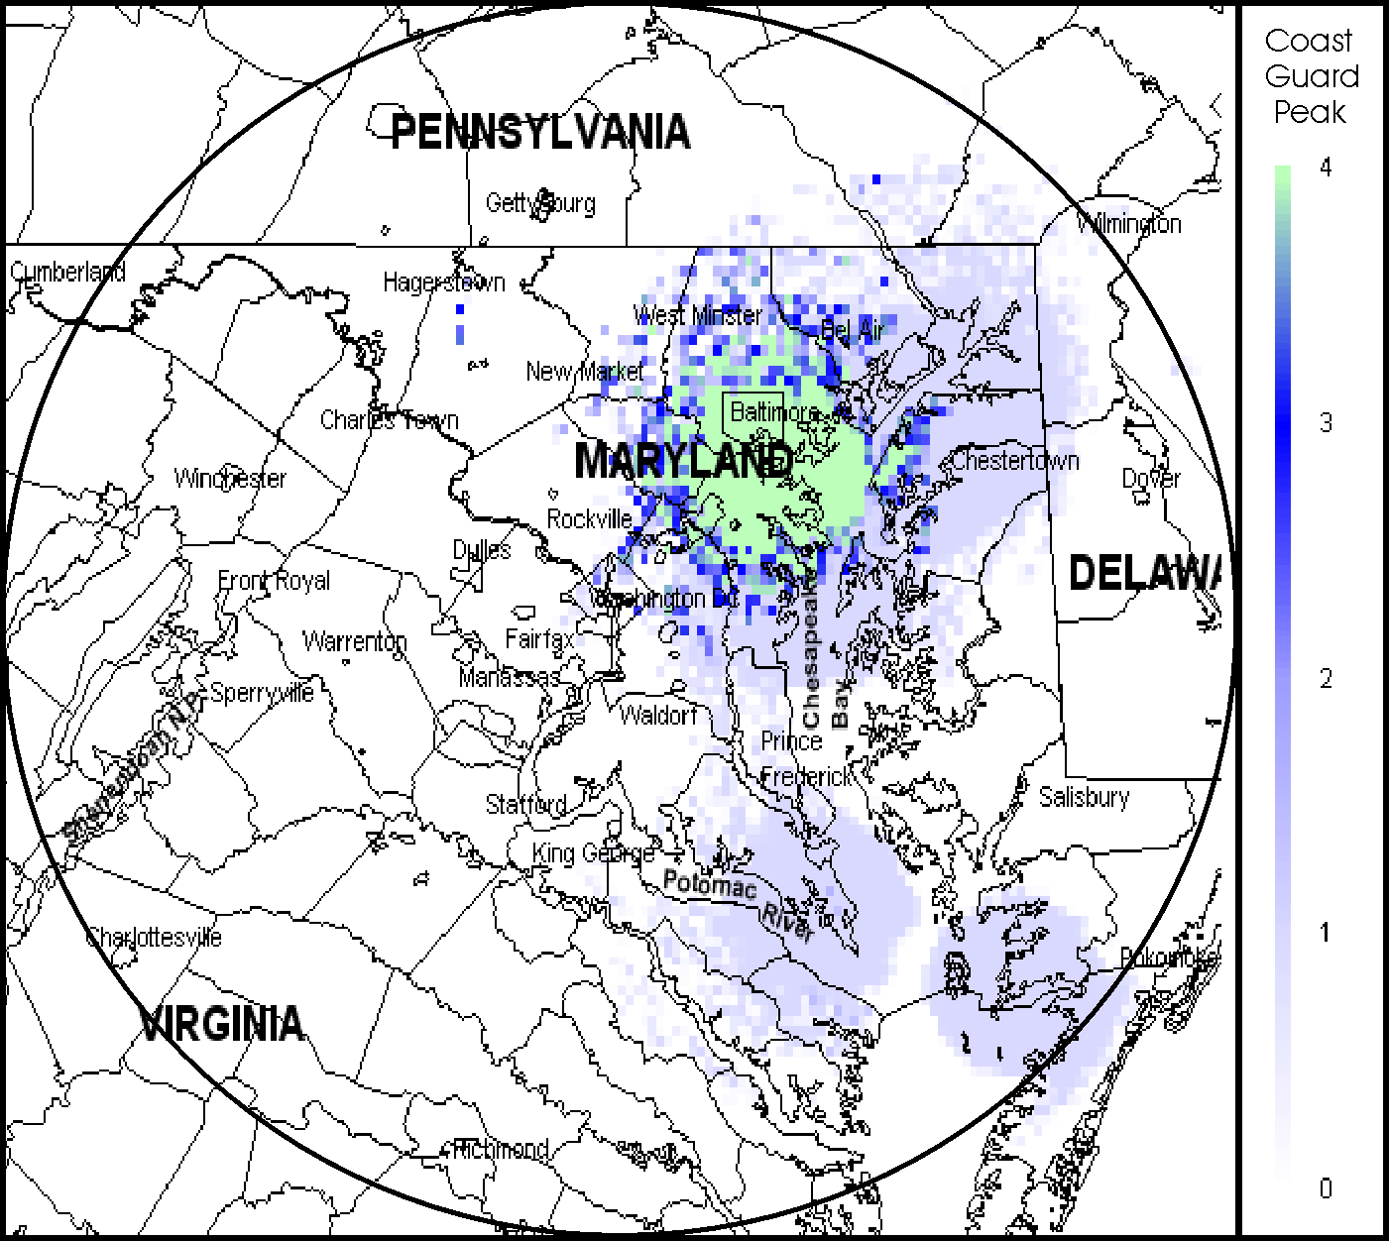
The various colors show geographic areas where between one and four different signals could be received by a mobile user. Maps for such networks can be combined with similar maps for other networks to produce SC maps for whole agencies. Individual maps for 12 of the larger
Figure 1. Signal capacity map for U.S. Coast Guard
agencies are included in the report. The maps for individual agencies can also be combined to create maps for groups of agencies; maps for several combinations of agencies have also been included. The results of the SCAP model indicate there are 48 federal agencies operating in the 100-mile radius circle from which GMF data was analyzed, using a total of 866 infrastructure-based transmitters to provide coverage to mobile/portable users. Out of the total coverage area for which SC results were calculated, 93 percent of the locations had coverage from at least one radio signal, counting the signals from all federal agencies. Ten percent of the locations had coverage from at least 100 independent radio signals, and approximately four percent of the locations had coverage from at least 200 independent radio signals. Figure 2 shows that mobile users at some locations near the center of Washington, D.C., could receive as many as 268 independent signals. In practice, federal agencies typically use only the radio signals assigned to their own agencies, which results in far fewer available signals for most users.

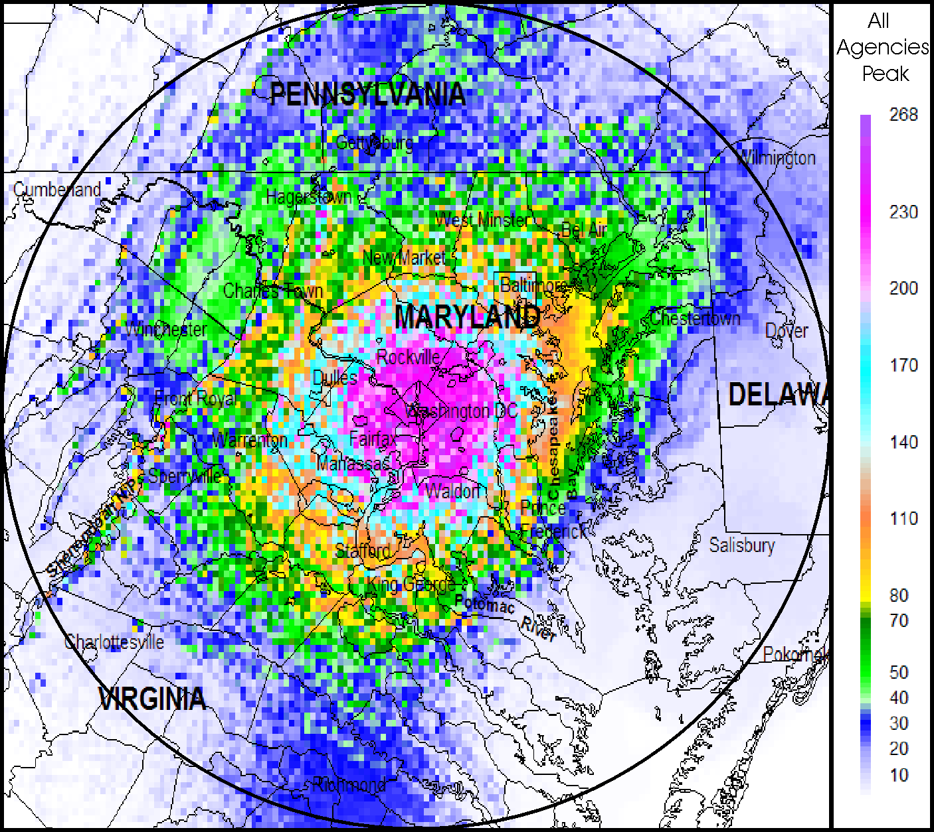

Figure 2. Peak signal capacity map for all Federal Agencies

The presence of 268 independent signals in downtown Washington, D.C. can be related to overall levels of crowding by noting that the 162-174 MHz band contains about 960 single-frequency channels (assuming 12.5 kHz channel spacing across 12 MHz of spectrum). However, most federal radio systems in this band are still using older 25-kHz channel technology (reducing the number of available frequencies to approximately 480). Many of the federal systems, including all repeater systems, require a pair of frequencies for normal operation of one channel. This would reduce the maximum number of independent channels to about 240. Thus, the presence of 268 independent signals in downtown Washington is made possible only because of some simplex-channel operations that require only a single frequency per channel and some agencies who have already switched to 12.5 kHz channel operation. This analysis shows that most of the available channels are already in use for specific functions. It does not mean that these assigned channels are actually carrying radio signals 100 percent of the time. Channel occupancy measurements by the NTIA Radio Spectrum Measurement System (RSMS) are planned for summer 2004. These measurements will provide detailed traffic statistics for many of these channels, as well as the total traffic loading that proposed future radio systems would need to support.

The SC maps described above are actually called “peak signal capacity” (PSC) maps. The PSC maps will be accompanied by a corresponding set of “average signal capacity” (ASC) maps in this report. The ASC maps show information similar to the PSC maps, except that the ASC maps contain data on the number of independent users per square mile that could be served by the existing analyzed mobile radio systems. The ASC data is needed so that future alternative radio systems can be designed with base stations having a range of different coverage areas, where the required traffic carried by a given base station will scale proportionally to the coverage area. The Appendix of this report includes a detailed description of computing and interpreting ASC and PSC maps.

The results obtained for the Phase 1 SC analysis provide a useful description of the coverage of current federal radio systems used in the 162-174 MHz band in the Washington, D.C. area. The data that is summarized in this report in the form of ASC and PSC maps and the channel occupancy data from the planned RSMS measurements will furnish an important part of the quantitative basis for the next phase of this initiative which considers the design of possible future shared radio systems

In May 2003, President George W. Bush signed an Executive Memorandum to develop and implement a comprehensive United States Spectrum Policy for the 21st Century. The initiative was designed to foster economic growth, ensure national and homeland security, maintain U.S. global leadership in communications technology development and satisfy other vital U.S. needs such as public safety, scientific research, federal transportation infrastructure and law enforcement. The Secretary of Commerce then established a Federal Government Task Force and initiated a series of public meetings to address improvements in policies affecting spectrum use by the Federal Government, State, and local Governments, and public sector. The recommendations resulting from these activities were included in a two-part series of reports released by the Secretary of Commerce in June 2004, under the title Spectrum Policy for the 21st Century- The Presidents Spectrum Policy Initiative. These reports contain recommendations regarding the efficient use of the radio spectrum. Since the report contained within was underway prior to the release of the Spectrum Policy for the 21st Century- The Presidents Spectrum Policy Initiative, it may be necessary for NTIA to modify its activities under the policy initiative based on the recommendations made to the President.

INTRODUCTION

Background

The National Telecommunications and Information Administration (NTIA), an agency of the U.S. Department of Commerce, is responsible for managing federal agency use of the radio spectrum. The NTIA establishes policies concerning frequency assignment, allocation and use, and provides the various federal departments and agencies with guidance to ensure that their conduct of telecommunications activities is consistent with these policies. The NTIA also serves under the Executive Branch as the President's principal adviser on telecommunication policies pertaining to the nation's economic and technological advancements and to the regulation of the telecommunications industry.

In support of these responsibilities, NTIA has undertaken numerous spectrum-related studies to: assess spectrum utilization; examine reallocating government spectrum or relocating federal government systems; identify existing or potential electromagnetic compatibility (EMC) problems between systems; provide recommendations for resolving EMC conflicts; recommend the changes to promote efficient and effective use of the radio spectrum; and improve the spectrum management process.

Since the radio frequency spectrum is a finite natural resource, efficient use of this resource must be one of the primary goals of government, both within the government sector (i.e., federal, state and local) and within the private/commercial telecom sector. Historically, efficient use of this spectrum, in the federal government, has been a process of self-policing, peer review, and regulatory controls. As demand for spectrum has increased, NTIA and the Federal Communications Commission (FCC) have examined policies and regulations that require, promote or facilitate efficient use of the spectrum to ensure adequate spectrum resources for growth of existing services and available spectrum for new services.

Spectrum efficiency is one of the cornerstones for obtaining maximum capacity from the limited frequency spectrum. Although spectrum efficiency can be defined in many ways, it remains difficult to balance theoretical efficiency with mission effectiveness, resource management and other important requirements. For example, the federal government uses mobile communications in support of congressionally mandated missions related to public safety and the welfare of life and property, military tactical services and operations associated with large, geographically dispersed organizations. Many of these services can and are being met through commercial service providers, where spectrum efficiency is inherently included as one of the aspects of a competitive market. The federal government places heavy reliance on the private sector in providing telecommunication service for it own use. In order to emphasize the government’s proper role as a user, any proposal designed to provide needed telecommunication service, which requires the government to perform any of the “provider” functions, shall be adopted only if commercial service is:

- not available to the user during the time needed;
- not adequate from either a technical or operational standpoint; or
- significantly more costly.

A non-commercial service approach is acceptable if it will result in significant savings over an otherwise acceptable commercial service offering.

NTIA has an ongoing telecommunication policy regarding spectrum efficiency consistent with its goals to administer this resource wisely and stimulate the economic growth of the nation. Key national objectives are to ensure effective, efficient, and prudent use of the spectrum in the best interest of the nation, taking care to conserve it for uses where other means of communication are not available or feasible. In addition, the process by which NTIA manages the federal government’s use of the spectrum ensures that spectrum is used for the public benefit in support of the missions and tasks of the federal government. Although these processes stress efficient and effective use of the spectrum, NTIA relies heavily on each agency to implement similar policies and ensure that systems, in their use or by their design, are spectrum efficient. NTIA has not generally reviewed the details of these agency decisions, beyond a general review of new systems and the frequency coordination and assignment processes. The decision as to whether an application or technology uses too much spectrum, or why an application cannot use a commercial service or alternate technology that does not consume spectrum resources, is generally left up to the operating agency which must ensure the effectiveness of its operations. However, within the mobile service, specifically land mobile, NTIA has taken a more aggressive position regarding spectrum efficiency.

In October 1992, Congress directed NTIA to implement a plan for federal agencies with existing mobile radio systems to use spectrum technologies that are at least as spectrum efficient and cost effective as readily available commercial mobile radio systems. NTIA submitted a plan to Congress in 1993 outlining the steps NTIA would take to ensure land mobile spectrum efficiency. The plan resulted in NTIA, with the advice of the Interdepartment Radio Advisory Committee (IRAC), developing policies and rules governing all users of the mobile bands allocated to the federal government on a primary basis. These rules included a transition to narrowband or equivalent technology, effectively doubling the number of channels available for future use. Federal agencies have been struggling through technology, budget and operational issues in their attempts to implement these rules. One difficulty is the transition to new digital technology, which is not necessarily backward compatible with 25 kHz analog operations.

A number of recent events and reports have highlighted the need to maintain a focus on spectrum efficiency. The results of these activities offer some insight into current thinking, historical references, and emerging initiatives concerning spectrum efficiency. These include, but are not limited to, the NTIA Spectrum Summit, the FCC Spectrum Policy Task Force, two General Accounting Office (GAO) reports on spectrum management, and a presidential initiative to move spectrum management into the twenty-first century.

One of the common objectives expressed in these reports and events is maximizing spectrum efficiency, especially in the bands used for mobile communications. Many believe that federal government agencies have fewer mobile users per unit of spectrum than is true for business, state and local public safety related, or common-carrier (i.e., cellular phone and personal communications system (PCS)) applications. As a result, there are concerns that the federal agencies are not using the spectrum as efficiently as their private sector counterparts. For example, public safety users require high reliability and availability with frequency channels whose traffic loads change drastically with planned or unplanned events. As a result, since these operations are not in use all of the time, it could be perceived as inefficient use of the spectrum.

In 1994, NTIA produced a report that enumerated the many well-known ways to improve the efficiency of mobile radio systems. These methods include, but are not limited to, decreasing bandwidth, increasing geographical frequency reuse and increasing the amount of time that a given frequency can be used by multiple users. The federal government has expended considerable effort to ensure that its use of the spectrum is efficient by adopting many spectrum efficient technologies including: narrowbanding, sharing, overlaying, and applying new spectrum planning techniques. Although these methods are well-known in the land mobile community and NTIA has encouraged their adoption, agencies have not applied them widely, because the methods may also have substantial disadvantages. Sometimes the disadvantage is a matter of higher cost stemming from a requirement to buy new equipment to replace older, less-efficient systems. Other possible disadvantages can include a decrease in performance or convenience, in addition to high cost and mission impact.

Therefore, in this report, an important “measure” regarding new mobile radio technologies has been consolidated under the title of “effectiveness.” Effectiveness includes spectrum efficiency, usability and cost factors. Usability factors include: equipment size and weight, power consumption, intelligibility, operational range, latency (i.e., delay time) between message input at the transmitter and message output at the receiver, interoperability with other users, complexity of operation, and requirements for special features like encryption and digital messages.

Evaluating spectrum effectiveness often requires “comparing apples and oranges.” How much should a 25 percent improvement in spectrum efficiency weigh against a 60 percent increase in cost or a ten percent decrease in intelligibility? The effectiveness of a proposed change could be evaluated differently by various users who have developed their own value of the relative benefits of various factors. Therefore, a single formula will not serve to calculate the relative effectiveness of a proposed change as seen by all federal users. For example, users competing for channels in a crowded urban environment will probably count spectrum efficiency as more valuable, compared to rural users, where unused spectrum is more plentiful. The problem however, is that rural locations do not have adequate coverage due to widely-spaced base stations.

“Effectiveness” forces planners to evaluate proposed changes against a much broader and more complete set of criteria. Proposed changes that benefit a wider range of users are more likely to be adopted and implemented than those that benefit some users, but which place other users at a disadvantage.

A study of effectiveness should consider broader questions about how the federal government is using the radio spectrum and consider whether larger-scale structural and organizational changes, such as shared radio systems, could improve both the technical efficiency and effectiveness of federal radio systems. Implementing a shared federal radio system would be a much more challenging project than switching to a more spectrum efficient radio technology. However, a large number of related factors are part of the “effectiveness” equation, including: large required expenditures to independently solve problems of interoperability between public safety agencies (e.g. the E-government Initiative on Interoperability. (Project SAFECOM); homeland security (e.g., the Department of Homeland Security (DHS) and the Integrated Wireless Network (IWN)); spectrum efficiency (e.g., meeting the narrowbanding deadlines); improved radio capabilities (e.g., data, encryption, emergency capacity, greatly expanded wireless Internet systems, etc.); and economies of scale and complexity arguments).

To better understand how the federal agencies use the spectrum and how to improve the effectiveness of this use, NTIA has undertaken a multi-phased study of spectrum effectiveness within the federal government land mobile bands. The first phase of the study, described in this report, analyzes the present federal use of the radio spectrum in the 162-174 MHz band in the vicinity of Washington, D.C. by developing a quantitative model of the “signal capacity” (SC) of current federal use of the radio frequency spectrum. The second phase will be based on the quantitative model results developed in the first phase and will explore various modern radio system alternatives to current federal systems such as shared federal systems. Depending on the apparent overall benefits (i.e., improved effectiveness) identified by the results of this phase, one or more concepts may be selected for further engineering and/or eventual large-scale or small-scale implementation (e.g., costs, requirements). Phase Two will also define the conditions under which the improvements could be made, taking into account items such as costs, schedules, and missions. Additional studies of the overall initiative will consider aspects such as frequency reuse criteria as it relates to spectrum management and the assignment process as well as spectrum standards to improve spectrum effectiveness. These additional studies will be conducted concurrently with Phase Two.

Scope of Work

Overall Objective

The objective is to conduct a multi-phased study of spectrum effectiveness and efficiency, within a federal government land mobile band. This effect will determine the improvements or changes that could be made through technologies, frequency coordination and assignment practices, standards, policies, and reorganization of communication architectures and organizations that would increase the effectiveness of spectrum use and spectrum efficiency to satisfy the future spectrum requirements of the federal government.

Specific Objectives

Phase 1:

- Gather and develop information on current federal government land mobile requirements within the 162-174 MHz band within 100 miles of Washington, D.C. including:

  - frequency assignments in the Government Master File (GMF);
  - the type of radio communication networks (trunked, conventional, etc.);
  - the equipment characteristics (power, bandwidth, nature of and quantity of information transfer, etc.);
  - nature of mission, technical and operating requirements for each federal agency (voice, data, availability required, priority, etc.);
  - future plans and spectrum requirements; and
  - measure of SC of current federal mobile radio systems via development of a quantitative model.

- Calculate SC results of current federal mobile radio systems, using the information obtained in (a).

Proposed Phase 2:

  - The NTIA Radio Spectrum Measurement System (RSMS) will make channel occupancy measurements for federal radio systems in the 162-174 MHz band during summer 2004. These measurements will be used to “calibrate” the geographical SC maps produced in Phase 1, producing similar maps expressed in Erlang per hour mobile radio traffic statistics.
  - Based on the quantitative SC results developed in Phase 1 and calibrated with RSMS traffic measurements, explore various modern radio system alternatives to the current federal systems.
  - Define the conditions under which the improvements could be made taking into account items such as costs, schedule of transition and mission.

Other Related Work

Other tasks will include:

- Review and evaluate the techniques, engineering practices, and related policies used in assigning spectrum for federal land mobile use, identifying and characterizing the various engineering techniques and procedures used in assigning spectrum for land mobile use; the improvements that could be made to these techniques and procedures to minimize spectrum use and maximize efficiency; and the changes required to the policy, procedures, and technical engineering (e.g., NTIA Manual, allotment strategies, standards and assignment nomination models (such as Spectrum XXI), Annex I (Procedure for Evaluating Frequency Proposals), Joint Spectrum Management System) necessary to make use of the spectrum more efficient and effective;

- Review of ongoing industry work in the area of land mobile standards to determine if the emission masks and receiver performance standards in Chapter 5 of the NTIA Manual need to be updated.

PHASE 1 OVERVIEW

General

When considering the possible advantages of replacing current smaller individual-agency radio systems with alternative future larger shared federal mobile radio system(s), spectrum users and managers must have realistic information on the services provided by the current systems. This information serves as a starting point for the design of any new system. Any system proposed to meet spectrum efficiency requirements must provide at least as much service as the existing systems and meet the mission requirements of the agencies. Any proposed alternative system may include many additional factors (e.g., projected growth), but as a minimum, spectrum users and managers must ensure these systems are designed with an awareness of what levels of service are provided by current systems. Otherwise, they cannot determine if any future alternative system would provide equivalent service.

The first phase of this study provides quantitative information on current system operations. Many advanced radio systems provide relative advantages or disadvantages that depend substantially on certain economy of scale factors. This is especially true for trunked radio systems, but such results affect many aspects of calculating peak loading factors. To compare future alternative systems with current systems, some basic parameters must be known, such as how many channels are required for current systems. The following provides an overview of the Phase 1 study, including the information required on current radio systems.

First, to develop a signal capacity analysis program (SCAP), NTIA sought to understand the mobile radio technologies currently being used by federal agencies. This SCAP includes SC algorithms to accurately analyze all of the pertinent radio technologies and architectures whose function could be included in future shared systems. Equally important was to identify the radio technologies or functions that could not be reasonably analyzed with the SCAP or included within future shared systems. The services of these systems will need to continue to be provided separate from the SCAP model and future shared systems. Typical LMR technologies used by federal agencies are described in Section 3.

In addition to understanding the current radio technologies and architectures, the current agency missions and specific operational requirements must be understood to supplement the data used in the SCAP. For example, the SCAP specifically does not include any information on receivers or the need to use multiple receive-only sites. Similarly, the SCAP contains no information on agency requirements for encryption, nationwide coverage, advanced data services. However, all of those factors will be needed as auxiliary specifications in order to design future systems. Therefore, NTIA identified and summarized current agency operations and special characteristics needed to support those operations. Section 4 includes this summary of current agency operations and activities.

Previous and ongoing federal studies and programs have mandated or have encouraged certain technologies and incentives promoting spectrum efficiency requirements to be used by various federal or non-federal public safety systems in many radio bands. Section 5 summarizes these various programs.

The concept of the SCAP is discussed in more detail in Section 6. Section 7 provides the SC results for each federal agency and for certain combinations of federal agencies. Section 8 provides a summary of the findings. The Appendix provides more specific details of the SCAP.

Concept of the Signal Capacity Analysis Program (SCAP)

To study the current level of service that exists for federal radio systems, NTIA needed to reduce a wide variety of federal mobile radio services to a “lowest common denominator” under which all mobile services could be considered together and summarized. The SCAP counts the number of independent radio signals that could be received by a mobile user at a given location, summarizing these results in a map of SC for locations in the Washington, D.C. area. Any alternative future radio system then will need to provide at least as many radio signals to a mobile user at any location on the map as the current system does. This model should help to quantify the advantages and disadvantages involved in future radio system reorganization, as well as provide insights into the best architectures and technologies to be employed and the circumstances under which maximum effectiveness would be achieved. Ongoing federal agency programs (i.e., IWN) are investigating the potential of federal radio systems operations being substantially improved by moving from individual-agency mobile radio systems to single shared systems that include state-of-the-art technologies.

Any model that is used to characterize the amount of service provided to federal users by current federal mobile radio systems in the 162-174 MHz band should reflect several characteristics. The model should: 1) calculate a quantity closely related to the service delivered to federal mobile radio users; 2) use only data available within the Government Master File (GMF); 3) be additive or otherwise allow easy manipulations to include different agencies or other user populations; 4) be transparent, in the sense that a given user can identify and verify its own contribution to the total results; 5) allow easy determination of anticipated results from prototype or proposed alternative radio systems, to facilitate comparisons between existing and alternative systems; and 6) require a minimum number of assumptions that could drastically change the model results.

The SCAP developed for this study is appropriate for estimating the amount of service currently used by the federal agencies. In its simplest form, the SCAP assumes that most federal radio users operate in a mobile or portable environment and depend on a two-way voice channel created by a federally-owned base station. Therefore, service can be quantified by merely counting the number of independent voice channels available at any given geographical location, assuming that “available” means sufficient base station signal field strength to be received by a typical portable LMR radio. The presence of an available signal transmitted by a base station means that the base station will also have a receiver that is suitable to receive a signal transmitted by the mobile unit. The model, however, only counts the number of signals that the mobile/portable unit can receive. Section 6 provides a more detailed description of the SCAP.

Selection of 162-174 MHz Band in the Washington, D.C. area

The 162-174 MHz band was selected for this study because this is the major band used for federal land mobile radio. The Washington, D.C. area was chosen because of the high concentration of federal users. Selection of the frequency band in the Washington, D.C. area provides an opportunity to: 1) investigate spectrum efficiency solutions in areas where those solutions are needed most; 2) realize economic savings due to economies of scale associated with potential solutions; 3) test solutions delivering required advanced technology capabilities like encryption and new digital services; and 4) consider a territory with maximum familiarity on the part of federal spectrum management personnel. The initial choice to include only the 162-174 MHz band was intended to minimize the effort required to obtain initial results.

Sources of Current Usage Data

To support the development of the SCAP, NTIA considered various methods for obtaining the information needed to estimate the level of services for current systems. For example, a detailed survey could be submitted to federal users to obtain their estimates of current and projected levels of service from their radio networks. However, a survey of this type would be difficult and time consuming for many of the agencies, since agencies may have to survey each independent bureau and coordinate the results. Furthermore, the individual agencies would each have had to develop suitable models to describe their own current levels of service, and NTIA would then have to convert the results of those models to a common overall model.

Another method would be using the NTIA/Institute for Telecommunication Sciences (ITS) Radio Spectrum Measurement System (RSMS) to conduct measurements within the Washington, D.C. area to determine the actual measured traffic occupancy for all frequencies in the band. A major concern with the RSMS data would be the time required to make and analyze such measurements at many sites over a wide geographical area. Measuring low power and intermittent applications would further complicate the measurements and the interpretation of their results. Furthermore, it would probably not be possible to collect and accurately interpret information on multi-site systems using the same frequencies.

The GMF is another possible source of information. It contains records of the frequencies assigned to all federal government agencies in the United States. Although the information contained in the GMF is somewhat limited, it provides information on federal radios over a wide geographic range.

After considering various possible methods of obtaining quantitative information on current federal mobile radio service levels, NTIA decided to estimate current levels of service by analyzing the data that is already available in the GMF, using computer modeling to generate maps showing SC. When necessary, the existing GMF data would be augmented using additional operational data provided by agency representatives.

To obtain the additional data on agency operations, an informal IRAC committee was established to assist NTIA personnel in understanding some of the technical details of agency systems operating in the 162-174 MHz band within the vicinity of the Washington, D.C. area.

Page 2-4/Blank

CHARACTERISTICS OF MOBILE RADIO SYSTEMS

General

Many types of radio technologies are represented in the mix of LMR systems used by federal agencies in the 162-174 MHz band. These various radio technologies described in this section are to: 1) provide an understanding of the differences among the various technologies; 2) understand the specific algorithms used to incorporate each of these technologies into the SCAP; and 3) determine whether there are system features that cannot easily be incorporated in the SCAP.

Simplex radio systems
A simplex radio system is most likely the simplest type of radio system, as well as being the first type of system that was widely used by radio users. In simplex systems, the user transmits and receives on the same frequency. Figure 3-1 shows a typical simplex radio system, composed of various mobile radio users, M₁-M₆, and a base station, B. A typical user listens to the traffic, if any, transmitted by the other users, and the base station, as shown in Figure 3-1A. If a given mobile user wants to talk with any, or all, of the other users, the user waits until no other user is speaking, then presses the “push-to-talk” button on the microphone and talks. This causes the radio to shift from “receive” mode to “transmit” mode, and the transmitted signal is received by the other radios tuned to that frequency (e.g., M₅ is shown transmitting in Figure 3-1B).
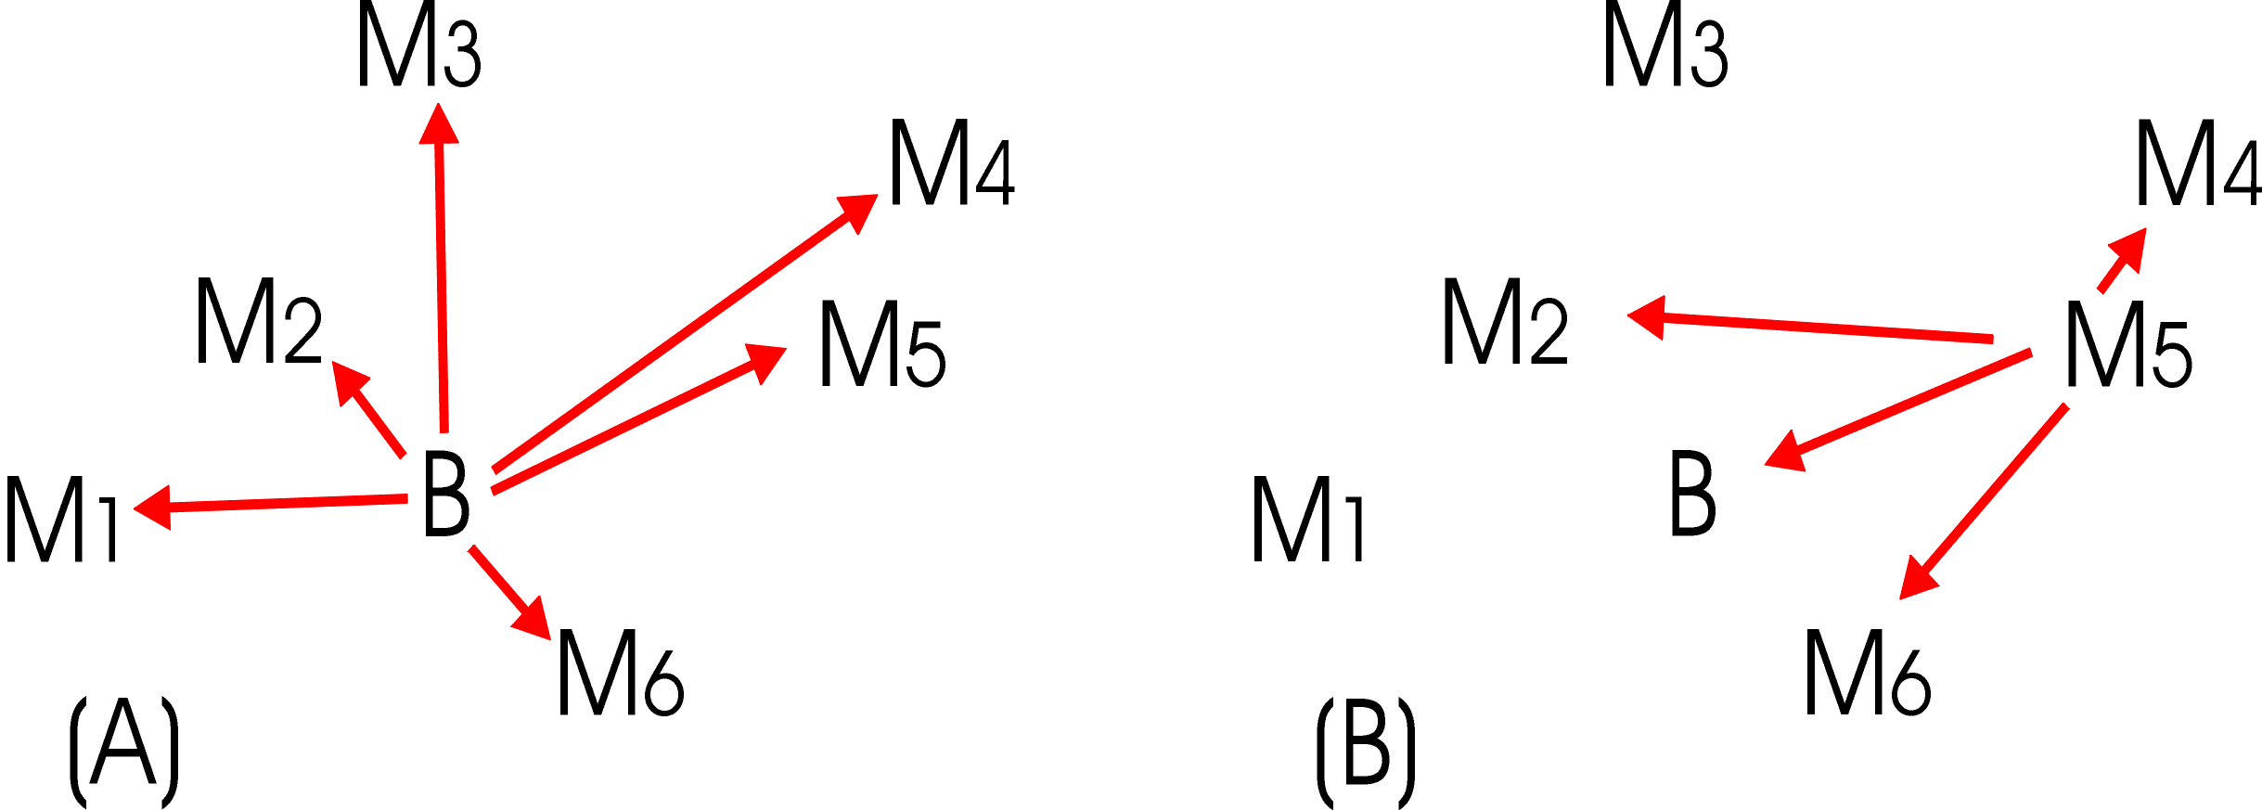

Figure 3-3. Simplex Radio System
Within a simplex radio system base stations are functionally equal to any of the mobile stations, except that base stations are in fixed locations, and they typically have more transmitter power and a more advantageously-placed antenna (e.g., at the top of a high tower near the communications center). This often gives a high-power, high-elevation base station the ability to “talk” further than typical low-power, low elevation mobile stations.

The situation is generally worse for communications between mobile users, where both the receiving and transmitting locations are lower and the radio paths between them are much more likely to be blocked by terrain and other obstacles. In Figure 3-1B, the signal from M₅ is shown to not be received by M_{3,} possibly because of terrain blockage between M₃ and M₅, or by M_{1,} possibly because of excessive distance. Thus, the number of users that can participate in a conversation may depend greatly on the location of the specific user that is transmitting. This situation can cause various problems. For example, in Figure 3-1B, M₃ and M₅ may be transmitting at the same time, each unaware that their messages are interfering with each other in the receivers of other listeners. A given mobile talker may not know whether the transmitted message has been received by another mobile listener. A critical mobile-to-mobile message may need to be relayed to a distant mobile user by the base station or by an intervening mobile user.

Radio Repeater Systems
Repeater architecture, shown in Figure 3-2, is used especially to solve some of the problems associated with the limited and variable mobile-to-mobile communications range that is inherent in the simplex system. The high tower or mountaintop base station is called a “repeater” and is labeled with an “R” in Figure 3-2. There are two major changes from the simplex architecture. First, the repeater, unlike the base station, does not originate or terminate any messages. Second, the repeater continuously listens on frequency F_{2,} (dashed blue arrow), and simultaneously transmits whatever it receives on a second frequency, F_{1,} (solid red arrow). The mobile units use the same two frequencies reversed in function, (i.e. mobile units continuously listen on F₁ and occasionally transmit on the frequency, F₂).

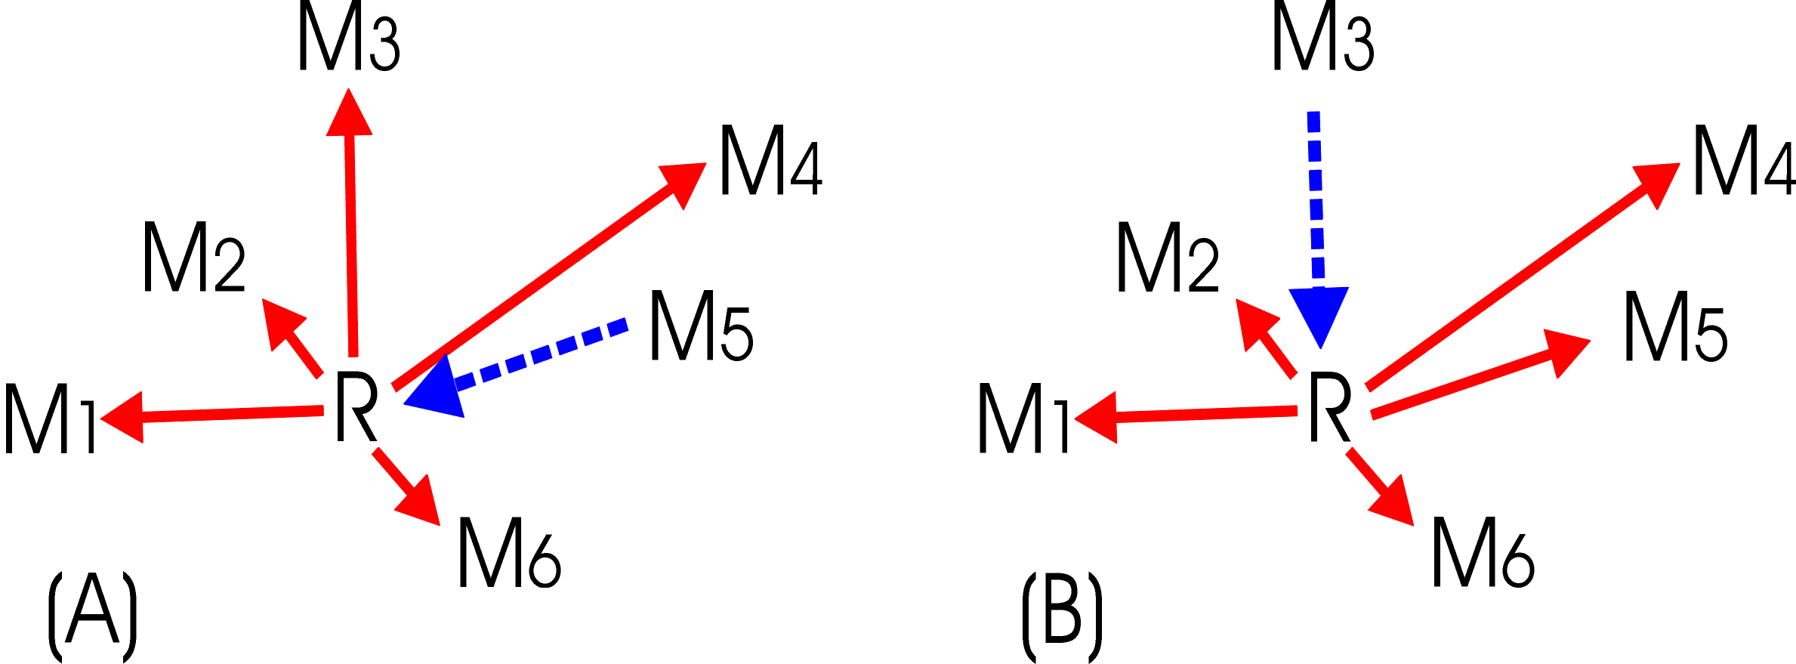

Figure 3-4. Repeater Architecture

At a given instant (e.g., when mobile user M₅ is transmitting on F₂), the other users, shown in Figure 3-2(A) are listening on frequency F₁. These mobile users hear the signal on F₁ that was originally transmitted at F₂ from M₅ and re-transmitted by the repeater at F₁. The important feature of the repeater architecture is that the ability of mobile users to communicate with each other depends entirely on how well the mobile users communicate with the repeater, instead of the often problematic direct path between mobile users.

Since the repeater site is typically chosen to provide low-path-loss propagation to a large geographic area, the usable mobile-to-repeater coverage is much greater than typical mobile-to-mobile coverage. Therefore, even though an intervening hill might prevent M₃ from hearing M₅ directly, they can communicate via the hilltop repeater site.

A primary user (e.g., a dispatcher at M₃) does not need to connect directly to the repeater site, but only needs radio contact with the repeater site, like any of the mobile users. This encourages placement of the repeater site on the top of a distant high tower or mountaintop, rather than being constrained to being close to the physical location of the communications center (e.g., downtown).

The use of separate transmit and receive frequencies for mobile users also solves a major equipment design problem, since mobile radios can be built with the assumption that all possible receive frequencies will be in one frequency band segment, while all possible transmit frequencies will be in a separate band segment. This simplifies the design of the radios, while permitting greater flexibility in tuning among many possible frequency channels. Simplex radios cannot depend on those critical design simplifications and traditionally have only a few channels of operation.

Mobile Talk-Around Mode
One disadvantage of the repeater architecture is that all communications must pass through the repeater. If the repeater site malfunctions or if mobile units drive out of range of the repeater site, communications will cease, no matter how close together the mobile units may be to one another. There are various methods of solving these problems. For example, in some systems it may be practical to switch to a “talk around” mode where closely-spaced mobile users switch to a simplex mode and communicate directly with each other using frequency F_{2,} independent of the base or repeater station. Although such talk-around operation has all of the range limitations associated with mobile-mobile simplex operations, it provides a very useful alternative mode that often extends the useful range of operations outside the normal repeater range.

Multi-Site Repeater Systems
The coverage area served by a single repeater site can be increased by using multiple repeater sites. A two site example is shown in Figure 3-3. A signal will be repeated by repeater R₁ if the mobile unit is within range of repeater R₁ or by repeater R₂ if the mobile transmitter is within range of repeater R₂. Unfortunately, if a mobile unit is within range of both R₁ and R₂ (e.g., M₅ in the figure), a signal will be transmitted by both R₁ and R₂. Simultaneous R₁ and R₂ signals that are received at about the same signal strength and frequency by any mobile users (e.g., M₁ and M₆ in the figure) can cause interference, which prevents the signal from being properly received. A discussion of simulcast systems, which are specially designed to prevent this problem, is included in the later paragraphs. However, some multiple repeater systems attempt to negate this problem, by locating/adjusting repeaters so they cause a minimum amount of such interference.
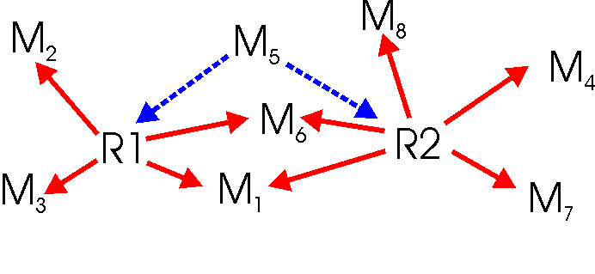

Figure 3-5. Multi-Site Repeaters

One way to avoid this interference problem is to use different transmit frequencies at the repeater sites. Unfortunately, this solution also requires that the mobile users adjust their receiver frequencies to match the transmitted frequency of the local repeater site. This adds some inconvenience for a mobile user. Another way to avoid simulcast interference is to add a continuous tone-coded squelch system (CTCSS) signal to the mobile voice transmission. The various codes that can be transmitted by CTCSS can be used to “activate” individual repeater sites, so that only the selected site is caused to repeat the message. The user would have several selectable channels on the mobile radio, which all used identical frequencies but transmitted different CTCSS codes. By selecting a particular channel, the user can select which repeater site to activate.

The use of different repeater transmitter frequencies, versus the use of activating different sites with CTCSS codes, gives various operational advantages and disadvantages. The use of CTCSS codes allows mobile users to operate everywhere using the same pair of frequencies. This means that mobile users do not need to continually switch frequencies depending on their location relative to the various repeater sites. The use of CTCSS also requires many fewer frequencies. However, if the repeater sites are used individually (i.e., if an incoming mobile message received at one site is not simultaneously repeated from all sites), the use of individual repeater transmit frequencies may allow more independent messages to be repeated from a set of repeater sites.

Half-Duplex Radio Systems
The half-duplex architecture combines elements of the simplex and the repeater architectures, as shown in Figure 3-4. As with the simplex system technology, half-duplex technology has a base station talking to multiple mobile users and receiving signals from these users. Like the repeater system, a half-duplex system transmits messages from the base station to the mobile users, Figure 3-4(A), at one frequency, F₁, (solid red line) and receives messages, Figure 3-4(B), from mobile users at another frequency, F₂, (dashed blue line). The primary functional difference between half-duplex and repeater architectures is that half-duplex base stations are directly linked to fixed communications networks, dispatchers, or a command center with wire-line or radio links.

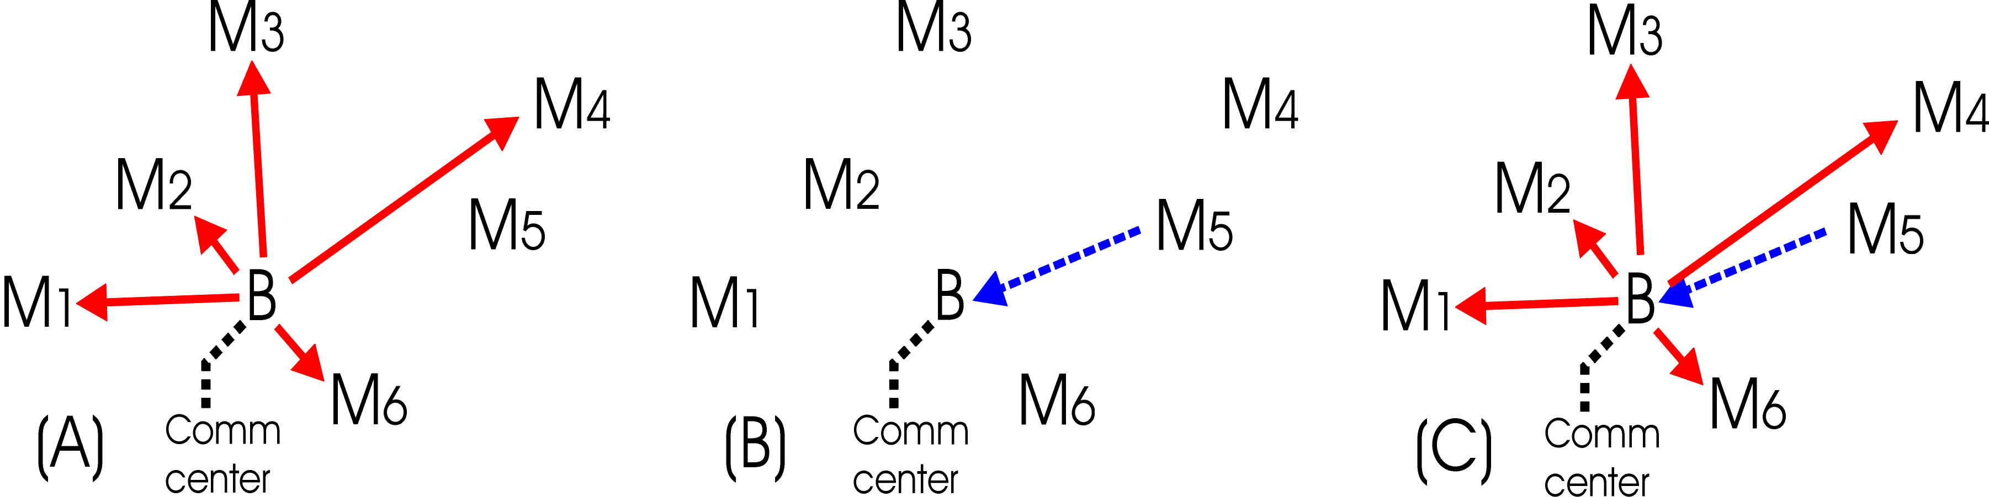

Figure 3-6. Half-Duplex Radio System

From a functional point of view, most half-duplex system messages originate or terminate at the base station, whereas all repeater messages originate and terminate at a distant mobile user. Since half-duplex system messages usually originate at the base station, mobile-to-base frequency F₂ and base-to-mobile frequency F₁ do not necessarily have to simultaneously transmit the same information, which allows some additional useful modes of operation. Messages can be sent from the base station to mobile users, with no activity in the mobile-to-base channel, Figure 3-4(A). Messages sent from the mobile users can be directed toward only the base station listeners (Figure 3-4(B)) or they can also be simultaneously re-transmitted to all users on frequency F₁ (Figure 3-4(C)) like a repeater system. So-called “full-duplex” capabilities simultaneously use F₁ and F₂ to provide full-time two-way voice communications, without the need for a push-to-transmit control (i.e., cell phone systems are full-duplex). A full-duplex capability also provides the ability for a mobile user to transmit a message to the dispatcher, without waiting for the end of an ongoing message from the dispatcher. However, many portable/mobile radios do not have the ability to simultaneously transmit and receive, so these radios could not provide full-duplex operation.

Multi-Site Duplex Systems
Duplex systems tend to be used for some large and high priority systems (i.e., the Federal Aviation Administration’s (FAA) National Radio Communications System (NRCS)). Multiple duplex base stations can be combined together into networks, providing a coverage area that represents the cumulative coverage area of the multiple individual base stations. Large multi-site duplex systems often have the ability for the user to enter the system at any base station site to gain access to a dispatcher at a communications center, to connect to the telephone system, or connect to another base station coverage area at a distant location. Although multi-site systems can provide a wide range of services and coverage area, they often also require a high degree of user knowledge and attention. For example, each base station will use different frequencies, and the user must continually change transmit and receive frequencies when moving from the coverage area of one site to another site. Similarly, a user might contact a distant user by using a distant base station to provide the needed radio link; however, this could only be accomplished if the current location of the distant user was known so that the correct base station could be selected.

Although a simplex channel provides two-way voice service using only half as many frequencies needed by a duplex system, the duplex architectures have some substantial advantages over simplex radios. The main reason is that, although simplex radios operate well by themselves for many purposes, they do not operate well within groups of other similar radios. A simplex radio transceiver must be able to receive at the same frequency that it transmits. A group of simplex transceivers (e.g., at a base station shared with 20 other simplex channel users) would need to have the ability to receive a signal simultaneously with 20 other users transmitting on the same antenna tower at nearby frequencies. This turns out to be extremely difficult from a technological basis. Even one nearby (in frequency and location) transmitter will overload the receiver front-end circuits and prevent reception, and combinations of transmitters will generate interfering intermodulation products at many unintended frequencies. Thus, sharing base station facilities with large numbers of other transmitters is difficult using simplex technology.

Duplex technology uses different frequency band segments for mobile and base station transmitters (e.g., the lower half of an LMR band is used for mobile transmitters and the upper half of the band is used for base station transmitters, with a fixed frequency separation between the corresponding base and mobile paired frequencies). This greatly simplifies the construction of radio transceivers and allows much easier sharing of base station sites. Repeating the earlier scenario of sharing a base station with 20 other radio systems means the 20 other transmitters are now all in a different frequency band from that used by the receiver, and there are far fewer restrictions on how the base station can be shared. It is much easier to construct receivers and transmitters that can tune across a whole band with hundreds of different frequency pairs (channels). Moreover, this easy sharing and channel flexibility extends to ad hoc mixtures of radios, such as might occur when multiple agencies deploy their systems in the vicinity of any major emergency. When the overall usefulness of simplex and duplex systems is considered, the greater freedom to use arbitrary duplex channels for many operational situations is often more important than the implicit efficiency of the single duplex channel in isolated circumstances.

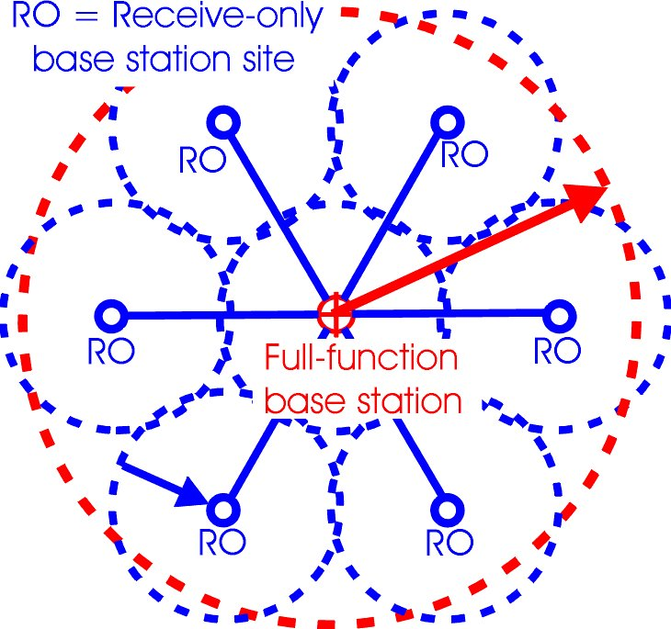
Receive-Only Sites
Duplex systems may, like repeater systems, have substantial problems with unequal effective operational ranges for mobile and portable radios versus the base station site. In many systems where reception is required for portable radios, especially for portable radios operating inside buildings, the problem of unequal range is solved by adding “receive-only” (RO) base stations as shown in Figure 3-5.

These additional RO base stations are located so that a base station receiver is always within the transmitting range of even lower power portable radios. Typically, the received audio from each of the receiver sites, RO and two-way, are transferred to a central point (e.g., the dispatcher or the associated full-function base station) and the “best quality” received signal is selected as the only received signal.
Figure 3-7. Base Station Reception Augmented with Receive-only Sites

Simulcast Radio Systems
When it is necessary to provide coverage over a larger geographical area than can be covered from a single base station, simulcasting can be a more convenient way to combine the coverage area of multiple base stations, as shown in Figure 3-6. Simulcast base stations use a duplex frequency plan at each site, but the same frequency pair, the same transmit frequency (solid red lines), and the same receive frequency (dashed blue line), is used at all sites. Unlike multi-site duplex systems described earlier, simulcast systems allow a mobile user to operate with a uniform pair of transmit and receive frequencies over the entire coverage area. The three circles in Figure 3-6 show nominal coverage areas for each of the three simulcast base stations.

As shown in Figure 3-6, the set of simulcasting sites typically produce some overlapping coverage areas where a given receiver, e.g., M₃, could receive approximately equal usable levels of signal from more than one base station site. To prevent these multiple signals from interfering with each other, the relative frequencies and time delays of these signals must be precisely controlled. This is accomplished by synchronizing frequencies transmitted at all sites and uniformly delaying the transmission of signals at each site to compensate for the relative time delays incurred in transporting the signal to each transmitter site. In the past, it was quite difficult to synchronize the frequencies, but now it is relatively simple to use Global Positioning System (GPS) signals from satellites to synchronize clocks and frequency sources at multiple sites.

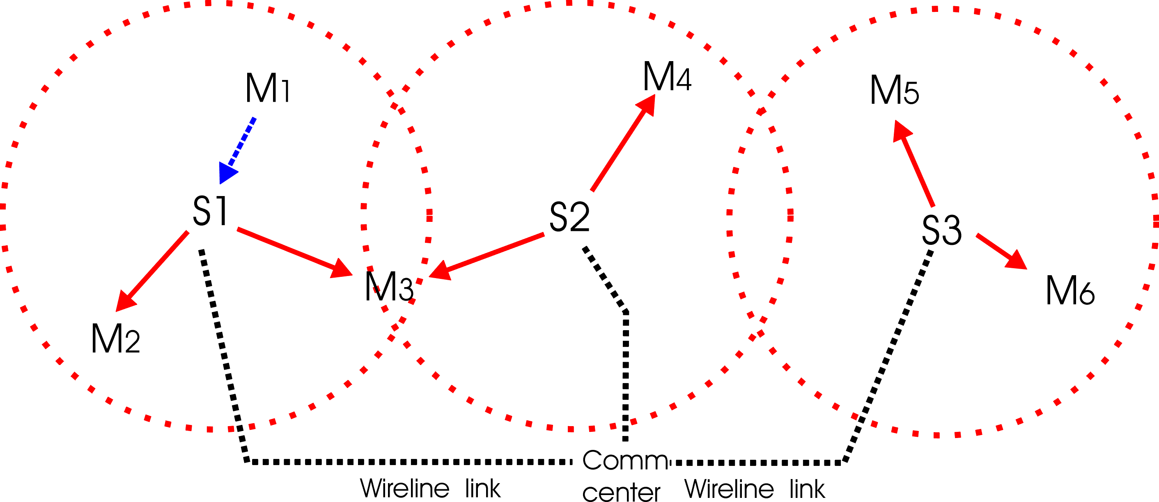

Figure 3-8. Simulcast System
Simulcast systems also allow a single frequency, paired with the base transmitter frequency, to be used for mobile transmitters sending messages to the simulcast base stations. Typically, the signals received by each base station are all sent back to the simulcast communications center, where they are compared and the best signal is sent to the dispatcher, similar to multiple receive-only sites. As with other duplex radio systems, any messages received from mobile users may, or may not, be simultaneously re-transmitted to the rest of the mobile users.

Thus, simulcast systems can provide very convenient duplex radio services over a much larger multi-site coverage area, using a single pair of base station transmit and receive frequencies. The simulcast system allows a simple mobile radio to be used across the full geographical coverage area without needing to switch frequencies or make other adjustments.

Trunked Radio Systems

When there are a large number of users concentrated in a given area (i.e., urban), and frequency resources are limited, trunked radio systems are a particularly useful type of half-duplex radio system. The half-duplex systems concepts demonstrated in figure 3-4 also applies to trunked radio systems. In trunked radio systems, multiple half-duplex radio channels are available, but none of them are permanently associated with a given user or function. Instead, the trunked system temporarily designates an arbitrary channel for a given user message at the instant that the user requests a radio channel. The only criterion for choosing a particular channel is that the channel is currently available (i.e., not being used by any other user) at the time when the user requests a channel.

The appeal of trunked radio systems is that each channel of a trunked radio system can carry considerably more traffic than a similar channel on a conventional radio system, with no apparent user awareness of the presence of the other users. If “User A” were sharing a channel with other users on a conventional radio system, User A would be blocked from service if any of the other users were currently talking on the shared channel. For example, if the other users kept the channel busy for 20 percent of the time, User A should expect to find the channel unavailable for use 20 percent of the time. If User A needed immediate access to a radio channel at all times, this could be accomplished only by sharing his channel with no other users (or perhaps only a very few users). However, if User A were sharing channels on a trunked radio system having ten channels, for example, where other users kept all of the channels in use for 20 percent of the time, the blocking situation is much different. Since User A can be given any one of the ten channels, User A will be blocked only if all ten channels are simultaneously in use. The probability of all ten channels being used is much smaller than the probability that a single “User A” channel is in use. Therefore, each trunked system channel can carry much more traffic on average before User A will typically have to wait until other users stop talking.

Another capability of trunked radio systems is the ability to divide users into various “talk groups.” These talk groups determine which users receive which messages. In general, each user belonging to a specific talk group hears the messages addressed to that talk group and transmits messages to the other members of that talk group. This feature allows the trunked radio system to divide its many users into various independent talk groups that match the functional groupings by which agency missions are accomplished. Additionally, existing talk groups can be rapidly modified to allow the talk group structures to adapt to new situations, such as major events or emergencies that require new cross-agency interoperability and command structures.

Trunked systems become particularly flexible and more powerful when multiple trunked sites are assembled into networks of trunked systems. Such networks are quite complex and expensive, but they can have considerable advantages over single-site trunked radio systems.

However, to provide these services, the capabilities of the individual trunked base stations must be combined into a system using inter-site connections, which are often broadband wireline or point-to-point microwave, and controlled with complex computer/controllers. For example, when a radio user within the coverage area of one site calls a talk group that is spread across the coverage areas of multiple sites, the required communications can be provided only by the unified network. Among various data that the network requires, for example, is the approximate current location of each talk group member, so that calls can be sent out via all of the required base stations. In addition, the network must know the current talk groups for each user, user radio capabilities, authorization, and encryption data. This information must be updated whenever a radio user moves from one base station coverage area to another, turns their radio off or if it moves temporarily out of range.

The ability of the intelligent network to connect the sites is important since the network intelligence is what converts individual base station capabilities to a system having statewide, nationwide, or possibly even worldwide, coverage with a wide range of techniques to adapt to highly variable communications needs. There are also issues about the reliability and robustness of the network connecting the sites as well as the ability of base stations to continue critical operations if the network connections are severed. Since all traffic has to move through the base station sites, a failure of the links connecting a site to the control network could render the system completely inoperable. In some systems, the base stations have independent local operation software that allows them to act as stand-alone trunked repeaters if the connections to the network fail. This allows a partial set of communications capabilities to continue functioning, though it could not provide capabilities that depend on interconnection to the other elements of the network.

Summary

The federal agencies currently operate various types of mobile radio systems. Most of these systems incorporate the techniques described previously in this section. These descriptions are useful in understanding the current operations of the various federal agencies that are described in Section 4 and in understanding the SC algorithms described in Section 6 or in Appendix A.

Page 3-10/Blank

FEDERAL OPERATIONS IN THE 162-174 MHz BAND

General

The federal government accommodates non-tactical land mobile operations in the 162-174 MHz and 406.1-420 MHz bands. These two bands are the most widely used by the federal agencies. Forty-eight federal agencies are authorized to operate in the 162-174 MHz band, which makes it one of the bands most heavily licensed by the federal government. The following section provides a summary of the 162-174 MHz band in terms of allocation usage as well as operational descriptions of the federal agencies’ usage in the Washington, D.C. area as of November 2002, when the study was initiated. The Department of Homeland Security (DHS) is not included because the department was not established until March 2003.

Allocation

The NTIA Manual contains the international and national allocations and footnotes, as shown in Table 4-1, for the 162-174 MHz band. The 162-174 MHz band is allocated on a co-primary basis with the fixed service, and this band is used for fixed systems in addition to mobile systems, including fixed point-to-point, fixed point-to-multipoint, maritime, and aeronautical mobile systems. Thus, federal land mobile operations are shared with other federal government services in this band and for this study. The SC analysis and results are derived from only the land mobile services.

Table 4-1. International and National Frequency Allocations and Footnotes for the 162-174 MHz Band
162-174 MHz
International Table |  |  | United States Table |  | Remarks
Region 1 | Region 2 | Region 3 | Federal Government | Non-Federal Government | Auxiliary Broadcasting  (74)  Private Land Mobile (90)
156.8375-174  FIXED  MOBILE except aeronautical mobile  5.226 5.229 | 156.8375-174  FIXED  MOBILE  5.226 5.230 5.231 5.232 |  | 162.0125-173.2  FIXED  MOBILE  5.226 US8 US11 US13 US216 US223 US300 US312  G5 | 162.0125-173.2  5.226 US8 US11 US13 US216 US223 US300 US312 | Auxiliary Broadcasting  (74)  Private Land Mobile (90)
 |  |  | 173.2-173.4 | 173.2-173.4  FIXED  Land mobile | Private Land Mobile (90)
 |  |  | 173.4-174  FIXED  MOBILE  G5 | 173.4-174

Footnotes Applicable to the Federal Government

5.226 – The frequency 156.8 MHz is the international distress, safety and calling frequency for the maritime mobile VHF radiotelephone service.
US8 – The use of frequencies 170.475, 171.425, 171.575 and 172.275 MHz east of the Mississippi River, and 170.425, 170.575, 171.475, 172.225 and 172.373 MHz west of the Mississippi River may be authorized for fixed, land and mobile stations operated by non-federal forest firefighting agencies. In addition, land stations and mobile stations operated by non-federal conservation agencies, for mobile relay operation only, may be authorized to use the frequency 172.275 MHz east of the Mississippi River and frequency 171.475 MHz west of the Mississippi River. The use of any of the foregoing nine frequencies shall be on the condition that no harmful interference will be caused to government stations.
US11 – The use of the frequencies 166.250 and 170.150 MHz may be authorized to non-government remote pickup broadcast base and land mobile stations and to non-government base, fixed and land mobile stations in the public safety radio services.
US13 – For the specific purposes of transmitting hydrological and meteorological data in cooperation with agencies of the federal government the following frequencies may be authorized to non-government fixed stations on the condition that harmful interference will not be caused to government stations:

MHz MHz MHz MHz
169.4250 170.2250 171.0250 171.8250
169.4375 170.2375 171.0375 171-8375
169.4500 170.2500 171.0500 171.8500
169.4625 170.2625 171.0625 171.8625
169.4750 170.2750 171.0750 171.8750
169.4875 170.2875 171.0875 171.8875
169.5000 170.3000 171.1000 171.9000
169.5125 170.3125 171.1125 171.9125
169.5250 170.3250 171.1250 171.9250

US216 - The frequencies 150.775 and 150.790, and the bands 152-152.0150, 163.2375-163.2625, 462.9375-463.1875, and 467.9375-468.1875 MHz are authorized for government/non-government operations in medical radio communications systems.
US300 – The frequencies 169.445, 169.505, 170.245, 170.305, 171.045, 171.105, 171.845 and 171.905 MHz are available for wireless microphone operations on a secondary basis to government and non-government operations.
US312 – The frequency 173.075 MHz may also be authorized on a primary basis to non-government stations in the Police Radio Service (with a maximum authorized bandwidth of 20 kHz) for stolen vehicle recovery systems.
G5 – Use by the military services is limited by the provisions specified in the channeling plans shown in Sections 4.3.7 and 4.3.9 of the NTIA Manual.

Use of the 162-174 MHz Band

The GMF was used as the baseline to obtain agency occupancy data for this Phase 1 study. The GMF is the U.S. Government’s database that contains a complete listing of government frequency assignments and is an important tool used for various spectrum management activities. Table 4-2 shows the GMF summary of assignments by station class per agency and radio service in the 162-174 MHz band as of November 2002. Accordingly, these assignments may have been revised, updated, or expanded as needed to meet changing spectrum management requirements.

Table 4-2. Number of Frequency Assignments
within a 100 Mile Radius of Washington, D.C.
 | Aeronautical | Land Mobile | Mobile | Fixed | Experimental | TOTALS
 | Mobile Service | Service | Service | Service
Agriculture |  | 23 | 8 | 5 |  | 36 | 1.9%
Commerce |  | 12 | 2 | 168 |  | 182 | 9.4%
Coast Guard |  | 4 | 10 |  |  | 14 | 0.7%
Dept. of Defense
Air Force |  | 51 |  | 1 |  | 52 | 2.7%
Army |  | 61 |  | 13 |  | 74 | 3.8%
Navy | 3 | 9 |  |  | 29 | 41 | 2.1%
Energy |  | 39 |  | 6 |  | 45 | 2.3%
FAA |  | 41 |  | 67 |  | 108 | 5.6%
Interior |  | 125 | 42 | 85 |  | 252 | 13.0%
Justice |  | 66 | 523 | 81 |  | 670 | 34.4%
Treasury |  | 197 | 19 | 15 |  | 231 | 11.8%
US Capitol Police |  | 25 |  |  |  | 25 | 1.3%
US Postal Service |  | 41 |  |  |  | 41 | 2.1%
Veterans Affairs |  | 30 |  |  |  | 30 | 1.5%
Others |  | 133 | 1 | 10 |  | 144 | 7.4%
TOTALS | 3 | 857 | 605 | 451 | 29 | 1,945
TOTALS | 0.2% | 44.0% | 31.1% | 23.2% | 1.5% |  | 100.0%
 | Services | Station Classes
 | Aeronautical Mobile | FA, FAD, FAT, MA
 | Land Mobile | FB, FBR, ML, MLP, MLPR, MLR
 | Mobile | FL, FLEC, FLR, MO, MOB, MOE, MOEB, MOEC, MOP, MOR
 | Fixed | FX, FXD, FXE, FXH, FXHR, FXR
 | Experimental | XT

In the 162-174 MHz band, there are 1,945 specific assignments within a 100 mile radius of Washington, D.C. The majority of the area-specific assignments are in the land mobile service (44 percent), followed by the mobile (31.1 percent), fixed (23.2 percent), experimental (1.5 percent) and aeronautical mobile (0.2 percent). The major users of this band are U. S. Department of Justice (DOJ), U. S. Department of Interior (DOI), U. S. Department of the Treasury (Treasury), and U. S. Department of Commerce (DOC). The location of these assignments is shown in Figure 4-1. Table 4-3 provides a summary count of assignments categorized by agency/bureau, station class and percentage of total assignments by bureau. There are also 2,816 area assignments in the band that can potentially be used at any given time. Table 4-4 shows a summary of area and statewide assignments by agency.

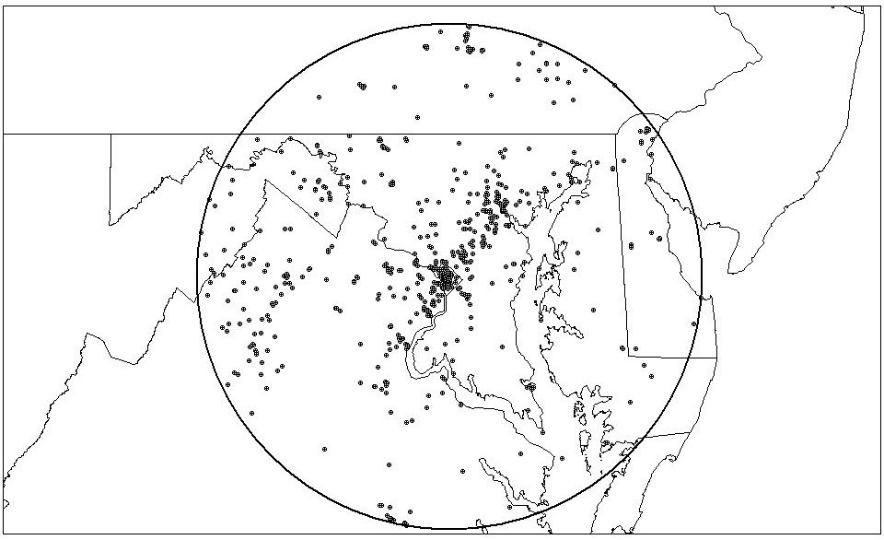

Figure 4-9. Plot of All Agency Frequency Assignments within a 100 Mile Radius
of Washington, D.C. in the 162-174 MHz Band

Table 4-3. Number of Frequency Assignments within a 100 Mile Radius of Washington, D.C. (162-174 MHz)
 | Aeronautical | Land Mobile |  | Mobile | Fixed | Experimental | TOTALS  Assignments % per Agency
Agency/Bureau | Mobile Service |  | Service | Service | Service
Agriculture
Animal and Plant Health  Inspection Service |  | 7 |  |  | 2 |  | 9 | 25.0%
Agriculture Research Service |  | 9 |  | 1 | 1 |  | 11 | 30.6%
Region 8 |  |  |  | 7 | 1 |  | 8 | 22.2%
Farm Service Agency |  | 1 |  |  |  |  | 1 | 2.8%
Washington Office |  | 2 |  |  |  |  | 2 | 5.6%
Office of Inspector General |  | 4 |  |  | 1 |  | 5 | 13.9%
TOTALS |  | 23 |  | 8 | 5 |  | 36
Commerce
(No Bureau) |  |  |  | 2 |  |  | 2 | 1.1%
National Institute of  Standards and Technology |  | 9 |  |  | 2 |  | 11 | 6.0%
National Weather Service |  |  |  |  | 166 |  | 166 | 91.2%
Office of the Secretary |  | 3 |  |  |  |  | 3 | 1.6%
TOTALS |  | 12 |  | 2 | 168 |  | 182
Coast Guard
Coast Guard District 5 |  |  |  | 9 |  |  | 9 | 64.3%
Coast Guard Headquarters  Unit 50 |  | 1 |  |  |  |  | 1 | 7.1%
Coast Guard Headquarters,  Washington, D.C. |  | 3 |  | 1 |  |  | 4 | 28.6%
TOTALS |  | 4 |  | 10 |  |  | 14
Dept. of Defense
Air Force
(No Bureau) |  | 51 |  |  | 1 |  | 52 | 100.0%
TOTALS |  | 51 |  |  | 1 |  | 52
Army
AFMO CONUS |  | 32 |  |  | 3 |  | 35 | 47.3%
Headquarters |  | 1 |  |  |  |  | 1 | 1.4%
Corps of Engineers |  | 5 |  |  | 5 |  | 10 | 13.5%
Military District of Washington |  | 23 |  |  | 5 |  | 28 | 37.8%
TOTALS |  | 61 |  |  | 13 |  | 74
Navy
(No Bureau) | 3 | 9 |  |  | 29 |  | 41 | 90.9%
TOTALS | 3 | 9 |  |  | 29 |  | 41 | 9.1%
Energy
Headquarters Office |  | 39 |  |  | 6 |  | 45 | 100.0%
TOTALS |  | 39 |  |  | 6 |  | 45
FAA
(No Bureau) |  |  |  |  | 5 |  | 5 | 4.6%
FAA Eastern Region |  | 41 |  |  | 61 |  | 102 | 94.4%
FAA Western Pacific Region |  |  |  |  | 1 |  | 1 | 0.9%
TOTALS |  | 41 |  |  | 67 |  | 108

Table 4-3. Number of Frequency Assignments within a 100 Mile Radius of Washington, D.C. (Continued)
Interior
Geological Survey  Administrative |  | 1 |  |  |  | 1 | 0.4%
Geological Survey  Biological Resources Division |  | 1 |  |  |  | 1 | 0.4%
Geological Survey  National Mapping Division |  | 1 |  |  |  | 1 | 0.4%
Office of the Secretary |  | 8 |  |  |  | 8 | 3.2%
National Park Service  National Capital Field Area |  | 65 | 41 | 51 |  | 157 | 62.3%
National Park Service  New England Field Area |  | 48 |  | 34 |  | 82 | 32.5%
U.S. Fish and Wildlife Service  CT,DE,D.C.,ME,MD,MA,NH,NY,  PA,RI,VT,VA,WV |  | 1 | 1 |  |  | 2 | 0.8%
TOTALS |  | 125 | 42 | 85 |  | 252
Justice
Bureau of Prisons |  |  | 1 |  |  | 1 | 0.1%
Drug Enforcement Administration |  |  | 3 |  |  | 3 | 0.4%
Federal Bureau of Investigation |  | 53 | 456 | 62 |  | 571 | 85.0%
Immigration and Naturalization  Service |  | 1 | 29 | 13 |  | 43 | 6.4%
Justice Management Division |  | 8 |  |  |  | 8 | 1.2%
U.S. Marshals Service |  | 4 | 36 | 6 |  | 46 | 6.8%
TOTALS |  | 66 | 525 | 81 |  | 672
Treasury
Bureau of Alcohol, Tobacco  and Firearms |  | 33 |  | 4 |  | 37 | 16.0%
U.S. Customs Service |  | 21 | 4 | 1 |  | 26 | 11.3%
White House Communications  Agency |  | 60 | 15 |  |  | 75 | 32.5%
Departmental Offices |  | 3 |  |  |  | 3 | 1.3%
Bureau of Engraving and Printing |  | 1 |  |  |  | 1 | 0.4%
Inspector General for Tax  Administration |  | 10 |  | 4 |  | 14 | 6.1%
IRS Criminal Investigation Division |  | 5 |  |  |  | 5 | 2.2%
Integrated Treasury Network |  | 4 |  |  |  | 4 | 1.7%
U.S. Secret Service |  | 60 |  | 6 |  | 66 | 28.6%
TOTALS |  | 197 | 19 | 15 |  | 231
U.S. Capitol Police
(No Bureau) |  | 25 |  |  |  | 25 | 100.0%
TOTALS |  | 25 |  |  |  | 25
U.S. Postal Service
Postal Inspection Service |  | 13 |  |  |  | 13 | 31.7%
Mail Processing and Distribution |  | 28 |  |  |  | 28 | 68.3%
TOTALS |  | 41 |  |  |  | 41
Veterans Affairs
National Cemetery Administration |  | 4 |  |  |  | 4 | 13.3%
VA Central Office |  | 3 |  |  |  | 3 | 10.0%
Veterans Health Administration |  | 23 |  |  |  | 23 | 76.7%
TOTALS |  | 30 |  |  |  | 30

Table 4-3. Number of Frequency Assignments within a 100 Mile Radius of Washington, D.C. (Continued)
 | Aeronautical | Land Mobile | Mobile | Fixed | Experimental | TOTALS  Assignments % per Agency
Other Agencies & Bureaus | Mobile Service | Service | Service | Service
Administrative Office of the
United States Courts
(No Bureau) |  | 7 |  |  |  | 7 | 100.0%
TOTALS |  | 7 |  |  |  | 7
Broadcasting Board of Governors
(No Bureau) |  | 2 | 1 |  |  | 3 | 100.0%
TOTALS |  | 2 | 1 |  |  | 3
Consumer Products Safety
Commission
(No Bureau) |  | 1 |  |  |  | 1 | 100.0%
TOTALS |  | 1 |  |  |  | 1
Environmental Protection Agency
(No Bureau) |  | 4 |  |  |  | 4 | 100.0%
TOTALS |  | 4 |  |  |  | 4
FCC
Field Operations Bureau |  | 7 |  |  |  | 7 | 100.0%
TOTALS |  | 7 |  |  |  | 7
General Services Administration
(No Bureau) |  | 13 |  |  |  | 13 | 68.4%
Office of Federal Supplies  and Services |  | 1 |  |  |  | 1 | 5.3%
Office of Federal Protection  and Safety |  | 1 |  |  |  | 1 | 5.3%
Office of Information  Resources Management |  | 1 |  |  |  | 1 | 5.3%
Public Buildings Service |  | 3 |  |  |  | 3 | 15.8%
TOTALS |  | 19 |  |  |  | 19
Government Printing Office
(No Bureau) |  | 1 |  |  |  | 1 | 100.0%
TOTALS |  | 1 |  |  |  | 1
Health and Human Services
National Institutes of Health |  | 9 |  |  |  | 9 | 64.3%
Office of the Inspector General |  | 1 |  |  |  | 1 | 7.1%
Substance Abuse & Mental  Health Administration |  | 3 |  | 1 |  | 4 | 28.6%
TOTALS |  | 13 |  | 1 |  | 14
House of Representatives
(No Bureau) |  | 2 |  |  |  | 2 | 100.0%
TOTALS |  | 2 |  |  |  | 2
Housing and Urban Development
(No Bureau) |  | 8 |  |  |  | 8 | 100.0%
TOTALS |  | 8 |  |  |  | 8
International Trade Commission
(No Bureau) |  | 1 |  |  |  | 1 | 100.0%
TOTALS |  | 1 |  |  |  | 1
Department of Labor
(No Bureau) |  | 4 |  |  |  | 4 | 100.0%
TOTALS |  | 4 |  |  |  | 4
Table 4-3. Number of Frequency Assignments within a 100 Mile Radius of Washington, D.C. (Continued)
National Aeronautical and Space Admin.
Goddard Space Flight Center |  |  |  |  | 1 |  | 1 |  | 2 |  | 40.0%
NASA Headquarters |  |  |  |  | 1 |  |  |  | 1 |  | 20.0%
Marshall Space Flight Center |  |  |  |  | 2 |  |  |  | 2 |  | 40.0%
TOTALS |  |  |  |  | 4 |  | 1 |  | 5
National Security Agency
(No Bureau) |  |  |  |  | 2 |  |  |  | 2 |  | 100.0%
TOTALS |  |  |  |  | 2 |  |  |  | 2
National Gallery of Art
(No Bureau) |  |  |  |  | 4 |  |  |  | 4 |  | 100.0%
TOTALS |  |  |  |  | 4 |  |  |  | 4
National Labor Relations Board
(No Bureau) |  |  |  |  | 1 |  |  |  | 1 |  | 100.0%
TOTALS |  |  |  |  | 1 |  |  |  | 1
Nuclear Regulatory Commission
(No Bureau) |  |  |  |  | 3 |  |  |  | 3 |  | 100.0%
TOTALS |  |  |  |  | 3 |  |  |  | 3
U.S. Senate
(No Bureau) |  |  |  |  | 8 |  |  |  | 8 |  | 100.0%
TOTALS |  |  |  |  | 8 |  |  |  | 8
Social Security Administration
(No Bureau) |  |  |  |  | 2 |  |  |  | 2 |  | 100.0%
TOTALS |  |  |  |  | 2 |  |  |  | 2
State Department
(No Bureau) |  |  |  |  | 10 |  |  |  | 10 |  | 90.9%
Office of Information  Resource Management |  |  |  |  | 1 |  |  |  | 1 |  | 9.1%
TOTALS |  |  |  |  | 11 |  |  |  | 11
U.S. Supreme Court
(No Bureau) |  |  |  |  | 8 |  | 3 |  | 11 |  | 100.0%
TOTALS |  |  |  |  | 8 |  | 3 |  | 11
Smithsonian
(No Bureau) |  |  |  |  | 13 |  | 5 |  | 18 |  | 100.0%
TOTALS |  |  |  |  | 13 |  | 5 |  | 18
Department of Transportation
Office of the Secretary |  |  |  |  | 8 |  |  |  | 8 |  | 100.0%
TOTALS |  |  |  |  | 8 |  |  |  | 8
 | Services |  |  | Station Classes
 | Aeronautical Mobile |  |  | FA, FAD, FAT, MA
 | Land Mobile |  |  | FB, FBR, ML, MLP, MLPR, MLR
 | Mobile |  |  | FL, FLEC, FLR, MO, MOB, MOE, MOEB, MOEC, MOP, MOR
 | Fixed |  |  | FX, FXD, FXE, FXH, FXHR, FXR
 | Experimental |  |  | XT

Table 4-4. Nationwide (US&P, USA, and US) and Statewide Assignments by Agency
 | Aeronautical | Land Mobile | Maritime | Mobile | Fixed | TOTALS
 | Mobile Service | Service | Mobile Service | Service | Service
Agriculture | 7 | 98 |  | 138 | 61 | 304 | 10.8%
Commerce |  | 27 |  | 11 | 30 | 68 | 2.4%
Coast Guard |  | 2 | 3 | 8 | 15 | 28 | 1.0%
Dept. of Defense
Air Force |  | 4 |  |  |  | 4 | 0.1%
Army |  | 10 |  |  | 19 | 29 | 1.0%
Navy |  | 3 |  |  |  | 3 | 0.1%
Energy | 10 | 59 |  | 26 | 17 | 112 | 4.0%
FAA | 2 | 12 |  | 1 | 2 | 17 | 0.6%
Interior | 2 | 51 | 1 | 1,032 | 170 | 1,256 | 44.6%
Justice | 2 | 85 |  | 279 | 41 | 407 | 14.5%
Treasury |  | 304 |  | 55 |  | 359 | 12.7%
U.S. Capitol Police |  | 2 |  |  |  | 2 | 0.1%
U.S. Postal Service |  | 30 |  |  | 43 | 73 | 2.6%
Veterans Affairs |  | 31 |  |  |  | 31 | 1.1%
Others | 14 | 92 | 1 | 11 | 5 | 123 | 4.4%
TOTALS | 37 | 810 | 5 | 1,561 | 403 | 2,816
TOTALS | 1.3% | 28.8% | 0.2% | 55.4% | 14.3% |  | 100.0%
 | Services | Station Classes
 | Aeronautical Mobile | FA, FAD, FAT, MA
 | Land Mobile | FB, FBR, ML, MLP, MLPR, MLR
 | Maritime Mobile | FC, FCB, FCD, MS, MSD, MSP, OD, OE
 | Mobile | FL, FLEC, FLR, MO, MOB, MOE, MOEB, MOEC, MOP, MOR
 | Fixed | FX, FXD, FXE, FXH, FXHR, FXR

Operational Description of Each Agency’s LMR Operations

Federal agencies operating in 162-174 MHz band have various functions that include law enforcement, transportation, natural resource management, and emergency and disaster relief. How each agency achieves these functions is based on mission and operational requirements. Not all of the agencies’ primary missions are concentrated in urban areas. For example, the Departments of Interior and Agriculture are more concentrated in the rural areas where their missions dictate the protection and preservation of large expanses of land such as the national parks and forests. Therefore, some agencies or bureaus may not be listed in Table 4-3 because they do not have any frequency assignments in the study area. The following subsections discuss the general mission, current use, and future plans for each agency that has assignments in the 162-174 MHz band within the study area. The information presented may include inputs provided by the various federal agencies.

United States Department of Agriculture (USDA)

The USDA’s mission is to enhance the quality of life for the American people by supporting production of agriculture by: ensuring a safe, affordable, nutritious, and accessible food supply; caring for agricultural, forest, and range lands; supporting sound development of rural communities; providing economic opportunities for farm and rural residents; expanding global markets for agricultural and forest products and services; and working to reduce hunger in America and throughout the world. The USDA has two distinct areas of operations within the 100 mile radius around Washington, D.C., as shown in Figure 4-2. These areas are: Washington, D.C., for headquarters operations, and the Blue Ridge Mountain area for the U. S. Forest Service, each of which is described below. A list of the assignments is shown in Table 4-3.

Headquarters

The USDA’s Washington, D.C. area current operations consist of a series of half-duplex and simplex wideband (25 kHz bandwidth) analog mobiles and hand-helds with repeaters used to extend the range of the networks. USDA’s headquarters nets are used primarily for in-building security and the inspection bureau. USDA’s headquarters future communications will be expanding to a narrowband (12.5 kHz bandwidth) digital, multi-cast system, utilizing numerous CTCSS activated repeaters throughout the Washington, D.C. area. This new system will be Project 25/Telecommunications Industry Association 102 (P25/TIA 102) compliant and incorporate voice over Internet protocol (VoIP) technology.

U.S. Forest Service

The U.S. Forest Service is in the process of upgrading their current analog wideband system in the George Washington and Jefferson National Forests (a large part of this forest is in the study area). The U.S. Forest Service is upgrading its current operations to an analog narrowband system utilizing tone-code squelch enabled repeaters. All U.S. Forest Service district offices will be tied to the supervisor’s office via a T-1 landline and system control and dispatch will be performed using radio control over Internet Protocol (IP) technology.

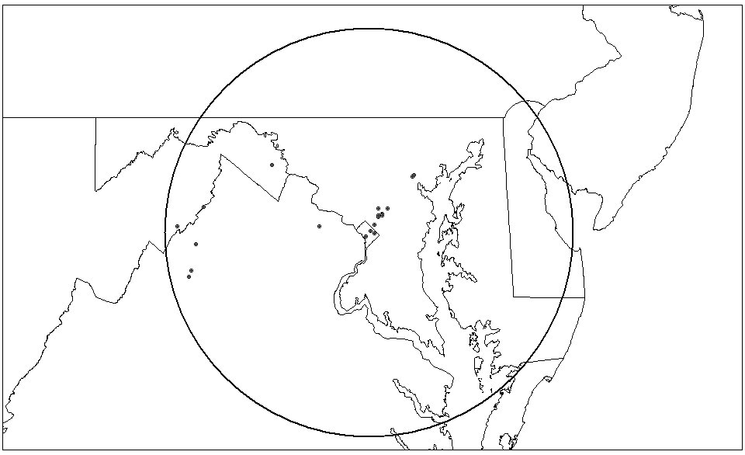
Figure 4-10. Plot of USDA Frequency Assignments within a 100 Mile Radius
of Washington, D.C. in the 162-174 MHz band

United States Department of Commerce (DOC)

The DOC mission is to promote job creation, economic growth, and improved living standards for all Americans by working in partnership with business, universities, communities, and workers to build for the future and promote U.S. competitiveness in the global marketplace by strengthening and safeguarding the nation’s economic infrastructure, and keeping America competitive with cutting-edge science and technology.

The DOC operates a variety of radio communications systems for weather data dissemination, National Oceanic and Atmospheric Administration (NOAA) Weather Radio (NWR), Emergency Managers Weather Information Network, as well as the more conventional systems found in most federal agencies. Many of these systems operate in bands other than the government Very High Frequency (VHF) band of 162-174 MHz. However, the DOC has the fourth largest amount of assignments in the Washington, D.C. area, with 182 assignments as shown in Table 4-3. The location of the GMF assignments is shown in Figure 4-3.

The DOC has two bureaus – the National Institute of Standards and Technology (NIST) and the National Weather Service (NWS) – that have frequency assignments in the outlined area and this band. The NWS has 74 assignments and NIST has nine, which are further described below. In addition, DOC has three assignments for the Office of the Secretary for the Silver Spring office and two other assignments in Baltimore.

National Institute of Standards and Technology (NIST)

Of NIST’s nine assignments, three are for police/fire/medical emergency communications, two for direct support of research and one for paging, and all are on or in the vicinity of the Gaithersburg campus. The other three serve to coordinate transportation, two transmitting in Washington, D.C., and one in Gaithersburg, Maryland. All operations are currently 25 kHz analog mobile and handheld radios. None of the operations use repeaters.

National Weather Service (NWS)

Many NWS assignments, both in and outside the Washington, D.C. area are associated with the collection and dissemination of meteorological information. These include
NWR stations, which operate continuously on one of seven frequencies (162.40-162.55 MHz) allotted for this use. This is a transmit-only broadcast type network. The Remote Atmospheric Monitoring and Observation System stations operate along U.S. coasts 24 hours a day on 163.325 and 163.350 MHz and report tide and other ocean data to central collection points. The hydrological stations operate 24 hours to collect such data as cumulative rainfall and rain rate, snow depth and stream height, typically at unmanned and remote locations. There are 60 hydrological assignments on the frequencies 169.425, 169.4375, 169.475, 169.5, 170.25, 171.1125 and 171.925 MHz.

DOC’s future plans indicate a one-for-one swap out of narrowband equipment for their current wideband radios. Some areas, such as the DOC security division, have already converted to narrowband analog operations.
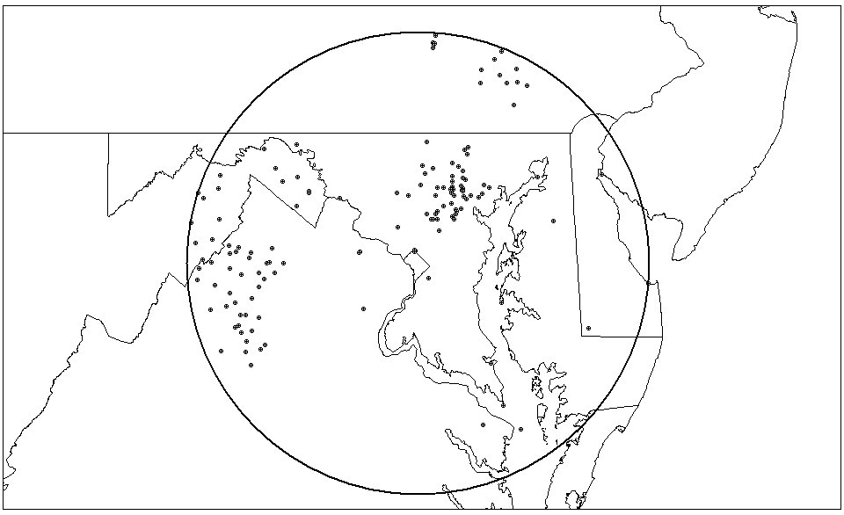
Figure 4-11. Plot of DOC Frequency Assignments within a 100 Mile Radius
of Washington, D.C. in the 162-174 MHz Band

United States Coast Guard (USCG)

The USCG is a military, multi-mission, maritime service and one of the nation’s five Armed Services. Its mission is to protect the public, the environment, and U.S. economic interests – in the nation’s ports and waterways, along the coast, on international waters, or in any maritime region as required to support national security.

The USCG has 14 assignments, as shown in Table 4-3, in the 162-174 MHz band, within the Washington, D.C. area. Figure 4-4 shows the location of those assignments. The USCG typically operates simplex, data encryption standard (DES), systems primarily for firefighting and security. The USCG has eight sites in the study area with all being fixed/mobile law enforcement or handheld building security. Currently, all channels are wideband (25 kHz); however, all USCG handheld and mobile radios are capable of narrowband analog and digital operation when required. The USCG is adding the 162-174 MHz and 406.1-420 MHz bands to their short-range Rescue 21 (R-21) communication system (talk-in coverage out to 20 miles from shore). R-21 will be capable of operating on the 40 discrete frequencies set aside in the VHF and UHF bands for interoperability between law enforcement and public safety organizations during disasters and emergencies. This will allow the USCG to communicate with federal, state, and local agencies operating on agency specific frequencies within the VHF (150.8–174 MHz) and UHF (406.1–420 MHz) frequency range. R-21 will be a P25/TIA 102 compliant digital narrowband system with console-to-console patch capability that can be used to link communications between the USCG and other federal, state, and local agencies that do not operate within R-21 frequency bands or use non-interoperable communication systems.
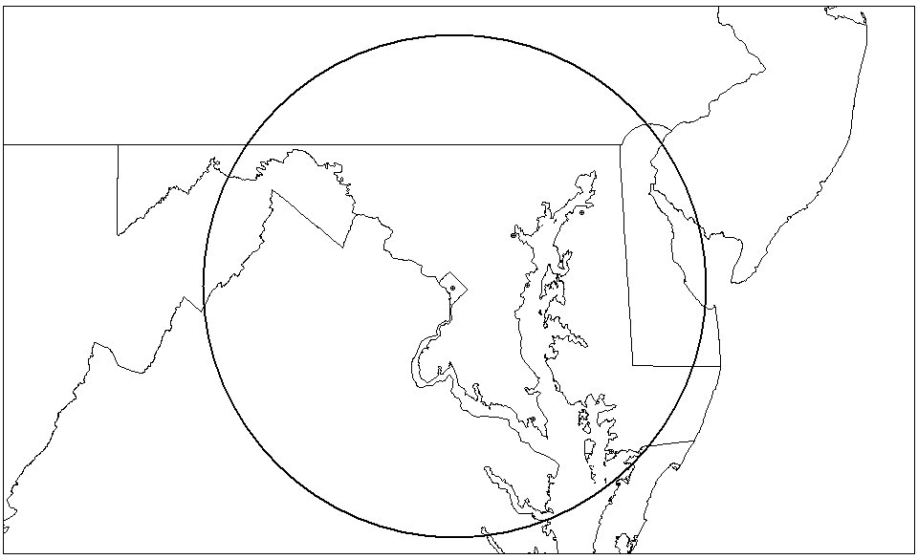
Figure 4-12. Plot of USCG Frequency Assignments within a 100 Mile Radius
of Washington, D.C. in the 162-174 MHz Band

United States Department of Defense (DOD)

The mission of the DOD is to defend United States territory and any occupied areas, overcome any aggressor that imperils our nation’s peace and security, maintain freedom of the seas, stabilize or contain international disturbances, and defend the United States through control and exploitation of air and space. The DOD is comprised of the four military branches: the Army, Navy, Marine Corps, and Air Force. DOD’s presence in the 162-174 MHz band is limited to base security (law enforcement), fire, and emergency medical services. Table 4-3 shows a breakdown of assignments by military branch and Figure 4-5 shows the location of those assignments for the Washington, D.C. area. The systems are typically wideband analog simplex or half-duplex channels using repeaters, where necessary, to extend the range of the net. On some bases, the Army has used cross-band repeaters to provide interoperability between security forces operating in different bands.

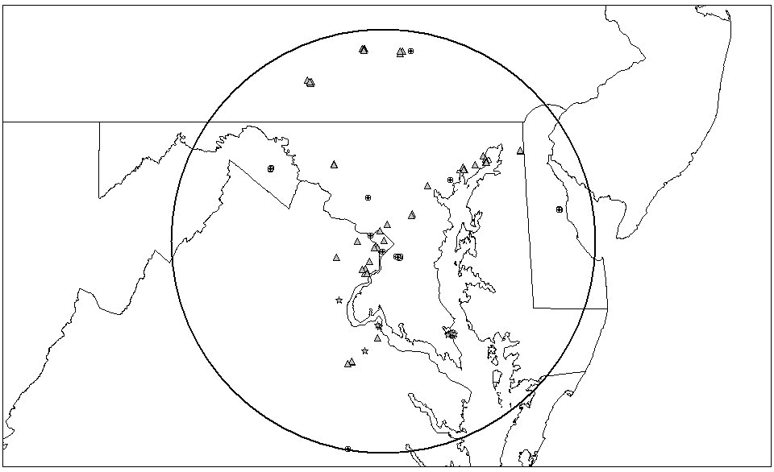
Figure 4-13. Plot of DOD Frequency Assignments within a 100 Mile Radius
of Washington, D.C. in the 162-174 MHz Band

The Army is developing a P25/TIA 102 compliant narrowband digital trunked system in the 380-400 MHz band to replace most systems currently in the 162-174 MHz band. Phase 1 of the Regional Concept 2005+ plan is tentatively scheduled to become operational by the end of 2004. The system will include all branches of the service and will expand region-by-region to eventually interconnect military installations throughout the United States.

United States Department of Energy (DOE)

The DOE’s mission is to advance the national and economic security of the United States; promote scientific and technological innovation in support of that mission; and ensure the environmental cleanup of the national nuclear weapons complex.

The DOE has 45 assignments, as shown in Table 4-3, in the Washington, D.C. area. Figure 4-6 shows the location of those assignments. The DOE already utilizes digital narrowband base stations, mobiles and portables to support a multi-channel force protection network between the headquarters building in Washington, D.C. and Germantown, Maryland. Each site operates on an independent pair of frequencies but can be linked via radio frequency (RF) to each other. This allows each site to have control of the Force Protection network. The network nominally operates in the digital narrowband mode, but has, on occasion, required encryption operation in wideband analog or digital modes. The DOE has other two-way repeater systems, a simulcast paging system, and simplex radios which are going to be gradually replaced with analog narrowband radios, due to the higher cost of digital narrowband equipment.

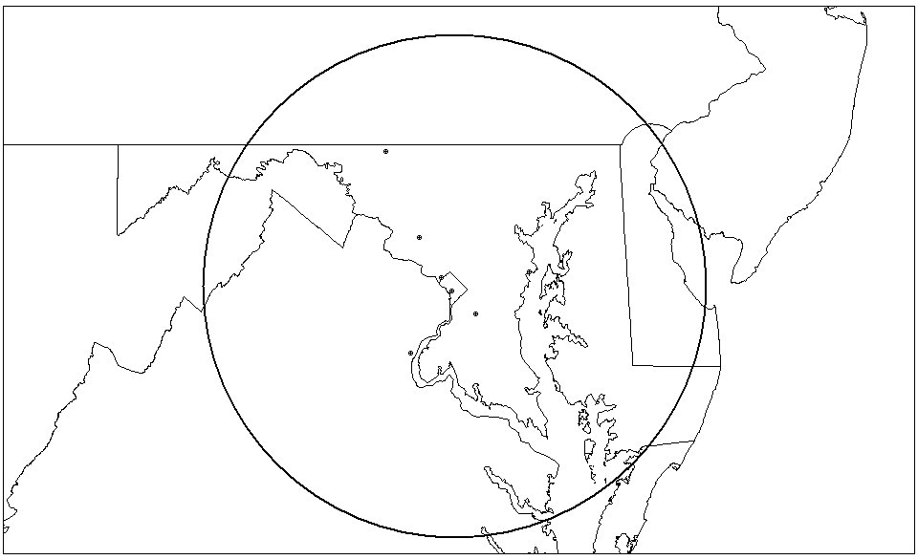
Figure 4-14. Plot of DOE Frequency Assignments within a 100 Mile Radius
of Washington, D.C. in the 162-174 MHz Band

Federal Aviation Administration (FAA)

The mission of the FAA is to provide a safe, secure, and efficient global aerospace system that contributes to national security and the promotion of U.S. aerospace safety. “As the leading authority in the international aerospace community, the FAA is responsive to the dynamic nature of customer needs, economic conditions, and environmental concerns.”

The FAA has 108 assignments, as shown in Table 4-3, in the Washington, D.C. area. Figure 4-7 shows the location of these assignments. Eighty-five percent of the FAA’s assignments are dedicated to meeting its nationwide land mobile requirements through its Command, Control and Communications (C3) program. Previously called the National Radio Communications System (NRCS), this conventional VHF/FM system is used to manage, operate and restore the National Airspace System in support of FAA, United States Department of Transportation (DOT), and DOD functions during national disasters and security emergencies. Also, this system provides daily support for airways facilities technicians, civil aviation security agents, air traffic administration, and flight standards. During local, regional, or national disasters or emergencies, field personnel use the network for command and control missions. The NCRS/C3 is not confined to urban areas or airports, but covers a wide territory to reach remote FAA facilities such as radars, microwave radios, and other navigation/communications facilities.

Currently, the FAA is upgrading and expanding its existing equipment to meet the NTIA 2005 narrowband mandate and provide greater command and control support in the aftermath of the events of September 11, 2001. Older, wideband analog radios are being replaced with new digital systems. Primarily, the FAA is replacing current repeaters and base stations on a one-to-one basis, using most existing frequency authorizations. In addition, the old NRCS frequency channel plan will remain the basis of the new C3 program. However, due to the need for expansion and changes in frequency allotments over the past two decades, there will be some alterations in geographical location and frequencies.
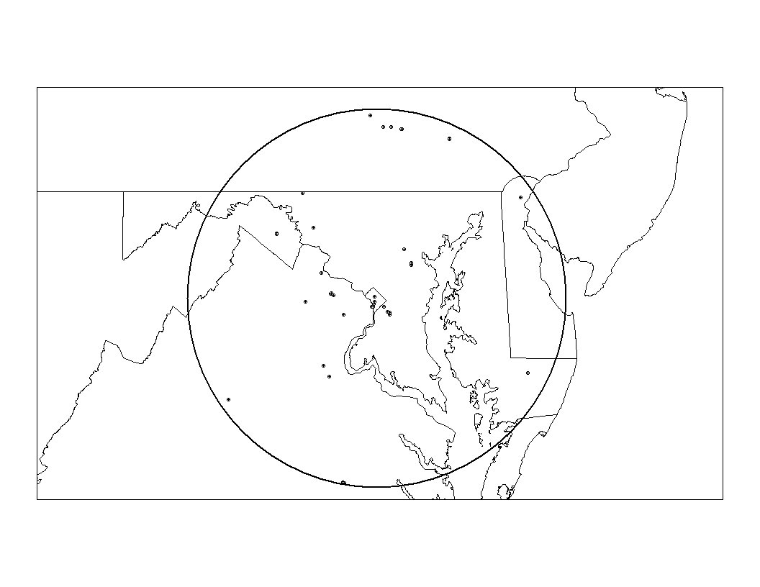

Figure 4-15. Plot of FAA Frequency Assignments within a 100 Mile Radius
of Washington, D.C. in the 162-174 MHz Band

United States Department of Homeland Security (DHS)

The DHS was created in March 2003, with its primary mission to protect the nation against further terrorist attacks. Component agencies will analyze threats and intelligence, guard our borders and airports, protect our critical infrastructure, and coordinate the response of our nation for future emergencies. Besides providing a better-coordinated defense of the homeland, DHS is also dedicated to protecting the rights of American citizens and enhancing public services, such as natural disaster assistance and citizenship services, by dedicating offices to these important missions. The DHS is a consolidation of agencies and bureaus from various departments, including: The Immigration and Naturalization Service (INS) (DOJ), The U.S. Customs Service (Customs) (Treasury), The Transportation Security Administration (TSA) (DOT), Federal Law Enforcement Training Center (Treasury), Animal and Plant Health Inspection Service (USDA), Office for Domestic Preparedness (DOJ), The Federal Emergency Management Agency (FEMA), Strategic National Stockpile and the National Disaster Medical System (Health and Human Services), Nuclear Incident Response Team (DOE), Domestic Emergency Support Teams (DOJ), National Domestic Preparedness Office (FBI), Chemical Biological Radiology and Nuclear Countermeasures Programs (DOE), Environmental Measurements Laboratory (DOE), National Biological Warfare Defense Analysis Center (DOD), Plum Island Animal Disease Center (USDA), Critical Infrastructure Assurance Office (DOC), Federal Computer Incident Response Center (Government Service Administration), National Communications System (DOD), National Infrastructure Protection Center (Federal Bureau of Investigation (FBI)), Energy Security and Assurance Program (DOE), the United States Secret Service (USSS) (Treasury) and the USCG (DOT). Although the GMF assignments from the various agencies have not been officially reassigned to DHS, as of November 2002, the department has the potential to become the largest user in the Washington, D.C. area in the 162-174 MHz band. DHS plans to join the IWN with Justice and Treasury as they change their legacy systems over to narrowband. For the purpose of this study, no GMF assignment records have been re-designated to DHS but remained under their previous departments or agencies.

United States Department of the Interior (DOI)

The DOI is the nation’s principal conservation agency. Its mission is to protect America’s treasures for future generations, provide access to our nation’s natural and cultural heritage, offer recreation opportunities, honor our trust responsibilities to American Indians and Alaska Natives and our responsibilities to island communities, conduct scientific research, provide wise stewardship of energy and mineral resources, foster sound use of land and water resources, and conserve and protect fish and wildlife. Within the United States, the DOI has radio communications requirements in support of the National Park Service, Bureau of Land Management, Fish and Wildlife Service, Bureau of Indian Affairs, Bureau of Reclamation, and the U.S. Geological Survey. It is the second largest user with 252 assignments, as shown in Table 4-3, in the Washington, D.C. area. The location of the assignments is shown in Figure 4-8. DOI primarily utilizes conventional simplex and half duplex analog wideband systems for building security, executive services, maintenance, and law enforcement. The DOI plans to convert all LMR radios to digital narrow-band. They are also in the initial planning stage, and are looking for partners, to establish and share a Washington, D.C. area P25/TIA 102 compliant digital trunked system with the U.S. Park Police.
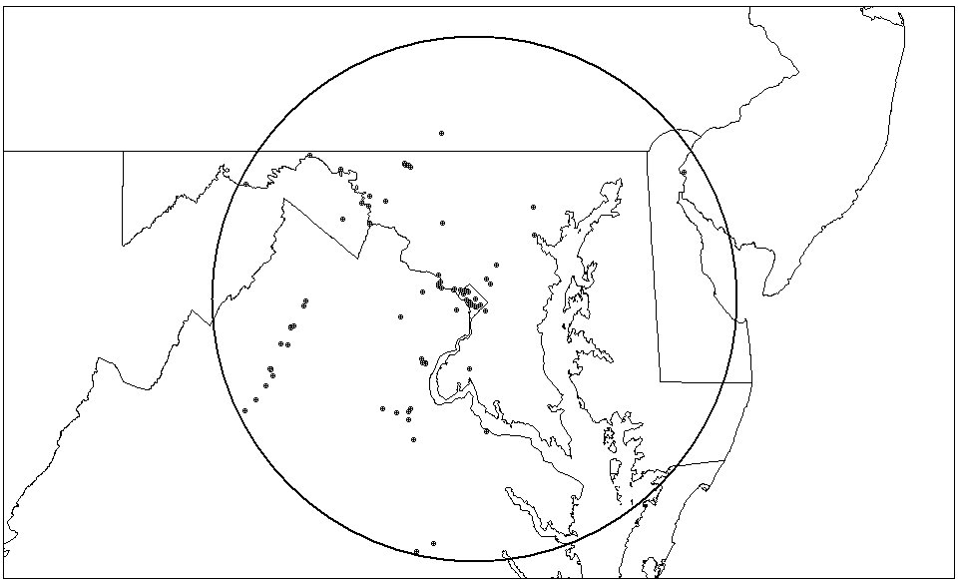
Figure 4-16. Plot of DOI Frequency Assignments within a 100 Mile Radius
of Washington, D.C. in the 162-174 MHz Band

United States Department of Justice (DOJ)

The DOJ has a primary mission to “enforce the law and defend the interests of the United States according to the law, to provide federal leadership in preventing and controlling crime; to seek just punishment for those guilty of unlawful behavior; to administer and enforce the nation’s immigration laws fairly and effectively; and to ensure fair and impartial administration of justice for all Americans.” Wireless communications are critical to meet these mission requirements. DOJ uses the 162-174 MHz band extensively for its LMR operations and it is the largest user of this band with 672 assignments, as shown in Table 4-3, in the Washington, D.C. area. The location of the assignments is shown in Figure 4-9. DOJ currently utilizes a series of multi-channeled, pseudo-simulcast (non-synchronized), wideband (25 kHz) analog repeaters located throughout the Washington, D.C. area. The system is also augmented with voting repeaters to “extend” the transmit range of the portable radios. Many of the voted receivers are connected to the network via landline.

The future plans for the DOJ involve the development of the IWN. The IWN initiative will consolidate all of the DOJ bureaus into a single LMR communications system. This new digital narrowband (12.5 kHz) system, which utilizes both the 162-174 MHz and 406.1-420 MHz bands, is being developed to increase spectrum efficiency, improve interoperability among all bureaus within DOJ as well as other federal law enforcement agencies, and maximize efficiencies and savings through shared communications systems. The IWN will consolidate the communications needs of the Office of the Attorney General, Federal Bureau of Investigation (FBI), Drug Enforcement Administration (DEA), Immigration and Naturalization Service (INS), U.S. Marshals Service (USMS), Bureau of Prisons (BOP) and various bureaus of the DHS. Section 6 of this report has a complete description of the IWN initiative.

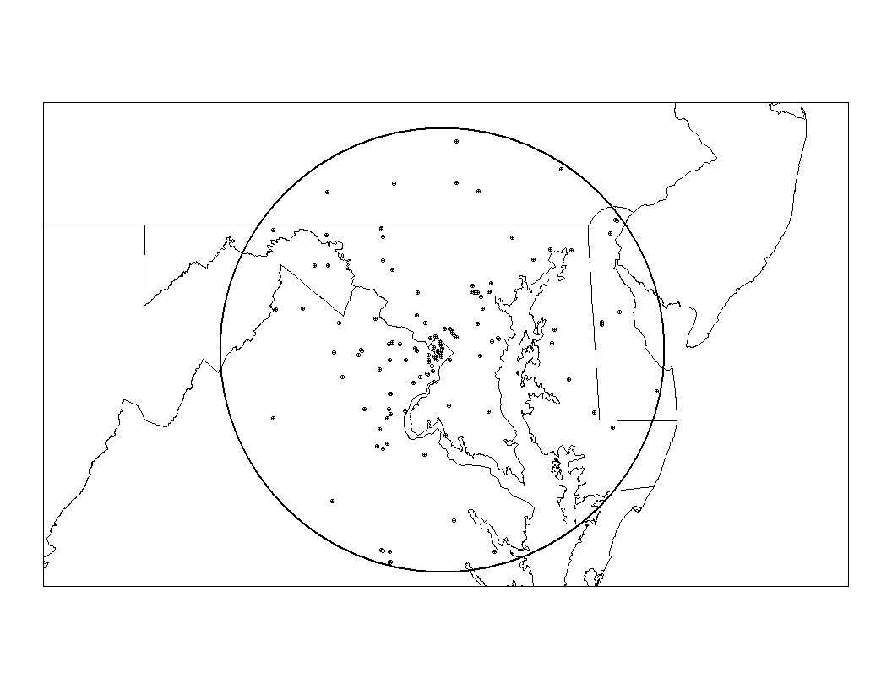
Figure 4-17. Plot of DOJ Frequency Assignments within a 100 Mile Radius
of Washington, D.C. in the 162-174 MHz Band

United States Department of the Treasury (Treasury)

The Treasury Department has a primary mission to promote prosperous and stable American and world economies, manage the government’s finances, and safeguard our financial systems. Prior to March 2003 Treasury also protected our nation’s leaders and pursued a safe and drug-free America. Wireless communications are critical to meet these mission requirements. For example, the USSS provides protection for the President, Vice President, and political leaders of the United States, as well as protection to visiting foreign dignitaries. Treasury uses both the 162-174 MHz and 406.1-420 MHz bands for 95 percent of its law enforcement and protection operations. The majority (more than 80 percent) of their land mobile radio equipment operates in the 162-174 MHz band. Treasury is the third largest user with 231 assignments, as shown in Table 4-3, in the Washington, D.C. area. The location of the assignments is shown in Figure 4-10. Treasury currently uses a variety of wideband analog systems based on the mission requirement. The USSS, due to their mission requirements, relies mostly upon mobile and hand-held radios, with repeaters, as necessary to extend the coverage of their radios. Treasury also has major in-building coverage requirements, such as bank vaults and building security, which requires them to use in-building repeaters for “campus” type communications. Treasury’s future plans include joining the IWN to satisfy the majority of their communications requirements.

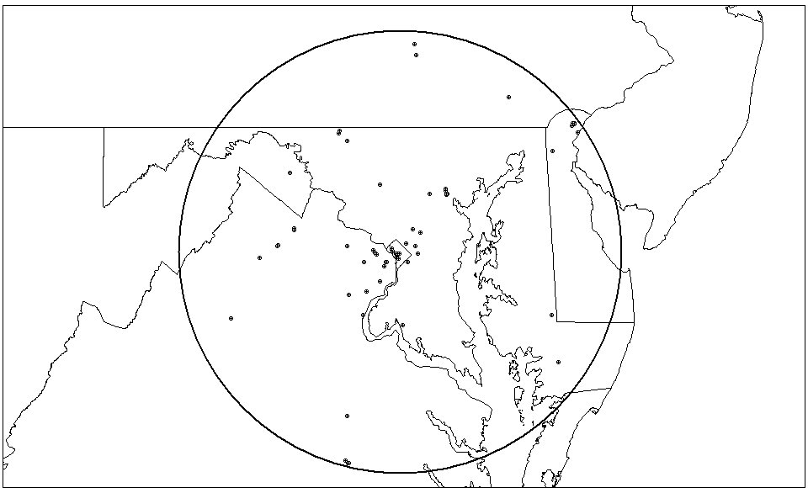
Figure 4-18. Plot of Treasury Frequency Assignments within a 100 Mile Radius
of Washington, D.C. in the 162-174 MHz Band

United States Capital Police (USCP)

The USCP is responsible for the safety and security of all members and staff of the United States House of Representatives and the United States Senate while they are physically located in and around the buildings of the Capitol campus and other locations within Washington, D.C. USCP also assists the United States Park Police, the United States Secret Service, Amtrak Police, Washington Metropolitan Area Transportation Agency (WMATA) Police, and the Washington, D.C. Metropolitan Police as needed for motorcades, demonstrations, emergency responses, and other special events.

In the Washington, D.C. area, the USCP has 25 assignments, as shown in Table 4-3. Figure 4-11 shows the location of those assignments. The USCP has ten frequency assignments in the VHF spectrum for use in the Washington, D.C. metropolitan area. These are paired into five channels used as a voting repeater system with satellite receivers and high power base stations. The combination of over 100 satellite receivers and high power transmitters provides officers and agents of the USCP with coverage of the Capitol and all buildings in the Capitol campus as well as off-campus communications in the Washington, D.C. metropolitan area. The USCP also has one shared frequency pair assignment for use when outside the Washington, D.C. metropolitan area.

The five “in-town” frequency pairs are used for voice communications 365 days per year. The single shared “out-of-town” assignment pair is used when the members Congress have a scheduled offsite event that requires a presence of officers and agents of the USCP for security and protection. The USCP also provide on-site security for congressional retreats and conferences at remote locations. While securing these locations, USCP utilizes shared frequency assignments to coordinate their efforts.

The USCP intends to continue conventional analog voice operations on all the existing assigned VHF frequencies to comply with the narrowband requirements. Equipment that is narrowband compliant is currently being purchased and issued to the officers and agents. The target date to complete the conversion to narrowband is late November 2004.

The USCP is planning to implement a full simulcast site on their Channel 4 (wide area channel) and a multi-transmit (simulcast, not timed) site on Channels 1, 2, 3, and 5 near Cheltenham, Maryland, where the new Federal Law Enforcement Training Center (FLETC) is being built. The USCP is planning to have a backup command center at the Cheltenham facility. There are no plans at this time to convert to any form of digital, shared agency, or trunked voice communications.

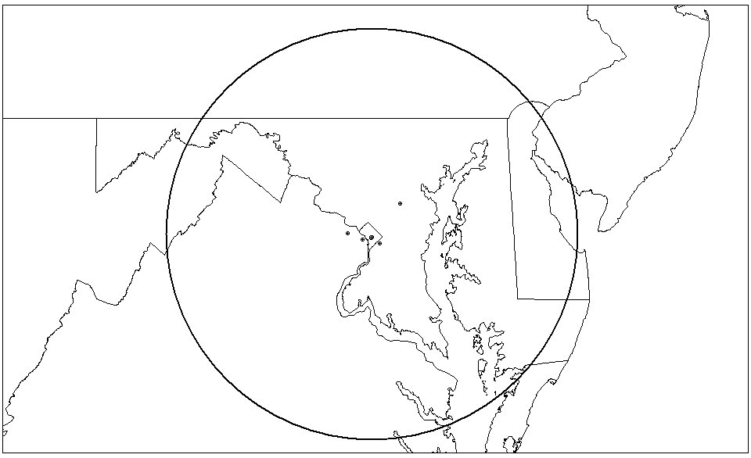
Figure 4-19. Plot of USCP Frequency Assignments within a 100 Mile Radius
of Washington, D.C. in the 162-174 MHz Band

United States Postal Service (USPS)

The USPS is a national institution that is an integral part of the infrastructure of the American economy. The USPS “binds the nation together through the business, literary, and personal correspondence of the people, providing prompt, reliable service to all communities as required by the Postal Reorganization Act of 1970.”

The USPS has 41 area specific assignments, as shown in Table 4-3, in the Washington, D.C. area. Figure 4-12 shows the location of these assignments. The USPS is divided into two major bureaus, the Mail and U.S. Postal Inspection Service both of which use the LMR system in the VHF band.

Mail Bureau

Currently, the Mail Bureau utilizes LMR systems at mail processing facilities within the Washington, D.C. area. These facilities have extensive requirements for in-building communications. The communications systems are used for maintenance, mail processing, safety and emergency operations. The communications at these facilities typically provide coverage around the facility for about 2-3 miles. The configuration presently is analog with multiple repeaters and an extensive in-building antenna system throughout the facilities. In some facilities, there are outside communications between mobiles and the repeater. The USPS is in the process of converting the wideband VHF systems to narrowband.

The Mail Bureau anticipates that the present VHF assignments for internal building communications will move to the UHF band. External mobile communications, however, will most likely remain in the VHF band. Both UHF and VHF equipment will remain analog.

U.S. Postal Inspection Service

Presently, the U.S. Postal Inspection Service utilizes conventional analog VHF LMR assignments for both in-building and external communications between repeaters, bases, mobiles and handhelds. The U.S. Postal Inspection Service is moving toward a UHF communications system. The wideband VHF assignments will be eliminated in place of UHF narrowband multi-link technology. There will be some VHF narrowband assignments to be used for interoperability between the bureaus and other law enforcement agencies.

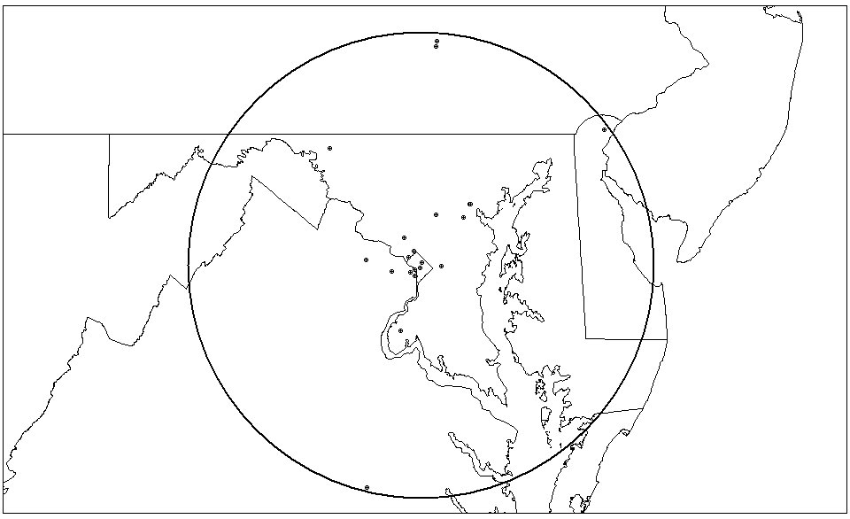
Figure 4-20. Plot of USPS Frequency Assignments within a 100 Mile Radius
of Washington, D.C. in the 162-174 MHz Band

United States Department of Veterans Affairs (VA)

The VA’s mission is to provide integrated and innovative health care services and benefits to eligible veterans and their beneficiaries. The VA has 30 assignments, as shown in Table 4-3, in the Washington, D.C. area. Figure 4-13 shows the location of these assignments. The VA operates several conventional wideband systems in the area supporting law enforcement, fire and security, emergency medical services, and maintenance in and around their hospital grounds and headquarters. The VA is in the process of moving its Washington, D.C., LMR operations out of the VHF band and joining the 1CommWireless narrowband trunked system, a commercial service operating in federal spectrum. The VA’s Baltimore operation has already transitioned to analog narrowband and is expected to remain analog until the end of the equipment’s life cycle.

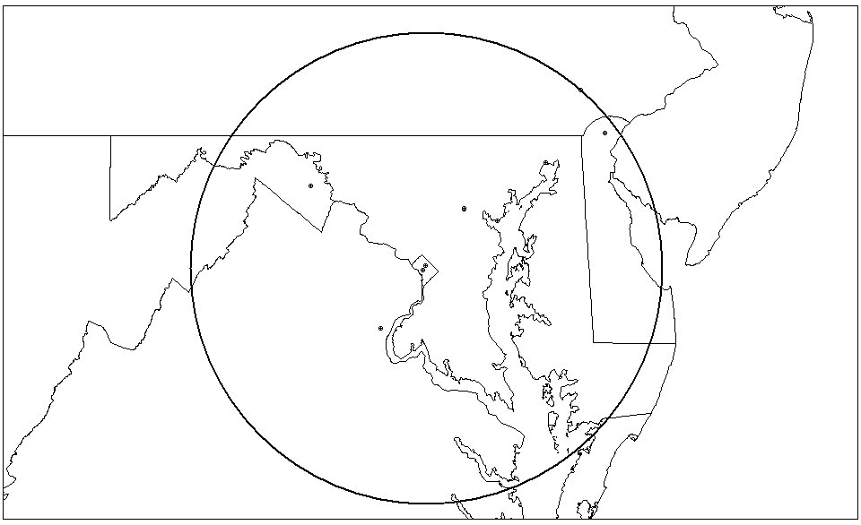
Figure 4-21. Plot of VA Frequency Assignments within a 100 Mile Radius
of Washington, D.C. in the 162-174 MHz Band

Other Agencies or Bureaus

Agencies or bureaus within this group are comprised of various federal government entities that have twenty or fewer assignments in the 162-174 MHz band within the Washington, D.C. area. Table 4-3 provides a list of the other agencies or bureaus and breakdown of their assignments. Figure 4-14 provides the location of these assignments. The assignments used by these entities are primarily used for law enforcement, building security, administrative, maintenance, or paging. Most agencies utilize simplex or half-duplex analog wideband networks, with some of the larger networks (e.g., the Government Services Administration’s in-building maintenance network), utilizing base stations or repeaters to provide the necessary in-building coverage for the numerous federally owned buildings they are responsible for. Some agencies, such as the Social Security Administration, are sharing frequencies and networks with other agencies because they do not have large enough requirements to justify their own systems. Most of the nets are agency-exclusive and the area of coverage required is just their headquarters building or buildings within a “campus” type environment. Future narrowbanding requirements for many of these agencies will be accomplished by a simple one-for-one swap-out of analog wideband to analog narrowband radios. Other agencies, such as the State Department, have already migrated to conventional narrowband digital radios.

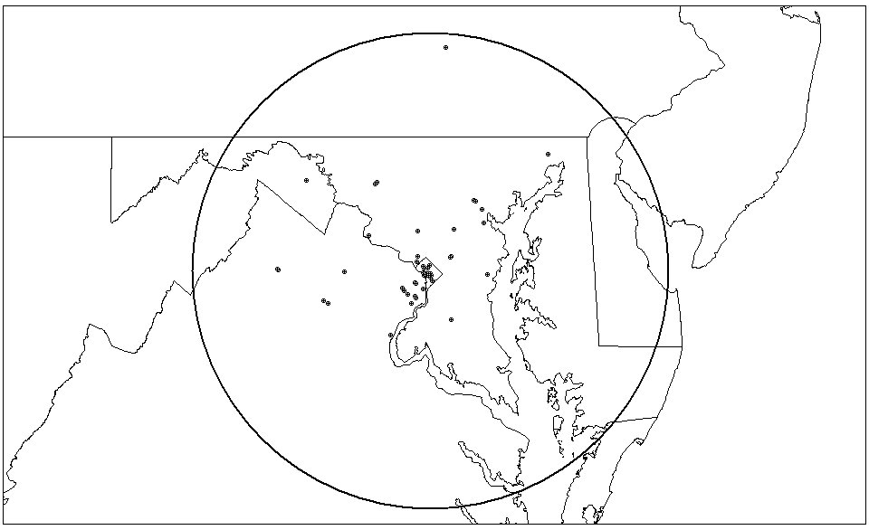
Figure 4-22. Plot of Other Agency or Bureau Frequency Assignments within a 100 Mile Radius
of Washington, D.C. in the 162-174 MHz Band

Summary

This section provides an overview of the federal agencies’ uses of the 162-174 MHz band in the Washington, D.C. area. In the early 1990’s, NTIA mandated that the federal agencies migrate to more spectrally efficient narrowband technologies in this band by January 1, 2005. Agencies are at different stages of meeting the narrowband mandate (see Section 5). This includes: already procured narrowband equipment to replace wideband radios, narrowband equipment on order, new systems proceeding through the test and evaluation phase, or having plans in development for replacement systems. Some agencies stated that due to their unique mission, sharing of systems may not be practical, while other agencies stated that if the opportunity were presented to them, they would consider joining a shared system (e.g., IWN).

OTHER FEDERAL GOVERNMENT EFFORTS

REGARDING SPECTRUM EFFICIENCY

General

Since there is limited land mobile spectrum, agencies must employ new technologies and techniques to satisfy future requirements. The areas in which the federal government is implementing new technologies and techniques to improve spectrum efficiency include, but are not limited to, the following: migration to narrowband technology, integrated wireless networks, performance standards, and trunking technology. This information is important to understand for potential incorporation into the study. This section provides a brief discussion of some of the various mandates, initiatives, and programs for improving spectrum efficiency in the federal government.

Migration to Narrowband Technology

In 1992, Congress passed the Telecommunications Authorization Act of 1992. Title I of this act required NTIA to develop and implement a plan to make federal LMR systems use more spectrum efficient technologies. A report summarizing the plan and its implementation schedule was prepared and submitted to Congress as required by the legislation. As part of this plan, NTIA selected a 12.5 kHz channel width for re-channeling (or re-farming) the federal fixed and mobile bands. The reduction in channel width from 25 kHz to 12.5 kHz will effectively double the number of available channels in the 162-174 MHz and 406.1-420 MHz bands.

The federal public safety agencies’ pursuit of more spectrum efficient technologies is a necessary tool to satisfy the growing demands for wireless communications within the federal government. As stated in the previous section, the federal agencies are in various stages of meeting the NTIA narrowband mandate.

Technical Performance Standards

NTIA has long been an advocate of technical standards for receivers to minimize interference and increase overall spectrum efficiency. In addition, state and local public safety entities are also recognizing the importance of establishing receiver standards to minimize interference. As the demand for wireless services continues to grow, straining the limited spectrum resources that are available, it is becoming increasingly important to manage the resource by considering total system performance. Thus, both the transmitter and receiver performance characteristics must be considered for maximum spectrum efficiency. In the 162-174 MHz and 406.1-420 MHz bands, NTIA has adopted receiver performance standards, in addition to transmitter performance standards, that include: intermodulation rejection; adjacent channel selectivity; and spurious response attenuation. NTIA and the federal public safety agencies believe that receiver performance standards are necessary to reduce interference from adjacent channel transmitters. This will allow transmitters and receivers to operate closer to each other, improve performance, and increase the overall efficiency of these bands.

On March 24, 2002, the FCC released a Notice of Inquiry (NOI) that requested information to a variety of questions pertaining to the use of receiver standards. NTIA submitted reply comments to the FCC’s NOI encouraging the use of receiver standards, where appropriate, to prevent interference and utilize the spectrum more efficiently.

The federal public safety agencies have also engaged in a long-term standards development process known as P25/TIA 102, a collective effort by industry and the state and local public safety agencies. This multi-phase effort has resulted in the development of an extensive set of standards for digital public safety wireless communications. Phase 1 of P25/TIA-102 specifies a 12.5 kHz channel width consistent with the NTIA narrowband mandate. Phase 2 provides a migration path to a narrower channel width of 6.25 kHz (or equivalent) as technology permits. The technology readiness obstacles currently associated with P25 Phase 2 include battery size and weight, linear amplifiers, and oscillator stability. Also, based on information from manufacturers, the 6.25 kHz Phase 2 option is likely to be delayed several years due to technical problems with encryption techniques in very narrow bandwidths.

Trunking Technology

The use of trunking technology as a means of increasing the efficiency and utility of spectrum resources is starting to be considered within the 162-174 MHz band and is already in use in the 406.1-420 MHz band. Federal agencies use trunked systems for limited areas with a high concentration of use and for campus environments, such as federal prisons, hospitals, laboratories, and training facilities. The DOD has the largest number of trunked systems operating and planned within the 406.1-420 MHz band. DOD uses these systems to satisfy the important needs of national security, training, administration, and emergency preparedness at its various facilities. Some planned federal systems, such as the IWN and the DOD Enhanced Land Mobile Radio (ELMR) System, will use trunking technology in their designs to satisfy some of their requirements, especially in areas with large concentrations of users.

162-174 MHz Band Restructuring

Although specifications and standards have long existed for equipment operating within the radio spectrum environment, the 162-174 MHz band is currently unstructured in its accommodation of user applications. Specifically, the current band allocation does not include separate frequency sub-bands for base station transmitters and mobile transmitters. Historically, this has not presented insurmountable difficulties for user applications within the band because spectrum has been readily available and most applications use simplex technologies. However, as the band becomes more congested, the ability to obtain additional suitable spectrum becomes increasingly difficult, even with the implementation of improvements in equipment technology (e.g., 12.5 kHz channels). As more users move to repeaters, trunked systems, and other technologies that require duplex frequencies, the need for a structured band becomes more evident. Structuring a band that already exhibits heavy use is a complicated process, and can also have numerous implications for spectrum management, the users, and their associated operations already within the band.

Frequency Reuse

Although the amount of spectrum available is finite, any given portion of spectrum can be re-used many times over, depending on the right circumstances. In many cases, the “right circumstances” includes the requirement that multiple users be separated by enough geographical distance so that the signals from the various user radios do not interfere with each other. If too large a distance is chosen, frequency re-use efficiency will suffer and not as many users will be able to use that frequency. If too small a distance is chosen, user systems will interfere with each other.

For routine licensing in a common radio service (e.g., federal LMR systems), theory and practical experience have often been summarized in procedural “rules-of-thumb” that require different users, on the same frequency, be separated by some fixed distance, e.g., 100 miles. For a specific set of users, however, the required minimum separation distance can vary over a wide range, depending especially on the propagation of radio signals over the specific terrain that separates the specific users. For a specific set of users and terrain, the rule-of-thumb separation distance can be much too large, resulting in inefficient frequency re-use. However, if the rule-of thumb distance is too small, interference may result.

The frequency reuse issue can be investigated in several ways. First, the existing procedure for establishing separation distances can be compared to terrain-dependent propagation models, agency requirements, and required signal to interference ratios for new systems. Once this is accomplished, it can be determined if existing separation policies could be refined to provide improved frequency re-use criteria. Secondly, possible changes in spectrum management techniques could be examined to determine whether the use of more accurate technical modeling used to routinely evaluate the required separations for specific users, will provide a useful amount of improved geographical frequency re-use. In this case, “useful” means a balance between improved re-use and the increased cost of processing a user assignment, as well as less future flexibility to make use of an assignment.

In addition, it should be noted that frequency re-use can be enhanced by deliberately restricting the size of transmitter coverage areas (e.g., low power/low antenna height sites). Such techniques also greatly decrease the required minimum separation distance for re-using a frequency. Although such small-cell techniques have been widely used by cellular systems, they have not yet been widely used by public safety agencies due to costs associated with constructing additional sites. Nevertheless, public safety agencies may potentially benefit from the use of small cells in a dense urban setting. The subject of frequency reuse as it relates to spectrum efficiency will be addressed in subsequent phases of this report.

Initiatives And Spectrum Efficiency Improving Programs

NTIA Spectrum Summit

NTIA held a Spectrum Summit in April 2002 to help identify the best solutions to challenges posed by management of the nation's airwaves. The purpose of the spectrum management and policy summit was to explore new ideas to develop and implement spectrum policy and management approaches that will make more efficient use of the spectrum; provide spectrum for new technologies; and improve the effectiveness of domestic and international spectrum management processes.

During the Spectrum Summit one of the major concerns expressed by the federal and private sector spectrum management community, and radio service users and providers, was future spectrum availability to satisfy needs to expand services and to accommodate new technologies. It was suggested that additional spectrum to fulfill these needs could possibly come from current users improving their spectrum efficiency through new technologies or creative assignment approaches, increased sharing, more realistic interference protection criteria, or some combination of all of these.

Federal Communication Commission’s (FCC) Spectrum Policy Task Force

In June of 2002, the FCC convened the Spectrum Policy Task Force to address a number of policy issues important to improving the way spectrum is managed. One primary issue addressed by the task force was spectrum efficiency. Spectrum efficiency questions focused on how to promote and measure spectrum efficiency, while protecting the ability of public safety entities to do their jobs in light of the increasing demand for spectrum. In its attempt to develop a method to measure spectrum efficiency, the task force concluded that, due to differences in radio services, it was not feasible to select an objective means to compare unlike services and users. The Task Force identified three variations on and definitions for the term “efficiency” as applicable to spectrum management: spectrum efficiency, technical efficiency and economic efficiency.

Both NTIA’s Spectrum Summit and the FCC’s Spectrum Policy Task Force provided valuable insight into current thoughts on spectrum efficiency. One of the common themes expressed in both forums is improving spectrum efficiency, especially in the bands used for mobile communications. Many have observed that the federal government agencies have fewer mobile users per unit of the spectrum than is true for business, non-federal public safety, or commercial (cellular phone and PCS) applications. Public safety users require high reliability and availability with frequency channels whose traffic loads change drastically with planned or unplanned events. As a result of these operational requirements, federal public safety frequencies are not in use all of the time, which could be perceived as inefficient use of the spectrum. Additionally, federal users generally require frequencies on a nationwide basis, limiting the ability to re-use much of what is used.

General Accounting Office (GAO) Reports

The GAO, in its report on improving spectrum management, found that, although NTIA has oversight activities that encourage efficient use of the spectrum, the lack of resources has hindered the agency’s effectiveness. Lack of resources was also an issue for the federal agencies. In fact, the federal agencies reported difficulties implementing NTIA initiatives such as land mobile narrowbanding, primarily due to staffing, priority, and budget issues. The report also points out that many federal government uses of the spectrum do not have commercial counterparts and cannot easily be compared using common efficiency measures, such as the number of subscribers per hertz. The report also briefly explored the concept of using spectrum fees as an incentive for spectrum efficiency. Interestingly, at least one of the agencies interviewed stated that NTIA’s current reimbursement structure for spectrum management services was not large enough to encourage spectrum efficiency. Spectrum fees to encourage efficiency versus fees to recover the cost of spectrum management will be addressed in a follow-on study.

In another report on current issues relating to spectrum management, the GAO, through interviews with agency and industry officials, attempted to determine how the federal government encourages efficient use of spectrum by federal agencies. In findings similar to the previous report, the GAO concludes that NTIA is required by law to promote the efficient and cost-effective use of the spectrum it manages. The process by which NTIA certifies and authorizes (assigns) spectrum is designed to promote efficiency, but the justification for use of spectrum and review of current assignments is largely left up to the individual agency. The GAO found that inadequate resources were the primary reason for a lack of comprehensive review of assignments, preventing any enforcement or monitoring activities to identify and return unused spectrum. GAO found that, in many cases, the five-year review process, the primary tool that NTIA uses to determine if assigned spectrum is actually used, is either not accomplished or overdue.

Presidential Initiative to Develop, Implement Spectrum Policy for the Twenty-First Century
On June 5, 2003, President Bush announced a new initiative to develop a radio spectrum policy for the Twenty-First Century. The Executive Memorandum directs the DOC to facilitate policy changes to create incentives for more efficient and beneficial use of spectrum and to provide a higher degree of predictability and certainty in the spectrum management process as it applies to incumbent users; and develop policy tools to streamline the deployment of new and expanded services and technologies, while preserving national security, homeland security, and public safety, and encouraging scientific research. The Secretary of Commerce announced the formation of a high-level interagency task force under the Executive Memorandum issued by the President that will recommend ways to stimulate more efficient use of the radio frequency spectrum by federal government users. The task force will provide recommendations that promote effective, efficient and beneficial use of spectrum without unacceptable interference to critical incumbents.
As a part of the initiative, NTIA published a NOI seeking comments on policy reforms relative to the management of the radio frequency spectrum. The NOI contains a list of questions to assist in identifying issues that may need to be addressed in changing U.S. spectrum management policies. Comments to the NOI were due May 2004.

The recommendations resulting from these activities were included in a two-part series of reports released by the Secretary of Commerce in June 2004, under the title Spectrum Policy for the 21st Century- The Presidents Spectrum Policy Initiative. These reports contain recommendations regarding the efficient use of the radio spectrum.

SAFECOM Program Office

SAFECOM was established in the spring of 2002 to address the wireless communication needs of public safety organizations. SAFECOM serves as the umbrella program within the federal government to help local, tribal, state and federal public safety agencies improve public safety response through more effective and efficient interoperable wireless communications. As a public safety practitioner driven program, SAFECOM is working with existing federal communications initiatives and key public safety stakeholders to address the need to develop better technologies and processes for the cross-jurisdictional and cross-disciplinary coordination of existing and future communications systems.

1CommWireless (Formerly FEDSMR)

The Washington/Baltimore system, operating under the name of 1CommWireless, is one of several federal communications systems in the northeast and southeast that is owned and operated by a commercial vendor that provides service to federal users. The Washington/Baltimore system is currently transitioning to a new narrowband, multi-site system using the transcript protocol (this protocol provides a digital backbone supporting system enhancements such as seamless roaming, over-the-air re-keying (OTAR), console interfaces, privacy, and compatibility with other systems). Radio equipment for use on the system is available from several vendors at a price considerably less than the wideband radios formerly employed on the company’s previous analog system. The sites include Baltimore Washington International airport, Martinsburg, West Virginia, Veterans Administration Building at Lafayette Park, Crystal City, and Dulles Airport with several others currently under consideration. The system will be using twenty channel pairs that will be reused throughout the area similar to cellular radio’s reuse of the spectrum. The frequencies are assigned to NTIA, which permits the contractor, in this case, 1CommWireless to use the frequencies to provide telecommunication services exclusively to the federal government in the 406-420 MHz government band. This system supports over 2,000 subscriber units. Current federal government agencies using the 1CommWireless system include Bolling Air Force Base, Smithsonian Institution, United States Holocaust Memorial Museum, United States Senate, Office of the Inspector General, and the Naval District of Washington Transportation among others. These user organizations pay a monthly fee based on the number of subscriber units accessing the system. Depending on the number of talk group assignments, monthly fees may be as low as $24.00 a month.

Federal agency participation in the 1CommWireless system is relatively small compared to the overall federal government radio equipment usage in the Washington/Baltimore area. This is because there are large government owned and operated systems in the area that were in operation before the 1CommWireless system became operational in 1990.

Integrated Wireless Network (IWN)

The U.S. House of Representatives, Committee on Appropriations Report addressed the issue concerning narrowbanding of the current DOJ land mobile systems. Specifically, it was noted that any DOJ narrowband conversion initiative must be based upon a comprehensive strategy, which achieves as one of its goals “maximized efficiencies and savings through shared infrastructure and common procurement strategies.” To increase spectrum efficiency and maximize the limited spectrum resources available to federal public safety agencies, DOJ, DHS, and Treasury are developing the IWN to address the needs of the numerous bureaus and agencies within their departments. The IWN will provide national coverage through hybrid LMR systems, which will consist of both trunked and conventional digital narrowband equipment.

Overall spectrum planning and support activities critically influence the IWN network design through four distinct phases.

- Phase 1 – Existing Capabilities Survey. In this phase, existing users within the scope of the IWN project design area are identified and defined by Operations and Engineering, and then characterized in accordance with their legacy system operational capabilities, coverage, and requirements.

- Phase 2 – Operational Requirements Definition. In this phase, user requirements anticipated to be supported by the IWN network are specifically defined by Operations. This phase is critical in determining the overall spectrum resources necessary for support of IWN network operations.

- Phase 3 – Frequency Selection and Assignment Processing. The third phase involves detailed identification and formal coordination/processing of the specific frequency assignments required for site operations within the IWN.

- Phase 4 – Operational Transition/Implementation. The final phase of spectrum planning and transition activities within the IWN is heavily predicated on the availability of the selected frequency resource to support the network’s overall operation channeling requirements.

Once the planning phases are concluded, an initial pilot test project will be conducted in the State of Washington. The IWN will be based on digital technical standards that maximize the use of the available spectrum and will be P25/TIA 102 compliant. The IWN is planned to increase spectrum efficiency through shared infrastructure and utilizing digital narrowband technology. The system will also provide economies of scale through common procurement strategies.

With limited spectrum resources in the 162-174 MHz and 406.1-420 MHz bands, more federal public safety agencies are looking at IWN-type systems to maximize the use of spectrum resources to meet the increasing spectrum demands of their agencies.

United States Department of Defense Trunked Network

The Department of the Army is planning to implement a P25/TIA-102 compliant, voice over internet protocol (VoIP) capable, digital narrowband trunked system in the 380-400 MHz band. The Regional Concept 2005+ plan is to expand the system region-by-region to eventually connect military installations throughout the United States. Most of the current operations using the 162-174 and 406-420 MHz bands will relocate to this new system. The system will be built-out in two phases. The first phase build-out will include Army installations within the National Capital Region (NCR) and the Military District of Washington (District of Columbia, Virginia, Maryland, and New York), along with a Navy system at the Navy Annex, Quantico Marine Base, Quantico, Virginia. The second phase build-out will include Navy and Air Force installations within the NCR. Dispatcher requirements will be controlled by digital consoles, or via mobile or base station assigned to each team or agency at the installation. The trunked system will be controlled from a central location by means of a Communications System Director, to facilitate collection of usage data, dynamic system configuration and reconfiguration, and control. Connectivity to the alternate zone and system controller main repeater site will be via T1, fiber, and hardwire over existing infrastructure, or constructed RF line-of-sight systems. Users will be comprised of DOD Operations, Defense Protective Service, fire departments, law enforcement center, medical, force protection, information management, administrative, public works, and Emergency Operations Center, training, and post support. The system is planned to employ cross band capabilities to allow interoperability with the multitude of federal, state, and local agencies in the area.

Page 5-10/Blank

THE SIGNAL CAPACITY ANALYSIS PROGRAM (SCAP)

General

One of the first steps in designing future spectrum efficient radio networks for federal radio systems in the Washington, D.C. area is to understand how much service is needed, of which types, and in what locations. The SCAP is designed to process existing GMF data to provide this radio service information. Every federal agency using the radio spectrum must have frequency assignments (licenses) listed in the GMF for every transmitter in use. Therefore, the GMF should contain frequency records corresponding to all federal radio systems in use in the Washington, D.C. area. Moreover, these GMF records will usually contain sufficiently detailed technical information that the records can be analyzed to accurately estimate the coverage area of the selected assignments. For this Phase 1 study, the GMF data were analyzed for all assignments located within a 100-mile radius of Washington, D.C. for frequencies within the 162-174 MHz federal land mobile band and supplemented with agency inputs.

Definition of Signal Capacity

There are several ways to define the amount of “service” provided by a given radio system. These definitions need to reflect the type of service provided by the particular radio systems, e.g., a radar system would be defined by completely different factors than a mobile radio. Different service definitions would be assumed to provide different types of information, would present various difficulties in obtaining the required information, and would have different applicability to the problem of providing specifications for a future radio system. The definition of radio service selected for this work is called signal capacity (SC). The SC is defined as the number of independent 2-way voice radio channels that can be received by a mobile radio user at a given geographical location. Note that the definition includes the word “received” rather than a phrase like “used by.” The SCAP considers only base station transmitters and the geographical distribution of the field strength that they produce. This model is based only on the base-to-mobile signals that can be received by mobile users. The SC model includes no information about base station receivers, or any receivers whatever. However, any future radio system designed to meet the SC specifications produced by the SCAP would also need to meet suitable base station receiver functions (possibly including receive-only sites) and (probably) be capable of mobile-to-mobile operation.

This SC definition is particularly useful for several reasons:

- The major service provided to federal users in the 162-174 MHz band is two-way voice channels to mobile users. Therefore, this definition captures most of the use in the 162-174 MHz band.

- The SC is additive. This means that the SC produced by Agency X assignments can be added to the SC associated with Agency Y assignments to obtain a SC for both agencies.

- The SC can be calculated from data that is available in GMF license records and technical models, including transmitter data, terrain/ground cover data, and propagation models.

- The SC could be used to design alternative future radio systems, which would provide coverage to various geographical areas, using a sufficient number of transmitter channels to match or exceed the respective SC values.

However, the SC definition makes many simplifications that may limit its usefulness in specific circumstances. These include:

- There is no data on whether a given channel is lightly or heavily used. However, the existence of a radio channel used or not used suggests that the system was built for a reason, and that reason still must be presumed to exist when a future system is built to replace the existing radio system.

- All voice channels are considered identical, whether analog or digital, narrowband or wideband, simplex or duplex, high priority or low, etc. Equally important, SC only considers the radio link, with no distinction as to what capabilities are available via that link: data, encryption, database access, telephone access, wide area access, etc. For the purpose of SC, “a channel is a channel is a channel.”

- Only permanently sited transmitters (and their corresponding coverage areas) are considered here; all receiver assignments and mobile transmitters are ignored. Future studies on designing replacement systems will also need to duplicate receiver coverage specifications (e.g., receive-only sites etc.). It is assumed mobile transmitters would probably not be replaced by a new permanent infrastructure. Therefore they do not need to be included.
- Many assignments include multiple station classes, different emission designators, and different transmitter powers. The SCAP analyzes the highest power signal from these multiple sets of specifications, giving the largest possible coverage area. In some cases, the assignments may authorize the use of transmitter power higher than the actual transmitter power installed.

- A single coverage criterion is used with SCAP, although various agencies may require a variety of coverage definitions. For example, some agencies may require high-reliability, in-building access to portable receivers, while other agencies may accept less reliable
rural access via outdoor vehicular radios. A single criterion of 10 microvolts/meter (µV/m) with 50 percent confidence and 90 percent reliability was selected to define coverage.

In summary, although the SC may not provide an exact measure of the service that a radio system (or a set of radio systems) produces, it provides a fairly realistic measure of service in the 162-174 MHz band that can be calculated. The SC is a particularly useful measure, because radio systems can be relatively easily designed to match or exceed a given SC, with a reasonable assurance that a new full-featured radio system (e.g., a trunked system) would reliably match or exceed most realistic performance measures of the current system.

Basic SCAP Analysis

The SCAP performs its analysis in several stages. Additional details are available in Appendix A. The first stage includes reading a modified version of the GMF, which has been sorted to include assignments in the 162-174 MHz band within a 100-mile radius of Washington D.C. In addition, each assignment record has been augmented with a function code that tells SCAP how each assignment record is to be analyzed. The function code includes a determination of function and network identification. Since the analysis for each network is performed independently, SCAP must first identify all transmitters belonging to each network. A network is defined as any related set of transmitters that are part of an integrated system or network following a uniform set of SC rules. In general, a minimal network includes a single transmitter. Other networks can include a simulcast system with 15 sites and ten frequencies at each site.

The SCAP uses the GMF assignment data for each transmitter assignment to obtain antenna and transmitter data, which is used with a terrain-based propagation program to compute predicted field strengths from that transmitter. The field strength predictions are combined with receiver sensitivity data to predict a coverage area for each transmitter; all field strengths higher than a certain threshold are assumed to provide coverage (service) for mobile users. The predicted coverage is calculated at one-mile intervals to show coverage over a 200-mile square, centered on Washington, D.C.

The SCAP uses the basic coverage information to calculate a pair of peak and average SC maps for each network, following the specific algorithms for each function code, as described in Appendix A. The peak SC and average SC maps for each network can be combined to give similar paired peak and average SC maps for multiple networks by simply adding the corresponding elements representing peak or average SC at respective geographical locations. The peak and average SC maps can continue to be added together to obtain peak and average SC maps for various larger groups of networks. Continuing the process of addition, coverage maps for groups of networks for individual agencies can become coverage maps for whole departments, and ultimately, the entire federal government.

The SC maps are calculated at one-mile intervals for all locations over a 200-mile square area. However, the GMF database used for these calculations included only GMF records for systems located within a 100-mile radius circle, centered on Washington, D.C. Therefore, there can be some substantial “edge” affects in this modeling. For example, a transmitter located just outside the 100-mile radius circle would not be included in the model at all, even though it could have a substantial portion of its coverage area inside the area of the map. Furthermore, a transmitter just inside the circle would be included in the model, but part of its coverage area could lie outside the calculated area of the square map. This reduction in the apparent size of its coverage area could affect the numbers in the average SC maps.

The use of a 200-mile square represents a compromise between performing the study using a larger square, which would require more extensive analysis, and using a smaller square, which would cause the edge effects to be relatively greater. A 200-mile square will produce minimal distortions in the immediate Washington, D.C. area, though the distortions could be larger near the edges of the map.

Peak and Average Signal Capacity Maps

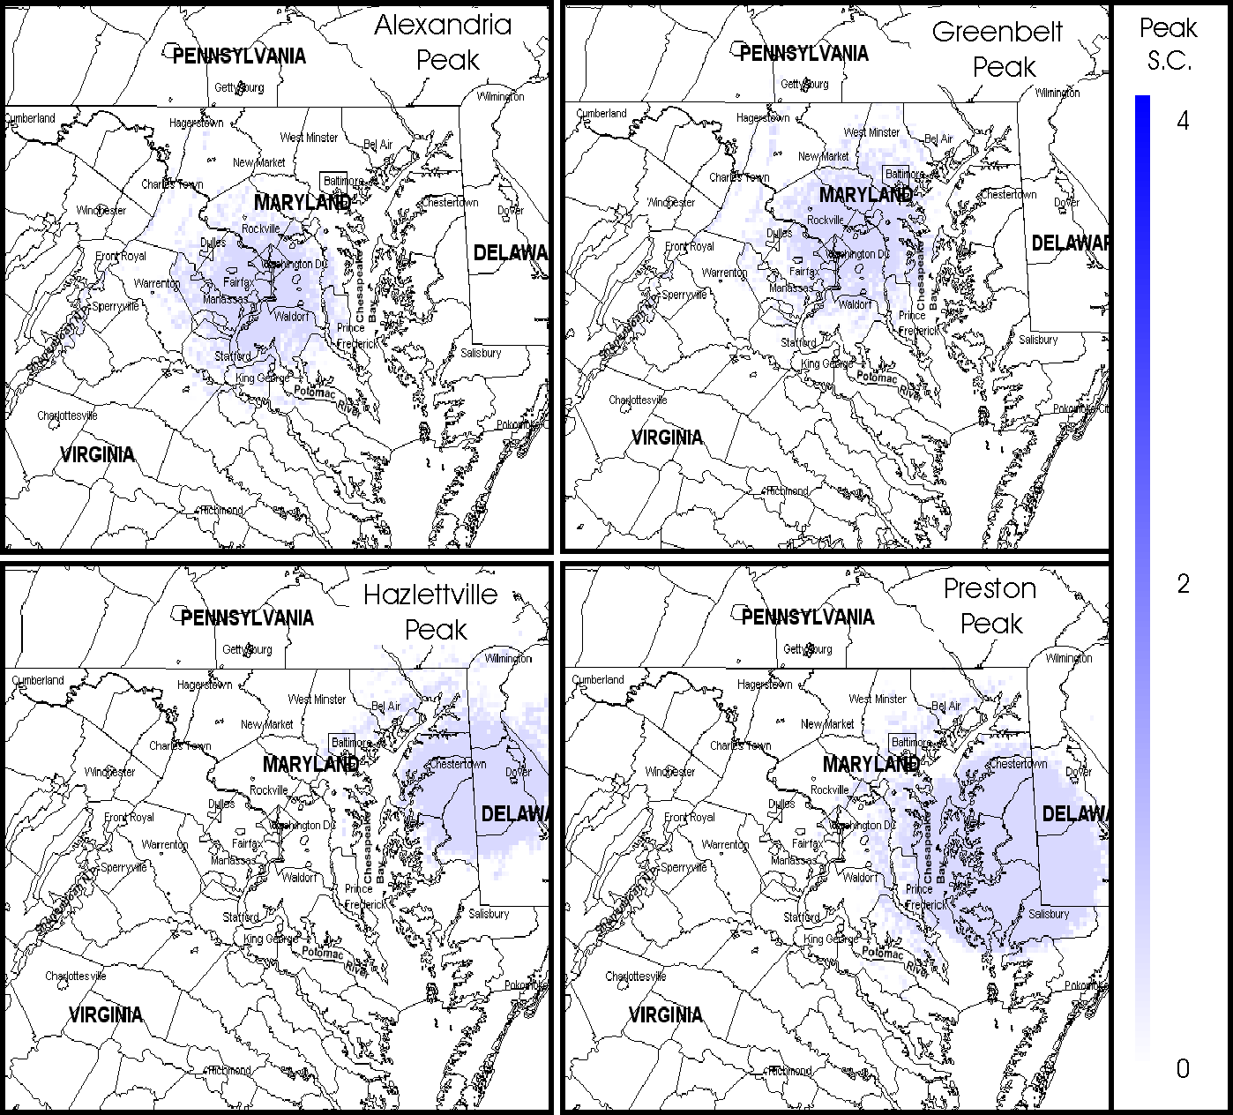
Although the SC was defined initially at a given location, it is convenient to summarize the SC at many adjacent locations as a contour map, using colors or contour lines to identify areas that have certain ranges of SC values. Figure 6-1 shows examples of four maps from single transmitters sited at Alexandria, Greenbelt, Hazlettville, and Preston. Each map shows geographical areas of coverage from each transmitter. The quantity plotted in these maps is called a “peak” signal capacity (PSC) map to distinguish it from an “average” signal capacity (ASC) map described later. The maps produced in this study are generated by calculating predicted field strength at one-mile intervals over a 200-mile square centered around Washington, D.C. The calculation uses transmitter and antenna data obtained from the respective GMF files. The terrain-based Longley-Rice propagation model is used in the analysis, with “coverage” defined as all locations with field strength in excess of 10 µV/m. The shaded areas of the maps indicate coverage from the associated transmitter. Since only one transmitter is present in each of these examples, every point on the maps will have coverage from either one or zero transmitters, (i.e., SC values of either zero or one, representing no coverage, or coverage by one transmitter). The effect of terrain is visible in enhancing or shadowing the coverage areas. The PSC map can be understood as showing the maximum number of independent users that could be simultaneously served at any given location, assuming that no other users were being served at other locations.
Figure 6-23. Peak Signal Capacity Coverage Map Examples

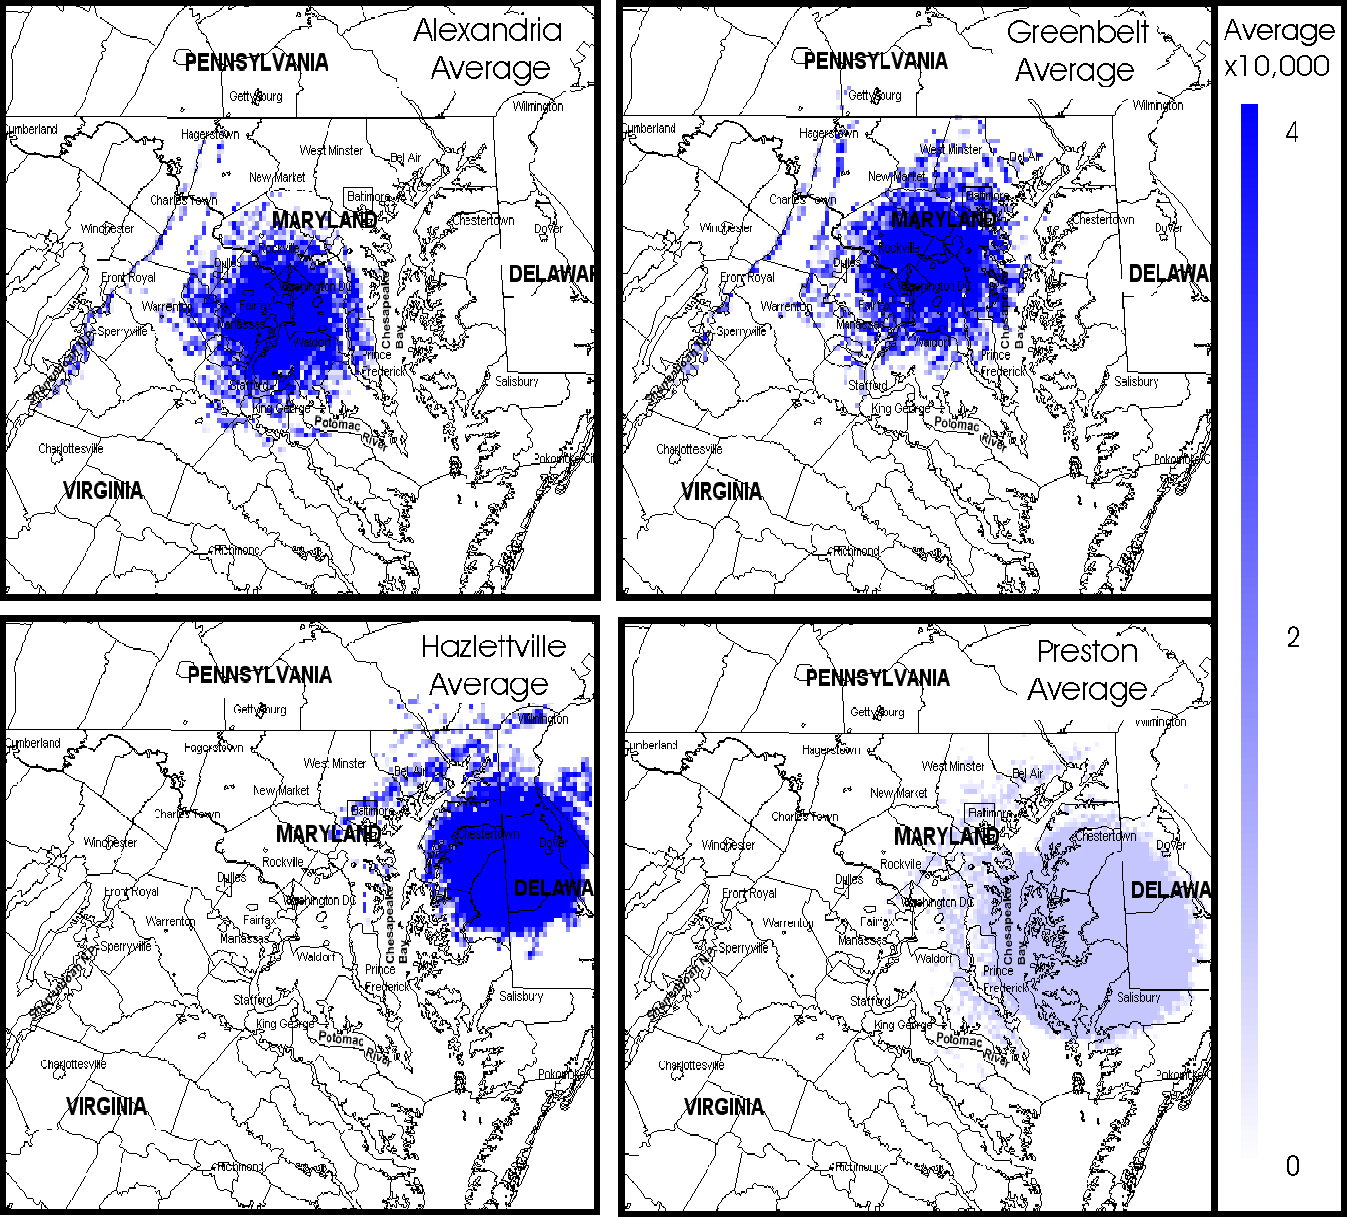
An ASC map, as shown in Figure 6-2, can also be created. The ASC map shows the maximum number of independent users per square mile that can be served at one time if users were distributed evenly across the coverage area of a transmitter. The ASC map for an individual transmitter is determined by calculating the PSC map, totaling the number of square miles of coverage for that transmitter, and dividing the PSC values by the total coverage area.
This computation means that the ASC map values at each location will be expressed in terms of users per square mile that the transmitter could provide service to, assuming that users were evenly spaced across all of the transmitter coverage area. Integrating the ASC values across the entire coverage area of one transmitter will give a total of exactly “one user.” Figure 6-2 shows an ASC map of the same transmitter whose PSC map was shown in Figure 6-1. Specifically, Hazlettville, in Figure 6-1, shows radio coverage of about 2,500 square miles (out of a total of 40,000 square miles included in the map). Therefore, the ASC map shows that this transmitter would provide coverage to about .0004 users per square mile, if the users were evenly distributed over the whole 2,500 square mile area of coverage, (2,500 mile squared x .00014 users/mile squared = 1 user). As a convenience in reading the ASC maps, the actual ASC values in this report have been multiplied by 10,000 before they have been plotted, so that .0004 is plotted as “4”. This gives values that are easier to read and relate to PSC values. Note that a smaller transmitter coverage area gives larger ASC values on the map. The Preston transmitter in Figure 6-2 has a noticeably larger coverage area, but the lighter shade corresponds to a plotted ASC value of around “2”, a number only about half as large as the ASC values corresponding to the other three transmitters.
Figure 6-24. Average Signal Capacity Map Examples

Both the previous ASC and PSC map examples describe use by one independent user. This does not imply that only one individual user can actually be served by the system at a given time. The independent user may be a talk group with a hundred members that are simultaneously receiving a common message. More likely, the one independent user would be several talk groups, each with multiple users, who time-share the single radio channel among themselves. The only constraint among the multiple users in each of the multiple talk groups is that only a single message can be carried by the radio channel at one time. Likewise, the one independent user could actually be a single user.

The PSC map and the ASC map provide two different methods of looking at the problem of providing service, based on different assumptions about how users are distributed geographically. The PSC map assumes that all users may be concentrated at the same geographic location. The ASC map assumes that users are evenly distributed across the coverage area of their respective base station transmitters. In analyzing the SC that is provided by an existing transmitter, it is not known whether that transmitter was intended to serve users who are statistically evenly distributed across the coverage area or users that are usually located in one small portion of the coverage area. Lacking this specific information for each transmitter, the analysis covered the extreme cases by calculating both the PSC and ASC maps. In many ways, the PSC and ASC maps represent the worst and best cases of user geographical distributions, respectively. Real-world user distributions presumably must lie somewhere between these two extremes, but it is not necessarily clear exactly where. Nevertheless, the PSC and ASC maps place bounds on the effects of user location.

If all transmitters had the same coverage area, the PSC and ASC maps would look identical, except for a scaling factor related to the coverage area of the transmitters. However, if transmitters with one coverage area are replaced with future transmitters having a different coverage area, the assumptions about whether replacement transmitter requirements scale proportionally to coverage area or not become very important, since these two different assumptions give much different results. ASC values scale proportional to coverage area; designing a new system with micro cells having ten percent of the coverage area of current transmitters would result in designing the micro cells to handle ten percent of the traffic. PSC values do not scale with coverage area. A ten percent-sized micro cell would still need to handle all of the traffic of the standard transmitter, since it is possible that all of the users from the standard cell may sometime be crowded into that single micro-cell. Therefore, both sets of maps are important as a more complete basis for designing a range of possible alternative radio systems to match the current capabilities of users in the 162-174 MHz band.

Although PSC and ASC maps show the coverage of individual transmitters, they are particularly useful because individual SC maps for individual transmitters can be combined with SC maps of other transmitters to get SC maps corresponding to groups of transmitters. In particular, the PSC map values at a given geographic location from one transmitter can be added to the PSC map values at the corresponding geographic locations for another transmitter to produce a PSC map for the combination of the two transmitters. Similarly, the ASC map values for one transmitter can be added to corresponding ASC map values for another transmitter, on a point-by point basis to obtain an ASC map for the two transmitters.

In similar fashion, PSC maps for a few transmitters can be added together to give PSC maps for arbitrarily large numbers of transmitters. Thus, PSC maps can be obtained for specific commands, whole agencies, or whole departments, or even the entire set of users in the Washington, D.C. area. Similarly, the individual ASC maps can be combined to give ASC maps for arbitrarily large groupings of transmitters.

The Use of Function Codes to Define Signal Capacity of Networks

Although the previous descriptions of ASC and PSC maps have discussed single transmitters, the lowest level of radio system that can actually be analyzed to produce PSC or ASC maps is not a single transmitter but is instead a “network.” A network is a group of transmitters (one or more) designed to produce a specific type of service over a given area. In many cases, a network contains only a single transmitter. The concept of network must be used to compute SC because, in many systems, the use of one transmitter constrains how other transmitters can be used. For example, if one simulcast transmitter is transmitting a signal, no other simulcast transmitter on that channel can be simultaneously used to transmit a different signal. Thus, the ability to receive an independent signal at one location is dependent on what is happening at another location. The network, as defined here, is the smallest set of transmitters that must be included in the SC calculations to obtain an accurate value. Once the ASC and PSC maps for a network have been properly calculated, these values are independent quantities and SC maps from one network can be freely combined with SC maps for other networks.

The SCAP uses the GMF frequency database as a source of technical information about LMR transmitters in the 162-174 MHz band. A function code (F, N) is added to each GMF assignment record that provides additional information needed by the SCAP. The parameter F shows SCAP what type of technology the network uses (i.e., what set of algorithms to use to compute SC maps). Different algorithms are needed for independent base stations, repeaters and multi-site repeater systems, simulcast systems, trunked base stations and multi-site systems, and others, as described in Appendix A. The parameter N shows what other transmitters to include in this analysis. All transmitters with the same N identifier belong to the same network. Transmitters are often assigned as individual equipments, but the SCAP needs to perform calculations on groups of transmitters (networks) therefore the “network” function codes are used to enable this required grouping. A more detailed description of the specific types of networks and the associated SC algorithms are given in Appendix A.

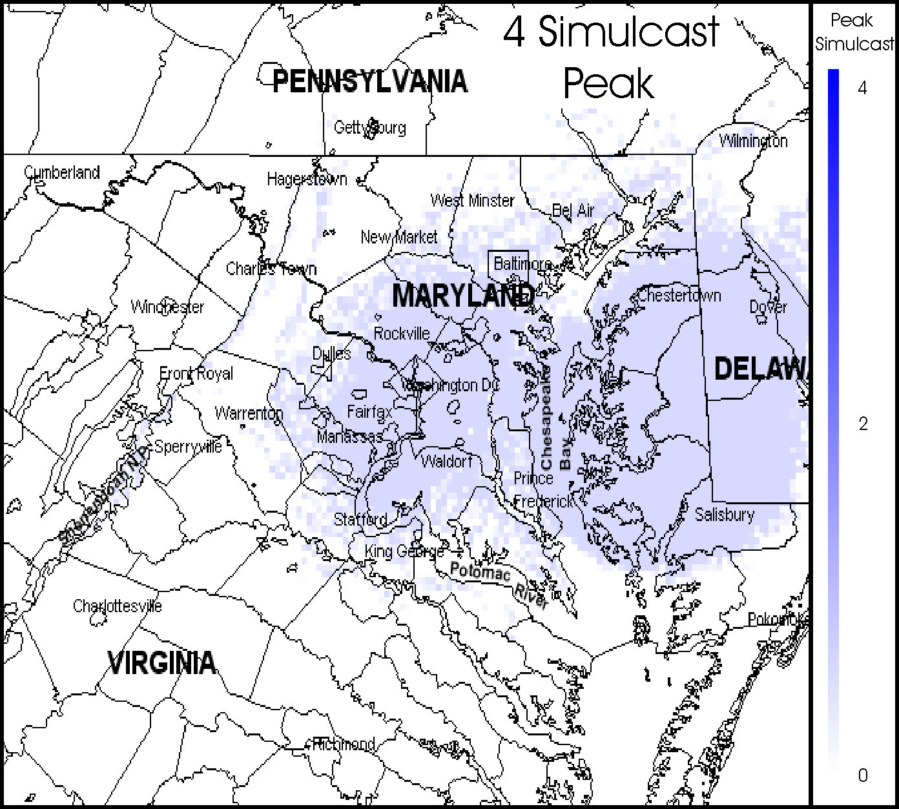
The function codes were determined by a study of the GMF records and consultations with frequency management staff at the various federal agencies. The function code determinations are only for purposes of SCAP analysis and no actual changes were made to any GMF records. Some GMF records did not fit exactly into the functional categories that were established. Consultations were made with agency staffs to attempt to get the closest possible fit.

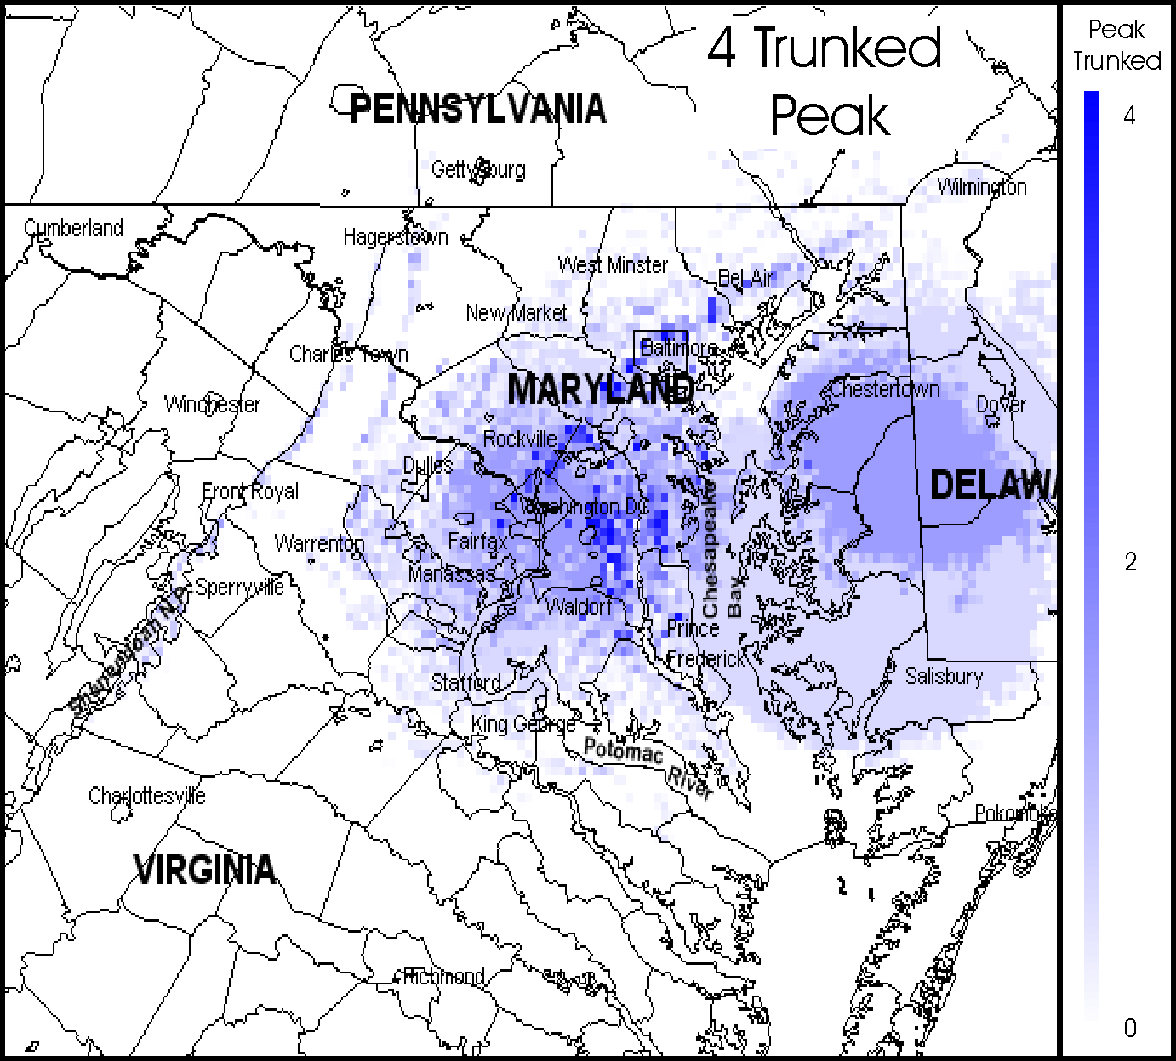
Figures 6-3 and 6-4 provide an example of the SCAP analysis of a basic network, showing how different types of networks give different PSC and ASC map results, in a network that consists of a group of four base stations. These four transmitters will be analyzed as a simulcast network and as a network of single-channel trunked radio systems.
Figure 6-25. PSC Map for Four Transmitters Analyzed as a Simulcast System

The PSC map for the simulcast system is shown in Figure 6-3 and the PSC map for the trunked radio system is shown in Figure 6-4. The simulcast system PSC map was created by first calculating the coverage areas of each base station and placing a “1” at each location where coverage was available from any of the four base station transmitters. In locations where coverage is available from more than one base station, the PSC for the simulcast system is still “1,” since all base stations transmit an identical message, so only one independent message can be received at any location. This PSC simulcast system map functions as though the radio system were a single transmitter with a very large coverage area, with a single color shade and a PSC value of “1” at all locations that get coverage from one or more transmitters.
Figure 6-26. PSC Map for Four Transmitters Analyzed as a Trunked System

Figure 6-4 shows the PSC map for the same four sites analyzed as trunked sites. A four-site trunked radio system using independent frequencies to provide coverage from each transmitter site could provide independent messages from each site. Therefore, in all locations where coverage is available from multiple base stations, the PSC values add together to equal the number of different sites from which coverage is available. As shown in Figure 6-4, some locations get independent coverage from as many as three of the transmitter sites. The darker shading represents the larger PSC values.
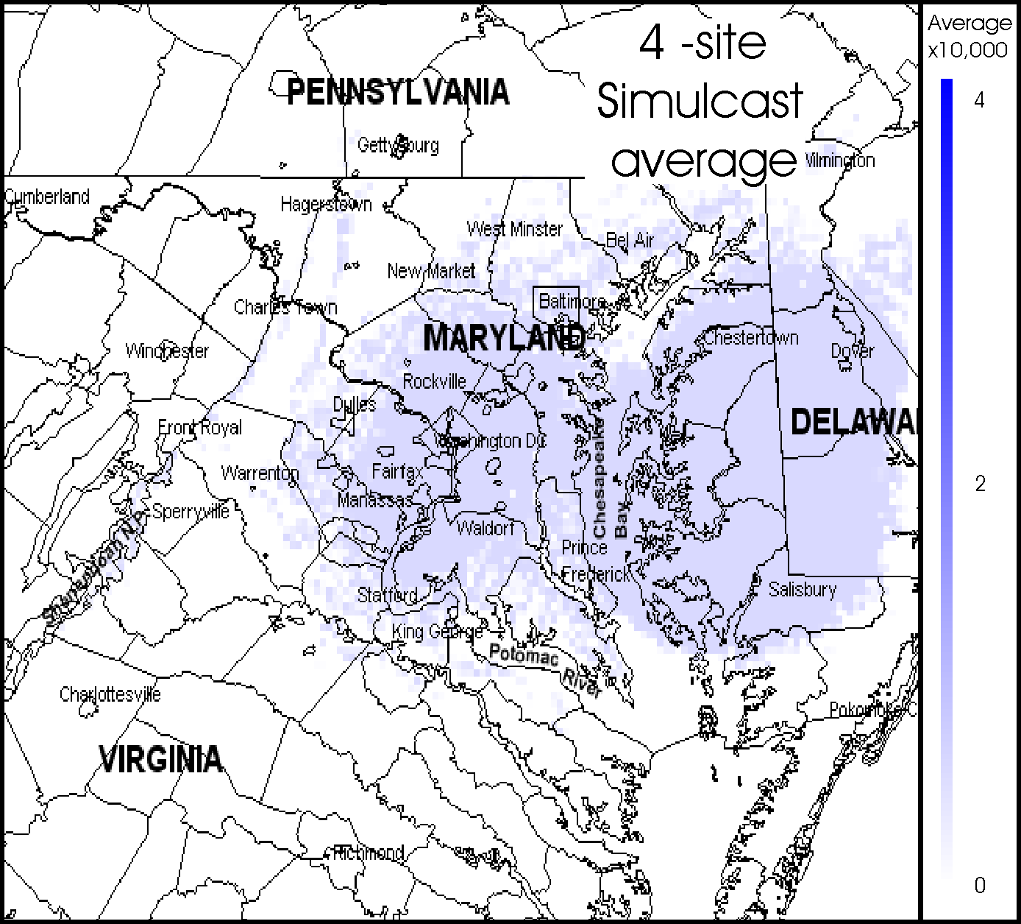
The average SC value is determined by dividing the PSC at a specific location by the area over which each transmitter provides coverage. In the case of a simulcast system, the entire four-site simulcast coverage area resembles what the coverage area of a single transmitter that covers a very large area would look like. Therefore, the simulcast system ASC map, Figure 6-5, looks identical to the simulcast PSC map, except for a scaling factor that shows a single relatively low average number of independent users per square mile that can be served by the simulcast system.

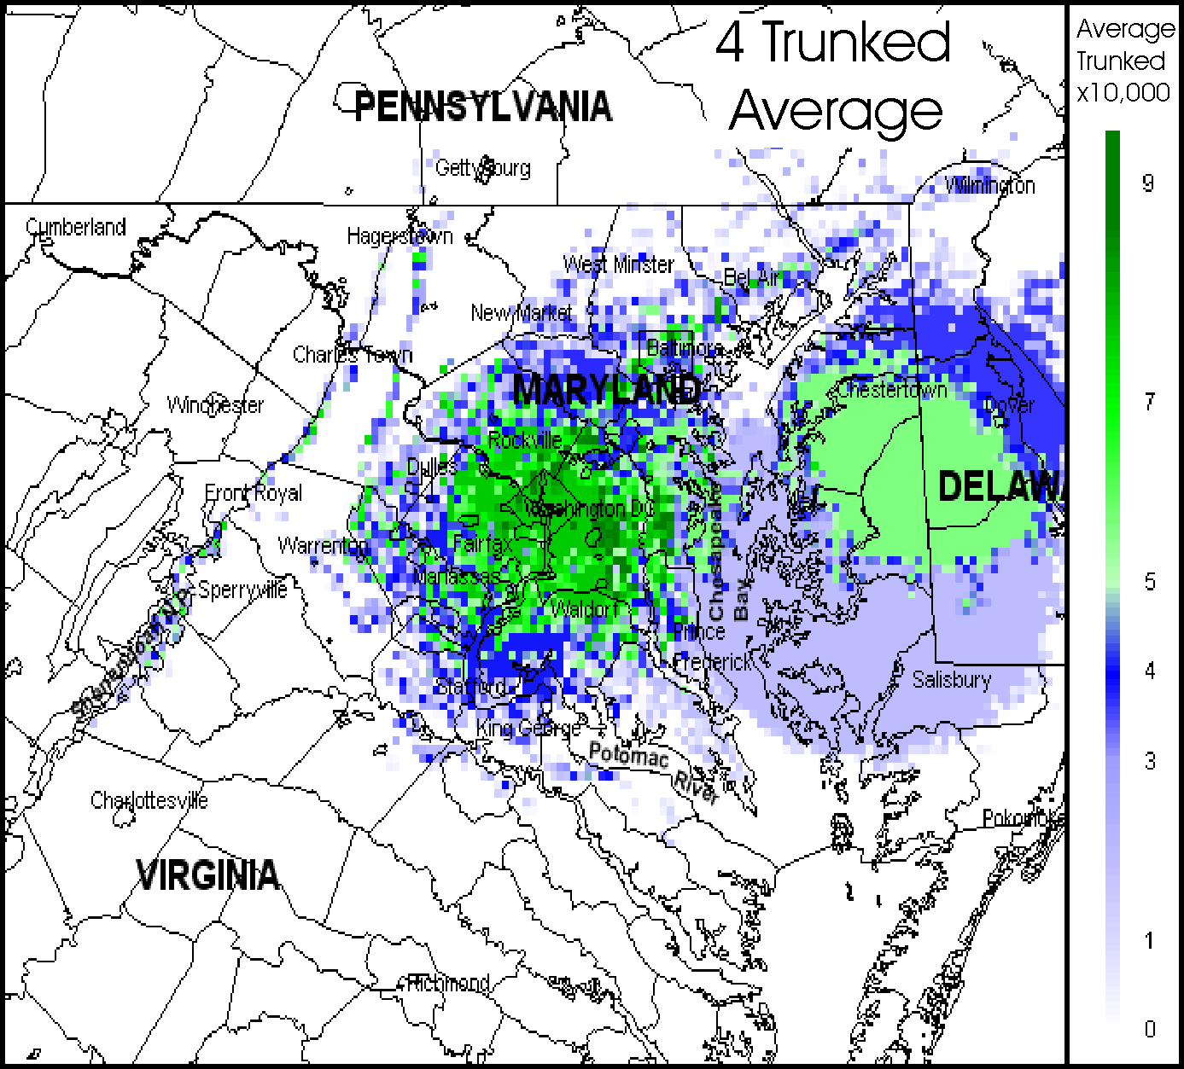
Figure 6-6 shows the ASC map for the four sites analyzed as trunked sites. The ASC values for the four base station trunked network is calculated by finding the ASC values for each base station on an individual basis, and adding the individually calculated ASC values at points where coverage is available from multiple stations. In this case, the transmitters operate independently, so the coverage area is the respective area for each separate transmitter. Since each transmitter can serve a different population of independent users, the ASC values add together where coverage is available from multiple transmitters.
Figure 6-27. ASC Map for Four Transmitters Analyzed as a Simulcast radio System

Therefore, PSC and ASC are different for the four-site simulcast network and the four-site trunked network. The peak usage per simulcast channel would be one independent user per channel over the entire four-site area. The peak use per trunked channel would be one independent user per channel at many points, but there would also be locations that may provide service to two to three independent users, due to overlapping coverage areas from multiple sites.
Figure 6-28. ASC Map for Four Transmitters Analyzed as a Trunked Radio System.
The average number of independent users per square mile that the four-station simulcast system can support would be smaller than the number of independent users per square mile for the four-site trunked system for two reasons. First, there is only one independent signal available from the simulcast system, whereas the trunked system provides multiple signals in many locations. Second, the coverage area is larger for the simulcast system than for any of the individual trunked sites, so the ASC value for the simulcast system is smaller than the ASC value for any of the individual trunked transmitters. Therefore, the ASC values, the average number of independent users per square mile, are smaller for the simulcast system, at any given location, than for the corresponding location on the ASC trunked system map.

The above analysis shows numbers that are based on independent users. An independent user can be a single user or a large talk group with hundreds of users as long as the talk group members all receive the same messages. Many public safety systems are not designed to support individual independent users, but are designed for talk groups containing many users spread across a wide area. Under these circumstances, large coverage areas are more important than being able to locally serve multiple independent users. Therefore, the apparent disadvantages of the simulcast system versus the trunked system may not be as great as shown in these numerical examples, when large talk groups spread across large areas are considered.

FEDERAL AGENCY SIGNAL CAPACITY MAPS

General

This section contains the SC maps for various agencies and groups of agencies, resulting from a SC analysis of the Washington, D.C. area GMF data within the 162-174 MHz band. The basic concepts of PSC and ASC have been described in Section 6, with additional technical details included in Appendix A. Also described in that section, and in Appendix A, are the function and network codes used to convert GMF assignment files into SC coverage maps

Technical parameters for Signal Capacity Maps

The SC maps contained in this section were generated from data found in the November, 2002 GMF files. The SC maps were developed from all assignments that are located within a 100-mile radius centered on coordinates 38°54'34"N, 077°00'00"W, which corresponds approximately to the National Capitol building. Assignments located outside of the described 100-mile radius circle were not included in the analysis, although the coverage areas of any included assignments were calculated over a square that is 200 miles on each side. This means that there are “corners” of the square that are outside the 100-mile radius circle where coverage from transmitter assignments located inside the circle were analyzed, but no GMF assignments in those corner areas were included in the SC modeling. No assignments located outside of the 100-mile circle were included in the analysis, but transmitters would normally be found outside this circle and provide additional coverage to locations inside the circle. Therefore, there are expected to be “edge effects” near the outside of the circle where less-than-expected numbers of transmitters will be seen in the maps. The selection of a 100-mile circle was intended to result in a minimum level of edge distortion over most of the map, but especially in areas near Washington, D.C.

The geographically selected GMF assignments were categorized using the function codes and network codes, according to how the respective assignment should be analyzed by the SCAP. Transmitters selected for inclusion in the SC modeling were analyzed to show their coverage areas. For this analysis, the terrain-based Longley-Rice propagation program was used, along with transmitter power, antenna, and location data from the GMF. The coverage analysis assumed that any location should be considered to have coverage if the 50-90 signal amplitude exceeded ten microvolts/m. This coverage criterion was chosen as a compromise between urban and rural coverage objectives, for a wide range of modulations and bandwidths. Appendix A provides a more detailed description of the model.

Many GMF assignments incorporate multiple modulations, bandwidths, and transmitter powers. In this case, the highest transmitter power was used to calculate the coverage area, ignoring other differences based on modulation and bandwidth.

Interpreting the Signal Capacity Maps

The SC maps are designed to easily summarize the service that is provided by existing federal mobile radio systems in the 162-174 MHz band in the Washington, D.C. area. As described in Section 6 and in Appendix A, two different types of SC maps were needed to describe different aspects of SC. PSC maps show how many independent radio signals are available at any given location to a radio receiver at that location. Figure 7-1 shows an example of a PSC map for several selected federal radio systems.
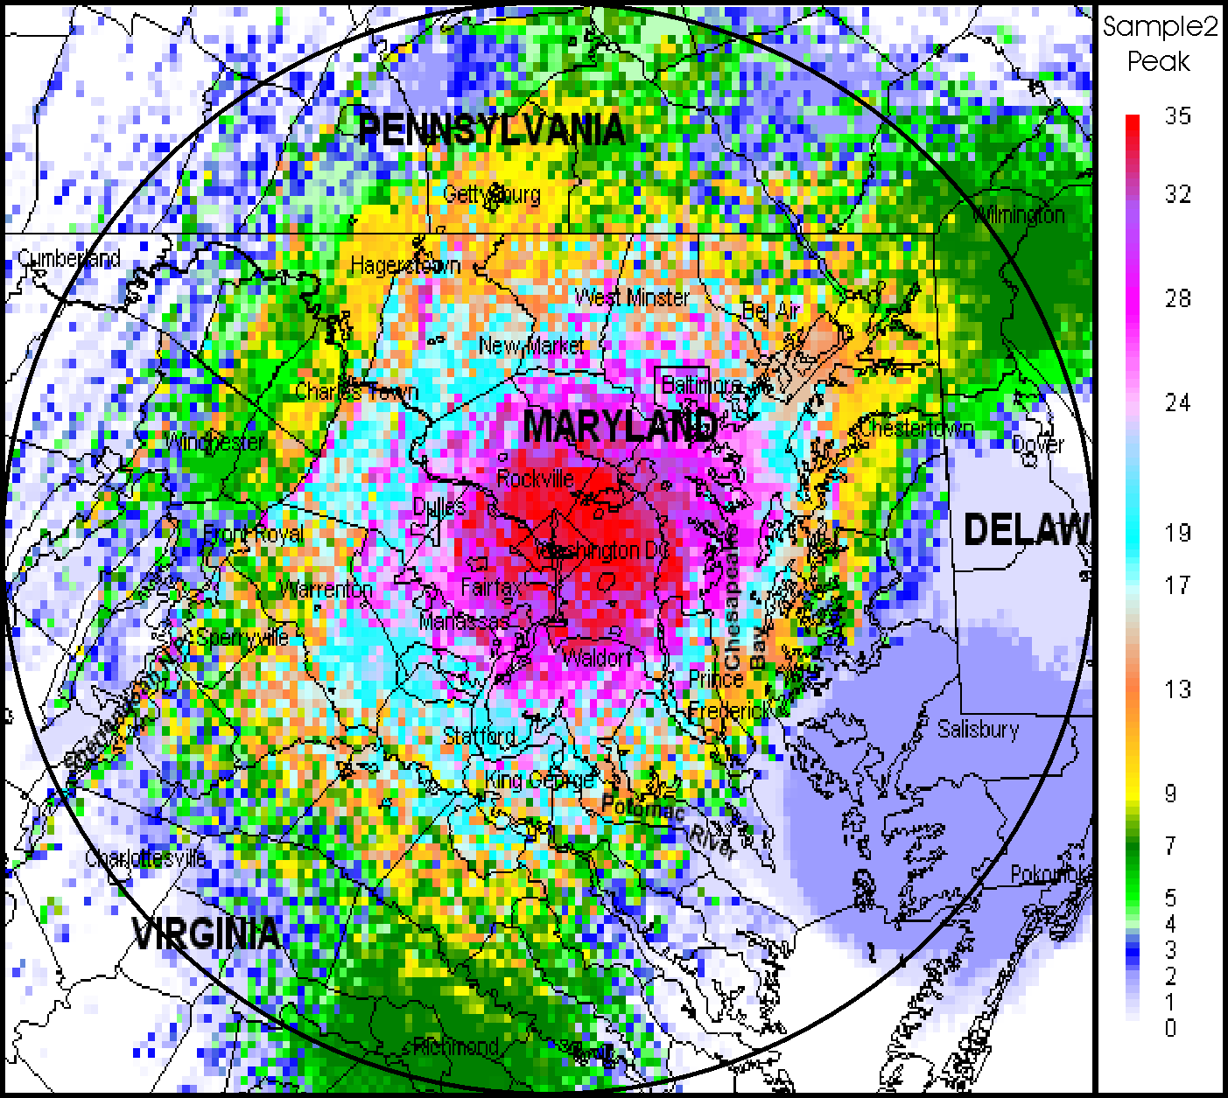

Figure 7-29. Peak Signal Capacity Map
for Several Federal Radio Systems
Figure 7-1 shows PSC values for all locations in a 200-mile square, centered around Washington, D.C. These values were calculated for locations spaced on a 1-mile grid. The color of the shading at every location indicates how many radio signals can receive at that location. Concentrations of radio signal coverage are located in the areas around Washington, D.C. In addition to certain cities, the map shows county and state boundaries, as well as major rivers and coastlines.

The red shades on the map show that a mobile user in several high-signal areas can receive as many as 35 independent signals from various transmitters analyzed on this map. However, at many locations outside the high-signal areas, the white area shows that no signals would be available to a mobile user. At various in-between areas, a few (but not many) signals could be received by a mobile user. However, one “independent signal” does not mean that only one user at one location can receive the signal. Instead, a very large number of mobile users can be simultaneously listening to that one same signal at many locations across the map.

In addition, the SC map does not show whether the “one signal” available at one location on the map is the same “one signal” that may be available at other locations on the map. In general, this ambiguity does not become troubling unless the required coverage is supplied by base stations placed at considerably different locations than the original base stations that were analyzed to produce the SC maps. Even assuming that different base station locations were used, one would generally expect that these SC map values would add up in different ways, some better, and some worse that would not result in systematic difference that would produce distorted results. However, consider the case where a specific existing base station was sited to provide coverage to a specific set of users operating in certain specific geographic areas. Changing base station locations in a potential future system might result in multiple base stations being required to provide coverage to all of the users who were covered before by a single base station. This could result in more future base stations being required than would normally be calculated. The magnitude of this effect is not known.

Areas are considered “high-signal” because of the number of independent signals present, not because the signals are strong signals (i.e., high field strength). In fact, a small, high-signal, almost-vertical line west of Washington is probably the result of a number of relatively weak, but above the coverage threshold value, signals from Washington adding to a number of the similarly weak signals coming from the Hagerstown/Fort Royal area. Thus, the vertical line shown in Figure 7-1 is composed of a large number of weak signals.

The effects of terrain are clearly seen in the maps. For example, near the lower, left-hand corner of the map is a diagonal line of higher-signal locations. This is caused by locations in high mountains receiving usable levels of signal from many distant radio base stations. Similar effects are seen from many mountain ranges scattered over the land, but not at locations over the ocean.

This specific PSC map was produced as part of a 5-step process:

- the various assignments (or agencies) to be included in the map were identified from the GMF,
- the assignments were categorized and coded for function/technology (by attaching a specific function and network code to each assignment),
- the coverage area was independently calculated for each transmitter in a network,
- PSC maps for each network were assembled from the transmitter coverage maps according to the applicable function codes for that network, and
- PSC maps for each network were combined into a PSC map for the agency or group of agencies.

The particular assignments included in this example were selected mainly to show multiple “high-signal” areas, terrain effects, and low signal rural areas.

Although the PSC map shown in Figure 7-1 provides much useful information for visualizing how many signals could be seen by a mobile user, this information is not necessarily the most useful information for designing future alternative mobile radio systems. The most useful type of system design information is usually in the form of the number of users per square mile that could be served by a radio system. This type of data is provided by ASC maps. The ASC map corresponding to the PSC map shown in Figure 7-1 is shown in Figure 7-2.

As with the PSC map, the ASC maps shows the number of “independent users” per square mile that current systems can support. A single independent user represents a voice channel in use 24 hours a day. The actual number of users supported can be quite large, since many users could be distributed across a wide area and simultaneously listening to a common signal. In addition, multiple talk groups could be time-sharing that single voice channel, each talk group containing many users.

The ASC maps were computed by following the same five steps that were used to compute the PSC map, except that a different algorithm was used in step 4. The algorithm followed in step 4 calculated the total effective area of a network and divided the PSC value at each location by area (in square miles) of the network coverage. This means that a network consisting of a single base station with a coverage area of about 36-mile radius would provide about 4,000 square miles of coverage. If there were a single transmitter at the base station, the PSC values for each point of coverage would be “1” at each location. The ASC values would be 1/4000 at each location, or 0.00025. Note that the total number square miles of coverage times the ASC value gives the total number of independent voice channels on the map.

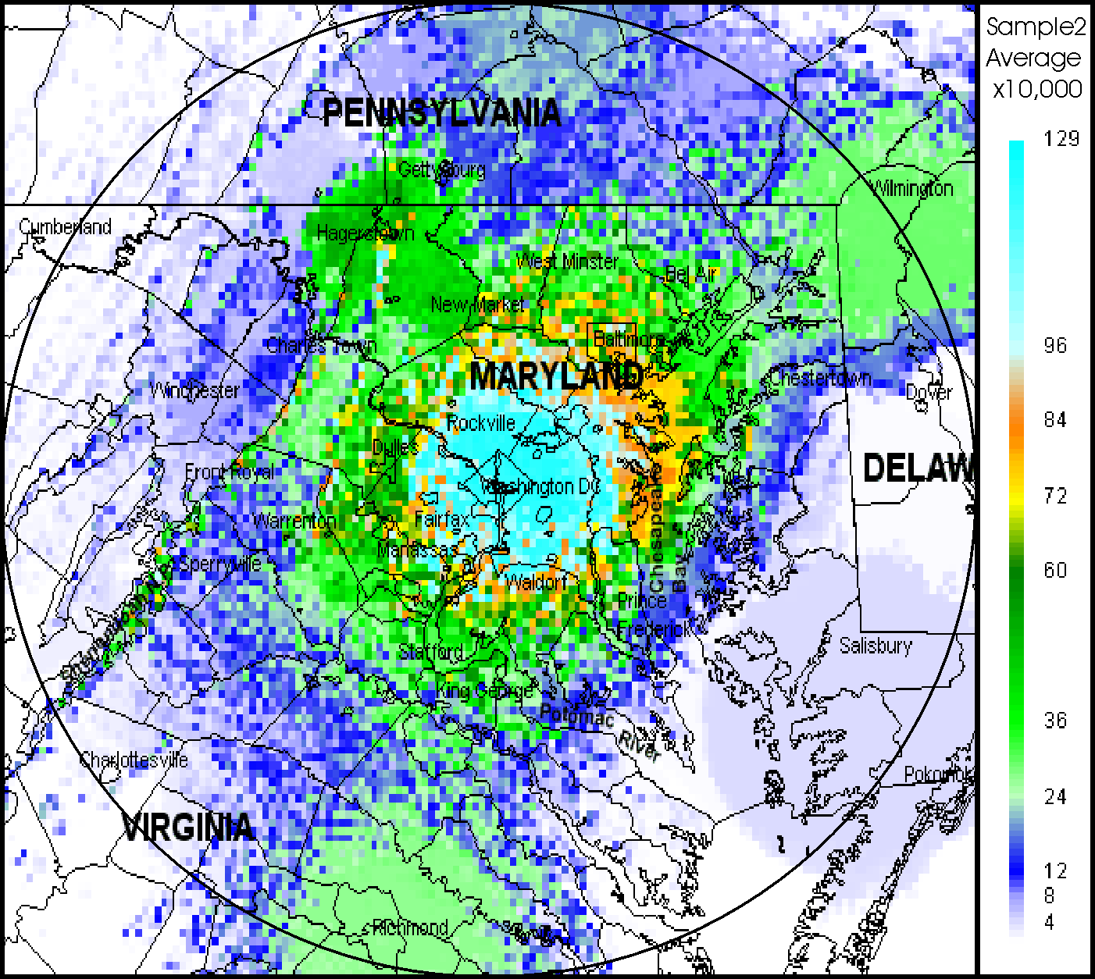

Figure 7-30. Average Signal Capacity Map for Several Federal Radio Systems

Although the PSC and ASC maps appear quite similar, there is a major difference in the numerical values that appear on the maps. Whereas the maximum PSC value is 35, the maximum ASC value is .0129. Since the ratio of these two values is about 2,600, this suggests that coverage area of the typical site is about 2,600 square miles, corresponding to a reception radius of about 29 miles.

The ASC map shows how many independent users per square mile could be served by the mapped radio stations. The ASC data can be used when future systems are designed with base station sites whose calculated coverage areas are substantially different in size from the original system coverage areas. For example, if two alternative future systems were designed and System A employed base station sites having typical coverage areas equal to 4,000 square miles, while System B sites had coverage areas of 2,000 square miles, each site in System A would need to be designed to carry about twice as much total traffic as each of the System B sites.

The ASC maps are computed by finding the total coverage area of a given transmitter and assuming that each independent transmitted frequency could support one independent mobile user. If one assumes that the one independent user is equally likely to be anywhere across the coverage area, on the average, the ASC map would show that the ASC value of average independent users per square mile is 1/A, where A equals the total coverage area in square miles.

For example, if a particular base station with a coverage area of 3,000 square miles can support one independent user somewhere over that total coverage area, the average density of independent users over the entire 3,000 square miles would be 1/3000 independent user per square mile = 0.00033. If another base station site provided coverage over only 500 square miles, the average density of users for that site would be 1/500 user per square mile = 0.002. Note that a base station with a small coverage area provides ASC maps having larger average user density values. The summation of average SC (user density) over a single transmitter coverage area = 1 (i.e., one user).

Note that a single independent user can consist of many actual users spread randomly across the coverage area (as long as all users are listening to the same message). Moreover, the users could include members from multiple talk groups, each talk group using the radio channel at different times, as long as the total duration of the multiple messages was less than 100 percent of the time.

The ASC values from a single channel or a single site add to ASC values from other channels or other sites, depending on whether the additional channels or sites contain independent message content. In the case of overlapping coverage from semi-independent sites (e.g., multi-message repeater networks, see Appendix A.), the ASC values are calculated first as though there were no overlapping. Then, the ASC values are averaged together in any areas of overlapping coverages. As with the PSC maps, the ASC maps for agencies and larger groups of assignments are produced by adding the ASC maps values for one network to the ASC map values for other networks on a point-to-point location basis.

Most ASC maps will closely resemble the corresponding PSC maps, except for a proportionality factor, P, which will be fairly constant over the entire map. If P = PSC value/ASC value at any given location, the value of P should be the approximate size of the coverage area of typical base station transmitters in that area. Therefore, the value of P should change over the map mainly if an agency uses different technologies or design criteria for different geographical areas. For example, mountaintop repeaters could give large coverage in rural areas, but short-range, high capacity systems might be used in urban settings.

A single color scale has been used to plot all of the ASC and PSC maps. This color scale was chosen to allow a quasi-logarithmic representation of the ASC and PSC numerical values, such that the colors will allow a useful differentiation of numerical values, whether a specific agency map has relatively large or small numeric values. This convention should aid in the reader being able to make a direct comparison in numeric values among the various agency maps.

In addition, since the ASC maps typically contain values that are 5,000-10,000 times smaller than the corresponding PSC maps, the ASC map numeric values have been multiplied by 10,000 times before being plotted. This change was made to facilitate an understanding of the similarities and differences between the corresponding ASC and PSC maps. A common color scale, as used in the PSC maps, has also been used for all of the ASC maps. A white background indicates “zero” SC (no receivable signals) for both the ASC and PSC maps.

Signal Capacity Maps for Federal Agencies

The following sections contain SC maps for various federal agencies. Each section is formatted in approximately the same way and contains approximately the same information. The agencies are mainly grouped by federal department and arranged in alphabetical order. The Army, Navy, and Air Force are grouped together under “Department of Defense.” Some agencies with less than 20 frequency assignments apiece are grouped together as “Other Federal Agencies.”

In addition to the individual departments, three sets of maps were made for a combination of combined departments. These groupings include SC maps for all federal agencies, for all of the agencies associated with the new IWN and for all federal agencies minus the IWN agencies. These additional three groupings are assumed to represent several logical combinations of federal agencies that may be involved in building future shared trunked systems.

Each agency/grouping includes a summary of assignment statistics for that agency. These assignment statistics show how many assignments were placed within each of the SCAP functional categories. Although wireless links (F = 4), simulcast stations (F = 5), and area assignments US/USA/US&P (F = 24) were included as potential categories of systems during the determination of SCAP function codes, no GMF assignments with these codes were identified for the Washington-area assignments. (In the case of “area-type” assignments, these assignment types were eliminated from the GMF assignments before the detailed function code determination was started.) Therefore, the function codes F = 4, F = 5, and F = 24 were omitted from the function code summaries for each agency. Table 7-1 provides the total number of agency assignments and their function codes that were used in the SCAP analysis and Table 7-2 provides the total number of assignments and their function codes that were not used in the SCAP analysis.

Table 7-5. Total Number of Assignments with Function Codes Included in SCAP
Total assignments included in SCAP analysis |  | 866
Individual base station transmitter | F = 3 | 247
Trunked network | F = 6 | 5
Single-message repeater network | F = 7 | 274
Multiple-message repeater network | F = 8 | 220
Mobile/mobile user net | F = 9 | 120

Table 7-6. Total Number of Assignments with Function Codes Not Included in SCAP Analysis
Total assignments not included in SCAP analysis |  | 1079
Obsoleted link | F = 20 | 84
Dedicated link | F = 21 | 333
Receiver | F = 22 | 418
Receive-only station | F = 23 | 180
Low power (10 mW or less) | F = 25 | 28
Mobile-only replace by new system | F = 26 | 36

The role of each agency is also described in general terms, with the expectation that this description may be useful in helping the reader to understand why the SC maps show more coverage at one location instead of others.

The major features in each of the following sections are “agency” PSC and ASC maps, which are displayed for each agency, department, or group of agencies.

Analysis of the Signal Capacity Maps By Agency

United States Department of Agriculture (USDA)

The locations of the USDA assignments within 100 miles of Washington, D.C. were shown previously in Figure 4-2. That figure shows two major transmitter concentrations, including national headquarter sites in and near Washington, D.C., and national forest sites west of Washington serving the Washington and Jefferson National Forests. The urban/headquarter sites will use P25 digital technology, while the rural national forest sites will use analog voice radios.

The PSC and ASC maps corresponding to current assignments are shown in Figures 7-3 and 7-4, respectively. The PSC map shows that USDA has a peak level of approximately 13, which indicates that there can be up to 13 individual signals concentrated around the USDA headquarters building in Washington, D.C. The second concentration of signals is in the area west of Washington, D.C., where up to three independent signals provide coverage in the national forests. A line of points of higher incidental coverage between Washington and the national forests occurs at high elevation locations, where the forest coverage is supplemented with occasional distant coverage from the Washington emitters. The ASC map shows the same concentration of signals that the PSC shows, but now represents a maximum average level of approximately .0080 signals per square mile of coverage. Table 7-3 provides the USDA assignments and function codes that were and were not included in the SCAP analysis.
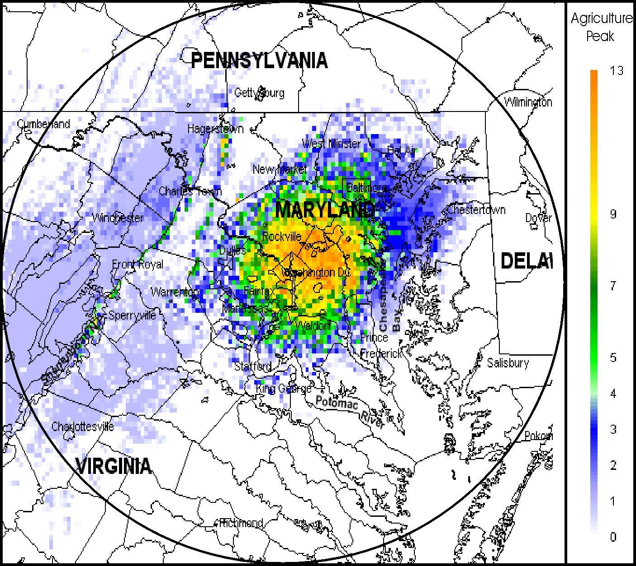
Figure 7-31. Peak Signal Capacity Map for U.S. Department of Agriculture

Table 7-7. U.S. Department of Agriculture Assignments and Function Codes
Function | Description | # of Assignments
F = 3 | Individual base station transmitter | 11
F = 6 | Trunked network | 0
F = 7 | Single-message repeater network | 9
F = 8 | Multiple-message repeater network | 0
F = 9 | Mobile-only user net | 2
Total included = 22
F = 20 | Obsoleted link | 0
F = 21 | Dedicated link | 2
F = 22 | Receiver | 12
F = 23 | Receiver-only station | 0
F = 25 | Low power (10 mW or less) | 0
F = 26 | Mobile-only (replaced by new system) | 0
Total not included = 14

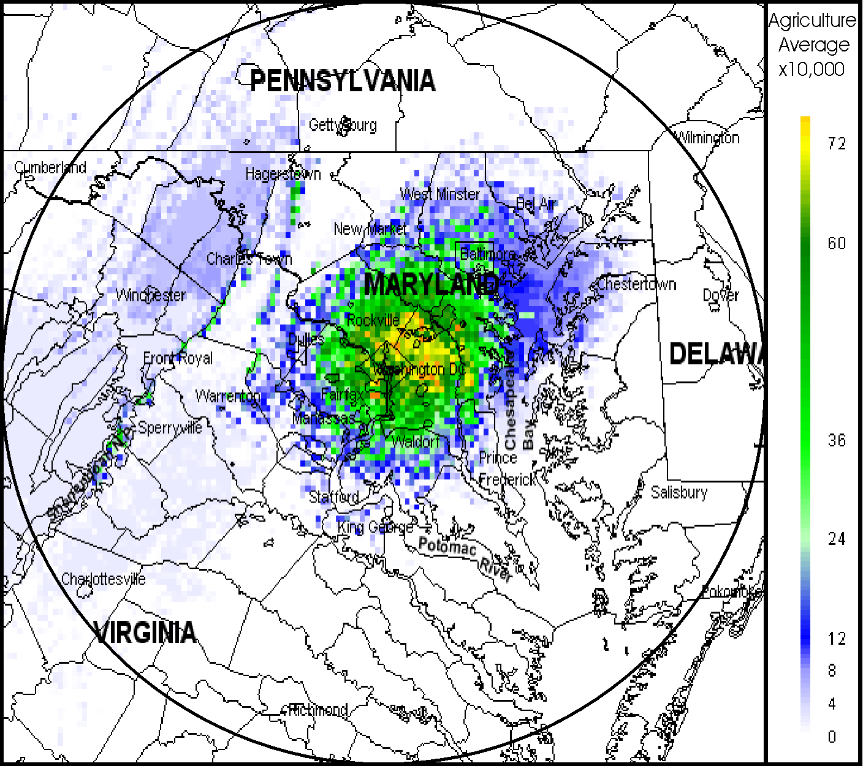

Figure 7-32. Average Signal Capacity Map for U.S. Department of Agriculture

United States Coast Guard (USCG)

The locations of the USCG assignments within 100 miles of Washington, D.C. were shown previously in Figure 4-4. That figure shows the major transmitter concentrations along the Chesapeake Bay, including the headquarter sites in and near Washington, D.C. The USCG currently uses wideband simplex systems, but all current radios have narrowband digital and analog capabilities. The USCG will be incorporating the 162-174 MHz band into their new Rescue 21 digital system. The PSC and ASC maps corresponding to current assignments are shown in Figures 7-5 and 7-6, respectively.

The PSC map shows that USCG has a peak level of approximately 4, indicating that there can be up to 4 individual signals around the Baltimore Coast Guard Activity. The remainder of the USCG signals are individual sites along the Chesapeake Bay, which represents a PSC of 1. The ASC map shows the same concentration of signals that the PSC shows, but now represents a maximum average level of approximately 0.0028. A distinct difference, though, is the higher ASC in the area just south of Salisbury, Maryland. This is due to the coverage area being smaller, thus a higher ASC per square mile. Table 7-4 provides the USCG assignments and function codes that were and were not included in the SCAP analysis.
Figure 7-33. Peak Signal Capacity Map for U. S. Coast Guard

Table 7-8. U.S. Coast Guard Assignment and Function Codes
Function | Description | # of Assignments
F = 3 | Individual base station transmitter | 9
F = 6 | Trunked network | 0
F = 7 | Single-message repeater network | 0
F = 8 | Multiple-message repeater network | 0
F = 9 | Mobile-only user net | 5
Total included = 14
F = 20 | Obsoleted link | 0
F = 21 | Dedicated link | 0
F = 22 | Receiver | 0
F = 25 | Low power (10 mW or less) | 0
F = 26 | Mobile-only (replaced by new system) | 0
Total not included = 0 |  | 0
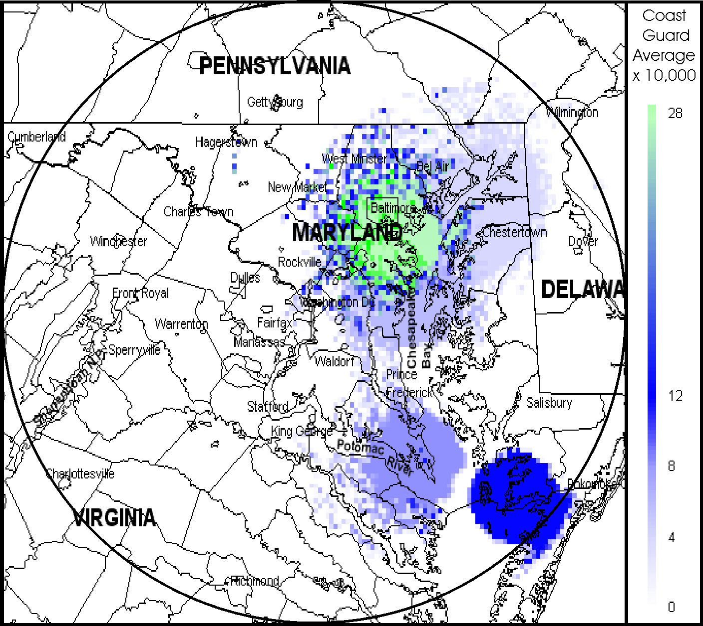

Figure 7-34. Average Signal Capacity Map for U. S. Coast Guard

United States Department of Commerce (DOC)

The locations of the DOC assignments within 100 miles of Washington, D.C. were shown previously in Figure 4-3. That figure shows the concentrations for the two line offices that use this band; the National Institute of Standards and Technology (NIST), with its heaviest concentration around Gaithersburg, Maryland, and the National Weather Service, which is located primarily in the mountainous area west of Washington, and other sites located around the area. DOC currently uses wideband analog radios, but will be transitioning to analog narrowband. The PSC and ASC maps corresponding to current assignments are shown in Figures 7-7 and 7-8, respectively.

The PSC maps show the largest peak usage of approximately 9 individual signals around the Washington, D.C. and Gaithersburg, Maryland areas. Some other notable remote areas have PSCs as high as 5. This is most probably due to the higher elevation of mountain locations picking up incidental signals from the Gaithersburg transmitters. The ASC map shows the same concentration of signals as the PSC map but results in an average of 0.0028 signals per square mile. Table 7-5 provides the DOC assignments and function codes that were and were not included in the SCAP analysis.
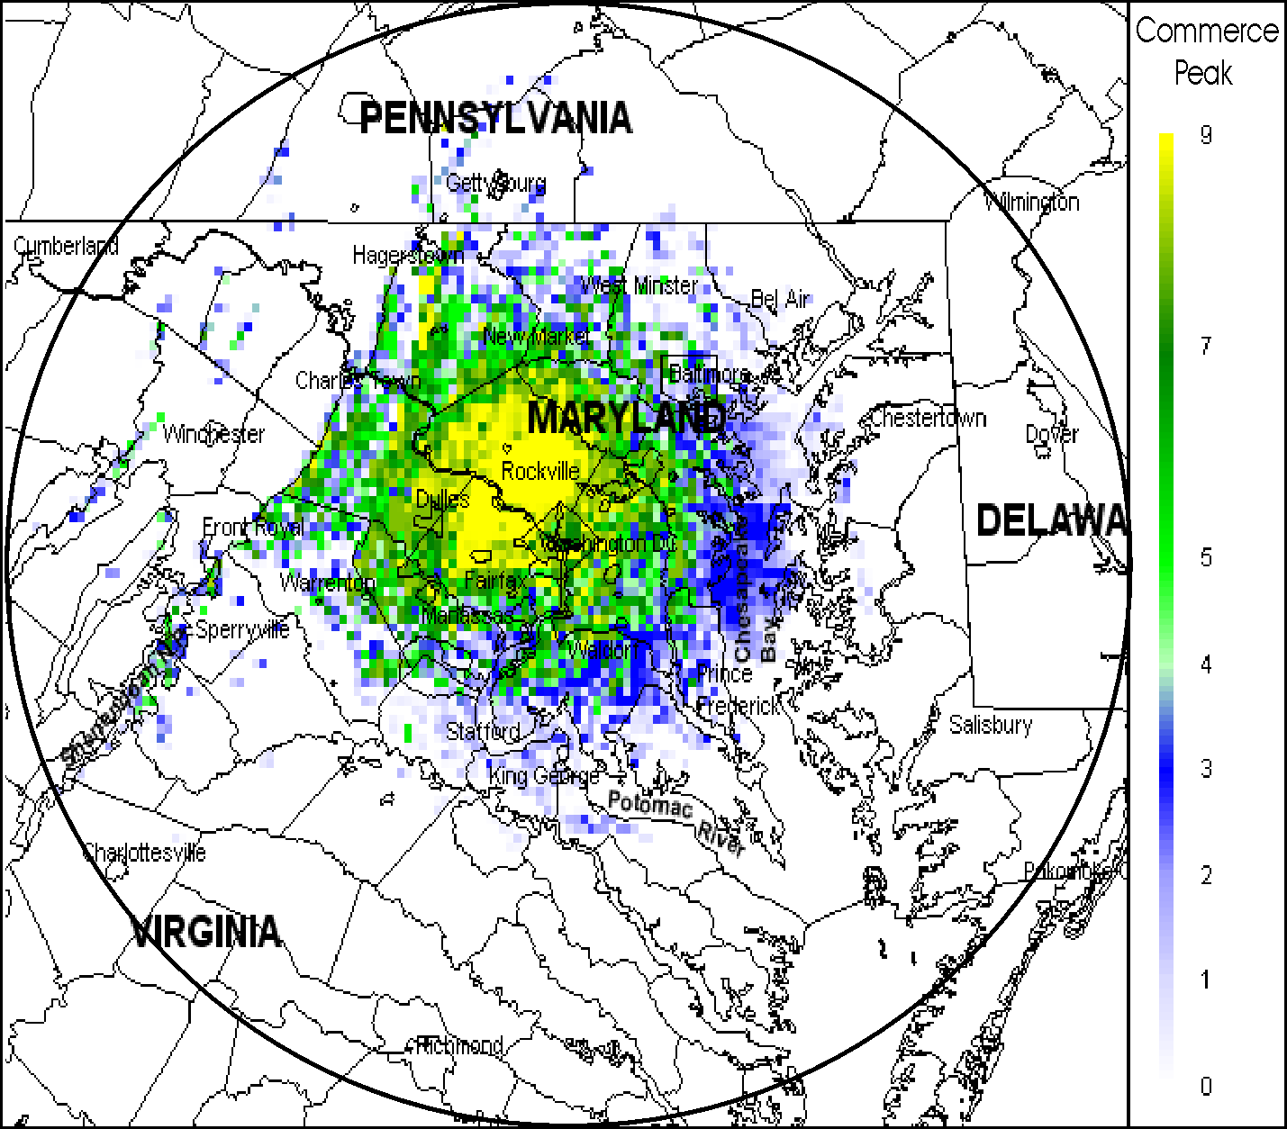

Figure 7-35. Peak Signal Capacity Map for U.S. Department of Commerce

Table 7-9. U.S. Department of Commerce Assignments and Function Codes
Function | Description | # of Assignments
F = 3 | Individual base station transmitter | 9
F = 6 | Trunked network | 0
F = 7 | Single-message repeater network | 0
F = 8 | Multiple-message repeater network | 1
F = 9 | Mobile-only user net | 1
Total included = 11
F = 20 | Obsoleted link | 0
F = 21 | Dedicated link | 172
F = 22 | Receiver | 0
F = 23 | Receiver-only station | 0
F = 25 | Low power (10 mW or less) | 0
F = 26 | Mobile-only (replaced by new system) | 172
Total not included = 172
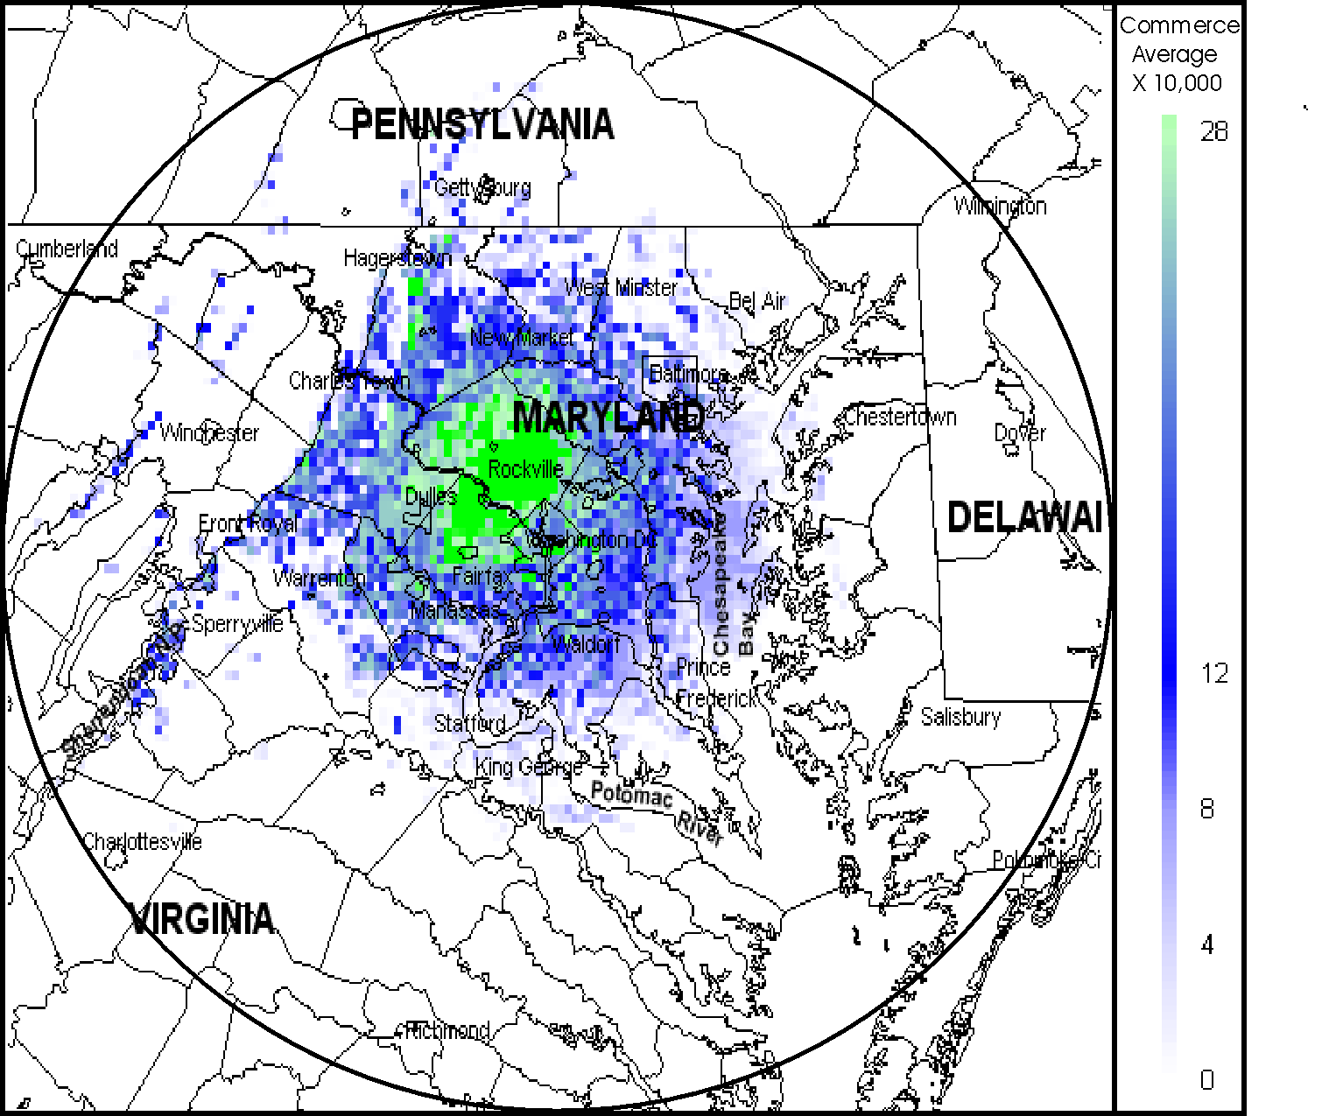

United States Department of Defense (DOD)
Figure 7-36. Average Signal Capacity Map for U.S. Department of Commerce

The locations of the DOD assignments within 100 miles of Washington, D.C. were shown previously in Figure 4-5. That figure shows that the assignments are spread out over the entire area. However, this is in relation to the various DOD facilities that are in and around the Washington area. DOD currently utilizes various systems in this band to support base security and fire, but there are plans to develop a joint service, digital narrowband trunked system in the 380-400 MHz band. The PSC and ASC maps corresponding to current assignments are shown in Figures 7-9 and 7-10, respectively.

The PSC map shows that DOD has a peak level of approximately 36. This is primarily concentrated around the Washington area due to the higher concentration of DOD facilities in close proximity to Washington. There are some higher capacity areas scattered northwest of Washington. This may be due to higher elevations receiving incidental signals from Washington and the surrounding area. The ASC map shows the same concentration of signals, except that the highest is in the northern section where it attains approximately 0.0228 signals per square mile. This could be due to smaller coverage areas. Table 7-6 provides the DOD assignments and function codes that were and were not included in the SCAP analysis.
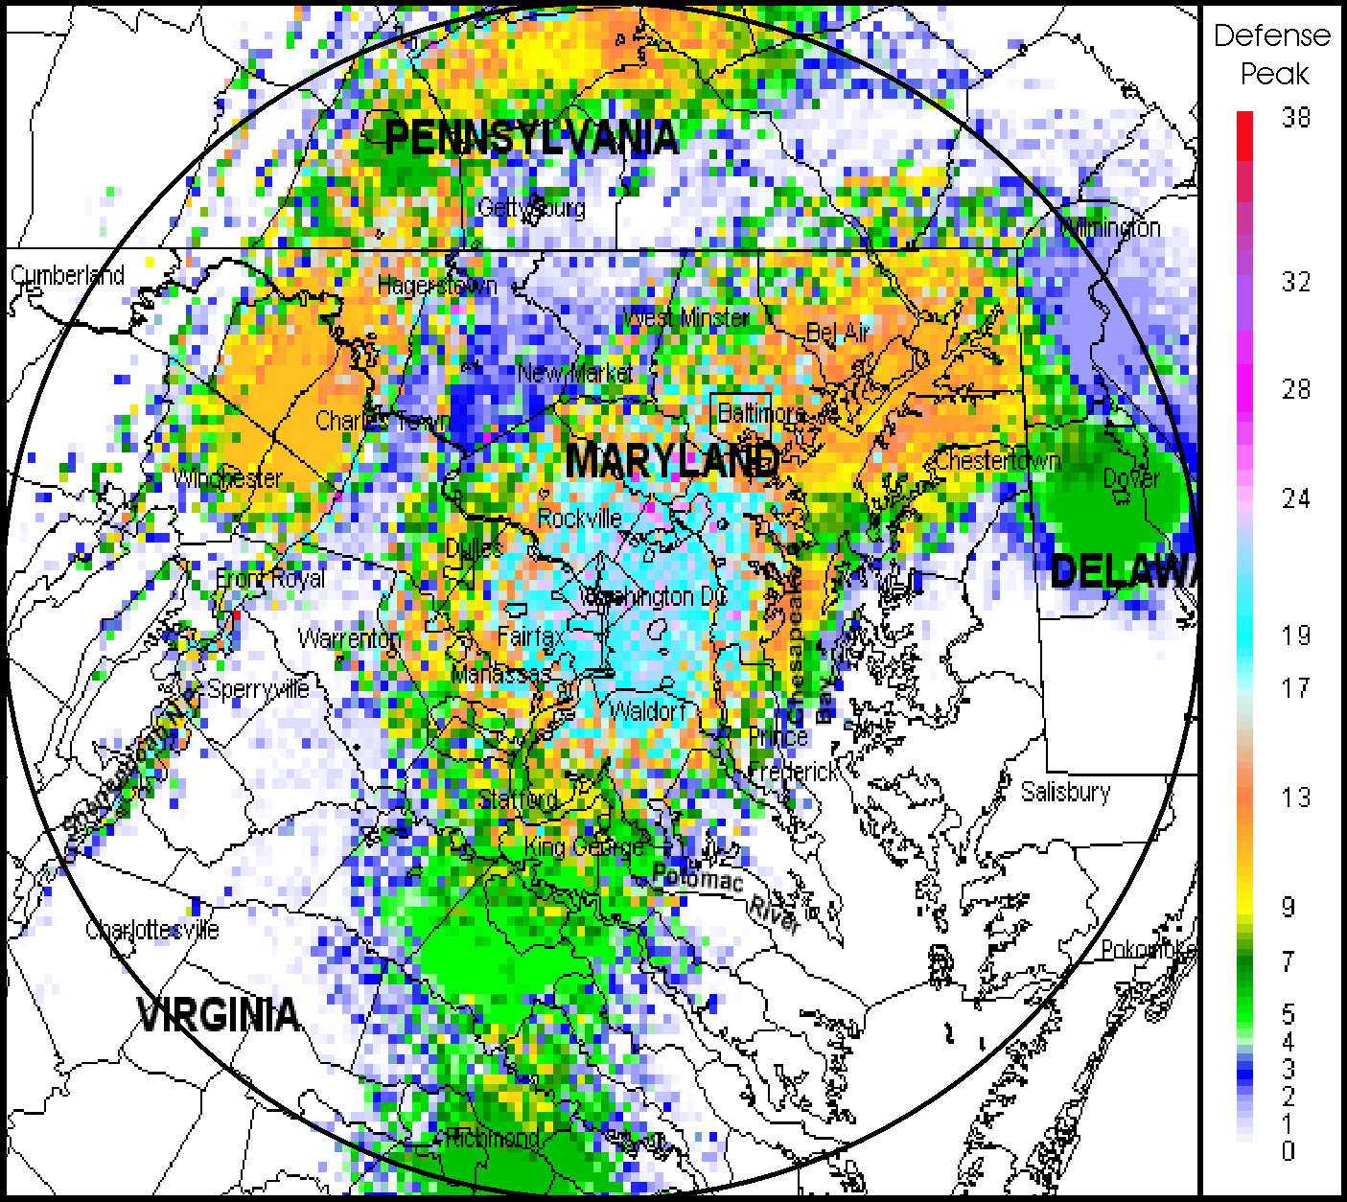
Figure 7-37. Peak Signal Capacity Map for U.S. Department of Defense

Table 7-10. U.S. Department of Defense Assignments and Function Codes
Function | Description | #of Assignments
F = 3 | Individual base station transmitter | 75
F = 6 | Trunked network | 0
F = 7 | Single-message repeater network | 9
F = 8 | Multiple-message repeater network | 0
F = 9 | Mobile-only user net | 24
Total included = 108
F = 20 | Obsoleted link | 0
F = 21 | Dedicated link | 39
F = 22 | Receiver | 6
F = 23 | Receiver-only station | 5
F = 25 | Low power (10 mW or less) | 9
F = 26 | Mobile-only (replaced by new system) | 0
Total not included = 59
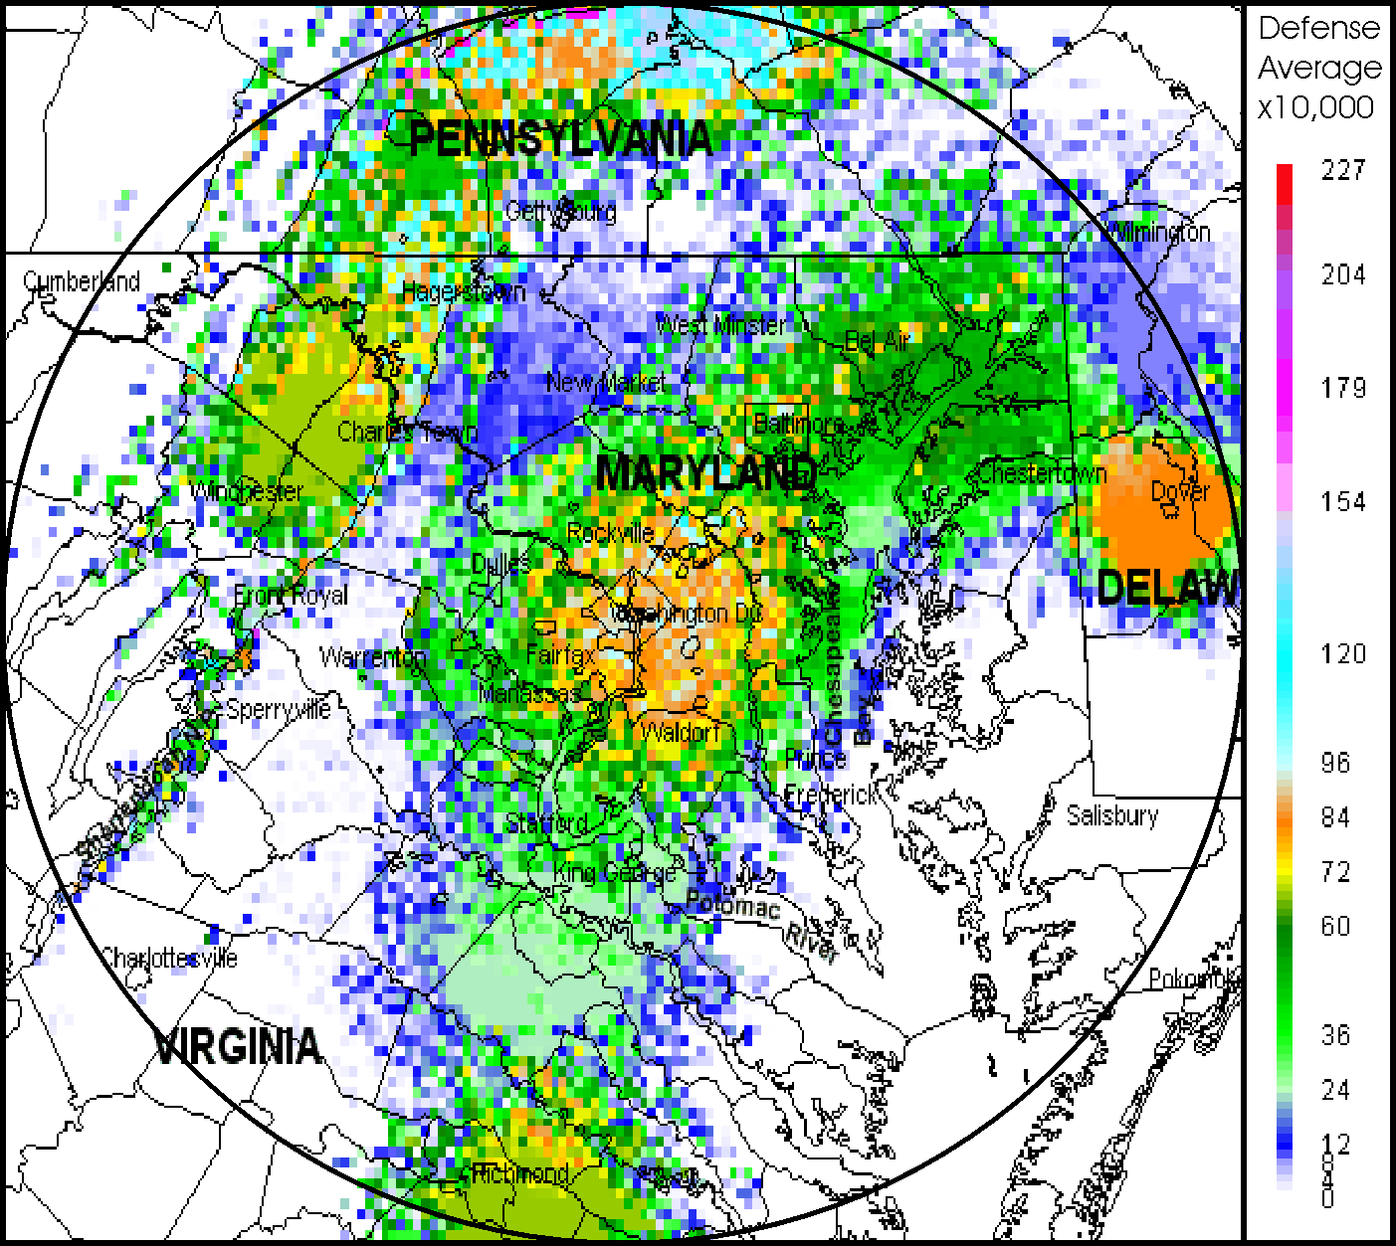

Figure 7-38. Average Signal Capacity Map for U.S. Department of Defense

United States Department of Energy (DOE)

The locations of the DOE assignments within 100 miles of Washington, D.C. were shown previously in Figure 4-6. That figure shows that transmitters concentrate in the Washington, D.C. headquarters and Germantown, Maryland campus areas. DOE is currently operating with digital narrowband equipment for their force protection operations, with the rest of their systems being gradually changed over to analog narrowband. The PSC and ASC maps corresponding to current assignments are shown in Figures 7-11 and 7-12, respectively.

The PSC and ASC maps are virtually identical in presentation. The maps show the highest peak of approximately 3, and highest average of approximately 0.0012 signals per square mile in the area between Washington and Germantown. Incidental signals are noticeable in the higher elevations northwest and west of Washington. Table 7-7 provides the DOE assignments and function codes that were and were not included in the SCAP analysis.
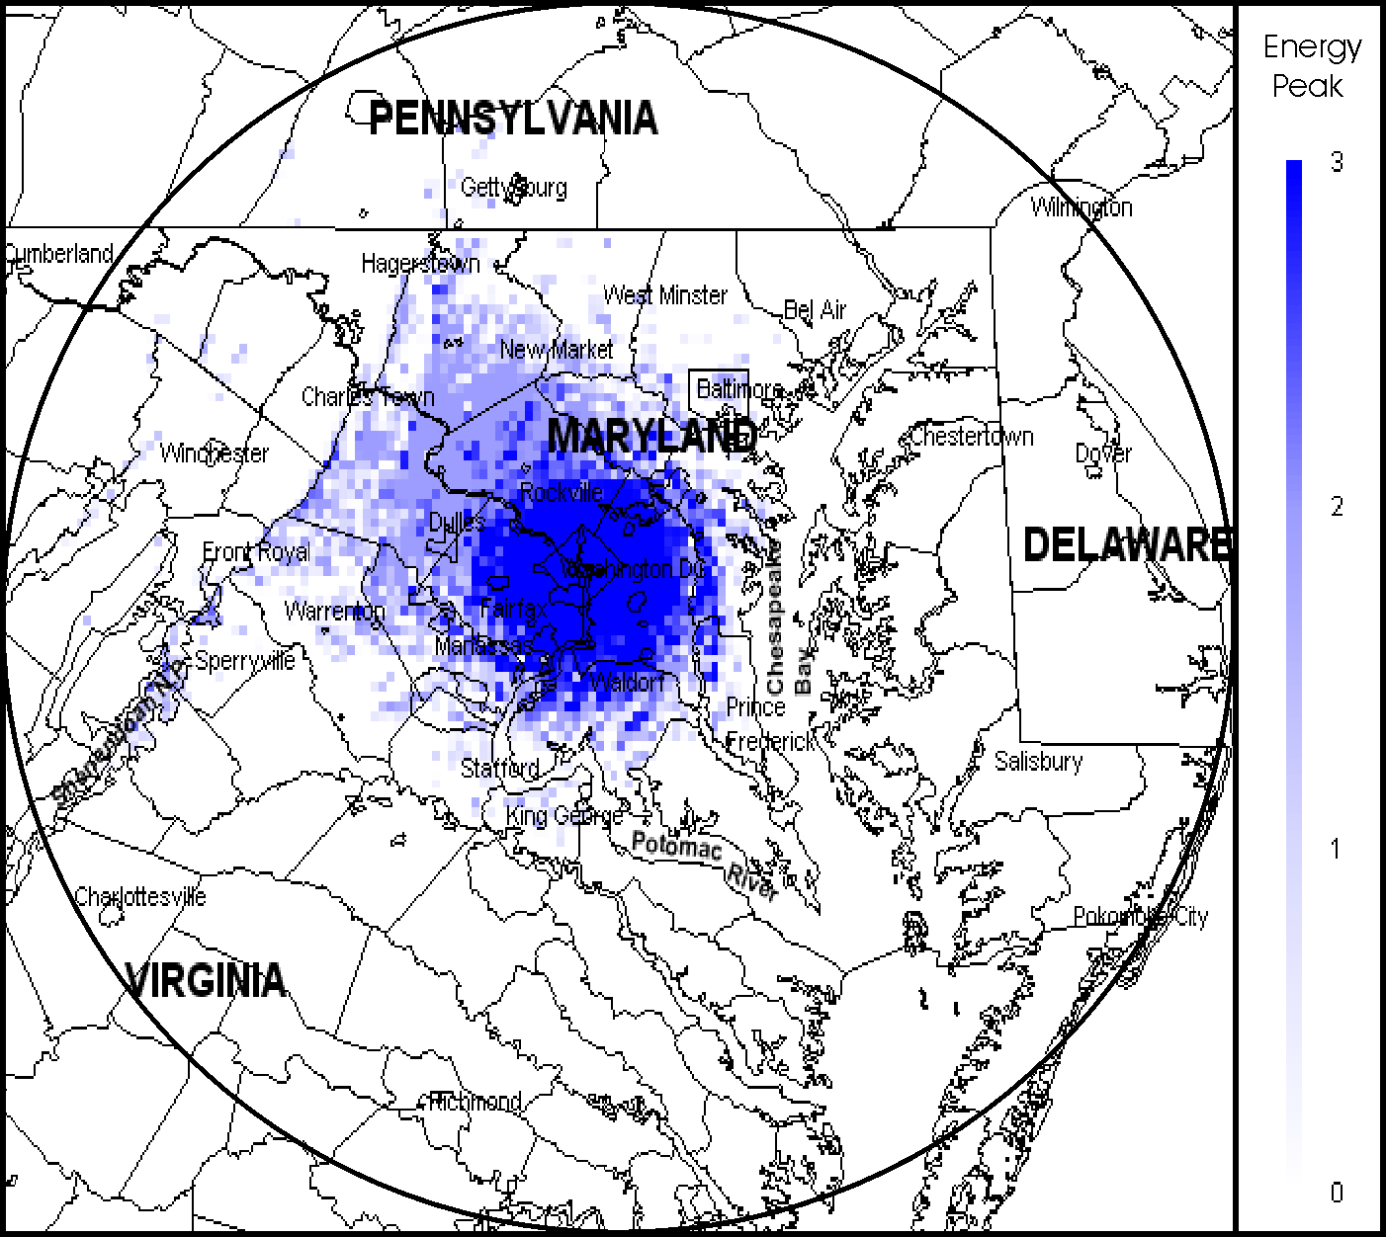
Figure 7-39. Peak Signal Capacity Map for U.S. Department of Energy

Table 7-11. U.S. Department of Energy Assignments and Function Codes
Function | Description | # of Assignments
F = 3 | Individual base station transmitter | 0
F = 6 | Trunked network | 0
F = 7 | Single-message repeater network | 8
F = 8 | Multiple-message repeater network | 0
F = 9 | Mobile-only user net | 1
Total included = 9
F = 20 | Obsoleted link | 0
F = 21 | Dedicated link | 34
F = 22 | Receiver | 0
F = 23 | Receiver-only station | 0
F = 25 | Low power (10 mW or less) | 2
F = 26 | Mobile-only (replaced by new system) | 0
Total not included = 36
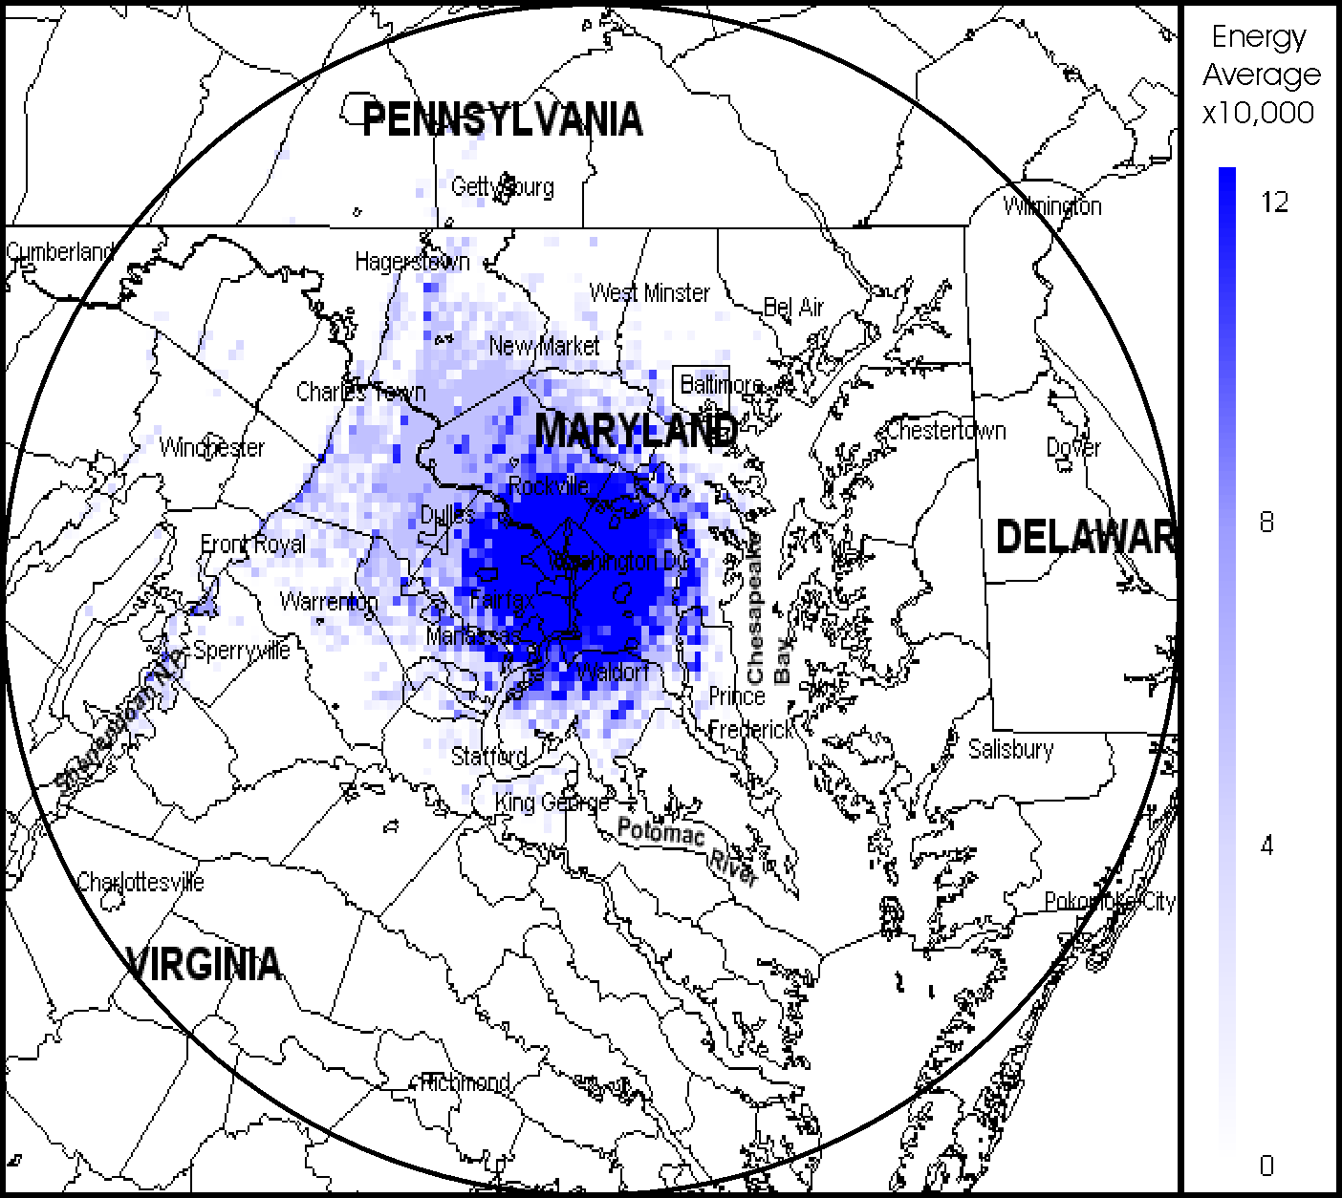

Figure 7-40. Average Signal Capacity for U.S. Department of Energy

Federal Aviation Administration (FAA)

The locations of the FAA assignments within 100 miles of Washington, D.C. were shown previously in Figure 4-7. That figure shows that the major transmitter concentration is in and near Washington, D.C., and Baltimore, Maryland. The FAA has a major nationwide communications system based on a regional concept that can tie all aviation and FAA support facilities together. The FAA will be replacing their older wideband system with a newer narrowband digital system. The PSC and ASC maps corresponding to current assignments are shown in Figures 7-13 and 7-14 respectively.

The PSC shows that the highest peak signal is approximately 13. This is consistent throughout the Washington/Baltimore area. This is due to three major airports being located in relative close proximity to each other. There are some mid-level and lower concentrations closely surrounding the other regional airports in the study area. Incidental signals from the Washington area are present in the higher elevations to the west giving those areas a higher peak capacity than is supported by actual transmitters. The ASC map shows that ASC reaches level of approximately 0.0060 signals per square mile. Table 7-8 provides the FAA assignments and function codes that were and were not included in the SCAP analysis.
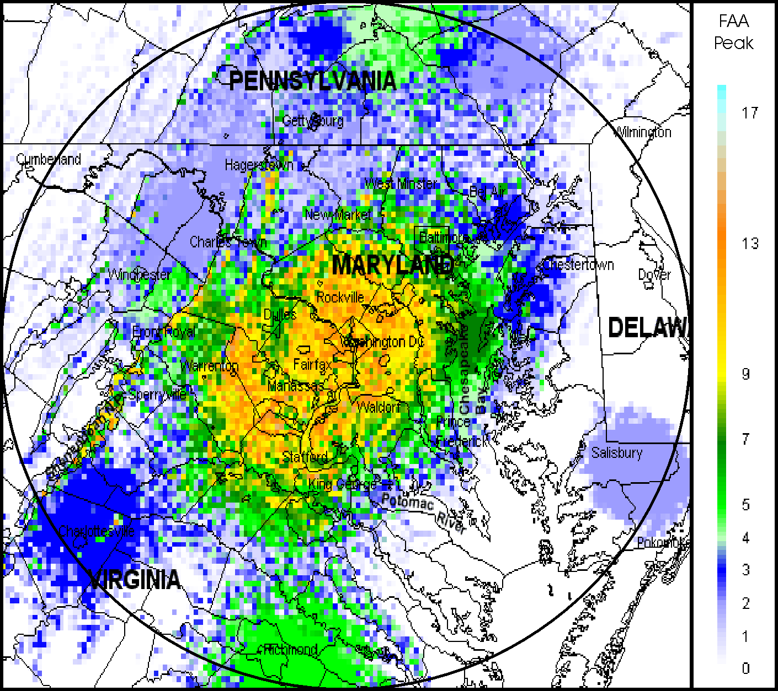

Figure 7-41. Peak Signal Capacity for the Federal Aviation Administration

Table 7-12. Federal Aviation Administration Assignment and Function Codes
Function | Description | # of Assignments
F = 3 | Individual base station transmitter | 25
F = 6 | Trunked network | 0
F = 7 | Single-message repeater network | 16
F = 8 | Multiple-message repeater network | 3
F = 9 | Mobile-only user net | 2
Total included = 46
F = 20 | Obsoleted link | 1
F = 21 | Dedicated link | 22
F = 22 | Receiver | 38
F = 23 | Receiver-only station | 0
F = 25 | Low power (10 mW or less) | 1
F = 26 | Mobile-only (replaced by new system | 1
Total not included = 63
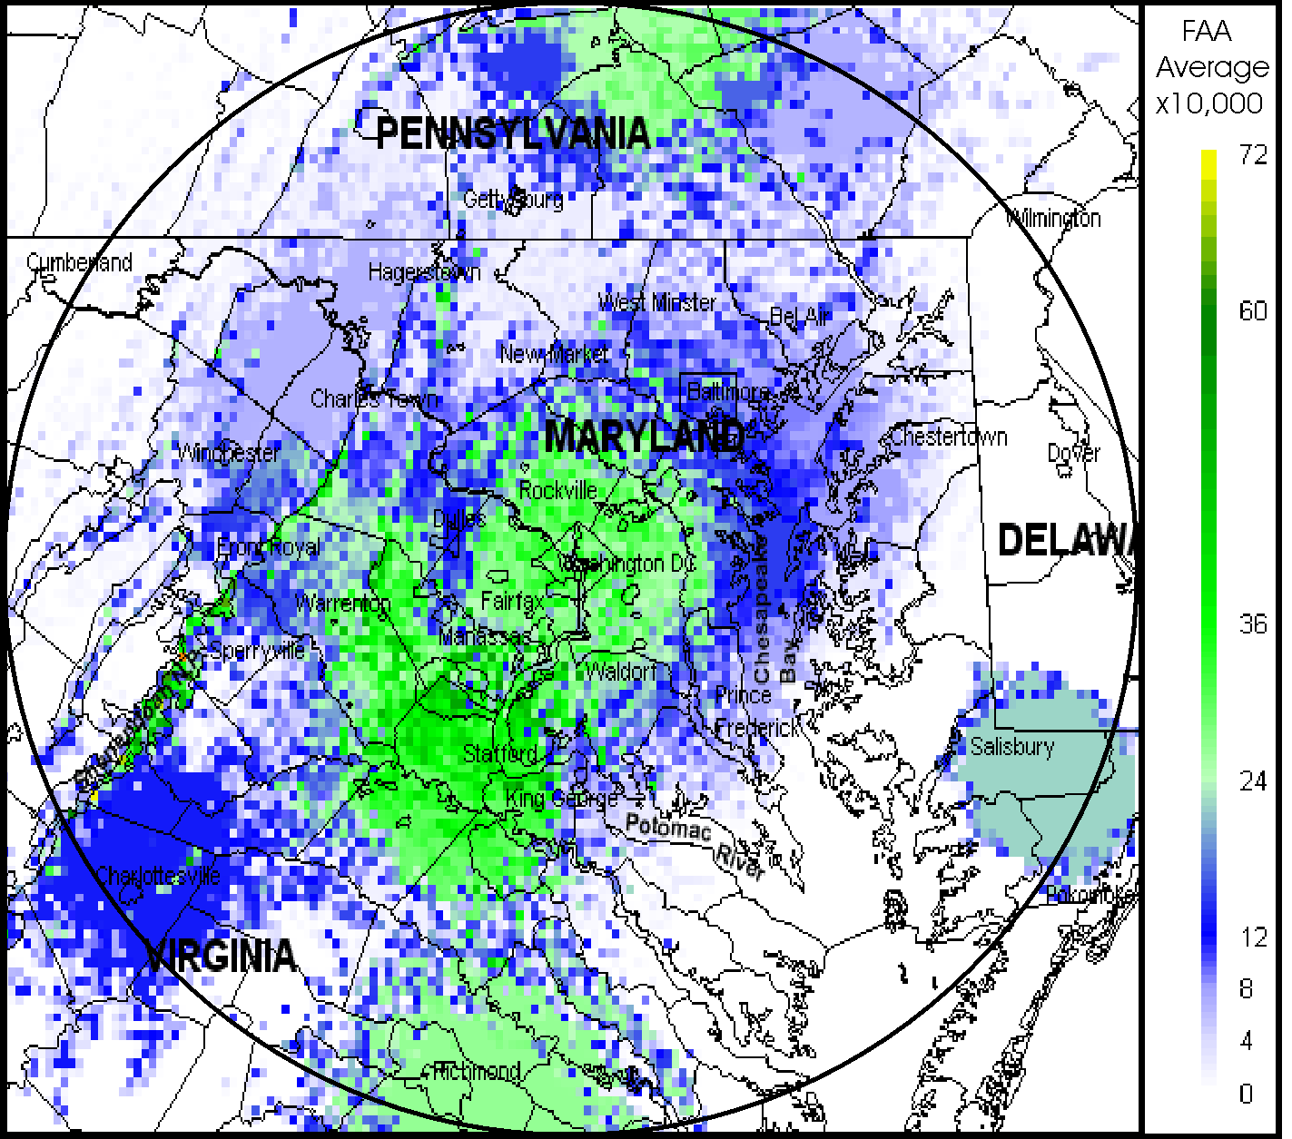

Figure 7-42. Average Signal Capacity for the Federal Aviation Administration

United States Department of Interior (DOI)

The locations of the DOI assignments within 100 miles of Washington, D.C. were shown previously in Figure 4-8. That figure shows the major transmitter concentration around the national headquarter sites in and near Washington, D.C. A lesser, but still notable peak signal concentration is noted around Washington, D.C. DOI is currently researching the feasibility of placing their law enforcement operations on a digital narrowband trunked system. Their other operations will convert to analog narrowband equipment. The PSC and ASC maps corresponding to current assignments are shown in Figures 7-15 and 7-16, respectively.

The PSC map shows concentrations of up to approximately 24 signals in, and closely around, the Washington, D.C. area. Noticeable higher peak levels are also noted around the immediate Washington, D.C. area. These areas correspond to the national parks that reside in the study area. The ASC map shows that the ASC reaches approximately 0.0096 signals per square mile. Table 7-9 provides the DOI assignments and function codes that were and were not included in the SCAP analysis.
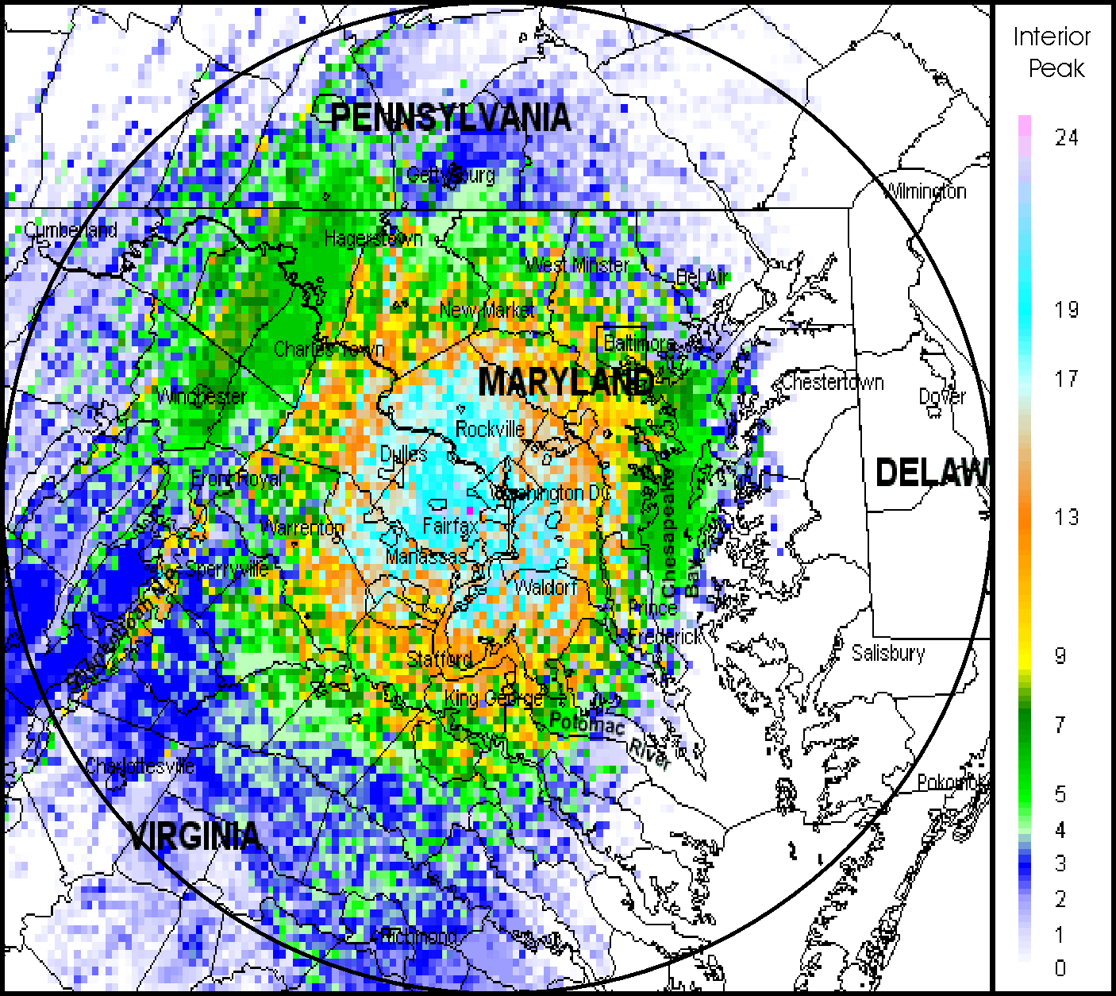

Figure 7-43. Peak Signal Capacity for U.S. Department of Interior

Table 7-13. U.S. Department of Interior Number Assignments and Function Codes
Function | Description | # of Assignments
F = 3 | Individual base station transmitter | 15
F = 6 | Trunked network | 0
F = 7 | Single-message repeater network | 12
F = 8 | Multiple-message repeater network | 63
F = 9 | Mobile-only user net | 4
Total included = 94
F = 20 | Obsoleted link | 23
F = 21 | Dedicated link | 5
F = 22 | Receiver | 93
F = 23 | Receiver-only station | 0
F = 25 | Low power (10 mW or less) | 1
F = 26 | Mobile-only (replaced by new system) | 36
Total not included = 158
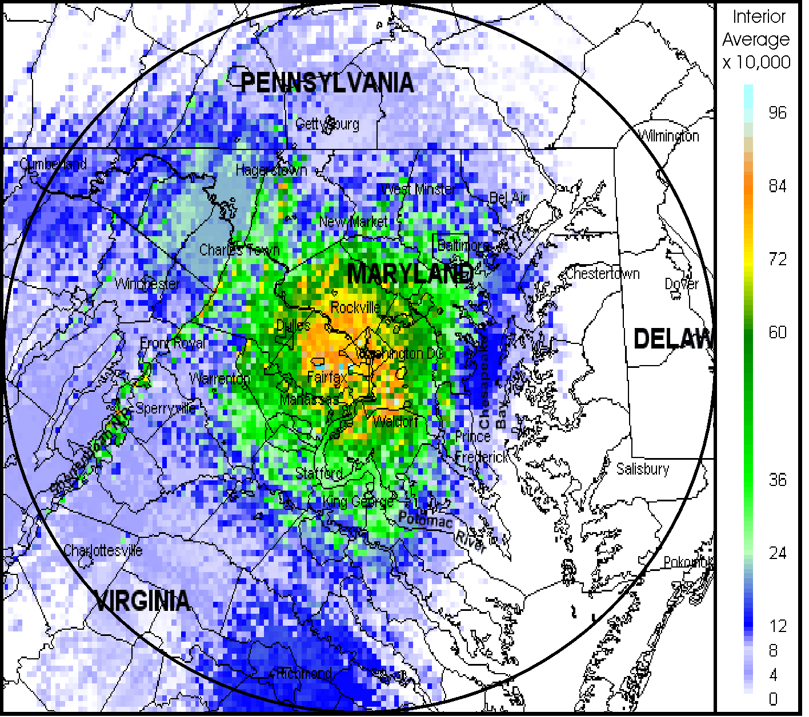

Figure 7-44. Average Signal Capacity for U.S. Department of Interior

United States Department of Justice (DOJ)

The locations of the DOJ assignments within 100 miles of Washington, D.C. were shown previously in Figure 4-9. That figure shows the major transmitter concentration in Washington, D.C., with other transmitters “scattered” throughout the study area. DOJ is in the process of developing their next generation communication system, IWN. This system will be a pseudo-nationwide P-25 digital trunked system. The PSC and ASC maps corresponding to current assignments are shown in Figures 7-17 and 7-18, respectively.

The PSC map shows that the PSC for DOJ is an almost linear decrease in peak signals moving out from Washington, D.C., with the highest concentration of signals, approximately 70, in Washington, D.C. The higher peaks in the diagonal line to the southwest are probably incidental signals received in the higher attitudes from the metro area. The ASC shows that DOJ reaches an ASC of approximately 0.0167 signals per square mile. Table 7-10 provides the DOJ assignments and function codes that were and were not included in the SCAP analysis.
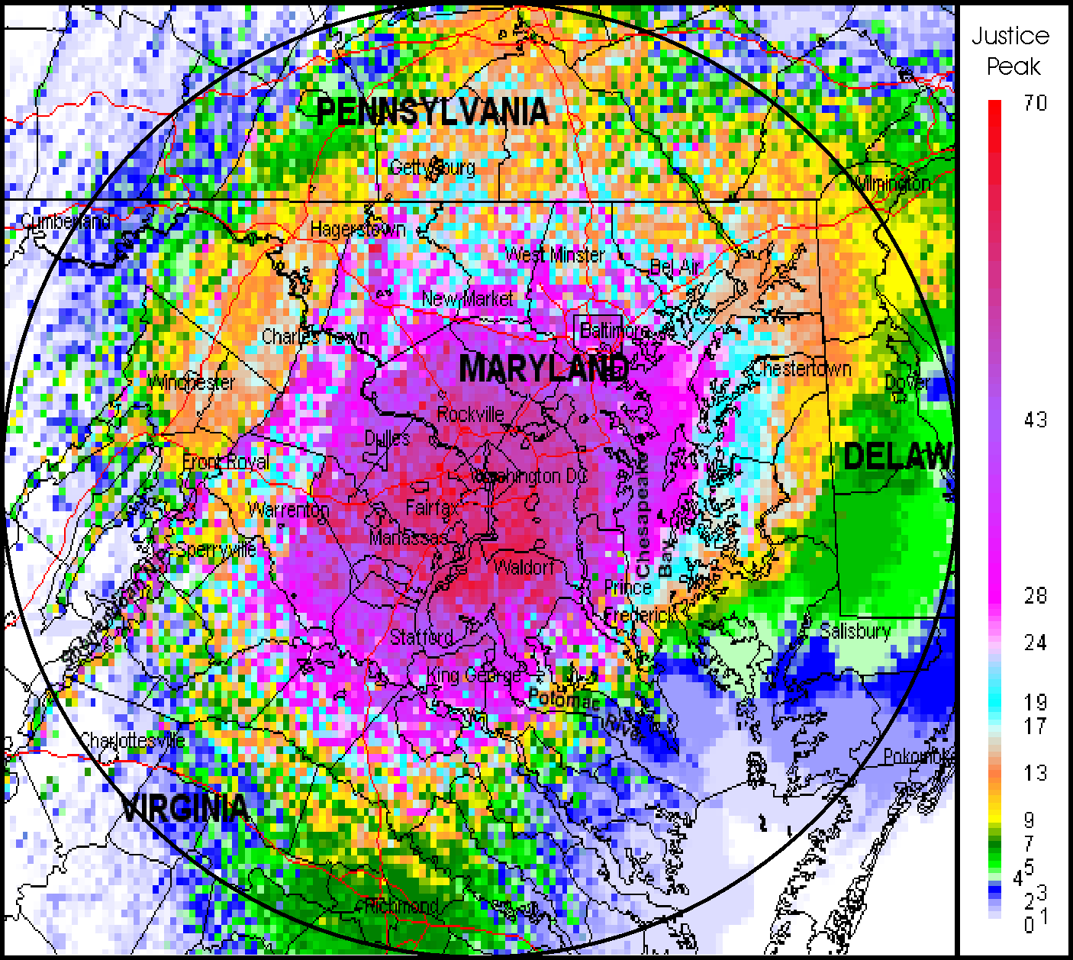
Figure 7-45. Peak Signal Capacity Map for U.S. Department of Justice

Table 7-14. U.S. Department of Justice Number Assignments and Function Codes
Function | Description | # of Assignments
F = 3 | Individual base station transmitter | 30
F = 6 | Trunked network | 0
F = 7 | Single-message repeater network | 139
F = 8 | Multiple-message repeater network | 54
F = 9 | Mobile-only user net | 12
Total included = 235

F = 20 | Obsoleted link | 52
F = 21 | Dedicated link | 13
F = 22 | Receiver | 191
F = 23 | Receiver-only station | 175
F = 25 | Low power (10 mW or less) | 4
F = 26 | Mobile-only (replaced by new system) | 0
Total not included = 435
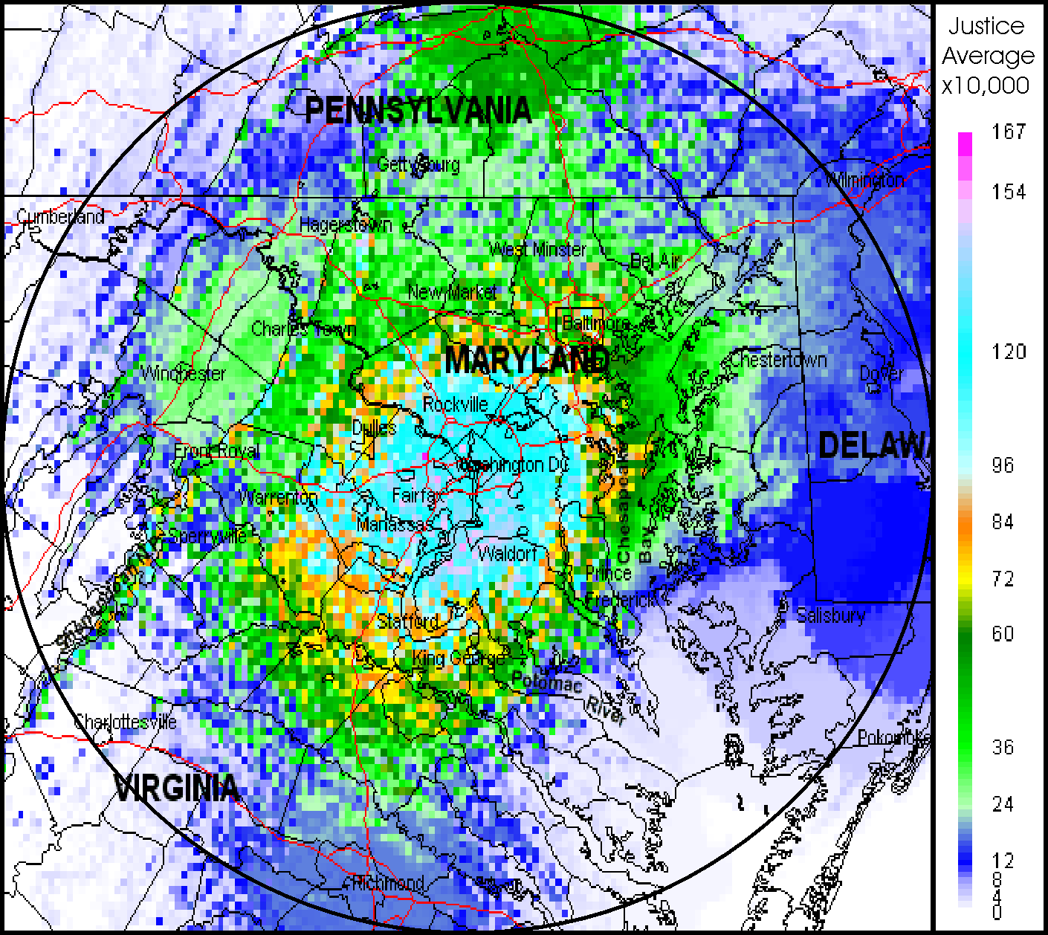

Figure 7-46. Average Signal Capacity Map for U.S. Department of Justice

United States Capitol Police (USCP)

The locations of the USCP assignments within 100 miles of Washington, D.C. were shown previously in Figure 4-11. That figure shows the major transmitter concentration is in Washington, D.C. area. The USCP currently uses a conventional wideband analog system. They will be replacing these radios with narrowband analog radios. The PSC and ASC maps corresponding to current assignments are shown in Figures 7-4 and 7-5, respectively.

The PSC map shows the highest PSC of approximately 5 in the Washington, D.C. area. Some peak signals are evident to the west due to incidental signals being present at higher elevations. The ASC map is virtually identical map to the PSC, but shows the highest ASC to be approximately 0.0013 signals per square mile. The ASC is higher than would be expected due to the concentrated operating area of the USCP. Table 7-11 provides the USCP assignments and function codes that were and were not included in the SCAP analysis.
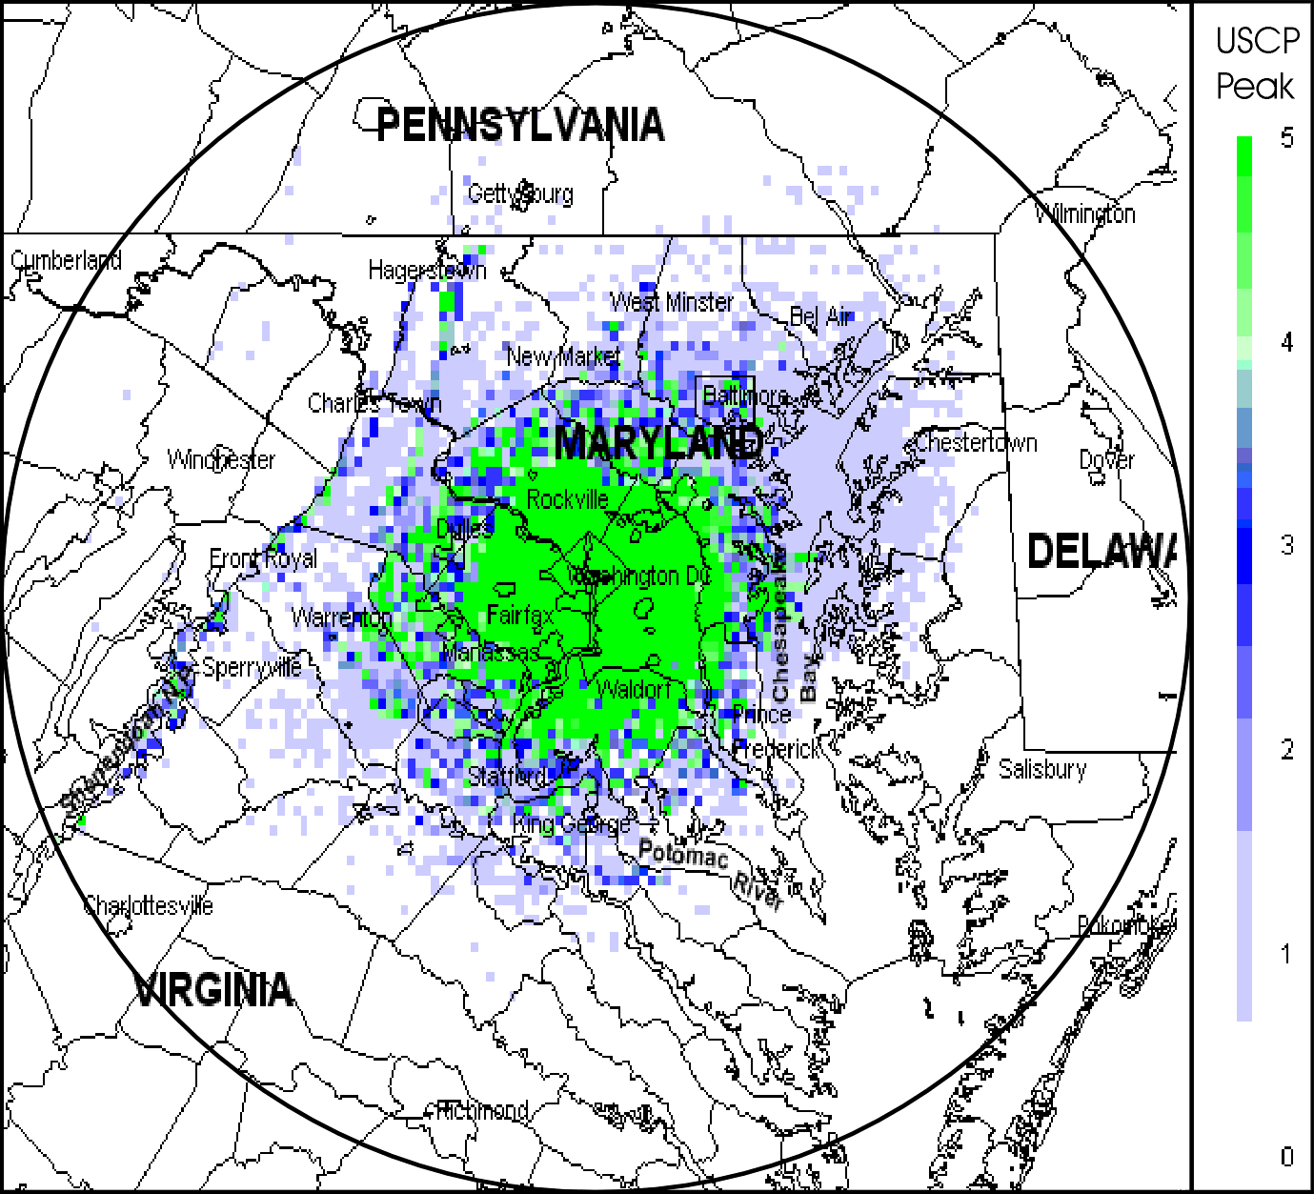
Figure 7-47. Peak Signal Capacity Map for U. S. Capitol Police

Table 7-15. U.S. Capitol Police Assignment and Function Codes
Function | Description | # of Assignments
F = 3 | Individual base station transmitter | 0
F = 6 | Trunked network | 0
F = 7 | Single-message repeater network | 14
F = 8 | Multiple-message repeater network | 0
F = 9 | Mobile-only user net | 5
Total included = 19
F = 20 | Obsoleted link | 0
F = 21 | Dedicated link | 0
F = 22 | Receiver | 6
F = 23 | Receiver-only station | 0
F = 25 | Low power (10 mW or less) | 0
F = 26 | Mobile-only (replaced by new system) | 6
Total not included = 12
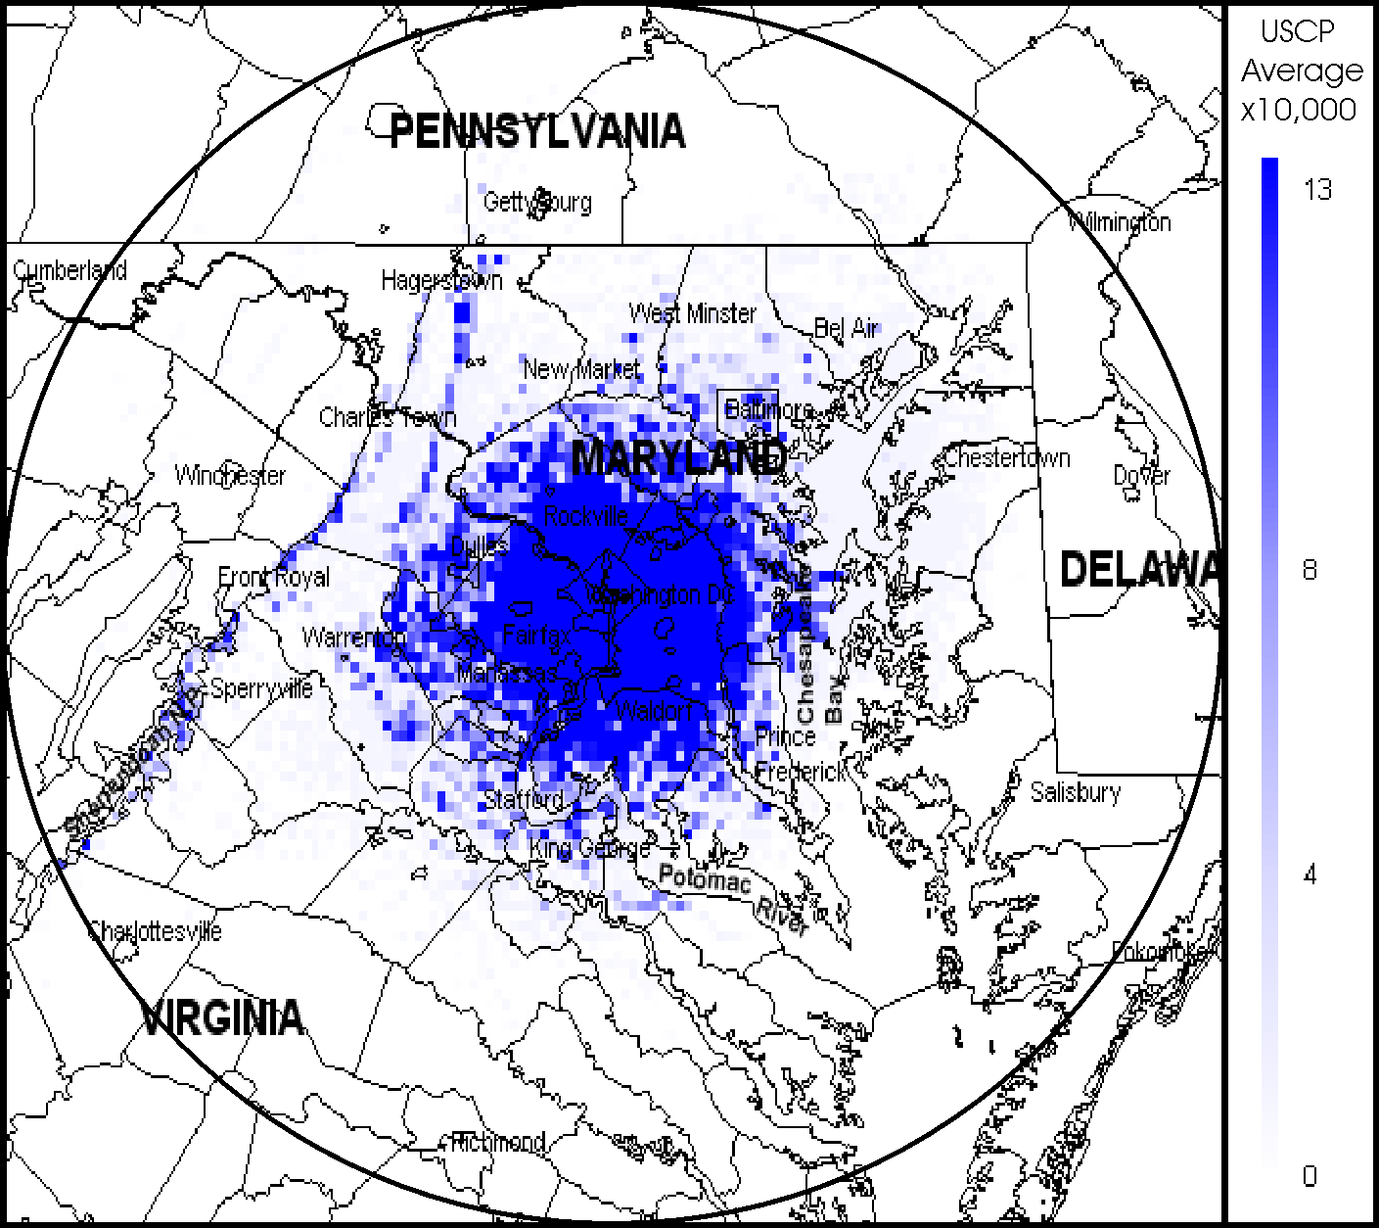

Figure 7-48. Average Signal Capacity Map for U. S. Capitol Police

United States Postal Service (USPS)

The locations of the USPS assignments within 100 miles of Washington, D.C. were shown previously in Figure 4-12. That figure shows the major transmitter concentration in Washington, D.C. The USPS currently uses wideband analog radios but is in the processes of changing over to narrowband. The PSC and ASC maps corresponding to current assignments are shown in Figures 7-21 and 7-22, respectively.

The PSC map shows a PSC of approximately 13 in and immediately around Washington, D.C. The peak level of three located to the north is due to a smaller number of transmitters in the Harrisburg, Pennsylvania postal facility. The higher peak levels that run in a diagonal line to the west of Washington, D.C. are most likely incidental signals in the higher elevations from Washington, D.C., and not representative of the actual transmitters supporting that area. The ASC map gives a virtually identical representation achieving an ASC of approximately 0.0072 signals per square mile. This higher level is concentrated due to the use of in-building, small area coverage repeaters in the Washington, D.C., postal facilities. Table 7-12 provides the USPS assignments and function codes that were and were not included in the SCAP analysis.
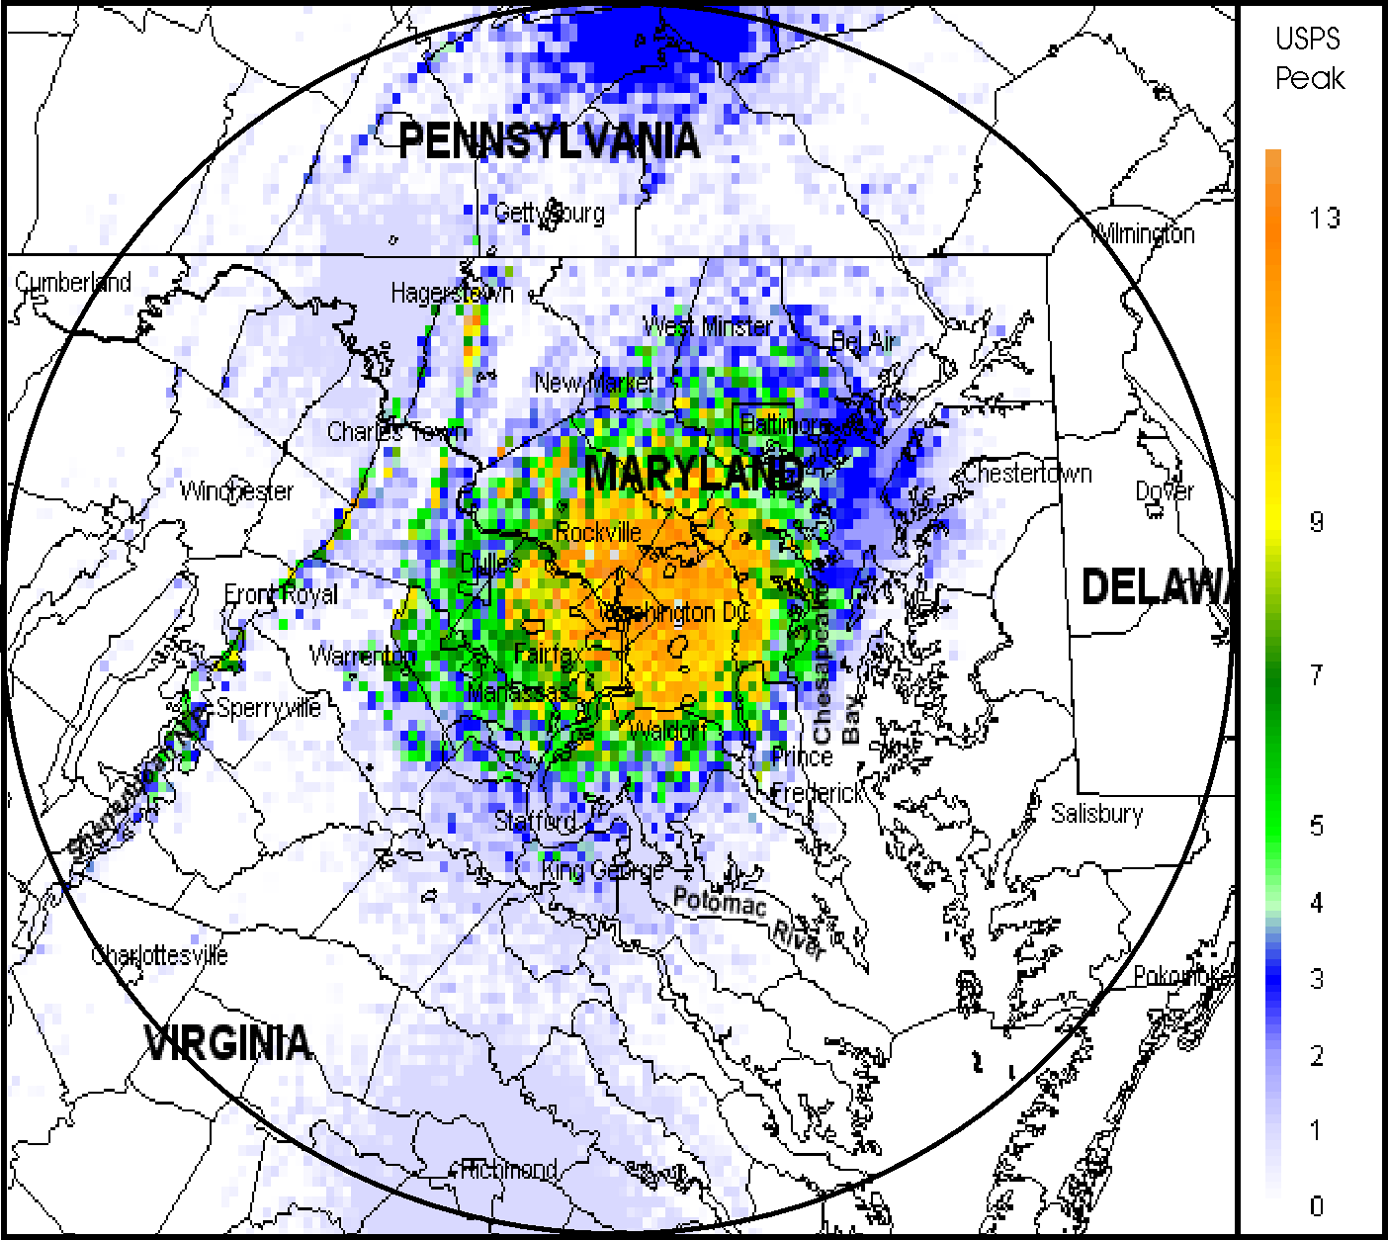

Figure 7-49. Peak Signal Capacity for U.S. Postal Service

Table 7-16. U.S. Postal Service Assignments and Function Codes
Function | Description | # of Assignments
F = 3 | Individual base station transmitter | 16
F = 6 | Trunked network | 0
F = 7 | Single-message repeater network | 6
F = 8 | Multiple-message repeater network | 0
F = 9 | Mobile-only user net | 14
Total included = 36
F = 20 | Obsoleted link | 0
F = 21 | Dedicated link | 0
F = 22 | Receiver | 5
F = 23 | Receiver-only station | 0
F = 25 | Low power (10 mW or less) | 0
F = 26 | Mobile-only (replaced by new system) | 0
Total not included = 5

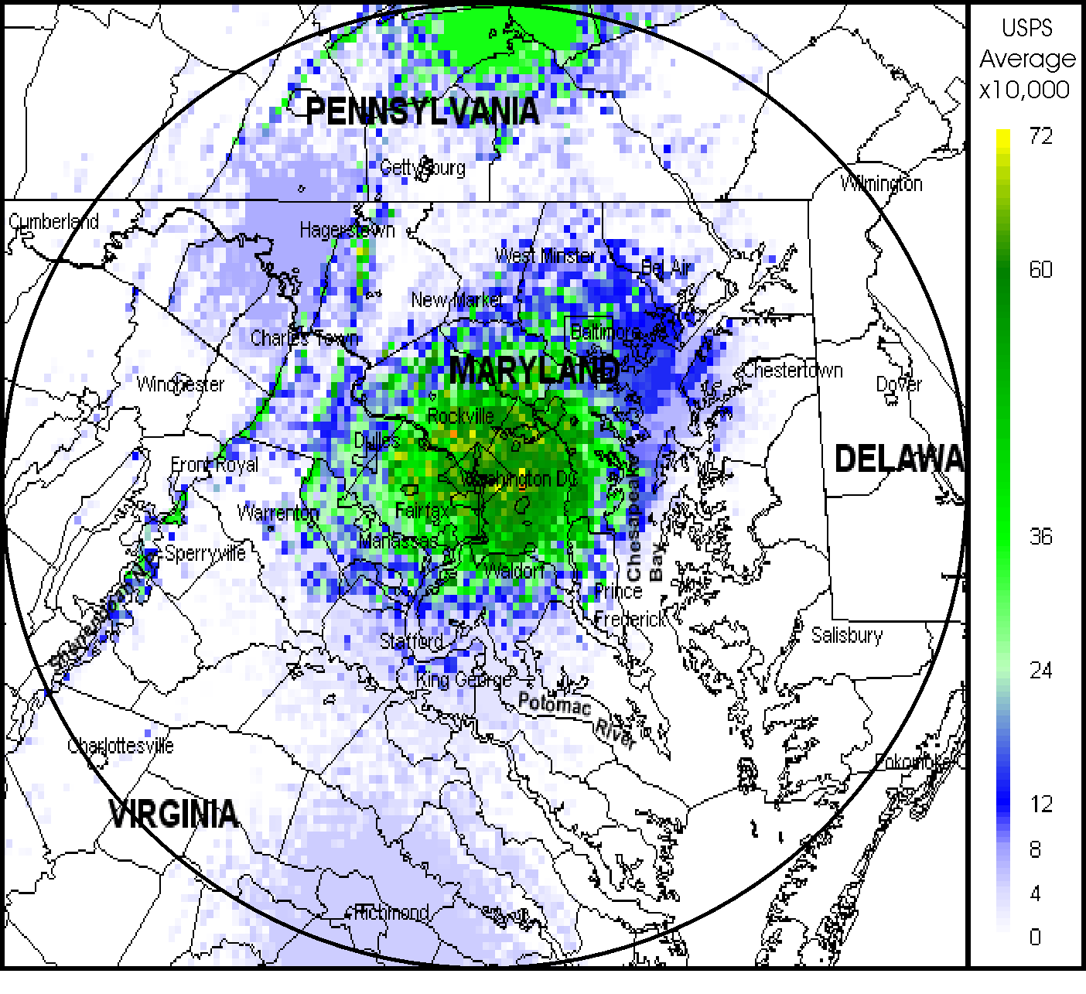

Figure 7-50. Average Signal Capacity for U.S. Postal Service

United States Department of Treasury (Treasury)

The locations of the Treasury assignments within 100 miles of Washington, D.C. were shown previously in Figure 4-10. That figure shows the major transmitters are in and around Washington, D.C., with smaller transmitter sites “scattered” throughout the study area. Many of Treasury’s bureaus were transferred over to the Department of Homeland Security and therefore will join the IWN with Justice. The PSC and ASC maps corresponding to current assignments are shown in Figures 7-23 and 7-24, respectively.

The PSC map shows that Treasury’s PSC is almost a linear taper-off from Washington, D.C. throughout the whole area, while attaining a PSC of approximately 35. A noticeable concentration of SC can be seen around the capitol cities of Richmond, Virginia, and Wilmington, Delaware. The ASC map shows the same concentration of signals as the PSC and attains an ASC of 0.0129 signals per square mile. Table 7-13 provides the Treasury assignments and function codes that were and were not included in the SCAP analysis.

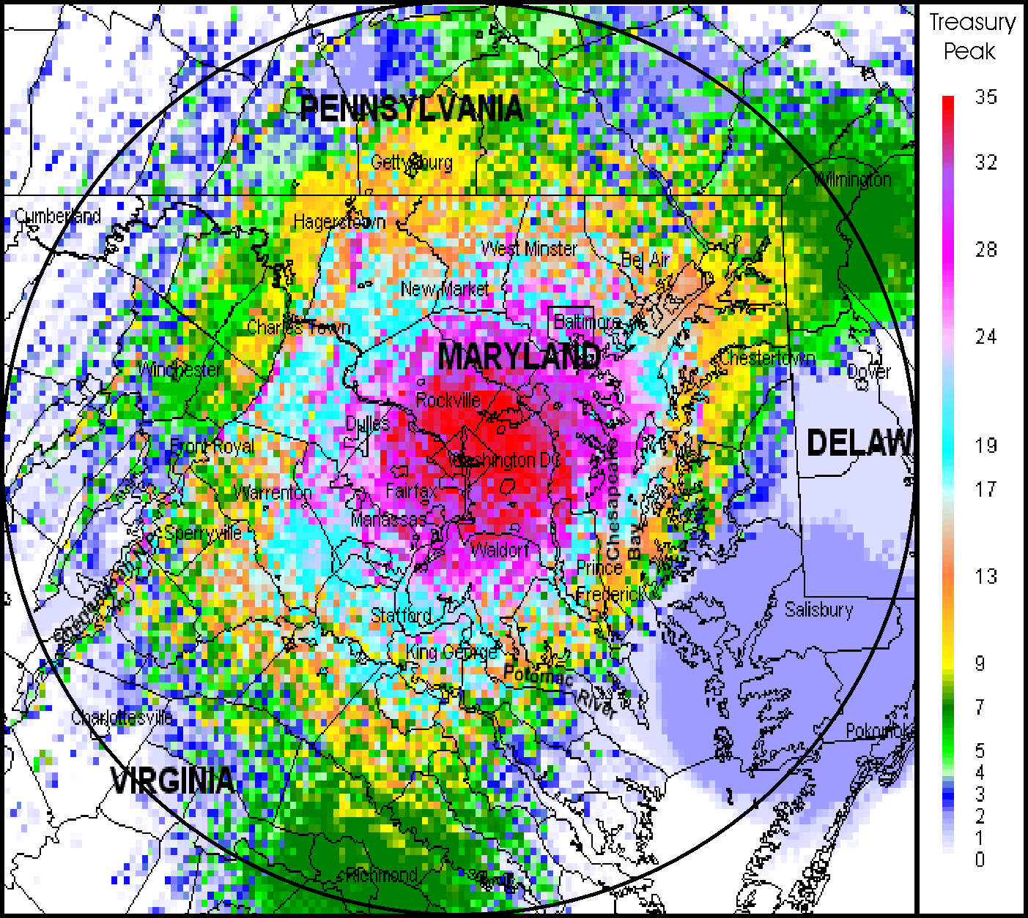

Figure 7-51. Peak Signal Capacity for U.S. Department of Treasury

Table 7-17. U.S. U.S. Department of Treasury Assignments and Function Codes
Function | Description | # of Assignments
F = 3 | Individual base station transmitter | 5
F = 6 | Trunked network | 5
F = 7 | Single-message repeater network | 38
F = 8 | Multiple-message repeater network | 100
F = 9 | Mobile-only user net | 17
Total included = 165
F = 20 | Obsoleted link | 7
F = 21 | Dedicated link | 13
F = 22 | Receiver | 46
F = 23 | Receiver-only station | 0
F = 25 | Low power (10 mW or less) | 0
F = 26 | Mobile-only (replaced by new system | 0
Total not included = 66

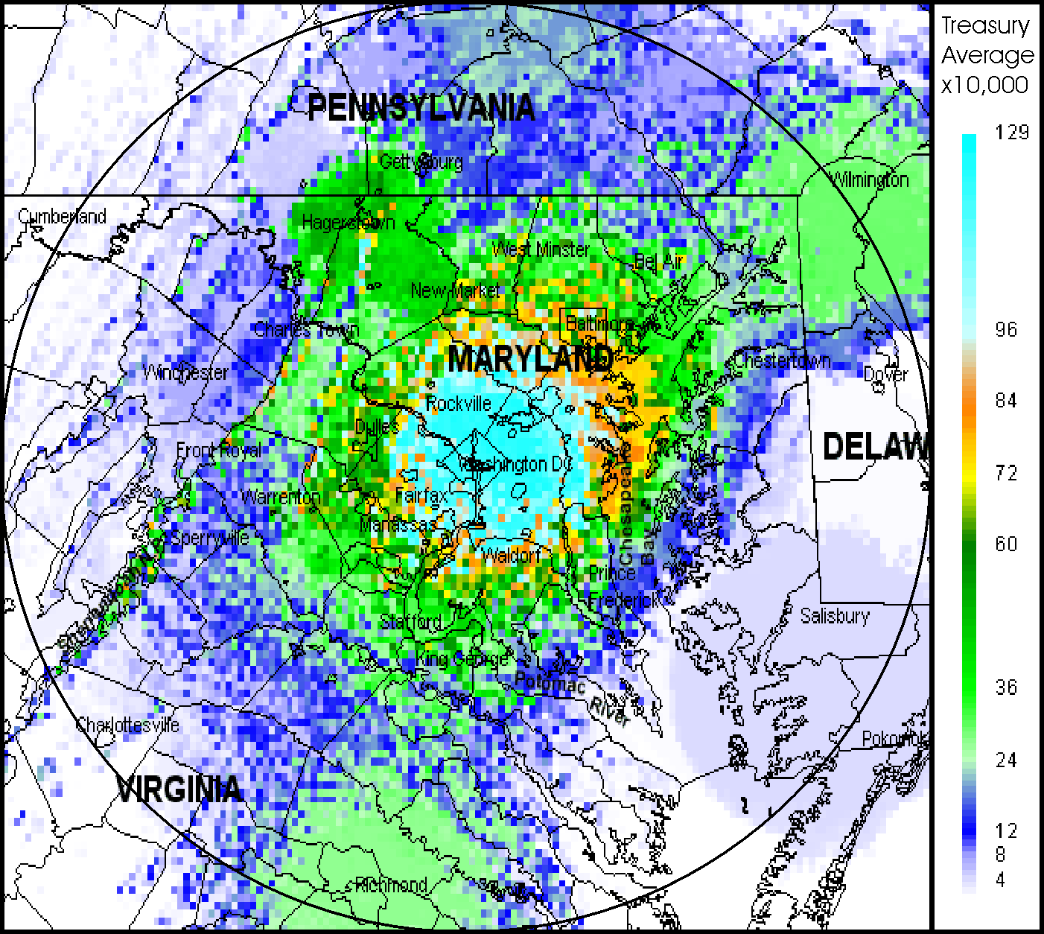

Figure 7-52. Average Signal Capacity Map for U.S. Department of Treasury

United States Department of Veterans Affairs (VA)

The locations of the VA assignments within 100 miles of Washington, D.C. were shown previously in Figure 4-13. That figure shows two major transmitter concentrations, including national headquarter sites in and near Washington, D.C., and a major VA facility in northeastern Maryland. The urban/headquarter sites will be changing over to the 1CommWireless system, a digital trunked system, while the other sites have already transitioned to analog narrowband radios. The PSC and ASC maps corresponding to current assignments are shown in Figures 7-25 and 7-26, respectively.

The PSC map shows that the higher peak signals of approximately 7 are more in the northeastern portion of the map. This is caused by an overlapping of transmitter signals from facilities in Pennsylvania, Maryland, and Delaware. The diagonal line to the west of Washington is most likely incidental signals in the higher elevations. The ASC map mirrors the peak map in that the highest average capacity of approximately 0.0036 signals per square mile is in that same area to the northeast. Table 7-14 provides the VA assignments and function codes that were and were not included in the SCAP analysis.
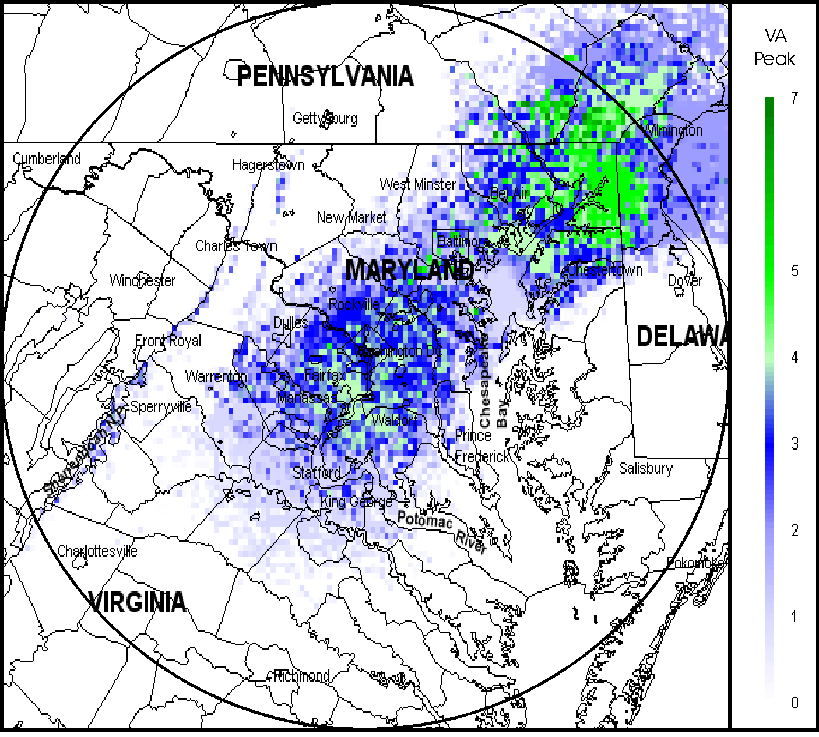

Figure 7-53. Peak Signal Capacity Map for U.S. Department of Veteran’s Affairs

Table 7-18. U.S. Department of Veterans Affairs Assignments and Function Codes
Function | Description | # of Assignments
F = 3 | Individual base station transmitter | 0
F = 6 | Trunked network | 0
F = 7 | Single-message repeater network | 5
F = 8 | Multiple-message repeater network | 6
F = 9 | Mobile-only user net | 6
Total included = 17
F = 20 | Obsoleted link | 0
F = 21 | Dedicated link | 7
F = 22 | Receiver | 5
F = 25 | Low power (10 mW or less) | 0
F = 26 | Mobile-only (replaced by new system) | 0
Total not included = 12
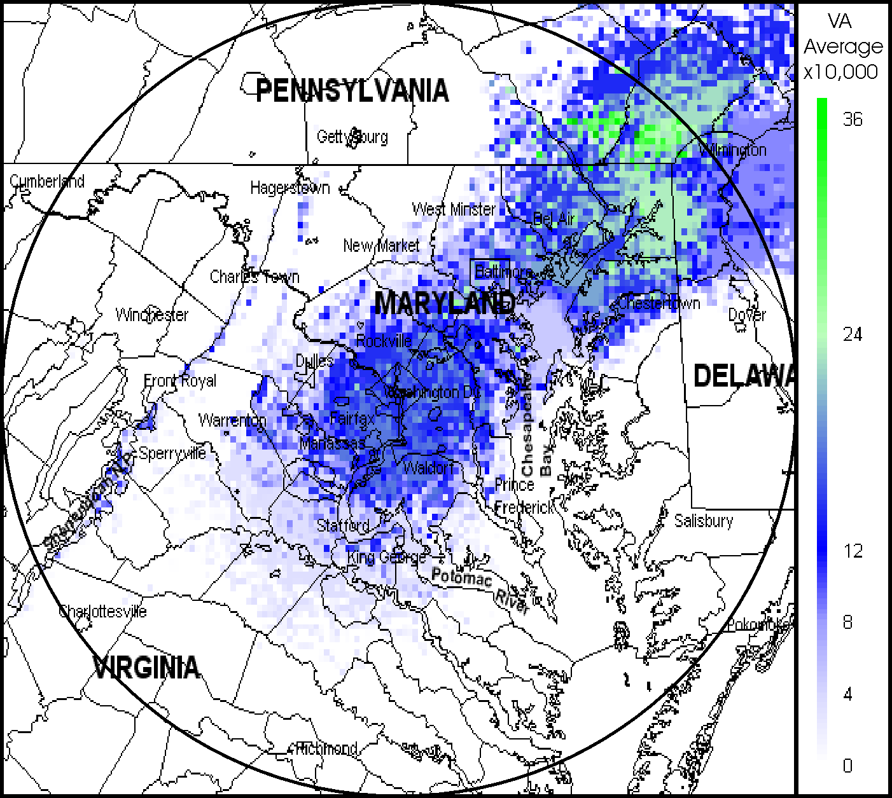
Figure 7-54. Average Signal Capacity Map for U.S. Department of Veterans Affairs

Other Agencies

The category of “other agencies” includes several smaller agencies and other agencies with the majority of transmitters located in the immediate Washington, D.C. area. Their assignments were shown previously in Figure 4-14. That figure shows a few separate locations outside of Washington, D.C. Most the various agencies utilize various forms of analog wideband radios while some have already transitioned to narrowband analog or digital. The PSC and ASC maps corresponding to current assignments are shown in Figures 7-27 and 7-28, respectively.

The PSC map show a large PSC, approximately 55, concentrated in and around Washington, D.C. This is indicative of the concentration of the various agencies conducting most, if not all of their LMR operations in and around Washington, D.C. There are some higher peaks to the northwest and west, but this is probably due to incidental signals at higher elevations from Washington, D.C., rather than being caused by actual transmitters. The ASC shows the same coverage pattern with the highest ASC at approximately 0.040 signals per square mile. This is a relatively large figure due to the majority of operations concentrated in the Washington, D.C. area. Table 7-15 provides the “other agency” assignments and function codes that were and were not included in the SCAP analysis.
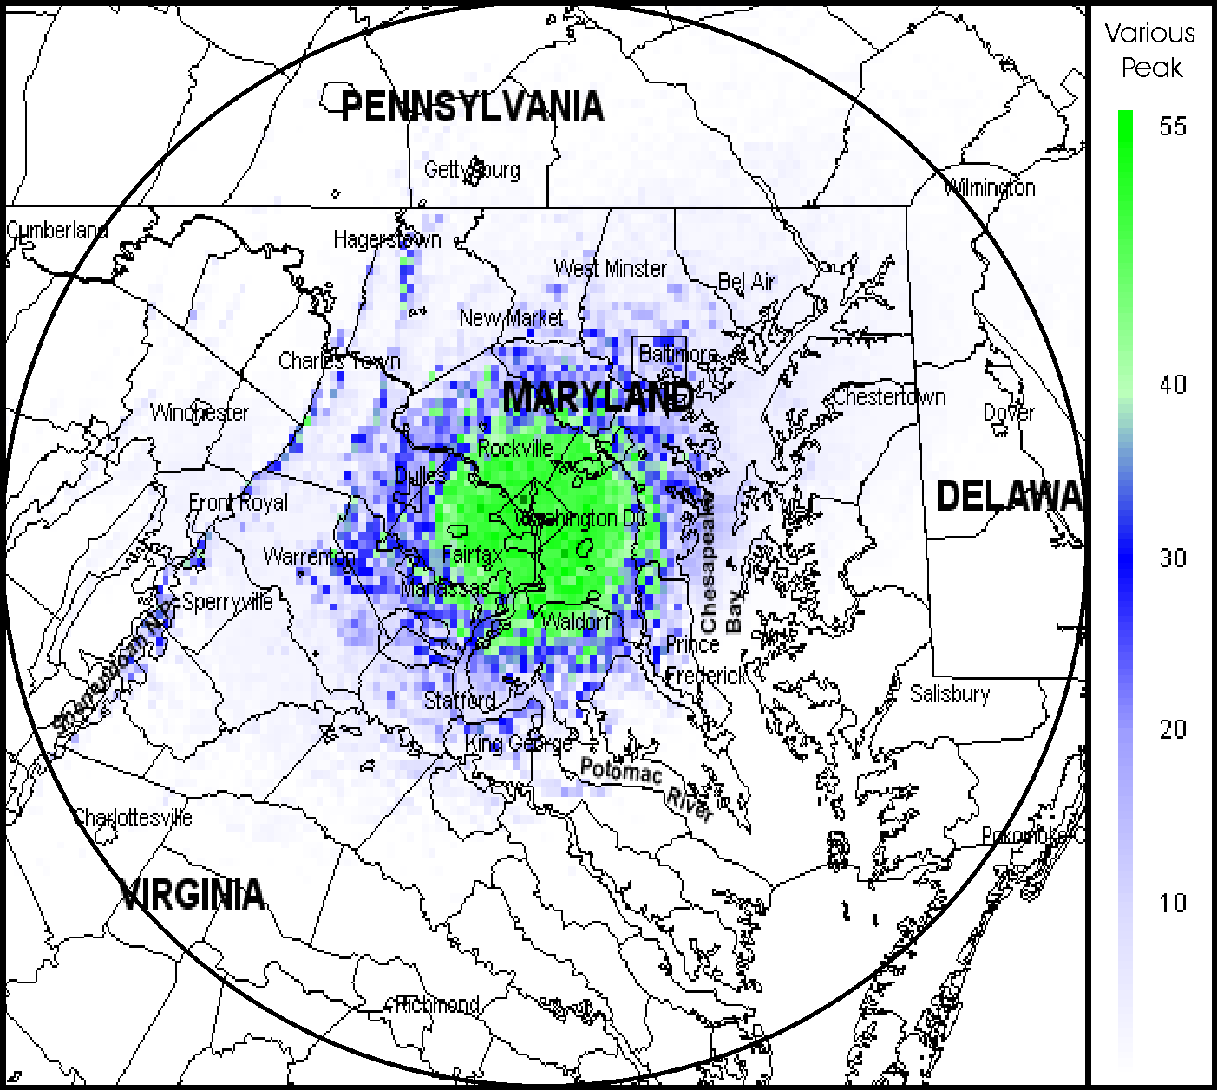

Figure 7-55. Peak Signal Capacity Map for “Other Agencies”

Table 7-19. “Other Agencies” Assignments and Function Codes
Function | Description | # of Assignments
F = 3 | Individual base station transmitter | 45
F = 6 | Trunked network | 0
F = 7 | Single-message repeater network | 18
F = 8 | Multiple-message repeater network | 27
Total included = 90
F = 20 | Obsoleted link | 1
F = 21 | Dedicated link | 26
F = 22 | Receiver | 16
F = 23 | Receiver-only station | 0
F = 25 | Low power (10 mW or less) | 11
F = 26 | Mobile-only (replaced by new system) | 0
Total not included = 54
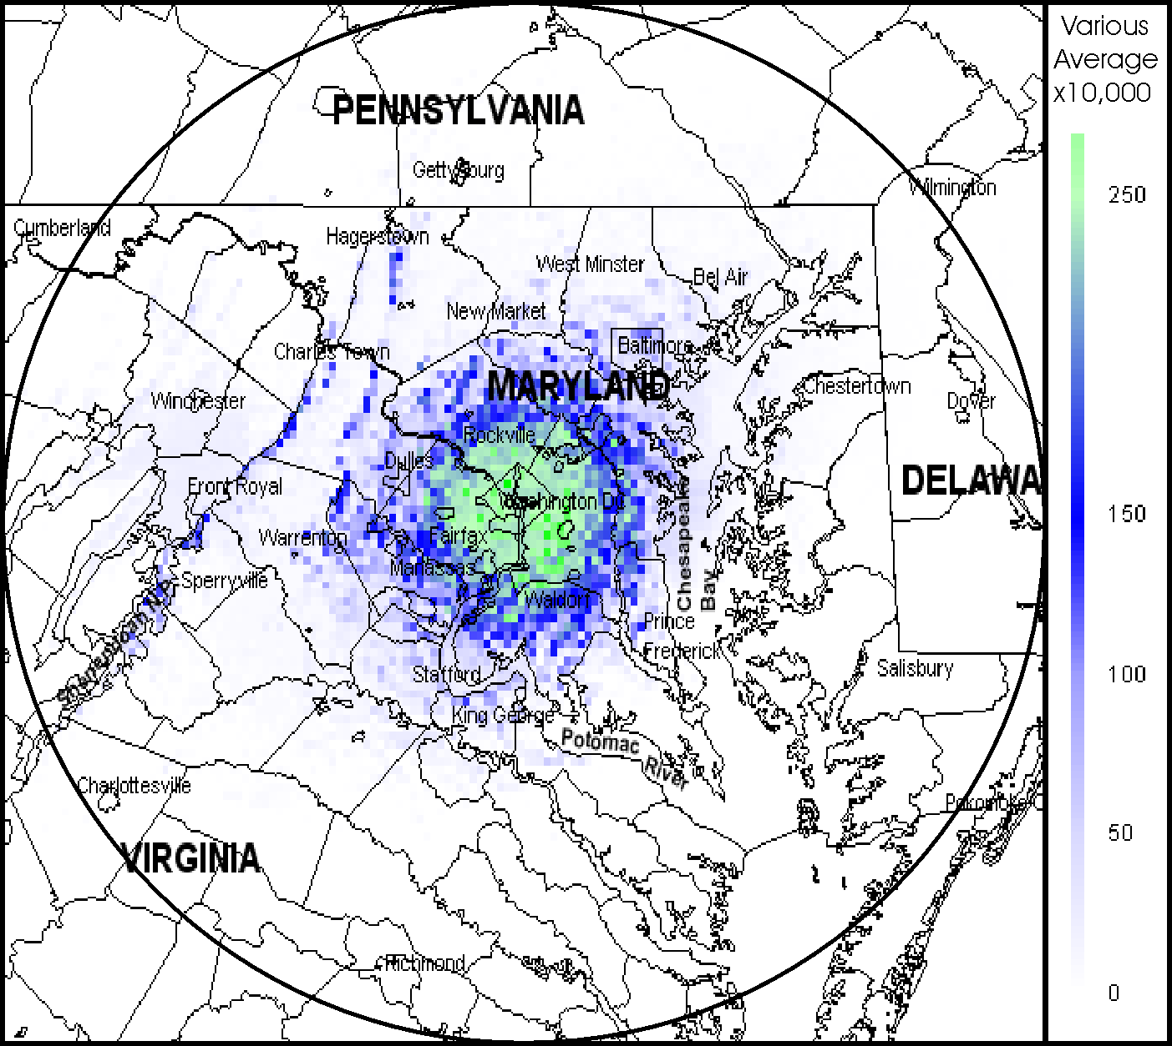
Figure 7-56. Average Signal Capacity Map for “Other Agencies”

All Federal Agencies

PSC and ASC maps were developed to give an overall “picture” of what the total federal usage looks like in the study area. As with all the individual agency maps, the highest peak, approximately 268, and average, approximately 0.1000, center in and around the Washington, D.C. area. This stands to reason, as all the agency headquarters are located in D.C. The PSC and ASC maps corresponding to current assignments are shown in Figures 7-29 and 7-30, respectively. Table 7-16 provides all federal agencies assignments and function codes that were and were not included in the SCAP analysis.
Figure 7-57. Peak Signal Capacity Map for all federal agencies
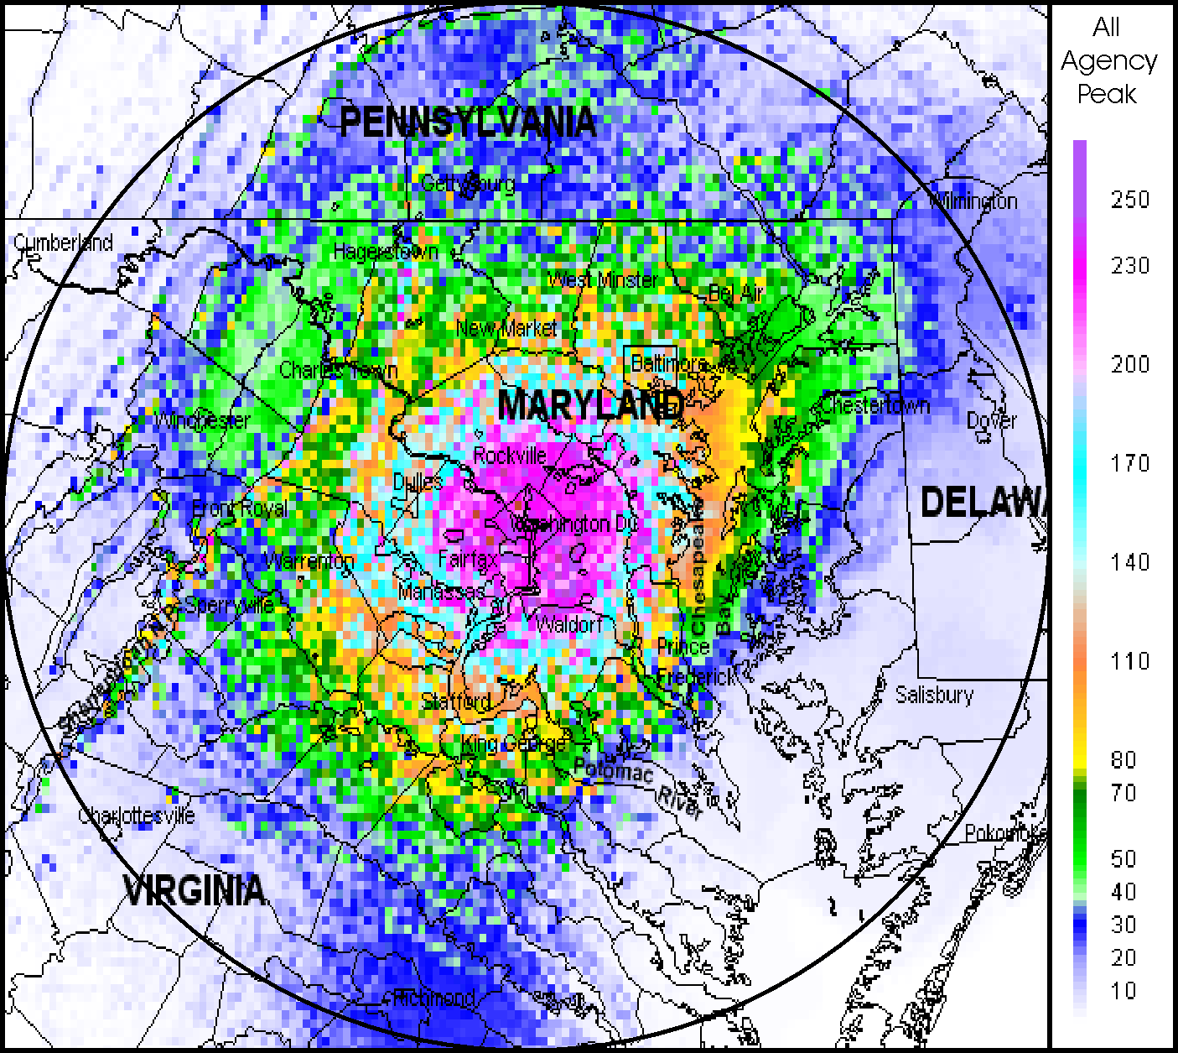

Table 7-20. All Federal Agencies Assignments and Function Codes
Function | Description | # of Assignments
F = 3 | Individual base station transmitter | 247
F = 6 | Trunked network | 5
F = 7 | Single-message repeater network | 274
F = 8 | Multiple-message repeater network | 220
F = 9 | Mobile-only user net | 120
Total included = 866
F = 20 | Obsoleted link | 84
F = 21 | Dedicated link | 333
F = 22 | Receiver | 418
F = 23 | Receiver-only station | 180
F = 25 | Low power (10 mW or less) | 28
F = 26 | Mobile-only (replaced by new system) | 36
 | Total not included = 1079

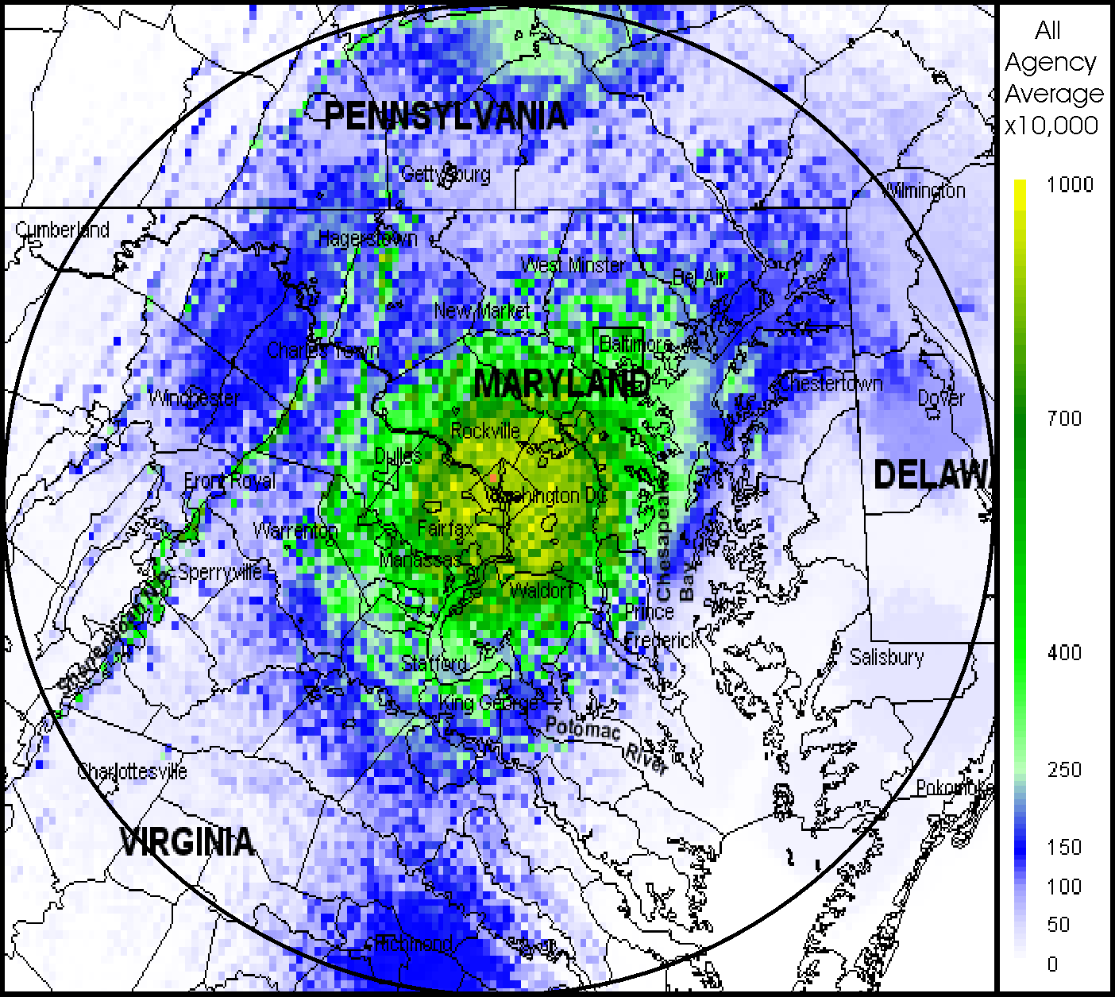
Figure 7-58. Average Signal Capacity map for all federal agencies

Integrated Wireless Network (IWN) (United States Departments of Justice, Treasury and Homeland Security)

The PSC and ASC maps for this section are a combination of the agencies that will be the initial users of the IWN. These agencies will include: Federal Bureau Investigation (FBI), U.S. Marshall Service (USMS), Bureau of Prisons (BOP), Drug Enforcement Administration (DEA), Alsohol, Tobacco and Firearms (ATF), Customs and Border Protection, Immigration and Naturalization Services, General Services Administration (GSA), Transportation Security Administration(TSA), and the U.S. Secret Service (USSS).

The PSC map shows that the main concentration of peak signals, approximately 84, is in close vicinity to Washington, D.C. The ASC shows the same properties, attaining a highest average capacity of approximately 0.0250 signals per square mile. Table 7-17 provides the IWN assignments and function codes that were and were not included in the SCAP analysis.

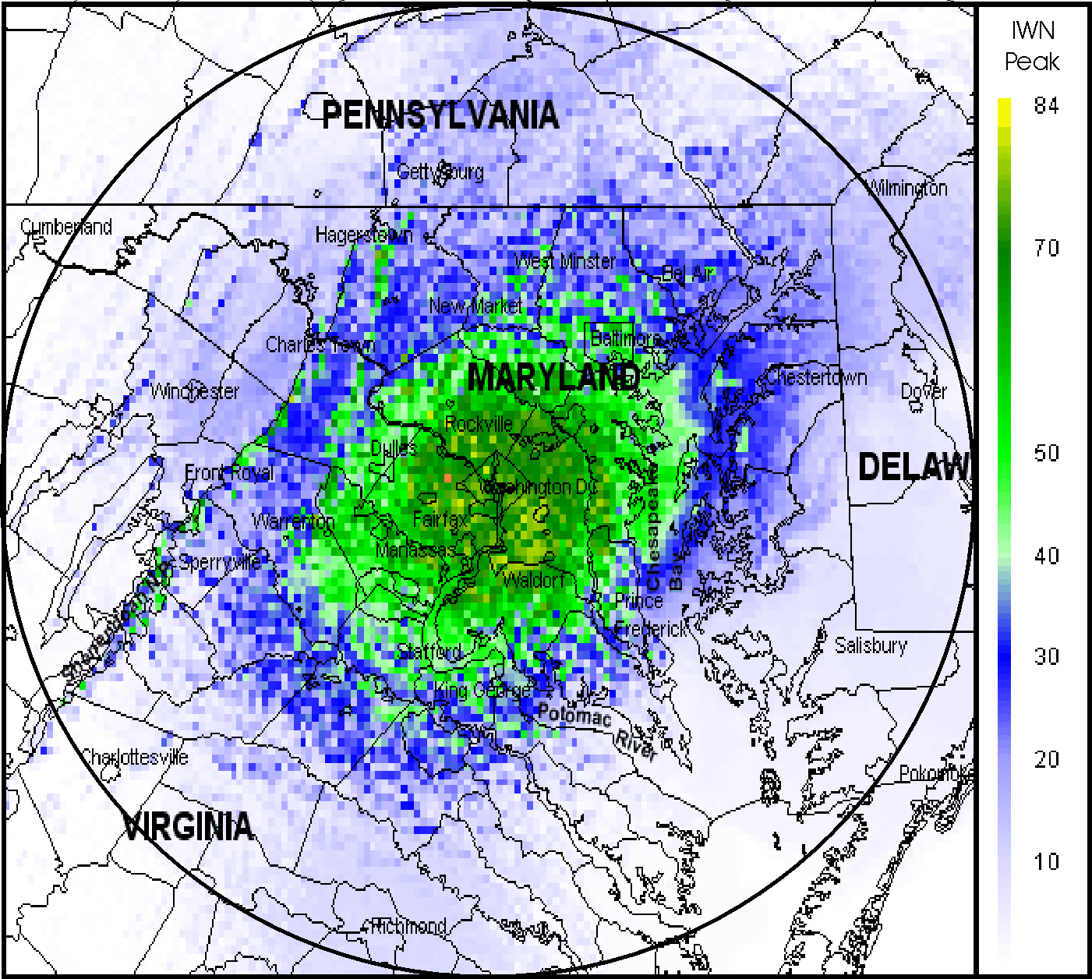
Figure 7-59. Peak Signal Capacity Map for IWN Agencies

Table 7-21. IWN Assignments and Function Codes
Function | Description | # of Assignments
F = 3 | Individual base station transmitter | 35
F = 6 | Trunked network | 5
F = 7 | Single-message repeater network | 149
F = 8 | Multiple-message repeater network | 85
F = 9 | Mobile-only user net | 24
Total included = 298
F = 20 | Obsoleted link | 56
F = 21 | Dedicated link | 27
F = 22 | Receiver | 217
F = 23 | Receiver-only station | 175
F = 25 | Low power (10 mW or less) | 4
F = 26 | Mobile-only (replaced by new system) | 0
Total not included = 479
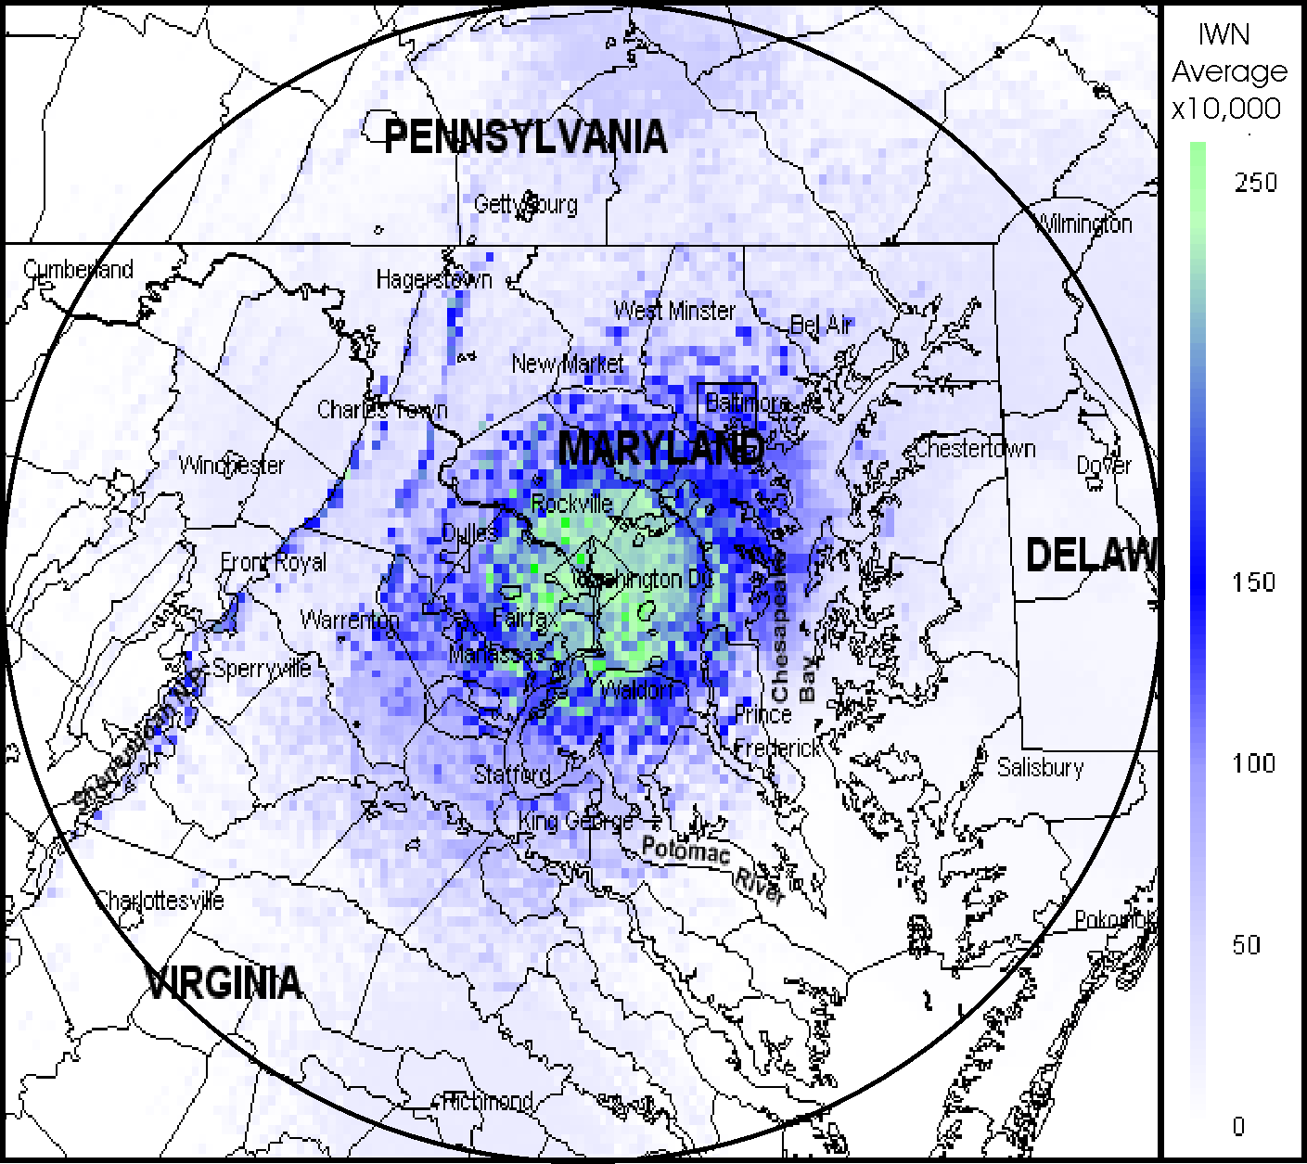

Figure 7-60. Average Signal Capacity Map for IWN Agencies

All Federal Agencies minus IWN

The last two maps represent the federal users in the study area minus the participants of the IWN. Once again, the highest peak, approximately 190, and average, approximately 0.0700, capacity signals are centered nearest Washington, D.C. This is primarily due to the various agencies’ headquarters being located within this area. Table 7-18 provides the Non-IWN assignments and function codes that were and were not included in the SCAP analysis.

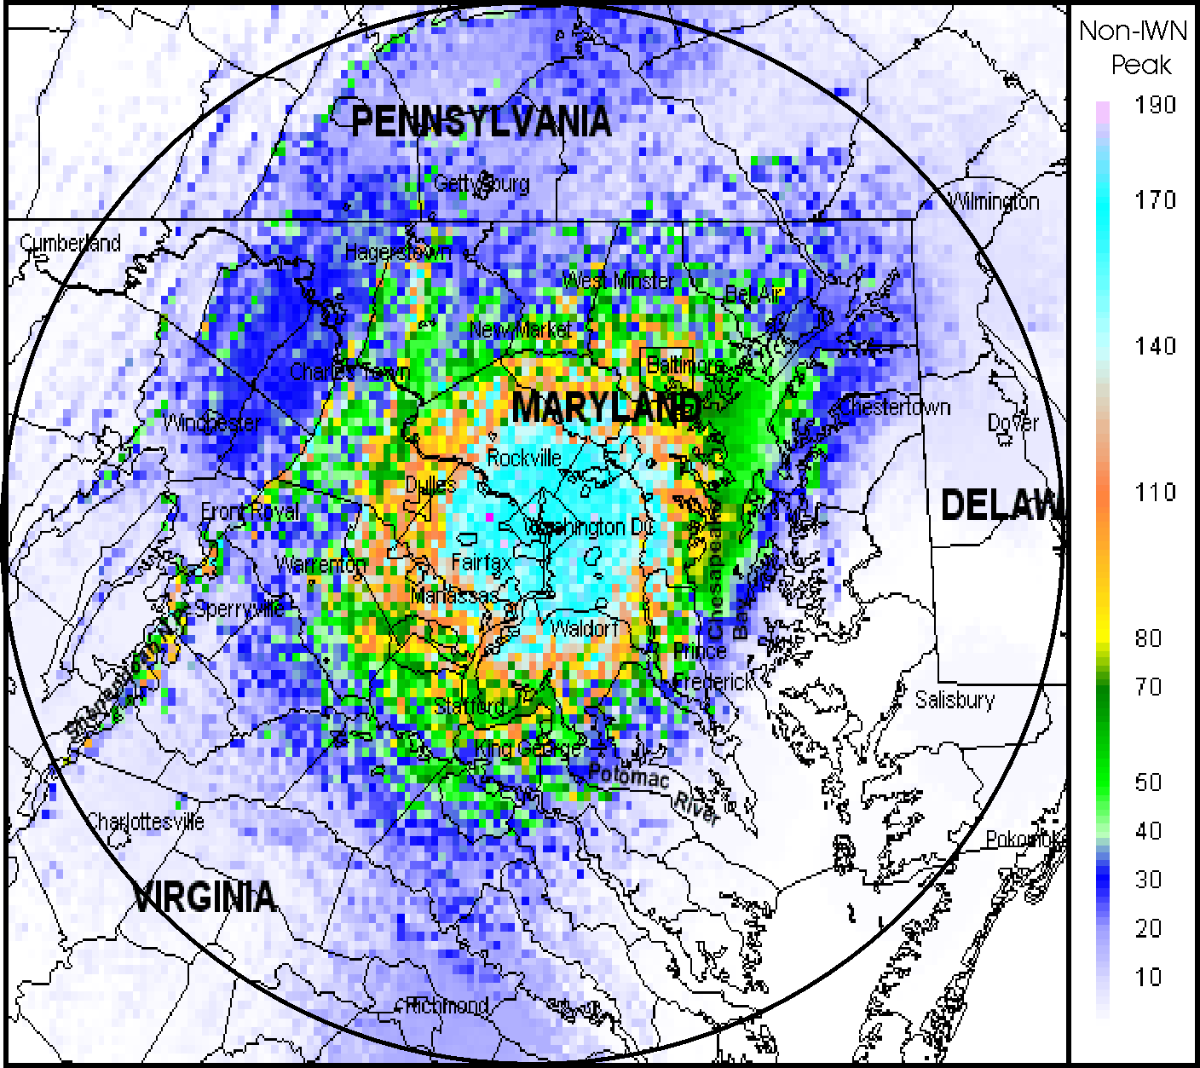

Figure 7-61. Peak Signal Capacity for Non-IWN Agencies

Table 7-22. Non-IWN Assignments and Function Codes
Function | Description | # of Assignments
F = 3 | Individual base station transmitter | 212
F = 6 | Trunked network | 0
F = 7 | Single-message repeater network | 125
F = 8 | Multiple-message repeater network | 135
F = 9 | Mobile-only user net | 96
Total included = 568
F = 20 | Obsoleted link | 28
F = 21 | Dedicated link | 306
F = 22 | Receiver | 201
F = 23 | Receiver-only station | 5
F = 25 | Low power (10 mW or less) | 24
F = 26 | Mobile-only (replaced by new system) | 36
Total not included = 600
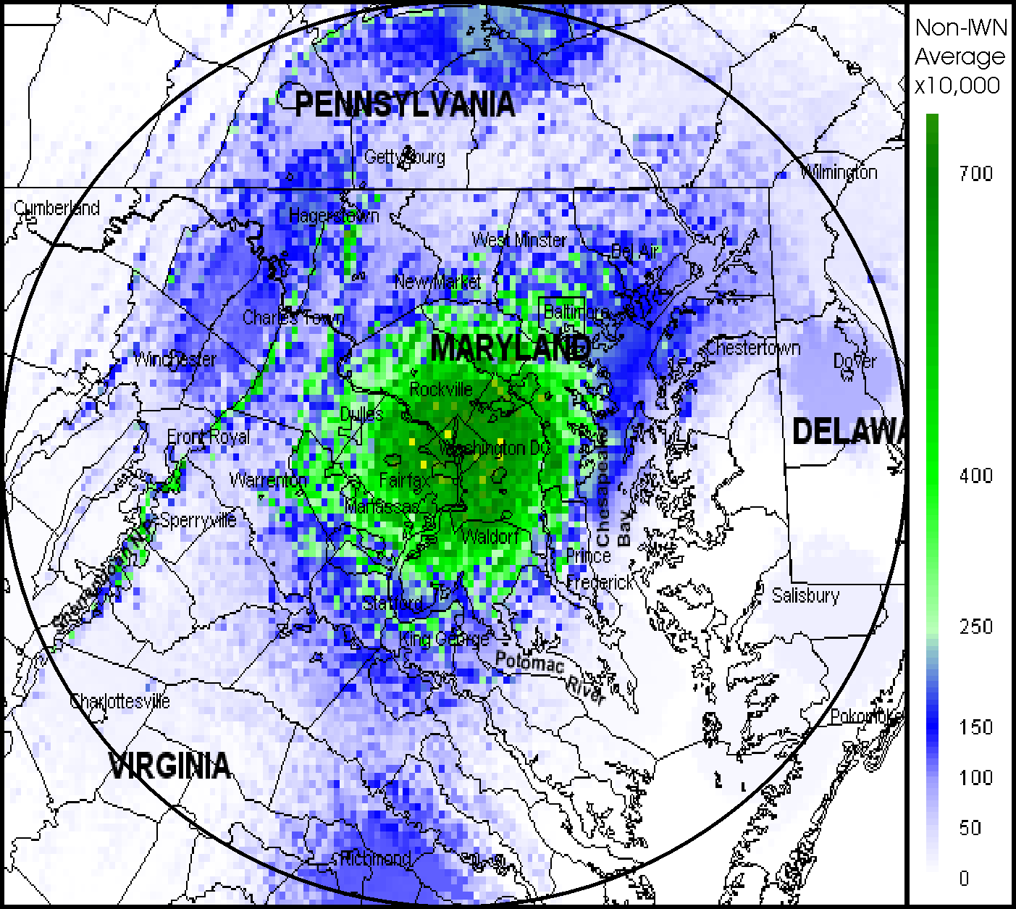

Figure 7-62. Average Signal Capacity Map for Non-IWN Agencies
Page 7-42/Blank

SUMMARY OF FINDINGS

The following section provides a summary of findings of the Phase 1 study that was based on a SCAP for the 162-174 MHz band in the vicinity of Washington, D.C. The SCAP produced results in terms of PSC and ASC contours maps for the various federal agencies.

- The SCAP was developed to provide a theoretical basis for understanding the services provided to federal LMR users in the 162-174 MHz band within a 100-mile radius of Washington, D.C. Radio services not provided by the fixed base station infrastructure were excluded from this study by assigning appropriate function codes.

- Data from the GMF, supplemented with information obtained from the agencies, allowed the SCAP to provide PSC and ASC maps for federal agencies in the 162-174 MHz band in the Washington, D.C. area. These results can provide an improved understanding of federal LMR services, and can be applied in the design of possible future LMR systems with higher spectrum efficiency and effectiveness than current systems.

- Although SCAP provides a useful tool with which to compare the services provided by current and future systems, it does not provide any measure of absolute spectrum efficiency achieved by either system.

Table 8-1 provides a summary of the maximum PSC map values and the total number of transmitters included in the SCAP for each federal agency and some groups of agencies. The maximum PSC map value shows what the highest level of PSC was in the PSC map for each agency, e.g., a value of “35” indicates that some locations provided coverage for as many as 35 separate radio channels. The “included transmitter” column shows how many LMR transmitters were included in the SC maps for each agency. Agencies with large numbers of radios and high PSC values included DOD, DOI, DOJ, and Treasury. These agencies had extensive LMR networks that could provide as many as 24-70 independent LMR channels in some locations. The All-Agency group contained a total of 866 transmitters and a maximum PSC map value of 268. Even the group of IWN agencies had only about 35 percent of the total transmitters, with almost 65 percent of the remaining for the other agencies. This means that even the largest agencies represent only a small percentage of the total number of federal government transmitters. The increased scale of an all-agency operation could provide substantial advantages, if future systems provide meaningful economy of scale factors.

Table 8-23. Maximum Peak Signal Capacity and Included Transmitters
Agency | Max Peak SC Map Value | # of Included Transmitters
Agriculture | 13 | 22
U.S. Coast Guard | 4 | 14
Commerce | 9 | 10
Defense | 38 | 108
Energy | 3 | 9
FAA | 17 | 46
Interior | 24 | 94
Justice | 70 | 235
U.S. Capitol Police | 5 | 19
U.S. Postal Service | 13 | 36
Treasury | 35 | 165
Other Agencies | 55 | 90
All Agencies | 268 | 866
IWN Agencies | 84 | 298
Non-IWN Agencies | 190 | 568

- Many agencies have no coverage adjacent to the immediate Washington, D.C. area. Such agencies may gain much greater coverage, extending their coverage to 93 percent of all locations within the 200-mile square area that was analyzed, if they could share the existing LMR radio systems of other federal agencies. (Of course, it is also possible that many agencies do not need any coverage outside their current coverage areas.) Agencies with small numbers of users, but needing wide coverage would probably find it much less expensive to get the required service with some type of future shared system. Analysis of PSC data from the All-Agency map shows that 93 percent of locations had coverage from at least one transmitter, and 63 percent of locations had coverage from at least ten transmitters. Ten percent of locations had coverage from at least 100 transmitters, almost four percent of the locations had coverage from at least 200 transmitters, and some locations received more than 265 transmitters. The few areas without any coverage were mainly in the corners of the map beyond the 100-mile radius circle, which may be largely due to “edge” effects inherent in the modeling.

- The SCAP encompasses only the base-to-mobile aspects of current radio systems. A future radio system, as a minimum, would need to duplicate the mobile-to-base and mobile-to-mobile capabilities of current radio systems. The base-to-mobile information provided by the SCAP model can help define the necessary corresponding mobile-to-base capabilities. However, the inferred mobile-to-base capability will need to be further studied to determine specific requirements (including in-building, portable coverage), so that the needed mobile-to-base capabilities can be completely included in the design specifications.

- Although the SCAP provides very useful information about the geographic locations where current radio services are provided to mobile radios, it provides no data showing where the served mobile users are located. A computed coverage area for a specific base station transmitter shows all of the locations where a mobile user could possibly receive a usable signal, but it does not necessarily mean that the mobile users actually are located uniformly over the computed coverage area when they receive that signal. For example, a given transmitter located near the center of Washington, D.C. could be used solely to provide in-building coverage, (e.g., the four sub-basement parking levels) for buildings in the middle of the city, or it could possibly be used solely to provide coverage to mobile units operating in the distant suburbs. Since SCAP provides no clue as to which set of mobile users such a system is designed to serve, an alternative future system might be unnecessarily designed to serve both sets of users.

- The SCAP analysis does not provide any information on the amount of radio traffic carried on each channel. Therefore, although it may be known that 23 independent radio signals are available at a given location, there is no information about how much of the time these 23 channels are actually used, or when the channels are used. This type of data could be obtained by measuring actual LMR radio traffic data, using equipment like the NTIA/ITS Radio Spectrum Measurement System (RSMS).

- The SCAP analysis (and the associated agency interviews) ensured that the analyzed LMR systems included no aspects of agency operation that would necessarily be disadvantaged by combining operations with other agencies, assuming that the required availability of service, reliability, response time, and protection of sensitive information could be provided by some future system. Technical functions of agency operation that could not be incorporated within the SCAP (e.g., mobile-to-mobile operation) were excluded from this analysis by the assignment of suitable function codes. Thus, it appears that the existing functions provided to agencies by the assignments included in the PSC and ASC maps could be provided by a future shared system. Whether such a future shared system could provide all of the desired features at a reduced cost, or with other advantages, remains to be seen. These details will be investigated in Phase 2 of the study. Similarly, the policy and managerial problems associated with possible future shared systems may not be trivial to resolve.

- The GMF, in its current form, did not always provide sufficient information to permit the assignment of function codes as an input to the SCAP model. Additional information on system operations was often required from the various agencies.

- There are various existing programs, initiatives, and studies on improving spectrum efficiency within the federal government. These programs will continue to provide a context within which future improvements to federal spectrum efficiency will need to adapt and conform. Such programs may be particularly important to consider in assessing the feasibility of various future LMR system designs proposed in Phase 2 of this overall study, as well as the scheduling and priority of the related studies.

- It is envisioned that the SCAP results developed for Phase 1 will help to quantify the advantages and disadvantages involved in a future radio system, as well as to provide insights to the best architectures and technologies to be employed and the circumstances under which maximum effectiveness would be achieved.

DESCRIPTION OF SIGNAL CAPACITY ANALYSIS PROGRAM

A crucial piece of the analysis of existing agency radio services is the determination of the current geographical SC of existing radio systems providing communications to existing federal mobile users. The resulting PSC and ASC maps will be the starting point for the design of several alternative future radio systems to be designed in Phase 2 of this study. Specifically, the PSC maps will show how many independent LMR channels can currently be received by mobile users, cumulatively, for all agencies, at any location within a 100-mile radius of Washington, D.C. The ASC maps will show how many average independent users per square mile can be supported by the current radio systems. It is assumed that any alternative future radio system that is capable of providing a similar, or greater, SC for all locations of the maps could be viewed as providing services that are equal to or greater than the services provided by current radio systems. The following section discusses, in detail, the computation algorithm for the SCAP.

COVERAGE ANALYSIS OF CURRENT RADIO SYSTEMS

In computing the SC maps for each network, the first step is to compute the coverage area for each included transmitter. This will require transmitter and antenna information that can be used to compute predicted signal strength as a function of geographical location, using a terrain-based propagation model. Any predicted field strengths in excess of an established limit may be presumed to constitute “coverage.” Since all of these network SC maps are intended to be added to other network SC maps, it may be useful to compute the field strength at a standard set of geographical locations, namely a fixed standard set of locations with 1-mile spacing over an approximate 100-mile radius centered on Washington, D.C. These geographical locations remain fixed at a standard set of locations, instead of being located relative to each transmitter location.

The field strength, S, from a transmitter can be calculated as:

S = P + G – R - L + 74.8

Where: S = field strength in decibels above 1 microvolt/meter (dB µV/m),
P = transmitter power in decibels above 1 Watt (dBW),
G = transmitting antenna gain in decibels above isotropic (dBi),
R = 20 log distance from transmitter (kilometers), and
L = Propagation loss (dB), compared with free-space.

The transmitter power and transmitting antenna gain, as well as antenna location and elevation, come from the GMF records. The propagation loss is calculated by using the Longley-Rice model with the required terrain data.

All systems will be analyzed to show coverage for a single field strength level of X µV/m for a certain percentage of locations and a certain percentage of time, assuming typical mobile radio parameters. For these coverage predictions, the terrain-dependent Longley-Rice model was used, giving predicted propagation path losses for 1-mile increments over a 200-mile square centered on Washington, D.C. The process of selection of proper parameters for field strength and percentages of time and locations is described in the next paragraphs.

Proper coverage analysis parameters for this modeling effort would be best selected to reflect the functional/operational requirements of each of the respective radio systems. On this basis, a radio transmitter used to service handheld radios that may be used inside large office buildings and provide very reliable continuous service may require a field strength of 30-100 µV/m outside the building. On the other hand, the need to intermittently maintain contact with a dispatcher at a maximum distance using a mobile transceiver might be accomplished with a signal level as little as 1 µV/m. Although there is a large difference between these two field strength requirements, it still may theoretically be possible to divide transmitters into categories that would show which field strength value should be used in the coverage analysis for each transmitter. However, the main purpose of the SC analysis is to develop a definition of coverage that is interchangeable between various systems. Otherwise, a future application of the SC data may attempt to provide a 1 µV/m signal to an operational mission that needed a 100 µV/m signal. Therefore, it was necessary to choose a single definition of coverage that could be used for all systems.

In addition to the decision about field strength values, there are similar choices concerning the values of “reliability” and “confidence” associated with the field strength values. A propagation model like Longley-Rice provides predictions for mobile radio signal strength, S, from base stations in the form of: “There is a confidence of at least C percent that the received mobile radio signal will be above S µV/m for R percent of the time.” Since this propagation model is being applied to a mobile/portable system where it is assumed that the mobile unit is moving, the R factor (reliability) includes the effects of moving through time as well as moving across geography. Choosing a higher value for reliability (R) or confidence (C) has a similar effect to choosing a higher value of field strength (S) (e.g., at a given location, a confidence of getting at least a small signal with very high reliability almost all of the time).

Figure A-1 shows the relative coverage areas of a group of transmitters, analyzed using different combinations of reliability, confidence, and field strength as the definition of “coverage” when generating these PSC maps. These 200-mile square PSC maps show how many transmitters can be received at each location on the map, using the same color scale on all
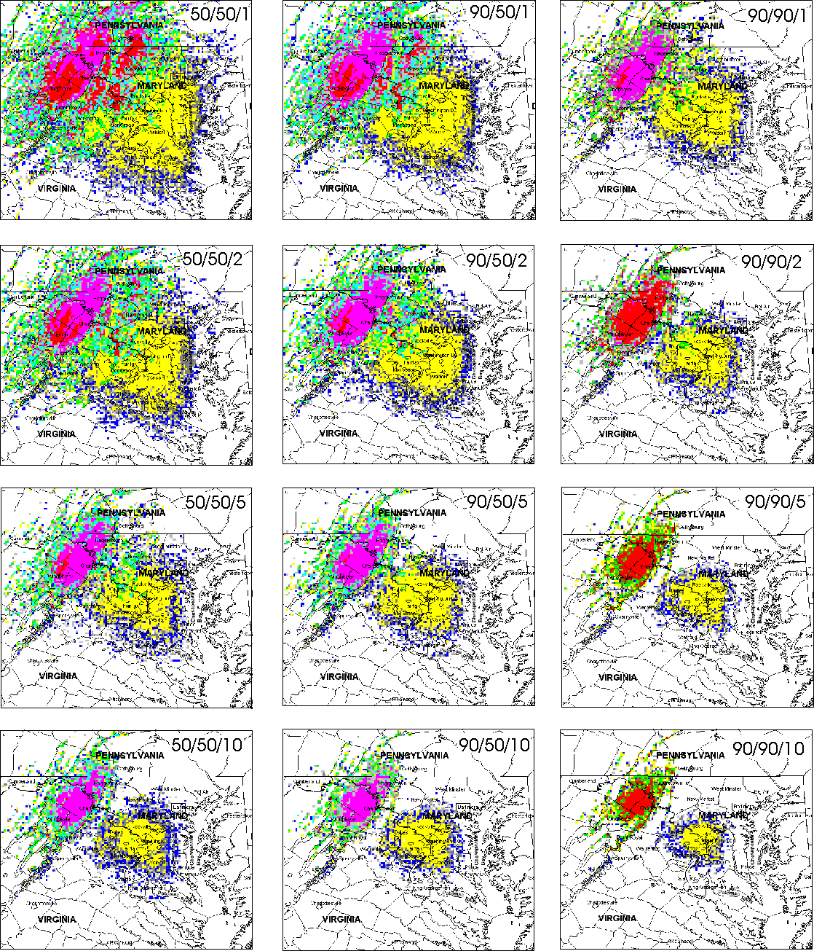
maps to show the number of receivable transmitters. The PSC coverage maps are arranged in 3 columns, having 4 rows each. The first column (left-most) was analyzed for a reliability of 50 percent and a confidence of 50 percent for 4 different field strength values. The middle column was analyzed for a reliability of 90 percent and a confidence of 50 percent; the right-most maps to show the number of receivable transmitters. The PSC coverage maps are arranged in 3 columns, having 4 rows each. The first column (left-most) was analyzed for a reliability of 50 percent and a confidence of 50 percent for 4 different field strength values. The middle column was analyzed for a reliability of 90 percent and a confidence of 50 percent; the right-most column was analyzed for a reliability of 90 percent and a confidence of 90 percent. All three columns were analyzed for identical field strength limits. The top row assumed that “coverage” required a signal of at least 1 µV/m, the second row assumed that “coverage” required a signal of at least 2 µV/m, the third row showed coverage based on 5 µV/m, and the bottom row was calculated for a coverage limit of 10 µV/m.
Figure A- . 200-mile square coverage maps for selected transmitters, based on 50/50, 90/50, and 90/90 (reliability/confidence) statistics for field strength of 1, 2, 5, and 10 µV/m.

In the preceding figures, the maps show that the coverage areas for a set of transmitters decrease greatly when the receiver/service requires higher reliability, higher confidence, or higher field strength. As described in the following paragraphs, the decision was eventually made to use a coverage criterion of reliability of 90 percent, confidence of 50 percent, and field strength of 10 µV/m.

Initially, it should not make any difference which threshold value and statistics are selected, since the major purpose of the SC model is to assure that the coverage of the new system(s) is at least as good as the coverage of the current systems. As long as the old and new systems are tested with the same coverage parameters, use of exact values is not so important. Unfortunately, the preceding statement is not quite true. The problem is that the SC model does not “know” what is the intended use of a given radio system. If the intended use of a current radio system is to provide some coverage at large distances, the SC modeling should capture that use in its analysis, since that use will need to be provided in a future system. If the extended rural coverage is merely an unintended consequence of a transmitter intended to provide highly reliable in-building communication in urban areas, then the SC modeling should not include it and a future system should not need to provide it. If all the future systems used the same base station placement as existing systems to provide duplicate coverage, there would be less need to determine the intended coverage of transmitters, since duplicating the urban coverage would also tend to duplicate the rural coverage whether it was needed or not. However, since some of the alternative future systems will use different architectures and cell sizes, there is less assurance that close-in and distant coverage will be similarly related in old and new systems.

The selection of a signal level near 1 µ/m was assumed to be inappropriate for several reasons. Many public safety personnel use portable handheld receivers, whose overall sensitivity in normal operating circumstances is likely to be as much as 3 µV/m. This high signal requirement is caused partly by less-efficient small antenna systems and partly by absorption and shielding by personnel holding the radio. The problems become even more pronounced when such handheld receivers are operated inside buildings, which can provide 10-30 dB of additional losses to radio signals. The general requirements of public safety personnel are to have higher reliability and availability of communications. Finally, the use of very low occupancy thresholds in analyzing current systems produced a strange anomaly. In some circumstances, the highest SC values occurred in rural locations where few users were present. The use of very low threshold values caused urban transmitters to produce “coverage” in some quite distant rural areas. In fact, there were some high-elevation rural locations where the weak signals from multiple distant urban areas could add together to produce coverage by total numbers of signals higher than in the core of any single urban area. Further analysis revealed that most urban transmitters were not installed with the intention of providing intermittent and unreliable coverage to large numbers of non-existent rural users. This “rural peak” effect seems to disappear for occupancy thresholds greater than 5µV/m.

However, most rural service is delivered to public safety users with mobile radios or operating outdoors with handheld radios. Such situations can provide good reception with signal levels of less than 3 µV/m, though rugged terrain might produce deep signal shadows that often had much less signal than that. Since it seems reasonable to include any signal levels that could be expected, to provide usable service to federal users, an amplitude level near 3 µV/m could be assumed as an appropriate coverage limit.

After considering many factors, coverage was eventually defined by using a field strength of 10 µV/m, providing 90 percent reliability at a 50 percent confidence. This set of parameters corresponds to the bottom map in the middle column in Figure A-1. For simplicity, this definition was used for all radio technologies, even though some signal modulation technologies require more or less signal power for operation. The SC summary maps in Section 7 of this report were computed using the above definition for coverage.

PEAK AND AVERAGE SIGNAL CAPACITY MAPS

This section contains a description of the algorithms used to calculate the PSC and ASC maps for networks having various function codes. Note that some network types may have different function codes, but use the same algorithm for computing the SC network maps. These multiple function codes are useful because the function codes are also intended to be used later in summarizing various statistical changes in how frequencies are used and the different function codes will facilitate some of this future analysis. Two distinct types of SC maps will be done for each network: a PSC and an ASC map. These two representations of SC will place two types of bounds on the SC provided by current systems. The PSC map produces results that assume that all users might be concentrated into a single small geographical area. Alternatively, the ASC maps assume the most benign geographical distribution of users, with users spread out as evenly and uniformly as possible. The ASC maps provide “users per square mile” data that is intended to scale base station traffic proportional to the coverage area of a given base station. Under the ASC assumptions, a base station with ten percent of the coverage would be expected to carry ten percent of the traffic. Designs using PSC data would not scale with coverage area, since all of the possible users could be crowded into that particular ten percent of the coverage area.

Any alternative future network would be required to assume some geographic distribution of users in its design. The calculation of both ASC and PSC maps provides two different extremes of rules, either of which might furnish a partial basis for new system design, but probably both should be used. Consider the implications of designing an alternative future system on the basis of ASC map values. Since the ACS values provide data on users per square mile, the design traffic loading on a given site would scale proportional with the area to which the site is providing coverage. If the new alternative system uses sites with the coverage areas smaller than current site coverage areas, the design traffic loading per site would be proportionally smaller than current traffic loading per site. However, if the future alternative design uses sites with larger coverage areas, presumably the new sites would be designed to carry proportionately larger traffic loads than the old sites. Under these conditions, the design criteria based on the ASC maps would be larger than the design criteria based on the PSC maps. Therefore, the PSC maps assume that the number of users does not change with coverage area, but remains constant with all possible users concentrated into a single location. Furthermore, a design based on the PSC maps would require a constant design site traffic load that would not change with coverage area of the site. This circumstance would require supporting the full PSC number of users within even very small cells, but the use of larger-than-current cells would require fewer channels based on PSC data than on ASC data.

Thus, the PSC and ASC maps represent the worst-case and best-case situations from the standpoint of designing alternative radio systems, depending on whether the alternative future systems use smaller or larger cells than the current systems. The exact design criteria that will be used to size possible future system designs is not yet known, but it must surely lie between these two bounding cases. The Phase 2 report on the design of possible alternative future systems will more fully consider this aspect of system design.

SC maps are computed in two distinct stages. First, the PSC and ASC maps for individual networks are calculated using the GMF data, the function code and corresponding algorithms for that specific network, and applicable propagation models. Once the PSC and ASC maps have been calculated for a specific network, these maps can be combined and recombined on a strictly additive basis, without regard for the specific function codes that were originally used to compute the maps. PSC maps are combined with other PSC maps, adding numeric values on a location point-by-point basis to get a new cumulative PSC map. Similarly, ASC maps are combined with other ASC maps, adding numeric values on a location point-by-point basis to get a new cumulative ASC map. Cumulative SC maps can be combined with other cumulative SC maps or network SC maps to get new SC maps representing more extensive combinations of assignments or agencies.

The PSC will be determined by placing a “1” in each location where one signal from a base station can be received. If a base station has ten independent signals that can all be received at a given location, a value of “10” would be placed at that location. If a receiver at a given location could receive nine signals from one base station and seven different signals from another base station, a value of “16” would be put in that location. This network PSC map shows the peak number of independent signals that can be received at each location. When a cumulative PSC map shows the combined PSC for all the networks belonging to a single agency, the map would indicate the maximum number of independent signals that can be received from all networks belonging to that agency at each location. Similarly, when the PSC maps for each agency are combined to give a cumulative PSC map for all agencies, that map will contain numbers showing the maximum number of independent radio signals that could be received from all agencies at each location. PSC values will all be positive integers, possibly as large as several hundred.

The ASC map is computed by normalizing the coverage area of a base station transmitter to give the average use per unit area (square mile) that could be obtained from a given transmitter. If a transmitter, “A,” has twice the coverage area of another transmitter, “B,” the average use per unit area for all areas of transmitter “A” coverage will be half of the average use of the transmitter “B” coverage area. The coverage area of a transmitter multiplied by the ASC value at each location of coverage will give a number that represents the total number of independent transmitters. The ASC value of a single transmitter is computed by modeling the coverage of that transmitter and putting a “1” at each location having coverage (note that this is identical to the PSC map for that transmitter). The total number of locations having a “1” are counted and placed into the value “K.” Since the computed locations are one mile apart, K represents the transmitter coverage area in square miles. Then the “1” at each coverage location is replaced with the value “1/K.” If a given base station had ten independent transmitters having the same coverage area, the ASC map for that base station would have a value of “10/K” for the ASC at each coverage location. ASC values will tend to be small positive fractions, typically in the range of .000l to 0.1. However, to make it easier to read ASC maps, the actual ASC values plotted on the ASC maps have been multiplied by 10,000. This gives ASC maps values ranging between 0 and 600.

The cumulative ASC map for all networks belonging to a single agency can be computed by adding the values at each corresponding geographical location from all of the ASC maps for each independent network for that agency. Similarly, the summary ASC map for all agencies can be generated by adding together the ASC values at each corresponding location for each of the summary ASC maps for each agency. If the values for every geographical location on the cumulative ASC map are summed, it will represent the total number of independent radio transmitters represented by the map, adjusting for the fact that the ASC map values have been multiplied by 10,000.

These two SC maps represent the maximum and minimum signal capacities that need to be provided by the new radio system. If all radio networks included in this analysis had identical coverage areas (same total area, not the identical geography), the maps would be identical (except that the ASC map would have values equal 1/K times the corresponding location values in the PSC map). The physical significance of the PSC and ASC maps is that the PSC map shows the capacity that the new comparable network would need to handle if all possible users were concentrated at a single location on the map. The ASC shows the capacity per square mile of coverage that the new comparable system would need if all users were spread out as evenly as possible over the coverage locations on the map.

The ASC and PSC maps do not represent realistic estimates. The actual SC values would be somewhere between the two. These two types of SC maps suggest the extreme range of circumstances that could be supported by the present infrastructure. Even if a comparable infrastructure was built to match the PSC maps, there would be no assurances that certain circumstances would not overload the system. It would only ensure that the comparable system would not have fewer capabilities than the current one. In a wide range of circumstances, a properly designed comparable system would be expected to work considerably better than the current system.

FUNCTION CODE DESCRIPTIONS AND ALGORITHMS

SC modeling begins by dividing all GMF assignments in the geographical area of concern into various classes. The GMF data and agency consultation is necessary to generate a “function code” for each assignment. The function code indicates how each assignment is to be analyzed by the SCAP. The function code (F, N) has two parameters. “F” denotes the function served by that assignment; “N” is an integer that identifies the specific network of which that assignment is a constituent part. The actual value of “N” has no significance except to identify assignments that are parts of the same network. Each assignment belongs to exactly one network; all assignments belonging to the same network will be given the same value of “N.” Networks containing only a single assignment do not exercise any network qualities and are given a value of N = 0. N = 0 indicates that no other assignment belongs to a given network.

Division of Assignments by Function (F): This variable is associated with the first parameter in the function code for each assignment. The function codes for assignments not included in the SC analysis are also specified, even though they all produce the same result (no action). This is because it is important that it is correctly understood why such assignments were not included, and this specification helps to document the understanding of each such assignment. In addition, such function codes will be useful in counting some aspects of “before and after” when frequencies are compared for particular purposes. The following paragraphs describe the details of the function codes and the associated SCAP analysis algorithms.

Assignments Included in SCAP Analysis:
Base station transmitter F = 3
Wireless link F = 4
Simulcast network F = 5
Trunked network F = 6
Single-message repeater network F = 7
Multiple-message repeater network F = 8
Mobile/mobile user net F = 9
US/USA/US&P incorporated into net F = 10

Assignments not Included in SCAP Analysis:
Obsoleted link F = 20.
Dedicated link F = 21
Receiver F = 22
Receive-only station F = 23
US/ USA/US&P w/o local F = 24
Low power (10 mW or less) F = 25
Mobile/portable-only networks F = 26

The function codes 3 through 10 describe GMF assignments for transmitters that directly provide communication services to mobile users, which services could be provided by a single shared network. Since these function codes represent assignments that will be included in the SCAP analysis, all of these function codes will also require a network number “N.”

Base Station Transmitter (F=3). This function code is used for an individual base station serving a number of mobile users, where it is likely that future service to these users could be provided by some type of large shared radio system. Each individual base station transmitter can be considered as an independent network and computed separately. All locations on the PSC map with predicted coverage will be labeled with a “1,” which shows that one radio link is available at that particular location. The ASC map is generated by counting the total number of points on the map with coverage, setting K equal to that number of points, and placing the value 1/K at all points that get coverage from the base station. N = 0 is the recommended network value for a single assignment, indicating that no other transmitters are part of that network.

If base station transmitters at multiple sites use the same frequencies, it may be difficult to know whether the base station signals can be considered to be independent or not. In general, if the base stations have coverage areas that overlap, they cannot be considered independent and need to be analyzed as a multi-site network. A user in an overlapping coverage area cannot receive multiple independent signals, since the signals are transmitted at the same frequency and they will interfere with each other. In the case of multiple same-frequency base stations, the function code (F=3) can be used with multiple assignments that all have an identical non-zero value for N. If the base station coverage areas do not overlap, this network algorithm will give the same results as multiple independent base stations.

The PSC map for the above network of multiple base stations can be computed by finding all locations where a signal can be received from one or more sites and placing a “1” in those locations. Locations receiving signals from one base station (non-overlapping coverage areas) would obviously get a PSC of “1.” Locations receiving signals from more than one base station (overlapping coverage areas) would also get a “1,” because no more than one signal could be received without interference (since all signals are at the same frequency). Therefore, the PSC maps would have a “1” in each coverage location, no matter whether coverage was from one base station site or from many sites. This result is identical to that obtained from multiple simulcast sites. This calculation might err on the side of being too optimistic, because many locations receiving multiple signals would actually be able to receive no signals; interference between the signals would prevent any signal from being received. In addition, some multi-site systems may allow only one site to transmit at one time to prevent interference between signals radiated from multiple sites.

The ASC map for a multiple sites network can be calculated in the following manner:

1. Calculate the ASC maps for all base station sites individually, using the same calculations as for a single base station.

2. Combine the ASC maps for the individual base station sites as follows:

a. At all locations where there is coverage only on a single ASC map, directly transfer the ASC values to the combined network ASC map.

b. For any locations where there is overlapping coverage, calculate an average ASC value from all of the non-zero ASC values at each location.

The above procedure should be used in any circumstances where multiple base stations using the same frequencies might have overlapping coverage. This algorithm will give the same ASC map results for multiple non-overlapping base stations sites as when the sites are analyzed individually and their individual SC maps are added together. This same algorithm will be used to analyze multiple site repeater systems using the same frequencies.

Fixed Wireless Link (F=4). This assignment is used for certain types of fixed radio systems (i.e., stationary base station and mobile/fixed auxiliary sites), whose services could be provided by some type of large shared radio system. In general, a more complex model would need to be used if the auxiliary sites communicate directly with each other, instead of only communicating with the base station. Each individual base station transmitter can be considered as an independent network and computed separately. All locations on the PSC map with predicted coverage will be labeled with a “1,” which shows that one radio link is available at that particular location. The ASC map is generated by counting the total number of points with coverage equal to K and placing the value 1/K at all points that get coverage from the base station. N = 0 is the recommended network value.

If this system is not suitable to be incorporated into a larger shared system, it should be coded “F = 21.” The difference between placing an assignment into the category of “dedicated link” (F = 21) or “wireless link” (F = 4) is whether the link function is able to be efficiently provided by the future shared system. For example, a dedicated link might be used to provide a narrowband backup voice and data link between two federal communication centers; this link could not be practically integrated into a future system. Another link might gather continuous status/location data from a fleet of vehicles (all vehicles updated every 30 seconds). While this could theoretically be serviced by a future mobile system with digital messaging capabilities, via the mobile radios in the vehicles, it would probably not be an efficient way to provide the service, and more detailed analysis might eliminate it from being a candidate for inclusion in the future network. However, a nominally similar service providing river flood warning data (e.g., short data message every 15 minutes) might turn out to better match the digital messaging capabilities in the future system; this system could be a candidate for inclusion. Depending on the exact function of the link and the features chosen for the future system, a given assignment may be placed in either of these categories.

Simulcast Network (F=5). This function code identifies an assignment used as part of a simulcast network, with multiple sites using the same transmit frequencies and receive frequencies. A previously unused non-zero value of “N” should be selected and used to label all simulcast transmitters belonging to this network and operating on a given frequency. The coverage areas from all base station transmitters at a given frequency are calculated, and a total coverage area for the entire set of transmitters is calculated. The PSC map is generated by putting a “1” at all locations that receive coverage from one or more sites. The ASC map is generated by counting the total number of points with coverage equal to K and placing the value 1/K at all points that get coverage from one or more base stations. Note that coverage at a single point from multiple simulcast base stations only results in a PSC value equal to 1 because the multiple base stations are all transmitting the same signal. Therefore, only one signal can be received, irrespective of how many base stations can deliver that single signal to the user.

In general, most simulcast networks use multiple frequencies. In this case, all sites operating at a specific single frequency should be calculated as a single network, with separate networks used for each different frequency. If desired, SC maps can be developed for the total simulcast system by combining the PSC maps and ASC maps for each frequency (i.e., independently computed networks) belonging to the simulcast system.

Trunked Network (F=6). This function code describes an assignment that is used for a trunked network, using only local channels. In the case of trunked networks, all channels at all base stations operate independently; this is much different from the earlier simulcast example. Therefore, a given trunked base station with ten channels would provide ten possible independent signals at each point of coverage. Coverage at a given location from two base stations (one with ten channels and one with five channels) would provide the possibility of receiving 15 independent signals.

Trunked networks should be assigned a function code (6, N), where N is the same for all assignments (transmitter frequencies) at all base stations in the entire trunked network. The peak SC map is constructed by computing a coverage area for each transmitter and placing a “1” at each location where coverage is available from that transmitter. The PSC values are additive at a given location; coverage at a given location by “M” different transmitters gives a PSC value equal to M for that location. The ASC map is computed by calculating a coverage area for each transmitter and counting the number of locations where coverage is available equal to K. A value of 1/K is placed into the average SC map at each location where coverage from that transmitter is available. The ASC values are additive at a given location. Coverage at a given location by M different transmitters (T₁, T₂, ... , T_{M} ) gives an ASC value equal to 1/K₁ + 1/K₂ + ... + 1/K_{M} at that location, where the K’s are the coverage areas for the respective transmitters. In general, all of the K’s will be equal for transmitters at a given site, but each different site will have different coverage areas.

One pair of frequencies at each site will be used for a control channel, and it would therefore not be available to carry traffic. However, some trunking technologies allow the control channel to carry traffic. Moreover, trunked radio channels generally carry more traffic than non-trunked channels. Therefore, all trunked system channels were counted as traffic channels.

Repeater Network (F=7). This function code is used for a repeater transmitter, or for a multi-site repeater network. If the repeater network uses a standard pair of repeater frequencies at multiple repeater sites with overlapping coverage areas to extend the geographical coverage of a system of repeaters, the analysis of the repeater system may need some additional detailed study, because it is not usually immediately evident which combinations of the repeaters could be used to support individual messages and which could not. The multi-site analysis presumes the most efficient possible repeater configuration; in some cases, the repeater network may only allow a single message to be carried throughout the entire system. The difference between these cases might also depend on options selected by the user for the specific message.

Single-Message Repeater Systems (F=7). This function code designates a repeater assignment, where the repeater (or repeaters) allows only a single message to be carried on the repeater system. Repeater systems are often constructed with multiple repeater sites with overlapping coverage areas that all use the same receiver frequency and transmitter frequency. This means that a mobile user could simultaneously transmit to multiple repeaters, which would each repeat (transmit) the same repeated message at the same frequency. Under such circumstances, the multiple repeated messages could be expected to interfere with each other, in the same way that interference can be caused if simulcast transmitters are not carefully designed and adjusted. Designing such repeater systems so that multiple repeaters do not transmit simultaneously at the same frequency often prevents this interference. Depending on how this is accomplished, a repeater system may (or may not) carry multiple independent messages. F = 7 includes all single-signal repeater systems. This includes systems that consist of a single repeater site. Other included repeater systems use multiple repeater sites that are controlled (e.g., with CTCSS codes) so that only a single repeater site re-transmits a message at a given time. Zone repeaters use multiple frequencies to transmit a single message from multiple sites that provide an extended coverage area; however, all sites transmit the same message content.

PSC maps for a single-message repeater system are computed by placing a “1” at each location where there is coverage from one or more repeater transmitters. ASC maps are computed by counting the total number of locations with coverage from one or more sites equal to K and placing the value 1/K at each location with coverage. Note that these calculations are identical to simulcast systems.

Multiple-Message Repeater Systems (F=8). This function code designates a multi-site repeater system that allows multiple independent signals to be repeated. Although some repeater systems are designed so that only a single message can be repeated at a given time, other types of repeater systems can handle multiple simultaneous messages. For example, consider a multi-site repeater system covering a large geographical area. When mobile User A is using a specific site to relay a message, an adjacent site (with approximately the same coverage area) cannot simultaneously be accessed by mobile user B, since A and B would be simultaneously using the same frequency at the same time in the same geographical area. However, simultaneous use would be possible if User A and User B were accessing repeater sites that were sufficiently separated from each other so that User A’s signal did not interfere with User B’s signal at the site which user A was attempting to access (and vice versa). In this example, mobile users can operate independently (using separate messages) in some geographical areas, but not in other areas. This is the circumstance that function code (F = 8) is intended to analyze. In addition, some repeater systems are designed to allow the user to choose how the repeater system operates (e.g., perhaps passing a message down a string of repeaters to headquarters or choosing to repeat the signal on the local repeater). Such systems will also be designated with F = 8, although F = 7 would appear to be correct for part of the time.

The PSC map is calculated by finding the total coverage area of all base station repeater transmitters and placing a “1” at all locations with coverage.

The ASC map for the multiple sites can be calculated in the following manner:

1. Calculate the ASC maps for all repeater sites individually, using the same calculations as for a single repeater station.
2. Combine the ASC maps for the individual repeater sites as follows:
a. At all locations where there is coverage only on a single ASC map, directly transfer the ASC values to the combined ASC map.
b. For any location where there is overlapping coverages, calculate an average value from all of the non-zero ASCs at each location.

The above procedure should be used in any circumstances where apparently independent repeater sites using the same frequencies might have overlapping coverage areas. If there is no overlap, this algorithm will give the same results as calculating the SC maps for independent repeaters and combining them.

Mobile/Portable User Net (F=9). This designation is used with an all-mobile/portable user net having no fixed base stations. In general, it may be difficult to determine the coverage area of such a system according to a set formula. A location and radius may be indicated on the assignment, or other data may become available. However, such a system could obviously be served by a shared, trunked network, assuming that the network provided service in the applicable system service area.

US/USA/US&P Assignment (F=10). This designation is used for a US/USA /US&P assignment added into the shared network. Since such an assignment has no localized geographical location and therefore no SC coverage area, these assignments will need to be estimated individually by hand, with some reasonable equivalent coverage included. For this reason, this function code was not incorporated into the study.

The function codes 20-26 represent assignments that have not been included in the SCAP analysis. This is because the codes represent assignments whose functions are never included (e.g., receivers), or because the function provided by a specific system could apparently not be easily incorporated in a shared radio system. In the case of these function codes, it is not necessary to include any value for N.

Obsoleted Assignment (F = 20). This indicates that the assignment would no longer be needed if an integrated trunked network were operational. Typical examples may include telemetry links used to control or indicate the status of equipment associated with the present LMR systems, or links used to transport communications between base station sites (as an alternative to a wire line connection). The important distinction is that such a link is not intended to directly provide communications to users. This function designation indicates that this assignment will not need to be supported in any way in the new system. Note that F = 20 does not imply in any way that the assignment is not needed to provide services to current networks, but only that its specific function would not be specifically transferred to a comparable network, especially when the actual architecture of an alternative comparable future system has not yet been defined.

Non-Incorporated Assignment (F=21). This assignment is used for a dedicated or special-purpose function that would not be expected to be incorporated in, or replaced by, the future shared trunked radio system. It is assumed that these frequency assignments will continue to be needed whether or not a new trunked system is constructed. However, for fixed links that intermittently transmit data or status in a geographic area served by the shared system, future incorporation into the shared system might be considered on an individual basis at a later time.

Since these links will be unaffected by any conversion to a future shared trunked systems, F = 21 will be the initial default setting for all assignments. If F = 21, the SCAP analysis program will ignore this assignment.

Receivers (F=22 or F=23). The first round of SCAP analysis will consider only transmitter assignments. It is assumed that many agency transmitter assignments have matching receiver information. If the receiver frequency is for a standard base station receiver or mobile receivers paired with a transmitter at that same site, let F = 22. This indicates that the specifics of the situation are adequately described by the transmitter coverage and no further action is necessary on the assignment. In many cases, however, the receiver information may provide important non-standard information on the nature of the functions of the associated network. Receive-only site information may identify functional requirements to provide in-building coverage to handheld transmitters, etc. If the receiver assignment is for a receive-only site or for some other specialized receiver site, let F = 23. Initially, only the transmitter information will be directly incorporated into the geographical SC maps, but F = 23 will serve as a reminder for possible later analysis that there are some special receiver requirements that may need to be accounted for in the final design. Note that the practice of providing assignments for receivers is optional and varies greatly between agencies. These assignments will be ignored in the SCAP analysis.

US/ USA/ US&P Assignments (F=24). The analysis assumes that any US/ USA/ US&P, and similar wide-area assignments having “000000" latitude or longitude values will be not be used to support any permanent local radio infrastructure. Although the same frequencies identified by these wide-area assignment types are often available for temporary or permanent local uses, it is understood that any local permanent uses of these frequencies will be identified by separate local assignments with geographical coordinates and specifics. These local assignments for any local use should be examined independently and designated with the appropriate function codes. However, in this analysis of existing local infrastructure capabilities, all US, USA, and US&P assignments that are not specifically associated with a location and function will be identified with F=24 and ignored in the SCAP analysis.

Low Power Assignments (power = 10 mW or less) (F = 25). This includes any low power assignments (10 mW). An example of this category is about 900 low power assignments for tracking wildlife tags used by the Department of Interior and some wireless microphones used by multiple agencies. These assignments will be ignored in the SCAP analysis.

Mobile/portable-only Assignments (F = 26). This includes assignments that include no specific base stations, but involve only portable or mobile radios talking between each other. Typical applications might involve a guard force patrolling a federal building, using handheld radios to talk with each other. These were excluded from further analysis, since they are using no fixed infrastructure that could be replaced by a shared radio system. At some time in the future, it might be useful to migrate such systems to become mobile units on a shared system, but such a determination would be uncertain and premature at this time. Therefore, the presumption is that such systems would continue to operate in their present mode.

COMBINING SIGNAL CAPACITY MAPS

The PSC and ASC maps for each network can be generated by the SCAP, after function codes have been assigned to each GMF assignment. The resulting ASC and PSC maps can be combined with other ASC and PSC maps to get ASC and PSC maps for any desired combination of transmitter networks. The process of combining these SC maps is limited only by the assumption that the original network SC maps were calculated in a compatible manner–i.e., the same distance scales, the same technical criteria for a definition of “coverage,” etc. As long as these criteria are maintained, SC maps could be combined from different frequency bands, from different agencies, from various federal, state, and local governments, etc. Attempts to combine SC maps from different services might be possible, but one would need to carefully explore whether a common meaning of “coverage” could be established for the different services. The actual SC maps selected to be combined will be dependent on the selection of combinations of agencies whose combined systems one would seek to describe.

Page A-16/Blank

National Telecommunications and Information Administration, U.S. Department of Commerce, Manual of Regulations and Procedures for Federal Radio Frequency Management, (May 2003 Ed.) (Revisions through January 2004), [hereinafter NTIA Manual], Chapter 1.
Telecommunications Authorization Act of 1992 Act, 47 U.S.C. §§901-904 (2004) [hereinafter NTIA Act].
NTIA Manual, supra note 1, at part 2.3.3.
.
Id., at part 2.1.
NTIA Act, supra note 2, 47 U.S.C. at 903 (d)(3).
.
National Telecommunications and Information Administration, U.S. Department of Commerce, NTIA Report 93-300, Land Mobile Spectrum Efficiency: A Plan for Federal Government Agencies to use More Spectrum-Efficient Technologies (October 1993) [hereinafter NTIA Report 93-300].
Institute for Telecommunication Sciences, National Telecommunications and Information Administration, U.S. Department of Commerce, NTIA Report 94-311, A Survey of Relative Spectrum Efficiency of Mobile Voice Communication Systems (July 1994).
The second phase of this study is on-going.
National Telecommunications and Information Administration, U.S. Department of Commerce, NTIA Special Publication 01-48, Alternative Frequencies for Use by Public Safety Systems: Response to Title XVII, Section 1705 or the National Defense Authorization Act for FY 2001 (December 2001), [Hereinafter NTIA Special Publication 01-48], at 2-5.
The spectrum assignments that were utilized by the agencies prior to their transition to the DHS, were, for the most part, reassigned to the DHS. See, Pub. L. No. 107-296 (2002).
? See supra note 9, at 3-1.
The GMF is the federal government’s master list of frequency assignments authorized by NTIA, but does not necessarily represent the number of pieces of radio equipment associated with each assignment. There may be many pieces of radio equipment associated with a single frequency assignment. In addition, the GMF utilized for this study does not contain any classified federal frequency assignments.
These station classes are defined in the NTIA Manual, supra note 1, at 6-18.
Area assignments are: US&P (United States and Possessions), US (the 50 states and the District of Columbia), and USA (the 48 contiguous states and the District of Columbia).
See supra note 13.
See supra note 13.
U.S. Department of Agriculture, Mission of USDA Agencies and Offices, at http://www.usda.gov/mission/miss-toc.htm.
Federal public safety agencies have engaged in a long-term standards development process known as P25/TIA 102, a collective effort by industry and the state and local public safety agencies. This effort has resulted in the development of an extensive set of standards for digital public safety wireless communications.
U.S. Department of Commerce, The Commerce Mission Statement, at http://www.osec.doc.gov/bmi/budget/strtgc/aintro.pdf.
U.S. Coast Guard, Overview, at http://www.uscg.mil/overview/.
NTIA has identified 40 (20-VHF and 20-UHF) interoperability channels in the 162-174 MHz and 406.1-420 MHz bands for law enforcement and incident response plans. See NTIA Manual, supra note 1, at Section 4.3.16.
U.S. Department of Defense, DOD 101: An Introductory Overview of the Department of Defense, at http://www.dod.mil/pubs/dod101/.
See, Section 5 for a more detailed description of this system.
U.S. Department of Energy, About DOE, at http://www.doe.gov
See Federal Aviation Administration, What We Do-Mission, at http://www.faa.gov
See supra note 10.
U.S. Department of Homeland Security, DHS Organization, at http://www.dhs.gov/dhspublic/theme_home1.jsp.
Id., at http://www.dhs.gov/dhspublic/display? Content = 3345.
U.S. Department of the Interior, DOI Quick Facts, at http://www.doiu.nbc.gov/orientation/facts.cfm.
U.S. Department of Justice, Organization, Mission, and Functions Manual, March 2004, Overview, at http://www.usdoj.gov/jmd/mps/manual/overview.htm
U.S. Department of Justice and U.S. Department of the Treasury, High Level Design Report (on file with author).
U.S. Department of the Treasury, Duties and Functions at http://www.ustreas.gov/education/duties/
? With the establishment of the Department of Homeland Security in 2002, the U.S. Secret Service and their functions, transferred from the Department of the Treasury effective March 1, 2003. See supra note 10.
? NTIA Special Publication 01-48, supra note 9 at 3-2.
United States Postal Service, Five Year Strategic Plan – Introduction (2003), at http://www.usps.com/strategicdirection/__pdf/fiveyearplan2004-2008.pdf
U.S. Department of Veterans Affairs, About VA., at http://www1.va.gov/about_va/.
Formerly the Federal Specialized Mobile Radio (FEDSMR); see Section 5 for a detailed description.
NTIA Act, supra note 2.
NTIA Report 93-300, supra note 6, at 1.
Id., at 8.
After Jan. 1, 2005, all systems in the 162-174 MHz band must conform to this standard. After Jan. 1, 2008, all systems in the 406.1-420 MHz band must conform to this standard.
NTIA Manual, Section 5.3.5.2. B, supra note 1, at 5-24-26.
Federal Communications Commission, ET Docket No 03-65, Interference Immunity Performance Specifications for Radio Receivers, March 24, 2003. 18 F.C.C.R. 6039 (2003).
National Telecommunications and Information Administration, U.S. Department of Commerce, Comments of the National Telecommunications and Information Administration in the matter of Interference Immunity Performance Specifications for Radio Receivers, ET Docket No 03-65, November 12, 2003.
The standards are published in the Telecommunications Industry Association/Electronics Industries, an American Standards Institute (ANSI) accredited process. For example, see, http://www.ANSI.org.
National Telecommunications and Information Administration, Notice, Spectrum Management and Policy Summit, 67 Fed. Reg. 10,682 ( March 5, 2002). See also, NTIA Spectrum Summit at http://www.ntia.doc.gov/ntiahome/summit/index.html.
d
Spectrum Policy Task Force Report, ET Docket No. 02-135, Federal Communications Commission, (November 15, 2002), at 21, available at http://hraunfoss.fcc.gov/edocs_public/attachmatch/doc_228542A.pdf.
? Id., at 21
t
Telecommunications: Better Coordination and Enhanced Accountability Needed to Improve Spectrum Management, General Accounting Office, GAO-02-906, (September 2002), at 25.
Id., at 31.
t
General Accounting Office, Telecommunications: History and Current Issues Related to Radio Spectrum Management, testimony before the Committee on Commerce, Science, and Transportation, U.S. Senate, GAO-02-814T (June 11, 2002), at 1.
Id., at 14.
Memorandum on the Spectrum Policy for the 21st Century, 39 Pub. Papers 23 (June 9, 2003).
Id.
National Telecommunications and Information Administration, Docket No. 040127027-4027-01, 69 Fed. Reg. 4,923 (February 2, 2004), available at http://www.ntia.doc.gov/ntiahome/frnotices/2004/spectruminitiativenoi_01282004.pdf.
Spectrum Policy for the 21st Century- The President’s Spectrum Policy Initiative: Report 1 “Recommendations of the Federal Government Spectrum Task Force, U.S. Department of Commerce, NTIA, June 2004; Spectrum Policy for the 21st Century- The President’s Spectrum Policy Initiative: Report 2 “Recommendations for State and Local Governments and Private Sector Responses, U.S. Department of Commerce, NTIA, June 2004.
Departments of Commerce, Justice, and State, the Judiciary, and Related Agencies Appropriations bill, Fiscal Year 1999, H.R. Rep. No. 105-636, at 12 (July 20, 1998).
See Appendix A, at A-2, for a detailed explanation of the threshold and confidence/reliability criteria.
National Telecommunications and Information Administration, U.S. Department of Commerce, NTIA Report 82-100, A Guide to the Use of the ITS Irregular Terrain Model in the Area Prediction Mode (April 1982).

