


APPENDIX A
Transportable Array Station Design

Principles of the TA station design:
The station is designed for broadband continuous recording of ground velocity with particular emphasis on earthquake generated motions. The station consists of an enclosure for the sensor and equipment and a nearby mast to provide a mount for solar panels for power and radio antennas for telemetry and GPS time.

The station is designed for very low power operation, approximately 4 watts and includes the capabilities for different modes of telemetry. This allows the station to be sited well away from sources of cultural noise- a primary contaminant of seismic data. When a low power telemetry option is not available, communication modules are used that can be separated from the seismic instruments to be near a power source or at a location far enough away that the large PV arrays do not become a source of noise from wind. The range of the RF connection is up to 15km, but often only a kilometer or two across a property to a barn.

The enclosures used by the transportable array are designed to provide a stable thermal environment in many soil/rock conditions for a rigid platform on which the sensor rests. The sensor platform is a simple concrete pour, though placed at depth below grade of typically 2m. The enclosure is meant to be water tight but allow relatively easy access for simple installation. The enclosure can be cut onsite to adjust the vertical dimension to the local conditions and the internal mounting of equipment is designed to adjust to varying heights within the enclosure.

Communication technologies are rapidly changing. The fundamental goal is IP based transport with commercially available technologies that do not require special provisioning or long term, high volume/unit data contracts. We prefer digital cellular where available, commercial VSAT for internet service (e.g., Hughes DirectWay) or partnering with schools and colleges for access to existing Internet connections. Consumer broadband services such as DSL, Cable Modem and Frame Relay are possible but not well utilized so far.

Construction
Details regarding the approved procedures used in construction and installation are found in the Station Handbook (in preparation). An overview is provided here though current practice may differ slightly.

Construction Design
The standard vault design A for USArray consists of a 42” diameter HDPE plastic corrugated sewer pipe buried vertically 6’ into the ground and a pond of 1.5 cu yds of concrete poured into the bottom. The pipe has an impermeable membrane (45 mil firestone EPDM geomembrane) strapped across the bottom and then pushed into the pond of concrete. An additional 1.5 yds of concrete (to a depth of 8”) is poured inside the tank, trapping the membrane between layers of concrete. The hole is backfilled. In cases where the hole has been excavated through relatively impermeable material, an impermeable apron in placed around the tank mound to shed water away from the disturbed area. The top of the plastic pipe is typically completely covered with a mound of soil making it fairly unobtrusive. We try to locate the station so that it bottoms onto competent rock. We also try to keep it out of the wind and out from under trees, so we often select hillsides or ridge saddles.

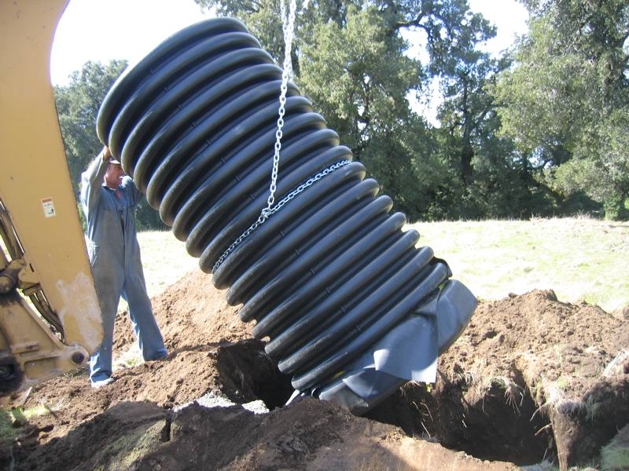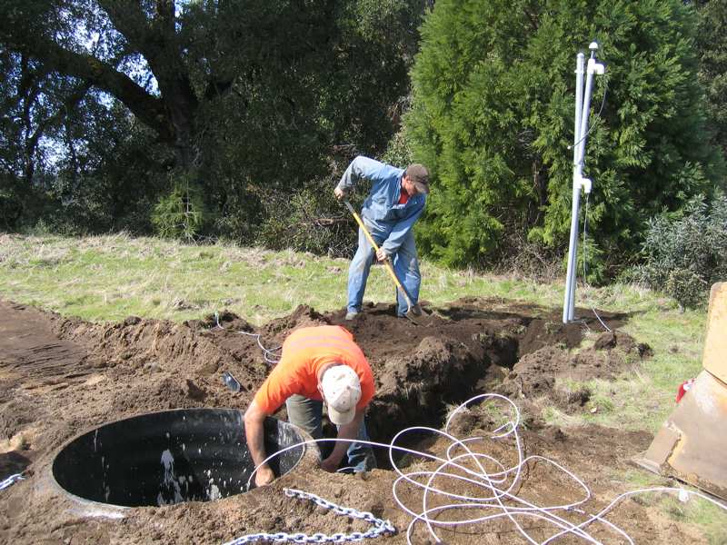

A mast is erected at a minimum of fifteen feet from the tank and preferably 22 feet (further away results in lower signal from wind induced vibration of mast). Longer distances are possible with special cabling terminations, particularly of the cellular or freewave radio. A 1.5” PVC conduit is buried in a 12” deep trench between the Mast and vault.

Installation
The installation can be divided into two basic parts. The main part is the seismic vault and associated equipment and, where necessary, a secondary part which is an external communication module. Stations use different forms of telemetry depending on the circumstances. See the external communication section for more information on these differences.

The sensor and batteries are located in the bottom portion of the tank and the electronics hang off the side near the top. Layers of foam divide the tank into three chambers to stabilize the temperature and the vault is capped with a manufactured plastic lid.

An 8’ mast is placed 15-22’ from the tank on which Photovoltaic Panels and a radio antenna is mounted.

The installation procedure typically consists of emplacing the sensor, connecting the power supply elements, interconnection of the station components, configuration of station information and exercising the telemetry capabilities. In parallel, the assembly of the mast supported PV array, radio antennas and the erection of fencing is undertaken. Some of the more relevant details in the station design are discussed below.

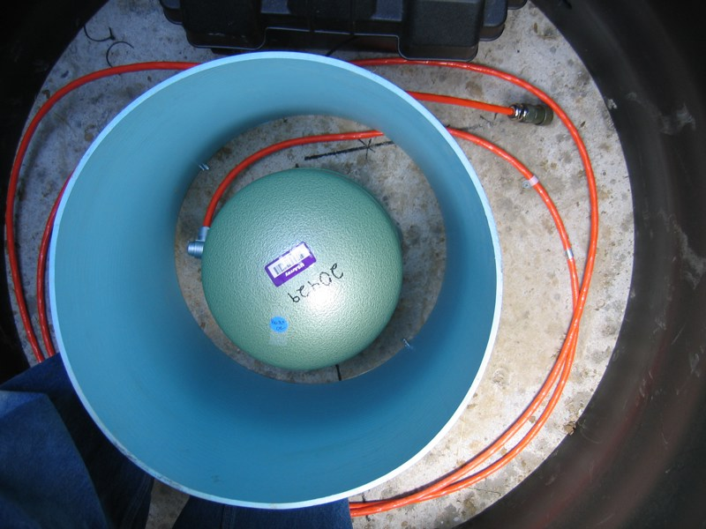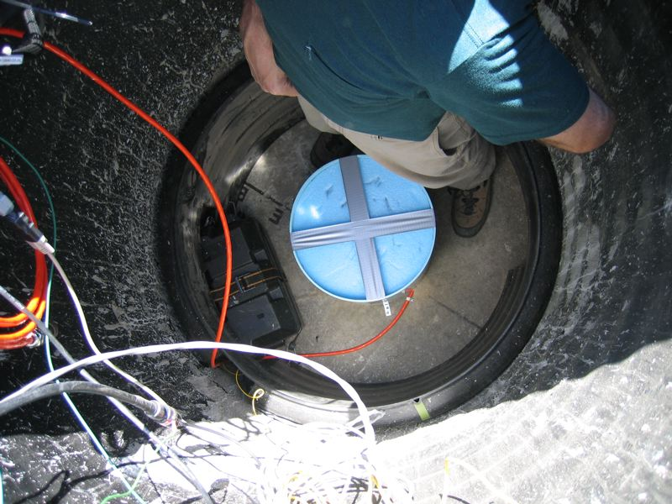

Sensor emplacement
The sensor must be oriented to within 2 degrees of true north. The best means to accomplish this at the bottom of the tank is still under investigation. Magnetic compass, dual antenna GPS heading and gyroscopes have been employed and theodolite sun transits are under investigation. Also important is the creation of a permanent reference mark on the tank bottom to allow replacement sensors to be relocated exactly as the original sensor. The exact technique will be prescribed by IRIS but onsite each method requires about the same attention and time (~45 minutes)

The sensor must be well insulated, secured from inadvertent displacement during servicing and secured from displacement during large ground motions due to earthquakes. We level and align the sensors, unlock the mechanism and then cover it with a 15” diameter tube and embed it within sand. The tube is anchored to the tank floor with plastic anchor screws. The orientation and proper insulation of the sensor may take up to an hour onsite including the orientation described previously.

The sensor must be powered, unlocked and centered for proper operation.

Tank Pump Installation
The tank station design also includes a 500GPH 12VDC Bilge Pump with electronic level switch and a logic level connection into the seismic data acquisition system that identifies when such a system is connected and when it is activated. The pump system is meant to prevent damage to critical equipment in the event of water penetration into the tank. This water penetration may arise due to holes in the tank wall, improper lid placement, or disturbance of the enclosure by animals or humans. A tank with water will generate a service visit to determine the nature of the problem and to correct it. The pump simply reduces the potential for damage. The operation of the pump, its level detector and the logic signals reported by the Q330 are easily tested onsite by placing fingers over test points on the level detector and listening for the pump to whir (and to shut itself off afterwards).

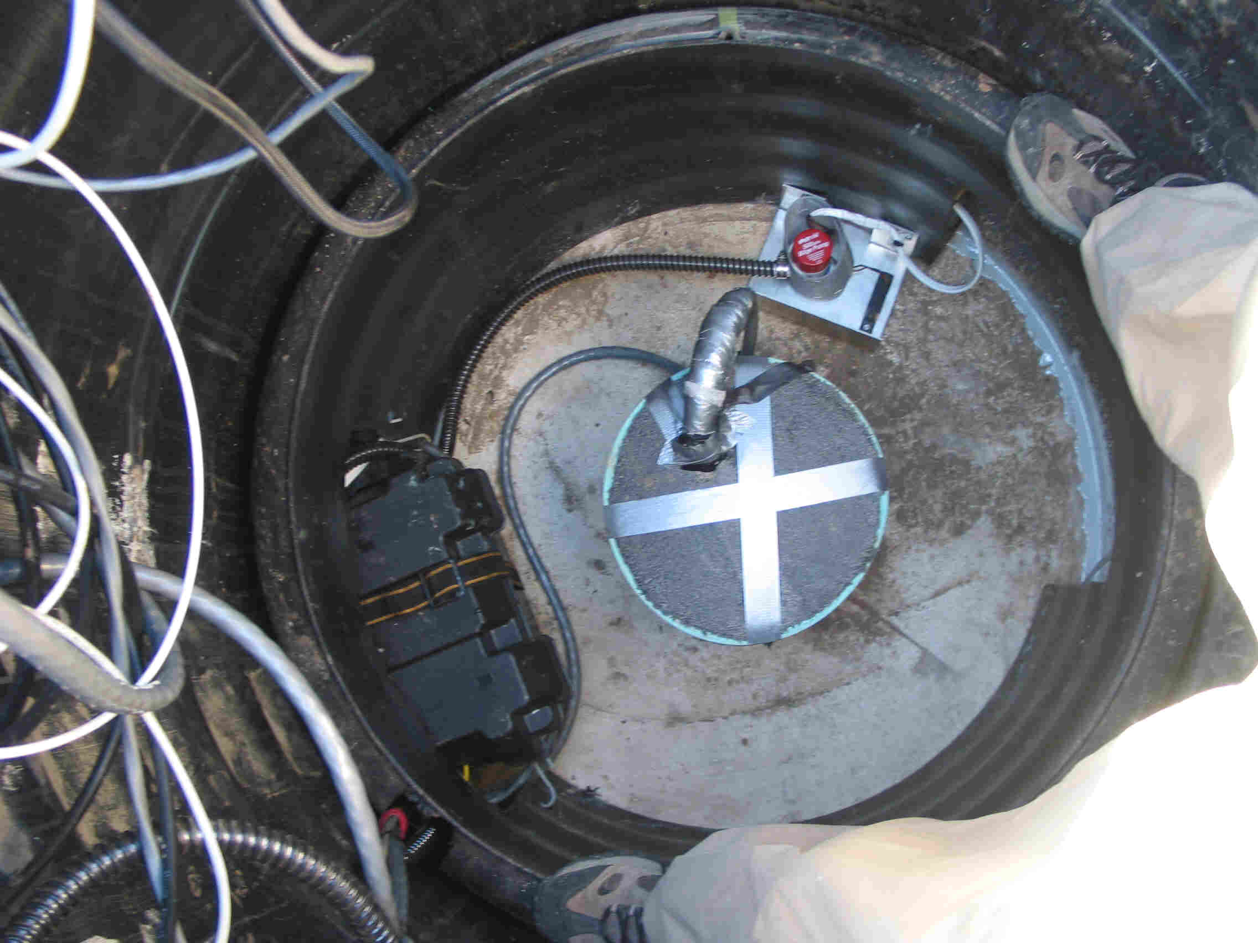

Power Supply connections
80-watt PV arrays are mounted on a pole 15-22 feet from the tank and connected via cabling run in 1.5” conduit. The mounts allow for two panels which are wired in parallel. The PV cables are connected to a Xantrex C12 charge controller and to Concorde AGM 100AH battery. The station load is routed through a 15A thermal breaker and distributed to a terminal strip and on to communication, sensor and datalogger equipment. Typical station power is 4W but varies somewhat with communication equipment or the addition of sensors from cooperative seismic networks reaching perhaps 7-10W. In that case we use two panels and two batteries.

Testing of the PV array, charge controller and batteries is important for the continued long-term operation of the station. This must be performed in field conditions which may not favor measurements. It is invariably cloudy when you want to test the panel output.

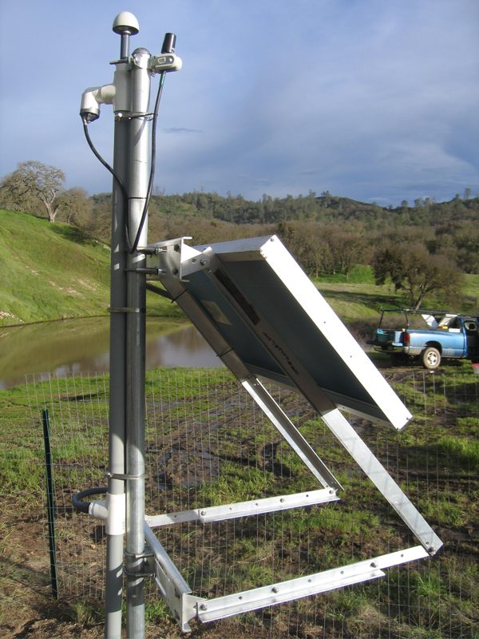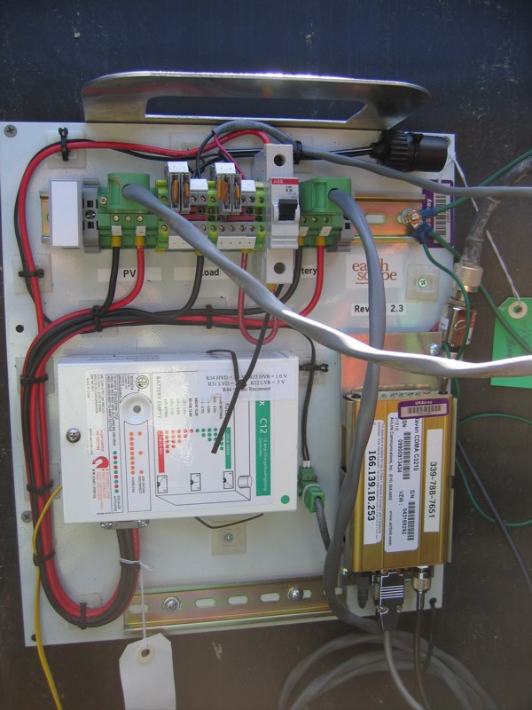

Station-Level Interconnection

The typical cabling diagram for a station with Serial Q330-Baler connection and an STS-2 sensor are given below. Other connections are used for different communication equipment. The example is provided as typical of the interconnection complexity.

Q330 Station Configuration
IRIS provides a set of Q330 configuration files and the instructions to modify those files onsite for station specific information, such as the station code, IP address and link adjustments. In practice, if the installer can achieve programming the Q330 with a reachable IP address all remaining configuration can be accomplished remotely. Except for detailed analysis of onsite diagnostics, all programming and verification of station operation can be performed with a simple Palm PDA using a wireless connection.

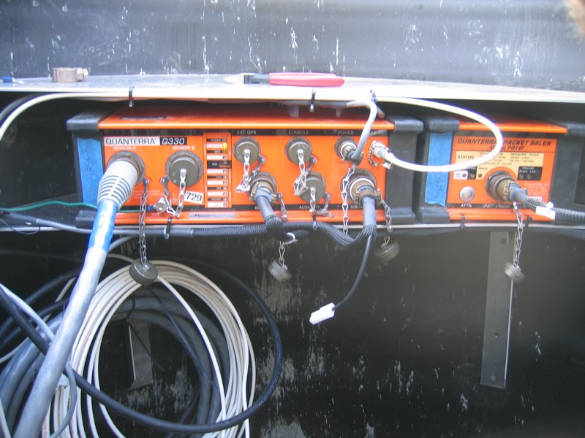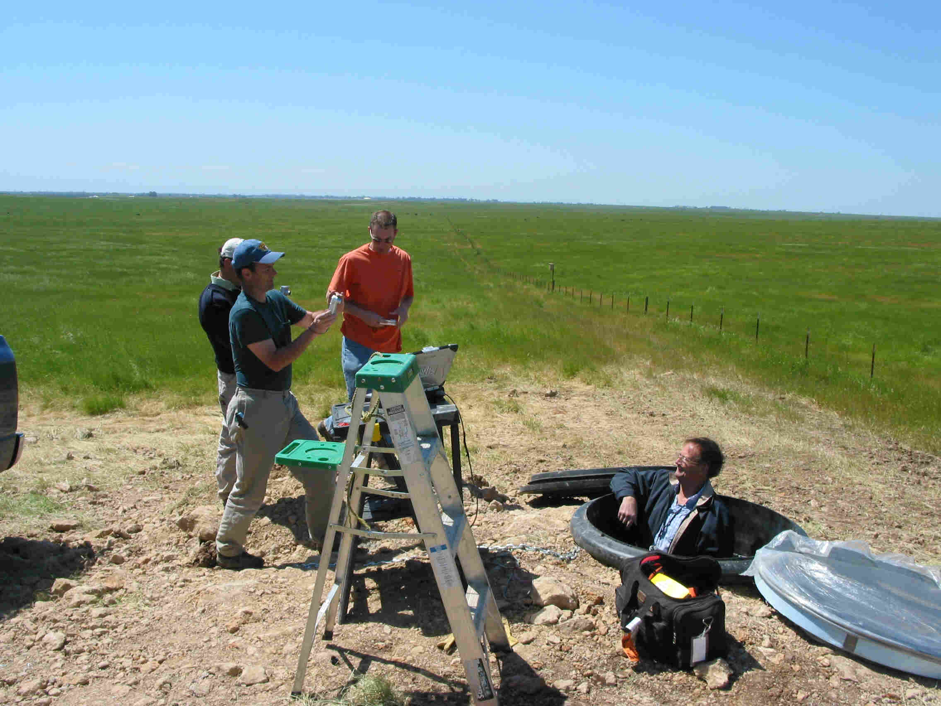

Telemetry Testing
The Q330 datalogger must be reachable via an IP connection from the Array Network Facility (ANF) computers in San Diego. This requires a correct IP address, suitable IP routing and a minimum bandwidth of at least 5kbps, with 50kbps typical. Evaluation programs that test throughput are used to measure two-way traffic.

A Gallery of installation images is available at:
http://www.passcal.nmt.edu/TA_Vtour_install/

Completed Installations:
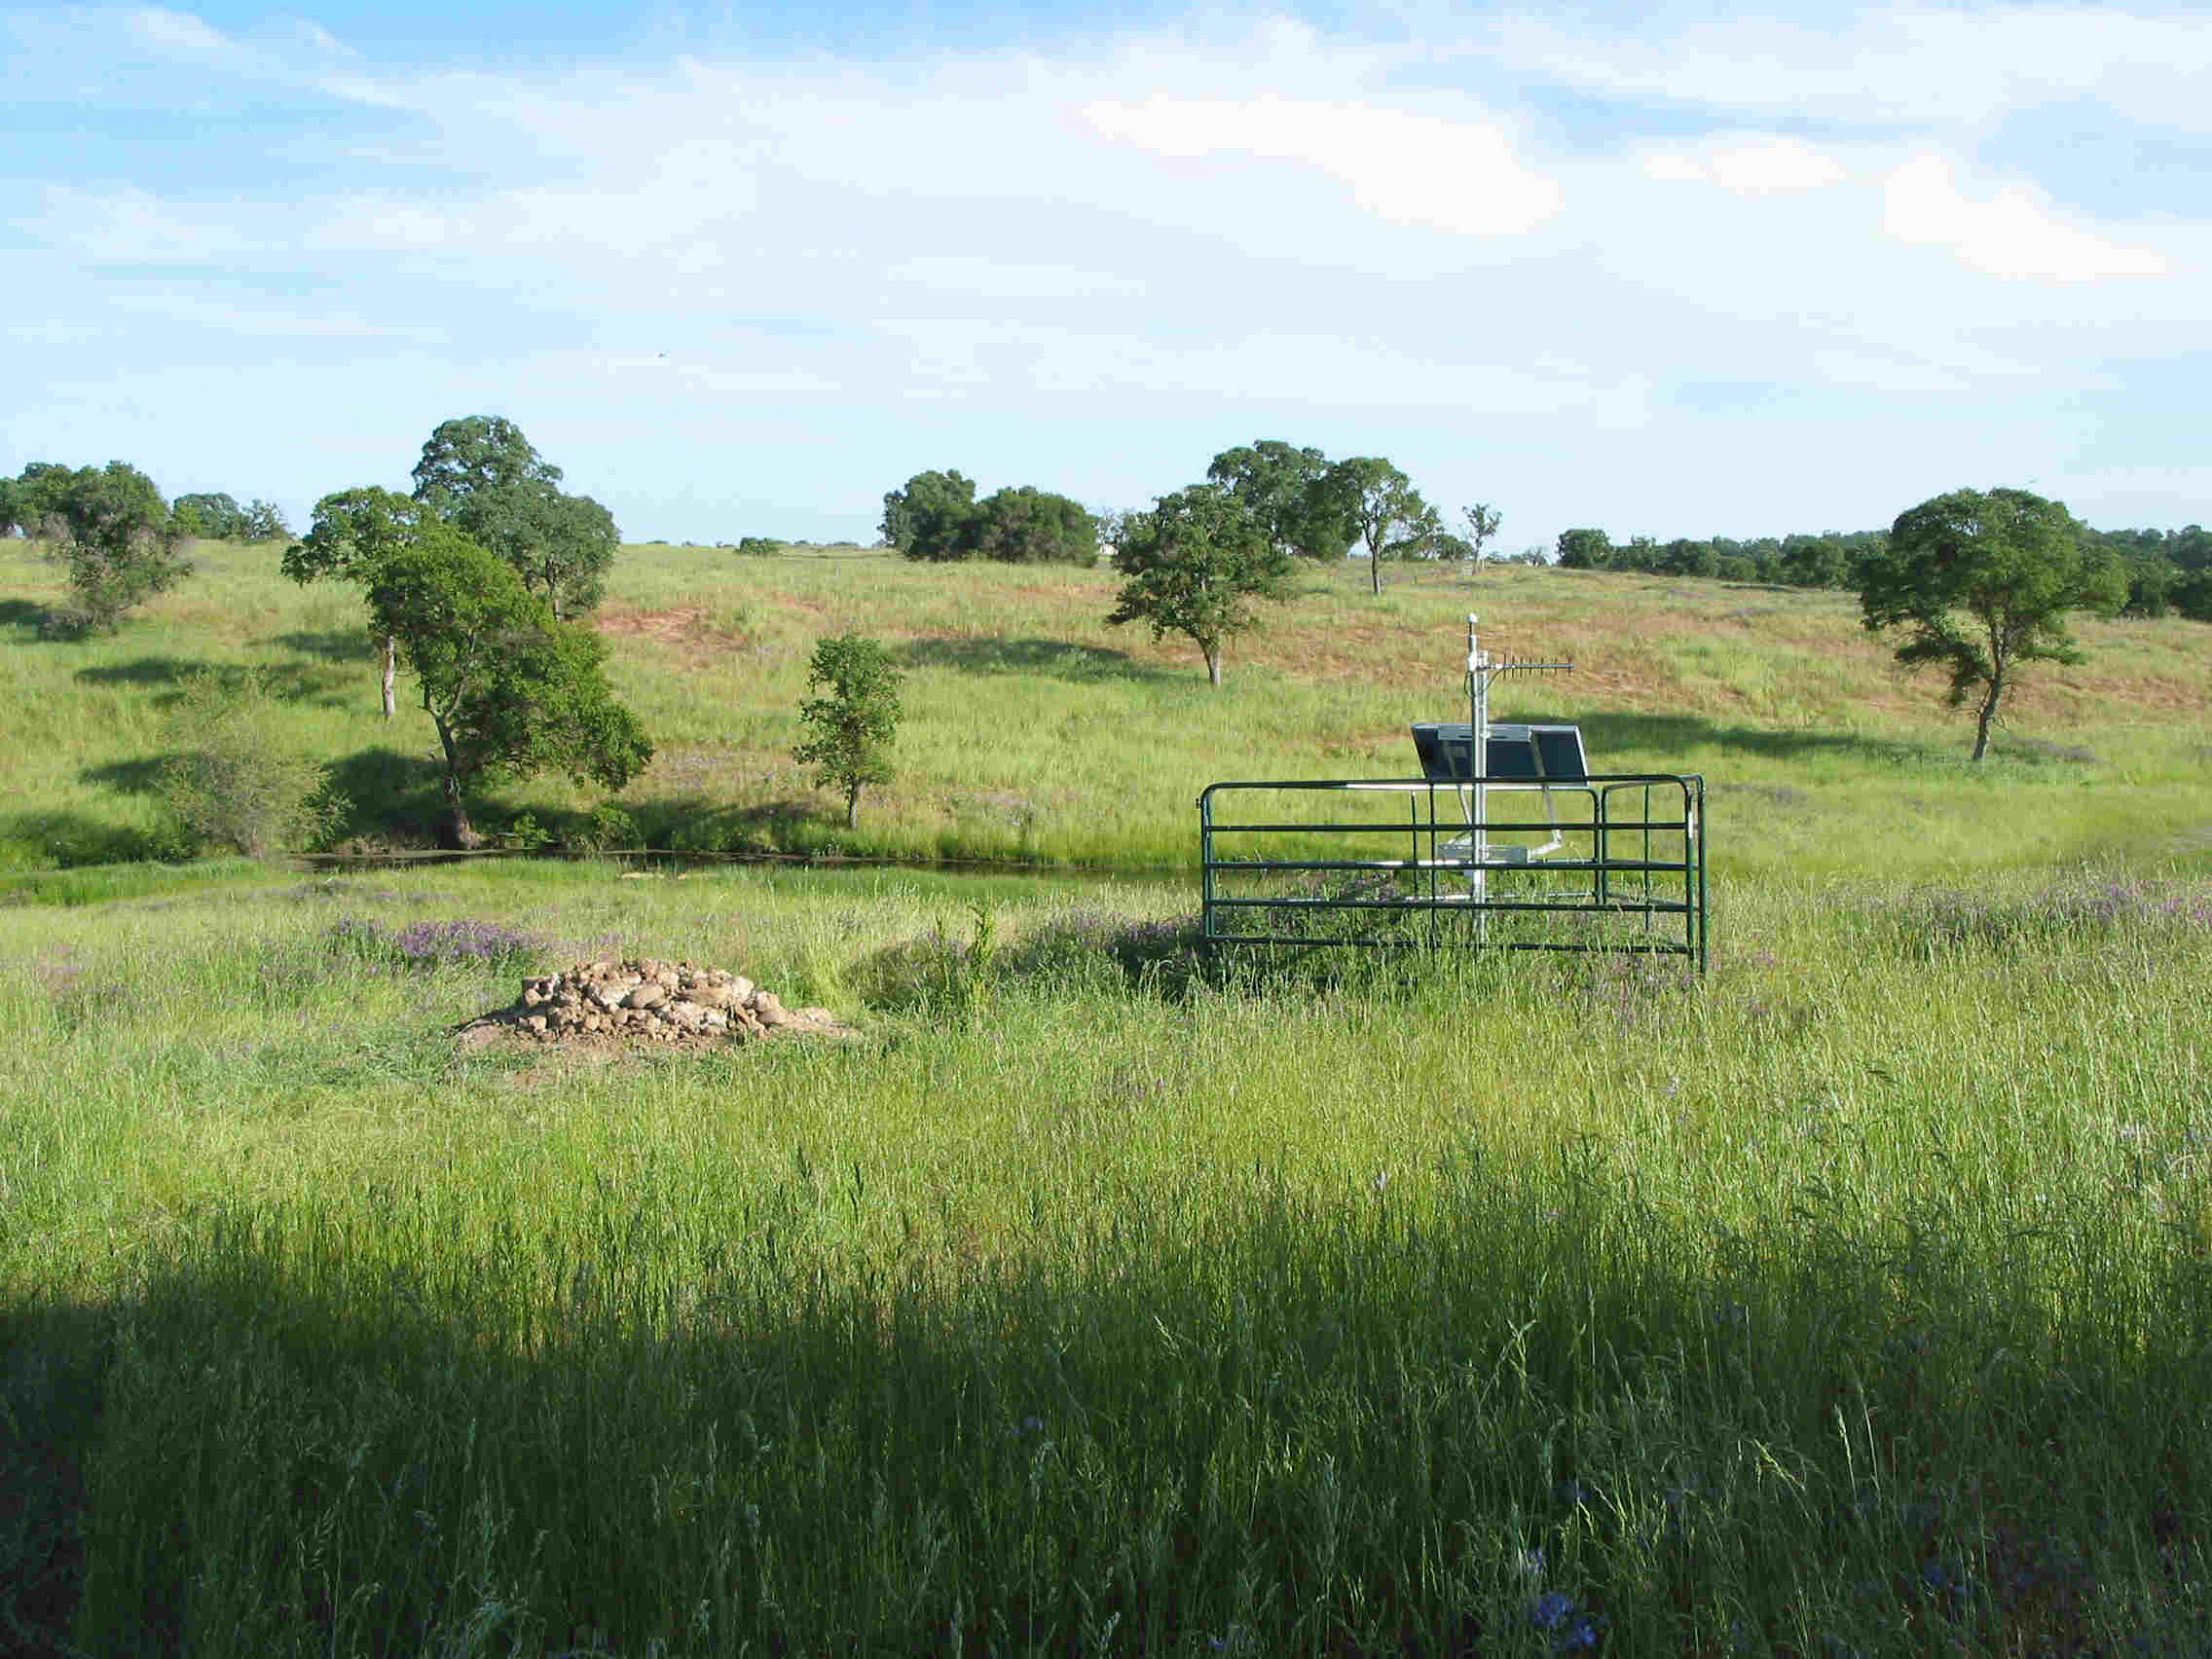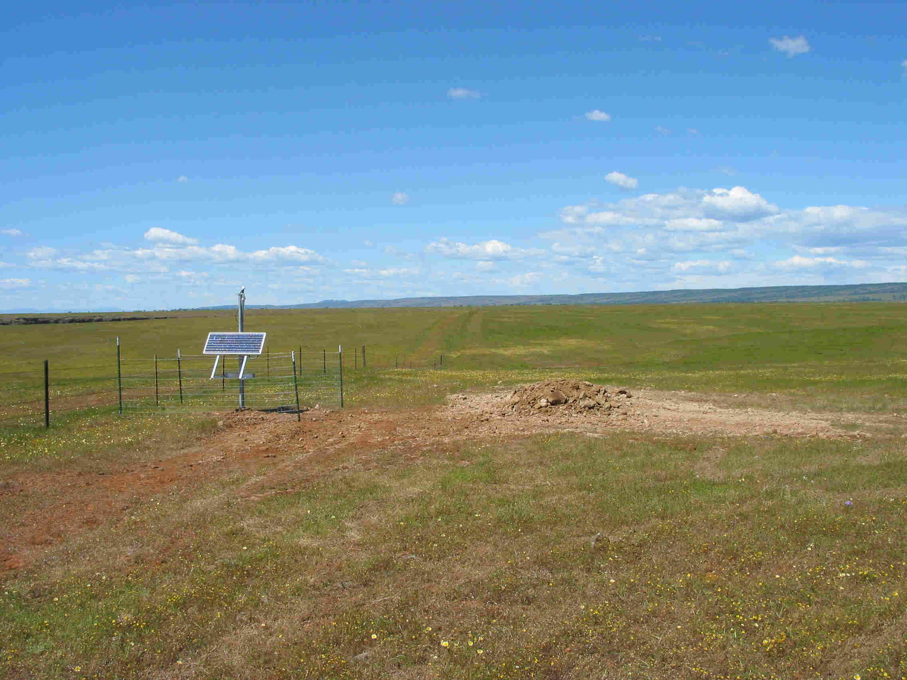

External Communication Modules
Included in about half the station installations is an external communication module. When digital cellular service is available these modules are not needed. There are two basic varieties but a range of options are employed depending on the site circumstances. Installation of the communications module may add a half day or up to two days and require a third person onsite. Without an external communication module a station is easily installed in 5 hours.

Because time estimates for installation depend on the communications equipment used at the site. The following estimates in terms of the number of stations with this configuration and the time to install this configuration are used for the proposal. For simplicity, we specified a composite estimate of 3 man-days per station install. The average below is 15 man-hours onsite. As installations progress, these estimates will be revised.

Communication Type | Percent of Stations | Est. Onsite Man-hours | Detail of man-hours
Internal Cellular | 50% | 10
Ext. VSAT w/AC | 17% | 20 | 4 AC enclosure + 4 VSAT +2 Radios
Ext. VSAT DC | 8% | 25 | 9 DC (avg) + 4 VSAT + 2 Radios
Ext. Radio to Internet | 25% | 18 | 2 Radios + 2 Cabling + 4 mount enclosure

The seismic equipment in the tank is connected to an internet service via a Freewave Ethernet Bridge radio (Spreadspectrum 920MHz). At the tank end, this is very similar to the cellular antenna except we use a directional Yagi antenna to aim at the receive site. The variety and complexity occurs at the receiving end, on the internet side of the radio link. The receiving radio may be connected directly to a host Ethernet and IP LAN, it may be connected to a USArray provisioned Broadband IP device such as a cable modem or DSL service, or it may be connected to a USArray supplied VSAT satellite IP connection. We estimate 25% of the total stations will use VSAT and 25% will use radio to either a hosted connection or a USArray provision broadband connection. The remaining 50% of the stations may use cellular.

Radio to Internet connection
This often involves mounting an antenna mast on a building, penetrating the building with a RF cable and connecting the receiving radio into a LAN, router, switch or combination thereof. In addition to the cabling variety, different network management and security protocols must be observed and integrated. Careful up front planning and dialog with network administrators regarding our modes of operation can make this fairly straightforward.

In the case where USArray supplies their own Broadband Internet connection, the host supplies a mounting place for this equipment in an enclosure and AC power. In certain cases we provide WiFi access to the host on a noninterference basis.

Radio to VSAT node
The VSAT system may be installed by a subcontractor or, after certification, by USArray contractors. The VSAT equipment includes a 0.98m dish mounted on a 2” schedule 40 galvanized pole and a terminal. The terminal and receiving radio (25W total) is expected to be powered by AC in 70% of VSAT stations and by Photovoltaic Panels in about 30% of the VSAT stations. Such solar powered sites, in poor conditions, require 800W of panels and may take 3 persons a full extra day to install. We use four sizes of PV arrays to support the VSAT power in different environments. The AC powered VSAT enclosures are relatively simple small boxes, similar to enclosures housing a broadband internet connection such as a DSL or cable modem.

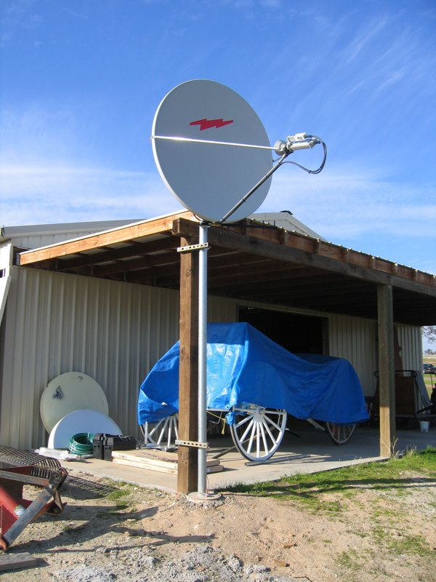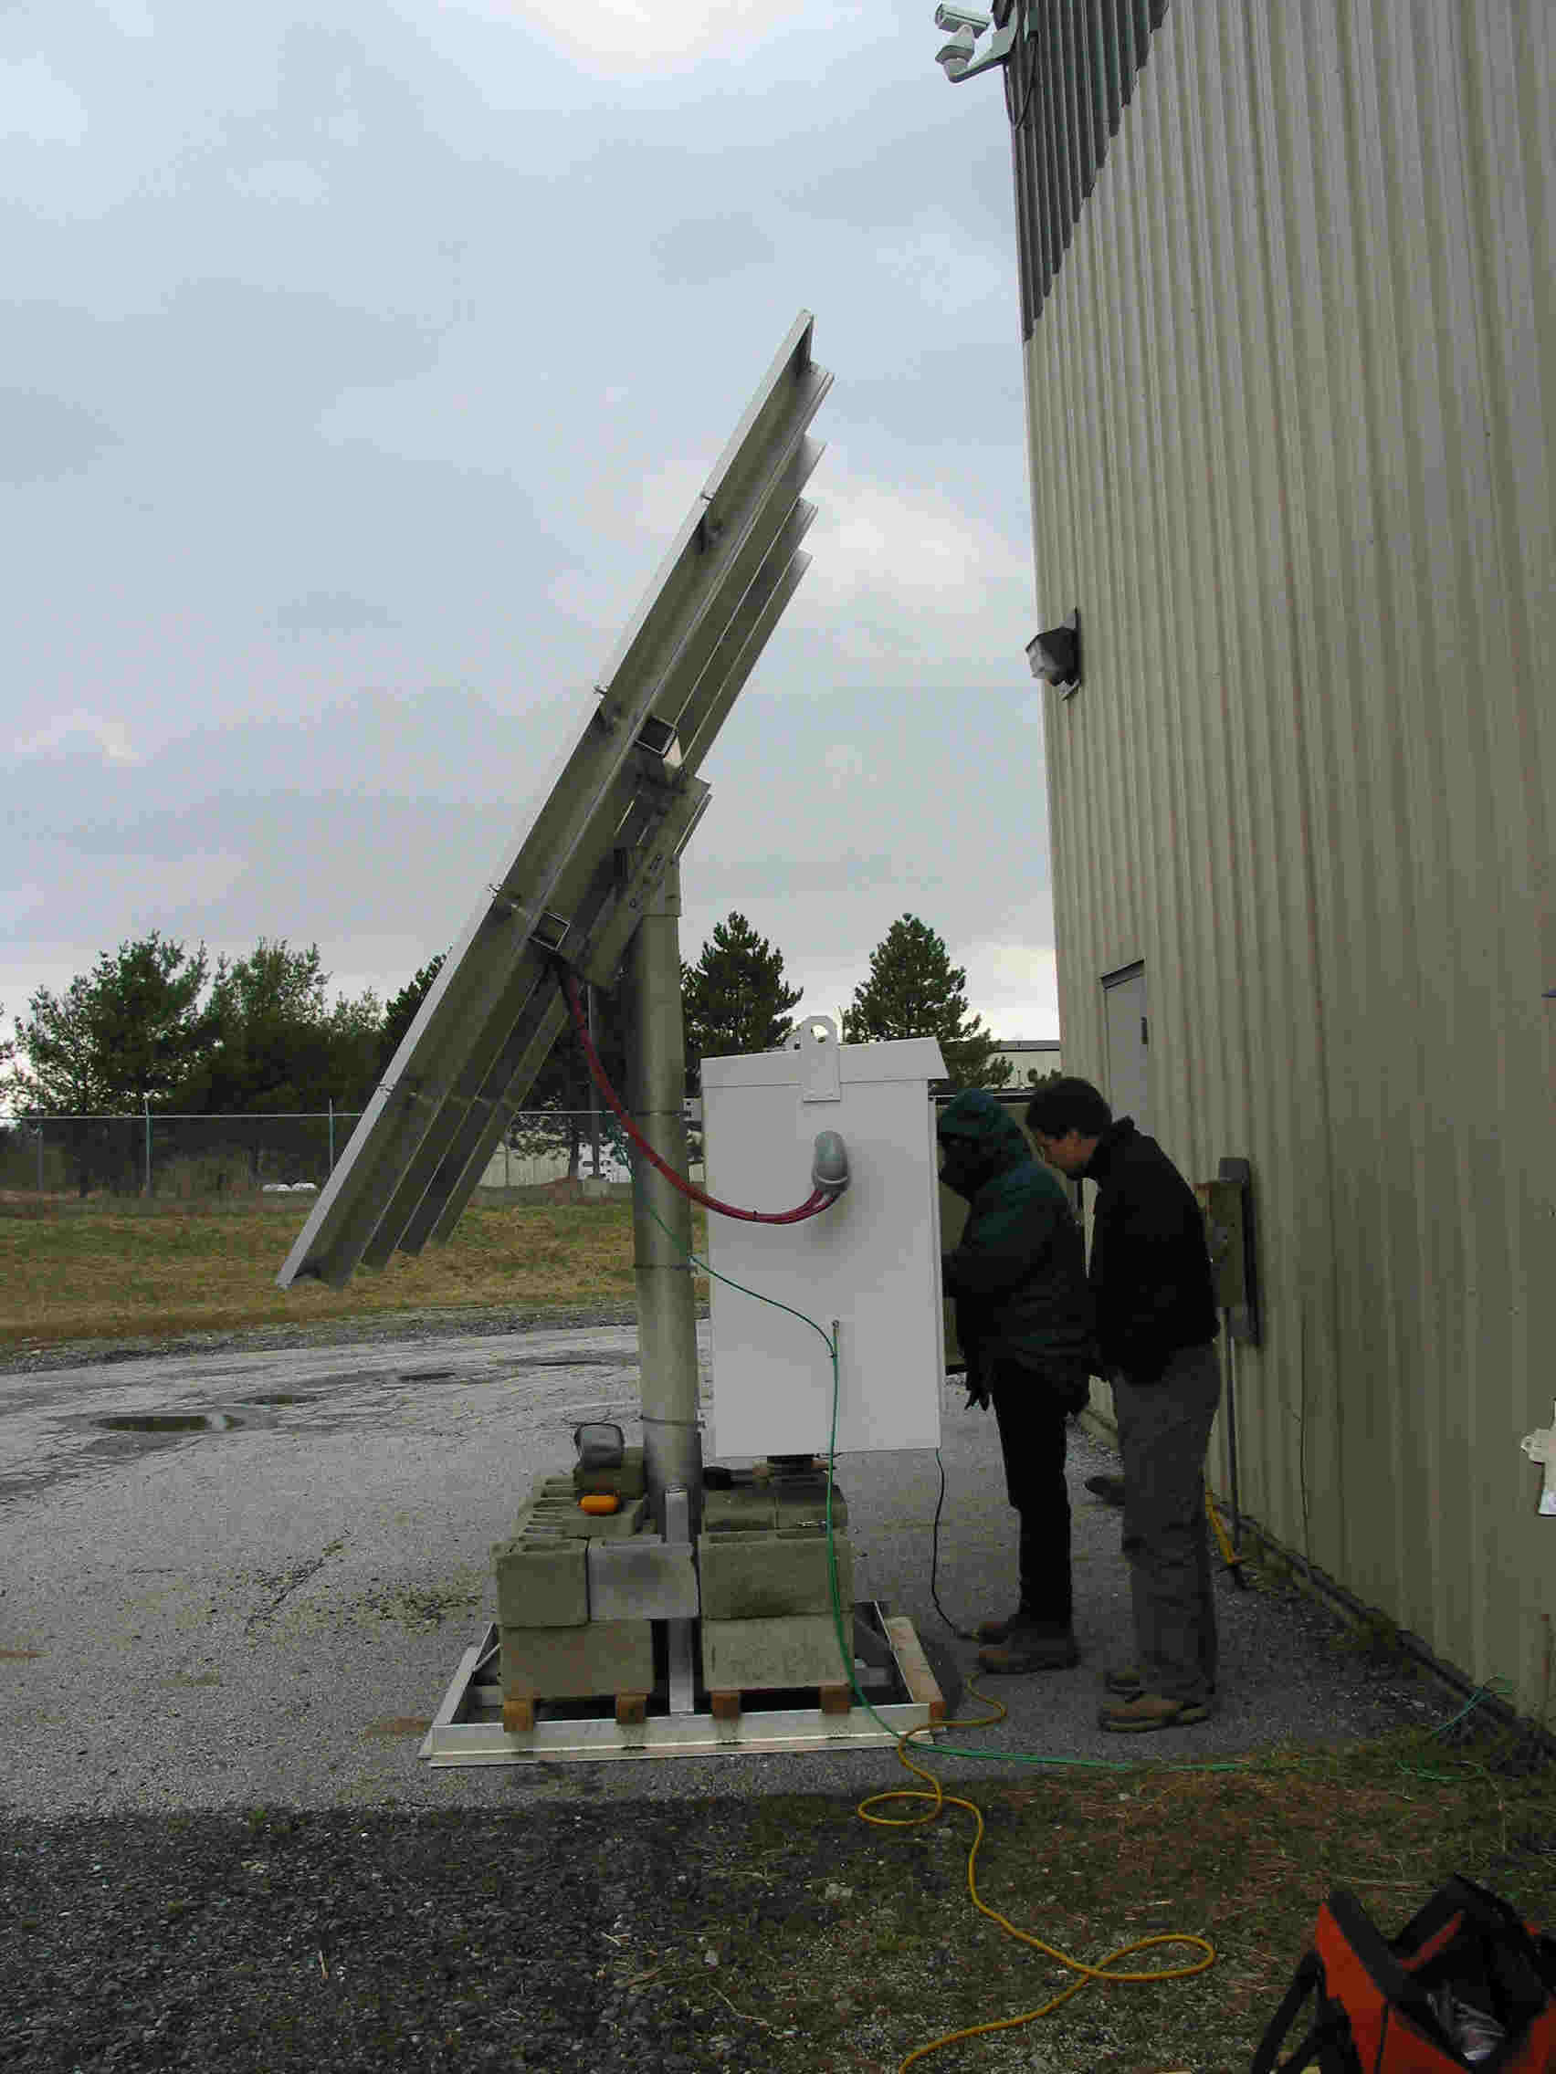
A 0.98m dish mounted above a barn entry. An 800W solar array for VSAT in northern coastal zones. Mounts on 6” schedule 40 pipe.
Normally dish is about 6 feet off the ground.

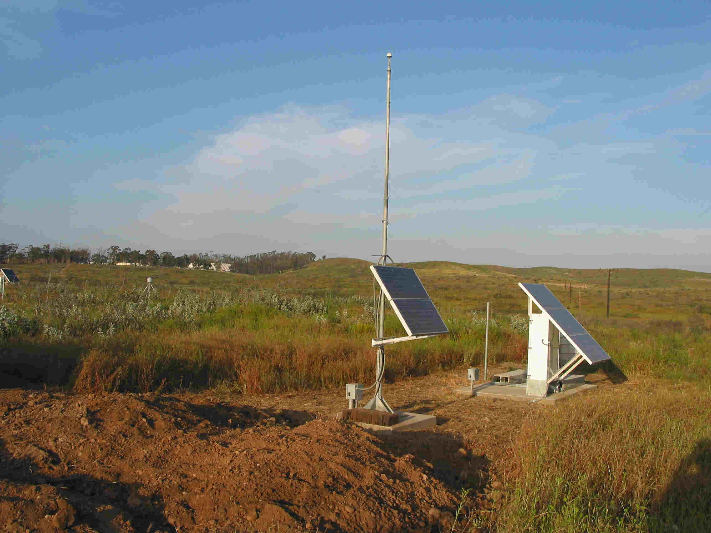
Southern VSAT 240W solar panel array (on right) mounted to enclosure. A ground mounted dish not visible behind white electronics enclosure.

