HOW TO ACCESS THE PARIS PROPERTY MODULE SYSTEM - PPM

Go to the TIGTA Homepage as shown below. Click on PARIS.

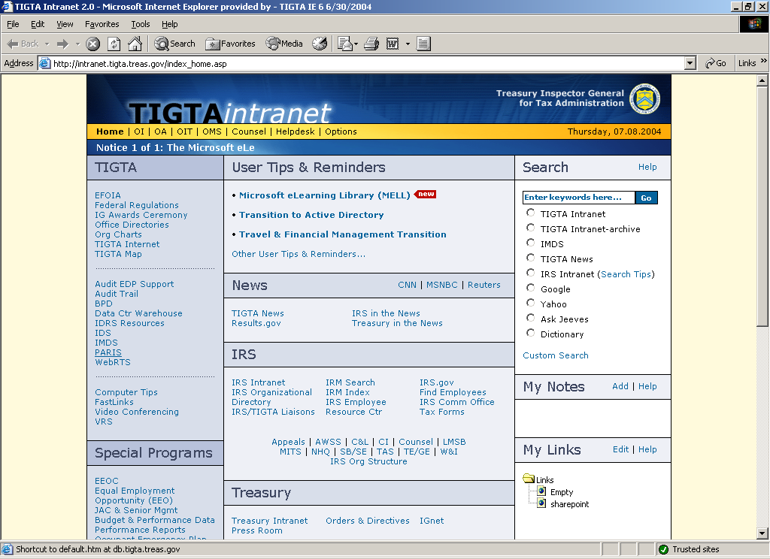

This will bring up the PARIS system as shown below. Click on Property.

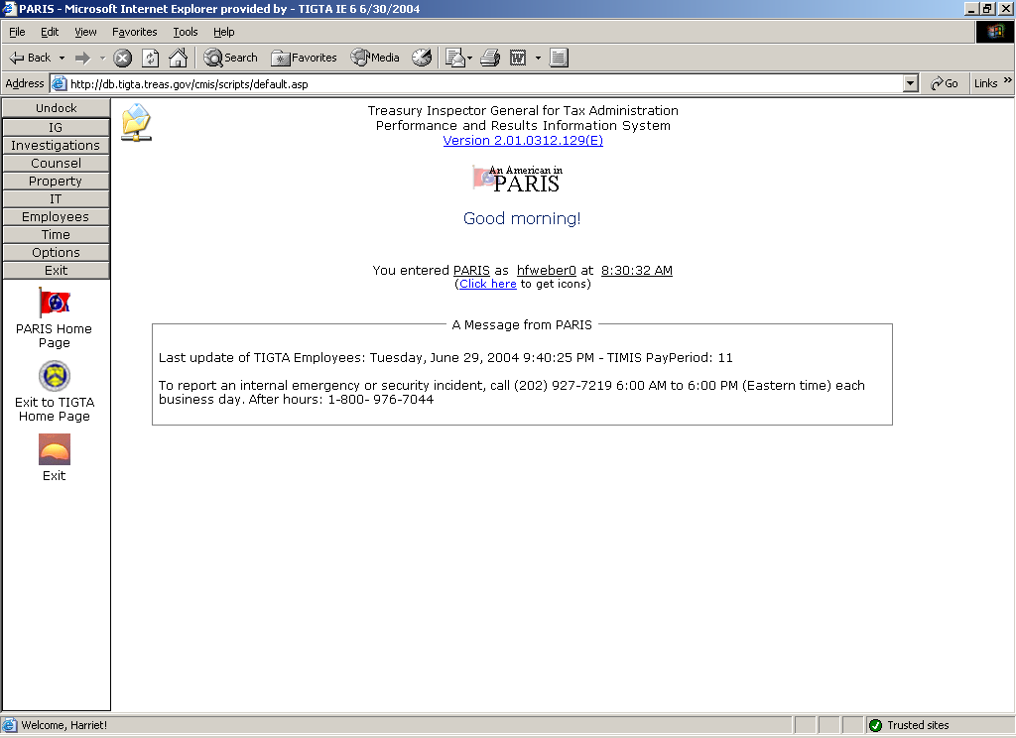

This will open the page shown below. Click on PPM (Remote).

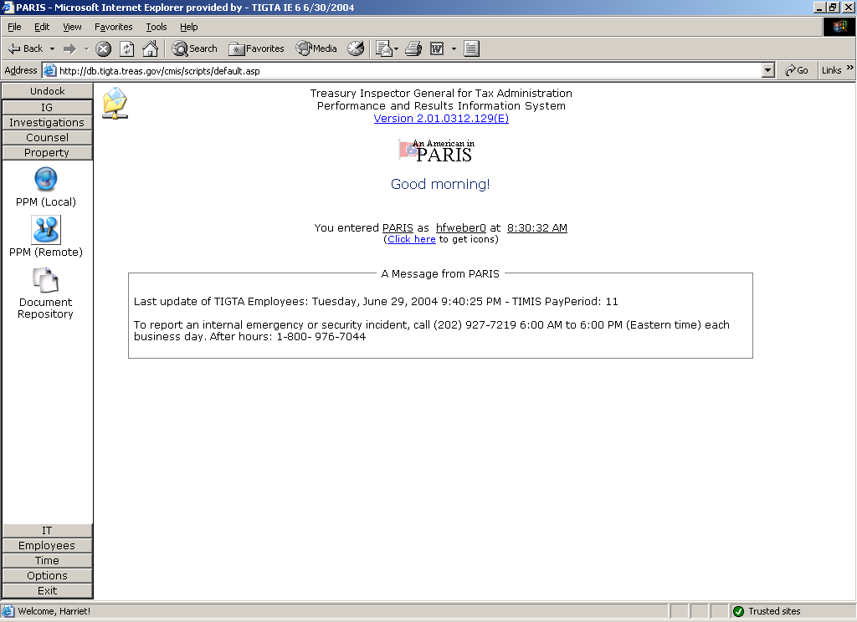

This will open the page shown below. Maximize the screen and then click on Connect.

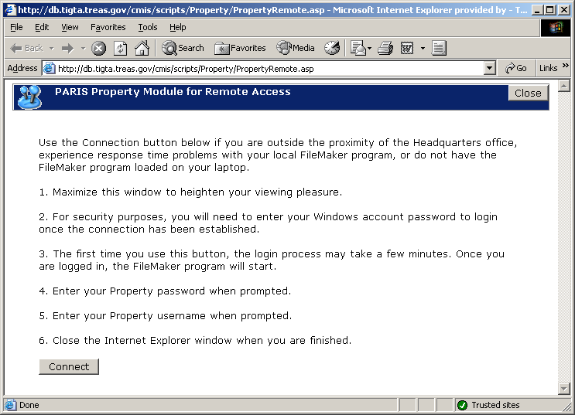

At the screen shown below, click on OK.

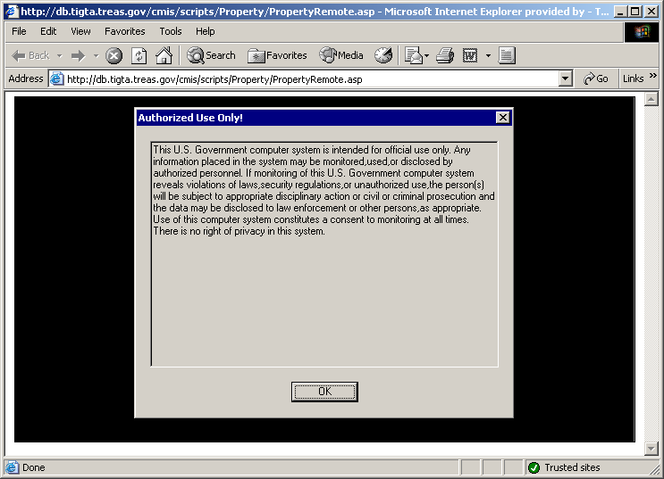

At the screen shown below, enter your network password, NOT YOUR PPM PASSWORD and click OK.

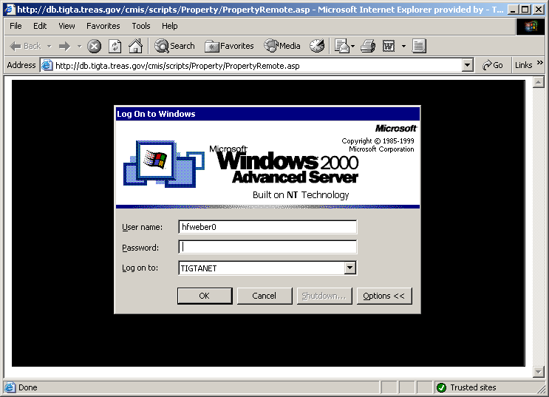

At the screen below, enter your PPM system password and click OK.

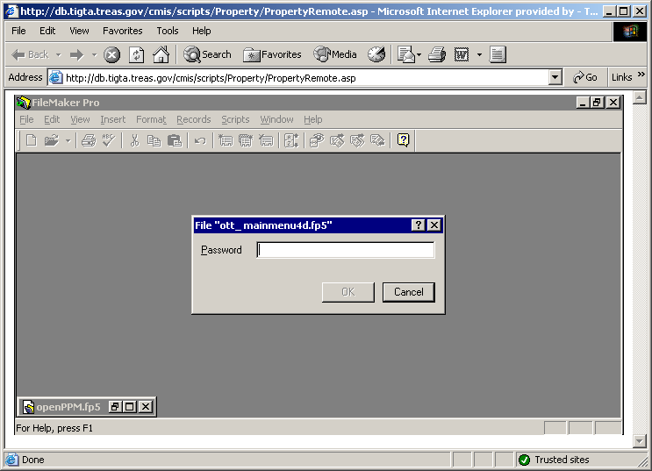

At the screen below, enter your PPM User Login and hold down the “Ctrl” button and hit the Enter Key or click on Continue at the left

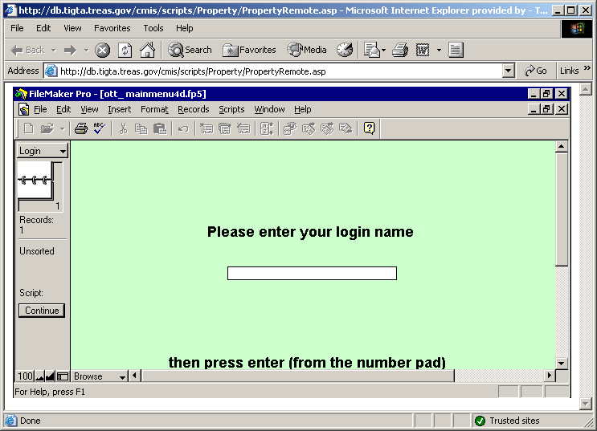

This will take you to the Main Menu of PPM.

PPM MENU SCREEN

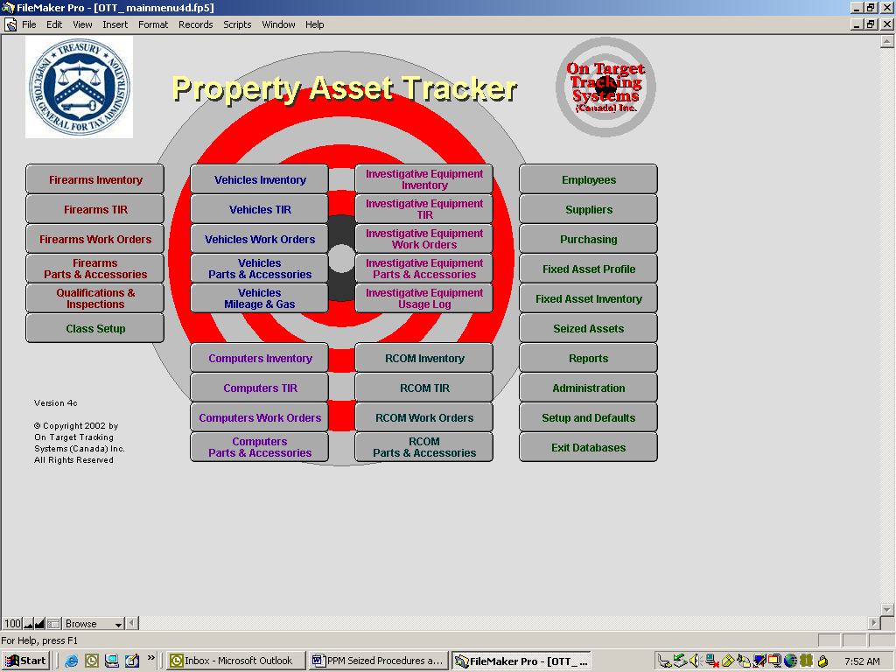

THE DATA ENTRY SCREEN

To view/enter data, select the Seized Assets button located on the extreme right column of the inventory database screen.

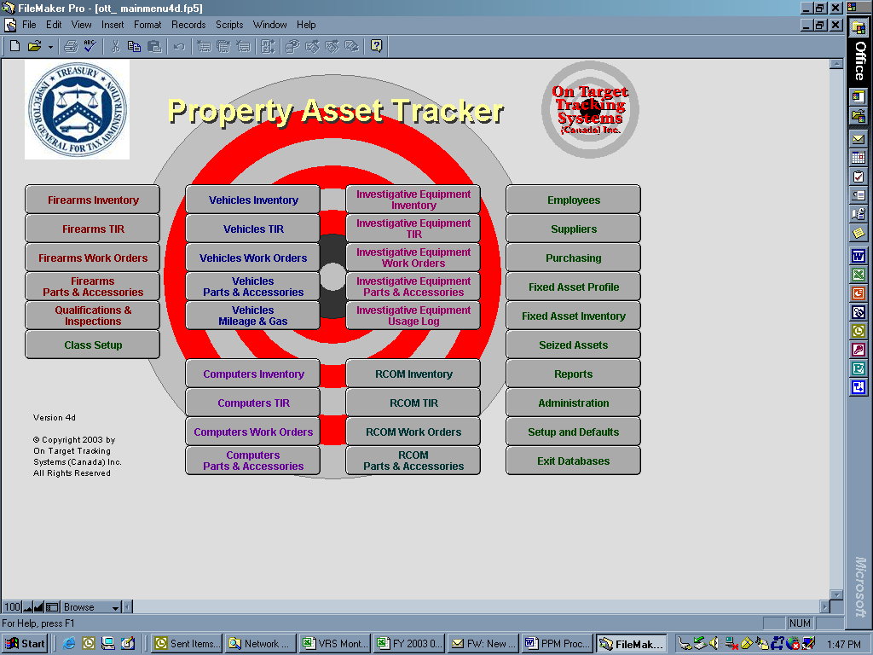

The next screen is the View as a List screen.

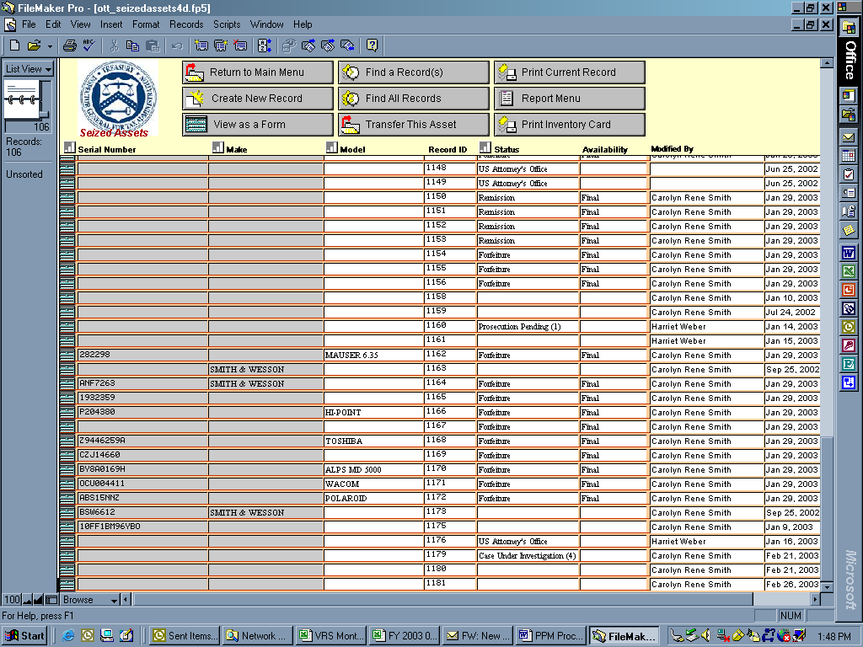

The following selections are shown across the top of the above screen:
- Return to Main Menu – This choice will return users to the Main Menu Screen shown on the previous page.
- Create New Record – This choice is used only by the National PPM Coordinator to input new records.
- View as a Form – This choice reflects the last record that was selected to be viewed. Note, once this record is selected, the title in this field changes to “View as a List”.
- View as a List – This choice reflects all records in sequential order by the four-digit Record ID number. Identify the ID number of the record to be viewed and tag the record symbol to the extreme left column of this row. Note, once this record is selected, the title in this field changes back to “View as a Form”.
- Find a Record(s) – This choice will open a blank data input screen. Enter the record ID number, case number or control number in the appropriate field and press the Enter key. This action will populate the data fields.
- Find All Records – While in the View as a List mode, this choice will only give you a list as you see it here.
- Transfer This Asset – This selection is used by the National PPM Coordinator to transfer forfeited assets to the appropriate TIGTA inventory database.
- Print Current Record – This choice prints the record that is selected. Once the desired record is on the screen, select “Print Current Record” and then Select “File” from the tool bar and then print. Another option is to select “Print Current Record” and then select the Continue button located on the left side of the screen. This will take you to the print screen where you can continue to print or cancel.
- Report Menu – This choice will take you to the report screen for all databases. From here you can choose form 5 seized asset reports by selecting the appropriate tab or return to the main menu by selecting the Return to Main Menu button located at the top left of screen. Note, some of these reports require a Start and End date (see asterisk). If required, these parameters must be entered before selecting the desired report. For all Seized Assets Reports the “Division” and “Group” codes must be cleared.
- Print Inventory Card – As with the Print Current Record, this choice will print the record that is selected.
Entering Case Data

Only the National Seized Assets PPM Coordinator has the ability to enter new cases. This is the screen that will be used to perform that function.

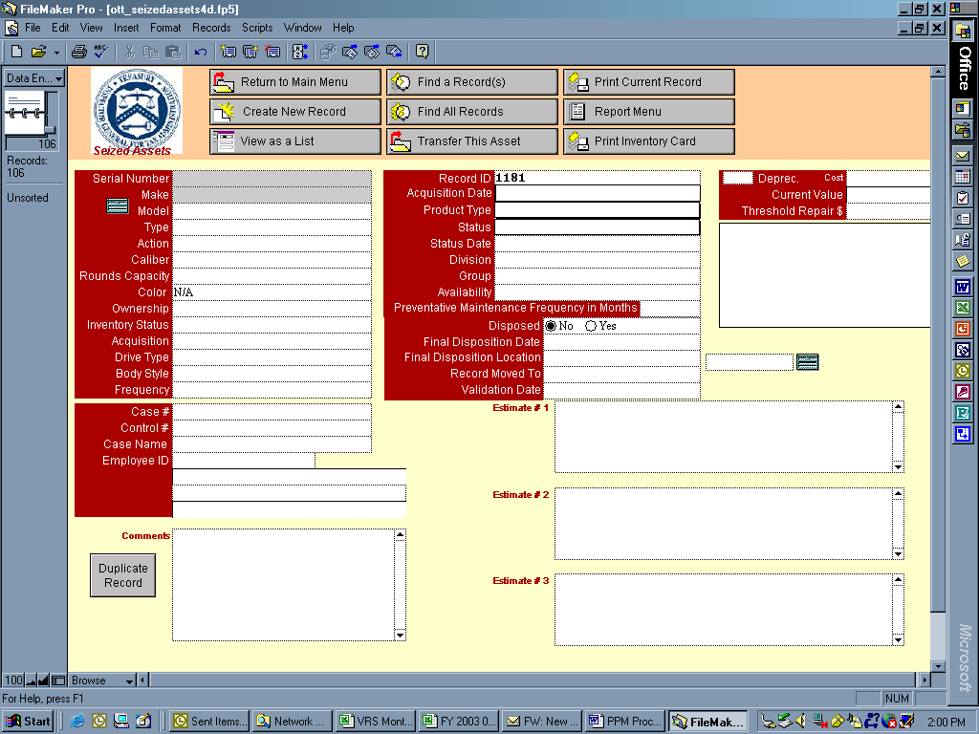

To ensure that accurate information is captured the case agents and Divisional Seized Assets PPM Coordinators must submit the following information:

SERIAL NUMBER – This number should be provided on the Form OI 141 by the case agent when possible, particularly for firearms, computers, other electronic items, or vehicles.

MAKE – Case Agent should provide on the Form OI 141 when information is available, particularly for firearms, computers, other electronic items, or vehicles.

MODEL – Case Agent should provide on the Form OI 141 when information is available, particularly for firearms, computers, other electronic items, or vehicles.

TYPE – As shown below there are several selections from which to choose. Only the following four selections apply to seized assets: Bribe Money; Recovered Monies Held as Evidence; Money Held for Safekeeping; and Seized General Property. The Case Agent will indicate the appropriate type of seizure in the Description section of the Form OI 141.

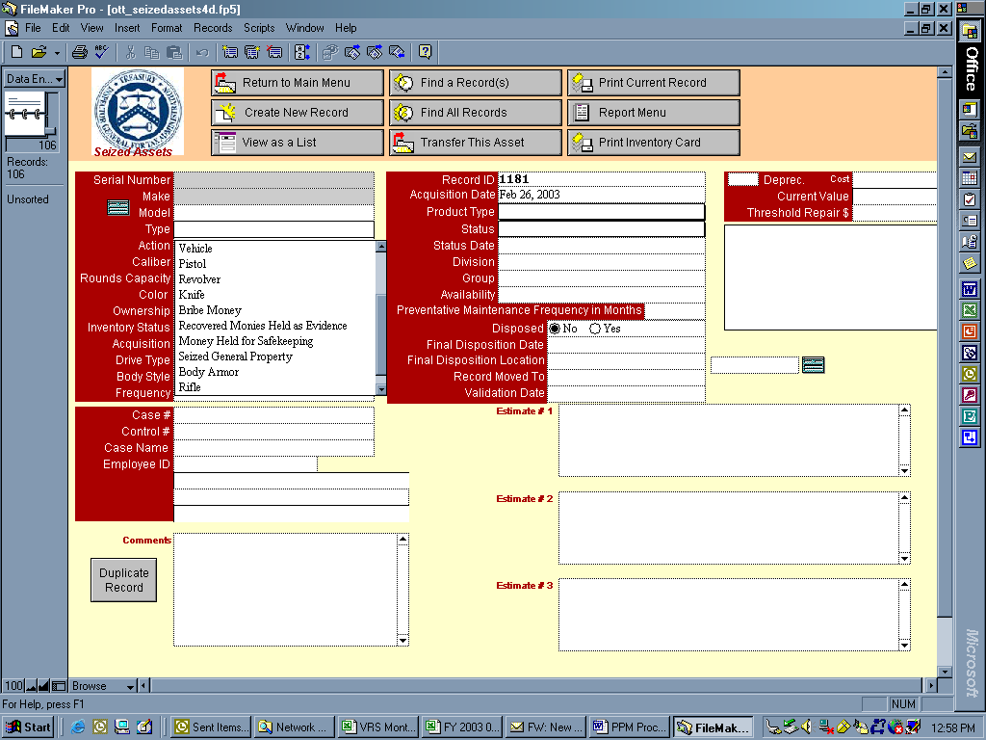

ACTION, CALIBER, ROUNDS CAPACITY, and COLOR – Case Agent should provide this information for seized firearms on the Form OI 141, block 7(a) or on an attachment.

OWNERSHIP – This category is not applicable to Seized Moneys and Property since TIGTA does not owned seized property but has custodial possession.

INVENTORY STATUS – Indicates where seized assets are physically maintained. In the drop down menu below there are four selections that apply to Seized Moneys and Property. If “Other” (See Comments) is selected, provide a statement in the Comments field. This information should also be provided on the Form OI 141, block 9.

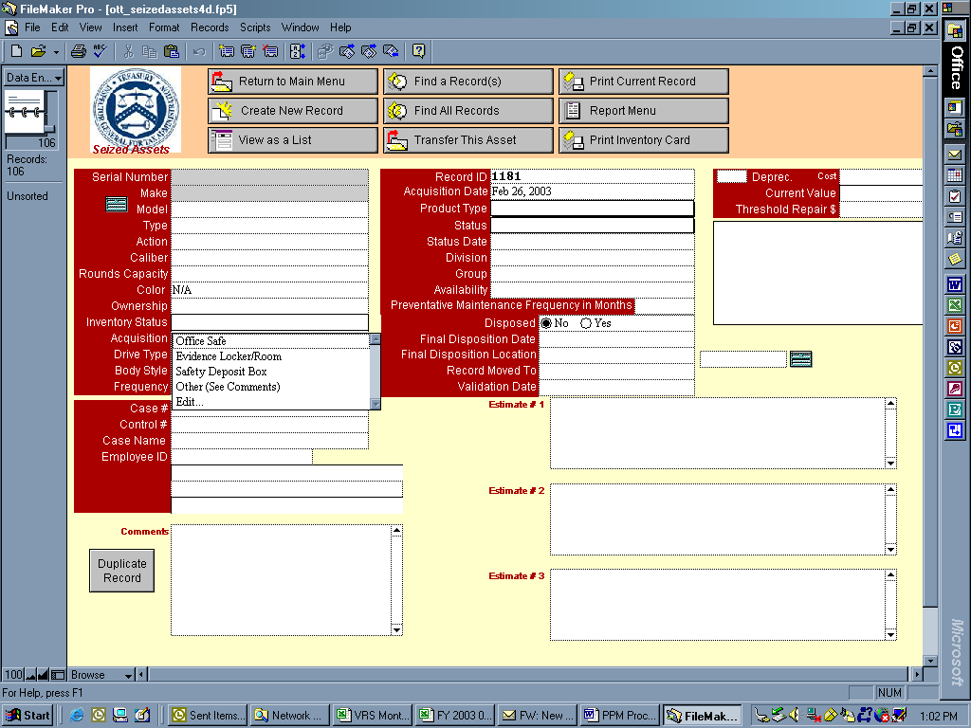

ACQUISITION – “Seized” is the only selection in the drop down menu applicable to seized assets and will automatically be captured by the National Seized Assets PPM Coordinator when entering the record. This does not need to be notated on the Form OI 141.

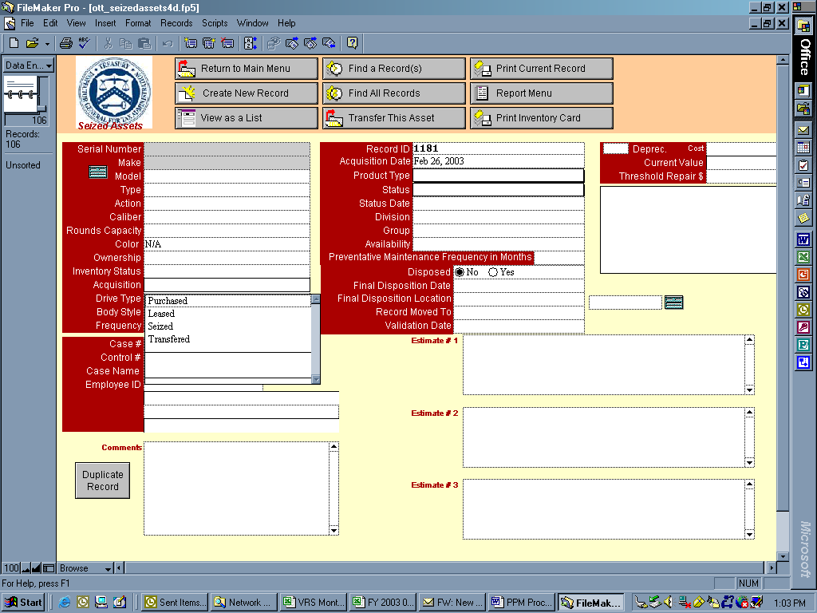

DRIVE TYPE and BODY STYLE - If applicable, the Case Agent will provide drive type and body style for seized vehicles on the Form OI 141, block 7(a) or in an attachment.

FREQUENCY – If applicable, the Case Agent will provide the frequency band for seized radios on the Form OI 141, block 7(a) or in an attachment.

CASE # - Case Agent will assign a PARIS case number when a case is opened and provide this number on Form OI 141, block 7(c).

CONTROL # - The National Seized Assets PPM Coordinator will assign a control number to Form OI 141, block 3 to each case. This same number should appear on all Form OI 141’s for subsequent seizures involving the same case.

CASE NAME – Case agent will provide subject’s name on the Form OI 141, block 7(c).

EMPLOYEE ID – Case agent will provide his/her name on Form OI 141, block 4.

DUPLICATE RECORD -- This button is used only by the National Seized Assets PPM Coordinator when inputting additional records with the same case number. This feature conveniently repopulates fields, such as the case number, control number, the case agent’s PARIS ID number, division etc.

COMMENTS - National Seized Assets PPM Coordinator will use this field for brief notes, such as, other Record ID numbers that pertain to the same case or a more detailed description of the seized property, etc.

RECORD ID – The PPM inventory system will assign a four-digit sequential number to each record that is created. In order for the inventory system to recognize the dollar value of each seized item, a new record for each item must be established. This number is unique to each seized item in a case. For example, if five items were seized on a given date, each of the five items will be assigned a separate record ID number.

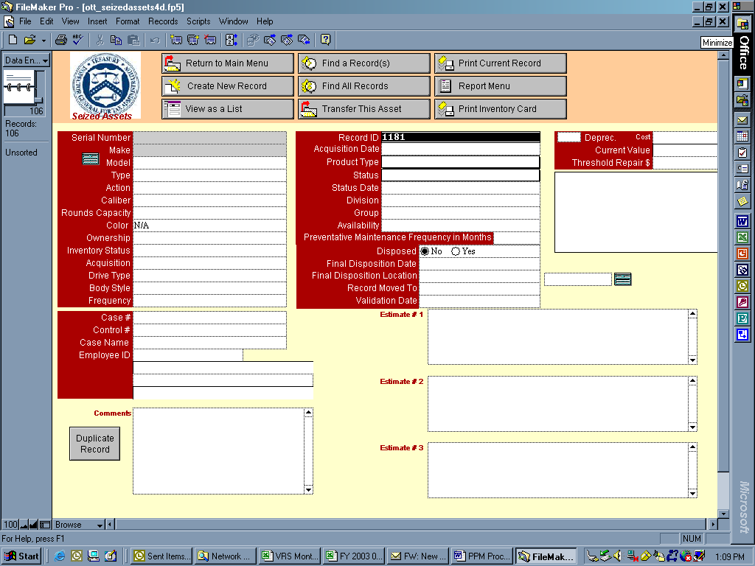

ACQUISITION DATE – This field represents the date the money or property was seized and is to be provided by the case agent on the Form OI 141, block 7(b).

PRODUCT TYPE - From the following dropdown menu, the National Seized Assets Coordinator will identify the appropriate selection based on the information provided by the case agent on the Form OI 141, block 7 (a) or on an attachment.

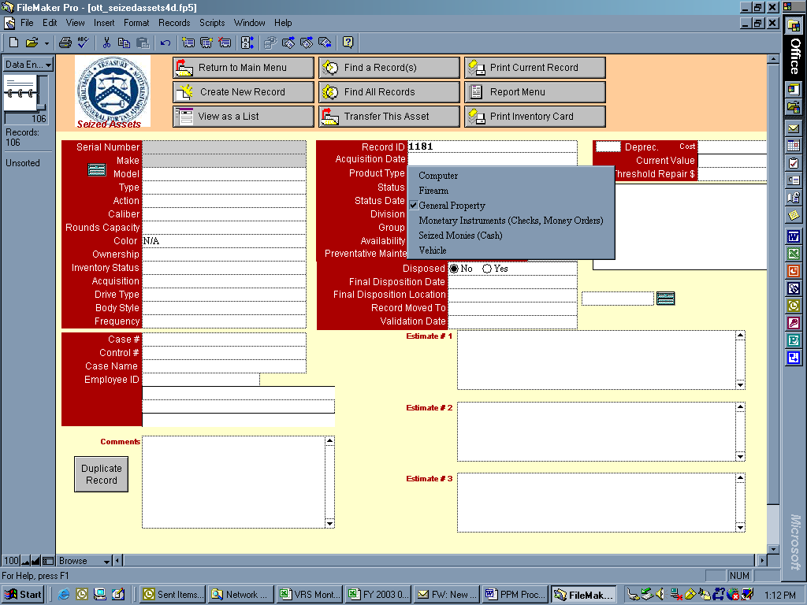

STATUS – (formerly called DISPOSITION CODES) When a case in initially entered into the PPM system the Status of the case is not generally reflected. Upon conclusion of the first quarter following the entry into PPM, the Divisional PPM Coordinators are to obtain and enter the appropriate Status Code, numbers 1 through 12 The Divisional Seized Assets PPM Coordinators will be responsible for updating this field quarterly at a minimum. The first five selections in the drop down menu are not applicable to seized assets. Two new selections, returned and forfeited, have been added. When a case is to be closed, the Case Agent or Divisional Seized Assets PPM Coordinator is to select one of these two choices on Form OI 141, block 8.

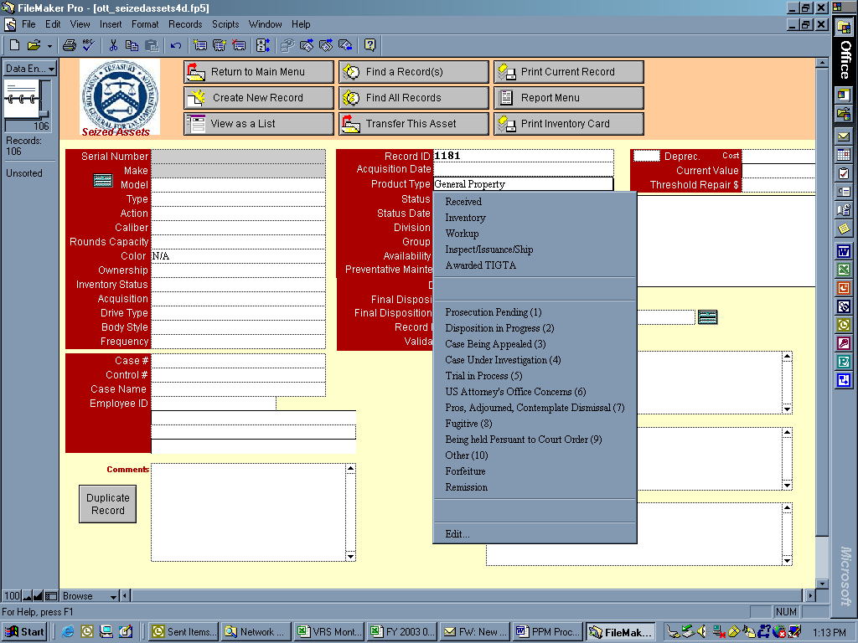

STATUS DATE—Divisional PPM Coordinators should use this field only when a status code changes (for example, from “Trial in Process (5)” to “Forfeiture (11)” when a case is closed). Unlike the Validation Date (explained below), the Status Date should not be routinely updated each quarter, but only when the actual status of the case changes.

DIVISION— The Case Agent and/or Divisional PPM Coordinator will provide the appropriate Division name on the Form OI 141, block 1.

GROUP – N/A

AVAILABILITY— The availability of an item is automatically system generated based on the type of action (transfer, issuance) is taken on the record. For Seized Assets, the availability will usually be shown as available until the case is closed. Once Form OI 141 has been submitted to close a case, the National PPM Coordinator is to select “Final” from the availability field drop down menu. In doing so, term “Final” will appear in the availability column of the “View as a List” and “Find All Records” screens. See sample below.

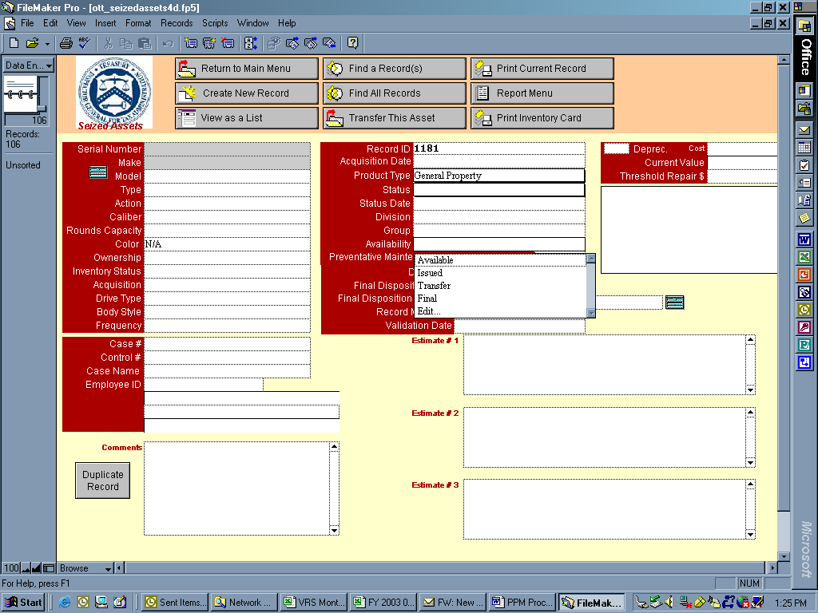

PREVENTATIVE MAINTENANCE FREQUENCY IN MONTHS— Not applicable to Seized Assets.

FINAL DISPOSITION DATE, FINAL DISPOSITION LOCATION—Date that a case or record is closed, and how property was disposed of. The closing date and final disposition location should be provided on Form OI 141, blocks 8(a) and (d). See the screen below for disposition locations. Final Disposition dates and Disposition Locations will be entered in PPM by the National Seized Assets Coordinator.

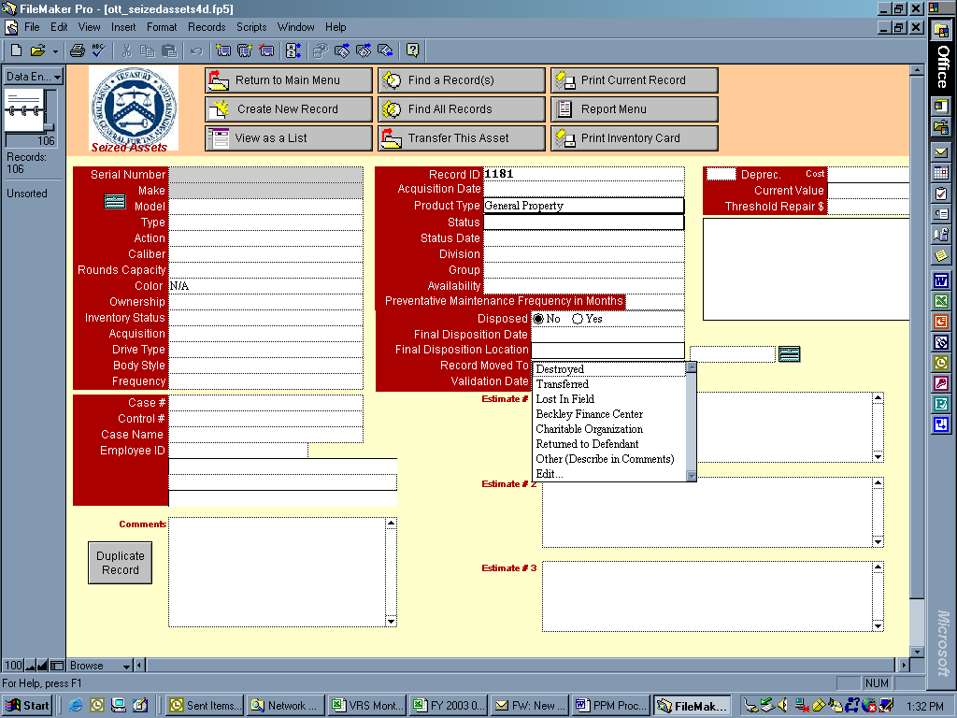

RECORD MOVED TO — When the court orders that seized assets are to be forfeited to the government and TIGTA decides to retain the property, the National Seized Assets PPM Coordinator will transfer the property to the appropriate property inventory database and notify the TIGTA Personal Property Officer that the transfer has been completed.

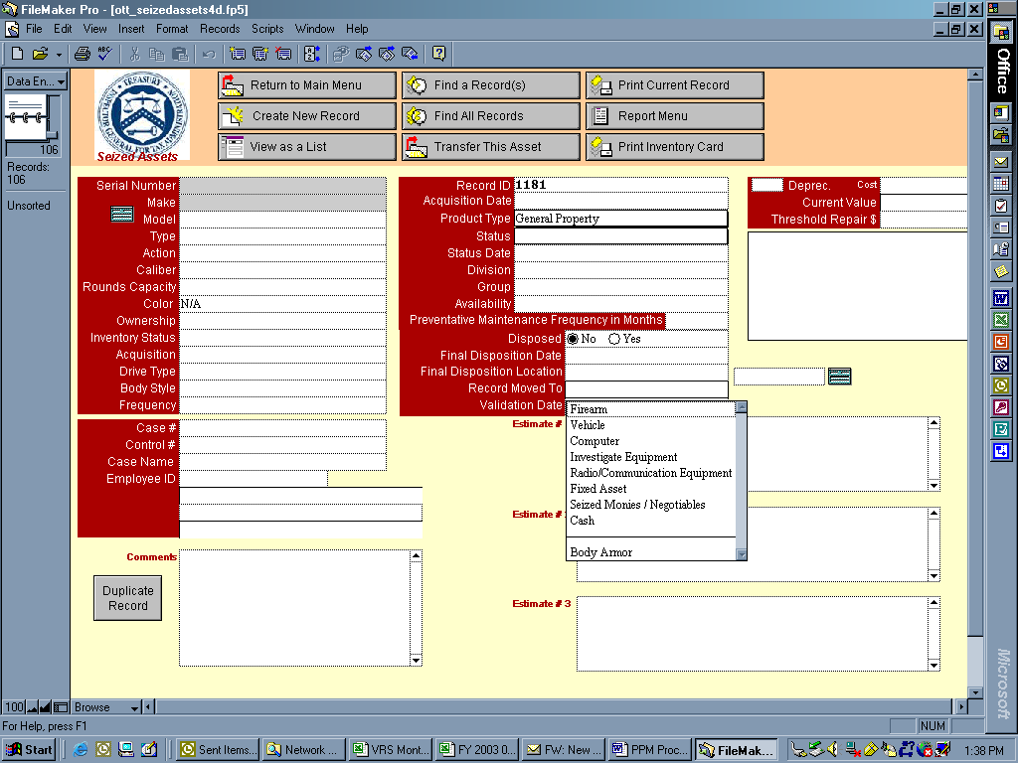

VALIDATION DATE—In the MAPS database, Divisional Coordinators are to update this field each quarter to verify that the status (disposition code) of each pending case is accurate, even if the code remained the same as the previous quarter. If there is a change in the STATUS of a case, the VALIDATION DATE field as well as the STATUS DATE field are to be updated.

The Validation Date field has been added so when the Status code remains unchanged from quarter to quarter, the Validation Date field should be used to identify when a review of the STATUS code for each case was last reviewed. When a case is first entered into PPM the VALIDATION DATE field is to be left blank. After conclusion of the first quarter following the entry into PPM, the Divisional PPM Coordinators are to enter the STATUS code, STATUS DATE and VALIDATION DATE.

DEPRECIATION — Is not applicable to seized assets because these items are not the property of TIGTA and therefore are not capitalized assets. Seized assets are classified as custodial assets unless they are forfeited to the government and are added to TIGTA’s database with capitalized assets (such as vehicles).

COST— Fair market value of the seized property and is provided by the case agent on the Form 141, block 7(d).

COST VALUE—This is a system-generated field that reflects the same dollar value as shown in the COST field.

THRESHOLD REPAIR — Not applicable to seized property.

ESTIMATE #1, ESTIMATE #2, and ESTIMATE #3 — Reserved for estimation of fair market value of seized assets. These estimates are to be noted on an attachment to the Form 141.

THE REPORTS MENU

The five seized assets reports are located on the General tab of the Reports Menu. Click on Reports.

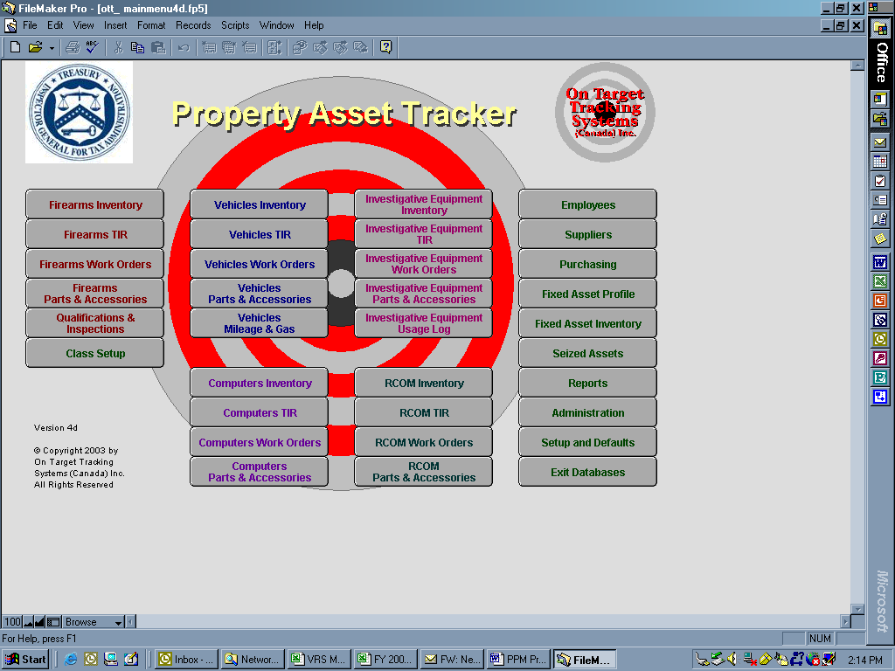

Some PPM reports require date parameters, while others provide for date parameters to be optional. Reports with the blue asterisk (*) have a date parameter requirement before the system will generate the report. Below is a listing of the reports applicable to seized monies and property. The reports will produce records for all cases within a given date parameter. The National Office will continue to have the option of querying all divisions or one divisions at a time. The Divisional PPM Coordinator will continue to only be able to access their own division’s records. After requesting a report, the system will display it on screen. To print or cancel the report, select the continue button on the left hand side to move to the print screen where you can send the report to your printer, or cancel and return to the report menu.

Seized Assets Bureau of Public Debt Report

Seized Asset Report*
Seized Asset Disposition Report*
Seized Asset Transfer Report*
Seized Assets Details

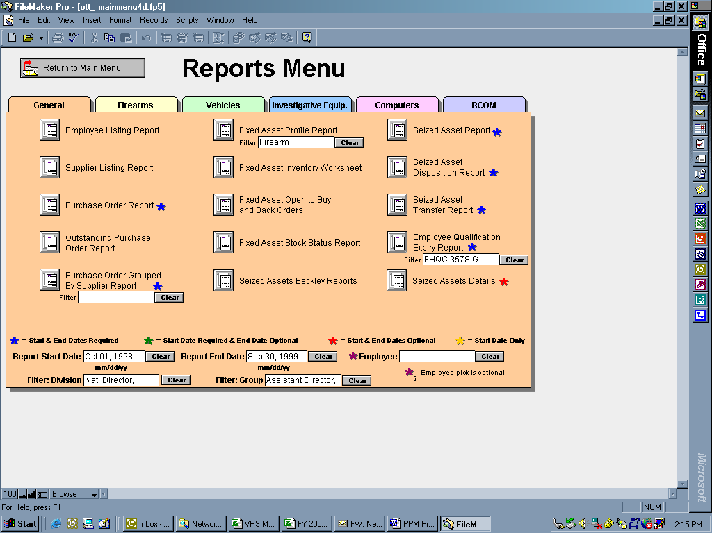

The Seized Assets BPD Report consists of two reports Property and Monetary for all divisions. The Monetary report includes cash and negotiable instruments. The Monetary and Property reports chronologically list all open cases for each division by seizure date. Both reports reflect the requested time-frame for each report, control number, seizure date, case number, line-item amounts, and division totals, and the print date of the report. The reports will provide the National Seized Assets PPM Coordinator with division subtotals, as well as, the TIGTA grand total. National Office will generate this report for submission to the Bureau of Public Debt. See examples below.

Seized Assets Bureau of Public Debt Report for Property

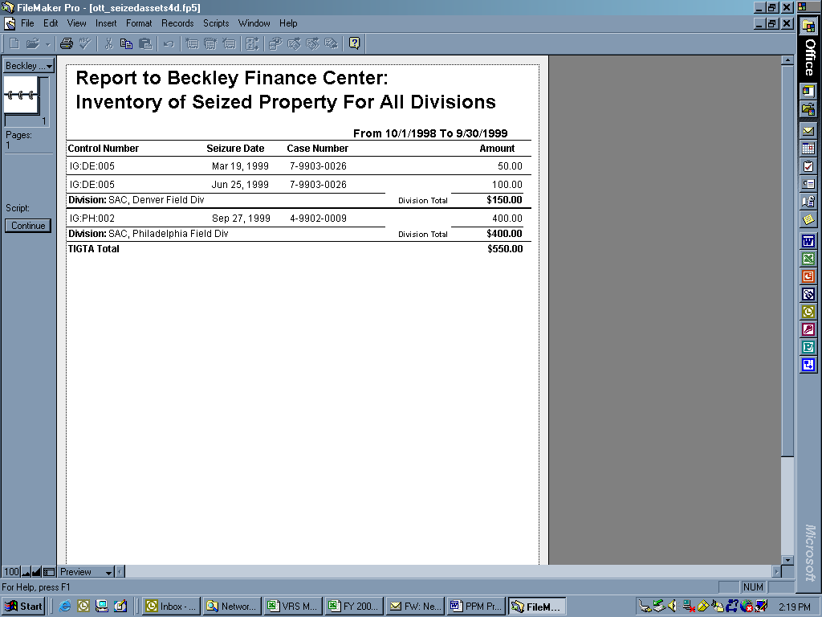

Seized Assets Bureau of Public Debt Report for Money (includes cash and monetary instruments)

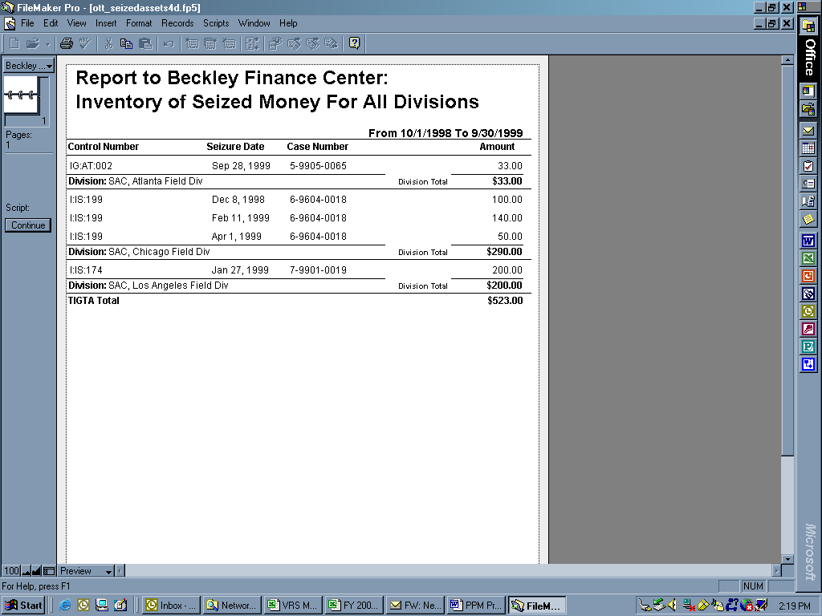

Similar to the data entry screen format, the Seized Asset Report* - prints each open record. Each record is defaulted to print in a portrait format.

THE SEIZED ASSET REPORT must be established with date parameters. A separate report of each record (see below) entered into PPM during the designated time frame will be reflected.

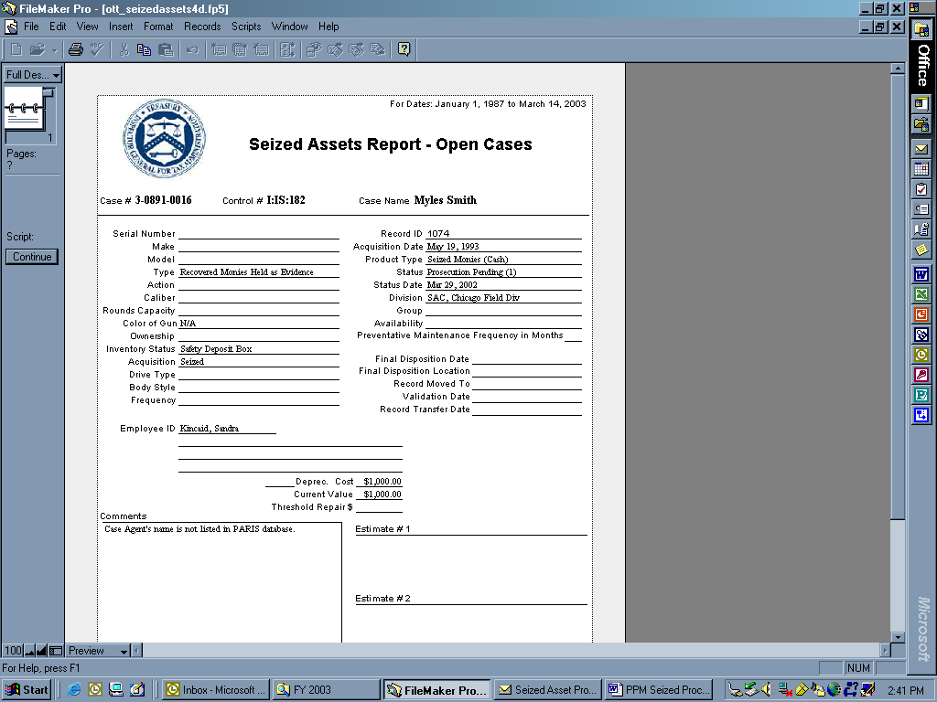

The Seized Asset Disposition Report* - must be established with date parameters and reflects a listing of a division’s closed records during the designated time frame.

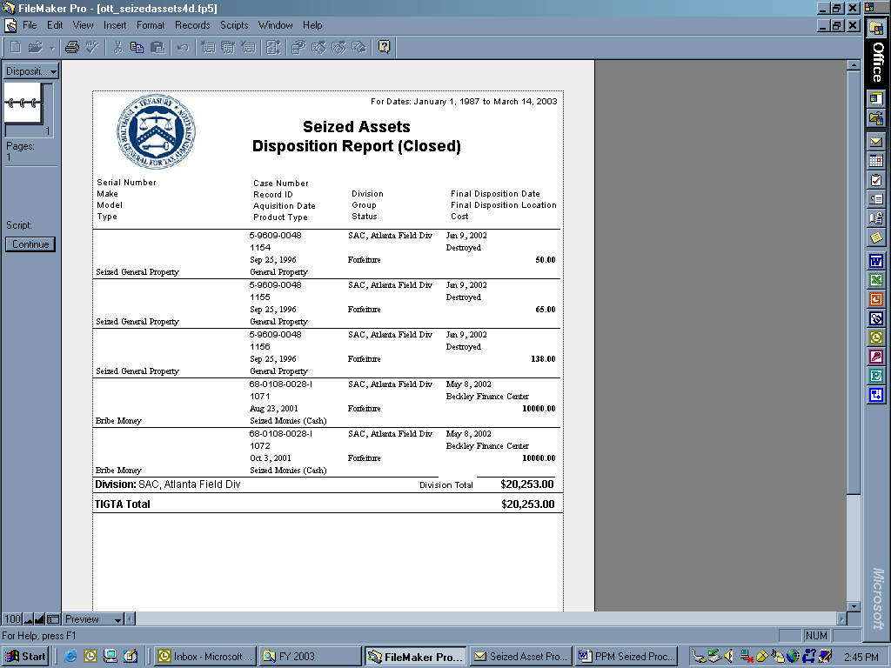

The Seized Asset Transfer Report* - Reflects items which were forfeited (become government property) to TIGTA and have been added to the appropriate TIGTA inventory database by the TIGTA property manager. No sample report can be generated at this time.

The Seized Assets Detail Report – Reflects a listing (in landscape format) of all current open records by division. Three reports are produced: Property, Negotiable Items, and Cash.

Seized Property of All Open Cases for All Divisions.

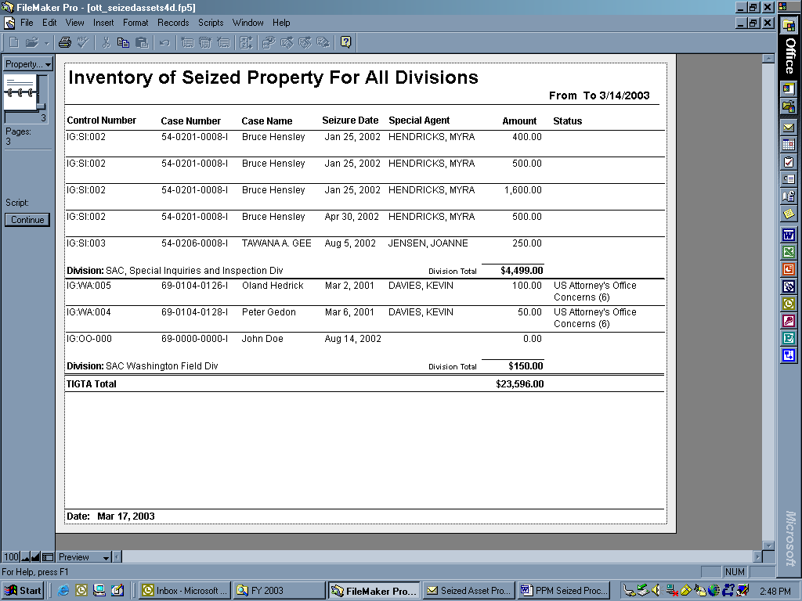

Report of Negotiables of All Divisions for open records or cases.

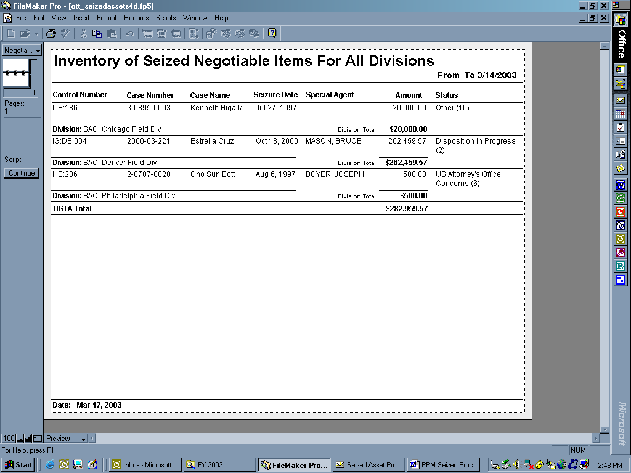

Report of Cash for All Open Cases for each Division



