REPORT ON THE ACTIVITIES OF THE GCOS TSP
THIRD –QUARTER
JANUARY –APRIL 2006

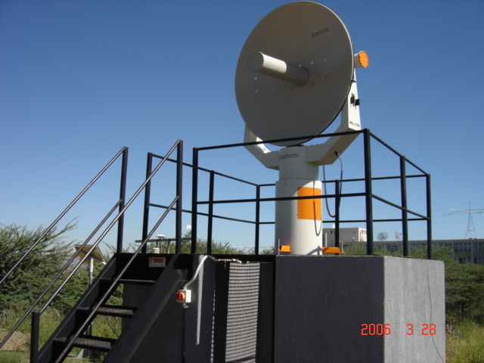

BY :MOMPATI BUTALE
:EMMANUEL MAGAGWA
SUMMARY ON THE THIRD QUARTER PROGRESS
REPORT JANUARY – MARCH 2006 – GCOS TSP – BOTSWANA

Following the installation of the Upper Air Sounding System in Harare –Zimbabwe in January 2006 operational problems were encountered with the operation of the Upper Air Sounding System. The problems were mainly technical and also due to faulty Radio sondes. However, as it was not clear at the beginning, an Operators’ Training was organized so that the operators could be confident in operating the system. The training was successful and all the teething problems with the system were eliminated.

We have noted in our monitoring that there is a continuous observations of Upper Air hence we can confidently say that there is an improvement in the availability of Upper information from this Zimbabwe GCOS-GUAN station. In this regard it will be noted that the GCOS Project is steadily realizing its objectives.

In Windhoek –Namibia several emails were exchanged in connection with the malfunctioning of the Upper Air Sounding System and the hydrogen generator. InterMet Africa and GCOS – TSP joined forces and undertook a mission to Windhoek in endeavor to rectify the existing faults. The main problems were with the Upper Air Sounding System and a representative of InterMet has partially eliminated some of the problems and could not completely resolve the software problem, which is still causing problems in the transmission of data. InterMet Africa is still following this problem with the hope that it will completely eliminate it.

The Hydrogen Generator appears to have no major problems. The only problem, which was noted, was a minor leak of gas from one of the valves. However, we note with concern from the report that there is some reluctance and lack of corporation from our Namibian counterparts. This attitude is rather discouraging and makes our efforts to ineffective.

It is true that training on the maintenance of the Hydrogen Generator was not properly done and efforts are being made to remedy the situation.

I have also been in contact with Tanzanian Authorities to find out why there is no continuous flow of information. However I have not yet received a clear indication of what is happening. My only guess is that there could be some operational and maintenance problems, which may have to be resolved through factory training as already demanded by my Namibian colleagues.

I am in contact with InterMet to try and organize some training and Proton Energy Systems will also be contacted in this regard.

HARARE UPPER AIR SOUNDING SYSTEM
TRAINING BY MICHAEL TALBOT
( INTERMET SYSTEMS AFRICA )
HELD 13TH – 17TH FEBRUARY 2006.

1. INTRODUCTION

The Harare Upper Air Sounding system was installed in January 2006 by Intermet Systems Africa and shortly there after operational staff started to have problems with the system. The problems were mostly confined to the inability of the antenna in tracking the radiosonde, communication between the decoder and the receiving computer, faulty radiosondes and missing of TEMP data and PILOT messages. As a result of the foregoing problems it was necessary to conduct this operators training in an endeavor to minimize the systems problems and also to impact a reasonable understanding of how the system works.

Figure 1 below depicts how the upper air system has been connected.
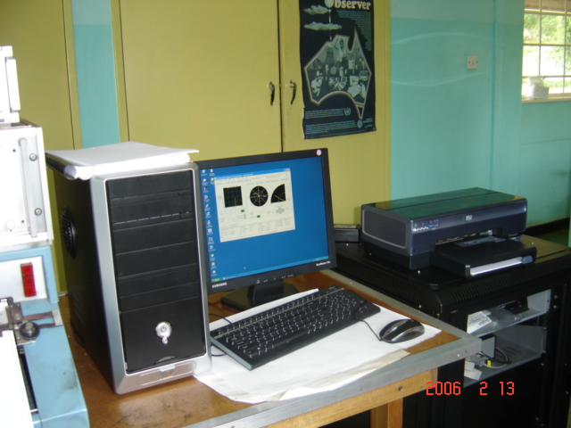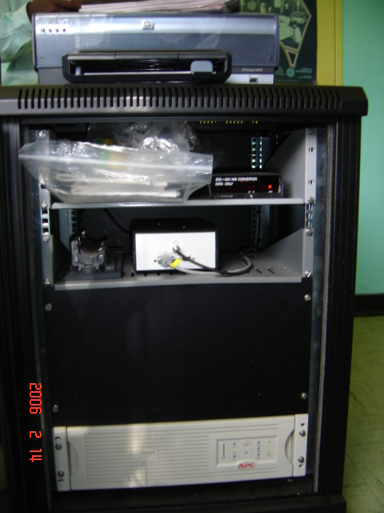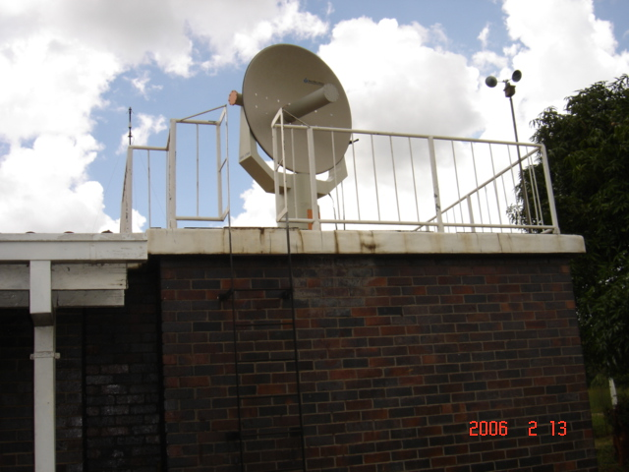
Receiver computer. Ups, decorder and RS485 IMS700 Antenna
/232 converter.
Figure1 Upper Air Sounding System.

2. PARTICIPANTS

Participants in the training were upper air operational staff and some members of the Forecasting Division who made valuable contributions in this field. Mr. Michael Talbot from Intermet Africa and Mr Mompati Butale from the TSP Botswana were resource persons. All the participants are shown in figure 2 below.

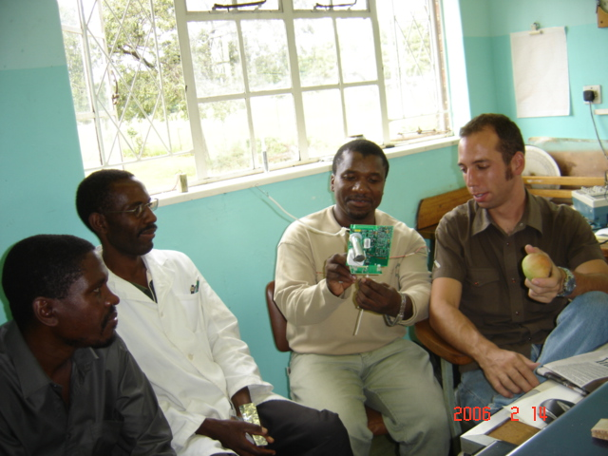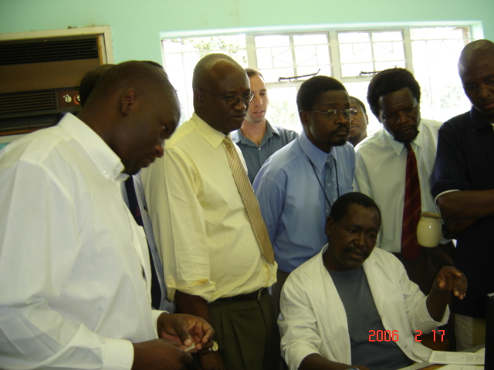
Mr. Talbot ( far right) with participants. Stakeholders being shown the system.
Figure 2 Participants training – workshop- Harare

3. TRAINING

The training, being an operators training, consisted mostly of the operation of the system mainly the antenna and IMETOS software. Proper preparation of the Sippican Mark II radiosonde was also emphasized. Two to three soundings were made daily including night ones.

IMETSO Software
This software forms the foundation of the operation of the whole upper air system. The software generates a number of products including TEMP, PILOT, T-PHIGRAMS and TRACKING PLOT of the radiosonde. The antenna controls were also included and full explanation of how the antenna can be controlled on the receiving computer was given. The IMETSO is capable of storing flight records that can be played back as simulated flights and any other reports of previous soundings can be retrieved.

IMS700 Antenna
The antenna can be controlled in two ways, one of which is with the receiving computer and the other is by a Crew Display Unit ( CDU ). The CDU is weather prove handset attached to the arm of the antenna with control buttons on it. The CDU proved handy in daytime or whenever the balloon can be seen or when the general direction the balloon is known. At night the use of night stick attached to the balloon can be useful in manual tracking of the balloon. During night ascents the use of a CDU is not practical but the tracking of the radiosonde can still be done on the computer.

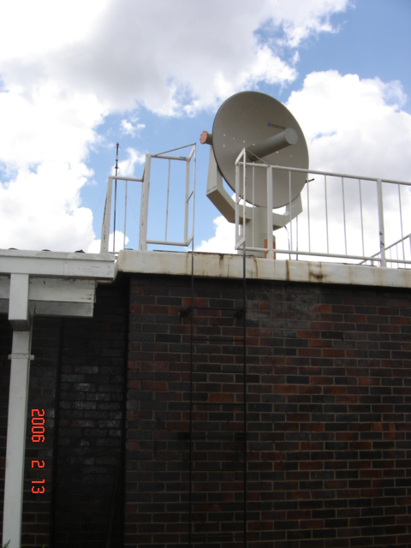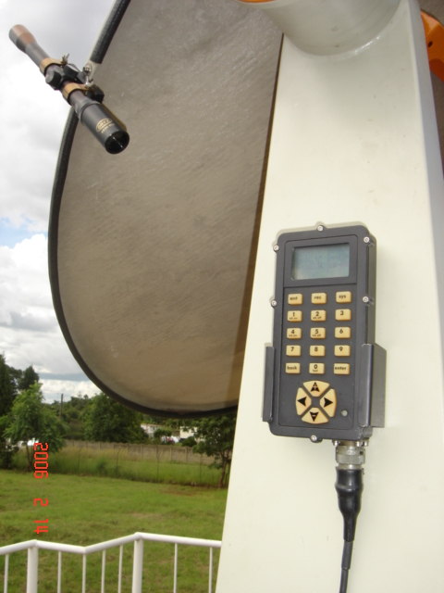
IM 700 Antenna. CDU handset.

Figure 3 Figure 4

SIPPICAN MARK II Radiosonde
The radiosonde plays a vital role leading to a successful ascent. This became very apparent in this training. The sippican mark II radiosonde comes with a set of instructions on how to prepare it for the flight and proved to be a very sensitive sonde, which can easily malfunction if the instructions are not followed properly. In our test flights two radiosondes were found to be faulty. The preliminary investigations showed that their transmitters were not functioning. Before launching the sonde, it is important to make sure that it transmits data to the computer ( this can easily be seen on the IMETSO ). The sonde together with the decoder are products of Sippican Company but the antenna and IMETSO software are products of Intermet Africa.

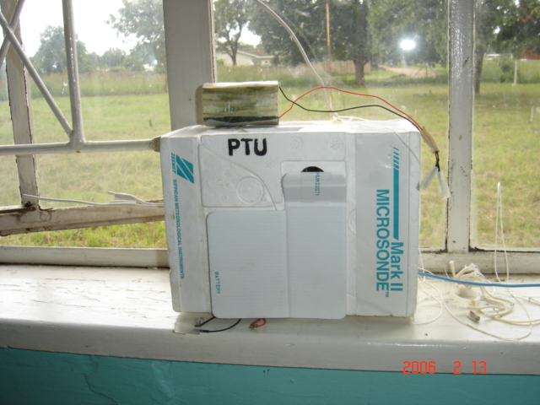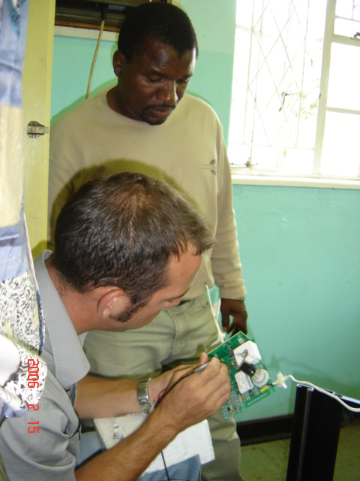
Sippican Mark II radiosonde. Mr. Talbot and Mr. Butale
Figure5 Checking a faulty sonde.
Figure 6

4. PROBLEMS REALISED

The problems that were encountered are summarized as listed below

a). Fading signal that resulted in tracking and data loss.

b). Decoder not communicating with the computer.

c). Faulty radiosondes

d). Side lobe tracking

e). Unsuitable launching site

f). Missing data in the generated TEMPS and PILOT messages.

5. CONCLUSION AND RECOMMENDATIONS

In bringing the training to a close Mr. Talbot promised to go and look into the problems encountered since most of them were software related. He also took some mark II radiosondes for further tests to establish why signal and transmitters fail. A temporary launch site was found on top of the building opposite the upper air building. It was difficult to launch the balloon on the ground since the antenna is mounted on top of the building hence it was not easy for the antenna to lock on the sonde. It is currently risky to climb up the building to launch since it does not have stairs and operators have to use a metallic stepladder. After releasing the balloon an officer has to run to the computer and initiate the start flight for the antenna to send data to the decoder and computer. This was seen as another setback, which needed to be corrected by making, timed start flight whereby an operator could time the start flight to coincide with the release of the balloon. The current setup require at least two officers to make an ascent.

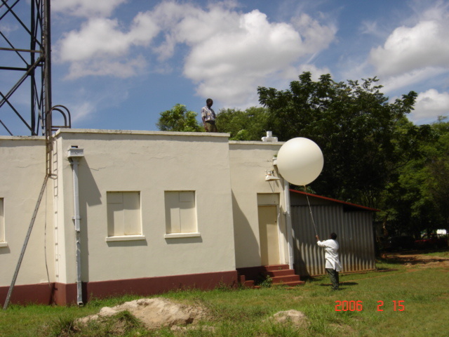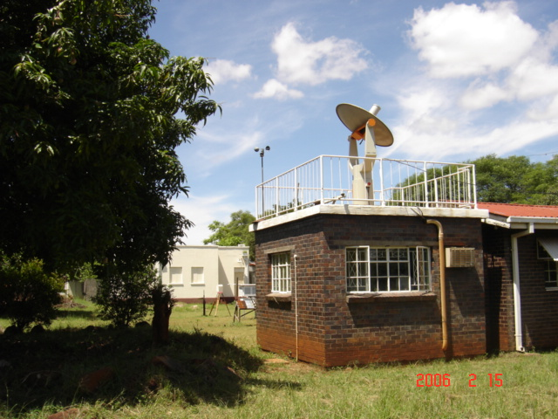
Building used as a launching site. Note Antenna and launching site building in the stepladder to the left of picture the background
Figure 8 Figure 7

For the missing groups in the TEMP and PILOT messages Mr. Talbot promised that the company will make the necessary changes in the software as soon as possible, he however indicated that the problem of losing tracking of the radiosonde and side lobe tracking would be easily picked by the antenna wherever the sonde is launched.

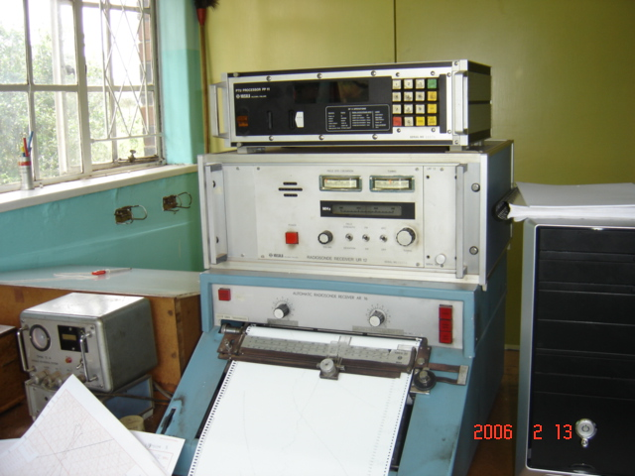
The old vaisala upper air system.
Figure 9

The problems mentioned above the participants appreciated both the training and products from the system and also recommended that the old system be run in parallel with the new one for comparison before doing away with the old one.

WINDHOEK-NAMIBIAN-OPERATIONAL TRAINING ON THE RADIO THEODOLITE AND MAINTENANCE TRAINING ON THE HYDROGEN GENERATOR
26TH MARCH – 01ST APRIL 2004

INTRODUCTION

The Intermet Upper Air System and Proton Hydrogen Generator for the Namibian Meteorological Services in Windhoek were simultaneously installed June 2005. Training of participants for both equipment was also done in the very same week after the installations. However participants felt that scheduling installation and training of the two systems at the same was not suitable as the same officers had to participate in the two activities, hence this did not give them enough time to attend both training activities as they were running concurrently. It was on these bases that a second training had to be provided for participants and to eliminate other operational and malfunction of the two systems, which are indicted to be continuously recurring.
PROBLEMS REAISED

- Weak signal realized in the first few minutes of ascent.
- TEMP format not matching WMO standard code format
- Code E-13 error in the hydrogen generator.

Intermet Equipment

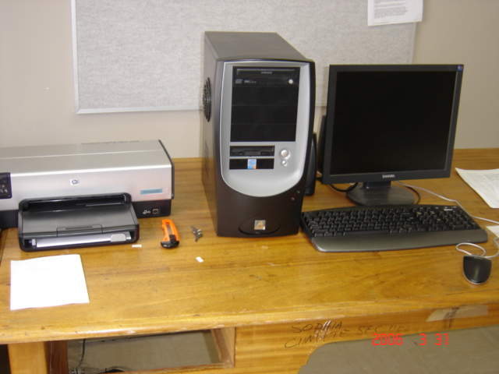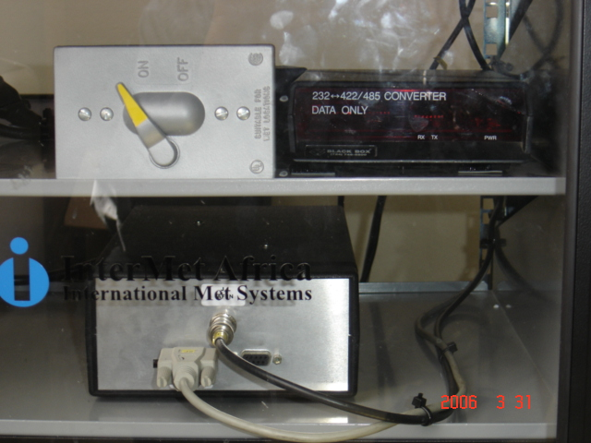
Workstation Decoder & Data Converter Intermet Dish
Figure 1

Proton Hydrogen Generator

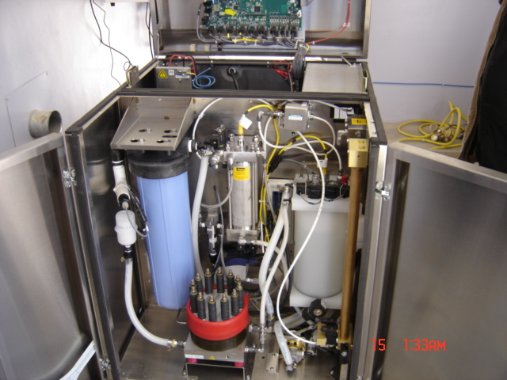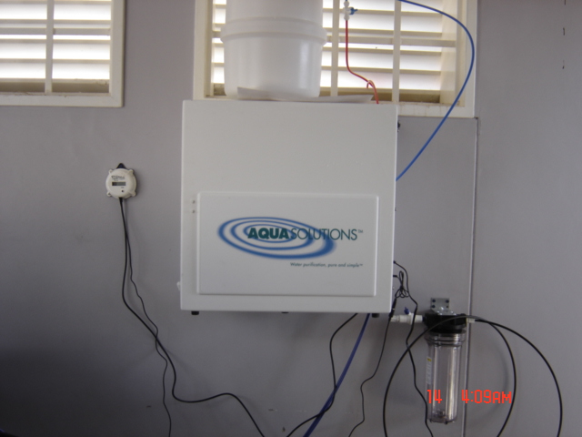
Hydrogen Generator Opened Water Deionizer
Figure 2

CONFIRMATION

Intermet Equipment

Two successful ascents were launched with both Intermet sonde and Sippican Mark II sonde. The third launched with the Sippican sonde confirmed the problem. The signal was lost some few minutes after launching. Troubleshooting was done and detected that the receiver in the antenna was faulty. It was found that moisture had gathered inside the housing of the receiver and that the gasket had blocked the breathers. A new receiver was flown in from Cape Town South Africa and was immediately installed. The system resumed normal operation. With the TEMP format it was a matter of making changes in the software.

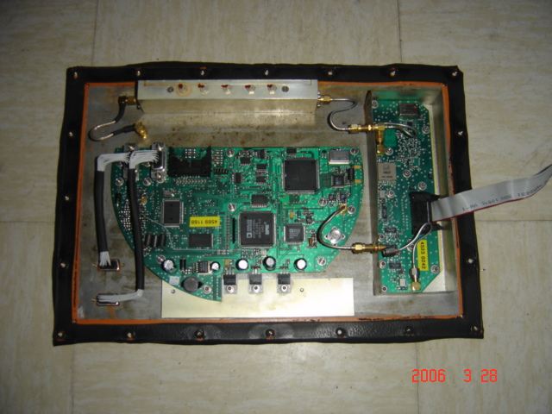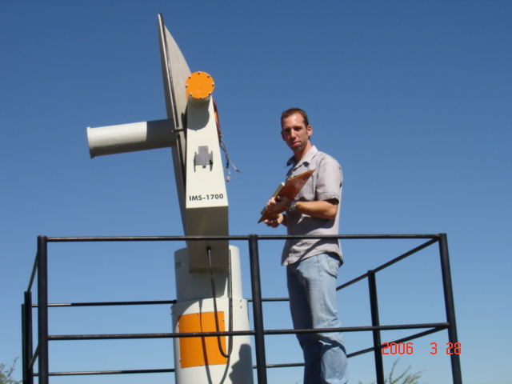
Faulty Receiver Board Mike holding the faulty receiver
Figure 3

Proton Hydrogen Generator
The E-13 error code indicated a leakage in the system. Gas leakage tester was used and no leakage was found except on the balloon-filling valve. On observation, it was found that the system error comes when the plant is in the idle mode. When the system is restarted the error disappears and resurfaces when all the tanks are filled and is back to idle mode.

TRAINING
As the training, was mainly for operators on the Intermet Upper Air System it covered the operation of the system, the antenna and IMETOS software, proper preparation of the Sippican Mark II radiosonde and manual insertion of headers on the TEMPS. On the Proton Hydrogen Generator it was resolved that the operators needed no training but technicians. The technicians who could attend were on field trip and when they came, seemed reluctant to participate until the very last day when one technician surfaced after persuasion. The training started on the 27th March 2006 to 31st March 2006.

PARTICIPANTS

Participants were mostly operators from Upper Air staff of Namibia Met office and myself (under the GCOS project for SADC countries). Although the Namibian Met Office authorities had requested the training, attendance was very poor especially on the maintenance of the hydrogen generator.
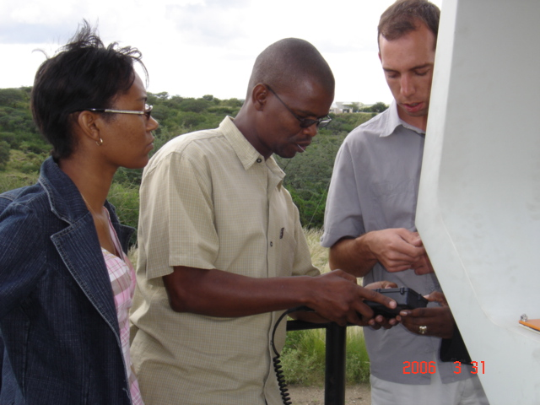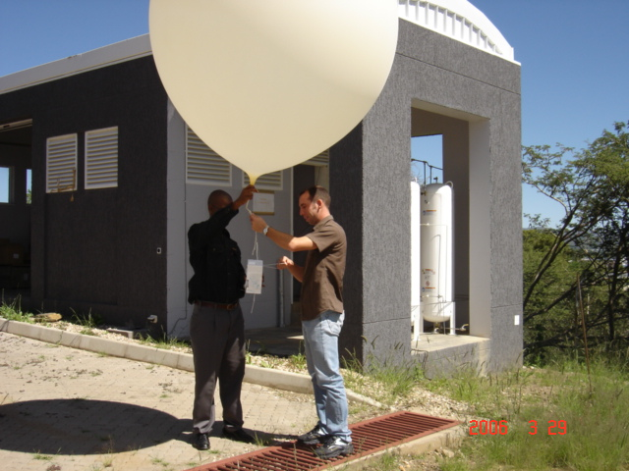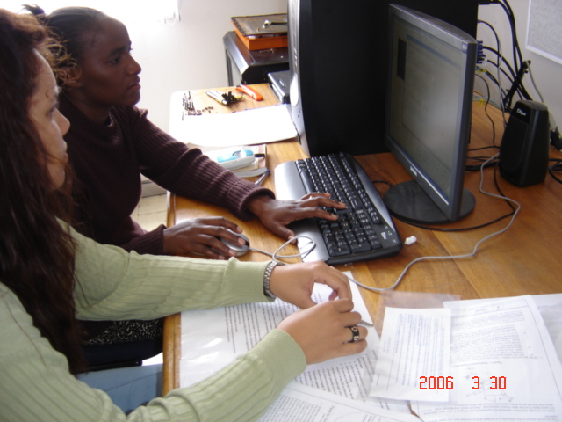
Mike showing use of CDU Ben with Mike Releasing balloon Operators practicing
Figure 4

IMETSO Software
This software forms the foundation of the operation of the whole upper air system. The software generates a number of products including TEMP, PILOT, T-PHIGRAMS and TRACKING PLOT of the radiosonde. The antenna controls are also included and hence the antenna can be controlled in the working station but cannot be started automatically from the working station. The IMETSO is capable of storing flight records that can be played back as simulated flights and any other reports of previous soundings can be retrieved.

IMS700 Antenna
The antenna can be controlled in two ways, one of which is with the receiving computer and the other by a Crew Display Unit (CDU). The CDU is weather prove handset attached to the arm of the antenna with control buttons on it. The CDU can also show the strength of the signal, which is very important. The CDU proved handy in daytime or whenever the balloon can be seen or the general direction the balloon is known. At night the use of nightstick attached to the balloon can be useful in manual tracking of the balloon.

SIPPICAN MARK II Radiosonde
The radio sonde plays a vital role leading to a successful ascent. The Sippican mark II radio sonde comes with a set of instructions on how to prepare it for the flight. The battery terminal cable if not twisted creates electro magnetic force (e.m.f) that would hamper the performance of the transmitter. The operators were strongly encouraged to follow the instructions on this radio sonde. Some failures of a successful ascent were as a result of improper sonde preparation. Before launching communication has to established first between the sonde and the workstation.

PROBLEM REALISED

- Side lobe tracking
- Unsuitable launch site
- Code E-13 error on the generator
- Indicators not reading the same values
- Leakage on the balloon filling hose.

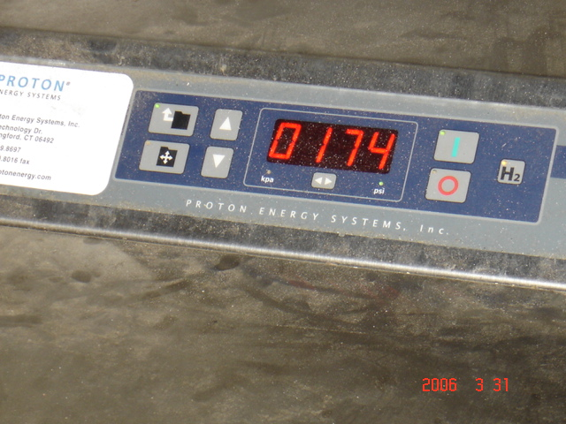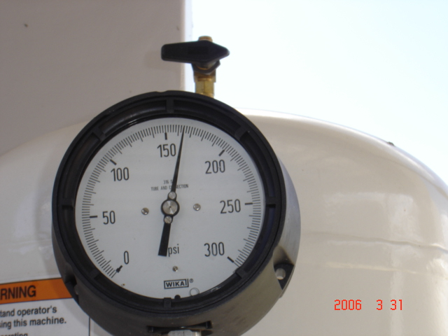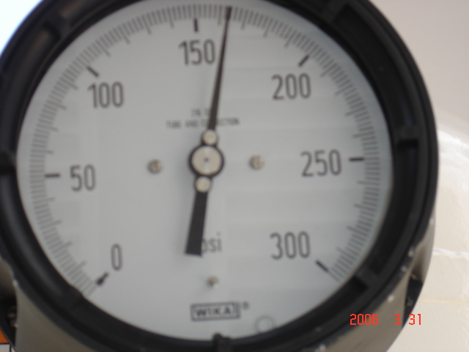
Product pressure on Gen Pressure on tank 1 Pressure on tank 2

The figure below show one of the valves suspected not to be closing hence a leak on the balloon filling. The valve was tried to disassembled but appeared to be a fixed valve had to open. No spares available.
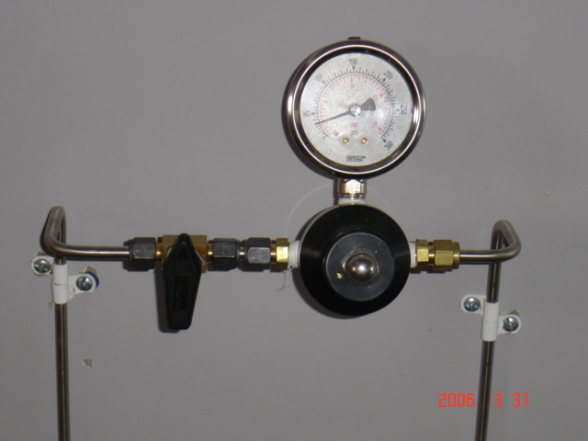
Figure 1

Figure 2 shows a new filter immediately after installation. This filter filters water from the tap before it gets to the water deionizer

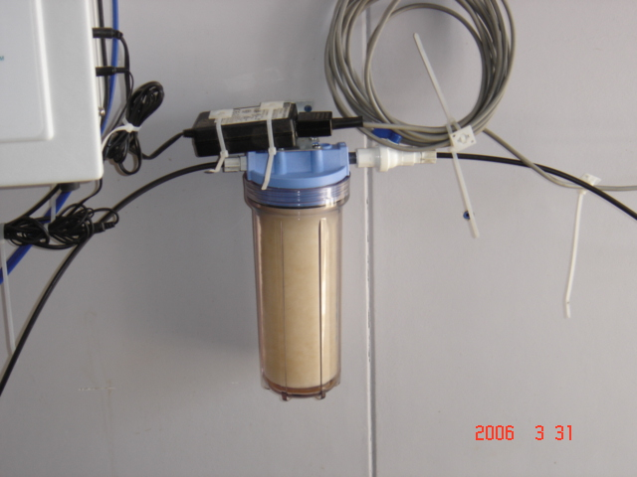
Figure 2

On observation, the Hydrogen Generator plant appeared dusty and power cables hang lose from the wall. It appears no one has been assigned to take care of the hydrogen equipment.

CONCULSION

At the end of the training operators felt that the problems they had are likely to come to an end. Michael Talbot promised to go and look further into WMO TEMP reports and try to compare. He would also to urge the software people to finish the correction in the TEMP as soon as possible. While still waiting for the correction in the TEMP software, the operators would manually enter the TEMP headers. As regards the maintenance technicians for the hydrogen generator they feel they still need to be trained at factory level.

