Born to Learn: Language, Reading, and the Brain of the Child

Dr. Patricia K. Kuhl

Co-Director
Center for Mind, Brain, and Learning
University of Washington
Seattle, WA. 98195

Voice-mail: (206) 221-6473
FAX: (206) 221-6472
E-mail: pkkuhl@u.washington.edu

Paper Presented at the Early Learning Summit

for the Northwest Region: Boise Idaho

June 9-10, 2002

The research described here is supported by grants to Patricia K. Kuhl from the National Institutes of Health, the Human Frontiers Science Program, the William P. and Ruth Gerberding Professorship, and by major support to the Center for Mind, Brain, and Learning from the Talaris Research Institute.
Born to Learn: Language, Reading, and the Brain of the Child

• I want to thank First Lady Laura Bush, and Idaho’s First Lady Patricia Kempthorne, as well as the First Ladies of the Northwest Region. I also want to thank the sponsors of the conference, the Talaris Research Institute of Seattle, Washington and Albertsons. The conference is important because it highlights the country’s most precious resource, our children.

• I’m delighted to be here today to talk about early learning and the brain. It’s an extraordinary time in this field. In the past decade, genetics and the genome project, biotechnology, and computer science have witnessed explosions in scientific information. In this decade, that kind of information explosion is taking place in the field of early learning and brain development in infants and children. This is creating a new science of learning, and the new science of learning is changing how we view the child’s developing mind, and how we view a child’s education.

• There are three factors contributing to this.

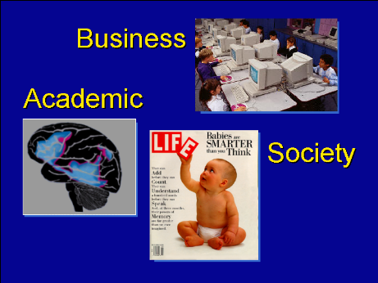
Slide 1: Academic, Society, and Business Interest in
Cognitive Development

• Academic: The 1990s was the “Decade of the Brain.” New technology was developed that allowed scientists, for the first time, to examine a living brain. It’s not always been like this. When I was a graduate student we only had access to the secrets of the brain when it was sliced and stained. Now, we have all seen magazine articles picturing a brain that is “lit up” while its owner thinks, looks at a picture, or listens to music. While I talk, I know which areas of your brain are activated. The new techniques are revealing, in a tangible way, how the brain really works.

• Society: At the same time, studies of infants and children are showing that they learn more, and learn earlier, than we ever imagined. They learn in novel ways that we hadn’t predicted or expected — I’ll provide an example shortly. Studies show that from the earliest ages, childrens’ brains code information that they see and hear. This happens automatically. These findings have been picked up by magazines, newspapers, and television documentaries — everything from CNN to the Nature channel — and the public has a voracious appetite for it.

• Business and industry have also taken notice of the new information about early learning. They know that childrens’ learning will be influenced by technology and the products that business provides. Education itself is undergoing a major transition, which is changing the face of the classroom.

• These three factors all contribute to our fascination with childrens’ learning.
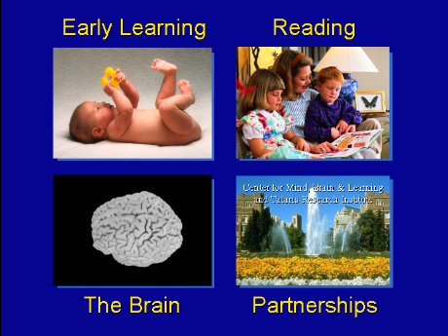
Slide 2 -- Four topics (Early Learning, Reading, The Brain, and New Partnerships)

• My goal today is to tell you about four new developments that make a difference to children (slide 2). First, I will describe new studies that reveal the incredible early learning skills that children possess. Second, I will tie infants’ early language skills to reading readiness. Third, I will describe the developing brain. And fourth, I will describe new partnerships between researchers and educators that are bringing the research results into the nation’s classrooms. There’s a big gap between the neuron and the chalkboard, but the bridge can be crossed if the right people work together.

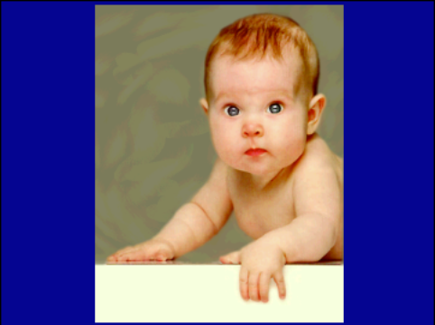
Slide 3 -- The baby

• Studies of infants and young children show that learning doesn’t begin the day children enter school for the first time. Learning doesn’t begin in first grade, or in Kindergarten. Learning begins in the first months of life. And parents, or caretakers, are our children’s first teachers.

Language Learning

• The chief example I’ll use today is language acquisition. We are beginning to understand exactly how infants go about learning language. We’ve discovered that they learn a great deal in the first year of life before they can speak. Very relevant to today’s discussion is the discovery that the fundamental steps in language acquisition play a critical role in the ability to read. I’ll use this as my primary example, but there are also other examples from cognitive and social development studied by my colleagues at the Center for Mind, Brain, and Learning. Language, social, and cognitive development follow the same path; studies on language provide a window on the developing mind.

• Language is made of building blocks — the consonants and vowels that make up words. Every language uses a unique set of building blocks. Our studies show that, at birth, infants are what I like to call “citizens of the world.” Early in life, infants can hear differences between all the consonants and vowels (the “building blocks”) used in any language. Their abilities far exceed our own. As adults, we are no longer “citizens of the world.” We are “culture-bound” listeners. We can hear distinctions between the sounds used in our own language, but have difficulty with the sounds of other languages, such as Mandarin or French. Infants initially can hear distinctions that we no longer can hear. But in order to learn a specific language, children have to learn the specific set of sounds used in that language. English is not Japanese.

• My studies show that infants begin learning the building blocks of their language very early. I conduct studies in many different countries — Japan, Russia, Sweden, Finland, and France, and test infants and children from zero to five years of age. We have learned that by the age of 6 months, infants recognize the sound units used in their particular language. By 6 months, infants raised in Sweden respond in a special way to the vowels of Swedish, and do not respond in that way to the vowels of English. American infants in Seattle do the opposite -- they respond to the vowels of English rather than those of Swedish.

• The studies show that early in development the infant brain is mapping the patterns of language — by 6 months, individual vowels and consonants, by 9 months, the patterns of words. Many studies show that the infant brain is unconsciously calculating information about language. Infants are behaving like a computer without its printer hooked up — they store millions of bits of information before they can speak, simply by listening, and this tunes the infant brain to English rather than French or Russian. They do this incredibly early. Infants are mastering language simply by listening to us talk.

• I want to show you how we conduct the studies on infants. In this test a 6-month-old sits on his mother’s lap and is entertained by a person holding toys. At the same time, a sound in the background repeats, like /a, a, a/. The baby’s job is to listen for the sound change and turn her head toward the loudspeaker when the sound changes. Let’s watch this little one and see how she does.

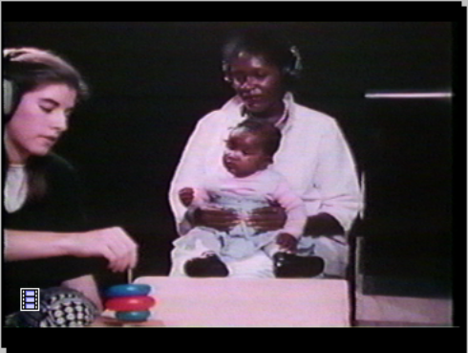
Slide 4 – Movie Showing an Infant Being Tested

• That was a really good baby, and as you can see, she’s also having fun.

• As the infant brain starts to master its own language, something interesting happens. Infants begin to ignore the sound differences that are not relevant to their language. I’ll show you the results of a recent study I completed on discrimination of American English sounds /r/ and /l/. These two sounds are distinguished in English (in words like “rake” and “lake”), but they are not in Japanese. Japanese people have a great deal of difficulty with these two sounds, just like we do when we listen to a foreign language.

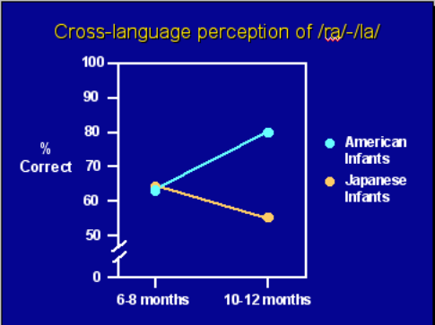
Slide 5 -- American and Japanese Babies at 7 and 11 months

• Infants in the US and in Japan were tested on these sounds at two ages, between 6 & 8 months, and again between 10 & 12 months. As shown in the slide, between 6 and 8 months, infants from the two countries are equally good at this task -- performing well above chance. But by 10-12 months, just two months later, a big change has occurred. Infants in the US are getting much better at it, while the infants in Japan are considerably worse. What has happened in this short period between 8 and 10 months?

• What’s happening is that the infant brain is focusing on what they are hearing — their native language. The infant brain no longer responds to foreign languages they have not heard. Japanese babies no longer respond to the change from /r/ to /l/. Their ability to hear foreign-language sound distinctions has declined. They are becoming more adult-like and lose their status as “citizens of the world.” They become more culture-bound, just like us. This specialization is essential for language learning, and illustrates how powerful early learning is.

• These results raise a question: What happens if we expose American infants to a new language — like Chinese — during this period of rapid learning? Can we reverse the decline typically seen in foreign language speech perception if we expose infants to the foreign language? Can we keep the baby brain open to the sounds of foreign languages? We recently tested this idea in the laboratory. We brought American infants into the laboratory and my Chinese graduate students played and talked with them while speaking Chinese. The babies came into the lab for 12 play sessions. After the 12 sessions, we tested infants in the US and Taiwan on Chinese sounds used in Chinese but not in English.

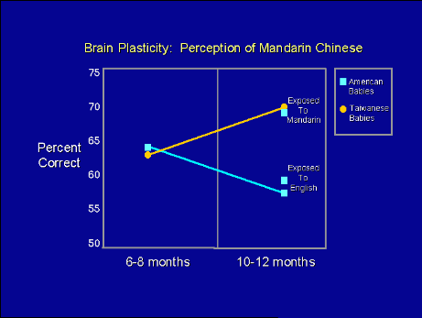
Slide 6 -- Impact of Chinese and English play sessions on Perception of Chinese Sounds

• The results of the study were pretty amazing. After our Chinese play sessions, The American infants reversed the typical decline seen in their ability to hear the sounds of Chinese. The message is clear — the brains of infants code and remember the patterns they hear — before they speak their first words, before they understand any words. The brain is at work early in development analyzing language. The brain is like a computer being programmed before the printer is hooked up. There is a tremendous amount of information stored in the infant brain that is revealed only by the studies.

• These studies show that the brains of infants are altered by listening to us speak. What kind of language do we use when we speak to children and what role does it play in their development? We use what has been called “Motherese,” or, now that we know fathers do it too, “Parentese,” or, because you don't have to be a parent to produce it, “Caretakerese.” Parentese is a unique, rather silly sounding kind of speech we use when we talk to children. This slide shows the pitch of the voice used by a mother as she speaks to another adult and as she speaks to her 2-month-old infant.

Slide 7 – “Motherese” or “Parentese” speech

• It's definitely not your job interview voice. But infants and children love it. If you allow a young child to choose whether to listen to women speaking Parentese vs. those same women speaking to other adults, they will choose Parentese every time. It’s the signal they prefer.

• Parentese not only sounds better to infants and children, it teaches them something. Parentese contains exaggerated, exceptionally well-formed phonetic units, more so than adult-directed speech. Language input to infants is an enriched signal that makes it easier for children to learn.

Language and Reading

• I’ve described how young children tackle language while they are still in the crib. What is the connection between these early skills and reading? Studies now show that children who have specific language problems (that means language problems in the absence of mental retardation and other cognitive factors) often have difficulty learning to read. Language and reading requires getting the sounds sorted out correctly. While typical readers can hear the differences between the “p” in “pat” and the “b” in “bat” or the “t” in “tall” and the “d” in “doll,” children with reading difficulties have trouble with this. There is some evidence to suggest that exaggerating the sounds, just as we do when we speak Parentese to infants, can help older children with reading problems.

• Diagnosing children with reading problems may be easier in the future. Our studies now show that infants’ abilities to distinguish speech sounds at 6 months of age correlates with later language abilities. The better infants are at distinguishing the building blocks of speech, the better they are years later at other more complex language skills.

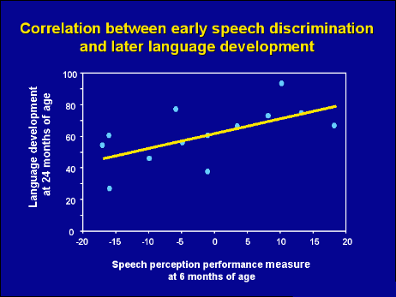
Slide 8 -- Early Speech Discrimination Predicts Later Language

• Since early speech skills predict later language skills, and since infants with later language problems have difficulty with the sound contrasts used in language, there is enormous hope that these tests will allow us to identify, very early, children who are “at risk” for later language difficulties. Early identification allows intervention.

The Developing Brain

• I’d like to turn to the brain itself now. When you understand that infants are the best learners in the universe, you start to ask, “what's going on up there?” As I mentioned, the new technology allows us to see brains at work. Well, we are beginning to see the infant brain at work, and there’s no more fascinating brain than that of the young child.

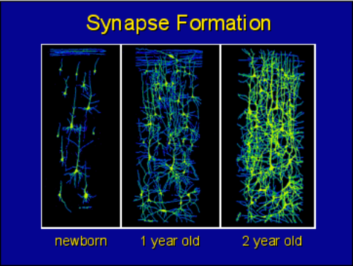
Slide 9 -- Synapse Formation at Newborn, One Year, and Two Years of Age

• The interesting thing about the infant brain is the fact that it forms its connections after birth. The trillion or so neurons that we all have in our brains are largely in place at birth, but they can’t talk to each other until they form neural connections that allow electric impulses to flow between them — think of telephone lines connecting houses. These telephone wires, or synapses, begin networking in a complex and interesting process, after birth. As this slide shows, the brain of an infant has relatively few synaptic connections between the neurons.

• In the first years of life, up to age three, the brains of children are forming connections furiously. Newborns have relatively few. By one year, they have many more, and by the time they approach the age of three, the child has twice the number of connections as the adult brain. Furthermore, the synapses create three times more brain activity than in an adult. Infants have far more synapses — more connections — than they will ever need. Once the brain is fully wired and all the connections are formed, the brain begins to “prune” excess connections. Quite literally like a rose bush, pruning some connections helps strengthen others. This pruning process continues to sculpt an individual’s brain until the end of puberty. The brain is being sculpted by experience during the entire period from early infancy to the end of puberty and it is important that parents and educators know this.

• We know that the brain cells and connections eventually reflect the individual information stored in each brain. We cannot as yet know how the brain codes the fine detail that infants and children are processing, but new studies do show a strong correlation between what we measure behaviorally and what we measure in the brain itself.

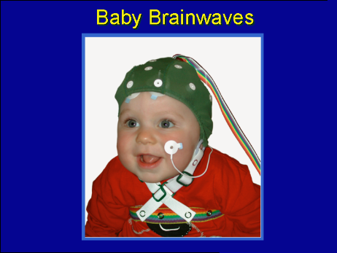
Slide 10 -- Baby Brainwaves

• The infant’s brain by measured by examining brain waves as the baby plays, looks at his mother, or listens to language. This baby is listening to language and has no idea that we are recording the brainwaves he creates as his brain works away. We can see how his brain responds to new information, like a new language. The tests show that early in life, the infant brain is very plastic and readily learns new information. This plasticity is remarkable and we believe it will lead to new ways of understanding how children best learn.

New Partnerships

• My final point relates to the new partnerships that are forming between researchers, business leaders, educators, and government agencies. When I met President Bush and First Lady Laura Bush in 1998, he was still the Governor of Texas. The First Lady of Texas was holding a conference to talk about the issues we are raising today. We talked together about the new research and what was needed to bring this information into the schools — how we might bridge the gap between the neuron and the chalkboard. We also talked about the need to link research to education — neuroscientists and developmental scientists had to get together with parents and teachers, those on the front lines of education. In order to do that we would need support not only from the NIH and NSF, but also from the private sector. We now see that all across the nation, private groups are beginning to step forward. It’s made an incredible difference, and we are very grateful.

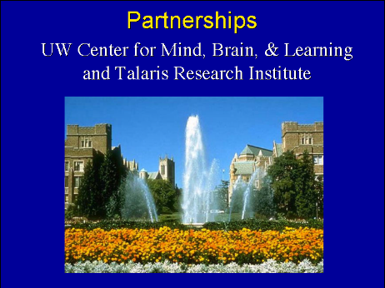
Slide 11 – Partnerships

• The new partnerships are dedicated to the scientific research, but also to disseminating that research. The public needs to know what the science shows about how kids learn, and people also need to know what methods don’t work, or what science hasn’t yet tested. It’s as important to explain that “Parentese” helps infants learn as it is to say that showing flash cards to a 5-month-old WILL NOT cause them to read any sooner. The goal, in fact, is not to make kids learn (or to read) at earlier and earlier ages, but to help all kids develop to their potential. Again the research indicates that normal language interaction — talking, reading, and playing with kids — produces the brain changes I described. This kind of learning is entirely natural — it doesn’t require fancy software. The research that underpins this understanding is needed to help direct policy in this area. We need to communicate information from the nation’s research laboratories to society.

• At the University of Washington in Seattle, with the help of the Talaris Research Institute, we have formed The Center for Mind, Brain, and Learning to make scientific discoveries and to disseminate them to parents, childcare workers, educators, and government agencies. The mission of our center is to conduct world-class research on early learning and the brain. Some of the specific research is supported by federal grant agencies such as NIH and NSF. But our goal is not only to make scientific discoveries. In partnership with the Talaris Research Institute we will disseminate the findings to parents and educators, and to the public at large.

• It is an extraordinary time, one in which great advances in the science of learning will take place. It will be a good decade for all our children. As represented by the President and First Lady, and the Governors and First Ladies of the Northwest states, our leaders have a longstanding commitment to education, especially those critical early years. We think that the coming years will be a dynamic and crucial time for scientists and practitioners in the field of early learning and the brain. Cooperation between basic scientists and people in the applied areas will show us how children learn, “what works,” and we can then begin to make policy decisions that are based on science, rather than opinion. Science-based policy decisions offer the best chance of helping this country’s most precious resource, our children.

Background Reading

(1) Scientific articles by Dr. Patricia K. Kuhl show how important learning and early experience is to language development. Four excellent papers on early learning, language, and the brain are:

Kuhl, P. K., Williams, K. A., Lacerda, F., Stevens, K. N., & Lindblom, B. (1992). Linguistic experience alters phonetic perception in infants by 6 months of age. Science, 255, 606-608.
Kuhl, P. K., Andruski, J. E., Chistovich, I. A., Chistovich, L. A., Kozhevnikova, E. V., Ryskina, V. L., Stolyarova, E. I., Sundberg, U., & Lacerda, F. (1997). Cross-language analysis of phonetic units in language addressed to infants. Science, 277, 684-686.
Kuhl, P. K. (2000). A new view of language acquisition. Proceedings of the National Academy of Sciences, 97, 11850-11857.
Kuhl, P. K., Tsao, F. M., Liu, H. M., Zhang, Y. & de Boer, B. (2001). Language/Culture/Mind/Brain: Progress at the Margins Between Disciplines. In A. R. Damasio (Ed.). Unity of Knowledge: The Convergence of Natural and Human Science (136-174). New York: The New York Academy of Sciences.

(2) There is a new book published in 2001 that supports the idea that children (from birth to three) are born to learn. It is called, The Scientist in the Crib: What Early Learning Tells us About the Mind, by A. Gopnik, A. Meltzoff, and P. Kuhl (Harper-Collins). The book describes how infants develop knowledge of language, objects, and people. The book discusses children as "little scientists" striving to understand the world around them.

