Instructions for Running ISR DAQ

13 September 2000

These instructions are available on the web at :

http://home.fnal.gov/~leer/DAQ_Documentation/Documentation_Homepage.htm

Contents

I. Introduction
II. Getting Started
- Starting Visual C++
- Starting the DAQ Program
III. Taking a Set of Data
- Initializing the Sensors
- The Run Settings Menu
IV. While the Program is Running
V. Known Bugs
VI. Trouble Shooting Guide
Instructions for Running ISR DAQ

Introduction

This is the instruction set for running the EMU Alignment DAQ at the CERN ISR. The present version of the program uses 2 COM ports to control two lines of DCOPS sensors and 1 COM port to control the HP Data Acquisition Unit.

Important Files :

Location of Datafiles : D:\Data
Location of Logfiles : D:\Log
Location of Archived Data : D:\Archive

Getting Started

A. Starting Visual C++

I did not leave a final compiled version of the this program on the computer. You will have to run the program from Visual VC++. Start Visual C++ by clicking on the icon which looks like  located on the toolbar next to the Windows Start button.

Once the program opens. Select the File Menu, go down the menu to Recent Workspaces, let the next menu pop out and then select the DAQ program – it will probably look like C:\Windows\Desktop\dual testDAQ v1\testDAQ.

Note: It may be labeled C:\Windows\Desktop\dual testDAQ v12\testDAQ
The copy I have at FNAL is in the folder marked v1. Either way, try selecting
whatever is first on the Recent Workspaces menu. I think I moved old versions
of the program off the desktop or at least clearly relabed them, so don’t worry !

If there is a problem, see Problem #1 or #2 in the TroubleShooting section:

Starting the DAQ Program

Look on the Visual C++ and click the button which looks like . It is located toward the upper right section of the screen near the end of the toolbar buttons and menus. Alternately, you can try and execute the program by holding down the CTRL key and pressing F5.

Once the program begins you should see the following screen :

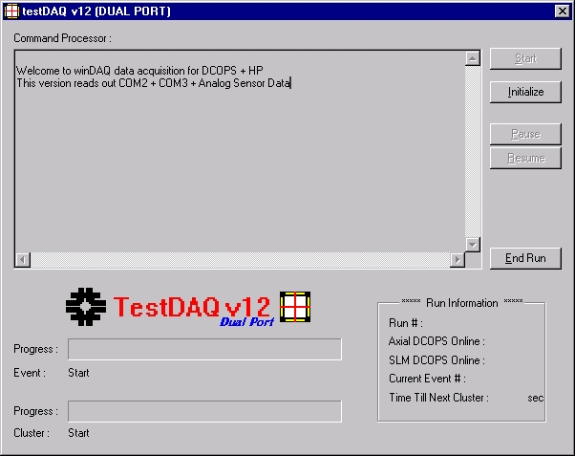

Since some of the buttons are inactive (light gray), you are allowed only two options – to Initialize the system and to End Run (exit the program).

Taking a Set of Data

A. Initializing the Sensors

The DCOPS sensors must be initialized and the correct data and log files must be created. To do this, simply click the Initialize button.

You should see a status response in the Command Processor Window as the program queries each of the sensor lines and creates the datafiles. You will also see the information in the Run Information box (lower left corner of the window) update with the number of Axial Sensors and number of SLM Sensors.

If everything goes well, you should see something similar to:

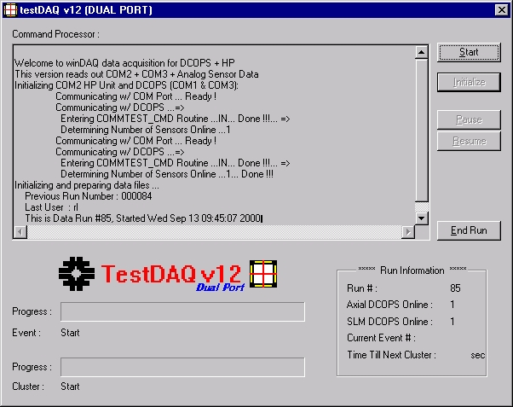

Notice the number of Axial and SLM Sensors is displayed on the lower right corner of the screen. If this is not the number of sensors you expected, click End Run to exit the program. Look at Problem #3 in the TroubleShooting section below and try to try and figure out the error.

If the screen suddenly disappears after a displaying a few lines of text, the program has probably crashed (very unlikely). See Problem #4 in Section VI (TroubleShooting).

Now click on the Start button to go to the Run Settings Menu :

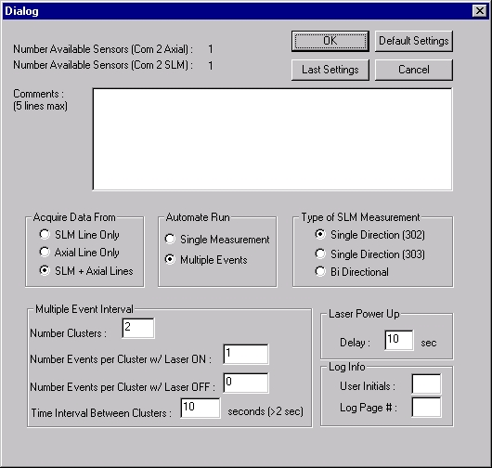

- The Run Settings Menu

Data taking is arranged in the following manner:
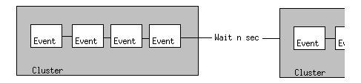
An event is defined as a reading of the one or both sensors lines. A cluster is defined as a collection of events separated by n seconds (which the user selects).

Note: Choosing to make ‘Bi-Directional’ measurements automatically doubles the number of Events entered in the ‘Multiple Events Interval’ Menu since each measurement must be taken twice – once with Laser 302 and once with Laser 303.

The following diagram details the options available to the user in this menu. Clicking on the OK button accepts the selections and starts the run.

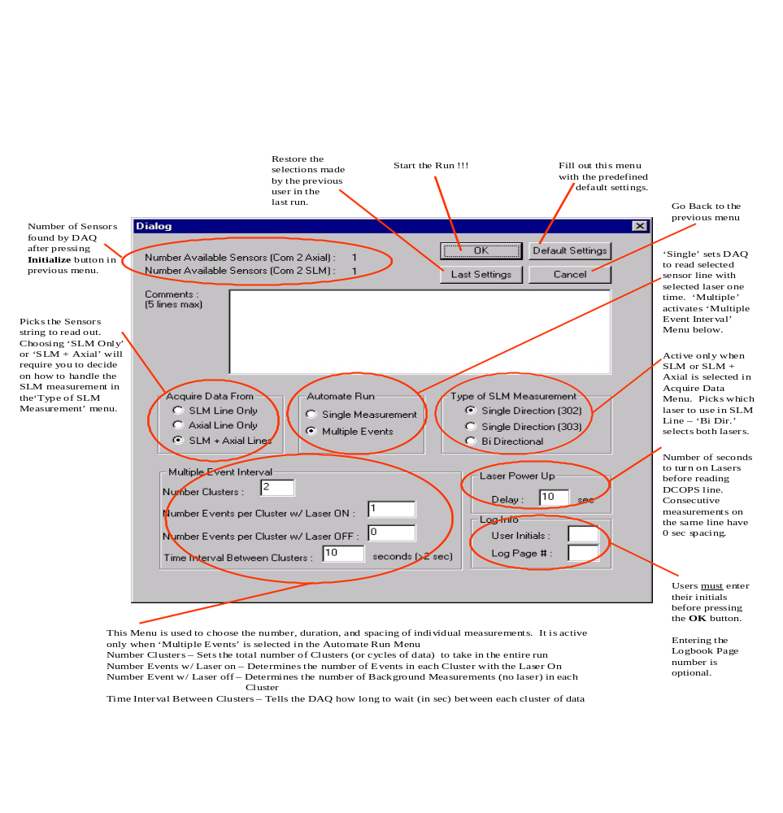
Most clusters taken during the July/August ISR test (and Integrated Runs) were done with 4 Events per cluster, a 30 sec Warmup on the Lasers (LDM), using both the Axial and SLM lines with the SLM line in Bi-Directional mode, and 300 sec between measurements.

While the Program is Running

After entering all the required information on the Settings Menu and clicking the OK, the DAQ begins to take data. You can take a look at the progress being made by looking at the bottom of the window :
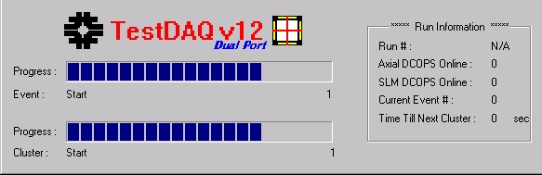

In this section, you can see which event is being read (right Run Info box) or the time until the next set of measurements or cluster will begin. The Progress bars (on the left) show the total number of events and clusters in the Run as well as where in the run the DAQ is.

Between clusters, the Timer on the left will count down the time until the next set of events in next cluster will begin. When the time expires, the Laser is turned on and measurements begin. While the Timer is counting down, however, you can click on the Pause button to freeze the timer. Click on the Resume button to continue the countdown or the End Run button to exit the program.

If the window fails to update, the program may have hung up or there might be a problem with the refresh on the window. See Section V (Bugs) B and C as well as Problem #5 in the Section VI (Troubleshooting) to decide the nature of the problem.

Known Bugs

Random Errors from DCOPS causing hangup in DAQ

Random errors in the DCOPS data stream have on a very few occasions caused the DAQ to hang up. This is probably due to errors returned from the DSP which interfere with the DAQ’s ability to distinguish the return prompt from the sensors. The problem does not occur very often. To kill the program, see the Troubleshooting section, Problem 5.

Window Refresh during long runs

If the DAQ is set to run for a large number of events (>70), the main window may not refresh properly and appear stuck. The Events and Readout will work fine (you should here periodic clicking of HP Unit), except you may no longer be able to view the progress of the Run in the Main Window. Again, data will be taken without a problem. You may, however, be able to see the timer counting down when the computer is pausing between measurements.

Poor tasking of I/O processes during running

The large volume of serial data being streamed makes it very difficult to track I/O very efficiently. Running an FTP or telnet client during data taking will slow the program down considerably.

Interference with Screen Saver

Again related to Window refresh problem – they screen saver should be disabled to prevent the DAQ window from being swiped over with white swatches.

Format Errors

There are some format errors (all systematic) in the DAQ output files. There is a C++ program to correct these errors as well as random errors n the DSP stream. The format errors are not significant.

Trouble Shooting Guide

Problem 1: You don’t see C:\Windows\Desktop\dual testDAQ v1\testDAQ on the menu.

Solution :

I am not 100% sure on the path name, the important thing is to choose the menu item which is the closest to the top has ...\dual testDAQ v1\testDAQ in it.

Problem 2: You don’t see, can’t find, or there are no menu choices on the Recent Workspaces menu.

Solution :

There is another way to load our DAQ into Visual C++. Look on the desktop for a folder similar to 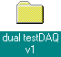. Double Click on the folder to open it and view the files inside. Find the file Testdaq.dsw (it looks like this :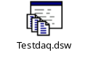 ) and double click on it . Visual C++ should start right up with our DAQ loaded.

Problem 3: The DAQ Program never makes it to the second menu after pressing the Initialize button..

Solution : The problem is caused by a null response from the sensors or the HP unit. You can look on the Command Processor window and check which sensor line was being queried as the program stalled. If the program is hung up, it will probably not allow you to click on the End Run button to exit. You will have to press the Ctrl, Alt, and Delete keys simultaneously one time – Be careful, pressing these keys twice will restart the computer. A few seconds after you press the three keys simultaneously, a small window will pop up asking you if you would like to ‘end the task’ or ‘wait’ – click on the End Task button. After another moment, the Main DAQ window will disappear and you can troubleshoot the problem and start the DAQ program again as in Step II B above.

After killing the Main DAQ window as described above, try and troubleshoot the sensors in the following manner:

- Check the power.
- Check that cables running from the DCOPS sensors run into the converter card
- Check the COM cables running from the converter cards to the computer are connected in this manner :
  - Com 1 – SLM line
  - Com 2 – HP unit (connection via 25 pin adapter)
  - Com 3 – Axial line

- Try and click one of the reset buttons on one of the DCOPS boards (the small black button near the EPROMS chip)
- You will have to check if the DCOPS sensors’ DSPs are hung up with hyperterm.
Look on the windows desktop for the hyperterm icon and double click on it.
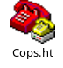
You will see :

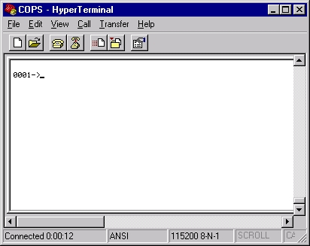

Hit the Enter key … if you see something similar as above with the 0001-> and a blinking cursor after it, this DCOPS string is online (the 0001-> prompt will be 000X-> where X is the number of DCOPS in the string). If you do not get the prompt described, the cursor seems ‘stuck’, or the white portion of the window is blank, then the Com port is hung up or the hyperterm program is not checking a Com port with an active sensor string. To make sure the problem is not with the DCOPS Sensor string, again press the reset button on one of the DCOPS board. Hopefully you will see a change in the Hyperterm window.

To check another Com port (or the other sensor string), click on the File menu, then select Properties. You will see a window pop-up which looks like this :

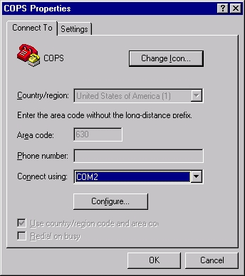

Use the pull down menu labeled ‘Connect Using’ to select another Com port.
The Com port with the HP unit connected to it returns only gibberish, so you only want to use Hyperterm to troubleshoot DCOPS sensors.

- If none of this works, restart the computer !

Problem 4: The DAQ Program never makes it to the second menu after pressing the Initialize button. The screen just disappears.

Solution: The program has crashed. This could be any number of things. You are using the same program as the July/August runs and there were no crashes reported, so odds are it is not a fatal programming error.

Check to make sure another program is not taking up one of the COM ports (Hyperterm or another copy of the DAQ running in the background ?). To see if another program is running in the background, click on the Windows desktop and then press the Ctrl, Alt, and Delete keys simultaneously one time – Be careful, pressing these keys twice will restart the computer. A few seconds after you press the three keys simultaneously, a small window will pop up with a list of applications currently running. If you see something which should not be there, click on the name of the program and then the button marked End Task. Otherwise click the Cancel button.

Problem 5: The DAQ has hung up during the middle of a run and will not respond.

Solution: Be sure this is not really one of the described bugs in the software (Section V B) !!! If it is really hung, you will have to kill the program and start it again. To kill the program, press the Ctrl, Alt, and Delete keys simultaneously one time – Be careful, pressing these keys twice will restart the computer. A few seconds after you press the three keys simultaneously, a small window will pop up asking you if you would like to ‘end the task’ or ‘wait’ – click on the End Task button. After another moment, the Main DAQ window will disappear and you can troubleshoot the problem and start the DAQ program again as in Step II B above. I recommend trying to use the Hyperterm program to look at the sensor strings after such a hangup – it may be the case that you will not see a prompt from the DCOPS. Try to hit the Return key a couple times and get the prompt back. See troubleshooting Problem 3 for more information regarding non-responsive sensors.

