Salmonella spp. and Listeria monocytogenes Risk Assessment for Production and Cooking of Blade Tenderized Beef Steaks

Principal Investigators:

James L. Marsden, Ph.D. jmarsden@oznet.ksu.edu
Randall K. Phebus, Ph.D. rphebus@oznet.ksu.edu
Harshavardhan Thippareddi, Ph.D. hthippar@oznet.ksu.edu
Curtis L. Kastner, Ph. D. ckastner@oznet.ksu.edu
James B. Gosch, GRA jgosch@oznet.ksu.edu

Submitted to :

National Cattlemen's Beef Association


Department of Animal Sciences and Industry
Kansas State University
Manhattan, KS 66506

ABSTRACT

Thermal destruction of Salmonella spp. and L. monocytogenes in blade tenderized steaks cooked to target end point temperatures of 120, 130, 140, 150, 160, and 170°F on a natural gas commercial grill was evaluated. Top sirloin subprimals were inoculated with five strain cocktails of Salmonella spp. and L. monocytogenes, separately to a level of ca. 10⁷ cfu/cm² on the top surface. Steaks of varying thicknesses (i.e. weights) were cut from each of the subprimals and cooked to one of the six endpoint temperatures. After removal from the oven, steaks were immersed in an ice bath to halt thermal lethality, and cooled to a temperature below 100°F before sampling. Although differences (p≤0.05) were observed in Salmonella spp. reductions on cooking steaks obtained from blade tenderized and non-tenderized subprimals, cooking to target endpoint temperatures of ≥130°F resulted in similar reductions in Salmonella spp. A target internal temperature of 120°F produced greater (p≤0.05) log reductions (CFU/g) in non-tenderized (NT) vs. tenderized (T) steaks (3.8 log reduction vs. 2.7 log reduction). At 130°F, T and NT steaks produced 4.0 and 4.4 log reductions, respectively, which was not significantly different, likely due to high standard deviations in bacterial counts, especially in low weight steaks. Cooking of steaks obtained from tenderized and non-tenderized subprimals showed differences (p≤0.05) in L. monocytogenes reductions when cooked to target internal end point temperatures of 120, 130, 140, 150 and 160 °F, but not 170°F. Complete destruction of L. monocytogenes was observed in steaks cooked to 170°F target temperature. It was observed that even after immersion in an ice bath, internal temperatures continued to rise above the target temperatures by as much as 11°F (in 5 oz steaks). In food service application, where steaks would not be rapidly cooled in this manner, an additional margin of safety would be incorporated into the cooking process due to this natural temperature rise after removal from the grill. At cooking temperatures ranging from rare (130°F) to well done (170°F), there were no differences in Salmonella spp. between intact and non-intact steaks using a natural gas commercial grill, although differences in L. monocytogenes reductions were observed. Both intact and non-intact steaks are safe for consumers when cooked to the endpoint temperatures ≥140°F by the natural gas commercial grill method.

INTRODUCTION

The meat industry must provide consistent quality and uniformity in its products to remain competitive. The quality characteristic that has received primary focus is tenderness. The primary technologies used to ensure tenderness and retail cut uniformity are blade tenderization and restructuring; technologies very effective and critical to the economic well being of the meat industry. Restructured meat products that result from the fibrinogen technology offer advantages to the industry and consumers. High quality products can be created from lower-cost muscle pieces. Precise control over composition, shape, and portioning are advantages of restructuring.
Blade tenderization is one of the most effective methods of meat tenderization, particularly for cuts higher in connective tissue. It also can significantly reduce the variability in tenderness regardless of the muscle. Even though the generic microbiological quality of blade tenderized muscle has been shown to be equivalent to non-tenderized controls on a per gram basis (Boyd et al., 1978), bacteria may be translocated into the muscle. Therefore, research is required to quantify this bacterial relocation, identify critical control points to minimize the risk for pathogenic contamination, and define effective cooking schedules for resultant products.

In November 1997, the National Advisory Committee on Microbiological Criteria for Foods (NACMCF), Meat and Poultry Subcommittee stated that Due to the low probability of pathogenic organisms being present in or migrating from the external surface to the interior of beef muscle, cuts of intact muscle (steaks) should be safe if the external surfaces are exposed to temperatures sufficient to effect a cooked color change. However, if meat is restructured so that original external surfaces are repositioned to the interior, as in restructured (fibrinogen) steaks, that interior will become contaminated. Additionally, if the surface of an intact muscle or muscle system is violated by mechanical tenderization (blade tenderization), contamination may be carried from the surface to the interior of the cut. The NACMCF Meat and Poultry Subcommittee also stated in 1997 that there is a lack of scientific data to address the hazards associated with those processes that may cause translocation of pathogens to the interior of meat cuts. Because of the widespread use of these two technologies and the potential food safety risks they may pose, the recently formed Beef Industry Food Safety Council (BIFSCO) identified this research as a priority for the beef industry. This industry group facilitates input from producers, packers, processors, distributors, restaurants, and food retailers in an effort to identify and implement workable E. coli O157:H7 controls in the beef industry.

Kansas State University has successfully performed a similar project "Escherichia coli O157:H7 Risk Assessment for Production and Cooking of Blade Tenderized and Fibrinogen Process Beef Steaks" and presented results to USDA-FSIS during the public meeting held in Washington, D.C. on March 8, 1999. Results indicate that the blade tenderization process transfers 3-4% of surface contamination to the interior of the muscle. Cooking studies indicated that a target internal temperature of 120°F produced greater (p≤0.05) log reductions (CFU/g) in non-tenderized (NT) vs. tenderized (T) steaks (5.2 log reduction vs. 3.2 log reduction), showing that blade tenderized steaks presented an increased risk only when cooked to very low internal temperatures. However, at endpoint temperatures of 140°, 150°, 160° and 170°F, log reductions were greater than 6 logs in both T and NT steaks, which represented virtually complete destruction. At cooking temperatures ranging from rare (130°F) to well done (170°F), there were no differences in E. coli O157:H7 between intact and non-intact steaks using the oven broiling method. It was concluded that both intact and non-intact steaks are safe for consumers when cooked to the endpoint temperatures ≥ 140°F by the oven broiling method. Although this study evaluated the risk of E. coli O157:H7, other foodborne pathogens such as Salmonella and Listeria monocytogenes have not been considered. It is possible that the translocation of these pathogens could be different compared to E. coli O157:H7 and further, the cooking protocols required for inactivation of Salmonella and Listeria monocytogenes could be different.

Therefore, the blade tenderization technology requires research to determine the process and preparation protocols required to ensure the safety of these effective and widely used technologies. Unlike ground beef which is now almost exclusively cooked to 160°F by food service establishments as a result of USDA and state health department recommendations, mechanically tenderized beef steaks are often perceived as whole muscle cuts and are, thus, prepared to customer orders of rare to medium doneness, which may pose a health risk to consumers. By validating the process and cooking protocols against Salmonella spp. and Listeria monocytogenes, suppliers and food service will be able to effectively establish standard cooking recommendations for food service HACCP programs for preparation of these products.

OBJECTIVE

The objective of the study is to determine the effectiveness of rare to well done cooking temperatures on reducing Salmonella spp. and Listeria monocytogenes populations contaminating the interior of meat cuts as a result of blade tenderization of artificially contaminated beef sub-primal surfaces.

MATERIALS AND METHODS

Preparation and Cooking of Blade Tenderized Steaks: Top sirloins (loin, beef top sirloin butt, center cut, boneless, cap off; IMPS 184B) were surface inoculated (non-fat side) to target contamination level of ca. 10⁷ Salmonella spp. and Listeria monocytogenes /cm². After an attachment period of 2 hrs, one set of top sirloins were blade tenderized (fat side down) using two passes through a Ross tenderizer (Fig. 1) with the units conveyor moving 1.25 inches (31.75 mm) forward and 0.5 inches (12.7 mm) laterally between each blade cycle. The 448 blades (Fig. 2) of the tenderizer produce 32 incisions per square inch with each passage through the unit (Figs. 3 and 4). The unit was thoroughly sanitized and disinfected between each subprimal processed. Matching top sirloins were inoculated, sliced, and cooked but did not receive the blade tenderization treatment. Tenderized and control subprimals were fabricated using North American Meat Processors guidelines. A cutting guide was used to uniformly cut steaks of 0.5, 0.9 or 1.25 inch target thicknesses. Steaks were aseptically trimmed on the non-inoculated fat surface to target weights of 5, 8 and 12 oz (142, 226 and 340 g ± 5 g), for respective thicknesses.

Steaks were held at 4°C until cooking (ca. 1 hr). A Type T thermocouple was inserted into the geometric center of each steak through the side of the steak. Steaks were cooked on both sides to a specific end-point temperature (uncooked, 120, 130, 140, 150, 160, and 170°F) on a commercial gas grill with 400 °F surface temperature. A sanitized weight (1 lb) was placed top of each steak when the steak was placed on the grill and a new sanitized weight was placed after the steak was flipped upon reaching the mid point of the cooking process to prevent curling. After reaching the target end-point, the steak was immediately removed from the grill, placed in oven cook bags and submerged in an ice bath. Temperature of the steaks was monitored until the steaks cooled to 100°F. A center slice of each steak was then blended to produce a uniform sample and 25 g portion of the blended sample was stomached with 50 mL of peptone water (0.1%, PW) for 2 min. The samples were microbiologically analyzed by plating on selective and non-selective repair media for each organism. Salmonella spp. and Listeria monocytogenes survival on non-tenderized control steaks was compared to survival in tenderized steaks.

Salmonella spp. and Listeria monocytogenes Cultures: A five strain cocktail of Salmonella spp. and Listeria monocytogenes was used in all investigations. Cultures were grown in tryptic soy broth at 35°C for 18 h to stationary phase, centrifuged and cell pellets from all five strains resuspended in 0.1% peptone water to establish a cocktail inoculum. The cocktail of each organism was mist inoculated on the top sirloins to obtain a surface inoculum of ca. 10⁷ CFU/cm².

Enumeration of Salmonella spp. and Listeria monocytogenes: Surviving Salmonella spp. and Listeria monocytogenes populations were enumerated by direct plating on Xylose Lysine De-oxycholate Agar (XLD) and modified Xylose Lysine De-oxycholate Agar (mXLD). Samples were plated on Modified Oxford Agar (MOX) and Tryptose Phosphate Agar (TPA) to recover the injured cells and estimate the rate of injury. Each subprimal (blade tenderization study) used in the study was mist inoculated with the 5 strain inoculum of each pathogen, separately. After 2 hr attachment, 40 cm² of inoculated meat surface (ca. 2 mm depth) was excised and plated to confirm initial surface inoculation levels (CFU/cm²).

After cooking to specified internal temperatures, a 2 in. wide strip (obtained parallel to the path of the blade penetration) of each steak was placed in a Waring blender jar, diluted 1:5 with 0.1% chilled peptone water, homogenized for 1 min, and plated to enumerate surviving Salmonella spp. and Listeria monocytogenes levels. Bacterial population reductions due to cooking was determined based on a comparison to inoculated but uncooked control steaks receiving the same processing treatment. In cases where the specific cooking time/temperature reduced the inoculated Salmonella spp. and Listeria monocytogenes populations to below the detection level of direct plating, samples were enriched according to modified USDA protocols. Three replications of the experiment were performed with duplicate steaks being cooked and analyzed for each cooking treatment within replications.

Experimental Design: A 2 x 3 x 7 factorial experimental design was used for the study, with two organisms (Salmonella spp., and L. monocytogenes), three weight ranges (5, 8, and 12 oz), and seven target endpoint temperatures (uncooked, 120, 130, 140, 150, 160, and 170 °F) as parameters. Three replications were performed and the results were statistically analyzed using general linear models procedures using SAS analytical software.

RESULTS AND DISCUSSION

Statistical analysis of all main effects (treatment, weights, and temperature) and all possible combinations of interaction, with bacterial reduction as the dependent variable for Salmonella spp. reductions, revealed a significance (p≤0.05) for the main effects and an interaction between the treatment (tenderized vs. non-tenderized) and temperature and weight and temperature. For all temperatures (treatment and thickness interaction), the Salmonella spp. reductions were greater in non-tenderized steaks (4.42 log CFU/g) compared to tenderized steaks (3.63 log CFU/g) for 5 oz steaks and the Salmonella spp. reductions were similar for 8 and 12 oz steaks (p>0.05) (Fig. 5). Further, Salmonella spp. reductions during cooking of tenderized and non-tenderized steaks were greater (p≤0.05) in non-tenderized steaks (3.76 log CFU/g) compared to tenderized steaks (2.73 log CFU/g) at 120 °F, and the treatments had similar Salmonella spp. reductions (p>0.05) at 130, 140, 150, 160 and 170 °F. This finding indicates that although tenderization of subprimals destined for further fabrication into steaks results in survival of larger populations of Salmonella spp. at 120 °F, tenderization did not result in survival of the pathogen when the steaks were cooked to internal temperatures of ≥ 130 °F (rare), the normal recommended cooking temperatures for beef steaks.

The Salmonella spp. reductions obtained in this study were lower than the E. coli O157:H7 reductions reported by Sporing (1999) cooking to the same endpoint temperatures of 120, 130, 140, 150, 160 and 170°F. This probably was due to the use of a commercial grill using natural gas compared to the oven broiler used by Sporing (1999), which results in uniform surface temperatures compared to a commercial grill.

Cooking of steaks obtained from tenderized and non-tenderized top sirloins inoculated with L. monocytogenes revealed differences for main effects (treatment, weights and temperature) and no interaction between the parameters. L. monocytogenes reductions were greater (p≤0.05) in non-tenderized steaks compared to tenderized steaks except for steaks cooked to 170°F, where complete reductions in L. monocytogenes populations were observed for both the tenderized and non-tenderized steaks (Fig. 6). The results for L. monocytogenes reductions were different from Salmonella spp. and E. coli O157:H7 reductions from tenderized and non-tenderized steaks due to higher surface inoculum achieved with L. monocytogenes due to modification in the experimental procedure. This was achieved by re-suspending the L. monocytogenes cell pellet in smaller volume of the PW compared to Salmonella spp. and E. coli O157:H7 to achieve higher surface inoculum level on the top sirloin surface. Further, reductions obtained for L. monocytogenes were lower compared to the Salmonella spp. and E. coli O157:H7 for each of the target temperatures, probably due to higher thermal tolerance of L. monocytogenes. Although reductions achieved on cooking tenderized steaks obtained from subprimals inoculated with L. monocytogenes, the probability of high surface contamination of subprimals with L. monocytogenes is very low.

Johnston et al. (1978) reported that salmonellae survived on both the surface and in the core of mechanically tenderized roasts oven cooked to an internal temperature of 130°F. The authors hypothesized that the presence of viable salmonellae on surface could be either due to purging of the cells from the center or survival on the surface. Johnston et al. (1978) concluded that tenderized roasts cooked to 130°F may be a public health problem. The reductions obtained at this target end point cooking temperature were 3.44 and 4.03 log CFU/g in the present study for steaks obtained from tenderized and non-tenderized sub-primals respectively, and may not be sufficient to result in a 6.5 log reductions as required by the proposed performance standards for Salmonella spp. in beef products. However, the risk of these high levels of Salmonella spp. during production of raw steaks is relatively low due to the minimal exposure of the meat surfaces of the primals used for the steaks and the use of intervention treatments used in the slaughter operations that further reduce the Salmonella spp. contamination levels on the carcasses.

Johnston et al. (1978) did not evaluate the effect of cooking inoculated, non-tenderized roasts to 130°F. Further, the authors used beef roasts (5 lb) in the experiment, whereas the present study evaluated the microbial reductions that could be achieved in steaks processed from the roasts (subprimals) to more accurately resemble restaurant operations. In addition, use of a larger mass of meat (5 lb) and heating to an internal temperature of 130°F would have resulted in a further increase in temperature, higher than what we observed in our study, resulting in higher lethalities and reductions in salmonellae.

The experimental design of this study incorporated the use of an ice bath to rapidly halt thermal lethality in the steaks after removal from the broiler, to provide more accurate information concerning thermal destruction achieved at the identified target internal temperatures. It is important to note that even after transfer to the ice bath, internal temperatures of the steaks continued to rise above these target temperatures, by as much as 11°F (Figs. 7 and 8). Temperature increases tended to be larger at the low target temperatures, and for 5 oz. Steaks, but no significant differences were observed within treatments or steak weights. In food service applications, the finished product would not be cooled as in this scientific study, and internal temperatures would likely rise to higher endpoints and be maintained for longer periods of time, thereby resulting in increased margin of safety in regard to pathogen destruction.

SUMMARY AND CONCLUSIONS

Results show that there is no difference in risks between intact (non-tenderized) and non-intact (tenderized) steaks at cooking temperatures ranging from rare (130°F) to well done (170°F) for Salmonella spp. However, differences in Listeria monocytogenes reductions between steaks obtained from tenderized and non-tenderized subprimals were observed on cooking to target temperatures of up to 160°F, and not 170°F. Sporing (1999) recommended a target endpoint temperature of ≥140°F for cooking both tenderized and non-tenderized steaks based on extensive studies with E. coli O157:H7 to reduce the risk of this pathogen in steaks obtained from tenderized subprimals. The present study shows that same target temperature would reduce the risk of Salmonella spp and L. monocytogenes in steaks obtained from blade tenderized subprimals. Baseline studies performed by USDA-FSIS indicates very low contamination levels of these pathogens on beef carcasses and concentrations of these pathogens would be even lower on cuts obtained from interior muscles such as those used for fabricating the steaks. Thus, both intact and non-intact steaks are safe for consumers, when cooked to the internal temperatures of rare to well done using a commercial grill.

In this study, we intentionally inoculated beef cuts with high levels of Salmonella spp. and Listeria monocytogenes in order to quantify the effect of mechanical tenderization on the translocation of bacteria from the surface of the beef cuts into interior of the muscle. The levels of contamination used do not reflect levels that are likely to be present. In actual practice, the source point of contamination for these pathogens is at the carcass level and contamination is prevented or reduced through application of numerous processing steps, including validated anti-microbial technologies and enforcement of USDA-FSIS’s zero tolerance policy for physical defects. The potential of contamination is further reduced by the removal of the carcass surface by trimming before mechanical tenderization.

A target internal temperature of 140°F appears to provide the necessary thermal destruction required to virtually eliminate Salmonella spp. and L. monocytogenes risk. By including validated antimicrobial intervention strategies in the slaughter and fabrication processes to improve initial microbial quality of products destined for blade tenderization, the likelihood of pathogenic contamination is further decreased, thus decreasing the level of process lethality required during cooking of tenderized cuts.

REFERENCES

Johnston, R.W., M.E. Harris, and A.B. Moran. 1977. Effect of mechanical tenderization on beef rounds inoculated with salmonellae. J. Food Safety 1:201-209.

SAS, 1990. Statistical Analysis System. User’s guide. 4th Ed. SAS Institute, Inc., Cary, NC.

Sporing, S. B. 1999. Escherichia coli O157:H7 risk assessment for production and cooking of blade tenderized beef steaks. M. S. Thesis. Kansas State University, Manhattan, KS.

LEGEND TO FIGURES:

Fig. 1. Photograph of Ross TC700M Blade Tenderization unit.

Fig. 2. Photograph of blade head (produces 32 penetrations/in²) for the Ross TC700M Blade Tenderization unit.

Fig. 3. Schematic of blade tenderization process, step 1 (prior to penetration).

Fig. 4. Schematic of blade tenderization process, step 2 (during penetration).

Fig. 5. Reductions in Salmonella spp. in tenderized and non-tenderized steaks cooked to various endpoint temperatures.

Fig. 6. Reductions in Listeria monocytogenes in tenderized and non-tenderized steaks cooked to various endpoint temperatures.

Fig. 7. Maximum internal temperatures reached in 5, 8 and 12 oz tenderized and non-tenderized steaks cooked to six target endpoint temperatures during cooking of steaks inoculated with Salmonella spp.

Fig. 8. Maximum internal temperatures reached in 5, 8 and 12 oz tenderized and non-tenderized steaks cooked to six target endpoint temperatures during cooking of steaks inoculated with Listeria monocytogenes.
.

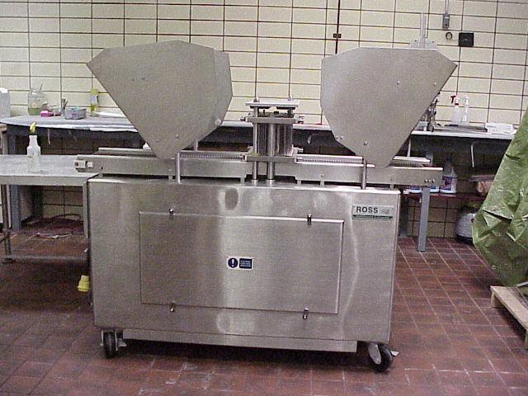
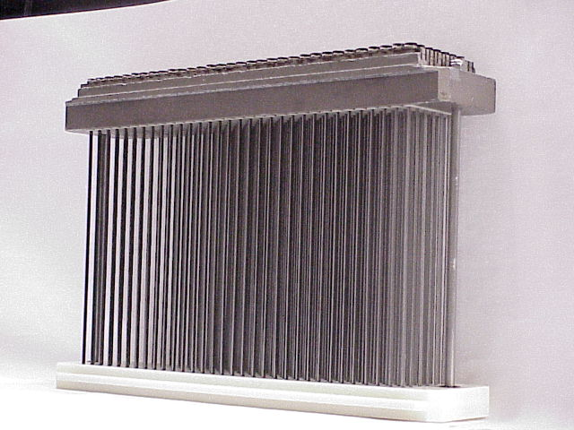
.
Figure 1: Photograph of Ross TC700M Blade Tenderization unit.

Figure 2: Photograph of blade head (produces 32 penetrations/in²) for the Ross TC700M Blade Tenderization unit.

1.25 in. forward,
0.5 in. laterally each cycle
32 penetrations/in.²
1.25 in. forward, 0.5 in. laterally each cycle
Blade Heads
Stainless Steel Belt

Figure 3: Schematic of blade tenderization process, step 1 (prior to
penetration).
Figure 4: Schematic of blade tenderization process, step 2 (during penetration).
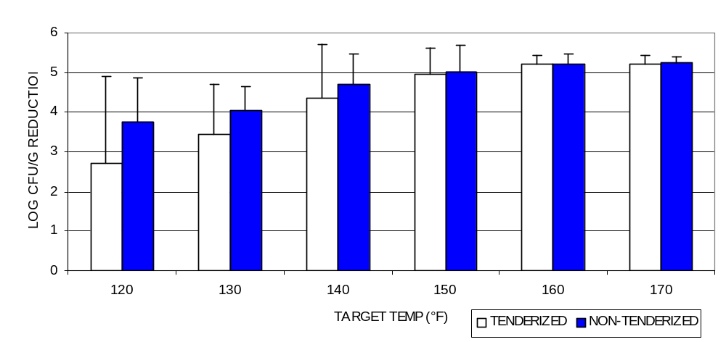

Figure 5: Reductions in Salmonella spp. in tenderized and non-tenderized steaks cooked to various endpoint temperatures.

Figure 6: Reductions in Listeria monocytogenes in tenderized and non-tenderized steaks cooked to various endpoint temperatures.

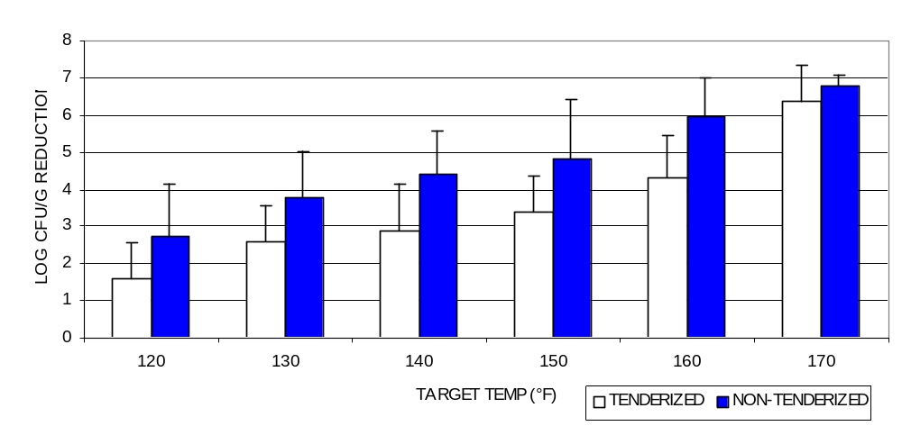

Fig. 7.
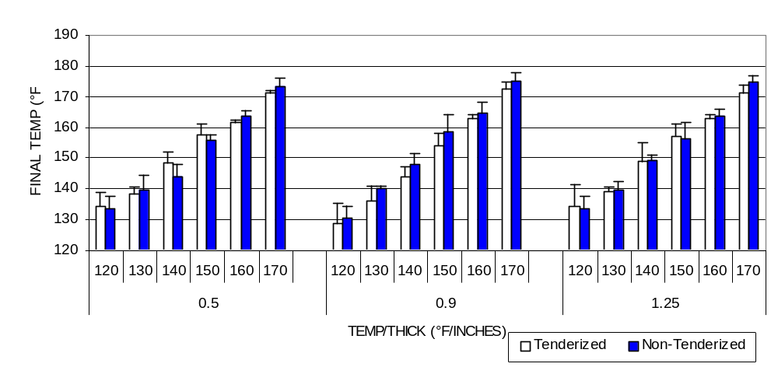

Figure 7: Maximum internal temperatures reached in 5, 8 and 12 oz tenderized and non-tenderized steaks cooked to six target endpoint temperatures during cooking of steaks inoculated with Salmonella spp.

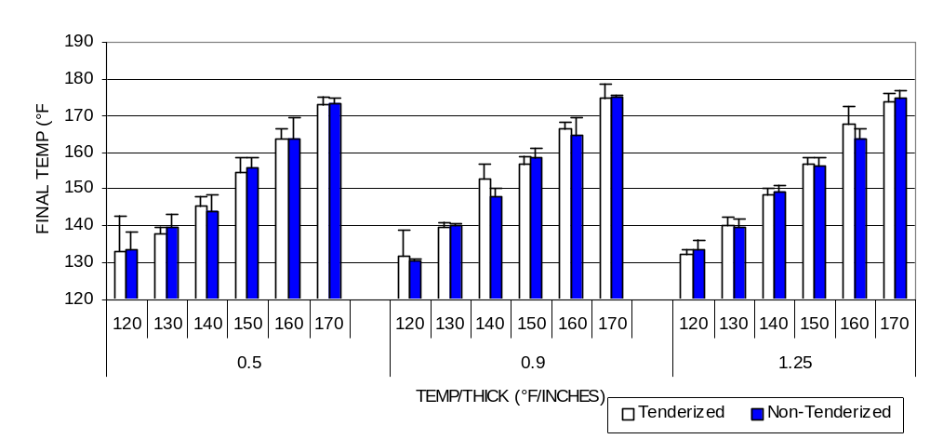

Figure 8: Maximum internal temperatures reached in 5, 8 and 12 oz tenderized and non-tenderized steaks cooked to six target endpoint temperatures during cooking of steaks inoculated with Listeria monocytogenes.

