Federal Parent Locator Service

National Interstate Case Reconciliation (ICR)

User Guide

Document Version 10.0
August 2008

Administration for Children and Families
Office of Child Support Enforcement
370 L’Enfant Promenade S.W.
Washington, DC 20447

This document was prepared for the Administration for Children and Families, Office of Child Support Enforcement by Northrop Grumman Information Technology (NGIT).

Document Name: ICR User Guide, verion 10.0
Date: August 2008

TABLE OF CONTENTS

1.0 How This User Guide Can Help You 1-1
1.1 Who Should Read this User Guide 1-1
1.2 How this Guide is Structured 1-2

2.0 How the ICR Fits Into Interstate Communication 2-1
2.1 Goals for Improving Interstate Communications 2-1
2.2 Goals and Objectives of the National ICR 2-2
2.3 How the ICR is a First Step 2-2

3.0 Importance of Case IDs 3-1
3.1 Why Standardized Case IDs are Important 3-1
3.2 Case ID Analysis 3-1
3.3 Case ID Analysis Results 3-2
3.4 What Case ID Standardization Means to You 3-2
3.5 Maintaining the Integrity of Case IDs 3-3
3.6 Case ID Matrix 3-4

4.0 How the ICR Works 4-1
4.1 What is the Basis for ICR Matching 4-1
4.2 What the ICR Reason Codes Mean 4-1
4.3 How the ICR Match Routine Works 4-2
4.4 The Multiple Cases Indicator 4-5
4.5 The ICR SSN Verification Process 4-10
4.6 How ICR Files Are Provided by States 4-11

5.0 How to Prioritize Your ICR Workload 5-1
5.1 Which Reason Codes Should be Worked First 5-1
5.2 Processing Multiple Reason Codes 5-3

6.0 Reason Code 00 – Case Data Matched and This Participant Matched 6-1
6.1 What Reason Code 00 Means 6-1
6.2 Reason Code 00 Example 6-1
6.3 What to Automate in Reconciling Reason Code 00 6-2
  - Decision Making for Reason Code 00 When Your State is
Either the Initiating State or the Responding State 6-3

7.0 Reason Code 02 – Case ID Mismatch, Case Found by
Matching a Child or Adult in Common 7-1
7.1 What Reason Code 02 Means 7-1
7.2 Reason Code 02 Example 7-1
7.3 What to Automate in Reconciling Reason Code 02 7-3
7.4 Decision Making for Reason Code 02 When Your State is
Either the Initiating or Responding State 7-4

8.0 Reason Code 07 – An SSN was Provided for this
Participant by the Other State 8-1
8.1 What Reason Code 07 Means 8-1
8.2 Reason Code 07 Example 8-1
8.3 What to Automate in Reconciling Reason Code 07 8-2
8.4 Decision Making for Reason Code 07 When Your State is
Either the Initiating or Responding State 8-3
8.5 Hot Tips for Reconciling Reason Code 07 8-4

9.0 Reason Code 08 – A Different SSN was Provided for
This Participant by the Other State 9-1
9.1 What Reason Code 08 Means 9-1
9.2 Reason Code 08 Example 9-1
9.3 What to Automate in Reconciling Reason Code 08 9-3
9.4 Decision Making for Reason Code 08 When Your State is
Either the Initiating or Responding State 9-3
9.5 Hot Tips for Reconciling Reason Code 08 9-4

10.0 Reason Code 04 – Your Case is Open,
Matches to Closed Case in the Other State 10-1
10.1 What Reason Code 04 Means 10-1
10.2 Reason Code 04 Example 10-1
10.3 What to Automate in Reconciling Reason Code 04 10-2
10.4 Decision Making for Reason Code 04 When Your State is the
Initiating State 10-3
10.5 Decision Making for Reason Code 04 When Your State is the
Responding State 10-3
10.6 Hot Tip for Reconciling Reason Code 04 10-4

11.0 Reason Code 01 – Could Not Find a Matching Case
In the Other State 11-1
11.1 What Reason Code 01 Means 11-1
11.2 Reason Code 01 Example 11-1
11.3 What to Automate in Reconciling Reason Code 01 11-3
11.4 Decision Making for Reason Code 01 When Your State is the
Initiating State 11-3
11.5 Decision Making for Reason Code 01 When Your State is the
Responding State 11-4
11.6 Hot Tips for Reconciling Reason Code 01 11-5

12.0 Reason Code 03 – Incorrect County Code for the Other State 12-1
12.1 What Reason Code 03 Means 12-1
12.2 Reason Code 03 Example 12-1
12.3 What to Automate in Reconciling Reason Code 03 12-3
12.4 Decision Making for Reason Code 03 When Your State is
Either the Initiating or Responding State 12-3

13.0 Reason Code 06 – This Participant was not Found in the Other State 13-1
13.1 What Reason Code 06 Means 13-1
13.2 Reason Code 06 Example 13-2
13.3 What to Automate in Reconciling Reason Code 06 13-2
13.4 Decision Making for Reason Code 06 When Your State is
Either the Initiating State or the Responding State 13-3
13.5 Hot Tips for Reconciling Reason Code 06 13-4

14.0 Reason Code 05 – Your Case is Closed,
Matches to Open Case in the Other State 14-1
14.1 What Reason Code 05 Means 14-1
14.2 Reason Code 05 Example 14-1
14.3 What to Automate in Reconciling Reason Code 05 14-2
14.4 Decision Making for Reason Code 05 When Your State is
Either the Initiating or Responding State 14-3

15.0 The Unidentified Interstate Cases Project 15-1
15.1 Impact of Unidentified Interstate Cases on State Systems 15-1
15.2 Option #1: OCSE Matches All Cases Receiving
Reason Code 01 with the Focus State’s Cases
Against the Focus State’s Cases on the FCR 15-2
15.3 Option #2: OCSE Uses a Supplemental Extract File
Submitted by the Focus State for Matching Purposes 15-4
  - Decision Making When Your State is the Focus State 15-6
  - Decision Making When Your State is One of the
Other (non-Focus) States 15-7

16.0 Interstate Reconciliation Report 16-1
16.1 IRR Description 16-1
16.2 Case ID and FIPS Code Information 16-2
16.3 Reason Code Information 16-3
16.4 Participant Information 16-3
16.5 Participant Matching and CP/NP Indicators 16-4
16.6 Contact Information 16-5
16.7 Printing the IRR 16-5
16.8 IRR Sample Format 16-6

17.0 Management Information Reports 17-1
17.1 What MI Reports are Available 17-1
17.2 MI Report 1: Match Results Report 17-2
17.3 MI Report 2: Open/Closed Discrepancies by
Initiating/Responding Indicator 17-5
17.4 MI Report 3: Cases Not Found by
Initiating/Responding Indicator 17-6
17.5 MI Report 6: View of How Other States Matched with Your State 17-7
17.6 MI Report 8: Provided and Different SSNs Report 17-10
17.7 MI Report 9 – Cases Not Reported to ICR by Focus State 17-12

APPENDIX A: ICR Reconciliation Matching Results File Record Format A-1

APPENDIX B: Option #1 Response File Record Layout B-1

TABLE OF FIGURES

3-1 FCR/ICR Case ID Matrix 3-5
4-1 ICR Match Routine 4-4
4-2 Single Case Matches to Multiple Cases: Original Process 4-6
4-3 Single Case to Matches Multiple Cases: Updated Process
(One Child per Case in One State, Two or More in the Other State) 4-8
4-4 Single Case Matches to Multiple Cases: Updated Process
(Only One Child/NCP and CP Change Prticipant Type) 4-9
5-1 Prioritization of ICR Reason Codes 5-2
5-2 Multiple Reason Codes 5-3
6-1 Reason Code 00 Match Routine 6-2
7-1 Reason Code 02 Match Routine 7-2
8-1 Reason Code 07 Match Routine 8-2
9-1 Reason Code 08 Match Routine 9-2
10-1 Reason Code 04 Match Routine 10-2
11-1 Reason Code 01 Match Routine 11-2
12-1 Reason Code 03 Match Routine 12-2
13-1 Reason Code 06 Match Routine 13-3
14-1 Reason Code 05 Match Routine 14-2
15-1 Unidentified Interstate Cases Project: Option #1 Match Process 15-3
15-2 Unidentified Interstate Cases Project: Option #2 Match Process 15-5
16-1 ICR Interstate Reconciliation Report 16-2
16-2 ICR Interstate Reconciliation Report 16-6
17-1 MI Report 1: Match Results Report 17-4
17-2 MI Report 2: Open/Closed Discrepancies by
Initiating/Responding Indicator 17-5
17-3 MI Report 3: Cases Not Found by Initiating/Responding State 17-6
17-4 MI Report 6: View of How Other States Matched with Your State 17-9
17-5 MI Report 8: Provided and Different SSNs 17-11
17-6 MI Report 9 – Case Not Reported to ICR by [Focus State] 17-12

SECTION 1.0

HOW THIS USER GUIDE CAN HELP YOU

Read this guide for help in how to reconcile cases using the results from the national Interstate Case Reconciliation (ICR). Remember what is offered within this guide are suggestions, not mandates or policy Statements from the Federal Office of Child Support Enforcement (OCSE), on how to handle your interstate case data.

This section of the User Guide identifies which users could benefit from reading this guide, and outlines how the guide is structured.

  - Who Should Read this User Guide

This guide provides valuable tips and tools on how to use ICR data results. You can look at this guide as a “survivor’s guide” because it suggests ways to automate the handling of ICR results as much as possible and alleviate the manual workload burden. A recurring theme of this User Guide is to “automate, automate!” whenever possible.

The following are targeted users whom this guide is directed to help:

- Decision Maker and/or Manager - This guide can help you plan your State’s reconciliation efforts. This includes determining how to manage the large amount of information being returned to your State by focusing on the most important tasks first. This also includes determining the extent to which automation can be used to accomplish reconciliation tasks. Management Information reports, provided as part of ICR, can be used to guide your decision about which other State caseloads you want to reconcile first.
- Caseworker or Central Registry Worker - This guide helps you understand how the ICR process works and what the results generated about your cases mean. Points you should consider, if you are asked to reconcile some of the discrepancies manually, are provided.
- Programmer - This guide provides you with suggestions on how to automate the handing of ICR response files. In addition to automation suggestions, which are provided throughout the User Guide, an example of an Interstate Reconciliation Report (IRR) is provided for your review. You can generate this report, which is a printout of your State’s ICR results file, by using an ICR print program sent to your State by OCSE as a tool for State use. This report helps display responses in a logical sequence and would be helpful for caseworkers or Central Registry workers to use when undertaking manual case reconciliation follow-up actions.

1.2 How this Guide is Structured

This User Guide is structured to emphasize how you should prioritize the results generated by the ICR matching process. Examples of why different errors have occurred are provided, with suggestions on completing case reconciliation actions within your State.

Look at the following sections of this User Guide for help in reconciling your interstate cases. The following sections of this User Guide contain:

- Section 2.0: How the ICR Fits into Interstate Communication – This section explains how the ICR is one of OCSE’s many efforts to foster effective interstate communication.
- Section 3.0: Importance of Case IDs – This section describes some of the actions taken in preparation for the ICR, and emphasizes the importance of States using the same case ID for all interstate communication. This section also includes information on the importance of maintaining correct case IDs after reconciliation efforts have been completed. Special suggestions and ideas for using ICR are presented in the form of “Hot Tips”, beginning in Section 3.0. The symbol designates these tips.
- Section 4.0: How the ICR Works – This section provides a brief explanation of the ICR matching process and what information is sent to you. It introduces ICR Reason Codes. These codes identify where discrepancies were found between your cases and other States’ cases, as well as where case data matched.
- Section 5.0: How to Prioritize Your ICR Workload – This section divides the Reason Codes into four levels of priority for reconciliation. This prioritization helps you tackle the reconciliation work before you and highlights which actions should be taken first to maximize the return on your investment of time, energy, and resources. This section also explains how you may receive more than one Reason Code for a mismatch between your data and another State’s data, and how the different Reason Codes relate to each other.
- Sections 6.0 through 14.0 – These sections describe each Reason Code in detail. Included in each section is a diagram that provides an example of why a specific Reason Code might be returned. Suggestions for reconciling Reason Codes are provided as Hot Tips, including suggestions for manual reconciliation.
- Section 15.0: The Unidentified Interstate Cases Project – This section describes OCSE’s project to assist States identify more of their true interstate cases. Two options for supplemental case matching are offered. This section explains the impact of unidentified interstate cases on State systems and the benefits to be obtained once all interstate cases are recorded as ‘interstate’.
- Section 16.0: Interstate Reconciliation Report – This section explains the report you can generate using the print program provided to your State by OCSE. The IRR is an actual printout of the data contained in your ICR results file. This report can be a valuable tool in managing your State’s reconciliation workload. Since ICR matching is done at the person level, this report helps you see how individual person-based ICR responses work together to give you the total picture of a presumed interstate case.

- Section 17.0: Management Information Reports – This section describes six Management Information reports that are part of the ICR. These reports summarize the information your State has received from matches with all other States, and are useful for prioritizing your State’s reconciliation efforts.
- Appendix A: ICR Reconciliation Matching Results, File Record Format – This appendix provides the record layout for the ICR response file. The record format shows exactly what data were used and sorted in the ICR matching process at OCSE.

The next section explains how the ICR plays a pivotal role in interstate and intergovernmental communication to ensure that families are served as effectively as possible.

SECTION 2.0

HOW THE ICR FITS INTO INTERSTATE COMMUNICATION

This section puts the Interstate Case Reconciliation (ICR) within the context of improving interstate and intergovernmental communications. Overall goals for improving interstate communication are presented, as well as the goals of the national ICR, and how the ICR is a first step towards achieving better interstate communication.

2.1 Goals for Improving Interstate Communication

The ICR is one piece of OCSE’s overarching goals of improving services to families and achieving reliable and ongoing sources of income for families served by the child support program. In order to achieve these overall goals OCSE has identified operational goals that seek to improve communication across the continuum of interstate case activities. These operational goals include:

- Use of the same case IDs across all interstate processes,
- Exchange of information in commonly understood terms,
- Determination of responsibility for providing interstate services, and
- Sharing of payment information.

OCSE’s vision for the future of interstate case processing includes collaborating with States to enhance the current tools used in interstate communication. In particular, OCSE has identified the need to collaborate with States on:

- Identification of both interstate case processing issues and possibilities,
- Consideration of a variety of tools, especially automated tools, to improve interstate communication, and
- Development of a “roadmap” to incrementally achieve better interstate and intergovernmental communication through coordinated State and national efforts.

Current activities undertaken by OCSE with the States include efforts to:

- Standardize and clarify interstate terms and definitions,
- Improve the accuracy of interstate case data,
- Identify ways to most efficiently and effectively work interstate cases,
- Streamline processes in order to better promote electronic communication through the Federal Case Registry (FCR), the Child Support Enforcement Network (CSENet), electronic funds transfer (EFT/EDI), Query Interstate Cases for Kids (QUICK), and
- Assist States in determining controlling orders and reconciling arrears.

Ongoing analysis and coordination efforts pave the way to a future of interstate case processing that offers the most efficient and effective way to serve families with interstate cases and ensure ongoing and reliable sources of income for all families served by the child support program.

2.2 Goals and Objectives of the National ICR

The objectives of the national ICR, in support of its primary goal to improve service to families involved in interstate cases, are to:

- Synchronize interstate caseloads,
- Establish clear accountability for interstate case processing,
- Provide and/or correct participant SSNs,
- Improve electronic communication among States, and
- Establish accurate State and national baselines of interstate cases.

The ICR provides your State with results derived by comparing your State’s interstate cases with other States’ interstate cases. Compared State caseloads include both open and closed cases. The matching results show whether the data maintained on your State’s system for each interstate case are accurate, or whether discrepancies exist. If discrepancies exist, you receive corrected data or sufficient information that allows you to evaluate the next appropriate action to resolve each discrepancy.

A major outcome for the ICR is to provide each State with correct case identifiers (case IDs) for the other States with which interstate cases are shared. If the case ID you have for another State is different than the case ID used by the other State, the ICR identifies the discrepancy and provides you with the correct case ID that should be used for interstate communication. This is the most significant benefit of the ICR.

2.3 How the ICR is a First Step

The national ICR offers an important first step by reconciling interstate cases and, as stated above, by providing correct Other State Case IDs. As part of the ICR effort, case IDs were analyzed to evaluate what States were using as a case ID in all forms of external communication. This initial analysis, which was a collaborative OCSE/State effort to address case ID inconsistencies, has led the way to standardizing how each State consistently uses its case IDs for interstate and intergovernmental communication. The standardization of case IDs establishes a foundation for better communication to occur among the States, and facilitates ongoing synchronization of interstate cases. Existing methods of electronic interstate communication, such as the FCR, CSENet, EFT/EDI, and QUICK, are dependent upon States maintaining correct Other State Case IDs for their interstate cases.

The next section of the User Guide discusses in more detail the importance of standardizing case IDs.

SECTION 3.0

IMPORTANCE OF CASE IDs

This section stresses the importance of each State using standardized case IDs across all lines of interstate and intergovernmental communication. Suggestions are provided as to how you can maintain the integrity of correct case IDs in your State system. A matrix also is provided in this section that shows what each State’s standardized case ID looks like, so that all other States know what to expect in the ICR matching results.

3.1 Why Standardized Case IDs are Important

In preparation for ICR, much attention was paid to each State’s case IDs, since accurate case IDs are key to effective interstate communication. OCSE performed an initial analysis with all of the States to determine if they consistently use the same case ID for all external communications with each other and with how they registered their cases on the FCR. The analysis found that most States in fact use the same case ID across the FCR, CSENet, and EFT/EDI, but that some States did use different case IDs for different modes of communication.

These case ID inconsistencies placed an undue (and, oftentimes, an unexpected) burden on other States. For example, a State might receive a case ID for another State through a proactive match generated by the FCR, a different variation might come from the same other State in a CSENet transaction; and yet a third variation might be specified by that same other State as to what should be sent to that State in incoming EFT/EDI transmissions.

3.2 Case ID Analysis

One of the immediate things noted at the beginning of the case ID analysis, was that the term ‘case number’ is a misnomer for how States identify their IV-D cases. Many States use alpha characters as well as numbers to identify cases within their State systems. Case ID is much more the appropriate term to describe the unique identifier each State uses to differentiate between cases. Case ID, then, is the term used throughout this User Guide.

Once this standard terminology was adopted, the case ID analysis effort sought to determine if States were reporting the same case IDs to the FCR as they were using in CSENet transactions, and as they were expecting to receive in EFT/EDI transmissions.

State staff were asked to describe their case IDs and provide examples. These examples were compared to case IDs provided on test files submitted by each State in preparation for the ICR. The case IDs submitted on the ICR test file were then compared to the case IDs each State uses when submitting cases to the FCR.

Some discrepancies were noted, which often involved the length of the case ID and/or the absence or presence of leading zeros. For example, a State might have described its case ID as an 8-character field (12345678), which was what was submitted on its ICR test file, but the State’s case ID on the FCR might contain 15 characters (000000012345678). These discrepancies usually stemmed from a misunderstanding of FCR reporting requirements. For instance, some States misinterpreted the 15-character FCR Case ID field as being numeric, not alphanumeric, and thought they had to put leading zeroes in front of their case IDs to “fill up” the entire field, rather than using trailing spaces behind their real case IDs. Conversely, for some States, leading zeroes are integral to their case IDs; and discrepancies arose when these integral leading zeroes were dropped.

In addition to the comparison between the ICR test files and the FCR, what States used when sending transactions via CSENet, and what States expected on incoming EFT/EDI transmissions, were compared. Here, additional case ID discrepancies were found. The problems within CSENet centered primarily on inconsistencies in the use of leading zeroes, and other variations in case IDs. The problems within EFT/EDI centered on how several States required a different ID (e.g., Member ID or EFT PIN) to be sent to their State Disbursement Unit (SDU) when support payments were forwarded via EFT/EDI.

3.3 Case ID Analysis Results

OCSE notified States that had various case ID inconsistencies and asked them to decide what their case ID should look like for purposes of all external communication. Nine States chose to change the format they used for reporting case IDs to the FCR, and nine States chose to change the format of their case IDs on CSENet transactions. (Note: Between these two groups, three States decided to change both their FCR and CSENet case IDs.)

States were notified, and agreed to modify their FCR and CSENet programming to use a standard case ID by certain dates, which were published for other States to anticipate. In an effort to facilitate the changes to cases already resident on the FCR, OCSE made mass case ID changes for the seven States in April 2004, and for one State in September 2005. The ninth State deleted all of its cases from the FCR in July 2006, then added them back with its corrected case ID. OCSE performed requisite data quality checks on the mass case ID corrections, and began using the new case ID format when sending FCR proactive matches to other States.

For States with EFT/EDI inconsistencies, changes have been made, or are in the making, to ensure that other States can use the same case ID for purposes of sending EFT/EDI to them as the case ID they themselves use for the FCR, CSENet and ICR purposes.

Until States could make their case IDs consistent, they could not participate in the ICR.

3.4 What Case ID Standardization Means to You

Having one standardized case ID for each State’s FCR, CSENet and EFT/EDI records greatly improves interstate communication in the following ways:

- You can communicate freely and quickly with another State about a case you have in common.
- You will not be constantly overlaying another State’s case ID in your records based on the latest communication received from that other State (e.g., replacing the case ID received from an FCR-to-FCR proactive match with a different one received on a CSENet transaction).
- When you receive FCR proactive match information about a participant in your case, you will know the correct case ID for that participant’s case in the other State.
- Incoming and outgoing CSENet transactions will not be dropped because the case ID is not recognizable.
- You will not be required to maintain two fields on your system, one for communicating case information and the other for sending EFT/EDI payments to another State.
- If another State develops on-line inquiry functionality via a web application, you will have the correct case IDs to view shared interstate cases.
- When your State begins to participate in QUICK, you will need the correct case ID when inquiring on the case in the other State.

With case ID formats standardized within each State, reconciling interstate case data becomes much more reliable. The remaining sections of this guide suggest how to accomplish that task in the most effective and efficient ways possible. However, correcting critical interstate case information, such as Other State Case IDs, is only the first step in promoting effective interstate communication. In order to prevent future disconnects between your State and other States, you must maintain the integrity of case IDs on your State’s system after the ICR.

3.5 Maintaining the Integrity of Case IDs

Once you have completed your reconciliation efforts, it is particularly important that you maintain correct case IDs throughout your State system and across all modes of interstate and intergovernmental communications. Here are several suggestions to help you maintain the integrity of both your own and other States’ case IDs:

- Exercise caution whenever a manual means is allowed to update your State’s, or another State’s, case IDs. Refer to the standardized case ID established by your State and other States in the FCR/ICR Case ID Matrix at the end of this section. Consider using the FCR/ICR Case ID Matrix to verify changes before anyone enters anything manually onto your State system.
- Remember that another State’s case ID may look much different than yours. For example, integral leading zeroes established in other States’ case IDs must be carried over to how their case IDs are stored in your State system.
- Perform automated updates to where you store Other State Case IDs in your State system only from FCR proactive matches and from regular CSENet transactions. Note that the LO1 CSENet transaction should not be used to automatically update another State’s case ID. These transactions may contain case IDs that were uniquely generated for the LO1 transaction, and not for an interstate case. Ongoing efforts are addressing the standardization of case IDs on LO1 transactions.
- Other States’ case IDs may be stored in various places in your State system. You must ensure that corrections are made to each module or screen, when authorized changes are made.
- Verify any case ID received on a UIFSA document. The case ID analysis effort was unable to verify that UIFSA documents display other State’s case IDs in the same format as provided on the FCR/ICR Case ID Matrix. The matrix could serve as a verification reference for UIFSA case IDs.

Note that there are valid reasons to change other States’ case IDs on your system. Some of these reasons are:

- A case ID may change from a temporary ID to a permanent ID. If the other State uses an NCP’s SSN as its case ID, and the valid SSN is not known at the time of case establishment, a temporary case ID may be created using a pseudo-SSN. When the NCP’s correct SSN is obtained, the case ID is changed to that corrected SSN. If the participant is registered on the FCR, a proactive match is sent; otherwise, another means of notification may be sent to your State.
- An incorrect case ID may have been assigned to a case in the other State. When the error is discovered, you may be informed of the corrected case ID via an FCR-to-FCR proactive match, a CSENet case ID change transaction, or a UIFSA document.

The FCR/ICR Case ID Matrix follows. It describes individual State conventions for displaying case IDs consistently in all interstate communications. This matrix helps you verify the correct case ID convention for any State prior to performing a manual update of your own or another State’s case ID in your State system.

3.6 Case ID Matrix

The basic format specifications for sending case IDs to the ICR are the same as those being put into effect for the FCR and CSENet. The OCSE case ID specifications are:

- 15-character alphanumeric field (this does not mean your case ID must be 15 characters)
- Any alphabetic, numeric, or special character except for an asterisk (‘*’) or a backslash (‘\’)
- All alphabetic characters must be in uppercase
- Data field is left-justified
- Case ID value may not begin with a space
- If the case ID value does not fill the entire field, the value is “right-padded” with spaces
- Case ID value may not be all zeroes (‘000000000000000’) or all spaces (‘ ’).

Within this standard, States have adopted various conventions for the content and display of their case IDs. For each State, Figure 3-1 provides a description of its unique case ID convention for each State.

Figure 3-1
FCR/ICR Case ID Matrix

State  Code/Name | FCR/ICR Case ID  Description | FCR/ICR Case ID  Example
01/AL | Description: 15 characters, includes integral leading zeros | 000000000608100  000000436983771
02/AK | Description: 9 characters, includes integral leading zeros | 004563456
04/AZ | Description: 12 characters, includes integral leading zeros | 000000012300  000000000200  000826683400
05/AR | Description: 9 characters, may include integral leading zeros | 004564567  800333760
06/CA | CSE System - Coordinated rollout of all counties to this system. Statewide sequential numbering of new cases.  ARS System (Los Angeles, San Diego, and Orange counties) – Prefix 3 characters represent the CA county FIPS code. May include alpha-character (A, B, C, etc.) suffix as payee identifier when there are multiple payees/payers. 'Z' character suffix indicates the payee is a foster care agency.  CASES System – Prefix 3 characters represent the CA county FIPS code. May include a hyphen and 2-digit suffix as payee identifier when there are multiple payees/payers. Typically, positions 1-13 used, 14-15 empty. | CSE example:  200000000000001  ARS example: 0370620502435A  CASES example: 0750000001-01
08/CO | Description: 12 characters, first 11 are numbers, 12th is alpha | 80002324442A  01006171456A  01015819905B
09/CT | Description: 6 numbers, then dash, then one or two numbers | 871916-1  000006-1
10/DE | Description: 6 characters, no leading zeros | 298797
11/DC | Description: 6 numbers, then dash, then one or two numbers | 374413-1
12/FL | Description: 10 characters, may include integral leading zeros | 0123456778  0000000019  1195644264
13/GA | Description: 9 characters, may include leading zeros | 376666328  000000151
66/GU | Description: 10 characters with leading zeros | 0000010123  0000000001
15/HI | Description: 7-9 characters, no leading zeros | 5821813
16/ID | Description: 6 characters, may include integral leading zeros | 205005  000001
17/IL | Description: 9 characters, ‘C’ followed by 8 numbers | C01509837  C00000009
18/IN | Description: 10 characters, all numbers, includes integral leading zeros | 0001234567
19/IA | Description: 7 characters, includes integral leading zeros | 0003471  0000010
20/KS | Description: 10 characters, all numbers, includes integral leading zeros | 0000244344  0000000014
21/KY | Description: 10 characters, includes integral leading zeros | 0001688842  0000001029
22/LA | Description: 11 characters, includes integral leading zeros | 00171251801  00000001501
23/ME | Description: 9 characters: 8 numbers, 1 alpha, may include leading zeros | 20333582P  00044580P
24/MD | Description: 9 characters, all numbers, may include integral leading zeros | 910062684  000000069
25/MA | Description: 10 characters, includes integral leading zeros | 0003746947
26/MI | Description: 9 characters, all numbers, may include integral leading zeros | 296747947  000024365
27/MN | Description: 12 characters, includes integral leading zeros | 001458610001  000000325801
28/MS | Description: 10 characters: nine numbers, tenth alpha | 600014153A
29/MO | Description: 8 characters, all numbers, some with leading zeros | 51012613  00050302
30/MT | Description: 15 characters, includes integral leading zeros. MT consistently uses this field with appended AP/CP suffixes for all interstate communications. | 0145777AP01CP01
31/NE | Description: 13 characters, always beginning with ‘CA’, no leading zeros | CA2CH4QYLE85X  CA2T62MRLSMNP
32/NV | Description: 10 characters: 9 numeric + 1 alpha. Leading zeros will not be suppressed. | 011234567A
33/NH | Description: 9 characters: 8 alphanumeric + ‘C’, some with leading zeros | KSL86837C  ABA5584WC  00085915C
34/NJ | Description: 11 characters: ‘CS’ + 8 numeric + 1 alpha, no leading zeros | CS71047867A
35/NM | Description: Up to 9 characters, no leading zeros. | 8  12  10369  7138251
36/NY | Description: 9 characters: alpha-alpha-numeric-numeric-numeric-numeric-numeric-alpha-numeric, no leading zeros | BJ79705H2
37/NC | Description: 10 characters, includes integral leading zeros | 0023456789
38/ND | Description: Maximum of 8 characters, no leading zeros | 11501  48030601
39/OH | Description: 10 characters, all begin with 70, no leading zeros | 7044027808
40/OK | Description: 12 characters, includes integral leading zeros | 000468375001  000000001001
41/OR | Description: 12 characters, first character is always zero, last 2 characters are always 41. Characters in between can be all numbers or a mixture of numbers and alpha characters | 001009210741
42/PA | Description: 9 characters, may include leading zeros | 324166675  000004351
72/PR | Description: 15 characters with integral leading zeros | 000000000133563
44/RI | Description: 10 characters, may include leading zeros | 0394823884  0013085731
45/SC | Description: 7 characters, includes integral leading zeros | 0471695
46/SD | Description: 10 characters, no leading zeros | 265108013A
47/TN | Description : 9 characters, includes integral leading zeros | 001013935
48/TX | Description: 10 characters, some with leading zeros, some of the older case numbers have alpha characters | 99999892N1  UR00000081
49/UT | Description: 10 characters: 'C' followed by 9 numbers, no leading zeros | C000636011
50/VT | Description: 10 characters | 0097250172  1144288961
51/VA | Description: 10 characters, includes integral leading zeros | 0003224507
78/VI | Description: 7 characters, no leading zeros | 1004572
53/WA | Description: 10 characters, includes integral leading zeros | 0001754773
54/WV | Description: 11 characters, may contain integral leading zeros | 72901278802
55/WI | Description: 10 characters, includes integral leading zeros | 0003690209
56/WY | Description: Maximum 9 characters | 28  130  65212  140652

You are encouraged to refer to this matrix prior to performing any manual update of Other State Case IDs (e.g., updating from a UIFSA form) in order to ensure the integrity of case IDs in your interstate case. Remember, correct case IDs are central to getting and keeping interstate cases synchronized.

Consider incorporating each State’s case ID format into your system as an edit function. This will reduce errors with manual data entry.

Store the Other State Case ID in only one place in your system. Use that one location for all interstate commuinication, including CSENet and EFT/EDI. This eliminates your having to remember to update the Other State Case ID in multiple places whenever you receive a corrected identitifier from another State.

The next section of the User Guide describes how the national ICR works and what responses you receive from the ICR matching process. Pay particular attention to the Reason Codes that identify matches and mismatches; these are your keys to getting your interstate cases in synch.

SECTION 4.0

HOW THE ICR WORKS

This section provides an overview of how the national Interstate Case Reconciliation (ICR) works, including the basis for ICR matching, what the ICR Reason Codes mean, and how files are provided by States for the ICR process to work.

4.1 What is the Basis for ICR Matching

ICR matches case and participant data submitted by your State for all of your open and closed interstate cases against the case and participant data submitted by the other States participating in the national ICR.

First, the ICR process uses the State code (e.g., 02 = Alaska) and the case ID you have for the other State to try to find an interstate case that corresponds to your interstate case. Then, if the match routine finds a corresponding interstate case in the other State’s ICR file, it checks for a match on county code, case status, and SSN or name for each participant on your interstate case.

- If the case ID you have for the other State’s case cannot identify a corresponding case, then the ICR process looks for a child in common between your case and a case in the other State’s ICR file.
- If a corresponding case cannot be identified using the SSN of a child in both States’ cases, the ICR process looks for an adult in common using the adult’s SSN and participant type. Then the ICR checks for a child in common based on the spelling of the child’s name.
- The match routine assigns Reason Codes to identify data discrepancies and to indicate the extent to which critical data match between your interstate case and the other State’s interstate case. Results are returned for each person submitted on your interstate case.

4.2 What the ICR Reason Codes Mean

It is important that you familiarize yourself with what the returned ICR Reason Codes mean in order to understand what matched and what did not between your interstate case and a presumed interstate case in another State. These Reason Codes provide you with the ability to prioritize the discrepancies to be worked first. The ICR Reason Codes are:

- Reason Code 00 – Case Data Matched and this Participant Matched: Success! Your case data match and this participant matches with data provided by the other State. Check the NP and CP Indicators for additional data.
- Reason Code 01 – Could Not Find a Matching Case in the Other State: An interstate case could not be found in the other State with which you thought you had an interstate case.
- Reason Code 02 – Case ID Mismatch, Case Found by Matching a Child in Common or Adult/Participant type and Child Name in Common: The other State’s case ID you have is incorrect, but the correct case ID for the other State has been found! This is the easiest ICR result to automate! You should start using the correct case ID provided by the other State as soon as possible so you can communicate effectively.
- Reason Code 03 - Incorrect County Code for the Other State: The county code you have for the child support office in the other State does not match the county code identified by that other State.
- Reason Code 04 – Your Case is Open, Matches to Closed Case in the Other State: Your case is open as an interstate case, but the interstate case in the other State is closed.
- Reason Code 05 – Your Case is Closed, Matches to Open Case in the Other State: Your case is closed as an interstate case, but the interstate case in the other State is open.
- Reason Code 06 – This Participant was Not Found in the Other State Case: This participant was not found in the other State’s case.
- Reason Code 07 – This Participant’s SSN was Provided by the Other State: Your State did not provide an SSN for this participant on your case, but the SSN has been provided by the other State.
- Reason Code 08 – Participant SSN Mismatch: The SSN You have Provided for this Participant does not Match the SSN Provided by the Other State.
- Reason Code 09 – Case Found on the FCR: This Reason Code, used with the Unidentified Interstate Cases Project only, informs your State that the other State’s interstate case matched to an FCR case in your State. For further information, refer to Section 15.0 of this User Guide.

Note: If the interstate case in your State is closed and an interstate case was not found in the other State, or your interstate case is closed and it matched to a closed interstate case in the other State, you do not receive a Reason Code error and no record is returned in your State’s ICR results file.

4.3 How ICR Match Routine Works

Figure 4-1 shows how the ICR match routine searches for interstate cases in other States and assigns Reason Codes based on discrepancies found in this comparison. Here are the basic steps:

- The ICR match routine starts by using the State code and case ID you have for the other State to try to find a corresponding interstate case in the other State’s ICR file.
- When the match routine finds a corresponding interstate case based on the State code and the Other State Case ID search, it begins to match participants by comparing SSNs for the participants on the two cases. If a participant is not found by using the SSN, the routine compares the first six letters of the last names and the first four letters of the first names for each participant on your interstate case with each participant on the other State’s interstate case. The match routine assigns a Reason Code 06 for any participant on your interstate case that could not be found on the other State’s case based on an SSN or name match.

- The match routine then compares the county code and case status to determine if these data are the same between the matched interstate cases. If discrepancies exist, the match routine assigns Reason Codes 03, 04 or 05 to categorize the case discrepancies.
- The match routine then checks the SSN of each matched case participant and assigns Reason Code 07 if the participant’s SSN is missing on your State’s case, but is present on the other State’s case, or Reason Code 08 if both State files contain an SSN for the participant, but those SSNs are not identical. When Reason Codes 07 and 08 are created, the Social Security Administration’s (SSA) match routines are used to verify the name/SSN combination.
- If the match routine does not find any discrepancies in the data compared between your interstate case and the other State’s interstate case, it assigns a Reason Code 00, to indicate that the case information matches exactly.
- If the match routine does not find a corresponding interstate case based on the State code and case ID you have for the other State, the routine searches for a child in common between your interstate case and the other State’s ICR file. It uses a child’s SSN, instead of the case ID, as the key identifier to search for a matching participant in the other State’s ICR file.
- If the child SSN search finds a matching participant, and that participant is a child on both States’ cases, then the match routine considers the two cases a match. The match routine assigns a Reason Code 02, which indicates that the case ID you have for the other State is incorrect, but a matching case was found based on a child in common.
- Once a matching case is identified, the child SSN search continues the same as the case ID search. It compares participants between the two cases by SSN or name to determine the extent to which the participants match. It then compares the county code and case status to determine if these data are the same between the matched interstate cases. If discrepancies exist, the match routine assigns Reason Codes 03, 04 or 05 to categorize the discrepancies.

Figure 4-1
ICR Match Routine

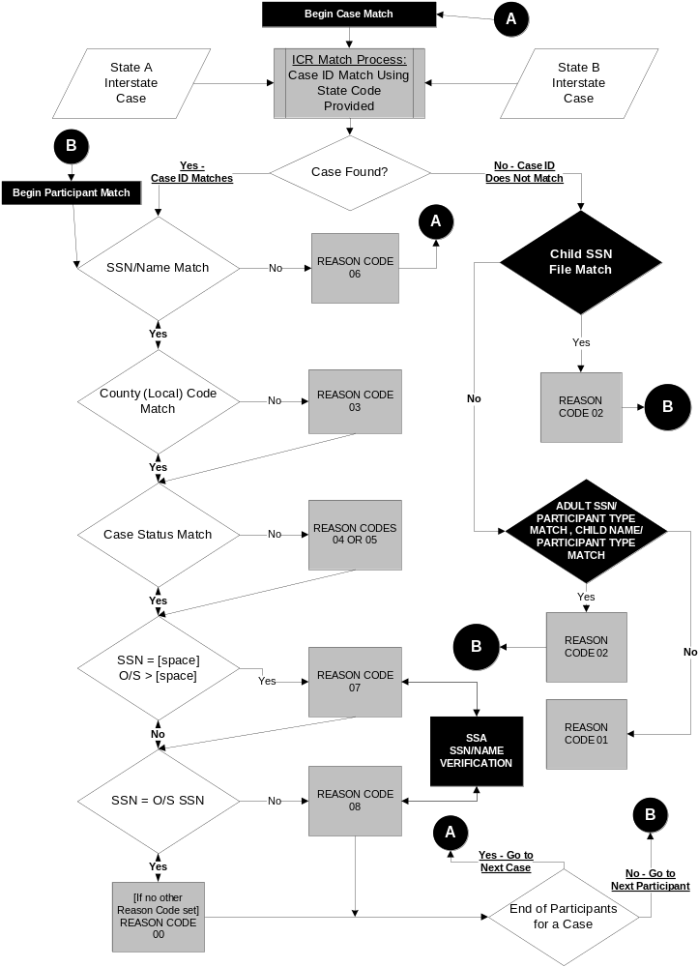

- If a matching case cannot be found using the child SSN, the match routine searches for an adult in common between your interstate case and the other State’s ICR file. It uses the adult’s SSN/participant type, instead of the child’s SSN, as the key identifier to search for a matching participant in the other State’s ICR file.
- If the adult SSN/participant type search finds a matching person, all of the case participants are loaded into a program and the participants are interrogated to find a matching child based upon child name. For purposes of this comparison, an NP (non-custodial parent) is the same as a PF (putative father).
- A case is considered a match if the adult SSN/participant type matches and at least one child matches by name (6 letters of the last name and 4 letters of the first name). The match routine assigns a Reason Code 02, which indicates that the case ID you have for the other State is incorrect, and the correct case ID is provided.
- Once a matching case is identified, the matching routine compares participants between the two cases by SSN or name to determine the extent to which the participants match. It then compares the county code and case status to determine if these data are the same between the matched interstate cases. If discrepancies exist, the match routine assigns Reason Codes 03, 04 or 05 to categorize the case discrepancies.
- The match routine then checks the SSN of each matched case participant and assigns Reason Code 07 if the participant’s SSN is missing on your State’s case, but is present on the other State’s case or Reason Code 08 if both State files contain an SSN for the participant, but those SSNs are not identical. When Reason Codes 07 and 08 are created, the Social Seccurity Administration’s routines are used to verify the name/SSN combination.
- When the match routine is unable to find a corresponding interstate case in the other State’s ICR file, through an adult in common search, it assigns a Reason Code 01 indicating failure to find a corresponding interstate case.
- In addition to the adult SSN matching process, the ICR routine examines whether the NCP and CP on both States’ cases match. If the same person is the NCP on both cases, a ‘Y’ is provided in the NP indicator; if the same person is the CP on both cases, a ‘Y’ is provided in the CP indicator. Even if there are multiple NCPs or CPs on your case, the ICR routine will provide a ‘Y’ if any of the NCPs or CPs match between your State and the other State.
- If the match routine identifies multiple matching cases in the other State, the Multiple Cases Indicator on the ICR response file is set to ‘Y’, as described in Section 4.4 below.

4.4 The Multiple Cases Indicator

On occasion, one case in your State matches to multiple cases in the other State. This may occur when your State system can accommodate children covered by multiple support orders on a single case, but the other State requires multiple cases on its system if there are two or more support orders covering the family’s children. It can also occur if paternity needs to be established on behalf of two different children, and your State system can have both children on a single case, but the other State requires two different cases, one for each child.
As States have become more experienced in working with their ICR response files, some of you noticed that, on a very limited number of cases, you would receive response file data giving you two different Other State Case IDs for multiple children in your case.

An illustration of the scenario is shown in Figure 4-2 below.

Figure 4-2
Single Case Matches to Multiple Cases: Original Process

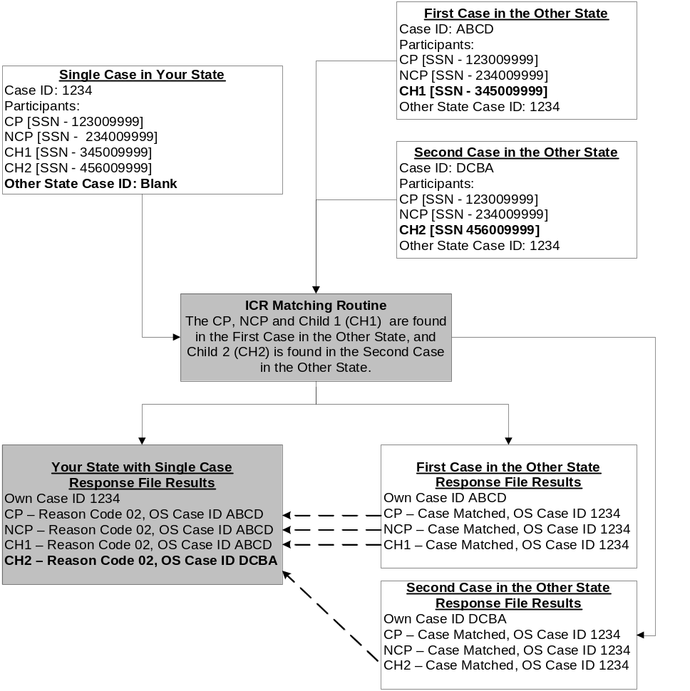

The above scenario only occurred when the State with the single case did not have the Other State Case ID, and the ICR provided it by matching on child or adult participants in common. The State with the single case received a Reason Code 02 response on behalf of each person in its case. But the Other State Case ID provided on one of the participants was different from the Other State Case ID provided on the rest of the participants. In Figure 4-2, the CP, NCP and CH1 receive Reason Code 02 and Other State Case ID ABCD. The second child in the case, CH2, also received a Reason Code 02, but received Other State Case ID DCBA, as the second child was not in case ABCD, but was found in the other State’s case DCBA.

The State with the multiple cases was never impacted by this situation, since on both cases the State maintained the single Other State Case ID, or received the corrected single Other State Case ID.

To help identify situations where a single case in one State matches to multiple cases in the other State a Multiple Cases Indicator was added to the ICR response file record layout in early 2008. This indicator is located at position 485 in an area that had formerly been filler on the response file. If the indicator is set to ‘Y’ your case matched to multiple cases in the other State. If the indicator is set to ‘N’ your case matched to a single case in the other State.

Figure 4-3 on the following page depicts the response file match results using the Multiple Cases Indicator. You will note that when your single case matches to multiple cases in the other State, your case will be returned to you one time for each case identified in the other State. On each case you receive, the Multiple Cases Indicator will be set to ‘Y’ to inform you of this situation.

As shown in Figure 4-3, you will receive multiple response records for your case that matches to multiple cases in the other State. In the ICR matching process, when your case does not contain the Other State Case ID, the system attempts to find a matching case by finding a child in common. When the first case, case ABCD, is found in the other State the matching routine checks each of the case participants to see if they can also be found in case ABCD. For each matched participant, a Reason Code 02 response is generated and the Other State Case ID of ABCD is given. As shown above, CH2 was not found in the other State’s case ABCD and received a Reason Code 06 (Participant Not Found) response.

Since CH2 was not found in the other State’s case ABCD, the ICR match routine now attempts to find a matching case for CH2. When the match routine finds the child in case DCBA, the match routine again checks each of the case participants to see if they can also be found in case DCBA. This time the CP, NCP, and CH2 receive the Reason Code 02 response with the Other State Case ID DCBA, and CH1, who is not found, receives a Reason Code 06 (Participant Not Found) response.

To inform you that your single case relates to more than one case in the other State (in the example here, the two cases in the other State are ABCD and DCBA), you will receive a ‘Y’ for the Multiple Cases Indicator with the data you receive for each of the cases.

Figure 4-3
Single Case Matches to Multiple Cases: Updated Process
(One Child per Case in One State, Two or More in the Other State)

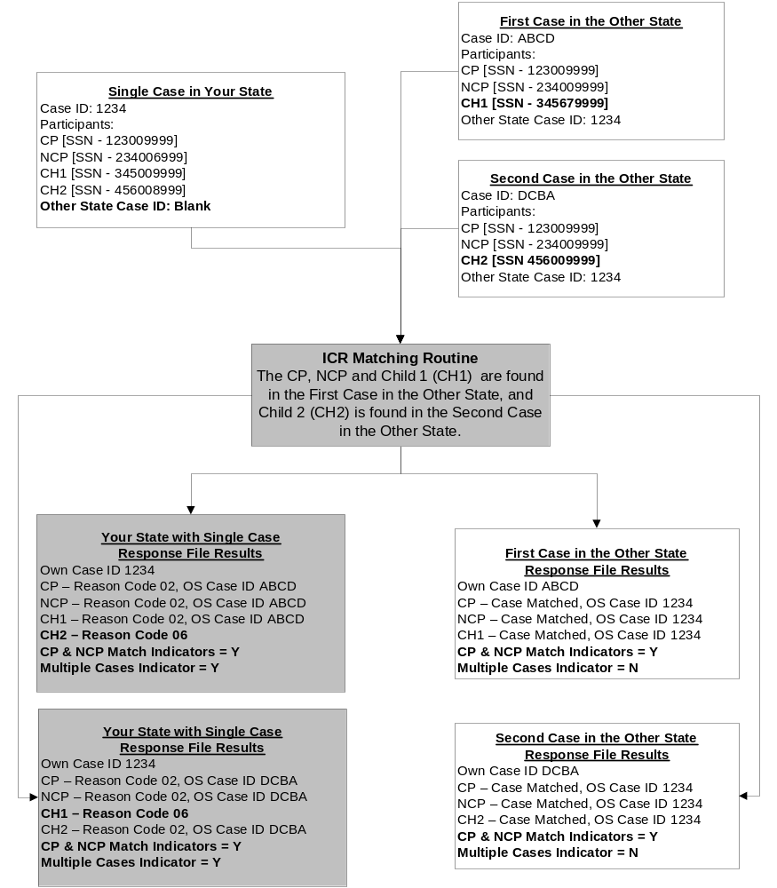

Figure 4-4 below depicts another circumstance when the Multiple Cases Indicator would be set to ‘Y’. In this example, a single case in your State matches to two cases in the other State because the other State has both a case for Mom (the CP) vs. Dad (the NCP) and a case for Dad (CP) vs. Mom (NCP), reflecting a change in custody of the child.

Figure 4-4
Single Case Matches to Multiple Cases: Updated Process
(Only One Child/NCP and CP Change Participant Type)

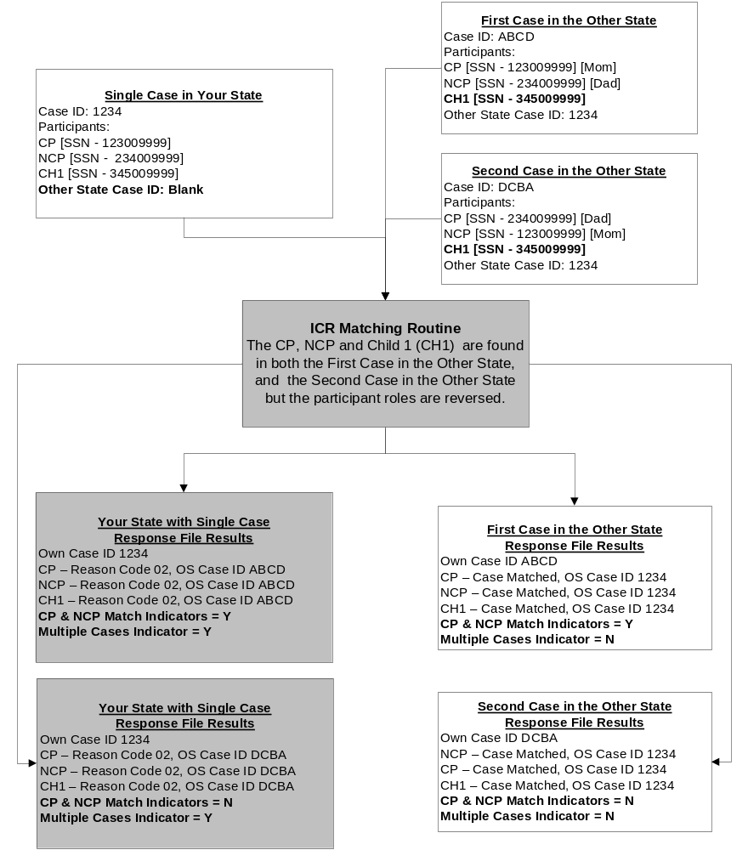

Your case did not contain the Other State Case ID, so the ICR matching logic attempts to find a matching case by finding a child in common. It finds both cases in the other State, because the child appears on both case ABCD and case DCBA, and you receive two responses, one for each matching case. On each case, you receive a Reason Code 02 response on each matched participant.

To alert you to your receipt of multiple matching cases, on each case the Multiple Cases Indicator will be set to ‘Y’. On the case where your CP equals the CP in the other State’s case, and your NCP equals the NCP in the other State’s case, the CP and NCP Indicators will also be set to ‘Y’. On the change of custody case, where the adults in the case have switched roles, the CP and NCP Indicators will be set to ‘N’.

Since the Multiple Cases Indicator displays in an area that was formerly filler on your ICR response file, you have options on whether to update your response file processing to accommodate it or not. Consider the following in making your decision:

- If your State always creates multiple cases for families with multiple orders, or when paternity needs to be established on behalf of multiple children, the Multiple Cases Indicator has no impact on you. There is no need to make any changes to the way you process your ICR response file.

- If your State system can accommodate multiple support orders, or multiple children needing paternity establishment, on a single case, do your major interstate communication partners create multiple cases?
  - If no, there is probably no reason for you to make any change to your response file processing.
  - If yes, it is suggested that you review all cases on which the Multiple Cases Indicator is set to ‘Y’. You may wish to update the Other State Case ID on these cases manually, rather than having them updated automatically. In this way you can update your system with the Other State’s Case ID that best meets your needs for ongoing case processing.

4.5 The ICR SSN Verification Process

The ICR verifies the SSNs of case participants receiving Reason Codes 07 and 08, but does not provide as detailed a verification as is provided by the FCR. With the ICR, the SSA verifies the participant’s SSN based on a name/SSN match. Through the FCR, SSA verifies the participant’s SSN based on a match of the person’s name, SSN, date of birth, and sex, and uses available ESKARI data when certain data elements are missing.

A decision was made not to duplicate the FCR SSN verification process within the ICR. The reasons for this decision are that:

- All fields are not required on the ICR. The case participant’s Sex and Date of Birth (DOB) are optional data elements. If a State did not submit all 4 data elements (Name, SSN, DOB, and Sex) the ICR would have to contain logic to verify the SSN based on 2, 3 or 4 matching data elements.
- The ICR response file would need to inform you of the number of data elements used in the verification process, and which data elements were used. This would require additional changes to the ICR response file, and additional programming on your part to process the multiple responses received.
- There is no provision in the ICR to capture, and provide to you, corrected SSNs or corrected Dates of Birth used in the SSN verification process. The FCR’s SSN verification process has this ability, and your system has already been programmed to receive and process this corrected information.
- There are several levels of verification that can be performed by SSA, using varying amounts of demographic information about the individual, such as ESKARI data. To obtain the same level of SSN verification from the ICR as from the FCR, many additional data elements would need to be added to the ICR extract file, requiring reprogramming by all States.
- States have already programmed a means for recording case participant’s SSNs as ‘verified’ or not, based upon responses received when the individual is added to the FCR. States would need to develop additional programming logic to record an SSN received from the ICR as ‘verified’.

The FCR should be used as the means of obtaining a more rigorous verification of each case participant’s SSN.

When you receive a verified SSN on a Reason Code 07 response, that SSN should be added to the case and the participant submitted, via an ‘add’ transaction, to the FCR. Persons without SSNs cannot be accepted onto the FCR. Your case participant is not currently on the FCR and you are not receiving the benefit of the proactive match information available through the FCR.

If you are unsure whether or not to update your system with a verified SSN received via a Reason Code 08 response, consider adding that SSN as an alias SSN for the individual. The SSN you currently store on your system has probably not been verified by the FCR, and the case participant has not been accepted onto the FCR. Submitting the alias SSN to the FCR will allow the FCR’s verification process to determine if the different SSN provided through the ICR process can receive full verification from SSA.

4.6 How ICR Files Are Provided by States

States participating in ICR develop programs to extract case and participant data for all open and closed interstate cases on their systems. These ICR files contain individual records for each participant on an interstate case. Case data are repeated on each participant record. No intrastate cases should be included in a State’s file of interstate cases submitted to the ICR.

Once the State programs create all of the ICR files, the files are transmitted to OCSE via CONNECT:Direct, which is a secure line of data transmission between the State and SSA, where national ICR processing takes place. The State files are then processed by the ICR match routine to identify matching interstate cases.

SECTION 5.0

HOW TO PRIORITIZE YOUR ICR WORKLOAD

Section 5.0 presents a suggested priority for your State to correct reconciliation discrepancies. It also discusses combinations of multiple Reason Codes that can be returned for individual ICR records. In Sections 6.0 through 15.0, each Reason Code is discussed separately. Included in those sections are descriptions, flow diagram scenarios, points to consider, and Hot Tips to simplify the reconciliation process for each of the Reason Codes.

  - Which Reason Codes Should Be Worked First

Figure 5-1 on the following page illustrates how you should prioritize which Reason Codes to address first. The Reason Code priority applies to where you should devote your time, energy and resources.

- Reason Code 02, which provides a correct case ID for your interstate case in the other State, should always be addressed first. Correction of incorrect case IDs is a top priority for the ICR. When multiple Reason Codes are returned for a single case/participant, correcting the 02 errors first eases your task of correcting other errors. The correction of a 02 error paves the way for better exchange of information with another State in a timely fashion, and makes available the benefits of automating data through CSENet, the Federal Case Registry (FCR), and EFT/EDI.

- Obtaining missing SSNs on case participants should be the second priority for the use of the ICR. Reason Code 07 (Participant SSN Provided by Other State) tells you when the missing SSN of the participant in your case has been provided on the corresponding case by the other State. When the case participant’s SSN is not known you are unable to get that person registered on the FCR, thereby missing out on all of the proactive information available on this person from the FPLS. Moving the individual’s SSN from the response file to your case is a process that can be automated easily.

- Case status and SSN mismatches constitute the next most important tier of reconciliation errors to be corrected. Reason Code 08 (Participant SSN Mismatch) tells you when your State and the other State have different versions of the SSN for the same case participant. Most often the mismatch is the result of transposed digits or a minor data entry error. Correcting these minor errors enables acceptance onto the FCR and receipt of full information from the FPLS.

Both Reason Code 01 (Could Not Find a Matching Case in the Other State) and Reason Code 04 (Your Case is Open, Matches to Closed Case in the Other State) identify conditions where a family may not be receiving the level of service required to effectively process their interstate case. Resolve these discrepancies by determining whether the family still requires service in an interstate case, whether a one-State action can be pursued on its behalf, or whether this particular family no longer requires service in the State and the case can be closed following Federal case closure criteria.

Figure 5-1
Prioritization of ICR Reason Codes

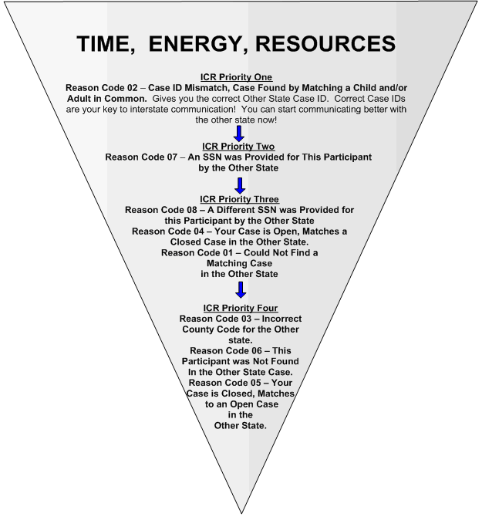

- Reason Code 05 (Your Case is Closed, Matches to Open Case in the Other State) Reason Code 06 (This Participant was Not Found in the Other State Case), and Reason Code 03 (Incorrect County Code for the Other State), represent the lowest priority for correction. If a correct case ID for the other State has been provided through Reason Code 02, then you can reconcile these discrepancies later, once you start communicating with the other State.

Reason Code 09 is not listed in the above priority pyramid, as it is sent only to a State choosing Option #1 in an Unidentified Interstate Cases Project match. All cases receiving Reason Code 09 are to be researched and corrected, as described in Section 15.0 of this User Guide.

5.2 Processing Multiple Reason Codes

The following matrix lists possible combinations of Reason Codes that can be returned for a single record in the ICR results file.

Remember: when Reason Code 02 appears as one of the error codes, correct it first, preferably through the execution of an automated update program. Correcting the 02 error first will facilitate the correction of any other errors associated with the same case/participant. If you receive a Reason Code 03, 04, 05, 07, or 08 without Reason Code 02, it means the Other State Case ID is correct. Automated means of exchanging information on the cases in question may assist in the reconciliation of Reason Codes 03, 04, 05, 07 or 08 errors.

Figure 5-2
Multiple Reason Codes

Reason Code | May Also Include Reason Codes: | Why  Multiple Reason Codes  Appear
02 | 03, 04 or 05;  07or 08 | The combination of Reason Codes 02, 03 and 04 represents an open interstate case in your State that is closed in the other State. The corresponding interstate case in the other State was found through an SSN match of a child in common, or of an adult SSN/participant type match and a child name in common. Your Other State Case ID is incorrect. The county code you have for the other State also is incorrect. If you receive Reason Code 07, you are being provided the SSN for this participant. If you receive Reason Code 08, you are being told that the SSN you have on your case is different from the SSN the other State has for this participant.  The combination of Reason Codes 02, 03 and 05 represents the same situation as above, except this case is a closed interstate case in your State and it is open in the other State. Reason Codes 04 and 05 are mutually exclusive and cannot appear in the same case. Reason Codes 07 and 08 are also mutually exclusive and cannot be received on the same person.
03 | 02, 04 or 05;  07 or 08 | The combination of Reason Codes 03, 02 and 04 represents an open interstate case in your State that is closed in the other State. The corresponding interstate case in the other State was found through an SSN match of a child in common, or of an adult SSN/participant type match and a child name in common. Your Other State Case ID is incorrect. The county code you have for the other State also is incorrect. If you receive Reason Code 07, you are being provided the SSN for this participant. If you receive Reason Code 08, you are being told that the SSN you have on your case is different from the SSN the other State has for this participant.  The combination of Reason Codes 03, 02 and 05 represents the same situation as above, except this case is a closed interstate case in your State that is open in the other State. Reason Codes 04 and 05 are mutually exclusive and cannot appear in the same case. Reason Codes 07 and 08 are also mutually exclusive and cannot be received on the same person.
04 | 02, 03, 07 or 08 | The combination of Reason Codes 04, 02, and 03 represents an open interstate case in your State that is closed in the other State. The corresponding interstate case in the other State was found through an SSN match of a child in common, or of an adult SSN/participant type match and a child name in common. Your Other State Case ID is incorrect. The county code you have for the other State also is incorrect. If you receive Reason Code 07, you are being provided the SSN for this participant. If you receive Reason Code 08, you are being told that the SSN you have on your case is different from the SSN the other State has for this participant. Reason Codes 07 and 08 are mutually exclusive and cannot be received on the same person.
05 | 02, 03, 07 or 08 | The combination of Reason Codes 05, 02, and 03 represents a closed interstate case in your State that is open in the other State. The corresponding interstate case in the other State was found through an SSN match of a child in common, or of an adult SSN/participant type match and a child name in common. Your Other State Case ID is incorrect. The county code you have for the other State also is incorrect. If you receive Reason Code 07, you are being provided the SSN for this participant. If you receive Reason Code 08, you are being told that the SSN you have on your case is different from the SSN the other State has for this participant. Reason Codes 07 and 08 are mutually exclusive and cannot be received on the same person.
07 | 02, 03, 04 or 05 | The combination of Reason Codes 07, 02, and 03 represents a person’s SSN being provided to you from the matching case in the other State. The corresponding interstate case in the other State was found through an SSN match of a child in common, or of an adult SSN/participant type match and a child name in common. Your Other State Case ID is incorrect. The county code you have for the other State also is incorrect. If you received Reason Code 04, your open interstate case matched to a closed case in the other State. If you received a Reason Code 05, your closed interstate case matched to an open case in the other State. Reason Codes 04 and 05 are mutually exclusive and cannot apper in the same case.
08 | 02, 03, 04 or 05 | The combination of Reason Codes 08, 02, and 03 represents a person whose SSN on your case is different from the SSN the other State has for this participant. The corresponding interstate case in the other State was found through an SSN match of a child in common, or of an adult SSN/participant type match and a child name in common. Your Other State Case ID is incorrect. The county code you have for the other State also is incorrect. If you received Reason Code 04, your open interstate case matched to a closed case in the other State. If you received a Reason Code 05, your closed interstate case matched to an open case in the other State. Reason Codes 04 and 05 are mutually exclusive and cannot appear in the same case.
Reason Code 00 – Case Data Matched and This Participant Matched, Reason Code 01 – Could Not Find a Matching Case in the Other State, and Reason Code 06 – This Participant was Not Found in Other State Case, do not appear on this chart. These Reason Codes never appear in combination with other Reason Codes.

Also, Reason Code 09, sent only to States choosing Option #1 in the Unidentified Interstate Cases Project, may be received in conjunction with Reason Code 05 if the State’s case is closed to IV-D on the FCR.

Apply the proposed priority to reconciling ICR discrepancies and you can resolve the most important issues with your interstate caseload first. The keys to this prioritization are the ICR Reason Codes. The following nine sections provide you with detailed information and examples for each Reason Code.

SECTION 6.0

REASON CODE 00
CASE DATA MATCHED AND THIS PARTICIPANT MATCHED

Success! Your interstate case data matched and this participant was found on the other State’s interstate case. This section explains Reason Code 00 and suggests reconciliation actions that may be necessary to take even though the ICR found no interstate case discrepancies.

6.1 What Reason Code 00 Means

Reason Code 00 means that all interstate case data matches. The ICR matching routine found the same Other State Case ID, county code, and case status in the other State as submitted on your State’s file. Reason Code 00 also means your participant was found in the other State’s case.

The ICR results file provides you with the number of adults and the number of children submitted for your case and the other State case. It also provides the number of adults and the number of children that match between the two cases. Keep in mind that case structures may vary from State to State; so, if the number of participants does not match completely, it may not necessarily mean there is a case discrepancy. For example, your State may allow multiple CPs or NCPs on a single case, whereas the other State may require a separate case for each NCP or CP.

You also receive a Y/N indicator that tells you whether the CP and NCP matched between the two States. If all case participants match, but both the CP Indicator and NP Indicator are set to ‘N’, use caution here since this may reflect that the wrong case was matched. The match may be with a change of custody case for the child(ren).

6.2 Reason Code 00 Example

Figure 6-1 shows how the ICR matching process identifies a Reason Code 00 and what is returned in your State ICR results file. At the top, critical ICR data submitted by your State and the other State are displayed in the Your State ICR File and the Other State ICR File boxes, respectively. The example then displays the results of the ICR match routine’s processing of these data in the ICR Match Routine Results box. At the bottom the ICR Reason Codes sent back to your State and to the other State for each participant are displayed in the Your State Response File Results and Other State Response File Results boxes.

Figure 6-1
Reason Code 00 Match Routine

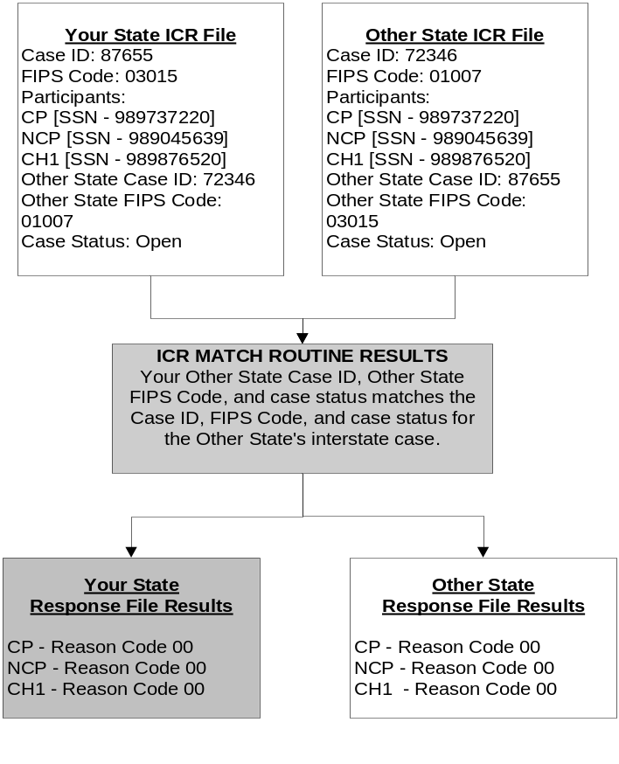
  - What to Automate in Reconciling Reason Code 00

The number of matching participants between your interstate case and the other State’s interstate case, and the CP Indicator and NP Indicator, are critical to whether further action is required on a Reason Code 00 record. Following are suggestions for automated action based on receiving Reason Code 00:

- The CP Indicator and the NP Indicator tell you whether these adults matched on both States’ interstate cases by participant type. These indicators are useful in identifying interstate Foster Care and joint custody cases. For example, States should not have sent a Foster Care agency to the ICR as a CP. Interstate Foster Care cases should not contain CP records in either State’s ICR files. Therefore, the CP Indicator would show an ‘N’ when this situation occurs.
- Some States open a new case and close an existing case when the NCP and CP roles in the case are switched due to rotating custody of the children. If all adults on both States’ interstate cases match, but the CP Indicator and the NP Indicator are both set to ‘N’, it is most likely that the adult participants have reversed roles on each interstate case.
- If the number of adult participants match and the number of child participants match between the two interstate cases, and both the CP Indicator and NP Indicator are set to ‘Y’, then no further action is required. The case data and participants are synchronized between the two States.
- If the number of adult participants does not match, or the CP Indicator or NP Indicator is set to ‘N’, manual reconciliation may be warranted.

6.4 Decision Making for Reason Code 00 When Your State is Either the Initiating State or Responding State

Whether your State is the Initiating or Responding State, consider the following points to help you determine the most effective action to take on your case.

Reason Code 00: Points to Consider When your State is Either the
Initiating State or Responding State

- Do the CP and NCP in your State match the CP and NCP in the other State’s case?

- Did any of the participants in your case receive Reason Code 06?
  - Was a 06 received on an adult in the case?
  - Was a 06 received on a child in the case?

- Are your State’s case participants reconciled with the case participants in the other State?

- Is additional reconciliation required for any individual case participant?

- Did any of the participants on your case receive Reason Code 07 or 08?

If you receive Reason Code 00 on a participant record, you will not receive any other Reason Codes. However, Reason Code 00 may be received for some, but not all, participants in your State’s case. Your case may match the case in the other State, but there could be a participant that could not be found; if so, a Reason Code 06 would identify that missing participant in your ICR results file. Please read Section 11.0 for suggestions on how to reconcile a missing participant on your interstate case.

Your case may match the case in the other State, but there could be a participant whose SSN was provided by the other State, or is different from the SSN used by the other State; if so, a Reason Code 07 or 08 would identify that participant in your ICR results file. Please read Sections 8.0 and 9.0 for suggestions on how to reconcile missing and different SSNs for participants on your interstate case.

Reason Code 00 indicates that your interstate case has all the basic other State interstate case data that is required to effectively communicate with that other State. The following section describes the reconciliation discrepancy that occurs when the most critical piece of interstate case data, the Other State Case ID, is incorrect on your interstate case.

SECTION 7.0

REASON CODE 02
CASE ID MISMATCH, CASE FOUND BY MATCHING A CHILD
OR ADULT IN COMMON

The Other State Case ID you have in your system is incorrect, but the correct case ID for the other State has been found! This is the easiest ICR result to automate! You should start using the correct case IDs provided by other States as soon as possible. This section discusses Reason Code 02 and suggests ways to reconcile Other State Case IDs in your State system.

7.1 What Reason Code 02 Means

Reason Code 02 means that the case ID your State maintains for the other State is incorrect. However, a corresponding case in the other State was found based on matching a child SSN in common, or an adult SSN/Participant Type and child name in common, with your interstate case. You can automate updates based on the correct case IDs provided by other States.

Remember, ICR matches are returned at the person level. Reason Code 02 is returned for each person in your case when your Other State Case ID is incorrect. Additionally, the number of matching adults and children is provided, as well as indicators that tell you whether the CP and NCP are the same on both cases. It is possible for you to receive other Reason Codes in addition to Reason Code 02 on a returned person record. You may receive:

- Reason Code 03 – Incorrect County Code for the Other State
- Reason Code 04 – Your Case is Open, Matches to Closed Case in the Other State
- Reason Code 05 – Your Case is Closed, Matches to Open Case in the Other State
- Reason Code 07 – An SSN was Provided for this Participant by the Other State
- Reason Code 08 – Different SSN was Provided for this Participant by the Other State.

Before you address any of these other Reason Codes, you should correct the Other State Case ID in your State system. Correcting the Other State Case ID in your interstate case is a top priority of the ICR and provides you with the ability to open up other automated avenues of communication with other States. Corrected Other State Case IDs facilitate future interstate communication.

7.2 Reason Code 02 Example

Figure 7-1 shows how the ICR matching process identifies a Reason Code 02 and what is returned in your State ICR results file. At the top, critical ICR data submitted by your State and the other State are displayed in the Your State ICR File and the Other State ICR File boxes, respectively. The example then displays the results of the ICR match routine’s processing of these data in the ICR Match Routine Results box. At the bottom the ICR Reason Codes sent back to your State and to the other State for each participant are displayed in the Your State Response File Results and Other State Response File Results boxes.

Figure 7-1
Reason Code 02 Match Routine

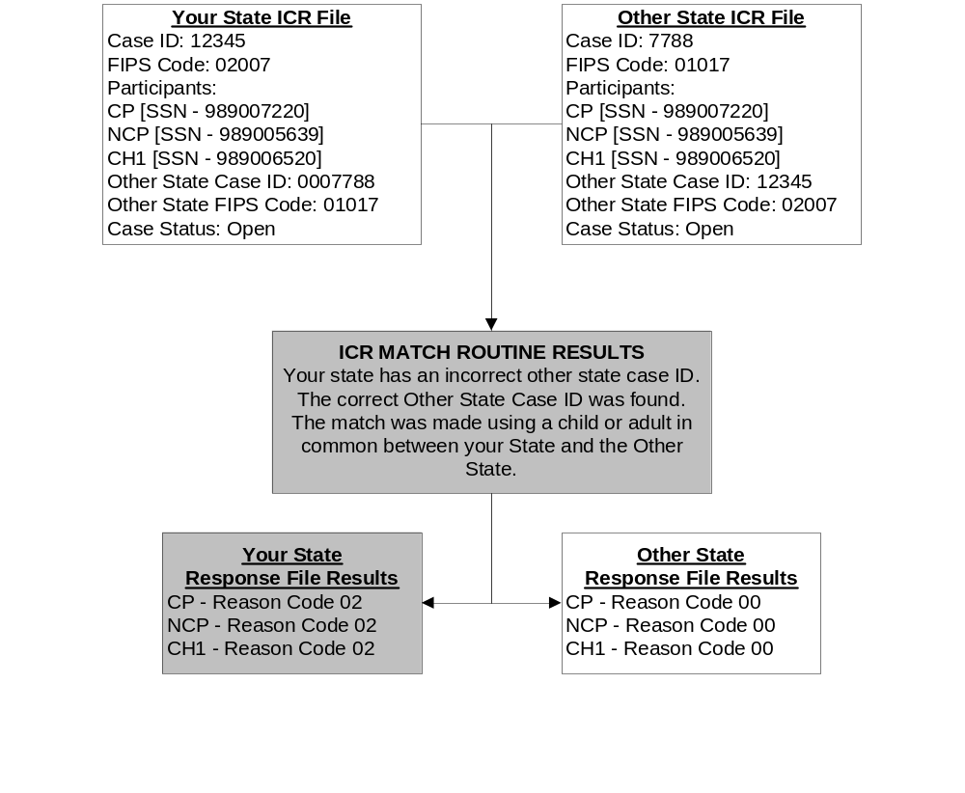
In this example, the correct interstate case ID in the other State was obtained by matching on a child SSN or adult SSN/participant type and child name in common on both States’ interstate cases. The result of the matching is the provision of the correct case ID for the other State’s case. Supplementing the match made based on a child and/or adult in common, are additional data to help you determine if the correct case has been identified. The following data allow you to further define the extent to which the participants in your interstate case match to the participants in the other State’s interstate case:

- CP Indicator, which shows whether a CP in your interstate case matches a CP in the other State’s interstate case,
- NP Indicator, which shows whether an NCP in your interstate case matches an NCP in the other State’s interstate case, and
- Number of case participants that match between your interstate case and the interstate case in the other State, which is broken out into the following six separate totals:
  - Number of adults submitted by your State
  - Number of adults submitted by the other State
  - Number of adults that matched between your State and the other State
  - Number of children submitted by your State
  - Number of children submitted by the other State
  - Number of children that matched between your State and the other State.

These totals of matched case participants tell you how well your interstate case matches to the interstate case in the other State. This information is useful in establishing thresholds for performing automated updates of the other State’s case ID in your State system when a Reason Code 02 is received. For instance, you may determine that it is acceptable for all but one child to match because of the possibility that either you or the other State did not know about one particular child (e.g., a new baby or an emancipated child).

One reason you might receive discrepancies in the number of participants submitted by your State in comparison to the number submitted by the other State would be if duplicate cases had been encountered in the ICR matching process. The ICR match routine would have treated the duplicate cases as one case, but the number of participants would be the combined total of participants for all of the duplicate cases.

To further help you determine the appropriate next step, use the CP and NP Indicators. The CP Indicator and the NP Indicator tell you whether these adults matched on both States’ interstate cases by participant type. These indicators are useful in identifying interstate Foster Care cases. For example, interstate Foster Care cases should not contain CP records in either States’ ICR files. Therefore, the CP Indicator would show an ‘N’ when this situation occurs.

Additionally, these CP and NP Indicators are helpful in identifying changed custody cases. Some States open a new case and close an existing case when the NCP and CP roles in the case are switched due to changed custody of the children. If all adults on both States’ interstate cases match, but the CP Indicator and the NP Indicator are both set to ‘N’, it is most likely because the adult participants have reversed roles on each interstate case.

The CP and NP Indicators also play a critical role in automating the reconciliation of Reason Code 02 by helping you establish a threshold of what constitutes an acceptable match.

7.3 What to Automate in Reconciling Reason Code 02

Following are suggestions for automated reconciliation of Reason Code 02, together with suggestions on how to establish an acceptable threshold to trigger automated Other State Case IDs in your State system:

- Use the number of case participants submitted by each State to establish a matching threshold for automated update of Other State Case IDs. Some States have developed automated programs that update the Other State Case ID only if the adult participants on their interstate case match to the adult participants on the other State’s interstate case, and at least one child matches between both States’ interstate cases.
- Establish a policy for the percent of children in your interstate case that must match the children in the other State’s interstate case. A child in either interstate case may now be emancipated or otherwise no longer active.
- The CP Indicator and the NP Indicator also play a role in potential automated updates. For example, an interstate case in your State and an interstate case in the other State may share an NCP, but have different CPs (e.g., the mother in one case, but a relative in the other case). If either the CP Indicator or the NP Indicator is set to ‘N’, the ICR may have identified an interstate case in the other State where there has been a custody change.
- Establish a rule that both adults in your interstate case must have the same role as the adults in the other State’s interstate case, based upon the CP Indicator and the NP Indicator. If either of the adults does not match based on participant type, the ICR may have identified a different interstate case in the other State.
- Communicate with the other State when matching criteria are not met.
- Update Other State Case ID with the exact case ID provided from the other State on the Reason Code 02 record. Include leading zeroes and special characters with the exception of asterisks and backslashes. (Note: These characters are problematic for EFT/EDI transactions.)
- If Reason Code 02 and 07 (An SSN was Provided for this Participant by the Other State) are received on the same participant, consider updating both data elements at the same time.
- Some States (Alabama, California, Montana, Nebraska and Puerto Rico) have case IDs with up to 15 characters. If your State system cannot store 15 characters in the field designated for Other State Case ID, your automated update program must truncate the Other State Case ID correctly to store the significant characters of the ID. The FCR/ICR Case ID Matrix in Section 3.6 describes all States’ case IDs to assist you with this issue.
- Maintain statistics on the number of Other State Case IDs that your State updated automatically, and the number that needed to be updated manually. Receiving a corrected case ID for the other State’s interstate case is the most important benefit to come from the ICR.

7.4 Decision Making for Reason Code 02 When Your State is Either the Initiating or Responding State

Whether your State is the Initiating or Responding State, consider these points to help you determine the most effective action to take on your interstate case.

Reason Code 02: Points to Consider When Your State is Either the
Initiating State or the Responding State

- Does the number of adults in your case equal the number of adults in the other State’s case? Do the CP and NCP in your State match the CP and NCP roles in the other State’s case?

- Did you receive multiple Reason Codes on this case?

- In addition to the matching adults, has your State’s threshold for the number of matching children been met?

- Will the corrected other State’s correct case ID fit into the Other State Case ID field on your State’s system?

Do not assume that other States follow the same conventions for storing case IDs that your State has adopted. If your State has not allowed fifteen characters for alphanumeric case IDs from other States, you must exercise caution in how you store Other State Case IDs. The FCR/ICR Case ID Matrix in Section 3.6 provides descriptions of each State’s case ID to assist you with this issue.

The next section discusses Reason Code 07, which indicates that the participant in your case did not have an SSN, but an SSN is provided to you from the corresponding case in the other State.

SECTION 8

REASON CODE 07
AN SSN WAS PROVIDED FOR THIS PARTICIPANT BY THE OTHER STATE

An SSN for one of the case participants in your State was provided on the corresponding interstate case in the other State. This section explains Reason Code 07 and suggests ways to use this participant’s missing information.

8.1 What Reason Code 07 Means

Reason Code 07 means that your State’s case was matched with a case in the other State, but you did not submit an SSN for this participant and the other State did. The SSN is being provided for this participant in your case. For example, your State submitted a case with CP, NCP, and Child 1. You provided an SSN for the CP and Child 1, but not for the NCP. The other State submitted a case with CP, NCP, and Child 1 and submitted an SSN for all participants, including the NCP. You will receive Reason Code 07 for that NCP with the SSN provided by the other State.

A verification indicator will inform you whether or not the provided SSN has been verified by the Social Security Administration (SSA). SSA verifies name/SSN combinations for all participants receiving Reason Code 07. See Section 4.4 for an explanation of the ICR’s SSN verification process.

Remember that ICR results are returned at the participant level. Most Reason Codes indicate case-level discrepancies, but Reason Code 07 is a participant-level discrepancy and can be returned with case-level Reason Codes.

8.2 Reason Code 07 Example

Figure 8-1 shows how the ICR matching process identifies a Reason Code 07 and what is returned in your State ICR results file. At the top, ICR data submitted by your State and the other State are displayed in the Your State ICR File and the Other State ICR File boxes. The example then displays the results of the ICR match routine’s processing of these data in the ICR Match Routine Results box. At the bottom, the ICR Reason Codes sent back to your State and to the other State for each participant are displayed in the Your State Response File Results and the Other State Response File Results boxes.

This example shows that you did not submit an SSN for the NCP in your case. For the two participants that matched (CP and Child1), Reason Code 00 is returned because there are no other discrepancies in the case data. The NCP participant in your interstate case will receive only Reason Code 07 and an SSN from the other State for that participant.

If you receive Reason Code 07 on an ICR results record, you also may have received other Reason Codes, including Reason Code 02, which provides a corrected case ID, Reason Code 03, which provides a different county code for the case in the other State, and Reason Code 04 or 05, which inform you of an interstate case status discrepancy between your State and the other State. Reason Code 02 should be reconciled before adding the SSN provided by the other State, or reconciling any other Reason Code.

Figure 8-1
Reason Code 07 Match Routine

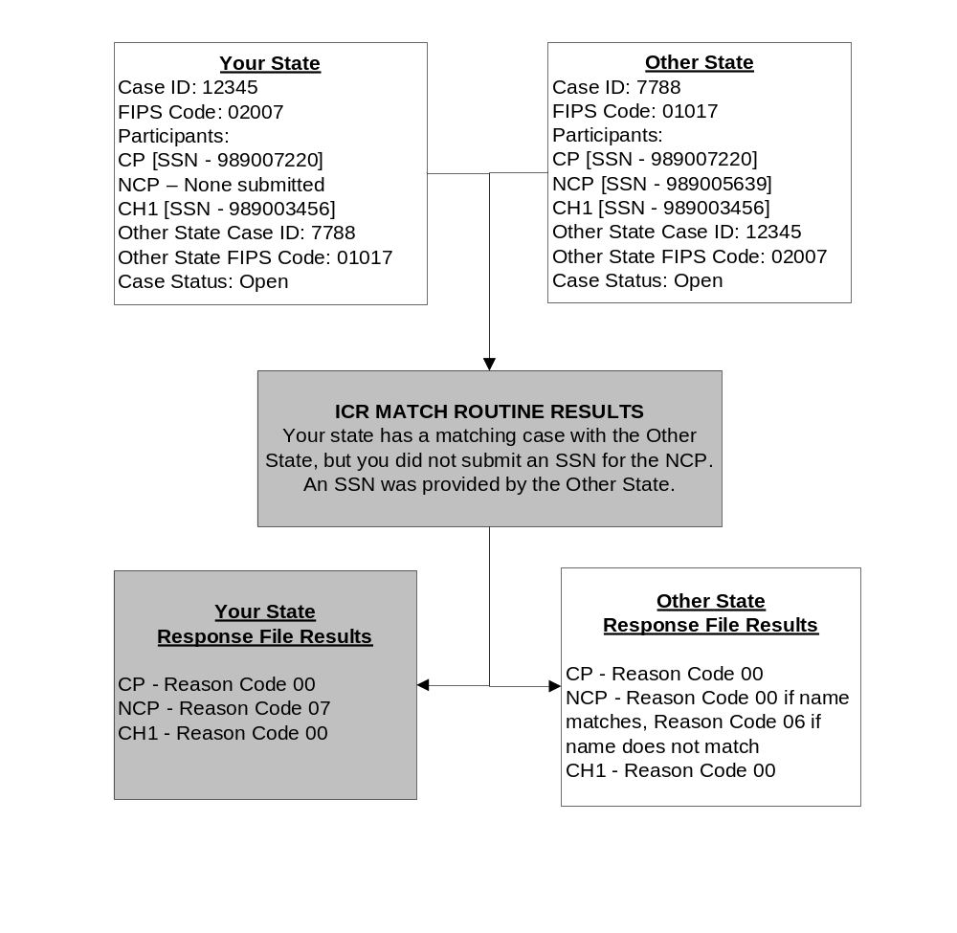
8.3 What to Automate in Reconciling Reason Code 07
Following are suggestions for automated reconciliation of Reason Code 07

- The CP Indicator and the NP Indicator play a role in potential automated updates. If you receive a new SSN for any case participant, establish a policy to check to make sure the CP or NP Indicator is set to ‘Y’ prior to automatically adding the new SSN to your case.
- If the SSN provided by the other State has been verified by SSA, automatically update your system with this participant’s SSN.
- Ensure that participants whose SSN has been provided by the other State via Reason Code 07 are submitted to the FCR so their SSNs can be verified, based on the person’s name, SSN, DOB, sex, and available ESKARI data. This will permit you to benefit from all proactive matching available through the FCR.
- Consider alerting the caseworker when an SSN is automatically updated. This will allow the worker to be notified of the change, and be given the opportunity to determine the next action to be taken on the case. For example, if a new SSN is provided for an NCP and that NCP had been in Locate status, the worker can access additional locate sources and proceed with the next appropriate action to further provide services to the family.
- Consider printing a report containing information on all individuals for whom you received Reason Code 07, but the Other State SSN Verification Indicator at position 484 displays as ‘N’, meaning not verified by SSA. On the report, include the individual’s Name, Date of Birth, and Sex code as recorded in positions 315 through 385 on the response file. Then compare these data from the response file against the data maintained on your system for the individual. Reviewing the information received from the other State against the data you store on your system, might convince you to add the unverified SSN to your system, as you believe the other information you have on the individual will allow this SSN to be verified through the FCR.
  - Might you have a better name for the individual? For example, might the other system have his name as Bob, where you know his legal name is Robert?
  - Might the other State have the child’s last name as Smith (the NCP’s last name), where you have the child’s last name as Jones (the CP’s last name)? If you know that paternity has not yet been established for this child, might the last name you have be the correct one?
  - Might you have sufficient ESKARI data for this individual to facilitate verification of the SSN through the FCR?
  - Consider maintaining statistics on the number of SSNs that your State updated automatically, and the number that needed to be updated manually. Having the correct SSN for the participants in your interstate case is very important in providing the best services possible.

8.4 Decision Making for Reason Code 07 When Your State is Either the Initiating State or the Responding State

Regardless of whether your State is the Initiating State or the Responding State, consider these points to help you determine the most effective action to take on your interstate case.

Reason Code 07: Points to Consider When Your State is Either the
Initiating State or the Responding State

- Do the CP and NCP in your State match the CP and NCP in the other State’s case?
  - Does your State system allow for multiple NCPs and/or CPs on one case?

- Does the response file indicate that this participant’s SSN was verified?

- If the provided SSN is for the NCP, is the NCP in Locate? If so, consider the appropriate enforcement actions that might be taken. (Examples include Income Withholding, Federal Tax Offset, and FIDM.)

- Did you receive multiple Reason Codes on this case?

- Have you already received an SSN from another source between the time of ICR submission and receipt of the results file?
  - Has the SSN been verified through the FCR?
  - Does that SSN match the SSN provided by the ICR?

- You might be receiving an SSN for an individual who is no longer in an open interstate action, or whose IV-D case may now be closed. Can you add the SSN to the case participant under either of these circumstances?

8.5 Hot Tips for Reconciling Reason Code 07

Monitor individuals whose SSN has been provided by the ICR to see if they are now accepted into the FCR. Use the proactive data provided through the FCR to provide further benefit to the family.

Caseworkers have often considered obtaining NCP SSNs more important than obtaining the SSNs of the CP or child. This may have been true in the past, but remember that having the correct SSN for the CP gives the State the ability to put the CP into Locate when the State has undistributed collections owed to that person. Having the correct SSN for the child in the case is also of increasing benefit; for example, the automated match with the Defense Manpower Data Center will provide proactive information on health insurance benefits available through the military for children registered on the FCR.

The next section addresses Reason Code 08, which occurs when your State submits an SSN for a participant in your interstate case that is different from the SSN provided for that participant in the other State.

SECTION 9.0

REASON CODE 08

A DIFFERENT SSN WAS PROVIDED FOR THIS PARTICIPANT

BY THE OTHER STATE

A different SSN for this participant was provided on the corresponding case by the other State. This section explains Reason Code 08 and suggests ways to reconcile the new information on this participant.

9.1 What Reason Code 08 Means

Reason Code 08 means that your State’s case was matched with a case in the other State, but the SSN you provided for this participant did not match the SSN provided by the other State. A different SSN is being provided for this participant in your case. For example, your State submitted a case with CP, NCP, and Child 1 with an SSN provided for each participant. The other State submitted a case with CP, NCP, and Child 1 and submitted an SSN for all participants. However, the SSN submitted for the NCP in your case did not match the SSN for the NCP in the other State’s case. You will receive Reason Code 08 for the NCP with the different SSN provided by the other State, as well as an SSN Verification indicator.

A verification indicator will inform you whether or not the provided SSN has been verified by the SSA. SSA verifies name/SSN combinations for all participants receiving Reason Code 08. See Section 4.4 for an explanation of the ICR’s SSN verification process. You will also receive a verification indicator showing whether the SSN you provided on your extract file has been verified by the SSA.

Remember that ICR results are returned at the participant level. Most Reason Codes indicate case-level discrepancies, but Reason Code 08 is a participant-level discrepancy and can be returned with case-level Reason Codes.

9.2 Reason Code 08 Example

Figure 9-1 shows how the ICR matching process identifies a Reason Code 08 and what is returned in your State ICR results file. At the top, critical ICR data submitted by your State and the other State are displayed in the Your State ICR File and the Other State ICR File boxes, respectively. The example then displays the results of the ICR match routine’s processing of these data in the ICR Match Routine Results box. At the bottom the ICR Reason Codes sent back to your State and to the other State for each participant are displayed in the Your State Response File Results and the Other State Response File Results boxes.

This example shows that the SSN you submitted for the NCP in your case did not match the SSN for the NCP in the other State’s case. For all of the participants who matched (CP and Child1), Reason Code 00 is returned because there are no other discrepancies in the case data. The NCP in your interstate case will receive only Reason Code 08, as a different SSN has been provided by the other State for that participant.

Note: Prior ICR matches have shown that many SSN discrepancies are due to transposition of numbers, or that the SSNs stored by the two States are only one digit off from each other. Check to see if the SSN you have stored on your State’s system has been correctly entered.

Figure 9-1
Reason Code 08 Match Routine

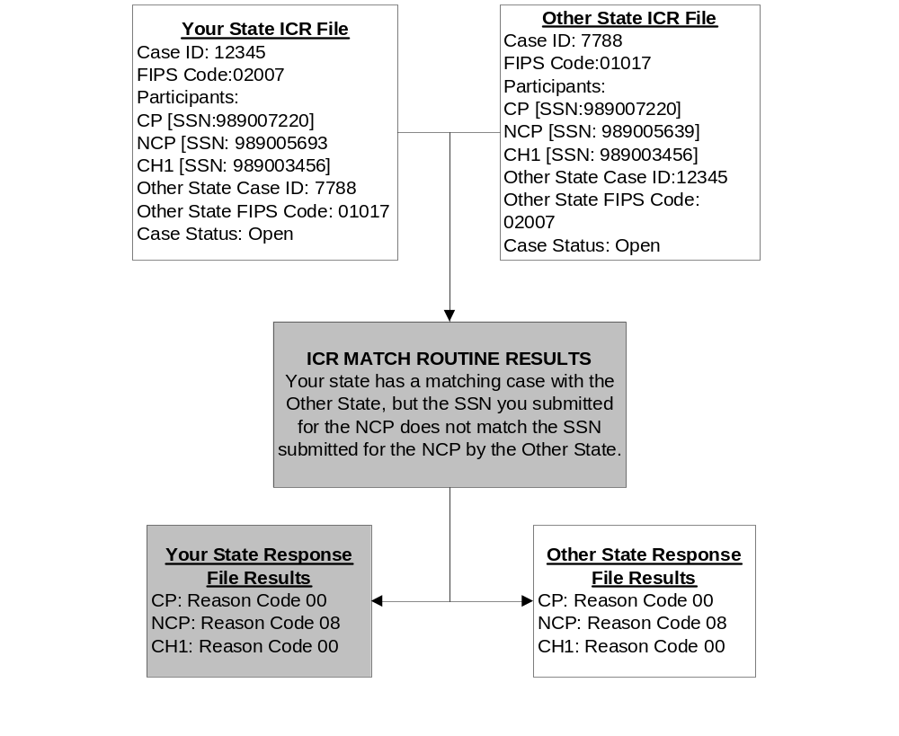
If you receive Reason Code 08 on an ICR results record, you also may have received other Reason Codes, including Reason Code 02, which provides a corrected case ID, Reason Code 03, which provides a different county code for the case in the other State, and Reason Code 04 or 05, which inform you of an interstate case status discrepancy between your State and the other State. Reason Code 02 should be reconciled before adding the SSN provided by the other State, or reconciling any other Reason Code.

9.3 What to Automate in Reconciling Reason Code 08

Automated processing for Reason Code 08 responses is possible due to the verification indicator attached to the SSN provided by the other State.

- If a different SSN is provided for a participant in your case, check to see if the SSN you have stored in your system has been verified. If the SSN you have on your system for this participant is unverified or invalid, automatically add the different SSN for this participant, if this different SSN has been verified.
- If the SSN you currently store for this individual has been verified, and the SSN provided by the other State is also verified, consider adding the SSN provided by the other State as an alias SSN. This participant might legally have multiple verifiable SSNs.
- Ensure that participants whose SSN has been changed to the SSN provided by the other State via a Reason Code 08 are submitted to the FCR. This will allow the FCR to verify the newly added SSN based on the person’s name, SSN, DOB, sex, and available ESKARI data. This will permit you to benefit from all proactive matching available through the FCR.
- The CP Indicator and the NP Indicators play a role in potential automated updates. If you receive a different SSN for any case participant, establish a policy to check to make sure the CP or NP Indicator is set to ‘Y’ prior to automatically adding the different SSN to your case.
- If neither the SSN your State submitted, nor the SSN provided by the other State, are verified, consider generating a report of participant SSNs for workers to reconcile manually.
- Consider maintaining statistics on the number of SSNs that your State updated automatically, and the number that needed to be updated manually. Having the correct SSN for the participants in your interstate case is very important in providing the best services possible.

9.4 Decision Making for Reason Code 08 When Your State is Either the Initiating State or the Responding State

Regardless of whether your State is the Initiating State or the Responding State, consider these points to help you determine the most effective action to take on your interstate case.

Reason Code 08: Points to Consider When Your State is Either the
Initiating State or the Responding State

- Do the CP and NCP in your State match the CP and NCP in the other State’s case?
  - Does your State system allow for multiple NCPs and/or CPs on one case?

- If the provided SSN is for the NCP, is the NCP in Locate? If so, consider the appropriate enforcement actions that might be taken. (Examples include Income Withholding, Federal Tax Offset, and FIDM)

- Did you receive multiple Reason Codes on this case?

- You might be receiving a different SSN for an individual who is no longer involved in an open interstate action, or whose IV-D case may now be closed. Can you change the SSN on a case participant under either of those circumstances?

9.5 Hot Tips for Reconciling Reason Code 08

Correcting the SSN of a case participant received via a Reason Code 08 response can be as valuable as adding an SSN received via a Reason Code 07 response. Correct SSNs on all case participants are the keys allowing the case to benefit from automated case processing.

You will see an interesting correlation between individuals receiving Reason Code 08 and the FCR. Reason Code 08 will be received in the following two circumstances:

- Your State submitted an SSN for an individual, but that SSN does not match the SSN the other State submitted. Both States receive Reason Code 08 and can see which of the two SSNs has been verified based on the name/SSN match.
- Your State submitted an SSN for an individual, but the other State did not submit an SSN for this individual. Your State will receive a Reason Code 08 and the other State’s SSN verification indicator will be set to ‘N’ for ‘not verified’. The other State will receive a Reason Code 07, receive the SSN you have for the individual, and see the ‘Y’ or ‘N’ showing whether your State’s SSN has been verified.

Before taking any other actions, check to see if the other State submitted an SSN for any participant receiving Reason Code 08.

In the situation where the other State has no SSN for a case participant, that participant is probably not registered on the FCR in the other State’s case. When the other State adds the SSN received from your State, and submits that participant to the FCR, your State should begin receiving FCR-to-FCR proactive matches providing you with information on the corresponding case in the other State.

The next section discusses Reason Code 04, which focuses on another significant case discrepancy indicating service to families is at risk. This is a case status discrepancy in which your open interstate case has matched a closed interstate case in the other State.

SECTION 10.0

REASON CODE 04
YOUR CASE IS OPEN,
MATCHES TO CLOSED CASE IN THE OTHER STATE

Your case is open as an interstate case, but the interstate case in the other State is closed. This section explains Reason Code 04 and suggests ways to reconcile this case status discrepancy. This discrepancy is a significant indication that your State and the other State are not communicating effectively in regards to an interstate case.

10.1 What Reason Code 04 Means

Reason Code 04 tells you that a corresponding interstate case has been found on the other State’s ICR file, but the interstate case in the other State is closed whereas your case is open. It is similar to Reason Code 01 in that it indicates a lack of communication and potential case processing problems between the two States. The primary difference between Reason Code 01 and Reason Code 04 is that Reason Code 04 tells you a matching case in the other State was found with a case status discrepancy, whereas Reason Code 01 tells you that a matching case could not be found at all.

Consider the following issues when working these discrepancies:

- Correcting a Reason Code 04 discrepancy ensures that the family is being effectively served.
- It may be that your case should be an intraState case. If you are the Initiating State, you may want to use long arm rather than requesting assistance from a Responding State.
- It also may be possible that an unnecessary interstate case can be closed in accordance with Federal case closure criteria.

10.2 Reason Code 04 Example

Figure 10-1 shows how the ICR matching process identifies a Reason Code 04 and what it returns in your State ICR results file. At the top, critical ICR data submitted by your State and the other State are displayed in the Your State ICR File and the Other State ICR File boxes, respectively. The example then displays the results of the ICR match routine’s processing of these data in the ICR Match Routine Results box. At the bottom the ICR Reason Codes sent back to your State and to the other State for each participant are displayed in the Your State Response File Results and the Other State Response File Results boxes.

Figure 10-1
Reason Code 04 Match Routine

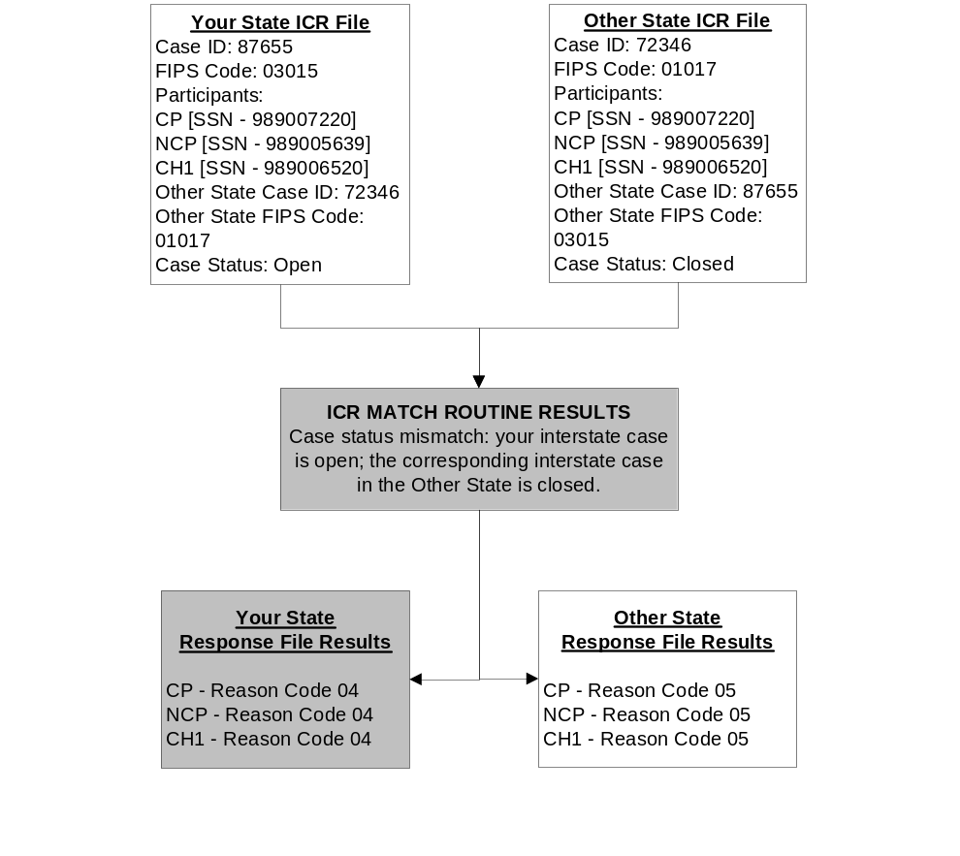
This example shows that your State and the other State are not in agreement concerning the status of this interstate case. Your State thought that the other State was still working this case with you, but the other State had closed its interstate case. Further investigation is needed to find out how the case should be handled. If you receive Reason Code 04 on an ICR results record, you also may have received other Reason Codes, including Reason Code 02, which provides a corrected case ID, Reason Code 03, which provides a different county code for the case in the other State, and Reason Code 07 or 08, which provide you a new or different SSN for a case participant. If Reason Code 02 has been received, you are strongly encouraged to reconcile that case ID discrepancy before reconciling the interstate case status open/closed issue.

10.3 What to Automate in Reconciling Reason Code 04

Automating the results data from Reason Code 04 can assist the worker by presenting necessary information to determine the most effective action to take next on this interstate case.

To shorten the time needed to research existing interstate case information, you could put in place a program to provide a list of cases where:

- A previous communication has been received through CSENet,
- NDNH information has previously been received from the FCR, or
- Money is being processed on the case.

Note: It may be necessary to create work lists of cases displaying only Reason Code 04 errors for the appropriate worker to review.

In approaching how to handle Reason Code 04, address what role your State has as either the Initiating or Responding State in the interstate relationship. Who has the primary role in answering to the family’s request for service? This helps determine the next course of action. The objective, whether you are the Initiating or Responding State, is to ensure service to the family is being provided, as needed.

Many of the decisions you should make upon receipt of Reason Code 04 are the same as those you make upon receipt of Reason Code 01. See Section 11.0 for a detailed discussion of Reason Code 01.

10.4 Decision Making for Reason Code 04 When Your State is the Initiating State

When your State is the Initiating State, your goal is to ensure that the case is appropriately worked, either by your own State as an intraState case, or by the other State. Consider these points to help you determine the most effective action to take on your interstate Initiating case.

Reason Code 04: Points to Consider When Your State is the
Initiating State

- What is the next action needed on this case?
  - Establishment of paternity or a support order
  - Enforcement of existing support order

- Has the Responding State provided information on this case?

- Has the FCR already provided:
  - FCR-to-FCR proactive matches from any State?
  - NDNH information?
  - Multi-State FIDM information?
  - Death information on the NCP?

- Do you need to initiate locate activities to obtain more information?

- Do you need the assistance of another State to take the next required action on this case?

10.5 Decision Making for Reason Code 04 When Your State is the Responding State

When the corresponding interstate case is closed in the Initiating State, examine whether either the CP or NCP has applied for IV-D services in your State. The case may need to be changed to an intraState case. It also is possible that the case status should be changed to non IV-D, or the case closed completely. The case cannot be closed unless it adheres to Federal case closure criteria.

Reason Code 04: Points to Consider When Your State is the
Responding State

- Is money being processed through your State’s system on this case?

- Is there a support order attached to this case?

- Has the CP or NCP applied for IV-D services in your State?

- Are arrears owed to your State?

10.6 Hot Tip for Reconciling Reason Code 04

To effectively work Reason Code 04 discrepancies, combine worklists of Interstate Responding cases receiving Reason Code 04 with worklists of Interstate Responding cases receiving Reason Code 01. Many of the same decisions need to be made for both types of case discrepancies.

The next section discusses Reason Code 01, which indicates that the ICR could not find a matching case in another State with which you thought you shared an interstate case.

SECTION 11.0

REASON CODE 01
COULD NOT FIND A MATCHING CASE IN THE OTHER STATE

A matching interstate case could not be found in the ICR file submitted by the State with which you thought you shared an interstate case. This section explains Reason Code 01 and suggests ways to reconcile the ICR’s failure to find a matching interstate case for your interstate case.

11.1 What Reason Code 01 Means

Reason Code 01 means that a matching interstate case could not be found in the other State’s ICR file that corresponds to your interstate case. This includes closed interstate cases as well as open interstate cases in the other State. However, this does not unilaterally mean that a case does not exist in the other State. The ICR matching routine may not have been able to identify it because:

- The other State does not identify its case as an interstate case (i.e., the case is considered an intraState case), so its case was not included in that State’s ICR file.
- The other State may have overwritten your State’s interstate action with information from subsequent interstate actions.
- The other State’s interstate case data may have been lost or overwritten in its system conversion efforts.
- The other State’s ICR file may contain your State’s interstate case, but with a different case ID and no SSNs for any of the children, or no SSNs for any of the adults and a different name for the child. So, the case could not be found using either of the ICR matching routines.
- The other State’s ICR file may contain your States’ interstate case with a different case ID and correct SSNs for the children, but your case does not contain SSNs for any of the children, or no SSNs for any of the adults and a different name for the child. So, neither of the ICR matching routines could identify the correct case.

Note: If the interstate case in your State is closed and an interstate case was not found in the other State, or your closed interstate case matched to a closed interstate case in the other State, no record is returned in your State’s ICR results file.

11.2 Reason Code 01 Example

Figure 11-1 shows how the ICR matching process identifies a Reason Code 01 and what is returned in your State ICR results file. At the top, critical ICR data submitted by your State and the other State are displayed in the Your State ICR File and the Other State ICR File boxes, respectively. The example then displays the results of the ICR match routine’s processing of these data in the ICR Match Routine Results box. At the bottom the ICR Reason Codes sent back to your State and to the other State for each participant are displayed in the Your State Response File Results and the Other State Response File Results boxes.

Figure 11-1
Reason Code 01 Match Routine

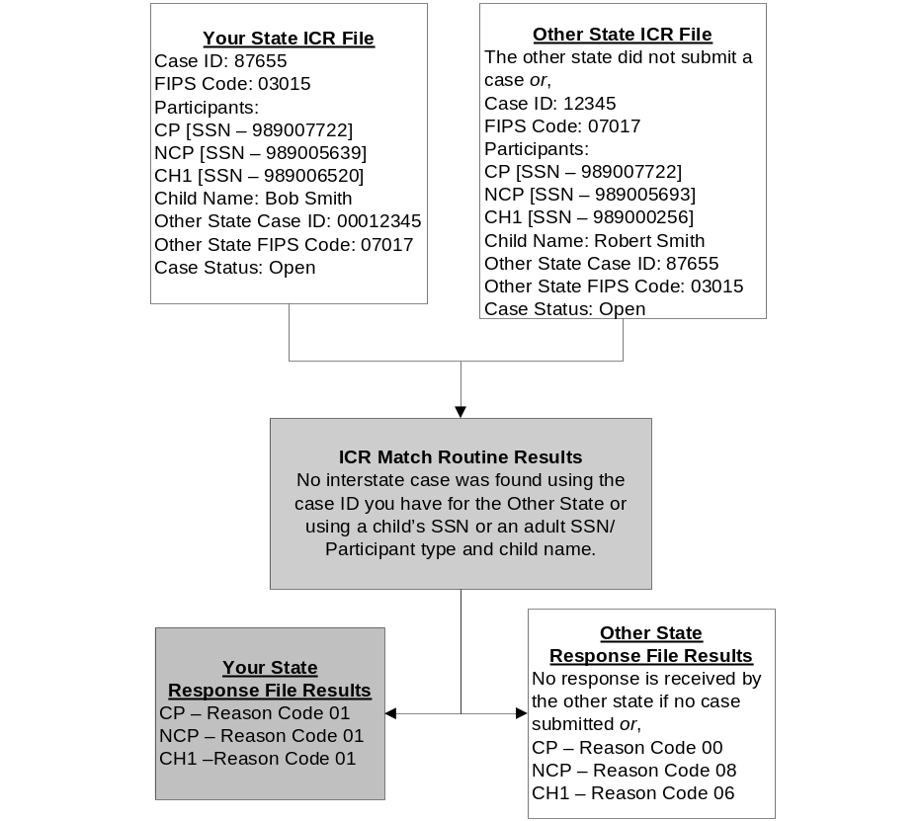

The regular ICR matching process first attempts to match the case ID you have for the other State with a case ID submitted in the other State’s ICR file. If a match cannot be made on case IDs, the ICR matching process then attempts to find a child in common between your case and a case in the other State’s ICR file by using a child’s SSN.

If you receive Reason Code 01 on an ICR record, you will not receive any other Reason Codes. The ICR matching routine was not able find a match, based on a combination of the State code and case ID you have for the other State, or the State code and a child in common, in order to find comparable data between your interstate case and any interstate case, whether open or closed, in the other State.

11.3 What to Automate in Reconciling Reason Code 01

Total automated processing for Reason Code 01 is probably not practical; however, automation can provide valuable reconciliation assistance. Following are suggestions for automated reconciliation of Reason Code 01:

- Consider how you can automate a process to present the information to a worker to help determine the most effective action to take on this interstate case. To shorten the time needed to research existing interstate case information, an automated reconciliation process could be programmed to provide a list of interstate cases where:
  - A previous communication has been received through CSENet,
  - NDNH information has previously been received from the FCR, or
  - Money is being processed on an interstate case.
- If you are not using the FCR proactive matches to update Other State Case IDs in your system, explore how you can do this after the ICR in order to keep case IDs in synch.
- Check how you are storing other States’ case IDs on your State system. Make sure you have not imposed your State’s storage conventions on other States’ case IDs. For example, you will have problems if you have defined the Other State Case ID field as numeric because some States use alpha characters in their case IDs. Also, you cannot delete leading zeroes from other States’ case IDs just because you do not use them. For some States, leading zeroes are integral to their case IDs.

It may be necessary to create work lists of cases displaying only Reason Code 01 for the appropriate individuals to review.

In approaching how to handle Reason Code 01, you should address what role your State has in the presumed interstate relationship. Is your State the Initiating State? Or, is your State the Responding State? Who has the primary role in answering to the family’s request for service? This helps determine the next course of action. The bottom line, whether you are the Initiating or Responding State, is to ensure service to the family is being provided as needed.

11.4 Decision Making for Reason Code 01 When Your State is the Initiating State

When your State is the Initiating State, your goal is to ensure that the case is appropriately worked, either by your own State as an intraState case, by another State from which you have requested interstate assistance, or by a third State where the NCP may now be living or working.

The possibility exists that the other State from which you requested assistance never received your interstate initiating action and never opened an interstate responding case. The possibility also exists that the other State did open an interstate responding case, but changed the case to an intraState case.

Consider these following points to help you determine the most effective action to take on your interstate initiating case.

Reason Code 01: Points to Consider When Your State is the
Initiating State

- What information do you have on your interstate case?
  - Do you have the other State’s case ID?
  - Do you have an SSN for at least one child?
  - Do you have an SSN for the adults in your case?
  - Might the inability to find a matching case via the ICR process be due to incomplete data on your State’s case?

- When did you send this outgoing interstate request to the other State?
  - So recently that the case might not yet be open in the other State?
  - So long ago that it might not have been converted accurately from that State’s former computer system?

- Have you ever received information about this case from the other State?
  - Via CSENet?
  - Via paper documents in the case file?

- What do you know about the current status of the NCP?

- Has a date of death been received for the NCP?

- Do you know where the NCP is located?
  - In your State?
  - In the State to which you sent the outgoing interstate request?
  - In a third State?
  - Whereabouts unknown?

- Based on the location of the NCP, do you still need the other State’s services?

  - Decision Making for Reason Code 01 When Your State is the Responding State

When your State is the Responding State, this interstate case originated in the other State, but your State’s assistance was determined as necessary to respond to the CP’s or NCP’s request for service. Your goal is to determine if your State’s assistance is still required by the other State. It is possible that the interstate case should become your responsibility and you need to make the interstate case an intraState case in your State. It also is possible that the case status should be changed to non IV-D, or the case should be closed completely.

Remember no interstate case can automatically be closed to IV-D. Adherence to Federal case closure criteria must be followed.

Consider these points to help you determine the most effective action to take on your Responding interstate case.

Reason Code 01: Points to Consider When Your State is the
Responding State

- Do you need to coordinate with the other State to find out why it made an Interstate Responding request to your State?

- Did the CP and/or NCP apply for IV-D services in your State?

- Is there a support order attached to this case? If so, is your State sending payments to the SDU in the other State?

11.6 Hot Tips for Reconciling Reason Code 01

Consider using the FCR as much as possible to determine if a case does exist in another State. Viewing previously received FCR proactive matches helps you determine if the participants on your interstate case are on an interstate case in another State. FCR proactive matches can be of benefit in providing not just a Case ID, but SSN data for other persons associated with that case, based on a match of one person you share with another State. If proactive information has been received from the FCR in the past, an FCR Query may be able to tell you if a case is currently open in the other State. Once you have established the correct case ID in the other State, and have entered it onto your State’s system, a CSENet CSI request can be sent to the other State to obtain additional interstate case information, including the county code of the office working the case.

Keep track of the number of interstate cases for families that no longer require services as an outcome of reconciling your cases. This may assist you in proving the value of participating in the ICR by allowing you to focus more effectively on those cases that do require your services. Remember cases can only be closed in accordance with Federal case closure criteria.

Reconciling a Reason Code 01 discrepancy is critical to ensuring service to this family. The next section discusses Reason Code 03, which occurs when the county code you have for the other State does not agree with the county code submitted for the corresponding interstate case by the other State.

SECTION 12.0

REASON CODE 03
INCORRECT COUNTY CODE FOR THE OTHER STATE

The county code you have for the child support office working your interstate case in the other State is not the same as the county code reported by the other State. This section explains Reason Code 03 and suggests ways to reconcile the county code discrepancy.

12.1 What Reason Code 03 Means
Reason Code 03 means that a matching interstate case was found in the other State’s ICR file, but the county code you show for the office working the case in the other State does not agree with the county code provided by the other State. The county code is referred to as the county FIPS code in the ICR results file.

When Reason Code 03 is received, the FIPS code provided by the other State is returned in the ICR results file. The returned FIPS code is five digits (e.g., 04015). The first two digits reference the State FIPS code (e.g., 04, which represents Arizona). The next three digits reference the county code (e.g., 015). In addition, a FIPS code verification indicator is returned. This indicator tells you whether the FIPS code provided by the other State is valid, when compared to the standard FIPS codes established by the National Institute of Standards and Technology (NIST).

If you are using the Interstate Reconciliation Report (IRR), the FIPS code provided by the other State displays in the Case Identifier section of the IRR. A FIPS code verification indicator also displays in the Case Identifier section of the IRR as Vld Ind.

12.2 Reason Code 03 Example

Figure 12-1 shows how the ICR matching process identifies a Reason Code 03 and what is returned in your State ICR results file. At the top, critical ICR data submitted by your State and the other State are displayed in the Your State ICR File and the Other State ICR File boxes, respectively. The example then displays the results of the ICR match routine’s processing of these data in the ICR Match Routine Results box. At the bottom the ICR Reason Codes sent back to your State and to the other State for each participant are displayed in the Your State Response File Results and the Other State Response File Results boxes.

You may receive Reason Code 03 if you have recorded a county code for a specific office in another State from previous communications with that office, but the State has decided that all inquiries or requests should be directed to its Central Registry. In these instances, you may receive a “corrected” county code of ‘000,’ which is assigned to a Central Registry. Whether you should overlay a county code you already are using for an automated means of communication (e.g., CSENet) is a matter you will want to take under advisement within your State and, possibly, in discussion with the other State.

Figure 12-1
Reason Code 03 Match Routine

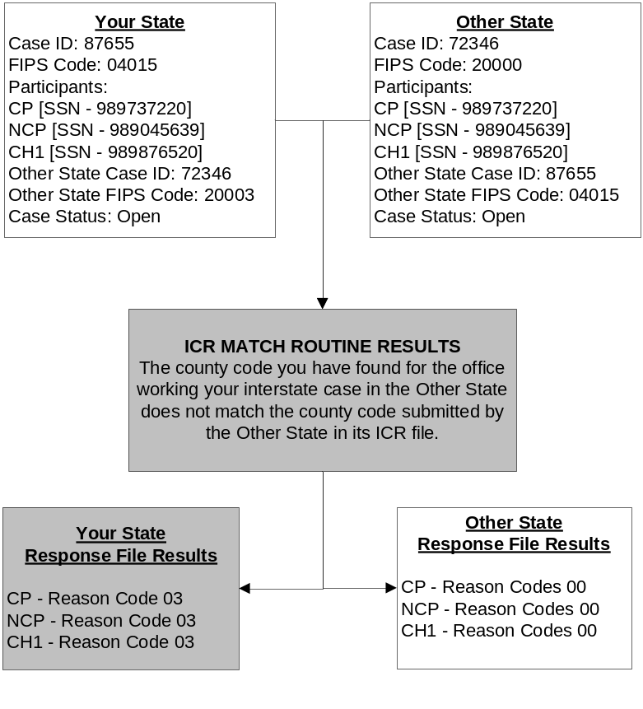
In this example, the county code you have for the office working your case in the other State is different than what the other State reported to the ICR. You think the county code should be ‘003’ for State ‘20,’ but State ‘20’ reported the county code as ‘000.’ State ‘20’ probably has decided that all inquiries or requests that come out of the ICR should be directed to its Central Registry (county code ‘000’).

In other examples, you may receive Reason Code 03 on an ICR results record with other Reason Codes, including Reason Code 02, which provides a corrected case ID, Reason Code 04 or 05, which inform you of an interstate case status discrepancy between your State and the other State, and Reason Code 07 or 08, which provide you a new or different SSN for a case participant. Reason Code 02 should be reconciled before reconciling the county code error or any other Reason Code. Remember, it is always more important to establish the correct Other State Case ID first.

12.3 What to Automate in Reconciling Reason Code 03

Automatic updates of the county codes for other States are not recommended. County code discrepancies, because of ongoing problems with county FIPS codes, should be addressed as a lesser priority. Automation may be used to:

- Sort cases with county codes returned as ‘000’ or some other code. Review how they should be reconciled.
- Identify cases in your State’s system where no county code is recorded for the other State. The county code obtained on the ICR results file may help you communicate better about this case with the other State.

12.4 Decision Making for Reason Code 03 When Your State is Either the Initiating or Responding State

Whether your State is the Initiating or Responding State, consider these points to help you determine the most effective action to take on your interstate case.

Reason Code 03: Points to Consider When Your State is the
Initiating State or the Responding State

- Was the county code you received from the other State ‘000’? Did you receive the ‘000’ county code on all cases or only for some of the cases you have in common with this other State?

- Does your case contain a county code for the other State that is a number other than ‘000’?
- Have you ever sent paper documents to that office?
- Have you ever received paper documents from that office?

- Does your State system maintain an automated listing of FIPS codes that contains the appropriate agency name and address for all county/regional offices in all other States?
- Does your State system contain an agency name and address for the county code of ‘000’ for the other State?
- What county code does your State’s FIPS code listing show for the Central Registry in the other State?
- What county/regional name and address does your State’s FIPS code listing show for the other State’s FIPS codes shown on your case?

- If a different FIPS code was received on the ICR results file, was the FIPS code verification indicator set to ‘Yes’ for that new FIPS code?

The next section addresses Reason Code 06, which occurs when a participant you submitted on an interstate case could not be found in the other State’s case.

SECTION 13.0

REASON CODE 06
THIS PARTICIPANT WAS NOT FOUND IN THE OTHER STATE CASE

A participant was not found in the other State’s interstate case that corresponds to your interstate case. This section explains Reason Code 06 and suggests ways to reconcile this missing participant discrepancy.

13.1 What Reason Code 06 Means

Reason Code 06 means that your State’s case was matched with a case in the other State; however, a participant identified on your case could not be found in the other State’s case. For example, your State submitted a case with CP, NCP, CH1, and CH2. The other State submitted a case with CP, NCP, and CH1. If all the case data matched between the two States, the ICR returns Reason Code 00 for CP, NCP, and CH1. CH2 is shown with Reason Code 06 (participant not found).

The ICR matching routine may not have been able to identify the participant for the following reasons:

- A child in the other State has emancipated and was not reported in the other State’s interstate file.
- A participant in the case was submitted without an SSN, or the SSN for the participant has transposed numbers, or a different SSN was submitted for the person.
- A participant’s name was misspelled or changed (e.g., maiden name to married name) in either case.
- The case structure may vary between States. For example, your State may set up Foster Care cases with two NCPs (both mother and father as NCPs with the Foster Care agency as the CP) while another State sets up two separate cases, one with the mother as the NCP and one with the father as the NCP. The matching routine for this example returns Reason Code 06 for one of the NCPs to your State.

The Interstate Case Reconciliation Report (IRR), which your State may opt to print, can be especially helpful in examining Reason Code 06 discrepancies. The IRR indicates missing participants in a case by displaying a ‘1’ in front of the name of each participant not found. In addition, the report displays the message, ‘Participant(s) Flagged were not Found in the Other State’s Case.’

The ICR results file lists Reason Code 06 for each participant not found. The ICR results file also provides the number of adults and number of children submitted for each case and the number of adults and children that match. For the participants that did match on a case, the discrepancy caused by the missing participant is reflected in a mismatch of the number of participants matched. This is one of the reasons why the number of matching adults and the number of matching children are provided. It becomes obvious looking at each matched person’s results that someone else on the case is unaccounted for at the end of the matching process.

Duplicate interstate cases (e.g., situations in which a State maintains case histories associated with open and closed statuses as separate cases with the same case ID) may cause a difference in the number of matched participants. While the ICR matching process treats duplicate cases as one case, the number of participants matched reflects the combined total of participants on all of the duplicate cases. Consequently, the number of matched participants may be duplicated.

13.2 Reason Code 06 Example

Figure 13-1 shows how the ICR matching process identifies a Reason Code 06 and what is returned in your State ICR results file. At the top, critical ICR data submitted by your State and the other State are displayed in the Your State ICR File and the Other State ICR File boxes, respectively. The example then displays the results of the ICR match routine’s processing of these data in the ICR Match Routine Results box. At the bottom the ICR Reason Codes sent back to your State and to the other State for each participant are displayed in the Your State Response File Results and the Other State Response File Results boxes.

This example shows that your case participant, Child 2 (CH2), could not be found in the other State’s interstate case that corresponds to your interstate case. For all of the participants that matched (CP, NCP, CH1), Reason Code 00 is returned because there are no other discrepancies in the case data. In other examples, it might be possible for those other participants to have received another Reason Code, or a combination of other Reason Codes. For the missing participant in any example, you only receive Reason Code 06.

Reconciliation of a missing participant should be addressed with less urgency than Reason Codes 02, 07, 08, 01, or 04. A missing adult is of greater concern than a missing child in terms of ensuring that the rest of the matched data actually points to the right interstate case. Missing children become important for order establishment or modification, so the next step may depend on where the case is in terms of case management.

13.3 What to Automate in Reconciling Reason Code 06

Automated processing for Reason Code 06 is not practical; however, automation can provide valuable reconciliation assistance as follows.

- Consider whether or not the missing participant is an adult or a child in the case. If the missing participant in the case is a child, reconciling this Reason Code should be given a lower priority than if the missing participant is an adult in the case. If the missing participant is an adult, this may not be a matching case and communication with the other State may be necessary.
- Develop an automated program to generate an FCR query for this participant, or send a CSENet transaction to the other State
- Consider expanding the participant data your system allows to be gathered and stored. Refer to the data elements for the FCR’s SSN matching routines. For example, consider adding such information as father’s name, mother’s name, or place of birth to your participant screens. These data elements (along with other data combinations) are known as ESKARI data, and they facilitate the identification of a participant’s SSN by the FCR when you do not have an SSN, or the SSN you have is invalid.

Figure 13-1
Reason Code 06 Match Routine

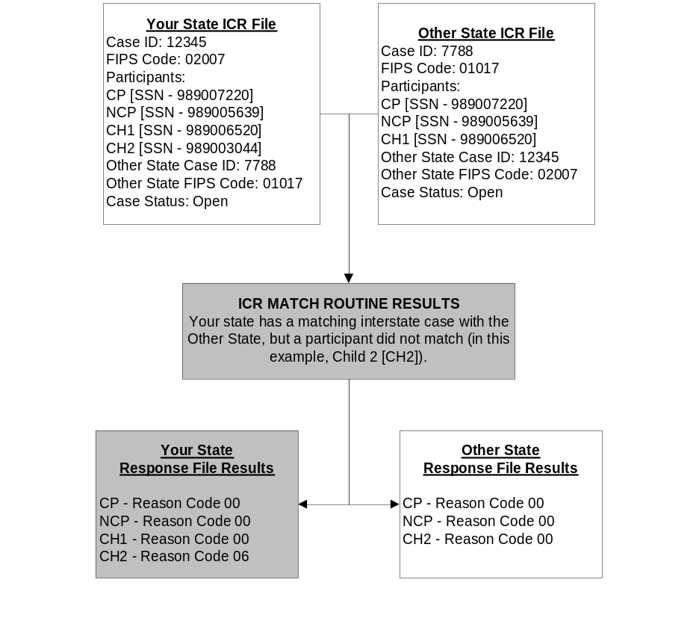

13.4 Decision Making for Reason Code 06 When Your State is Either the Initiating State or the Responding State

Regardless of whether your State is the Initiating State or the Responding State, you want the active participants in both States’ cases to be the same, and for both States to have complete participant information (e.g., SSNs).

Consider these points to help you determine the most effective action to take next.

Reason Code 06: Points to Consider When Your State is Either the
Initiating State or the Responding State

- Do the CP and NCP in your State match the CP and NCP in the other State’s case?
  - Does your State system allow for multiple NCPs and/or CPs on one case?

- Might the missing person be a putative father (PF) in your case against whom paternity was not established?
  - Is there a difference because one State maintains multiple PFs?

- Does the missing person mean that the ICR match routine might not have identified the correct case in the other State?

- Is there information you need to provide to the other State to assist them in working this case more effectively?

- Is the missing person important to order establishment or modification?

- Is the missing person important to enforcement of your case?

13.5 Hot Tips for Reconciling Reason Code 06

If you are the Initiating State, prioritize actions you ask the other State to take for the participant missing on their case. If a court order is in effect, and only arrears are being collected, the fact that there is a missing individual in the other State’s case may be less important than if you asked the other State to establish paternity, support, or medical support.

Some States delete emancipated children from their interstate cases. If the missing participant is a child who has reached the age of majority, it may not be necessary to reconcile data on this missing case participant.

The following section addresses Reason Code 05, which is the reverse situation from Reason Code 04. Reason Code 05 is generated when your interstate case is closed, but the corresponding case in the other State is open.

SECTION 14.0

REASON CODE 05
YOUR CASE IS CLOSED,
MATCHES TO OPEN CASE IN THE OTHER STATE

Your case is closed as an interstate case, but a corresponding interstate case is open in the other State. This section explains Reason Code 05 and suggests ways to reconcile this case status discrepancy.

14.1 What Reason Code 05 Means

Reason Code 05 tells you that a corresponding interstate case has been found in the other State’s ICR file, but your State and the other State do not agree on the status of the case. Your interstate case is closed; the other State’s interstate case is open. Just as with Reason Code 04 (your case open/other State’s case closed), service to the family may be in jeopardy. A key difference between Reason Codes 04 and 05, however, is the priority you assign to reconciling the case discrepancy. You would address all Reason Code 04 errors first because you see those cases as open. You may wish to wait on Reason Code 05 errors until the other State contacts you, as they resolve their Reason Code 04 errors that involve your State.

Most likely, when you receive a Reason Code 05, the other State has received a Reason Code 04. The exception would be if the other State did not have either your correct case ID or the SSN for a child you share in common or an adult SSN/participant type and child name in common. The ICR matching process then would have returned a Reason Code 01, Could Not Find a Matching Case in the Other State, to the other State.

14.2 Reason Code 05 Example

Figure 14-1 shows how the ICR matching process identifies a Reason Code 05 and what is returned in your State ICR results file. At the top, critical ICR data submitted by your State and the other State are displayed in the Your State ICR File and the Other State ICR File boxes, respectively. The example then displays the results of the ICR match routine’s processing of these data in the ICR Match Routine Results box. At the bottom the ICR Reason Codes sent back to your State and to the other State for each participant are displayed in the Your State Response File Results and the Other State Response File Results boxes.

This example shows that your State and the other State are not in agreement concerning the status of this interstate case. Your State has closed the interstate case; however, the other State still has the interstate case open. The other State should contact you, since most likely a Reason Code 04 error that corresponds to your Reason Code 05 error was sent to that State.

Figure 14-1
Reason Code 05 Match Routine

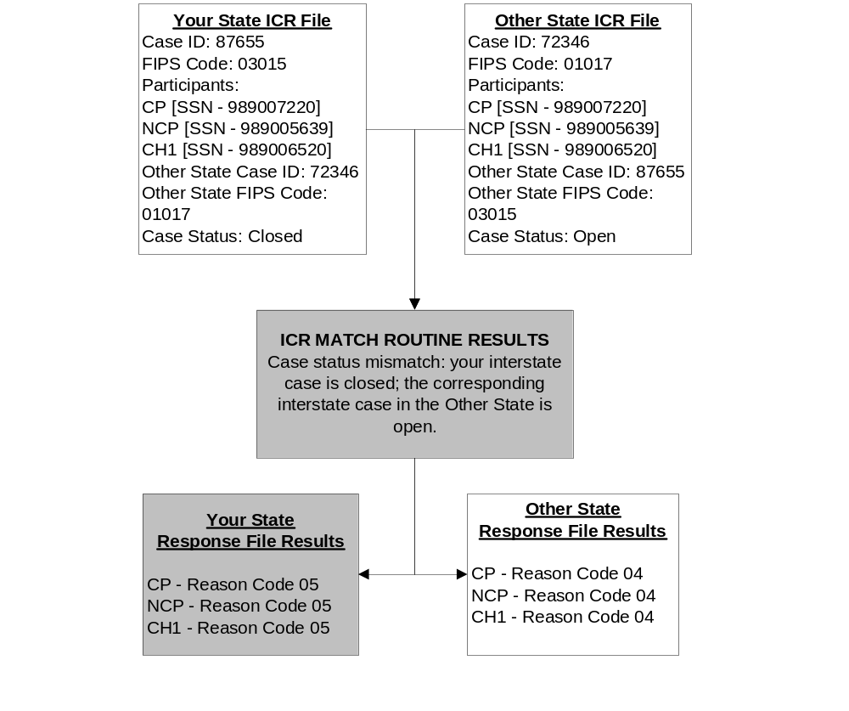
If you receive Reason Code 05 on an ICR results record, you may have received other Reason Codes, including Reason Code 02, which provides a corrected case ID, and Reason Code 03, which provides a different county code for the case in the other State, and Reason Code 07 or 08 which provide you a new or different SSN for a case participant. If Reason Code 02 appears on this case, it should be corrected first before reconciling the open/closed interstate case status discrepancy. It is more important to correct the Other State Case ID first. Moreover, your Reason Code 05 errors may be resolved as other States contact you concerning their Reason Code 04 errors.

14.3 What to Automate in Reconciling Reason Code 05

Since your interstate case is closed, no automated reconciliation of Reason Code 05 is recommended.

The State maintaining an open interstate case should assume responsibility for the reconciliation of the status of this interstate case to ensure that families are receiving appropriate services.

14.4 Decision Making for Reason Code 05 Whether Your State is Either the Initiating or Responding State

Even though your interstate case is closed, you may still be working the case as an intraState case, or you may now have an interstate case that you share with a different State.

Gauge by the number of Reason Code 05 errors how many requests for assistance you may receive from other States as they resolve corresponding Reason Code 04 errors. Correction of Reason Code 05 errors should be a natural progression as each State attempts to resolve Reason Code 04 errors.

The following section describes the Unidentified Interstate Cases Project, designed to assist States in correctly identifying more of their true interstate cases. Proper identification of all interstate cases allows them to be sent to the ICR for complete case matching.

SECTION 15.0

THE UNIDENTIFIED INTERSTATE CASES PROJECT

Since the implementation of the ICR project, OCSE has noticed that several States have significantly fewer cases processed with all other States than those other States have processed with them.

States have reported to the ICR team that they have cases on their systems that are known to be interstate cases, but are not marked as being ‘interstate’. These cases are called ‘unidentified interstate cases’. When a case in a State is not identified correctly as an interstate case, the case is not included on that State’s ICR extract file and sent for case matching. Other States receive a Reason Code 01 (Case Not Found) response on each case they have in common with unidentified interstate cases in those States.

OCSE is committed to helping States with large numbers of unidentified interstate cases to properly identify those cases so they can be recorded as ‘interstate’ on their State systems. OCSE has developed two options for identifying additional interstate cases. The States being offered assistance are referred to as the ‘focus States’ for purposes of the Unidentified Interstate Cases Project. States identified as focus States may change over time, as information from future annual ICR case matches is reviewed.

The Unidentified Interstate Cases Project is voluntary, and each focus State’s participation is independent of the participation of the other States. OCSE is able to assist one or all of the focus States individually or collectively over the coming years. States will decide whether and when to participate, and which of the two options to use.

15.1 Impact of Unidentified Interstate Cases on State Systems

States report to the ICR team that they are able to send payments to and receive payments from the other State, even when their cases are not identified appropriately as interstate cases. Having unidentified interstate cases can impact States in several ways:

- If a State loses track of its Initiating State cases, the Responding and Initiating States may both be taking enforcement actions against the NCP, thus duplicating effort.
- If a State loses track of its Responding State cases, it may not be communicating to the Initiating State what enforcement actions it is taking in the case, thereby generating many questions from the Initiating State’s workers.
- A State may not be able to reference the cases with other States via CSENet, neither sending nor receiving CSENet transactions.
- A worker may not think of using QUICK to obtain additional information on a case when it is not recognized as an interstate case.

The Unidentified Interstate Cases Project thus helps all States:

- The focus States identify more of their interstate cases, and
- The other States learn that many of the cases on which they received the Reason Code 01 responses already contain the correct case ID of the case in the focus State, or they obtain the focus State’s correct case ID.

The Unidentified Interstate Cases Project offers focus States two options for identifying additional interstate cases.

15.2 Option #1: OCSE Matches All Cases Receiving Reason Code 01 with the Focus State’s Cases Against the Focus State’s Cases on the FCR

In Option #1, OCSE will match all cases where all other States received a Reason Code 01 (Case Not Found) response on the ICR on cases with the focus State against all of the focus State’s cases registered on the FCR.

A focus State that chooses this option would receive an ICR response file that shows the FCR matched cases that other States believe are interstate cases. On each matched case, the focus State will receive Reason Code 09 (Case Found on the FCR). This new Reason Code informs the focus State that the other State’s interstate case matched to an FCR case in the focus State.

A focus State choosing Option #1 will also receive a new Management Information (MI) report, MI Report 9, showing the number of Reason Code 01 cases each of the other States found among the focus State’s cases on the FCR. Additional information on MI Report 9 can be found in Section 17.0 of this User Guide.

The focus State should evaluate its response file to determine if each case is truly an interstate case, and update its system with the information provided by the other States. All cases identified as ‘interstate’ are to be submitted to the next regularly-scheduled ICR for more complete case matching.

Figure 15-1 on the following page depicts the Option #1 match process.

Figure 15-1
Unidentified Interstate Cases Project:
Option #1 Match Process

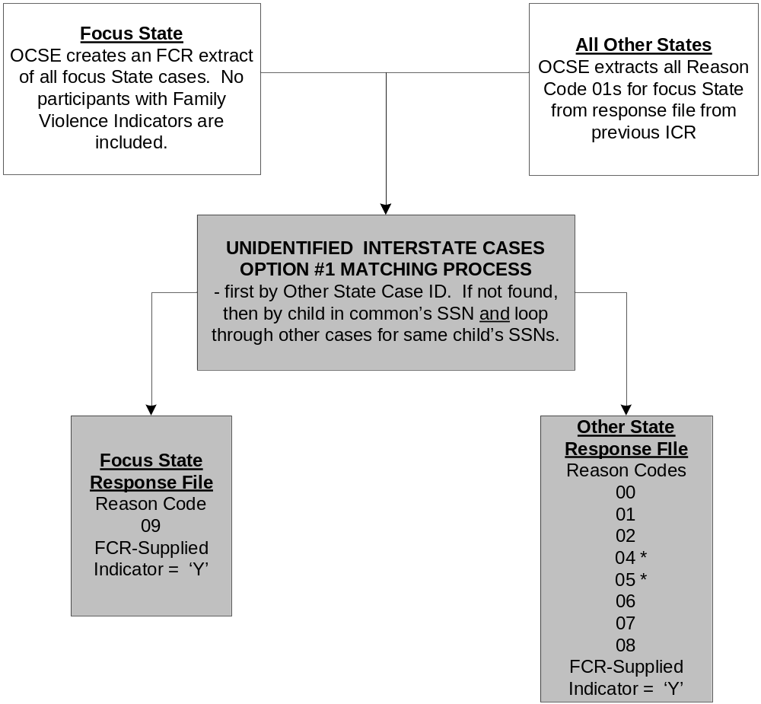
* Reason Codes 04 and 05 indicate whether the focus State’s case on the FCR is open or closed to IV-D.

The other States would also receive an ICR response file showing the information obtained from the FCR. FCR-derived information includes the case ID and participant information, but not the open or closed interstate case status, as interstate information is not stored on the FCR. No participants with Family Violence Indicators will be included on the response file.

It is important to note that for these FCR-derived matches, Reason Codes 04 and 05 will have a slightly different meaning, and will show if the matching case on the FCR is open or closed to IV-D.

Other States will be informed that the match information is derived from a match against the focus State’s cases on the FCR by the FCR-Supplied Indicator at position 242 on the response file being set to ‘Y’. The FCR-Supplied Indicator has been a part of the ICR response file since ICR-1, but States have not previously seen this indicator set to ‘Y’.

Other States will also receive a Multiple Cases Indicator with their response file. The indicator at position 485 on the response file is set to ‘Y’ if the other State’s case matched to multiple FCR cases, and ‘N’ if the other State’s case matched to only one FCR case. More information on the Multiple Cases Indicator can be found in Section 4.4 of this User Guide.

Other States may be able to use their existing ICR response file programming, with minor modifications, to update their systems with this FCR-derived data.

Shown in Appendix B is the response file record layout that all States receive when a focus State chooses Option #1. The several differences from the regular ICR response file layout are highlighted in bold.

15.3 Option #2: OCSE Uses a Supplemental Extract File Submitted by the Focus State for Matching Purposes

In Option #2, OCSE will match a supplemental extract file submitted by the focus State against all cases from other States in their previous ICR submission, and also match all cases where other States received a Reason Code 01 (Case Not Found) response against the supplemental extract file submitted by the focus State.

Focus States that choose this option might consider either of the following possibilities in creating their supplemental extract file:

- Expand the selection criteria that were used to generate the ICR extract file, and submit a supplemental file that contains all of the cases that are believed to be interstate cases, even if they lack specific data elements which have excluded them from previous extract files, or
- Submit a file that contains all of the cases where either the CP or NCP has an out-of-State address, but the case is not recorded as an interstate case. Not all of these cases will be interstate cases, but the ones that match against cases that another State believes to be interstate probably are.

A focus State that chooses this option will receive an ICR response file containing case match information for all submitted cases, as their supplemental file will be matched against all cases that the other States submitted with the focus State on the most recent ICR. The Multiple Cases Indicator, at position 485 on the response file, will be set to ‘Y’ if the single State’s case matches to multiple cases in the other State, and to ‘N’ if it does not, as described in Section 4.4 of this document.

Option #2 is a two-step match process, as shown in Figure 15-2 on the following page.

Figure 15-2
Unidentified Interstate Cases Project:
Option #2 Match Process
Step One
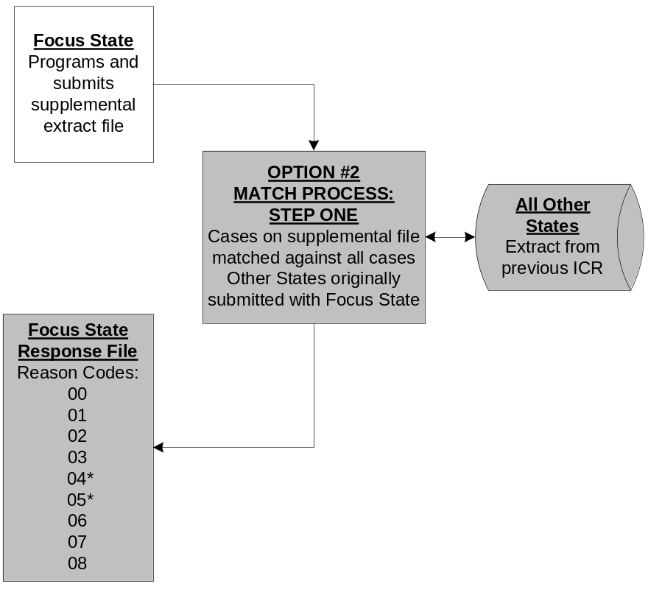
Step Two
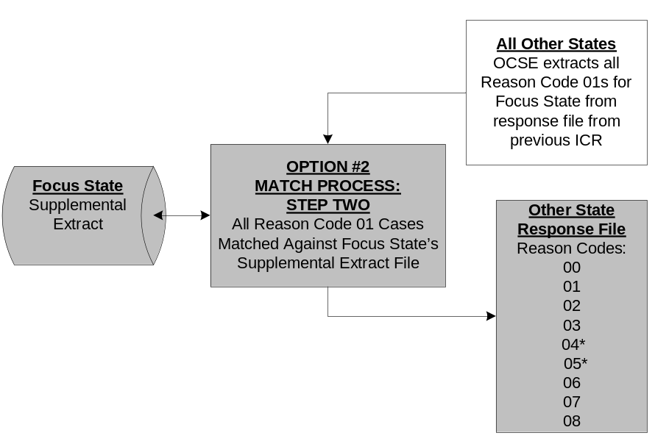

* Reason Codes 04 and 05 are to be ignored by both the focus State and other States because the focus State’s supplemental extract file contains cases that are not necessarily identified as interstate cases, so those cases may have no open or closed interstate status indicators.
The Multiple Cases Indicator, at position 485 on the response file, will be set to ‘Y’ if a single case in the other States matches to multiple cases in the focus State’s supplemental extract file, and to ‘N’ if it does not, as described in Section 4.4 of this document

15.4 Decision Making When Your State is the Focus State

Whether your State has chosen Option #1 or Option #2, when you are the focus State you will need to review each case on your Unidentified Interstate Cases response file to determine if it is truly an interstate case.

The following items are suggestions to help you conduct this review:

- Does a partially completed Interstate screen on your State system indicate that there has been interstate activity on this case?
  - Would incomplete data on that screen prevent the case from being considered a full interstate case?
  - Would incomplete data on that screen prevent the case from being sent to the ICR?
- Are payments being sent to, or received from, the other State’s SDU?
- Are CSENet transactions being received from the other State?
  - Some State systems have the ability to receive and display incoming CSENet transactions even though the case is not an interstate case.
  - Some State systems write incoming CSENet transactions on non-interstate cases to an error report to be researched further.
- Does the case narrative reflect the receipt of phone calls or faxes from the other State?
- Does the case narrative reflect receipt of an interstate request from the other State?
- Does the case narrative indicate that your State’s worker initiated an interstate request to the other State?

Your State may be able to develop simple programs to compare cases on your response file to specific data on your database, in order to create reports of groups of cases meeting one or more of the above criteria. For example, your State may be able to create a report of all cases on your response file where your State is receiving payments from another State, as opposed to receiving payments from an employer or the NCP. If payments are being directed to your State’s SDU from another State’s SDU, you can feel comfortable that the case is an interstate case, and that your State is the Initiating State. Updating your system with this information, and recording the Case ID of the case in the Responding State will cause this case to be picked up on your State’s next ICR extract file, and submitted for more complete case matching.

In addition to Reason Code 09, your response file contains all of the information submitted on the case the other State believes it has in common with your State. All of this information can be used in determining if the case in your State is an interstate case.

You may not be able to update your system on cases receiveing Reason Code 05 along with Reason Code 09, as Reason Code 05 tells you the FCR shows your case to be closed to IV-D. If you receive a large number of Reason Code responses, however, you may wish to review a sample of these cases to ensure your State is communicating the case closing to other States.

15.5 Decision Making When Your State is One of the Other (non-Focus) States

As each of the focus States chooses to participate in the Unidentified Interstate Cases Project and selects an option for case matching, your State will receive a supplemental response file that converts some of your Reason Code 01 cases into matched cases, or cases where you receive a corrected Case ID from the focus State.

For you, the priorities for case reconciliation remain the same:

- Update your system with corrected case IDs received from the focus State.
- Update your system with verified SSNs received from the focus State.

Then wait for a more complete reconciliation of the case, including its open or closed interstate status, on the next regular ICR case match.

Although this Unidentified Interstate Cases Project focuses on helping a limited number of States that are underreporting their interstate caseload, the Project helps all States. Other States, having cases in common with those focus States, should see a reduction in their number of cases receiving Reason Code 01 (Case Not Found). This improves reconciliation levels and provides benefits that:

- Enable efficient and effective electronic communication between the States. This includes CSENet and QUICK.
- Decrease the number of phone calls that are sent and received as States attempt to work cases in common.
- Provide verified SSNs to store on State systems, thereby improving case processing even when the case is no longer an interstate case.
- Prevent the inappropriate closing of cases when families do need child support services.

SECTION 16.0

INTERSTATE RECONCILIATION REPORT

The ICR program matches your State’s ICR file against ICR files from all other States, and returns the ICR results file to you. You may also request a print program to convert your ICR results file into a printout version, called an Interstate Reconciliation Report (IRR). To make the request, please contact the ICR coordinator in your State, and ask them to request the IRR from their ICR State liaisons.

The IRR is a valuable tool for workers in your State. This section provides a sample IRR and describes its components.

16.1 IRR Description

OCSE will provide your State a print program to generate the IRR. The IRR formats your State’s ICR results file data into a printout.

The IRR is written in COBOL. Even if a State does not use COBOL, it can use this source code as a guide to developing its own print program. The source code and sample job control language (JCL) can be sent as a text file or as an e-mail attachment to any State that requests it.

If you have chosen to reconcile all your cases manually, the IRR print capability should be especially useful to you. It also is helpful to States writing automated programs for some of the matching functions, as certain cases may not meet the State’s own criteria for automated processing and need to be worked manually.

Information received on the ICR results file is person-based and is formatted with one record per case participant. Data on the IRR display at the case level and summarizes the information on all participants in the case.

Figure 16-1 on the following page shows a partial IRR printout; with Reason Codes 02 and 07 returned. Figure 16-2, located at the end of Section 16.0, is a more comprehensive sample of the IRR, and shows examples of other Reason Codes returned in an IRR.

For each case, there are five sections of data on the report that show:

- Case ID and FIPS Code Information,
- Reason Code Information,
- Participant Information,
- Participant Matching and CP/NP Indicators, and
- Contact Information.

Figure 16-1
ICR Interstate Reconciliation Report

INTERSTATE RECONCILIATION REPORT
FIPS CODE: 42/043
OTHER STATE: 05 - ARKANSAS

CASE OTHER STATE OTHER ST. VLD FCR MULTIPLE
CASE-ID I/R STATUS CASE-ID FIPS CODE IND SUPPLIED CASES
----------- --- ------ ----------- --------- --- -------- --------
YOUR STATE: 1779988481 R O 000562186 06065 Y
CORRECT: 065790292186 06065 Y N N

REASON CODE: 02 CASE-ID DID NOT MATCH, NEW CASE-ID PROVIDED
07 NO SSN SUBMITTED, OTHER STATE SSN PROVIDED

PARTICIPANTS: SSN VER PART
OTHER SSN IND MEMBER-ID TYPE NAME
--------- --- --------------- ---- ---------------------------------
614004149 7989444479 CH MEANY TIMMIE A
610004101 7989455487 CH RIMINNI TAMMY
139004313 7989466598 NP MEANY JOFFREY A
2 – 111004107 Y 7989477061 CP RIMINNI DOMINIQUA F

2-PARTICIPANT WAS SUBMITTED WITHOUT AN SSN OR A DIFFERENT SSN, THE OTHER STATES SSN IS SUPPLIED

SUBMITTING OTHER
STATE STATE MATCHED CP MATCH IND NCP MATCH IND
---------- ----- ------- ------------ -------------
ADULTS: 2 2 2 Y Y
CHILDREN: 2 2 2

CONTACT: JANEY PARSONS
PHONE: 909-123-4110
E-MAIL: JPPARSONS@CO.RIVERVIEW.CA.US

Each of these IRR sections is explained below.

16.2 Case ID and FIPS Code Information

For each case, the IRR displays your State case ID, the Other State Case ID, and the FIPS codes for each interstate case. The first two digits of the FIPS code comprise the State code; the next three digits comprise the county code.

CASE OTHER STATE OTHER ST. VLD FCR MULTIPLE
CASE-ID I/R STATUS CASE-ID FIPS CODE IND SUPPLIED CASES
----------- --- ------ ----------- --------- --- -------- --------
YOUR STATE: 1997530379 R C 499922-1 09009 Y
CORRECT: 499922-1 09009 Y N N

The Your State line displays the information taken from your State’s ICR file. Fields show your State’s Case-ID; the I/R indicator, which shows whether your State is the Initiating or Responding State; the Case Status indicator, which shows whether the interstate case is open (O) or closed (C) in your State; the Other State Case-ID for the other State; the Other St. FIPS Code, which represents where your State thinks the interstate case is being worked in the other State; and, Vld Ind to show whether that FIPS code is valid.

The Correct line displays the information obtained from the other State, either through a match with the other State’s ICR file; or from its FCR data, if a State did not submit an extract file of its interstate cases to the ICR. The case ID in the other State is displayed beneath the number provided by your State. The FIPS code that the other State has provided for the case displays beneath the FIPS code provided by your State.

The FIPS code validation indicator shows whether the FIPS code provided by the other State is valid.

The FCR-Supplied Indicator shows whether the information was obtained from a match with the FCR.

The Multiple Cases Indicator shows whether the single case in your State is matched with two or more cases in the Other State.

16.3 Reason Code Information

The Reason Codes display in the IRR as follows:

- REASON CODE: 00 ALL INFORMATION MATCHES CORRECTLY
- REASON CODE: 01 CASE COULD NOT BE FOUND USING EITHER CASE-ID OR SSNS
- REASON CODE: 02 CASE-ID DID NOT MATCH, NEW CASE-ID PROVIDED
- REASON CODE: 03 POSITIONS 3-5 OF THE FIPS CODE DID NOT MATCH
- REASON CODE: 04 YOUR OPEN CASE IS CLOSED IN THE OTHER STATE
- REASON CODE: 05 YOUR CLOSED CASE IS OPEN IN THE OTHER STATE
- REASON CODE: 07 NO SSN SUBMITTED, OTHER STATE SSN PROVIDED
- REASON CODE: 08 SSNS PROVIDED DO NOT MATCH, CHECK VERIFICATION IND
- REASON CODE: 09 CASE NOT REPORTED TO ICR, FCR CASE WAS PROVIDED

All appropriate Reason Codes and descriptions received for an interstate case (except for Reason Code 06) display on the IRR. Information on a participant in your State, who does not exist in the other State’s case, is shown separately (refer to section 16.4 below).

Note: There is no Reason Code to tell you when both your case and the other State’s case are closed, or when your case is closed and no matching case was found in the other State. If either situation occurs, your case is not returned in your ICR results file. The number of cases sent in your ICR file may be greater than the number of cases received in your ICR results file.

16.4 Participant Information

All case participants listed on your State’s ICR file are displayed in the Participants section of the IRR. There is one line for each case participant, with each participant’s SSN, VER(ification) IND(icator) Member-ID, Part(icipant) Type (CP, NP, PF, or CH), and Name.

PARTICIPANTS: SSN VER PART
OTHER SSN IND MEMBER-ID TYPE NAME
--------- --- --------------- ---- --------------------------
108006666 7607747474 CH BRAGG ALEC
078007766 7954622399 NP BRAGG ARNOLD
1 - 7845534233 CP BRAGG PATTI
2 - 098708352 Y 7954621501 CH BRAGG ANDI

1 -PARTICIPANT(S) FLAGGED WERE NOT FOUND IN THE THE OTHER STATES CASE

2 -PARTICIPANT WAS SUBMITTED WITHOUT AN SSN OR A DIFFERENT SSN, THE OTHER STATES SSN IS SUPPLIED

Preceding certain lines of participant data is a ‘1’ or a ‘2’ (as seen in the example above):

- If a participant in your case cannot be found in the other State’s case, a message line displays below the participant list stating, “1- Participant(s) flagged were not found in the other case.” A ‘1’ in front of that person’s line of data identifies the specific individual who could not be found.
- If “2 – Participant was submitted without an SSN or a different SSN, the other State SSN is supplied” precedes a participant’s data, it identifies the participant whose SSN was provided by the other State, or whose SSN in the other State does not match the SSN stored on your system. If the verification indicator is set to Yes (Y) the SSN has been verified by the Social Security Administration based on name and SSN match only. If the Verification Indicator is set to No (N), the SSN could not be verified. See section 4.4 for more information on SSA’s SSN verification process. For individuals receiving Reason Code 08 there will normally be a Y next to one SSN and an N next to the other SSN, showing which of the two has been verified.

16.5 Participant Matching and CP/NP Indicators

Information on the number of matching individuals between your case and the other State’s case also is displayed on the IRR.

SUBMITTING OTHER
STATE STATE MATCHED CP MATCH IND NCP MATCH IND
---------- ----- ------- ------------ -------------
ADULTS: 2 2 2 Y Y
CHILDREN: 2 2 1

This matching is attempted by first matching on SSNs. If the SSN is missing on either State’s file, the matching routine compares the first six letters of the individual’s last name and first four letters of the individual’s first name to determine if there is a match. If either criterion is met, the participants are considered “matched” and will appear in the Matched column as shown above.

Check if the mismatched participant is an adult or a child in the case. If one of the adults in the case does not match to one of the adults in the other State’s case, the cases may not be the same (e.g., there may be two cases – one with a mother as CP and the other with another relative as CP). Proactive FCR responses could be checked, an FCR Query could be requested, or a CSENet CSI transaction could be sent to learn more about the case in the other State.

On the IRR, if your State has a larger number of case participants than the other State, a ‘1’ appears by the person who is not on the other State’s file (see section 16.4 above). Additionally, you will receive data such as:

SUBMITTING OTHER
STATE STATE MATCHED CP MATCH IND NCP MATCH IND
---------- ----- ------- ------------ -------------
ADULTS: 2 2 2 Y Y
CHILDREN: 3 2 2
If your State has the smaller number of case participants, an example of what you might see is:

SUBMITTING OTHER
STATE STATE MATCHED CP MATCH IND NCP MATCH IND
---------- ----- ------- ------------ -------------
ADULTS: 2 2 2 Y Y
CHILDREN: 2 3 2

The State for which the ICR identified a participant as missing in the other State’s case should consider taking the lead on resolving this discrepancy. A missing child may have become emancipated; and, consequently, may no longer be considered active in the interstate case. A non-matched adult may be a PF who is one of multiple PFs in one State’s case, whereas in the other State a separate case is established for each PF.

Resolving issues related to a discrepancy in the number of matched case participants should be considered a lower priority than reconciling the other State’s case ID.

A CP indicator shows whether the CP on your case matches the CP on the other State’s case, and an NP Indicator shows whether the NCP on your case matches the NCP on the other State’s case. The CP Match Ind and NCP Match Ind columns display to the right of the participant number matches. A ‘Y’ shows that the ICR match found the CP or NCP participant type to be the same in both your State and the other State. An ‘N’ shows a discrepancy.

16.6 Contact Information

The IRR displays information for contacting the other State for issues related to possible cases in common.

CONTACT: JANEY PARSONS
PHONE: 909-123-4110
E-MAIL: JPPARSONS@CO.RIVERVIEW.CA.US

Some States prefer that other States send their case matching inquiries to a single individual in the Central Registry. Other States provide contact information for a specific caseworker assigned to an interstate case, while other States provide a single phone number or email address to receive all inquiries coming into their States.

16.7 Printing the IRR

States have the ability to customize the source code provided by OCSE for the IRR to meet their own needs.

When printing the IRR, it is suggested that the entire report not be printed at one time due to its length. It may be preferable to print out the matching information received from one State, or all cases with a specific Reason Code, so your workload is sorted to your specific needs.

The following are suggestions for printing and customizing the IRR for your State:

- If printing individual reports based upon specific Reason Codes, remember that a case may display on multiple reports.

- If your State is automatically updating other State’s case IDs based upon receipt of Reason Code 02, look to see if a second Reason Code also was provided. If not, and if the number of case participants matches between your State and the other State, you may wish to suppress the printing of case information for this case. This can shorten the length of the printed report, as cases where no additional action is needed probably do not need to appear on any printed report.

Other suggestions for your consideration are:

- Add additional data elements to the report to display information received on the ICR results file, but not currently shown on the report. For example, if your State is planning manual reconciliation at the caseworker level, you could include assigned caseworker information. This necessitates that your State had provided case contact names on the file of interstate cases submitted to the ICR.
- Add a sort by Reason Code, to enable the State to reconcile certain Reason Codes before reconciling others.

16.8 IRR Sample Format

Figure 16-2 displays a sample of the ICR IRR. It shows how Reason Codes 03, 05, 06, 07, and 08 are displayed to you on the IRR. This sample provides you with a more complete picture of how Reason Codes are returned than the breakouts of the report provided in preceding subsections.

Also displayed is a sample of a printout with Reason Code 09.

Finally, there is an example of the new multiple cases function. In the example shown, the other State maintains two cases for which your State maintains only one case. The IRR displays data for each of the other State’s cases, the only difference in this example is that you receive a different Other State Case ID for each case. For the two cases displayed, the Multiple Cases Indicator will show ‘Y’.

Figure 16-2
ICR Interstate Reconciliation Report

INTERSTATE RECONCILIATION REPORT
FIPS CODE: 42/043
OTHER STATE: 02 - ALASKA
CASE OTHER STATE OTHER ST. VLD FCR MULTIPLE
CASE-ID I/R STATUS CASE-ID FIPS CODE IND SUPPLIED CASES
----------- --- ------ ----------- --------- --- -------- --------
YOUR STATE: 1150689407 R C 106639 02001 Y
CORRECT: 106639 02003 Y N N

REASON CODE: 03 POSITIONS 3-5 OF THE FIPS CODE DID NOT MATCH
05 YOUR CLOSED CASE IS OPEN IN THE OTHER STATE
08 SSNS PROVIDED DO NOT MATCH, CHECK VERIFICATION IND.

PARTICIPANTS: SSN VER PART
OTHER SSN IND MEMBER-ID TYPE NAME
--------- --- --------------- ---- --------------------------------------------------
584001196 7801232221 CH HERNANDO JASON
2 – 221002429 N 7874568220 CH HERNANDO CHRIS
221003429 Y
112004977 7877893229 CP HERNANDO BAMBI
053005005 7871232229 NP HERNANDO CHRIS G

2-PARTICIPANT WAS SUBMITTED WITHOUT AN SSN OR A DIFFERENT SSN, THE OTHER STATES SSN IS SUPPLIED

SUBMITTING OTHER
STATE STATE MATCHED CP MATCH IND NCP MATCH IND
---------- ----- ------- ------------ -------------
ADULTS: 2 2 2 Y Y
CHILDREN: 2 2 2

CONTACT: LIVIA LOWAN
PHONE: 302-123-6024
E-MAIL: LIVIA.LOWAN@STATE.AK.US

INTERSTATE RECONCILIATION REPORT
FIPS CODE: 42/043
OTHER STATE: 13 - GEORGIA

CASE OTHER STATE OTHER ST. VLD FCR MULTIPLE
CASE-ID I/R STATUS CASE-ID FIPS CODE IND SUPPLIED CASES
----------- --- ------ ----------- --------- --- -------- --------
YOUR STATE: 1198713660 R C 160022224 13031 Y
CORRECT: 160022224 13000 Y N N

REASON CODE: 03 POSITIONS 3-5 OF THE FIPS CODE DID NOT MATCH
05 YOUR CLOSED CASE IS OPEN IN THE OTHER STATE
07 NO SSN SUBMITTED, OTHER STATE SSN PROVIDED

PARTICIPANTS: SSN VER PART
OTHER SSN IND MEMBER-ID TYPE NAME
--------- --- --------------- ---- --------------------------------------------------
266008222 7890528222 NP ALEXANDER ANDY E
256002333 7890527222 CP JOINER PERNIA
2 – 256003444 Y 7890528222 CH JOINER BRITTNI

2-PARTICIPANT WAS SUBMITTED WITHOUT AN SSN OR A DIFFERENT SSN, THE OTHER STATES SSN IS SUPPLIED

SUBMITTING OTHER
STATE STATE MATCHED CP MATCH IND NCP MATCH IND
---------- ----- ------- ------------ -------------
ADULTS: 2 2 2 Y Y
CHILDREN: 1 2 1

CONTACT: GAROOBY KENNY
PHONE: 912-123-8227
E-MAIL: STATEBOROCSE@DHR.STATE.GA.US

FIPS CODE: 42/043
OTHER STATE: 09 - CONNECTICUT

CASE OTHER STATE OTHER ST. VLD FCR MULTIPLE
CASE-ID I/R STATUS CASE-ID FIPS CODE IND SUPPLIED CASES
----------- --- ------ ----------- --------- --- -------- --------
YOUR STATE: 1997530379 R C 499922-1 09009 Y
CORRECT: 499922-1 09009 Y N N

REASON CODE: 05 YOUR CLOSED CASE IS OPEN IN THE OTHER STATE
06 THE CASE WAS FOUND, BUT A PARTICIPANT WAS NOT
07 NO SSN SUBMITTED, OTHER STATE SSN PROVIDED

PARTICIPANTS: SSN VER PART
OTHER SSN IND MEMBER-ID TYPE NAME
--------- --- --------------- ---- ---------------------------------
108006666 7607747474 CH BRAGG ALEC
078007766 7954622399 NP BRAGG ARNOLD
1 - 7845534233 CP BRAGG PATTI
2 – 098700252 Y 7954621501 CH BRAGG ANDI

1-PARTICIPANT(S) FLAGGED WERE NOT FOUND IN THE THE OTHER STATES CASE

2-PARTICIPANT WAS SUBMITTED WITHOUT AN SSN OR A DIFFERENT SSN, THE OTHER STATES SSN IS SUPPLIED

SUBMITTING OTHER
STATE STATE MATCHED CP MATCH IND NCP MATCH IND
---------- ----- ------- ------------ -------------
ADULTS: 2 2 1 N Y
CHILDREN: 2 3 2

CONTACT: LOURDES A. GARZA
PHONE: 203-123-8265

1 INTERSTATE RECONCILIATION REPORT
FIPS CODE: 06/067
OTHER STATE: 08 - COLORADO

CASE OTHER STATE OTHER ST. VLD FCR MULTIPLE
CASE-ID I/R STATUS CASE-ID FIPS CODE IND SUPPLIED CASES
----------- --- ------ ----------- --------- --- -------- --------
YOUR STATE: 0670661156-01 R O 08001 Y Y N
CORRECT: 01051262930B 08001 Y

REASON CODE: 09 - CASE NOT SUBMITTED, FCR CASE PROVIDED TO OTHER STATE

PARTICIPANTS: SSN VER PART
OTHER SSN IND MEMBER-ID TYPE NAME
--------- --- --------------- ---- -----------------------------------------------
559003368 NP VILLCOY RONALD GARY
530000071 CH VILLCOY GENE WAYNE
524008739 CP WOMBATH CRISTAL JANE

SUBMITTING OTHER
STATE STATE MATCHED CP MATCH IND NCP MATCH IND
---------- ----- ------- ------------ -------------
ADULTS: 2 2 2 Y Y
CHILDREN: 1 2 1

CONTACT: MARILOU MONCRIEF
PHONE: 916-800-7083

INTERSTATE RECONCILIATION REPORT
FIPS CODE: 08/001
OTHER STATE: 06 - CALIFORNIA

CASE OTHER STATE OTHER ST. VLD FCR MULTIPLE
CASE-ID I/R STATUS CASE-ID FIPS CODE IND SUPPLIED CASES
----------- --- ------ ----------- --------- --- -------- --------
YOUR STATE: 01046233902C I C 91 5973 48000 Y Y Y
CORRECT: UR00161661 48141 Y

REASON CODE: 02 CASE-ID DID NOT MATCH, NEW CASE-ID PROVIDED
03 POSITIONS 3-5 OF THE FIPS CODE DID NOT MATCH
05 YOUR CLOSED CASE IS OPEN IN THE OTHER STATE

PARTICIPANTS: SSN VER PART
OTHER SSN IND MEMBER-ID TYPE NAME
--------- --- --------------- ---- --------------------------------------------------
523004300 AL100731 CH CORTEZ STACY
456004600 AN400741 NP CORTEZ JOSE
442002134 AH303349 CP CASAREAL MARIA

SUBMITTING OTHER
STATE STATE MATCHED CP MATCH IND NCP MATCH IND
---------- ----- ------- ------------ -------------
ADULTS: 2 2 2 Y Y
CHILDREN: 1 1 1

CASE OTHER STATE OTHER ST. VLD FCR MULTIPLE
CASE-ID I/R STATUS CASE-ID FIPS CODE IND SUPPLIED CASES
----------- --- ------ ----------- --------- --- -------- --------
YOUR STATE: 01046233902C I C 91 5973 48000 Y Y Y
CORRECT: UR00161662 48141 Y

REASON CODE: 02 CASE-ID DID NOT MATCH, NEW CASE-ID PROVIDED
03 POSITIONS 3-5 OF THE FIPS CODE DID NOT MATCH
05 YOUR CLOSED CASE IS OPEN IN THE OTHER STATE

PARTICIPANTS: SSN VER PART
OTHER SSN IND MEMBER-ID TYPE NAME
--------- --- --------------- ---- --------------------------------------------------
523004300 AL100731 CH CORTEZ STACY
456004600 AN400741 CP CORTEZ JOSE
440082100 AH303349 NP CASAREAL MARIA

SUBMITTING OTHER
STATE STATE MATCHED CP MATCH IND NCP MATCH IND
---------- ----- ------- ------------ -------------
ADULTS: 2 2 2 N N
CHILDREN: 1 1 1

SECTION 17.0

MANAGEMENT INFORMATION REPORTS

This section describes and provides examples of the Management Information (MI) reports sent to your State to assist you in your reconciliation efforts.

17.1 What MI Reports are Available

Six MI reports are provided with your State’s ICR file. Four reports provide information regarding number of errors (broken out by Reason Code) that your State has with all other States participating in the ICR. The fifth report provides the number of errors (broken out by Reason Code) each of the other States had with your State. It is suggested that these reports be printed and used for making decisions on how to sequence reconciliation activities. A sixth report - Cases Not Reported to ICR by Focus State - is used for the Unidentified Interstate Cases Project only. For further information refer to Section 15.0 of this User Guide.

The MI Reports help you determine which States’ caseloads already are reconciled the best, and which States’ caseloads require the most work. The MI Reports can help you determine where your State will get the biggest benefit from your reconciliation efforts.

Use the MI Reports to prioritize reconciling with other States. Possible priority considerations:

- Neighboring States with which you share the largest caseloads,
- States with which you want to implement CSENet to enhance interstate communication, or
- States to which you want to transmit EFT/EDI to save money through electronic payment processing.

The ICR reports available for your use are:

- MI Report 1 – Match Results Report
- MI Report 2 – Open/Closed Discrepancies by Initiating/Responding Indicator
- MI Report 3 – Cases Not Found by Initiating/Responding Indicator
- MI Report 6 – View of How Other States Matched with Your State
- MI Report 8 – Provided and Different SSNs by Initiating/Responding Indicator
- MI Report 9 – Cases Not Reported to ICR by Focus State

The reports are addressed in detail with an example of the report, in the following sections.

17.2 MI Report 1 - Match Results Report

The Match Results Report provides your State’s matching statistics with each of the other States participating in the ICR program. It also provides State totals.

An example of the Match Results Report is shown in Figure 17-1. Your State is identified at the top of the report.

Columns of data on the Match Results Report include:

- ST. This column lists the States in alphabetical order by State code (e.g., AL for Alabama). Totals are provided for each of the States with which your ICR extract file was matched. The last entry in this column is “Tot” for the total of your matched results with all participating States.
- Number of Cases Processed. This column shows the number of your cases processed through the ICR match program. This total excludes any duplicate records submitted in your extract file, and it excludes any cases “dropped” because the case was closed in both your State and the other State, or no matching case could be found in the other State for a closed case in your State. This total reflects your ICR workload in that you and/or the other State consider an interstate case to be open. Looking at the Match Results Report in Figure 16-1, you should note that the columns, which are checked rather than bulleted below, total the Number of Cases Processed, as follows:

Number of Cases Matched
+ No Match
+ Corrected Case IDs
Number of Cases Processed

- Number of Cases Matched. This column shows the number of cases matched by case ID. This means that the Other State Case ID you submitted was correct. The higher this total, the better. You should already be communicating with the other State because you have the correct case ID for that State.
- Exact Matches. This column is a subset of the Number of Cases Matched (by case ID) column. It shows how many cases sent by your State were “exact” matches (i.e., matches of the case ID, the [open/closed] case status, and the FIPS Code with a case in the other State).
- No Match. This column shows the number of your cases processed for which no matching case could be found in the other State’s ICR extract file by either the Other State Case ID you submitted or a child-in-common’s SSN, or adult SSN/participant type match and child name in common.
- Corrected Case IDs. This column shows the number of cases that could not be matched by case ID, but did match based on a child-in-common’s SSN, or adult SSN/participant type match and child name in common. The ICR was able to provide you with a corrected case ID for the other State. These are the cases on which, whenever possible, automatic updates should be made to your State system so that communication may be opened up between your State and the other State.
- Corrected FIPS Code. This column shows the number of cases in which the county code you have for the child support office working your case in the other State did not match the county code identified by the other State. The FIPS code identified by the other State is provided in your ICR results file.
- Open Cases/Closed in Other State. This column shows the number of cases in which the interstate status for a case submitted by your State was open, but the ICR match process found that case status is closed in the other State.
- Closed Cases/Open in Other State. This column shows the number of cases in which the interstate status for a case submitted by your State was closed, but the ICR match process found that case status is open in the other State.
- Participants Not Found. This column provides the number of your participants that could not be found by the ICR process in matching interstate cases in the other State.
- Closed Cases Dropped. At the bottom of the MI Report 1 - Match Results Report is a line that refers to the number of cases that were “dropped” from the Number of Cases Processed. These are cases that were either:
  - Closed in your State and closed in the other State, or
  - Closed in your State and not found in the other State.
The following seven columns in the MI Report 1 - Match Results Report correspond to seven of the ICR Reason Codes:

MI Report 1 Column | Reason Code Equivalent
Exact Matches | Reason Code 00
No Match | Reason Code 01
Corrected Case IDs | Reason Code 02
Corrected FIPS Code | Reason Code 03
Open Cases Closed in Other State | Reason Code 04
Closed Cases Open in Other State | Reason Code 05
Participants Not Found | Reason Code 06

Each column provides totals by each State that participated in the National ICR. The columns for Reason Codes 00 through 05 show the number of interstate cases receiving these Reason Codes. Note that it is possible for more than one Reason Code to be returned on a single case. Reason Code 06 shows the number of participants receiving this Reason Code.

Figure 17-1
MI Report 1 - Match Results Report

ICR-#
MI Report 1 - Match Results Report for [Your STATE]

OPEN CASES CLOSED CASES
NUMBER OF CASES EXACT NO CORRECTED CORRECTED CLOSED IN OPEN IN PARTICIPANTS
ST. PROCESSED MATCHED MATCHES MATCH CASE IDS FIPS CODE OTHER STATE OTHER STATE NOT FOUND
--- --------- --------- --------- --------- ----------- --------- ----------- ----------- ------------

AK 105 59 3 16 30 80 13 22 16
AZ 284 2 1 280 2 1 0 2 1
AR 287 86 0 85 116 201 1 14 29
CA 1,046 44 36 514 488 117 47 39 106
CO 281 61 40 33 187 70 19 42 40
CT 112 1 0 29 82 17 22 9 8
DE 49 20 17 20 9 6 0 1 5
DC 26 0 0 26 0 0 0 0 0
FL 2,645 918 786 582 1,145 485 416 110 261
GA 1,507 318 5 852 337 566 7 82 104
.
.
.
.

SAMPLE
.
.
.
.
.

VA 953 350 227 142 461 320 99 77 108
WA 406 1 0 130 275 241 0 6 24
WV 695 216 139 125 354 178 56 86 56
WI 290 1 1 72 217 30 20 31 30
WY 59 0 0 14 45 6 4 3 2
GU 5 0 0 5 0 0 0 0 0
PR 20 0 0 7 13 2 0 4 0
VI 1 0 0 1 0 0 0 0 0
--- --------- --------- --------- --------- ----------- --------- ----------- ----------- ------------
TOT 29,895 4,807 2,501 15,290 9,798 7,421 1,471 1,582 2,141

CLOSED CASES DROPPED: 8,004

17.3 MI Report 2 - Open/Closed Discrepancies by Initiating/Responding Indicator

MI Report 2 provides detailed information on interstate cases receiving Reason Codes 04 and 05. This report shows whether your State is the Initiating or Responding State for both Reason Codes.

The three columns of data under the heading Closed Cases Open in Other State provide a breakdown for Reason Code 05 as to:

- Initiating (State)
- Responding (State)
- Unknown.

The three columns under Open Cases Closed in Other State provide a breakdown of Reason Code 04 as to:

- Initiating (State)
- Responding (State)
- Unknown.

Figure 17-2
MI Report 2 - Open/Closed Discrepancies by Initiating/Responding Indicator

ICR-#
MI Report 2 - Open/Closed Discrepancies by Initiating/Responding Indicator for [YOUR STATE]

CLOSED CASES OPEN OPEN CASES CLOSED
IN OTHER STATE IN OTHER STATE
INITIATING RESPONDING UNKNOWN INITIATING RESPONDING UNKNOWN
---------- ---------- ------- ---------- ---------- -------

AK 4 1 0 4 28 0
AZ 0 3 0 1 0 0
AR 0 0 0 13 5 0
CA 91 26 0 41 64 0
CO 8 40 0 65 54 0
.
.

SAMPLE
.
.
.
.
.
VA 77 71 0 25 89 0
WA 0 0 0 6 24 0
WV 116 60 0 141 211 0
WI 23 23 0 16 28 0
WY 2 1 0 1 3 0
GU 0 0 0 0 0 0
PR 9 2 0 11 11 0
VI 0 0 0 0 0 0
---------- ---------- ------- ---------- ---------- -------

TOT 2,110 1,362 0 1,131 1,935 0
17.4 MI Report 3 - Cases Not Found by Initiating/Responding Indicator

MI Report 3 provides additional information on the cases where your State has received Reason Code 01. This report divides the interstate cases that received a Reason Code 01 between those where your State is the Initiating State and those cases where your State is the Responding State.

Figure 17-3
MI Report 3 - Cases Not Found by Initiating/Responding Indicator

ICR-#
MI Report 3 - Cases Not Found by Initiating/Responding Indicator for [your State]

CASES NOT FOUND
INITIATING RESPONDING UNKNOWN
---------- ---------- -------

AK 23 8 0
AZ 798 288 0
AR 182 48 0
CA 946 680 0
CO 128 46 0
CT 44 26 0
DE 32 16 0
DC 59 24 0
FL 1,608 350 0
GA 1,063 846 0
HI 12 3 0
ID 8 3 0
IL 1,296 339 0
IN 937 835 0
IA 156 284 0
.
.

SAMPLE
.
.
.
.
.
.
.
NE 20 22 0
NV 163 64 0
NH 33 1 0
NJ 148 393 0
NM 44 5 0
NY 443 234 0
NC 1,098 812 0
ND 2 7 0
OH 9 1 0
OK 105 19 0
OR 53 32 0
PA 434 314 0
RI 9 6 0
SC 707 416 0
SD 6 2 0
TX 570 211 0
UT 12 7 0
VT 7 4 0
VA 239 109 0
WA 147 138 0
WV 398 181 0
WI 92 65 0
WY 20 18 0
GU 9 4 0
PR 111 27 0
VI 10 7 0
---------- ---------- -------
TOT 16,735 10,120 0
17.5 MI Report 6 – View of How Other States Matched with Your State

MI Report 6, sometimes referred to as the ‘Reverse Image Report’, shows you the number and types of Reason Codes each of the other States received on cases they said they had in common with your State.

An example of the View of How Other States Matched with Your State Report is shown in Figure 17-4.

Columns of data in the View of How Other States Matched with Your State Report are identical to the columns in the Match Results Report, including:

- ST. This column lists the other States in alphabetical order.
- Number of Cases Processed. This column shows the number of cases each of the other States had processed with your State. The total at the bottom of the column shows the total number of cases all of the other States had processed with your State.
- Number of Cases Matched. This column shows the number of cases each State matched by case ID. This means that the other State has your correct case ID recorded.
- Exact Matches. This column is a subset of the Number of Cases Matched (by case ID) column. It shows how many cases the other State has that are “exact” matches (i.e., matches of the case ID, the [open/closed] case status, and the FIPS county code with a case in your State).
- No Match. This column shows the number of cases for which no matching case could be found in your State’s ICR extract file, by either your State case ID or a child-in-common’s SSN.
- Corrected Case IDs. This column shows the number of cases that could not be matched by case ID, but did match based on a child-in-common’s SSN, and the other State was provided with your State’s corrected case ID.
- Corrected FIPS Code. This column shows the number of cases in which the county code the other State has for the child support office working your case did not match the county code you submitted.
- Open Cases/Closed in Other State. This column shows the number of cases in which the interstate status for a case submitted by the other State was open, but the ICR match process found that the case status is closed in your State.
- Closed Cases/Open in Other State. This column shows the number of cases in which the interstate status of a case submitted by the other State was closed, but the ICR match process found that the case status is open in your State.
- Participants Not Found. This column provides the number of other State case participants that could not be found by the ICR process in the matching interstate case in your State.

The number of cases your State had processed with all other States, as shown at the bottom of the Number of Cases Processed column of the Match Results Report, should be close to the number of cases the other States had processed with your State, as shown at the bottom of the Number of Cases Processed column on this View of How Other States Matched with Your State Report.

Figure 17-4
MI Report 6 – View of How Other States Matched with Your State

ICR-#
MI REPORT 6 - VIEW OF HOW OTHER STATES MATCHED WITH [your State]

OPEN CASES CLOSED CASES
NUMBER OF CASES EXACT NO CORRECTED CORRECTED CLOSED IN OPEN IN PARTICIPANTS
ST. PROCESSED MATCHED MATCHES MATCH CASE ID FIPS CODE OTHER STATE OTHER STATE NOT FOUND
--- --------- --------- --------- --------- ----------- --------- -----------
AZ 741 515 0 79 147 660 230 30 64
AR 138 116 26 4 18 94 5 29 14
CA 1,726 1,121 154 100 505 1,375 104 121 179
CO 332 312 47 8 12 263 13 59 11
CT 47 37 6 2 8 34 3 14 7
DE 32 25 1 5 2 24 1 3 6
DC 14 7 1 0 7 12 5 1 2
FL 490 442 340 17 31 0 32 86 27
GA 234 128 22 39 67 165 31 5 17
.

SAMPLE
VA 164 136 0 20 8 144 9 0 12
WA 2,986 2,874 592 45 67 2,243 155 162 346
WV 95 49 6 25 21 61 29 2 5
WI 203 158 56 44 1 95 15 16 15
WY 97 87 78 8 2 0 4 5 4
GU 18 3 0 2 13 16 0 2 1
PR 36 17 4 13 6 19 0 0 2
VI 10 2 0 4 4 4 1 1 0
--- --------- --------- --------- --------- ----------- --------- ----------- ----------- ------------
TOT 15,100 12,319 3,789 1,134 1,671 9,016 1,538 1,334 1,356
81.5% 25.0% 7.5% 11.0% 59.7%
17.6 MI Report 8 – Provided and Different SSNs Report

MI Report 8 provides a count of the verified and unverified Social Security Numbers (SSNs) your State received on its Reason Code 07 and Reason Code 08 responses. The report breaks this information down by State from which you received the SSN and by case participant type.

Reason Code 07 is received when your State had no SSN for the participant, but an SSN was PROVIDED by the other State. Two columns of data under the heading Provided show a breakdown for participants receiving Reason Code 07 as to:

- Verified. “Verified” means that the SSN you received from the other State was verified by the Social Security Administration on the basis of a name/SSN match.
- Unverified. “Unverified” means that the SSN you received from the other State was not verified by the Social Security Administration on the basis of a name/SSN match.

Under the columns of both Verified and Unverified are headings for columns showing the number of custodial parents, noncustodial parents, and children on whose behalf an SSN was Provided by the other State.

To determine the number of ‘verified’ SSNs your State received via Reason Code 07 responses, add the totals at the bottom of columns 1 (CH), 2 (NP) and 3 (CP).

Reason Code 08 is received when the SSN your State submitted for a case participant did not match the SSN submitted by the other State. Two sections of data under the heading Different show whether the SSN for the participant came from YOUR STATE or from the OTHER STATE, Within each section the Reason Code 08 responses are divided as to:

- Verified. “Verified” means that the SSN you provided to, or received from, the other State was verified by the Social Security Administration on the basis of a name/SSN match.
- Unverified. “Unverified” means that the SSN you provided to, or received from, the other State was not verified by the Social Security Administration on the basis of a name/SSN match.

Under the columns of both Verified and Unverified are headings for columns showing the number of custodial parents, noncustodial parents, and children on whose behalf a Different SSN was obtained from the other State.

To determine the number of ‘verified’ SSNs your State received via Reason Code 08 responses, add the totals at the bottom of columns 13 (CH), 14 (NP) and 15 (CP).

Figure 17-5
MI Report 8 – Provided and Different SSNs

ICR-#
MI Report 8 – Provided and Different SSNs for [your State]

PROVIDED DIFFERENT

YOUR STATE OTHER STATE

VERIFIED UNVERIFIED VERIFIED UNVERIFIED VERIFIED UNVERIFIED
ST. CH NP CP CH NP CP CH NP CP CH NP CP CH NP CP CH NP CP
-----------------------------------------------------------------------------------------------------------------------------------
AL 1 1 1 4 0 0 2 1 0 0 0 0 0 0 0 2 1 0
AK 0 0 1 0 0 0 0 0 0 0 0 0 0 0 0 0 0 0
AZ 2 0 0 0 0 0 0 0 0 0 0 0 0 0 0 0 0 0
AR 2 0 0 0 0 0 6 1 0 0 0 1 0 1 1 6 0 0
CO 0 0 0 0 1 1 1 0 0 0 0 0 0 0 0 1 0 0
CT 4 0 0 1 0 0 0 0 0 0 0 0 0 0 0 0 0 0
DE 1 0 0 0 0 0 0 1 0 0 1 1 0 0 0 0 2 1
FL 1 0 1 0 0 0 3 0 0 2 0 0 1 0 0 4 0 0
GA 0 0 0 0 0 1 21 3 1 0 0 0 3 0 0 18 3 1
HI 0 0 0 0 0 0 2 0 1 0 0 0 0 0 0 2 0 1
IN 0 0 0 0 0 0 0 0 0 0 0 0 0 0 0 0 0 0
IA 1 0 0 0 0 0 0 0 0 0 0 0 0 0 0 0 0 0
KS 1 0 0 0 0 0 0 0 0 0 0 0 0 0 0 0 0 0
KY 0 0 0 0 0 0 0 0 0 0 0 0 0 0 0 0 0 0

SAMPLE
LA 0 0 0 0 0 0 0 0 0 0 0 0 0 0 0 0 0 0
ME 0 0 0 0 0 0 0 0 0 0 0 0 0 0 0 0 0 0
MD 0 0 0 0 0 0 1 1 0 1 0 0 1 0 0 1 1 0
MA 0 0 0 0 0 0 0 0 0 0 0 0 0 0 0 0 0 0
MI 7 0 1 0 0 0 3 1 2 0 0 0 0 0 1 3 1 1
MO 2 0 0 0 0 0 0 0 0 1 0 1 1 0 1 0 0 0
NV 1 0 0 0 0 0 3 0 0 0 1 0 0 0 0 3 1 0
.
.
.
.
.
.
.

TOT 47 3 7 5 2 2 56 16 9 6 11 4 10 5 4 52 22 9

17.7 MI Report 9 – Cases Not Reported to ICR by Focus State

Note: This report is used for the Unidentified Interstate Cases Project only. For further information refer to Section 15.0 of this User Guide.

MI Report 9 provides additional information on cases where the focus State, in the Unidentified Interstate Cases Project, received Reason Code 09. The total number of Initating and Responding cases is displayed in the ‘Unknown’ column, because the cases submitted more than likely did not have initating or responding indicators, and therefore cannot be not broken out.

Figure 17-6
MI Report 9 – Case Not Reported to ICR by [Focus State]
Unidentified Interstate Cases Project

ICR-x
MI REPORT 9 - CASES NOT REPORTED TO THE ICR BY [FOCUS STATE]
INITIATING RESPONDING UNKNOWN
---------- ---------- -------

AL 0 0 1
AK 0 0 4
AZ 0 0 2
AR 0 0 1
CA 0 0 8
CO 0 0 7
FL 0 0 1
GA 0 0 2
HI 0 0 1
ID 0 0 11
IL 0 0 4
IN 0 0 1
IA 0 0 2
ME 0 0 1
MD 0 0 2
MI 0 0 1
MN 0 0 3
MS 0 0 2
MO 0 0 2
NE 0 0 4
NV 0 0 4
NH 0 0 1
NJ 0 0 1
NM 0 0 3
ND 0 0 4
OH 0 0 1
OK 0 0 1
.
.
.

SAMPLE

TX 0 0 6
UT 0 0 3
VA 0 0 2
WA 0 0 29
WV 0 0 1
WI 0 0 1
WY 0 0 5
---------- ---------- -------

TOT 0 0 139

APPENDIX A
ICR RECONCILIATION MATCHING RESULTS
FILE RECORD FORMAT

The following matrix contains the file record layout for the‘response file’ returned to the States after the matching process is complete.

The most recent changes to the record layout are for the Unidentified Interstate Cases Project, to accommodate the new Reason Code 09 (positions 259-260), the definition of the FCR-Supplied Indicator (position 242), and the Multiple Cases Indicator (position 485).

Field Name | Pos. | Len. | A/N | Comments
Case ID | 1-15 | 15 | A/N | Your State’s Case ID
Initiating/Responding Indicator | 16 | 1 | A/N | Your State’s I/R Indicator  I - Initiating  R - Responding
FIPS Code | 17-21 | 5 | A/N | Your State and county FIPS Code
FIPS Code  Positions 6-7 | 22-23 | 2 | A/N | Positions 6-7 of the FIPS Code for States that use them (if they are not used, the positions will be blank)
SSN | 24-32 | 9 | A/N | Your State’s SSN
Member ID | 33-47 | 15 | A/N | Your State’s Member ID
Participant Type | 48-49 | 2 | A/N | Your State’s Participant Type:  NP - Noncustodial Parent  CP - Custodial Party  PF - Putative Father  CH - Child
Case Status | 50 | 1 | A/N | Your State’s Interstate Case Status:  O - Open  C - Closed
Last Name | 51-80 | 30 | A/N | Your State’s participant Last Name
First Name | 81-96 | 16 | A/N | Your State’s participant First Name
Middle Name | 97-112 | 16 | A/N | Your State’s participant Middle Name
Date of Birth | 113-120 | 8 | A/N | Your State’s participant Date of Birth in CCYYMMDD format
Sex | 121 | 1 | A/N | Your State’s participant Sex Code:  M - Male  F - Female  O - Other
Other State Case ID | 122-136 | 15 | A/N | The Other State Case ID stored on your State’s system
Filler | 137 | 1 | A/N | Future use
Other State FIPS Code | 138-144 | 7 | A/N | The FIPS Code for the other State's case stored on your State’s system
Filler | 145-159 | 15 | A/N | Future use
Filler | 160-161 | 2 | A/N | Future use
Contact Name | 162-201 | 40 | A/N | The contact name or worker ID for the person assigned to this case in your State
Contact Phone Number | 202-211 | 10 | A/N | The phone number for the contact or caseworker assigned to this case in your State
Contact E-Mail | 212-241 | 30 | A/N | The e-mail address for the contact or caseworker assigned to this case in your State
FCR-Supplied Indicator | 242 | 1 | A/N | Indicates that the information is coming from the other State’s case on the FCR. This indicator will always be blank for regular ICR matches, and will only be populated on a match conducted through Option #1 of the Unidentified Interstate Cases Project, as described in Section 15.0 of this User Guide.
1st Reason Code | 243-244 | 2 | A/N | First code for explanation of the match results
2nd Reason Code | 245-246 | 2 | A/N | Second code for explanation of the match results
3rd Reason Code | 247-248 | 2 | A/N | Third code for explanation of the match results
4th Reason Code | 249-250 | 2 | A/N | Fourth code for explanation of the match results
5th Reason Code | 251-252 | 2 | A/N | Fifth code for explanation of the match results
6th Reason Code | 253-254 | 2 | A/N | Sixth code for explanation of the match results
7th Reason Code | 255-256 | 2 | A/N | Seventh code for explanation of the match results
8th Reason Code | 257-258 | 2 | A/N | Eighth code for explanation of the match results.
9th Reason Code | 259-260 | 2 | A/N | Ninth code for explanation of the match results.
10th Reason Code | 261-262 | 2 | A/N | Future use. This field will not be used for the initial case-based ICR
11th Reason Code | 263-264 | 2 | A/N | Future use. This field will not be used for the initial case-based ICR
12th Reason Code | 265-266 | 2 | A/N | Future use. This field will not be used for the initial case-based ICR
Case ID (from Other State) | 267-281 | 15 | A/N | This field contains the case ID from the other State
FIPS Code (from Other State) | 282-288 | 7 | A/N | This field contains the FIPS Code from the other State
SSN (from Other State) | 289-297 | 9 | A/N | This field contains the SSN for this participant from the other State
Member ID (from Other State) | 298-312 | 15 | A/N | Future use. This field will not be used for the initial case-based ICR
Participant Type (from Other State) | 313-314 | 2 | A/N | This field contains the Participant Type from the other State.
Last Name (from Other State) | 315-344 | 30 | A/N | This field contains the Last Name for this participant from the other State.
First Name (from Other State) | 345-360 | 16 | A/N | This field contains the First Name for this participant from the other State.
Middle Name (from Other State) | 361-376 | 16 | A/N | This field contains the Middle Name for this participant from the other State.
Date of Birth (from Other State) | 377-384 | 8 | A/N | This field contains the Date of Birth for this participant from the other State.
Sex (from Other State) | 385 | 1 | A/N | This field contains the Sex for this participant from the other State.
Number of Adults From Your State | 386-387 | 2 | N | This field contains the number of participants in your State’s case that have a participant type of NP, CP or PF
Number of Adults From Other State | 388-389 | 2 | N | This field contains the number of participants in the other State's case that have a participant type of NP, CP or PF
Number of Adults Matched | 390-391 | 2 | N | This field contains the number of participants that matched and have a participant type of NP, CP or PF
Number of Children from Your State | 392-393 | 2 | N | This field contains the number of participants in your State’s case that have a participant type of CH
Number of Children from Other State | 394-395 | 2 | N | This field contains the number of participants in the other State's case that have a participant type of CH
Number of Children Matched | 396-397 | 2 | N | This field contains the number of participants that matched and have a participant type of CH
Other State Contact Name | 398-437 | 40 | A/N | This field contains the contact name or worker ID for the person assigned to this case in the other State
Other State Contact Phone Number | 438-447 | 10 | A/N | This field contains the phone number for the contact or caseworker assigned to this case in the other State
Other State Contact E-Mail | 448-477 | 30 | A/N | This field contains the e-mail address for the contact or caseworker assigned to this case in the other State
Other State FIPS Code Verification Indicator | 478 | 1 | A/N | Verification indicator for the five-byte Other State FIPS Code that your State submitted  Y – Your Other State FIPS Code is valid  N – Your Other State FIPS Code is invalid
FIPS Code Verification Indicator (from Other State) | 479 | 1 | A/N | Verification indicator for the five-byte FIPS code submitted by the other State  Y - The FIPS Code from the other State is valid  N - The FIPS Code from the other State is invalid
CP Match Indicator | 480 | 1 | A/N | Match indicator for participant information (SSN and participant type match) on the CP.  Y - The person was submitted as a CP on both cases, based on SSN match.  N - The person was not submitted as a CP on both cases, based on SSN match.
NP Match Indicator | 481 | 1 | A/N | Match indicator for participant information (SSN and participant type match) on the NCP.  Y - The person was submitted as an NCP on both cases, based on SSN match.  N - The person was not submitted as an NCP on both cases, based on SSN match.
Other State I/R Indicator | 482 | 1 | A/N | This field will contain the Initiating/Responding indicator if submitted by the other State.
Submitting State SSN Verification Indicator | 483 | 1 | A/N | This field indicates whether or not the SSN submitted in position 24-32 is verified (if a Reason Code ‘08’ is assigned).  Y - The SSN submitted is verified.  N - The SSN submitted is not verified.
Other State SSN Verification Indicator | 484 | 1 | A/N | This field indicates whether the Other State SSN provided in position 289-297 is verified (if a Reason Code ‘07’ or ‘08’ is assigned).  Y - The SSN provided by the Other State is verified.  N - The SSN provided by the Other State is not verified.
Multiple Cases Indicator | 485 | 1 | A/N | This field indicates whether your case matched to multiple cases in the other State.  Y - The case matched to multiple cases in the other State  N - The case did not match to multiple cases in the other State
Filler | 486-550 | 66 | A/N | Future use

APPENDIX B

OPTION #1 RESPONSE FILE RECORD LAYOUT

Below is the response file record layout that all States will receive when a focus State chooses the Unidentified Interstate Cases Project, Option #1. The several differences from the regular ICR response file layout are highlighted in bold.

Field Name | Pos. | Len. | A/N | Comments
Case ID | 1-15 | 15 | A/N | Your State’s Case ID
Initiating/Responding Indicator | 16 | 1 | A/N | Your State’s I/R Indicator  I - Initiating  R - Responding
FIPS Code | 17-21 | 5 | A/N | Your State and county FIPS Code
FIPS Code  Positions 6-7 | 22-23 | 2 | A/N | Positions 6-7 of the FIPS Code for States that use them (if they are not used, the positions will be blank)
SSN | 24-32 | 9 | A/N | Your State’s SSN
Member ID | 33-47 | 15 | A/N | Your State’s Member ID
Participant Type | 48-49 | 2 | A/N | Your State’s Participant Type:  NP - Noncustodial Parent  CP - Custodial Party  PF - Putative Father  CH - Child
Case Status | 50 | 1 | A/N | Your State’s Interstate Case Status:  O - Open  C - Closed
Last Name | 51-80 | 30 | A/N | Your State’s participant Last Name
First Name | 81-96 | 16 | A/N | Your State’s participant First Name
Middle Name | 97-112 | 16 | A/N | Your State’s participant Middle Name
Date of Birth | 113-120 | 8 | A/N | Your State’s participant Date of Birth in CCYYMMDD format
Sex | 121 | 1 | A/N | Your State’s participant Sex Code:  M - Male  F - Female  O - Other
Other State Case ID | 122-136 | 15 | A/N | The Other State Case ID stored on your State’s system
Filler | 137 | 1 | A/N | Future use
Other State FIPS Code | 138-144 | 7 | A/N | The FIPS Code for the other State's case stored on your State’s system
Filler | 145-159 | 15 | A/N | Future use
Filler | 160-161 | 2 | A/N | Future use
Contact Name | 162-201 | 40 | A/N | The contact name or worker ID for the person assigned to this case in your State
Contact Phone Number | 202-211 | 10 | A/N | The phone number for the contact or caseworker assigned to this case in your State
Contact E-Mail | 212-241 | 30 | A/N | The e-mail address for the contact or caseworker assigned to this case in your State
FCR-Supplied Indicator | 242 | 1 | A/N | Indicates that the information is coming from the other State’s case on the FCR. This indicator is provided only on a match conducted through Option #1 of the Unidentified Interstate Cases Project, as described in Section 15.0 of this User Guide.  Y - Case identified via an FCR extract
1st Reason Code | 243-244 | 2 | A/N | First code for explanation of the match results
2nd Reason Code | 245-246 | 2 | A/N | Second code for explanation of the match results
3rd Reason Code | 247-248 | 2 | A/N | Third code for explanation of the match results
4th Reason Code | 249-250 | 2 | A/N | Fourth code for explanation of the match results
5th Reason Code | 251-252 | 2 | A/N | Fifth code for explanation of the match results
6th Reason Code | 253-254 | 2 | A/N | Sixth code for explanation of the match results
7th Reason Code | 255-256 | 2 | A/N | Seventh code for explanation of the match results
8th Reason Code | 257-258 | 2 | A/N | Eighth code for explanation of the match results.
9th Reason Code | 259-260 | 2 | A/N | Ninth code for explanation of the match results.
10th Reason Code | 261-262 | 2 | A/N | Future use. This field will not be used for the initial case-based ICR
11th Reason Code | 263-264 | 2 | A/N | Future use. This field will not be used for the initial case-based ICR
12th Reason Code | 265-266 | 2 | A/N | Future use. This field will not be used for the initial case-based ICR
Case ID (from Other State) | 267-281 | 15 | A/N | This field contains the case ID for the other State from the FCR
FIPS Code (from Other State) | 282-288 | 7 | A/N | This field contains the FIPS Code for the other State from the FCR
SSN (from Other State) | 289-297 | 9 | A/N | This field contains the SSN for this participant in the other State from the FCR
Member ID (from Other State) | 298-312 | 15 | A/N | This field contains the Member ID for the participant in the other State from the FCR
Participant Type (from Other State) | 313-314 | 2 | A/N | This field contains the Participant Type in the other State from the FCR.
Last Name (from Other State) | 315-344 | 30 | A/N | This field contains the Last Name for this participant in the other State from the FCR.
First Name (from Other State) | 345-360 | 16 | A/N | This field contains the First Name for this participant in the other State from the FCR.
Middle Name (from Other State) | 361-376 | 16 | A/N | This field contains the Middle Name for this participant in the other State from the FCR.
Date of Birth (from Other State) | 377-384 | 8 | A/N | This field contains the Date of Birth for this participant in the other State from the FCR.
Sex (from Other State) | 385 | 1 | A/N | This field contains the Sex for this participant in the other State from the FCR.
Number of Adults From Your State | 386-387 | 2 | N | This field contains the number of participants in your State’s case that have a participant type of NP, CP or PF
Number of Adults From Other State | 388-389 | 2 | N | This field contains the number of participants in the other State's case from the FCR that have a participant type of NP, CP or PF
Number of Adults Matched | 390-391 | 2 | N | This field contains the number of participants that matched and have a participant type of NP, CP or PF
Number of Children from Your State | 392-393 | 2 | N | This field contains the number of participants in your State’s case that have a participant type of CH
Number of Children from Other State | 394-395 | 2 | N | This field contains the number of participants in the other State's case on the FCR that have a participant type of CH
Number of Children Matched | 396-397 | 2 | N | This field contains the number of participants that matched and have a participant type of CH
Other State Contact Name | 398-437 | 40 | A/N | This field is not used
Other State Contact Phone Number | 438-447 | 10 | A/N | This field is not used.
Other State Contact E-Mail | 448-477 | 30 | A/N | This field is not used.
Other State FIPS Code Verification Indicator | 478 | 1 | A/N | Verification indicator for the five-byte Other State FIPS Code that your State submitted  Y – Your Other State FIPS Code is valid  N – Your Other State FIPS Code is invalid
FIPS Code Verification Indicator (from Other State) | 479 | 1 | A/N | Verification indicator for the five-byte FIPS code from the FCR for the other State  Y - The FIPS Code from the other State is valid  N - The FIPS Code from the other State is invalid
CP Match Indicator | 480 | 1 | A/N | Match indicator for participant information (SSN and participant type match) on the CP.  Y - The person was submitted as a CP on both cases, based on SSN match.  N - The person was not submitted as a CP on both cases, based on SSN match.
NP Match Indicator | 481 | 1 | A/N | Match indicator for participant information (SSN and participant type match) on the NCP.  Y - The person was submitted as an NCP on both cases, based on SSN match.  N - The person was not submitted as an NCP on both cases, based on SSN match.
Other State I/R Indicator | 482 | 1 | A/N | This field will be blank.
Submitting State SSN Verification Indicator | 483 | 1 | A/N | This field indicates whether or not the SSN submitted in position 24-32 is verified (if a Reason Code ‘08’ is assigned).  Y - The SSN submitted is verified.  N - The SSN submitted is not verified.
Other State SSN Verification Indicator | 484 | 1 | A/N | This field indicates whether the Other State SSN provided in position 289-297 is verified (if a Reason Code ‘07’ or ‘08’ is assigned).  Y - The SSN provided by the Other State is verified.  N - The SSN provided by the Other State is not verified.
Multiple Cases Indicator | 485 | 1 | A/N | This field indicates whether your case matched to multiple cases in the other State.  Y - The case matched to multiple cases in the other State  N - The case did not match to multiple cases in the other State
Filler | 486-550 | 66 | A/N | Future use

