
SOCIAL SECURITY
The Commissioner
December 31, 2007
The Honorable Max Baucus
Chairman, Committee on Finance United States Senate
Washington, D.C. 20510

Dear Mr. Chairman:

The purpose of this letter is to transmit the Social Security Administration's (SSA) Report to Congress on Fiscal Year (FY) 2007 Competitive Sourcing Efforts as required by Section 647(b) of Division F of the Consolidated Appropriations Act, 2004, Public Law 108-199. The report has been prepared in accordance with Office of Management and Budget Memorandum M-08-02.

SSA continues to focus on results that create more efficient functions within the Agency, generate cost savings and improve performance. In FY 2007, SSA completed six competitive sourcing competitions, which resulted in improved service and increased efficiency for the Agency.

SSA continues to use competitive sourcing in a reasoned and responsible manner to improve the efficiency of the organization. If there are any questions concerning the report, your staff may contact Dennis Wilhite, Director of Competitive Sourcing Staff, at 410-966-6988.
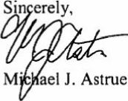
Enclosures:
Tab A -- FY 2007 Summary Spreadsheets
Tab B -- Narrative Statement
Tab C -- Statement on Alignment of Human Capital

SOCIAL SECURITY ADMINISTRATION BALTIMORE MD 21235-000l


SOCIAL SECURITY
SOCIAL SECURITY ADMINISTRATION BALTIMORE MD 21235-0001
The Commissioner
December 31, 2007
The Honorable Richard B. Cheney President of the Senate Washington, D.C. 20510

Dear Mr. Cheney:

The purpose of this letter is to transmit the Social Security Administration's (SSA) Report to Congress on Fiscal Year (FY) 2007 Competitive Sourcing Efforts as required by Section 647(b) of Division F of the Consolidated Appropriations Act, 2004, Public Law 108-199. The report has been prepared in accordance with Office of Management and Budget Memorandum M-08-02.

SSA continues to focus on results that create more efficient functions within the Agency, generate cost savings and improve performance. In FY 2007, SSA completed six competitive sourcing competitions, which resulted in improved service and increased efficiency for the Agency.

SSA continues to use competitive sourcing in a reasoned and responsible manner to improve the efficiency of the organization. If there are any questions concerning the report, your staff may contact Dennis Wilhite, Director of Competitive Sourcing Staff, at 410-966-6988.
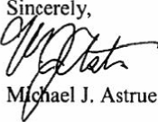
Enclosures:
Tab A -- FY 2007 Summary Spreadsheets
Tab B -- Narrative Statement
Tab C -- Statement on Alignment of Human Capital
SOCIAL SECURITY
The Commissioner
December 31, 2007

The Honorable Susan M. Collins United States Senate
Washington, D.C. 20510
Dear Senator Collins:
The purpose of this letter is to transmit the Social Security Administration's (SSA) Report to Congress on Fiscal Year (FY) 2007 Competitive Sourcing Efforts as required by Section 647(b) of Division F of the Consolidated Appropriations Act, 2004, Public Law 108-199. The report has been prepared in accordance with Office of Management and Budget Memorandum M-08-02.
SSA continues to focus on results that create more efficient functions within the Agency, generate cost savings and improve performance. In FY 2007, SSA completed six competitive sourcing competitions, which resulted in improved service and increased efficiency for the Agency.
SSA continues to use competitive sourcing in a reasoned and responsible manner to improve the efficiency of the organization. If there are any questions concerning the report, your staff may contact Dennis Wilhite, Director of Competitive Sourcing Staff, at 410-966-6988.
Sincerely,
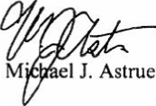
Enclosures:
Tab A -- FY 2007 Summary Spreadsheets
Tab B -- Narrative Statement
Tab C -- Statement on Alignment of Human Capital

SOCIAL SECURITY ADMINISTRATION BALTIMORE MD 21235-0001

SOCIAL SECURITY
The Commissioner
December 31, 2007
The Honorable Tom Davis House of Representatives Washington, D.C. 20515

Dear Mr. Davis:

The purpose of this letter is to transmit the Social Security Administration's (SSA) Report to Congress on Fiscal Year (FY) 2007 Competitive Sourcing Efforts as required by Section 647(b) of Division F of the Consolidated Appropriations Act, 2004, Public Law 108-199. The report has been prepared in accordance with Office of Management and Budget Memorandum M-08-02.

SSA continues to focus on results that create more efficient functions within the Agency, generate cost savings and improve performance. In FY 2007, SSA completed six competitive sourcing competitions, which resulted in improved service and increased efficiency for the Agency.

SSA continues to use competitive sourcing in a reasoned and responsible manner to improve the efficiency of the organization. If there are any questions concerning the report, your staff may contact Dennis Wilhite, Director of Competitive Sourcing Staff, at 410-966-6988.

Sincerely,
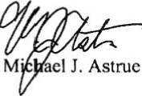
Enclosures:
Tab A -- FY 2007 Summary Spreadsheets
Tab B -- Narrative Statement
Tab C -- Statement on Alignment of Human Capital

SOCIAL SECURITY ADMINISTRATION BALTIMORE MI) 21235-0001


SOCIAL SECURITY
The Commissioner
December 31, 2007

The Honorable Charles E. Grassley
United States Senate
Washington, D.C. 20510

Dear Senator Grassley:

The purpose of this letter is to transmit the Social Security Administration's (SSA) Report to Congress on Fiscal Year (FY) 2007 Competitive Sourcing Efforts as required by Section 647(b) of Division F of the Consolidated Appropriations Act, 2004, Public Law 108-199. The report has been prepared in accordance with Office of Management and Budget Memorandum M-08-02.

SSA continues to focus on results that create more efficient functions within the Agency, generate cost savings and improve performance. In FY 2007, SSA completed six competitive sourcing competitions, which resulted in improved service and increased efficiency for the Agency.

SSA continues to use competitive sourcing in a reasoned and responsible manner to improve the efficiency of the organization. If there are any questions concerning the report, your staff may contact Dennis Wilhite, Director of Competitive Sourcing, at 410-966-6988.

Sincerely,
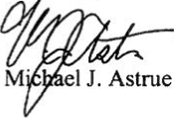
Enclosures:
Tab A -- FY 2007 Summary Spreadsheets
Tab B -- Narrative Statement
Tab C -- Statement on Alignment of Human Capital

SOCIAL SECURITY ADMINISTRAT1ON BALTIMORE MD 21235-0001


SOCIAL SECURITY
The Commissioner
December 31, 2007
The Honorable Tom Harkin
Chairman, Subcommittee on Labor, Health
and Human Services, Education, and Related Agencies Committee on Appropriations
United States Senate
Washington, D.C. 20510

Dear Mr. Chairman:

The purpose of this letter is to transmit the Social Security Administration's (SSA) Report to Congress on Fiscal Year (FY) 2007 Competitive Sourcing Efforts as required by Section 647(b) of Division F of the Consolidated Appropriations Act, 2004, Public Law 108-199. The report has been prepared in accordance with Office of Management and Budget Memorandum
M-08-02.

SSA continues to focus on results that create more efficient functions within the Agency, generate cost savings and improve performance. In FY 2007, SSA completed six competitive sourcing competitions, which resulted in improved service and increased efficiency for the Agency.

SSA continues to use competitive sourcing in a reasoned and responsible manner to improve the efficiency of the organization. If there are any questions concerning the report, your staff may contact Dennis Wilhite, Director of Competitive Sourcing Staff, at 410-966-6988.
Enclosures:
Tab A -- FY 2007 Summary Spreadsheets
Tab B -- Narrative Statement
Tab C -- Statement on Alignment of Human Capital
SOCIAL SECURITY ADMINISTRATION BALTIMORE MD 21235-0001

SOCIAL SECURITY
The Commissioner
December 31, 2007
The Honorable Sam Johnson House of Representatives Washington, D.C. 2051 5

Dear Mr. Johnson:

The purpose of this letter is to transmit the Social Security Administration's (SSA) Report to Congress on Fiscal Year (FY) 2007 Competitive Sourcing Efforts as required by Section 647(b) of Division F of the Consolidated Appropriations Act, 2004, Public Law 108-199. The report has been prepared in accordance with Office of Management and Budget Memorandum M-08-02.

SSA continues to focus on results that create more efficient functions within the Agency, generate cost savings and improve performance. In FY 2007, SSA completed six competitive sourcing competitions, which resulted in improved service and increased efficiency for the Agency.

SSA continues to use competitive sourcing in a reasoned and responsible manner to improve the efficiency of the organization, If there are any questions concerning the report, your staff may contact Dennis Wilhite, Director of Competitive Sourcing Staff, at 410-966-6988.

Sincerely,
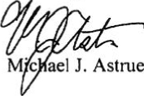
Enclosures:
Tab A -- FY 2007 Summary Spreadsheets
Tab B -- Narrative Statement
Tab C -- Statement on Alignment of Human Capital

SOCIAL SECURITY ADMINISTRATION BALTIMORE MD 21235-0001


SOCIAL SECURITY
The Commissioner
December 31, 2007
The Honorable Joseph I. Lieberman
Chairman, Committee on Homeland Security
and Government Affairs United States Senate
Washington, D.C. 20510

Dear Mr. Chairman:

The purpose of this letter is to transmit the Social Security Administration's (SSA) Report to Congress on Fiscal Year (FY) 2007 Competitive Sourcing Efforts as required by Section 647(b) of Division F of the Consolidated Appropriations Act, 2004, Public Law 108-199. The report has been prepared in accordance with Office of Management and Budget Memorandum M-08-02.

SSA continues to focus on results that create more efficient functions within the Agency, generate cost savings and improve performance. In FY 2007, SSA completed six competitive sourcing competitions, which resulted in improved service and increased efficiency for the Agency.

SSA continues to use competitive sourcing in a reasoned and responsible manner to improve the efficiency of the organization. If there are any questions concerning the report, your staff may contact Dennis Wilhite, Director of Competitive Sourcing Staff, at 410-966-6988.

Sincerely,
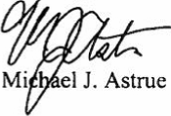
Enclosures:
Tab A -- FY 2007 Summary Spreadsheets
Tab B -- Narrative Statement
Tab C -- Statement on Alignment of Human Capital
SOCIAL SECURITY ADMINISTRATION BALTIMORE MD 21235-0001

SOCIAL SECURITY
The Commissioner
December 31, 2007
The Honorable Michael R. McNulty
Chairman, Subcommittee on Social Security
Committee on Ways and Means House of Representatives Washington, D.C. 20515

Dear Mr. Chairman:

The purpose of this letter is to transmit the Social Security Administration's (SSA) Report to Congress on Fiscal Year (FY) 2007 Competitive Sourcing Efforts as required by Section 647(b) of Division F of the Consolidated Appropriations Act, 2004, Public Law 108-199. The report has been prepared in accordance with Office of Management and Budget Memorandum M-08-02.

SSA continues to focus on results that create more efficient functions within the Agency, generate cost savings and improve performance. In FY 2007, SSA completed six competitive sourcing competitions, which resulted in improved service and increased efficiency for the Agency.

SSA continues to use competitive sourcing in a reasoned and responsible manner to improve the efficiency of the organization. If there are any questions concerning the report, your staff may contact Dennis Wilhite, Director of Competitive Sourcing Staff, at 410-966-6988.

Sincerely,
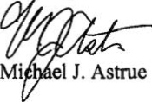
Enclosures:
Tab A -- FY 2007 Summary Spreadsheets
Tab B -- Narrative Statement
Tab C -- Statement on Alignment of Human Capital
SOCIAL SECURITY ADMINISTRATION BALTIMORE MD 21235-0001
SOCIAL SECURITY
The Commissioner
December 31, 2007
The Honorable David R. Obey
Chairman, Subcommittee on Labor, Health
and Human Services, Education, and Related Agencies
Committee on Appropriations House of Representatives Washington, D.C. 20515

Dear Mr. Chairman:

The purpose of this letter is to transmit the Social Security Administration's (SSA) Report to Congress on Fiscal Year (FY) 2007 Competitive Sourcing Efforts as required by Section 647(b) of Division F of the Consolidated Appropriations Act, 2004, Public Law 108-199. The report has been prepared in accordance with Office of Management and Budget Memorandum
M-08-02.

SSA continues to focus on results that create more efficient functions within the Agency, generate cost savings and improve performance. In FY 2007, SSA completed six competitive sourcing competitions, which resulted in improved service and increased efficiency for the Agency.

SSA continues to use competitive sourcing in a reasoned and responsible manner to improve the efficiency of the organization. If there are any questions concerning the report, your staff may contact Dennis Wilhite, Director of Competitive Sourcing Staff, at 410-966-6988.
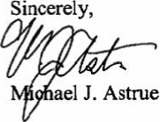
Enclosures:
Tab A -- FY 2007 Summary Spreadsheets
Tab B -- Narrative Statement
Tab C -- Statement on Alignment of Human Capital
SOCIAL SECURITY ADMINISTRATION BALTIMORE MD 21235-0001

SOCIAL SECURITY
The Commissioner
December 31, 2007
The Honorable Nancy Pelosi
Speaker of the House of Representatives Washington, D.C. 20515

Dear Madam Speaker:

The purpose of this letter is to transmit the Social Security Administration's (SSA) Report to Congress on Fiscal Year (FY) 2007 Competitive Sourcing Efforts as required by Section 647(b) of Division F of the Consolidated Appropriations Act, 2004, Public Law 108-199. The report has been prepared in accordance with Office of Management and Budget Memorandum M-08-02.

SSA continues to focus on results that create more efficient functions within the Agency, generate cost savings and improve performance. In FY 2007, SSA completed six competitive sourcing competitions, which resulted in improved service and increased efficiency for the Agency.

SSA continues to use competitive sourcing in a reasoned and responsible manner to improve the efficiency of the organization. If there are any questions concerning the report, your staff may contact Dennis Wilhite, Director of Competitive Sourcing Staff, at 410-966-6988.
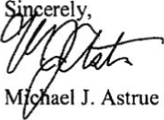
Enclosures:
Tab A -- FY 2007 Summary Spreadsheets
Tab B -- Narrative Statement
Tab C -- Statement on Alignment of Human Capital

SOCIAL SECURITY ADMINISTRATION BALTIMORE MD 21235-0001


SOCIAL SECURITY
The Commissioner
December 31, 2007
The Honorable Arlen Specter United States Senate Washington, D.C. 20510

Dear Senator Specter:

The purpose of this letter is to transmit the Social Security Administration's (SSA) Report to Congress on Fiscal Year (FY) 2007 Competitive Sourcing Efforts as required by Section 647(b) of Division F of the Consolidated Appropriations Act, 2004, Public Law 108-199. The report has been prepared in accordance with Office of Management and Budget Memorandum M-08-02.

SSA continues to focus on results that create more efficient functions within the Agency, generate cost savings and improve performance. In FY 2007, SSA completed six competitive sourcing competitions, which resulted in improved service and increased efficiency for the Agency.

SSA continues to use competitive sourcing in a reasoned and responsible manner to improve the efficiency of the organization. If there are any questions concerning the report, your staff may contact Dennis Wilhite, Director of Competitive Sourcing Staff, at 410-966-6988.

Sincerely,
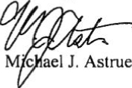
Enclosures:
Tab A -- FY 2007 Summary Spreadsheets
Tab B -- Narrative Statement
Tab C -- Statement on Alignment of Human Capital

SOCIAL SECURITY ADMINISTRATION BALTIMORE MD 21235-0001


SOCIAL SECURITY
The Commissioner
December 31, 2007
The Honorable James T. Walsh House of Representatives Washington, D.C. 20515

Dear Mr. Walsh:

The purpose of this letter is to transmit the Social Security Administration's (SSA) Report to Congress on Fiscal Year (FY) 2007 Competitive Sourcing Efforts as required by Section 647(b) of Division F of the Consolidated Appropriations Act, 2004, Public Law 108-199. The report has been prepared in accordance with Office of Management and Budget Memorandum M-08-02.

SSA continues to focus on results that create more efficient functions within the Agency, generate cost savings and improve performance. In FY 2007, SSA completed six competitive sourcing competitions, which resulted in improved service and increased efficiency for the Agency.

SSA continues to use competitive sourcing in a reasoned and responsible manner to improve the efficiency of the organization. If there are any questions concerning the report, your staff may contact Dennis Wilhite, Director of Competitive Sourcing Staff, at 410-966-6988.
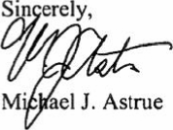
Enclosures:
Tab A -- FY 2007 Summary Spreadsheets
Tab B -- Narrative Statement
Tab C -- Statement on Alignment of Human Capital

SOCIAL SECURITY ADMINISTRATION BALTIMORE MD 21235-0001


SOCIAL SECURITY
SOCIAL SECURITY ADMINISTRATION BALTIMORE MD 21235-0001
The Commissioner
December 31, 2007
The Honorable Henry A. Waxman Chairman, Committee on Oversight and Government Reform
House of Representatives
Washington, D.C. 20515

Dear Mr. Chairman:

The purpose of this letter is to transmit the Social Security Administration's (SSA) Report to Congress on Fiscal Year (FY) 2007 Competitive Sourcing Efforts as required by Section 647(b) of Division F of the Consolidated Appropriations Act, 2004, Public Law 108-199. The report has been prepared in accordance with Office of Management and Budget Memorandum M-08-02.

SSA continues to focus on results that create more efficient functions within the Agency, generate cost savings and improve performance. In FY 2007, SSA completed six competitive sourcing competitions, which resulted in improved service and increased efficiency for the Agency.

SSA continues to use competitive sourcing in a reasoned and responsible manner to improve the efficiency of the organization. If there are any questions concerning the report, your staff may contact Dennis Wilhite, Director of Competitive Sourcing Staff, at 410-966-6988.
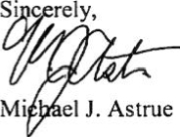
Enclosures:
Tab A -- FY 2007 Summary Spreadsheets
Tab B -- Narrative Statement
Tab C -- Statement on Alignment of Human Capital
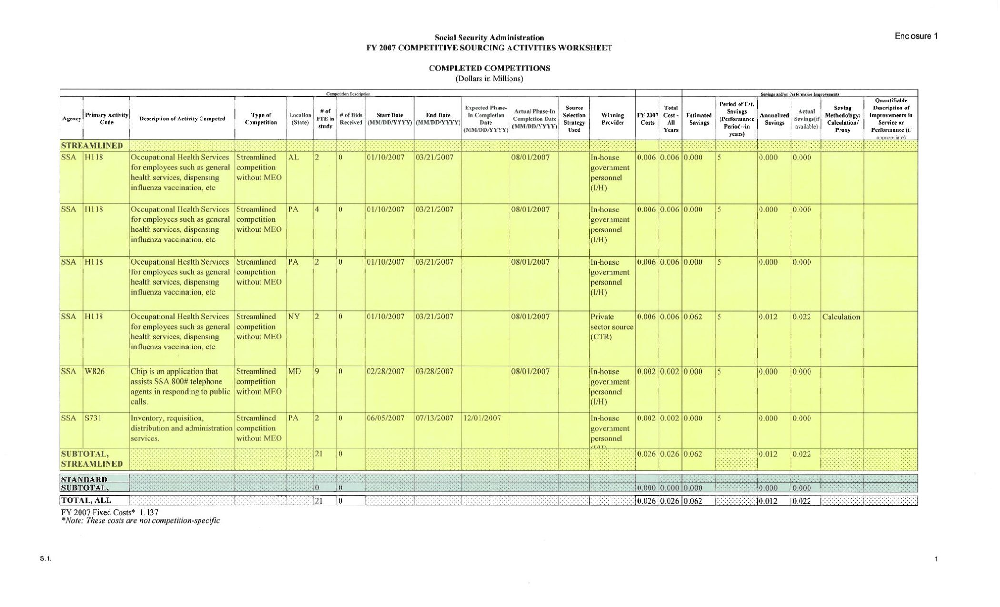
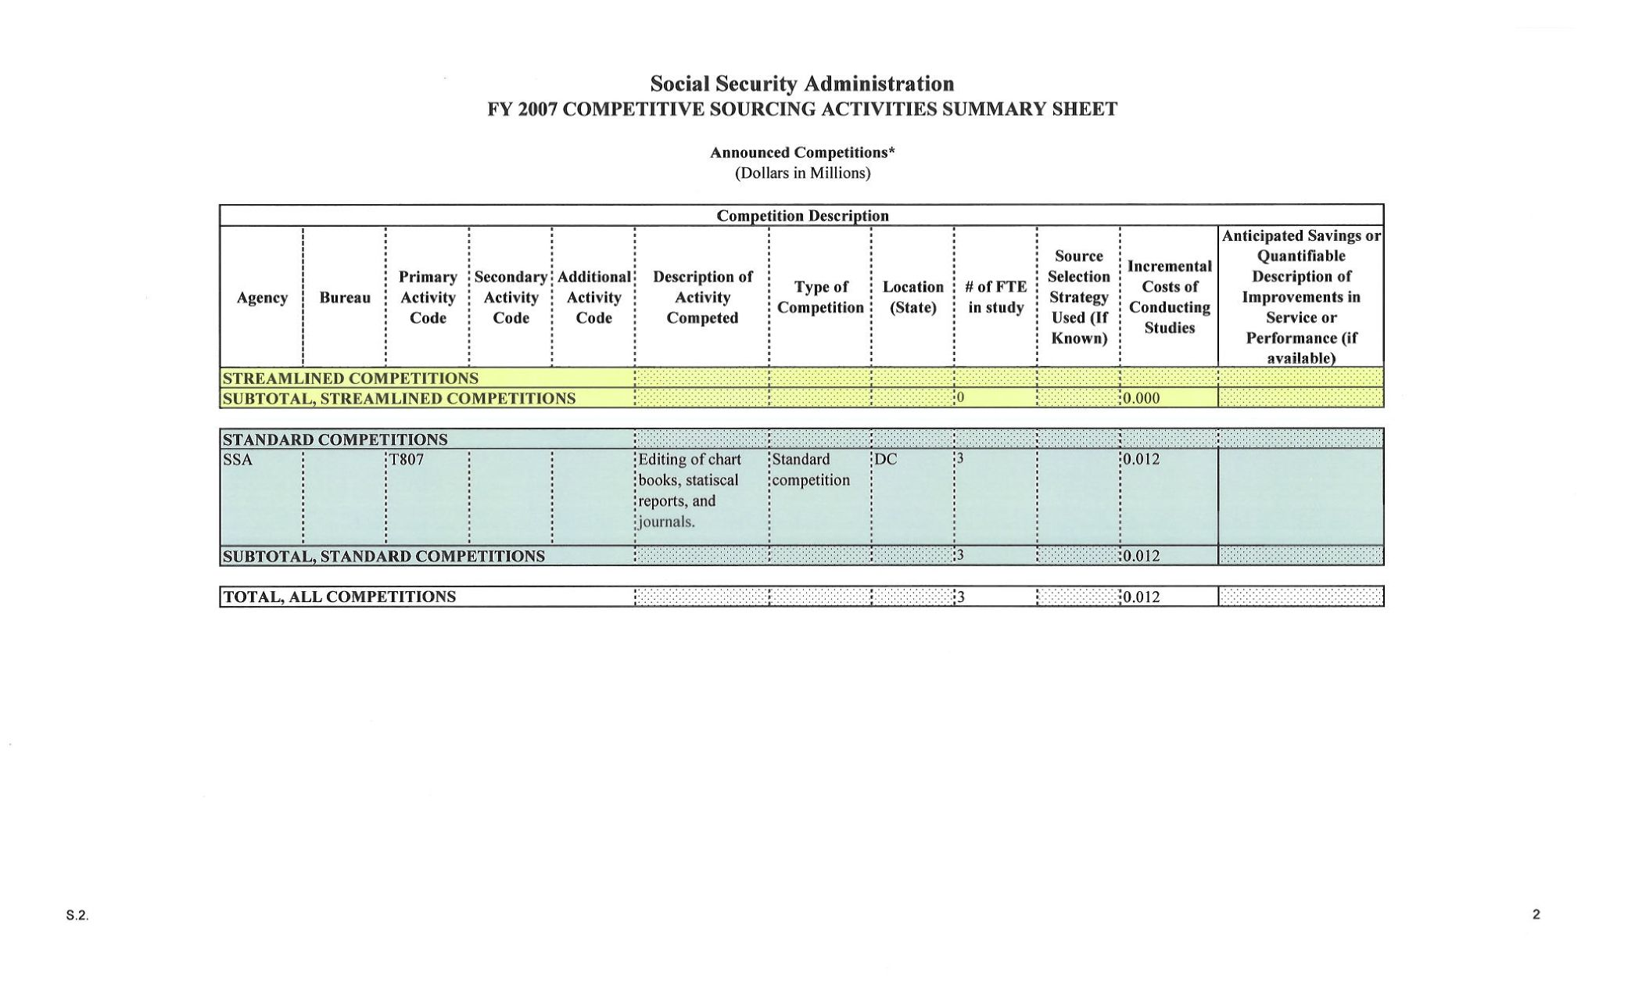
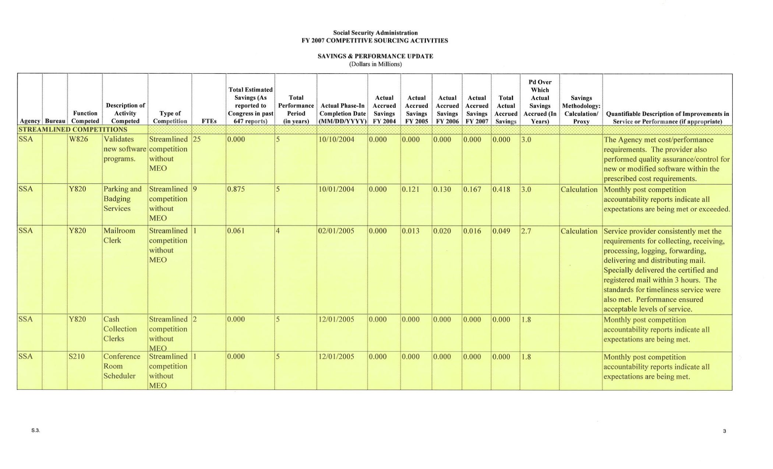
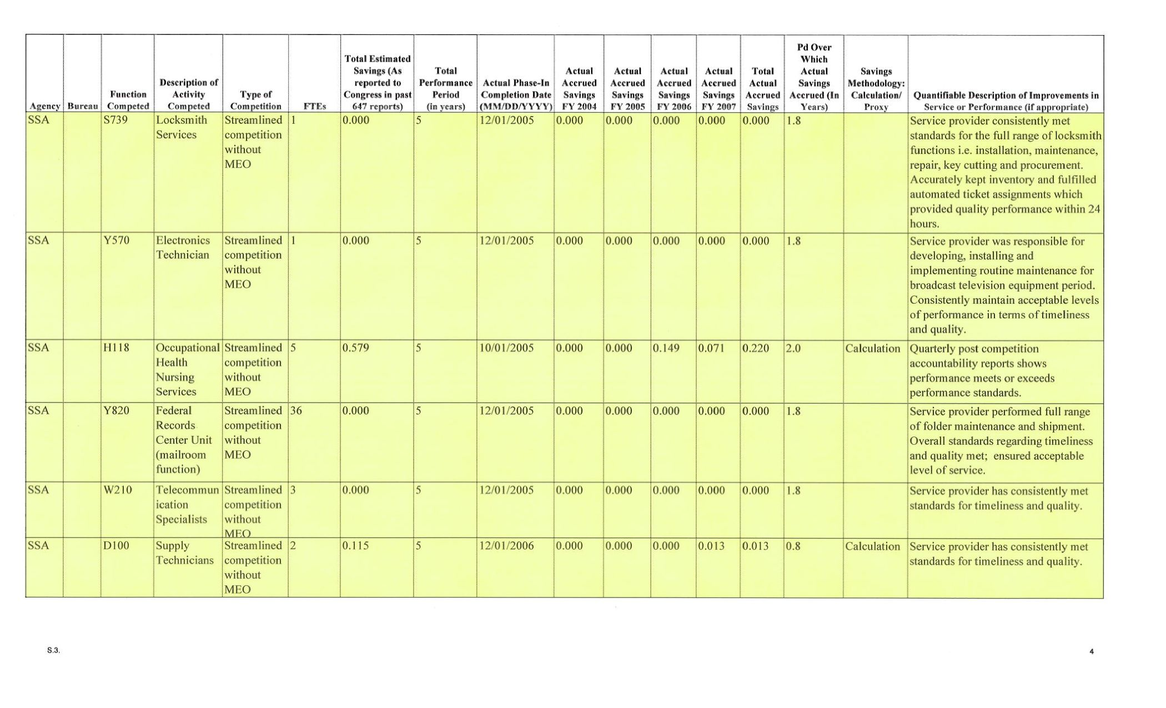
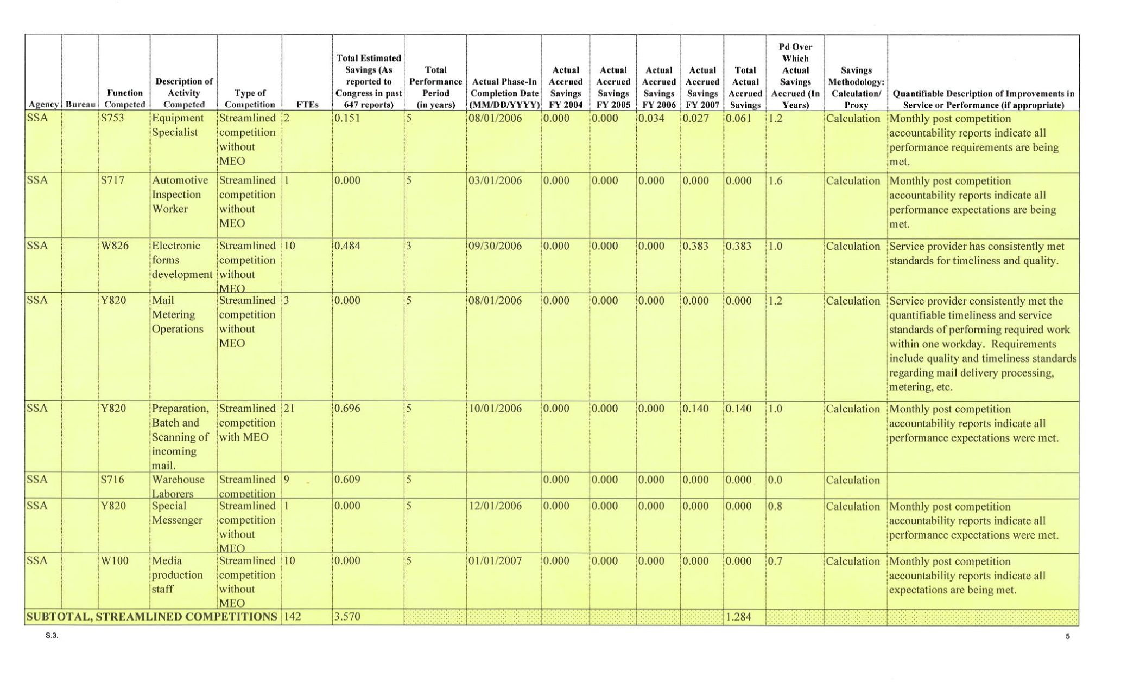
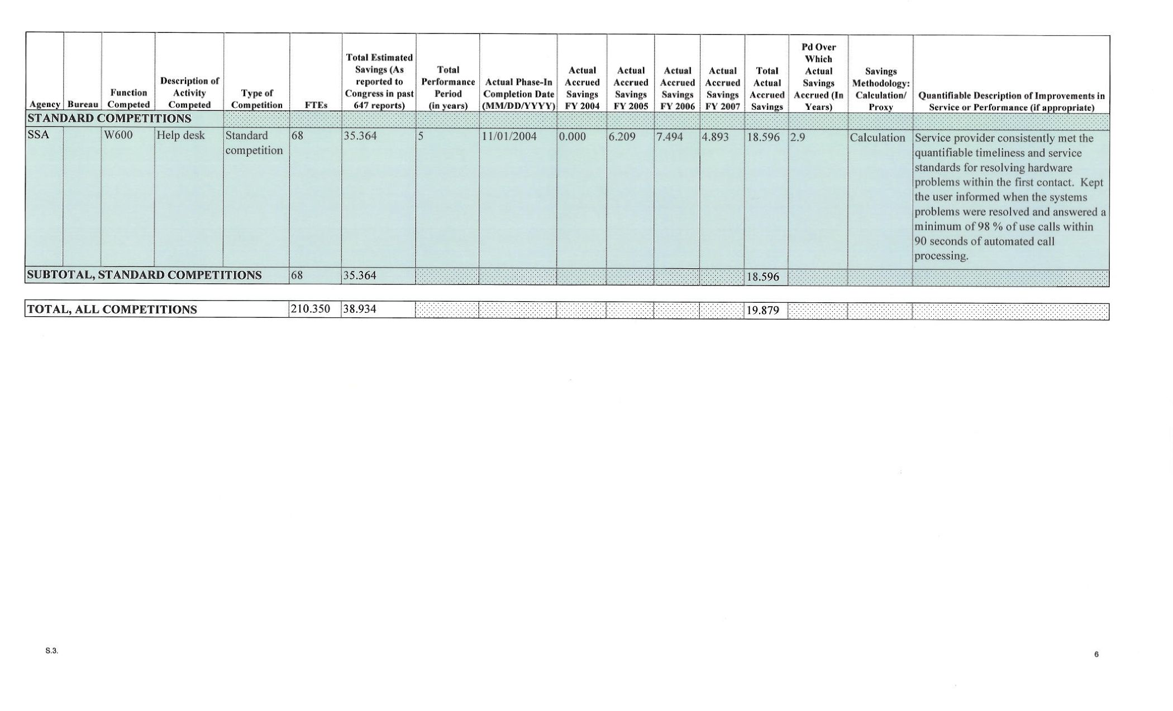
Enclosure 2 Narrative Statement

Total Projected Number of Full-time Equivalents Scheduled for Competition in Fiscal Year 2008
• The Social Security Administration plans to analyze activities involving 139 full-time equivalents (FTE) in Fiscal year 2008 for potential competition.
Enclosure 3 Alignment of Competitive Sourcing and Human Capital

SSA has taken several steps to ensure that its competitive sourcing plans and human capital plans are aligned and complement each other. Specific human resources and human capital issues affected by competitive sourcing are addressed in the Agency's Competitive Sourcing Human Resources Plan and Labor Relations Strategic Plan. These plans outline alternatives for employees affected by competitive sourcing and offer strategies for placing, hiring, training and accommodating those employees. SSA's Competitive Sourcing Human Resources Plan also supports the Agency's efforts to hire and promote people with disabilities. (In FY 2007, the Agency hired 5,077 permanent and temporary employees, of which 348 were people with disabilities; bringing the overall percentage for this group to 8.1% of the total workforce.) The SSA Labor Relations Strategic Plan addresses labor relations obligations and issues arising from competitive sourcing activities.

The Competitive Sourcing Human Resources Plan and Labor Relations Strategic Plan are strategically aligned with the Agency's major human capital planning and accountability documents. SSA has developed a comprehensive Strategic Human Capital Plan (SHCP) that fully supports the President's Management Agenda on the Strategic Management of Human Capital. The SHCP, which is aligned with the Agency Strategic Plan and the Office of Personnel Management's Human Capital Assessment and Accountability Framework, sets our course for achieving measurable human capital results that will not only improve the service we provide, but also provide accountability for all of our human capital activities. Specific goals and strategies regarding competitive sourcing activities and the use of the aforementioned strategic competitive sourcing plans are identified in the SHCP. Further, these and other activities in the SHCP are tracked quarterly through SSA's Future Workforce Transition Plan, and annual goal attainment is evaluated and reported in the annual Human Capital Management Accountability Report.

The Office of Human Resources (OHR) and Human Capital Planning Staff work closely with the Competitive Sourcing Staff on competitive sourcing activities. When a study is announced, OHR also works with the component developing the Performance Work Statement to identify a specific transition plan for potentially affected employees involved in the competition. These transition plans include identifying potential positions where employees could be redirected, if necessary, as well as skill gap assessments and training. OHR also identifies the extent to which functions are occupied with persons with disabilities. This information is used in considering functions for competitive sourcing. As new functions are considered for study, SSA evaluates the effect that competition will have on this significant part of our workforce, working to ensure employees with disabilities are not adversely affected by any of the Agency's competitions.

Finally, on an Agency-wide scale, OHR has been actively working for many years to identify and properly plan for the potential effects of the impending retirement wave on the Agency's ability to deliver services. The primary document that captures this effort is the "Retirement Wave Analysis." This document is updated annually and shared with all staffs, including the Competitive Sourcing Staff, and can be used to help determine whether a function is a potential candidate for a competitive sourcing study.

