Clozaril® (clozapine) Tablets

Briefing Document for Psychopharmacological Drugs Advisory Committee Meeting (June 16, 2003)

Appendix 2: Post-text Tables (United Kingdom Data)

Document status: | Final
Release date: | May 19, 2003
Number of pages: | 44

Available for public disclosure without redaction
Table of contents
1 Agranulocytosis incidence per 1,000 person-years and 95% CI, by treatment duration, in the UK CPMS. 4
2 Agranulocytosis incidence per 1,000 person-years and 95% CI, by calendar year and treatment duration, in the UK CPMS. 5
3 Agranulocytosis incidence per 1,000 person-years and 95% CI, by treatment duration and monitoring frequency, in the UK CPMS. 7
4 Agranulocytosis incidence per 1,000 person-years and 95% CI, by calendar year (2-year intervals), treatment duration and monitoring frequency, in the UK CPMS. 8
5 Agranulocytosis incidence per 1,000 person-years and 95% CI, by treatment duration and cohort in the UK CPMS. 10
6 Agranulocytosis incidence per 1,000 person-years and 95% CI, by treatment duration, monitoring frequency and cohort in the UK CPMS. 11
7 Severe leukopenia incidence per 1,000 person-years and 95% CI, by treatment duration, in the UK CPMS. 12
8 Severe leukopenia incidence per 1,000 person-years and 95% CI, by calendar year and treatment duration, in the UK CPMS. 13
9 Severe leukopenia incidence per 1,000 person-years and 95% CI, by treatment duration and monitoring frequency, in the UK CPMS. 14
10 Severe leukopenia incidence per 1,000 person-years and 95% CI, by calendar year (2-year intervals), treatment duration and monitoring frequency, in the UK CPMS. 15
11 Severe leukopenia incidence per 1,000 person-years and 95% CI, by treatment duration and cohort in the UK CPMS. 17
12 Severe leukopenia incidence per 1,000 person-years and 95% CI, by treatment duration, monitoring frequency and cohort in the UK CPMS. 18
13 Red Alert incidence per 1,000 person-years and 95% CI, by treatment duration, in the UK CPMS. 19
14 Red alert incidence per 1,000 person-years and 95% CI, by calendar year and treatment duration (3 periods), in the UK CPMS. 20
15 Red alert incidence per 1,000 person-years and 95% CI, by calendar year and treatment duration (12 periods), in the UK CPMS. 22
16 Red alert incidence per 1,000 person-years and 95% CI, by treatment duration and monitoring frequency, in the UK CPMS. 27
17 Red alert incidence per 1,000 person-years and 95% CI, by calendar year (2-year intervals), treatment duration and monitoring frequency, in the UK CPMS. 28
18 Red alert incidence per 1,000 person-years and 95% CI, by treatment duration and cohort in the UK CPMS. 30
19 Red alert incidence per 1,000 person-years and 95% CI, by treatment duration, monitoring frequency and cohort in the UK CPMS. 31
20 Red alert treatment withdrawal criteria, in the UK CPMS 33
21 Demographic characteristics of the UK CPMS patients included in the analysis, by cohort. 34
22 Demographic characteristics of the UK CPMS patients with agranulocytosis , by cohort. 35
23 Demographic characteristics of the UK CPMS patients with severe leukopenia, by cohort. 36
24 Demographic characteristics of the UK CPMS patients with red alert, by cohort. 37

Figures 38
1) Agranulocytosis incidence per 1,000 person years and 95% CI, for the first 84 weeks of treatment (in 2-week intervals). 39
2) Agranulocytosis incidence per 1,000 person years and 95% CI, by treatment duration (in 6-week intervals). 40
3) Severe leukopenia incidence per 1,000 person years and 95% CI, for the first 84 weeks of treatment (in 2-week intervals). 41
4) Severe leukopenia incidence per 1,000 person years and 95% CI, by treatment duration (in 6-week intervals). 42
5) Red alert incidence per 1,000 person years and 95% CI, for the first 84 weeks of treatment (in 2-week intervals). 43
6) Red alert incidence per 1,000 person years and 95% CI, by treatment duration (in 6-week intervals). 44

1 Agranulocytosis incidence per 1,000 person-years and 95% CI, by treatment duration, in the UK CPMS.
Table 4.1. Agranulocytosis incidence per 1,000 person-years and 95% CI, by treatment duration, in the UK CPMS.
 | Cases | Pat-yrs | Incidence | 95% | CI
Trt duration | 162 | 7,579.46 | 21.37 | 18.08 | 24.66
0-18 wks
19-52 wks | 16 | 11,147.43 | 1.44 | 0.82 | 2.33
+52 wks | 40 | 56,757.91 | 0.70 | 0.49 | 0.92

2 Agranulocytosis incidence per 1,000 person-years and 95% CI, by calendar year and treatment duration, in the UK CPMS.
Table 4.2. Agranulocytosis incidence per 1,000 person-years and 95% CI, by calendar year and treatment duration, in the UK CPMS.
 |  | Cases | Pat-yrs | Incidence | 95% | CI
trt duration | Calendar year | 4 | 131.03 | 30.53 | 8.32 | 78.15
0-18 wks | 1990
0-18 wks | 1991 | 7 | 394.33 | 17.75 | 7.14 | 36.57
0-18 wks | 1992 | 11 | 415.40 | 26.48 | 13.22 | 47.38
0-18 wks | 1993 | 11 | 421.84 | 26.08 | 13.02 | 46.65
0-18 wks | 1994 | 15 | 430.83 | 34.82 | 19.49 | 57.42
0-18 wks | 1995 | 13 | 592.05 | 21.96 | 11.69 | 37.55
0-18 wks | 1996 | 18 | 765.97 | 23.50 | 13.93 | 37.14
0-18 wks | 1997 | 4 | 574.28 | 6.97 | 1.90 | 17.83
0-18 wks | 1998 | 19 | 765.86 | 24.81 | 14.94 | 38.74
0-18 wks | 1999 | 29 | 945.67 | 30.67 | 19.50 | 41.83
0-18 wks | 2000 | 19 | 969.67 | 19.59 | 11.80 | 30.60
0-18 wks | 2001 | 12 | 1,010.03 | 11.88 | 6.14 | 20.75
0-18 wks | 2002 | . | 162.50 | . | . | .
19-52 wks | 1990 | . | 56.70 | . | . | .
19-52 wks | 1991 | 1 | 374.28 | 2.67 | 0.07 | 14.89
19-52 wks | 1992 | . | 630.79 | . | . | .
19-52 wks | 1993 | 2 | 662.72 | 3.02 | 0.37 | 10.90
19-52 wks | 1994 | . | 585.94 | . | . | .
19-52 wks | 1995 | 1 | 797.02 | 1.25 | 0.03 | 6.99
19-52 wks | 1996 | 2 | 1,159.13 | 1.73 | 0.21 | 6.23
19-52 wks | 1997 | 2 | 994.78 | 2.01 | 0.24 | 7.26
19-52 wks | 1998 | 3 | 1,037.32 | 2.89 | 0.60 | 8.45
19-52 wks | 1999 | 2 | 1,430.98 | 1.40 | 0.17 | 5.05
19-52 wks | 2000 | 2 | 1,499.66 | 1.33 | 0.16 | 4.82
19-52 wks | 2001 | 1 | 1,645.98 | 0.61 | 0.02 | 3.39
19-52 wks | 2002 | . | 272.15 | . | . | .
+52 wks | 1990 | . | 1.69 | . | . | .
+52 wks | 1991 | . | 141.41 | . | . | .
+52 wks | 1992 | 1 | 747.61 | 1.34 | 0.03 | 7.45
+52 wks | 1993 | . | 1,572.48 | . | . | .
+52 wks | 1994 | 1 | 2,302.91 | 0.43 | 0.01 | 2.42
+52 wks | 1995 | 1 | 3,009.96 | 0.33 | 0.01 | 1.85
+52 wks | 1996 | 3 | 4,232.59 | 0.71 | 0.15 | 2.07
+52 wks | 1997 | 4 | 5,535.94 | 0.72 | 0.20 | 1.85
+52 wks | 1998 | 4 | 6,718.51 | 0.60 | 0.16 | 1.52
+52 wks | 1999 | 9 | 8,129.39 | 1.11 | 0.51 | 2.10
+52 wks | 2000 | 10 | 10,091.22 | 0.99 | 0.48 | 1.82
+52 wks | 2001 | 7 | 12,077.15 | 0.58 | 0.23 | 1.19
+52 wks | 2002 | . | 2,197.04 | . | . | .

3 Agranulocytosis incidence per 1,000 person-years and 95% CI, by treatment duration and monitoring frequency, in the UK CPMS.

Table 4.3. Agranulocytosis incidence per 1,000 person-years and 95% CI by treatment duration and monitoring frequency, in the UK CPMS.
 |  | Cases | Pat-yrs | Incidence | 95% | CI
trt duration | Monitoring freq. | 162 | 7,575.17 | 21.39 | 18.09 | 24.68
0-18 wks | 1W
19-52 wks | 1W | 12 | 2,506.63 | 4.79 | 2.47 | 8.36
19-52 wks | 2W | 4 | 8,616.53 | 0.46 | 0.13 | 1.19
+52 wks | 1W | 17 | 2,518.03 | 6.75 | 3.93 | 10.81
+52 wks | 2W | 6 | 10,978.36 | 0.55 | 0.20 | 1.19
+52 wks | 4W | 17 | 43,181.76 | 0.39 | 0.23 | 0.63
1W - patients who were monitored weekly
2W - patients who were monitored every two weeks
4W - patients who were monitored every four weeks (monthly)

4 Agranulocytosis incidence per 1,000 person-years and 95% CI, by calendar year (2-year intervals), treatment duration and monitoring frequency, in the UK CPMS.

Table 4.4. Agranulocytosis incidence per 1,000 person-years and 95% CI, by calendar year (2-year intervals), treatment duration and monitoring frequency, in the UK CPMS.
 |  |  | Cases | Pat-yrs | Incidence | 95% | CI
trt duration | monitor | Calendar year | 11 | 524.90 | 20.96 | 10.46 | 37.49
0-18 wks | 1W | 1990-1991
0-18 wks | 1W | 1992-1993 | 22 | 836.64 | 26.30 | 15.31 | 37.28
0-18 wks | 1W | 1994-1995 | 28 | 1,022.03 | 27.40 | 17.25 | 37.54
0-18 wks | 1W | 1996-1997 | 22 | 1,339.29 | 16.43 | 9.56 | 23.29
0-18 wks | 1W | 1998-1999 | 48 | 1,710.74 | 28.06 | 20.12 | 36.00
0-18 wks | 1W | 2000-2002* | 31 | 2,141.58 | 14.48 | 9.38 | 19.57
19-52 wks | 1W | 1990-1991 | 1 | 115.98 | 8.62 | 0.22 | 48.04
19-52 wks | 1W | 1992-1993 | 2 | 295.12 | 6.78 | 0.82 | 24.48
19-52 wks | 1W | 1994-1995 | 1 | 315.53 | 3.17 | 0.08 | 17.66
19-52 wks | 1W | 1996-1997 | 3 | 472.24 | 6.35 | 1.31 | 18.56
19-52 wks | 1W | 1998-1999 | 3 | 577.84 | 5.19 | 1.07 | 15.17
19-52 wks | 1W | 2000-2002* | 2 | 729.92 | 2.74 | 0.33 | 9.90
19-52 wks | 2W | 1990-1991 | . | 314.03 | . | . | .
19-52 wks | 2W | 1992-1993 | . | 995.66 | . | . | .
19-52 wks | 2W | 1994-1995 | . | 1,064.82 | . | . | .
19-52 wks | 2W | 1996-1997 | 1 | 1,677.30 | 0.60 | 0.01 | 3.32
19-52 wks | 2W | 1998-1999 | 2 | 1,884.78 | 1.06 | 0.13 | 3.83
19-52 wks | 2W | 2000-2002* | 1 | 2,679.93 | 0.37 | 0.01 | 2.08
+52 wks | 1W | 1990-1991 | . | 13.73 | . | . | .
+52 wks | 1W | 1992-1993 | . | 207.76 | . | . | .
+52 wks | 1W | 1994-1995 | 2 | 346.71 | 5.77 | 0.70 | 20.84
+52 wks | 1W | 1996-1997 | 1 | 434.40 | 2.30 | 0.06 | 12.83
+52 wks | 1W | 1998-1999 | 6 | 646.84 | 9.28 | 3.40 | 20.19
+52 wks | 1W | 2000-2002* | 8 | 868.59 | 9.21 | 3.98 | 18.14
+52 wks | 2W | 1990-1991 | . | 128.91 | . | . | .
+52 wks | 2W | 1992-1993 | 1 | 2,107.50 | 0.47 | 0.01 | 2.64
+52 wks | 2W | 1994-1995 | . | 3,828.73 | . | . | .
+52 wks | 2W | 1996-1997 | 2 | 1,524.43 | 1.31 | 0.16 | 4.74
+52 wks | 2W | 1998-1999 | 1 | 1,594.00 | 0.63 | 0.02 | 3.50
+52 wks | 2W | 2000-2002* | 2 | 1,794.79 | 1.11 | 0.13 | 4.03
+52 wks | 4W | 1994-1995 | . | 1,128.30 | . | . | .
+52 wks | 4W | 1996-1997 | 4 | 7,795.15 | 0.51 | 0.14 | 1.31
+52 wks | 4W | 1998-1999 | 6 | 12,586.90 | 0.48 | 0.17 | 1.04
+52 wks | 4W | 2000-2002* | 7 | 21,671.41 | 0.32 | 0.13 | 0.67
1W - patients who were monitored weekly
2W - patients who were monitored every two weeks
4W - patients who were monitored every four weeks (monthly)

5 Agranulocytosis incidence per 1,000 person-years and 95% CI, by treatment duration and cohort in the UK CPMS.

Table 4.5. Agranulocytosis incidence per 1,000 person-years and 95% CI, by treatment duration and cohort in the UK CPMS.
 |  | Cases | Pat-yrs | Incidence | 95% | CI
Trt duration | Cohort | 43 | 1,731.75 | 24.83 | 17.41 | 32.25
0-18 wks | Initial system
0-18 wks | Current system, new patients | 119 | 5,839.83 | 20.38 | 16.72 | 24.04
0-18 wks | Current system, old patients | . | 1.20 | . | . | .
19-52 wks | Initial system | 3 | 2,586.62 | 1.16 | 0.24 | 3.39
19-52 wks | Current system, new patients | 13 | 8,552.11 | 1.52 | 0.81 | 2.60
19-52 wks | Current system, old patients | . | 3.14 | . | . | .
+52 wks | Initial system | 2 | 6,542.55 | 0.31 | 0.04 | 1.10
+52 wks | Current system, new patients | 18 | 30,693.75 | 0.59 | 0.35 | 0.93
+52 wks | Current system, old patients | 20 | 19,499.30 | 1.03 | 0.63 | 1.58

6 Agranulocytosis incidence per 1,000 person-years and 95% CI, by treatment duration, monitoring frequency and cohort in the UK CPMS.

Table 4.6. Agranulocytosis incidence per 1,000 person-years and 95% CI, by treatment duration, monitoring frequency and cohort style, in the US CPMS.
 |  |  | Cases | Pat-yrs | Incidence | 95% | CI
Trt duration | monitor | Cohort | 43 | 1,730.38 | 24.85 | 17.42 | 32.28
0-18 wks | 1W | Initial system
0-18 wks | 1W | Current system, new patients | 119 | 5,836.92 | 20.39 | 16.72 | 24.05
0-18 wks | 1W | Current system, old patients | . | 1.20 | . | . | .
19-52 wks | 1W | Initial system | 3 | 576.70 | 5.20 | 1.07 | 15.20
19-52 wks | 1W | Current system, new patients | 9 | 1,927.84 | 4.67 | 2.13 | 8.86
19-52 wks | 1W | Current system, old patients | . | 0.79 | . | . | .
19-52 wks | 2W | Initial system | . | 2,004.42 | . | . | .
19-52 wks | 2W | Current system, new patients | 4 | 6,605.80 | 0.61 | 0.17 | 1.55
19-52 wks | 2W | Current system, old patients | . | 2.05 | . | . | .
+52 wks | 1W | Initial system | 1 | 492.97 | 2.03 | 0.05 | 11.30
+52 wks | 1W | Current system, new patients | 6 | 1,303.73 | 4.60 | 1.69 | 10.02
+52 wks | 1W | Current system, old patients | 10 | 718.72 | 13.91 | 6.67 | 25.59
+52 wks | 2W | Initial system | 1 | 6,038.57 | 0.17 | 0.00 | 0.92
+52 wks | 2W | Current system, new patients | 3 | 3,310.65 | 0.91 | 0.19 | 2.65
+52 wks | 2W | Current system, old patients | 2 | 1,625.35 | 1.23 | 0.15 | 4.45
+52 wks | 4W | Current system, new patients | 9 | 26,034.87 | 0.35 | 0.16 | 0.66
+52 wks | 4W | Current system, old patients | 8 | 17,131.16 | 0.47 | 0.20 | 0.92
1W - patients who were monitored weekly
2W - patients who were monitored every two weeks
4W - patients who were monitored every four weeks (monthly)

7 Severe leukopenia incidence per 1,000 person-years and 95% CI, by treatment duration, in the UK CPMS.
Table 4.7. Severe leukopenia incidence per 1,000 person-years and 95% CI, by treatment duration, in the UK CPMS.
 | Cases | Pat-yrs | Incidence | 95% | CI
trt duration | 244 | 7,579.46 | 32.19 | 28.15 | 36.23
0-18 wks
19-52 wks | 45 | 11,147.43 | 4.04 | 2.86 | 5.22
+52 wks | 111 | 56,757.91 | 1.96 | 1.59 | 2.32

8 Severe leukopenia incidence per 1,000 person-years and 95% CI, by calendar year and treatment duration, in the UK CPMS.

Table 4.8. Severe leukopenia incidence per 1,000 person-years and 95% CI, by calendar year and treatment duration, in the UK CPMS.
 |  | Cases | Pat-yrs | Incidence | 95% | CI
Trt duration | Calendar year | 7 | 131.03 | 53.42 | 21.48 | 110.05
0-18 wks | 1990
0-18 wks | 1991 | 12 | 394.33 | 30.43 | 15.73 | 53.15
0-18 wks | 1992 | 14 | 415.40 | 33.70 | 18.43 | 56.55
0-18 wks | 1993 | 13 | 421.84 | 30.82 | 16.41 | 52.70
0-18 wks | 1994 | 18 | 430.83 | 41.78 | 24.77 | 66.03
0-18 wks | 1995 | 18 | 592.05 | 30.40 | 18.02 | 48.05
0-18 wks | 1996 | 22 | 765.97 | 28.72 | 16.72 | 40.72
0-18 wks | 1997 | 15 | 574.28 | 26.12 | 14.62 | 43.08
0-18 wks | 1998 | 27 | 765.86 | 35.25 | 21.96 | 48.55
0-18 wks | 1999 | 44 | 945.67 | 46.53 | 32.78 | 60.28
0-18 wks | 2000 | 26 | 969.67 | 26.81 | 16.51 | 37.12
0-18 wks | 2001 | 22 | 1,010.03 | 21.78 | 12.68 | 30.88
0-18 wks | 2002 | 6 | 162.50 | 36.92 | 13.55 | 80.37
19-52 wks | 1990 | . | 56.70 | . | . | .
19-52 wks | 1991 | 2 | 374.28 | 5.34 | 0.65 | 19.30
19-52 wks | 1992 | 3 | 630.79 | 4.76 | 0.98 | 13.90
19-52 wks | 1993 | 4 | 662.72 | 6.04 | 1.64 | 15.45
19-52 wks | 1994 | 1 | 585.94 | 1.71 | 0.04 | 9.51
19-52 wks | 1995 | 3 | 797.02 | 3.76 | 0.78 | 11.00
19-52 wks | 1996 | 4 | 1,159.13 | 3.45 | 0.94 | 8.83
19-52 wks | 1997 | 5 | 994.78 | 5.03 | 1.63 | 11.73
19-52 wks | 1998 | 6 | 1,037.32 | 5.78 | 2.12 | 12.59
19-52 wks | 1999 | 5 | 1,430.98 | 3.49 | 1.13 | 8.16
19-52 wks | 2000 | 7 | 1,499.66 | 4.67 | 1.88 | 9.62
19-52 wks | 2001 | 4 | 1,645.98 | 2.43 | 0.66 | 6.22
19-52 wks | 2002 | 1 | 272.15 | 3.67 | 0.09 | 20.47
+52 wks | 1990 | . | 1.69 | . | . | .
+52 wks | 1991 | 1 | 141.41 | 7.07 | 0.18 | 39.40
+52 wks | 1992 | 3 | 747.61 | 4.01 | 0.83 | 11.73
+52 wks | 1993 | 4 | 1,572.48 | 2.54 | 0.69 | 6.51
+52 wks | 1994 | 5 | 2,302.91 | 2.17 | 0.70 | 5.07
+52 wks | 1995 | 3 | 3,009.96 | 1.00 | 0.21 | 2.91
+52 wks | 1996 | 8 | 4,232.59 | 1.89 | 0.82 | 3.72
+52 wks | 1997 | 8 | 5,535.94 | 1.45 | 0.62 | 2.85
+52 wks | 1998 | 14 | 6,718.51 | 2.08 | 1.14 | 3.50
+52 wks | 1999 | 19 | 8,129.39 | 2.34 | 1.41 | 3.65
+52 wks | 2000 | 27 | 10,091.22 | 2.68 | 1.67 | 3.68
+52 wks | 2001 | 17 | 12,077.15 | 1.41 | 0.82 | 2.25
+52 wks | 2002 | 2 | 2,197.04 | 0.91 | 0.11 | 3.29

9 Severe leukopenia incidence per 1,000 person-years and 95% CI, by treatment duration and monitoring frequency, in the UK CPMS.

Table 4.9. Severe leukopenia incidence per 1,000 person-years and 95% CI, by treatment duration and monitoring frequency, in the UK CPMS.
 |  | Cases | Pat-yrs | Incidence | 95% | CI
Trt duration | Monitor | 244 | 7,575.17 | 32.21 | 28.17 | 36.25
0-18 wks | 1W
19-52 wks | 1W | 39 | 2,506.63 | 15.56 | 10.68 | 20.44
19-52 wks | 2W | 6 | 8,616.53 | 0.70 | 0.26 | 1.52
+52 wks | 1W | 72 | 2,518.03 | 28.59 | 21.99 | 35.20
+52 wks | 2W | 13 | 10,978.36 | 1.18 | 0.63 | 2.02
+52 wks | 4W | 25 | 43,181.76 | 0.58 | 0.35 | 0.81

10 Severe leukopenia incidence per 1,000 person-years and 95% CI, by calendar year (2-year intervals), treatment duration and monitoring frequency, in the UK CPMS.

Table 4.10. Severe leukopenia incidence per 1,000 person-years and 95% CI, by calendar year (2-year intervals), treatment duration and monitoring frequency, in the UK CPMS.
 |  |  | Cases | Pat-yrs | Incidence | 95% | CI
trt duration | monitor | Calendar year | 19 | 524.90 | 36.20 | 21.79 | 56.53
0-18 wks | 1W | 1990-1991
0-18 wks | 1W | 1992-1993 | 27 | 836.64 | 32.27 | 20.10 | 44.44
0-18 wks | 1W | 1994-1995 | 36 | 1,022.03 | 35.22 | 23.72 | 46.73
0-18 wks | 1W | 1996-1997 | 37 | 1,339.29 | 27.63 | 18.72 | 36.53
0-18 wks | 1W | 1998-1999 | 71 | 1,710.74 | 41.50 | 31.85 | 51.16
0-18 wks | 1W | 2000-2002* | 54 | 2,141.58 | 25.22 | 18.49 | 31.94
19-52 wks | 1W | 1990-1991 | 1 | 115.98 | 8.62 | 0.22 | 48.04
19-52 wks | 1W | 1992-1993 | 7 | 295.12 | 23.72 | 9.54 | 48.86
19-52 wks | 1W | 1994-1995 | 4 | 315.53 | 12.68 | 3.45 | 32.45
19-52 wks | 1W | 1996-1997 | 7 | 472.24 | 14.82 | 5.96 | 30.54
19-52 wks | 1W | 1998-1999 | 10 | 577.84 | 17.31 | 8.30 | 31.83
19-52 wks | 1W | 2000-2002* | 10 | 729.92 | 13.70 | 6.57 | 25.19
19-52 wks | 2W | 1990-1991 | 1 | 314.03 | 3.18 | 0.08 | 17.74
19-52 wks | 2W | 1992-1993 | . | 995.66 | . | . | .
19-52 wks | 2W | 1994-1995 | . | 1,064.82 | . | . | .
19-52 wks | 2W | 1996-1997 | 2 | 1,677.30 | 1.19 | 0.14 | 4.31
19-52 wks | 2W | 1998-1999 | 1 | 1,884.78 | 0.53 | 0.01 | 2.96
19-52 wks | 2W | 2000-2002* | 2 | 2,679.93 | 0.75 | 0.09 | 2.70
+52 wks | 1W | 1990-1991 | 1 | 13.73 | 72.83 | 1.82 | 405.82
+52 wks | 1W | 1992-1993 | 4 | 207.76 | 19.25 | 5.25 | 49.29
+52 wks | 1W | 1994-1995 | 4 | 346.71 | 11.54 | 3.14 | 29.53
+52 wks | 1W | 1996-1997 | 11 | 434.40 | 25.32 | 12.64 | 45.30
+52 wks | 1W | 1998-1999 | 24 | 646.84 | 37.10 | 22.26 | 51.95
+52 wks | 1W | 2000-2002* | 28 | 868.59 | 32.24 | 20.30 | 44.18
+52 wks | 2W | 1990-1991 | . | 128.91 | . | . | .
+52 wks | 2W | 1992-1993 | 3 | 2,107.50 | 1.42 | 0.29 | 4.16
+52 wks | 2W | 1994-1995 | 4 | 3,828.73 | 1.04 | 0.28 | 2.67
+52 wks | 2W | 1996-1997 | 1 | 1,524.43 | 0.66 | 0.02 | 3.66
+52 wks | 2W | 1998-1999 | 2 | 1,594.00 | 1.25 | 0.15 | 4.53
+52 wks | 2W | 2000-2002* | 3 | 1,794.79 | 1.67 | 0.34 | 4.88
+52 wks | 4W | 1994-1995 | . | 1,128.30 | . | . | .
+52 wks | 4W | 1996-1997 | 4 | 7,795.15 | 0.51 | 0.14 | 1.31
+52 wks | 4W | 1998-1999 | 7 | 12,586.90 | 0.56 | 0.22 | 1.15
+52 wks | 4W | 2000-2002* | 14 | 21,671.41 | 0.65 | 0.35 | 1.08
1W - patients who were monitored weekly
2W - patients who were monitored every two weeks
4W - patients who were monitored every four weeks (monthly)

11 Severe leukopenia incidence per 1,000 person-years and 95% CI, by treatment duration and cohort in the UK CPMS.

Table 4.11. Severe leukopenia incidence per 1,000 person-years and 95% CI, by treatment duration and cohort in the UK CPMS.
 |  | Cases | Pat-yrs | Incidence | 95% | CI
trt duration | Cohort | 58 | 1,731.75 | 33.49 | 24.87 | 42.11
0-18 wks | Initial system
0-18 wks | Current system, new patients | 186 | 5,839.83 | 31.85 | 27.27 | 36.43
0-18 wks | Current system, old patients | . | 1.20 | . | . | .
19-52 wks | Initial system | 11 | 2,586.62 | 4.25 | 2.12 | 7.61
19-52 wks | Current system, new patients | 34 | 8,552.11 | 3.98 | 2.64 | 5.31
19-52 wks | Current system, old patients | . | 3.14 | . | . | .
+52 wks | Initial system | 17 | 6,542.55 | 2.60 | 1.51 | 4.16
+52 wks | Current system, new patients | 58 | 30,693.75 | 1.89 | 1.40 | 2.38
+52 wks | Current system, old patients | 34 | 19,499.30 | 1.74 | 1.16 | 2.33

12 Severe leukopenia incidence per 1,000 person-years and 95% CI, by treatment duration, monitoring frequency and cohort in the UK CPMS.

Table 4.12. Severe leukopenia incidence per 1,000 person-years and 95% CI, by treatment duration, monitoring frequency and cohort in the UK CPMS.
 |  |  | Cases | Pat-yrs | Incidence | 95% | CI
Trt duration | monitor | Cohort | 58 | 1,730.38 | 33.52 | 24.89 | 42.15
0-18 wks | 1W | Initial system
0-18 wks | 1W | Current system, new patients | 186 | 5,836.92 | 31.87 | 27.29 | 36.45
0-18 wks | 1W | Current system, old patients | . | 1.20 | . | . | .
19-52 wks | 1W | Initial system | 10 | 576.70 | 17.34 | 8.31 | 31.89
19-52 wks | 1W | Current system, new patients | 29 | 1,927.84 | 15.04 | 9.57 | 20.52
19-52 wks | 1W | Current system, old patients | . | 0.79 | . | . | .
19-52 wks | 2W | Initial system | 1 | 2,004.42 | 0.50 | 0.01 | 2.78
19-52 wks | 2W | Current system, new patients | 5 | 6,605.80 | 0.76 | 0.25 | 1.77
19-52 wks | 2W | Current system, old patients | . | 2.05 | . | . | .
+52 wks | 1W | Initial system | 10 | 492.97 | 20.29 | 9.73 | 37.30
+52 wks | 1W | Current system, new patients | 38 | 1,303.73 | 29.15 | 19.88 | 38.41
+52 wks | 1W | Current system, old patients | 22 | 718.72 | 30.61 | 17.82 | 43.40
+52 wks | 2W | Initial system | 7 | 6,038.57 | 1.16 | 0.47 | 2.39
+52 wks | 2W | Current system, new patients | 4 | 3,310.65 | 1.21 | 0.33 | 3.09
+52 wks | 2W | Current system, old patients | 2 | 1,625.35 | 1.23 | 0.15 | 4.45
+52 wks | 4W | Current system, new patients | 16 | 26,034.87 | 0.61 | 0.35 | 1.00
+52 wks | 4W | Current system, old patients | 9 | 17,131.16 | 0.53 | 0.24 | 1.00
1W - patients who were monitored weekly
2W - patients who were monitored every two weeks
4W - patients who were monitored every four weeks (monthly)

13 Red Alert incidence per 1,000 person-years and 95% CI, by treatment duration, in the UK CPMS.
Table 4.13. Red alert incidence per 1,000 person-years and 95% CI, by treatment duration, in the UK CPMS.
 | Cases | Pat-yrs | Incidence | 95% | CI
trt duration | 664 | 7,579.46 | 87.61 | 80.94 | 94.27
0-18 wks
19-52 wks | 256 | 11,147.43 | 22.96 | 20.15 | 25.78
+52 wks | 421 | 56,757.91 | 7.42 | 6.71 | 8.13

14 Red alert incidence per 1,000 person-years and 95% CI, by calendar year and treatment duration (3 periods), in the UK CPMS.

Table 4.14. Red alert incidence per 1,000 person-years and 95% CI, by calendar year and treatment duration (3 periods), in the UK CPMS.
 |  | Cases | Pat-yrs | Incidence | 95% | CI
Trt duration | Calendar year | 17 | 131.03 | 129.74 | 75.58 | 207.74
0-18 wks | 1990
0-18 wks | 1991 | 44 | 394.33 | 111.58 | 78.61 | 144.55
0-18 wks | 1992 | 42 | 415.40 | 101.11 | 70.53 | 131.68
0-18 wks | 1993 | 46 | 421.84 | 109.05 | 77.53 | 140.56
0-18 wks | 1994 | 47 | 430.83 | 109.09 | 77.90 | 140.28
0-18 wks | 1995 | 54 | 592.05 | 91.21 | 66.88 | 115.54
0-18 wks | 1996 | 61 | 765.97 | 79.64 | 59.65 | 99.62
0-18 wks | 1997 | 40 | 574.28 | 69.65 | 48.07 | 91.24
0-18 wks | 1998 | 73 | 765.86 | 95.32 | 73.45 | 117.18
0-18 wks | 1999 | 88 | 945.67 | 93.06 | 73.61 | 112.50
0-18 wks | 2000 | 75 | 969.67 | 77.35 | 59.84 | 94.85
0-18 wks | 2001 | 64 | 1,010.03 | 63.36 | 47.84 | 78.89
0-18 wks | 2002 | 12 | 162.50 | 73.85 | 38.16 | 128.98
19-52 wks | 1990 | 2 | 56.70 | 35.27 | 4.27 | 127.43
19-52 wks | 1991 | 14 | 374.28 | 37.41 | 20.45 | 62.76
19-52 wks | 1992 | 18 | 630.79 | 28.54 | 16.92 | 45.10
19-52 wks | 1993 | 29 | 662.72 | 43.76 | 27.83 | 59.69
19-52 wks | 1994 | 8 | 585.94 | 13.65 | 5.89 | 26.90
19-52 wks | 1995 | 19 | 797.02 | 23.84 | 14.35 | 37.23
19-52 wks | 1996 | 23 | 1,159.13 | 19.84 | 11.73 | 27.95
19-52 wks | 1997 | 18 | 994.78 | 18.09 | 10.73 | 28.60
19-52 wks | 1998 | 31 | 1,037.32 | 29.88 | 19.36 | 40.41
19-52 wks | 1999 | 31 | 1,430.98 | 21.66 | 14.04 | 29.29
19-52 wks | 2000 | 25 | 1,499.66 | 16.67 | 10.14 | 23.21
19-52 wks | 2001 | 34 | 1,645.98 | 20.66 | 13.71 | 27.60
19-52 wks | 2002 | 4 | 272.15 | 14.70 | 4.01 | 37.63
+52 wks | 1990 | . | 1.69 | . | . | .
+52 wks | 1991 | 2 | 141.41 | 14.14 | 1.71 | 51.09
+52 wks | 1992 | 11 | 747.61 | 14.71 | 7.34 | 26.32
+52 wks | 1993 | 22 | 1,572.48 | 13.99 | 8.14 | 19.84
+52 wks | 1994 | 24 | 2,302.91 | 10.42 | 6.25 | 14.59
+52 wks | 1995 | 25 | 3,009.96 | 8.31 | 5.05 | 11.56
+52 wks | 1996 | 27 | 4,232.59 | 6.38 | 3.97 | 8.79
+52 wks | 1997 | 37 | 5,535.94 | 6.68 | 4.53 | 8.84
+52 wks | 1998 | 38 | 6,718.51 | 5.66 | 3.86 | 7.45
+52 wks | 1999 | 63 | 8,129.39 | 7.75 | 5.84 | 9.66
+52 wks | 2000 | 74 | 10,091.22 | 7.33 | 5.66 | 9.00
+52 wks | 2001 | 84 | 12,077.15 | 6.96 | 5.47 | 8.44
+52 wks | 2002 | 14 | 2,197.04 | 6.37 | 3.48 | 10.69

15 Red alert incidence per 1,000 person-years and 95% CI, by calendar year and treatment duration (12 periods), in the UK CPMS.

Table 4.15. Red alert incidence per 1,000 person-years and 95% CI, by calendar year and treatment duration (12 periods), in the UK CPMS.
 |  | Cases | Pat-yrs | Incidence | 95% | CI
Trt duration | Calendar year | 18 | 156.61 | 114.94 | 68.13 | 181.66
0-6 months | 1990
0-6 months | 1991 | 49 | 515.49 | 95.05 | 68.44 | 121.67
0-6 months | 1992 | 46 | 572.54 | 80.34 | 57.13 | 103.56
0-6 months | 1993 | 56 | 586.39 | 95.50 | 70.49 | 120.51
0-6 months | 1994 | 50 | 583.93 | 85.63 | 61.89 | 109.36
0-6 months | 1995 | 64 | 803.47 | 79.65 | 60.14 | 99.17
0-6 months | 1996 | 71 | 1,066.48 | 66.57 | 51.09 | 82.06
0-6 months | 1997 | 50 | 797.96 | 62.66 | 45.29 | 80.03
0-6 months | 1998 | 84 | 1,037.57 | 80.96 | 63.65 | 98.27
0-6 months | 1999 | 102 | 1,307.23 | 78.03 | 62.88 | 93.17
0-6 months | 2000 | 83 | 1,332.41 | 62.29 | 48.89 | 75.69
0-6 months | 2001 | 76 | 1,408.42 | 53.96 | 41.83 | 66.09
0-6 months | 2002 | 14 | 225.69 | 62.03 | 33.91 | 104.08
6-12 months | 1990 | 1 | 31.12 | 32.14 | 0.80 | 179.06
6-12 months | 1991 | 9 | 253.12 | 35.56 | 16.26 | 67.52
6-12 months | 1992 | 14 | 473.65 | 29.56 | 16.16 | 49.59
6-12 months | 1993 | 19 | 498.17 | 38.14 | 22.96 | 59.56
6-12 months | 1994 | 5 | 432.85 | 11.55 | 3.75 | 26.96
6-12 months | 1995 | 9 | 585.60 | 15.37 | 7.03 | 29.18
6-12 months | 1996 | 13 | 858.63 | 15.14 | 8.06 | 25.89
6-12 months | 1997 | 8 | 771.10 | 10.37 | 4.48 | 20.44
6-12 months | 1998 | 20 | 765.61 | 26.12 | 15.96 | 40.35
6-12 months | 1999 | 17 | 1,069.42 | 15.90 | 9.26 | 25.45
6-12 months | 2000 | 17 | 1,136.91 | 14.95 | 8.71 | 23.94
6-12 months | 2001 | 22 | 1,247.58 | 17.63 | 10.27 | 25.00
6-12 months | 2002 | 2 | 208.96 | 9.57 | 1.16 | 34.58
1-2 yrs | 1990 | . | 1.69 | . | . | .
1-2 yrs | 1991 | 2 | 139.85 | 14.30 | 1.73 | 51.66
1-2 yrs | 1992 | 10 | 615.56 | 16.25 | 7.79 | 29.88
1-2 yrs | 1993 | 11 | 880.96 | 12.49 | 6.23 | 22.34
1-2 yrs | 1994 | 12 | 865.40 | 13.87 | 7.17 | 24.22
1-2 yrs | 1995 | 4 | 844.15 | 4.74 | 1.29 | 12.13
1-2 yrs | 1996 | 9 | 1,201.30 | 7.49 | 3.43 | 14.23
1-2 yrs | 1997 | 13 | 1,551.52 | 8.38 | 4.46 | 14.33
1-2 yrs | 1998 | 9 | 1,343.70 | 6.70 | 3.06 | 12.72
1-2 yrs | 1999 | 12 | 1,536.78 | 7.81 | 4.04 | 13.64
1-2 yrs | 2000 | 20 | 2,069.81 | 9.66 | 5.90 | 14.92
1-2 yrs | 2001 | 20 | 2,137.51 | 9.36 | 5.72 | 14.45
1-2 yrs | 2002 | 2 | 385.31 | 5.19 | 0.63 | 18.75
2-3 yrs | 1991 | . | 1.56 | . | . | .
2-3 yrs | 1992 | 1 | 130.91 | 7.64 | 0.19 | 42.56
2-3 yrs | 1993 | 9 | 567.66 | 15.85 | 7.25 | 30.11
2-3 yrs | 1994 | 9 | 784.19 | 11.48 | 5.25 | 21.79
2-3 yrs | 1995 | 9 | 785.30 | 11.46 | 5.24 | 21.76
2-3 yrs | 1996 | 5 | 830.19 | 6.02 | 1.95 | 14.06
2-3 yrs | 1997 | 5 | 1,085.79 | 4.60 | 1.49 | 10.75
2-3 yrs | 1998 | 10 | 1,480.25 | 6.76 | 3.24 | 12.42
2-3 yrs | 1999 | 13 | 1,306.44 | 9.95 | 5.30 | 17.02
2-3 yrs | 2000 | 5 | 1,498.00 | 3.34 | 1.08 | 7.79
2-3 yrs | 2001 | 18 | 2,000.27 | 9.00 | 5.33 | 14.22
2-3 yrs | 2002 | 4 | 328.92 | 12.16 | 3.31 | 31.13
3-4 yrs | 1992 | . | 1.14 | . | . | .
3-4 yrs | 1993 | 2 | 122.71 | 16.30 | 1.97 | 58.88
3-4 yrs | 1994 | 3 | 532.89 | 5.63 | 1.16 | 16.45
3-4 yrs | 1995 | 7 | 750.70 | 9.32 | 3.75 | 19.21
3-4 yrs | 1996 | 2 | 791.33 | 2.53 | 0.31 | 9.13
3-4 yrs | 1997 | 4 | 785.56 | 5.09 | 1.39 | 13.04
3-4 yrs | 1998 | 5 | 1,050.66 | 4.76 | 1.54 | 11.11
3-4 yrs | 1999 | 11 | 1,433.33 | 7.67 | 3.83 | 13.73
3-4 yrs | 2000 | 11 | 1,277.78 | 8.61 | 4.30 | 15.40
3-4 yrs | 2001 | 10 | 1,459.22 | 6.85 | 3.29 | 12.60
3-4 yrs | 2002 | 2 | 296.60 | 6.74 | 0.82 | 24.36
4-5 yrs | 1992 | . | . | . | . | .
4-5 yrs | 1993 | . | 1.15 | . | . | .
4-5 yrs | 1994 | . | 119.33 | . | . | .
4-5 yrs | 1995 | 5 | 512.37 | 9.76 | 3.17 | 22.78
4-5 yrs | 1996 | 8 | 760.57 | 10.52 | 4.54 | 20.72
4-5 yrs | 1997 | 7 | 758.19 | 9.23 | 3.71 | 19.02
4-5 yrs | 1998 | 8 | 767.03 | 10.43 | 4.50 | 20.55
4-5 yrs | 1999 | 9 | 1,023.35 | 8.79 | 4.02 | 16.70
4-5 yrs | 2000 | 16 | 1,412.07 | 11.33 | 6.48 | 18.40
4-5 yrs | 2001 | 10 | 1,259.16 | 7.94 | 3.81 | 14.60
4-5 yrs | 2002 | 2 | 208.53 | 9.59 | 1.16 | 34.65
5-6 yrs | 1994 | . | 1.09 | . | . | .
5-6 yrs | 1995 | . | 116.32 | . | . | .
5-6 yrs | 1996 | 1 | 526.84 | 1.90 | 0.05 | 10.58
5-6 yrs | 1997 | 4 | 724.06 | 5.52 | 1.51 | 14.14
5-6 yrs | 1998 | 5 | 737.86 | 6.78 | 2.20 | 15.82
5-6 yrs | 1999 | 6 | 759.48 | 7.90 | 2.90 | 17.20
5-6 yrs | 2000 | 5 | 1,012.04 | 4.94 | 1.60 | 11.53
5-6 yrs | 2001 | 9 | 1,397.41 | 6.44 | 2.94 | 12.23
5-6 yrs | 2002 | 2 | 226.66 | 8.82 | 1.07 | 31.88
6-7 yrs | 1995 | . | 1.13 | . | . | .
6-7 yrs | 1996 | 2 | 121.12 | 16.51 | 2.00 | 59.65
6-7 yrs | 1997 | 2 | 509.52 | 3.93 | 0.47 | 14.18
6-7 yrs | 1998 | 1 | 713.63 | 1.40 | 0.04 | 7.81
6-7 yrs | 1999 | 6 | 732.03 | 8.20 | 3.01 | 17.84
6-7 yrs | 2000 | 4 | 753.58 | 5.31 | 1.45 | 13.59
6-7 yrs | 2001 | 7 | 1,007.17 | 6.95 | 2.79 | 14.32
6-7 yrs | 2002 | 1 | 204.06 | 4.90 | 0.12 | 27.31
7-8 yrs | 1996 | . | 1.22 | . | . | .
7-8 yrs | 1997 | 2 | 120.02 | 16.66 | 2.02 | 60.20
7-8 yrs | 1998 | . | 506.01 | . | . | .
7-8 yrs | 1999 | 3 | 706.52 | 4.25 | 0.88 | 12.41
7-8 yrs | 2000 | 4 | 733.75 | 5.45 | 1.49 | 13.96
7-8 yrs | 2001 | 2 | 747.44 | 2.68 | 0.32 | 9.67
7-8 yrs | 2002 | . | 147.97 | . | . | .
8-9 yrs | 1997 | . | 1.28 | . | . | .
8-9 yrs | 1998 | . | 118.35 | . | . | .
8-9 yrs | 1999 | 3 | 512.29 | 5.86 | 1.21 | 17.11
8-9 yrs | 2000 | 6 | 705.50 | 8.50 | 3.12 | 18.51
8-9 yrs | 2001 | 3 | 734.61 | 4.08 | 0.84 | 11.93
8-9 yrs | 2002 | . | 111.43 | . | . | .
9-10 yrs | 1998 | . | 1.03 | . | . | .
9-10 yrs | 1999 | . | 118.15 | . | . | .
9-10 yrs | 2000 | 2 | 508.27 | 3.93 | 0.48 | 14.21
9-10 yrs | 2001 | 2 | 707.49 | 2.83 | 0.34 | 10.21
9-10 yrs | 2002 | . | 115.89 | . | . | .
>10 yrs | 1999 | . | 1.03 | . | . | .
>10 yrs | 2000 | 1 | 120.42 | 8.30 | 0.21 | 46.27
>10 yrs | 2001 | 3 | 626.86 | 4.79 | 0.99 | 13.99
>10 yrs | 2002 | 1 | 171.69 | 5.82 | 0.15 | 32.45

16 Red alert incidence per 1,000 person-years and 95% CI, by treatment duration and monitoring frequency, in the UK CPMS.

Table 4.16. Red alert incidence per 1,000 person-years and 95% CI, by treatment duration and monitoring frequency, in the UK CPMS.
 |  | Cases | Pat-yrs | Incidence | 95% | CI
Trt duration | Monitor | 658 | 7,575.17 | 86.86 | 80.23 | 93.50
0-18 wks | 1W
19-52 wks | 1W | 223 | 2,506.63 | 88.96 | 77.29 | 100.64
19-52 wks | 2W | 33 | 8,616.53 | 3.83 | 2.52 | 5.14
+52 wks | 1W | 309 | 2,518.03 | 122.71 | 109.03 | 136.40
+52 wks | 2W | 40 | 10,978.36 | 3.64 | 2.51 | 4.77
+52 wks | 4W | 71 | 43,181.76 | 1.64 | 1.26 | 2.03
1W - patients who were monitored weekly
2W - patients who were monitored every two weeks
4W - patients who were monitored every four weeks (monthly)

17 Red alert incidence per 1,000 person-years and 95% CI, by calendar year (2-year intervals), treatment duration and monitoring frequency, in the UK CPMS.

Table 4.17. Red alert incidence per 1,000 person-years and 95% CI, by calendar year (2-year intervals), treatment duration and monitoring frequency, in the UK CPMS.
 |  |  | Cases | Pat-yrs | Incidence | 95% | CI
Trt duration | monitor | Calendar year | 61 | 524.90 | 116.21 | 87.05 | 145.38
0-18 wks | 1W | 1990-1991
0-18 wks | 1W | 1992-1993 | 88 | 836.64 | 105.18 | 83.21 | 127.16
0-18 wks | 1W | 1994-1995 | 100 | 1,022.03 | 97.84 | 78.67 | 117.02
0-18 wks | 1W | 1996-1997 | 98 | 1,339.29 | 73.17 | 58.69 | 87.66
0-18 wks | 1W | 1998-1999 | 161 | 1,710.74 | 94.11 | 79.57 | 108.65
0-18 wks | 1W | 2000-2002* | 150 | 2,141.58 | 70.04 | 58.83 | 81.25
19-52 wks | 1W | 1990-1991 | 13 | 115.98 | 112.09 | 59.68 | 191.67
19-52 wks | 1W | 1992-1993 | 43 | 295.12 | 145.70 | 102.15 | 189.25
19-52 wks | 1W | 1994-1995 | 26 | 315.53 | 82.40 | 50.73 | 114.07
19-52 wks | 1W | 1996-1997 | 33 | 472.24 | 69.88 | 46.04 | 93.72
19-52 wks | 1W | 1998-1999 | 54 | 577.84 | 93.45 | 68.53 | 118.38
19-52 wks | 1W | 2000-2002* | 54 | 729.92 | 73.98 | 54.25 | 93.71
19-52 wks | 2W | 1990-1991 | 3 | 314.03 | 9.55 | 1.97 | 27.92
19-52 wks | 2W | 1992-1993 | 4 | 995.66 | 4.02 | 1.09 | 10.28
19-52 wks | 2W | 1994-1995 | 1 | 1,064.82 | 0.94 | 0.02 | 5.23
19-52 wks | 2W | 1996-1997 | 8 | 1,677.30 | 4.77 | 2.06 | 9.40
19-52 wks | 2W | 1998-1999 | 8 | 1,884.78 | 4.24 | 1.83 | 8.36
19-52 wks | 2W | 2000-2002* | 9 | 2,679.93 | 3.36 | 1.54 | 6.38
+52 wks | 1W | 1990-1991 | 1 | 13.73 | 72.83 | 1.82 | 405.82
+52 wks | 1W | 1992-1993 | 27 | 207.76 | 129.96 | 80.94 | 178.98
+52 wks | 1W | 1994-1995 | 34 | 346.71 | 98.06 | 65.10 | 131.03
+52 wks | 1W | 1996-1997 | 51 | 434.40 | 117.40 | 85.18 | 149.63
+52 wks | 1W | 1998-1999 | 73 | 646.84 | 112.86 | 86.97 | 138.75
+52 wks | 1W | 2000-2002* | 123 | 868.59 | 141.61 | 116.58 | 166.63
+52 wks | 2W | 1990-1991 | 1 | 128.91 | 7.76 | 0.19 | 43.22
+52 wks | 2W | 1992-1993 | 6 | 2,107.50 | 2.85 | 1.04 | 6.20
+52 wks | 2W | 1994-1995 | 14 | 3,828.73 | 3.66 | 2.00 | 6.14
+52 wks | 2W | 1996-1997 | 4 | 1,524.43 | 2.62 | 0.72 | 6.72
+52 wks | 2W | 1998-1999 | 6 | 1,594.00 | 3.76 | 1.38 | 8.19
+52 wks | 2W | 2000-2002* | 9 | 1,794.79 | 5.01 | 2.29 | 9.52
+52 wks | 4W | 1994-1995 | 1 | 1,128.30 | 0.89 | 0.02 | 4.94
+52 wks | 4W | 1996-1997 | 9 | 7,795.15 | 1.15 | 0.53 | 2.19
+52 wks | 4W | 1998-1999 | 22 | 12,586.90 | 1.75 | 1.02 | 2.48
+52 wks | 4W | 2000-2002* | 39 | 21,671.41 | 1.80 | 1.23 | 2.36
1W - patients who were monitored weekly
2W - patients who were monitored every two weeks
4W - patients who were monitored every four weeks (monthly)

18 Red alert incidence per 1,000 person-years and 95% CI, by treatment duration and cohort in the UK CPMS.

Table 4.18. Red incidence per 1,000 person-years and 95% CI, by treatment duration and cohort in the UK CPMS.
 |  | Cases | Pat-yrs | Incidence | 95% | CI
Trt duration | Cohort | 182 | 1,731.75 | 105.10 | 89.83 | 120.36
0-18 wks | Initial system
0-18 wks | Current system, new patients | 482 | 5,839.83 | 82.54 | 75.17 | 89.91
0-18 wks | Current system, old patients | . | 1.20 | . | . | .
19-52 wks | Initial system | 79 | 2,586.62 | 30.54 | 23.81 | 37.28
19-52 wks | Current system, new patients | 177 | 8,552.11 | 20.70 | 17.65 | 23.75
19-52 wks | Current system, old patients | . | 3.14 | . | . | .
+52 wks | Initial system | 77 | 6,542.55 | 11.77 | 9.14 | 14.40
+52 wks | Current system, new patients | 228 | 30,693.75 | 7.43 | 6.46 | 8.39
+52 wks | Current system, old patients | 113 | 19,499.30 | 5.80 | 4.73 | 6.86

19 Red alert incidence per 1,000 person-years and 95% CI, by treatment duration, monitoring frequency and cohort in the UK CPMS.

Table 4.19. Red incidence per 1,000 person-years and 95% CI, by treatment duration, monitoring frequency and cohort in the UK CPMS.
 |  |  | Cases | Pat-yrs | Incidence | 95% | CI
Trt duration | monitor | Cohort | 180 | 1,730.38 | 104.02 | 88.83 | 119.22
0-18 wks | 1W | Initial system
0-18 wks | 1W | Current system, new patients | 478 | 5,836.92 | 81.89 | 74.55 | 89.23
0-18 wks | 1W | Current system, old patients | . | 1.20 | . | . | .
19-52 wks | 1W | Initial system | 72 | 576.70 | 124.85 | 96.01 | 153.69
19-52 wks | 1W | Current system, new patients | 151 | 1,927.84 | 78.33 | 65.83 | 90.82
19-52 wks | 1W | Current system, old patients | . | 0.79 | . | . | .
19-52 wks | 2W | Initial system | 7 | 2,004.42 | 3.49 | 1.40 | 7.19
19-52 wks | 2W | Current system, new patients | 26 | 6,605.80 | 3.94 | 2.42 | 5.45
19-52 wks | 2W | Current system, old patients | . | 2.05 | . | . | .
+52 wks | 1W | Initial system | 57 | 492.97 | 115.62 | 85.61 | 145.64
+52 wks | 1W | Current system, new patients | 170 | 1,303.73 | 130.39 | 110.79 | 150.00
+52 wks | 1W | Current system, old patients | 80 | 718.72 | 111.31 | 86.92 | 135.70
+52 wks | 2W | Initial system | 20 | 6,038.57 | 3.31 | 2.02 | 5.12
+52 wks | 2W | Current system, new patients | 14 | 3,310.65 | 4.23 | 2.31 | 7.10
+52 wks | 2W | Current system, old patients | 6 | 1,625.35 | 3.69 | 1.35 | 8.04
+52 wks | 4W | Current system, new patients | 44 | 26,034.87 | 1.69 | 1.19 | 2.19
+52 wks | 4W | Current system, old patients | 26 | 17,131.16 | 1.52 | 0.93 | 2.10
1W - patients who were monitored weekly
2W - patients who were monitored every two weeks
4W - patients who were monitored every four weeks (monthly)

20 Red alert treatment withdrawal criteria, in the UK CPMS

Table 4.20. Red alert treatment withdrawal criteria, in the UK CPMS.
Criteria | n | %
Agran | 215 | 16.03
Neutropenia | 762 | 56.82
Other | 215 | 16.03
Leucopenia | 149 | 11.11

21 Demographic characteristics of the UK CPMS patients included in the analysis, by cohort.

Table 4.21. Demographic characteristics of the UK CPMS patients included in the analysis, by cohort.
 | All |  | Cohort
 |  |  | . |  | Initial system |  | Current system, new patients
 | n | % | n | % | n | % | n | %
Sex | 9077 | 32.54 | 13 | 28.26 | 2174 | 34.10 | 6890 | 32.09
F
M | 18817 | 67.46 | 33 | 71.74 | 4201 | 65.90 | 14583 | 67.91
Age groups | 14483 | 51.92 | 27 | 58.70 | 3220 | 50.51 | 11236 | 52.33
<=35
36-50 | 9273 | 33.24 | 12 | 26.09 | 2208 | 34.64 | 7053 | 32.85
51-65 | 3400 | 12.19 | 6 | 13.04 | 767 | 12.03 | 2627 | 12.23
>65 | 738 | 2.65 | 1 | 2.17 | 180 | 2.82 | 557 | 2.59
Race | 1669 | 5.98 | 2 | 4.35 | 278 | 4.36 | 1389 | 6.47
AFRO-CARIB
ASIAN | 1206 | 4.32 | 3 | 6.52 | 206 | 3.23 | 997 | 4.64
CAUCASIAN | 24444 | 87.63 | 37 | 80.43 | 5755 | 90.27 | 18652 | 86.86
MIXED | 460 | 1.65 | 3 | 6.52 | 112 | 1.76 | 345 | 1.61
ORIENTAL | 115 | 0.41 | 1 | 2.17 | 24 | 0.38 | 90 | 0.42

22 Demographic characteristics of the UK CPMS patients with agranulocytosis , by cohort.

Table 4.22. Demographic characteristics of the UK CPMS patients with agranulocytosis , by cohort.
 | All |  | Cohort
 |  |  | Initial system |  | Current system, new patients |  | Current system, old patients
 | n | % | n | % | n | % | n | %
Sex | 85 | 38.99 | 20 | 41.67 | 58 | 38.67 | 7 | 35.00
F
M | 133 | 61.01 | 28 | 58.33 | 92 | 61.33 | 13 | 65.00
Age groups | 52 | 23.85 | 12 | 25.00 | 35 | 23.33 | 5 | 25.00
<=35
36-50 | 91 | 41.74 | 25 | 52.08 | 54 | 36.00 | 12 | 60.00
51-65 | 66 | 30.28 | 11 | 22.92 | 52 | 34.67 | 3 | 15.00
>65 | 9 | 4.13 | . | . | 9 | 6.00 | . | .
Race | 3 | 1.38 | 1 | 2.08 | 1 | 0.67 | 1 | 5.00
AFRO-CARIB
ASIAN | 11 | 5.05 | 2 | 4.17 | 9 | 6.00 | . | .
CAUCASIAN | 202 | 92.66 | 45 | 93.75 | 138 | 92.00 | 19 | 95.00
MIXED | 2 | 0.92 | . | . | 2 | 1.33 | . | .

23 Demographic characteristics of the UK CPMS patients with severe leukopenia, by cohort.

Table 4.23. Demographic characteristics of the UK CPMS patients with severe leukopenia, by cohort.
 | All |  | Cohort
 |  |  | . |  | Initial system |  | Current system, new patients |  | Current system, old patients
 | n | % | n | % | n | % | n | % | n | %
Sex | 153 | 38.25 | 2 | 100.00 | 34 | 39.53 | 105 | 37.77 | 12 | 35.29
F
M | 247 | 61.75 | . | . | 52 | 60.47 | 173 | 62.23 | 22 | 64.71
Age groups | 126 | 31.50 | 1 | 50.00 | 27 | 31.40 | 86 | 30.94 | 12 | 35.29
<=35
36-50 | 158 | 39.50 | . | . | 40 | 46.51 | 101 | 36.33 | 17 | 50.00
51-65 | 101 | 25.25 | . | . | 19 | 22.09 | 77 | 27.70 | 5 | 14.71
>65 | 15 | 3.75 | 1 | 50.00 | . | . | 14 | 5.04 | . | .
Race | 22 | 5.50 | . | . | 4 | 4.65 | 17 | 6.12 | 1 | 2.94
AFRO-CARIB
ASIAN | 21 | 5.25 | . | . | 4 | 4.65 | 16 | 5.76 | 1 | 2.94
CAUCASIAN | 353 | 88.25 | . | . | 78 | 90.70 | 243 | 87.41 | 32 | 94.12
MIXED | 4 | 1.00 | 2 | 100.00 | . | . | 2 | 0.72 | . | .

24 Demographic characteristics of the UK CPMS patients with red alert, by cohort.

Table 4.24. Demographic characteristics of the UK CPMS patients with red alert, by cohort.
 | All |  | Cohort
 |  |  | . |  | Initial system |  | Current system, new patients |  | Current system, old patients
 | n | % | n | % | n | % | n | % | n | %
Sex | 528 | 39.34 | 3 | 100.00 | 136 | 40.24 | 348 | 39.23 | 41 | 35.96
F
M | 814 | 60.66 | . | . | 202 | 59.76 | 539 | 60.77 | 73 | 64.04
Age groups | 645 | 48.06 | 1 | 33.33 | 173 | 51.18 | 419 | 47.24 | 52 | 45.61
<=35
36-50 | 433 | 32.27 | 1 | 33.33 | 109 | 32.25 | 274 | 30.89 | 49 | 42.98
51-65 | 226 | 16.84 | . | . | 53 | 15.68 | 161 | 18.15 | 12 | 10.53
>65 | 38 | 2.83 | 1 | 33.33 | 3 | 0.89 | 33 | 3.72 | 1 | 0.88
Race | 160 | 11.92 | . | . | 28 | 8.28 | 126 | 14.21 | 6 | 5.26
AFRO-CARIB
ASIAN | 53 | 3.95 | . | . | 8 | 2.37 | 38 | 4.28 | 7 | 6.14
CAUCASIAN | 1108 | 82.56 | 1 | 33.33 | 297 | 87.87 | 711 | 80.16 | 99 | 86.84
MIXED | 19 | 1.42 | 2 | 66.67 | 5 | 1.48 | 11 | 1.24 | 1 | 0.88
ORIENTAL | 2 | 0.15 | . | . | . | . | 1 | 0.11 | 1 | 0.88

Figures

Agranulocytosis incidence per 1,000 person years and 95% CI, for the first 84 weeks of treatment (in 2-week intervals).
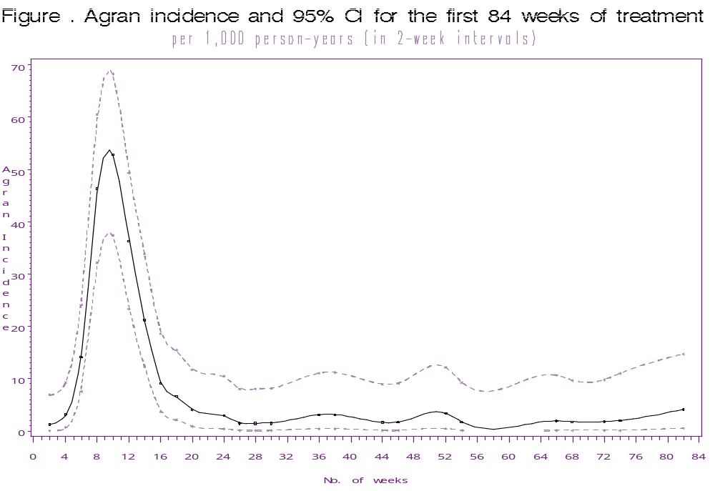

Agranulocytosis incidence per 1,000 person years and 95% CI, by treatment duration (in 6-week intervals).
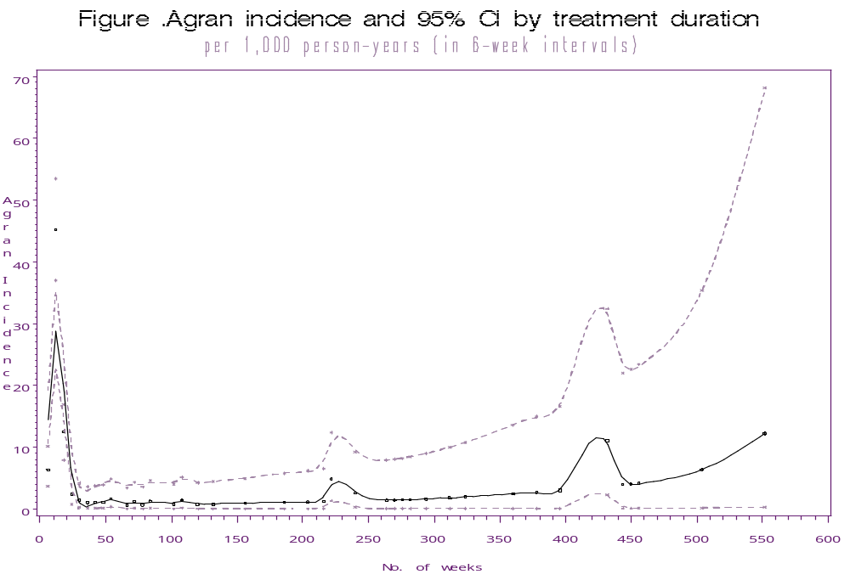

Severe leukopenia incidence per 1,000 person years and 95% CI, for the first 84 weeks of treatment (in 2-week intervals).
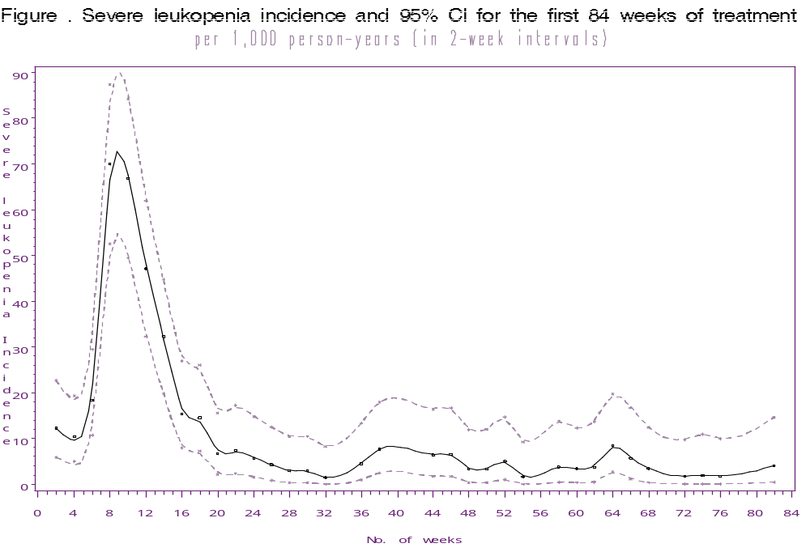

Severe leukopenia incidence per 1,000 person years and 95% CI, by treatment duration (in 6-week intervals).

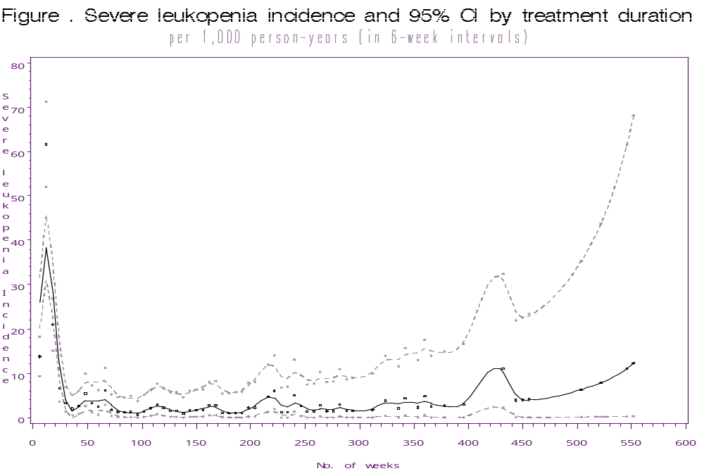

Red alert incidence per 1,000 person years and 95% CI, for the first 84 weeks of treatment (in 2-week intervals).
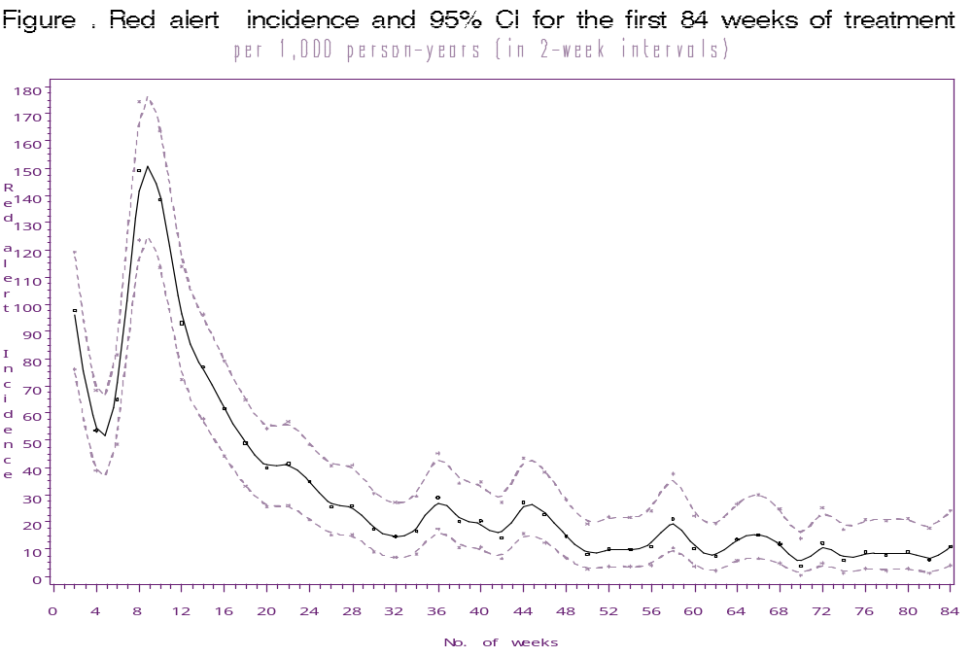

Red alert incidence per 1,000 person years and 95% CI, by treatment duration (in 6-week intervals).



