3.2 Waste Management:
Types of waste (solid, liquid, gas) (organic and non-organic)
Sources of waste products (biological {human & animal} and non-biological)
Collection, storage, and processing/disposal of waste products (Super Critical Water Oxidation process )
Medical hazards associated with waste management

WASTE MANAGEMENT
Kira Bacal, MD PhD MPH

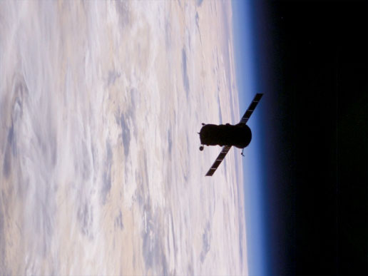
Backdropped by Earth’s horizon and the blackness of space, an unpiloted Progress 14 supply vehicle departs from the International Space Station, carrying its load of trash and unneeded equipment to be burned up in Earth's atmosphere during reentry. (http://www.nasa.gov/multimedia/imagegallery/image_feature_204.html)

WASTE MANAGEMENT

This chapter is designed to provide you with a basic understanding of how wastes are handled in the spaceflight environment. Emphasis is placed on understanding the sources and types of waste and their potential effects on crew health. The chapter will also review how wastes are collected, processed, stored, and/or discarded, as well as the design considerations for both spacecraft hardware and crew procedures.

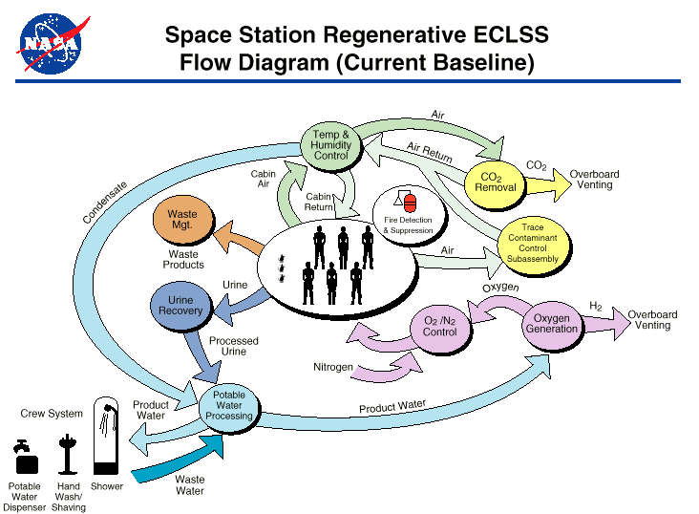
Figure 1: This diagram shows the flow of recyclable ("regenerative") resources in the Space Station's Environmental Control and Life Support System (ECLSS).

Waste Management

Types of waste

Have you ever lived through a garbage strike or faced a delay before Housecleaning came to a room in your emergency department, office, or hospital? For most of us, the items we casually toss in the trash seem to disappear magically, thanks to the garbage collection services at home and work. Take a moment to think of the wide variety of things that you throw or flush away in your own household – discarded napkins, banana peels, torn clothing, crumpled paper, used Kleenex… Now consider the issue on a spacecraft, where there is no garbage pickup. In the microgravity environment, your trash tends to stay with you – even contaminating the air you breathe, since the lint, dust, hair, eraser rubbings, and all the other things we sweep off our desks or brush off our clothing will not drop to the ground, but rather remain floating around your person.

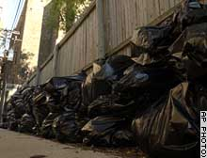
Figure 2: Trash piling up during a Chicago sanitation workers’ strike (http://www.cnn.com/2003/US/Midwest/10/09/garbage.strike.ap/)

It is thus imperative for a spacecraft’s environmental control and life support system (ECLSS) to be able to handle all types of waste, be they solid, liquid, or gaseous. Such waste accumulation also presents considerable vehicle storage and crewmember handling challenges.

As occurs lamentably often in history, previous lessons were forgotten when the ISS was designed and launched, and the experiences in trash handling gained aboard the Mir and Skylab space stations were not utilized. Instead, it was erroneously assumed that Shuttle flights would be adequate to remove any and all accumulated waste from the ISS, though little attention was in fact directed to the issue. It was even unclear what types and number of waste stowage bags had been manifested.

The problem of waste accumulation, handling and disposal quickly became so acute on ISS that NASA established a team tasked solely with developing an ISS Trash Plan (SSP 50481), including procedures for the management of ISS waste. This also included ground-based processing of the Shuttle-returned trash at Kennedy Space Center which must comply with OSHA regulations. For example, before ISS Expedition 1, there was no flight rule to prevent the stowage of trash with food. In addition to relearning the lessons from Skylab and Mir, NASA also sought help from the US Navy’s handling of trash on submarines. The Navy views trash in this context as such a significant issue that the Chief of the Boat (COB), who is responsible for habitability, sets the cleanup policy for the vessel and has direct access to the captain.

The ISS Trash Plan included development of a label which could be attached to a trash bag to enable the crewmembers to identify its contents once the bag had been sealed, an issue that had not been identified pre-flight.

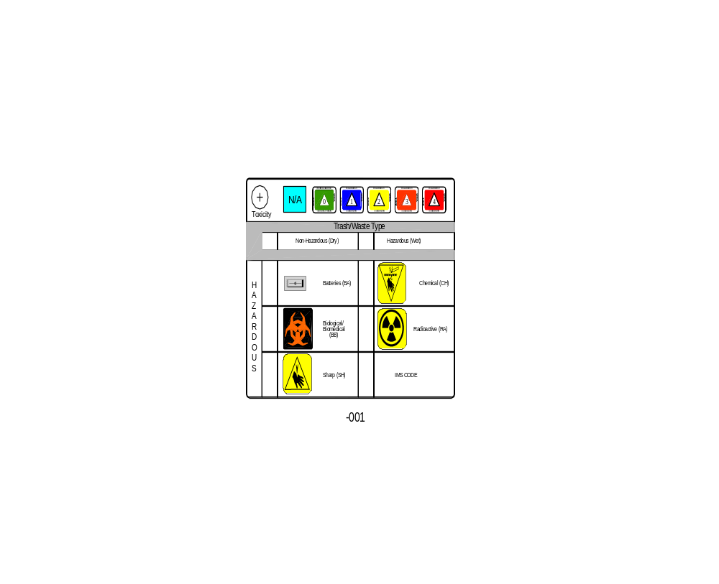Figure 3: An ISS trash label.

Perhaps the most dangerous (at least in the sense of rapidly hazardous) contaminant is the carbon dioxide produced by the crew. As described in a previous lesson, CO₂ levels can build up quickly, endangering crew health and safety. The ECLSS system must utilize ventilation fans and lithium hydroxide filters to maintain safe levels. Other airborne (though not necessarily gaseous) contaminants that the system must control include particulate matter (things like dust or nail cuttings), trace contaminants (from off-gassing materials), biological compounds (such as aerosolized droplets and bacteria from a sneeze), and odors. Liquid wastes include urine, sweat, hygiene water (i.e. water used for washing), and effluent from payload experiments. Solid wastes include not only feces but also food refuse and non-biological waste, from paper to metals.

Biological solid waste, such as those from food, are generally not stable, as they contain 40-90% moisture and soluble organic compounds. As a result, these wastes cannot be stored for extended periods, because they will decompose, leading to the growth of undesirable anaerobic microorganisms (which could pose a threat to crew health), produce noxious gases (including N₂O, NH₃, H₂S), and create foul odors from volatile fatty acids. Unfortunately, with the current limitations to ISS operations, this is an unavoidable fact of life. While the Shuttle is grounded, waste can only be disposed of via Progress vehicles. This has exacerbated the difficulties with waste stowage already present on the ISS. Imagine if you could only have your trash picked up once every three to six months and even then you could dispose of only a small proportion. The ISS Trash Plan allocates a minimum dedicated stowage volume for the accumulation of waste and trash of no less than 75 cubic feet. This volume equates to 25 days of trash volume for a crew of 3 based on a production figure of 1 ft³/day/crewmember.

In addition, wastes may be in mixed form (such as “semi-solid”), and they may be handled by more than one ECLSS system, as when water condensed from the ambient air by the atmosphere-management system is then sent to the water-processing system for final disposition. Life support designers must also take into account the need to conserve resources wherever possible. Particularly on long duration and exploration missions, wastes must be recycled and/or reused, and this imposes requirements on how wastes are categorized and handled. For example, liquid waste from food preparation might be able to be re-used for hydroponics projects and should therefore be captured and stowed separately from liquids contaminated by toxic chemicals, as might result from certain payload experiments. Composting, the process of accelerating decomposition in an aerobic environment, is also being explored as an option for safely handling biological wastes.

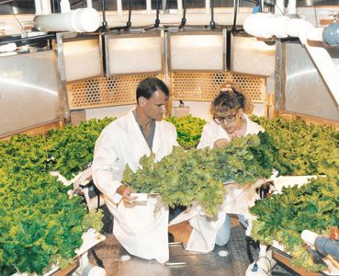
Figure 4: Plant researchers at Kennedy Space Center’s hydroponic Biomass Production Chamber prepare to harvest a crop of lettuce. (http://www.hydroponics.com.au/back_issues/issue58.html)

Sources of waste products
The following table, taken from Human Spaceflight: Mission Analysis and Design Chapter 17 “Environmental Control and Life Support Systems”, lists several types and sources of wastes in the spaceflight environment.

Waste Category | Waste Sources
Liquid, biological, decomposable | Hygiene water, metabolic water, respiration/transpiration water, urine, liquid feces
Solid, biological, decomposable | Solid feces, waste with bound water, solids from urine/sweat/hygiene water, clothes
Gaseous, metabolic | CO2, trace gases, methane
Liquid, nonrecoverable | Medicines, payload/experiment products or effluent
Solid, nonrecoverable | Spare parts, plastics, metals

In short-duration missions, recycling is less of an issue, and wastes can simply be collected in order to ensure they do not impair crew health and performance. As mission length and distance from Earth (and therefore the resupply chain) lengthens, more attention must be paid to the ability to gain the maximum use from everything. On exploration missions, such as Mars missions or Moon bases, the crew may grow some of their own food themselves. This will create large amounts of inedible plant material for the waste management system to handle, along with additional liquid and gaseous wastes. A wider variety of microorganisms may also exist, as a result of the more diverse organisms, and this could require additional filtration systems to maintain air and water purity. At the same time, the waste management system will grow in complexity as other, recycled wastes will need to be diverted to the growth chambers.

Particularly for exploration class missions, another category of waste must be considered: contaminants from the external environment, such as moon dust. The habitats used by crew on lunar and martian missions will need to have systems, such as forced air blowers, sticky strips, or other devices to remove any such “pollutants” from an astronaut’s suit or tools and to dispose of them in a safe manner. In addition, there is a desire not to contaminate the external environments with terrestrial compounds. For example, studies into the possibility of life (past or present) on Mars could be confounded if terrestrial bacteria were carried from a habitat module into the larger martian environment. Accordingly, the waste collection and disposal system will likely be used by astronauts as they leave the base, as well as when they reenter it, creating (potentially) twice as much waste material of two very different kinds, endogenous to the habitat and exogenous.

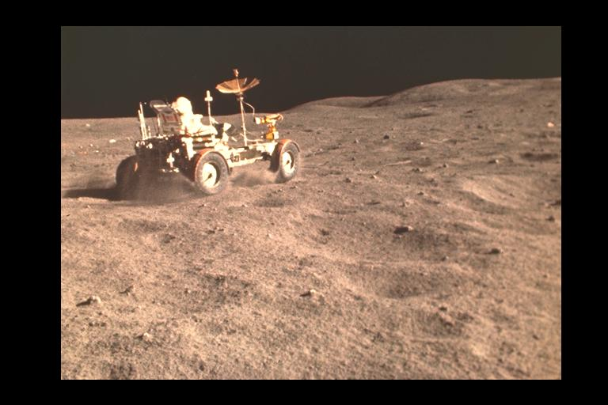
Figure 5: Dust is kicked up by the lunar rover during an Apollo mission.

Although external contamination is not seen as such an important issue for missions to low earth orbit, even these can have the risk of outside contaminants, as was seen during STS-98, when an EVA crewmember became covered in ammonia crystals during the connection of the US Lab module to the rest of the ISS. The EVA crewmember was safe, of course, but there was great concern that upon reentry, ammonia remaining on his suit could contaminate the cabin atmosphere and jeopardize the intravehicular crew. A multi-step protocol designed to clean his suit was followed, and there were no difficulties, but spacecraft designers and flight surgeons must realize that waste management systems may be called upon to handle more than the anticipated compounds; in the above case, the atmospheric system might have needed to remove ammonia from the air, as well as the more routine CO₂, water vapor, and odors.

Medical waste considerations

Medical waste falls into a special category, as it can be more hazardous to the crew than other wastes. To date, there have been very few cases of illness (other than rare cases of Space Motion Sickness) in which crewmembers have generated large amounts of medical waste. Eventually, however, this “lucky streak” will end, and someone will become seriously ill or injured and produce a large amount of medical waste. This could be in the form of vomit, sputum, blood, teeth, diarrhea, or any other potentially contaminated body fluid. As anyone who is familiar with an emergency department is aware, bloody spillage is difficult to manage and requires significant protective measures to be taken. Now imagine an ER where waste products can float away or be suspended in mid air. Microgravity significantly magnifies the problems associated with medical waste and caregiver protection.

Currently, there are limited supplies for personal protection and cleaning: latex gloves, alcohol pads, soap, bandages, etc. Unfortunately, in the event of a serious medical event, these supplies will quickly run out, and the crew may therefore be exposed to biological hazards. For example, the ISS has a ventilator and endotracheal tubes, so intubation is a possibility. Unfortunately, there is no medical suction apparatus available for endotracheal suction, as all such terrestrial devices make use of gravity to separate the air and fluids. In the absence of such a device, improvised materials, such as using a Foley catheter, will be needed, increasing the possibility for unintentional release of biological materials into the cabin.

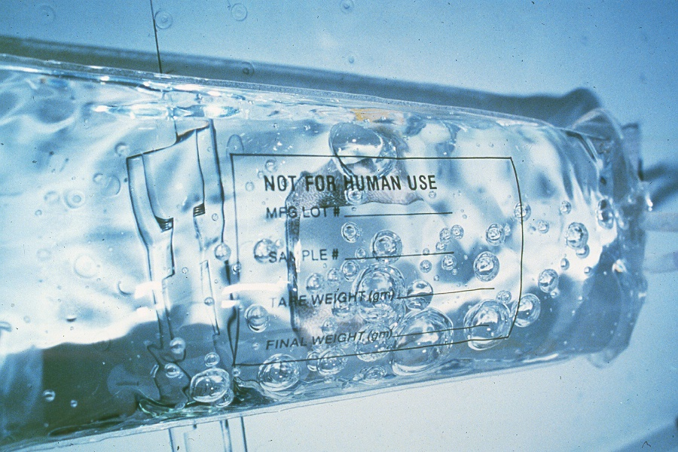
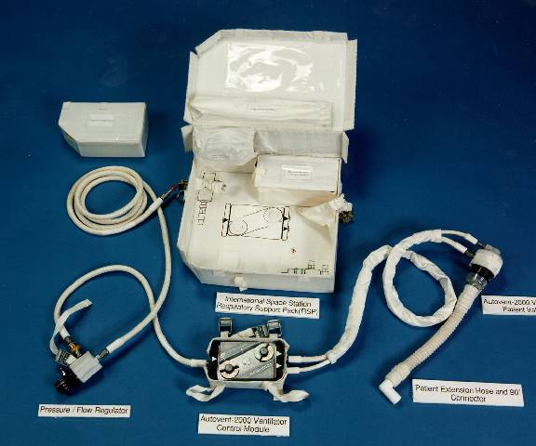
Figure 6: At left, an IV bag in microgravity shows the lack of air-fluid separation. At right, a picture of the ventilator currently flown on the ISS

There is also the question of what to do with any medical samples. The current ISS blood analysis device, the iStat Portable Clinical Blood Analyzer, only uses a few drops of blood, which is wicked into a self-contained cartridge. If longer duration missions have expanded laboratory facilities, though, additional attention to the question of discarded samples will be needed. Another question (that has to date been largely avoided) is what to do in the event of a death on orbit. Leaving aside the questions of how death would be ascertained and declared, what effects such an event would have on the other crew members, the impact for the mission, and other such matters, there remains the issue of what to do with the remains. Are they to be returned to Earth? While that might be feasible – albeit unpleasant – on the Shuttle, the tight quarters of the Soyuz make it much more difficult to transport a body. And what about longer duration missions? Even if a crewmember’s death were to force the abandonment of the mission, the time required to return to Earth might be too long to permit the transport of an unpreserved cadaver. At present, there is no procedure to handle a death on orbit.

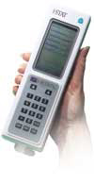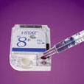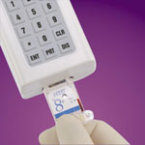
Figure 7: Images of (from left) the Portable Clinical Blood analyzer, loading a typical sample, inserting the test cartridge into the machine (http://www.amedical.com/istat.html)

Collection, storage, and processing/disposal of waste products

Generally speaking, waste collection is designed to be as simple for the crew as possible. In some cases, crew members merely place the refuse in a container and stow it. In other cases, the waste may be automatically collected and stored, as is the case for the toilet appliance. In all cases, however, the limited stowage space remains an issue which drives disposal of the wastes.

On the short-duration Shuttle missions, “regular” trash is collected, compressed into as small a volume as possible, and stowed for disposal following return to the ground. Wet trash is defined as all items that could off-gas and cause unpleasant smells. Overall, four trash containers are located in the Shuttle's crew compartment (3 for dry trash and 1 for wet trash). Each trash container has a trash liner placed inside. If the liner becomes full, it is closed with a velcro strip, removed and stowed in a stowage container below the middeck floor. There are separate stowage containers for dry and wet. The wet trash container is airtight, closed by a zipper and connected to the waste management system by a venting hose. During stowage, developing gases are vented through this hose, which helps to control odor development inside the crew compartment. Overall, 8 ft³ of wet trash stowage is available under the middeck floor. All wet and dry trash is returned to earth for disposal. For longer duration missions, however, this is obviously impractical.
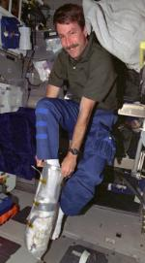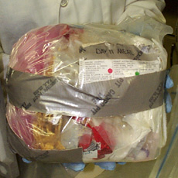
Figure 8: At left, astronaut Kent V. Rominger uses an age-old trash compacting method on the Space Shuttle. At right, a “football”, trash wrapped in plastic and duct tape, is an acceptable method of waste storage for short duration Shuttle flights, but not for longer duration station or exploration missions.
(http://liftoff.msfc.nasa.gov/News/2001/News-Housekeeping.asp)

Rather, the ISS crew collect trash in much the same way as Shuttle crews, but then they remove it from the station either by sending it back to Earth with a visiting Shuttle crew, or by placing it into a Progress rocket which has delivered new supplies and will subsequently burn up upon reentry. The hiatus in Shuttle flights has exacerbated problems with this approach, however, and trash has built up significantly.

For waste material that the crew should not handle for reasons of health or safety, the appropriate systems usually collect and package the waste automatically. One frequently asked question has to do with the handling of biological wastes – how do astronauts go to the bathroom? Generally speaking, most current systems, Russian or American, work the same way: as wastes exit the body, they are drawn away by a stream of air and captured by the toilet.

The first American in space, Alan Shepherd, was given no toileting options. Since his flight was only scheduled to last 15 minutes, this oversight on the part of the ship designers and his flight surgeons can perhaps be excused, but a lengthy delay prior to launch forced him to urinate in his suit (which had the unwelcome side effect of compromising his EKG electrodes). Later astronauts wore incontinence pads, similar to adult-size diapers, until later, longer flights came along. For these flights (through Apollo 12), a condom catheter-like device was used for urination, with the urine passing through a valve and into a collection bag, which could then be vented overboard. One problem with overboard dumping was the resultant “haze” of ice crystals which could stay around the spacecraft for some time afterwards; because of this, dumping did not occur during mission critical phases of flight.

For defecation on these flights, the astronaut first had to secure a plastic bag around his anus, and use a built-in finger cot to move the stool further into the receptacle. When defecation was complete, he removed the bag and cleaned the area with tissues that were then placed in the bag. Because feces could not be dumped overboard as the urine was, it had to be carried back to Earth for disposal. Accordingly, the astronaut had to squirt a germicide into the bag, seal it, and knead the contents together. The bag was then placed into a second bag in case of leaks, formed into the smallest volume possible, and stored for transport to Earth. This method was universally despised by the crew and invariably led to soiling of the crew and environment, despite all possible care. In addition, the process was time consuming, requiring up to 45 minutes.

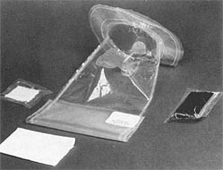
Figure 9: Apollo era fecal bag (http://history.nasa.gov/SP-368/s6ch2.htm)

Although the lack of toilet facilities during launch and landing still require crewmembers to wear “adult diapers” during those phases of flight, during the rest of the mission Shuttle and ISS crewmembers have an actual toilet. The Shuttle version is known as the WCS (Waste Collection System) and is located immediately aft of the ingress and egress side hatch. The compartment door is used as the ingress platform when astronauts crawl into the orbiter before launch (the vertical position of the orbiter on the launch pad makes the rear wall the floor). When it is used during flight, its door is opened and two curtains, attached to the top and the side of the door, are deployed to provide privacy. The WCS is actually a multi-functional system used to collect and process all biological wastes. The main function of the system is to collect and store fecal wastes and to process urine and transfer it to the waste water tank. It also processes condensate and waste water from other Shuttle systems. One of the first tasks of the astronauts after reaching orbit is to activate the WCS for operations.
Technically, the WCS consists of a commode, urinal, fan separators, odor and bacterial filter, vacuum vent quick disconnect, and controls. The commode that processes the fecal wastes is 27 by 27 by 29 inches and is used like a regular toilet. The WCS compartment also has many stowage lockers located along the inside walls. These are stocked with towels, washcloths, urinal funnels, wet wipes, dry wipes, tissues, disposable gloves, and emesis bags. The back of the door has color coded rubber grommets (four for each crewmember) to restrain towels and washcloths used by the astronauts. For each day in orbit, a Shuttle astronaut typically uses two washcloths (12 inches by 12 inches) and one towel (16 by 27 inches) for personal care. A water hose, located next to the Shuttle's galley, dispenses water if needed.

The urinal is essentially a flexible hose with attachable funnels. Every astronaut has a personal funnel, which are differently shaped for men and women. The urinal can be used in either a "standing" position or while the astronaut is "sitting" on the commode. Urine is collected in a funnel, carried along by the airflow from the WCS fan-separator. The air/urine is pumped through a flexible hose to a chamber below the toilet seat, where an assembly of rotating vanes creates centrifugal force that pushes the liquid to the walls of the chamber. The liquid is drawn off to the wastewater tank under the deck, and the air returns to the crew cabin after passing through an odor and bacteria filter. The wastewater tank can be dumped overboard, just as it was in the earlier days of the space program, though this is less frequently done nowadays.

To handle feces, the toilet has a cylinder system where a plastic bag is placed in the toilet before use. Crew use two foot restraints and two body restraints (bars positioned over the thighs) to position and hold themselves on the toilet seat, ensuring a good seal with the contoured, soft seat. The good seal is a requirement, ensuring that the toilet’s airflow will be able to draw the waste away. The hole for solid wastes is only 10 cm (4 inches) in diameter, and crewmembers actually practice positioning themselves on a toilet trainer before flight. A camera placed within the toilet trainer, directly beneath the hole for solid waste, allows them to see if they are positioning themselves correctly.

Feces enter the commode through the seat opening and are drawn in by air flowing through holes under the seat. This downrushing airflow (850 L/min) substitutes for gravity in collecting and keeping the waste material inside the commode. The wastes are then broken up by rotating vanes and deposited along the walls in a thin layer. A hydrophobic liner inside the commode prevents free liquid and bacteria from leaving the collector. The plastic bag is then sealed, and a plunger attached to a lever forces it to the bottom of the cylinder. A new bag is then placed in the toilet for the next astronaut. When the cylinder is filled, it is replaced by a new cylinder.

Because of the toilet’s limited volume, toilet tissues are temporarily placed in a small canister which is installed on the wall and later moved to the wet trash compartment. When the astronaut is finished using the toilet, he or she then opens a valve which exposes the solid waste container to space, instantly freeze-drying the stool. During the mission, it may also be necessary to compact the solid wastes to avoid overflow.

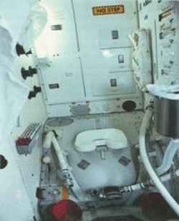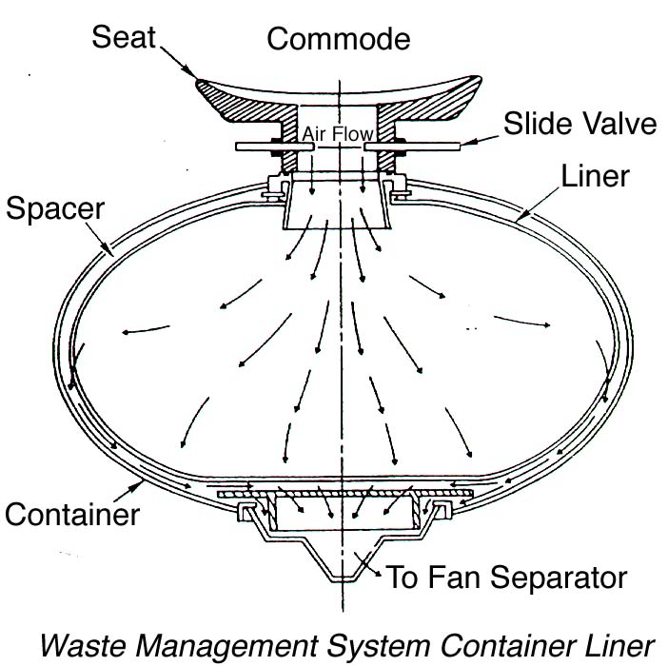
Figure 10: Shuttle toilet (http://www.abc.net.au/science/slab/shuttle/nature.htm and http://lsda.jsc.nasa.gov/kids/L&W/hygiene.htm)

On the ISS, the ASU toilet used is in the Russian built Service Module block. This looks like a more earth bound toilet that uses metal containers. Prior to use, the containers are stored rather like empty buckets, however once full they present considerable stowage and hygiene issues.

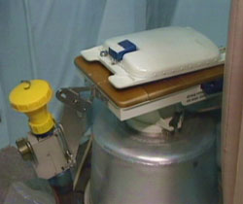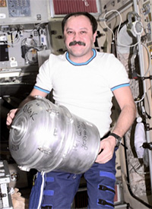
Figure 11: The ASU toilet at left. At right, as part of routine procedures, cosmonaut Yury V. Usachev, Expedition Two mission commander, changes out a solid waste container in the Zvezda/Service Module in 2001. (http://www.nasa.gov/missions/science/f_compost.html)
As described above, virtually all forms of waste disposal currently make use of the Earth, both by returning some trash to the ground for final disposal and by utilizing the atmospheric reentry to destroy other trash in the Progress rockets. Unfortunately, these options are not ideal for long-duration exploration missions, where Earth will not be available. In these situations, waste will need to be reused or destroyed in more efficient ways, so as not to take up valuable storage space.

High efficiency waste destruction
Rather than planning to create a garbage dump on the Moon or litter the way to Mars by periodically jettisoning trash, NASA is investigating other methods to dispose of wastes. Ideally, these would facilitate reuse of whatever useful components remain.

Supercritical water oxidation process (SCWO) is one method under investigation to destroy hazardous organic waste in a completely closed system. It uses an oxidant in water at extremely high temperature and pressure (374 C and 218 ATM). Under these conditions, organic molecules can be rapidly and completely oxidized to CO2, water, and inorganic salts, which could easily be recycled.

SCWO is currently being investigated as a way to dispose of terrestrial toxic wastes, such as chemical warfare agents and solid rocket fuels, in a safe manner. While the efficiency of the process makes it attractive for use in space, the associated temperature and pressure that are required may pose too great a hazard in such close quarters. However, the development of a compact unit for use onboard US Navy ships may overcome some of these design challenges and holds out hope for use of the process even in the tight quarters of a closed environmental system.

Medical hazards associated with waste management
Any system of waste management has certain hazards and regulations associated with it. Here on Earth, waste handling is regulated by OSHA; while OSHA rules may not apply on the ISS, they are in effect when the waste is offloaded from the Shuttle MPLM at Kennedy Space Center. Depending upon the amount of contact the inflight or ground based crew must have with the assembled wastes, there could be bacterial contamination, sharp edges, and/or exposure to biohazards. As a result, designers generally try to minimize the need for crew interaction with the systems, making them as self-contained as possible.

On both the Shuttle and ISS, the galley and toilet are geographically close to each other. In the event of an illness, therefore, good hygiene could be compromised and food consumption areas contaminated. In the Shuttle’s cramped environs, there is no dedicated location where a sick crewmember can be placed in order to avoid contamination of the rest of the crew – or merely to decrease what is often (particularly for non-clinicians) the provocative stimulus of someone vomiting nearby. These close quarters can thus pose both public health and performance hazards.

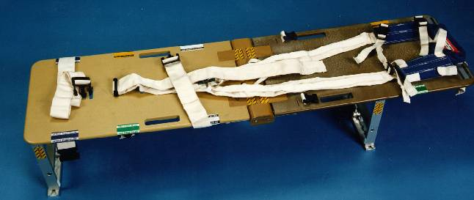
Figure 12: Crew Medical Restraint System (CMRS) will be deployed in the US Lab module and provide not only a place for ill/injured crewmembers to be located but also the restraint straps necessary for caregivers.

The ISS, with its larger internal volume, does have a dedicated location for casualties, complete with “bed” (in the form of a foldout, electrically isolated crew medical restraint system). Interestingly, however, the ISS medical system is based in the US Lab module, at the other end of the station from the toilet facility. This suggests that if someone is seriously ill, they may have to choose between having access to medical supplies (including medical oxygen) or a toilet. Not only will this increase the amount of care other crew members will have to provide to a casualty, but it also creates additional challenges for managing medical wastes.

In one oft-described case, the Shuttle toilet broke down, requiring two crew members (including the commander) to break up the solid wastes by hand in order to try to repair it and avoid an early deorbit or the use of the always unpopular Apollo fecal bags. As unpleasant as such work is in a terrestrial environment, it is infinitely worse in the confined volume of the Shuttle, with the lack of gravity making any stray particles instantly airborne.

When, as is inevitable, other plant and animal life exists in the spacecraft, there will be additional wastes produced, both in terms of quantity and types, with the associated new microbial flora as well. This will further increase the hazards to crew health in the event of improper waste management.

References and Suggested Readings

1) Clement, G. (2003). Fundamentals of Space Medicine. Space Technology Library. El Segundo: Microcosm Press.

2) Harding, R. (1989). Survival in Space. London: Routlege.
Office.

3) Stine GH. (1997). Living in Space: A Handbook for Work and Exploration Stations Beyond the Earth’s Atmosphere. New York: M. Evans and Company.

4) Larson WJ and Pranke LK (Eds.). (1999). Human Spaceflight: Mission Analysis and Design. New York: McGraw Hill.

5) Nichols, M. (2001) “The Next Step: Mars or Bust”, Practical Hydroponics and Greenhouses, issue 58,
http://www.hydroponics.com.au/back_issues/issue58.html

6) NASA Research Award: Denitrification Composter to Stabilize Space Mission Trash, http://lssc.ksc.nasa.gov/als/projects/nra.php

7) Heiney A, “Not Your Back Yard Compost Heap”, NASA Feature article, http://www.nasa.gov/missions/science/f_compost.html

8) Kneir, G. (2001) “Housecleaning in Space”, http://liftoff.msfc.nasa.gov/News/2001/News-Housekeeping.asp

9) “Solid Waste Handling trade Study”, Advance Life Support Systems, http://advlifesupport.jsc.nasa.gov/documents/simaDocs/MSAD-00-0501.pdf

10) “Guidelines and Capabilities for Designing Human Missions”, NASA Exploration Team, Human Subsystem Working Group (2002) http://research.hq.nasa.gov/code_u/nra/current/NRA-02-OBPR-01/HSSWG.pdf

11) Kruszelnicki, K. (2003) “Great Moments in Science: Space Toilet”, http://www.abc.net.au/science/k2/moments/s348188.htm

12) “The History of Household Wonders: The Space Toilet”, http://www.historychannel.com/exhibits/hometech/spacetoilet.html

13) “Hazardous Waste Destruction: Supercritical Water Oxidation”, http://demil.ga.com/haz/scwo-haz.html)

14) Halvorson T. (2001) “Destiny Installed Despite Toxic Coolant Link”, Space.Com Spaceflight News, http://www.space.com/missionlaunches/missions/sts98_eva1pm_010210.html

15) Sauer RL and Jorgensen GK. (1975) “Waste Management System” in Biomedical Results of Apollo SP-368, Johnston RS, Dietlein LF, and Berry CA (Eds), http://history.nasa.gov/SP-368/s6ch2.htm

The effect of odors should not be underestimated in the relatively confined environment of spacecraft. Cases of flatulence or gastrointestinal distress can, particularly on the crowded Shuttle, create a highly unpleasant atmosphere for the entire crew and, at the very least, affect morale. Even in the absence of illness, odors tend to build up in the small environment, albeit usually so gradually that the crew do not recognize them. However, ground personnel who are among the first to enter the Shuttle following landing and wheel stop have often commented upon the strong odor in the cabin even after relatively short duration missions.
In order to obtain the maximum possible use of hydroponically grown plants, efforts are underway to use exogenous enzymes to break down normally inedible compounds, like cellulose, into more simple sugars that humans can digest. If a human could obtain nutrition from more of the biomass (as, say, a rabbit can) then in situ agriculture would be much more efficient and it would reduce the amount of vegetative waste produced.
A video showing proper use of the Shuttle toilet can be found at the website: http://edspace.nasa.gov/text/livespace/gottago.html Please note: The video is intended for use by schoolteachers, not clinicians.

