

The Allegheny Portage Railroad National Historic Site Presents

TRY-ITS

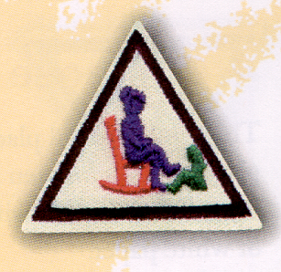

Listening to the Past

FOR BROWNIE GIRL SCOUTS

Dear Brownie Girl Scouts,

Welcome to the Allegheny Portage Railroad National Historic Site! We are so happy that you chose our site to complete your Listening to the Past Try It badge. In this packet you will find six activities to do that relate to Allegheny Portage Railroad. To earn your Try It badge, you must complete four of the activities. If you want to have even more fun you can do five or even all six! Just by coming to visit this building you are on your way to completing one of your four activities. Good job!
Now, while you are here take a look around and learn all about Allegheny Portage Railroad and the Main Line system of transportation. If you already know the story, try to find out some interesting things you did not know. We have lots of fun exhibits and a very interesting film. If you ever have a question just find one of our park rangers and she or he will be able to help you. And most important of all, don’t forget to have fun!

A special note to Troop Leaders…

This packet has been created to help your Girl Scouts earn the Try It badge entitled “Listening to the Past”. The program has been designed so that the Girl Scouts can perform activities that relate to the Allegheny Portage Railroad National Historic Site and may, therefore, extend their knowledge about the site and its interpretive story. We are so pleased that you have chosen to visit this site and we hope that you and your troop have a great deal of fun completing these activities. If you have any questions, please ask a ranger.
Try It badges may be purchased through the Girl Scout Council Office. The office is located at 612 Locust Street in Johnstown and the phone number is (814) 536-5371. Thank you for visiting our site and please let us know how you enjoyed this program!

Sincerely,
The Education Department
Allegheny Portage Railroad National Historic Site
(814) 495-9614 x103

Listening to the Past

When you listen to the past you learn to appreciate your own life. You also learn many interesting things about what life was like in the past. Earning this badge will help you learn about what life was like in the Allegheny Mountains over 150 years ago and how the Allegheny Portage Railroad was a part of the exciting things happening in Pennsylvania at that time. There are six activities to choose from. To earn your badge, you must complete four of them. The six activities are:

- Community Stories – listen to and share the stories of some of the oldest people in your community.
- If These Buildings Could Talk – visit historic buildings, monuments, and sites in your neighborhood (just what you are doing now!)
- Visit the Oldest Cemetery – visit a cemetery and learn some interesting facts as you look about, make rubbings, and search for different things.
- Tell Stories of the Past – learn and share two stories written in the past or about the past (there are lots of very interesting stories to learned here!)
- Acting Out – act out a scene from the past involving an historical or fictional character.
- Games of the Past – learn to play a fun game of the past and teach it to others!

The following pages will tell you about the six activities and how to perform them. Remember to ask a ranger if you have questions and have fun!

Activity # 1: Community Stories

*This activity will not be done at the APRR site. You will complete it at another time, after you have found one or more people to interview*

Did you know that there are lots of people in your community who have hundreds of interesting stories to tell about what life was like in the past? People who are older have lived longer and have had more experiences. Because of that, they have more stories to tell than younger people do. Just think, if someone is 80 years old, they have 80 years worth of stories to tell! Imagine how many stories you will have to tell about your life by the time you are 80.

To complete activity #1 you must find some older people in your community and listen to their stories. Tape record their stories or take notes while they are talking so you can remember their stories and you can share them with your Brownie Girl Scout Troop. When you do this, you are conducting an interview. And when you interview people about their past experiences, you are taking part in oral history!

Who should you interview?

Since you are learning about the Allegheny Portage Railroad (APRR) today, try to find someone who can tell you about railroads in Pennsylvania. The APRR closed down in 1854, over 140 years ago, so you won’t be able to find anyone who worked on it, but you probably could find someone who worked on the Pennsylvania Railroad, which took over the APRR in 1854. Ask the person you are interviewing if she or he remembers the railroads and what they were like.

How to find someone to interview

In order to find some older people to interview you can look at a local nursing home or at a community center. You can also get the names of some older people in the community at the local historical society or try looking in your own family. The stories that older members of your family have to tell you will probably be the most interesting of all. Ask the person about her/his life experiences, her/his family, what she/he did as a child, what her/his job was, and anything else you may want to know.
Interviewing Etiquette | 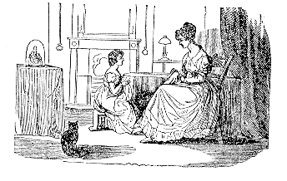

When you are interviewing someone, you must remember certain manners. Remember, the person you are interviewing is giving you her/his time, so you must be sure to treat her/him accordingly. Here are some good things to remember:

- Be on time.
- Be prepared. Have your questions ready, your notebook out, and your equipment in good working order.
- Be polite. Say please and thank you and address people formally (using Mr., Mrs., Ms., Miss, and so on)
- Provide time for the person to answer questions. Be patient when answers take a long time.
- Do not argue with or correct the subject. Oral histories are not always accurate but they do provide important information about feelings and impressions.
- End your interview by thanking your subject.
- After the interview, send a thank you letter to the subject.

(This list of manners was provided by the Library of Congress)

One more thing…

If you plan to tape record the interview be sure to ask the person first. Some people don’t like to be taped and would prefer that you just take notes. Always be polite and follow their wishes. And make sure you find out some fun or exciting facts to share with your Brownie Girl Scout Troop!

Activity # 2: If These Buildings Could Talk

One of the most fun things to do with an adult is to visit historic buildings, monuments, and sites in your neighborhood. To complete this activity, you must visit some historic sites and learn some interesting facts about them.

Congratulations! You have already completed half of this badge by coming to visit the Allegheny Portage Railroad National Historic Site. If you’ve been here long, you’ve probably completed the other half. There are so many interesting stories and facts about the Allegheny Portage Railroad that I’m sure you’ve come across lots of them.

While you look around the APRR Visitor’s Center try to find the answers to these interesting facts:

- What is another name for a canal boat?
- Name some famous people who traveled on the Allegheny Portage Railroad.
- What two towns were linked by the Allegheny Portage Railroad?
- What two large cities were linked by the Main Line System?
- How many inclined planes did the Allegheny Portage Railroad use?
- Before train locomotives were used, what pulled cars along the level sections of the Allegheny Portage Railroad?
- How long did an average trip on the Allegheny Portage Railroad take?

There are so many interesting stories to hear about the Allegheny Portage Railroad. The park rangers will be able to tell you all about them. Politely ask one of the park rangers one or all of the following questions and see how many amazing stories she or he can tell you.

- Please tell me about the experiences of a typical traveler on the Allegheny Portage Railroad.
- Could you please tell me how the Horseshoe Curve helped to close down the Allegheny Portage Railroad?
- How much quicker was the Allegheny Portage Railroad and Main Line system than a wagon?
- Was the Main Line system much slower than the Pennsylvania Railroad?
- As you look around, try to think of other questions for the park rangers. They know all about the Allegheny Portage Railroad and they would love to tell you about it.

The Staple Bend Tunnel

Did you know that you live near the first railroad tunnel in America? It is called the Staple Bend Tunnel and you can still visit it, even today. Staple Bend Tunnel is 900 feet long and has a beautiful stone arch at the entrance. It was constructed in 1833 and was a part of the Allegheny Portage Railroad. When you visit it, you will be able to see where horses pulled the railroad cars through the tunnel. In 1833, a 900-foot long tunnel through a mountain was an amazing thing to see! When you see it, try to imagine how exciting it would have been to have lived in 1833 and seen the first railroad tunnel in the country.

Directions to the Staple Bend Tunnel:  Take the Sidman/St. Michael exit off of Route 219. Go west on route 869. At the stop sign, turn left onto Rager’s Hill Road. Travel 2 miles. Veer right at the first intersection onto Clapboard Run Road. Travel 1.3 miles and turn right on Beech Hill Road (across from the Locust Grove Church of the Brethren). Travel 2.6 miles to Staple Bend Tunnel. | 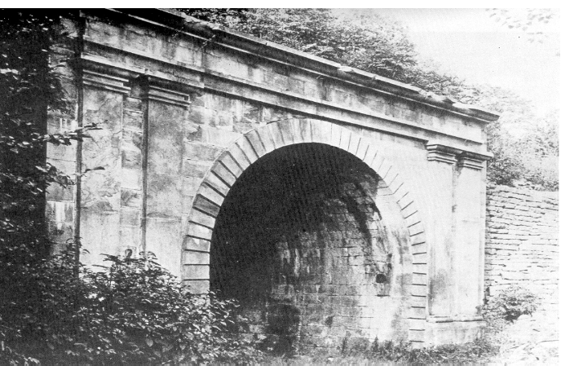

This area is a place very rich in local history. Here are some other historic sites nearby that you could also visit:

- The Johnstown Flood National Memorial
- The Johnstown Flood Museum
- The Horseshoe Curve
- The Johnstown Inclined Plane
- The Altoona Railroaders Museum

Some other interesting things to remember during your visit:

- Look at the relief map on the wall behind the information desk. This will help you understand just how steep the Allegheny Mountains are and why they were such a big problem for travelers until the Allegheny Portage Railroad was built.
- Walk down to the engine house. You can see how the engines pulled cars up the inclines. Look at the exhibits to learn how the engines worked.
- Walk down to the Lemon House. Here you can see where many travelers on the Allegheny Portage Railroad stopped to rest and eat dinner.

Activity # 3: Visit the Oldest Cemetery

*This activity will be completed at Presbyterian Cemetery in Hollidaysburg*

Presbyterian Cemetery is unusual in that it is older than the first church built there. It is the oldest cemetery in the Altoona area and dates from the 1770s. To complete activity #3 you will visit Presbyterian Cemetery and learn some things about it while you are there.

While you are at the cemetery, you will look for certain things. It’s a big place so be sure to always stay with an adult while you are there. Also, remember that a cemetery is a place to remember your best behavior. Don’t run or shout. Always behave in a respectful manner.

What you will need…

When you visit Presbyterian Cemetery, you will be making some tombstone rubbings. In order to do this you will need:
- Children’s crayons (the large ones with one flat side if possible)
- Paper (If possible, get a roll of paper so you can rip off the appropriate size)

Tombstone Rubbings

Making a rubbing of a tombstone teaches us respect for the tombstone monuments as well as for history and time. Try to find tombstones of people who lived during the time of the Allegheny Portage Railroad. Perhaps some of them worked on the railroad. To make a tombstone rubbing…

- Brush off the stone with your hand or a paper towel.
- Rip off a piece of paper the appropriate size.
- Hold it firmly against the stone (this works better if you have a helper to hold it for you).
- Rub the flat side of the crayon against the paper (if you have white or light paper, use a dark color like black or blue).
***Remember, do not use the point of the crayon. It won’t work that way!***
- Most Important: respect the tombstones, don’t damage them, and clean up after yourself before you leave.

Samuel and Jean Moore Lemon

Samuel and Jean Lemon owned and operated the Lemon House, a tavern along Incline #6 on the Allegheny Portage Railroad. Sam and Jean lived in the Lemon House until 1847 when they retired to Hollidaysburg. They are buried in Presbyterian Cemetery. Try to find their tombstones and make a rubbing so you can show the other members of your troop.
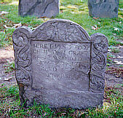

Always be sure to treat tombstones with
care and respect; especially older
tombstones. They have lasted through
many years of wind, rain, and erosion
and need special care if they are going
to last longer.

The Oldest Cemetery

Presbyterian Cemetery is the oldest cemetery in this area. It was first used in the late 1700s. That’s over 200 years ago! Try to find the oldest tombstone in the cemetery. If you find one that you think is the oldest, make a rubbing of it. If the tombstone is in poor condition and you think your tombstone rubbing might damage it, just write down the name and dates instead. If other members of your troop came to visit this cemetery, you can compare information and see who found the oldest tombstone.

Directions to Presbyterian Cemetery…

From the Diamond in the center of Hollidaysburg, travel east on Allegheny Street approximately 12 blocks to the intersection of Allegheny and Conlon Streets. Turn left onto Conlon Street and follow the road to the end (approximately 5 blocks).

Activity # 4: Tell Stories of the Past

One of the best things about learning about the past is that you get to learn lots of interesting stories that you can tell to others. There are so many interesting stories about the Allegheny Portage Railroad that you could spend years trying to learn them all. Luckily for you, to complete this activity you only have to learn two.

Once you have read these stories, you can share them with your troop, your friends at school, your family, and just about anyone. If you are here with your troop, you will all be reading the same stories so you might want to try going to the library to find another story. Or, maybe you could find an interesting story in the exhibits at the Visitor’s Center.

These two stories are both are both about people involved with the Allegheny Portage Railroad. One is the story of a young woman who traveled on the Allegheny Portage Railroad. She was a famous author and her name was Harriet Beecher Stowe. Have you ever heard of her? The other is the story of a woman who lived much her life right next to the Allegheny Portage Railroad. She and her husband ran a tavern on incline #6. Her name was Jean Moore Lemon. You can visit her tavern when you come to the Allegheny Portage Railroad National Historic Site. It is called the Lemon House.

Harriet Beecher Stowe and Her Travels

Harriet Beecher Stowe was born on June 14, 1811 in Litchfield, Connecticut. She was the seventh child of Roxana and Reverend Lyman Beecher. Harriet’s father knew that it was very important to give all of his children a good education. At the time Harriet was born, most girls learned only what was needed to run a household. Reverend Beecher decided that his daughters would learn science, higher mathematics, and all the other subjects that were usually taught to boys.
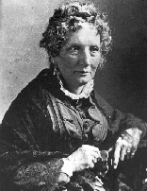
Harriet was sent to school at the Hartford Female Academy. This school was very special because it gave young ladies a good education in more than just the “female subjects” of keeping house. It was also special because Harriet’s older sister, Catherine Beecher, founded it. Catherine
was just 23 years old when she established the school and her young sister Harriet received an excellent education there.
When Harriet was old enough to work, she became a teacher. She taught at the school where she had been a student, the Hartford Female Academy. She also taught at Cincinnati's Western Female Seminary, the second school established by her sister, Catherine.
In 1836, Harriet married Calvin Stowe. Together they had seven children. Even with a household and seven children to manage, Harriet was still a very busy woman. After teaching, Harriet decided to become an author. She wanted to write books so that other people could read them and learn about the things she thought were important. Authors have to do a lot of research before they write books. Sometimes, people have to travel to do research.
In 1841 Harriet Beecher Stowe took a trip across Pennsylvania. Perhaps she was doing research for a book. Perhaps she was visiting friends. Whatever she was doing, it required her to travel on the Main Line. She made the six-hour journey over the Allegheny Mountains on the Allegheny Portage Railroad. She probably stopped to rest at the Lemon House. Then she traveled down the mountain and across the state on a canal boat.
Imagine how exciting the trip must have been. Harriet could sit on the roof of the canal boat and enjoy the fresh air and sunny weather. When the canal boat went under a bridge, she and the other passengers on the roof would have to duck down so they wouldn’t hit their heads on the bridge. The ride up and down the inclines on the Allegheny Portage Railroad must have been fun and a little bit scary.
At night, when Harriet went down into the canal boat, she was greeted with a surprising sight. All the people on the boat had to cram into a tiny space to sleep. The tiny little bunks or berths that were provided for the passengers were so small that it was hard to believe a person could fit into one. Harriet wrote about this experience when she said, “The appearance of the berths in the ladies’ cabin was so repulsive, that we were seriously contemplating sitting out all night when it began to rain so as to leave us no choice.” Harriet made it through the cramped conditions and back home to her family in Connecticut. Surely, she never forgot her exciting trip on the Allegheny Portage Railroad.
The Beecher family is one of the most famous families in Connecticut. They are known for their intelligence and all of the wonderful things they did, like establishing schools and writing books. Harriet had to work hard to set herself apart from all her brothers and sisters who were also doing wonderful things. She decided to work for the causes that she believed in. One of the causes that the Beecher family supported was Abolition.
Harriet Beecher Stowe was one of the most famous abolitionists in the history of the United States. Abolitionists were people who wanted to end slavery in the Southern states. “Abolish” is a word that means “to end” or “to stop” so people that wanted to stop slavery were called abolitionists.
Slavery was a terrible system in which people owned other people like property. This was illegal in the Northern states but when Harriet was growing up, it was very common in the South. Harriet and her family knew slavery was terrible and wanted to stop it. She helped several slaves escape on the Underground Railroad, a secret system of places and people that helped slaves escape to the North. Harriet also wanted to tell people all over the world about slavery and why it should be abolished. She decided the best way to do this would be to write a book.
Harriet had written several books but her most famous book was about slavery and it was called Uncle Tom’s Cabin. Harriet wrote Uncle Tom’s Cabin in 1852 and it became a best seller immediately. It is one of the most famous books ever written. Have you heard of it?
Uncle Tom’s Cabin is a book about some slaves and their owners in the South. It told the story of slavery and how terrible slavery was. This book made people all over the United States very angry. People in the South thought it was an unfair picture of slavery and people in the North became very angry that slavery was allowed to continue because it was so terrible.
In 1861, the United States Civil War started. One of the reasons the Southern states went to war with the Northern states was slavery. Harriet’s book had helped to inform people all over the world about the horrors of slavery. President Abraham Lincoln called her "the little lady whose book started the Civil War." At the end of the Civil War, slavery was abolished. It was a dream that Harriet Beecher Stowe lived to see.
In 1896, Harriet Beecher Stowe died. In her lifetime she had done much to end slavery, help former slaves, and support the education of women. Harriet’s book Uncle Tom’s Cabin is one of the best selling books in the world and has never been out of print. She was a great lady who stood up for what she believed in and took action to make her dreams a reality.

Jean Moore Lemon and the Lemon House

Jean Moore was born in Manor Hill in Huntingdon County, Pennsylvania in 1797. Like many other people in that part of Pennsylvania, Jean’s father had moved to America from Scotland. She grew up in Manor Hill with her family and in the early 1820s she married a young man who lived nearby. His name was Samuel Lemon.
Soon after they were married, Sam and Jean decided to move west and try their luck in the less populated areas of Pennsylvania. During this time many people were heading west, trying to make a good living for themselves in a newer part of the country.
In 1826, Sam and Jean moved to the Allegheny Mountains in Cambria County and built a two-story log tavern. They realized that they could make a good living running a tavern along the Huntingdon, Cambria, and Indiana Turnpike. This turnpike was a major transportation route and many people would stop in at their tavern for rest.
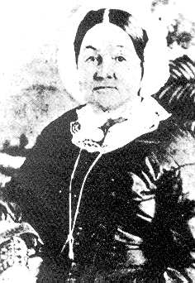
Sam and Jean made a good team. He ran
the tavern and she kept the account books. The
log tavern on the turnpike was a very good business.
Sam and Jean made enough money to build a
larger tavern. In 1831, Sam and Jean built a
beautiful two-story sandstone tavern on the
Allegheny Mountain. They called it The Lemon
House. The Lemon House served as a tavern and a
home. Sam, Jean, and their children lived on the
upper floor while the lower floor held tavern guests.
When the Allegheny Portage Railroad was
built it was laid out right next to Sam and Jean’s tavern.
This was wonderful news for them since it meant that
thousands of travelers would be visiting their tavern in
the future. Travelers on the Allegheny Portage Railroad
were much different from the travelers on the
Huntingdon, Cambria, and Indiana Turnpike. Elegant
ladies and gentlemen would be traveling on the railroad and they would need a suitable place to stop for refreshment. That place was to be the Lemon House.
Sam and Jean not only ran a tavern but owned and operated a coal mine and a stone quarry. They also rented horse teams out and leased land to the railroad. Soon, Sam and Jean became one of the wealthiest couples in Cambria County.
Because the tavern did so well, Jean Lemon was able to furnish her home handsomely. She filled her fancy parlor with fine furniture from Philadelphia. Philadelphia was one of the best places to get furniture and since Jean’s house was right on the railroad line, she could have things shipped the whole way across the state for her house.
The fancy parlor was a room where Jean, her daughter, and her personal guests could sit and get away from the noisy part of the tavern. You can see Jean’s parlor when you visit the Lemon House. Try to imagine what it was like to walk through the lively tavern, past the barroom and dining room, and into the quiet, beautifully furnished parlor. Jean spent many hours there entertaining guests and relaxing when she wasn’t busy keeping account books or looking after the tavern.
Jean and Sam had four children: Robert, John, Margaret, and Samuel. They lived on the second floor of the Lemon House with their parents. The children got to meet many interesting people. Families who were headed west, important government officials, and Philadelphia ladies making a trip to Pittsburgh all traveled on the Allegheny Portage Railroad. The children also had a lot of fun looking out their windows and seeing the cars going up and down the inclines. The Lemon House was at the top of Incline #6 so the Lemon family had one of the most spectacular views in the county.
The Allegheny Portage Railroad didn’t last long. Eventually the Pennsylvania Railroad completed its track across the state and put the Main Line system out of business. In 1847 Sam and Jean decided to buy a home in Hollidaysburg and move there. They continued to use the beautiful Lemon House for a summer home.
In 1867 Sam Lemon died and Jean’s children inherited the Lemon House while she continued to live in her Hollidaysburg home. Because of the her hard work in running the tavern with her husband, Jean was able retire comfortably and enjoy the company of her children and grandchildren. Surely, she often thought of the lively times in the Lemon House when the Allegheny Portage Railroad was running and travelers heading east and west crossed the mountain and stopped at the tavern to tell interesting stories and enjoy the Lemons’ hospitality.
Jean died in 1880. She left behind 15 grandchildren. She was a kind, well-educated woman who had led an exciting life. In her obituary she was honored for her charity, sympathy and generous nature.
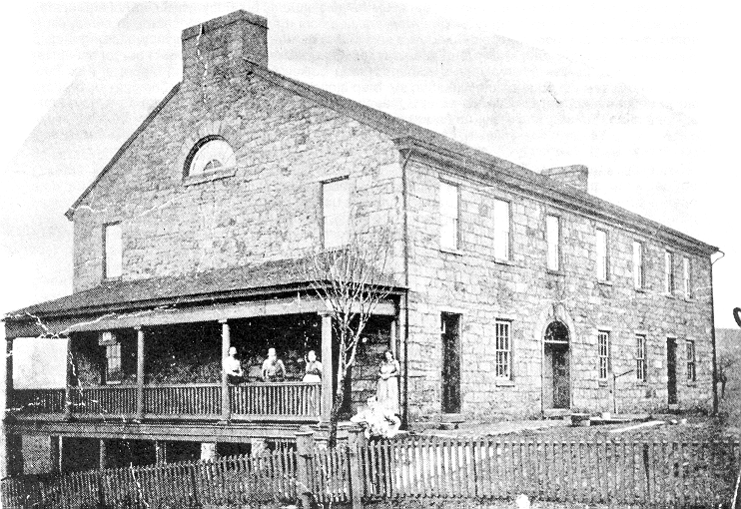

Activity # 5: Act It Out

Have you ever wanted to be an actress like the people you see on TV and in the movies? Well, here’s your chance! To complete this activity, you will become an actress.

Activity #5 requires you to choose a favorite real person or fictional character from the past and act like her. Here’s what you can do:

- Choose a person or character and act out a scene from her life. You can use the stories in activity #4 to act out a scene from the life of Harriet Beecher Stowe or Jean Moore Lemon. Or, research the life of another person who was involved in the Allegheny Portage Railroad and act out a scene from her life. You can get one of your friends from your Girl Scout troop to act with you and you can write a small scene to act out. This could be the beginning of a career as a playwright! If you choose not to write a scene you can just make up the words as you go along. This is called improvisation. Or you can…

- Dress up like the person you chose and act like her during your Girl Scout meeting. If you chose Jean Moore Lemon, this could mean that you pass out snacks to your troop members the way Jean entertained travelers on the Allegheny Portage Railroad. Be creative with your costume and the way you act and explain it to your troop members so they can learn the story too.
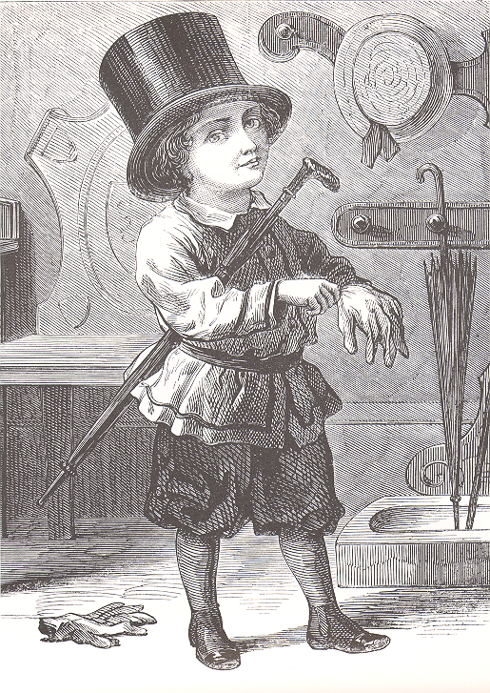

Activity # 6: Games of the Past

You and your friends probably do many different things together. One thing that most people love to do is play games. When your parents and grandparents and great-grandparents were children, they played lots of games too.

During the time of the Allegheny Portage Railroad, children played many different kinds of games. Verbal games were popular because you didn’t need any extra items to play them. Board games and card games were also popular amusements for young children. Games such as football and baseball were strictly for boys. Proper young ladies did not engage in such rough sports. If a young lady wished to amuse herself out of doors, a civilized game of croquet would be just the thing. My, how times have changed!

To complete activity # 6 you must learn to play a game from the past and teach it to others. The following games were popular children’s games in the 1850s. There is one verbal game and one card game for you to learn. Young ladies traveling on the canal boats of the Allegheny Portage Railroad may have played them. You may already know these games. If you wish, you may want to ask your parents, grandparents, aunts, or uncles to teach you a game from their childhood. You may be surprised at how much fun you’ll have.

Yes or No

Yes or No was a parlor game that was popular because it could be played without any props and was useful for settling children down “after a romp.” In order to play, one person had to think of something and the other children asked questions in order to “guess the thought.” The questions must require only a yes or no answer. For example:
The thought is “a cat.”
- Is the thing you’re thinking of alive? (yes)
- Is it a plant? (no)
- Is it an animal? (yes)
- Is it bigger than a person is? (no)
- Is it a dog? (no)
- Is it a cat? (yes)
The children take turns asking questions and the person to guess the thought thinks of the next thought.

Crazy Eights

Card playing has been a popular pastime for hundreds of years. King Charles VI of France commissioned a decorative deck of cards to be made for him in 1392. Crazy Eights is a card game that was invented many years ago and was popular in the Victorian Era. It is played with a standard deck of cards among 2 – 4 players. The object of the game is to be the first to get rid of all your cards.
- Deal five cards face down to each player (seven cards if there are only 2 players).
- Place the remainder of the deck face down to be the “draw deck”.
- Turn the top card over and place it next to the draw deck. This is the “starter card”.
- Play starts with the player to the left of the dealer. She must play on the starter card a card of the same suit or rank. (Example: If the card is the queen of hearts, the player must play either a queen or a heart.)
- Play then continues clockwise around the circle. If a player cannot play, she must pick up a card from the draw deck.
- Eights are wild in this game. If a player plays an eight, she then decides what suit will follow. She can play an eight of clubs and change the suit to diamonds if she wishes. The next player then has to play an eight or a diamond.
- The first player to play all her cards wins.



