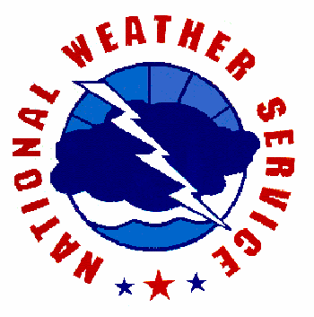
N W S Recommendations When Developing a Severe Weather Emergency Plan for a School

While no plan is storm proof, recommendations provided in this guide are based on safety measures that have been proven to help mitigate the loss of life.

Table of Contents

● Introduction
● Guide Purpose and Layout
● Severe Weather Coordinator

●  Section 1: Local Weather Dangers: Why a SWEP is Recommended
● Thunderstorm Dangers: Lightning, Hail, Downbursts and Tornadoes
● Floods
● Tropical Storms and Hurricanes
● Hot Temperature Extremes
● Local Weather Danger Summary

●  Section 2: Designing a SWEP
● How to Receive Emergency Weather Information
● How School Administration Alerts Faculty and Students to Take Action
● How to Determine Tornado and High Wind Safety Zones in Your School
● When to Activate Your SWEP and When to Return to Normal Activities
● When to Hold Departure of School Buses
● School Bus Actions
● Special Considerations for Other Weather Hazards
● Periodic Drills and Severe Weather Safety Instruction

●  Appendices
● Appendix A: National Weather Service Products
● Appendix B: Glossary of Weather Terms
● Appendix C: NOAA Weather Radio
● Appendix D: School Severe Weather Safety Checklist
● Appendix E: NWS and Emergency Management Contacts

Introduction

Guide Purpose and Layout

This guide was designed as a basis for schools when designing their individualized Severe Weather Emergency Plan (SWEP). All weather related situations cannot be covered in this guide and having a SWEP will not guarantee that your facility is storm proof, but this document will serve as a starting point and a general outline of recommended safety actions when severe weather threatens. You may wish to work with your county Public Safety Office and county Emergency Management when developing your customized school’s SWEP. Recommendations provided in this document may also help enhance School District’s Emergency Plan. Most material focuses on thunderstorms and the hazards they can produce. These dangers can occur suddenly, with little or no warning.

Section 2 of the guide, "Designing a SWEP," makes suggestions on how to receive weather information, how to alert faculty and students of an impending weather threat, and what actions we recommend to take to reduce the risk of injury. Safety is the foremost concern. The ultimate goal of a SWEP is to quickly inform staff and students anywhere on school grounds of the imminent threat of severe weather and to move them quickly to pre-designated safe shelter areas.

For a SWEP to work efficiently, it must be practiced. We recommend that schools conduct at least two tornado drills during the school year and that severe weather safety instruction be included in curriculum. It is important to understand weather terminology that is referenced in National Weather Service (NWS) watches and warnings as well as why certain response actions are advised during an impending weather emergency. The appendices in this guide contain reference materials that can assist with both designing a SWEP and gathering educational materials. There is a glossary of weather terms, a NWS product list, weather hazard safety tips, a SWEP guideline checklist as well as a list of NWS contacts.

Severe Weather Team and Coordinators

We recommend a school "Severe Weather Team" which may include a primary and at least one assistant coordinator. The coordinators would be responsible for developing the customized school’s SWEP. This may involve working with the local school board, administrators and faculty to implement the plan.

Section 1: Local Weather Dangers:
Why a SWEP is Recommended

Thunderstorms Dangers: Lightning, Hail, Downbursts and Tornadoes

Lightning

Florida averages 80 to 100 thunderstorm days each year. Thunderstorms are most common from late spring through early fall during the late afternoon and early evening, but storms can occur at anytime of year, anytime of the day. Lightning occurs with all thunderstorms; therefore, all thunderstorms are dangerous. Florida leads the nation in lightning deaths which kills an average of 9 Floridians and injures an additional 37. In Florida, most lightning deaths occur to children ages 10 to 19 years old. Most lightning strike victims are struck outside, including on athletic fields and in swimming pools.

Thunderstorms can build 5 to 10 miles up into the atmosphere. Winds aloft can blow the upper storm cloud (anvil) many miles downstream. Lightning can emanate from the anvil cloud and strike the ground 10 to 15 miles away from where it is raining; in fact, many lightning strike victims are struck by a “Bolt From the Blue” which describes that there are not many clouds, if any, overhead, when the victim is struck. If you are close enough to a storm to hear thunder, then you are close enough to be struck by lightning.

If a thunderstorm produces large hail (≥ ¾ inch in diameter), damaging winds (≥ 58 mph) or a tornado, then is it defined as a severe thunderstorm. Severe thunderstorm warnings are not issued for lightning.

Hail

Large hail can cause extensive damage to a large area in a short period of time, as well as bodily harm. Some hail stones can descend from the storm at speeds of 100 mph, severely impacting whatever object or person they strike.

Downbursts

A downburst is a strong wind that descends from a thunderstorm, impacts the ground, and continues to travel at a high speed along the earth’s surface. Downburst winds level objects in their path including telephone and power poles, trees and many types of structures. Outdoor objects can become projectiles if in the path of a downburst wind and these projectiles can cause extensive damage to whatever object they strike.

Tornadoes

Tornadoes are violent columns of rotating air that develop from severe thunderstorms. The tornado circulation can produce surface wind speeds over 200 mph and is capable of lifting objects from the ground and projecting them in the air, landing miles away. This debris can strike structures causing extensive and deadly damage. Tornadoes can develop very quickly in fast moving thunderstorms, and often there is little time to react when a tornado is approaching. When seconds count, a predetermined evacuation plan to a safe shelter can save lives.

Floods

In Florida, many flash floods are a result of poor drainage areas and creeks rapidly overflowing with water caused by heavy rainfall over a localized area during a short period of time. There have been cases of flash flooding near creeks and drainage basins filling rapidly with water, overflowing onto roads and flood waters moving cars downstream. A flash flood is defined as a rapid rise of high velocity water within 6 hours of the causative event that poses a threat to life and property.

Areal flooding is a common type of flood in Florida and is caused by a gradual rise in water levels over a longer period of time compared to flash floods. Areal flooding can occur when rivers overflow their basins and overspread onto property that is normally free of water. The flood waters can blanket roads and these waters may gradually seep into private residences or businesses. Areal flooding can pose a threat to property, but most areal flooding occurs on long-enough time scales to significantly reduce the threat to life. This type of flood has caused school closures and prevented public transportation, including school bus services.

Tropical Storms and Hurricanes

Florida is prone to tropical storm and hurricane landfalls both from the Gulf of Mexico and Atlantic Ocean. A tropical storm is composed of bands of precipitation that rotate around a center of low pressure. Wind speeds increase toward the center of low pressure. If sustained wind speeds around the center of the storm increase above 74 mph, then the system is defined as a hurricane.

Several factors influence how a tropical system will affect an area. These factors include the strength and of size the system as well as the speed and direction it is moving. Sometimes small tropical systems can be intense and cause extreme destruction over a small area like Category 4 Hurricane Charley in 2004. A slow moving storm can produce a lot of heavy rainfall over a specific area for a prolonged period of time and cause extensive flooding. The direction a storm travels can influence where the higher storm surge will occur, which is usually to the right of center. This is also a favored region for tornado formation, and tornadoes that form in tropical cyclones can develop and move quickly causing small but intense paths of destruction.

Hot Temperature Extremes

Floridians are used to hot and humid conditions, but sometimes the combination of the two can create dangerous heat index values which can pose a threat to life. The heat index is a measure of how hot it feels to the human skin; high heat indices indicate that hot temperatures and high levels of humidity make it extremely dangerous to be outdoors, and mild exertion may rapidly lead to over-exertion and possibly heat stroke.

Local Weather Danger Summary

Thunderstorm hazards and floods can occur rapidly and sometimes with little or no warning. Evacuation decisions should be made quickly and executed immediately and efficiently. We recommend preparing a SWEP now which can save lives when seconds count.

Schools may also need to consider what to do when tropical storms, hurricanes, or excessive heat indices are expected to affect the school district. It may also be prudent to address the rare occurrence of winter weather and excessive cold. These weather hazards are not routine in our area and are usually predicted at least a day in advance which can allow decision makers more time to address how the weather may affect school operations.

A clearly written SWEP can enable parents, faculty and students to know how to react when time is critical. A SWEP can provide peace-of-mind that appropriate actions are being done to promote safety. By practicing your SWEP, consistent actions will be reinforced which can save lives when seconds count.

Section 2: Designing a SWEP

How to Receive Emergency Weather Information

Tornadoes and severe thunderstorms can occur with little or no warning. In just five minutes, a tornado may travel four miles on the ground. Even using the latest and fastest technology possible, from the time the National Weather Service (NWS) issues a warning, to the time you receive that warning via radio or television, ten minutes may have elapsed.

The fastest, most accurate and reliable means of receiving critical weather information, including NWS severe weather watches and warnings, is through a NOAA Weather Radio (NWR). When the NWS issues a tornado warning, the NWR will automatically sound an audible alarm and then broadcast the severe weather watch or warning information. The radio can be in a silent “Alert” mode, meaning that it will not constantly broadcast forecast information. However, when a severe weather watch or warning is issued for your area, the NWR will automatically tone alert which will alert you of the possibility of severe weather in your area, even in the middle of the night. Some NWR receivers are programmable to only tone alert for your specific county. This feature is called a specific area message encoder (SAME). Most retail stores sell various models of NWR, and they range in price from $30-$80.

If using a NWR, the radio should be set at all times in "alert" mode. Some radios will automatically turn on when an alert sounds while others must be manually turned on after the tone is heard. It is recommended to have the type of NWR that automatically broadcasts in case you are out of the room when the tone alert is activated. If using NWR, the information cycles every few minutes, so if you do not hear all of the warning information the first time the watch or warning is broadcast, the information will repeat shortly. More expensive NWR models include features such as a link to your public announcement (PA) system, the ability to set off a pager or to call someone, flashing lights for new warnings and a button to play the warning back with a date/time stamp.

Alternative methods of receiving NWS warnings other than NWR include, but are not limited to:

- Monitor the local NWS website for real time local information (www.weather.gov).
- Monitor local news radio stations for Emergency Alert System (EAS), which include watches and warning from the National Weather Service. EAS operates on a cooperative agreement between broadcasters and federal, state, and local government agencies.
- If you have cable television access, The Weather Channel uses NWS products and broadcasts warnings immediately upon receipt from the NWS via a satellite link. Warnings are continuously scrolled across the bottom of the screen.
- Some cable companies include a channel with a local NWS radar display and use NWR as a voice-over.

Your radio or television should be located in the main office or near the person(s) responsible for enacting the SWEP. Main offices are recommended because generally there are people present who could hear the weather emergency then quickly inform the rest of the school via the PA system. Listen for the type of watch or warning and where it is in effect. The person(s) monitoring should know what actions to take based on this information. It is suggested you have a map nearby for easy reference to counties and towns to locate storms and their movement in reference to your school. There is no need to take emergency action if the warning is not for your location. It should, however, heighten your awareness to the potential for severe weather to affect your school district.

How School Administration Alerts Faculty and Students to Take Action

Most schools utilize a public announcement (PA) system to directly inform faculty and students. In some cases, electricity may be lost during a storm before you have activated your SWEP. We recommend a back-up alerting device such as a compressed air horn or megaphone.

If your school has portable classrooms, detached gymnasiums or another facility that is not connected to the PA, then we recommend making special arrangements to notify these areas of the impending weather hazard. Sending "runners" outside to mobile classrooms is not advisable due to lightning risks. Wireless communication devices are an effective means for such communication. "Walkie-talkies" may be the least expensive means of communication or even a cell phone call to the faculty member who is with the students.

Handicapped or learning-disabled students may require special attention. You may wish to assign a teacher or student to each special needs student who will insure that the student is transported to an appropriate safe place.

We strongly recommend that your school routinely practices the SWEP.

How to Determine Tornado and High Wind Safety Zones in Your School

Schools are diverse in design. We recommend that this phase of the SWEP be accomplished with the help of an engineer or architect familiar with the school's design. You may also wish to reference FEMA’s document entitled “Tornado Protection: Selecting Refuge Area in Buildings.” Below, you will find some general guidelines and basic concepts to help you locate safe shelter areas in your school where staff and students can congregate when hazardous weather is approaching.

Some of the greatest threats from strong winds caused by a tornado, tropical system, thunderstorm downburst or a strong pressure surge behind a cold front include:
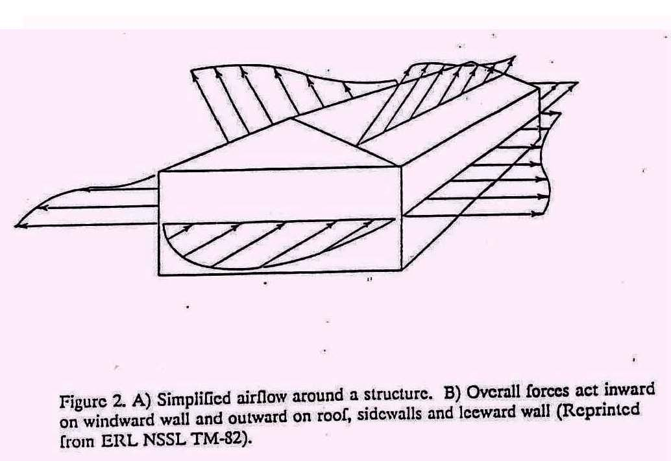
1. Roof failure
2. Breaking glass, and
3. Flying debris (airborne missiles).

Some of the most dangerous locations during strong wind events are generally large rooms with big expansive roofs such as cafeterias, gymnasiums, and auditoriums. The collapse of the room's outer load-bearing wall can lead to the failure of the entire roof.

Gravity helps keep roofs attached. When strong winds act on a structure, pressure differences are created causing outward pressures forces that can act to lift the roof.

Rooms with large windows that can shatter from airborne missiles or from pressure stresses are extremely dangerous. While windows on the side of the school facing the storm are most susceptible, as the storm passes, any windows could potentially shatter.

NEVER OPEN WINDOWS WHEN A STORM APPROACHES! Once winds enter a building, additional damage is highly likely.
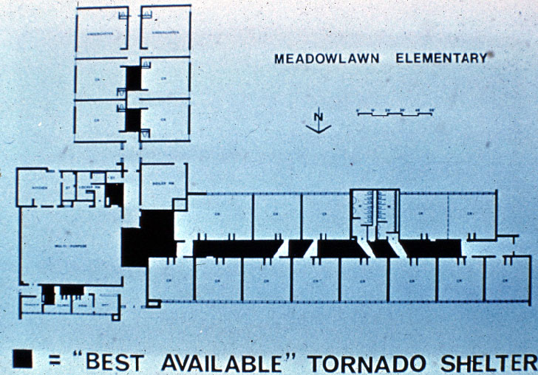
Small interior rooms, bathrooms, and windowless interior hallways that are away from exterior doors offer protection. All doors should be closed, if possible. Interior load-bearing walls (with short roof spans) provide better protection than temporary or non-load-bearing walls. If your school has more than one level, we recommend evacuating the upper floor of the school. The lowest level of a structure is safer.

Schools designed for the "open classroom" concept may have a difficult task of finding safe areas due to a lack of interior load-bearing walls, large spanning roofs and the use of a lot of glass. You may not be able to find enough ideal space to occupy your entire faculty and student body. You can, however, find safer locations. Below is a list of vulnerable areas, beginning with the locations that have the highest probability of failure from severe weather:
- Mobile Classrooms
- Rooms with large roof spans (gymnasium, auditorium, cafeteria)
- Windows on exterior walls
- Roof
- Exterior walls of upper level
- Interior walls of upper level; exterior walls of lower level; interior glass; interior, lower level, non-load bearing walls.

You may wish to rank areas of your school according to safety. Next, begin filling the safest areas first with faculty and students and continue down your safe place list until you have found space for the entire school body.

We strongly suggest seeking the professional advice of an engineer or architect to locate the safest areas of your school. The safe areas listed above are based on broad generalities.

When to Activate Your SWEP and When to Return to Normal Activities

When deciding to activate the SWEP, you will need to determine the type of weather hazard expected as well as the time of impact on your school. A SWEP may work best with phases of activation.

General Thunderstorm Threats including Lightning

Outdoor activities will be the most susceptible to all weather hazards, including lightning. If thunder is heard and/or lightning is seen, outdoor activities should be delayed immediately and students, faculty and spectators moved as quickly as possible into a grounded structure. The delay in activities should last until the storm has safely passed. We advise that thunder is not heard nor lightning seen for at least 30 minutes before resuming outdoor events in the wake of a thunderstorm.

Severe Thunderstorm or Tornado Watches

In a tornado or severe thunderstorm watch, outdoor activities should be postponed. If a line of storms is approaching your school and you remain under a watch, you may want to proactively move students from the most susceptible areas of your school which may include portables and gymnasiums. You might also do this for "High Wind Warnings". For potentially severe thunderstorms, you may want to post teachers or school personnel trained in spotting severe weather to watch the storms as they approach for the need to take special actions.

Severe Thunderstorm Warning


If a severe thunderstorm warning is issued and the storm is approaching your location, all of the above actions are advised. In addition to strong damaging winds, severe thunderstorms may contain large destructive hail. We recommend relocating faculty and students away from windows and skylights to pre-designated safe areas until the storm passes.

Tornado Warning

If a tornado warning is issued and the tornado is approaching your location, we recommend executing your SWEP immediately and relocating faculty and students to the safest areas of the school. We recommend the ‘Tornado Crouch Position,’ as illustrated above. Sit down, crouch over and cover your head.

If the storm has not yet reached your school, you may wish to move students from relatively unsafe areas and post a trained storm spotter to monitor the storm's approach. Your SWEP drills will determine approximately how long it will take to relocate everyone to pre-designated safe areas.

If you did not receive a tornado warning and students and teachers are in class when the classic “freight train” noise is heard, we recommend everyone drop to the floor and under desks and form the ‘Tornado Crouch Position.’

Once the storm has past, you may wish to return students may to classrooms if the environment is safe. Remain alert for the possibility of additional storms.

Consider the need to activate the SWEP during class change when the halls are crowded and students may not know where to go. It may be best to hold classes beyond regular dismissal time until the severe weather threat has passed. Likewise, at the end of the school day, students may need to be held from boarding busses until the weather threat has passed.

We recommend designating at least a couple personnel that can turn off the main power line (electricity) and gas line (if applicable). If a tornado or severe thunderstorm has significantly damaged your school, shut off the gas and electricity for safety purposes immediately.

When to Hold Departure of School Buses

Consider holding the departure of buses when severe weather watches or warning are in effect for your area. There are two primary considerations:

- How long will it take before all students reach home safely? Include the time it takes for students to walk from the bus stop to their home or after school care.
- How much time before the storm impacts your district? Severe weather watches are sometimes issued several hours in advance of thunderstorm development. It may also be a rapidly evolving severe weather situation with less than an hour before severe weather is expected to develop.

If condition number 2 above is less than condition 1, then we recommend delaying the departure of school buses. Although buses may shelter from lightning, they may not provide protection from severe storms. We do not advise the dismissal of children during severe weather. We recommend everyone seek a safe location during imminent severe weather.

You may also wish to consider if your students live in mobile homes. These homes are highly susceptible to high winds regardless if they are anchored or tied down. The school would be a safer place for students compared to a mobile home during a severe storm.

School Bus Actions

We recommend that all school bus drivers are trained on how to handle severe weather situations. Severe weather can develop quickly, including flash floods and tornadoes.

Tornado Safety for School Buses

NEVER ATTEMPT TO OUTRUN A TORNADO! If a bus driver has reason to believe a tornado is approaching, we advise the following actions:

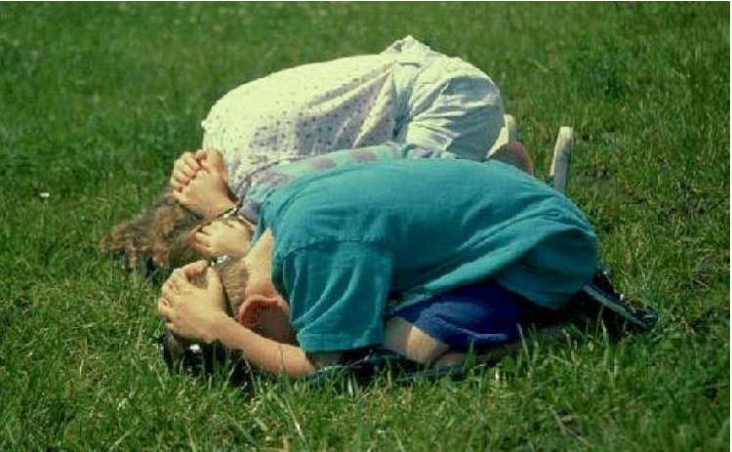
- If you have time, transport students to a well constructed building. Lead them to an interior room or basement away from windows and doors.
- If a well-constructed building is not available, look for a ditch or low lying, un-flooded area. Stop the bus downwind of the location you selected to prevent winds from rolling the bus toward students. Unload the bus and lead students to the low area and have them get into the ‘Tornado Crouch Position.’

Flood Safety for School Buses

NEVER ATTEMPT TO DRIVE THROUGH FLOOD WATERS!

If your bus route takes you across small streams and creeks or along a river, we recommend having either an alternate route or a contingency plan to return to the school if flood waters are encountered. River flooding and coastal flooding are generally well forecast with warnings issued early enough that schools and bus drivers can plan their strategy prior to placing the students on the bus. However, flash flooding, which includes a sudden and dramatic rise in fast moving water levels, can occur with little warning.

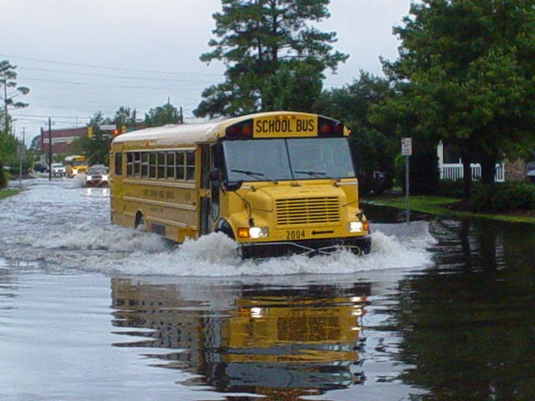
If you cannot determine how deep the water is that covers the road, we strongly suggest not passing through it. The road may have been undermined or the water may be deep enough to stall the bus and place all of it occupants in danger. It may also be a sinkhole. We recommend not entering underpasses that are filling with water. If the water appears to be flowing (moving across the road), do not enter. The bus may act as a barrier, and the water may lift and move the bus. If water is flooding over or around a bridge, do not cross it, it could collapse from the weight of the bus. The foundation of the bridge may have been compromised.

Water levels can rise rapidly and the force of the water against a vehicle, including a school bus, can be powerful enough to move it. If the driver is caught in an unavoidable situation and the vehicle stalls in rising water, we advise that the driver lead all occupants out of the bus immediately to seek higher ground.

Special Considerations for Other Weather Hazards

Tropical Systems
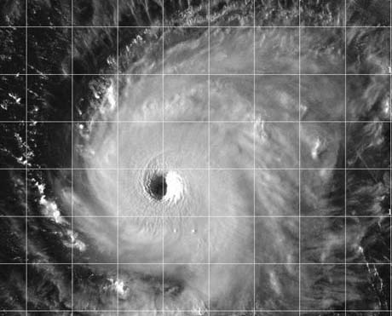
Hurricanes and tropical storms can produce extreme coastal flooding, flash flooding, and river flooding. This flooding is responsible for the majority of hurricane related fatalities. Winds can gust over 100 mph and hurricanes may spawn tornadoes. Local emergency management will decide if evacuations are needed.

If school is in process when a hurricane or tropical storm strikes, we recommend actions similar to those advised for flooding, lightning, and strong damaging winds. Schools susceptible to river or coastal flooding may be asked to evacuate. Some schools may become shelters for people in flood prone areas or those living in mobile homes. Actions taken by those sheltered at the school should be the same as if the school were in session.

Excessive Heat

Hot temperatures in combination with high humidity values are common in our area. The heat index is a value that indicates how hot it feels outside when temperatures and humidity are high. Heat indices can reach dangerously high values and create hazardous conditions for those outside. Heat disorders such as cramps, heat exhaustion, and heatstroke are possible from high heat indices. The NWS issues Heat Advisories and Excessive Heat Warnings to warn of dangerously warm conditions. We recommend keeping students out of the sun and reducing or eliminating strenuous activities, even indoors. You may wish to encourage students to drink water and wear light-colored, light-weight clothing. Faculty may wish to learn the symptoms of heat disorders and first aid procedures.

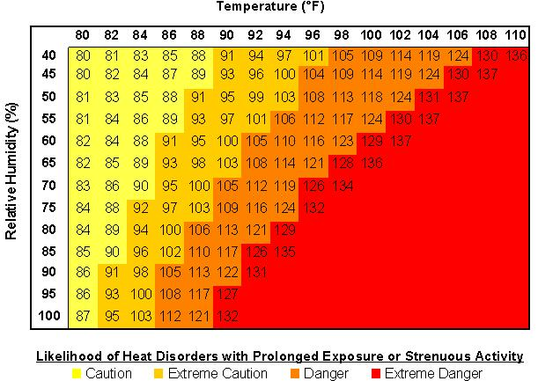

Winter Weather Hazards

Although rare in our area, about 60 percent of deaths in winter storms occur in vehicle accidents on icy and snowy roads. Some deaths occur from exposure to the cold. Those most susceptible to the cold are young children (under 2 years old) and the elderly (over 60 years old). Some deaths occur from fires started by improper use of alternative heat and light sources such as fireplaces, candles, wood stoves, and space heaters. Proper cold weather preparedness, wearing appropriate winter clothes, and following safety procedures will save lives.

Schools should be aware of extreme cold weather conditions and the impacts on students. Students waiting for buses or playing outside during recess are vulnerable to extreme cold and wind chills. The degree of exposure the student will experience will be a function of the temperature, the wind, the clothes they wear, and the amount of time they are exposed. The NWS issues Wind Chill Warnings and Advisories when the combination of winds and low temperatures will make it dangerously cold to be outdoors for a prolonged period. In cases of extreme cold, proper clothing is very important and should be stressed to students. Outdoor activities may need to be rescheduled or cancelled. Faculty may wish to learn the signs of frost bite and hypothermia as well as first aid for these conditions.

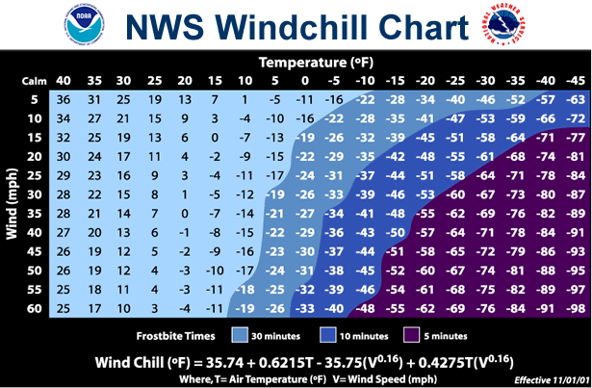

Periodic Drills and Severe Weather Safety Instruction

In order to have an effective SWEP, we strongly recommend periodic severe weather drills and severe weather safety training. Drills not only help students and faculty practice the actions they need to take during a severe weather event, but they will also allow you to evaluate your plan's effectiveness and address possible questions that need answers before a real severe weather event approaches your school including:

- Did everyone hear the alert message & understand what to do?
- Were they able to get to designated safe areas in a reasonable amount of time?
- Did the designated safe areas accommodate the students and faculty?

We suggest you conduct drills in conjunction with a severe weather awareness program. This education will reinforce why sudden safety actions are required when severe weather approaches and hopefully encourage students and faculty to develop a severe weather safety plan at home.

The NWS and the Florida Department of Emergency Management (FDEM) conduct a statewide weather awareness campaign. Each February, the state participates in Severe Weather Awareness Week. During this week, the NWS, FDEM and local media encourage schools to participate in a coordinated tornado warning drill which includes a test tornado warning from the NWS and the media triggering the Emergency Alert System (EAS). This drill ensures that the warning message is received and will serve as an opportunity for your school to practice your SWEP. We encourage that at least two tornado drills are conducted throughout the school year, preferably more.

Lightning Awareness and Tropical Awareness Weeks occur each spring. These weeks may be opportune times for your school to conduct severe weather drills and promote weather awareness education. You can contact your local NWS or emergency management office if you would like a speaker to come to your school and discuss severe weather safety.

Appendices

Appendix A: National Weather Service Products

WARNINGS – When a weather warning is issued for your area the hazard is imminent. We recommend immediate action and to seek adequate shelter. The probability of your experiencing severe weather is high if your area is under a severe weather warning. Warnings are issued based on eyewitness reports or persistent and strengthening radar signatures.

- Tornado Warning: Issued when a severe storm has strong rotation signatures via Doppler radar close to the ground or based on an eyewitness report of a developing tornado. Also issued if a waterspout (tornado over water) is making landfall.
- Severe Thunderstorm Warning: Issued for thunderstorms capable of producing damaging winds (≥ 58 mph) or large hail (diameter ≥ ¾ inch).
- Flood Warning: Issued when rising water will threaten life and property. Includes Flash Flood Warnings, Areal Flood Warnings and river Flood Warnings.
- Hurricane Warning: Hurricane force conditions (sustained winds ≥ 74 mph) are expected within 24 hours.
- Tropical Storm Warning: Tropical Storm force conditions (sustained winds ≥ 39 mph) are expected within 24 hours.
- Excessive Heat Warning: Issued when the heat index is forecast to be ≥ 115°F.
- Freeze Warning: Issued when temperatures ≤ 32 ° F are imminent.
- Hard Freeze Warning: Issued when temperatures are ≤ 27 ° F are imminent.
- High Wind Warning: Issued for non-convective wind speeds of ≥ 40 mph or non-convective wind gusts ≥ 58 mph.
10. Wind Chill Warning: Issued for wind chills ≤ 10 ° F and winds of ≥ 10 mph for ≥ 4 hours.
11. Winter Storm Warning: Issued when ≥ 2 inches of snow are expected in 24 hours; or when falling snow will reduce visibilities below ¼ mile and winds gust ≥ 35 mph; or when any accumulation of ice or sleet will impact transportation, commerce or power.

WATCHES – When the ingredients to produce a specific significant weather threat are forecast, a weather watch is issued. Watches generally cover larger areas than warnings. A weather watch means that it would be prudent to continue to monitor the evolving weather situation and to be prepared to take necessary safety actions in case a warning is later issued.

- Tornado Watch: Conditions are favorable for severe thunderstorms to produce tornadoes and/or waterspouts.
- Severe Thunderstorm Watch: Conditions are favorable for severe thunderstorms to develop.
- Flood Watch: Conditions are favorable for flooding to occur in the watch area. Flooding could threat life and property. Includes Flash Flood Watches, Areal Flood Watches and river Flood Watches.
- Hurricane Watch: Hurricane force conditions possible within 36 hours.
- Tropical Storm Watch: Tropical Storm force conditions possible within 36 hours.
- Freeze Watch: Issued when temperatures ≤ 32 ° F are possible.
- Hard Freeze Watch: Issued when temperatures ≤ 27 ° F are possible.
- Winter Storm Watch: Issued when ≥ 2 inches of snow are expected in 24 hours; or when falling snow will reduce visibilities below ¼ mile and winds gust ≥ 35 mph; or when any accumulation of ice or sleet will impact transportation, commerce or power.

ADVISORIES – An advisory is issued for weather that is expected to be a disruption and an inconvenience, but it is not expected to be an imminent threat to life or property.

- Urban and Small Stream Flood Advisory: Issued for minor street flooding and swollen creeks and streams.
- Dense Fog Advisory: Issued when visibilities are reduced below ¼ miles in fog.
- Dense Smoke Advisory: Issued when visibilities are reduced below ¼ miles in smoke.
- Heat Advisory: Issued when the heat index is 110-114 ° F and is extended over night if minimum temperatures are ≥ 76 ° F.
- Lake Wind Advisory: Issued for wind speeds 20-24 mph or wind gusts 30-39 mph.
- Wind Advisory: Issued for wind speeds 25-39 mph or wind gusts 40-57 mph.
- Wind Chill Advisory: Wind chills of ≤ 25 ° F and winds of ≥ 10 mph for ≥ 4 hours.
- Winter Weather Advisory: A winter weather event is possible within 12 hours but will likely remain below warning criteria.

STATEMENTS – Statements are issued to update current weather situations or highlight upcoming significant weather changes. Statements are also used to explain why watches, advisories, or warnings have been issued.

- Special Weather Statement – Issued for strong storms below severe limits but capable of producing frequent lightning, small hail and gusty winds to 55 mph.
- Short-Term Forecasts - Discuss the short-range forecasts for the next 1 to 6 hours. During active weather, these statements may be issued hourly.

FORECASTS – Forecasts provide general weather information such as maximum and temperatures, prevailing sky conditions, chances of rain as well as expected weather.

Appendix B: Glossary of Weather Terms

Clouds and Thunderstorms
- Cumulus Cloud: A cauliflower shaped cloud with a flat base and sharp edges. Tufts are rising columns of air condensing. As the cloud and cloud droplets grow in size, the base will begin to gray.
- Towering Cumulus Cloud: A cumulus cloud that continues to grow so that its height is taller than or equal to its width. It may be producing a shower and continue to grow into a thunderstorm.
- Thunderstorm (Cumulonimbus): The towering cumulus cloud has continued to grow in height and width and now lightning is occurring. The storm may extend 5-10 miles high into the atmosphere and extend 5-25 miles across. Heavy rain, gusty winds and hail may occur.
- Precipitation Shaft: A visible column of rain or hail falling from a cloud.
- Hail: Precipitation in the form of ice that might descend from a thunderstorm.
- Squall Line: A solid line or band of active thunderstorms.
- Anvil Cloud: The spreading out of the upper portion of the thunderstorm. It usually has a fibrous or smooth appearance. With long lasting thunderstorms, the anvil may spread 100 miles downwind and indicates the direction that upper level winds are blowing.
- Mammatus Cloud: Cloud forms that appear to be hanging, rounded protuberances or pouches on the underside of the cloud. They are usually seen under the anvil of a thunderstorm and often accompany severe storms.
- Gust Front: The leading edge of rain cooled air that travels along ground away from the precipitation area of a shower or storm. Gusty cool winds and cooler temperatures often accompany a gust front as it moves through an area.
10. Shelf Cloud: A low-level, horizontal, wedge-shaped cloud that moves away from the precipitation area of a storm. It forms above the gust front as warm air ahead of the storm rides over the cool outflow from the thunderstorm.
11. Roll Cloud: Rarely a shelf cloud may turn into a roll cloud. The motion of the warm air riding up and over the cool air moving down and under creates a swirling of air or an eddy. The cloud takes on the shape of a horizontal tube that appears to be rolling. It is detached from the thunderstorm on its leading edge.
12. Rain-free Base: The dark underside of a cloud (its base) that has no visible precipitation falling from it. This marks the updraft area of a thunderstorm.
13. Wall Cloud: This cloud appears as an isolated lowering of the rain-free base portion of a storm. It is attached to a thunderstorm and may be rotating. This is the portion of the thunderstorm from which a funnel cloud may descend.
14. Funnel Cloud: A funnel-shaped cloud extending from a towering cumulus or thunderstorm. It is associated with a rotating column of air that has condensed to form a cloud.
15. Tornado: A violently rotating column of air in contact with the ground and extending to the thunderstorm base often seen extending from near the wall cloud. It can be a few yards across to a mile wide.
16. Flanking Line: A line of cumulus clouds that builds into a thunderstorm. The cloud line has roughly a stair step appearance with the taller clouds adjacent to the parent cumulonimbus. It is most frequently associated with strong or severe thunderstorms and indicates inflow into the storm.
17. Hook Echo: A radar signature that sometimes indicates a tornadic thunderstorm. The rain echo forms the hook pattern as air rotates around the strong updraft. The updraft is the hollow portion of the hook (looks like a ‘6’) and is where the tornado would most likely be found (if the storm were to produce one).
18. Scud Clouds: Low cloud fragments often seen in association with gust fronts. These clouds are ragged and wind torn and are not usually attached to the thunderstorm. 19. Updraft: Warm, moist, rising air. As the air rises, it condenses into a visible cumulus or cumulonimbus cloud. The updraft fuels the storm. In an ordinary thunderstorm, air rises in the updraft around 40 mph. In a severe thunderstorm, updrafts may exceed 100 mph.
20. Downdraft: A column of cool air that sinks toward the ground. It is most often accompanied by precipitation.
21. Downburst: A downward rush of cool air toward ground that can impact with speeds over 60 mph and produce damage similar to that of a tornado. It usually occurs near the leading edge of the storm or may occur in heavy rain. Downburst wind damage levels objects along the ground in the direction that the downburst wind traveled.
22. Microburst : A downburst affecting an area ≤ 2.5 Km in diameter.
23. Macroburst : A downburst affecting an area ≥ 2.5 Km in diameter.
24. Severe Thunderstorm: A thunderstorm producing winds ≥ 58 mph and/or hail ≥ ¾ inch in diameter.

Tropical Weather
- Tropical Disturbance: A moving area of thunderstorms in the tropics that maintains organization for ≥ 24 hours.
- Tropical Depression: A cluster of thunderstorms in the tropics that maintains organization indicates a surface circulation with sustained speeds ≤ 38 mph.
- Tropical Storm: Evolves from a tropical depression or may be a hurricane in its dissipating stage. Circulation is distinct around a center of low pressure and sustained winds range from 39-73 mph.
- Hurricane: Evolves from a tropical storm. Circulation has become pronounced and an eye is detectable (center of the storm). Sustained winds are ≥ 74 mph.
- Eye: The center of a hurricane where winds are light and skies are clear to partly cloudy. The eye is rimmed by massive thunderstorms producing torrential rains and extreme winds.
- Eye Wall: A wall of thunderstorms around the eye.
- Spiral Bands: Bands of thunderstorms that appear to spiral in toward the tropical storm or hurricane center.
- Storm Surge: A dome of water that advances inland near the area where the center of the tropical storm or hurricane makes landfall.
- Storm Tide: A storm tide is produced when the storm surge moves inland around the time of astronomical high tide.

Floods
- Flash Flood: A flood that occurs suddenly during or shortly after heavy rains or from a sudden release of water as in a dam break. Small streams and creeks usually react first to heavy rains and rise several feet in hours or even minutes.
- River Flood: A flood on large river such that usually develops over 1-2 days. Rain water first runs into the small streams which flow into tributaries of the main river.
- Coastal Flood: High tides, persistent onshore winds or a tropical storm or hurricane storm surge can cause flooding along coastal areas.
- Urban Flood: Concrete causes rapid runoff of rain water which means rainfall cannot be absorbed into the ground. Poor drainage can lead to flooded roadways and underpasses.
- Bankfull: The maximum height of the river before it overflows its banks.
- Flood Stage: The height of the river at which property damage begins to occur.
- Flood Crest: The highest height that the river reaches during a flood event.

Winter Weather
- Snow: Refers to a steady fall and accumulation of snow for several hours or more. It may be modified by terms such as "light," "intermittent," or "occasional" to indicate intensity or periodic snow.
- Snow Flurries: Light snow falling for short durations. No accumulation to a light dusting (or trace) is expected.
- Blizzard: Strong winds (greater than 35 mph) and heavy snow or blowing snow combine to produce very poor visibility.
- Sleet: Ice pellets or granules of frozen rain. Occurs when rain falls into a layer of air with temperatures below freezing. Sleet usually bounces when hitting a surface and does not stick, but can accumulate on roadways causing a hazard to motorists.
- Freezing Rain: Rain that falls onto a surface with a temperature below freezing causing it to freeze to the surface forming a coating of ice or glaze.
- Freezing Drizzle: Drizzle that falls onto a surface with a temperature below freezing causing it to freeze to the surface forming a thin coating of ice or rime. Drizzle is a very light precipitation with little accumulation, but even a small amount of ice can be dangerous.
- Ice storm: Significant and possibly damaging accumulations of ice are expected during freezing rain situations. Significant ice accumulations are usually accumulations of .25 inches or greater, but may vary from region to region across the country.
- Wind chill (Wind chill factor): Combines the rate of heat loss of a human body caused by wind and low temperature. As the wind rises, heat is carried away from a person's body at a more accelerated rate driving down the body temperature.
- Freeze: When temperatures at or near the surface (ground) are expected to be 32°F degrees or below. Sometimes used with adjectives "Killing," "severe," or "hard". A freeze may or may not be accompanied by frost.
10. Frost: The formation of ice crystals in the forms of scales, needles, feathers, or fans, which develop under conditions similar to dew, except that the temperature has dropped to at least 32°F.
11. Hypothermia: When the body temperature drops below 95°F.
12. Frost Bite : Frozen body tissue.

Appendix C: NOAA Weather Radio

NOAA Weather Radio (NWR) provides a continuous broadcast of weather information including forecasts, and, if needed, severe watches and warnings. All severe weather watches and warnings tone alert the radio even when it is in ‘silent’ mode. NWR broadcasts are automatically generated, and a computer reads forecast and warning information as soon as it is transmitted by the NWS. NWRs can be purchased at most retail stores or on-line. Some models have feature called the Specific Area Message Encoder (SAME) which allows you to program the radio to tone alert for the counties you choose. The SAME feature uses the county Federal Information Processing Standards (FIPS) code to program which counties you want your radio to tone alert for severe weather watches and warnings.

National NOAA Weather Radio Web Site: www.nws.noaa.gov/nwr
Florida County FIPS Codes: www.weather.gov/nwr/CntyCov/nwrFL.htm

NOAA Weather Radio Transmitters Serving Northeast Florida

NWR Transmitter Location (in FL) | Call Sign | Frequency  (MHz) | Power  (Watts) | Counties Served in Broadcast
Jacksonville | KHB-39 | 162.550 | 1000 | Baker, Clay, Duval, Nassau, St. Johns
Gainesville | WXJ-60 | 162.475 | 1000 | Columbia, Gilchrist, Marion, Putnam, Suwannee, Union
Ocala | WWF-85 | 162.525 | 300 | Marion
Lake City | KEB-97 | 162.400 | 300 | Baker, Columbia, Hamilton, Suwannee
Palatka | WNG-522 | 162.425 | 300 | Clay, Flagler, Putnam, St. Johns
Inverness | WWF-38 | 162.400 | 300 | Marion
Daytona Beach | KIH-26 | 162.400 | 1000 | Flagler, Putnam
Sumterville | KPS-505 | 162.500 | 1000 | Marion

Appendix D: School SWEP Checklist

We recommend the following checklist to help design a SWEP for your school. Remember the ultimate goal of the SWEP is that faculty and students anywhere on campus can be quickly alerted of the weather danger then proceed quickly to a safe place.

- Who is responsible for activating the plan (severe weather coordinator)?
- Is there a back-up severe weather coordinator?
- What are the primary means of receiving severe weather information? A battery back-up NOAA Weather Radio with an alert feature is recommended.
- What type of communication will you use to alert faculty and students?
- Is there a back-up communication method that does not require electricity?
- We recommend making provisions for the following areas which may lack communication with the rest of the school:
  - Portable classrooms.
  - The cafeteria or gymnasium.
  - Students with disabilities who may not hear the warning and/or not be able to respond to it without assistance. You may wish to assign someone to each special needs student to maximize that student’s safety.
  - Students and faculty outside, including after-school activities.

Aspects of Your SWEP to Consider:
- Practice your plan. We recommend drills at least semi-annually.
- Include Severe Weather Safety Instruction as part of the drill period.
- Encourage faculty to develop a SWEP for their families at home. Knowing that their families have a safety plan will enable faculty to focus their attention on the students. The Florida Department of Emergency Management and the American Red Cross have brochures on developing a "Family Protection Plan."
- Encourage faculty to go through the NWS Skywarn Storm Spotter Training, either on-line or attend a class in person. The class will teach the structure of severe thunderstorms in our area as well as safety actions.
- For optimum planning purposes, an engineer and a member of the local school board should participate in the design of an emergency plan.
- Encourage administrators to contact the nearest National Weather Service Office or Local Emergency Services Coordinator for assistance in answering ANY questions that may arise in developing a plan.

Summary of Tornado Concerns:
- Forces caused by winds and the airflow around the building.
- Forces caused by other objects (debris) impacting school walls.
- Pressure differences caused by a tornado (secondary to first two).
- Gas leaks and electrical hazards after the storm. Have someone knowledgeable in turning off gas and electricity at the school during school hours.
- "Wind Tunnel Effect" - Debris blown by tornado winds (such as fragments of glass, wood, and metal) can cause serious injury when accelerated by relatively narrow hallways in schools.

Summary of Severe Thunderstorm Hazards:
- Lightning will be a threat from all storms. Athletic teams on open fields and children outside during recess will be susceptible.
- Flood-prone areas near the school may make transportation difficult or impossible.
- Downburst winds and large hail can be serious life-threatening dangers.

Summary of Safe Places in a School (assuming no underground shelter):
- Interior hallway on the lowest level.
- Away from windows.
- In a small room, such as a bathroom, surrounded by load-bearing walls.
- In a room without small objects (may serve as projectiles).

Appendix E: NWS, Emergency Management and American Red Cross Contacts

For weather information and preparedness materials, contact your local NWS office. This is the office that has warning responsibility for your area. The NWS in Jacksonville’s county warning area includes the following 15 counties in northeast Florida, as well as 14 counties in southeast Georgia:

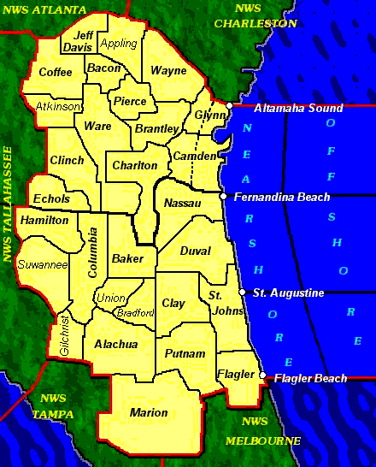
- Hamilton
- Suwannee
- Gilchrist
- Columbia
- Baker
- Union
- Bradford
- Alachua
- Marion
- Nassau
- Duval
- Clay
- St. Johns
- Putnam
- Flagler
National Weather Service Jacksonville, Florida
13701 Fang Drive, Jacksonville, Fl, 32218
(904)-741-4370
www.weather.gov/jax

Angie Enyedi, angela.enyedi@noaa.gov
Assistant Warning Coordination Meteorologist
StormReady® Supporter for Schools Program Leader for Northeast Florida

Al Sandrik, al.sandrik@noaa.gov
Warning Coordination Meteorologist

Steve Letro, steve.letro@noaa.gov
Meteorologist-in-Charge

National Weather Service National Site: www.weather.gov
Federal Emergency Management Agency: www.fema.gov
Florida Division of Emergency Management: www.floridadisaster.org
American Red Cross National Site: www.redcross.org
American Red Cross of Northeast Florida: www.nefloridaredcross.org
American Red Cross North Central Florida: http://alachua.redcross.org

Acknowledgements

This guide was originally written by Barbara McNaught Watson, Meteorologist-in-Charge with the National Weather Service, Binghamton NY Forecast Office. It has been adapted for use by the National Weather Service around the country. This version was edited by Angela Enyedi of the National Weather Service Office in Jacksonville, Florida. While it is designed specifically for schools, this guide may also be applied to various public facilities including businesses, shopping malls, depots, hotels and hospitals.

