UNITED STATES DEPARTMENT OF JUSTICE
DRUG ENFORCEMENT ADMINISTRATION

PHILADELPHIA DIVISION

MISSION STATEMENT


As the Special Agent in Charge of the Philadelphia Division of the Drug Enforcement Administration, my role is to lead the men and women of this division to make a significant difference in the challenges we face - the battles against drug trafficking, violent crime, and the use of illegal drugs. My goal is to provide aggressive leadership to ensure that we maintain a position as the premier drug law enforcement agency and contribute successfully to the overall mission of DEA throughout the world. We have committed our time, energy, and professionalism to a career in government and have selected drug law enforcement as our focus. I want to encourage all of you to be the best you can be, to work together as a team, and to help us all successfully meet the difficult task that lies ahead. In accomplishing that goal, we must keep safety of our personnel as the number one priority at all times.

Everyone in this division must do their jobs, each in a creative and aggressive manner, always looking for new and inventive ways to solve old problems. Our goal is to wage war on drugs. Like soldiers on a battlefield, we must work as a team. The front line agents cannot succeed unless they have effective leadership and training. They cannot succeed without a vast support network of personnel. Without effective intelligence, the agents are operating in the dark at their peril. When we succeed, we must tell our story to the community through our relationship with the media so that the public knows DEA is on the battlefield, arresting those who choose to traffic drugs. Our goal is to win this war and we will!

Additionally, the diversion investigators must pursue the illegal diversion of pharmaceutical drugs. The Demand Reduction Program must educate the community to recognize the drug problems we face. Our recruiting personnel must select the best person to do the job. We must train our employees and develop leaders for the future. All of these units must work together like a well-oiled machine. We must “Dare to be the Best,” both as individuals and collectively as DEA.

In summary, I want to share with you some words of wisdom that I recently ran across. “When it comes to making your mark in the world, being sharp isn’t enough, for there’s a thin line between better and best and a trail of grinding persistence behind every winner. The point is not to be sharp, the point is to stay keen.” With that, I wish you all great success in your endeavors ahead.
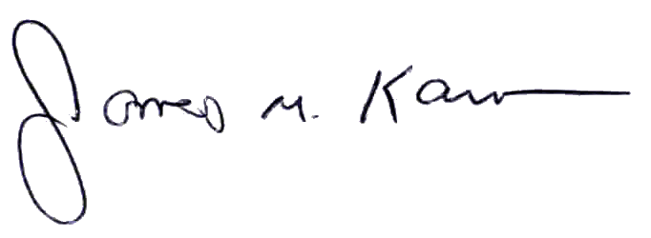

James M. Kasson
Special Agent in Charge
February 2003

