Harpers Ferry NHP News Release

Harpers Ferry National Historical Park
P.O. Box 65
Harpers Ferry, WV

304-535-6748 phone
304-535-6244 fax
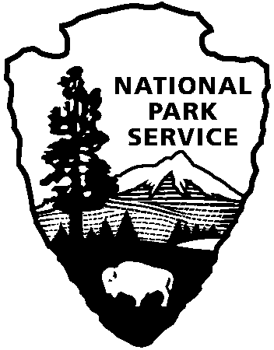
National Park Service
U.S. Department of the Interior

Release date:
Contact(s):
Phone number:
Date:
Release code:
America’s Picnic: Celebrating the Glorious Fourth

On Saturday June 30, Harpers Ferry National Historical Park invites visitors to experience America’s Picnic: Celebrating the Glorious Fourth. This special event showcases a Harpers Ferry of the past--an 1860 town decked out in patriotic finery to celebrate Independence Day. The year is 1860. Americans celebrated the nation’s birthday with picnics, band concerts, and patriotic speeches honoring the founding fathers and the glorious republic. Americans looked back to honor a century of progress with a new experiment called democracy in the brave new world. Looking ahead, Americans also wondered whether the country would still be united for next year’s celebration or if civil war would come to pass. References to the recent John Brown raid, his execution and the coming Presidential election will be topics that stir fervor and questions about the nation’s future.

Volunteers and staff in period clothing will help set this mid-century scene. Children are invited to enroll and march with the hometown defenders, the local militia. Families can enjoy a special ranger-guided walking tour America’s Picnic: Celebrating the Glorious Fourth. This living history presentation reveals famous July 4^{ths} from the town’s tumultuous history. A ranger-guided program and historic weapons demonstration called Life, Liberty, and the Pursuit of Happiness joins the town’s militia company as they bring to mind the purpose of the Declaration of Independence and defense of a young nation.

Visitors are invited to enjoy a brass band concert, Patriotism, Pride, and A Slice of Early America. Travel back in time and experience the relaxation and recreation of an 1860’s hometown band concert with the Wildcat Regiment Band of the 105th Pennsylvania Volunteer Infantry.

Immediately
Marsha B. Wassel
304-535-6748
June 25, 2007
xx-xx
Subject here

