B1 tunnel studies from April to September 2004

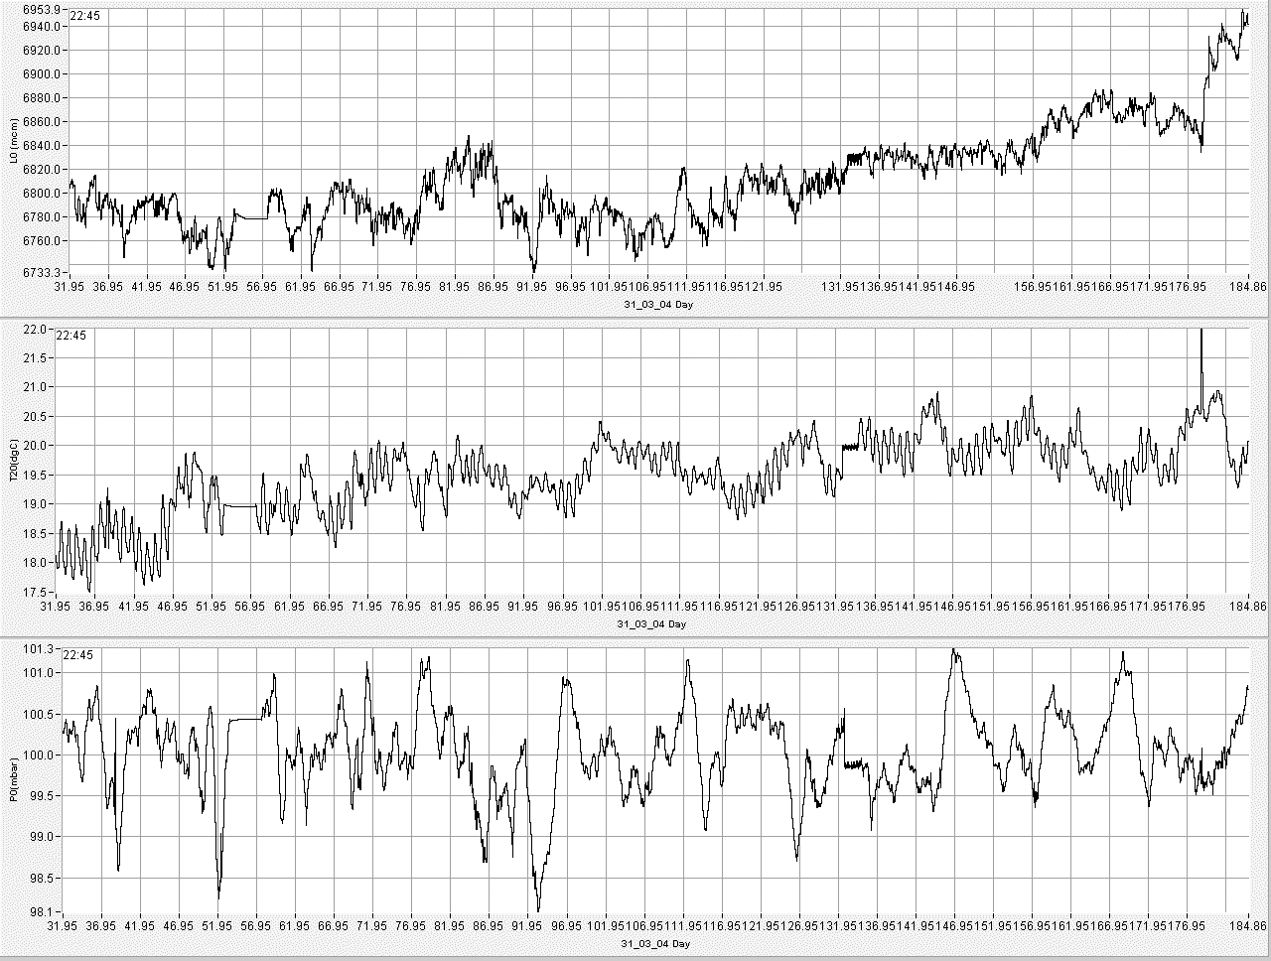
Level, Temperature ,Pressure
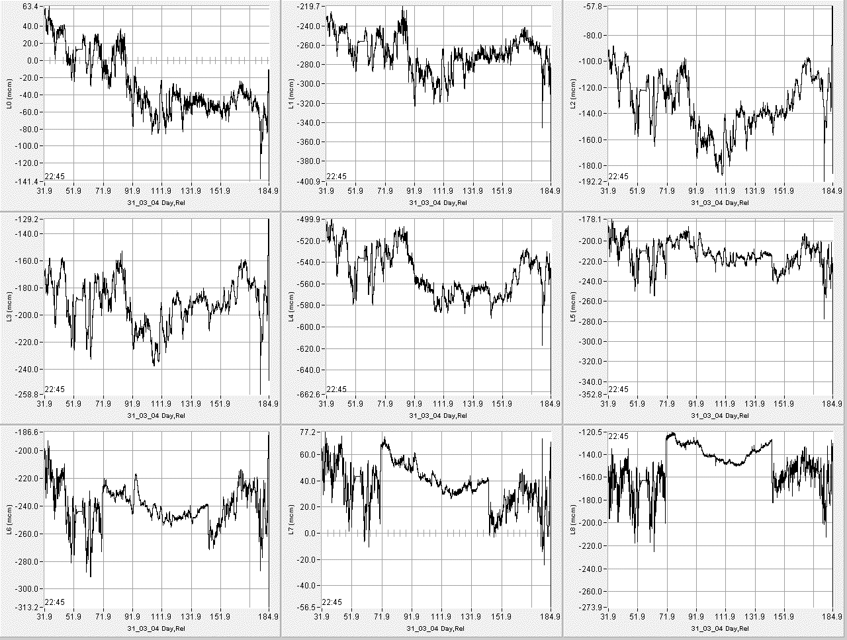
An example of relative levels
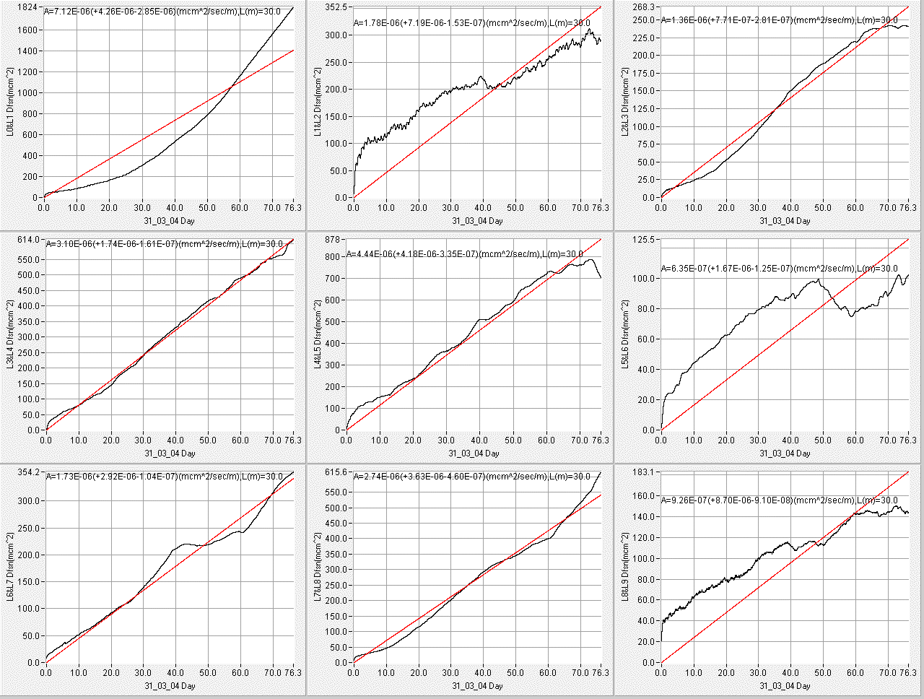
30 meters first diffusion example
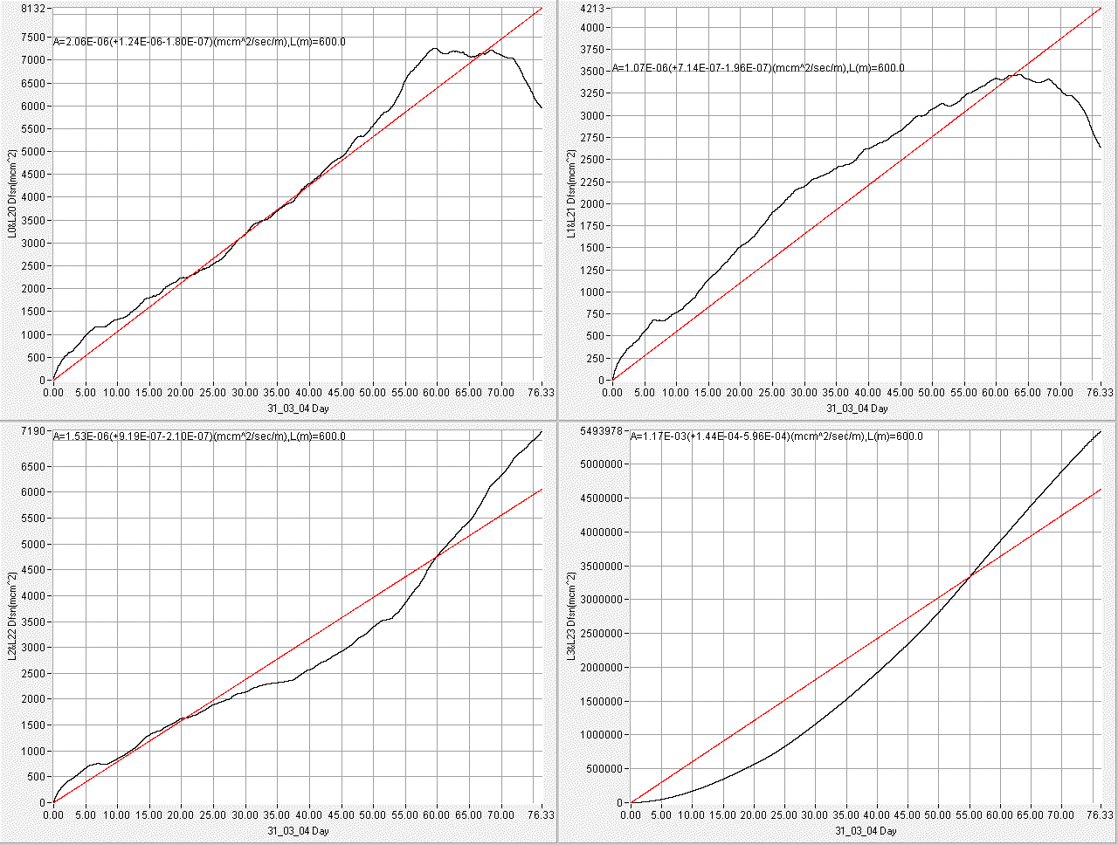
600 meters first diffusion example
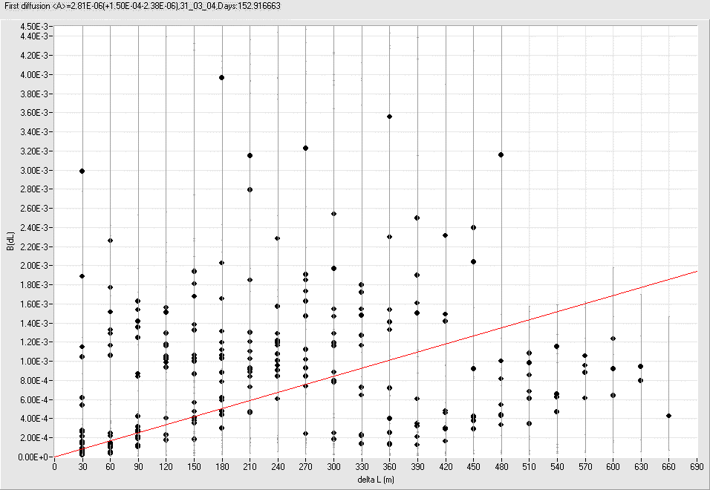
B(dL)
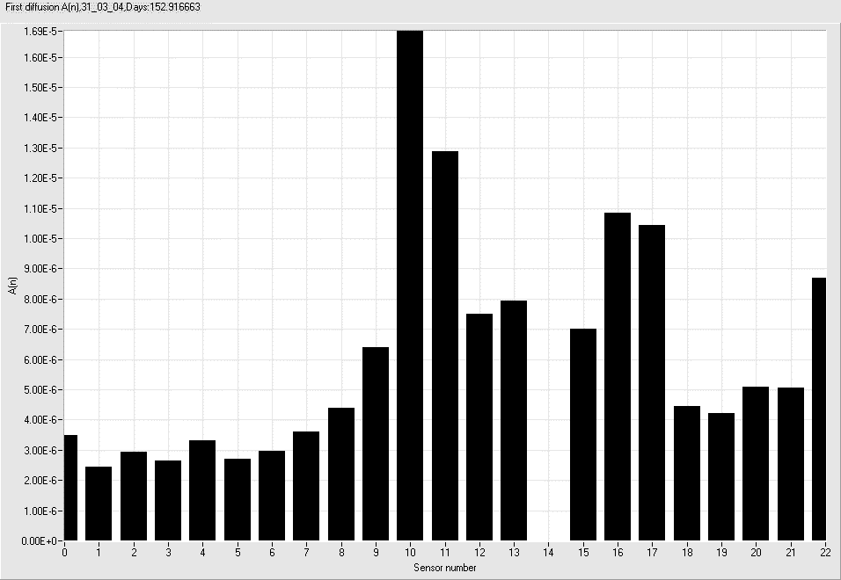
A from sensor number

Sensor 14 is off due to water level in this sensor is so big to reach the measure surface of sensor.

Sensors 10,11,15,16,22 has abnormal big diffusion. Visual study of water tube shows water lock in tubes between this sensors.
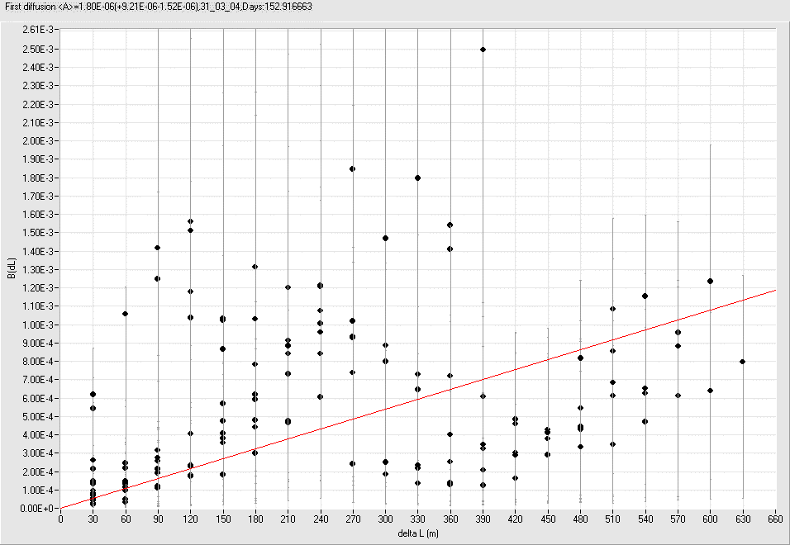
B(dL) without “bad” sensors

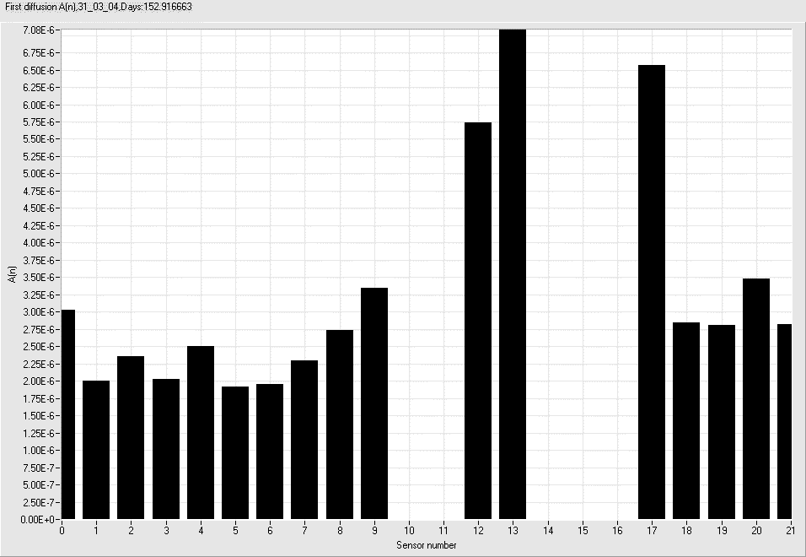
A from sensor number) without “bad” sensors

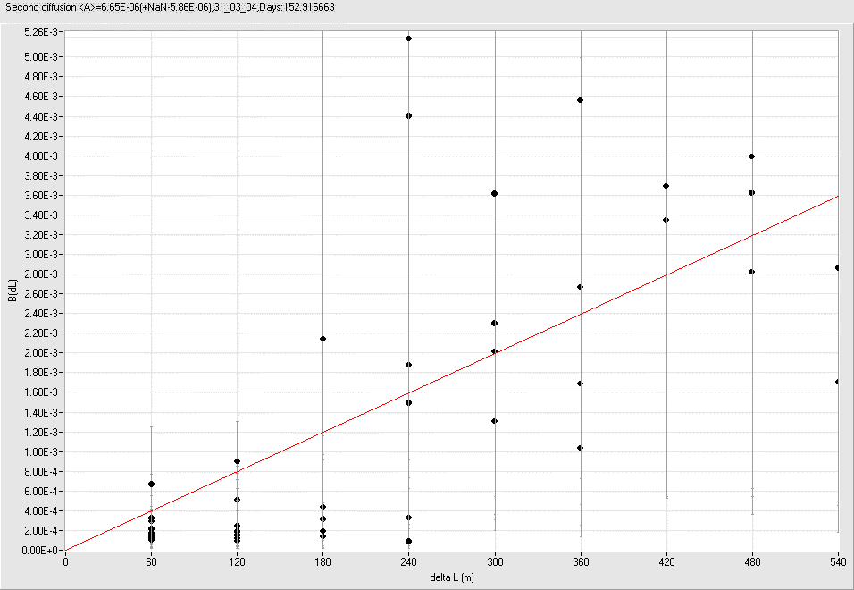

B(dL) without “bad” sensors for second diffusion
Some numerical data for diffusion

First Diffusion on 30 meters,Sensors: 0- 1 A=7.12E-06
First Diffusion on 30 meters,Sensors: 1- 2 A=1.78E-06
First Diffusion on 30 meters,Sensors: 2- 3 A=1.36E-06
First Diffusion on 30 meters,Sensors: 3- 4 A=3.10E-06
First Diffusion on 30 meters,Sensors: 4- 5 A=4.44E-06
First Diffusion on 30 meters,Sensors: 5- 6 A=6.35E-07
First Diffusion on 30 meters,Sensors: 6- 7 A=1.73E-06
First Diffusion on 30 meters,Sensors: 7- 8 A=2.74E-06
First Diffusion on 30 meters,Sensors: 8- 9 A=9.26E-07
First Diffusion on 30 meters,Sensors: 9-10 A=3.48E-05
First Diffusion on 30 meters,Sensors:10-11 A=9.95E-05
First Diffusion on 30 meters,Sensors:11-12 A=9.27E-06
First Diffusion on 30 meters,Sensors:12-13 A=1.80E-05
First Diffusion on 30 meters,Sensors:15-16 A=5.33E-06
First Diffusion on 30 meters,Sensors:16-17 A=6.29E-05
First Diffusion on 30 meters,Sensors:17-18 A=2.06E-05
First Diffusion on 30 meters,Sensors:18-19 A=2.33E-06
First Diffusion on 30 meters,Sensors:19-20 A=4.88E-06
First Diffusion on 30 meters,Sensors:20-21 A=8.65E-06
First Diffusion on 30 meters,Sensors:21-22 A=3.84E-05
mean A=1.64E-05

First Diffusion on 60 meters,Sensors: 0- 2 A=4.09E-06
First Diffusion on 60 meters,Sensors: 1- 3 A=7.74E-07
First Diffusion on 60 meters,Sensors: 2- 4 A=1.62E-06
First Diffusion on 60 meters,Sensors: 3- 5 A=2.22E-06
First Diffusion on 60 meters,Sensors: 4- 6 A=2.30E-06
First Diffusion on 60 meters,Sensors: 5- 7 A=5.03E-07
First Diffusion on 60 meters,Sensors: 6- 8 A=2.30E-06
First Diffusion on 60 meters,Sensors: 7- 9 A=1.91E-06
First Diffusion on 60 meters,Sensors: 8-10 A=1.77E-05
First Diffusion on 60 meters,Sensors: 9-11 A=2.95E-05
First Diffusion on 60 meters,Sensors:10-12 A=3.77E-05
First Diffusion on 60 meters,Sensors:11-13 A=2.14E-05
First Diffusion on 60 meters,Sensors:13-15 A=8.46E-07
First Diffusion on 60 meters,Sensors:15-17 A=2.21E-05
First Diffusion on 60 meters,Sensors:16-18 A=1.94E-05
First Diffusion on 60 meters,Sensors:17-19 A=1.76E-05
First Diffusion on 60 meters,Sensors:18-20 A=3.64E-06
First Diffusion on 60 meters,Sensors:19-21 A=2.44E-06
First Diffusion on 60 meters,Sensors:20-22 A=2.52E-05
mean A=1.12E-05

First Diffusion on 90 meters,Sensors: 0- 3 A=3.50E-06
First Diffusion on 90 meters,Sensors: 1- 4 A=1.27E-06
First Diffusion on 90 meters,Sensors: 2- 5 A=2.84E-06
First Diffusion on 90 meters,Sensors: 3- 6 A=1.36E-06
First Diffusion on 90 meters,Sensors: 4- 7 A=2.12E-06
First Diffusion on 90 meters,Sensors: 5- 8 A=1.20E-06
First Diffusion on 90 meters,Sensors: 6- 9 A=2.37E-06
First Diffusion on 90 meters,Sensors: 7-10 A=1.50E-05
First Diffusion on 90 meters,Sensors: 8-11 A=1.71E-05
First Diffusion on 90 meters,Sensors: 9-12 A=1.39E-05
First Diffusion on 90 meters,Sensors:10-13 A=1.81E-05
First Diffusion on 90 meters,Sensors:12-15 A=4.72E-06
First Diffusion on 90 meters,Sensors:13-16 A=1.10E-06
First Diffusion on 90 meters,Sensors:15-18 A=9.33E-06
First Diffusion on 90 meters,Sensors:16-19 A=1.51E-05
First Diffusion on 90 meters,Sensors:17-20 A=1.57E-05
First Diffusion on 90 meters,Sensors:18-21 A=3.06E-06
First Diffusion on 90 meters,Sensors:19-22 A=9.66E-06
mean A=7.63E-06

First Diffusion on 120 meters,Sensors: 0- 4 A=1.49E-06
First Diffusion on 120 meters,Sensors: 1- 5 A=1.45E-06
First Diffusion on 120 meters,Sensors: 2- 6 A=1.87E-06
First Diffusion on 120 meters,Sensors: 3- 7 A=1.96E-06
First Diffusion on 120 meters,Sensors: 4- 8 A=3.37E-06
First Diffusion on 120 meters,Sensors: 5- 9 A=1.42E-06
First Diffusion on 120 meters,Sensors: 6-10 A=1.26E-05
First Diffusion on 120 meters,Sensors: 7-11 A=1.08E-05
First Diffusion on 120 meters,Sensors: 8-12 A=8.64E-06
First Diffusion on 120 meters,Sensors: 9-13 A=9.81E-06
First Diffusion on 120 meters,Sensors:11-15 A=9.68E-06
First Diffusion on 120 meters,Sensors:12-16 A=7.79E-06
First Diffusion on 120 meters,Sensors:13-17 A=1.30E-05
First Diffusion on 120 meters,Sensors:15-19 A=8.79E-06
First Diffusion on 120 meters,Sensors:16-20 A=8.48E-06
First Diffusion on 120 meters,Sensors:17-21 A=1.26E-05
First Diffusion on 120 meters,Sensors:18-22 A=8.21E-06
mean A=7.17E-06
First Diffusion on 150 meters,Sensors: 0- 5 A=2.71E-06
First Diffusion on 150 meters,Sensors: 1- 6 A=1.21E-06
First Diffusion on 150 meters,Sensors: 2- 7 A=2.53E-06
First Diffusion on 150 meters,Sensors: 3- 8 A=2.36E-06
First Diffusion on 150 meters,Sensors: 4- 9 A=3.16E-06
First Diffusion on 150 meters,Sensors: 5-10 A=9.22E-06
First Diffusion on 150 meters,Sensors: 6-11 A=7.09E-06
First Diffusion on 150 meters,Sensors: 7-12 A=6.83E-06
First Diffusion on 150 meters,Sensors: 8-13 A=6.88E-06
First Diffusion on 150 meters,Sensors:10-15 A=1.21E-05
First Diffusion on 150 meters,Sensors:11-16 A=1.29E-05
First Diffusion on 150 meters,Sensors:12-17 A=3.79E-06
First Diffusion on 150 meters,Sensors:13-18 A=5.77E-06
First Diffusion on 150 meters,Sensors:15-20 A=6.66E-06
First Diffusion on 150 meters,Sensors:16-21 A=8.82E-06
First Diffusion on 150 meters,Sensors:17-22 A=1.12E-05
mean A=6.45E-06
First Diffusion on 180 meters,Sensors: 0- 6 A=2.44E-06
First Diffusion on 180 meters,Sensors: 1- 7 A=1.66E-06
First Diffusion on 180 meters,Sensors: 2- 8 A=3.28E-06
First Diffusion on 180 meters,Sensors: 3- 9 A=2.66E-06
First Diffusion on 180 meters,Sensors: 4-10 A=1.12E-05
First Diffusion on 180 meters,Sensors: 5-11 A=6.21E-06
First Diffusion on 180 meters,Sensors: 6-12 A=4.35E-06
First Diffusion on 180 meters,Sensors: 7-13 A=7.29E-06
First Diffusion on 180 meters,Sensors: 9-15 A=6.64E-06
First Diffusion on 180 meters,Sensors:10-16 A=9.20E-06
First Diffusion on 180 meters,Sensors:11-17 A=4.89E-06
First Diffusion on 180 meters,Sensors:12-18 A=3.44E-06
First Diffusion on 180 meters,Sensors:13-19 A=5.72E-06
First Diffusion on 180 meters,Sensors:15-21 A=5.89E-06
First Diffusion on 180 meters,Sensors:16-22 A=2.20E-05
mean A=6.46E-06
First Diffusion on 210 meters,Sensors: 0- 7 A=2.20E-06
First Diffusion on 210 meters,Sensors: 1- 8 A=2.26E-06
First Diffusion on 210 meters,Sensors: 2- 9 A=3.48E-06
First Diffusion on 210 meters,Sensors: 3-10 A=8.79E-06
First Diffusion on 210 meters,Sensors: 4-11 A=5.25E-06
First Diffusion on 210 meters,Sensors: 5-12 A=4.00E-06
First Diffusion on 210 meters,Sensors: 6-13 A=5.72E-06
First Diffusion on 210 meters,Sensors: 8-15 A=4.89E-06
First Diffusion on 210 meters,Sensors: 9-16 A=6.19E-06
First Diffusion on 210 meters,Sensors:10-17 A=1.33E-05
First Diffusion on 210 meters,Sensors:11-18 A=4.43E-06
First Diffusion on 210 meters,Sensors:12-19 A=4.34E-06
First Diffusion on 210 meters,Sensors:13-20 A=4.21E-06
First Diffusion on 210 meters,Sensors:15-22 A=1.50E-05
mean A=6.00E-06

First Diffusion on 240 meters,Sensors: 0- 8 A=3.51E-06
First Diffusion on 240 meters,Sensors: 1- 9 A=2.52E-06
First Diffusion on 240 meters,Sensors: 2-10 A=9.51E-06
First Diffusion on 240 meters,Sensors: 3-11 A=3.77E-06
First Diffusion on 240 meters,Sensors: 4-12 A=4.19E-06
First Diffusion on 240 meters,Sensors: 5-13 A=5.02E-06
First Diffusion on 240 meters,Sensors: 7-15 A=5.37E-06
First Diffusion on 240 meters,Sensors: 8-16 A=4.97E-06
First Diffusion on 240 meters,Sensors: 9-17 A=4.48E-06
First Diffusion on 240 meters,Sensors:10-18 A=6.55E-06
First Diffusion on 240 meters,Sensors:11-19 A=4.86E-06
First Diffusion on 240 meters,Sensors:12-20 A=5.06E-06
First Diffusion on 240 meters,Sensors:13-21 A=3.99E-06
mean A=4.91E-06
First Diffusion on 270 meters,Sensors: 0- 9 A=3.43E-06
First Diffusion on 270 meters,Sensors: 1-10 A=7.06E-06
First Diffusion on 270 meters,Sensors: 2-11 A=3.12E-06
First Diffusion on 270 meters,Sensors: 3-12 A=2.73E-06
First Diffusion on 270 meters,Sensors: 4-13 A=6.84E-06
First Diffusion on 270 meters,Sensors: 6-15 A=4.15E-06
First Diffusion on 270 meters,Sensors: 7-16 A=6.02E-06
First Diffusion on 270 meters,Sensors: 8-17 A=3.45E-06
First Diffusion on 270 meters,Sensors: 9-18 A=8.89E-07
First Diffusion on 270 meters,Sensors:10-19 A=5.45E-06
First Diffusion on 270 meters,Sensors:11-20 A=6.42E-06
First Diffusion on 270 meters,Sensors:12-21 A=3.77E-06
First Diffusion on 270 meters,Sensors:13-22 A=1.19E-05
mean A=5.02E-06

First Diffusion on 300 meters,Sensors: 0-10 A=8.46E-06
First Diffusion on 300 meters,Sensors: 1-11 A=2.61E-06
First Diffusion on 300 meters,Sensors: 2-12 A=2.66E-06
First Diffusion on 300 meters,Sensors: 3-13 A=4.89E-06
First Diffusion on 300 meters,Sensors: 5-15 A=3.87E-06
First Diffusion on 300 meters,Sensors: 6-16 A=5.15E-06
First Diffusion on 300 meters,Sensors: 7-17 A=2.96E-06
First Diffusion on 300 meters,Sensors: 8-18 A=6.13E-07
First Diffusion on 300 meters,Sensors: 9-19 A=8.31E-07
First Diffusion on 300 meters,Sensors:10-20 A=4.30E-06
First Diffusion on 300 meters,Sensors:11-21 A=3.98E-06
First Diffusion on 300 meters,Sensors:12-22 A=6.56E-06
mean A=3.91E-06
First Diffusion on 330 meters,Sensors: 0-11 A=3.52E-06
First Diffusion on 330 meters,Sensors: 1-12 A=2.20E-06
First Diffusion on 330 meters,Sensors: 2-13 A=5.44E-06
First Diffusion on 330 meters,Sensors: 4-15 A=5.21E-06
First Diffusion on 330 meters,Sensors: 5-16 A=4.68E-06
First Diffusion on 330 meters,Sensors: 6-17 A=1.96E-06
First Diffusion on 330 meters,Sensors: 7-18 A=4.09E-07
First Diffusion on 330 meters,Sensors: 8-19 A=6.60E-07
First Diffusion on 330 meters,Sensors: 9-20 A=7.12E-07
First Diffusion on 330 meters,Sensors:10-21 A=3.84E-06
First Diffusion on 330 meters,Sensors:11-22 A=4.48E-06
mean A=3.01E-06

First Diffusion on 360 meters,Sensors: 0-12 A=3.91E-06
First Diffusion on 360 meters,Sensors: 1-13 A=4.28E-06
First Diffusion on 360 meters,Sensors: 3-15 A=3.69E-06
First Diffusion on 360 meters,Sensors: 4-16 A=6.39E-06
First Diffusion on 360 meters,Sensors: 5-17 A=2.00E-06
First Diffusion on 360 meters,Sensors: 6-18 A=3.79E-07
First Diffusion on 360 meters,Sensors: 7-19 A=3.48E-07
First Diffusion on 360 meters,Sensors: 8-20 A=6.97E-07
First Diffusion on 360 meters,Sensors: 9-21 A=1.11E-06
First Diffusion on 360 meters,Sensors:10-22 A=9.87E-06
mean A=3.27E-06
First Diffusion on 390 meters,Sensors: 0-13 A=6.40E-06
First Diffusion on 390 meters,Sensors: 2-15 A=4.12E-06
First Diffusion on 390 meters,Sensors: 3-16 A=4.87E-06
First Diffusion on 390 meters,Sensors: 4-17 A=1.55E-06
First Diffusion on 390 meters,Sensors: 5-18 A=3.18E-07
First Diffusion on 390 meters,Sensors: 6-19 A=5.33E-07
First Diffusion on 390 meters,Sensors: 7-20 A=8.29E-07
First Diffusion on 390 meters,Sensors: 8-21 A=8.91E-07
First Diffusion on 390 meters,Sensors: 9-22 A=3.85E-06
mean A=2.60E-06
First Diffusion on 420 meters,Sensors: 1-15 A=3.38E-06
First Diffusion on 420 meters,Sensors: 2-16 A=5.51E-06
First Diffusion on 420 meters,Sensors: 3-17 A=1.09E-06
First Diffusion on 420 meters,Sensors: 4-18 A=7.18E-07
First Diffusion on 420 meters,Sensors: 5-19 A=3.84E-07
First Diffusion on 420 meters,Sensors: 6-20 A=1.15E-06
First Diffusion on 420 meters,Sensors: 7-21 A=6.82E-07
First Diffusion on 420 meters,Sensors: 8-22 A=3.55E-06
mean A=2.06E-06

First Diffusion on 450 meters,Sensors: 0-15 A=5.33E-06
First Diffusion on 450 meters,Sensors: 1-16 A=4.53E-06
First Diffusion on 450 meters,Sensors: 2-17 A=9.51E-07
First Diffusion on 450 meters,Sensors: 3-18 A=6.45E-07
First Diffusion on 450 meters,Sensors: 4-19 A=8.40E-07
First Diffusion on 450 meters,Sensors: 5-20 A=9.11E-07
First Diffusion on 450 meters,Sensors: 6-21 A=9.14E-07
First Diffusion on 450 meters,Sensors: 7-22 A=2.04E-06
mean A=2.02E-06
First Diffusion on 480 meters,Sensors: 0-16 A=6.57E-06
First Diffusion on 480 meters,Sensors: 1-17 A=1.13E-06
First Diffusion on 480 meters,Sensors: 2-18 A=8.96E-07
First Diffusion on 480 meters,Sensors: 3-19 A=9.23E-07
First Diffusion on 480 meters,Sensors: 4-20 A=1.70E-06
First Diffusion on 480 meters,Sensors: 5-21 A=6.94E-07
First Diffusion on 480 meters,Sensors: 6-22 A=2.08E-06
mean A=2.00E-06
First Diffusion on 510 meters,Sensors: 0-17 A=2.13E-06
First Diffusion on 510 meters,Sensors: 1-18 A=6.78E-07
First Diffusion on 510 meters,Sensors: 2-19 A=1.20E-06
First Diffusion on 510 meters,Sensors: 3-20 A=1.68E-06
First Diffusion on 510 meters,Sensors: 4-21 A=1.34E-06
First Diffusion on 510 meters,Sensors: 5-22 A=1.93E-06
mean A=1.49E-06
First Diffusion on 540 meters,Sensors: 0-18 A=1.16E-06
First Diffusion on 540 meters,Sensors: 1-19 A=8.69E-07
First Diffusion on 540 meters,Sensors: 2-20 A=2.13E-06
First Diffusion on 540 meters,Sensors: 3-21 A=1.21E-06
First Diffusion on 540 meters,Sensors: 4-22 A=1.22E-06
mean A=1.32E-06
First Diffusion on 570 meters,Sensors: 0-19 A=1.07E-06
First Diffusion on 570 meters,Sensors: 1-20 A=1.67E-06
First Diffusion on 570 meters,Sensors: 2-21 A=1.54E-06
First Diffusion on 570 meters,Sensors: 3-22 A=1.85E-06
mean A=1.54E-06
First Diffusion on 600 meters,Sensors: 0-20 A=2.06E-06
First Diffusion on 600 meters,Sensors: 1-21 A=1.07E-06
First Diffusion on 600 meters,Sensors: 2-22 A=1.53E-06
mean A=1.55E-06
First Diffusion on 630 meters,Sensors: 0-21 A=1.26E-06
First Diffusion on 630 meters,Sensors: 1-22 A=1.50E-06
mean A=1.38E-06
First Diffusion on 660 meters,Sensors: 0-22 A=6.45E-07
mean A=6.45E-07

First Diffusion mean A=6.18E-06

If excluding sensors 10,11,15,16,22:

First Diffusion mean A=3.27E-06

First Diffusion on 30 meters, mean A=5.60E-06
First Diffusion on 60 meters, mean A=3.58E-06
First Diffusion on 90 meters, mean A=4.73E-06
First Diffusion on 120 meters, mean A=5.56E-06
First Diffusion on 150 meters, mean A=3.92E-06
First Diffusion on 180 meters, mean A=3.86E-06
First Diffusion on 210 meters, mean A=3.74E-06
First Diffusion on 240 meters, mean A=4.11E-06
First Diffusion on 270 meters, mean A=3.52E-06
First Diffusion on 300 meters, mean A=2.39E-06
First Diffusion on 330 meters, mean A=1.90E-06
First Diffusion on 360 meters, mean A=1.82E-06
First Diffusion on 390 meters, mean A=1.75E-06
First Diffusion on 420 meters, mean A=8.06E-07
First Diffusion on 450 meters, mean A=8.52E-07
First Diffusion on 480 meters, mean A=1.07E-06
First Diffusion on 510 meters, mean A=1.40E-06
First Diffusion on 540 meters, mean A=1.34E-06
First Diffusion on 570 meters, mean A=1.43E-06
First Diffusion on 600 meters, mean A=1.56E-06
First Diffusion on 630 meters, A=1.26E-06

Second diffusing (excluding sensors 10,11,15,16,22):

Second Diffusion mean A=5.48E-06

Second Diffusion on 60 meters,Sensors: 0- 1- 2 A=4.81E-06
Second Diffusion on 60 meters,Sensors: 1- 2- 3 A=2.37E-06
Second Diffusion on 60 meters,Sensors: 2- 3- 4 A=2.84E-06
Second Diffusion on 60 meters,Sensors: 3- 4- 5 A=5.33E-06
Second Diffusion on 60 meters,Sensors: 4- 5- 6 A=2.77E-06
Second Diffusion on 60 meters,Sensors: 5- 6- 7 A=1.86E-06
Second Diffusion on 60 meters,Sensors: 6- 7- 8 A=2.16E-06
Second Diffusion on 60 meters,Sensors: 7- 8- 9 A=1.75E-06
Second Diffusion on 60 meters,Sensors:17-18-19 A=5.35E-06
Second Diffusion on 60 meters,Sensors:18-19-20 A=3.57E-06
Second Diffusion on 60 meters,Sensors:19-20-21 A=1.11E-05
mean A=3.99E-06
Second Diffusion on 120 meters,Sensors: 0- 2- 4 A=4.22E-06
Second Diffusion on 120 meters,Sensors: 1- 3- 5 A=1.55E-06
Second Diffusion on 120 meters,Sensors: 2- 4- 6 A=2.06E-06
Second Diffusion on 120 meters,Sensors: 3- 5- 7 A=7.65E-07
Second Diffusion on 120 meters,Sensors: 4- 6- 8 A=1.23E-06
Second Diffusion on 120 meters,Sensors: 5- 7- 9 A=9.92E-07
Second Diffusion on 120 meters,Sensors:17-19-21 A=7.46E-06
mean A=2.61E-06
Second Diffusion on 180 meters,Sensors: 0- 3- 6 A=2.41E-06
Second Diffusion on 180 meters,Sensors: 1- 4- 7 A=1.74E-06
Second Diffusion on 180 meters,Sensors: 2- 5- 8 A=7.53E-07
Second Diffusion on 180 meters,Sensors: 3- 6- 9 A=1.06E-06
Second Diffusion on 180 meters,Sensors: 6- 9-12 A=1.19E-05
mean A=3.57E-06
Second Diffusion on 240 meters,Sensors: 0- 4- 8 A=1.36E-06
Second Diffusion on 240 meters,Sensors: 1- 5- 9 A=3.53E-07
Second Diffusion on 240 meters,Sensors: 4- 8-12 A=7.82E-06
Second Diffusion on 240 meters,Sensors: 5- 9-13 A=6.21E-06
Second Diffusion on 240 meters,Sensors: 9-13-17 A=1.83E-05
Second Diffusion on 240 meters,Sensors:13-17-21 A=2.16E-05
mean A=9.28E-06
Second Diffusion on 300 meters,Sensors: 2- 7-12 A=6.70E-06
Second Diffusion on 300 meters,Sensors: 3- 8-13 A=4.35E-06
Second Diffusion on 300 meters,Sensors: 7-12-17 A=7.66E-06
Second Diffusion on 300 meters,Sensors: 8-13-18 A=1.20E-05
mean A=7.69E-06
Second Diffusion on 360 meters,Sensors: 0- 6-12 A=2.87E-06
Second Diffusion on 360 meters,Sensors: 1- 7-13 A=4.68E-06
Second Diffusion on 360 meters,Sensors: 6-12-18 A=7.41E-06
Second Diffusion on 360 meters,Sensors: 7-13-19 A=1.27E-05
mean A=6.91E-06
Second Diffusion on 420 meters,Sensors: 5-12-19 A=7.96E-06
Second Diffusion on 420 meters,Sensors: 6-13-20 A=8.78E-06
mean A=8.37E-06
Second Diffusion on 480 meters,Sensors: 1- 9-17 A=5.87E-06
Second Diffusion on 480 meters,Sensors: 4-12-20 A=7.55E-06
Second Diffusion on 480 meters,Sensors: 5-13-21 A=8.31E-06
mean A=7.24E-06
Second Diffusion on 540 meters,Sensors: 0- 9-18 A=3.16E-06
Second Diffusion on 540 meters,Sensors: 3-12-21 A=5.30E-06
mean A=4.23E-06

Second Diffusion mean A=5.48E-06

