Department of the Interior
U.S. Geological Survey

USGS LDCM
Ground Network Element (GNE)
Requirements Document

Version Draft

04-29-2008



EROS
Sioux Falls, South Dakota

1 Introduction 5
1.1 Purpose 5
1.2 Scope 5
1.3 Function 5
2 Reference Documents 7
3 Requirements 8
3.1 General 8
3.1.1 GNE Information System Security 8
3.1.2 Institutional 10
3.2 LGN Station 10
3.2.1 General 10
3.2.2 Antenna 12
3.2.3 S-Band Equipment 14
3.2.4 X-Band Equipment 17
3.2.5 Ground Station Control (GSC) 18
3.3 Scheduling and Reporting System (SRS) 20
3.4 Data Collection and Routing Subsystem (DCRS) 22
3.4.1 DCRS General 22
3.4.2 DCRS File Routing 22
3.4.3 DCRS Interval Routing 22
3.5 Network 24
3.5.1 General 24
3.5.2 Mission Data Return Connection 24
3.5.3 Telemetry and Command Connection 25
3.5.4 Scheduling and Reporting Connection 25
3.6 Interfaces 25
3.6.1 External GNE Interfaces 25
4 Appendix A: Allocations 29
5 Appendix B: Traceability Matrix 30
6 Appendix C: Verification Matrix 33
7 Appendix D: Priority Matrix 36
8 Appendix E: Acronyms 39

Introduction

Purpose

Scope

This document establishes the Requirements for the Ground Network Element (GNE) broken down into the operational subsystems as described in the GNE Operational Concepts Document.

Function

Figure 1-1 illustrates a segment level diagram of the LDCM System. The GNE is the focus of this document and is circled in red in the diagram.
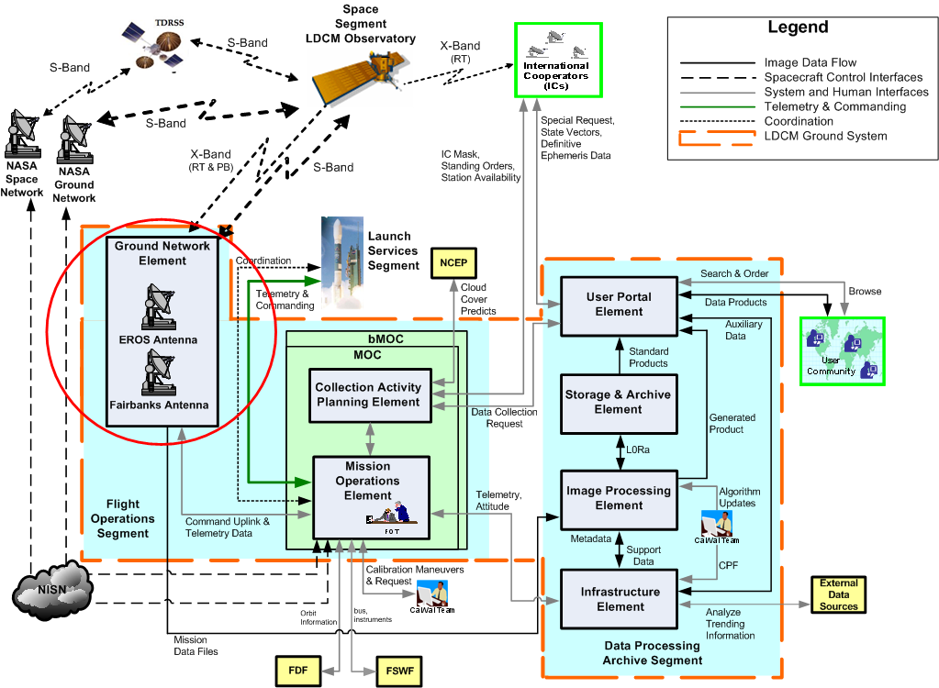

Figure 1-1 LDCM Segment Diagram Focusing on the Ground Network Element

Figure 1-2 Illustrates the element level functional diagram of the GNE.

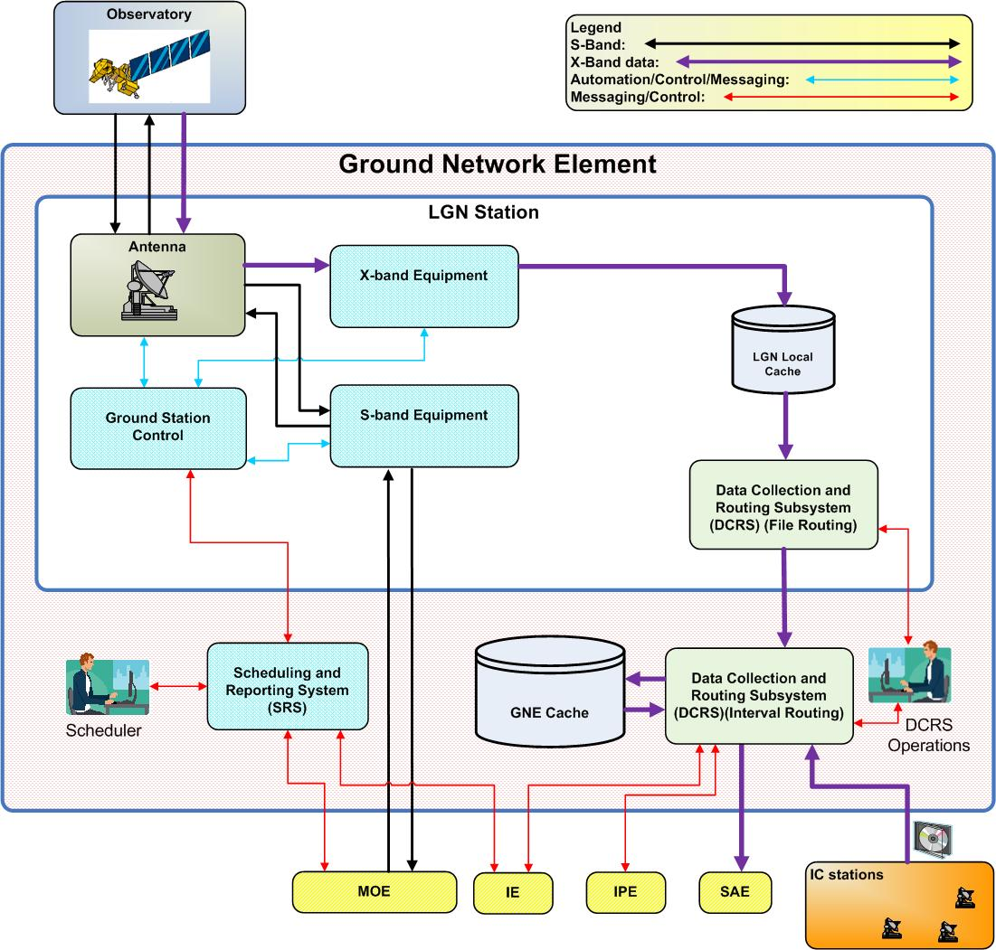

Figure 1-2 GNE Functional Architecture

Reference Documents

Landsat Data Continuity Mission (LDCM) Ground System Requirements Document

Landsat Data Continuity Mission (LDCM) Ground System Requirements Document

Mission Operations Element Requirements Document (MOERD)

Landsat Data Continuity Mission (LDCM) Ground System Operations Concept Document

Ground Network Element (GNE) Operations Concept

Observatory Interface Requirements Document (OIRD)

CCSDS 727.0-B-4 CCSDS File Delivery Protocol Blue Book

Requirements

General

GNE474: The GNE shall deliver at least 99% of the mission data acquired by the LGN to the science data archive, measured on a quarterly basis.
Rationale: Supporting the delivery of science data to the archive. In supporting the parent requirement the GNE has an allocation of 0.6% which will be broken out in an appendix.

GNE28: The GNE shall provide at least 100 minutes per day of X-Band contact time with the Observatory.
Rationale: This contact time is required in order to provide sufficient contact time to downlink all science data. Derived assuming a downlink rate of twice the realtime acquisition rate. (400 scenes * 23.92 s/scene / 2 channels / 60 s/min * 16 days/cycle * 1.25) The 125% factor provides for calibration data and capacity to catchup a backlog situation.

GNE Information System Security

GNE587: The GNE shall provide network connectivity in compliance with the LDCM IT security policy.
Rationale: The GNE will abide by IT security policy when applicable. Certain circumstances may exist where waivers may be required (current Landsat configurations require waivers).

GNE654: The GNE shall employ automated mechanisms to support the management of information system accounts.
Rationale: This requirement supports the GSRD requirement and the NIST 800-53. The requirement would include the deletion of temporary and emergency accounts along with automated deletion of inactive accounts.

GNE655: The GNE shall employ automated account management notification of information systems.
Rationale: This requirement supports the GSRD requirement and the NIST 800-53. Ensures the GNE employs automated mechanisms to ensure account creation, modification, disabling, and termination actions are audited and the appropriate individuals are notified.

GNE656: The GNE shall enforce assigned authorizations to control access to GNE assets.
Rationale: This requirement supports the GSRD requirement and the NIST 800-53. The IS enforces the assigned authorizations for controlling access to systems in accordance in accordance with applicable policies.

GNE657: The GNE shall restrict IS security functions to authorized users.
Rationale: This requirement supports the GSRD requirement and the NIST 800-53. The IS restricts access to security functions and security relevant information to explicitly authorized personnel.

GNE658: The GNE shall employ information flow enforcement for all computer systems.
Rationale: This requirement supports the GSRD requirement and the NIST 800-53. The information system enforces assigned authorizations for controlling the flow of information between interconnected systems in accordance with local security policies.

GNE659: The GNE shall utilize the Least Privilege system for information security on all computer systems.
Rationale: This requirement supports the GSRD requirement and the NIST 800-53. This IT system enforces the most restrictive set of rights/privileges/accesses for all users to perform their specific tasks.

GNE660: The GNE shall employ automated monitoring/control of all remote access IT functions.
Rationale: This requirement supports the GSRD requirement and the NIST 800-53.

GNE661: The GNE shall utilize cryptography protection for remote access sessions.
Rationale: This requirement supports the GSRD requirement and the NIST 800-53. The GNE will utilize cryptography to protect the confidentiality and integrity of remote access sessions.

GNE662: The GNE shall restrict wireless access to all GNE assets.
Rationale: This requirement supports the GSRD requirement and the NIST 800-53. The GNE will establish usage restrictions and implement guidance for wireless technologies.

GNE671: The GNE shall control network communications at the external boundaries of its information systems.
Rationale: This requirement supports the GSRD requirement and the NIST 800-53. This includes protection from denial of service attacks and putting publicly accessible systems on separate sub networks. The boundary protection will use a managed interface.

GNE673: The GNE shall deny network traffic by default and allow network traffic by exception.
Rationale: This requirement supports the GSRD requirement and the NIST 800-53. This also includes the release of connections at the end of active sessions.

GNE672: The GNE shall provide information system transmission integrity.
Rationale: This requirement supports the GSRD requirement and the NIST 800-53. This requirement means the GNE will employ information system tools and rules that protect the integrity of outgoing transmissions and provide confidentiality to the transmitter.

GNE674: The GNE shall provide mechanisms to protect the authenticity of communication sessions.
Rationale: This requirement supports the GSRD requirement and the NIST 800-53. This includes not allowing mobile code and having policies for public key support. This also would restrict any type of collaborative computing on the critical networks such as video conferencing on the telemetry return networks.

GNE675: The GNE shall provide mechanisms to centrally manage virus protection tools.
Rationale: This requirement supports the GSRD requirement and the NIST 800-53. The mechanisms can be policies for the use of virus protection tools and protection from malicious code. The mechanisms will also provide for flaw remediating.

Institutional

GNE651: The GNE shall be implemented such that the EROS facility will be automated for 72 hours at a minimum.
Rationale: This supports the parent GSRD requirement for creating EROS to support the 8x5 shifting approach

GNE652: The GNE shall be implemented to support a 10 year mission life or longer.
Rationale: The GS is responsible for supporting the 10 year mission life of the LDCM mission at a minimum and this is a general GNE translation.

GNE293: The GNE shall provide physical security for USGS assets in accordance with NIST SP 800-53 and all relevant annexes.
Rationale: USGS institutional requirement.

LGN Station

General

GNE209: All LGN stations shall have the ability to be scheduled within 15 minutes if the station will be in view of the S/C in the event that the FOT declares a S/C Emergency.
Rationale: In support of rapid response to spacecraft emergencies. Fifteen minutes is consistent with SN and GN performance. The requirement is for space craft emergencies and does not affect the availability of the station in subsequent requirements. The requirement is for S-Band receive and commanding services only as typically in a S/C emergency there is no imaging.

GNE639: All LGN stations shall have an availability of at least 97% (TBR) measured on a monthly basis.
Rationale: This equates to a 24 hour outage over a month. There is sufficient LGN contact time margin to accommodate a 24 hour ground station outage. With multiple apertures available at the polar station,
24 hours allows time to switch to a backup aperture. This also contributes to the 99.9% GS availability requirement in the GSRD 165 for critical command functions.

GNE44: All LGN Stations shall receive real-time S-band telemetry from the Observatory.
Rationale: GS662 Support for receiving the S-Band telemetry downlink from the observatory. The reception and transmission of S-Band data are requirements to be considered an LGN station.

GNE210: All LGN stations shall exchange telemetry and command data with the Observatory as specified in the Space to Ground ICD (Add Document Number).
Rationale: This interface is required for telemetry, commanding and science data to flow through GNE. The space to ground ICD shall be provided by the Bus vendor.

GNE311: All LGN Stations shall be configurable in an International Cooperator (IC) Earth Station mode of operation (TBC).
Rationale: The current Landsat 7 LGN includes an IC station operating in this mode. This requirement will support testing of the IC functionality of the Bus.

GNE262: All LGN Stations shall transmit command uplink data from MOE to the Observatory in real time.
Rationale: The parent requirement in GSRD specifies within 1 second time which is a cost driver for measurement.

GNE263: All LGN Stations shall transmit command uplink data from bMOE to the Observatory in real time.
Rationale: The parent requirement in GSRD specifies within 1 second time which is a cost driver for measurement.

GNE94: All LGN stations shall provide real time S-band telemetry data to two MOE facilities simultaneously.
Rationale: Test requirement and support for IOC operations and MOE facility change over.

GNE237: All LGN stations shall provide S-Band services while simultaneously retransmitting previously received stored telemetry from a prior pass to the MOE.
Rationale: This interface is required for telemetry, commanding and science data to flow through GNE.

GNE235: All LGN stations shall initiate the retransmission of stored telemetry data to the MOE within 1 hour of receiving the retransmission request from the FOT.
Rationale: This allows manual retransmission of stored telemetry data.

GNE253: All LGN stations shall accept RF output from the RF suitcase test equipment.
Rationale: The GNE is required to support GRT testing and RF Compatibility testing prior to launch. In support of the mission level I&T plan.

GNE250: All LGN stations shall generate timestamps with an accuracy of 100 microsecond or better.
Rationale: Clock calibration onboard the observatory is supported through the accuracy of GNE time tagging of realtime telemetry data.

Antenna

General

GNE480: The antenna shall program track the Observatory.
Rationale: LGN ground stations must generate pointing angles, the MOE will not provide these data. Program track is defined as tracking the observatory utilizing the acquisition data IIRV to build a computed track path of the observatory. Program tracking does not utilize the signal from the Observatory for tracking but should allow the reception and transmission of S-Band successfully while program tracking.

GNE481: The antenna shall utilize acquisition data IIRV for positioning and program tracking.
Rationale: Compatibility with present practice and LDCM MOE operations concept (IIRV). TLE is a contingency-mode format.

GNE513: The antenna shall perform configurable automatic signal tracking (auto-track).
Rationale: Without automatic signal tracking the reception of the X-Band signal would not be efficient.

GNE482: The antenna shall autonomously switch between program and autotrack modes of operation.
Rationale: The antenna shall have a preference for autotracking X-Band signals. The autonomous switch over is required for the antenna to begin to program track then switch to autotrack when the signal strength is high enough to provide reliable data reception. The autonomous switching will be for both directions to and from program track and autotrack.

GNE483: The antenna shall receive X-band data and S-band data concurrently while sending S-band data.
Rationale: Matches the performance specification for the observatory.

GNE532: The antenna shall provide real time status to the GSC.
Rationale: In support of GNE operations and maintenance staff troubleshooting and GNE to MOE interface agreement.

X-Band Characteristics

GNE514: The antenna shall perform automatic signal tracking using the X-Band signal.
Rationale: The rationale for this link is due to receiving X-Band data it requires automatic signal tracking to accomplish the task. Without autotrack X-Band data would not be reliably received.

GNE493: The antenna shall be capable of simultaneously receiving two X-band signals.
Rationale: Limited to two carriers to limit ground station expense - 2 carriers is sufficient for all reasonably conceivable communications architectures. Requirement changed from 3 carriers to two to match bus vendor RFO

GNE491: The antenna shall have an X-band G/T of at least 31 dB/K at 5 degrees elevation clear sky.
Rationale: Compatible with heritage 10 m LGN antennas supporting a reasonable link margin. The requirement does not intend to include any radome effects. With or without a radome the required specification must be achieved.

GNE511: The antenna shall receive the transmission of X-Band spectrally overlapping channels separated by polarization (TBD) from the Observatory.
Rationale: Dual-polarization downlinks may be required to achieve the overall data throughput requirements depending on the modulations and other design choices made by the bus vendors.

GNE489: The antenna shall provide X-Band axial ratio of 1.5 dB (TBD) or better.
Rationale: Required axial ratio supports the required 28 dB of isolation between the dual polarization. The 1.5 dB requirement is listed in the Bus IRD. The requirement does not intend to include any radome effects. With or without a radome the required specification of 1.5 dB axial ratio or better must be achieved.

GNE512: The antenna shall support selectable LHC and RHC polarization on each X-band downlink channel (TBR).
Rationale: These represent the only two polarization reasonable for the LDCM S-band link.

S-Band Characteristics

GNE494: The antenna shall transmit S-band command uplink to the Observatory compliant with the space to ground ICD ( add ICD number).
Rationale: Compatibility with observatory RD stated capability.

GNE495: The antenna shall transmit S-band LHCP or RHCP signals (TBR).
Rationale: This represents the transmit requirement from the GSRD. Currently the transmit polarization is not known, so making requirement cover both.

GNE519: The antenna shall support the S-Band transmit frequency range of 2025 MHz to 2108 MHz (TBR).
Rationale: This represents the entire spectrum allocation for Earth Science missions for telemetry uplink.

GNE520: The antenna shall support the S-Band receive frequency range of 2200 MHz to 2290 MHz (TBR).
Rationale: This represents the entire spectrum allocation for Earth Science missions for telemetry downlink.

GNE496: The antenna shall have an S-Band uplink with a minimum EIRP of 54 dBW.
Rationale: Compatible with heritage 9 m LGN antennas supporting a reasonable link margin. The requirement does not intend to include any radome effects. With or without a radome the required specification must be achieved.

GNE497: The antenna shall have an S-band G/T of at least 20 dB/K at 5 degrees elevation clear sky.
Rationale: Compatible with heritage 9 m LGN antennas supporting a reasonable link margin. The requirement does not intend to include any radome effects. With or without a radome the required specification must be achieved.

S-Band Equipment

GNE72: The S-Band equipment shall receive S-Band RF signals from the antenna.
Rationale: Interface requirement so the S-Band equipment interfaces to the antenna system in case of multiple vendors. Duplicated in interface section.

GNE492: The S-Band equipment shall support selectable BPSK S-band modulation formats consistent with CCSDS 401.0-B (TBC).
Rationale: BPSK modulation is robust, widely adopted and sufficient for the LDCM S-band requirements.

GNE73: The S-Band receive equipment shall receive real time S-Band telemetry at 2 Kbps, 16 Kbps and 32 Kbps (TBR).
Rationale: This maximum rate was chosen as a worst case for what is required to downlink the stored telemetry data assuming the highest rate in GS546 was also used as the stored telemetry generation rate.

GNE641: The S-Band receive equipment shall receive the S-Band stored telemetry data at 1 Mbps aggregate (TBR).
Rationale: This requirement supports the playback and realtime aggregate rates from the observatory.

GNE74: The S-Band transmit equipment shall support command data rates of 1 Kbps and 32 Kbps (TBR).
Rationale: This range of standard rates goes from the low-rate tumbling TDRSS case all the way up to a maximum which supports a large stored command load in a single LGN contact.

GNE294: The S-Band transmit equipment shall support a configurable sweep of the command uplink at a rate of 5 KHz - 35 KHz/second (TBR).
Rationale: The uplink sweep supports proper negotiation of the space to ground communications and is typically considered standard practice on the Landsat missions.

GNE75: The S-Band transmit equipment shall support a configurable sweep of the command uplink of up to +/- 160 KHz about the center frequency.
Rationale: The uplink sweep supports proper negotiation of the space to ground communications and is typically considered standard practice on the Landsat missions.

GNE76: The S-Band transmit equipment shall produce a decaying sweep of the command uplink signal.
Rationale: GS662 Support for decaying the uplink to allow the observatory to synchronize with the ground station prior to turning on modulation for proper signal acquisition by the observatory. Decaying sweep is defined as returning the swept uplink carrier signal back to the center frequency at a controlled rate so the Observatory does not lose lock on the ground station uplink signal.

GNE77: The S-Band transmit equipment shall BPSK modulate the S-Band command uplink (TBR) complaint with the space to ground ICD (ICD #).
Rationale: GSRD GS550 requires BPSK modulation. BPSK modulation is robust, widely adopted and sufficient for the LDCM S-band requirements.

GNE78: The S-Band receive equipment shall BPSK or QPSK (TBR) demodulate signals from the S-Band received telemetry data carrier compliant with the Space to Ground ICD.
Rationale: BPSK modulation is robust, widely adopted and sufficient for the LDCM S-band requirements.

GNE81: The S-Band receive equipment shall demodulate received S-band data and modulate S-band uplink data simultaneously.
Rationale: GS662 Support for demodulating the S-Band telemetry data for transfer to the MOE.

GNE84: The S-Band receive equipment shall store a minimum of 7 (TBR) days of telemetry files.
Rationale: GS654 Support for playing back historical telemetry files to the MOE for trending and troubleshooting.

GNE85: The S-Band receive equipment shall timestamp all telemetry data frames with an accuracy of 100 microseconds or better.
Rationale: Clock calibration onboard the observatory is supported through the accuracy of GNE time tagging of realtime telemetry data.

GNE351: The S-Band receive equipment will store data time stamped with a precision of 100 microseconds.
Rationale: Timestamp formats must support the accuracy requirement in GS534.

GNE86: The S-Band receive equipment shall store telemetry files with unique filenames.
Rationale: Support S-Band file playback capabilities.

GNE87: The S-Band receive equipment shall support CCSDS-131.0-B-1 TM Synchronization/Channel Coding.
Rationale: Support for GS547.

GNE396: The S-Band transmit equipment shall support CCSDS 231.0-B-1 command uplink Synchronization/Channel Coding.
Rationale: Support for GS548.

GNE88: The S-Band transmit equipment shall receive Observatory command data from the MOE.
Rationale: The requirement supports both the encrypted and non-encrypted command uplink data streams from the MOE.

GNE91: The S-Band receive equipment shall transfer stored playback telemetry files to the MOE.
Rationale: GS664 Support for telemetry file playback to the MOE upon request.

GNE92: The S-Band receive equipment shall transfer real time housekeeping telemetry data to the MOE in real-time.
Rationale: GS544 Support for sending telemetry files to the MOE in real time.

GNE95: The S-Band transmit equipment shall be capable of sending the command uplink to the antenna.
Rationale: GS662 Interface support for sending command uplink data from the S-Band processing equipment to the antenna for transmit to the observatory.

GNE561: The S-Band equipment shall send real time S-Band data quality statistics to the GSC.
Rationale: In support of troubleshooting of GN links by the Flight Operations Team and GNE operations.

GNE126: The S-Band receive equipment shall provide remote status of operational status (green/yellow/red).
Rationale: In support of troubleshooting of GN links by the Flight Operations Team.

GNE223: The S-Band transmit equipment at each LGN station shall introduce no more than 1 error in (TBD bits) during the handling of command uplink data.
Rationale: Required to maintain the link quality between the Observatory and the Ground station.
Need a parent in GSRD.

GNE224: The S-Band receive equipment at each LGN station shall introduce no more than 1 error in (TBD bits)during the handling the S-Band receive telemetry.
Rationale: Required to maintain the link quality between the Observatory and the Ground station.
Need a parent in GSRD.

GNE398: The S-Band receive equipment shall support selectable error-correction decoding on the S-Band telemetry downlink compliant with CCSDS 131.0-B-1, sections 3.1 and 4.
Rationale: Error correction codes from CCSDS 131 were chosen to ensure integrity of the downlink and because the standard is widely adopted.

GNE400: The S-Band transmit equipment shall support selectable error-correction encoding on the S-Band command uplink compliant with CCSDS 231.0-B-1.
Rationale: Error correction codes from CCSDS 231 were chosen to ensure integrity of the uplink and because the standard is widely adopted.

GNE401: The S-Band receive equipment shall support selectable de-randomization of the S-Band telemetry downlink in accordance with CCSDS-131.0-B-1.
Rationale: Derandomization is required to ensure successful demodulation and CCSDS standards are widely adopted.

X-Band Equipment

GNE106: The X-Band equipment shall demodulate the QPSK format (TBR) from the observatory.
Rationale: This capability is required in order to support the entire range of space to ground RF interface options provided to the RSDO vendors. This requirement is subject to reduction of scope or removal when the bus vendor is chosen.

GNE279: The X-Band equipment shall be able to demodulate two X-band downlink channels simultaneously.
Rationale: In support of the bus RFP stating 2 simultaneous X-Band downlink channels.

GNE107: The X-Band equipment shall support configurable synchronization/channel decoding, as per CCSDS-131.0-B-1 Blue Book Issue 1, September 2003.
Rationale: Error detection and correction is necessary to know when retransmission of data files is required. The CCSDS RS standard is widely adopted.

GNE110: The X-Band equipment shall support data rates up to 300 Mbps (TBC) per carrier.
Rationale: This rate assumes typical overheads for CCSDS protocols and no compression.

GNE336: The X-Band equipment shall remove all artifacts of the space to ground transmission such as encoding and randomization.
Rationale: GNE will not pull apart or process the files beyond how they are stored on the recorder.

GNE114: The X-Band equipment shall accept the X-Band data stream which is formatted compliant with the "Class 1" specification of CFDP, given in CCSDS 727.0-B-3 File delivery Protocol Blue Book.
Rationale: A non-proprietary standard was chosen based on availability of COTS receiving hardware/software for LGN and IC stations. This file-based protocol supports the file-based onboard storage requirements.

GNE569: The X-Band equipment shall send real time X-Band data quality statistics to the GSC.
Rationale: This information is important for MOC troubleshooting of observatory performance as well as GNE operations and maintenance troubleshooting.

GNE239: The X-Band equipment shall provide real-time CFDP data quality statistics to the GSC.
Rationale: This information is to be used to close the CFDP file status with MOE to initiate retransmission or deletion of files from the GNE storage.

GNE242: The X-Band equipment shall introduce no more than (TBD bits) during the receipt of the mission data stream from the Observatory.
Rationale: Required to maintain the link quality between the Observatory and the Ground station.
Need a parent in GSRD. Currently no parent exists in the GSRD but there will be one added to support this requirement.

GNE243: The X-Band equipment shall support selectable Reed-Solomon error decoding on the X-band downlink compliant with CCSDS 131.0-B-1 (TBC).
Rationale: Error detection and correction is necessary to know when retransmission of data files is required. The CCSDS RS standard is widely adopted.

GNE245: The X-Band equipment shall support selectable derandomization of the X-band downlink in accordance with CCSDS-131.0-B-1 (TBC).
Rationale: Randomization of the X-band downlink will be necessary to ensure demodulation performance and the CCSDS standard is widely adopted.

Ground Station Control (GSC)

GNE345: The GSC shall send real-time X-Band quality statistics to the SRS.
Rationale: This information is important for MOC troubleshooting of observatory performance as well as GNE operations and maintenance troubleshooting.

GNE570: The GSC shall send X-Band CFDP status message in real-time to SRS.
Rationale: This information is important for MOC troubleshooting of observatory performance as well as GNE operations and maintenance troubleshooting.

GNE571: The GSC shall send Ground Station Equipment (GSE) status information to the SRS in real time.
Rationale: This information is to be used to close the CFDP file status with MOE to initiate retransmission or deletion of files.

GNE548: The GSC shall receive station specific contact schedules from the SRS.
Rationale: The MOE uses its FD to determine contact schedule and sends selected set to GNE for confirmation.

GNE549: The GSC shall configure the LGN station equipment based on the contact schedule.
Rationale: The MOE uses its FD to determine contact schedule and sends selected set to GNE for confirmation.

GNE550: The GSC shall process the acquisition data (IIRV) sent from the SRS.
Rationale: In preservation of spacecraft physical security. This applies to LDCM inputs for the LDCM Observatory it does not preclude multi-mission support. The processing includes integrating into master IIRV file for distribution to LGN stations. Processing also includes sending acquisition data to proper equipment like the antenna system as needed.

GNE552: The GSC shall collect pass event statistics from the LGN station equipment.
Rationale: The data will be collected at the SRS and inserted into a post pass report. Post pass reports will allow troubleshooting and trending of ground station equipment for problem resolution. The report is data collected at specific intervals throughout the pass event, to include both pre and post pass times.

GNE553: The GSC shall send real-time S-Band quality statistics to the SRS.
Rationale: In support of GNE operations and maintenance staff troubleshooting and GNE to MOE interface agreement.

GNE572: The GSC shall forward the real time pass event statistics to the SRS.
Rationale: This report is needed for troubleshooting problems and future trending and analysis.

Scheduling and Reporting System (SRS)

GNE346: The SRS shall provide long-range predictions of planned site outages of the all the LGNs to the MOE.
Rationale: In support of the 28 day forecast schedule on the MOE side.

GNE248: The SRS shall be capable of adding a new LGN station or removing an existing one for scheduling without recompiling the application code.
Rationale: It is expected that the USGS may alter the LGN during the mission and this helps reduce costs when doing so.

GNE379: The SRS shall notify maintenance personnel of critical system equipment failure.
Rationale: In order to satisfy the availability requirements and 8x5 shift requirements the SRS will need to notify maintenance personnel while the station is not manned.

GNE357: The SRS shall collect real time status from the LGN station during a pass event.
Rationale: Support for troubleshooting and notification of issues to the MOE/MOC/FOT.

GNE666: The SRS shall send the LGN station status to the MOE in real time.
Rationale: This information is important for MOC troubleshooting of observatory performance as well as GNE operations and maintenance troubleshooting.

GNE667: The SRS shall generate the post pass event report utilizing the status collected during the pass event.
Rationale: The post pass event report will be utilized for troubleshooting performance issues. It will also be utilized to trend the station and Observatory performance as needed.

GNE668: The SRS shall send the post pass event report to the MOE within 15 minutes of the end of the pass event.
Rationale: The post pass event report will be utilized for troubleshooting performance issues. It will also be utilized to trend the station and Observatory performance as needed.

GNE283: The SRS shall report any LGN station equipment failure or error to the local operator.
Rationale: Support for troubleshooting and notification of issues to the MOE/MOC/FOT. The requirement is also tied to availability as failures would need to be repaired or worked around in under 24 hours to meet the LGN station availability. Also, the reporting will be done via the operations GUI or other system notification feature.

GNE282: The SRS shall collect any station scheduling conflicts from the LGN GSC.
Rationale: Support for MOE schedule requests. Reporting errors allows for automatic or manual corrections.

GNE669: The SRS shall send any LGN station scheduling conflict reports to the MOE.
Rationale: Support for MOE schedule requests. Reporting errors allows for automatic or manual corrections.

GNE177: The SRS shall receive acquisition data (IIRV) files from the MOE.
Rationale: GNE support for IIRV data distribution. This would cover the nominal file receive. Contingency modes would have the SRS retrieve the IIRV files from a predetermined location.

GNE176: The SRS shall receive contact schedules from the MOE.
Rationale: The nominal reception of the contact schedule from the MOE. The contingency would have the SRS retrieve the contact schedule from a predetermined location.

GNE175: The SRS shall provide each LGN station with acquisition data (IIRV) files.
Rationale: GNE support for IIRV data distribution. This covers the SRS to create the IIRV files and send them over the network to the individual station GSC. This would occur at the same time as the contact schedule dissemination.

GNE173: The SRS shall have the capability to interface with two LGN stations simultaneously.
Rationale: Ability for the MOE to communicate with more than one LGN station at the same time to support multiple events.

GNE174: The SRS shall provide each LGN station with an individualized contact schedule.
Rationale: SRS support to provide contact schedule for LGN stations based off MOE requests. Deconfliction complete at this stage.

GNE171: The SRS shall store all reports for a minimum of 6 months.
Rationale: Storage of reports allows for trending and analysis for several months after a potential problem occurred.

GNE170: The SRS shall allow the scheduler to manually generate or update the pass event forecast schedule.
Rationale: Supports the long range planning for the MOE scheduling activities.

GNE169: The SRS shall allow the scheduler to manually create a LGN station specific contact schedule.
Rationale: Supports scheduling from MOE in contingency situations where contact schedule from MOE is not available. This also includes editing the existing schedule based on contingency mode requirements.

GNE167: The SRS shall allow the scheduler to configure the LGN station equipment configurations.
Rationale: Allows operations to configure mission priorities for contingency and normal operation changes. LGN station configurations will be pre-built configurations considered nominal equipment. This requirement allows the scheduler to change the potential equipment or equipment configuration based on the SRS to GSC functionality.

GNE372: The SRS shall maintain a master contact schedule for all LGN stations.
Rationale: Allows the SRS to deconflict pass events based on MOE requests.

GNE164: The SRS shall perform pass deconfliction for all LGN stations based on a configurable priority scheme.
Rationale: Allows the control of resources based on several mission parameters to utilize the LGN assets for the best possible efficiency.

Data Collection and Routing Subsystem (DCRS)

DCRS General

GNE428: The DCRS shall be able to dynamically add one or more ground stations as an LGN station.
Rationale: This needs to be dynamic so that if an LGN station goes down another station can be added quickly enough so that there won't be loss of mission data. The current Landsat 7 LGN includes an IC station operating in this mode.

GNE581: The DCRS shall operate in either File Routing or Interval Routing mode of operation.
Rationale: This is needed when a catastrophe/contingency calls for the remote LGN stations to directly pass the mission data to the DPAS.

GNE576: The DCRS shall identify new files that are sent to the cache.
Rationale: Move to Level 5

DCRS File Routing

GNE473: The DCRS shall provide a cache for storing 90 days of mission data files at each LGN station.
Rationale: Supports retransmission to DPAS when required. Ninety days is consistent with DPAS recovery requirements. Each LGN station shall store 90 days of mission data files and the DCRS Interval Routing system will store 90 days of mission data files from all LGN stations.

DCRS Interval Routing

GNE162: The DCRS shall ingest mission data files from any IC that are in accordance with the DFCB (TBD).
Rationale: In support of station validation and IC data validation and evaluation activities.

GNE477: The DCRS shall notify the IPE Ingest Subsystem (IS) after an interval has been transferred to SAE.
Rationale: Nominal interval transfer and hand shake.

GNE557: The DCRS shall provide the mission data directory to the MOE on configurable intervals.
Rationale: The successful ingest of all the mission data file that make an interval need to be communicated to the MOE so that MOE can command the observatory SSR to mark these files for deletion.

GNE146: The DCRS shall make a CONUS priority interval available to the IPE IS within 2 hours of LGN capture.
Rationale: Supports the data transfer latency requirement to DPAS.

GNE642: The DCRS shall make a non-CONUS priority interval available to the IPE IS within 8 hours of LGN capture.
Rationale: Supports the parent latency requirement

GNE643: The DCRS shall make all global standard intervals available to the IPE IS within 16 hours of LGN capture.
Rationale: Supports the parent latency requirements.

GNE129: The DCRS shall only transfer mission data files to the SAE that constitute a complete interval.
Rationale: In support of data transfer to DPAS. Interval list will be defined/redefined by MOE in case of a permanent loss of file.

GNE147: The DCRS shall flag all files that are successfully ingested by the IPE IS.
Rationale: This will enable the DCRS to delete after 90 days the successfully ingested files/intervals by the DPAS. This flag occurs internal to the DCRS and its software and/or database components. The IPE would return a message to the DCRS upon successful ingestion of the interval.

GNE150: The DCRS shall receive the interval to file mapping table from the MOE.
Rationale: Mapping list is required for transfer of complete interval support to the DPAS. The nominal state is a push from MOE and contingency would include a retrieve component.

GNE151: The DCRS operator shall initiate ingest of the interval to file mapping tables as required.
Rationale: Mapping list is required for transfer of complete interval support to the DPAS. This would be a contingency after the retrieval of the mapping tables.

GNE278: The DCRS shall receive mission data interval retransfer requests from the IPE.
Rationale: Retransfer capability allowing the IPE to request interval retransfer.

GNE196: The DCRS shall retransfer mission data intervals to the SAE.
Rationale: Retransfer capability in case of contingency. Possible versioning of the intervals.

GNE559: The DCRS shall notify the IPE IS that an interval has been retransferred to SAE.
Rationale: Retransfer capability for notification support. Versioning will be part of the message for data delivery to the IPE IS.

Network

General

GNE591: The GNE shall provide network connectivity between the DCRS and the Infrastructure Element (IE).
Rationale: In support of mandatory mission management office data requirement. The IE will utilize a service oriented architecture SOA for message and service transfer between all elements. The system needs to be compliant with the IE SOA to allow communication to the other elements to properly perform the mission.

GNE589: The GNE shall provide network connections to the NISN in compliance with the NISN security policy.
Rationale: In support of testing as well contingency operations.

GNE425: The GNE networks shall operate autonomously for up to 72 hours.
Rationale: The USGS wants all ground segment operations to support this staffing profile in support of operations cost targets.

Mission Data Return Connection

GNE436: The GNE shall provide network connection from each LGN station to the DCRS (Interval Routing).
Rationale: In support of the mission data transfer to DPAS. This includes bidirectional communications between the LGN stations and the DCRS IR.

GNE409: The GNE shall provide network connections between DCRS (File Routing) to DCRS (Interval Routing) with a capacity of 450 GB (TBC) in a 24 hour period.
Rationale: Increased capacity to support GSRD minimums - the 450 GB is an estimated amount based on current data probabilities

Telemetry and Command Connection

GNE236: The GNE shall provide network connection for the transfer of the telemetry data between the MOE and all LGN stations.
Rationale: This (TBD) capacity is needed in order to make real time data transfer in nominal mission mode.

GNE670: The GNE shall provide network connection for the transfer of the command uplink data between the MOE and all LGN stations.
Rationale: This (TBD) capacity is needed in order to make real time data transfer in nominal mission mode.

GNE647: The GNE shall forward the real-time telemetry to the MOE in real-time.
Rationale: Minimal delay of real-time telemetry to maximize efficiency of station contacts. This time begins when the last RF symbol of a transfer frame is received and ends when the first bit of the encapsulated packet hits the WAN pipe. It does not include the WAN transfer time.

GNE648: The GNE shall forward the real-time telemetry to the bMOE in real-time.
Rationale: Minimal delay of real-time telemetry to maximize efficiency of station contacts. This time begins when the last RF symbol of a transfer frame is received and ends when the first bit of the encapsulated packet hits the WAN pipe. It does not include the WAN transfer time.

GNE269: The GNE shall provide network connections for telemetry and command with an availability of 99.9% over a 30 day period.
Rationale: Supports GS165 for the command uplink and telemetry downlink criticality.

Scheduling and Reporting Connection

GNE270: The GNE shall provide network connection for scheduling and reporting with an availability of 99.9% over a 30 day period.
Rationale: The requirement supports the GS requirement for reporting in GS165.

GNE590: The GNE shall provide network connectivity between all LGN stations and the SRS.
Rationale: In support of scheduling and status report data transfer.

Interfaces

External GNE Interfaces

Missions Operations Center (MOC)

GNE607: The GNE shall receive contact forecast requests from the MOE.
Rationale: The MOE uses its FD to determine contact schedule and sends selected set to GNE for confirmation.

GNE608: The GNE shall make available the contact forecast confirmation to the MOE within 24 hours of request.
Rationale: This is the response and completion of the contact forecast request from the MOE. It will outline the potential LGN, assets and configurations that would be utilized for any given pass event in the forecast request.

GNE609: The GNE shall receive the confirmed contact schedule from the MOE.
Rationale: The MOE uses its FD to determine contact schedule and sends selected set to GNE for confirmation.

GNE610: The GNE shall receive the acquisition data (IIRV) from the MOE.
Rationale: Compatibility with present practice and LDCM MOE operations concept (IIRV).

GNE611: The GNE shall provide bidirectional messaging and confirmation to the MOE.
Rationale: Bidirectional messaging is necessary to perform MOC operational needs.

GNE612: The GNE shall provide CFDP status messages to the MOE.
Rationale: This information is important for MOC troubleshooting of observatory performance as well as GNE operations and maintenance troubleshooting.

GNE613: The GNE shall provide the mission data directory information to the MOE.
Rationale: The mission data directory contents come from the DCRS and are sent to the MOE to aid in memory management of the Observatory. The current implementation thought would be to have this done on a timed interval or from a message request.

GNE614: The GNE shall receive the interval to file mapping tables from the MOE.
Rationale: In preservation of spacecraft physical security. This applies to LDCM inputs for the LDCM Observatory it does not preclude multi-mission support.

GNE615: The GNE shall provide GSE real-time status to the MOE.
Rationale: In support of GNE operations and maintenance staff troubleshooting and GNE to MOE interface agreement.

GNE616: The GNE shall provide a post-pass event report to the MOE.
Rationale: Used for closing the loop on file downlink status with MOE for subsequent retransmission or deletion.

GNE617: The GNE shall receive GSE directives from the MOE.
Rationale: The directives would be received by the SRS in relation to the current pass event. An example would be changing the received telemetry rate for the S-Band equipment in the LGN station.

GNE618: The GNE shall receive the command uplink from the MOE.
Rationale: In preservation of spacecraft physical security. This applies to LDCM inputs for the LDCM Observatory it does not preclude multi-mission support.

GNE619: The GNE shall send the received S-Band real-time telemetry to the MOE.
Rationale: This information is important for MOC troubleshooting of observatory performance as well as GNE operations and maintenance troubleshooting.

GNE620: The GNE shall send the received S-Band play-back telemetry to the MOE.
Rationale: Since stored telemetry transfer could potentially take hours, this capability is required.

Storage and Archive Element (SAE)

GNE625: The GNE shall transfer complete mission data intervals to the SAE.
Rationale: IPE must have all the files comprising an interval before the ingest and processing algorithms can be run. This only means holding individual files until all the files from the same interval are together, and transferring all the files as a group. No data processing is implied. (An interval is a continuous data collection.)

Ingest and Processing Element (IPE)

GNE621: The GNE shall notify the IPE IS that an interval has been delivered.
Rationale: Notification to the IPE will utilize the SOA from the IE. The notification will consist of several pieces of information about the files and the interval, to include its location on the SAE internal cache.

GNE622: The GNE shall receive ingest confirmation messages from the IPE.
Rationale: The ingest confirmation message will allow the GNE to flag the data as successfully ingested and mark it for future deletion.

GNE623: The GNE shall receive mission data retransmit requests from the IPE.
Rationale: Interface allowing the retransmission of data to the SAE and re-notification of the IPE the data has been delivered. The retransmission implies versioning of the interval at some level which has not been defined.

Observatory

GNE628: The GNE shall transmit the command uplink to the observatory.
Rationale: This interface is required for telemetry, commanding and science data to flow through GNE.

GNE629: The GNE shall receive the real-time telemetry downlink from the observatory.
Rationale: Compatibility with observatory RD stated capability.

GNE630: The GNE shall receive the play-back telemetry downlink from the observatory.
Rationale: Compatibility with observatory RD stated capability.

GNE631: The GNE shall receive the mission data files from the observatory.
Rationale: A non-proprietary standard was chosen based on availability of COTS receiving hardware/software for LGN and IC stations. This file-based protocol supports the file-based onboard storage requirements.

Infrastructure Element

GNE627: The GNE shall provide communication compatibility to the IE for element to element communications.
Rationale:

GNE Operations Staff

GNE632: The GNE shall provide manual interfaces for the operations staff.
Rationale:

GNE633: The GNE shall provide status to the operations staff for all GNE equipment.
Rationale:

International Cooperators (IC)

GNE634: The GNE shall receive mission data files from IC stations in accordance with the DFCB (TBD).
Rationale: In support of station validation and IC data validation and evaluation activities.

Appendix A: Allocations

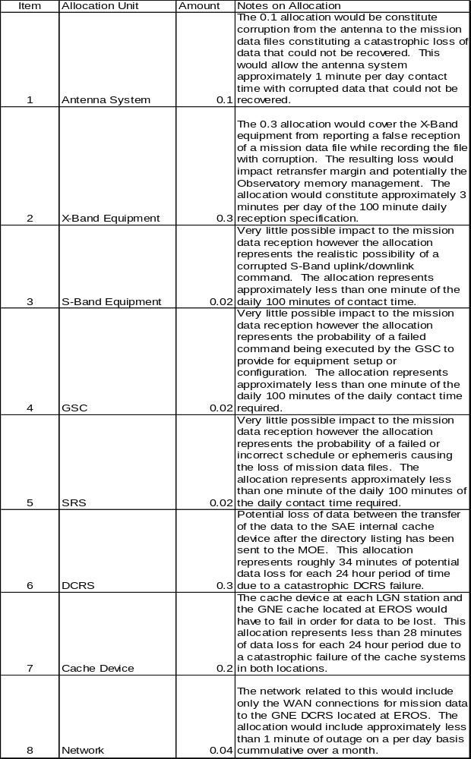

Appendix B: Traceability Matrix

GNE ID | GSRD ID
GNE652 | GS162
GNE639 | GS165  GS623
GNE269 | GS165
GNE270 | GS165
GNE346 | GS1682
GNE170 | GS1682
GNE581 | GS1745
GNE477 | GS1745
GNE129 | GS1745
GNE147 | GS1745
GNE150 | GS1745
GNE151 | GS1745
GNE278 | GS1745
GNE196 | GS1745
GNE559 | GS1745
GNE591 | GS1745
GNE625 | GS1745
GNE621 | GS1745
GNE622 | GS1745
GNE623 | GS1745
GNE146 | GS177
GNE643 | GS181
GNE552 | GS1843  GS1844
GNE572 | GS1843  GS1844
GNE171 | GS1843  GS1844
GNE667 | GS1844
GNE668 | GS1844
GNE589 | GS26
GNE474 | GS2830
GNE651 | GS532
GNE379 | GS532  GS623
GNE575 | GS532
GNE425 | GS532
GNE250 | GS534
GNE253 | GS539  GS656
GNE548 | GS540
GNE549 | GS540
GNE282 | GS540
GNE669 | GS540
GNE169 | GS540
GNE372 | GS540
GNE164 | GS540
GNE607 | GS540
GNE609 | GS540
GNE262 | GS543
GNE263 | GS543
GNE88 | GS543
GNE648 | GS543
GNE611 | GS543  GS544  GS666
GNE92 | GS544
GNE647 | GS544
GNE629 | GS544  GS662
GNE532 | GS545
GNE561 | GS545
GNE126 | GS545
GNE553 | GS545
GNE615 | GS545
GNE73 | GS546
GNE87 | GS547
GNE398 | GS547
GNE396 | GS548
GNE400 | GS548
GNE401 | GS549
GNE492 | GS550
GNE77 | GS550
GNE78 | GS550
GNE496 | GS551
GNE497 | GS552
GNE75 | GS553
GNE294 | GS554
GNE520 | GS555
GNE519 | GS556
GNE357 | GS557  GS1843  GS1844
GNE666 | GS557
GNE619 | GS557  GS666
GNE239 | GS558
GNE570 | GS558
GNE612 | GS558
GNE110 | GS559
GNE107 | GS560
GNE243 | GS560
GNE245 | GS562
GNE106 | GS563
GNE491 | GS564
GNE512 | GS566
GNE511 | GS567
GNE489 | GS567
GNE493 | GS568
GNE279 | GS568
GNE114 | GS592
GNE631 | GS592
GNE495 | GS593
GNE480 | GS595
GNE74 | GS650
GNE84 | GS654
GNE86 | GS654
GNE336 | GS655
GNE550 | GS657
GNE176 | GS657
GNE173 | GS657
GNE174 | GS657
GNE608 | GS657
GNE613 | GS657
GNE614 | GS657
GNE617 | GS657
GNE618 | GS657  GS666
GNE210 | GS66
GNE237 | GS66  GS666
GNE236 | GS66
GNE670 | GS66
GNE628 | GS66
GNE209 | GS661
GNE44 | GS662
GNE494 | GS662
GNE72 | GS662
GNE76 | GS662
GNE81 | GS662
GNE95 | GS662
GNE630 | GS662
GNE235 | GS664
GNE91 | GS664
GNE620 | GS666
GNE436 | GS669
GNE409 | GS669
GNE513 | GS70
GNE482 | GS70
GNE483 | GS70
GNE514 | GS70
GNE162 | GS73
GNE634 | GS73
GNE569 | GS74  GS89  GS557  GS558
GNE345 | GS74  GS557  GS558
GNE616 | GS74
GNE311 | GS75
GNE428 | GS75
GNE248 | GS77
GNE167 | GS77
GNE590 | GS77  GS540  GS661
GNE85 | GS79  GS534
GNE351 | GS79
GNE28 | GS802
GNE642 | GS804
GNE473 | GS84
GNE481 | GS88
GNE177 | GS88
GNE175 | GS88
GNE610 | GS88
GNE571 | GS89
GNE283 | GS89  GS1843  GS1844
GNE557 | GS89
GNE587 | GS930
GNE654 | GS930
GNE655 | GS930
GNE656 | GS930
GNE657 | GS930
GNE658 | GS930
GNE659 | GS930
GNE660 | GS930
GNE661 | GS930
GNE662 | GS930
GNE671 | GS930
GNE673 | GS930
GNE672 | GS930
GNE674 | GS930
GNE675 | GS930
GNE293 | GS942

Appendix C: Verification Matrix

ID |  | Verification
GNE28 |  | Analysis
GNE269 |  | Analysis
GNE270 |  | Analysis
GNE209 |  | Demonstration
GNE481 |  | Demonstration
GNE346 |  | Demonstration
GNE425 |  | Demonstration
GNE587 |  | Inspection
GNE654 |  | Inspection
GNE655 |  | Inspection
GNE656 |  | Inspection
GNE657 |  | Inspection
GNE658 |  | Inspection
GNE659 |  | Inspection
GNE660 |  | Inspection
GNE661 |  | Inspection
GNE662 |  | Inspection
GNE671 |  | Inspection
GNE673 |  | Inspection
GNE672 |  | Inspection
GNE674 |  | Inspection
GNE675 |  | Inspection
GNE293 |  | Inspection
GNE311 |  | Inspection
GNE468 |  | Test
GNE469 |  | Test
GNE644 |  | Test
GNE474 |  | Test
GNE646 |  | Test
GNE650 |  | Test
GNE651 |  | Test
GNE652 |  | Test
GNE639 |  | Test
GNE44 |  | Test
GNE210 |  | Test
GNE262 |  | Test
GNE263 |  | Test
GNE94 |  | Test
GNE237 |  | Test
GNE235 |  | Test
GNE253 |  | Test
GNE250 |  | Test
GNE480 |  | Test
GNE513 |  | Test
GNE482 |  | Test
GNE483 |  | Test
GNE532 |  | Test
GNE514 |  | Test
GNE493 |  | Test
GNE491 |  | Test
GNE511 |  | Test
GNE489 |  | Test
GNE512 |  | Test
GNE494 |  | Test
GNE495 |  | Test
GNE519 |  | Test
GNE520 |  | Test
GNE496 |  | Test
GNE497 |  | Test
GNE72 |  | Test
GNE492 |  | Test
GNE73 |  | Test
GNE641 |  | Test
GNE74 |  | Test
GNE294 |  | Test
GNE75 |  | Test
GNE76 |  | Test
GNE77 |  | Test
GNE78 |  | Test
GNE81 |  | Test
GNE84 |  | Test
GNE85 |  | Test
GNE351 |  | Test
GNE86 |  | Test
GNE87 |  | Test
GNE396 |  | Test
GNE88 |  | Test
GNE91 |  | Test
GNE92 |  | Test
GNE95 |  | Test
GNE561 |  | Test
GNE126 |  | Test
GNE223 |  | Test
GNE224 |  | Test
GNE398 |  | Test
GNE400 |  | Test
GNE401 |  | Test
GNE106 |  | Test
GNE279 |  | Test
GNE107 |  | Test
GNE110 |  | Test
GNE336 |  | Test
GNE114 |  | Test
GNE569 |  | Test
GNE239 |  | Test
GNE242 |  | Test
GNE243 |  | Test
GNE245 |  | Test
GNE345 |  | Test
GNE570 |  | Test
GNE571 |  | Test
GNE548 |  | Test
GNE549 |  | Test
GNE550 |  | Test
GNE552 |  | Test
GNE553 |  | Test
GNE572 |  | Test
GNE248 |  | Test
GNE379 |  | Test
GNE357 |  | Test
GNE666 |  | Test
GNE667 |  | Test
GNE668 |  | Test
GNE283 |  | Test
GNE282 |  | Test
GNE669 |  | Test
GNE177 |  | Test
GNE176 |  | Test
GNE175 |  | Test
GNE173 |  | Test
GNE174 |  | Test
GNE171 |  | Test
GNE170 |  | Test
GNE169 |  | Test
GNE167 |  | Test
GNE372 |  | Test
GNE164 |  | Test
GNE575 |  | Test
GNE428 |  | Test
GNE581 |  | Test
GNE576 |  | Test
GNE473 |  | Test
GNE162 |  | Test
GNE477 |  | Test
GNE557 |  | Test
GNE146 |  | Test
GNE642 |  | Test
GNE643 |  | Test
GNE129 |  | Test
GNE147 |  | Test
GNE150 |  | Test
GNE151 |  | Test
GNE278 |  | Test
GNE196 |  | Test
GNE559 |  | Test
GNE591 |  | Test
GNE589 |  | Test
GNE436 |  | Test
GNE409 |  | Test
GNE236 |  | Test
GNE670 |  | Test
GNE647 |  | Test
GNE648 |  | Test
GNE590 |  | Test
GNE607 |  | Test
GNE608 |  | Test
GNE609 |  | Test
GNE610 |  | Test
GNE611 |  | Test
GNE612 |  | Test
GNE613 |  | Test
GNE614 |  | Test
GNE615 |  | Test
GNE616 |  | Test
GNE617 |  | Test
GNE618 |  | Test
GNE619 | Test
GNE620 | Test
GNE625 | Test
GNE621 | Test
GNE622 | Test
GNE623 | Test
GNE628 | Test
GNE629 | Test
GNE630 | Test
GNE631 | Test
GNE626 | Test
GNE627 | Test
GNE601 | Test
GNE632 | Test
GNE633 | Test
GNE602 | Test
GNE634 | Test
GNE665 | Test

Appendix D: Priority Matrix

GNE ID | Priority
GNE293 | Priority 1
GNE44 | Priority 1
GNE210 | Priority 1
GNE262 | Priority 1
GNE263 | Priority 1
GNE237 | Priority 1
GNE253 | Priority 1
GNE480 | Priority 1
GNE481 | Priority 1
GNE483 | Priority 1
GNE532 | Priority 1
GNE493 | Priority 1
GNE491 | Priority 1
GNE511 | Priority 1
GNE489 | Priority 1
GNE512 | Priority 1
GNE494 | Priority 1
GNE495 | Priority 1
GNE496 | Priority 1
GNE497 | Priority 1
GNE72 | Priority 1
GNE492 | Priority 1
GNE73 | Priority 1
GNE641 | Priority 1
GNE74 | Priority 1
GNE294 | Priority 1
GNE75 | Priority 1
GNE76 | Priority 1
GNE77 | Priority 1
GNE78 | Priority 1
GNE84 | Priority 1
GNE92 | Priority 1
GNE95 | Priority 1
GNE561 | Priority 1
GNE126 | Priority 1
GNE223 | Priority 1
GNE224 | Priority 1
GNE398 | Priority 1
GNE400 | Priority 1
GNE401 | Priority 1
GNE106 | Priority 1
GNE279 | Priority 1
GNE107 | Priority 1
GNE110 | Priority 1
GNE114 | Priority 1
GNE242 | Priority 1
GNE245 | Priority 1
GNE553 | Priority 1
GNE589 | Priority 1
GNE236 | Priority 1
GNE611 | Priority 1
GNE612 | Priority 1
GNE615 | Priority 1
GNE628 | Priority 1
GNE629 | Priority 1
GNE630 | Priority 1
GNE631 | Priority 1
GNE468 | Priority 2
GNE469 | Priority 2
GNE644 | Priority 2
GNE474 | Priority 2
GNE28 | Priority 2
GNE646 | Priority 2
GNE587 | Priority 2
GNE654 | Priority 2
GNE655 | Priority 2
GNE656 | Priority 2
GNE657 | Priority 2
GNE658 | Priority 2
GNE659 | Priority 2
GNE660 | Priority 2
GNE661 | Priority 2
GNE662 | Priority 2
GNE671 | Priority 2
GNE673 | Priority 2
GNE672 | Priority 2
GNE674 | Priority 2
GNE675 | Priority 2
GNE650 | Priority 2
GNE651 | Priority 2
GNE652 | Priority 2
GNE209 | Priority 2
GNE639 | Priority 2
GNE94 | Priority 2
GNE235 | Priority 2
GNE250 | Priority 2
GNE513 | Priority 2
GNE482 | Priority 2
GNE514 | Priority 2
GNE519 | Priority 2
GNE520 | Priority 2
GNE81 | Priority 2
GNE85 | Priority 2
GNE351 | Priority 2
GNE86 | Priority 2
GNE87 | Priority 2
GNE396 | Priority 2
GNE88 | Priority 2
GNE91 | Priority 2
GNE336 | Priority 2
GNE569 | Priority 2
GNE239 | Priority 2
GNE243 | Priority 2
GNE345 | Priority 2
GNE570 | Priority 2
GNE571 | Priority 2
GNE548 | Priority 2
GNE549 | Priority 2
GNE550 | Priority 2
GNE552 | Priority 2
GNE572 | Priority 2
GNE346 | Priority 2
GNE379 | Priority 2
GNE357 | Priority 2
GNE666 | Priority 2
GNE667 | Priority 2
GNE668 | Priority 2
GNE283 | Priority 2
GNE282 | Priority 2
GNE669 | Priority 2
GNE177 | Priority 2
GNE176 | Priority 2
GNE175 | Priority 2
GNE173 | Priority 2
GNE174 | Priority 2
GNE171 | Priority 2
GNE170 | Priority 2
GNE169 | Priority 2
GNE167 | Priority 2
GNE372 | Priority 2
GNE164 | Priority 2
GNE575 | Priority 2
GNE581 | Priority 2
GNE576 | Priority 2
GNE473 | Priority 2
GNE477 | Priority 2
GNE557 | Priority 2
GNE146 | Priority 2
GNE642 | Priority 2
GNE643 | Priority 2
GNE129 | Priority 2
GNE147 | Priority 2
GNE150 | Priority 2
GNE151 | Priority 2
GNE278 | Priority 2
GNE196 | Priority 2
GNE559 | Priority 2
GNE591 | Priority 2
GNE436 | Priority 2
GNE409 | Priority 2
GNE670 | Priority 2
GNE647 | Priority 2
GNE648 | Priority 2
GNE269 | Priority 2
GNE270 | Priority 2
GNE590 | Priority 2
GNE607 | Priority 2
GNE608 | Priority 2
GNE609 | Priority 2
GNE610 | Priority 2
GNE613 | Priority 2
GNE614 | Priority 2
GNE616 | Priority 2
GNE617 | Priority 2
GNE618 | Priority 2
GNE619 | Priority 2
GNE620 | Priority 2
GNE625 | Priority 2
GNE621 | Priority 2
GNE622 | Priority 2
GNE623 | Priority 2
GNE626 | Priority 2
GNE627 | Priority 2
GNE601 | Priority 2
GNE632 | Priority 2
GNE633 | Priority 2
GNE602 | Priority 2
GNE665 | Priority 2
GNE311 | Priority 3
GNE248 | Priority 3
GNE428 | Priority 3
GNE162 | Priority 3
GNE425 | Priority 3
GNE634 | Priority 3

Appendix E: Acronyms

Acronym | Description
bMOE | backup Mission Operations Element
bps | bits per second
BPSK | Band Phase Shift Keying
BPSK | Binary Phase Shift Keyed
CCSDS | Consultative Committee for Space Data Systems
CFDP | CCSDS File Delivery Protocol
CONUS | CONterminous United States
COTS | Commercial Off The Shelf
dB/K | Decibel /Kelvin
dBW | Decibel Watt
DCPF | Data Capture and Processing Facility
DCRS | Data Collection and Routing System
DCRS (FR) | Data Collection and Routing System (File Routing)
DCRS (IR) | Data Collection and Routing System (Interval Routing)
DFCB | Data Format Control Book
DPAS | Data Processing and Archive Segment
EIRP | Effective Isotropic Radiated Power
EROS | Earth Resources Observation and Science
FD | Flight Dynamics
FOT | Flight Operations Team
G/T | Gain Vs system thermal noise Temperature dB/K
GN | Ground Network
GNE | Ground Network Element
GRT | Ground Readiness Test
GSC | Ground Station Control
GSE | Ground Station Equipment
GSFC | Goddard Space Flight Center
GSRD | Ground System Requirements Document
I&T | Integration & Testing
IC | International Cooperators
ICD | Interface Control Document
IIRV | Improved Inter-Range Vector
IOC | Initial Operating Capability
IPE | Image Processing Element
IPE IS | IPE Ingest Subsystem
IT | Information Technology
Kbps | Kilo bits per second
LGN | LDCM Ground Network
LHCP | Left Hand Circular Polarization
Mbps | Mega bits per second
MHz | Mega Hertz
MOC | Mission Operations Center
MOE | Mission Operations Element
MOERD | Mission Operations Element Requirements Document
MRT | Mission Readiness Test
OAR | On-Orbit Acceptance Review
OIRD | Observatory Interface Requirements Document
RF | Radio Frequency
RHCP | Right Hand Circular Polarization
RS | Reed Solomon
RSDO | Rapid Spacecraft Development Office
SAE | Storage and Archive Element
SN | Space Network
SOP | Standard Operating Procedures
SRS | Scheduling and Reporting System
SSR | Solid State Recorder
TBC | To Be Confirmed
TBD | To Be Defined
TBR | To Be Reviewed
TDRSS | Tracking Data Relay Satellite System
TLE | Two Line Element
TM | TeleMetry
UPE | User Portal Element
USGS | United States Geological Survey

