DOT/FAA/AR-xx/xx  Office of Aviation Research  Washington, DC 20591 | FINAL REPORT  Demographic Study of General  Aviation Fleet  October 15, 2007  This document is available to the U.S. public through the National Technical Information Service (NTIS), Springfield, Virginia 22161.    U.S. Department of Transportation  Federal Aviation Administration

NOTICE

This document is disseminated under the sponsorship of the U.S. Department of Transportation in the interest of information exchange. The United States Government assumes no liability for the contents or use thereof. The United States Government does not endorse products or manufacturers. Trade or manufacturer's names appear herein solely because they are considered essential to the objective of this report. This document does not constitute FAA certification policy. Consult your local FAA aircraft certification office as to its use.

This report is available at the Federal Aviation Administration William J. Hughes Technical Center's Full-Text Technical Reports page: actlibrary.tc.faa.gov in Adobe Acrobat portable document format (PDF).

Technical Report Documentation Page
1. Report No.  DOT/FAA/AR-xx/xx | 2. Government Accession No. |  | 3. Recipient's Catalog No.
4. Title and Subtitle  DEMOGRAPHIC STUDY OF GENERAL AVIATION FLEET |  |  | 5. Report Date
 |  |  | 6. Performing Organization Code
7. Author(s)  X |  |  | 8. Performing Organization Report No.  X
9. Performing Organization Name and Address |  |  | 10. Work Unit No. (TRAIS)
11. Contract or Grant No.
X

12. Sponsoring Agency Name and Address  U.S. Department of Transportation  Federal Aviation Administration  Office of Aviation Research  Washington, DC 20591 |  |  | 13. Type of Report and Period Covered  Draft Report
 |  |  | 14. Sponsoring Agency Code
15. Supplementary Notes

16. Abstract
Through the Federal Aviation Administration (FAA) Aging Aircraft Safety Program, the Wichita State University National Institute for Aviation Research (NIAR) will assist the FAA in their initiative to maintain the safe operation of the existing General Aviation (GA) fleet through improved maintenance practices and inspections. In order to assist in determining if potential continuing airworthiness problems exist for the GA fleet as a function of the aging process, NIAR will conduct a Demographic Study of the GA fleet. For purposes of this proposal, GA is defined as fixed wing aircraft with capacity of less than 30 passengers, or less than 7500 pounds maximum payload, operated to Part 91, Part 121, or Part 135 requirements. The objective of this Demographic Study is to collect pertinent data related to the GA fleet for future risk assessment, particularly on aging aircraft issues. Fleet demographics will include, but is not limited to, fleet distribution by type, manufacturer, model, calendar year, and aircraft usage. NIAR will collect data about the composition of the GA fleet from numerous data sources, such as, but not limited to, the FAA Federal Registry and professional aircraft organizations representing GA airplanes (AOPA, GAMA, etc.). Data collected will include, but is not limited to, make, model, manufactured year, number of flight hours, number of flights, and type of usage (i.e., private or commercial). From the various data sources, NIAR will create a relational database that is capable of interfacing with the data sources and updating searchable data on various fields, such as make, model, and manufactured year. NIAR will review the demographic data on the GA fleet (as defined for this research) in order to determine the current size, age, and usage of the existing fleet, focusing initially on the multi engine GA aircraft, which are extensively used in commuter and commercial service. The demographic data will provide key information for use in future studies of aging aircraft maintenance practices and future risk assessments for the GA fleet. This information will assist the FAA in determining where to focus their limited resources to address the aging aircraft issues that GA owners and operators are currently facing.
17. Key Words  X |  | 18. Distribution Statement  This document is available to the public through the National Technical Information Service (NTIS), Springfield, Virginia 22161.
19. Security Classif. (of this report)  Unclassified | 20. Security Classif. (of this page)  Unclassified |  | 21. No. of Pages | 22. Price

Form DOT F 1700.7 (8-72) Reproduction of completed page authorized

TABLE OF CONTENTS
Page

1. INTRODUCTION 1
1.1 BACKGROUND 1
1.2 RESEARCH OBJECTIVES 1
1.3 TECHNICIAL APPROACH 1
2. database design and reporting 10
2.1 PROJECT REQUEST 10
2.2 PLATFORM 10
2.3 APPLICATION 11
2.3.1 Login 11
2.3.2 Administration 12
2.3.3 Aircraft Data Collection 13
2.3.4 Demographic Info (Reporting) 17
3. APPENDIX A – faa general aviation demographics user manual 20
3.1 ADMINISTRATION MODULE 20
3.2 AIRCRAFT DATA COLLECTION MODULE 21
3.3 DEMOGRAPHIC INFO MODULE 24
3.4 BUILDING A CUSTOM REPORT 26
3.5 DEMOGRAPHIC INFO MODULE – GRAPHIC DATA 37

LIST OF FIGURES

Figure 1. Program Schedule 2
Figure 2. GAATA Survey 3
Figure 3. Microsoft® Excel Spreadsheet – Hours by Aircraft Type and Age 4
Figure 4. Microsoft® Excel Spreadsheet – Aircraft Hours/Weights, Sheet 1 5
Figure 5. Microsoft® Excel Spreadsheet – Aircraft Hours/Weights, Sheet 2 6
Figure 6. Microsoft® Excel Spreadsheet – Hours/Weights Calculations 8
Figure 7. Aircraft Models from FAA Database 9
Figure 8. FAA Demographics System – Application Login and Available Modules 11
Figure 9. Administration Module 12
Figure 10. Aircraft Data Collection Module 14
Figure 11. Demographic Info Module 17
Figure 12. Graphic Display of Fixed Wing Aircraft by Region 19
Figure 13. Administration Module 20
Figure 14. Aircraft Data Collection Module – Select Aircraft Data Collection 21
Figure 15. Aircraft Data Collection Module – Select Required Data Type 22
Figure 16. Aircraft Data Collection Module – Data Input Results and Entry 23
Figure 17. Demographic Info Module 25
Figure 19. Demographic Info Module – Select Custom Report 28
Figure 20. Demographic Info Module – Overview 29
Figure 21. Demographic Info Module – Field Selection 30
Figure 22. Demographic Info Module – Select Manufacturer Name and Model 31
Figure 23. Demographic Info Module – Selection Criteria 1 32
Figure 24. Demographic Info Module – Selection Criteria 2 33
Figure 25. Demographic Info Module – Create Title and Submit 34
Figure 26. Demographic Info Module – Select Format and Export 35
Figure 27. Database Custom Report in Microsoft® Excel Format 36
Figure 28. Demographic Info Module – Graphic Display Overview 37
Figure 29. Select Demographic Info Module 38
Figure 30. Demographic Info Module – Aircraft Selection by Region or State 39
Figure 31. Demographic Info Module – Select Certification Type 40
Figure 32. Demographic Info Module – Select Class of Aircraft 41
Figure 33. Demographic Info Module – Select Aircraft Manufacturer 42
Figure 34. Demographic Info Module – Select Model of Aircraft 43
Figure 35. Demographic Info Module – Query Results 44
Figure 36. Demographic Info Module – Totals for Beech 400A 45
Figure 37. Demographic Info Module – Percentages for Beech 400A 46
Figure 38. Demographic Info Module – Totals for Raytheon 400A 47
Figure 39. Demographic Info Module – Percentages for Raytheon 400A 48

LIST OF ACRONYMS

AOPA Aircraft Owner and Pilots Association
CFR Code of Federal Regulations
FAA Federal Aviation Administration
GA General Aviation
GAA General Aviation Aircraft
GAMA General Aviation Manufacturer’s Association
GAATA General Aviation and Air Taxi Activity
NIAR National Institute for Aviation Research
NTIS National Technical Information Service
pdf Portable Document Format
SSL Secure Socket Layer
WSU Wichita State University

INTRODUCTION
Using congressional support, the Wichita State University (WSU) National Institute for Aviation Research (NIAR) proposes to use its technical personnel, facilities, and equipment to support and enhance the safety goals of the Federal Aviation Administration (FAA). NIAR will conduct research for developing technologies, technical information, procedures, and practices in order to help ensure the continued airworthiness of aircraft structures in the General Aviation (GA) fleet. The Aging Aircraft Research Laboratory of NIAR is involved in a FAA research program assisting with investigations for maintaining the structural integrity and airworthiness of commuter-class aircraft fleets. The proposed research program will compliment this ongoing work and enhance the research and evaluation capabilities of NIAR to support future FAA needs.

BACKGROUND
Although the general public is primarily concerned with the airworthiness of commercial aircraft, which is where most research funding resources and efforts have been focused, a growing concern also exists in the small airplane fleet. While numerous investigations are being conducted on the aging aspects of large transport and military airplanes, limited resources are being expended to understand the aging aspects of the small airplane fleet. Investigations performed on large transport and military aircraft have focused on the structural integrity as well as wiring and systems related aging concerns. The results of these investigations can benefit a similar research program that investigates the same issues on small airplanes.

RESEARCH OBJECTIVES
Collect pertinent demographic data related to the GA fleet for future risk assessment, particularly pertaining to aging aircraft issues. The data collection is necessary to aid not only with aging aircraft issues, but to also help with future risk assessment for the continuous FAA Aging Aircraft Safety Program.

TECHNICIAL APPROACH
NIAR has collected and reviewed demographic data on the GA (as defined for this research) fleet to determine the current size, age and usage of the existing fleet to support future risk assessment. NIAR has created a relational database that is capable of updating searchable data on various fields, such as make, model, and manufactured year. This database was built using commercially available software, and the data was collected through the FAA Aircraft Registry, other existing database systems, and from personal contact with professional aircraft organizations representing small airplanes (AOPA, GAMA, etc.). Data collected included make, model, manufactured year, number of flight hours, number of flights and type of usage (i.e., private or commercial). Upon data collection, a comprehensive analysis was conducted to determine what data is useful for future assessments conducted by the FAA. These actions are intended to aid the FAA with risk assessment and risk management.

Figure 1 provides the program schedule utilized for completion of all accomplished technical tasks.

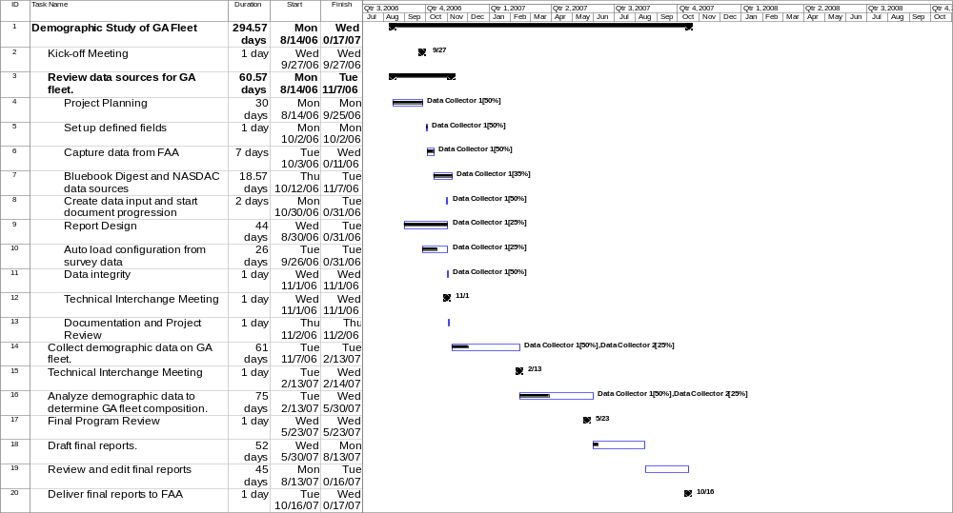

Figure 1. Program Schedule

The official start date of the Demographic Study was August 14, 2006. During this time, monthly research began and information was gathered to use in the database. The first site used to collect data was the FAA webpage. Information from this site included the FAA Aircraft Registry, which lists registered aircraft, the owner, and general specifications of the specific aircraft.

Throughout September 2006, a shift of focus to capture what particular type of information to research came from the actual list of aircraft to data used in calculating the average number of hours and flights also pending on the aircraft type and number of engines. On September 27, 2006, the first Kick-Off Meeting was held to discuss an overview of the program and provide a project plan on what sources would be used to make available a complete and accurate database.

During the month of October 2006, a viable source was found that provided the required data described in the paragraph above. Again, this data was found on the FAA webpage under the General Aviation and Air Taxi Activity (GAATA) and Avionics Surveys. The General Aviation Manufacturer’s Association (GAMA) completes these surveys every year. Because the surveys are published only once in December, the most recent survey was that of 2005. Figure 2 shows an example of the GAATA Survey data.

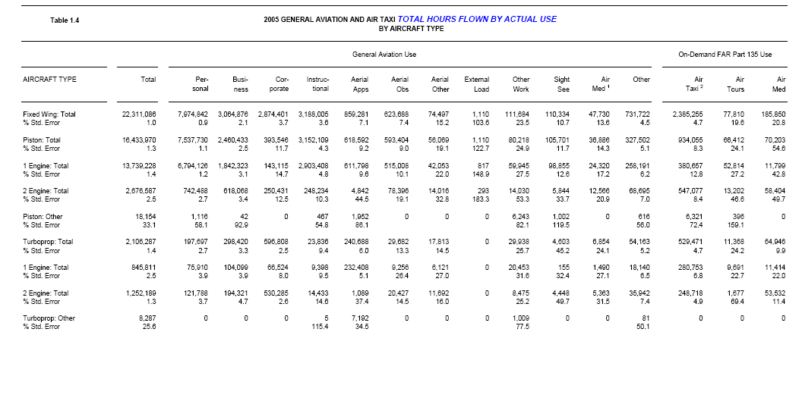

Figure 2. GAATA Survey

The GAATA Survey was used to obtain a value for the average number of flights per hour. The value of each of the categories was taken, i.e., single reciprocating engine, multi reciprocating engine, multi turboprop engine, etc. These values were placed into a Microsoft® Excel spreadsheet (ref. Figure 3) entitled “Hours by Aircraft Type and Age.” The first column is the listing of all of the separate types of aircraft. The second column is the total number of flights for the specified aircraft type taken from the GAATA Survey. In addition, the third column is taken straight from the GAATA Survey and is the total number of hours for the aircraft type. From these two values, the number of hours per flight and the number of flights per hour were calculated. The last column is not required; however, it shows the average length of flight in minutes. Ratios of both hours and flights are needed due to how the calculations have been computed. In the database, the number of flights to find the number of hours for the aircraft is used, so the hours per flight ratio is needed. All the information discovered is by the hours, so the flights per hour ratio has been used to obtain a value for the flights. Therefore, the hours and the flights can both be calculated and the ratios can be used to compute the other value if one is unknown.

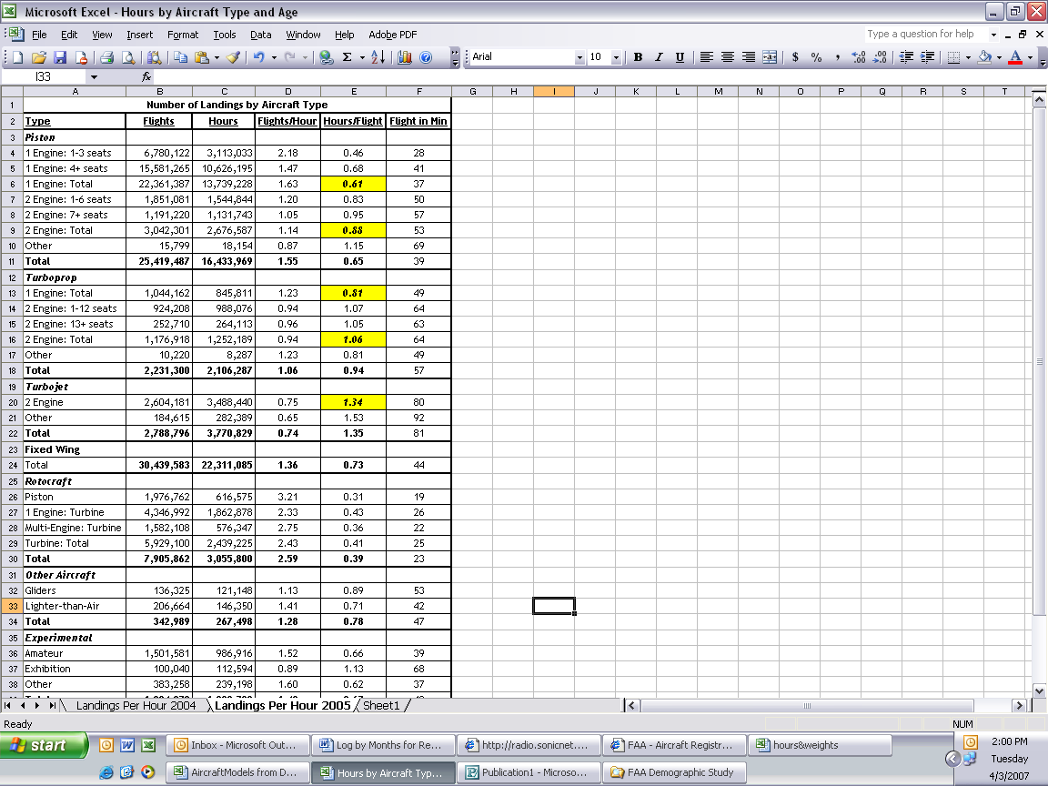

Figure 3. Microsoft® Excel Spreadsheet – Hours by Aircraft Type and Age

To find the number of hours to relate to these aircraft types, the Aircraft Bluebook was used. The first action after receipt of the Aircraft Bluebook were to compile information from two tables located in the appendix that were transferred into an electronic form, these tables are found in the document under “Hours and Weights, see Figure 4. Both tables consisted of the average hours per year for a specific make and model of aircraft over a given span of time, in addition to specification for each make and model that listed the gross and empty weights of the aircraft. After both tables were in electronic form, the tables were manipulated such that the hours to find the average number of hours of a specified aircraft type was given. In order to complete this, the span of years were separated into two separate columns to sort the data better. Upon completion, if a span of years covered multiple decades, for the age of the aircraft, an additional line for each other decade the aircraft spanned. For example, if the aircraft was in production from 1994 to 2006, this aircraft spans the 0-10 year and 11-20 year decades and would then have rows consisting of the age of 0-10 years with the value of hours for the 1994-2006, as well as a row comprising of the age 11-20 years again with the same value of hours for the 1994-2006 aircraft. While going through the Aircraft Bluebook, the number, type of engine for each make, and model were listed on the same spreadsheet. The “Aircraft Type” tab shows this data. Upon completion the table was filled with the required data, the data was then copied and placed onto another tab to sort and begin calculation of the average hours by aircraft type. The other tab “Avg Hours,” held the data sorted by the number of engines, then the type of engine, and lastly by the age.

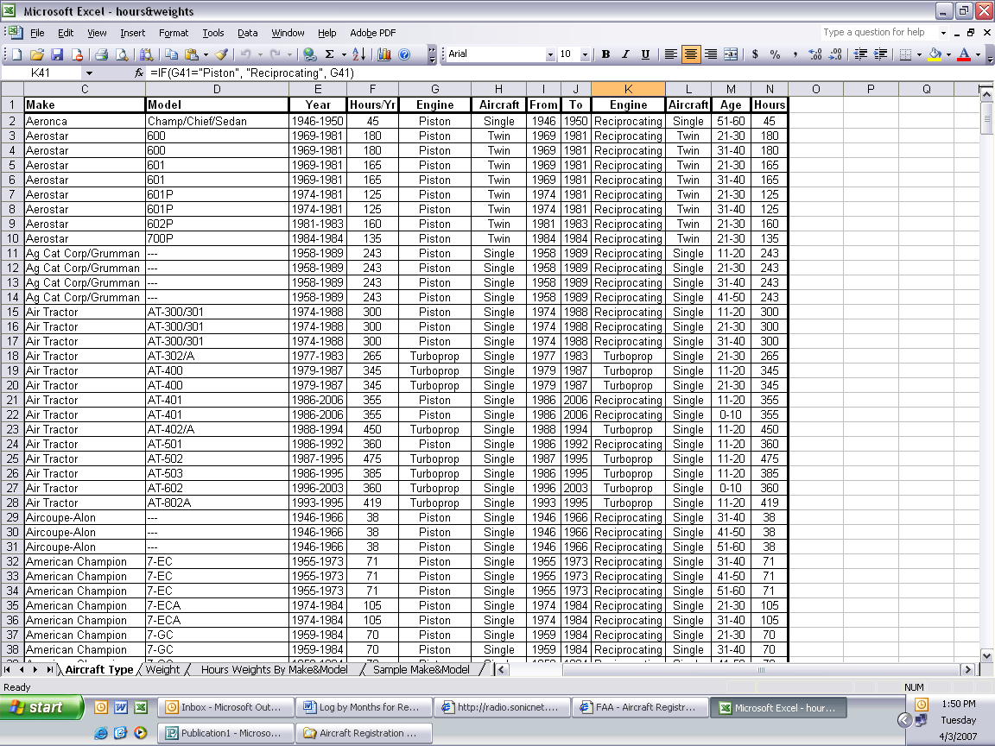

Figure 4. Microsoft® Excel Spreadsheet – Aircraft Hours/Weights, Sheet 1

After the data had been sorted, the average hours per decade of age was found by using the average formula. For example, the multi jet engine aircraft in the 11-20 year range had a calculated average number of hours of 383 hours per year. This calculation was done for each range of ages for all number and type of engine categories. After these computations were completed, the values were entered into the formula sheet by the system designer; this sheet was a list of the number and engine types that are found in the database. In this Microsoft® Excel spreadsheet shown in Figure 5, all of the hours were entered and then the flights per hour ratio from the “Hours by Aircraft Type” was used to calculate average number of flights per year for the specified number and engine types. After completing this task, the “Calculated Data by Aircraft Type” form in the database was ready to be entered.

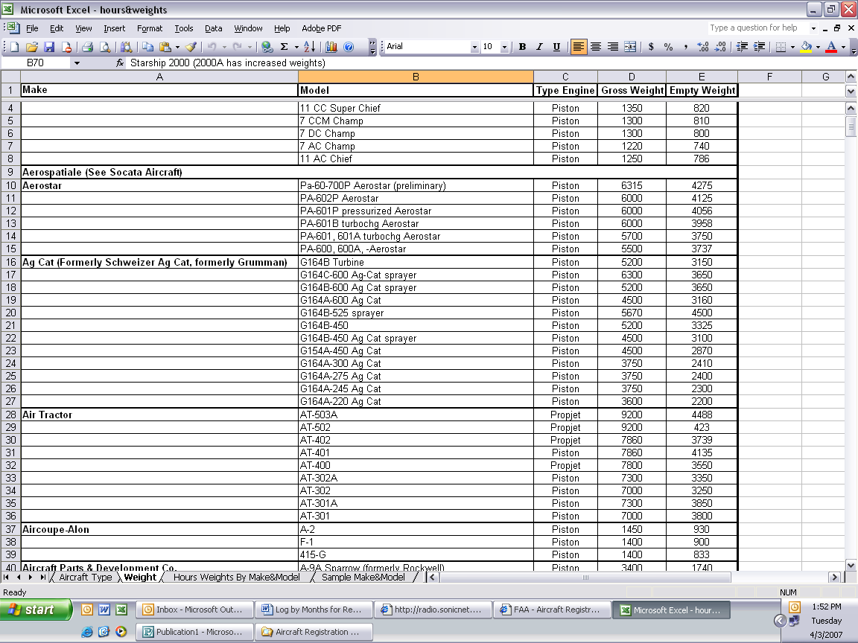

Figure 5. Microsoft® Excel Spreadsheet – Aircraft Hours/Weights, Sheet 2

December 2006:
Nevertheless, because the database is calculating the number of hours per flight, the number of flights that had been calculated had to be entered. Once entered, the input of the inverse of the ratio flights per hour allows the database to correctly compute the number of hours per year for the aircraft. For example, for the single reciprocating engines of the age of 0-10 years, the values of 249 flights and 0.65 hours per flight were input in the fields of the database for this aircraft type. The next objective is to compute an average weight to be added to this data.

Another method of computing hours in the database is by aircraft make and model. This method consists of listing every make and model along with its specific average hours per year, flights per year, and gross weight. Because the average number of hours can vary greatly between two aircraft of the same type, this calculation will give a more accurate value for a specific aircraft. The results of these calculations are shown in Figure 6.

January 2007: At the final “Go-To” Meeting held January 29, 2007, it was decided to focus on a method to exclude all “experimental data” from the database by default. To accomplish this task, the FAA Registry Master File was used. The FAA Registry Master File lists every registered aircraft as well as a column containing “Airworthiness Classification Code” that specifies if the aircraft is used for experimental purposes. After looking in the column that lists the “Classification Code,” a new master file was opened in Microsoft® Notepad and all the aircraft that did not have a designation of “4,” experimental, in the Classification Code column was deleted. On January 8, 2007, the system designer was contacted to find out if there would be an easier way to isolate the experimental aircraft from a list of registered aircraft.

The system designer implemented a function in the database that will allow the experimental aircraft to be excluded by default and included a drop down menu that would allow it to be included in the reporting if needed at a later date. Focus has resumed on calculating the hours for the aircraft by make and model using the Aircraft Bluebook, the tables in the appendix of the Aircraft Bluebook, and the ratios of “Hours per Flight” and “Flights per Hour” using the GAATA Survey data from 2005.

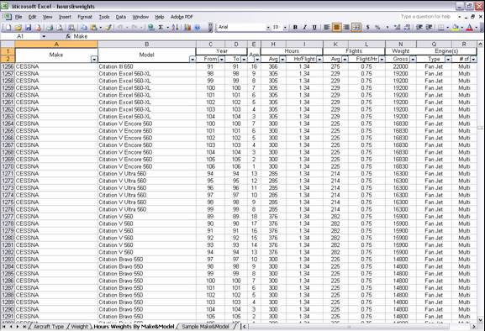

Figure 6. Microsoft® Excel Spreadsheet – Hours/Weights Calculations
February 2007: Data from the Aircraft Bluebook into a Microsoft® Excel spreadsheet (ref. Figure 7) was implemented into the tables along with the corresponding make and model.

Some aircraft did not have weights listed in the appendix of the Aircraft Bluebook, so the specific Type Certificates were used as references to find the aircraft’s gross weight.

Upon completion and after all columns of the spreadsheet were filled out, organization of each aircraft by make and model into their designated age range ensued, this was accomplished in order to input the data into the database.

To input the correct data for each aircraft, compared data from the aircraft listed in the database to the data in the Aircraft Bluebook required correlation.

Over time, Type Certificate (owners) information changes, this factor being relevant required finding what manufacturer information in the Aircraft Bluebook corresponded to the manufacturer from the database.

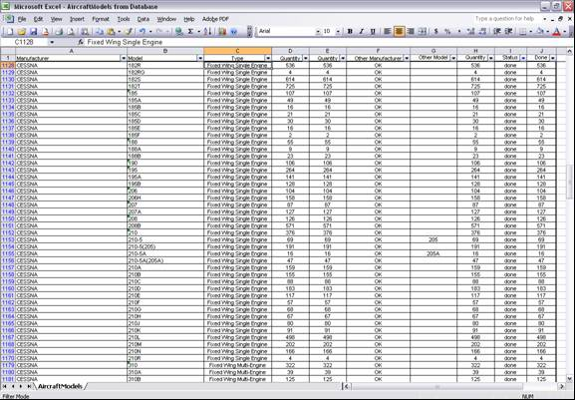

Figure 7. Aircraft Models from FAA Database

March 2007: For the collected data to be used in the database, it must be input through the Aircraft Data Collection module of the database. The first data to be entered is the calculations by aircraft type and number and type of engines.

To simplify this procedure a list of all the aircraft in the database requires printing. After the data is printed and because many aircraft models have had numerous Type Certificate owners, the list of aircraft from the database is compared with the list of aircraft from the Aircraft Bluebook. This will assist at finding the average number of hours flown per year as well as the ratio to calculate the average number of flights per year.

For example, Aeronca sold the company to American Champion; therefore, some Aeronca aircraft models may be listed under the American Champion make; however, the model would still use the data of the Aeronca model.

database design and reporting

PROJECT REQUEST
The project is to develop a web-based platform to study aircraft demographics of GA aircraft use. The FAA also requested that all software platform designs be based on current design methods and that all development is based on commercially available software.

PLATFORM
The application for the study developed on the Microsoft® platform consists of:
- Microsoft® 2003 Server Platform
- Microsoft® SQL 2005 Enterprise Server with Reporting Services
- Microsoft® Internet Information Server (IIS V6.0)
- Security for site access will be controlled using Secure Socket Layer (SSL) encryption, the ASP.Net 2.0.50727 “Forms” based security option, and standard security practices.
- The hardware is a Dell® Server with 2.0 GB memory, 120 GB disk space and four Intel® Xeon 3.2 GHZ processors. This specific hardware platform is typical for the software requirements and is sufficient for the application. This project when completed required 150 MB disk space for the database size and 3 MB disk space for the website.
- Network bandwidth design for the application was for minimal utilization. Actual measurement of bandwidth utilization was less than .1% or minimal. The server network connection is via a 1GB physical connection with the actual internet connection, governed and controlled by WSU is in excess of 100 MB.

APPLICATION
The application design consists of four primary components:
- Logon
- Administration
- Aircraft Data Collection
- Demographic Info (Reporting)

Figure 8 displays the application login and the modules available for use. Help screens and logout functionality aid in system functionality. Users may register on the site for access to the Demographic Info (reporting) module; a system administrator controls additional access.

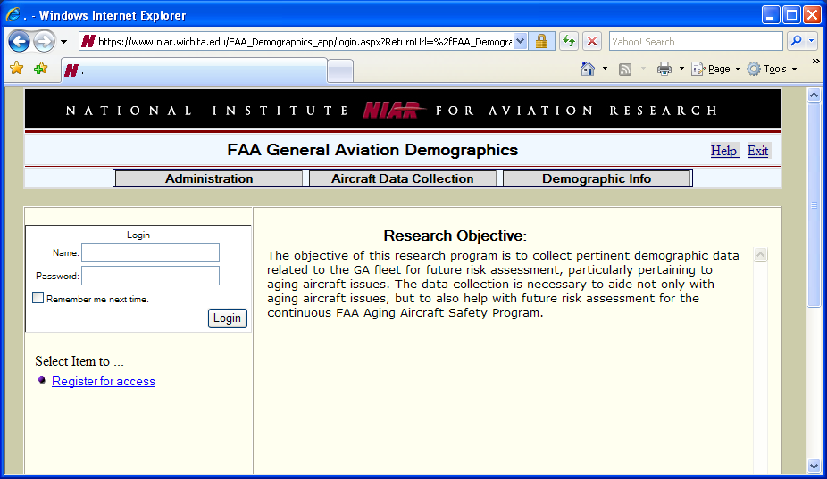

Figure 8. FAA Demographics System – Application Login and Available Modules

Login
After execution of the login or registration function, the user is presented with several actions. All users are given the option of changing their login password and users who have only registered on the site will be given access to the Demographic Info module to obtain reporting data only. Additional functionality on the site is controlled. The system administrator function controls access to the Administration module and/or Aircraft Data Collection module.

Administration
The Administration module controls user administration of the application and is divided into several functions. Figure 9 shows current system users, their module access assigned, and the administrator selections.

1. Create User – Creates a user by entering a user name, password of eight characters or more, and a valid e-mail address.

2. User Access Control – When you edit a user, you may now select which module the user has access to and update the user access. User will have to logout and login to make the changes effective.

3. Change User Password – Enter the user name and press submit. The system will generate a new password for the user and e-mail it to them. The e-mail address used is that used from Item 1 “Create User.”

4. Current System Users – A listing of all users that can log onto the system.

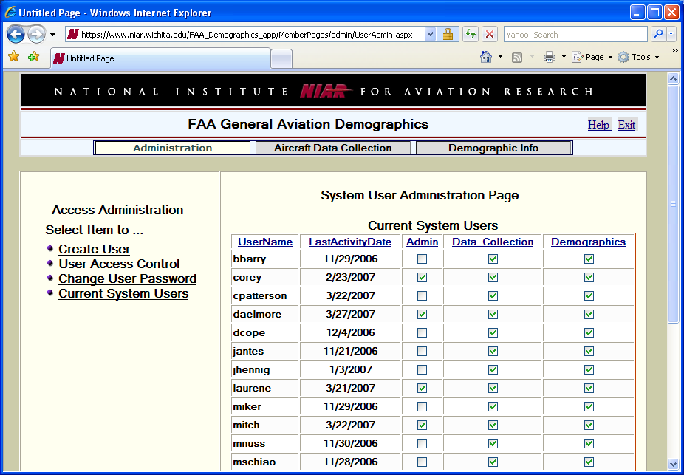

Figure 9. Administration Module

Aircraft Data Collection
The purpose of this project is to study the demographic information for non-commercial small aircraft in the United States. The data application was created to provide the primary data source for the study and as a tool to complete the project requirements. The data source for the study was based on data contained in the FAA Aircraft Registry. The FAA Aircraft Registry database is divided into multiple files and is located on the following website:

http://www.faa.gov/licenses_certificates/aircraft_certification/aircraft_registry/releasable_aircraft_download/
The files used for the study are the FAA Aircraft Registry, Master file, and the FAA Aircraft Reference file by make/model/series sequence. Primary data required for the study are:

1. The FAA Aircraft Reference used for the study contained information on the following:
a) Fixed wing single engine
b) Fixed wing multiple engine
c) Engine types
i. Reciprocating
ii. Turboprop
iii. Turbo Shaft
iv. Two Cycle
v. Four Cycle

2. FAA Master Registry listing used to obtain:
a) State where aircraft is registered.
b) Region where aircraft is located (Southwest, Eastern, etc.)
c) Year aircraft was manufactured.

3. The third data element is data collected, not from the FAA but from other sources (generally survey information), to obtain details of the following:
a) Flight Hours per Aircraft – Expect to obtain a calculation methodology to determine average flight hours for each aircraft based upon age and aircraft type.
b) Number of Flights per Aircraft – Expect to obtain a calculation methodology to determine average umber of flights for each aircraft based upon age and aircraft type.
c) Type of Usage (Commercial vs. Non-commercial) Aircraft Operation Weight (Avg.)

The data base design linked all data together such that the FAA Master file could be used as a baseline with both the aircraft reference data and the data collection information linked to it. This created a virtual database table with all data in it for reporting requirements.

Note that the purpose of the project was for small winged aircraft only; however, it was found that all aircraft types, Blimps, Gliders, etc., were contained in the data. Reports are for the demographics of all aircraft types, only the winged aircraft types would include the third section of data. This additional data gave the FAA more information than the original project request at no additional cost.

Aircraft Data Collection Module
The Aircraft Data Collection module (displayed in Figure 10) was developed to show data obtained from the FAA Aircraft Registry, to add data to calculate aircraft usage from flown hours, age, etc., and to exclude certain aircraft from the report.

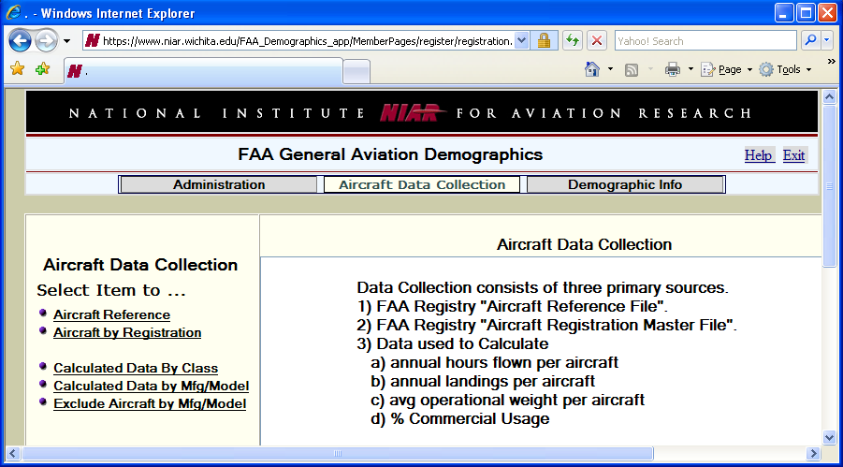

Figure 10. Aircraft Data Collection Module

Selections are available in this module to perform the following functions.

1. Aircraft Reference – Provides a list of aircraft produced by a specific manufacturer.

2. Aircraft by Registration – Provides a list of aircraft registered by state and/or manufacturer

3. Calculated Data by Class – Sets up data for calculations based on aircraft classification (fixed wing, Blimp, etc.), engine classification, and age in 10-year increments from the original production data. The data for this function was obtained from various sources referenced in other sections of this report. The form for this function is as follows:

Aircraft Class:
Engine Class:
Age Range:
Avg Hours Flown/Flight: | 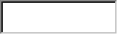
Avg Landings/Yr:
% Commercial Use:
Avg Operating Weight:

4. Calculated Data by Manufacturer/Model – Sets up data for calculations based on aircraft manufacturer, model, and age in 10-year increments from original production data. The data for this function was obtained from various sources referenced in other sections of this report. The form for this function is as follows:

Aircraft Manufacturer:
Aircraft Model:
FAA RegID:
Aircraft Age Range:
Avg Hours Flown/Flight:
Avg Landings/Yr:
% Commercial Use:
Avg Operating Weight:

5. Exclude Aircraft by Manufacturer/Model – It was determined that certain aircraft should not be included in the report (i.e., Museum Displays registered but not in service). An exemption control box was added to the database in order to remove those aircraft from the reporting data. The form for this function is as follows:

Aircraft Manufacturer:
Aircraft Model:
FAA RegID:
Aircraft Age Range:

All data collection requirements were met with the five functions outlined in this section.

Demographic Info (Reporting)
The Demographic Info module as shown in Figure 11 was developed to provide a reporting function to complete the project. Generally, after a database is established, containment of a specific set of data reporting content is virtually unlimited.

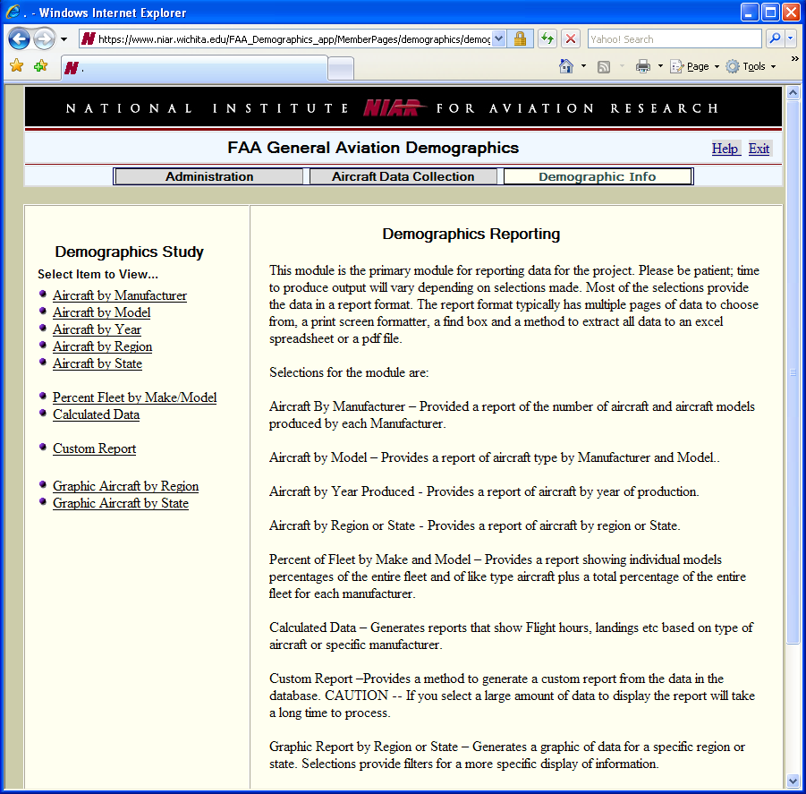

Figure 11. Demographic Info Module

Demographic Info Module
Reports generated for the demographic data will be available to the public. This module is the primary module for reporting data for the project. Most of the selections provide the data in a report format. The report format typically has multiple pages of data to choose from, a print screen formatter, a find box and a method to extract all data to a Microsoft® Excel spreadsheet or a pdf file. Module selections are:

1. Aircraft by Manufacturer – Provides a report of the number of aircraft and aircraft models produced by each manufacturer.

2. Aircraft by Model – Provides a report of aircraft type by manufacturer and model.

3. Aircraft by Year Produced – Provides a report of aircraft by year of production.

4. Aircraft by Region – Provides a report of aircraft by region.

5. Aircraft by State – Provides a report of aircraft by state.

6. Percent Fleet by Make/Model – Provides a percentage of a manufacturer model and aircraft type against the complete FAA Federal Registry.

7. Calculated Data – Generates reports that show flight hours, landings, etc., based on type of aircraft or specific manufacturer.

8. Custom Report – Provides a method to generate a custom report from the data in the database.

9. Graphic Aircraft by Region or State – Generates a data graphic for a specific region or state. Selections provide filters for a more specific display of information (ref. Figure 12).
a) Filter by aircraft certification
b) Filter by aircraft class
c) Filter by aircraft manufacturer
d) Filter by aircraft model
e) Display percentages of selected aircraft within each region and overall (available on region data graph only) aircraft distributed within each region/state.
f) Display average ages

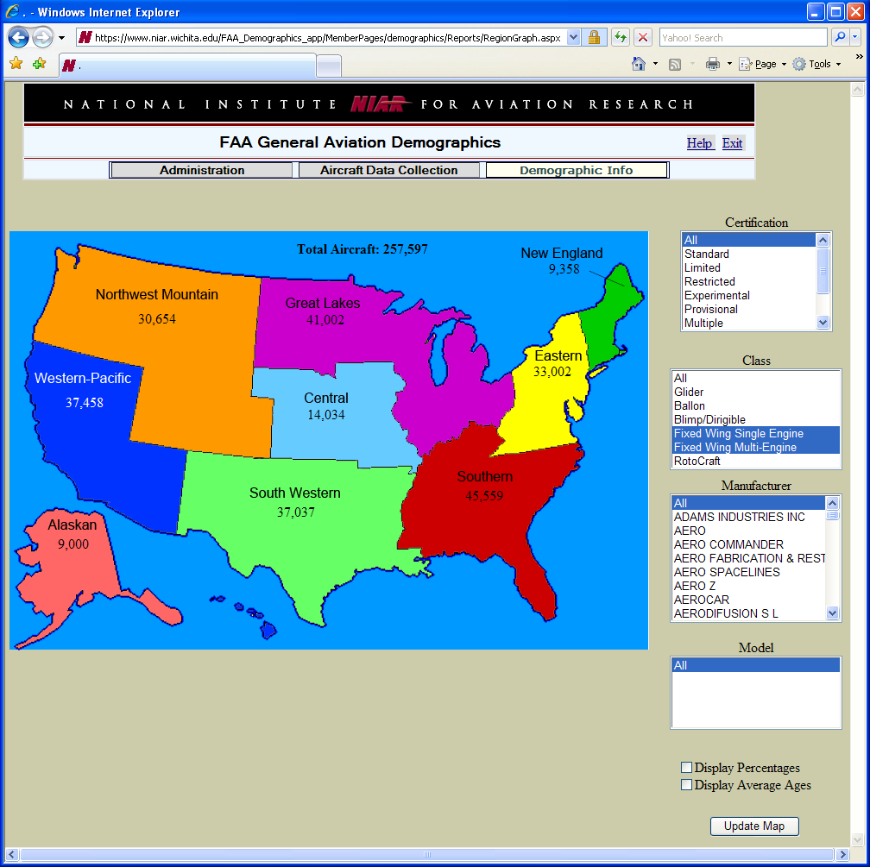

Figure 12. Graphic Display of Fixed Wing Aircraft by Region

APPENDIX A – faa general aviation demographics user manual

ADMINISTRATION MODULE
The Administration module shown in Figure 13 is used solely for administrative purposes only. The Administration module allows designated administrators to grant access for database usage. This module also allows an administrator to view users with real time access to the data.

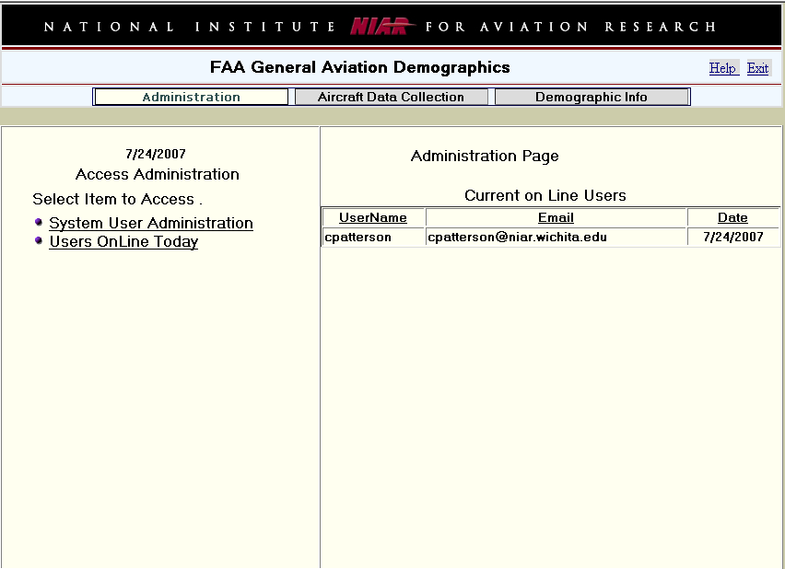
Shows current users online.
This selection allows viewing of all users. Provides option
to create new users or change user passwords.

Figure 13. Administration Module

AIRCRAFT DATA COLLECTION MODULE
The Aircraft Data Collection modules shown in Figure 14 through Figure 16 are used solely for input of data into the database for updating or creating revisions. These actions are accomplished with limited access privileges only. Be advised this module is not used to obtain a database report.

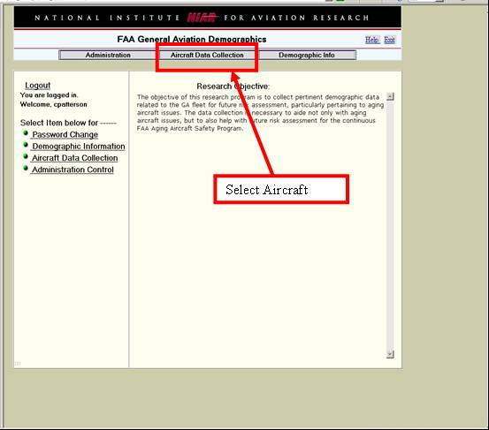

Figure 14. Aircraft Data Collection Module – Select Aircraft Data Collection

Aircraft Data Collection consists of three primary sources:

1. FAA Registry “Aircraft Reference File”

2. FAA Registry “Aircraft Registration Master File”

3. Data used to Calculate
a) Annual hours flown per aircraft
b) Annual landings per aircraft
c) Average operation weight per aircraft
d) Percent commercial usage

Selections for the Aircraft Data Collection module (ref. Figure 15) are:

1. Aircraft Reference – Displays Aircraft Reference File.

2. Aircraft by Registration – Displays a listing of aircraft registered in a specific state made by a specific manufacturer.

3. Calculated Data by Class – Allows for entry of data for a specific class of aircraft.

4. Calculated Data by Mfg/Model – Allows for entry of data for a specific aircraft selected by manufacturer and model.

5. Exclude Aircraft by Mfg/Model – Excludes aircraft from the list based on the manufacturer and model.

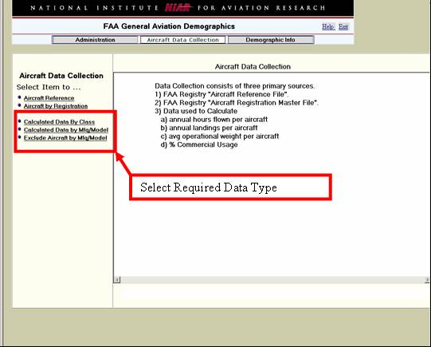

Figure 15. Aircraft Data Collection Module – Select Required Data Type

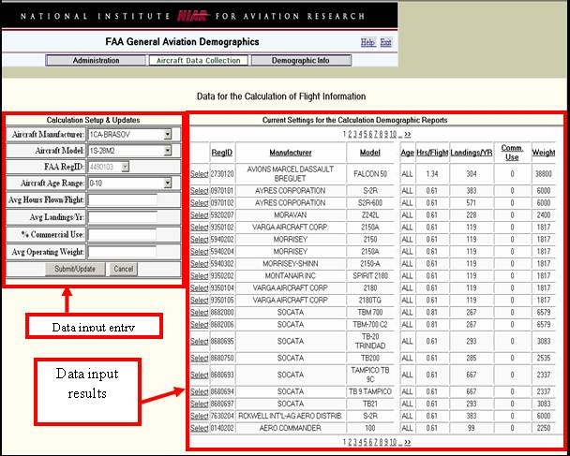

Figure 16. Aircraft Data Collection Module – Data Input Results and Entry

DEMOGRAPHIC INFO MODULE
The Demographic Info module shown in Figure 17 is the primary module for reporting data for a specific project and for building a custom report. Time to produce output will vary depending on the quantity of selections made and current database requisitions in progress. Most of the selections provide the data in a report format. The report format typically has multiple pages of data to choose from, such as, a print screen formatter, a find box and a method to extract data to a Microsoft® Excel spreadsheet or a pdf.

1. Aircraft by Manufacturer – Provides a report of the number of aircraft and aircraft models produced by ach manufacturer.

2. Aircraft by Model – Provides a report of aircraft type by manufacturer and model.

3. Aircraft by Year – Provides a report of aircraft by year of production.

4. Aircraft by Region – Provides a report of aircraft by region.

5. Aircraft by State – Provides a report of aircraft by state.

6. Percent Fleet by Make/Model – Provides a report showing individual model percentages combined with a total percentage of the entire fleet for each manufacturer.

7. Calculated Data – Generates reports that show flight hours, landings, etc., based on type of aircraft or specific manufacturer.

8. Custom Report – Provides a method to generate a custom report from the data in the database. CAUTION – If a large amount of data is selected for display, the report will take time to process. This may require patience by the requestor.

9. Graphic Aircraft by Region – Generates a data graphic for a specific region. Selections provide filters for a specific display of information.

10. Graphic Aircraft by State – Generates a data graphic for a specific state. Selections provide filters for a specific display of information.

Figure 17. Demographic Info Module

BUILDING A CUSTOM REPORT
This section is an illustrated step-by-step process of how to build a custom report using the Demographic Info module (ref. ). Begin by selecting “Custom Report” (ref. Figure 19) in the Demographic Info module.

Select data desired for your report; this may be accomplished by clicking on a title in the left box next by clicking on the arrows at the bottom and to the right of the box. After selecting all the data required for the report, next input selected criteria for particular aircraft.

For example, by inputting a manufacturer name and a year of manufacture, then title the report and click “Submit.” (Figure 20 through Figure 25 shows examples of the setup for creating a report.) This report will show the manufacturer, model of plane, and the year of manufacture. The aircraft model used in the examples will limit the sample report to Beechjet 400A aircraft built before 1980.

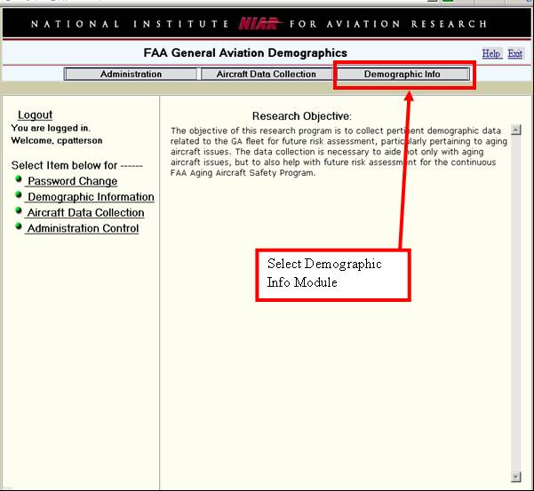

Figure 18. Creating a Custom Report – Select Demographic Info Module

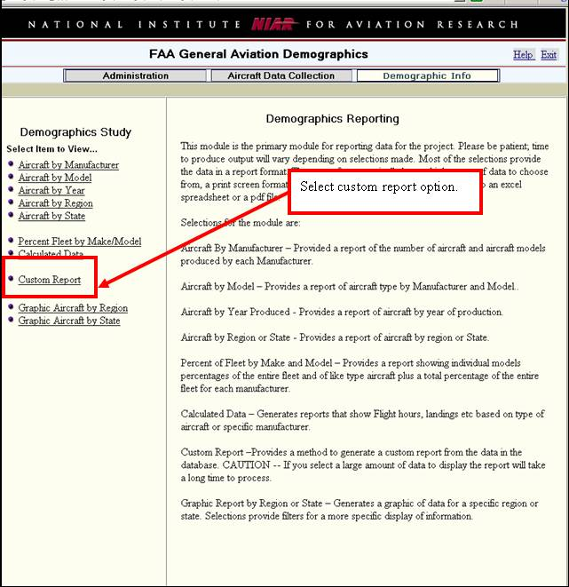

Figure 19. Demographic Info Module – Select Custom Report

Figure 20 shows an overview of the module used for creating a custom report.

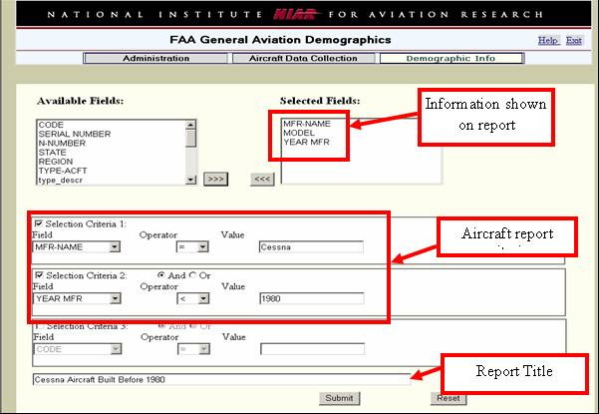

Figure 20. Demographic Info Module – Overview

Select desired data for your report; accomplish this by clicking on a title in the left box, next by clicking on the arrows at the bottom and to the right of the box as shown in Figure 21 and Figure 22.

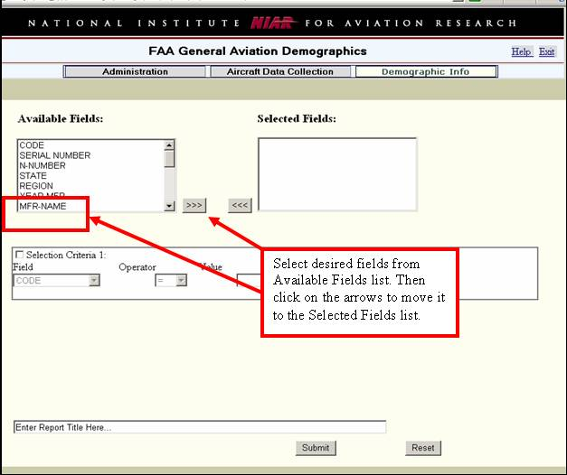

Figure 21. Demographic Info Module – Field Selection

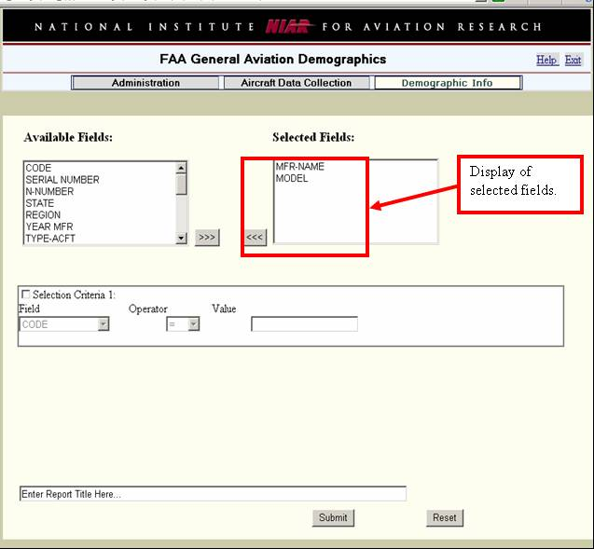

Figure 22. Demographic Info Module – Select Manufacturer Name and Model

After selecting all the data required for the report, input criteria using “Selection Criteria 1” box (ref. Figure 23) and “Selection Criteria 2” box (ref. Figure 24) for particular aircraft. A user has the option of using one or more criteria boxes.

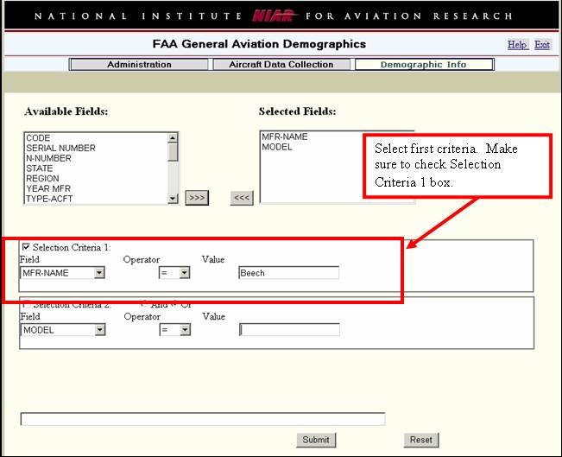

Figure 23. Demographic Info Module – Selection Criteria 1

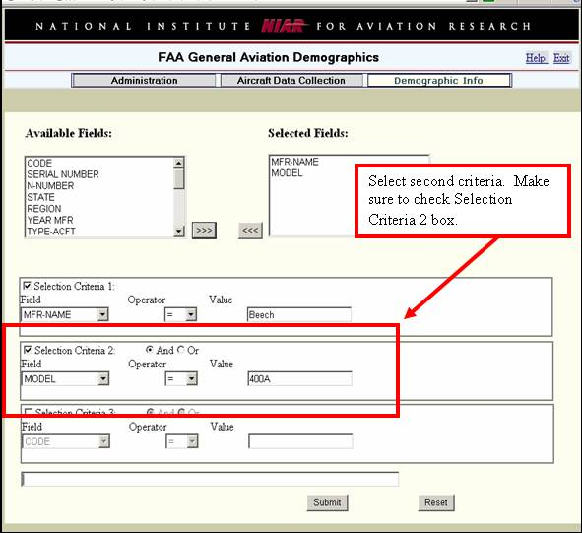

Figure 24. Demographic Info Module – Selection Criteria 2

To complete the process you must create a title for the report and click “Submit” as shown in Figure 25.

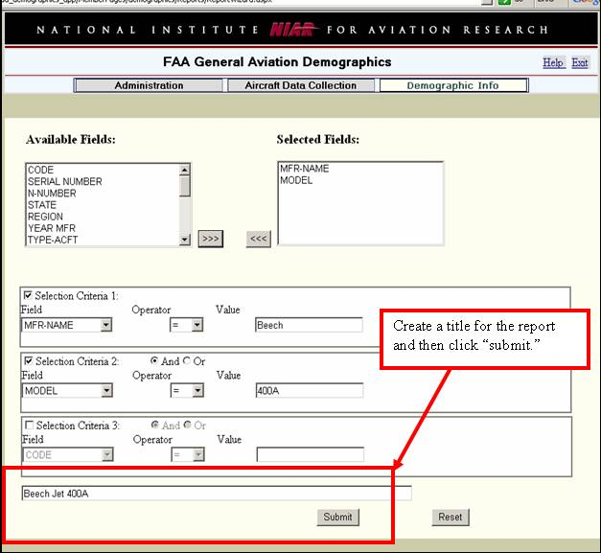

Figure 25. Demographic Info Module – Create Title and Submit

After the “Submit” button has been selected/activated (ref. Figure 25), select a report format (ref. Figure 26) by exporting gathered information to an xls or pdf format. If Microsoft® Excel format is selected, the information will be displayed as shown in example Figure 27. After data has been transferred to a Microsoft® Excel format, the data can be manipulated as desired by the user.

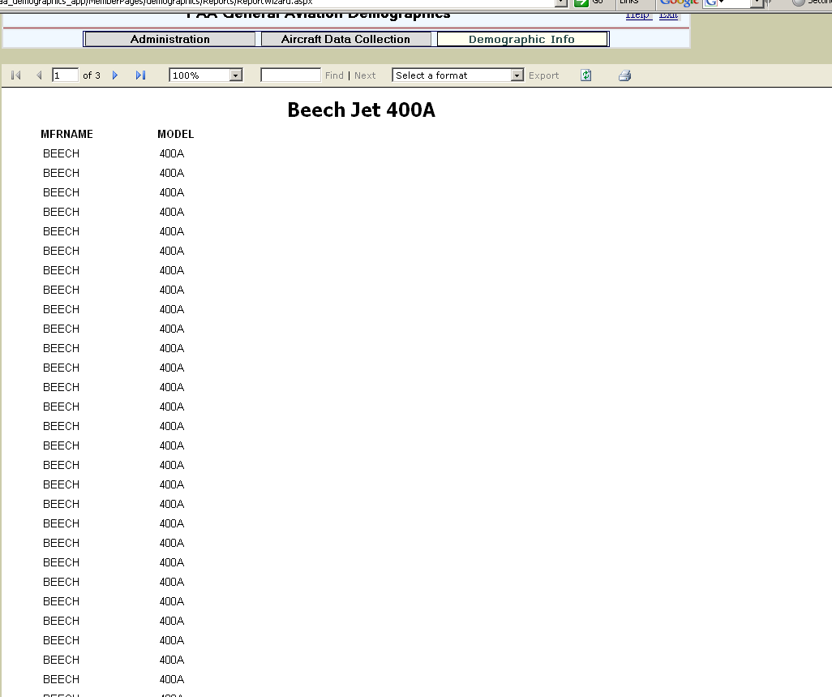
Select format for report and then click “Export.”

Figure 26. Demographic Info Module – Select Format and Export

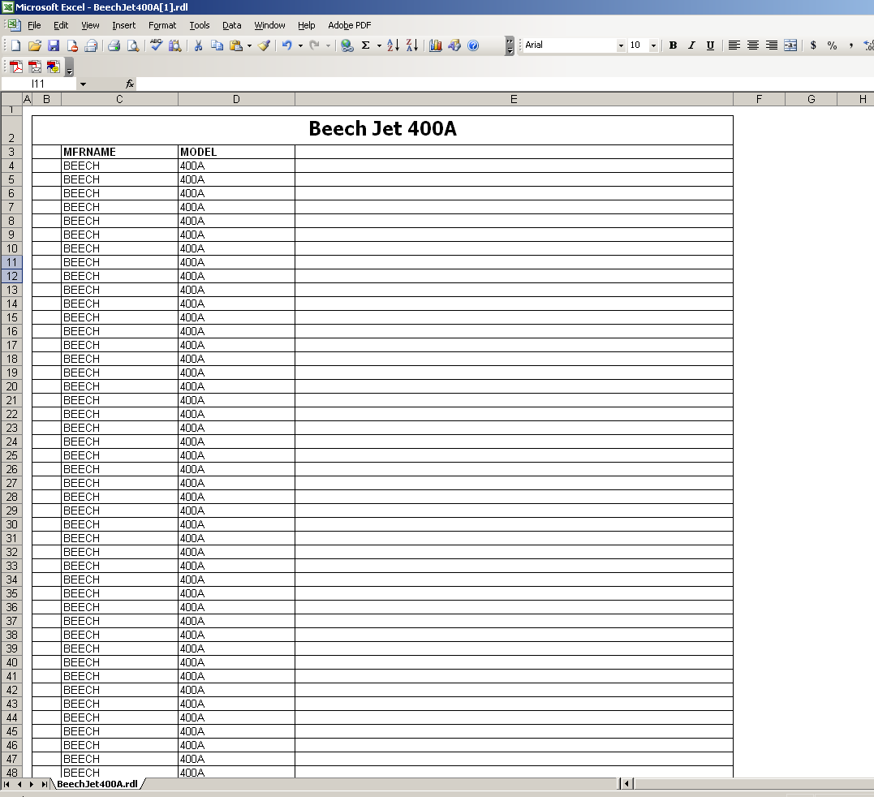

Figure 27. Database Custom Report in Microsoft® Excel Format

DEMOGRAPHIC INFO MODULE – GRAPHIC DATA
Figure 28 provides an overview graphic display model. In order to generate a graphical data report, the first step is to select the Demographic Info module (Figure 29).

Graphic Report by Region or State – Generates a graphic of data for a specific region or state. Selections provide filters for a more specific display of information. Figure 29 through Figure 39 provide systematic illustrations on how to use the demographic information. The following specific options are available.

1. Filter by Aircraft Certification (ref. Figure 31).

2. Filter by Aircraft Class (ref. Figure 32).

3. Filter by Aircraft Manufacturer (ref. Figure 33).

4. Filter by Aircraft Model (ref. Figure 34).

5. Display percentage of selected aircraft distributed with each region/state
(ref. Figure 35).

6. Display the average age of the selected aircraft within each region and overall (available on region graph only). (Ref. Figure 36.)

Figure 28. Demographic Info Module – Graphic Display Overview

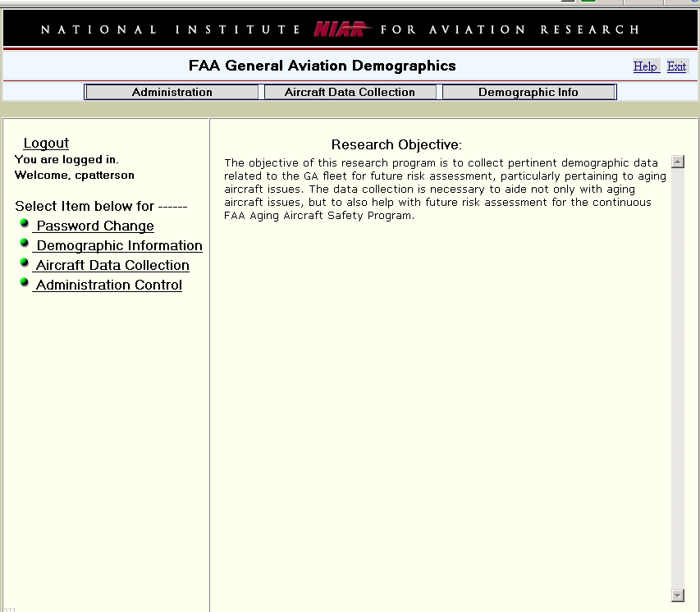
Select Demographic Info Module

Figure 29. Select Demographic Info Module

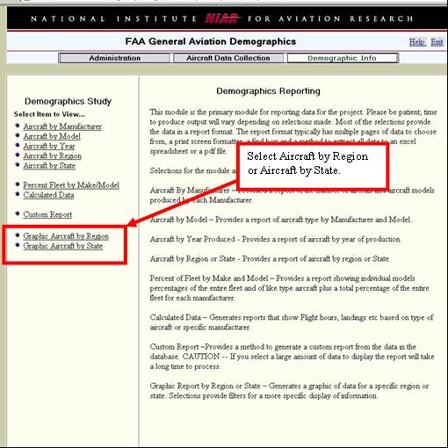

Figure 30. Demographic Info Module – Aircraft Selection by Region or State

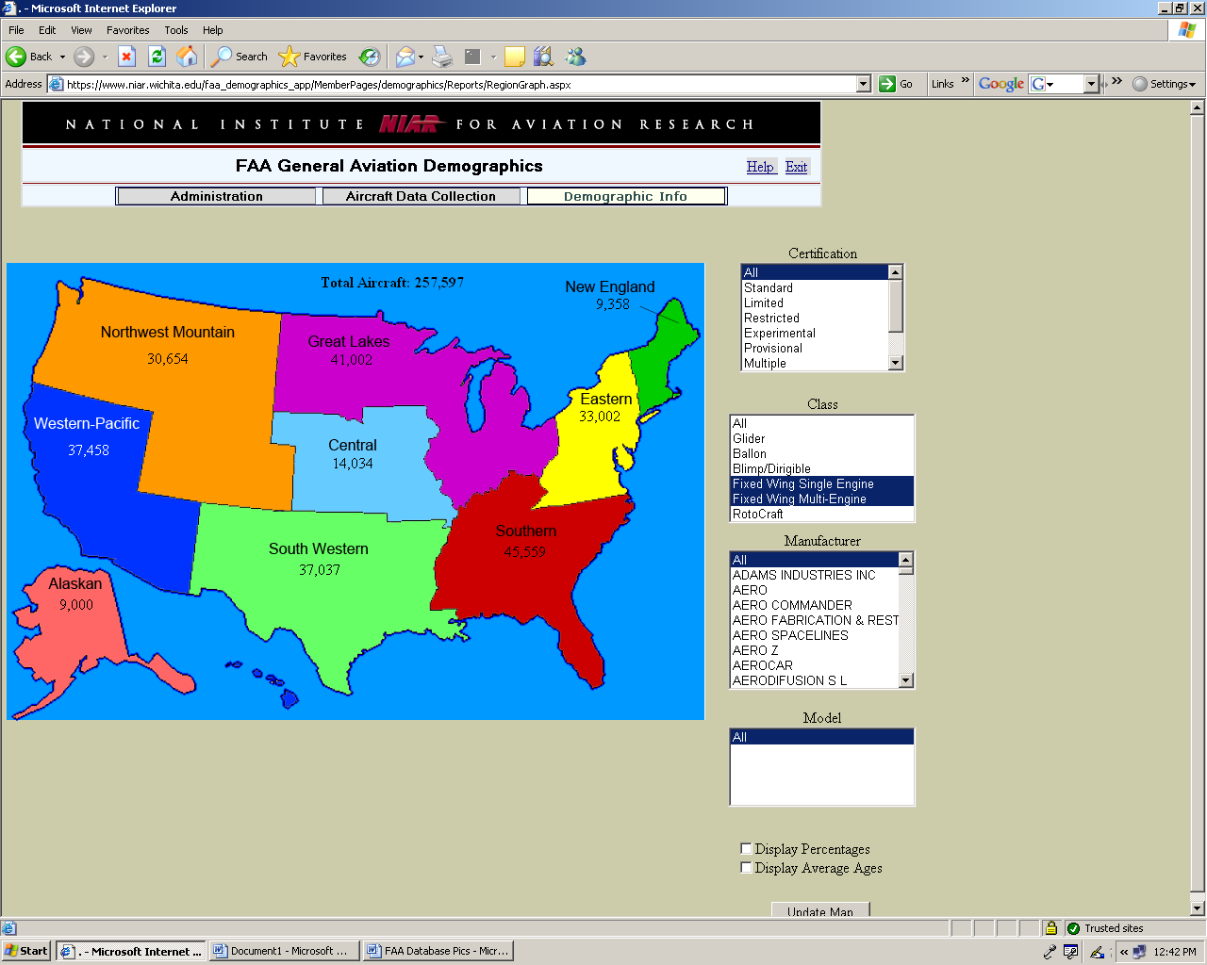
Select Certification type.

Figure 31. Demographic Info Module – Select Certification Type

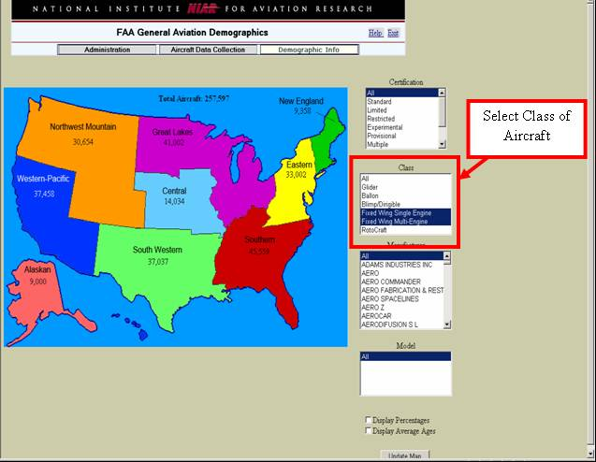

Figure 32. Demographic Info Module – Select Class of Aircraft

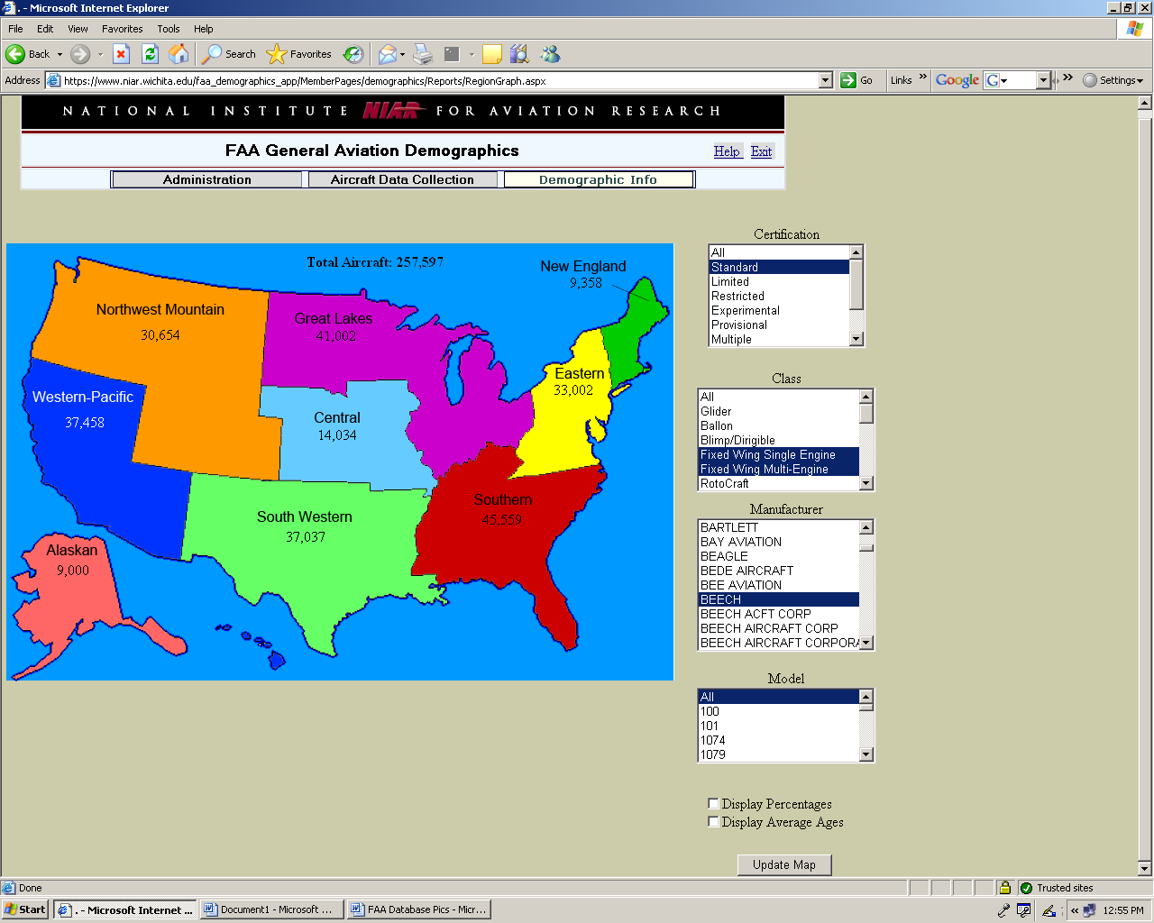
Select Aircraft Manufacturer.

Figure 33. Demographic Info Module – Select Aircraft Manufacturer

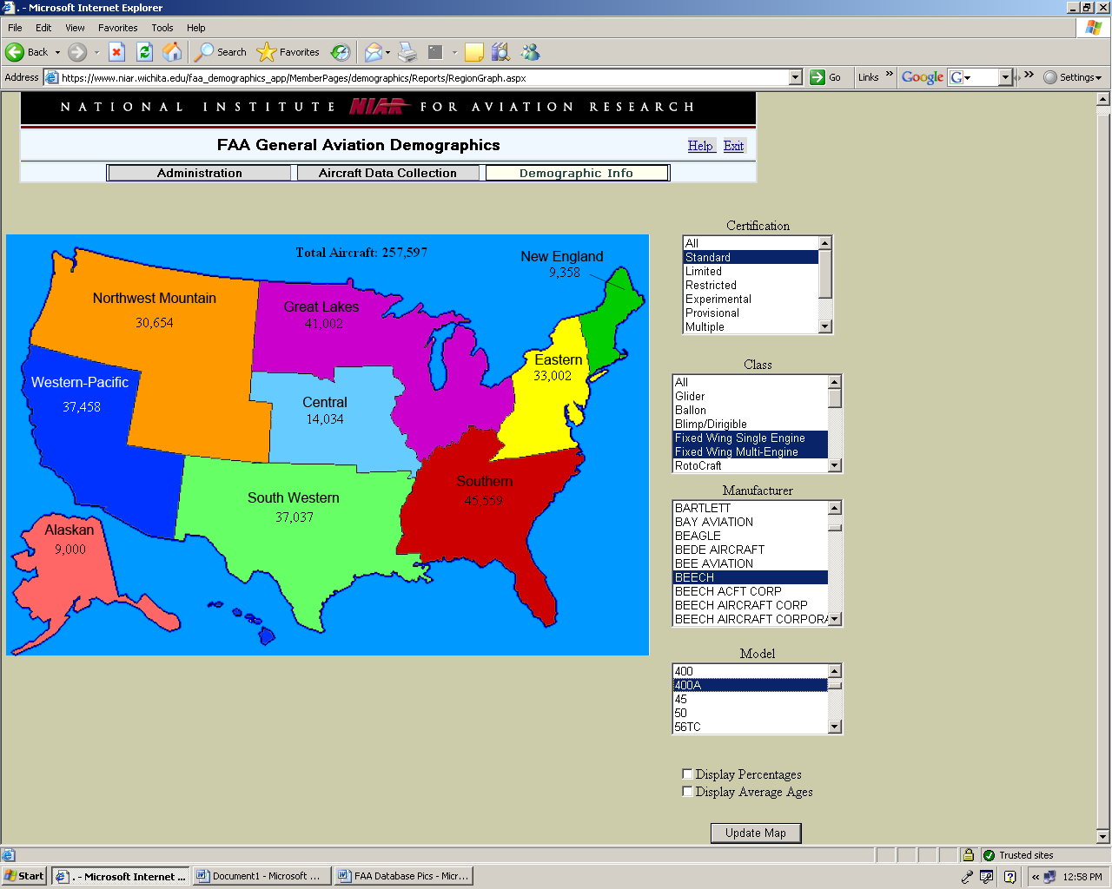
Select Model of Aircraft.

Figure 34. Demographic Info Module – Select Model of Aircraft

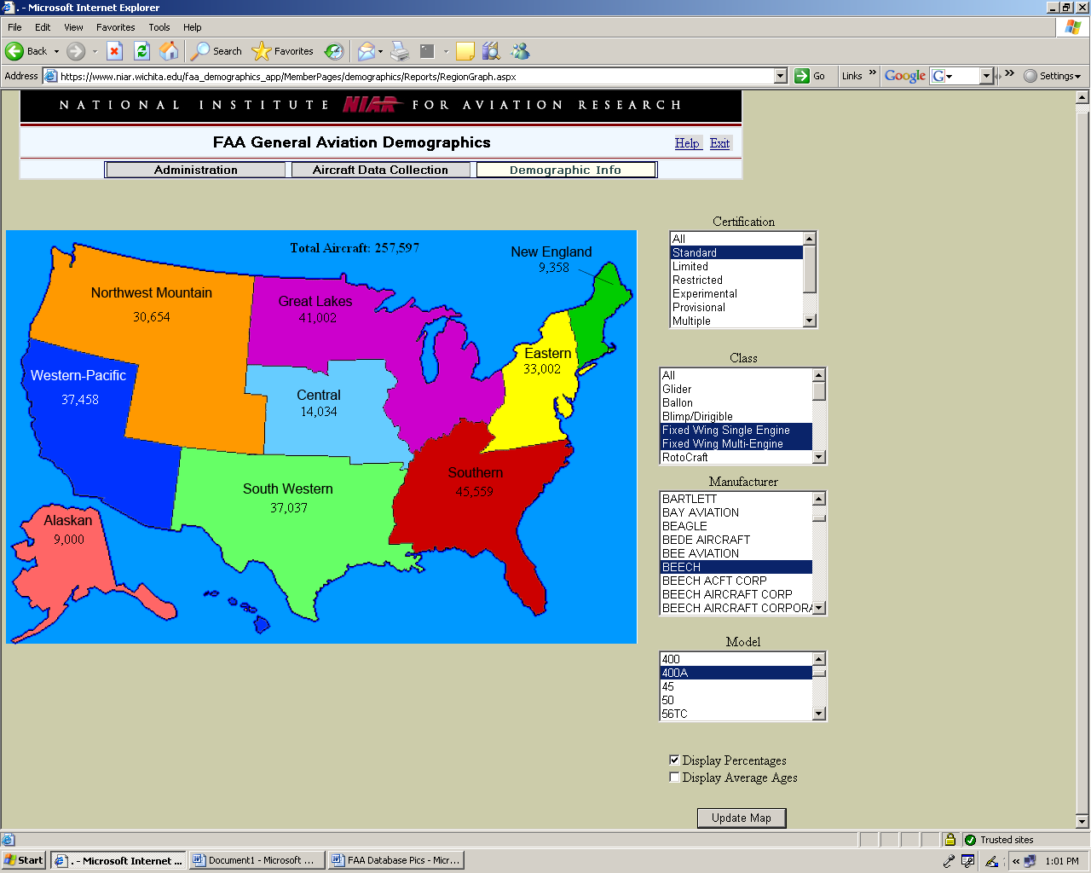
Select data to be displayed; then select “Update Map.”

Figure 35. Demographic Info Module – Query Results

Graphical data may be displayed in either “Total Number of Aircraft” or by “Total Percentage of Aircraft” or both. The sample in Figure 36 illustrates the total number of Beech 400A aircraft registered in the United States, while the example in Figure 37 shows the percentage of Beech 400A aircraft registered in the United States.

Be aware that some models such as the Beech 400A are manufactured under a different manufacturer, for example Raytheon 400A (ref. Figure 38 and Figure 39).

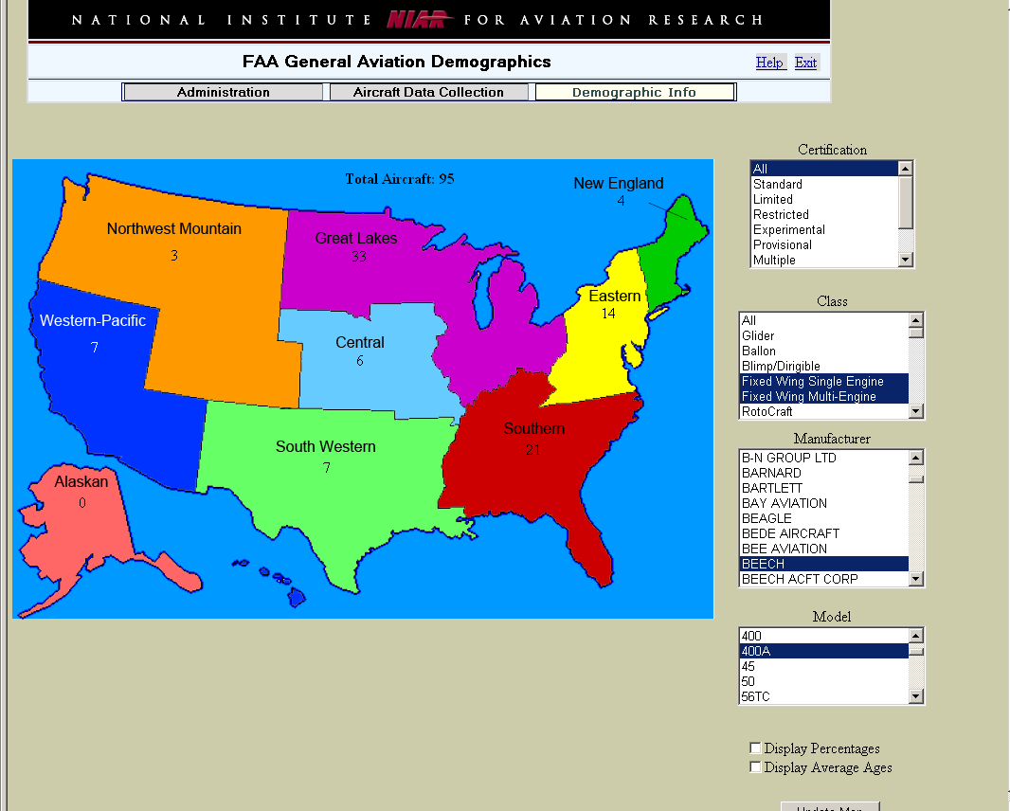

Figure 36. Demographic Info Module – Totals for Beech 400A

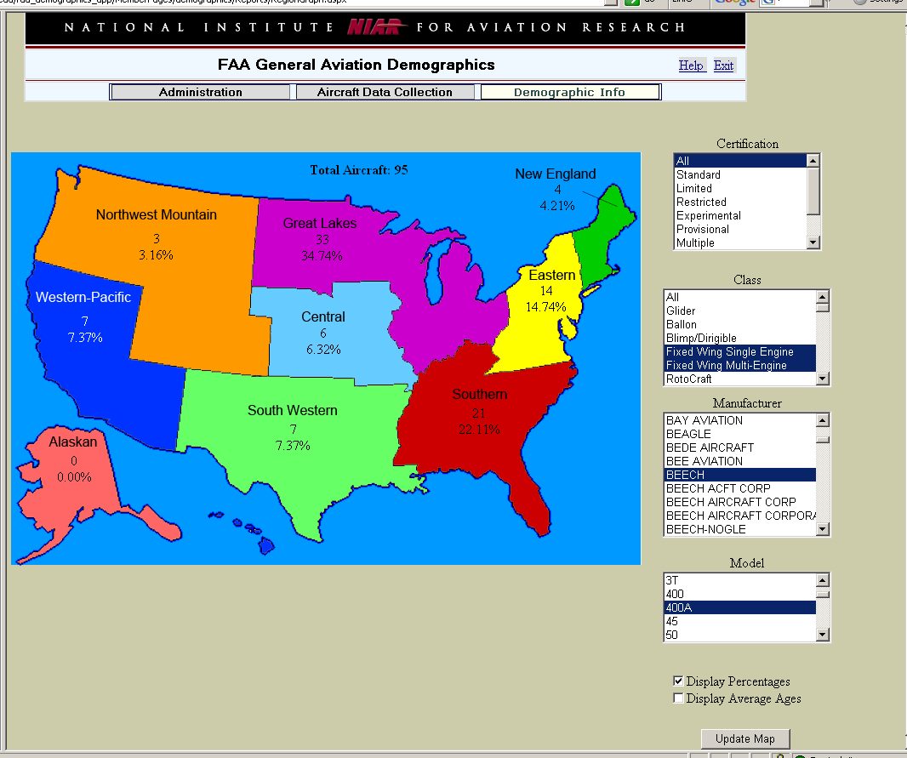

Figure 37. Demographic Info Module – Percentages for Beech 400A

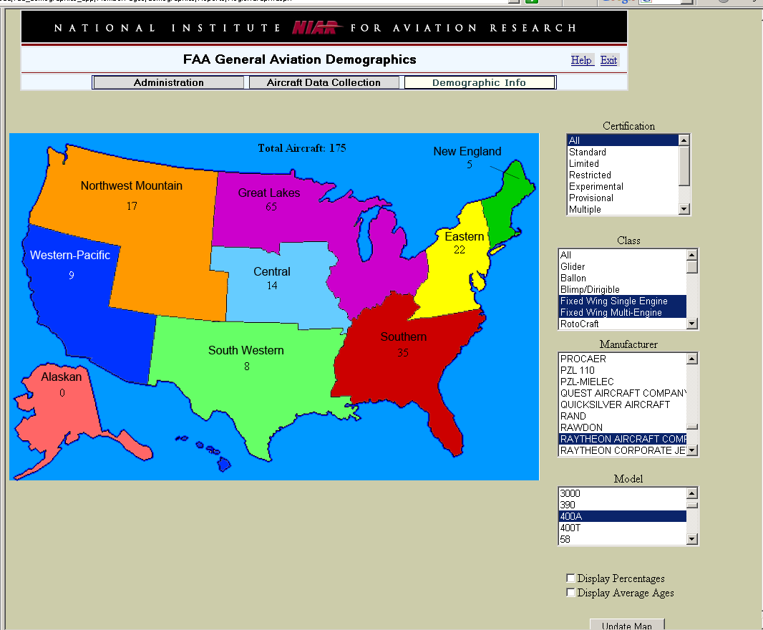

Figure 38. Demographic Info Module – Totals for Raytheon 400A

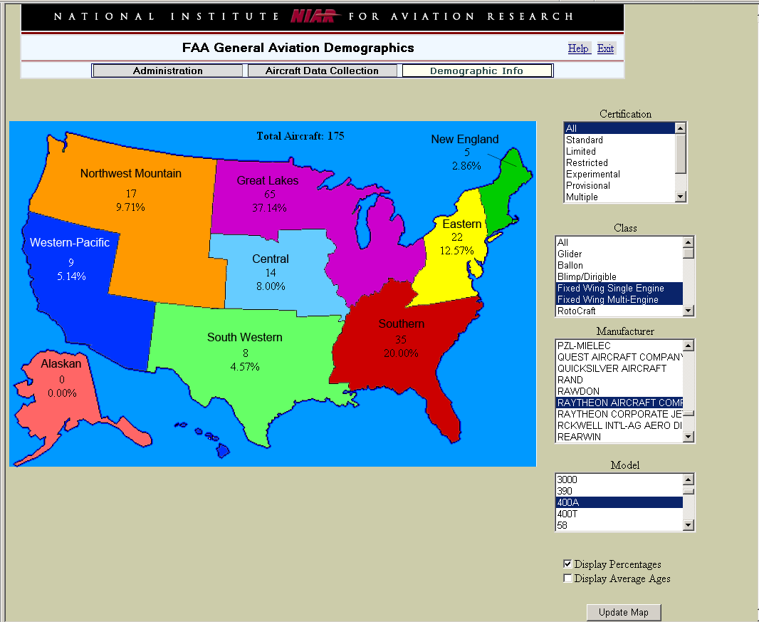

Figure 39. Demographic Info Module – Percentages for Raytheon 400A

