Promoting Good Nutrition in
Tribal Head Start & Early Head Start Programs
(0-5 years old)

A Hands-on Cooking Workshop

March 10 - 13, 2008
April 22-24, 2008
May 13 - 15, 2008
Santa Fe, NM

Sponsored by the IHS National Head Start Program

Who should attend?

This workshop is designed for cooks, nutrition coordinators and teachers working in Tribal Head Start Programs serving American Indian/Alaska Native children ages 0-5 years.

There will be three full days of cooking, lectures and group discussions. Those applying for the workshop must be willing to attend the full 3-day (8:00 a.m. to 4:30 p.m.) workshop. Only those committed to attend the full workshop will be considered for selection.
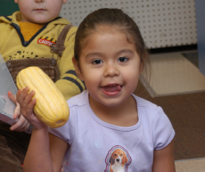
`
What will you learn?

● Your job & the Head Start Performance Standards
● Ways to cook healthier!
● Create meals that “put smiles on their faces!”

● Put the “yummy” back in your meals with seasonings
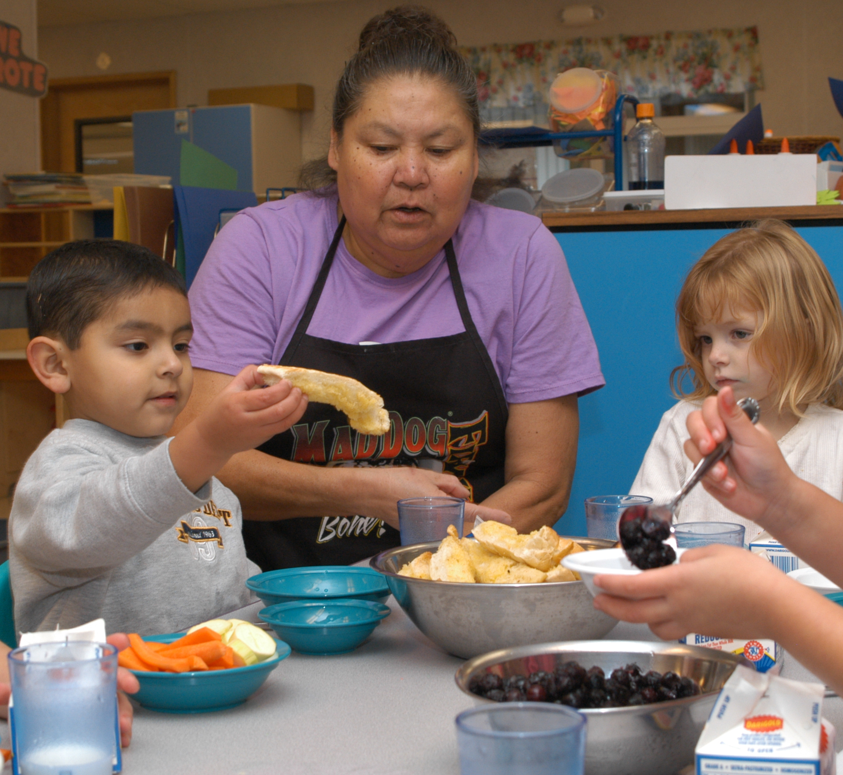
● Save time, effort and money through menu planning
● Keep your children safe from food borne illnesses
● Fun Nutrition Education Activities to play with your children

About the Instructor:
Letitia Sherman, RD, MEd, received her Bachelor of Science in Food Service from the University of California, Davis and her Masters of Education from Phillips University in Oklahoma. Letitia (Tish) received her Culinary Education Certification from the American Culinary Federation. She works with New Mexico's Long Term Care facilities and also works with New Mexico's Head Starts. Tish was the recipient of the “Chef of the Year” award in 1995 from the American Culinary Federation Rio Grande Chapter of New Mexico. Tish is one of our most popular and enjoyable instructors.

How to Apply:

- Complete the application form, read/sign the certification & have your supervisor sign/date.
- Fax or email your completed application to (505) 248-7728 or IHSheadstart@ihs.gov, no face sheet is needed.
3. Call (505) 248-7694 to confirm your fax was received. You will be notified in writing (or via e-mail) regarding selection and travel details 4-6 weeks prior to the workshop. Do NOT make non-refundable airline reservations until you have confirmed your acceptance into the class.
4. Participants are responsible for their own travel, meals and miscellaneous expenses.
THERE IS NO REGISTRATION FEE TO ATTEND THESE WORKSHOPS.

application form is on the back of this announcement

PGN Tribal Head Start Programs (0-5 y.o.):
A Hands-on Cooking Workshop

Make copies of this Blank Form

Which workshop are you applying to attend? (Please check next to date):

March 10 - 13, 2008

April 22 – 24, 2008

May 13 – 15, 2008

Your Name:
(Verify your information! Wrong information causes delays in application processing.)

Job Title:
TYPE OR PRINT CLEARLY, USE BLACK INK
Name of Program:

Work Address:

City: State: Zip:

Work Phone: Work Fax:

Your E-mail address:

Local tribe(s) that your program serves, (please be specific, do NOT put “All US Tribes”):

Print or type Supervisor’s Name and Title:

Supervisor’s Signature and date signed:

Supervisor’s Phone # if different from applicant’s:

CERTIFICATION

"If selected to attend, I certify that I am committed to attend the FULL 3 DAY workshop, (8:00 a.m. - 4:30 p.m.), and will not make my return airline reservation earlier than 7:00 p.m. on the last day of the workshop."

Your Signature Date

Call to confirm your fax was received. No face sheet is necessary when faxing this form.

IHS National Head Start Program
801 Vassar Dr. NE., Albuquerque, NM 87106
(505) 248-7694
Fax: (505) 248-7728 or email:
IHSheadstart@ihs.gov

