PLANT MATERIALS SPECIALIST REPORT OF PLANTS IN FIELD PLANTINGS

R. J. Joy, Plant Materials Specialist

July 2003

This report includes a summary of promising species in field plantings. It serves as a guide to field office personnel when considering plants for new field plantings.

Information gained from field plantings is incorporated into the Field Office Technical Guide (FOTG) to make it more useful. New cultivars or varieties that are released through our Plant Materials Program depend on the data collected from field plantings to support and document their release. The field planting is the final phase of testing in the plant materials systematic testing process. It is where a new plant is tested on a farm or other site under actual use conditions. Field office personnel may request a field planting of any of the species described in this report from the Plant Materials Specialist.

The excellent cooperation between plant materials and field office personnel in the Pacific Basin Area and Hawaii has enabled us to maintain a viable Plant Materials Program. We look forward to the continued high interest in plant materials by our field people who are so important to the success of the program.

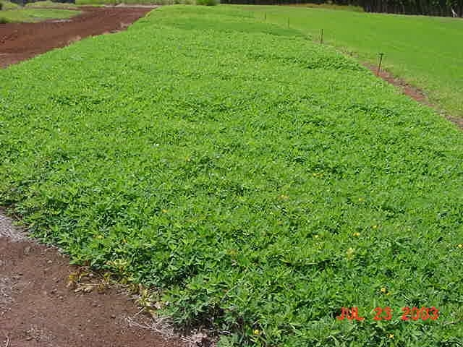 Arachis glabrata (forage peanut): Forage or perennial peanuts are creeping, low growing legumes native to Brazil and make a dense cover. They are somewhat slow to establish and spread. They may be grazed and are useful as low maintenance, permanent covers for erosion control and beautification. They have yellow flowers and although Arachis glabrata accessions don’t flower as much as the commercially available cultivars of Arachis pintoi such as Golden Glory, Amarillo and Forrajero, they are not as susceptible to leaf yellowing caused by spider mites. Propagation is by rhizomes since very little seed is produced.
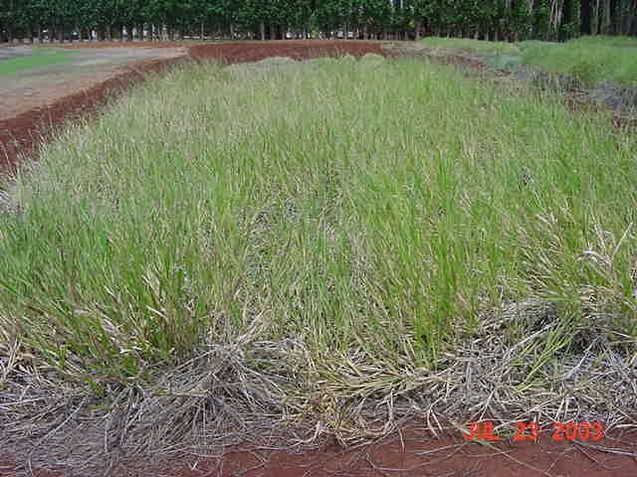
Brachiaria brizantha syn. Urochloa brizantha, Brachiaria decumbens (signalgrass): Signalgrass is a perennial, stoloniferous pasture grass that is resistant to the yellow sugar cane aphid, which can be severe at times in Hawaii. The aphid can significantly reduce yields of other pasture grasses such as kikuyu. Signalgrass grows well on the limestone soils of Guam and Tinian. It is propagated by seeds or stolons. According to the PLANTS Database, the genus has been changed from Brachiaria to Urochloa. A fact sheet on signalgrass can be found on the Web site http://www2.ctahr.hawaii.edu/oc/ under Free Publications, Livestock Management.
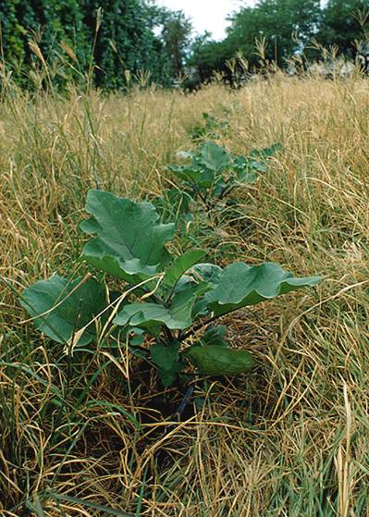
Chloris gayana (rhodesgrass): Rhodesgrass is a perennial, drought tolerant, erect bunchgrass with long stolons that root at the nodes. It is naturally adapted to areas that receive between 24 and 40 inches of rainfall annually. It has long been a popular grass for grazing in these areas. Because it is stoloniferous, it is useful for critical area plantings, as a cover crop and as living mulch for vegetable and other crop production. It is pictured here as a living mulch in zucchini. Although it may not persist in high rainfall areas, it will grow and may have application as living mulch in vegetable production where it would be re-seeded periodically. It is tolerant of high salinity and pH. Seeds are available commercially. Seeds of the cultivar Bell are produced in Texas while Nemkat and Katambora are from Australia. Nemkat is resistant to root-knot nematodes and Katambora is resistant to reniform nematodes. A fact sheet on rhodesgrass can be found on the Web site http://www2.ctahr.hawaii.edu/oc/ under Free Publications, Sustainable Agriculture, Cover Crops.

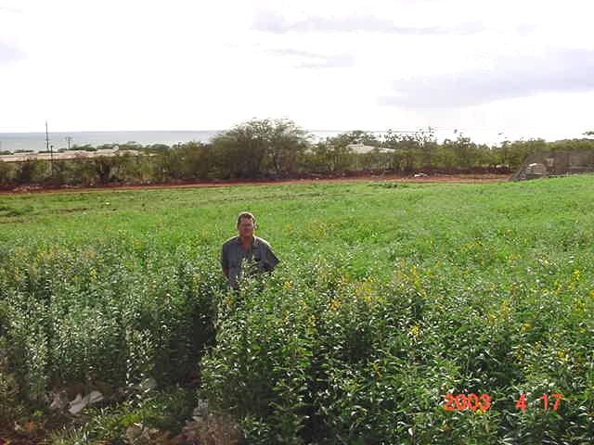
Crotalaria juncea (sunn hemp): Sunn hemp is an erect, annual legume that grows well throughout the Pacific Basin Area and Hawaii. The cultivar Tropic Sun is an excellent cover/green manure crop and is resistant to root-knot and reniform nematodes. It is popular with organic farmers for soil improvement and nematode control. On the Mainland, sunn hemp is used in California and the South. The restrictions on the use of methyl bromide have increased its popularity because of its ability to control nematodes. The Plant Materials Center (PMC) on Molokai has seed available of Tropic Sun for demonstration type field plantings and seed increase plantings. A fact sheet on Tropic Sun can be found on the Web site http://www2.ctahr.hawaii.edu/oc/ under Free Publications, Sustainable Agriculture, Green Manure Crops. In addition, each field office should have copies of the USDA Program Aid 1335.
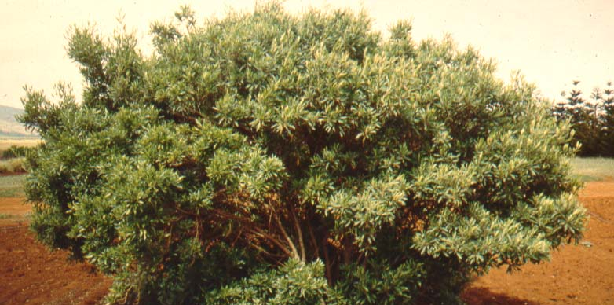
Dodonaea viscosa (‘a’ali’i, lampuaye): A widely adapted indigenous shrub that is native to Hawaii and naturalized in the Northern Marianas. It is a good windbreak, hedge and screen plant. It grows to a height of approximately 10 to 20 feet, depending on the amount of moisture it receives, and has a moderate growth rate. It is propagated by seed and its attractive seed capsules make colorful leis. We have released a source identified selection collected on Molokai referred to as Kamiloloa Germplasm ‘A’ali’i.
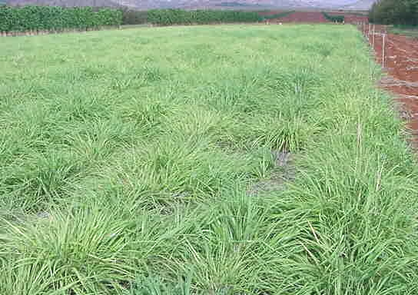
Eragrostis variabilis (‘emoloa, kawelu, lovegrass): ‘Emoloa is a perennial bunchgrass that is endemic to Hawaii. It is an attractive grass that is found on all the main islands and the Northwestern Hawaiian Islands as well. The native Hawaiians sometimes used ‘emoloa as an alternative to piligrass for thatching their houses. It occurs on coastal dunes and grasslands, open sites in dry forests and on exposed cliffs up to approximately 3,600 feet. It shows promise for erosion control on critical areas, restoration and beautification. It may be somewhat short lived. It is propagated by seed.
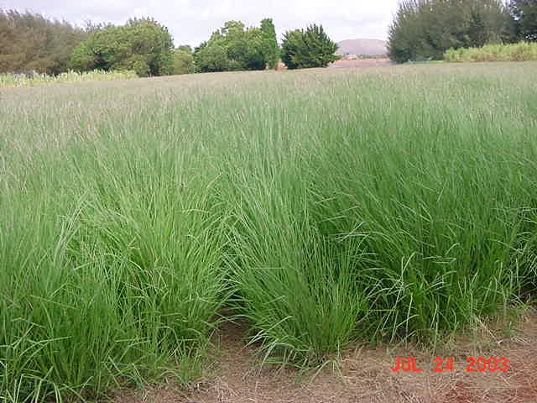
Heteropogon contortus (piligrass, tanglehead): Piligrass is indigenous to Hawaii and is widely distributed in the tropics and subtropics. The native Hawaiians used it to thatch their houses and other buildings in dry areas. It is a drought tolerant bunch grass that is currently being used for erosion control and restoration on the Hawaiian island of Kaho’olawe. The piligrass pictured was collected on Kaho’olawe and has recently been formally released as Kaho’olawe Germplasm Piligrass Source Identified Class of Natural Germplasm. It is propagated by seed.
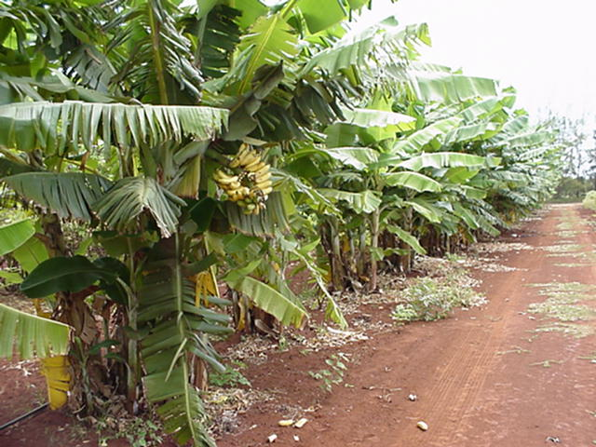
Musa sp. (dwarf Brazilian banana): The cultivar Santa Catarina Prata is a delicious dessert banana that has enough wind tolerance to be used as a windbreak. It was brought to Hawaii from Brazil by Dr. Leng Chia of the University of Hawaii. We began testing it as a windbreak because of requests from Pacific Basin Area farmers for multipurpose windbreaks. The University of Guam is evaluating it as a firebreak. It has performed well wherever it has been planted in the Pacific Basin Area and Hawaii. The bananas are well accepted in the produce markets. Propagation is by corms.
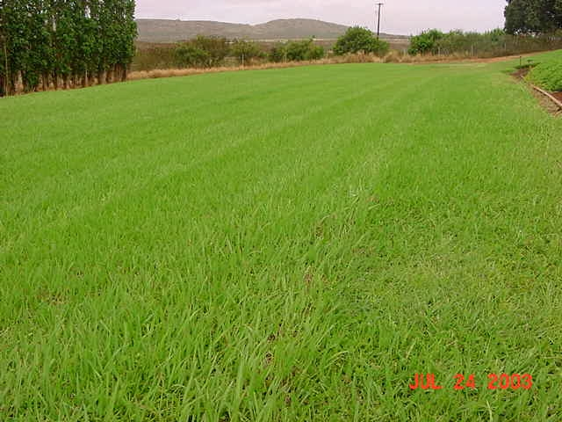
Paspalum hieronymii (paspalum): The cultivar Tropic Lalo is widely adapted in Hawaii and the Pacific Basin Area. It is a perennial, creeping grass that forms a dense cover when mowed. It is tolerant of traffic and is low maintenance. It is used for waterways, terraces, farm roads, lawns and as a cover crop in orchards. It produces very little seed so propagation is by stolons. Tropic Lalo has become a standard recommendation for erosion control in Hawaii and, therefore, field plantings are warranted only for special applications. The PMC will provide small amounts for growers to increase their own planting material for conservation plantings if material isn’t available commercially. The Pacific Basin Area is in need of more field plantings. A fact sheet on Tropic Lalo can be found on the Web site http://www2.ctahr.hawaii.edu/oc/ under Free Publications, Turf Management and Sustainable Agriculture, Cover Crops.
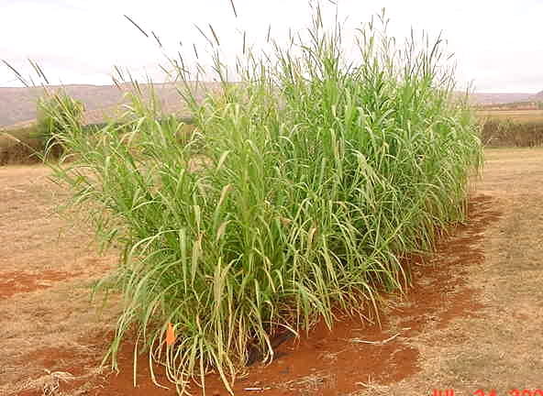
Pennisetum purpureum (hybrid napiergrass or elephantgrass): Napier hybrids and hybrids of napier and pearl millet are sterile. ‘Mott’ is a hybrid napier cultivar that was released by the University of Florida. It is very leafy and makes good forage for cut and carry or grazing. A PMC developed hybrid (HA-5690) is a cross between bannagrass, a tall napier, and a male sterile pearl millet. HA-5690 performed well on a slope planting using the live fascine technique. A napier x pearl millet hybrid called PMN Hybrid (pictured) was developed by the Hawaiian Sugar Planters’ Association for the USDA-ARS Georgia Coastal Plain Experiment Station. It was developed for forage and has thinner stems than other napiers. All of these tall grasses have promise for windbreak, vegetative barrier and forage. They are propagated by stem cuttings and planted in furrows, similar to sugar cane.
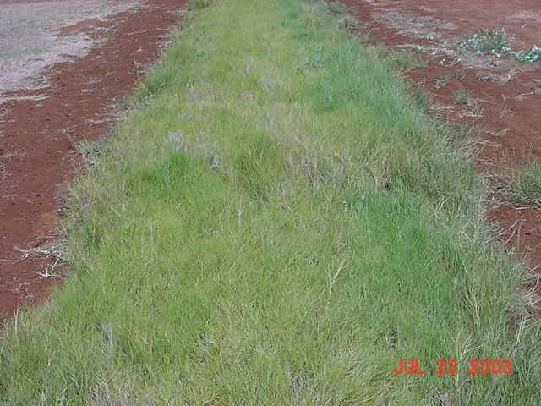
Sporobolus virginicus (totoput, ‘aki’aki, seashore rushgrass): An indigenous, creeping, perennial grass that is propagated by rhizomes. It is native to sandy, usually coastal, sites in tropical and subtropical areas worldwide. It is usually found just above the high-tide mark. It will grow up to 1,000 feet in elevation but the soil must be fairly loose for the rhizomes to spread. It is drought tolerant and very salt tolerant and should be useful for shoreline, stream bank and critical area stabilization. There is a vigorous stand on the beach near Garapan, Saipan. The most promising accession in Hawaii (HA-4846) was collected from Papohaku Beach on the west end of Molokai.
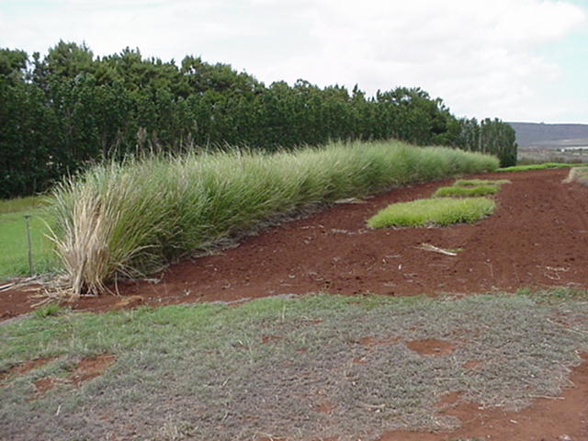
Vetiveria zizanioides, syn. Chrysopogon zizanioides (“Sunshine” vetivergrass): This tall bunch grass from Sunshine Louisiana is sterile. Its main use is as a vegetative barrier (FOTG Practice Code 601) for erosion control. It is planted as a vegetative barrier on Guam, Saipan, Maui and Oahu. On the island of Hawaii, it is stabilizing waterway outlets. Vetivergrass is native to India. It has a strong root system that contains an essential oil used in making perfume. The World Bank has promoted the use of vetiver for erosion control in developing countries. Propagation is by plantlets or slips produced by dividing the crown of a mature plant. According to the ARS Germplasm Resources Information Network (GRIN), the genus Vetiveria has recently been changed to Chrysopogon. More information may be obtained from the vetiver publication located in each field office.

