MINUTES OF THE NUTRITION COORDINATING COMMITTEE (NCC)
MEETING, NATIONAL INSTITUTES OF HEALTH (NIH)
Rockledge 2, Conference Room 9100-9104, Bethesda, MD
November 2, 2006 2:00- 4:00 PM

WELCOME
Dr. Van Hubbard, Director, Division of Nutrition Research Coordination (DNRC), convened the meeting at 2:05 PM and welcomed participants. Participating via phone were Ms. Jean-Charles Azure, IHS; Dr. Shirley Blakely, FDA; Ms. Tammy Brown; COL Karl Friedl, DOD; Dr. Deborah Galuska, CDC; Dr. Patricia Guenther, USDA CNPP; Dr. James Herrington, NIH FIC; Dr. Christine Hunter, NIH NIDDK; Dr. Marguerite Klein, NIH NCCAM; Dr. Molly Kretsch, USDA; Dr. Marshall Plaut, NIH NIAID; Dr. Dan Raiten, NIH NICHD, Dr. William Riley, NIH, NIMH; Ms. Denise Sofka, HRSA; Dr. Cynthia Tuttle, USDA CSREES; and Ms. Dorothea Vafiadis, USDA CNPP. The agenda for the meeting is provided as Appendix A, and the list of attendees is provided as Appendix B.

APPROVAL OF MINUTES FROM THE OCTOBER 5, 2006 NCC MEETING
Minutes from the Oct 5, 2006 NCC Meeting had previously been sent to NCC members via email. Dr. Hubbard asked if there were any other corrections to the minutes. There were none. Dr. Mary Frances Picciano, Office of Dietary Supplements (ODS), made a motion to approve the minutes, and Dr. Sue Krebs-Smith, National Cancer Institute (NCI), seconded the motion. The minutes were thus approved and will be posted on the DNRC website, http://www.dnrc.nih.gov, along with the minutes from previous NCC Meetings.

LARGEST LONG-TERM STUDY OF HEALTH AND DISEASE IN HISPANIC/LATINO POPULATIONS
Dr. Larissa Avilés-Santa, NHLBI, presented information about the Hispanic Community Health Study that will begin recruitment starting in 2007. The Hispanic/Latino population is the largest minority group in the U.S., yet it is both underserved and understudied. In addition, researchers are interested in understanding the Hispanic Paradox, in which most Hispanic groups are characterized by low socioeconomic status, yet have better than expected health and mortality outcomes. Determining if this paradox is true, if it applies to every Hispanic/Latino group, and to gather more information regarding the protective and predisposing factors that are not currently well understood form the basis for this study.

The specific aims are to identify CV risk factors through baseline medical history and examination, compare these CV risk factors cross-sectionally, make longitudinal comparisons of changes in health status and outcomes, and to determine the role of acculturation on the onset or progression of disease. The target population includes Hispanics and Latinos living in the U.S. who are between the ages of 18 – 74. The study will be carried out in 4 different locations: San Diego, Chicago, Miami, and New York. Each study location will have a goal of recruiting 4,000 participants. The study duration will be 6.5 years.

Each participant will undergo an extensive baseline evaluation, which will include anthropometrics, an electrocardiogram, an oral glucose tolerance test, pulmonary function testing (spirometry), sleep studies, acculturation measures, and a nutritional assessment as well as many other procedures. Annual personal and telephone contact will be made to record changes to health status and adverse events. With such rich data, there will be opportunity for various ancillary studies.

Further details about the study can be found in Dr. Avilés-Santa’s presentation, which is attached in Appendix C.

SEAFOOD CHOICES: BALANCING BENEFITS AND RISKS
Dr. Susan Krebs-Smith, NCI, gave a summary of the recently released IOM report on "Seafood Choices: Balancing Benefits and Risks." The report was commissioned by the National Oceanic and Atmospheric Administration with additional support from the Food and Drug Administration. It covers US consumption patterns and composition of seafood; health benefits; health risks; analysis of the balance between benefits and risks; and understanding consumer decision making as the basis for the design of consumer guidance. The benefits of seafood consumption are that it provides a source of high quality protein; is low in saturated fatty acids; and may confer developmental benefits to infants and reduce risk of cardiovascular disease among adults. The risks include the exposure of pregnant women to methyl mercury and exposure of the general population to persistent organic pollutants and microbiological hazards. Several examples of how to provide integrated information to consumers were presented. Copies of the report can be viewed/purchased from www.nap.edu.
Federal employees can order a free copy of any National Academies report from http://www7.nationalacademies.orga/RequestReport.asp. The report fact sheet is available in Appendix D.

In response to Dr. Krebs-Smith’s presentation, a further discussion of fish ensued. Marshall Plaut, NIAID, brought up a concern about seafood allergies and how, if at all, this would affect recommendations. To clarify any confusion regarding the prevalence of seafood allergies, Dr. Plaut provided the following information for the minutes. The prevalence in the general population is 2.3%, which is more common than previously appreciated and represents the most common form of food allergy in adults. The prevalence in the general population is 0.4% to fish, 2.0% to shellfish and 0.2% to both. Seafood allergy is less common in children (0.6%) than adults (2.8%) (J Allergy Clin Immunol 2004; 114: 159-65).

HHS GUIDELINES ON PHYSICAL ACTIVITY
CAPT Rick Troiano, ODPHP/OS, provided a follow-up to the October meeting when he informed the NCC that IOM would be holding a workshop to address the question of whether sufficient scientific evidence was available to serve as the basis of comprehensive physical activity guidelines. This meeting took place on October 23rd and 24th (http://www.iom.edu/CMS/3788/36887.aspx ), and a report from the meeting should be available from IOM early in 2008. In summing up the meeting, it was noted that there was a lot of variability in the strength of evidence across conditions, subgroups and outcomes. However, it was clear that extensive strong evidence exists on the relationship between physical activity and major chronic disease conditions in adults and older adults. The synthesis of these studies reassured the Department that it was time to proceed.

On Thursday, October 26, during his luncheon speech at the fourth National Prevention Summit, Secretary Leavitt announced that the Department would develop comprehensive physical activity guidelines. The physical activity guidelines were the focus of the press release on the Secretary’s speech (available at http://www.hhs.gov/news/press/2006pres/20061026.html).

Dr. Troiano stated that the Department is now moving ahead with next steps that will lead to the development of guidelines. A Federal Advisory Committee will be created and a systematic literature review will be conducted for use by the Committee. The federal steering group is developing a list of desired content areas to be covered in the Committee. Once this is complete, members of the federal PA Guidelines Interest Group will be contacted to suggest nominees. (Anyone who is interested in being included in the federal PA Guidelines Interest Group should inform Dr. Troiano of their interest by email to Richard.Troiano@hhs.gov.) The CDC will be conducting the literature review under the leadership of Dr. Bill Kohl. The plan is for 3 meetings of the Federal Advisory Committee in 2007 and 2008, with a target of releasing the guidelines by late 2008. Similar to the process for the 2005 Dietary Guidelines for Americans, the report of the Advisory Committee will serve as the basis for the actual guidelines that will be developed by HHS.

The Physical Activity Guidelines build on and extend the physical activity guideline within the Dietary Guidelines for Americans. The intention is that the Physical Activity and Dietary Guidelines will be complimentary and will inform one another.

ODS ACTIVITIES UPDATE
Dr. Mary Frances Picciano provided several updates from ODS. First, she recognized Rebecca Costello, Ph.D. and Johanna Dwyer, D.Sc., R.D. from the Office of Dietary Supplements. They will receive a NIH Merit Award along with other members of the Planning Committee for the NIH Conference on Dietary Supplements, Coagulation and Antithrombotic Therapies held earlier this year on Monday November 6, 2006. Other members of the planning committee are Ahmed A.K. Hasan, M.D., Ph.D., Frank Pucino, PharmD., Darla E. Danford, D.Sc., M.P.H., Blakeley Denkinger, R.D., Ditina C. Desai, PharmD., M.S., Stephen C. Groft, PharmD., Maureen Leser, M.S., R.D., Barbara Radziszewska, Ph.D., M.P.H., and Shan S. Wong, Ph.D.

Dr. Picciano reminded the NCC that the next speaker in the ODS Seminar Series will be Dr. Tsunenobu Tamura, MD. Dr. Tamura will present a seminar entitled “Folate and Reproduction” on Wednesday, November 8th at 11:00 in room C of Neurosciences Building (6001 Executive Blvd.) as part of the ODS Seminar Series. See Appendix E for the seminar flyer.

Dr. Picciano also noted the pending Evidence Based Review on Vitamin D and the possible next steps. ODS commissioned the evidence based review to provide a critical evaluation of the published literature to assess to what extent vitamin D deficiency is a major public health problem in the US, and if so, to identify the contributing factors. The questions specifically addressed were provided as a handout (see Appendix F). To compile these questions, the ODS queried all NIH Institutes and Centers. Current ODS programmatic activities associated with Vitamin D and possible next steps in anticipation of the EBR were summarized and provided to the NCC (Appendix G).

UPDATE FROM THE DHHS OFFICE OF DISEASE PREVENTION AND HEALTH PROMOTION (ODPHP)
Ms. Kathryn McMurry provided the NCC with several updates from ODPHP:

DRI Research Recommendations:
On October 20, 2006 the Food and Nutrition Board (FNB) of the Institute of Medicine (IOM) released the workshop summary and database that constitute a synthesis of research recommendations related to the Dietary Reference Intakes (DRIs). The pre-publication version of the report and database are available at http://www.iom.edu/CMS/3788/33354.aspx . This project provides avenues for the dissemination of the research recommendations identified in the DRI reports and will inform research planning processes.

This project has been an excellent collaborative effort between the Federal DRI Steering Committee and IOM, and provides a good foundation for future DRI activities. It was supported by the U.S. Department of Health and Human Services (Office of Disease Prevention and Health Promotion; the Division of Nutrition Research Coordination and the Office of Dietary Supplements, National Institutes of Health); the U.S. Department of Agriculture (Agricultural Research Service); and Health Canada (Food Directorate and Canadian Institutes of Health Research). The subcommittee of the Federal DRI Steering Committee will continue to spearhead dissemination of the report and database among the nutrition research and policy community and explore avenues to inform research agendas.

Review of the DRI Model:
A new Task Order has been awarded to IOM to conduct the Review of Dietary Reference Intakes and Related Processes using an open public process.
The task order requests the convening of a public workshop to solicit information on a number of issues related to the development and application of Dietary Reference Intakes (DRIs), coordination of this workshop with a similar workshop to be held in Canada under the sponsorship of Health Canada, and a report of the discussions that arose during these workshops. These inputs will be useful in informing future DRI updates. Dr. Christine Taylor will serve as Study Director/ IOM Scholar for this endeavor beginning on December 4, 2006.

This project is being funded by the HHS Office of the Secretary/ Office of Public Health and Science and Office of Disease Prevention and Health Promotion, NIH/Division of Nutrition Research Coordination, NIH/Office of Dietary Supplements, NCI/Division of Cancer Prevention, Food and Drug Administration, CDC/ National Center for Health Statistics (NHANES), and USDA/ Agricultural Research Service.

HP2010 Midcourse Review
The MCR is on schedule to be published in 2006. The next step will be Departmental clearance by all agencies, which will take place within the very near future. The agency directors have been briefed on the project.

Prevention Summit
The Summit was held on Oct. 26-27 with many community and state-level participants. One of the highlights included the personal testimony of a participant from the TV show, “Honey, We’re Killing the Kids,” during the Obesity Prevention Plenary Session. Her commentary was touching and brought a realistic perspective from an individual dealing with many challenges of parenting and nutrition. Ms. McMurry encouraged personal testimonies at other conferences in the future.

CSR NUTRITION RESEARCH REVIEWS
Dr. Sooja Kim and five Scientific Review Administrators (Nancy Sheard, Ann Jerkins, Sally Mulhern, Patricia Greenwel, and Chris Sempos) from the Center for Scientific Review (CSR) gave an overview of the organization, role, and some of the recent activities in CSR and led a discussion regarding the assignment of grant applications dealing with Nutrition. Information regarding applications from new investigators was also presented. Grant applications dealing with Nutrition are predominantly assigned to one of 10 Integrated Review Groups (IRG), each of which is composed of 7-18 individual study sections. The Endocrinology, Metabolism, Nutrition and Reproductive Sciences (EMNR) IRG (specifically, Integrative Nutrition and Metabolic Processes (INMP), Clinical and Integrated Diabetes and Obesity (CIDO), and Cellular Aspects of Diabetes and Obesity (CADO) study sections) reviews a large percentage of Nutrition applications. Both the Digestive Diseases (DIG) IRG and Oncology (ONC) IRG also review a significant number of applications, including a large percentage of those that deal with dietary supplements/ complementary medicine (Xenobiotic and Nutrient Disposition and Action (XNDA) and Chemo/Dietary Prevention (CDP) study sections, respectively). Applications dealing with nutrition epidemiology are reviewed in the Health of the People (HOP) IRG (specifically, the Kidney, Nutrition, Obesity and Diabetes (KNOD) study section). An organizational chart of CSR can be viewed at http://www.csr.nih.gov/welcome/orgchart_new.asp. Any NCC members who would like additional information should contact Dr. Kim at kims@csr.nih.gov.

UPDATE OF DNRC ACTIVITIES
Nutrition Education Subcommittee (NES). Dr. Jean Pennington, DNRC, provided an update of the activities of the NIH NCC NES for the minutes. For the calendar year 2006, the NES has received 34 documents for review including six from NIH, 14 from other DHHS agencies, and 17 from USDA. Materials reviewed or under review since the last NCC meeting are:
- Interactive DRI Feature for Nutrition.Gov (FNIC, USDA)
- Materials for Live Well! Enjoy Nutrient-Rice Foods (CNPP, USDA)
- Balanced Choices (ORS, NIH)
A listing of reviewed and published NIH nutrition education materials is provided on the DNRC website. Updates from NCC members should be communicated to the DNRC. Individuals interested in participating on the NES, please contact Dr. Hubbard.

NEXT NCC MEETING
The next meeting will be January 4, 2006

ADJOURNMENT
The meeting was adjourned at 4:40 PM.

LIST OF APPENDICES
Appendix A: NIH NCC Meeting Agenda for November 2, 2006
Appendix B: NCC Meeting Attendees for November 2, 2006
Appendix C: Hispanic Community Health Study Presentation
Appendix D: Fact Sheet – Balancing Choices: Supporting Consumer
Seafood Consumption Decision
Appendix E: Office of Dietary Supplements Fall 2006 Seminar Series – “ Folate
and Human Reproduction”
Appendix F: Vitamin D, Effectiveness and Safety
Appendix G: Current ODS programmatic activities associated with Vitamin D and
possible next steps
APPENDIX A: NIH NUTRITION COORDINATING COMMITTEE MEETING AGENDA

Thursday, November 2, 2006
2:00-4:00pm
Rockledge 2, CR#9100-9104

1. Welcome………………………………..……….……………...…… Van Hubbard

- Approval of Minutes of the October 5, 2006 meeting….……….. Van Hubbard
- Largest Long-Term Study of Health and Disease
In Hispanic/Latino Populations……………..........Larissa Aviles-Santa, NHLBI

- Seafood Choices: Balancing Benefits and Risks………...Sue Krebs-Smith, NCI

- HHS Guidelines on Physical Activity………………..Rick Troiano, ODPHP/OS

- ODS Activities Update…….………………………Mary Frances Picciano, ODS

- ODPHP Activities Update …………….………..Kathryn McMurry, ODPHP/OS

- CSR Nutrition Research Reviews………………….Sooja Kim, INMP, EMNR IRG; Ann Jerkins, CADO, EMNR IRG; Nancy Sheard, CIDO, EMNR IRG; Sally Mulhern, CDP, ONC IRG; Patricia Greenwel, XNDA, DIG IRG

- Current DNRC Update of Activities….........…………………...…..DNRC Staff
- Nutrition Education Subcommittee Update……………..Jean Pennington*
- International Committee Information……..Pam Starke-Reed/Dan Raiten*
- HNRIM Update……………………………Jim Krebs-Smith/Karen Regan
- HHS Obesity Related Activities…………………………..…Van Hubbard

- Reports from NCC Members and Liaisons…………….………..NCC Members

- Next Meeting - January 4, 2007

- Old Business

* Updates will be included in the minutes of the meeting only

APPENDIX B. NCC MEETING ATTENDEES FOR NOVEMBER 2, 2006

Members Present Members Absent Alternates Present

Chairperson: V Hubbard P Starke-Reed

NIH Members:
NCI J Milner
NHLBI D Danford
NIDCR R Nowjack-Rayner
NIDDK C Miles
NINDS M Mitler
NIAID M Plaut
NIGMS S Somers
NICHD G Grave D Raiten
NEI N Kurinij
NIEHS E Maull
NIA J Hannah
NIAMS J McGowan
NIDCD B Wong
NIMH P Muehrer
NIDA G Lin
NIAAA R Breslow
NINR Y Bryan
NCCAM M Klein
NCRR L Yager
FIC J Herrington
NHGRI M.K. Holohan

NIH Liaison Members:
CC N Sebring
CIT J Mahaffey
CSR S Kim N Sheard
NLM S Phillips
OBSSR D Olster
OC M Stern
ODS P Coates
OD/ODP B Portnoy
OLPA
ORWH
PRCC M Vogel-Taylor

Agency Liaison Representatives:
CDC/NCCDPHP D Galuska
CDC/NCHS V Burt
FDA K Ellwood S Blakely HRSA M Lawler
IHS T Brown J Azure
ODPHP K McMurry
USDA M Kretsch
DOD K Friedl
OPHS M Terpeluk

DNRC: R Fisher, W Johnson-Taylor, J Krebs-Smith, C McDade-Ngutter, K Regan, L Somuah

Guests: L Avilés-Santa (NHLBI), P Greenwel, P Guenther (USDA/CNPP), C Hunter (NIDDK), A Jerkins (CSR), C Kaefer (NCI), S Krebs-Smith (NCI), M McDowell (NCHS), M Miller (NIDDK), S Mulhern (CSR), MF Picciano (ODS), C Sempos (CSR), D Sofka (HRSA), R Troiano (ODPHP/OS), C Tuttle (USDA/CSREES), W Riley (NIMH) and D. Vafiadis (USDA/CNPP).
APPENDIX C – HISPANIC COMMUNITY HEALTH STUDY

*Double Click to View Presentation

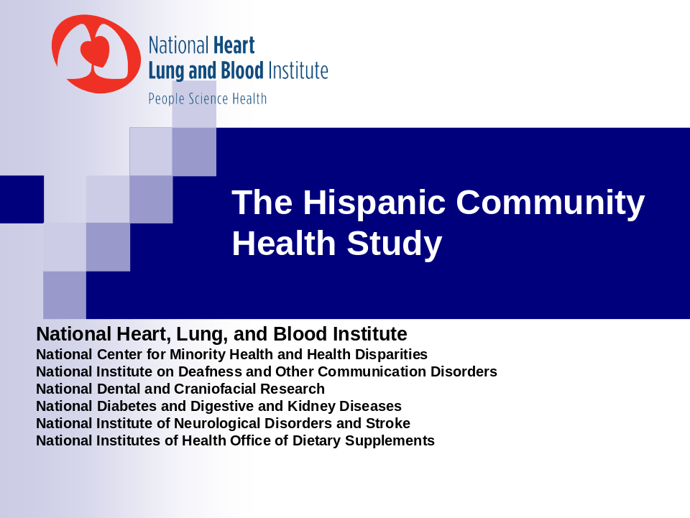
APPENDIX D – FACT SHEET (Double Click to View Full Document)

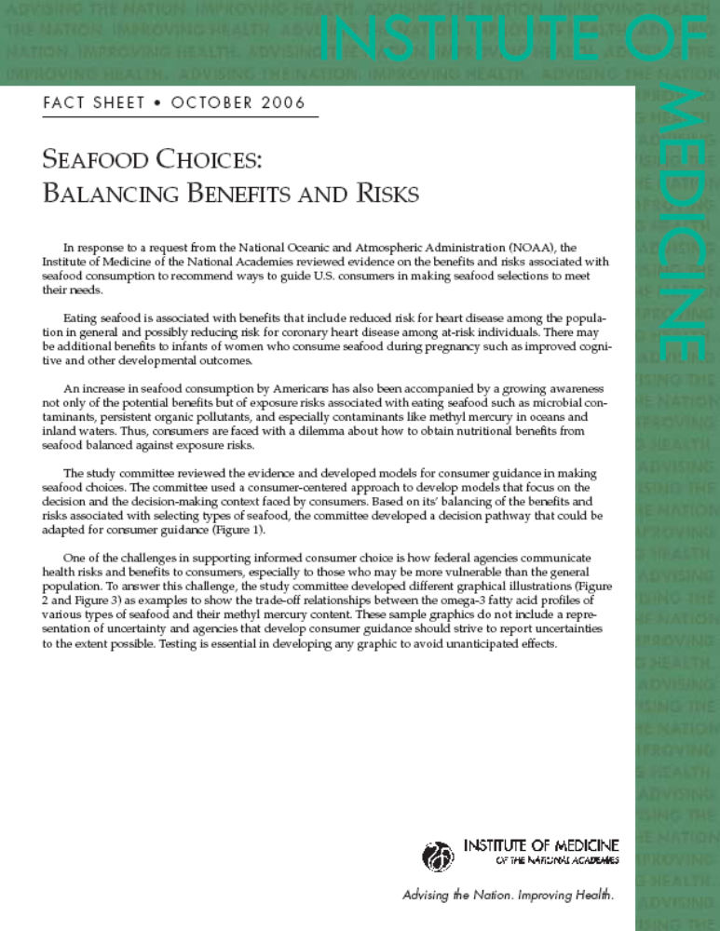

APPENDIX E

Office of Dietary Supplements Fall 2006 Seminar Series

“Folate and Human Reproduction”

Tsunenobu Tamura, M.D.

Date: November 8, 2006

Time: 11:00 am – 12:00 pm

Location: 6001 Executive Blvd.
Neuroscience Building)
Room C, Bethesda, MD

Hosted by: The Office of Dietary Supplements,
National Institutes of Health

Tsunenobu Tamura, M.D. Professor in the Departments of Nutrition Sciences and Obstetrics and Gynecology University of Alabama at Birmingham

Dr. Tsunenobu Tamura received a MD degree from Fukushima Medical College, Tohoku University School of Medicine in Japan; and a Doctor of Medical Sciences degree specializing in folate metabolism in infants from the same institution. He is a member of the editorial boards of Experimental Biology and Medicine and Journal of Nutritional Science and Vitaminology and serves on the WHO panel on craniofacial abnormalities and the FDA advisory committee for reproductive health drugs. He was awarded a distinguished professorship at the University of Georgia in 1998. Dr. Tamura is the author of over 150 publications and his research activities center around folate metabolism, trace element nutrition and inborn errors of metabolism.

Recent Publications include:
Zinc status of women with low bone mineral density who receive calcium supplements. Biol Trace Elem Res. 2006 Jun; 110(3):211-22.

Folate and human reproduction. Am J Clin Nutr. 2006 May; 83(5):993-1016. Review.
Folate status of mothers during pregnancy and mental and psychomotor development of their children at five years of age. Pediatrics. 2005 Sep; 116(3):703-8
APPENDIX F

Vitamin D, Effectiveness and Safety

Key Questions

- Are specific circulating concentrations of serum 25(OH)D associated with the following health outcomes in:
  - Children: rickets, bone mineral density (BMD) or bone mineral content (BMC), fractures, PTH?
  - Women of reproductive age (includes pregnant and lactating women): BMD, ultrasound, fractures, calcium absorption, PTH?
  - Elderly men and women: BMD, fractures, falls?

- Does dietary intake (fortified foods), sun exposure, and/or supplementation affect circulating concentrations of serum 25(OH)D?
  - Does this vary with different age groups, ethnicity, use of sunscreen, geography and/or BMI?
  - What is the effect from fortified foods on circulating 25(OH)D concentrations?
  - What is the effect of sun exposure and vitamin D supplementation on levels of 25(OH)D?

- What is the evidence regarding the effect of supplemental doses of vitamin D on bone density and fracture and fall risk in:
  - Women of reproductive age and postmenopausal women?
  - Elderly men?
  - Is there variation with baseline levels of 25(OH)D?

- Is there a level of sunlight exposure (time of year, latitude, BMI, amount of skin exposed) that is sufficient to maintain adequate vitamin D levels, but does not increase the risk of non-melanoma or melanoma skin cancer?

- Does intake of vitamin D above current recommendations lead to toxicities? (specifically hypercalcemia, hypercalciuria, and calcification of soft tissue and major organs)

APPENDIX G – CURRENT ODS PROGRAMMATIC ACTIVITIES ASSOCIATED WITH VITAMIN D AND POSSIBLE NEXT STEPS



