MegaBACE 4000 DNA Analysis System
Users Protocol

Version Number: 2.4
Production Start Date: 12/05/03
Version 2.4 Date: 08/18/04
Author: Chris Daum
Reviewed/Revised by: Nahal Lalefar

Summary
This protocol outlines the operation of the MegaBACE 4000 DNA Analysis System for high throughput capillary electrophoresis of DNA samples.

Materials & Reagents

Materials/Reagents/Equipment  Disposables  384-well PCR Microplate, Blue  Clear Adhesive Plate Sealers  Reagents  MegaBACE 4000 Long Read Matrix (LPA)  MegaBACE 10X Running Buffer  Milli-Q water  Equipment  MegaBACE 4000 Sequencer  Watson Marlow Pump  Heat Block  Vortex  Centrifuge 5810 | Vendor  Axygen/ISC BioExpress  Edge Biosystems  GE Healthcare*  GE Healthcare*  Millipore Milli-Q System  GE Healthcare*  Watson Marlow  VWR Scientific  VWR Scientific  Eppendorf | Stock Number  T-3019-BCS  48461  415002  US79686  -  -  -  -  -  -

* GE Healthcare, formerly Amersham Biosciences

Procedure
NOTE: All reagents/stock solutions should be prepared prior to the start of the procedure.

1. Pre-Run Setup
  - Verify the run start time using the posted Run Schedule.
  - Prior to the start time, assess how many instruments will be loaded and prepare the materials you will need for the run:
- Check the sample freezer in Rm121 to see if plates have been assigned for the run. If no plates have been assigned, then pull plates from the sample freezer or BET Freezer201 in Rm140 and assign plates in FW & RV pairs to the same instrument for two runs.
- Ten minutes before loading sets of instruments, use the Watson-Marlow pump to fill the appropriate number of water tanks with 120ml of Milli-Q water and buffer tanks with 120ml of 1X running buffer.
Important! Run 240ml additional Milli-Q water through the pump after running 1X buffer through it in order to cleanse it and prevent buffer residue buildup.
Important! The dispense volume of the Watson-Marlow pump must be checked on a weekly basis. To do this, dispense into a graduated cylinder and measure the delivered volume; if it varies from 120ml + 5ml, notify MegaBACE instrumentation so that the pump may be calibrated.
NOTE: If the Watson-Marlow pump is non-functional, the water and buffer tanks may be manually filled using a graduated cylinder to measure out the 120ml dispense volumes.
- Set out a single buffer tank and water tank for each instrument in the loading set.

2. Sequencing Run
NOTE: A single sequencing run consists of loading sets of instruments. Refer to the posted Run Schedule for set information and start times. Make sure to fully complete the loading (matrix fill & sample injection) of one set before starting the next.
  - Set out the matrix fill and pre-run materials you will need for each instrument in the set:
- One buffer tank containing 120ml of 1X running buffer per instrument in the set.
- Six pre-spun (2 minutes at 3,000rpm) matrix tubes per instrument in the set.
  - Perform the Matrix Fill and Prerun Protocol for a set of instruments:
- In the Instrument Control window, with the Matrix Fill and Prerun protocol selected, click on START (perform this on each instrument in the set).

- Follow the instructions on the instrument display window to load the buffer tank into the left (cathode) side of each instrument followed by the matrix tubes into the right (anode) side of each instrument in the set; from the display window messages, verify that the drawers have been closed completely. Refer to Figures 1 & 2 in Appendix A.

Important! Check the matrix tubes for bubbles and make sure there are no empty tubes; do not load these unsuitable tubes. If empty tubes are found, set them aside and label them with the LPA lot# and date found. If bubbles are still present in any of the tubes, re-centrifuge them for 2 minutes at 3,000rpm.
- After opening the anode and cathode drawers, wipe any spilled buffer, water or matrix with a damp paper towel.
- After loading the matrix tubes, listen for any high-pressure leaks. Inform MegaBACE instrumentation if any leaks occur.
  - Preparation of DNA samples for a set of instruments:
- After loading the matrix tubes and while the instrument is performing its automated fill and prerun, prepare the DNA sample plates for the set of instruments being loaded.
  - Pull the assigned sample plates from the freezer and thaw them on the heat blocks for 15 seconds at 90ºC.
  - Vortex the sample plates on the Vortexer for 2 minutes on setting 7; loading no more than 12 plates on a Vortexer at a time.
  - Quick spin the sample plates in the centrifuge for 1 minute at 1,000rpm.
Important! Once the sample plates have been centrifuged they must be handled gently as not to induce bubbles or produce air pockets at the bottom of wells.
- After preparing the DNA samples, the plates need to be scanned into the instrument on which they are to run; this will import the associated samplesheet record.
  - In the Plate Setup window, click on NEW.
  - In the Plate ID box, scan in the barcode on the sample plate that will be run on that instrument.
  - Verify that the correct values appear in the Electrophoresis Parameters: Sample Injection Voltage: 1.6 KV, Run Voltage: 5.25 KV, Sample Injection Time: 36 sec, Run Time: 250 min.
  - Performing the Inject Samples and Run Protocol for a set of instruments:
- Set out the materials you will need for each instrument in the set:
- One water tank containing 120ml of Milli-Q water.
- The prepared DNA sample plate assigned to each instrument.

- A blue buffer plate containing 25μl of 1X running buffer per well.
Important! Examine the buffer plate to ensure that each well has buffer in it and that the volume looks uniform across the plate.
- In the Instrument Control window, with the Inject Samples and Run protocol selected, click on START. After the Select a Plate window appears, scan in the barcode on the assigned sample plate (perform this on each instrument in the set).
Important! It is crucial to sample performance that the following steps are completed as soon as the instrument prompts that it is ready. Otherwise, a timeout error will occur and it may affect the quality of the sequencing run.
  - Follow the instructions on the instrument displays to load the water tank into the left side of each instrument in the set; from the display window message, verify that the drawer has been closed completely. Refer to Figure 3 in Appendix A.
  - Once the instruments finish their automated tip rinsing, the Confirm to Continue window appears, click on ENTER to continue.
  - Follow the instructions on the instrument displays to load the assigned sample plate on the adapter into the left side of each instrument in the set; from the display window message, verify that the drawer has been closed completely. Refer to Figure 4 in Appendix A.
Important! Ensure that the clear plate seal is completely removed and that no torn pieces of the seal remain on the plate while it is loaded. Remaining pieces of seal may harm the instrument if loaded.
  - After the instrument injects the samples, follow the instructions on the instrument display window to load the blue buffer plate on the adapter into the left side of each instrument in the set.
Important! Examine the buffer plate before it is loaded to ensure that each well has buffer in it and that the volume looks uniform across the plate.
  - Putting the instrument to sleep after the sequencing run (only to be done when instruments are to be slept for the night; refer to posted Run Schedule):
  - In the Instrument Control window, select the Sleep Parameters tab.
  - In the Sleep Time field, enter the number of hours the instrument is to sleep (1-16 hours).
  - Select the Sleep After This Run check box; the Instrument Control Manager will automatically store the capillaries in the run matrix and buffer after the current run has finished.
Important! After the entered sleeping time has elapsed, it requires 2 full hours for the instrument to warm back up before it may be run again.

3. Monitoring and Assessing the Quality of the Run
  - Check the Fluorescence Image Display area to ensure that the scan images are being collected across the plate:
    - Click on the Run Image window of each instrument.
    - Click on the well buttons above the Fluorescence Image Display to view electropherograms for individual lanes. Initially, all 4 baselines should be present. The lack of an image after 40 minutes (no sequencing data or baseline noise across all channels) may be indicative of instrument problems; notify MegaBACE instrumentation immediately.
  - Check the capillary current for uniform electrical current:
    - In the Options drop down menu select Current Monitor.
    - Examine the Current Monitor window for uniformity of current values across the plate, checking for regions of no current, abnormally high/low current, or erratic current that constantly changes values:
      - Individual zeros may indicate broken/clogged capillaries, an empty buffer plate well, or the presence of bubbles.
      - Groups of zeros or regions of abnormally high/low current may indicate more severe problems; notify MegaBACE instrumentation or administration immediately.
  - While monitoring MegaBACE runs, if any abnormal electropherograms are found which may include overloading, bubbles in the capillaries, sequencing artifacts, tandem repeats, or double traces, take a screen shot, paste it onto a PowerPoint slide (include: date, run #, instrument #, average intensity, the room’s temperature, and a brief description of the abnormal sequence) and email it to mb4000@cuba.jgi-psf.org.
  - While loading and monitoring runs in the MegaBACE Sequencing Lab, it is important to take note of and report any aberrations from the normal workflow. With as much detail as possible (documentation and screen shots if applicable) notify MegaBACE administration and instrumentation of the abnormality and send out an electronic depiction to mb4000@cuba.jgi-psf.org. This would include any abnormalities, no matter how seemingly small, within the following areas:
    - MegaBACE Instruments – on-screen errors; software/hardware crashes; instrument malfunctions; poor current; failed or blinking lasers; difficulty in opening anode/cathode drawers; operator error while loading; aborting of runs.
    - Sample Plates – missing wells; damaged plates or barcodes; blank run images; run images with abnormal motifs.
    - Loading Runs – instruments down for service or PMs; evaporated buffer plates when pulling them out of instruments; loading sets at a different time than what is posted on the posted schedule; loading plates on the wrong MegaBACE instrument.
    - Venonat Database – outages; forms not working; scanning plates into the wrong MegaBACE field; choosing the wrong reagent lots, run number, or operator; plates that have not posted.
    - Reagents – changing of lots; empty or partially filled matrix tubes; buffer plates with empty wells; supply inventory; low on supplies.
    - Supporting Equipment & Robotics – issues with the Multidrop/Twister, Tecan, or Watson-Marlow pump; calibration checks; work requests.
    - Facilities – room temperature; running of the auxiliary AC; issues with the sink or Super-Q.

4. Post-Run
  - Scan in the barcodes of the sample plates that were loaded into the MegaBACE database:
- In the Venonat database (http://venonat.jgi-psf.org/psfs/pfs.home), click on MegaBACE DB → Run Scan in Form MB4000s → enter in: run date, run #, your name as the operator, matrix lot, and buffer lot.
- Click on SUBMIT.
- Scan in the barcodes of the sample plate corresponding to the MegaBACE instrument on which it was loaded.
- Click on SUBMIT.
  - The loaded sample plates will be stored for a two-week period before disposal:
- After scanning the barcodes of the loaded sample plates into the Venonat database, tape the plates together and label with: Run Date, Run Number, Operator’s Initials.
- Store the plates in the Loaded Samples freezer in Rm121, placing them on the shelf that corresponds to the day of the week that they were loaded.
- To dispose of plates after a two-week storage period:
  - In the Venonat database (http://venonat.jgi-psf.org/psfs/pfs.home), click on MegaBACE DB → Check Plate Status Before Disposing.
  - Scan the barcodes of the plates slated for disposal into the Enter Barcodes box.
  - Check the selection boxes next to Search for Yunian’s QC Reports and Display only runs that are not posted.
  - Click on SUBMIT.
  - An on-screen report will be generated, as long as a sample plate’s name is not displayed it may be thrown away in a lab garbage can. If a sample plate’s name is displayed, the plate has not yet posted. Save these plates and notify MegaBACE administration.
  - After loading the sets for a given run, the remaining water and buffer in the tanks used for the sequencing run must be disposed of and the tanks washed:
- Take the water tanks and buffer tanks to the sink.
- For Water Tanks:
- Dump and shake out the water into the sink and rinse the tanks with Milli-Q water only.
- Shake out the excess Milli-Q water and set the tank on the designated rack to dry.
- For Buffer Tanks:
  - Disposal of LPA/Buffer mixture - Dump and shake out each buffer tank into the large funnel above the carboy in the sink.
  - Rinse each buffer tank with hot tap water to remove all of the remaining LPA/Buffer mixture and shake out the excess water. Once visible LPA strings no longer appear while shaking, rinse the tanks with Milli-Q water. Shake out the excess water and set the tank on the designated rack to dry.
  - When the carboy containing disposed of LPA/Buffer reaches ¾ of the way full, fill it the rest of the way with hot tap water.
  - Open the spigot at the bottom of the carboy so that the waste drains into the sink.
  - Turn on the hot tap water all the way so that the waste becomes as dilute as possible as it goes down the drain.
  - When the carboy is empty close the spigot and continue to let the water run for at least 5 minutes to flush the sink’s drain.

5. Aborting a Running Protocol
In the event of an instrument issue (i.e. on screen error messages, abnormal or extreme current indicating an empty buffer plate or matrix tube, laser shut downs, operator error, etc.), the following steps will abort a run:
  - In the Instrument Control window, click on STOP to end the running protocol. It will take the instrument ~30 seconds to abort the run and re-initialize itself.
  - If the issue is not serious in nature, the protocol may be restarted or the instrument may be left idle until the next run is ready to start. If there is not another run to start or the instrument requires service, it must be stored in water to prevent the capillaries from drying out (refer to Section 6).

6. Restarting the Instrument & Rebooting the Computer
In the event of an instrument or software issue, the following steps will restart the instrument and reboot the computer and software:
  - While the instrument is stopped, close as many of the open software windows on the computer desktop as possible (some windows many not close if there is a software issue).
  - Turn the instrument’s power switch, located on the bottom right side, to the off position (a quick venting of the instrument’s pressure system may be heard).
  - Completely shut down the instrument’s computer and power it off.
  - Turn the instrument’s power switch to the on position, wait ~30 seconds for the system to initialize itself.
  - Once the instrument is initialized, turn the computer on and allow it to boot-up:
- While booting-up, the Notice to Users security screen will display, click OK and the computer will automatically log itself into the network (if the login is not automatic, refer to the User ID and Password posted on the top of the monitor to manually login).
- Once Microsoft Windows has started, the MegaBACE 4000 Host Scan Controller program will automatically start, allow it ~30 seconds to initialize.
  - Open the Instrument Control Manager program; its start icon is located in the MegaBACE folder on the computer’s desktop.

7. Leaving the Instrument Idle & Storing the Capillaries
Leaving the instrument idle means that the instrument power is on, but it is not running samples. If the instrument is left idle for 1 – 7 days, the capillaries need to be stored wet to prevent them from drying out. Leaving the instrument idle for more than 7 days requires the capillaries to be flushed and dried by MegaBACE instrumentation. The following steps will store the capillaries for a specified period:
  - Materials Required:
- Water tank with 120ml of Milli-Q water.
- Six 2-ml tubes, each containing 1.6ml of Milli-Q water.
  - In the Instrument Control window, select the Sleep Parameters tab; type the length of time the instrument will be idle in the Sleep Time field (1-168 hours).
  - In the Instrument Control window, with the Store Capillaries protocol selected, click on START. Follow the instructions on the instrument’s display window to load the water tank into the left (cathode) side of each instrument followed by the 6 water tubes into the right (anode) side of the instrument.
Important! After the entered sleeping time has elapsed, it requires 2 full hours for the instrument to warm back up before it may be run again.
8. Rinsing the Capillary Tips
Use the Rinse Tips protocol to clean capillary tips, minimize contamination of the electrodes, and to prevent clogging of the holes in the circuit board. It is important to run this protocol after storing the instrument for long periods or leaving it idle in matrix/buffer for long periods.
  - Materials Required:
- Water tank with 120ml of Milli-Q water.
- Six 2-ml tubes, each containing 1.6ml of Milli-Q water.
  - In the Instrument Control window, with the Rinse Tips protocol selected, click on START. Follow the instructions on the instrument’s display windows to load the water tank into the left (cathode) side of each instrument followed by the 6 water tubes into the right (anode) side of the instrument.

9. Troubleshooting the MegaBACE 4000 DNA Analysis System
Refer to the MegaBACE 4000 DNA Analysis System Users Troubleshooting Guide as a reference for troubleshooting various issues that may be encountered while operating the MegaBACE 4000 instrument.

Reagent/Stock Preparation

1X Running Buffer
- Add 200ml MegaBACE 10X Running Buffer to a 2-L bottle.
- Add 1.8L of Milli-Q water to the 2-L bottle.
- Mix well by inverting bottle.
- Label bottle: lot number, date prepared, and initials.
- Store in 4°C deli.

Preparing the MegaBACE 4000 Matrix (LPA)
  - Remove the matrix tubes from their heat-sealed tray that they were shipped in and transfer them into the gray tube-blocks.
Note: Save the tray and lid. Take them to the washroom (Rm 143) where they will be washed and sent back to GE Healthcare for re-use.
  - Centrifuge the matrix in the blocks for 2 minutes at 3,000rpm.
Important! After centrifuging the matrix tubes, check for any empty tubes or tubes that still have bubbles in them. If empty tubes are found, set them aside and label them with the LPA lot# and date found. If bubbles are still present in any of the tubes, re-centrifuge them for 2 minutes at 3,000rpm.
  - After centrifuging the matrix tubes, check for any empty or low level tubes. If any are found write the lot number and date found on the side of the tube, put them aside and notify MegaBACE administration.
  - Seal tubes with a clear plate seal and label: lot number, date prepared, and initials.
  - Store in 4°C deli.
NOTE: Make sure to place the freshly made tubes in the back of the deli and bring the older tubes to the front.

Preparing the MegaBACE 384-well Buffer Plates
Refer to the Multidrop/Twister Operation Protocol for MegaBACE 4000 384-well Buffer Plates.

Preparing the 1.6ml Water Tubes for storing & rinsing tips on the MegaBACE instruments
Refer to the Tecan Miniprep 60 Operation Protocol for MegaBACE Water & Buffer Tubes.

SOP Approval
DEPARTMENT | APPROVED BY | DATE
Lab Supervisor
Research & Development
Instrumentation
QC
Purchasing
EH & S
Informatics
Seq Assessment & Analysis
Dept Head of Prod Seq

Appendix A
Figure 1. Buffer tank loaded onto the left (cathode) side of the MegaBACE 4000 instrument.

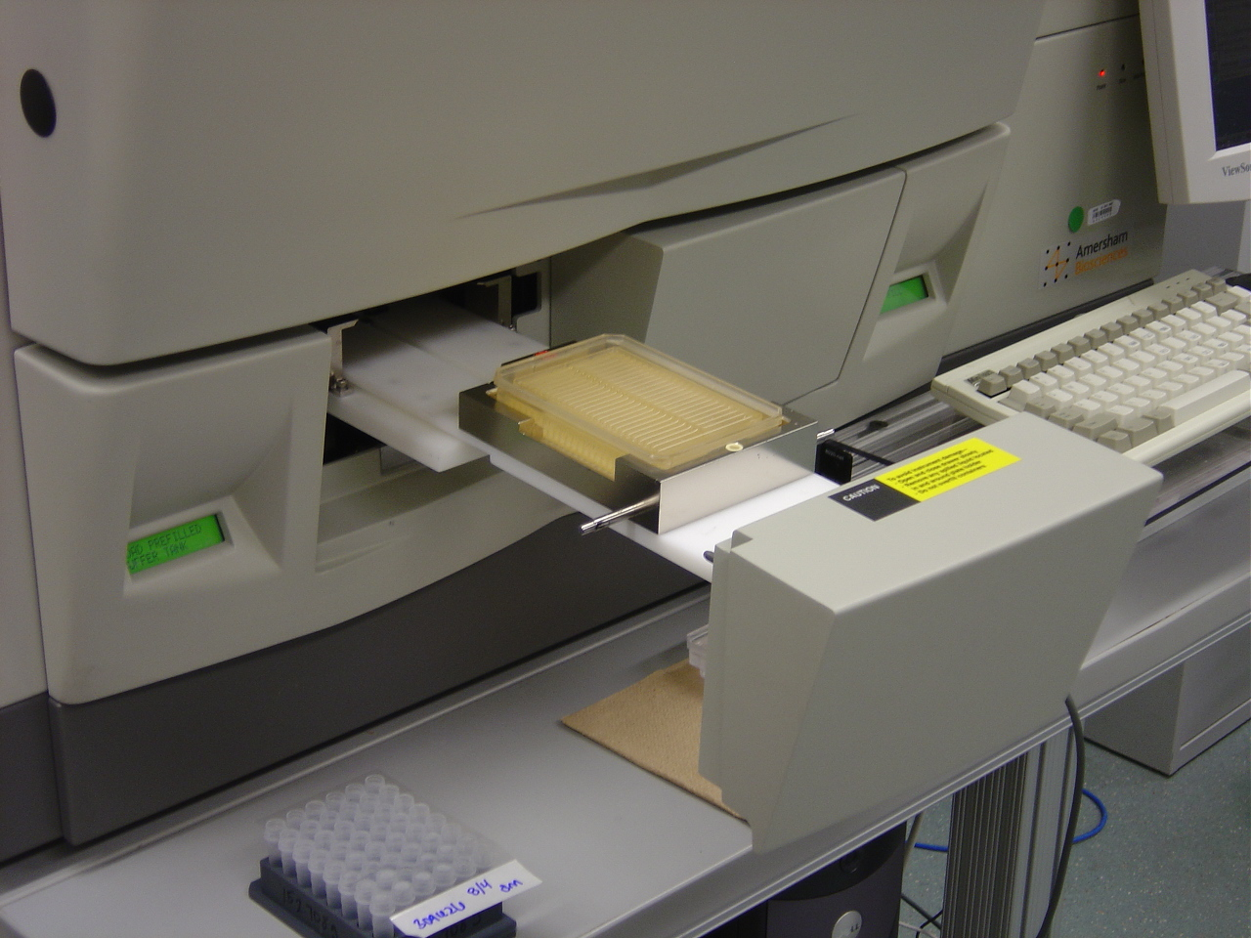

Figure 2. Six matrix tubes loaded onto the right (anode) side of the MegaBACE 4000 instrument.

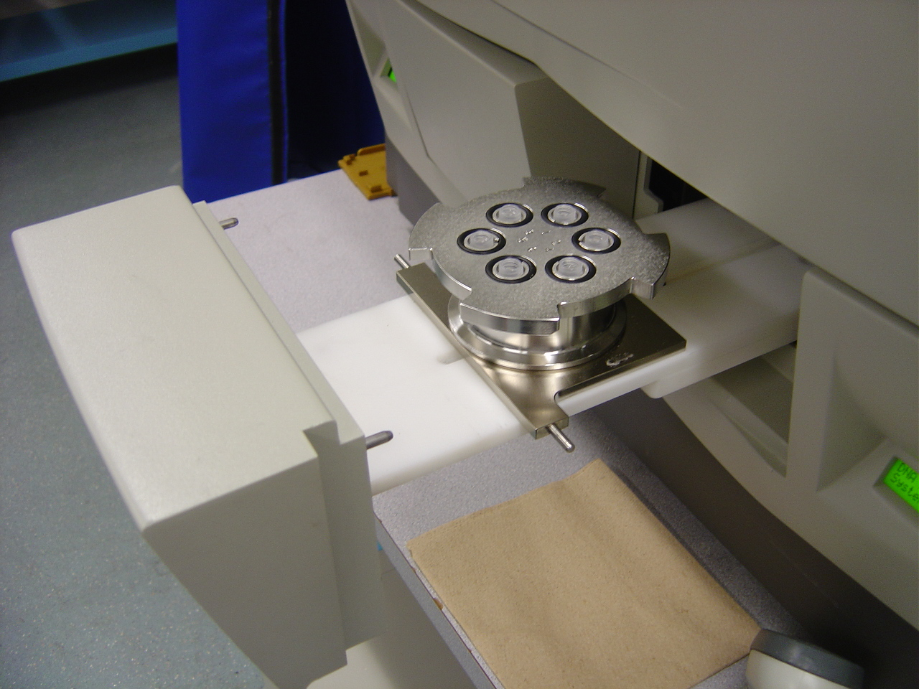
Figure 3. Water tank loaded onto the left (cathode) side of the MegaBACE 4000 instrument.

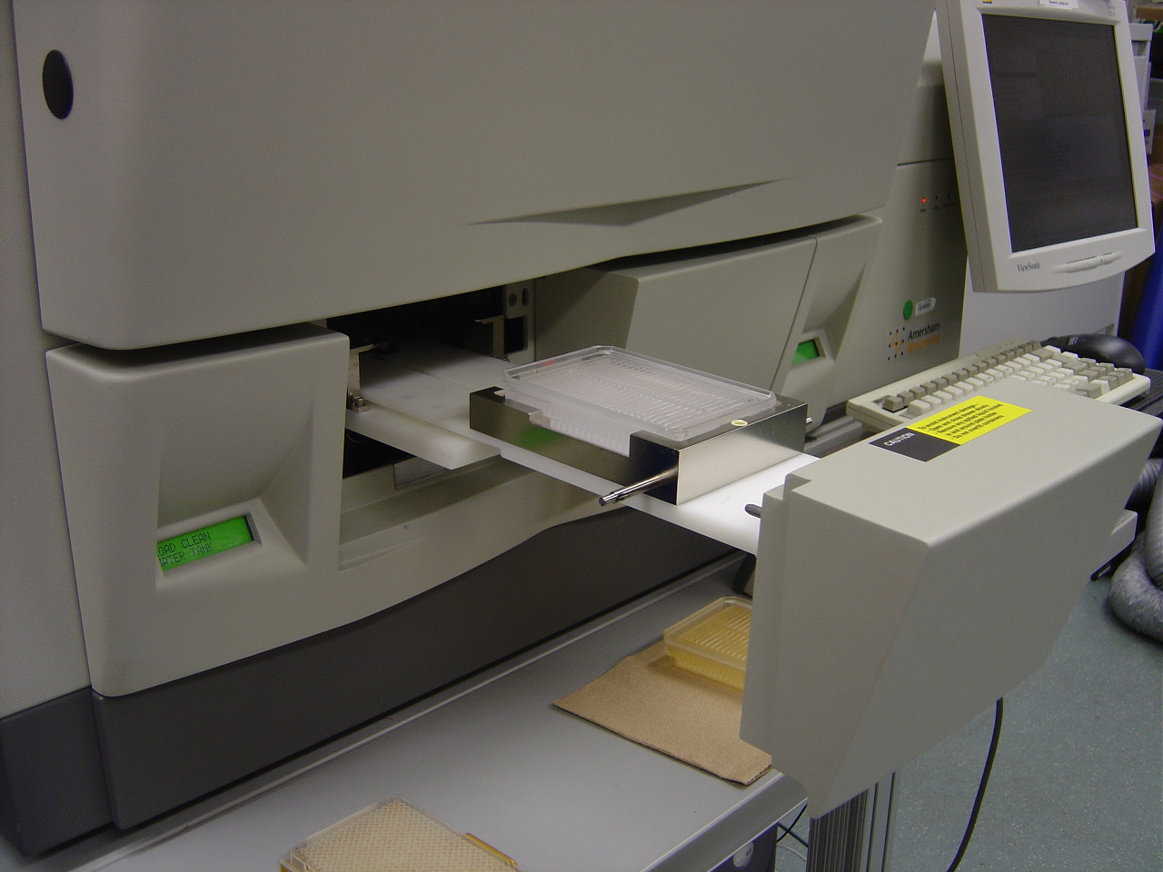

Figure 4. Sample plate with adapter loaded onto the left (cathode) side of the MegaBACE 4000 instrument.

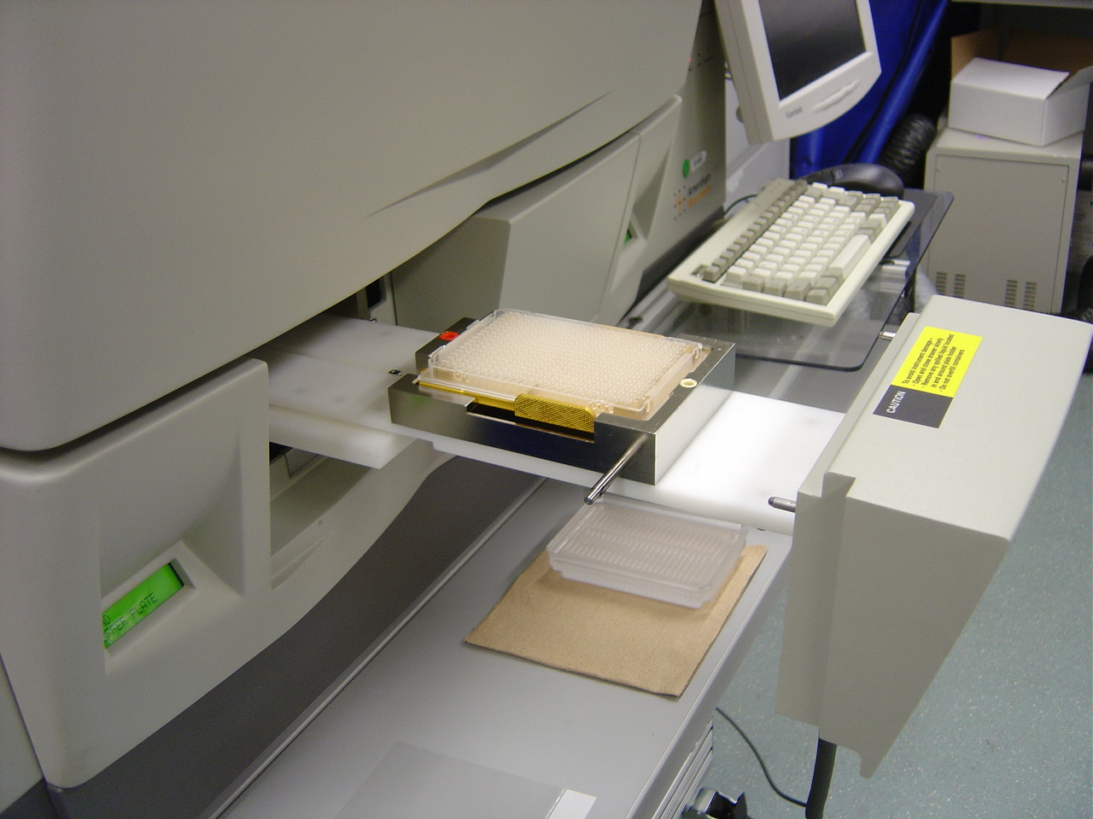

Appendix B
AUDIT TRACKING
5/27/04 – Alla Lapidus and Tijana Glavina performed an audit between 11:00AM – 12:35PM. The operator was Albert Linkowski. Changes from audit incorporated 8/04/04.

PROCEDURAL CHANGES
1/29/04 Stopping Blank Plates – Do not stop any more blank plates (no labeled DNA sample present), even if the plate will post with a very high failure rate. The reason for this policy change is that stopping blank plates skews overall performance results, making readlengths and pass rates appear higher. By letting these blank plates run and post, a more accurate representation of performance is gained and allows for better troubleshooting of the process line for areas that require improvement.
When a run that appears blank is encountered, continue the troubleshooting steps of checking the current monitor, HSC, and zooming in on the run electropherogram to see if the laser has cut off or if low intensity sequencing peaks may be seen. Additionally, continue to document these blank runs by taking screen shots of the run image and notifying the MegaBACE Maintenance Technician or Lead Operator; make note of it in your daily run log email as well.
4/6/2004 Lab Hygiene: Buffer Spills – Keep a damp towel handy while loading instruments or doing prep work in order to wipe up buffer spills as they occur; remember that wet buffer is much easier to clean-up than allowing it to dry which requires scrubbing.
5/17/2004 Saving HSC & HT Communication Data – Save the Host Scan Controller (HSC) and Hyper Terminal (HT) communication data from instruments that experience the following hardware/software issues:
  - HSC crashes (i.e. runs not starting/stopping, bad instrument status 51 & 52, and general loss of communication errors).
  - INTC/Board errors (i.e. CMON, TMPR, BEAM, ADAQ, SCAN, and EPHV board errors).
  - Any unusual/uncommon errors (i.e. instrument not going to sleep/HSC still acquiring data errors).
HSC communication data may be saved on any instrument when one of the above errors occurs. However, HT communication data may only be saved on those instruments with the program installed, which are MB115, 116, 122 - 135, & RNDMB1. Refer to the MegaBACE 4000 Comprehensive Users Protocol for instructions on saving HSC and HT communication data.
7/12/2004 Adhering to Run Schedules – Adhere to the posted MB run sets and loading times as noted in the daily Run Schedule, unless instructed otherwise by MegaBACE Administration or Instrumentation. Furthermore, completely load one set before moving on to the next, do not overlap sets (i.e. start the Matrix Fill protocol on one set while still performing the Inject Samples and Run protocol on the previous set). There are several reasons for the posted Run Schedule with set start times, instruments split up into loading sets, and breaks between some of the sets. The foremost of these are:
- Operator health and safety.
- Instrument well-being and prevention of catastrophic crashes/malfunctions.
- Prevention of operator error. Errors easily occur while rushing to load too many instruments at once or while loading overlapping sets, which can lead to harmful situations for both the operator and instrument.
- The ability to predict when instruments will be down, which is vital to the planning of instrument service and assigning priority samples.
- Minimization of variation. Introducing variation to any scientific/manufacturing process may lead to severe problems and be detrimental to performance; especially if the introduced variations are not properly noted and tracked.

