Slide 1 |  | This block of instruction will cover the tests, concepts and use of the new Superpave binder specifications. At the end of this block the student will be familiar with the :  * Concepts behind the PG binder grading system.  * Tests used for determining performance-related binder properties.  * Selection of an appropriate PG binder grade.
Slide 2 |  | The PG grading system was developed to address the short comings seen in the traditional asphalt cement specifications.  This specification is referred to as a binder rather than an asphalt cement specification. The difference is that a binder can be either a neat (unmodified) or modified asphalt cement. The term “asphalt cement” usually refers to an unmodified asphalt cement.
Slide 3 |  | This specification uses tests which evaluate the fundamental material properties (stress, strain, and strain rate). Changes in asphalt properties due to temperature, rate of loading and the effect of aging are considered.  Asphalt is a viscoelastic material. That is, it can both exhibit elastic and viscous properties at the same time. To demonstrate, take a penetration tin of asphalt cement at room temperature. Press your thumb into the asphalt; this will leave a large depression in the surface. Then use a hammer to hit the a remaining flat section of the asphalt; this will not leave much of an impression. Under light but long term loads, the asphalt has a noticeable viscous behavior (it flows out from under the load). Higher, but much shorter duration loads result in a primarily elastic response.
Slide 4 | 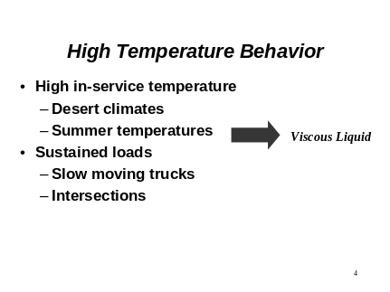 | The viscous component of the binder response dominates its warm temperature behavior and is seen as permanent deformation. The magnitude of this deformation is increased with the time that the load is applied.
Slide 5 | 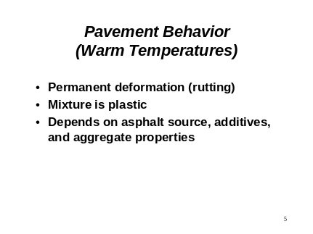 | Permanent deformation or rutting of the pavement is the result of non-recoverable or plastic deformation due to traffic loads. At the warmer temperatures, the aggregate structure carries a major portion of the loads. Stiffer binders help to keep the aggregate structure intact as well as help resist deformation in the binder matrix.
Slide 6 | 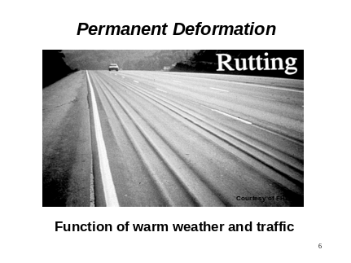 | Ruts can be very visible in extreme cases such as the one shown in this photo. Other places where rutting can be observed are at stop lights. In many cases, the crosswalk lines can highlight this type of distress.
Slide 7 | 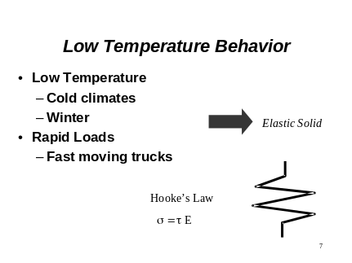 | At cold temperatures, or under very quick loads, the binder response is predominately elastic.
Slide 8 | 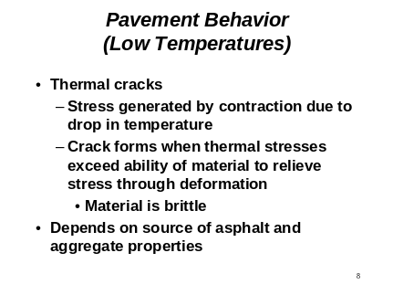 | A length of pavement can be considered to be a semi-infinite constrained beam. As the temperature drops the asphalt concrete wants to contract but is restrained. This results in internal stresses building up as the temperature drops. Thermal cracks occur when the contraction-induced stresses exceed the tensile strength of the mixture.  A number of researchers have shown that the low temperature behavior of the asphalt concrete pavement is highly dependent upon the properties of the binder.
Slide 9 | 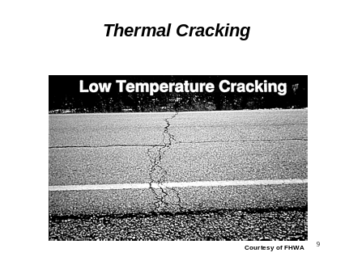 | Thermal cracks are transverse cracks, usually at relatively evenly spaced intervals. The spacing gets closer together with increasing binder stiffness the colder the temperatures.
Slide 10 | 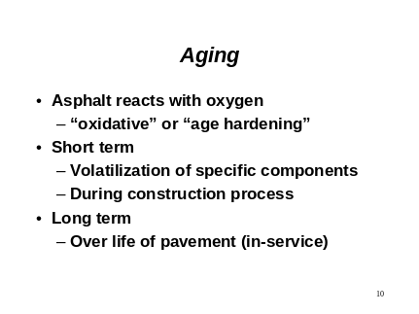 | Aging also needs to be considered in the specification as oxidation and heat hardening during tank storage, mixing and placement (short term aging) of the asphalt concrete change the properties of the original binder.  Long term aging refers to the changes in binder property after 7 to 10 years of exposure to environmental factors.
Slide 11 | 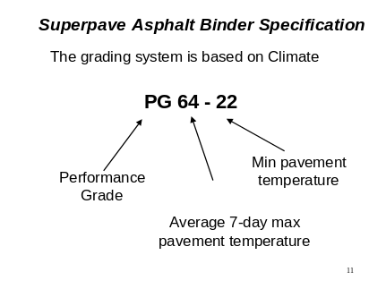 | The binder designation is based on expected extremes of hot and cold pavement temperatures.
Slide 12 | 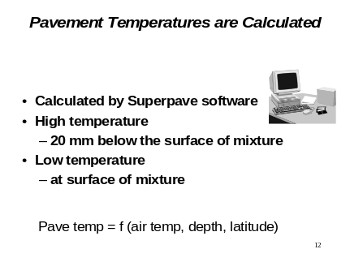
Slide 13 | 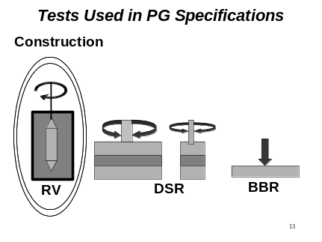 | A series of four test methods are used to assess key performance-related properties of binders. The first, the rotational viscometer, evaluates the viscosity of the binder at temperatures similar to those commonly used during production.
Slide 14 | 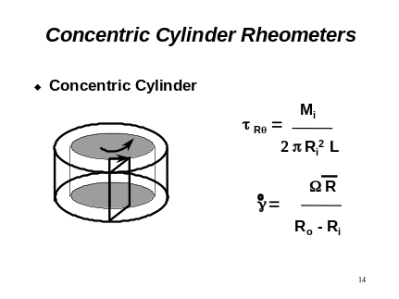 | The rotational viscosmeter (also referred to at a Brookfield viscometer) is a concentric cylinder rheometer. This means that one cylinder rotates inside of another. Viscosity is determined from the amount of torque needed to rotate a cylinder (called a spindle) with a known geometry. Viscosity, as defined earlier, is the ratio of the shear stress to the strain rate. This viscometer uses information about the torque, speed, and geometry to obtain these measurements.
Slide 15 | 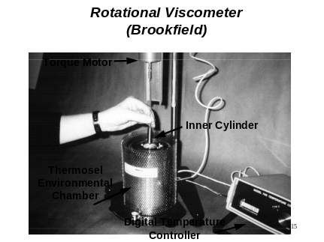 | This photograph shows a typical rotational viscometer set-up.
Slide 16 | 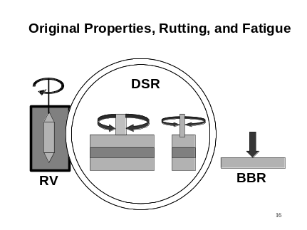 | The second test method used to characterize the binder is the dynamic shear rheometer. This test method is used to evaluate the original and short term aged binder properties at the warmest expected pavement temperature. By changing the geometry (i.e., using smaller diameter plates), the same test method and equipment can be used to determine binder properties after long term aging and at intermediate in-service temperatures.
Slide 17 | 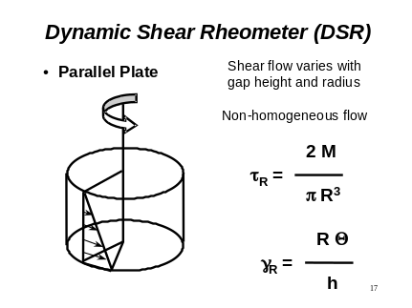 | This type of rheometer has a parallel plate configuration. The stress and strain measurements are based on the assumption of a cylindrical geometry. This is why a great deal of effort is expended in preparing and trimming the specimen prior to starting the test.
Slide 18 | 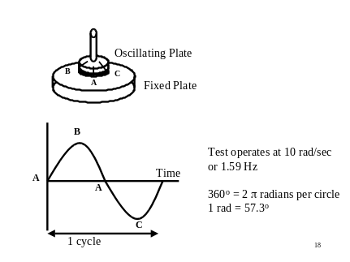 | The main advantage to this test is that it can be run using a sinusoidal wave form. The elastic and viscous component of the material response can then be determined by evaluating the strain response to an applied stress (see next two slides).  The time for one cycle has been set at 10 rad/sec (1.59 cycles per second). This is generally representative of the time for one cycle of loading due to 55 mph traffic.
Slide 19 | 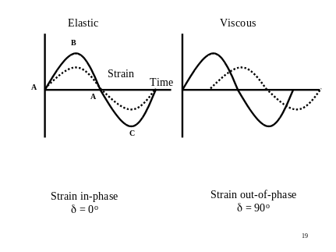 | If a material is elastic, then the strain response will be in-phase with the applied stress. If a material is viscous, then the response will be 90º out of phase.
Slide 20 | 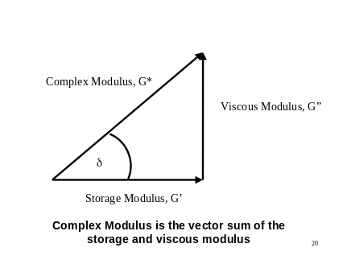 | When a material has both an elastic and viscous component to its behavior, this type of testing can sort out the contribution of each to the total response. Delta is the phase angle, that is, the degrees that the strain response is out of phase with the applied stress.  The complex modulus, G*, is the vector sum (Pathagorean’s theorem). If delta is 0, the G* equals the storage modulus. In other words, the response is all elastic. If delta is 90º, then the response is all viscous (G* = viscous component).
Slide 21 | 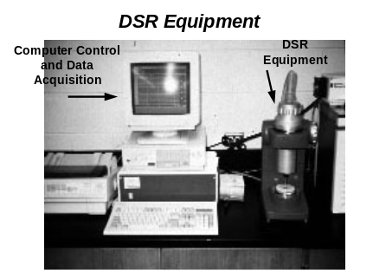 | This photograph shows a typical dynamic shear rheometer set-up. The chiller which is used for temperature control is not shown.
Slide 22 | 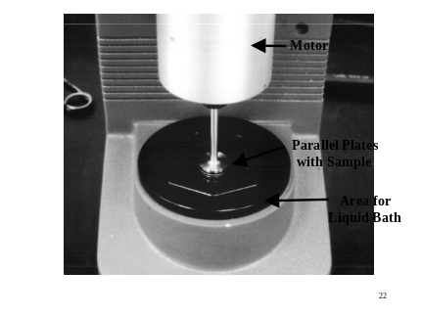 | This shows a close up of the upper parallel plate with a sample of asphalt between it and the lower (black hexagonal platform) plates. Once the sample is loaded, this chamber will be covered and filled with liquid at the desired temperature.
Slide 23 | 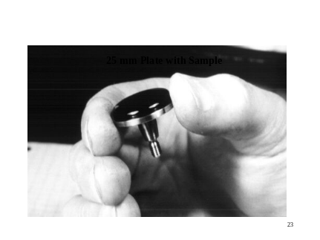 | This photograph shows a sample of asphalt cement placed on the upper DSR plate. This plate will be mounted in the rheometer and the plate moved downward to achieve the desired gap. The asphalt will be squeezed out the sides and the excess trimmed off.
Slide 24 | 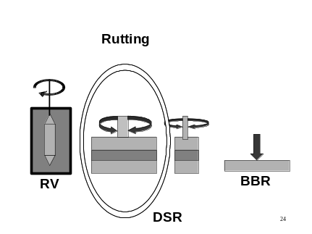 | When the DSR is run at warm test temperatures, the results are used to indicate the ability of the binder to resist rutting. For this testing, a 25 mm diameter parallel plate configuration is used.
Slide 25 | 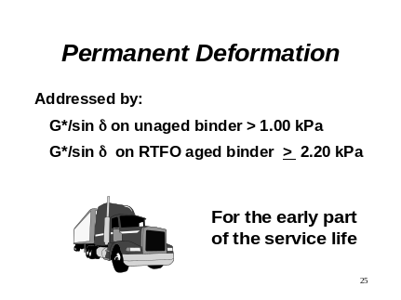 | The first DSR parameter used in the PG grading system is G*/sin δ, based on testing the original asphalt at the average 7 day high pavement temperature. At high temperatures, the potential for permanent deformation (rutting) is the major pavement distress being evaluated.  G* in Pascals at 10 rad/sec is numerically equal to viscosity in Poise:  η = [G* (Pascal)/ (ω in s⁻¹)] * (10 Poise/1 Pascal.s)  Since increasing the viscosity of asphalt has been historically used as one means of helping to reduce rutting, using G* in this specification parameter makes sense. Including the sin δ parameter allows a softer but more elastic (less permanent deformation per load cycle) to be used rather than simply increasing the viscosity.
Slide 26 | 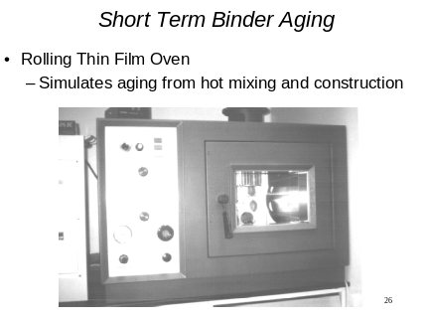 | Short term aging is accomplished using the same RTFO oven as has been traditionally used in the AR viscosity graded specification.
Slide 27 | 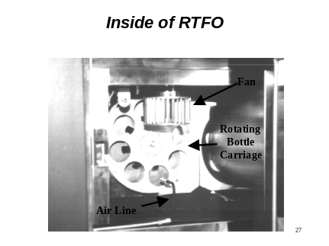 | This photograph shows a close-up of the inside of the oven. Glass jars (shown in the next photograph) fit snuggly in the circular openings in the rotating carriage. As the opening of each jar passes the air line nozzle, air is blown over the continually moving thin film of asphalt inside. A fan in the oven keeps the temperature even throughout the chamber.  Once the jars are loaded into the carriage, the door is shut, the temperature stabilized at 163ºC, and the aging process continues for 80 minutes.
Slide 28 | 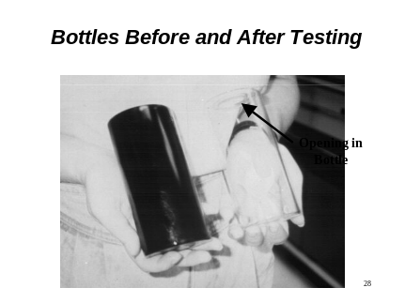 | This shows an example of a clean jar before adding 35 g of asphalt. The other jar shows how it looks at the end of the test.
Slide 29 | 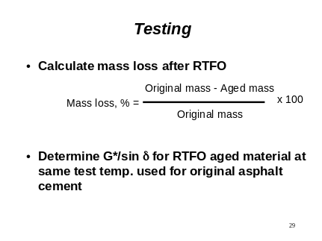 | In addition to preparing simulated short term aging of binders for further tests, the mass loss due to volatilization of the light fractions can be measured. This is done by determining the mass of two jars with asphalt at the beginning of the test, cooling these jars at the end of the aging, then determining the mass once again.
Slide 30 | 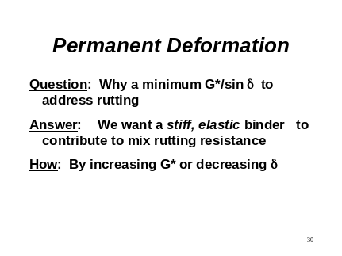 | This briefly summarizes the concepts behind this specification parameter.
Slide 31 | 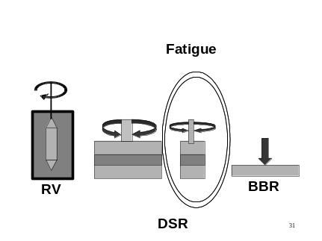 | Fatigue is addressed by assessing G* sin δ after RTFO aging (simulating aging during mixing and construction) and PAV aging (simulating aging after 7 to 10 years of service). This is because fatigue cracking takes time, exposure to environmental factors, and traffic before it occurs. An intermediate test temperature is used to simulate the appropriate average field conditions.  The configuration is changed from a 25 mm to a 8 mm diameter plate. This is necessary to keep within the torque limits of the DSR equipment.
Slide 32 | 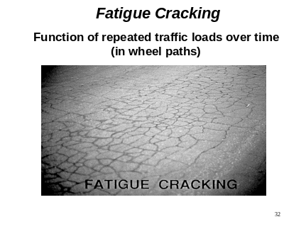 | Fatigue cracking shows up in the wheel paths and is the result of the tensile strength at the bottom of the asphalt concrete layer being exceeded by the flexing of the pavement due to traffic loads. Since the crack starts at the bottom of the layer and works its way up, the pavement is thoroughly cracked once the they are visible.  Some limited examples of fatigue cracks starting at the pavement surface have been noticed lately. This type of fatigue cracking has been linked to an increase in tire pressures in the newer truck tires.
Slide 33 | 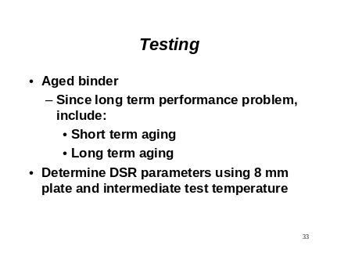 | This summarizes the testing required for this specification requirement.
Slide 34 | 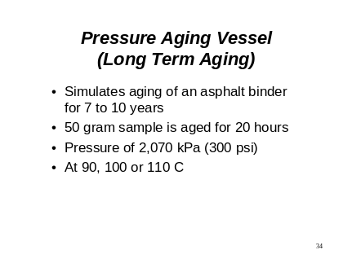 | A pressure aging vessel (PAV) treatment of the RTFO binder is used to further age the binder. This simulates long term aging changes.
Slide 35 | 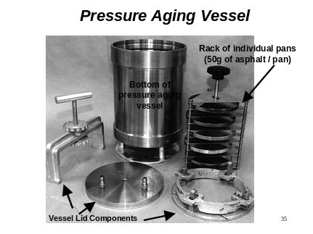 | This photograph provides an example of an older type of pressure aging vessel equipment. There are currently several makes and models of PAV ovens available.
Slide 36 | 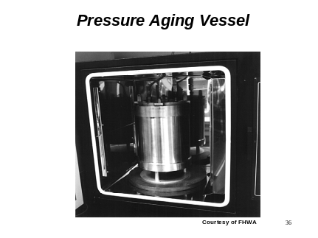 | This shows the vessel inside an oven. The pans with the binder are in the rack inside the vessel.
Slide 37 | 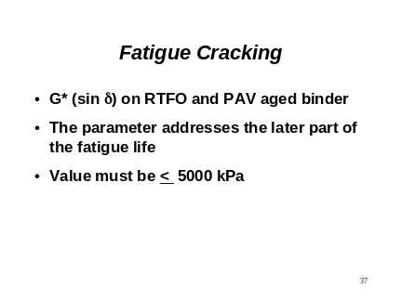 | Note that G* is now multiplied by sin δ instead of divided by it. Going back to the vector representation, it can be seen that G* sin δ is simply viscous component of G*. Since the specification places a maximum on G* sin δ , it is essentially limiting the viscous component of the asphalt.  A maximum on this parameter is set to ensure that the binder is soft enough to flex under traffic loads without cracking.
Slide 38 |  | This summarizes the concepts for this specification requirement.
Slide 39 | 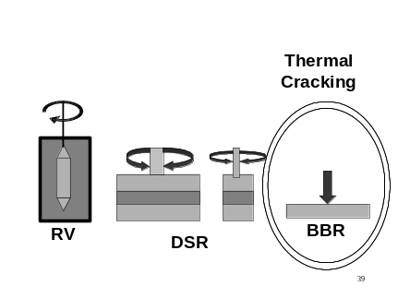 | Low temperature binder properties are determined using the bending beam rheometer (BBR).
Slide 40 | 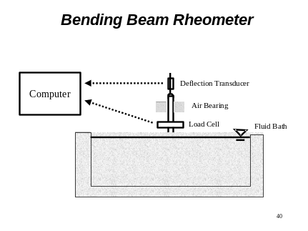 | This test applies a static load to a simply supported beam of asphalt cement. Temperature is held constant using a liquid bath. A computer provides both equipment control and data acquisition.
Slide 41 | 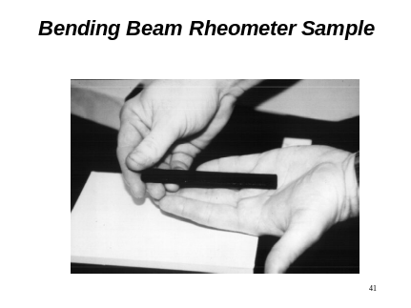 | This is what the asphalt beam looks like immediately after removing the mold (not shown). Care should be taken in handling the sample as just the heat from a hand can soften the beam sufficiently, allowing it to deform considerably.
Slide 42 | 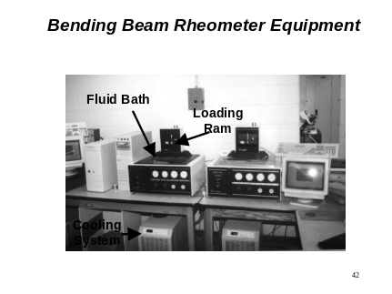 | The entire system is comprised of the computer hardware, BBR,and chiller system located under the counter (liquid circulates from the chiller through the BBR fluid bath).
Slide 43 | 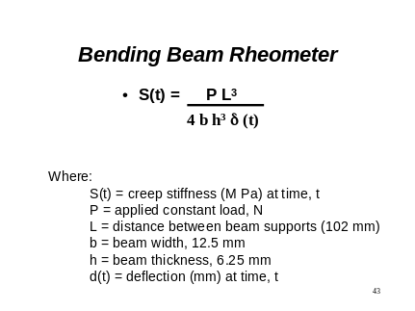 | The equation used to determine the change in stiffness with time is that for a simply supported beam. The geometry parameters remain constant throughout the test. The only values that change are the deformation of the beam due to the static load and the stiffness calculated using this time-dependent deformation.
Slide 44 | 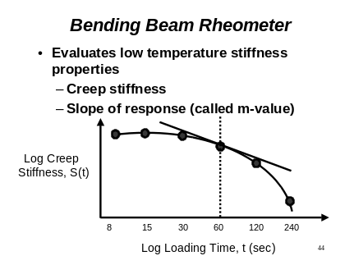 | The software collects deformation measurements at 8, 15, 30, 60, 20,and 240 seconds and the corresponding stiffness is calculated. The stiffness is then plotted versus the log of time. Since deformation increases the longer the load is left on the sample (and deformation is in the denominator of the preceding equation), stiffness decreases with time.  The parameters used in the specification are the creep stiffness at 60 seconds and the slope of the tangent line at this point (called m-value). There is a maximum requirement on the binder stiffness to ensure that the binder is sufficiently soft at cold temperatures.  There is a minimum set on the slope requirement. This is to ensure that the material can relax (deform) quickly enough to prevent cracking.
Slide 45 |  | If the binder fails the BBR stiffness requirement, it is not necessarily an unacceptable material. In this case, the direct tension test (DTT) is used to determine if the binder can stretch a given distance without failing (breaking).  The original testing device mounted and pulled a sample vertically. Because of problems with sensors mounted outside the chamber, sample molding, and alignment problems, the equipment has been redesigned.
Slide 46 | 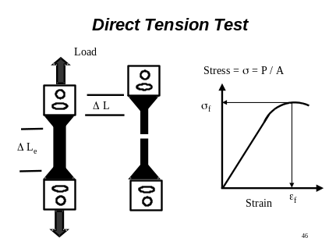 | Regardless of the type of equipment used, a sample of binder is molded into a “dog bone” shape with a uniform center cross section. The sample is pulled until the it breaks in the middle. The stress and strain at failure are recorded. This test requires a minimum strain before the sample fails.
Slide 47 | 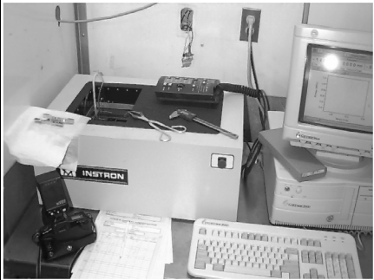 | This is the new direct tension test equipment. In this unit, a set of four samples are pulled horizontally. Temperature is controlled by using a liquid bath rather than air-cooled. As with all of the other equipment, this one is also computer controlled.
Slide 48 | 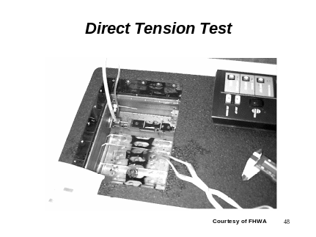
Slide 49 | 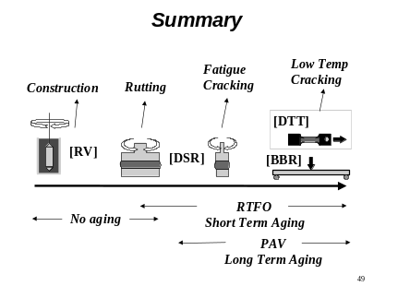 | This figure summarizes the testing required for the PG binder specification.
Slide 50 | 

