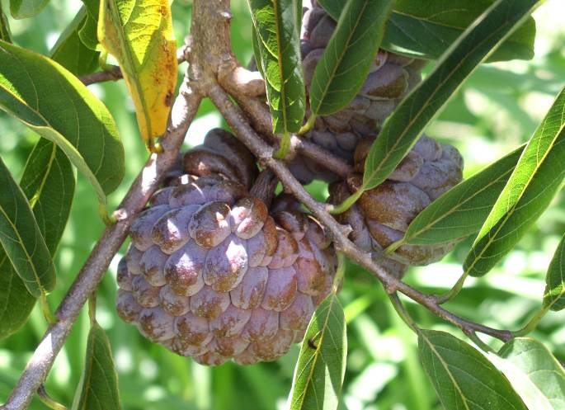
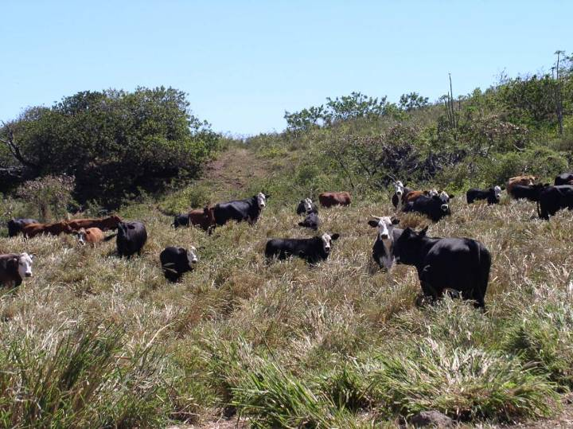
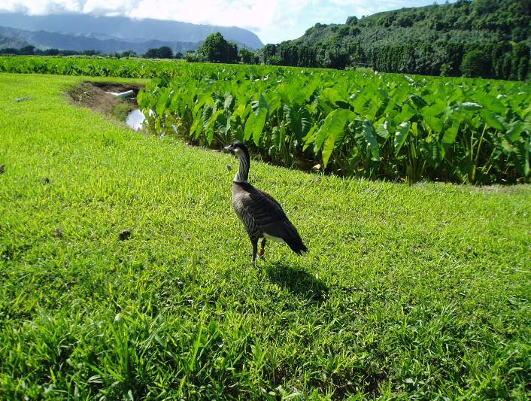
CONSERVATION RECORDS
For Your Farm or Ranch
Name:
Farm/Ranch:

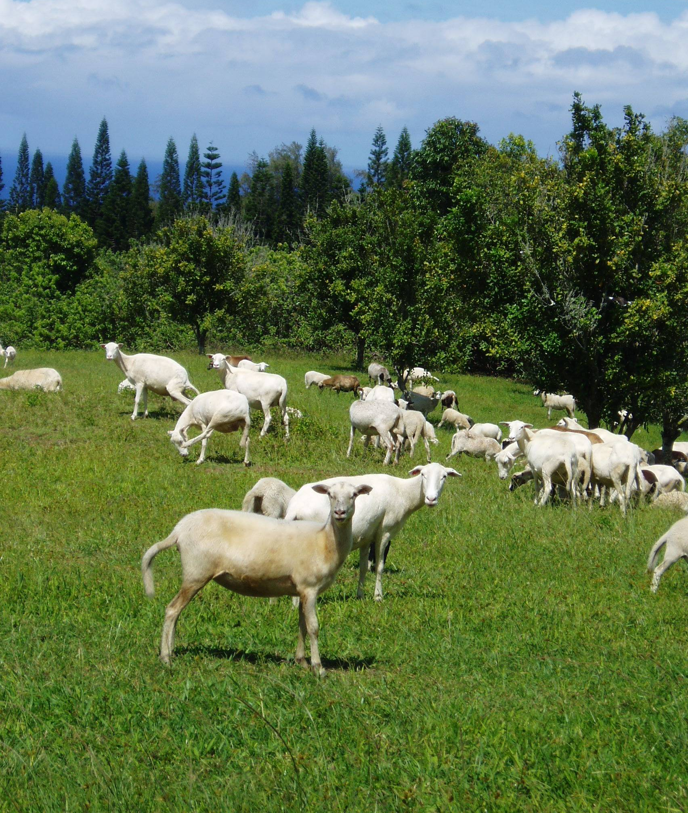
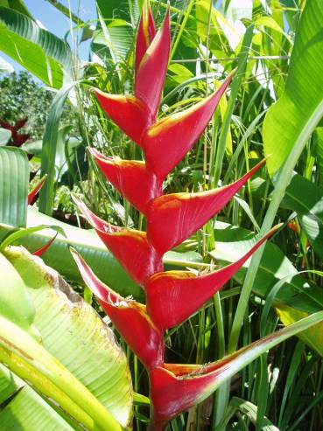

Hawaii version 1.0 12-15-05
Tables of Contents

Land Operation Information 3

Property Information 4

Farm Location Map 5

Conservation Farm Map 6

The Privacy Act 8

Conservation Records: Crop and Hay Land Inventory 11

Conservation Records: Range and Pasture Land Inventory 25

Land Operator Information

The following information is needed by our conservation planner to develop a quality conservation plan. A privacy statement is available for you to fill out on page 8-9. This ensures that the information you detail throughout this plan remains confidential between you and the Natural Resources Conservation Service.

Name of Landowner (s)
Property Location:
In order to identify the property location, please fill out the table below. Your farm number, tract number and total acres can be located on an aerial map. Aerial map photocopies of your property can be obtained at your local US Department of Agriculture Service Center. Tax Map Key (TMK) can be located from the county courthouse, deed of land and the local irrigation district.
Name of Land Manager (s)
Business or Farm Name
Address
City |  |  |  |  |  |  |  |  | State
County |  |  |  |  |  |  |  |  | Zip Code
Phone Numbers: |  |  |  | Home
 |  |  |  | Business
 |  |  |  | Cell
E-mail Address

Property Information
Property Location
Property  Name | Farm or Tract Number | Field Number | Tax Map Key | Acres | Own | Operate
Koloa Farm | 2 | 1A | 4-42-000 1 | 10 | √
Koloa Farm | 2 | 1B | 4-42-000 1 | 25 | √
Koloa Farm | 2 | 1C | 4-42-000 1 | 5 | √
Property Name | Farm or Tract Number | Field Number | Tax Map Key | Acres | Own | Operate
In order to identify the property location, please fill out the table below. Your farm number, tract number and total acres can be located on an aerial map. Aerial map photocopies of your property can be obtained at your local US Department of Agriculture Service Center. Tax Map Key (TMK) can be located from the county courthouse, deed of land and the local soil and water conservation district.
Farm Location Map

On this page, please draw or attach a map showing directions to your farm in relation to well-known features (highways, towns). On the following page, draw or attach a detailed map of your farm or ranch operation (field boundaries, access roads, streams, etc.). Include the location of conservation practices (fences, terraces, pipelines, etc.) you have installed on each field. Attach additional pages if necessary.
Property Location Map


Conservation Farm Map
Property Boundary Road —7—7— Fence T Homestead ; Well & Trough
Stream  Field Number Spring ¢ ¢ ¢ Pipeline Ditch Water

Farm Map Legend
Please indicate North with Compass
Label Land Uses in Designated Fields

Notes

The Privacy Act
Privacy Act Statement for NRCS Conservation Program Applications
Your Conservation Plan is confidential. According to the Privacy Act, none of the information you provide in your conservation plan with the Natural Resources Conservation Service is allowed to be shared with other individuals without your written permission.
Name:
In order to process your program application, the Natural Resources Conservation Service (NRCS) and Soil and Water Conservation District (SWCD) employees, directors and board members while acting for NRCS may be required to release a minimum amount of your personal information. This release of information will only be in the course of processing the application, and will only consist of the information stated below. It will only be released to the person(s) listed below.
Disclosure of information by you is voluntary. Failure to provide information requested on this form may result in the government's inability to determine your suitability for the program for which you are applying. Please read the information form carefully, then sign and date where indicated.
Do not release any of my application information:
NRCS has my permission to release the following information:

Name:
Address:
Other Information:
NRCS has my permission to release the above information in the following situations:
Soil and Water Conservation District open meetings and minutes from the meeting.
Other Situations or Persons

Privacy Act of 1974 Compliance Information: Solicitation of information contained herein is authorized by
Executive Order 10450, and/or Section 231 of the Crime Control Act of 1990 (42 U.S.C. 13041), and may be used as a basis for suitability determinations. Information may be transferred as a routine use to appropriate federal, state or local agencies when relevant to the issuance of a license, grant, or approval for participation in a conservation program.
USDA Nondiscrimination Statement: The U.S. Department of Agriculture (USDA) prohibits discrimination in all its programs and activities on the basis of race, color, national origin, sex, religion, age, disability, political beliefs, sexual orientation, and marital or family status (Not all prohibited bases apply to all programs). Persons with disabilities who require alternative means for communication of program information (Braille, large print, audiotape, etc.) should contact USDA's TARGET Center at (202) 720-2600 (voice and TDD). To file a complaint of discrimination write USDA, Director, Office of Civil Rights, Room 326-W, Whitten Building, 14 and Independence Avenue, SW, Washington, DC 20250-9410 or call (202) 720-5964 (voice or TDD.) USDA is an equal opportunity provider and employer.
Authorization and Release: I hereby authorize the Natural Resources Conservation Service (NRCS) to release certain information contained in the enclosed application. The information released will only be information needed to process my application. I have been informed of my rights under the Privacy Act of 1974 and the protection of my personal information under USDA NRCS General Manual Part 408.
Signature: |  |  | Date:

The Privacy Act

Authorization for NRCS Release of Conservation Plan File Information
This form allows us to share specific information in your conservation plan with other agencies. By signing this form, NRCS has the ability to make sure that you and NRCS are both complying with the following laws: the Endangered Species Act, Wetland Reserve Act, National Historic Preservation Act and Clean Water Act.
If you do not sign this form, we are unable to provide you any technical or financial assistance for New Practices or Enhancement Activities under the Conservation Security Program.
Authorization for NRCS Release of Conservation Plan File Information

Persons receiving Federal funding or final designs/specifications through the USDA Natural Resources
Conservation Service (NRCS) to implement conservation projects are required to comply with all Federal, State, and local laws, as well as obtain any required Federal, State, or local permits prior to construction of the project. In order to ensure compliance with Endangered Species Act (ESA) and the Magnuson-Stevens
Act (MSA), NRCS is required to consult with US Fish and Wildlife Service (USFWS) and National Oceanic and Atmospheric Administration (NOAA) – Fisheries [formerly referred to as the National Marine Fisheries Service (NMFS)] if we determine our actions will affect Threatened or Endangered species or their habitat. The National Historic Preservation Act (NHPA) requires NRCS to cooperate with the State Historic Preservation Office (SHPO) and the Advisory Council on Historic Preservation (Advisory Council).

I, , have control of said project and/or property, and give my consent for NRCS to consult with and/or release pertinent information from my project or construction plans relating to said consultation with the USFWS, NOAA Fisheries, Advisory Council, and SHPO to ensure compliance with ESA, MSA, and NHPA. This does not authorize access to my private property by non-NRCS agencies, groups or individuals.
I, , have control of said project and/or property and choose not to give my consent for NRCS to consult with and/or release pertinent information from my project or construction plan relating to said consultation with the USFWS, NOAA Fisheries, Advisory Council, and SHPO to ensure compliance with ESA, MSA, and NHPA.

If you choose not to give your consent, you may work directly with these agencies when the need arises and provide assurance of ESA, MSA and NHPA compliance to the NRCS prior to implementation of your planned project. NRCS will provide you no further assistance until the consultation process has been completed.

Note: Failure to provide consent may affect your eligibility to receive USDA funding for your project. You may cancel this consent by written notice.
Signature: |  |  | Date:

The Natural Resources Conservation Service provides leadership in a partnership effort to help people conserve, maintain, and improve our natural resources and environment
An Equal Opportunity Provider and Employer

Left intentionally blank

Conservation Records
Crop and Hay Land Inventory

Page 12 Crop Rotation and Management
Page 14 Cultivation and Field Operations
Page 16 Typical Field Operations
Page 17 Crop Nutrients Input
Page 19 Pest Management Input
Page 21 Irrigation Management
Cropland Inventory
Crop Rotation and Management

This worksheet will provide information regarding your crop varieties as well as the rotation they are grown on your operations. Please fill out this form if you have cropland or hayland that has a rotational sequence. Use the example below to fill out your information on the following page.
1. EXAMPLE: Crop Rotation and Management Worksheet
Tract Number | Field Number | Typical Rotation Sequences per Year
Tract Number | Field Number | Weeks | Weeks | Weeks | Weeks | Weeks | Weeks | Weeks | Weeks | Weeks | Weeks
486 | 3 | Rye | Papaya |  |  |  | Squash | Tom. | Squash | Rye | Papaya
486 | 4 | Banana |  |  |  | Papaya |  |  |  | Squash | Tom
490 | A | Mac Nut—no ground cover
490 | B | Coffee with permanent grass cover
490 | C | Coffee with permanent grass cover
491 | D | Mixed Tropical Fruit Trees with permanent grass cover

Additional Comments or Observations:

Cropland Inventory
- Crop Rotation and Management

Tract Number | Field Number | Typical Rotation Sequences per Year
Tract Number | Field Number | Weeks | Weeks | Weeks | Weeks | Weeks | Weeks | Weeks | Weeks | Weeks | Weeks

Additional Comments or Observations:
Cropland Inventory
Cultivation and Field Operations

This worksheet provides information on your present tillage practices. On pages 17 and 18 you will find a list of typical tillage sequences to assist in the completion of the Typical Tillage Sequence by Crop column. Please use this to help you fill out this section and include the time period in which the tillage took place, as shown by the example.
Please refer to the example below for your reference and then fill out your information on the following page.
2. EXAMPLE: Cultivation and Field Operations Worksheet
Crop Grown | Field  Number | Tract Number | Typical Tillage Sequences by Crop (Include Date)
Cucumber | 1 | --- | 2/2 disk (2 times)
 |  |  | 2/3 rototill on beds
 |  |  | 2/4 lay black plastic mulch 3’ wide, 2’ between beds
 |  |  | 2/5 plant cucumber transplants
 |  |  | 3/5 weed between beds by hand
 |  |  | 5/5 harvest
 |  |  | 6/5 end harvest
Weeds | 1 | --- | 6/6
 |  |  | 7/1 disk weeds between rows
 |  |  | 8/1 disk weeds between rows
Tomato | 1 | --- | 8/15 plant tomato in existing plastic mulch
 |  |  | 9/15 weed between beds by hand
 |  |  | 11/15 harvest

Cropland Inventory

2. Cultivation and Field Operations Worksheet
Crop Grown | Field  Number | Tract Number | Typical Tillage Sequences by Crop  (Include Date)

Additional Comments or Observations:

Cropland Inventory
Typical Field Operations
Aerial seeding | Harrow, rotary
Bale straw or residue | Harrow, spike tooth
Bed shaper, 12 in | Mower, swather, windrower
Bedder, hipper, disk hiller | Permeable weed barrier applicator
Bedder, hipper, hiller 12 in high | Planter
Bedder, hipper, hiller 15 in high | Planter, small vegetative seed
Bedder, hipper, hiller 18 in high | Planter, transplanter, vegetable
Burn residue | Planter, transplanter, vegetable, no-till
Chisel, st. pt. | Planting, broadcast seeder
Chisel, st. pt. 12 in deep | Plastic mulch applicator 100 percent cover
Cultipacker, roller | Plastic mulch applicator 75 percent cover
Cultivator, field 6-12 in sweeps | Plastic mulch applicator 40 percent cover
Cultivator, field w/ spike points | Plastic mulch, 05 percent removal
Cultivator, row 1 in ridge | Plastic mulch, 10 percent removal
Cultivator, row 3 in ridge | Plastic mulch, 25 percent removal
Disk, offset, heavy | Plastic mulch, 50 percent removal
Disk, offset, heavy 12 in depth | Plastic mulch, remove
Disk, offset, heavy 15 in depth | Plow, disk
Disk, tandem heavy primary op. | Plow, moldboard
Disk, tandem light finishing | Rotary hoe
Disk, tandem secondary op. | Rototiller, field
Graze, rotational | Shredder, flail or rotary
Harrow, coiled tine | Subsoiler
Harrow, heavy | Sweep plow, wider than 40 in

Cropland Inventory
Crop Fertilizer Input

This worksheet contains information on the nutrient applications on your operation. In the Soil Test column please indicate if your fertilizer application rate is based on soil test results. Please attach a copy of the latest soil test for each field.
Please refer to the example below for your reference and then fill out your information on the following page.
3. EXAMPLE: Crop Fertilizer Input Worksheet
Crop Grown | Field  Number | Fertilizer Formulation | Application Rate lbs/ac | Application  Method and Date | Application Depth | Soil Test
Corn | 5, 6, & 7 | Manure | 10 tons/acre | Broadcast April | Disk to 4 inch depth | No
Papaya | 5, 6, & 7 | 20-10-10 | 500 lbs/acre | Banded at Planting | 4 inches | Yes

Cropland Inventory
3. Crop Fertilizer Input Worksheet
Crop Grown | Field  Number | Fertilizer Formulation | Application Rate lbs/ac | Application  Method and Date | Application Depth | Soil Test

If irrigated, has water been tested for nitrates? Yes No

If you have the results from this test, please attach them to this page for your planners’ reference.

Additional Comments or Observations:

Cropland Inventory
Pest Management Input
This worksheet includes information on the methods used to control pests and weeds on your operation. The following bullets include additional information to assist in completing this worksheet.

• Under the Suppression Method column please include the product name or the active ingredient of the method used to manage the target pest listed.
• Under the Pesticide Application Rate column include the pounds or ounces of the active ingredient (ai).
• In the Broadcast or Banded column, indicate if the pesticide was broadcast applied (more than 50% of field) or banded (less than 50% of field) if these options do not apply simply indicate not applicable.
• In the Surface, Soil Incorporated or Foliar Applied column, indicate if the pesticide was surface applied (applied to soil surface), soil incorporated (mixed into the soil with light tillage or irrigation), or foliar applied (sprayed on a nearly full crop/weed canopy and/or on a more than 50 percent residue cover). If none of these practices apply simply indicate not applicable.
• Under the Application Method column indicate if fertilizer was ground or aerial applied.

Please refer to the example below for reference and then fill out your information on the following page.

4. EXAMPLE: Pest Management Input Worksheet
Crop Grown | Field  Number | Target Pest | Suppres-sion Method | Pesticide  Applica-tion Rate | Date  Applied | Broadcast  or  Banded | Surface, Soil Incorp., or Foliar Applied
Corn |  | Weeds | Row Cult. 2X | --- | 5/1 to 5/20 | --- | ---
Alfalfa |  | Clover Leaf Weevil | Malathion | 1.0 lbs of ai | When needed | Broadcast | Foliar

Cropland Inventory
4. Pest Management Input Worksheet

Crop Grown | Field  Number | Target Pest | Suppres-sion Method | Pesticide  Applica-tion Rate | Date  Applied | Broadcast  or  Banded | Surface, Soil Incorp., or Foliar Applied

Additional Comments or Observations:

Cropland Inventory
Irrigation Management and System Description

This worksheet includes information on your irrigation method and description. Please refer to the information below to help complete this worksheet.

The following information gives examples of irrigation descriptions needed and will help to complete the Irrigation System Description column.

Sprinkler System Description:
Mainline Size
Lateral Spacing
Sprinkler Head Spacing
Nozzle Size
Revolution/Set Time
Speed of Gun
Operating Pressure of Line
Pressure Regulator Rating
Flow to Irrigation System (GPM)

Surface System Description:
Length of Fields
Furrow/Border Spacing
Grade at the end of the field: flat, moderate, steep
Furrow Method: siphon tubes, gated pipe, dirt ditch, concrete ditch

Please refer to the example below for your reference and then fill out your information on the following page.

5. EXAMPLE: Irrigation Management and System Description Worksheet

Crop Grown | Tract  Number | Field  Numbers | Do you measure or monitor your water? If yes, explain | Irrigation System  Description | Irrigation Dates
Potatoes | 696 | 5 & 6 | Tensiometer | 100 acre Center Pivot | 5/15 - 8/20
Corn | 695 | 7 | Hand feel method for moisture testing | 15,000 ft of dirt ditch, 300 1.25 inch siphon | 5/1 - 7/1

Cropland Inventory
5. Irrigation Management and System Description Worksheet
Crop Grown | Tract  Number | Field  Numbers | Do you measure or monitor your water? If yes, explain | Irrigation System  Description | Irrigation Dates

Additional Comments or Observations:

Notes

Left intentionally blank

Conservation Records
Range and Pasture Land Inventory

Page 26 Livestock Inventory
Page 28 Forage Inventory
Page 30 Grazing System Plan
Page 32 Grazing Records - Range
Page 34 Grazing Records - Pasture
Page 36 Pasture Nutrient Input
Page 38 Pasture & Range Pest Management
Page 40 Pasture Irrigation Management

Range and Pasture Land Inventory
Livestock Inventory
The next two worksheets will break down your herd inventory needs (demands) and corresponding forage and roughage inventory available (supply). This will help you and your conservation planner determine if your grazing system is balanced for the most sustainable use of your grazing land.
This worksheet will provide an overall description of your livestock operation, including the number of animals you have and their corresponding animal unit equivalents (aue). One animal unit is equivalent to the intake required for one 1,000 pound mature cow and her calf (see chart below). This worksheet will also help to identify the appropriate number of Animal Units per Month (AUM) needed for your livestock. An AUM is the amount of forage needed to sustain one animal unit, or its equivalent, for one month. This equates to 26 pounds of dry feed for one day and 790 pounds of dry feed for one month. Your total AUMs/year (indicated with an asterisk) will determine the number of AUMs of forage or roughage needed for your operation. Use the chart below to help you determine the appropriate animal unit for your livestock type for column 3 of the worksheet titled Animal Unit Equivalent. Please refer to the example for your reference and then fill out your information on the following page.
Determining Animal Unit
Equivalent
Type of Livestock | Animal Unit
1,000 lb Cow w/calf | 1.0 au
1,200 lb Cow w/calf | 1.15 au
850 lb Replacement Heifers | .9 au
1,500 lb Bull | 1.35au
1,500 lb Horse | 1.25au
200 lb Ewe/Doe | .16au
- EXAMPLE: Livestock Inventory, Total AUMs Needed Worksheet
1 | 2 | 3 | 4 | 5 |  | 6
Livestock Type | Number of Animals | Animal Unit Equivalent (aue) | Total AUs (multiply columns 2&3) | Months on Unit |  | Total AUMs Needed per Year (Multiply column 4 by column 5)
Pairs (1,200 lb) | 350 x 1.15 au = 403 AUs x 12 = 4,836 AUMs/year
Replace-ment Heifers | 30 | 0.9 au | 27 AUs |  | 12 |  | 324 AUMs/year
Bulls | 20 | 1.35au | 27 AUs |  | 12 |  | 324 AUMs/year
Totals Amount | 400 |  | 457 AUs |  |  |  | *5,484 AUMs/year

Range and Pasture Land Inventory
- Livestock Inventory, Total AUMs Needed

1 | 2 | 3 | 4 | 5 | 6
Livestock Type | Number of Animals | Animal Unit Equivalent (aue) | Total AUs  (multiply columns 2&3) | Months on Unit | Total AUMs Needed per year (Multiply columns 4 and 5)
 | Animals x Animal Unit = AU’s x Months = AUMs/year
Totals

Range and Pasture Land Inventory
Forage Inventory
The following worksheet will determine the total amount of forage on your operation. Utilizing this and the livestock inventory will allow you to create a balanced grazing program.
If you are unable to determine the amount of AUMs your pasture or range produces in a year, please contact your local NRCS conservation planner. This information is critical in order to complete the rest of the Rangeland Worksheets.
In order to calculate total AUMs on your field (column 4) one of the following two calculations will be needed.
1) If your yield/acre per year (column 3) is calculated number of Acres per AUM then:
Total Acres (column 2) divided by #Acres per AUM (column 3) equals Total AUMs per year (column 4).

2) If your yield/acre per year (column 3) has been calculated as number of AUMs per Acre then:
Total Acres (column 2) multiplied by #AUMs (column 3) equals
Total AUMs per year (column 4).

*Note: If your yield is in tons multiply the total number of tons by 2.54 to get the number of AUMs.
Please refer to the example for your reference and then fill out your information on the following page.
- EXAMPLE: Forage Inventory, Number of AUMs Available Worksheet
1 | 2 | 3 |  | 4 | 5
Field Number/Name | Acres | Yield/Acre  per Year |  | Total AUMs Available | Type of Forage or Feed
Field 11,15,&16 | 18.4 ac x 3.74 AUM/ac = 68.8 AUMs |  |  |  | Alfalfa aftermath
Tract 523 | 5000ac / 4 ac/AUM = 1250 AUMs |  |  |  | Rangeland
Tract 2395 | 103 | 4.5ac/AUM | 464 AUMs |  | Irrigated Pasture
Miller Place | 2000 | 0.33 ac/AUM | 660 AUMs |  | Rangeland
Home Place | 55 | 1.36 AUM/ac | 75 AUMs |  | Irrigated Pasture
Totals | 7,176.4 |  | 2,619.8 AUMs

Range and Pasture Land Inventory
2. Forage Inventory, Number of AUMs Available Worksheet
Field Number/Name | Acres | Yield/Acre per Year | Total AUMs  Available | Type of Forage or Feed
 | Acres x AUM/Acre = Total AUMs
 | Acres / Acre/AUM = Total AUMs
Totals

Range and Pasture Land Inventory
Grazing System Plan

The following worksheet can be used to assist in your grazing management. Use the information identified in Worksheet 2 Forage Inventory, specifically, field, and total AUMs, to fill in the first two columns and then simply identify the herd or movement group and their AUs from column 4 of the Worksheet 1 Livestock Inventory and mark the corresponding time grazed in each field or pasture. This worksheet needs to show the grazing system for each of herd or movement group for your operation.
Use additional sheets to document each year.
3. EXAMPLE: Grazing System Plan Worksheet YEAR:
Field | AUMs | Herd | AUs | Jan | Feb | Mar | Apr | May | Jun | Jul | Aug | Sep | Oct | Nov | Dec
Tract | 464 | Pairs | 403  au | Fed Hay |  |  |  |  |  |  |  |  |  | Fed Hay
Miller Place | 660 AUMs | Pairs | 403  au
Tract 523 | 1250  AUMs | Pairs | 403  au
Home Place | 75 AUMs | Heifers | 27 | Fed Hay
Fields 11, 15, 16 | 69 | Heifers | 27 |  |  |  |  |  |  |  |  |  | Fed Hay

Range and Pasture Land Inventory
3. Grazing System Plan Worksheet YEAR:
Field | AUMs | Herd | AUs | Jan | Feb | Mar | Apr | May | Jun | Jul | Aug | Sep | Oct | Nov | Dec

Range and Pasture Land Inventory
Grazing Records for Range
This worksheet will combine the information you have determined and developed in the last three worksheets. The following charts are provided for your use in keeping track of your grazing records on rangeland and will help you determine the current balance of forage and animals on each field.

Use the following descriptions to determine your Use Class for the last column of the chart. At or near the end of the grazing period determine the degree of use from the chart below. When properly grazed, the vegetation left will supply adequate cover for soil protection and will maintain or improve the quantity and quality of desirable vegetation (identified as "Full" use below).

Degree of Use | Description
None: 0-15 percent | Very little or no use of key forage plants. Only choice areas and choice forage grazed.
Light: 16-25 percent | Key forage plants lightly to moderately used. Practically no use of low-value forage plants. Most of accessible range shows grazing. Very little trailing to grazing.
Moderate: 36-65 percent | Key forage plants used correctly for the season of grazing. Some use of low-value forage plants. All fully accessible areas are grazed; some trampling damage may be evident.
Heavy: 66-80 percent | Key forage plants closely cropped. Low value forage plants generally being grazed.  Trampling damage is widespread in accessible areas.
Severe: 81-100 percent | Key forage plants are weakened from continual grazing or regrowth and mechanical damage. Low-value forage plants carrying the grazing load and are closely cropped.

4. EXAMPLE: Grazing Record - Range
Grazing Record - Range
Field Name | Miller Place
Year or Season | 2003 - Summer |  |  |  | Total Acres |  | 2000
Livestock Type | Livestock Number | Date  In | Date  Out | Days Grazed | Animal Units | AUMs (Days x AUs/30.4) | Use Class Percent
Pairs | 350 | 5/1 | 6/15 | 46 | 403 | 610 | Moderate
Totals | 350 |  |  | 46 |  | 610

AUM Available (From Forage Inventory Worksheet 2): 660

AUM Balance (AUMs Available – Total AUMs Column): + 50

Range and Pasture Land Inventory
4. Grazing Record – Range
Grazing Record - Range
Field Name
Year or Season |  |  |  |  | Total Acres
Livestock Type | Livestock  Number | Date  In | Date  Out | Days  Grazed | Animal  Units | AUMs (Days x AUs/30.4 |  | Use Class Percent
Totals
AUMs Available (From Forage Inventory Worksheet 2):
AUM Balance (AUMs Available – Total AUMs Column):
Grazing Record - Range
Field Name
Year or Season |  |  |  |  | Total Acres
Livestock Type | Livestock  Number | Date  In | Date  Out | Days  Grazed | Animal  Units | AUMs (Days x AUs/30.4 |  | Use Class Percent
Totals

AUMs Available (From Forage Inventory Worksheet 2):
AUM Balance (AUMs Available – Total AUMs Column):
Range and Pasture Land Inventory
Grazing Records for Pastureland
The following charts are provided for your use in keeping track of your grazing records on pastureland.
Please refer to the example below for your reference and then fill out your information on the following page.

5. EXAMPLE: Grazing Record – Pasture
Grazing Record - Pasture
Pasture Name | Tract 2395
Year or Season | 2003 |  |  |  | Total Acres |  | 103
Soil Test (year) | 1999 |  |  |  | Forage type |  | Orchard grass
Fertilizer – date applied | March 10, 2003: Broadcast |  |  |  | Fertilizer  type |  | 46-0-0  100 pounds/ac
Livestock Type | Livestock  Number | Last  Irrigation | Date  In | Forage  Height |  | Date  Out | Forage  Height | Notes
Pairs | 350 | 3-15 | 4-1 | 10 inches |  | 5-1 | 4 inches | About 400 AUMs  Harvested.

Range and Pasture Land Inventory
5. Grazing Record Pasture

Grazing Record - Pasture
Pasture Name
Year or Season |  |  |  |  | Total Acres
Soil Test (year) |  |  |  |  | Forage type
Fertilizer – date applied |  |  |  |  | Fertilizer  type
Livestock Type | Livestock  Number | Last  Irrigation | Date  In | Forage  Height |  | Date  Out | Forage  Height | Notes

Grazing Record - Pasture
Pasture Name
Year or Season |  |  |  |  | Total Acres
Soil Test (year) |  |  |  |  | Forage type
Fertilizer – date applied |  |  |  |  | Fertilizer  type
Livestock Type | Livestock  Number | Last  Irrigation | Date  In | Forage  Height |  | Date  Out | Forage  Height | Notes

Range and Pasture Land Inventory
Pasture Nutrients Input
This worksheet contains information on the nutrient applications on your pastures. In the Soil Test column please indicate if your fertilizer application rate is based on soil test results.
Please refer to the example below for your reference and then fill out your information on the following page.
6. EXAMPLE: Pasture Nutrient Input
Forage  Grown | Field Number | Nutrient  Source | Application  Rate lbs/ac | Application  Method and Date | Application | Soil  Test
Irrigated Orchard grass | 3&4 | 20-0-0 | 400 lbs/ac | Surface Broadcast  3 times | ----- | No
Int. Wheatgrass and Alfalfa | 6 | 20-10-0 | 150 lbs/ac | Surface Broadcast  3 times | ----- | Yes

Range and Pasture Land Inventory
- Pasture Nutrient Input Worksheet

Forage  Grown | Field Number | Nutrient  Source | Application  Rate lbs/ac | Application  Method and Date | Application  Depth | Soil  Test

If irrigated, has water been tested for nitrates? Yes No

If you have the results from this test, please attach them to this page for your planners’ reference.

Additional Comments or Observations:

Range and Pasture Land Inventory
Pasture and Range Pest Management Input
This worksheet includes information on the methods used to control pests and weeds on your operation. The following bullets include additional information to assist in completing this worksheet.
- Under the Suppression Method column please include the product name or the active ingredient of the method used to manage the target pest listed.
- Under the Pesticide Application Rate column include the pounds or ounces of the active ingredient (ai).
- In the Broadcast or Banded column, indicate if the pesticide was broadcast applied (more than 50% of field) or banded (less than 50% of field) if these options do not apply simply indicate not applicable.
- In the Application Surface, Soil Incorporated or Foliar Applied column, indicate if the pesticide was surface applied (applied to soil surface), soil incorporated (mixed into the soil with light tillage or residue cover), foliar applied (sprayed on a nearly full crop/weed canopy and/or a more than 50 percent residue covers), if none of these practices apply simply indicate not applicable.
- Under the Application Method column indicate if fertilizer was ground or aerial applied.

Please refer to the example below for reference and then fill out your information on the following page.
- EXAMPLE: Pasture and Range Pest Management Inputs
Forage Grown | Field  Number | Target Pest | Suppres-sion Method | Pesticide  Applica-tion Rate | Date  Applied | Broadcast  or  Banded | Surface, Soil Incorp., or Foliar Applied
Irr. Orchard Grass | 3 & 4 | Spiny Amaranth | Clipping and Mowing | None | --- | --- | ---

Range and Pasture Land Inventory
7. Pasture and Range Pest Management Inputs Worksheet
Forage Grown | Field  Number | Target Pest | Suppres-sion Method | Pesticide  Applica-tion Rate | Date  Applied | Broadcast  or  Banded | Surface, Soil Incorp., or Foliar Applied

Additional Comments or Observations:

Range and Pasture Land Inventory
Pasture Irrigation Management
This worksheet includes information on your irrigation method and description. Please refer to the information below to help complete this worksheet.
The following information will help to complete the Irrigation System Description column.
Sprinkler System Description:
Mainline Size
Lateral Spacing
Sprinkler Head Spacing
Nozzle Size
Revolution/Set Time
Speed of Gun
Operating Pressure of Line
Pressure Regulator Rating
Flow to Irrigation System (GPM)

Surface System Description:
Length of Fields
Furrow/Border Spacing
Grade at the end of the field: flat, moderate, steep
Furrow method: siphon tubes, gated pipe, dirt ditch, concrete ditch

Please refer to the example below for your reference and then fill out your information on the following page.

- EXAMPLE: Pasture Irrigation Management Worksheet

Forage Grown | Tract  Number | Field  Numbers | Do you measure or monitor your water? If yes, explain | Irrigation System  Description | Irrigation Dates
Guinea Grass | 100 | 7 | Hand feel method for moisture testing | 5,000 ft of dirt ditch, earth cutouts to grade | 5/15 - 8/20

Range and Pasture Land Inventory
8. Pasture Irrigation Management Worksheet
Forage  Grown | Tract  Number | Field Numbers | Do you measure or monitor your water?  If yes, explain | Irrigation System Description | Irrigation Dates

Additional Comments or Observations:

Notes

