Improper Payments in the Improper Payments in the Child Care Program
A CCDF Issue Brief
May 2006
CCDF Plans
This Issue Brief examines State and Territory child care assistance improper payment policies as detailed in the Child Care and Development Fund (CCDF) Plans for FY 2006-2007 of the 50 States, the District of Columbia, and U.S. Territories. The CCDF Plans for Federal Fiscal Years (FY) 2006-2007 became effective October 1, 2005, and may be amended as policies or initiatives change.
Funding and Administration of Child Care Programs
Each year, CCDF provides Federal funding to States, Territories, and Tribes to subsidize the cost of child care for low-income families.¹ This Federal investment provides early care and education services for more than 1.7 million children each month and supports a host of efforts to improve the quality and supply of child care for all families.² Eligible families must meet certain income requirements and must need child care so they can work or participate in approved training or education programs. CCDF agencies in States and Territories issue vouchers to families, who may select any legally operating provider participating in the subsidy program to care for their children, or contract with providers to serve eligible families. Families typically share the responsibility for child care costs by paying a copayment fee directly to their provider according to a sliding fee scale established by the State or Territory.
CCDF is administered by the Child Care Bureau in the Administration for Children and Families at the U.S. Department of Health and Human Services. States and Territories administering CCDF work in partnership with the Child Care Bureau and multiple Federal, State, Tribal, and local entities, including private-sector partners, to administer the child care program. States and Territories are permitted to administer some or all portions of the program through other governmental and non-governmental entities. In some cases, States and Territories have devolved administrative responsibility for CCDF to local jurisdictions or contractors, including eligibility determination and payment processing responsibility.
FY 2006-2007 FAST FACTS
- Fifty States, DC, and three Territories have developed strategies to prevent, measure, identify, reduce, and/or collect improper payments.
- Forty-eight States, DC, and three Territories have developed strategies to identify errors in the determination of eligibility.
Source: (Child Care Bureau, in press)

Improper Payments in the Child Care Program
The Improper Payments Information Act of 2002 (IPIA) requires Federal agencies to report an annual estimate of improper payments for some Federal programs and activities, and identify the steps being taken to reduce these payments and improve the integrity of these programs (U.S. Office of Management and Budget, 2002). In response to the President’s Management Agenda and the IPIA, the Child Care Bureau established a pilot project, Measuring Improper Payments in the Child Care Program, to document best practices to help States, Territories, and Tribes identify, measure, and prevent errors in the administration of child care funds. As part of the project, new questions on improper payments were included in the CCDF State and Territories Plan Preprint, FFY 2006-2007 (Child Care Bureau, 2005). All States and Territories identified various strategies to prevent, measure, identify, and collect improper payments in the CCDF Plans for FY 2006-2007.³ Strategies include automation of data systems, stricter eligibility determination processes, training and outreach, monitoring and auditing, various payment recovery methods, and penalties in cases of intentional errors or fraud by families and child care providers.⁴
Definitions of Improper Payments
The implementation guidance for the IPIA defines an erroneous or improper payment as “…any payment that should not have been made or that was made in an incorrect amount under statutory, contractual, administrative, or other legally applicable requirement. Incorrect amounts are overpayments and underpayments (including inappropriate denials of payment or service). An improper payment includes any payment that was made to an ineligible recipient or for an ineligible service. Improper payments are also duplicate payments, payments for services not received, and payments that do not account for credit for applicable discounts” (U.S. Office of Management and Budget, 2002).
States and Territories use a variety of terms in their definition of improper payments. As indicated in the CCDF Plans for FY 2006-2007, the vast majority of the definitions include terms such as overpayment and underpayment, intentional and unintentional error, provider and recipient error and/or fraud, and administrative errors.

“In most cases, the cause of improper payments can be traced to a lack of or breakdown in internal control” (U.S. Government Accountability Office, June 2004).
Prevention Strategies
Prevention is a critical component in strategies to reduce improper payments. States and Territories reported using several internal control standards to prevent and reduce improper payments, including automated data systems; training for providers, parents, and agency staff; stricter processes for authorization of services; and outreach activities to prevent improper payments. Prevention strategies are identified based on internal control standards established in the U.S. Government Accountability Office State Control Self-Assessment Instrument: risk assessment, control environment, control activities, and information and communication (U.S. Government Accountability Office, June 2004).
Risk Assessment Strategies: Looking for Weaknesses in the System
One of the internal control standards used by CCDF agencies to prevent improper payments is risk assessment—analyzing program operations to determine where risks exist, what they are, and the potential or actual impact of those risks. CCDF agencies in States and Territories each have a unique set of risks due to the variation in policies and procedures, and risk assessment strategies vary widely to meet the needs of each agency.
In 2005, Kansas partnered with the Child Care Bureau to pilot a State Internal Control Self-Assessment Instrument to identify vulnerabilities in the child care program. According to the Federal and State team, the Instrument provides a systematic method to review and document the adequacy of a State’s internal control system; identifies internal control weaknesses; and provides documentation of any findings, follow-up, or corrective actions that might be required.
Control Environment Strategies: Establishing a Culture of Accountability
Control environment strategies, such as an emphasis on competence and assignment of authority and responsibility, are used to promote a culture of accountability and supportive attitude toward achievement of program outcomes. Case reviews can be used by supervisory staff in States and Territories to review work completed by caseworkers, ensuring correct application of policy and procedures. Eleven States reported that case reviews are conducted by supervisory staff to identify areas prone to repeated errors and to ensure caseworker accountability.
In Utah, a case review process for both new and experienced workers is in place. All of a new worker’s cases are reviewed for the first 3 months, before any benefits are authorized. During the 4th through the 11th month, new workers have 50 percent of their cases reviewed. Experienced workers are reviewed six times a month by their supervisor.
Another control environment strategy to help prevent improper payments is the training of internal and external staff working for or in the child care program.
Illinois provides periodic training to child care resource and referral agency staff to ensure that they are knowledgeable about the program policies and are applying procedures correctly.
Control Activities: Establishing Policy and Procedural Safeguards to Mitigate Risk
Internal control activities may include policies, procedures, and techniques an agency uses to achieve accountability and to meet established program outcomes. Some of the control activities States and Territories reported using to prevent improper payments include automation of data systems; development of policy manuals, procedure guides, and checklist forms; and activities related to authorization processes.
A data system with features that contribute to data accuracy is a valuable tool for government agencies seeking to prevent and reduce improper payments. A total of 34 States reported using data systems with features that contribute to accuracy. In 25 of these States, the child care data system detects errors during the eligibility determination and runs reports that flag possible improper payments. Sixteen States reported the capacity to share, review, and/or match data from other government programs (e.g., the Child and Adult Care Food Program, Temporary Assistance for Needy Families, Medicaid, Food Stamps, Child Support Enforcement, and Unemployment Insurance). Eleven States reported using an automated system to collect information from the provider regarding child attendance and provider billing and for automated provider payment; 10 States reported using an automated data system for eligibility determination.
Vermont’s data system includes safeguards that identify and prevent double data entry and payments, conduct electronic collection and verification of attendance, and share and compare information with the Child and Adult Care Food Program when issues of possible fraudulent reporting of attendance are suspected.
Mississippi’s new Child Care Information System contains several parameters and case edit checks designed to reduce the occurrence of improper payments:
- The system automatically assigns a unique family identification number to each parent;
- The system will not allow a parent or child’s Social Security Number to be entered more than once;
- The system calculates the household income and automatically assigns the correct copayment fee to each child; and
- Once the birth date information has been entered, the system automatically calculates the child age, ensuring the correct rate is applied to that child’s certificate.
Authorization processes, such as document verification, communication with parents about rules and responsibilities, and the eligibility redetermination process, are some of the other control activities identified by 21 States and 2 Territories. The development of policy manuals, procedure guides, and checklist forms are essential control activities used by CCDF agencies to ensure that staff at all levels follow management directives.

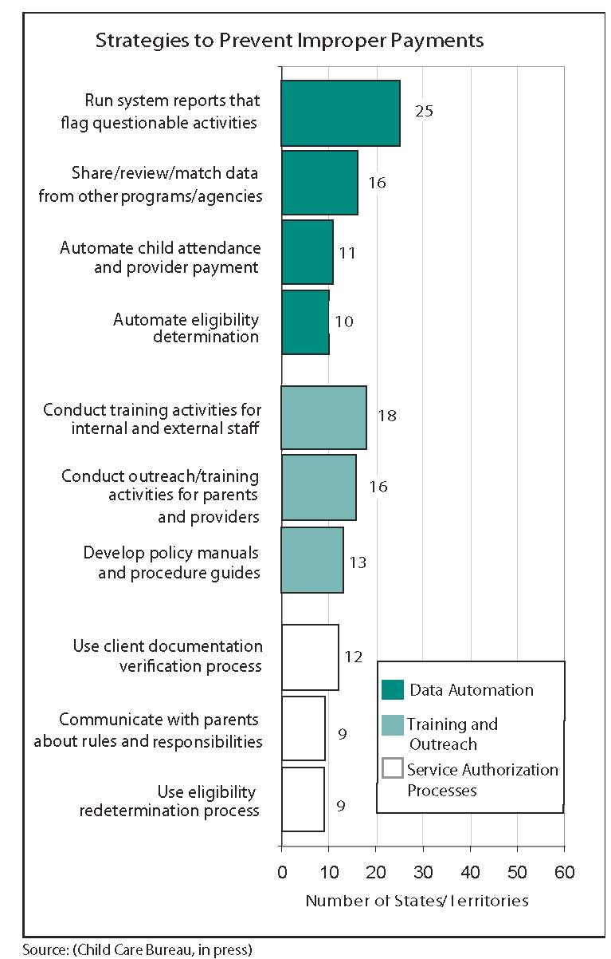
Information and Communication Strategies: Sending the Message to Parents and Providers
Effective and clear communication with parents and providers is also an important tool used by States and Territories to prevent improper payments. Sixteen States reported that outreach and training activities are conducted to inform families and child care providers of the requirements for participating in the child care assistance program and the rules regarding billing and payment.
In Rhode Island, every provider approved to accept payments in the child care assistance program must attend a mandatory introductory training session on program rules and provider responsibilities before they can receive their first reimbursement check.
Identification and Measurement Strategies
Monitoring: Examining and Evaluating Performance
Another essential internal control standard established by the GAO’s State Control Assessment Instrument is monitoring. Ongoing monitoring allows States and Territories to examine and evaluate the performance of contracted and noncontracted providers. Most States and Territories reported using several strategies to measure and identify improper payments, including reviewing the caseload, monitoring provider records, monitoring/auditing grantees and contractors, and establishing monitoring requirements for contractors, grantees, field offices, and local agencies. Several States reported that they developed a case review and monitoring tool to ensure uniformity in case review and edits.
In Oregon, approximately 200 billing forms are selected randomly each month for a desk audit. Providers submit their attendance logs, which are checked against the amount billed and family case record information, helping identify overpayments.
A few States conducted benefit error studies to measure errors.
California conducted an error rate study in the winter of 2004-2005, which estimated and reported potential improper payments resulting from parent or provider fraud or error. The study produced error rates ranging from 3 percent to 5 percent in the area of eligibility and parent fees (California Department of Education, April 2005).
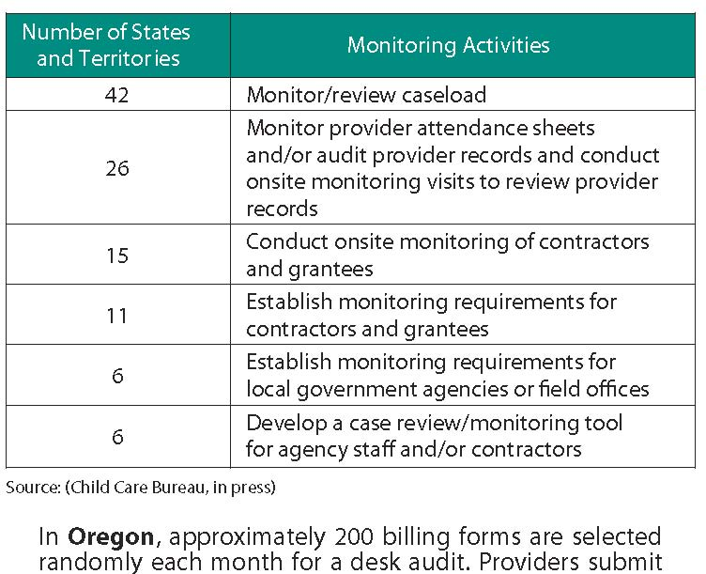
Collection Strategies and Additional Penalties
States and Territories reported using multiple strategies to collect overpayments and to penalize families and child care providers when it is established that improper payments resulted from fraudulent or erroneous activities. Thirty-one States and two Territories reported using repayment plans, reduction of future payments, tax intercepts, and other options to collect overpayments. Twenty-two States reported that they established family and provider sanctions to reduce and prevent improper payments. Sanctions vary in each State and Territory and may include one or more of the following: program disqualification, program exclusion, child care license revocation, and criminal prosecution. In some cases, a minimum overpayment amount must be owed by the parent or provider before an agency will pursue collection or penalties; five States and one Territory reported such a threshold.
North Carolina has the authority to impose sanctions on families or providers when fraud has occurred, if a county or local agency submits such a request. Sanctions may be imposed in addition to requiring repayment of the child care subsidy services or funds received in error. When a sanction is imposed, the individual is ineligible to receive subsidized child care services for 12 months in any county. If a second instance occurs, the individual becomes permanently ineligible. Sanctions imposed on providers operate in the same manner.
Connecticut’s penalties for providers may include lifetime disqualification from the child care program and State license forfeiture.
To investigate records identified as possible improper payments, 16 States have designated staff or have established a fraud unit or quality assurance unit to monitor and identify improper payments. Twenty-six States and two Territories coordinate with or make referrals to a fraud monitoring unit.
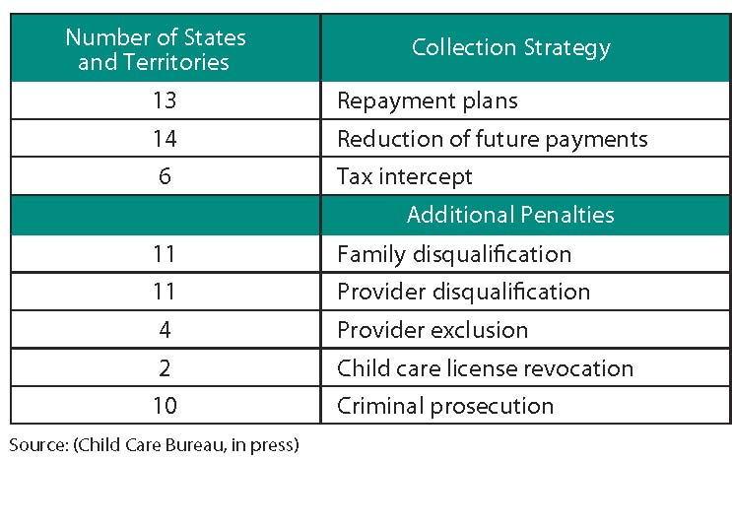
Conclusion
States and Territories are using a variety of tools and standards to help prevent, measure, identify, and collect improper payments. CCDF agencies have defined the issue carefully and are implementing strategies to address problems as they are discovered, including strong policies and procedural safeguards to mitigate risk.
As part of the Measuring Improper Payments in the Child Care Program Pilot Project, the Child Care Bureau partnered closely with 11 States, visiting 6, to examine their approaches to improper payments. In the project’s next phase, the Child Care Bureau tested an error rate methodology in 4 States and is testing an internal control assessment tool in 10 more. In addition, the Child Care Bureau disseminated a voluntary survey to States and Territories, which allowed them to share information about their policies, practices, challenges, and solutions related to improper payments. Additional information about the project and State and Territory strategies to prevent improper payments is available on the Child Care Bureau Web site at www.acf.hhs.gov/programs/ccb/ta/ipi/ipi.htm.
Endnotes
¹ The summary information provided categorizes the District of Columbia as a State.
² After including direct funding from Temporary Assistance for Needy Families (TANF), the Social Services Block Grant (SSBG), and excess Maintenance of Effort (State dollars), 2.3 million children are served. The estimated total number of children served is calculated based on CCDF administrative data (ACF 801) and financial data from CCDF (ACF 696), TANF, and SSBG programs.
³ Identified strategies are based on State and Territory CCDF Plan responses to several open-ended questions and may not reflect all of the strategies currently in place to prevent and reduce improper payments. CCDF Plan responses on improper payments are not available for American Samoa and the Virgin Islands.
⁴ Additional CCDF Plan information on State and Territory strategies to address improper payments is available in the Child Care Bureau’s publication, Child Care and Development Fund: Report of State and Territory Plans, FY 2006-2007, which will soon be available at http://nccic.acf.hhs.gov/pubs/stateplan/stateplan-intro.html.
References
California Department of Education. (2005, April). CalWORKS and alternative payment child care programs: Error rate study report required by Chapter 229, Statutes of 2004. Retrieved March 28, 2006, from www.cde.ca.gov/sp/cd/re/documents/errorratestudy.doc
Child Care Bureau, Administration for Children and Families, U.S. Department of Health and Human Services. (n.d). Measuring improper payments in the child care program: A project of the ACF/Child Care Bureau. Retrieved January 16, 2006, from www.acf.hhs.gov/programs/ccb/ta/ipi/ipi.htm
Child Care Bureau, Administration for Children and Families, U.S. Department of Health and Human Services. (2005). CCDF state and territories plan preprint, FFY 2006-2007. Retrieved December 30, 2005, from www.acf.hhs.gov/programs/ccb/policy1/current/ACF118/preprint_2006_final.htm
Child Care Bureau, Administration for Children and Families, U.S. Department of Health and Human Services. (in press). Child Care and Development Fund: Report of state and territory plans, FY 2006-2007. Washington, DC: Author.
U.S. Government Accountability Office. (2004, June). TANF and child care programs: HHS lacks adequate information to assess risk and assist States in managing improper payments (Publication No. GAO-04-723). Retrieved January 16, 2006, from General Accountability Office Reports Online via GPO Access: www.gao.gov/new.items/d04723.pdf
U.S. Office of Management and Budget. (2002). Implementation guidance for the Improper Payments Information Act of 2002, P.L. 107-300. Retrieved December 30, 2005, from www.whitehouse.gov/omb/memoranda/m03-13-attach.pdf
About this Brief

This Issue Brief was developed at the direction of the Child Care Bureau, Administration for Children and Families, U.S. Department of Health and Human Services to meet the information needs of Child Care Administrators. It was prepared for the Child Care Bureau by the National Child Care Information Center, through contract #233-01-0011 with Caliber, an ICF International Company.
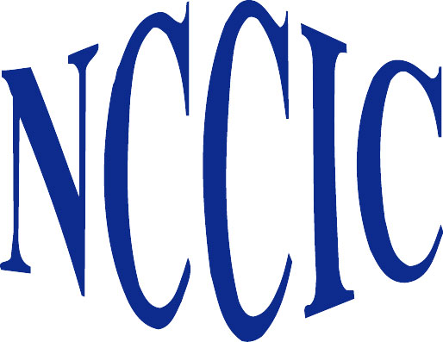
National Child Care Information Center
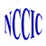 | National Child Care Information Center
 | A service of the | 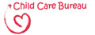
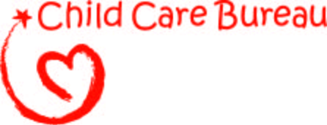
A service of the
Linking information and people to complement, enhance, and promote the child care delivery system
10530 Rosehaven St., Suite 400, Fairfax, VA 22030 • Voice: 800-616-2242 • TTY: 800-516-2242
E-mail: info@nccic.org • Web: http://nccic.acf.hhs.gov

 | U.S. Department of Health and Human Services  Administration for Children and Families  Administration on Children, Youth and Families


U.S. Department of Health and Human Services
Administration for Children and Families
Administration on Children, Youth and Families

