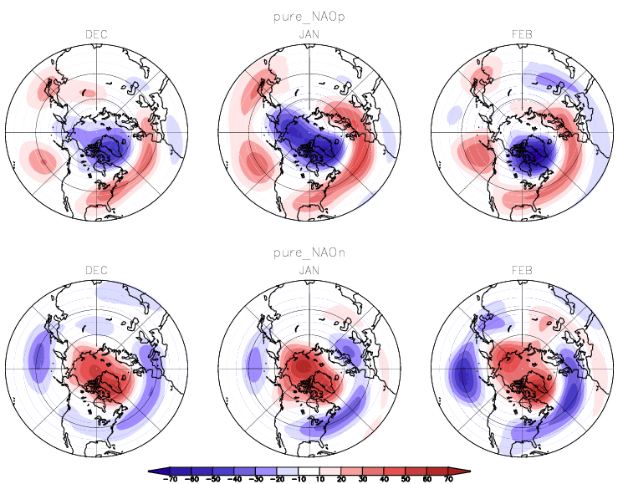
Top three panels shows the pure positive and negative NAO composites of 250-hPa height anomalies for December, January and February. In January, the height anomalies are zonally symmetric, with strong negative anomalies in the polar region and positive anomalies around the latitude circle in the midlatitude. In the February, the negative anomalies in the Arctic Sea weakened and shift to the Iceland. Meanwhile, there is negative anomalies forms in the Mediterranean???, emanating the second wave train across North Atlantic.
The pure negative NAO composites for January shows similar anomalous pattern as the counterpart of the NAO (+) with high degree with annularity. However, distinct difference can be seen between composite NAO(+) and NAO(-) in February. The anomalies in Aleutian are significantly enhanced in February, and the positive anomalies in Arctic Sea maintains through February, the second wave train propagate more further down to the ??? . It is suggested that the non-linearity of the transition from January to February between the NAO (+) and NAO (-).
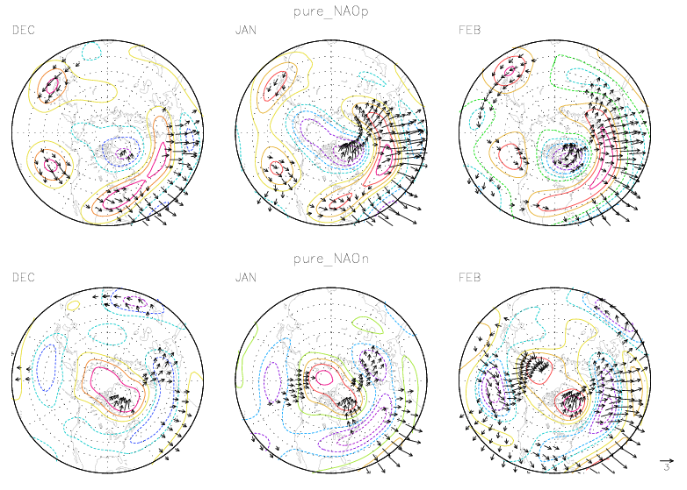

Top panels are wave activity flux with (arrows) based on the pure NAO (+) of height anomalies at 250-hPa, superimposed on contours for the streamfunction (psi’=z’*g/f, 10⁶m²s⁻¹). In January, the wave activity in the Aleutian region propagates eastward equatorward for NAO (+), with none polarward component of wave activity. Thus the negative anomalies disappear in Arctic Sea in the following month. While for NAO (-), the wave activity propagates polarward to the Arctic Sea region. The convergence of the wave-activity flux in the Arctic Sea explains the maintenance of strong positive anomalies in the following month. In February, the wave activity in the Aleutian region splits into two branches, with one propagating polarward and the other one eastward and equatorward. What’s more, the wave activity flux propagating more equatorward and east ward associated with the second wave train emanating from the Iceland and North eastern Atlantic.

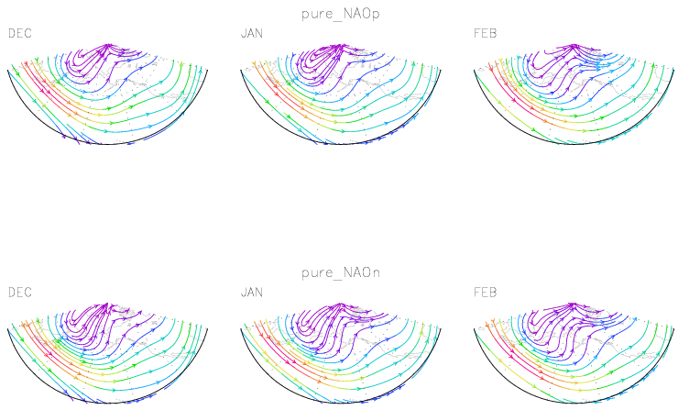

The positive (top) and negative (bottom) NAO composites of the stramlines for the mean flow at 250-hPa.
The split of the mean flow over Alaska is more distinct in the NAO(-) composites. Specifically, the polarward branch is in the south-to-north direction. Since the mean flow serves as a “wave guide” for the high-frequency migratory eddies, it may be related to the more northward wave-activity flux over that region.

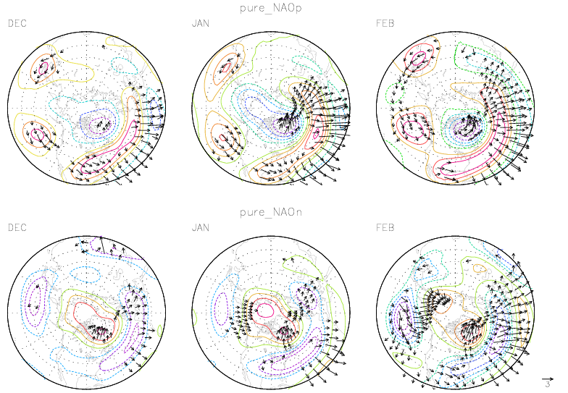

The wave-activity flux based on the composite streamfunction anomalies are very similar to the counterpart based on the composite height anomalies, indicating it is reliable to getting the streamfunction using the geostropcial approximation in the middle and high latitude.

