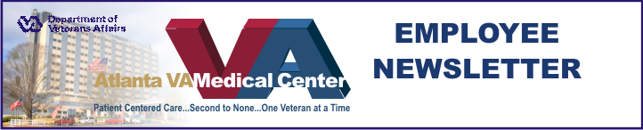

July 9, 2008
Apri

Fee staff makes history
By Martie Hartley
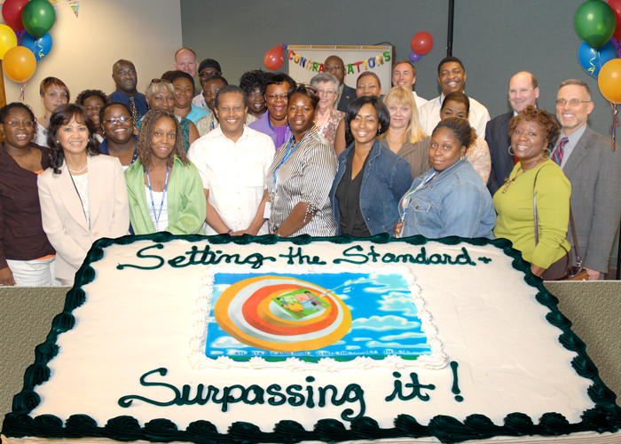
VAMC Director Mr. James Clark (far right) and Health Administration staff celebrate the success of the Fee Basis Program.

In less than 12 weeks after Ms. Judy Lawhead, RN, stepped in to take over as the Acting Chief for the Fee Basis Program, the processing of claims skyrocketed from a rate of 35% to 96.18%, exceeding the claims processing performance measure for the first time in the history of the program.
Ms. Lawhead credits the dramatic improvement to the commitment and dedication of the Fee Staff.
“They worked an exorbitant number of hours and deserve all the recognition,” she said.
As a result of putting more structure in place to improve accountability, establishing a tracking data base for all information on patients, and fostering a positive work environment, the processing of claims went from 1600 -1800 to over 9,800 in the month of June.
Mr. Bart Hall, from the office of Senator Saxby

See Fee on page 2

News Briefs
Director’s Town Hall Meeting- Engineering Service will host the Director’s Town Hall meeting July 22 at 3pm in the Pete Wheeler Auditorium.
Car pool/vanpool -The easiest way to connect with others in your area who wish to car pool or vanpool from near your home to near your place of business is through:
https://www.myridesmart.com/html/index.htm
You can register and receive a list of persons who live near you and have similar commutes. For more information, contact Steve Sherwood, Energy Manager, at ext. 6101.
Voluntary Leave Transfer Program – The following are approved participants in the VLTP and are eligible to receive annual leave donations: Primary Care –Michelle Pough. EMS- Robert Wingo. Health Administration Service-Carol Mabry. Surgical-John Robinson. Medical & Specialty Care-Erica Jowers. Atlanta Vet Center-Anita Salamon. Police-Bobby Keener. If you wish to make a leave donation, call Freida Philpotts at ext 6306 or Marie Robinson at ext. 4376 to complete form OF-630A.
Computer classes- The following computer classes are available during the month of July: Excel (Beginners) – July 16, 1pm to 2:30pm; Outlook (Beginners)- July 10, 1pm to 2:30 pm; Word – July 24, 2pm to 3pm; Smartphone and PDA (Beginners) – 8am to 9am; Understanding PKI in the VA – July 21, 1pm to 2pm Please resister in Synquest in “Other Assignments”. All classes will be held in room 6C-156. For more information please call Mikel Shavers at ext. 7475.
Joint Commission- For patient safety concerns, contact Quality Management at ext. 6243; to file a complaint, contact the Office of Inspector General at (800) 488-8244 or VA IG at 53E/P.O. Box 50410, Washington, DC 20091 or contact Joint Commission at (800) 994-6610 or email complaint@jointcommission.org. No adverse action will be taken against those who report safety or quality of care concerns.
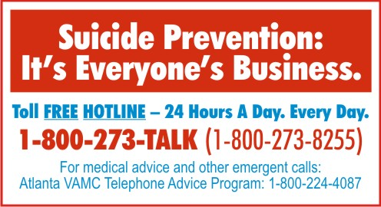

Taking it all in stride, Ms. Lawhead said she
and her team will continue to take on the challenges and actively look for ways to make improvements and better serve our veterans.
“Transforming culture is never easy and a lot of credit goes to the entire staff because they didn’t just accept change; they embraced it,” she added.

Fee from page one

Chambliss came by to personally congratulate staff members on such an amazing accomplishment.
During her July 8 visit, Elena Gabrysh, Constituent Services Representative from the office of Congressman John Linder, praised the Fee staff and joked that she might not have a job if they continue performing at such a high level.

VAMC program helps today's students become tomorrow's leaders
By Elton Taylor

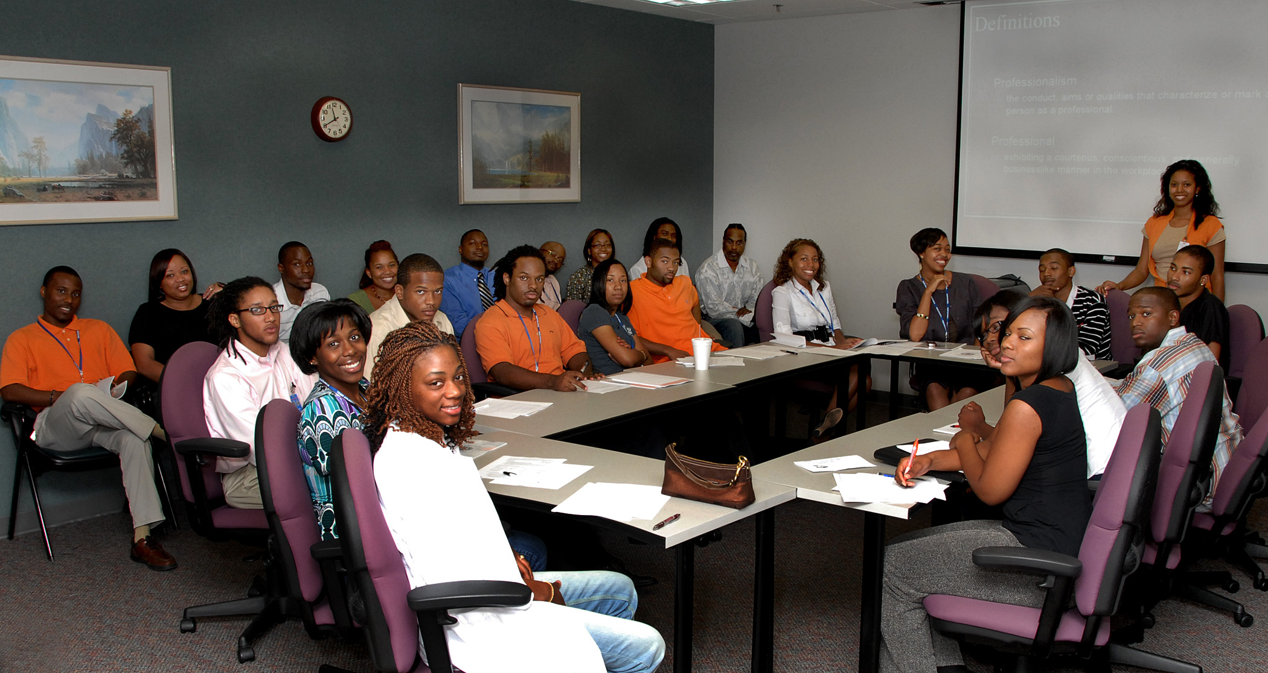
Mrs. Tiffany Marshall conducts a class on professional conduct in the work place.

Dr. Hardison has been the recipient of many awards for his excellent teaching by medical school classes and the residents. In 2001 he received the Angeline Papageorge award by the Emory University School of Medicine the highest award given for a lifetime of excellence as a clinical teacher.
His encyclopedic knowledge, sharp wit and gentle but forceful guidance have made him a legend throughout the region, a reputation fostered by his former students. Their respect and appreciation for his contribution to their professional development is heartfelt.

Mrs. Marshall is very passionate about helping her students reach their full potential.
“I want them to have a well-rounded internship, where they can experience the benefits and endless opportunities of federal employment,” she said.
To prepare her students to be confident, competent, and competitive participants in the global market place,
Mrs. Marshall, along with other staff members, hosts Lunch and Learn sessions which cover topics such as professionalism and resume writing.
The ultimate goal is to prepare and empower students with superior skills needed to accomplish their career objectives.

It’s been said that becoming a leader is synonymous with becoming yourself, that it is precisely that simple and yet that difficult. An Atlanta VA Medical Center training program helps students take on that difficult challenge.
The Student Placement Program provides minority undergraduates with the knowledge, personal skills and experiences required to become leaders in tomorrow’s careers.
Mrs. Tiffany Marshall oversees the
14-week program which currently includes 23 students from Morehouse College, Hampton University, Georgia State University and other prestigious institutions.

