
eDigest | February 2008
In This Issue  - From the Mission Director  - USAID/Macedonia in Action  - Off the Wires  - Inside USAID  Things to Know  IRI releases survey on politics in Macedonia:  IRI Survey Results  Media Watch  USAID programs featured in business weekly KAPITAL:  Interview with Patricia Rader and Marcia Wong, USAID  Interview with Aleksandar Sahov, BEA Chief of Party  Interview with James Maxwell, AgBiz Chief of Party  USAID in Numbers  - Over 3,000 election monitors trained  - 1000 jobs created by the USAID e-Biz Centers  - 7,000 students enrolled in South East European University, established with USAID support  Who’s Who at USAID/Macedonia  Patricia Rader, Mission Director  prader@usaid.gov  Marcia Wong, Economic Growth Director  mwong@usaid.gov  Michael Eddy, Democracy & Governance Director  meddy@usaid.gov  Dwaine Lee, Education Director  dlee@usaid.gov  Olya Catto, Communications Director  ocatto@usaid.gov | From the Mission Director  I am pleased to introduce the first issue of the USAID/Macedonia e-Digest. The purpose of this monthly electronic newsletter is to share information about new developments at the Mission, USAID program accomplishments, as well as useful resources. Our audience is diverse – from implementing partners and government officials to students and the business community. I hope that this newsletter will be interesting and relevant to each of you, and that it will help you learn more about our important work in this country. I look forward to your comments.  Patricia Rader  USAID/Macedonia in Action  Off the Wires  Politics – Macedonian public welcomed the victory of the pro-EU liberal Boris Tadic in Serbian presidential elections on February 3rd. Tadic’s win is seen as a stabilizing development that will help to bring prosperity to the Balkan region and boost the capacities for joint collaboration and progress towards Euro-Atlantic integration. All eyes are now on Kosovo as it prepares to declare independence from Serbia.  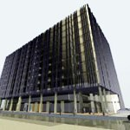  Economy - Slovenian group ERA has begun construction of the largest commercial and entertainment center in the region, ERA City Skopje. ERA Group will invest about 150 million Euros in the project during the next five years, and the entire investment will create about 800 jobs. The 85,000 square meter complex will feature a business center, a shopping mall, cinema and restaurants. (MIA)  Education – This month, the Government of Macedonia will begin installing the first of 100,000 computers targeted for primary and secondary schools. In a meeting with the Minister of Information Society, USAID agreed to support the “One Computer for Every Student” initiative through teacher training and adaptation of educational software into Macedonian and Albanian languages.
  
  Economic Growth - Understanding the importance of a clean environment comes from an early age. That is why children are the centerpiece of the USAID Plastic Recycling Project’s outreach campaign. With help from USAID, primary school students in Skopje, Strumica, Gostivar and Kocani leap into action to educate their classmates, family members and neighbors about the importance of plastic recycling. Students of the Bratstvo School in Skopje’s Municipality of Karpos dressed in blue and yellow plastic bags - blue for the collection of paper and yellow for the collection of plastic – to distribute collection bags and educational leaflets to households in their neighborhoods. More fun activities for all ages are planned for the upcoming Earth Day Fair on April 20th. The children’s enthusiasm is inspiring, but equally important are the public-private partnerships between the municipalities, public utility companies and schools, which will continue far into the future. Photo by Olya Catto: Children in Strumica present an educational program on plastic recycling.
  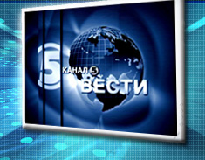
  Democracy – A truly free and open society is characterized by independent and responsible media on one hand, and a vibrant and active civil society on the other. For years, USAID has been working with local media and NGOs to strengthen their partnership and to help them play a more prominent role in society. On January 30th, the USAID Civil Society Strengthening Project joined the Macedonian Institute for Media (MIM) in presenting the winners of the 2007 Civil Society Media Awards. Television station Kanal 5 received the top overall award, with other winners including newspapers Utrinski Vesnik, Monitor and Dnevnik, and the A1 television program Rano Den. The winners were selected through a voting process among all registered NGOs, citizens’ associations and foundations. The final decision was made by a seven-member jury, comprised of prominent NGO representatives and media researchers. This is the second non-monetary annual award conducted by MIM. Last year, the top prize was awarded to A1 television station, with recognitions given to Sitel TV, Utrinski Vesnik and MRTV.
  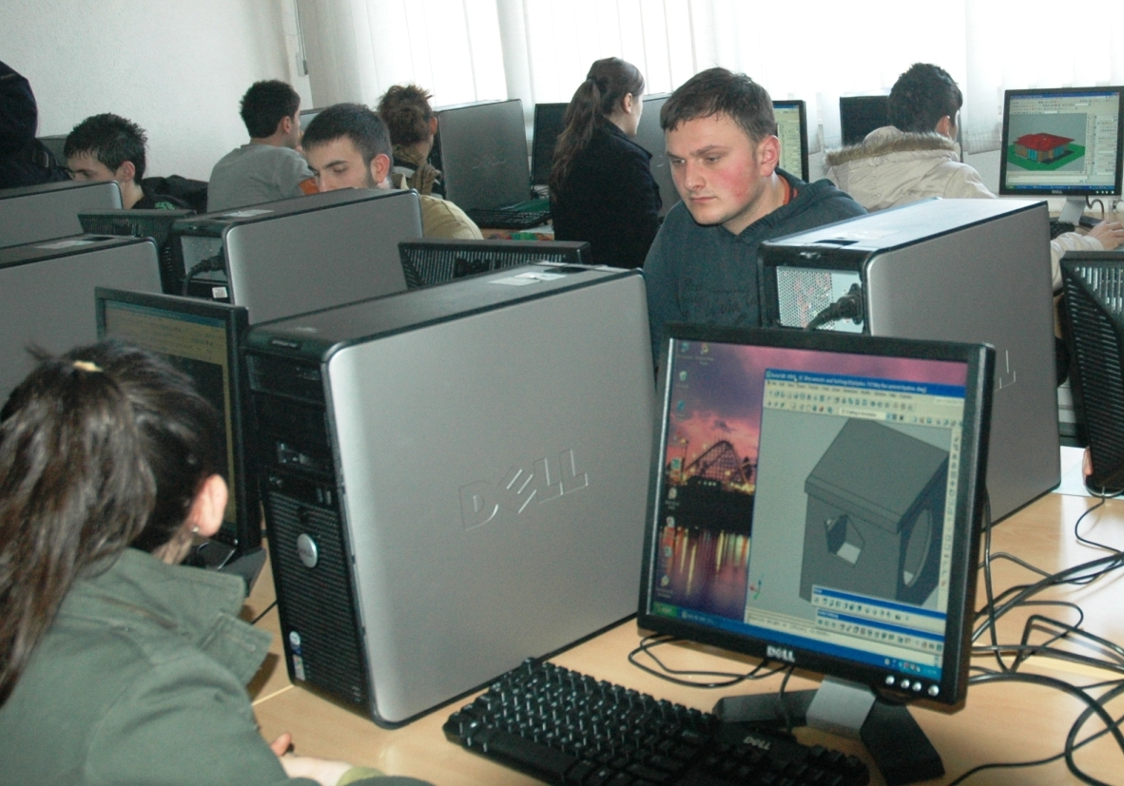
  Education – The quality of education in any school, in any country depends largely on those who have the most effect on the children – the teachers. In Macedonia, teaching techniques and equipment are often outdated, and instructors don’t have access to modern teaching tools and materials. The USAID Creative Teaching and Learning Project addresses these challenges by modernizing eight public Teacher Training Institutions (TTIs) across the country. Since December 2005, the project has invested over $1,000,000 to renovate facilities, install media labs and model classrooms, update curricula and train future teachers on innovative teaching techniques at all TTIs. Most recently, the project has equipped media labs at two faculties of the Tetovo State University with computers, printers, copiers, television sets and furniture. Selected teachers and students from all TTIs were trained in the European Credit Transfer System, education for social justice, curricula revision and the use of information technology – all elements necessary to bring Macedonian educational system to EU standards. Photo by Olya Catto: Students in Tetovo State University enjoy the new media lab.
Contact Us:  ocatto@usaid.gov  bvelickovska@usaid.gov  http://macedonia.usaid.gov | Inside USAID  Mission Announcements  In January, USAID/Macedonia Education Specialist Natasha Murdzeva Buleska was featured as a keynote speaker at the Strategy Institute's 2nd Annual Canadian Municipal Wireless Summit in Toronto, Ontario. The conference, which attracts business and political leaders from around the globe, provided an excellent opportunity to showcase how USAID helped Macedonia become the first wireless country in the world.  Mission Holidays  February 18th – Presidents’ Day  Upcoming events  February 21st - Macedonian Civic Education Center project closing, Civil Society Strengthening Project (CSSP)  March 7th – Open Day for Women in Parliament, Parliament Development Project  March 15th - Consumers Organization project closing, CSSP  April 20th – Earth Day Fair at the Skopje City Park, Plastic Recycling Project
The American people, through USAID, have invested nearly $500 million in Macedonia since 1993. USAID is implementing projects that create jobs, reduce corruption and improve the quality of education. For more information please visit http://macedonia.usaid.gov.

