Scenic Drive Hiking Trails
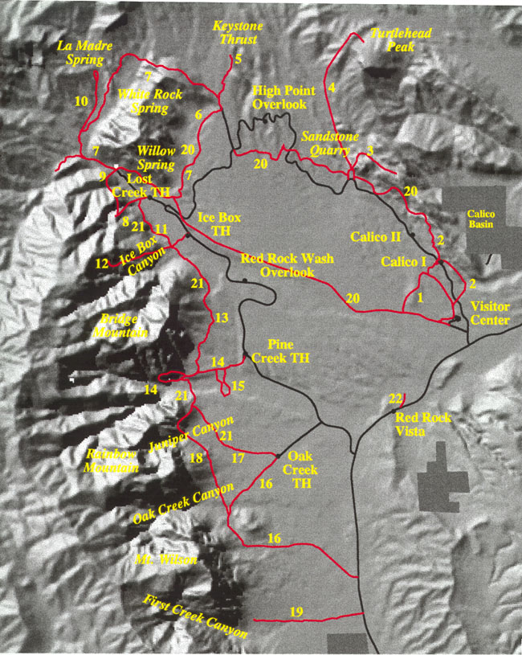
Trail # | Trail Name | Trail # | Trail Name
1 | Moenkopi Loop | 12 | Ice Box Canyon
2 | Calico Hills | 13 | Dale
3 | Calico Tanks | 14 | Pine Creek
4 | Turtlehead Peak | 15 | Fire Ecology
5 | Keystone Thrust | 16 | Oak Creek
6 | White Rock - Willow Springs | 17 | Arnight
7 | White Rock Loop | 18 | Knoll
8 | Children's Discovery - Lost Creek | 19 | First Creek Canyon
9 | Willow Spring Loop | 20 | Grand Circle Loop
10 | LaMadre | 21 | Base of the Escarpment (composed of 11, 13 and 17)

