Spaceward Bound Expedition 2006
Atacama Desert
Yunguy, Chile
6/19/06 – 7/01/06

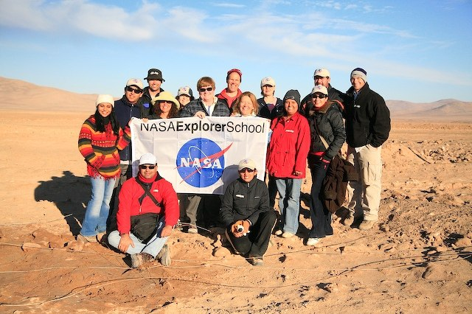

By:
Geoffrey Hammond
Lake View School
Huntington Beach, CA
8/28/06

0000.doc

6/19/2006 Three Days of Travel (Transect)

The story begins at 1:15 p.m. at John Wayne (Orange County) Airport. I was to fly to Dallas, meet up with Liza Coe and crew and then continue on together to Santiago where we would meet Chris McKay (our fearless leader) and fellow scientists for the transect portion of our journey. I said goodbye to my father-in –law, Richard, and my oldest son Grant and resigned myself to the long days of travel ahead of me.
Three hours later (+2 hours for time zone change) I was in the Dallas airport searching for Liza Coe (our NASA representative from Ames in charge of teachers) and the other NASA Explorer School teachers. There were a total of seven teachers chosen from throughout the United States to participate in this exploration and research expedition into the Atacama Desert. The American teachers included Matt Allner from Sioux City, Iowa; Cherlyn Anderson from Gaston, South Carolina; Cathy Campbell from Ann Arbor, Michigan; Phyllis Isbell from Lakebay, Washington; Karie Trupka from Wahpeton, North Dakota; Koby Van Beest from Canaan, New Hampshire; and myself, Geoff Hammond from Huntington Beach, California. The Atacama desert has been found to be the driest place on earth. In fact, it is forty times drier than our own Death Valley. There can be literally decades between periods of rain fall. The only water to be found in this region of Chile, sandwiched between the coastal mountains on the west and the mighty Andes to the east, is underground. There are also a few rivers fed by the Andes that flow through the parched land in route to the sea.
In the Yunguy Region of this desert NASA has set up a Mars Analog Research Station. The landscape is similar to Mars and so devoid of life NASA uses this station to test techniques and equipment that could be used to explore the Martian planet or other extra terrestrial surfaces in the near future. Just to play a small part in something like this is an awesome experience in itself.
After a quick dinner at the airport I found our group and made introductions. In addition to the teachers previously mentioned we would be traveling with a few of the NASA scientists…Jim Nienow a biologist, Henry San a microbiologist and Penny Boston a geomicrobiologist. The only person missing was our organizer Liza Coe! We heard a bit later that she had been delayed and would not be joining us. Yikes! We were on our own entering a foreign country with fingers crossed that someone would be there to meet us in Santiago.

6/20/2006

After the overnight flight from Dallas we arrived in the early morning to Santiago, Chile. At some point during the night we crossed over the equator and went from the Northern Hemisphere to the Southern Hemisphere. In so doing we went from summer to winter or from long summer days to short winter days. After disembarking from our plane, checking through customs and paying the Chilean government $100 each for visiting their country we wandered around this international airport sticking together like a school of fish hoping that there was safety in numbers and that somebody would know what we were supposed to do next. Thankfully, we soon saw the smiling face of Chris McKay towering over a sea of black haired heads working his way towards us. We were off in no time for the next portion of our journey.
We loaded into our rented vans and four wheel drive vehicles and headed to Chris’s hotel to pick up his gear and a few other scientists that had arrived a few days earlier. When all was loaded up and tied down we settled in to our 850 mile drive through Chile, caravan style.
It was a long yet very scenic and interesting drive through the Chilean countryside. We would stop occasionally for food, gas, bathroom breaks or for Kobi to take a swim in the cold waters of the Pacific. It was very cool and foggy in Santiago but it began to get warmer and drier the further north we progressed. We arrived late to a small town called Vallenar and stopped for the night. The town buildings and the people in Chile reminded me a lot of Mexico; however, the food was not nearly as good. It was very plain cuisine, as a general rule of thumb. One exception was the bread; it was delicious and I also liked their “raw” (big grained white) sugar.

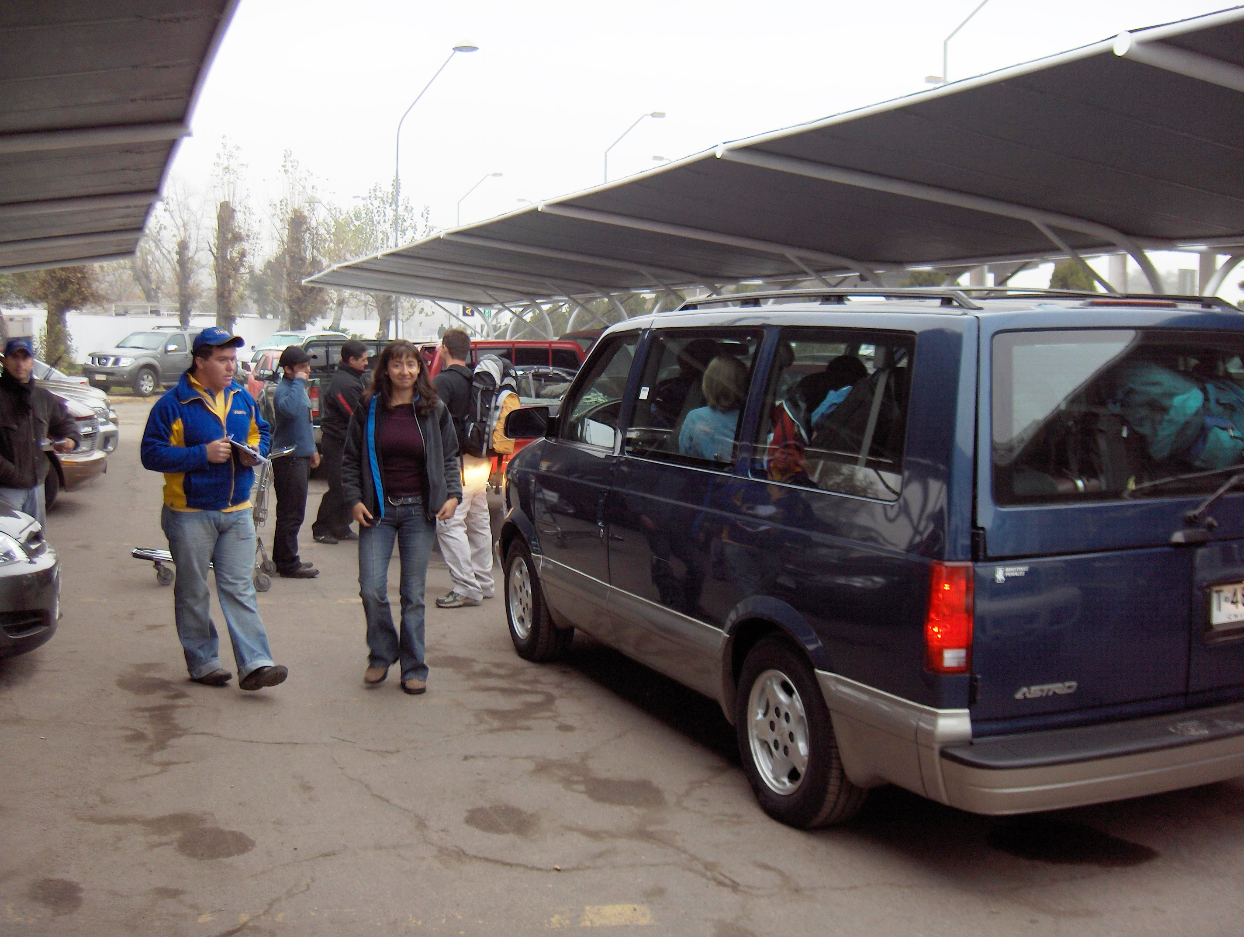

6/21/2006

Today is my nine year anniversary and Kelly Snook, aerospace engineer, planetary scientist, technological gadget junkie and cement truck specialist, allowed me to use her cell phone during a brief period of cell reception and I was able to talk to my wife. I owe my wife big next year. This is the second year in a row that I’ve been gone on our anniversary for a NASA sponsored venture.
As we continued north and turned inland towards our destination in the Yungay the terrain quickly began to change. Vegetation became less and less until there was none left at all for as far as the eye could see. No little shrubs, cactus, lichen, nothing. It was just sand, dirt and rock. The area was very desolate and seemingly very lifeless. We stopped twice to “get our feet wet” and do some sampling of the soils. This was to look for life at a microscopic level. Penny Boston and a scientist named Linda Powers gave us a quick introduction on sampling techniques and what we were looking for. We quickly got to work.
We pulled into the Yungay Station around 10:00 p.m., made quick introductions, made ourselves ham and cheese sandwiches (which are the main staple of this facility), set up our tents, dressed against the cold (below freezing at night), said goodnight and hit the sack.

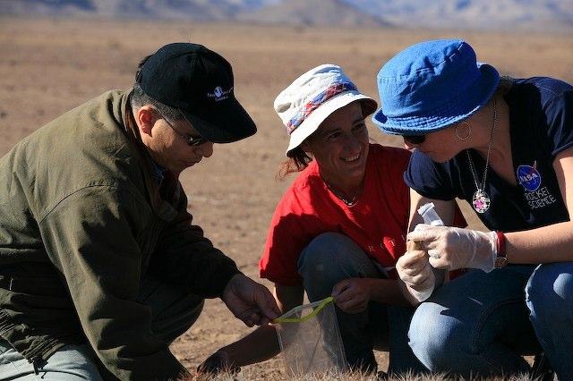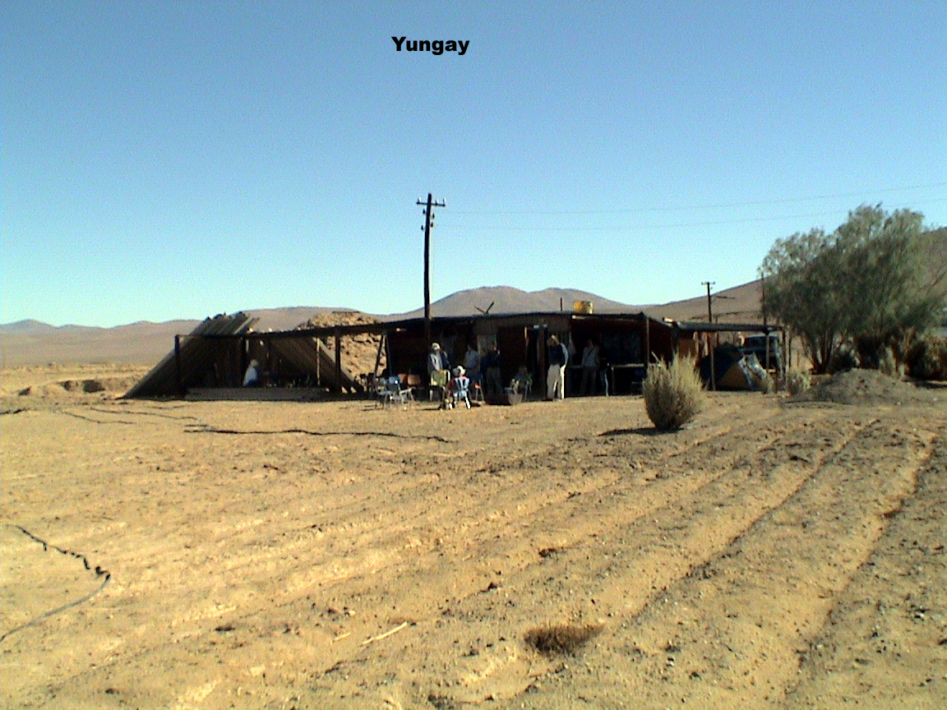
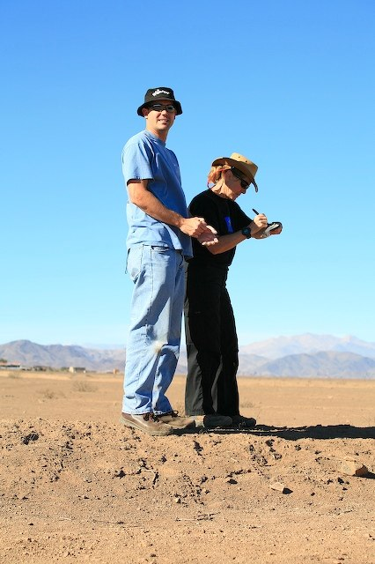
6/22/2006

Today was our first full day at the Yunguy Station. We were able to sleep in and I didn’t arise from the tent until after 8:00 a.m. It seems that Karie Trupka and I have hooked up with a scientific team from the University of Utah. Linda Powers is the main scientist and she is an extremely dynamic lady who has lived and experienced life to the fullest. Her assistant’s name is Shayne Rich who is an engineer and former counter intelligence agent with the U.S. Army. Karie and I feel lucky because after assisting Linda and Shayne in the field collecting samples from the two day transect Linda appears to have chosen us to help her do day side trips up in the mountains, away from the base camp. Linda and Shayne are looking for the presence of organic matter in the soil. They have a special machine that analyzes a sampling of soil and can tell you approximately how many organic units per one by one cm of soil are present. Linda was very excited because on my first sampling just north of Vallenar I took a sample near some donkey dung and the results were very good. They got a reading of ten to the sixth or 1,000,000 parts per one by one cm of soil from my surface sample and 10to the one or 10 units from the sample that I took from 10 inches under the surface.
Today we went to see that “Rock Garden” area and Chris gave an Atacama talk. When everyone left to go back to camp Linda and gang drove up a bit and took some more samples from a remote hillside. We arrived back for lunch at 2:00 p.m.
This afternoon we took a field trip to the salt flats and looked at bacteria that have colonized inside of salt rocks. We walked to a small hidden weather sensing station and watched a scientist hook his laptop to it and learned that the temperature outside 32 degrees Celsius outside and the humidity was 1.5%. Inside the rocks the temperature was the same but the humidity was up to 6.4%.
This evening we had a teacher meeting and learned about our case study we are going to write about. We ate dinner around 8:30 p.m. Accommodations and food seem to be an afterthought for the science minded.
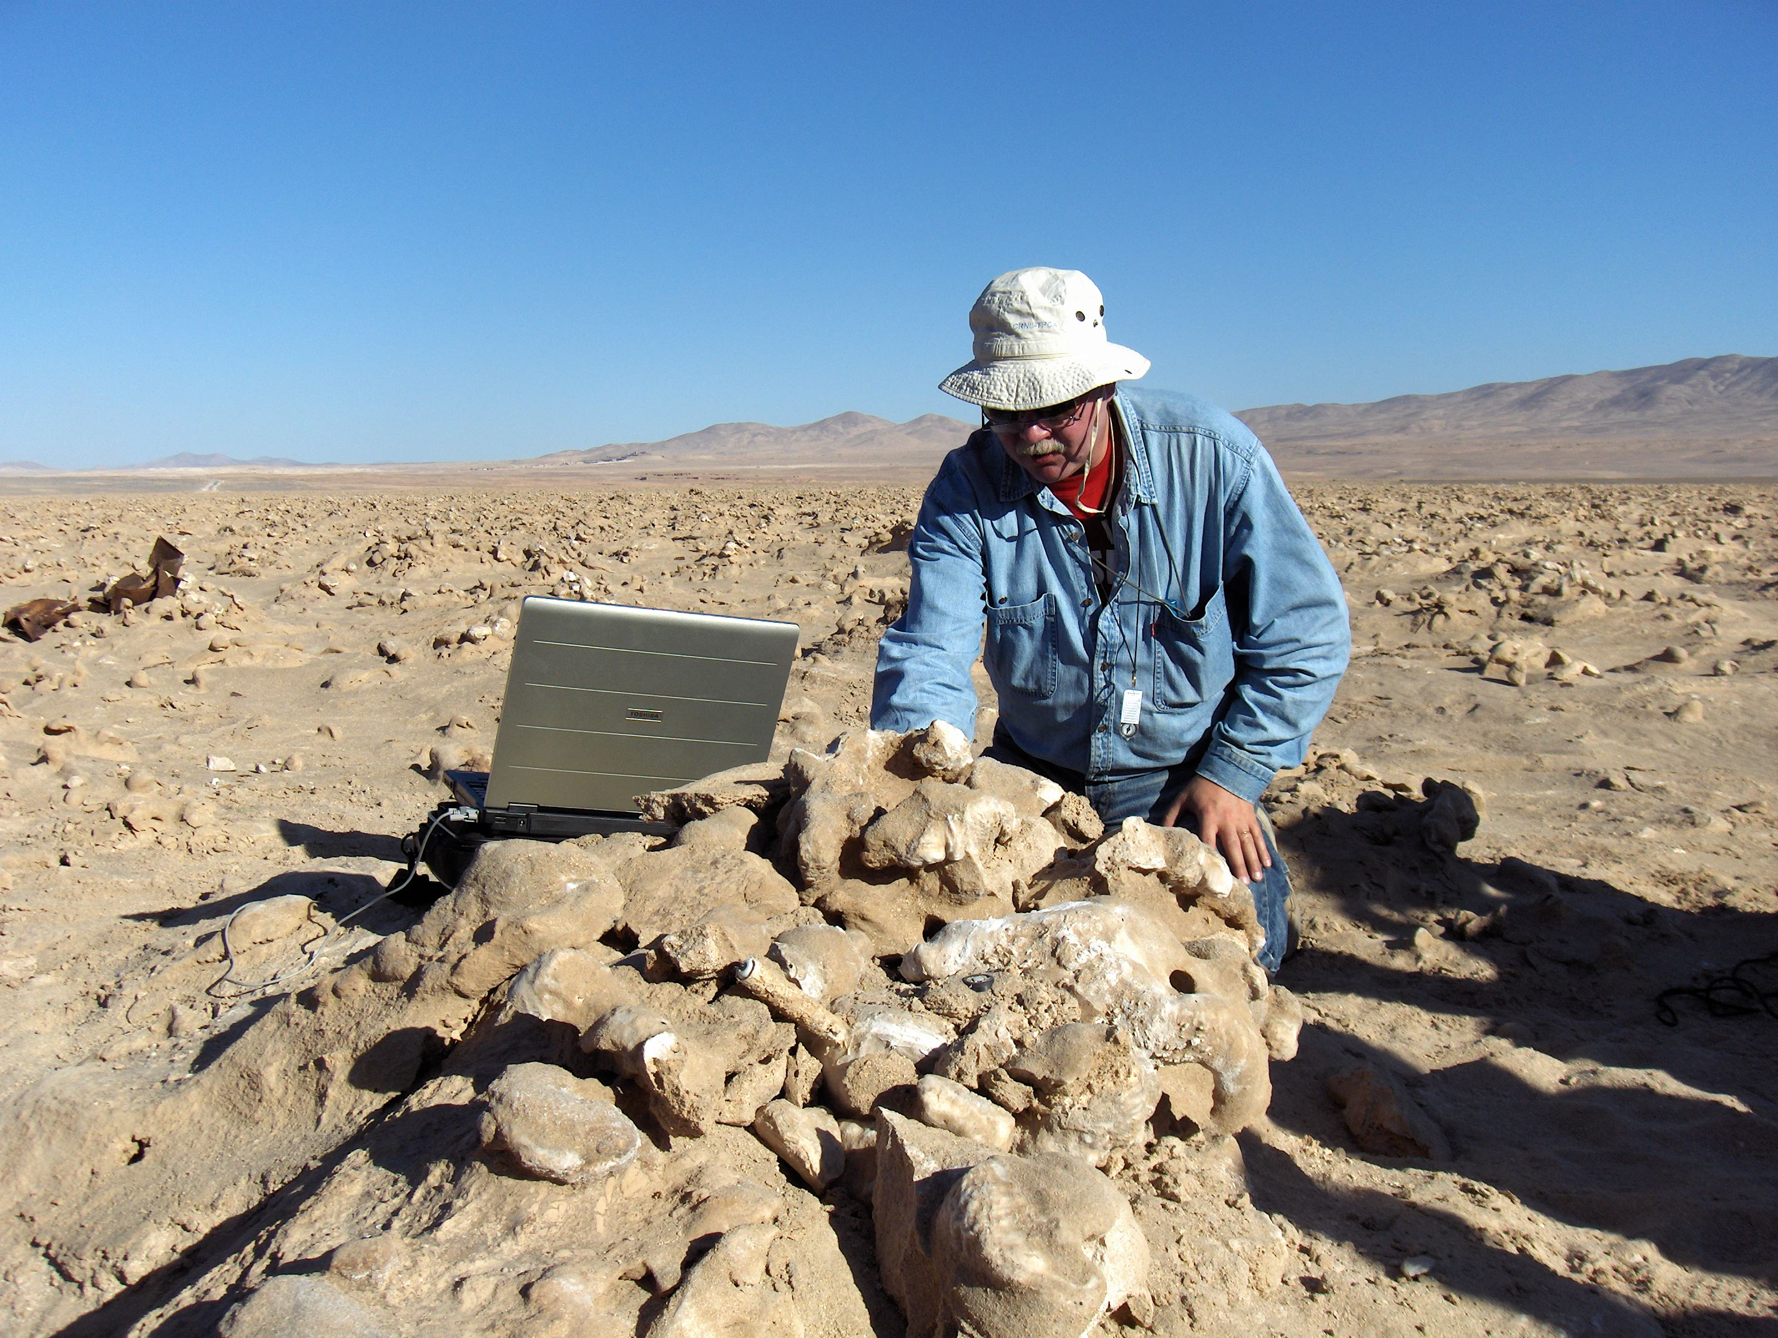
6/23/2006

After another cold night, although not as cold as the first because I was more prepared, we headed back to the rock garden. Linda and Shayne were excited about some of the results from samples we took yesterday and wanted to head back early. Matt and I, along with our Chilean partners, Ivan and Marcos, were sent up on the hill to relocate our digs from the previous day and get GPS readings and photographs of the sites. We were successful and brought data back to the main group.
We then worked with Penny Boston and Karie Trupka taking samples of top soil for bacteria growth purposes. Karie and I took samples of soil and placed it in four vials containing nutrient rich gel and moisture to try and grow any bacteria that might be present. This process can take from four days to three or four years to produce bacteria. We sterilized our equipment with alcohol and fire. Next we filled one vial that contained a solution that acted as formaldehyde to kill, preserve and dehydrate anything living for viewing under an electron microscope. Finally, we filled a large bulk sample and then did the whole thing over again. I helped Shayne with more sampling with his machine and chuckled at the scientists getting so excited over some potholes in the rocks that appear to have been filled with water at times.
On the road back to the station we stopped at an old cemetery and took some pictures in an abandoned vehicle. Unfortunately, that might be my only EVA experience. Back at camp we had lunch, ham and cheese sandwiches again, rested and played paddle ball. Maite and I set the record at 161! We had our gift exchange during the teacher meeting and talked about our days. We decided to use Lewis and Clark’s expedition as a back drop for this program instead of New World Explorers. Matt already has some good information and ideas about the Lewis & Clark expedition and this is also part of Fifth Grade U.S. history.
Right now it is 8:46 p.m. and dinner is still cooling…we eat very late around here. Just participated in a Southern Hemisphere telescope astronomy presentation put on by Brian Day. The session was very cool and informative. We looked at star clusters, galaxies, super novas waiting to happen, and the planet Jupiter. Jupiter was very cool and we were able to see four moons orbiting the planet.
Not sure if I’m going with Linda tomorrow…there are four people that really want to go and only two spots. We’ll see. Linda won’t pick and told Liza to tell us that the four of us need to decide amongst ourselves.

6/24/2006

I’m in! Karie and I ended up teaming with Linda and Shayne and might actually be going to Bolivia! Tomorrow we are loading up and driving to a volcano named Lazcar with a guide and hiking to the top. We will be taking samples along the way and from the top, which is 5,641 miles high. Not really prepared for that kind of thing dress wise but I will make do. Then on Monday we are heading to the highest volcano in the area named Lincancabur which is 5,916 miles high and has a fresh water lake in its crater at the top. Very exciting but it is late so I will write about the long drive to the Solar and San Pedro tomorrow. Buenos Noches.
Our long, dusty, potholed drive through the back roads of the Atacama began early and ended late. The scenery was pretty spectacular and driving through a huge Copper Mine was incredible to see. The desert is very rich in minerals and colors change from yellows, whites, reds, purples, blacks and greens. It is abundant in copper, manganese, salts and iron.
Our caravan was slow moving with lots of stops for sample collection mostly done by Pierre who is looking for worms in wet soil near the Salars. Pierre is also the youngest son of famous oceanographer Jacques Cousteau. We had a radiator leak at a restroom stop but it ended up just being an overfilled radiator leaking the overflow. Then a few kilometers down the highway in the Salar de Atacama, which is a huge salt flat, one of our vehicles got a flat tire. Changing the tire might have been easy had the spare tire been ok. It had a huge bulge sticking out of the side and then the spare from another vehicle was a slightly different size so they decided to patch the flat with a plug kit. Matt and Pierre did the dirty work and things seemed to work out fine. We got the tire professionally fixed at a small town called Toconao.
It took so long getting to San Pedro that we all ended up checking into a very nice hotel and having dinner. I had a good conversation with Geoff, Cherlyn, Phillis and Karie. I also had my first shower sine the states and then got ready for climbing a volcano named Lazcar.

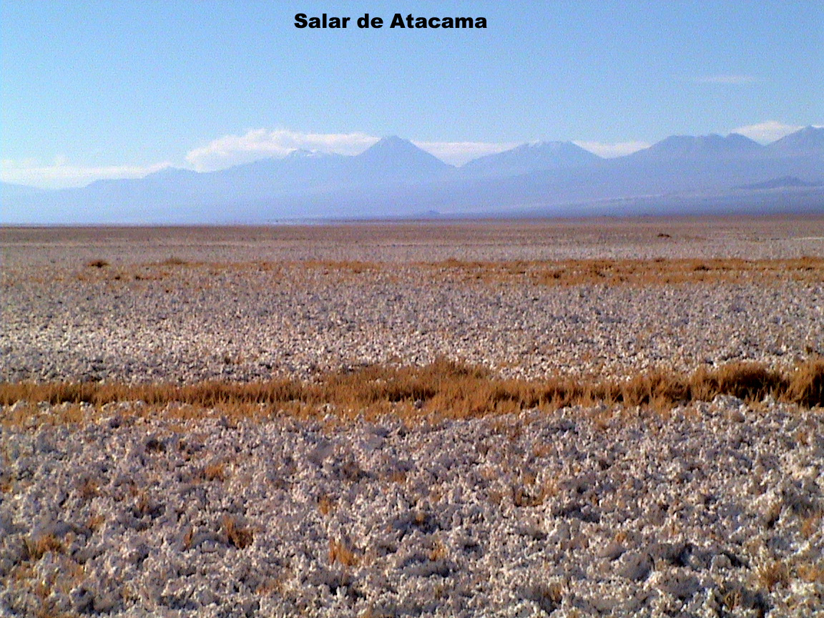

6/25/2006

What a day. We (Linda, Karie, Shayne and me) met for breakfast at 6:00 a.m. to get ready for our climb up Lazcar. Our guide and his son met us and we began our three hour drive to the base of the mountain. The drive was spectacular and most of it was done in four wheel drive. We actually drove to the back side of Lazcar to an elevation of almost 15,000 feet to begin our climb.
We started out about 11:00 a.m. hiking very slowly. Shayne was having trouble hauling the sensor machine “Mahana”. We switched packs but it was still slow going and Shayne had a headache so Linda decided to stop and get some samples. It was cold and very windy so sampling was difficult. Our guides, Juan and Miguel (son) said we needed to get moving. Shayne turned around to head back to the car and the rest of us continued up the mountain. Juan stayed with Karie who decided to turn back after a valiant effort up the mountainside.
After very strenuous, steep climbing, being buffeted around by the wind and straining for oxygen we finally came upon the rim of the volcano. We were at 18,025 feet and could peer into the active volcano’s abyss! The cul we were standing on was a low point on the rim and looking at the crater was pretty awesome. It is still venting and steaming sulpher and fumes from many different areas. The scale of the crater was much bigger than I had imagined and looking out over the edge you could see that the crater dropped straight down into steam and emptiness. You could not see the bottom. The smell was pretty potent and Linda and I both began to cough from the fumes. We collected our samples from the rim. One sample was even over the rim a bit (still makes me nervous thinking about this at night). Another we took about 10 meters from the rim and the last about 100 meters from it. The hike down took about an hour and a half and I felt pretty good until I sat in the van completely spent. A wave of nausea hit me and we couldn’t have driven down that mountain fast enough. It was dark by now and the guides navigated our way down a maze of tracks and trails in pitch blackness. I was very happy to get back to San Pedro and tried to get food in my belly for energy for tomorrow’s climb.

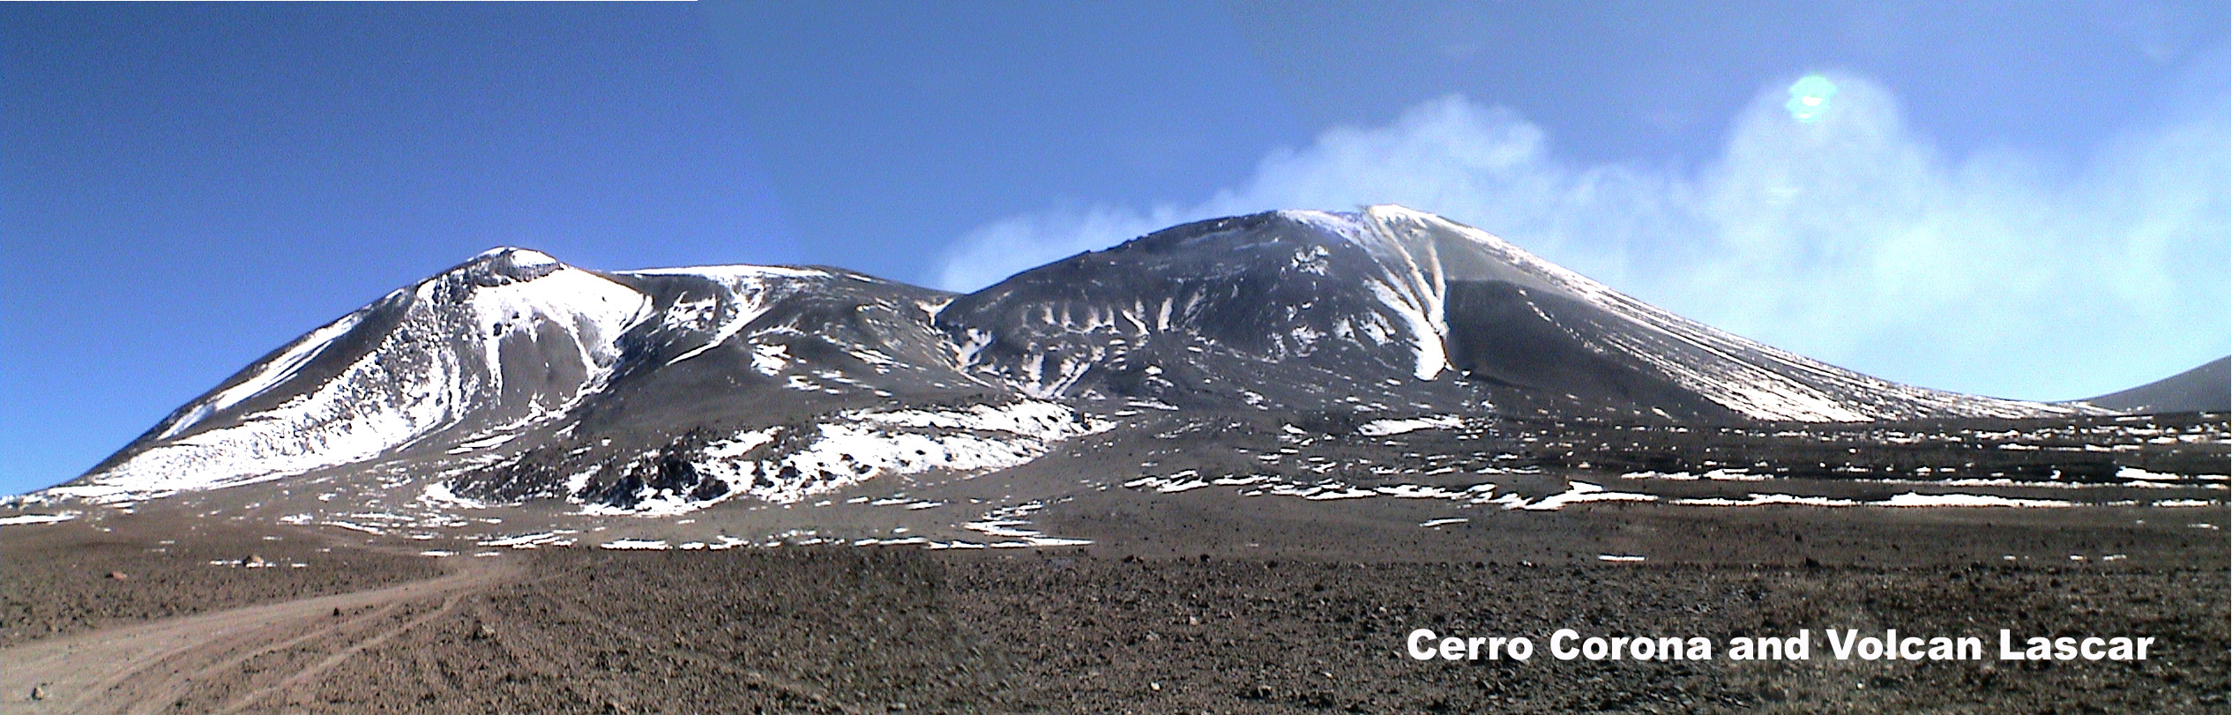

6/26/2006

Today we decided to divide and conquer and kill two birds with one stone. Karie and Shayne were to keep our home base in San Pedro and spend the day at Valley of the Moon. Linda and I were to drive into Bolivia and collect samples from the banks of Lincancabur. We started out early and guide Carlos picked us up at 7:00 a.m. to begin the drive back up into the high country. I tried to eat as much as I could for breakfast knowing that this was probably the last full meal I’d be able to stomach for the next two days in high elevation. Linda suggested packing yet another ham and cheese sandwich for lunch. I conceded and put one together knowing that it would never be eaten.
Carlos drove us though town to another larger bus which we boarded for our trip across the border to Bolivia. Already on board were a couple of German girls traveling with their American boyfriends. All recently graduated from college and traveling together one last time before heading into the next phases of their lives. Also on board were a couple of European older gentlemen looking forward to their four wheel drive three day excursion around the high mountain plateaus, Laguna’s and ancient ruins of Bolivia. It was a slow process crossing the borders between Chile and Bolivia. It took about one hour to check out of Chile and get our passports stamped. We then drove from 3,500 feet to over 14,000 feet high in about 25 miles of road. The Bolivian guard post was a small single building with a flat roof and a flag pole. It was manned by some military types with automatic weapons at hand. Luckily, all my paperwork was in order and after about half an hour we were back in our bus heading down a dirt road across the high desert to the Reserva Nacional De Fauna Andima Eduardo Averao. This is the name of the National Park where the volcano Lincancabur is located (at least half of it). During this leg of the trip Linda was the star attraction on our little bus. She explained our NASA expedition and her role and my role as a teacher on the trip. She went into detail about what we were looking for and how this work relays to space travel and searching for life on other planets, and places, such as Mars. Everyone on board was fascinated and asked many questions which I was glad I didn’t have to answer. Instead, Linda handled them easily and eloquently. She explained that if extra-terrestrial life does exist in our Solar System it is going to be found in or under the soil, rock, or ice and will most likely be on the microscopic level. The techniques for looking for life in this kind of environment that we practice and perfect here on Earth will be used by robots and humans in space in exploration.
We got to the Refugio (mountain shelter) located at 14,266 feet above sea level at about 11:30 a.m. After a brief rest and a snack of bread, butter, and hot tea we checked into our bunk and got ready for the climb. We packed only the essentials for our day up on the mountain. Next, we met our guide and loaded into the four wheel drive Jeep for transportation to the trailhead. We began hiking around 15,000 feet and were surprised by how warm the weather was today. Our guide said in would get very windy higher up but we were soon shedding layers of clothing to cool down.
Over the first ridge we came to a relatively flat open area on which there stood some ancient Inca ruins dating back thousands of years. There were no roofs left, and the remaining walls were no longer very high; however, it was an awesome sight to see. You could still make out where doors, rooms, and different chambers had been.
The hiking after the ruins was very difficult and I was moving slowly. I think I was still feeling the affects of yesterday’s climb and my body was just not in the game today. I was pushing myself but kept falling behind and the altitude was beginning to take a toll. Linda wanted to get to 17,000 feet for samples. We had decided as a group earlier that Linda and I would not be attempting the summit. If we were we would have needed another day and we would have begun hiking at 4:00 A.M. in order to make it to the top and back. As we kept pushing up the mountain the scenery looking back at Lagunas Verde and Blanco was spectacular. The ruins became a small dot on the Inca landscape far below.
Right around 17,000 feet we stopped for a water break and Linda handed me her Powerade. I took two swigs when a powerful wave of nausea hit me so suddenly that I barely had time to turn my head before I littered the landscape with my own organic matter! Well needless to say that was the end of my climb up the mountain for the day. Linda and our guide went about 100 yards further up the trail to get some samples and left me to gather my senses and fight off the chills on the lonely mountainside.
They were soon back and the always exuberant Linda was very excited about the samples she had collected. As we began our hike down Lincancabur I was feeling much better and quite refreshed. We were making good time and were able to stop three more times on the way to collect more samples. We observed some interesting short eared rabbits, called vizcachas, playing in the rocks above the ruins. They proved to be too elusive to get a picture of, so we soon resumed our descent of the volcano. As we dropped down below the ruins we made visual contact with our Jeep, which had returned right on time to pick us up at 6:00 p.m. The driver was taking a cat nap on the roof of the vehicle but soon had us packed up and bouncing along back to the Refugio. Linda kept asking him to stop so she could take a picture of this or that, or to take a drink from her water bottle.
Back at the Refugio we thanked our guide, dropped our stuff off at the bunks, dressed warmly and sat heavily in our chairs in the dining room anxiously awaiting some hot tea, food, and a fire. We received all three. The tea with natural sugar was delicious and rejuvenating. The fire was even better than that! The food consisted of a bowl of vegetable soup and a plate piled with spaghetti. It all looked wonderful but my stomach wouldn’t have it. I was able to eat the soup broth, a couple of vegetables and one bite of spaghetti. That was it! Linda said there was a late bus heading down to San Pedro tonight and that we should get on it because of my altitude sickness. I said that I was fine and that I really wanted to sleep at 14,266 feet in elevation. She relented and said, “Okay, the decision is yours”.
We finally turned in after a very pleasant conversation about past trips, careers, family and of course…science. As tired as I was I found sleeping at this altitude was very difficult. It consisted of twenty minute dozes between restless stirring. I also had a pounding headache and couldn’t take aspirin because of my queasy stomach. Needless to say, it was a long night.

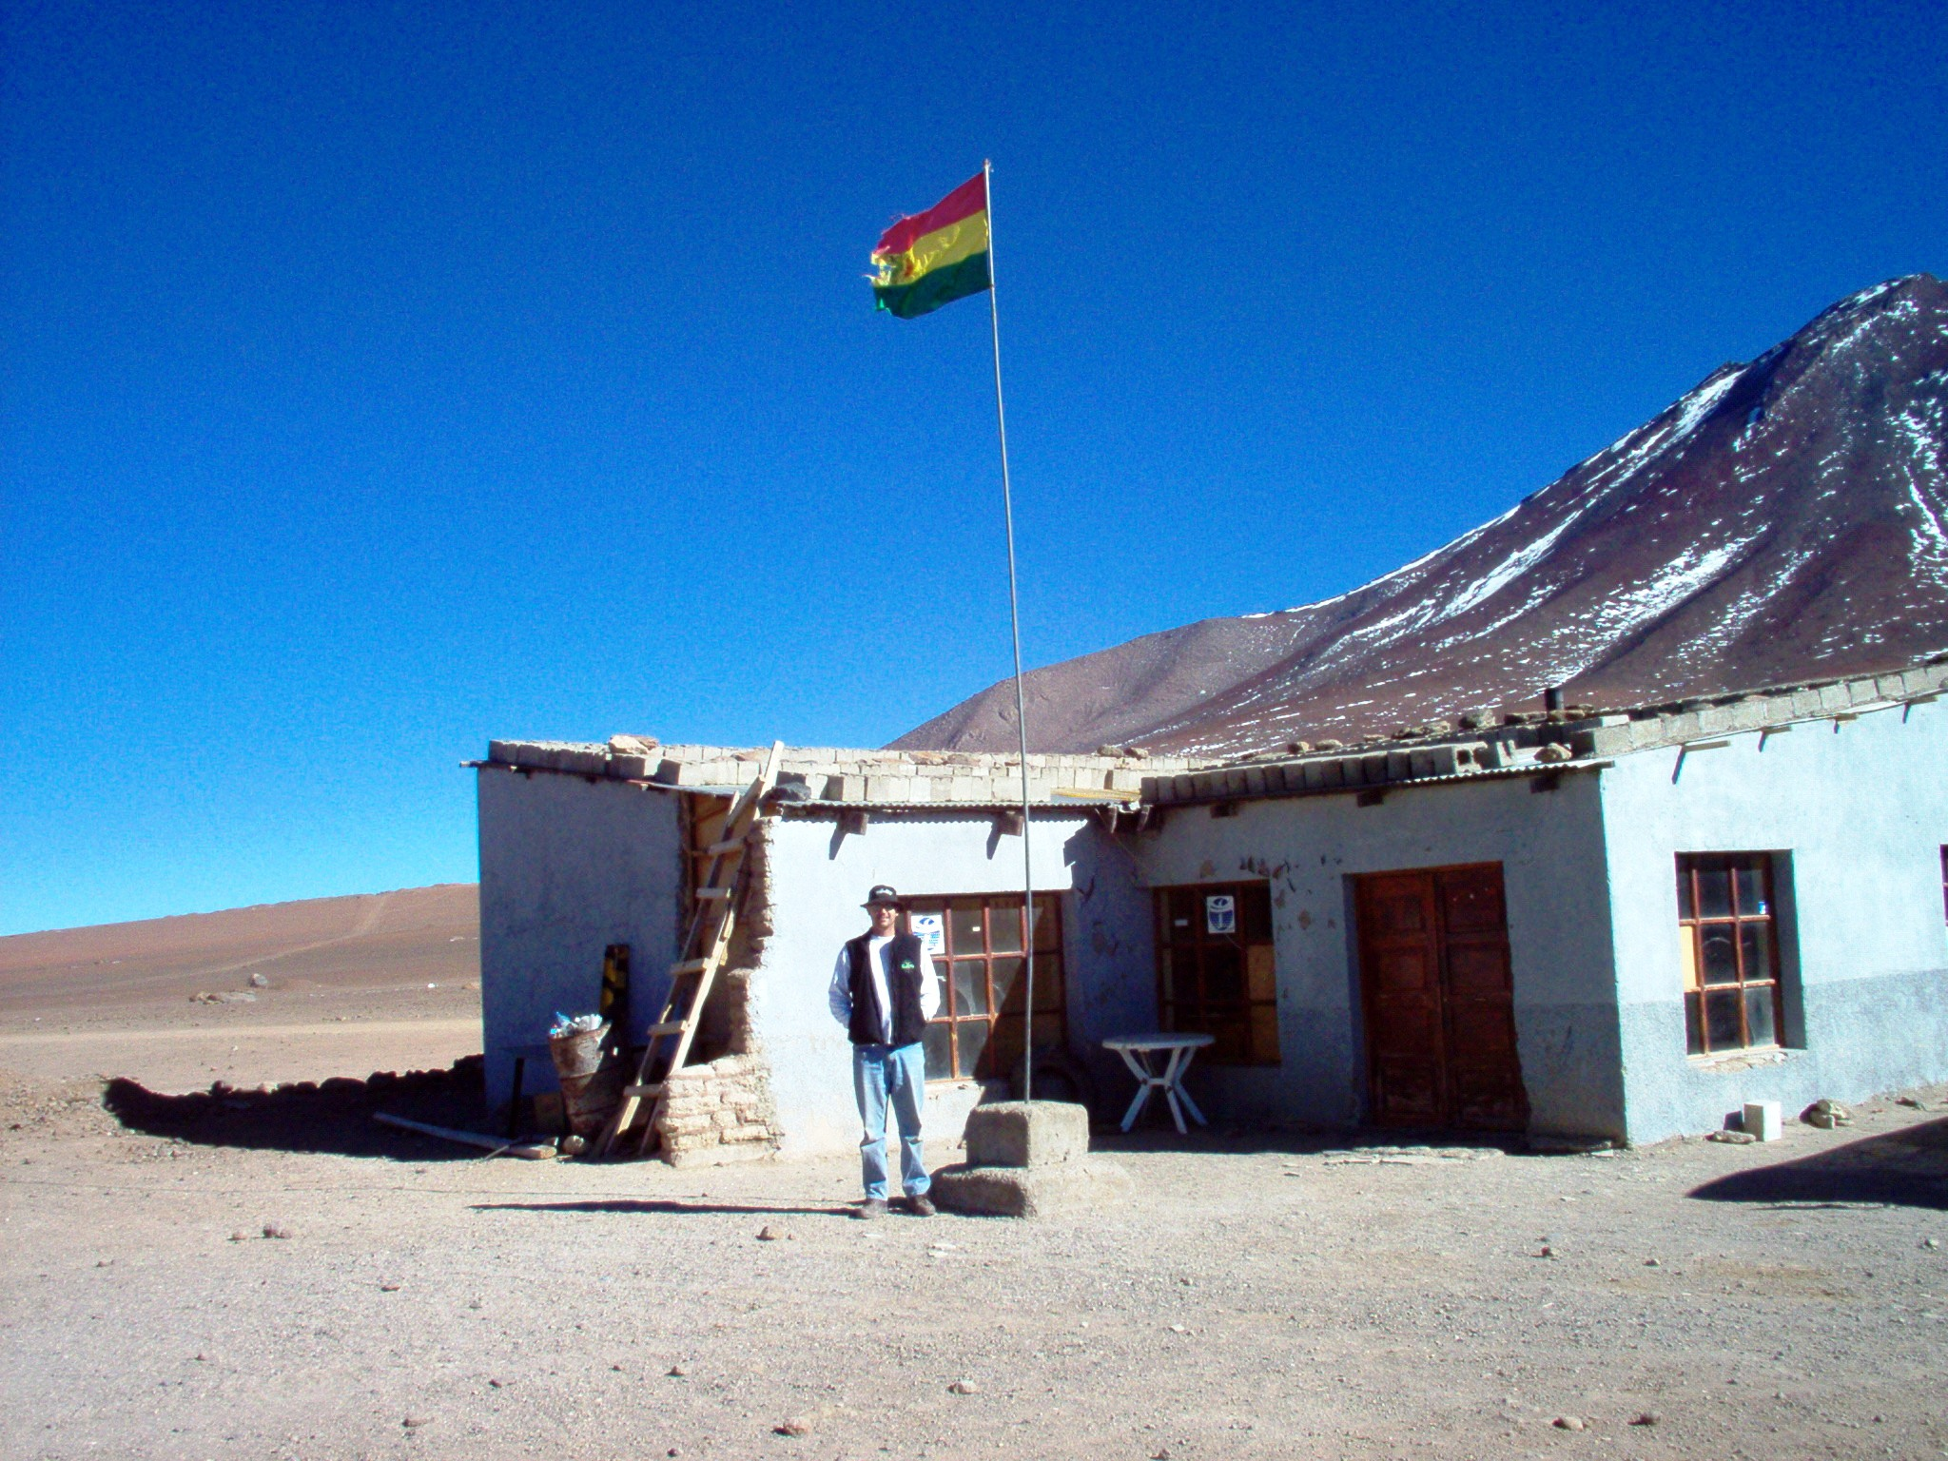

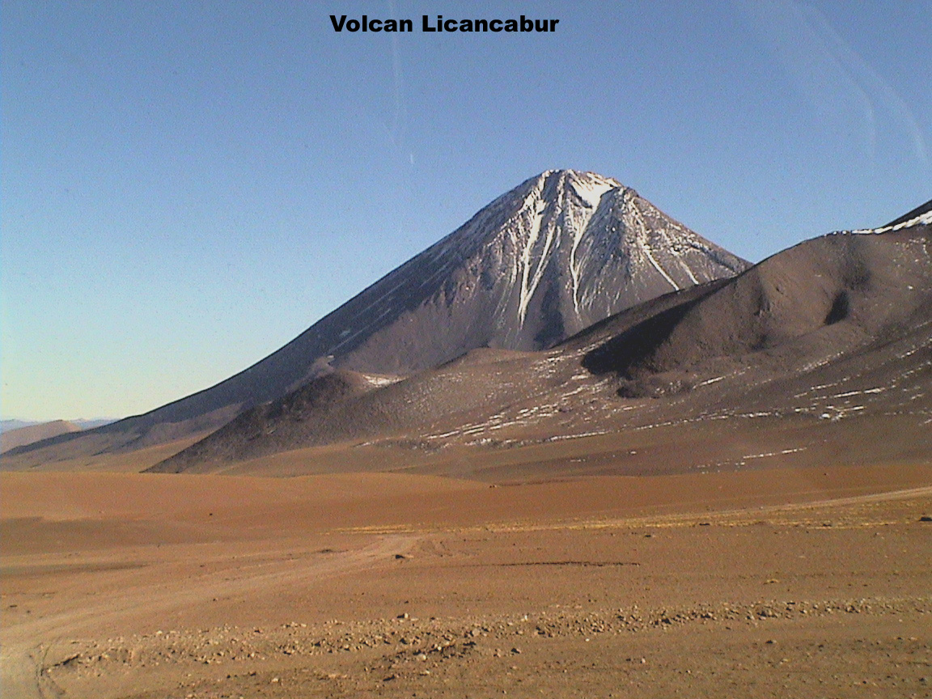
6/27/2006

I awoke early, yet was reluctant to leave the warmth of my sleeping bag and enter the chilly mountain air. Linda and I both waited until the sun was shining through the window to actually get up and start the day. My head was still pounding and my stomach was still turning but I decided to have a cup of tea and then go for a walk to explore the area around the Refugio. It was still very cold; in fact the INDOOR toilets were frozen solid. I looked in the back of one of the toilets and that water was also frozen solid. When you hit the flush lever you would hear the “kink, kink” of metal on ice and that was it.
In my explorations around the Refugio I found that the place was inhabited by two hardy cats, one sleepy dog, eight to ten mountain guides and one tiny weathered older woman who seemed to keep everyone in line. During my walk along the partially frozen salt banks of Laguna Blanca I saw many sea gulls, a few high altitude ducks, and a pair of larger birds which appeared to be some type of geese.
At 11:30 a.m. we loaded our bus for the trip down the mountain and back to Chile. The “lady in charge” of the Refugio accompanied us and we made many unquestioned stops for her along the way to pick up this or that. Whatever she needed out driver was quick to provide it.
Our trip back to the border crossings took about an hour and a half and I couldn’t wait to get back to the lower elevations and to feel normal again. To get back into Chile we stopped for about a half an hour and had to unload all people and gear from our bus. Before stepping off the Chilean guards set a large damp piece of foam for us to step on to remove the Bolivian soil from our boots so that we would not contaminate the Chilean soil. This seemed to me a bit extreme and I began to worry about the ten plus pounds of Bolivian soil that I was carrying in my backpack. Sure enough, the border agent going through my pack quickly reached in and pulled out a zip locked soil sample from the flanks of Lincancabur and said “Que es?” I said, “That’s just dirt.” This prompted Linda to quickly come to the rescue and explain that we were scientists collecting samples of “volcanic ash” from the volcanoes. Fortunately, this seemed to satisfy the agent and he let me pass with everything intact.
We arrived back in San Pedro about 2:00 p.m. and quickly met with Shayne and Karie at the rendezvous point in front of our hotel, briefly exchanged our adventures of the past thirty six hours and found ourselves with a couple of hours to walk around, shop, and get some food.
I suddenly found myself ravenous and realized that I had eaten the equivalent of one meal in the last two and a half days! Shayne stayed at the truck while the three of us headed into town on foot on a mission to find Chile’s only fast food…empanadas. Our mission was unfruitful and I quickly left the two ladies to continue their empanada search and followed my nose to half a rotisserie chicken and a side of fries swimming in grease. I happily ate my chicken and fries walking the dirt streets of San Pedro accompanied by the biggest wiener dog I’ve ever seen. This dog followed me for a good hour and would take the occasional hand outs of chicken but would turn his nose up to my greasy fries. Smart dog! I managed to get some souvenir shopping done during this time and purchased some things for my wife and the boys.
We met back at the truck around 4:00 p.m. and began our drive to the large port city of Antofagasta, thinking our adventures of the day were over. Boy, were we wrong! Driving around an unfamiliar, and huge, South American city at night looking for a hotel is an experience I will not soon forget. It was like a real life Mr. Toad’s Wild Ride! We literally ended up driving. the wrong way down a crowded one way street, made two or three highly illegal, high speed u-turns in the middle of very busy multi-laned streets just ahead of oncoming traffic, bouncing and skidding against a curb on one such occasion. Shayne actually did a great job at the wheel during a stressful situation and after an hour of searching we found our saving oasis at the Hotel De Antofagasta safe and still in one piece.
We checked in, unloaded, walked to a very late dinner and went to bed for some much needed rest.

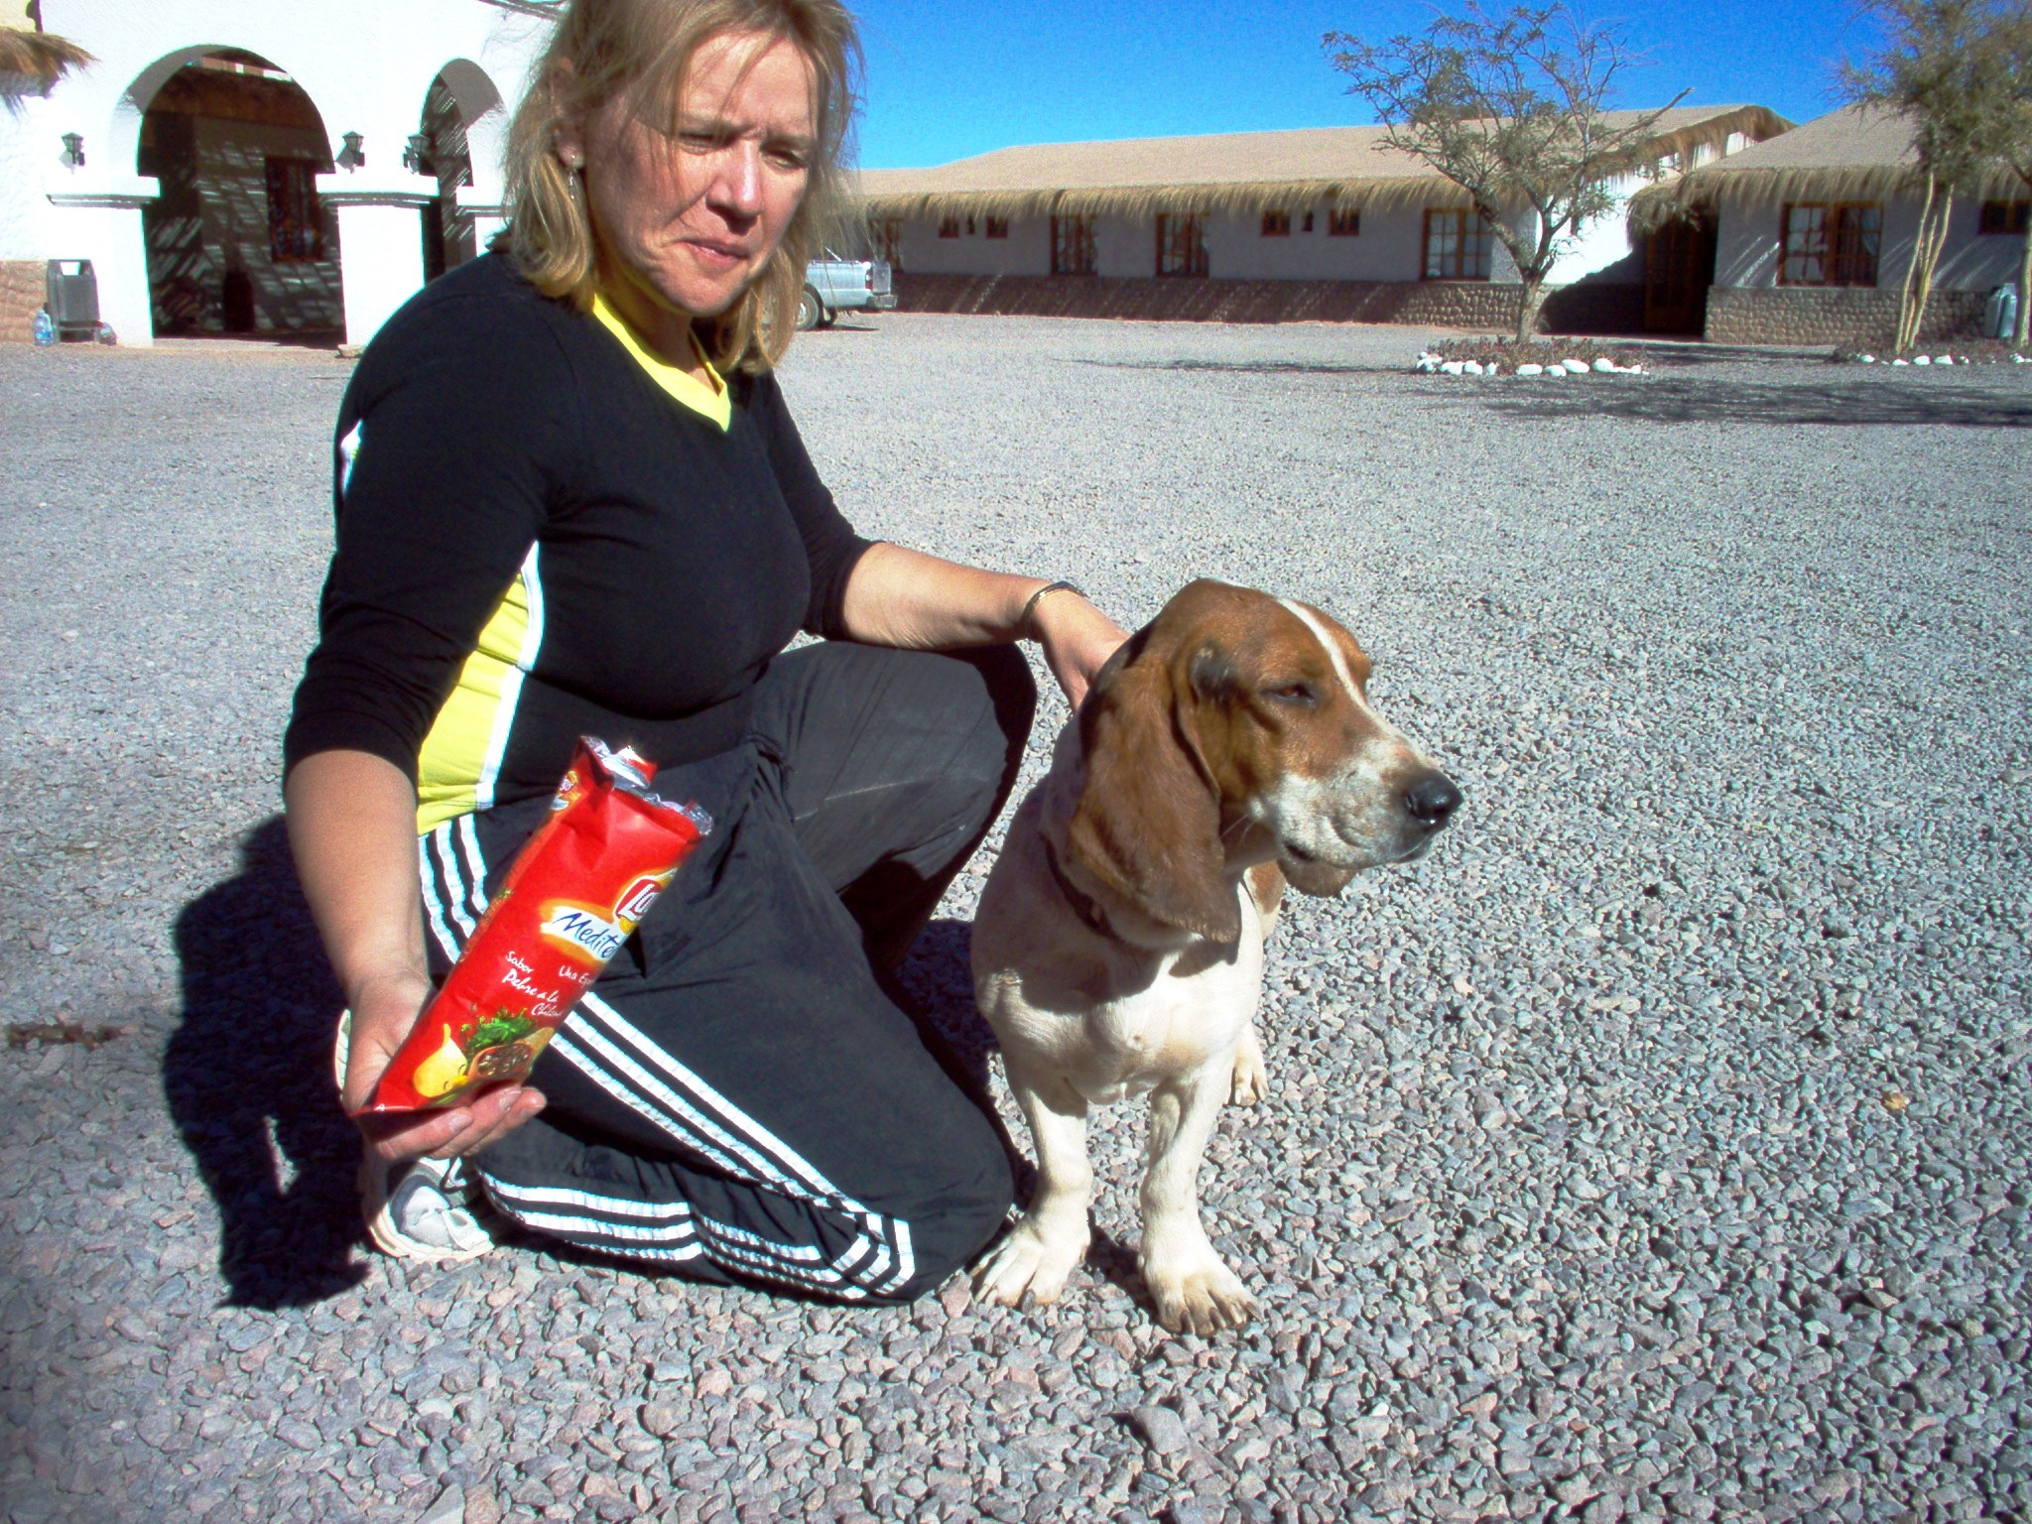

6/28/2006

We were up and out of Antofagasta before the sunrise to beat the morning rush hour traffic and not risk a repeat of last night’s driving escapade around the city. Our mission for the day was to return to the Atacama Desert and search for two “Brad sites” that Linda wanted to get some samples from. She wanted these two sites specifically because they are both areas where NASA scientists (one of which is named Brad) have been collecting data for the past fifteen years. This is important so she can compare her findings with data that has already been documented.
Brad site #1 was located on the back side of a small desert mountain called Cerro Buenos Aires. Locating the exact site was much easier said than done. We used written descriptions of the landscape, pictures of the area, and GPS coordinates to locate this spot in the desert where two NASA scientists camped out and dug a pit many years ago.
It was a true team effort and every one of us played a key role in locating our destination. After much effort we finally found it and had a brief celebration by taking pictures where the Indians made stone tools, and then we got to work. There were two pits, one large (about four feet deep) and one small (about two feet deep). We carefully took samples from the rims, sides, and bottoms of both pits. Next we took samples from eight different sites within a forty yard radius around the larger pit. I collected some rock fragment samples of my own, took more pictures, loaded up and hit the road.
After maneuvering our way back to the 5 highway (same 5 in CA) Shayne took a break at the wheel and I took over for the next leg to Brad Site #2. As we headed further south and the road lulled Shayne and Karie to sleep, Linda explained to me that Brad Site #1 was the easy one to locate and that #2 should prove to be much more difficult.
Boy was she correct! We turned East off the 5 onto an old dirt mining road and followed this at least twenty five miles into the interior of the Atacama searching for a set of railroad tracks and a set of car tracks leading the way still deeper into the desert, and further from civilization. We searched and searched along this dirt road for the correct car tracks. We became discouraged after many failed attempts. It was only the unfaltering persistence and good instincts of Linda that we finally located the right set of car tracks in the dirt that would lead us to an old abandoned mine ruin and towards Brad Site #2. Our search wasn’t over yet. After following our trail and bouncing along in four wheel drive for a good hour the GPS coordinates began to get further away from our target. Therefore, after a brief discussion, we turned into the desert making tracks of our own using the GPS as our only guide. The sun was beginning to get pretty low on the horizon and I began to worry that we would be unable to drive in the dark. It looked inevitable that we might be spending the night out in the desert. We were a good two hours drive from any paved road at this point and we were still searching desperately. Shayne must have been thinking the same thing and voiced his concerns but Linda’s determination won out again and we were soon gazing at the ruins of Catalina. It wasn’t long after this that we located Brad Site #2. We hastily took pictures and samples of the area. Interestingly enough at both Brad Sites we found experiments set up by the University de Antofagasta. They consisted of a pole anchored into the desert on top of which sat an aluminum bowl covered with a screen. On top of this sat a hundred or so marbles. It asked us not to touch and said that they were collecting dust samples. They had been there about six months.
When finished we quickly loaded up our gear and the race against the sun to get out of the desert was on. Shayne said that I could still have the wheel and didn’t even tell me to slow down this time as we raced through the dirt. Almost two hours later we emerged tired and dusty onto highway 5, just as the last hint of light disappeared from the evening sky.
Happy to be back on a level paved surface Shayne took the drivers seat and drove us into the seaside city of Chanaral. We pulled in late, found a very cool, quaint, well secured hotel and checked in for the night. We had another late but memorable dining experience. I had “lomo pobre”, which consisted of grilled steak with two fried eggs on top. The main dish was accompanied by grilled onions and a hearty portion of greasy french fries. I went to bed full and happy.

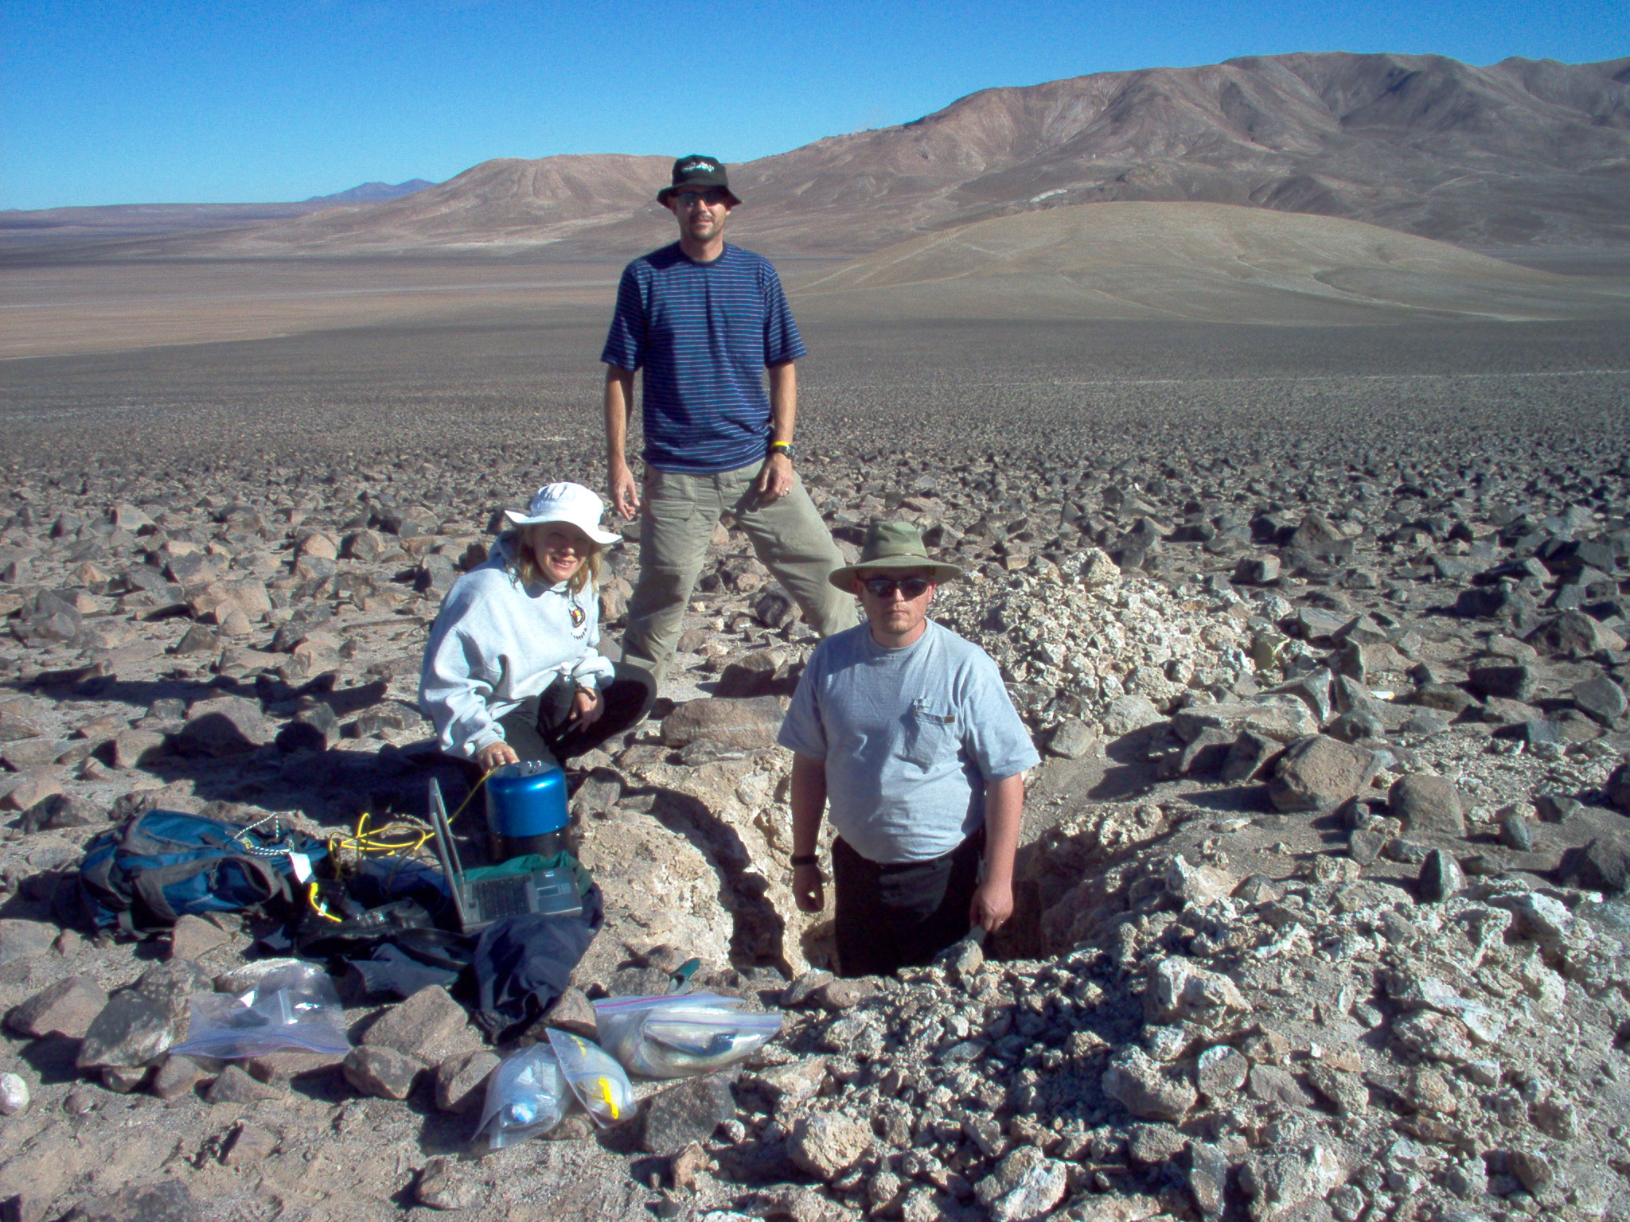

6/29/2006

This was to be our first leisurely morning, much to the chagrin of Shayne, who by this time was in “get home as fast as possible” mode. He lost the vote thought and we all slept in a bit. I was able to get out and take a walk along the beach. Chanaral is a scenic, small, sleepy beach community. I found the head of a dog in the street, a dead pelican on the sand, and a flock of what seemed to be very content vultures perched on a rock overlooking their beach.
When I made my way back to the hotel there was Shayne with our truck loaded and tied down eagerly awaiting the ladies and myself so we could get on the road. All that was planned for the day was an unhurried drive down to the city of La Serena which would put us 474 km from Santiago and our flight home. On the way we enjoyed the scenery, talked about life back in the states, and had an interesting conversation about our past jobs, of which I have had many.
We arrived early into town and were actually unloaded and checked into a hotel by 4:00 P.M.! We took much needed showers and met in the lobby for our search to find a place for dinner. La Serena is a medium size city with lots of shops, vendors, restaurants, paved streets and of course…stray dogs. We found a small two-story restaurant and had a very pleasant meal with the whole second story to ourselves. I had the pescado pobre which is just like lomo pobre but with fish. We were entertained during the whole meal by our waiter, Manuel, who was a very chatty fellow. His English was good and he offered to show us around town when our meal was finished.
Manuel led us on a personally guided shopping spree through the streets of La Serena. The ladies went crazy and had armfuls of bags within an hour. Manuel was a very informed fellow and Linda gave him a nice tip when we eventually parted ways.
I finally located an internet café with enough gumption for me to check and send emails. I sent a few into cyberspace hoping they would make it to family and friends. By this time it was late and I made my way back to the hotel.

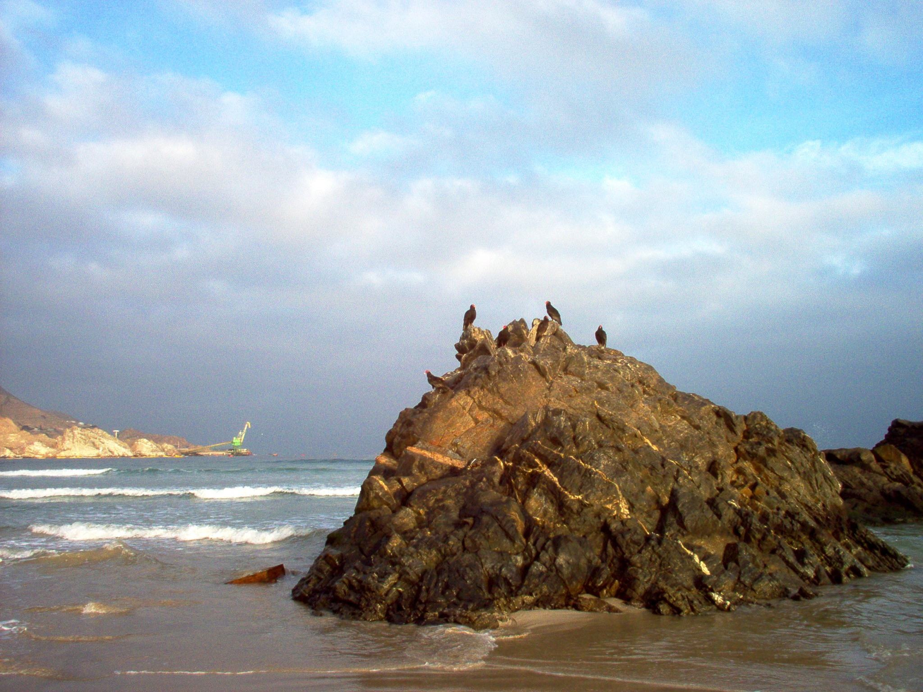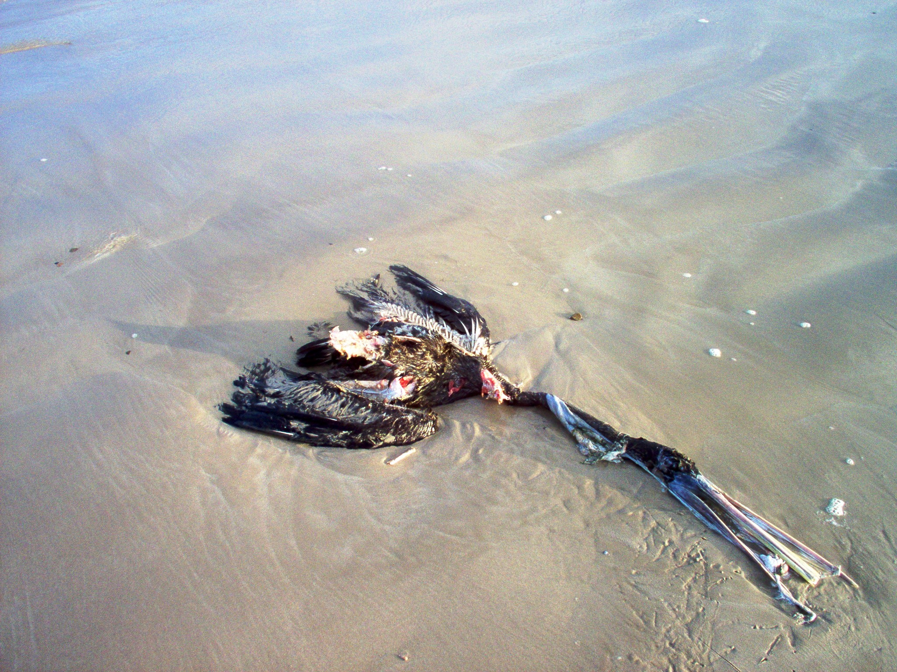

6/30/2006

We awoke at a reasonable hour, packed up, and hit the road for our last leg to Santiago and our flight home. I drove the first half of the journey until we stopped for lunch. Lunch was at a roadside restaurant that served the elusive empanadas, and my now favorite, lomo pobre. Shayne had both. Linda had a steaming bowl of seafood soup and Karie couldn’t decide. After lunch we boarded our van and Shayne finished off our drive to Santiago. During the trip I stared out the window trying to soak it all in as our trip in Chile slowly came to an end.
It was great meeting up with everybody back at the airport and we spent the next several hours exchanging stories, turning in cars, hauling and checking luggage, eating, standing in lines, and airport shopping. Matt and I were one of the last ones through the security checks and bought some nice Chilean wines. One of the drawbacks of going with Linda and crew was that I didn’t get to know the rest of the group as well as I would have liked to. This was unfortunate but there are pros and cons to every choice we make, and I wouldn’t change this one at all. On our way through security Matt and I both forgot to check our multi-plier tools in with our luggage and they were both confiscated from us.
Once we were all boarded on the plane we settled into our seats and prepared for a long overnight flight back to the Northern Hemisphere where we would land in Dallas. I had a window seat next to Phyllis on the plane. We chatted for awhile, I watched a couple of movies, played solitaire, and tried to get some sleep sitting up. It was a long night.

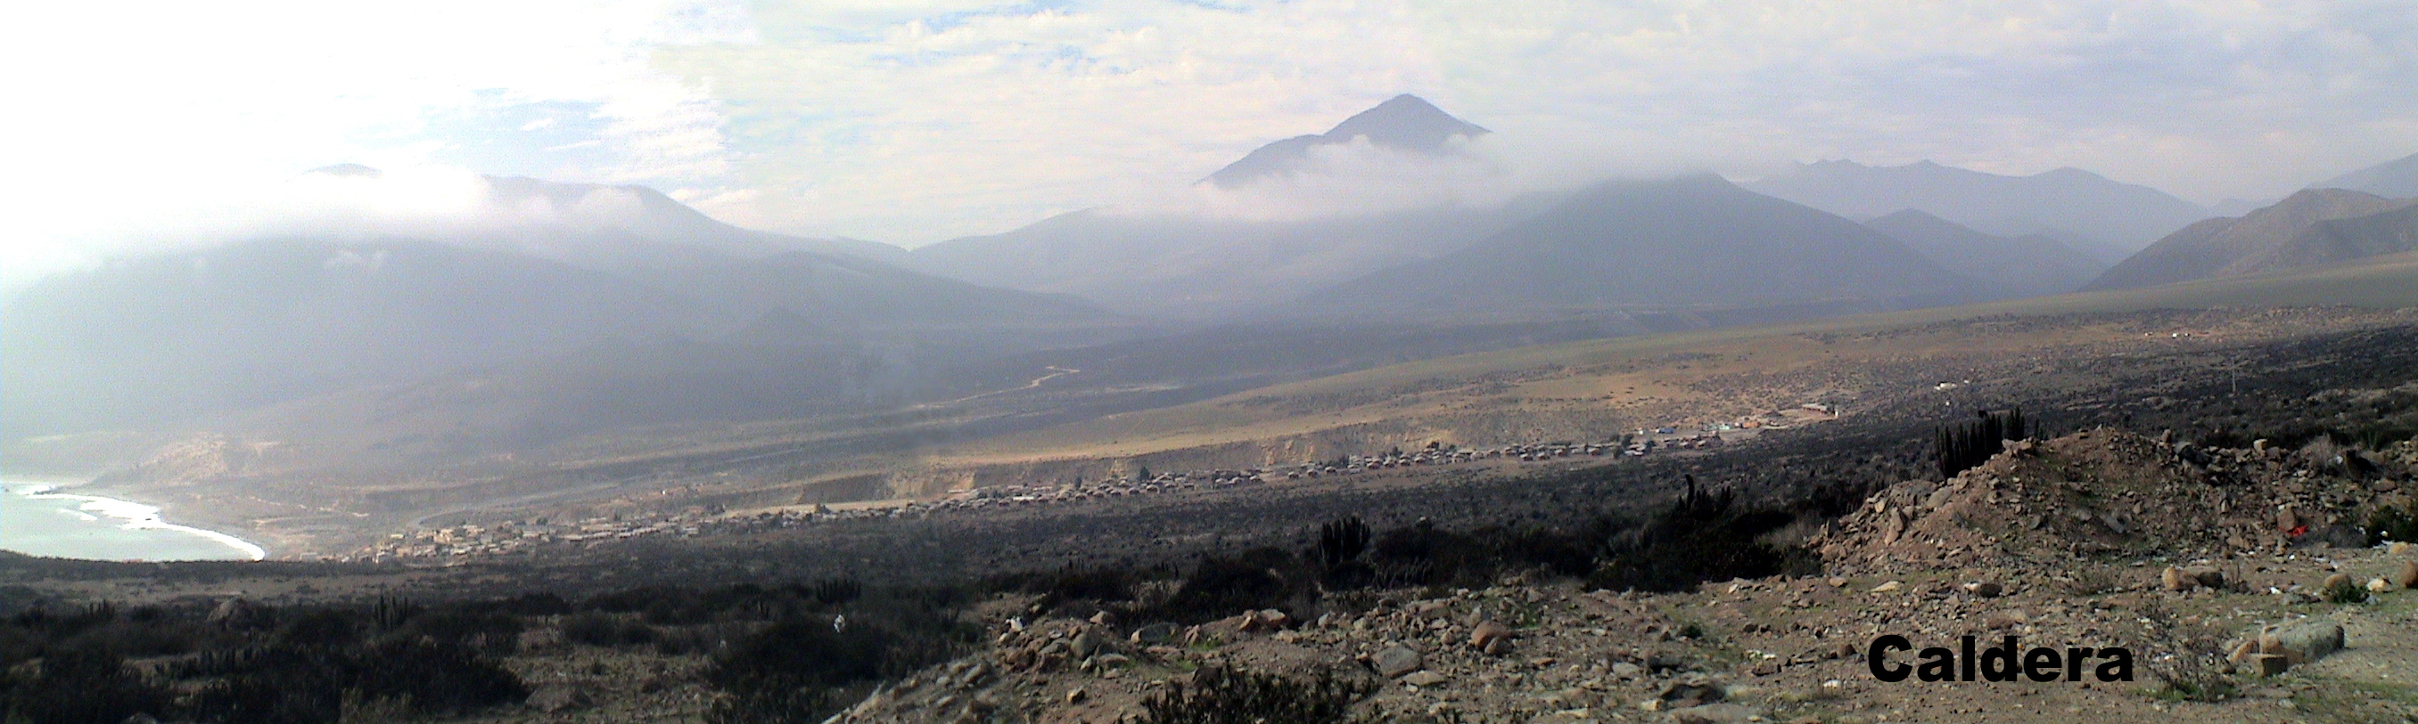

7/1/2006

We flew into Dallas early in the morning yet it was already hot and muggy. Everybody sluggishly made their way off of the plane and followed each other like a herd of cattle to claim our luggage and head to customs. It felt good to be back in the United States but there was also a pervasive sadness in me knowing that our trip was at an end. The scientists had a heck of a time getting their various samples, rocks, and equipment through customs. While they were in the midst of being checked with bags unzipped and gear strewn about the table tops the customs agents had a lock down drill. Sirens started sounding, agents were yelling and jumping and everything came to a sudden halt. It was just a practice drill much to the relief of Rosalba who thought she had set off some type of alarm.
The group gathered outside of customs for a few moments of pictures and final goodbyes. An airport attendant who volunteered to take our group picture asked if we had just gotten back from Woodstock. We were a pretty grungy looking crew by this time. Our group began to fragment and break up into smaller and smaller parts as people began heading to individual gates for their flights back to our own corners of the United States. Dallas International is a huge airport and I ended up taking a shuttle tram towards my gate with Matt, Koby and Karie. Coincidentally, Karie was the last person I said goodbye to as I headed toward my own flight back to Orange County.
At three hours, flying from Dallas to Orange County is a relatively short flight yet it seemed like three days before I began the final descent home. Finally, back on the ground I grabbed my daypack, deplaned, and headed towards baggage claim. As I descended the steps I saw my family waiting for me at the bottom. My oldest son, Grant, was holding a poster of me that said “Welcome Home Daddy!” With my hat and facial hair it took a minute for them to recognize me. When they did Grant came running yelling, “Daddy, Daddy”! I gave him a hug and a kiss. I kissed my lovely wife and my youngest son, Kai. It was good to be home. That is, until the dreaded…”unpacking blues”!
This brings to an end my experience of the Spaceward Bound 2006 expedition to the NASA Mars Analog Research Station in the Yunguy region of the Atacama Desert, Chile.


