Recycler Upgrade Pre-Amplifier- Transition Module Design

R. Webber, P. Prieto

Pre-Amp:
The pre-amp in the Recycler is connected to the BPM plate where it converts the derivative of the beam current into a voltage. It uses a shunting resistor network followed by a gain stage. A 25 MHz low-pass filter follows the gain stage limiting the signal bandwidth in the pre-amp. A differential amplifier drives the measured signal between the tunnel and a transition module in the service. Provisions for BPM ion clearing electrode connections and calibration circuitry are also contained in the pre-amp.

Transition Module:
The transition module has a differential receiver stage and an impedance matching network connected to the pre-amp in the tunnel. A gain stage compensates for cable attenuation so the full dynamic range of the A/D converter is used and anti-aliasing filter with a corner frequency of 8 MHz provides added filtering. In addition there is an adjustment to match the signals from both BPM plates due to differences introduced by the anti-aliasing filters.

Specifications:
The digital BPM has to resolve positions for the 4 bunch mode case, separated at 396 ns and 12 bunch mode case separated at 132 ns with a dynamic range of 2.0 to 50e10 injected particles. The

89.818 KHz de-bunched beam has intensities varying between 1e10 to 400e10 particles. The expected transfers into the recycler are 2.0e11 injected particles for protons and 5e10 injected particles for pbars.

In the Recycler a horizontal BPM has a sensitivity factor of 0.273 dB/mm and a vertical BPM has a sensitivity factor of 0.512 dB/mm. The position in mm. is inversely proportional to the BPM sensitivity factor (dB/mm) times the digital receiver sensitivity factor (V/dB), all multiplied the measured signal with units of Volts.

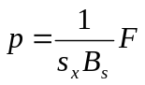

The beam current is given by the expression:

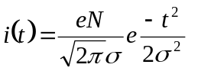

The BPM plate current is the derivative the beam current:
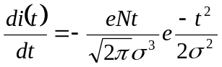
The expected 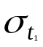(sigma t) for the different bunches are:

Table 1.
Frequency | (sec) | 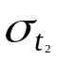 (sec)
89e3 | 1824e-9 | 11172e-9
2.5e6 | 25e-9 | 50e-9

Table 2 below lists the peak voltages at the output of the BPM where there is a shunt circuit consisting of an 800 Ω resistor network. The values were obtained from SPICE simulations.

Table 2.
#Bunches | 4 | 4 | Unbunched
 | 25ns | 50ns
Tot. Inj. Part. | V peak | V peak | Tot. Inj Part. | V Peak.
50e10 | 0.850 | 0.320 | 400e10 (1962ns) | 0.40
30e10 | 0.470 | 0.200 | 20e10 (2094ns) | 0.015
20e10 | 0.320 | 0.130 | 20e10 (8830ns) | 0.003
2e10 | 0.032 | 0.012

Factors Contributing to the Selection of the Pre-Amp Gain:

The pre-amp voltage gain is defined as the ratio of the voltages at the shunt resistor and the output of the differential driver (V107/V103).
The output stage of the pre-amp (AD8131) can drive 7.75 Volts peak-to-peak. The overall gain of the pre-amp is selected to produce the maximum voltage possible at the output reducing signal loss due to cable attenuation. The largest voltage in table 2 corresponds to the case where the sigma_t is 25ns. for a total of injected particles of 50e10.
The pre-amp gain should be based on the 30e10 particle, 25ns case which from table 2 shows the voltage at the shunt resistor to be 0.48 volts-peak. This value should be multiplied by 2 to account for the case when the beam is nearest one of the plates, which is ~1.0 volts-peak. Using this voltage the pre-amp gain becomes 3.8 V/V.

Table 3.
#Bunches | 4 | 4 | Unbunched Beam
 | 25ns | 50ns
Tot. Inj Part. | V peak | V peak | Tot. Inj Part. | V peak
50e10 | 1.62 | 0.61 | 400e10 | 0.76
30e10 | 0.90 | 0.38 | 20e10 | 0.029
20e10 | 0.61 | 0.24 | 20e10 | 0.006
2e10 | 0.04 | 0.025

The values in table 3 are the voltages listed in table 2 times G=3.8 and divided by 2 due to the series cable matching output resistors. These are the levels in volts-peak that would be obtained at the input to the cable connected to the pre-amp.

Input Voltages at the transition Module due to Cable Losses:

The pre-amp drives a shielded twisted pair cable whose length varies from 150ft. to 1300ft., with an attenuation factor approximating square root of the frequency.

The cable attenuation factor is listed below in table 4 for the 4-bunch case with 2 different different sigma_t’s. Also the peak values for the unbunched case are listed.

Table 4.
Cable Length | Bunch length | Bunch length | Bunch length
feet | 25ns | 50ns | Unbunched
100 | 0.804 | 0.859 | 0.891
200 | 0.663 | 0.743 | 0.797
300 | 0.553 | 0.639 | 0.712
400 | 0.456 | 0.553 | 0.636
500 | 0.373 | 0.48 | 0.57
600 | 0.31 | 0.414 | 0.511
700 | 0.261 | 0.362 | 0.459
800 | 0.218 | 0.315 | 0.412
900 | 0.18 | 0.274 | 0.37
1000 | 0.154 | 0.24 | 0.334
1100 | 0.13 | 0.209 | 0.301
1200 | 0.109 | 0.184 | 0.272
1300 | 0.094 | 0.161 | 0.245

The resulting peak voltage at the input of the transition module due to the cable length attenuations factorsand bunch sigma_t are listed in table 5.

Table 5.
Cable Length | Attn for 2.5MHz | Total Inj Particles | Total Inj Particles | Attn for 2.5MHz | Total Inj Particles | Total Inj Particles
feet | Sigmat=25ns | 3.00E+11 | 2.00E+10 | Sigmat=50ns | 3.00E+11 | 2.00E+10
100 | 0.804 | 0.7236 | 0.03216 | 0.859 | 0.32642 | 0.021475
200 | 0.663 | 0.5967 | 0.02652 | 0.743 | 0.28234 | 0.018575
300 | 0.553 | 0.4977 | 0.02212 | 0.639 | 0.24282 | 0.015975
400 | 0.456 | 0.4104 | 0.01824 | 0.553 | 0.21014 | 0.013825
500 | 0.373 | 0.3357 | 0.01492 | 0.48 | 0.1824 | 0.012
600 | 0.31 | 0.279 | 0.0124 | 0.414 | 0.15732 | 0.01035
700 | 0.261 | 0.2349 | 0.01044 | 0.362 | 0.13756 | 0.00905
800 | 0.218 | 0.1962 | 0.00872 | 0.315 | 0.1197 | 0.007875
900 | 0.18 | 0.162 | 0.0072 | 0.274 | 0.10412 | 0.00685
1000 | 0.154 | 0.1386 | 0.00616 | 0.24 | 0.0912 | 0.006
1100 | 0.13 | 0.117 | 0.0052 | 0.209 | 0.07942 | 0.005225
1200 | 0.109 | 0.0981 | 0.00436 | 0.184 | 0.06992 | 0.0046
1300 | 0.094 | 0.0846 | 0.00376 | 0.161 | 0.06118 | 0.004025

Unbunched Beam voltage attenuation:

Table 6.
Cable Length | Cable Attn. for | Total Inj Particles | Total Inj Particles | Total Inj Particles
feet | Unbunched | 4.00E+12 | 2.00E+11 | 2.00E+11
100 | 0.891 | 0.67716 | 0.025839 | 0.005346
200 | 0.797 | 0.60572 | 0.023113 | 0.004782
300 | 0.712 | 0.54112 | 0.020648 | 0.004272
400 | 0.636 | 0.48336 | 0.018444 | 0.003816
500 | 0.57 | 0.4332 | 0.01653 | 0.00342
600 | 0.511 | 0.38836 | 0.014819 | 0.003066
700 | 0.459 | 0.34884 | 0.013311 | 0.002754
800 | 0.412 | 0.31312 | 0.011948 | 0.002472
900 | 0.37 | 0.2812 | 0.01073 | 0.00222
1000 | 0.334 | 0.25384 | 0.009686 | 0.002004
1100 | 0.301 | 0.22876 | 0.008729 | 0.001806
1200 | 0.272 | 0.20672 | 0.007888 | 0.001632
1300 | 0.245 | 0.1862 | 0.007105 | 0.00147

Transition Module:

The transition module input can be configured using a differential receiver op-amp (AD8130) or using a passive element such as a transformer. Both modes convert the differential signal to a single ended one. The signal from the tunnel travels down 2 coupled transmission lines (twisted pair) with equal magnitude but 180 degrees out of phase. The termination placed at the end of the cable is two resistors matching the cable common mode impedance (50 Ω) connected to each terminal referenced to the center connection that is a virtual ground.
The AD8130 has the limitation in that the maximum differential input voltage is 2.5 Volts (1.25 Volts-peak). Any larger differential voltage will clip the signal giving an erroneous position.

The main function of the transition module is compensate for cable attenuation and normalize the input voltage to use the full dynamic range of the A/D converter.
The gain is determined by the maximum signal amplitude at the input of the transition module, the –6 dB attenuation at the anti-aliasing filter and the –6dB lost in the input impedance matching at the input of the A/D converter.

Table 7 below has a list of cable lengths and the input voltages at the transition module after they have been attenuated. These voltages are the largest peak voltages expected at the pre-amp output.

Table 7.
Cable Length | Bunch length
 | 25ns | Module Gain
feet
100 | 1.43916 | 1.52867
200 | 1.18677 | 1.853771
300 | 0.98987 | 2.222514
400 | 0.81624 | 2.695286
500 | 0.66767 | 3.295041
600 | 0.5549 | 3.964678
700 | 0.46719 | 4.709005
800 | 0.39022 | 5.637845
900 | 0.3222 | 6.828057
1000 | 0.27566 | 7.980846
1100 | 0.2327 | 9.454233
1200 | 0.19511 | 11.27569
1300 | 0.16826 | 13.075

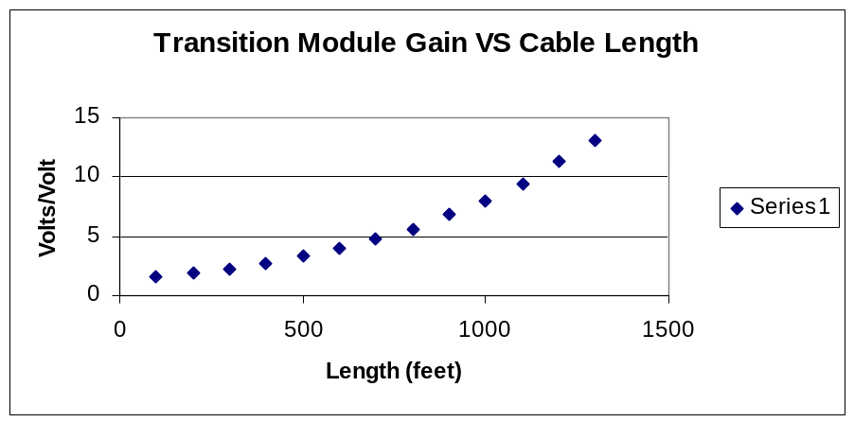

This plots the range of gains vs. cable lengths the transition module requires to normalize the output voltages to 1.1 Volts peak-to-peak.

The plots below show in graphical format the output voltages obtained after applying the computed gains for the 30e10 total injected beam with 25ns and 50 ns sigma_t case and the 2e10 25ns and 50ns case. The unbunched beam case data is plotted in two graphs, one for the 400e10 case where the signal intensities would be large. The second unbunched beam case deals with the 20e10 case with two different head-tail time separations 2094ns and 8830ns.

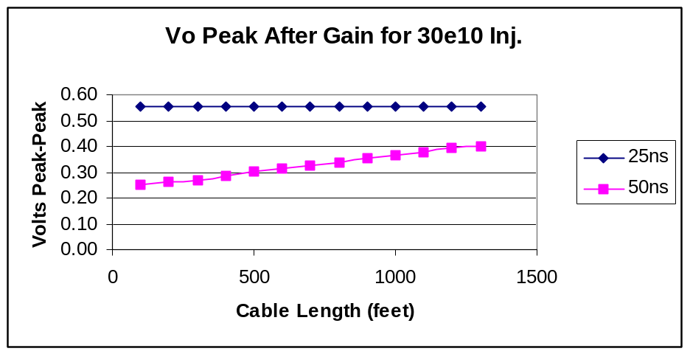

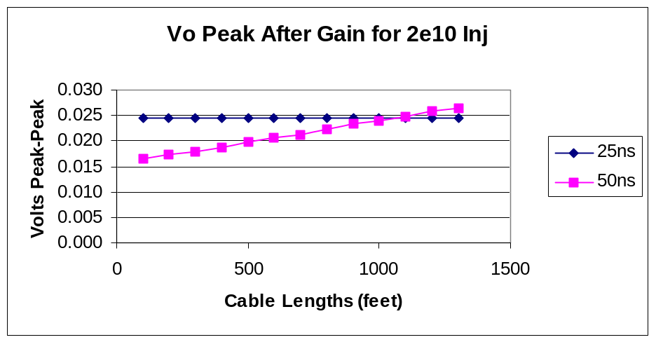

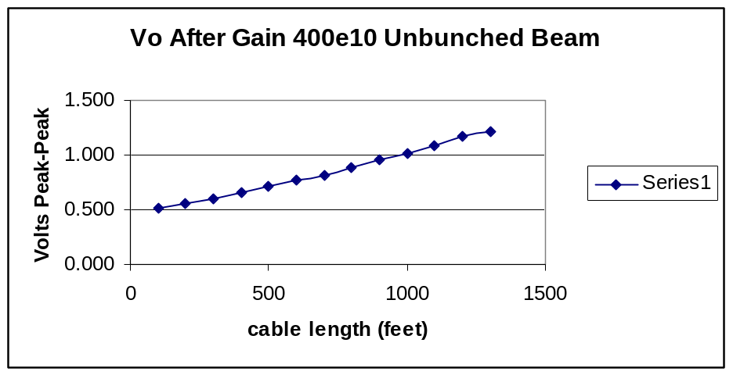

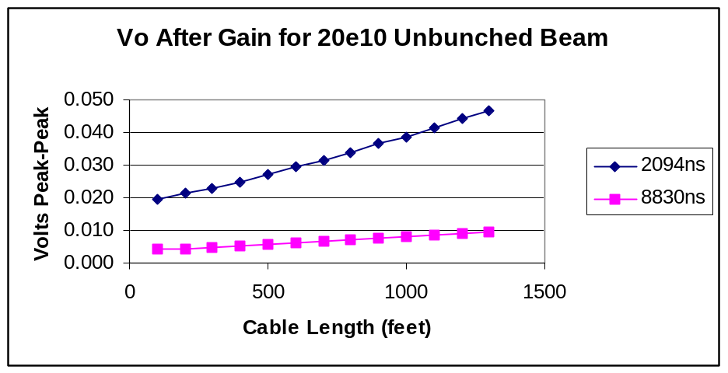

Transition Module Gain Selection:

The range of gains in the transition module can be lumped as follows:

- 150 to 300 ft use gain of 1.5
- 300 to 500 ft use gain of 2.2
- 501 to 800 ft use gain of 3.3
- 801 to 1100 ft use gain of 5.5
- 1101 to 1300 ft use gain of 9.5

The plots below show the voltages obtained for the different injected intensities after the selected gain ranges have been applied.
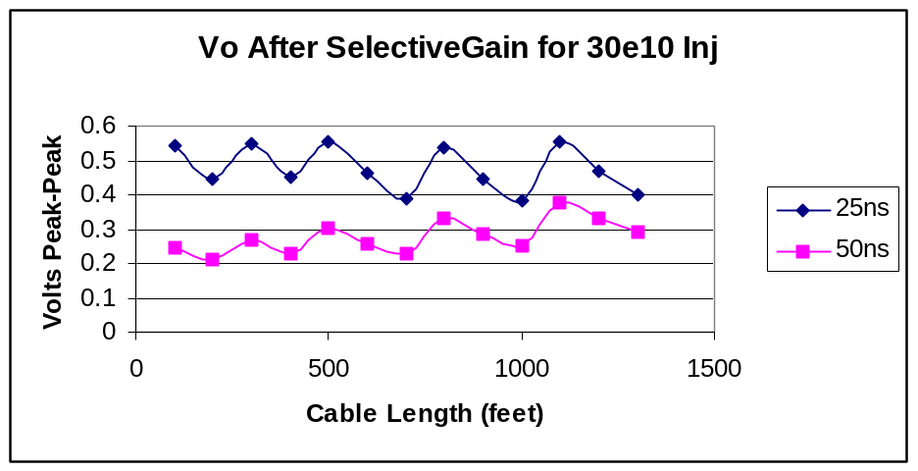

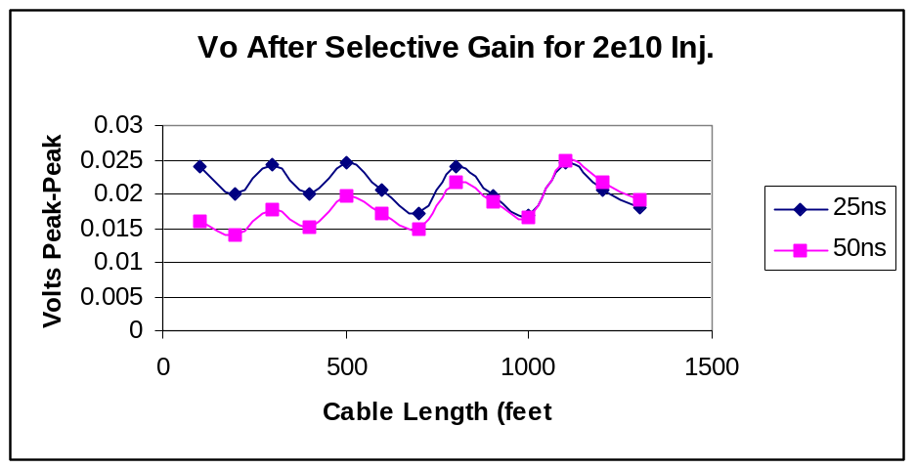

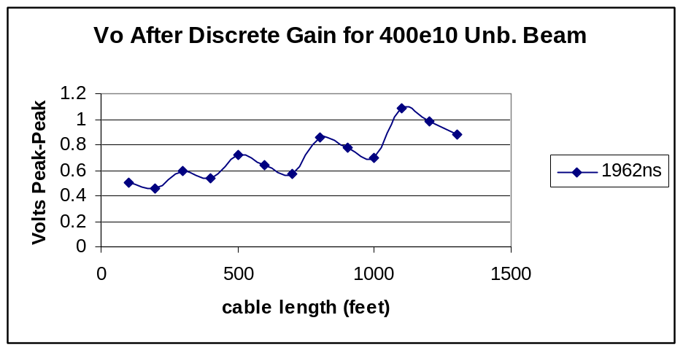

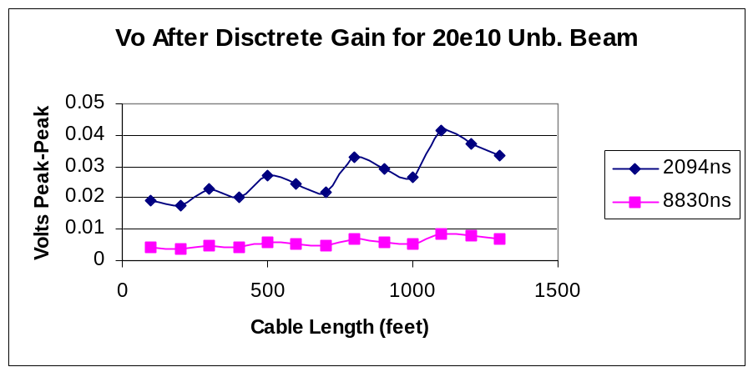

Transition Chassis Requirements:

Table 8.
Service Bldg | #Crates per service building | #DDC Boards/Bldg | #DDC chan for Crate 1 | #DDC Chan for Crate 2 | #Modules in Transition Crate | #Channels/Transition Module
MI-10 | 1 | 9 | 72 |  | 14 | 8
MI-20 | 2 | 11 | 72 | 16 | 14 | 8
MI-30 | 2 | 12 | 80 | 16 | 14 | 8
MI-40 | 2 | 10 | 72 | 8 | 14 | 8
MI-50 | 1 | 9 | 72 |  | 14 | 8
MI-60 | 1 | 10 | 80 |  | 14 | 8

Table 8 columns 4 and 5 show the number of digital down-converter channels required per service building. The maximum number of channels the transition crate must handle is 96 based on the totals for MI-30 service building.

Connections:
The signals from each pre-amp come from the tunnel via a multi-conductor twisted pair cable that has 3 pairs of #24 gauge wire for plate signals and 1 pair of # 18 gauge wire for pre-amp power and ground. In the present BPM system the cable has a DB-9 connector that terminates on the top plate in the service building.
The proposed design is to leave the DB-9 connector on this cable, mate with cable extenders terminated with DB-9 at each end distributing the signals within the house to the new location of the transition crate.

Module Functionality in the Transition Crate:
Transition Crate
Module function | # Modules | #Channels/Module
Signal Conditioning | 13 | 8
Calibration Driver | 1 | 2 analog 3 digital
DDC Clock Distribution | 1 | 12

Conditioning Channels:
The transition crate will have 10-12 signal conditioning modules and each module will handle 8 plate signals. There are 2 plate signals per BPM, therefore each module will be capable of handling 4 BPM’s. Each transition module channel output will then connect to an input of a GC-814 board which has 8 channels.

Transition Module signal Conditioning Channel Topology:
Each transition module channel consists of a differential receiver (AD8130) and a cable termination network at its input. It is then followed by an adjustable stage that allows matching pairs of channels. This matching is required due to small matching differences introduced by the anti-aliasing filter between channels.
A non-inverting gain stage follows, it has the necessary gain to compensate for cable attenuation between the pre-amp and the transition channel and make up for the insertion loss (-6 dB) of the anti-aliasing filter. This filter has a corner frequency of 8 MHz. Two buffers drive the output signal, one to the front panel for monitoring and one to the input of the GC-814 digital down-converter board. The output signals use a BNC for the monitoring signal and an SMA female connector for the DDC signal.

Board Layout Scheduling:

Layout Schedule:
Layer1 | Signal (each Channel trenched)
Layer2 | Analog and Digital Ground (trench)
Layer 3 | Analog and Digital Power (trench)
Layer 4 | Analog and Pre-Amp Ground (trench)
Layer 5 | Signal (each Channel Trenched)

Board Power Requirements:
Part # | # Parts Used/Chan | +5 VDC | -5 VDC | Total I (amps)/Channel
AD8130 | 1 | 11.6 mA | 20 mA | 32 mA
LMH6655 | 4 | 7 mA | 7 mA | 56 mA

Total Board Current (8 Channels) | 0.71 Amps
Total Chassis Current (12 Modules) | 8.5 Amps

Chassis Power Distribution :
The transition module requires power for the different modules as well as power for the pre-amps in the tunnel.
A power supply chassis all ready exists to provide power for the pre-amps. It is proposed that four 4-pin Burndy’s be placed on the rear of the chassis frame where the connectors will distribute pre-amp power through the back plane to each plug-in module. From there the transition module will provide power through the DB-9 connectors on each board to the pre-amps in the tunnel.
The power required by the modules themselves originates from a separate power supply. This power supply could reside in the pre-amp chassis, but this has to be analyzed.

Calibration Module Topology:
The calibration module distributes a 2.5 MHz waveform that can be a CW signal or 4 bunch signal to each of the pre-amps in the tunnel for that service building. The module receives the 4 bunch spaced at 398ns. signal generated externally using a buffer through a front panel BNC, distributes it to 2 channels driving the local houses’ sectors through 2 rear-panel BNC’s.
The board is capable of generating a 2.5 MHz CW signal that can be activated using a jumper allowing it a stand-alone operation. Provision for front-panel monitoring of the calibration signal exist through a front panel BNC.
There are three calibration switches in the pre-amp that need to be controlled. Presently there is an RG-58 cable daisy-chained between the pre-amps that carries one of these control signals. It is intended to use the spare twisted-pair in the cable between the pre-amp and the tunnel to carry the control signal for the remaining two switches.
All of the switch control signals come into the module through opto-couplers and then cable drivers (75451) send the signal to the pre-amps or they are distributed through the back plane of the chassis to the individual channels in each transition module for individual distribution.

DDC Clock Distribution Module:
This module has 3 inputs from a clock-generating PMC module. The board has 3 4-WAY-0 splitters mounted in it so the clock signal can be distributed to each digital-down converter module in the VME64X crates.

Pre-amp and Transition Module Noise Analysis :

The following table lists the noise values computed for the resistor elements around the two amplifiers used in the pre-amp.

Table 11.
 | AD8001 | AD8131
enw | 2nV/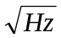 | 5nV/
inw | 2pA/. 18pA/ | 2pA/
Fh | 76 MHz | 40 MHz
Fl | 1mHz | 1mHz
Rs1 | 14.71 Ω | 1.994 KΩ
Rs2 | 897 Ω | 1.994 KΩ
et1 | 13.67 μVrms | 36.15 μVrms
et2 | 28.38 μVrms | 36.15 μVrms
et3 | 4.2 μVrms
In1 | 17. 44 nA rms | 12.66 nArms
In2 | 156.90 nA rms
En | 17.44 μVrms | 31.82 μVrms
Esubtotal | 38.13 μVrms | 70.0 μVrms
Etotal | 79.71 μVrms

Table 11 has the calculated noise for one pre-amp channel consisting of two op-amps and their associated elements. The input of the GC-814 A/D is a 14-bit converter that can resolve 61.04 μV. The total noise of a single channel without any further electronics or resistors sets the noise floor of the digital down-converter.
The output stage of the pre-amp (AD8131) could be optimized by making the gain equal to one, and using lower values for the resistors.
Transition Module Noise analysis :

Table 12.
 | AD8130 | LMH6655
enw | 12.5 nV/ | 4.5 nV /
inw | 1 pA / , 1.4 pA/ | 1.7pA /
Fh | 76 MHz | 8 MHz
Fl | 1 mHz | 3e3
Rs1 | 200 Ω | 50 Ω
Rs2 | 500 Ω | 182 Ω
et1 | 15.78 μV rms | 2.56 μV rms
et2 | 24.45 μV rms | 4.89 μV rms
En | 109 μV rms | 12.85 μV rms
In | 8.74 nA rms , 12.24 nA rms | 4.85 nA rms
Ent1 | 109.2 μV rms | 2.71 μV rms
Ent2 |  | 2.8 μV rms
Ent | 114.7 μV rms

Table 12 shows the calculated noise for the transition module. The noise level of this module is ~2 times greater than the noise from the pre-amp. It is equivalent to approximately two counts in the A/D converter.

Pre-Amp and Transition Module Frequency Response Design:

The frequency response of the pre-amp is set by the capacitance of the plate and cable connecting the pre-amp to the BPM together with the 800 Ω shunt resistor. This network produces a corner frequency at 10.1 MHz.. The coupling capacitor in the circuit (0.01 μF) together with the 800 Ω resistor produce a corner frequency at 19.89 KHz .

Pre- Amp Frequency Measurement:

Plot 1.
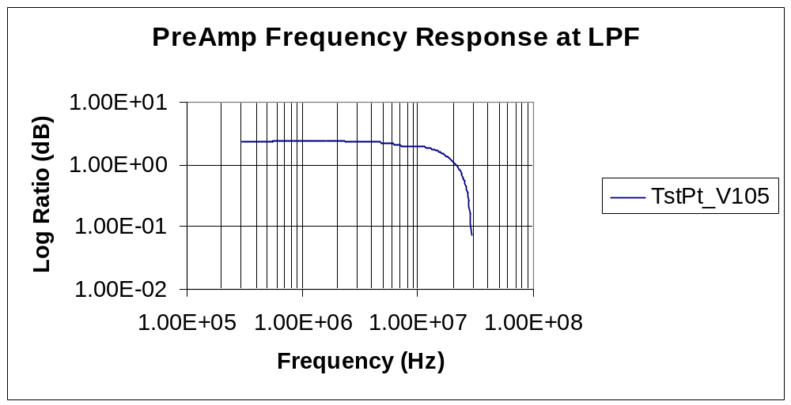

Plot 1 shows the frequency response measured the input network and the LPF output.

Plot 2.
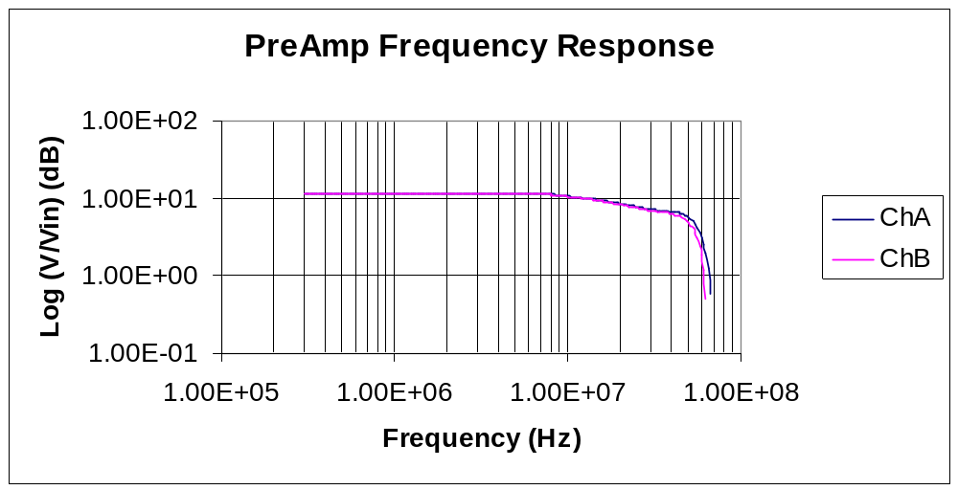

Plot 2 is the frequency response measured between the input network and the differential driver stage. The setup using a HP8751A network analyzer and an 85047A S-parameter test set swept between 300 KHz and 100 MHz.

Plot 3.
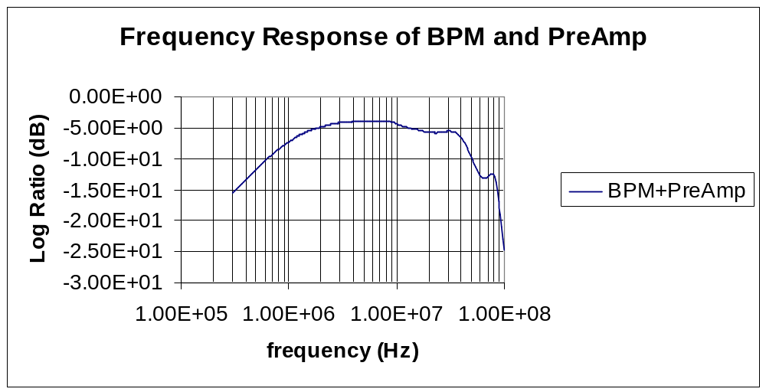

Plot 3 is the frequency response of the pre-amp with the BPM connected at both of its inputs. The system response up to 1 MHz is due to the BPM response rising at 20 dB/decade. At 1.5 MHz the impedance corner frequency flattens out the BPM response.
The measurements pass 20 MHz are not clearly understood but probably due to standing waves in the BPM itself.

Plot 4.
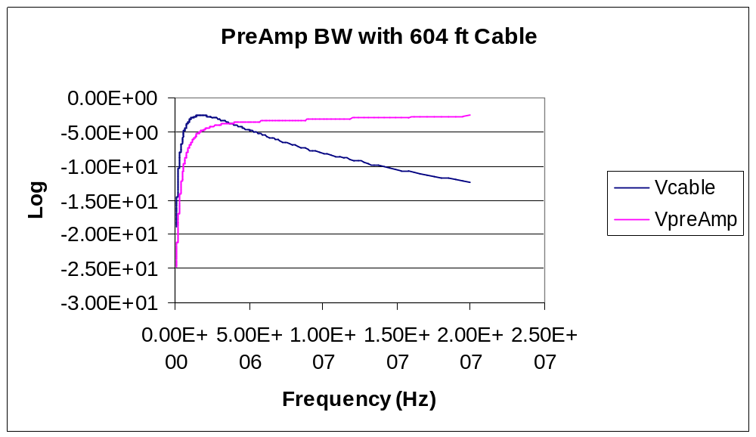

Plot 4 has the measured response of the output of the gain stage and the voltage at the end of a ~604 ft. twisted pair.

Plot 5.
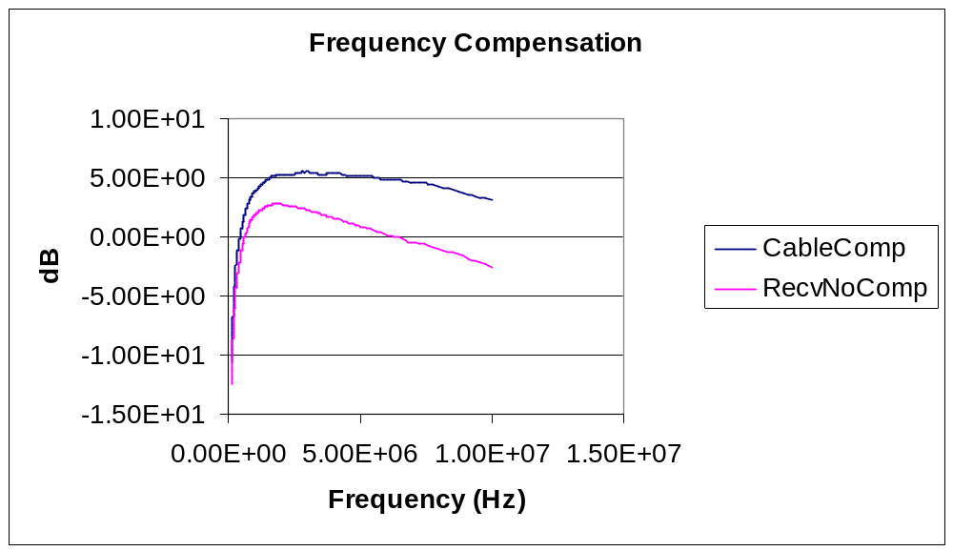

The cable attenuation is a function of frequency, increasing approximately with the square root of the frequency. For the BPM system it would be desirable to have a flat frequency response at least between 2.5MHz and 7.5MHz. By adding a network consisting of a resistor in series with a capacitor in the feedback loop, the frequency response seen in plot 8 was obtained.

Plot 6.
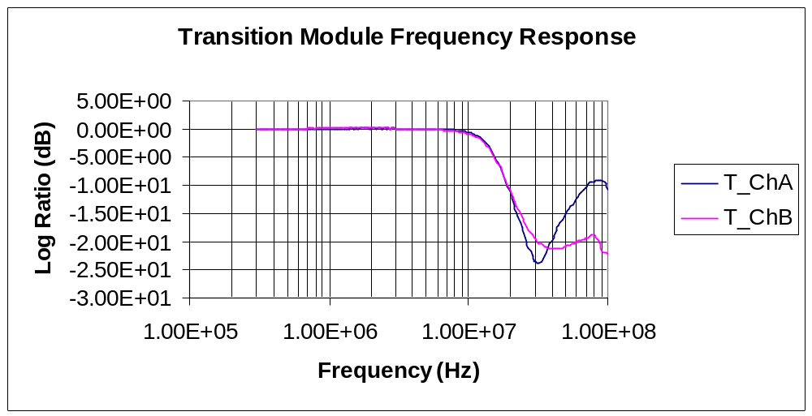

Plot 6 shows the frequency response of both channels in the transition module prototype. The filter was designed with a slope with a minima near or at 53 MHz to obtain the most attenuation possible at this frequency.
The differences of the two channels at higher frequencies are attributed to the prototype board and layout.

Dynamic Range Specifications:

- Bunched Beam: 2e10 to 30e10 Total Inj. Particles.
- Unbunched Beam : 20e10 to 400e10 particles.

Signal at A/D converter worst case considering cable attenuation and transition and pre-amp gains

2e10 Bunched Total Injected Beam:

- 0.02 Vpp for sigmat=50ns
0.017 Vpp for sigmat=25ns

20e10 Unbunched Beam:

- 0.033 Vpp for 20e10 for 2094 ns bunch
0.007 Vpp for 20e10 for 8830 ns bunch
Can the GC814 board resolve these signals and report a position with a resolution of 0.4 mm.

Actual Bits Available:

The GC-814 board has a 14 bit A/D converter whose signal to noise ratio and distortion at 15.5 MHz is 75 dB. This sets the effective number of bits to:

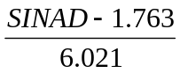

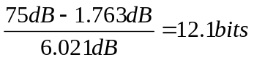

note: It can be stated the SINAD value would be different at 2.5 MHz but this needs to be measured.

OverSampling:

By sampling the input frequency at rates greater than nyquist, the system gains some resolution:

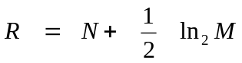

N is the effective number of bits computed above

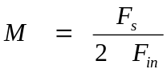

for 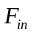= 2.5 MHz and 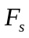= 80 MHz M= 16

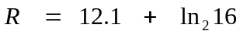

R = 14.

The effective number of bits goes from the nominal 12 back to 14.
The total Noise floor computed for the pre-amp and the transition module is .

The measured non-linearity of the A/D converter on the GC-814 was 3 counts for each channel.

The A/D with the effective number of bits resolves:

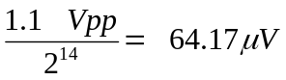 /count.

It looses 3 counts of dynamic range due to the noise in the signal.

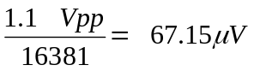/count.

For the unbunched case, the lowest predicted signal is 7 mVpp, the system needs 104 counts to resolve this input level.

