TO: Suborbital Science Program FAX: (202) 358-2770
NASA Headquarters Voice: (202) 358-7212
Mail Suite 3F71
Attn: Andrew Roberts
andrew.c.roberts@nasa.gov

Flight Report

Aircraft : | NASA P-3B
Operating Site(s)  From / To : | KWAL/KWAL
Flight Date : | March 25, 2008
Flight Number : | PCF#1 536
Take Off Time : | 1111 (L)
Landing Time : | 1411(L)
Flight Time : | 3.0
Flt Request # / PI: | 8P301/ Phil Russell
Purpose of Flight : | Data [ ] Ferry [ ] Functional Check [ ] Other [X ]
Sensor Payload : | ARCTAS
Comments : | Project check flight #1. Perfect weather for the check flight. Aside from some tracking problems with ATTS-14 and problems with the REVEAL, all the other instruments were up and the flight was considered highly successful. Tomorrow will be used to work and fine tune the instruments for PCF #2 which is scheduled for Thursday, March 27 with an 1100 Take-off

SUBMITTED BY: Dave Easmunt 25 March, 2008

Flight Hours for ARCTAS Campaign

Flight | Date | Flight # | Duration (hr) | Remaining Hours*
Total Allocated |  |  |  | 75
Engineering Check Flt | 3/14/2008 | 535 | 2.8 | 72.2
Engineering Check Flt 2 | 3/24/2008 | 537 | 2.3 (1.0)* | 71.2
Project Check Flight #1 | 3/25/2008 | 536 | 3.0 | 68.2
* Science only charged 1 hour for ECF #2,

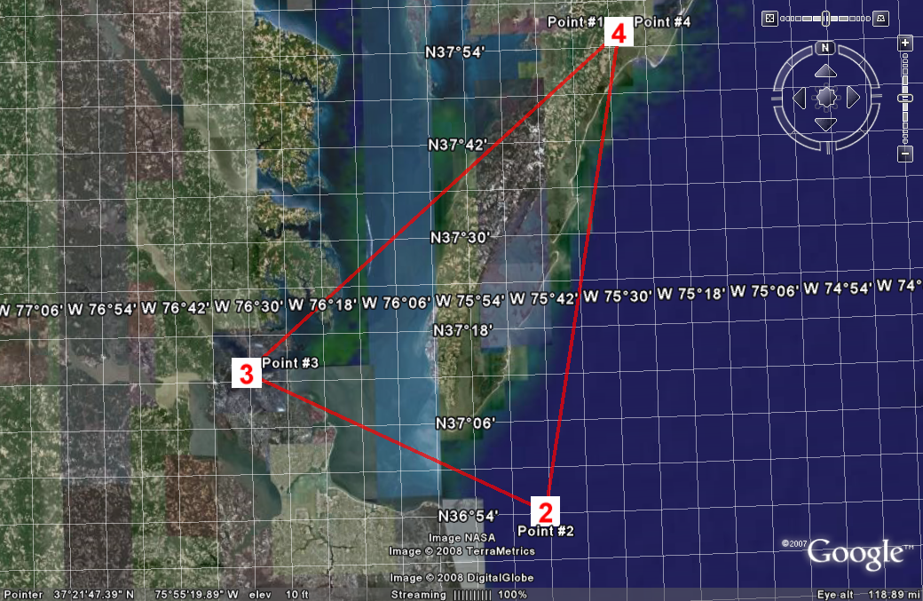
Planned flight track

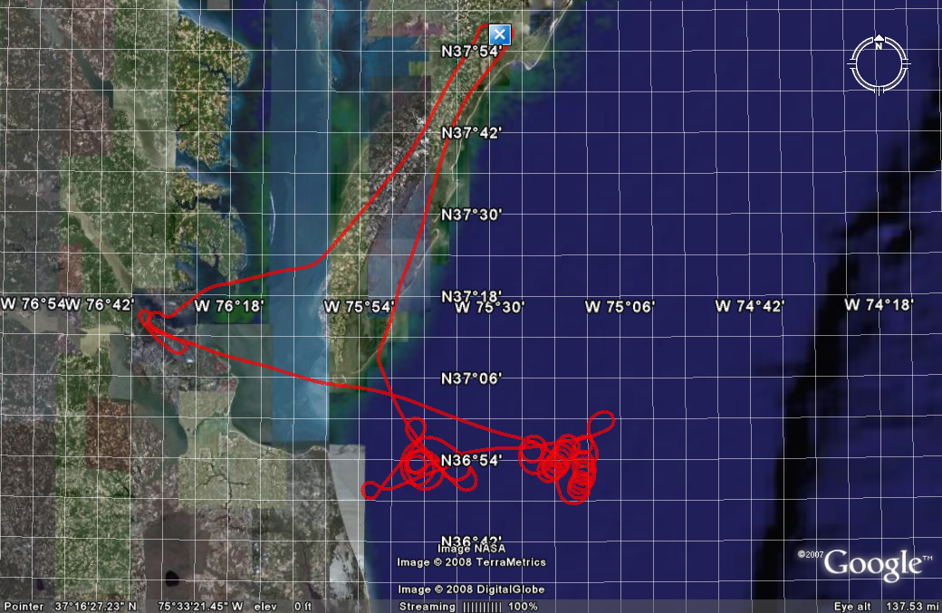
Actual flight track

Instrument Reports

AATS: Didn’t track 1st 1.5 hrs of flight. Then tracked & got data. Request time on ramp Wed, fly Wed or Thur.

AERO3X: First flight ever. Operated & took data whole flight. Operated both nephs without humidification. Spot checks w HiGEAR looked good. To add humidification next flight. Not getting PDS data. Port needs checking. Need to add aethalometer before next flight. Could fly Wed, Thur would be better.

BBR: AOK all flight. Need to check identity of zenith sensors: Solar vs IR. Can fly Wed or Thur.

CAR: Praise & thanks to all P-3 staff for getting us this far. CAR worked well. CAR nav data system worked well. Some software issues to work in next flight Wed or Thur. Try to keep circles to 2-3 minutes in future flights, which may require steeper bank. INU needs accurate time reference. To work this with P-3, PDS, & REVEAL.

CCN: Not operated today. To operate on next flight.

COBALT: Worked well. Need headset when kneeling to operate. Instrument stopped operating during takeoff, but able to restart after getting permission to get out of seat. Can fly Wed or Thur. AERO3X couldn’t see COBALT data after cutoff during takeoff.

HiGEAR
Front (Cam McNaughton): Worked well, but some flow problems caused by low speeds and varying speeds. 240 kt would be better than the 200 kt flown today.
Rear (Steve Howell): Impressed by smoothness & quietness of P-3. Prefer next flight be Thur rather than Wed.

PDS: AOK. Can fly Wed or Thur.

REVEAL: Not operated on this flight. Request 4 hrs with P-3 outside Wed, then fly Thur. Expect partial performance Thur, hope to have more by 31 Mar transit flight.

SSFR: Worked well takeoff to landing. Triangle pattern flown very well by P-3. Ideal day for SSFR. Instrument can fly Wed or Thur.

