Subsurface Drip Irrigation and IWM

Subsurface Drip Irrigation (SDI) is one of several types of Microirrigation (Conservation Practice Standard 441). It is a planned irrigation system in which water is applied directly to the root zone of plants by means of applicators (E.g. orifices, emitters, and porous tubing) placed below the ground surface. It is operated under low pressure. It is one of the more advanced irrigation methods in use today. It is potentially more efficient than flood or sprinkler irrigation, due, in large part to reduced evaporation.
Basic requirements: An operational SDI system involves a pressurized water distribution system and includes a variety of components such as pumps, valves, filters, chemical injectors and a distribution system of solid pipes and flexible tape or tubes.

Advantages:
SDI has gained attention during recent years. SDI systems can apply water and nutrients directly to individual plants or trees, reducing the wetted surface area to a fraction of other types of irrigation systems.
- SDI is a low pressure, low volume irrigation system suitable for high return value crops such as vegetable and nut crops.
- If managed properly, it can increase yields and decrease water, nutrient, pesticide, and labor requirements.
- SDI applies water to the plant’s root zone reducing evaporation losses.
- Weed growth is reduced.
- It has a high distribution uniformity allowing for high application efficiency.
- SDI can irrigate sloping or irregularly shaped land areas that cannot be flood irrigated.
- There is no runoff which results in reduced soil erosion or wasted water.
- Limited deep water drainage (with proper scheduling – management).
- High Fertilizer efficiency: Fertilizer is applied directly to root area and can be applied at any time and any dosage without wetting plant foliage. Any water soluble fertilizer may be injected through a SDI system.
- Yields are typically increased. Soil moisture and fertility in root zone can be maintained at optimum levels.
- Fewer tractor passes through field

Disadvantages:
As with other irrigation methods, concerns arise and SDI is no exception. Some concerns include initial system cost, power cost, emitter uniformity, system hygiene, longevity, fertility, maintenance, germination, crop performance, and rotation into other crops.
- SDI requires a heavy initial investment. Presently, initial start up cost is between $1,200 and $1,500 per acre. As an example, amortizing a loan at 8% interest rate over a 10 year period amounts to 22% of the initial investment that must be recovered every year. This, along with other costs, has to be compared to the benefits.
- As with anything, there is always apprehension about the decision to convert to a something different. A sizeable personal effort is required to understand the anticipated outcome as well as the operation and maintenance of a SDI system.
- SDI requires a higher skilled labor than most other irrigation systems.
- The systems must be carefully designed to ensure proper emitter and row spacing for the crop grown.
- Maintenance of the system must be performed in order to ensure the investment for the planned service life of the system.
- Soil salinity issues must be addressed as well as the effects of excess calcium carbonate dissolved in the irrigation waters.
- Filtration is critical. Emitter clogging will affect distribution uniformity. Algae growth and scale build up (CaCO3) must be controlled. As with all systems that use filters, provisions must be made for utilizing the flush water.
- Components can be easily damaged by vandals, rodents, or equipment operator error.
- Few pesticides are available for injection.
- Water must be available on a regular basis.

Micro Irrigation Methods for SDI and Other Systems
Micro-irrigation can be the most water efficient of all systems. The irrigator has a high degree of control over the way water is applied. These systems must be designed, installed, operated, and maintained carefully. Systems are prone to clogging and need clean water. Water applications are so light and frequent but can be operated to ensure a full root zone. Soil moisture must be managed carefully throughout the season.
Point source emitters:
The numerous emitters available apply water in drops or trickles, spray or mist (micro-sprinklers), or small fountains (bubblers). Emitters are generally placed in or along polyethylene tubing and dissipate water pressure through the use of long paths, small orifices, or diaphragms. Some emitters are pressure compensating, designed to discharge at a nearly constant rate over a range of pressures. Most drip emitters are designed to be used above ground.
Line Source emitter systems (Also known as drip tape or tubing):
Line source emitters are basically flexible tubing with uniformly spaced emitter points. Some drip tape emits water through small laser drilled holes. Other drip tape designs (turbulent flow tape) include equally spaced tortuous path emitter devices within the tubing. Some drip tape is designed for above ground use, while other types may be buried.
Basin Bubblers:
Basin bubblers apply water in a small basin or depression in the surrounding soil holds the water to allow infiltration. Basin bubbler systems are more applicable in orchards.
Spray or Mini-Sprinklers:
Spray or mini-sprinkler systems emit droplets from small, low pressure heads. Some micro-sprinklers have spinners, while others contain no moving parts. These systems cover a wider area than most drip emitters, with a typical wetting diameter of two to seven feet. Mini-sprinklers are less prone to clogging than point source emitters.
Typical systems in the southwest utilize groundwater, although surface water can be used.

The following pictures show a typical SDI system. - Luna County
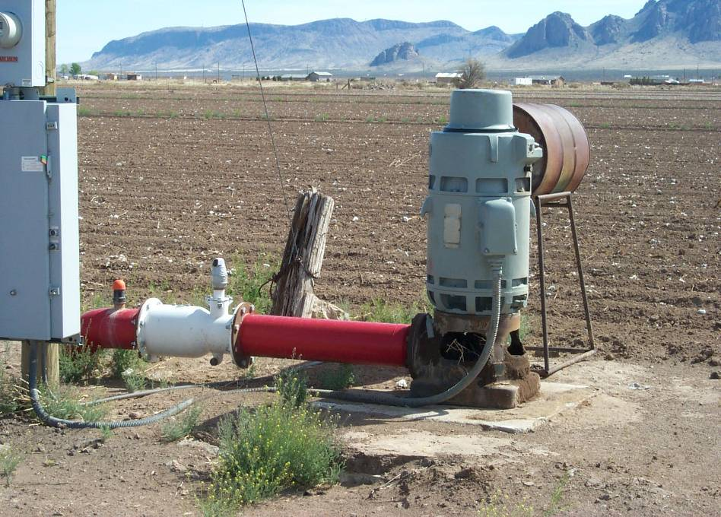 | 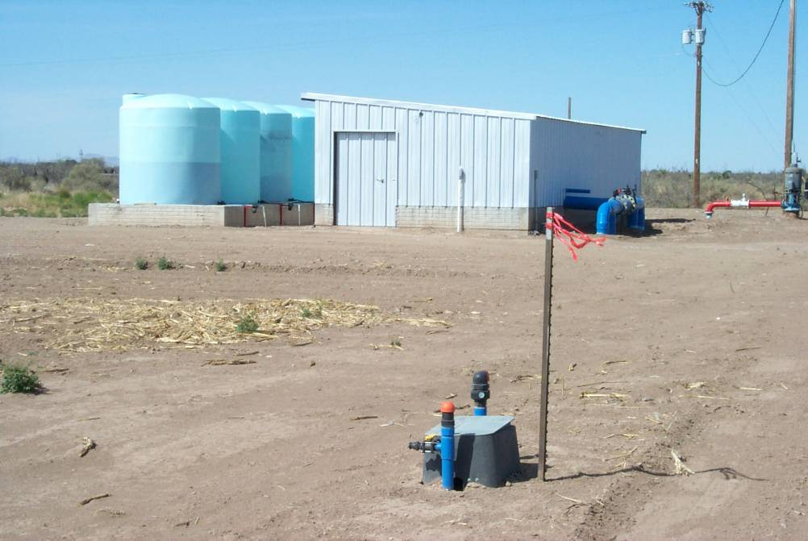
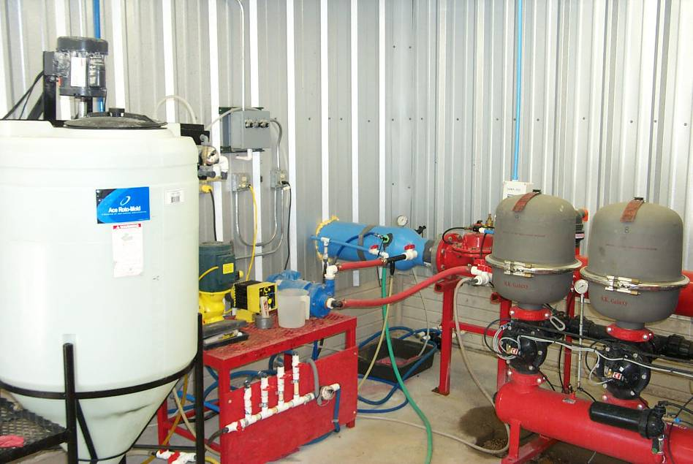 | 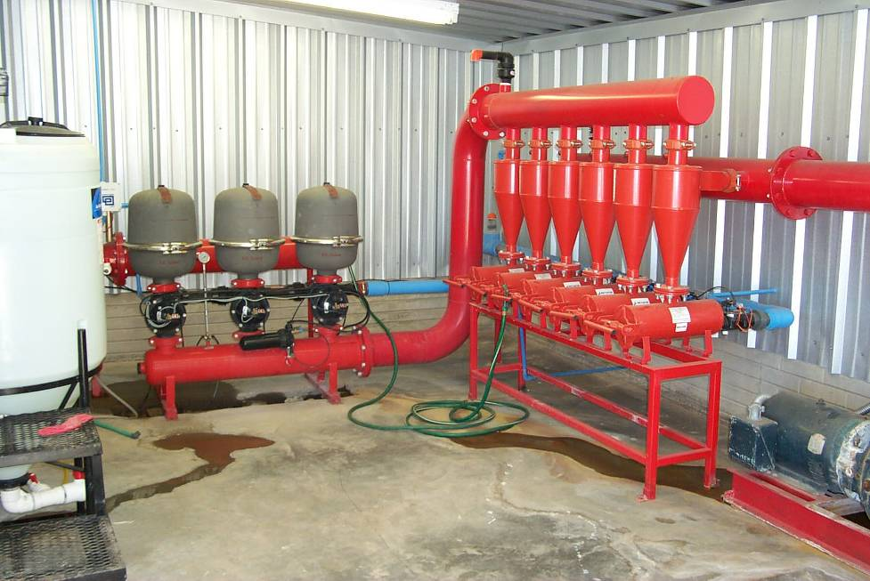
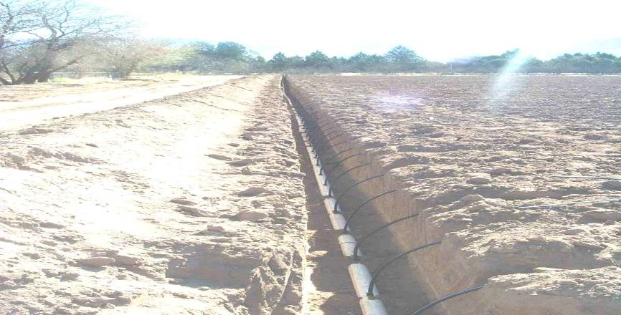 | 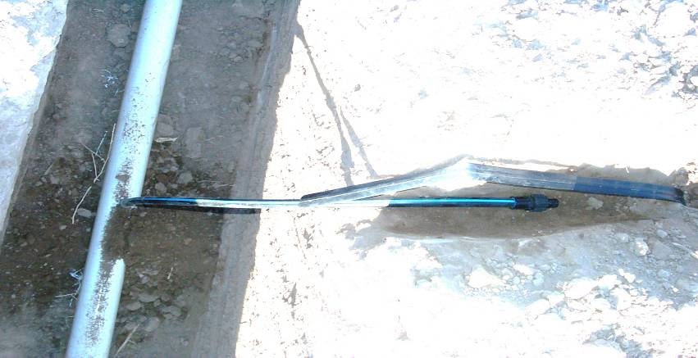
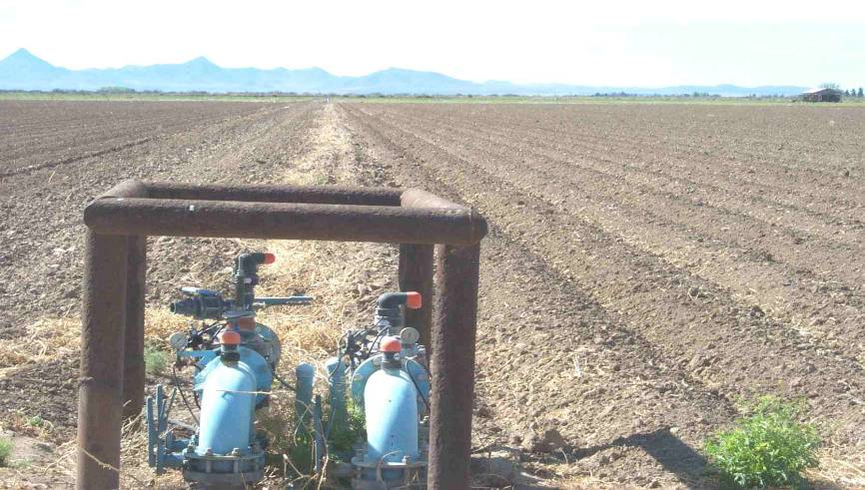 | 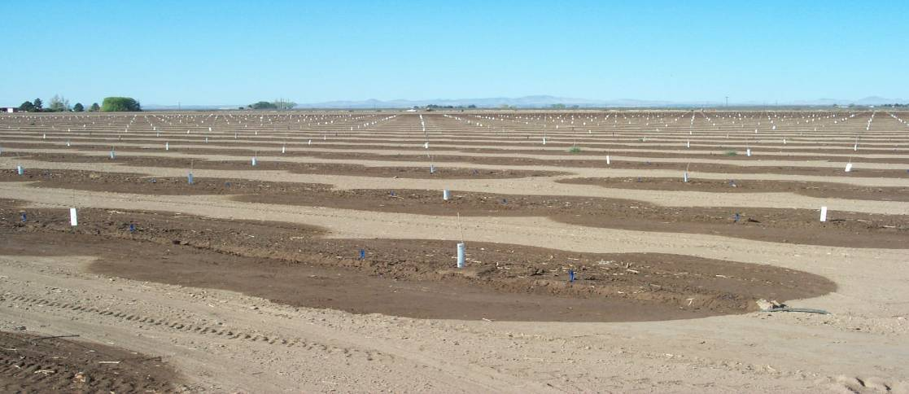
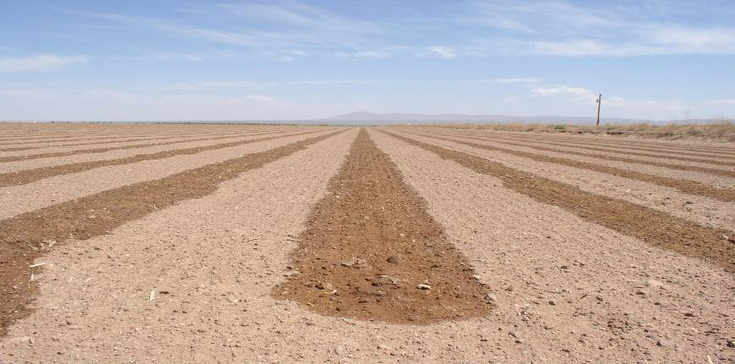 | 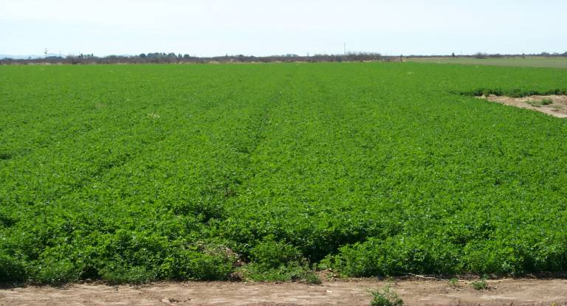

Design Requirements for Subsurface Drip Irrigation - Irrigation System, Microirrigation (441):

An irrigation system for distribution of water directly to the plant root zone by means of surface or subsurface applicators.

This practice will be designed in accordance with all federal, state and local laws and ordinances. Micro irrigation Systems shall consist of acceptable pipe design and layout to distribute the water in a uniform manner for the intended life of the practice. Resource inventories, local conditions and the intended use will need to be assessed for the proposed Micro irrigation System design and location. A Micro irrigation System design will be developed with the client that meets the intended goals and objectives. All materials shall be of high quality. All appropriate job sheets, maps and reports must be developed with landowners input, review and concurrence (See Practice Standard, Specification and Job Sheet 441).

The important components of a drip irrigation system include a water source, pump, backflow preventer, injector, filter, pressure regulator, valves, and a distribution system of pipes (main and submain lines) and tubes (laterals). Solenoid valves and a controller can be used to automate a system.

The minimum system capacity shall be adequate to deliver the average daily water requirement during the peak use month in not more than 18 hours of operation. The system design capacity shall be adequate to meet the intended water demands during the peak use month for all plants planned to be irrigated in the design area. Design capacity shall include an allowance for reasonable water losses (evaporation, runoff, leaching requirements, and deep percolation).

Determine the volume of water available and the maximum flow rate of that water. Currently most SDI system are being planned and designed by private contractors. The following information sheet is what the SW Area Engineer is requesting that the contractors provide upon review approval.

Design Area (Plan Map) | Submain/manifold
Producers Name | All Calculations & Input
Structure locations, well locations (water supply location) | per block
Dimensions – elevations - slopes - scale | pressure rating & pressure in pipe
Block Layout | type (diameter, type, etc)
North Arrow | length (from mainline to lateral total lengths of lateral)
Water source and available Q | layout (location)
Location of Pressure relief & air relief valves | show lateral location
Location of all appurtenances | Velocity & Q
Crops | Laterals
Cu of crops | All Calculations & Input
How many blocks will be irrigated simultaneously | # laterals / block
how much time to irrigate each block or set | spacing
Maximum velocity 5 fps in pipeline | type of drip tape - size, weight, etc
Drip System (Design) | emitter spacing
All Calculations & Input | Emitter flow rate @ __ psi according to manufacturer
Filter System | emission uniformity
System Q | distribution uniformity
Capacity of filter & requirements of filter | Total Q per lateral & block
Chemigation-injection | Flush lines
All appurtenances required (well, filter, flushing, shutoff valves, air relief etc.) | All Calculations & Input
pressure @ filter inlet | flows (Q)
pressure @ filter outlet | how many laterals attached to flush line
pump pressure | type (diameter, type, etc)
All pipelines to be installed to NRCS standards (depths, velocity, psi, etc.) | lengths
Mainline | layout
All Calculations & Input
Is mainline pressure same as pressure @ filter outlet
velocity & Q
type (diameter, type, etc)
pressure rating & pressure in pipe
Layout
show submain locations- direction of outlet flow

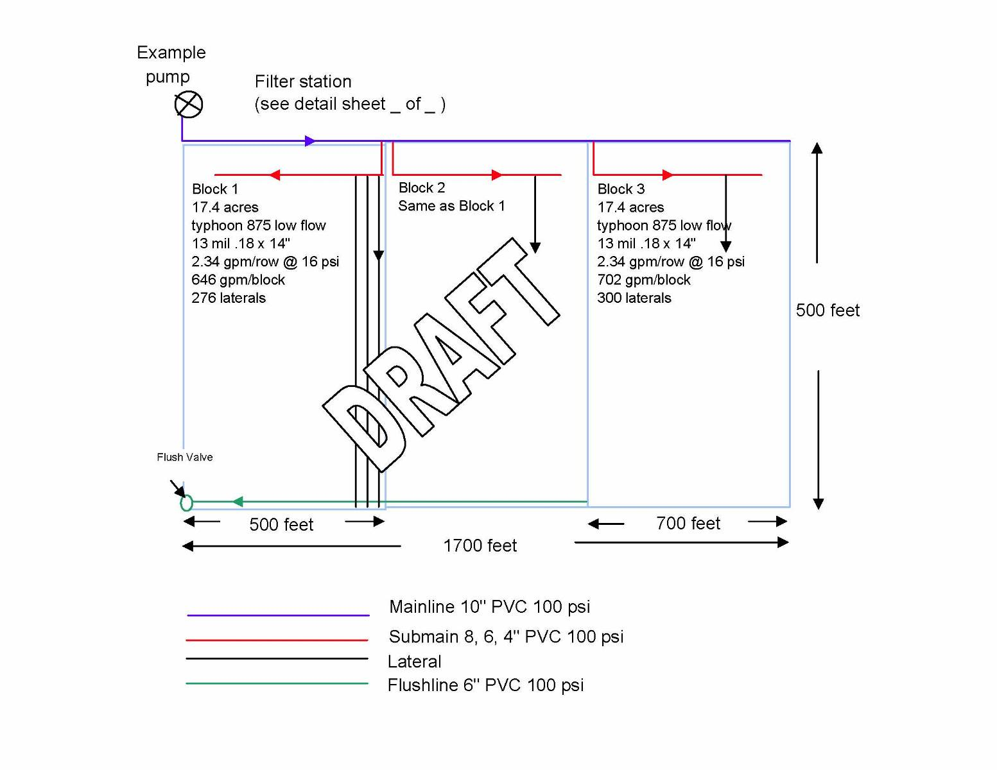
Maintenance of Micro Irrigation Systems
Water quality is a factor in maintaining micro irrigation systems. A water quality test will measure silt or sand; algae; bacteria; dissolved solids such as iron, sulfur, salts, and calcium; and the pH of the water. For additional information on system maintenance, contact the equipment manufacturer.

Maintenance tasks:
Annually treat system with acid to neutralize calcium carbonates if the water is “hard”. Consult equipment manufacturer for type of acid and treatment interval.

Regularly:
- Irrigation system evaluation by a trained professional is highly recommended.
- Check for leaks, rodent damage, and mechanical damage.
- Inspect pressure regulating valves and pressure gauges for correct operation and pressure readings. Liquid filled pressure gauges are recommended.
- Flush lateral lines. Depending on water quality and filtration system, flushing should be done bi-weekly and after fertilizer or chemical injection or chlorination.
- Regularly check for and clean or replace clogged emitters. Drip emitters that are only partially clogged are difficult to identify without catching the flow to determine the discharge rate.
- Check emitters for correct flow. Take precise measurements at least twice each year by catching the flow from several emitters in a calibrated cylinder (such as a rain gauge) during a carefully timed interval.
- Backwash filters either manually or using automatic cycle, depending on system design and type of filter.
- Replace cartridge filters.
- If filter media (such as sand) cakes, replace media. For sand filters, periodically supplement with additional media.
- Chlorinate system with 10 ppm if water has high organic load.
- If clogging due to organic matter continues to be a problem, inject 50-100 ppm of chlorine and allow to sit for 24 hours.
- If clogging due to precipitates (such as calcium carbonate) persists, inject system with acid to lower pH to about 5. Allow to sit for 24 hours. Contact equipment manufacturer before undertaking this task to determine the minimum pH allowable for system type.

At Season Shutdown:
- Treat entire system with 40 ppm residual chlorine concentration for at least four hours, and completely flush the system.
- Drain water from all pipelines. The system may have to be blown out lateral by lateral with an air compressor to accomplish this. Don’t exceed 15 to 20 psi of air pressure, or you’ll blow off the emitters. Polyethylene pipes can withstand some freezing without breaking, so it isn’t critical that all water be removed. In cases where freezing may be a problem, add non-toxic antifreeze (type used in RV’s) to the piping system and distribute it throughout with compressed air.

Efficiency of Micro-Irrigation systems (SDI)

Application efficiency, which is the percentage of applied water beneficially used by the crop can approach 100% for SDI. High efficiency is also realized with fertilizer application using SDI. Injected fertilizer (fertigation) is applied directly to root area and can be applied at any time and any dosage without wetting plant foliage.

Properly designed systems are highly efficient in their use of water and energy. Below are a few suggestions for ensuring that the system is running efficiently:

Make sure you know your exact field size. It’s common to overestimate field size, leading to overestimating water requirements. This concern is commonly taken care of by proper planning, design, and monitoring of the soil moisture.

Avoid excessive back flushing that wastes water and energy and creates a water disposal problem. Measure back flushing amounts.

Find and address causes of plugging. Investigate the source and fix the plugging problem.

Check for plugged filter screens. Undo and clean any screens that are plugged.

Scheduling Irrigations – The Irrigation Requirement:

To effectively schedule irrigations, you must know:
- The flow rate of each emitter
- The crop (or plant) canopy area
- An estimate of the plant’s daily water-use (evapotranspiration or ET)

The equation used to estimate the irrigation requirement (IR) per Plant is:
IR = (0.623 x CA x Plant Factor x ETr) / IE
Where:
IR = the irrigation requirement in gallons
0.623 = gallons of water required to fill 1 square foot 1 inch deep
CA = plant canopy area in square feet
Plant factor = 0.85 for tomatoes, chili, and sweet corn (may be higher for melons, squash, cucumbers, etc.)
ETr = reference ET (refer to Irrigation water requirements by local/crop data)
IE = irrigation efficiency (assume 90% for SDI)

Calculating the Crop Canopy Area:
Area of a circle = d2 x 0.785 (diameter x diameter x 0.785)
Example: plant diameter = 18 inches or 1.5 ft.
Area = 1.5 x 1.5 x 0.785 = 1.77 sq. ft..

EXAMPLE: Scenario
Location – Albuquerque
Date – May 25 (ETr = 0.41 inch)
Chile plant (plant factor = 0.85)
Measured (circular) plant diameter = 1 foot
Estimated irrigation efficiency (IE) = 90 % or 0.9
Calculations: CA = 1 x 1 x 0.785 = 0.785
IR = (0.623 x 0.785 x 0.85 x 0.41)/0.9 = 0.19 gallons (24 fluid ounces) per plant per day
NOTE: There is no substitute for frequently checking the moisture in the soil profile.

Water Quality and SDI systems:

The irrigation water to be used in a drip system should be evaluated carefully to assess any potential clogging problems. Materials suspended in the water, such as sand, silt, and algae, can block emitter flow passages or settle out in the drip lines. Other contaminants, such as calcium, bicarbonate, iron, manganese, and sulfide, can also precipitate to clog emitter flow passages.

All water needs to be tested to determine levels of dissolved salts, pH, and turbidity (sediment levels). Growers need to be aware of high levels of pH (7.5) and high dissolved bicarbonate levels (=> 5.6 meq/liter). If water quality analysis indicates these levels, sulfuric acid and/or gypsum should be injected to acidify the water to lower the pH to prevent the emitters from clogging with precipitates. A pH of 6.5 is favorable for injecting fertilizers or other agricultural chemicals into the system.

References:

NRCS Conservation Practice Standard: Irrigation System, Microirrigation (code 441)

Water Management: The New Mexico Irrigator’s Pocket Guide

Assessing Water Quality Before Installing a Chemical Injection System. Robert Flynn, Extension Agronomist, NMSU Circular 573, Drip Irrigation for Row Crops, Aug. 2001.

Maintenance of Microirrigation Systems. Larry Schwanki, Irrigation Specialist, UC-Davis, NMSU Circular 573, Seasonal or Minimum Tillage, Drip Irrigation for Row Crops, Aug. 2001.

