CLINICAL REVIEW
Amgen, Biologic Licensing Application
STN 103950, anakinra for use in the treatment of rheumatoid arthritis
Prepared July 9, 2001
TABLE OF CONTENTS
I. BACKGROUND 4
A. Guidance document for clinical development programs for products for the treatment of rheumatoid arthritis (RA guidance document) 4
B. Regulatory history 4
II. Study 990145 6
A. Clinical Trial Design 6
B. Study Conduct 7
C. Efficacy Analysis 10
1. Time Course of Response and Components of ACR20 12
2. Subset analyses 15
3. Summary of efficacy data 20
D. Safety 20
1. Deaths 20
2. Serious adverse events 20
3. Other adverse events 22
4. Infections 23
5. Summary of safety data 24
III. Study 990757 24
A. Clinical trial design 24
B. Study conduct 25
C. Results 31
1. Deaths 31
2. Serious Adverse Events 33
3. Malignancies 34
4. Infections and Serious Infections 35
5. Other Adverse Events 40
6. Adverse Events Leading to Withdrawal 42
7. Summary 42
IV. Studies 560 and 960180 43
A. Clinical Trial Design 43
1. Amendments to Study 960180 44
B. Study Conduct 44
1. Study 0560 44
2. Study 960180 48
C. Efficacy Analysis 51
1. Sensitivity Analysis 66
2. Summary 67
D. Radiographic Progression 67
1. Reanalysis of the Data using a Modified Sharp Score 69
2. Summary 70
E. Safety 71
1. Deaths 71
2. Serious Adverse Events 71
3. Discontinuations due to Adverse Events 76
4. Leukopenia and other Laboratory Abnormalities 76
5. Other Adverse Events 83
V. Study 960182 84
VI. Study 20000125: Enbrel Combination 85
A. Summary 87
VII. Overall Summary of Safety and Efficacy 87

BACKGROUND

Guidance document for clinical development programs for products for the treatment of rheumatoid arthritis (RA guidance document)
The RA guidance document recognizes relief of the symptoms of rheumatoid arthritis as a central therapeutic effect of most RA therapeutics. The standard set forth for demonstrating an improvement in signs and symptoms for a product belonging to a novel pharmacologic class is a demonstration of efficacy in a clinical trial of at least six months’ duration. Acceptable outcome measures include validated composite endpoints or indices of signs and symptoms, such as the ACR definition of improvement (ACR20) or well-accepted sets of signs/symptoms measures. Since RA is a chronic disease, sponsors of investigational products are also expected to demonstrate durability of effect for their agents.
The RA guidance document also recognizes additional potential clinical benefits of products for RA, including the ability to produce a major clinical response, a complete clinical response, remission, improvement in physical function/disability and inhibition of progression of structural damage. The evidence that would be expected for support of each of these enhanced claims is provided in the RA guidance document. Sponsors hoping to demonstrate that a product is effective in inhibition of structural damage must conduct a trial of at least one year in duration and use one of several standard methods for assessing structural damage, including the Larsen or modified Sharp score.

Regulatory history for anakinra
Following completion of study 560, a phase 2 trial of anakinra monotherapy in patients with rheumatoid arthritis, Amgen initiated a small (30 subjects/arm), 3-month, randomized, phase 2 trial of anakinra in combination with methotrexate: trial 960180. While study 960180 was being conducted, Amgen changed the protocol to extend the study to 6 months, to add additional treatment arms and to add additional subjects. In addition, the primary endpoint was changed to an efficacy endpoint. In September, 1998, the sponsor met with the agency to discuss results from an interim analysis of study 960180 and to ask whether that study could serve as a pivotal trial. The agency worked with the sponsor to optimize the statistical analytic plan, but noted that since the trial was ongoing, there were limits to the changes that could be made. Among other concerns, the agency noted that independent blinded joint assessors had not been included in the study to minimize the potential for bias resulting from the high incidence of unblinding injection site reactions seen with anakinra treatment.
In the spring of 1999, after receiving the results of study 960180, the sponsor approached the agency about whether the clinical trial data would be adequate to file a biologic license application (BLA) for anakinra for patients with rheumatoid arthritis. The agency agreed to allow Amgen to file a BLA, but recommended the company carry out additional studies to explore areas that were not fully addressed in the clinical trial experience to date. In particular, the agency recommended that Amgen carry out:
- a randomized safety trial in a patient population representative of patients who would receive anakinra if it were approved, including patients with concomitant medical conditions and patients who were receiving additional disease-modifying anti-rheumatic drugs (DMARDs).
- Studies of anakinra in combination with TNF antagonists
- Studies of anakinra in children with JRA
In addition, the agency suggested that if the sponsor sought a claim of inhibition of structural damage, they should initiate a 1-year trial to measure x-ray progression. Following these discussions, the sponsor initiated clinical trials in each of these areas.
On December 30, 1999, Amgen Corp. submitted a BLA for anakinra for rheumatoid arthritis. Upon review of the data, the agency concluded that, while the data suggested that anakinra had activity in RA, there were inconsistencies in the efficacy data and the safety data were inadequate for a product with potential immunosuppressive properties that was intended for chronic use in disease as common as rheumatoid arthritis. The agency issued a Complete Review letter stating that additional safety and efficacy information would be required for an approval. On February 28, 2001, the sponsor filed a response that included complete data on all 1414 subjects for the first 6 months of the randomized safety trial (990757) and data from an interim analysis of the first 506 subjects treated for 6 months in the study of radiographic progression (990145).

Table 1. Phase 2 and 3 Studies of anakinra
Study | Phase | # of subjects | Doses (all given subcu qd) | Notes
0560 | 2 | 473 | 30, 75, 150 mg
960180 | 2/3 | 419 | 0.04,0.1, 0.4, 1, 2 mg/kg
960182 | 2 | 141 | 2.5, 10 30 mg | Exploration of lower doses
990145 | 3 | 506 | 100 mg | Clinical endpoint at 6 mo  X-ray endpoint at 1 year
990757 | 3 | 1414 | 100 mg | Safety study
20000125 | 3 | 58 | 100 mg | Enbrel combination

Study 990145

Clinical Trial Design
Clinical trial 990145 is a randomized, phase 3, double-blind, controlled study comparing anakinra 100 mg sc qd with placebo in patients with active rheumatoid arthritis receiving stable doses of methotrexate. The trial was conducted at 106 sites in the US, Canada and Australia. Randomization uses a 1:1 allocation and is stratified by study center. Subjects are assessed monthly by independent, blinded assessors for safety and for the components of the ACR response criteria. The blinded portion of the study is planned for 12 months, with an open-label extension phase following. The primary endpoint for the study is the radiographic outcome at 12 months. Although the total number of subjects planned for enrollment is 990, data are presented here on signs and symptoms of RA and safety based on an interim analysis of 24 weeks of treatment of the first 506 subjects randomized as of May 18, 2000. The results of the radiographic outcomes will remain blinded until 12 month treatment of all subjects has been completed.
The study enrolled adult patients with active rheumatoid arthritis for at least 6 months, who had radiographic evidence of at least one bony erosion. All subjects were receiving stable doses of methotrexate for at least 8 weeks and stable doses of NSAIDs and low dose corticosteroids. The inclusion and exclusion criteria are provided in the appendix.
In addition to concomitant methotrexate in all subjects and stable doses of NSAIDs and corticosteroids, the study allowed rescue analgesics to be used, including acetaminophen, codeine and/or propoxyphene except within 12 hours of a scheduled study evaluation. Intra-articular corticosteroids to 2 joints was permitted on 2 separate occasions ≥2 weeks before the next assessment visit. The treated joint was thereafter classified as a failed joint in the joint assessment.
To retain the maximum number of subjects in the trial for radiographic assessments, the study incorporated a subject status designation, Lack of Efficacy (LOE). Subjects requesting LOE designation on or after 16 weeks of treatment who met prespecified criteria (see below) were allowed to receive additional treatments with protocol-specified agents. Lack of efficacy was defined as a failure to achieve an ACR20 response on 3 consecutive visits spanning 8 weeks. For patients designated as meeting LOE criteria, they were to continue study medication and, in addition, their regimen was to be optimized by adjustment of their MTX, corticosteroids and/or NSAIDs. If the subject still met criteria for LOE, then they could have their treatment adjusted by addition of the following medications: hydroxychloroquine, sulfasalazine, gold, minocycline, leflunomide or cyclosporine.
To minimize the unblinding effects of injection site reactions, which have been observed in patients receiving anakinra in earlier studies, independent blinded joint assessors were used to assess swollen and tender joint counts. Previous injection sites were covered during joint assessments. In addition, results of CRP and ESR values were blinded to study site personnel and the sponsor. In the original protocol, assessments were scheduled for the 3 month and 6 month visits. After 128 subjects had been randomized, the protocol was amended so that assessments were performed monthly.
Randomization was performed via a central site with 1:1 allocation. Both anakinra and placebo were provided as a clear liquid in single-use glass vials.
The primary endpoint for this interim analysis was the ACR20 response at week 24. An ACR20 responder is defined as a subject who meets the following criteria:
- 20% improvement in tender/painful joint count and swollen joint count
- 20% improvement in ≥ 3 of the following:
  - Patient global assessment
  - M.D. global assessment
  - Patient assessment of pain (VAS – visual analog scale)
  - Health Assessment Questionnaire (HAQ)
  - Acute phase reactant (CRP or ESR)
Any subject who had an increase in their baseline dose of DMARD or corticosteroid is deemed a non-responder for purposes of the primary endpoint. The primary analysis was specified as a logistic regression, using Intention to Treat (ITT), adjusted for center effect only. The specified level of significance for the analysis was a 2-tailed alpha level of 0.05. The primary analysis population was all randomized subjects who received at least one dose of study drug. Subjects requiring an increase in DMARDs or corticosteroids were deemed non-responders. A non-responder imputation was specified for missing data. To preserve the integrity of this ongoing trial studying radiographic progression, individual treatment assignments were not unblinded for the interim analysis.
Secondary endpoints included ACR50 and ACR70 responses at 6 months, the mean change in the ACR20 components, the mean change in the duration of morning stiffness and the proportion of subjects who experienced a sustained ACR20 response. A sustained ACR20 response was defined as an ACR20 response for 4 of 6 months, not necessarily consecutive, of which 1 response was observed at month 3 or month 6. The addition of sustained ACR20 responder was made to the protocol after approximately 100 subjects had completed 2 months of treatment and had not received assessments at months 1 and 2. For these subjects, a sustained ACR20 response was defined as a response at 3 of 4 months (month 3, 4, 5 or 6).

Study Conduct
A total of 506 subjects were randomized (Table 2). A total of five subjects never received study drug. The likelihood that the number of randomized-but-not-treated subjects may have biased the results is small because there were a similar number in each arm: 2 on the placebo arm; 3 on the anakinra arm. Approximately three-quarters of all subjects completed 6 months of blinded therapy overall. A higher proportion of subjects completed the full 6 months of treatment in the anakinra arm than the placebo arm (table 1). The difference in the number of patients completing therapy is accounted for by a higher proportion in the placebo arm withdrawing due to subject request (12% vs. 5%) and disease progression (4% vs. 1%) outweighing the higher proportion of subjects withdrawing due to adverse events in the anakinra arm (13% vs. 9%). There were no deaths during the study.

Table 2 Study 990145: Subject Disposition
Patients enrolled: 506
 | Placebo | Anakinra
Patients randomized | 253 (100%) | 253 (100%)
Received ≥ 1 dose: modified ITT population | 251 (99%) | 250 (99%)
Completed 6 months of blinded therapy | 186 (74%) | 197 (79%)
Reasons for not completing:
Adverse event | 22 (9%) | 33 (13%)
Subject request | 29 (12%) | 12 (5%)
Disease progression | 10 (4%) | 3 (1%)
Death | 0 (0%) | 0 (0%)
Other | 6 (2%) | 8 (3%)
A total of 32 subjects had protocol violations involving eligibility criteria or protocol procedures. The most common violations were: fewer than the required number of tender or swollen joints at screening (10), inadequate DMARD washout before randomization (N=6), unstable dose of MTX or corticosteroids in the 4 weeks before randomization (N=6) and never received study drug (N=5). A similar number of subjects from each treatment arm had protocol violations. During the study, a similar number of subjects from each arm deviated from protocol-prescribed concomitant medications with one or more increases, decreases or missed doses of MTX, other DMARD, corticosteroid or narcotic (30 in the placebo arm; 26 in the anakinra arm. Sensitivity analyses were carried out to assess the possibility of bias due to protocol violations (see below). A level of compliance with study mediation of 90% or greater was attained by 99% of subjects in the placebo arm and 95% of subjects receiving anakinra.
The baseline demographics of study subjects is shown in Table 3. No imbalances were noted with respect to sex, ethnic group, age and weight. The two treatment groups were also balanced regarding baseline disease activity measures, including the components of the ACR 20 and the duration of morning stiffness (Table 4 and Table 5).

Table 3. Subject baseline demographics
 | Placebo (N=251) | Anakinra (N=250)
Female (%) | 189 (75%) | 197 (79%)
Ethnic group
Caucasian | 219 (87%) | 216 (86%)
Black, African-American | 16 (6%) | 12 (5%)
Hispanic | 11 (4%) | 15 (6%)
Other | 5 (2%) | 7 (3%)
Age (mean) | 57.0 | 55.7
Weight (mean, kg) | 80.2 | 81.9

Table 4. Subject baseline disease information
 | Placebo (N=251) | Anakinra (N=250)
RF positive | 196 (78%) | 189 (76%)
NSAID use | 194 (77%) | 189 (76%)
Corticosteroid use | 131 (52%) | 133 (53%)
MTX dose (mg/wk, mean) | 15.6 | 15.6
Duration of RA (yrs, mean) | 10.4 | 11.1

Table 5. Subject baseline disease activity (mean values)
 | Placebo  (N=251) | Anakinra  (N=250)
Tender/painful joint count (0-68) | 24.5 | 26.8
Swollen joint count (0-66) | 20.0 | 20.1
MD global assessment (0-100) | 57.0 | 57.4
Patient global assessment (0-100) | 52.3 | 53.2
Pain, VAS (0-100) | 55.7 | 59.2
Health Assessment Questionnaire (0-3) | 1.32 | 1.36
CRP (mg/dL) | 2.60 | 2.66
ESR (mm/hr) | 42.9 | 41.5
Duration of morning stiffness (min/d) | 111 | 102

Efficacy Analysis
The results of the ACR (American College of Rheumatology) 20, 50 and 70 assessments at 6 months are summarized in Table 6.

Table 6. ACR Responses in Study 990145
 | Placebo  (N=251) | Anakinra  (N=250) | P value
ACR20
6 mo | 55 (22%) | 94 (38%) | P<0.001
ACR50
6 mo | 20 (8.0%) | 43 (17%)
ACR70
6 mo | 5 (2.0%) | 14 (5.6%)
Analysis of the primary endpoint of the trial showed an increase in the proportion of subjects attaining an ACR20 response at 6 months among subjects treated with anakinra 100 mg sc qd compared to placebo-treated subjects: 38% of anakinra-treated subjects attained an ACR20, compared to 22% of placebo-treated subjects. The results were statistically significant with a p value <0.001, based on the prespecified logistic regression analysis adjusted for center.
The primary analysis of the trial specified that subjects with missing data at 6 months due to dropout for any reason or to increasing their DMARD or corticosteroids would be counted as non-responders (non-responder imputation). To assess how use of the non-responder imputation influenced the results of the trial, three sensitivity analysis were performed (Table 7). First, instead of considering subjects who did not complete the 6 months of blinded therapy as non-responders, a completer analysis was carried out, which was restricted to subjects who completed 6 months of therapy and did not drop out due to lack of efficacy, toxicity or any other reason. 200 anakinra-treated subjects and 187 placebo-treated subjects completed 6 months of therapy. Of these subjects, 47% of subjects in the anakinra arm and 29% of subjects in the placebo arm had an ACR20 response at 6 months. The difference in response rates between study arms of 18% compares to 16% using an intent-to-treat analysis with non-responder imputation. The second sensitivity analysis assessed the effect of considering subjects who increased corticosteroids or DMARDs as non-responders in the primary analysis. In this analysis, subjects who increased corticosteroids or DMARDs were considered responders or non-responders based on their observed ACR20 response at 6 months. This analysis showed results very similar to the primary analysis. Finally, the potential bias contributed by the unblinding effects of injection site reactions in anakinra-treated subjects was assessed by analyzing the ACR20 responses of that subset of patients who had no injection site reactions. Approximately one-third of anakinra-treated and four-fifths of placebo-treated subjects had no injection site reactions. The response rates in this subset were similar to those in the intent-to-treat population.

Table 7. Study 990145: Sensitivity Analyses
 | Placebo  (N=251) | Anakinra  (N=250)
Completer analysis
N | 187 | 200
Responders | 55 (29%) | 94 (47%)
Substitute observed values for
completers who increased
corticosteroids or DMARDS
N | 251 | 250
Responders | 56 (22%) | 98 (39%)
Subjects without injection site reactions
N | 192 | 87
Responders | 37 (19%) | 32 (37%)

Time Course of Response and Components of ACR20
The time course of response to anakinra was rapid, with differences between anakinra and placebo apparent by 4 weeks of treatment (Figure 1). The percent of placebo subjects achieving an ACR20 response increased up to week 12 then reached a plateau, while responses to anakinra continued to increase at least to week 20.

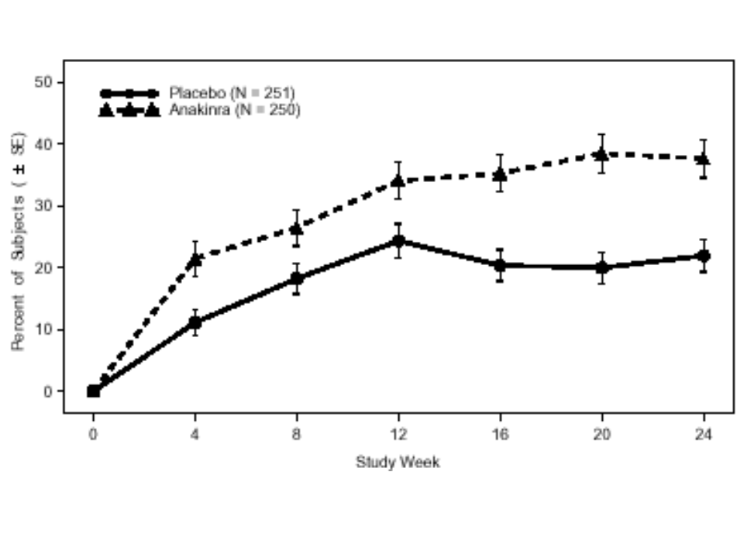
Figure 1. Study 990145: Percent of ACR20 responders by study week
The changes in the individual components of the ACR20 are shown in Table 8. A repeated measures mixed model was used to impute missing data. All components of the ACR20 showed improvement in the anakinra arm. However, the responses to different components demonstrated heterogeneity. The components that showed the largest difference between anakinra and placebo are the ESR (38% improvement with anakinra vs. 14% with placebo), the patient global (34% vs. 17%) and the CRP (19% vs. 4%). In contrast, other components showed less difference between treatment arms. In particular, the fall in swollen joint count was similar in anakinra-treated subjects and placebo-treated subjects (34% vs. 32%, anakinra vs. placebo, respectively). The nominal p value for the difference in swollen joint count was 0.7.
Although the improvement in swollen joint count was similar in the two treatment arms at 6 months, earlier time points show a larger improvement in anakinra-treated subjects. As shown in Figure 2, swollen joint counts fell more in anakinra-treated subjects at 4 weeks than in placebo-treated subjects. Anakinra-treated subjects continued to have a larger improvement at subsequent time points, but the difference between treatment arms lessened until 6 months, when the degree of improvement was similar across treatments.

Table 8. Study 990145: Mean change in components of ACR20 at 6 months
 | Baseline value (average) | Placebo  (N=251) | Anakinra  (N=250) | P value
Tender/painful joint count (0-68) | 26 | -8.6 | -12 | P=0.006
Swollen joint count (0-66) | 20 | -6.4 | -6.8 | P=0.7
MD global assessment (0-100) | 57 | -20 | -25 | P=0.01
Patient global assessment (0-100) | 53 | -8.9 | -18 | P<0.001
Pain (VAS, 0-100) | 57 | -12 | -19 | P=0.003
HAQ (0-3) | 1.3 | -0.18 | -0.29 | P=0.02
CRP (mg/dL) | 2.63 | -0.10 | -0.51 | P=0.001
ESR (mm/hr) | 42 | -6.0 | -16 | P<0.001
Duration of morning stiffness (min/d) | 106 | -36 | -48 | P=0.112

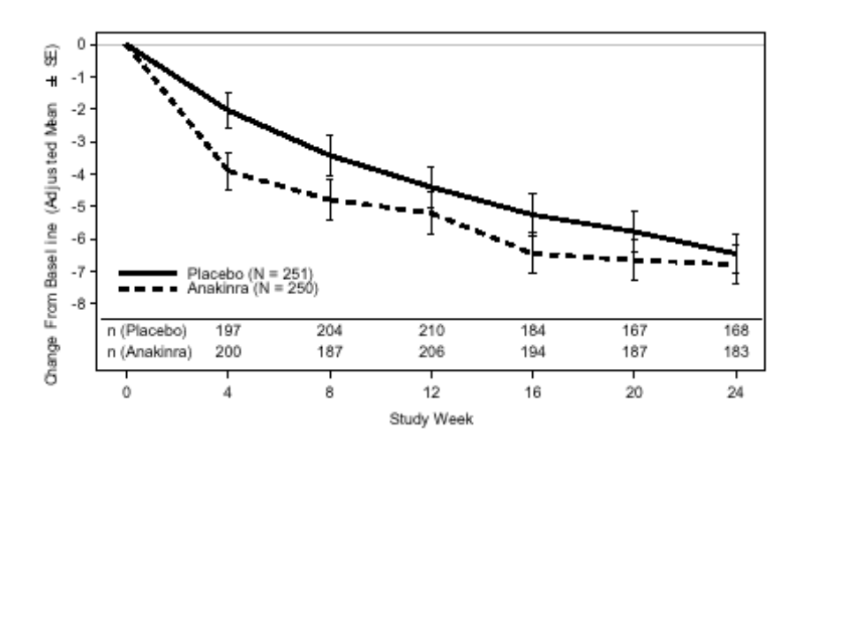
Figure 2. Study 990145: Swollen joint count change from baseline

Subset analyses
In order to assess whether baseline demographic factors or disease-related factors may have influenced the likelihood of responses, the proportion of responders in the two treatment arms was analyzed in subsets of patients. When subjects were subsetted based on gender (Figure 3), on age (Figure 4) or on ethnic background (Figure 5), a higher proportion of responders were seen in subjects treated with anakinra than in subjects who received placebo.
To assess whether duration of disease influenced the likelihood of response to anakinra, subjects were grouped based on the top quartile of disease duration. As shown in Figure 6, responses were similar in the group with disease duration of 15 years or longer and the group with shorter duration of disease. Patients with a positive rheumatoid factor and patients with elevated acute phase reactants have been reported to have a worse prognosis than patients lacking those abnormal laboratory values. Both patients with and those without these adverse prognostic factors had a higher likelihood of having an ACR20 response when treated with anakinra (Figure 7 and Figure 8). Finally, when subjects were subsetted based on the baseline level of disease activity, as measured by the tender joint count (top quartile vs. all others), a higher proportion of responders were seen in the anakinra-treated patients than the placebo-treated patients (Figure 9).

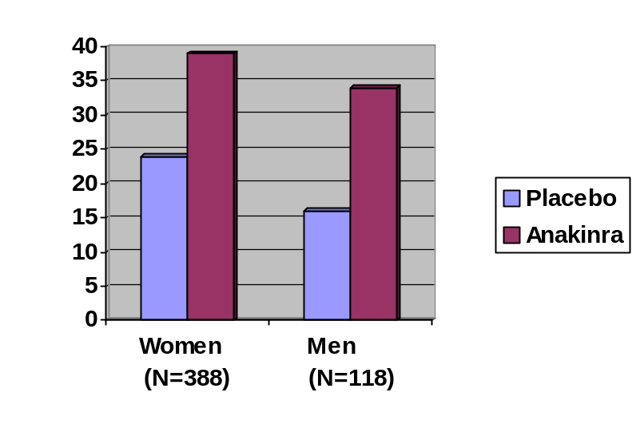
Figure 3. Study 990145: ACR20 subsetted by gender

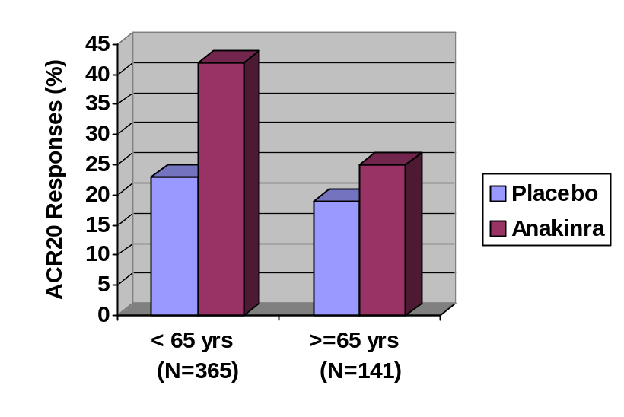
Figure 4. Study 990145: ACR20 subsetted by age

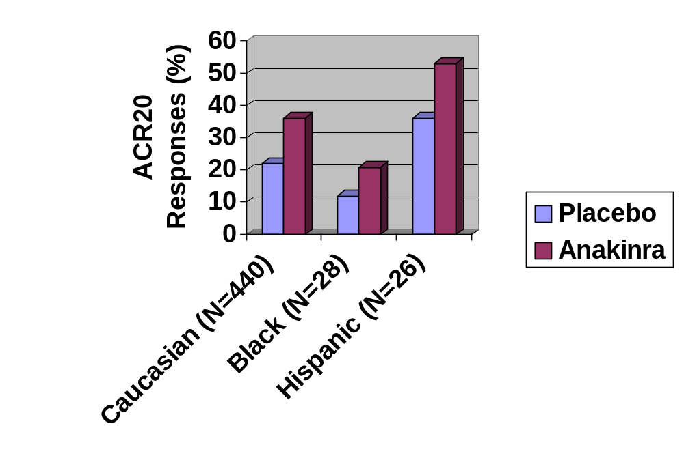
Figure 5. Study 990145: ACR20 subsetted by ethnicity

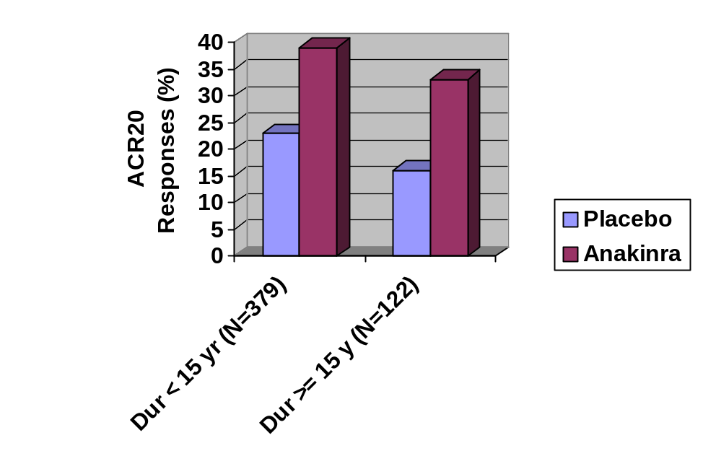
Figure 6. Study 990145: ACR20 subsetted by duration of disease

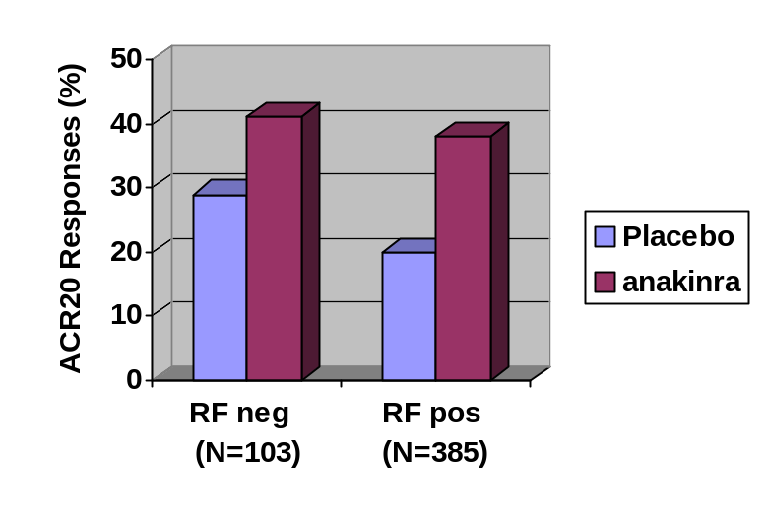
Figure 7. Study 990145: ACR20 subsetted by RF positivity

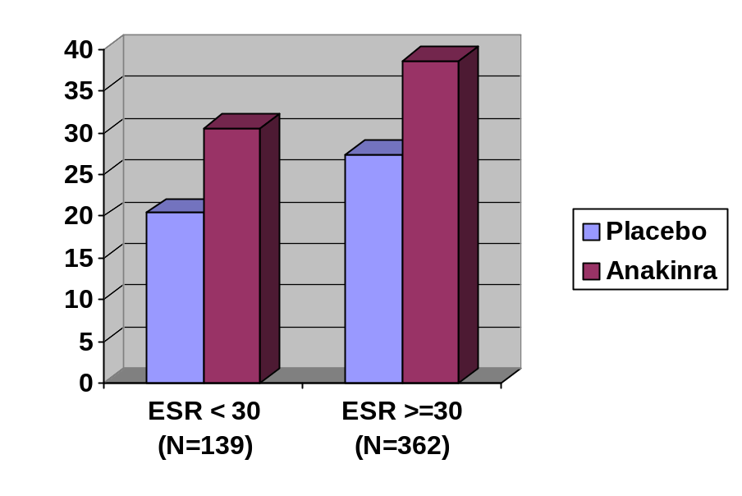
Figure 8. Study 990145: ACR20 subsetted by baseline ESR > 30

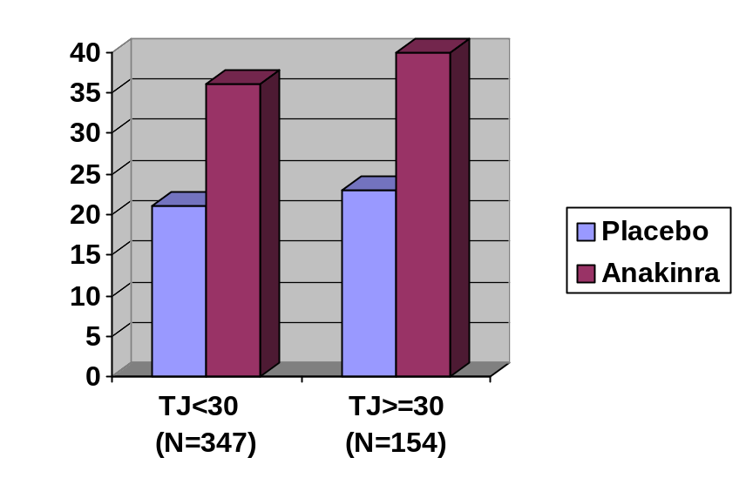
Figure 9. Study 990145: ACR20 subsetted by baseline tender joint count

Summary of efficacy data
In this trial, an increased proportion of patients receiving anakinra 100 mg sc qd had an ACR20 response at 6 months. Sixteen percent more patients achieved a response with anakinra than with placebo. The effects of anakinra were relatively rapid, with ACR20 responses seen as early as 1 month. Improvement was spread broadly across the seven components of the ACR response criteria. However, improvement in the swollen joint count component was less compared to placebo than the other components. Approximately one-quarter of all the subjects enrolled did not complete 6 months of blinded therapy, but sensitivity analyses did not suggest that dropouts were an important source of bias. There was no evidence that the benefits associated with use of anakinra were limited to any identifiable subset of RA patients.

Safety

Deaths
There were no deaths during the time of blinded drug administration, but one subject died 37 days after discontinuation of study medication from a condition that began while taking study drug. This 80 year old man had a long history of chronic interstitial lung disease, with RA treated with methotrexate and gold. He was hospitalized with congestive heart failure and interstitial lung disease after 10 weeks on anakinra. He died 4 weeks later despite receiving high dose steroids, oxygen and antibiotics.

Serious adverse events
Twenty serious adverse events were seen during the trial in 19 subjects: 12 on anakinra; 8 on placebo. Table 9 shows the serious adverse events occurring during the study. There were three infectious SAEs in two subjects in the anakinra arm: 2 cases of pneumonia and 1 pulmonary infection. One subject in the placebo arm had an infectious SAE: bronchitis. There was one SAE that was a malignancy: a case of prostate ca in the placebo arm.

Table 9. Study 990145: Serious adverse events
Age, sex | Description
Anakinra
74, female | Surgery: total knee replacement
77, male | Pneumonia
61, female | DVT
51, female | Aortic stenosis
70, female | Arrhythmias
47, female | Appendicitis
72, female | CVA
64, male | Hiccups, respiratory infection
 | Pneumonia
68, female | Lumbar spinal stenosis
44, female | Chronic interstitial pneumonitis
80, female | CHF, pulmonary fibrosis: death
Placebo
62, male | Gangrene 2º atherosclerosis
68, male | Kidney stone, aortic aneurysm
70, female | CHF
76, female | Fall, fractured femur
57, female | TIA
 | Surgery: tendon repair
61, female | Bronchitis
83, male | Prostate ca

Other adverse events
Other adverse events observed are shown in Table 10 by body system. For several body systems, there were a higher proportion of subjects in the anakinra-treated group developing adverse events than the placebo-treated patients. Adverse events in application site were observed in 65% of anakinra-treated subjects compared to 24% of placebo recipients. The higher incidence of AEs related to the application site was accounted for by a higher incidence of injection site erythema, pruritus, pain, inflammation, injection site reactions as well as pruritic erythema, urticaria and edema. Of the body systems with AEs in at least 5% of subjects, somewhat higher rates of adverse events were observed with anakinra in the following: respiratory, gastrointestinal, skin & appendages, resistance mechanism and hematologic. Upon review of the individual adverse events in each category, no individual adverse event was observed at a rate of 5% or more in the anakinra group than in the placebo group.
The large majority of injection site reactions were characterized as mild or moderate, but 14 were characterized as severe: 12 in the anakinra arm and 2 in the placebo arm. None were characterized as serious, i.e. none required hospitalization or resulted in any disability. Five resulted in discontinuation of study drug. Most required no treatment, but a minority were treated symptomatically.

Table 10. Study 990145: Adverse Events by Body System
 |  | Placebo |  | Anakinra
 |  | (N = 251) |  | (N = 250)
Number of subjects reporting AEs | 202 | 80.5% | 226 | 90.4%
BODY SYSTEM | n | % | n | Crude
APPLICATION SITE | 59 | 24 | 163 | 65
MUSCULO-SKELETAL | 107 | 43 | 80 | 32
RESPIRATORY | 70 | 28 | 76 | 30
GASTROINTESTINAL | 53 | 21 | 61 | 24
SKIN AND APPENDAGES | 37 | 15 | 53 | 21
BODY AS A WHOLE | 41 | 16 | 41 | 16
CNS/PNS | 41 | 16 | 28 | 11
RESISTANCE MECHANISM | 10 | 4 | 18 | 7
URINARY DISORDERS | 15 | 6 | 17 | 7
HEMATOLOGIC | 5 | 2 | 14 | 6
PSYCHIATRIC DISORDER | 8 | 3 | 11 | 4
CARDIOVASCULAR | 6 | 2 | 10 | 4
HEARING/VESTIBULAR | 5 | 2 | 9 | 4

Infections
Infections were reported in 83 anakinra subjects (33%) and 65 placebo subjects (26%). The most common infections involved the respiratory tract, involving 53 anakinra-treated subjects (21%) and 39 placebo subjects (16%). There were two episodes of serious infection in each treatment arm (<1%): 1 subject with pneumonia, 1 with gangrene associated with atherosclerosis, 1 with esophagitis and pneumonia and 1 with asthmatic bronchitis. The case of gangrene was characterized as infectious, although the patient did not receive antibiotics. All resolved with the patients remaining on study drug except the case of gangrene.
In the case of the subject with pneumonia, review of laboratories revealed that this patient, a 77 year old man, had had a low neutrophil count (1530/mm³) and WBC count (2,000/mm3) 4 days before he presented with pneumonia. The patient’s assigned study drug was anakinra. WBC count had risen into the normal range at the time of presentation (5,600/mm³). None of the other subjects with serious infections had leukopenia. Because the study remains blinded and this review may be distributed publicly before the blind is broken, the treatment assignments of the other subjects will not be specified.

Summary of safety data
In summary, no major safety concerns were identified in study 990145. Injection site reactions were seen in 65% of anakinra-treated subjects. Most were mild or moderate in intensity and were uncommonly a cause for discontinuing treatment. No pattern of increase in serious adverse events was seen and there was no increase in serious infections.

Study 990757
Study 990757 was carried out to provide additional safety data regarding the use of anakinra in rheumatoid arthritis. The study was designed to gather safety data for the product as it is likely to be used in clinical practice if anakinra is approved. To this end, inclusion and exclusion criteria were designed to allow enrollment of patients receiving concomitant anti-rheumatic medications and those with concurrent medical conditions. The study is ongoing. Data are provided here for the first 6 months of the study.

Clinical trial design
Study 990757 is a multicenter, international trial conducted at 169 sites in Australia, Belgium, Canada, Germany, Ireland, the Netherlands, Sweden, the United Kingdom and the United States. It is a double-blind, randomized placebo-controlled study of anakinra 100 mg sc qd for 3 years in approximately 1000 subjects with active RA. Subjects are randomized in a 1:4 ratio of placebo to anakinra. Subjects in the trial were adult patients with active rheumatoid arthritis for at least 3 months, who were receiving a stable DMARD regimen for at least 2 months. Stable NSAIDs and low dose corticosteroids were allowed. Subjects were excluded who had an uncontrolled medical condition or a malignancy within the previous 5 years. Detailed inclusion and exclusion criteria can be found in the appendix.
Changes in NSAIDs, corticosteroids or DMARDs were allowed during the study as needed to provide adequate supportive care. However, the following medications were proscribed: CellCept, cyclophosphamide, Enbrel, Remicade, Prosorba column and cyclosporine.
Clinic visits for assessment of safety were conducted at day 1, week 1 and at months 1, 3 and 6. Adverse event information was collected at each visit. Adverse events were graded as mild, moderate, severe, life-threatening or fatal. Serious adverse events were defined as events that suggested a significant hazard regardless of the possible relation to study medication.
The clinical hypothesis for the study was that anakinra use would present no significant safety concerns compared with placebo. With a sample size of 1000 subjects, there was a 63% probability of observing at least one case of an adverse event occurring at an incidence of 0.1% or greater and an 87% probability of detecting an event occurring at a 0.2% incidence rate over a 2 ½ year time span. During the 6 months of the blinded phase, there was a >99% chance of detecting a adverse event which occurs at a 1% rate in anakinra-treated patients. The primary endpoints for the study were the incidence of adverse events, including deaths, serious adverse events, infections and discontinuations due to adverse events.

Study conduct
A total of 1414 subjects were enrolled in the study at 168 sites: 284 in the placebo arm and 1130 in the anakinra arm. 83% of subjects were enrolled in US sites, 12% in Western Europe, 4% in Canada and 2% in Australia. Subject disposition is shown in Table 11. Only a small number of randomized subjects never received study drug, with similar proportions in the two study arms. Approximately 80% of subjects completed 6 months of blinded study medication, with a slightly higher proportion of subjects withdrawing prematurely from the anakinra arm than the placebo arm: 23% vs. 19%. The major reason for the difference in rates of premature withdrawal between the 2 study arms was withdrawals for adverse events, which were more common in the anakinra arm: 12% vs. 6%. The adverse events leading to withdrawal is discussed in more detail below. Disease progression was cited as the reason for premature withdrawal more frequently in the placebo arm than the anakinra arm: 2.5% vs. 1%.

Table 11. Study 990757: Subject Disposition
 | Placebo |  | Anakinra
 | (N = 284) |  | (N = 1130)
 | N | % | n | %
Total randomized | 284 | 100 | 1130 | 100
Never received study drug | 1 | <1% | 14 | 1
Completed 6 months of blinded treatment | 230 | 81 | 875 | 77
Withdrew prematurely | 54 | 19 | 255 | 23
Reason for premature withdrawal
Ineligibility determined | 0 | <1% | 8 | <1%
Patient noncompliance | 2 | <1% | 6 | <1%
Adverse event | 17 | 6 | 130 | 12
Consent withdrawn | 18 | 6 | 73 | 7
Disease progression | 7 | 2 | 11 | 1
Administrative decision | 4 | 1 | 10 | <1%
Lost to follow up | 4 | 1 | 10 | <1%
Death | 1 | <1% | 3 | <1%
Other | 1 | <1% | 4 | <1%

Compliance with study drug was assessed by comparing the number of expected doses against the subject’s returned vials and the completed study diaries. Overall, over 90% of subjects received 90 or more of their assigned study drug. Compliance was similar in the two treatment arms: 92% and 93% of subjects received >90% of study medication in the placebo and anakinra arms, respectively.
The subjects’ baseline demographics are shown in Table 12. Approximately 75% of subjects were women, consistent with the female predominance in rheumatoid arthritis. The large majority of subjects, approximately 90% were white, also consistent with the demographics of rheumatoid arthritis patients generally. The mean age was approximately 55, with over one-quarter over age 65 and approximately 5% over age 75.
As shown in Table 13, a large majority of subjects were receiving concomitant medications for their rheumatoid arthritis. Approximately 86% were receiving NSAIDs and approximately 60% concomitant corticosteroids. Approximately 80% of subjects were receiving DMARDs. A somewhat higher proportion of placebo subjects were receiving MTX than anakinra-treated subjects: 59% vs. 52%. The mean (and median) MTX dose was 15 mg/wk and was similar in the two groups. Approximately 12% of subjects were receiving doses of MTX of greater than 20 mg/wk. Combination DMARD therapy was common: 22% were receiving MTX plus one or more DMARDs and 7% were receiving a combination DMARD regimen that did not include MTX. Only about 10% of subjects were receiving neither corticosteroids nor a DMARD, while 47% were receiving both corticosteroids and a DMARD. Apart from the above noted difference in proportion of subjects receiving concomitant MTX, the use of concomitant antirheumatic medications appeared balanced across treatment arms. The other DMARDs used by patients in this study are shown in Table 14. The most common DMARDs, after methotrexate, were hydroxychloroquine, sulfasalazine and leflunomide. The use of other DMARDs was balanced across treatment arms.
Table 12. Study 990757: Subject Baseline Demographics
 | Placebo  (N=283) | Anakinra  (N=1116)
Female | 211 (75%) | 834 (75%)
Ethnic group
Caucasian | 255 (90%) | 980 (88%)
Black, African-American | 10 (4%) | 49 (4%)
Hispanic | 15 (5%) | 68 (6%)
Other | 3 (1%) | 19 (2%)
Age (mean) | 56 | 55
Age 65-74 | 56 (20%) | 191 (17%)
Age  75 | 17 (6%) | 58 (5%)
Weight (mean, kg) | 76 | 77

Table 13. Study 990757: Concomitant Antirheumatic Medications
 | Placebo  (N=283) | Anakinra  (N=1116)
NSAIDs use - n (%) | 244 (86) | 973 (87)
Corticosteroid use – n (%) | 172 (61) | 636 (57)
DMARDs use (excluding MTX) - n (%) | 135 (48) | 532 (48)
DMARDs use (including MTX) - n (%) | 233 (82) | 869 (78)
MTX use – n (%) | 168 (59) | 579 (52)
MTX dose (mg/wk)⁸
n | 168 | 579
Mean | 15 | 15
SD | 5 | 5
Median | 15 | 15
MTX dose group (mg/wk) – n (%)
None | 115 (41) | 537 (48)
<12.5 | 45 (16) | 158 (14)
12.5 – 14.9 | 17 (6) | 89 (8)
15.0 – 19.9 | 67 (24) | 204 (18)
20.0 – 25.0 | 38 (13) | 126 (11)
>25 | 1 (<1%) | 2 (<1%)
MTX use and DMARDs use
No DMARDs | 50 (18) | 247 (22)
MTX alone | 98 (35) | 337 (30)
Single DMARD other than MTX | 48 (17) | 215 (19)
MTX and 1 other DMARD | 51 (18) | 175 (16)
MTX and 2 or more other DMARDs | 19 (8) | 67 (6)
Combination DMARDs excluding MTX | 17 (6) | 75 (7)

Table 14. Study 990757: Most Frequent Concomitant Antirheumatic Medications

Medication | Placebo  (N=283) | Anakinra  (N=1116)
Methotrexate | 168 (59%) | 580 (52%)
Hydroxychloroquine | 63 (22%) | 242 (22%)
Sulfasalazine | 40 (14%) | 154 (14%)
Leflunomide | 28 (10%) | 111 (10%)
Gold | 10 (4%) | 49 (4%)
Azathioprine | 7 (2%) | 48 (4%)
Glucosamine | 12 (4%) | 36 (3%)
Chondroitin | 6 (2%) | 19 (2%)
Penicillamine | 2 (1%) | 11 (1%)

The subjects’ baseline disease activity measures are shown in Table 15. Most of the patients in the study had long-standing rheumatoid arthritis, with a mean duration of 10 years. The patients enrolled in the study generally had highly active disease, with elevated C-reactive protein levels and many tender and swollen joints. No imbalances were noted between study arms in the duration or activity of disease.

Table 15. Study 990757: Baseline Disease Activity
 | Placebo  (N=283) | Anakinra  (N=1116)
Duration of rheumatoid arthritis (mean, yr) | 11 | 10
Tender/painful joint count | 23 | 23
Swollen joint count | 18 | 19
CRP (mg/dL) | 2.7 | 2.7

For the 1116 subjects in the anakinra arm, a total of 11,234 concomitant medical conditions were reported at baseline. Of these, the most common diagnoses were in the musculoskeletal system (23%), gastrointestinal (12%), genitourinary (12%) and cardiovascular (9%). The frequency of certain concomitant medical conditions in the whole patient population is shown in Table 16

Table 16. Study 990757: Frequency of Selected Medical Conditions

Condition | N (%of subjects)
COPD | 69 (5%)
Pneumonia | 123 (9%)
Asthma | 121 (9%)
Coronary artery disease | 138 (10%)
DM | 48 (6%)

Results

Deaths
Five deaths (Table 17) were observed during the 6 month study period: 4 in the anakinra group (0.4%) and 1 in the placebo group (0.4%). One patient had a history of interstitial lung disease and diabetes. She had been receiving methotrexate 20 mg/wk. After 5 months on anakinra, she was hospitalized with respiratory distress, hypoxemia and bilateral infiltrates. She deteriorated despite treatment with corticosteroids and antibiotics. The consulting pulmonologist believed the condition to be interstitial pulmonary fibrosis induced by MTX or related to RA. Post-mortem exam showed bilateral advanced chronic lung disease. The second death on anakinra involved a 67 year old woman with a history of panic attacks and long-standing depression who committed suicide after 56 days on study drug. A 56year old man with a history of melanoma died of metastatic melanoma, which was diagnosed 105 days after beginning anakinra. Finally, a 61 year old woman with a history of esophagitis, gastric ulcers and gastritis died after 1 month on study drug of an upper GI bleed.

Table 17. Study 990757: Deaths
Treatment | Age, sex | Cause of death
Anakinra | 60, female | Pulmonary fibrosis
Anakinra | 67, female | Suicide
Anakinra | 67, male | Melanoma
Anakinra | 61, female | UGI bleed
Placebo | 68, male | Myocardial infarction

Serious Adverse Events
Overall, the incidence of serious adverse events (SAEs) was similar between treatment arms: 8% in both the placebo group (22 subjects) in the anakinra group (86 subjects). When analyzed by body system (Table 18), the body systems with a higher proportion of SAEs were gastrointestinal (2% vs. <1%) and respiratory (2% vs <1%).

Table 18. Study 990757: Serious Adverse Events by Body System

Body system | Placebo (N=283) | Anakinra (N=1116)
Musculoskeletal | 8 (3%) | 28 (2%)
Gastrointestinal | 1 (<1%) | 20 (2%)
Respiratory | 1 (<1%) | 18 (2%)
Body as a whole | 4 (1%) | 9 (<1%)
Cardiovascular | 1 (<1%) | 6 (<1%)
Myo/endo/pericardial | 1 (<1%) | 6 (<1%)
Vascular disorders | 2 (<1%) | 6 (<1%)
Resistance mechanism | 0 (0%) | 5 (<1%)
Skin and appendages | 2 (<1%) | 5 (<1%)
In the gastrointestinal system, there was a single SAE in the placebo arm (paralytic ileus) and 20 in the anakinra arm. There was no predominant event constituting the anakinra events. Rather, there were 4 episodes of abdominal pain, 3 episodes each of abdominal hernia and nausea, 2 episodes each of appendicitis, esophagitis, gastric ulcer hemorrhage, GI hemorrhage and vomiting and 1 episode each of 11 different events.
In the respiratory system, there were 18 SAEs in the anakinra arm vs. 1 in the placebo arm. The SAE in the placebo arm was lung cancer. The higher rate in the anakinra arm can be in part accounted for by the higher incidence of pneumonia (9 events with anakinra vs. none with placebo). The other serious pulmonary events observed in the anakinra arm were bronchitis (2), dyspnea (2), epistaxis (2) and one episode each of 15 other events.
In the body system category of resistance mechanism, there were 5 SAEs in the anakinra arm and none in placebo. Three SAEs were called infection and there was one episode each of abscess and empyema. Serious infections are discussed in greater detail below.

Malignancies
A total of 9 malignancies were diagnosed during the 6 month study: 4 (<1%) in the anakinra group and 5 (2%) in the placebo group. The types of malignancies diagnosed are shown in Table 19.

Table 19. Study 990757: Malignancies

Treatment group | Malignancy
Anakinra | Melanoma
 | Adenoca of the cecum
 | Uterine ca
 | Basal cell ca
Placebo | Basal cell ca of skin
 | Squamous cell ca of skin
 | Hodgkin’s lymphoma
 | Bladder ca
 | Lung ca

Infections and Serious Infections
Overall, the incidence of infections was similar in the anakinra-treated patients (26%) and the placebo-treated patients (27%). When analyzed by body system, only the gastrointestinal system showed a higher proportion of subjects with infections in the anakinra arm compared to the placebo arm (5.0% vs. 2.8%). No individual type of infection or group of infections accounted for the difference.
In contrast to the similar overall rate of infections, the incidence of serious infectious episodes (Table 20) was higher in the anakinra group (2% of subjects) than the placebo group (<1%). For study 990757, serious infections were defined as serious adverse events of an infectious nature. Serious events were defined as any event that suggested a significant hazard and included events that were fatal or life-threatening, required in-patient hospitalization or involved a persistent or significant disability. Only one serious infection was seen among the placebo-treated patients (a urinary tract infection) while 23 serious infections were seen among subjects receiving anakinra. The most common infections represented were pneumonia, cellulitis and osteomyelitis.
To help understand the serious infection rate in study 990757, that rate can be considered along with data on the serious infection rate seen in other clinical trials of anakinra. For study 990757, as stated above, the serious infection rate was 2%, and the 95% confidence interval was 1.3-3.1%. In study 990145, there were 4 serious infections among 506 subjects (2 on anakinra, 2 on placebo) corresponding to a rate of <1% (95% CI: 0.2-2.0%). In study 960180 (see below), there were 7 serious infections among a total of 419 subjects treated for 6 months for a serious infection rate of 2% (95% CI: 0.7-3.4%).
Table 20. Study 990757: Serious infections

Infection | Placebo  (N=283) | Anakinra  (N=1116)
 | N (%) | N (%)
All serious infections | 1 (0.4%) | 23 (2.1%)
Pneumonia | 0 (0%) | 10 (0.9 %)
Cellulitis | 0 (0%) | 3 (0.3%)
Osteomyelitis | 0 (0%) | 3 (0.3%)
None of the 23 serious infections in the anakinra-treated patients was fatal. All resolved with the exception of one case of osteomyelitis. Microbiologic data is not available for the majority of serious infections, but where available was generally typical for the type of infection, with streptococcus pneumoniae cultured in subjects with pneumonia and staphylococcus aureus in cases of bone and joint infection. However, one subject with pneumonia had blood cultures positive for gram negative bacteria. Another subject developed a pulmonary infection with mycobacterium avium complex identified by DNA probe. The subject was treated with ethambutol and azithromycin. Subject 50001 had a pneumonia that was diagnosed as legionella. None of the subjects with serious infections had leukopenia.

To explore whether there were risk factors predisposing subjects to serious infections, the baseline demographics and disease characteristics were compared between anakinra-treated subjects who did and those who did not develop serious infections. The subjects who developed serious infections (Table 21) were more likely to be male and tended to be older than those who did not. NSAID use was comparable between the 2 groups. The duration of disease and the level of disease activity appeared similar, both with respect to joint counts and acute phase reactants (Table 22). However, corticosteroid use was more common in the subjects who developed serious infections. DMARD use overall and use of methotrexate in particular were similar between the 2 groups (Table 23 and Table 24). No interaction was found between corticosteroid use and DMARD use regarding the incidence of serious infection. Serious infections were less common among subjects not receiving corticosteroids, whether they were receiving concomitant DMARDs or not. In addition, serious infections were more common among patients receiving corticosteroids, whether or not they were receiving DMARDs. The mean dose of corticosteroid was 8.0 mg/d in the group that developed serious infections and 7.0 in the group that did not. To further explore the role of corticosteroid dose in patients developing serious infection, all subjects were identified who received a dose of prednisone exceeding 10 mg/d. Of the 23 subjects who developed serious infections, only a single patient (patient 30206) developed a serious infection after receiving high doses of corticosteroids. Patient 30206 received 120 mg IM of methylprednisolone 7 days after starting anakinra. She developed a lower respiratory infection 8 days later. For all other subjects with serious infection who received high dose corticosteroids, the corticosteroids were given along with or following the serious infection.
Table 21. Study 990757: Baseline Demographics for Anakinra-Treated Subjects with Serious Infections

 | Subjects with serious infections  (N=23) | Subjects without serious infections  (N=1093)
Male (N, %) | 8 (35%) | 274 (25%)
Female (N,%) | 15 (65%) | 819 (75%)
Age (yr, mean) | 60 | 54
Age 45-54 | 6 (26%) | 320 (29%)
Age 55-64 | 9 (39%) | 299 (27%)
Age 65-74 | 7 (30%) | 184 (17%)
Age 75 | 0 (0%) | 58 (5.3%)
Weight (kg, mean) | 81 | 77

Table 22. Study 990757: Baseline Disease Status of Anakinra-treated Subjects who developed serious infections
 | Subjects with serious infections  (N=23) | Subjects without serious infections  (N=1093)
NSAID use (N, %) | 19 (83%) | 954 (87%)
Corticosteroid use (N, %) | 19 (83%) | 617 (56%)
DMARD use (N, %) | 16 (70%) | 853 (78%)
MTX use (N, %) | 13 (56%) | 566 (52%)
MTX dose 20 mg/wk | 3 (13%) | 125 (12%)
Duration of RA (mean, yr) | 12 | 10
Tender/painful joint count (mean) | 23 | 23
Swollen joint count (mean) | 20 | 19
CRP (mean, mg/dL) | 3.1 | 2.6

Table 23. Study 990757: Corticosteroid Use and DMARD Use among Anakinra-Treated Subjects Developing Serious Infections
 | Subjects with serious infections  (N=23) | Subjects without serious infections  (N=1093)
No corticosteroids, no DMARDs | 1 (4.3%) | 122 (11%)
No corticosteroids, DMARDs | 3 (13%) | 354 (32%)
Corticosteroids, no DMARDs | 6 (26%) | 118 (11%)
Corticosteroids, DMARDs | 13 (56%) | 499 (46%)

Table 24. Study 990757: DMARDs Used at Baseline by Anakinra-treated patients who did or did not Develop Serious Infections
Medication | Serious Infection  (N=23) | No Serious Infection  (N=1093
Methotrexate | 13 (57%) | 580 (52%)
Hydroxychloroquine | 4 (17%) | 242 (22%)
Azathioprine | 2 (9%) | 48 (4%)
Leflunomide | 1 (4%) | 111 (10%)
Penicillamine | 1 (4%) | 11 (1%)

Other Adverse Events
Other adverse events occurring at a rate of 5% or greater in the anakinra arm are shown in Table 25. Injection site reaction (ISR) was seen in 73% of anakinra-treated subjects, considerably higher than the rate in placebo-treated subjects. Severe ISR was seen in 38 anakinra-treated subjects, of whom 14 withdrew from treatment. None of the other adverse events occurred at a clearly higher rate among patients in the anakinra arm compared to placebo.
Table 25. Study 990757: Other Adverse Events
Event | Placebo  (N=283) | Anakinra  (N=1116)
Injection site reactions | 93 (33%) | 810 (73%)
Rheumatoid arthritis | 78 (28%) | 223 (20%)
Headache | 33 (12%) | 161 (14%)
Upper respiratory infection | 54 (19%) | 160 (14%)
Nausea | 23 (8.1%) | 104 (9.3%)
Sinusitis | 21 (7%) | 84 (8%)
Diarrhea | 17 (6%) | 84 (7.5%)
Influenza-like symptoms | 18 (6.4%) | 72 (6.5%)
Abdominal pain | 16 (5.7%) | 63 (5.6%)
Dizziness | 17 (6%) | 57 (5.1%)
Arthralgia | 17 (6%) | 56 (5%)

Adverse Events Leading to Withdrawal
Overall 13% of anakinra-treated and 9% of placebo-treated subjects withdrew from the study because of adverse events. The major contributor to the difference in rates between treatment arms was the 7% incidence of withdrawal due to injection site reactions, compared to 1% seen with placebo. There was no other adverse associated with a clearly higher rate of withdrawals in the anakinra-treated patients.

Summary
In study 990757, a higher proportion of anakinra-treated subjects experienced a serious infection compared to subjects receiving placebo. The only potential risk factors identified for serious infections was corticosteroid use and, possibly, asthma. Injection site reactions were also seen more commonly in anakinra-treated patients, leading to withdrawal in 7%. A higher proportion of subjects in the anakinra arm experienced serious events in the gastrointestinal and pulmonary systems. The difference in serious pulmonary events was in part accounted for by the higher incidence of pneumonia. While a higher incidence of serious infections was identified in patients with asthma and those receiving corticosteroids, other safety concerns were not identified for patients with a variety of concomitant medical conditions and those taking a variety of commonly used DMARDs. It should be noted that study 990757 did not assess the safety of anakinra use in combination with TNF antagonists.

Studies 560 and 960180

Clinical Trial Design
Studies 560 and 960180 were two phase 2 randomized, controlled trials of anakinra in rheumatoid arthritis. They were both multi-center, 6-month, dose-ranging studies. They differ in that study 560 was carried out in Europe, while study 960180 was carried out in the US, Canada and Australia. Study 560 examined the effects of anakinra used as monotherapy, while 960180 studied anakinra added to background methotrexate. Since the results of these 2 trials are similar, they will be examined together. Pertinent differences will be pointed out.
In study 560, anakinra was given at doses of 30, 75 or 150 mg qd subcutaneously for 6 months. The protocol required subjects to meet the following criteria:
- Rheumatoid arthritis meeting American College of Rheumatology (ACR) criteria
- Stable doses of NSAIDs, prednisone (10 mg/d)
- Disease duration 6 mo-8 years
- 10 swollen joints and 3 of: 10 tender joints; “severe or very severe disease activity” by MD assessment; “severe or very severe disease activity” by patient assessment; CRP > 1.5 mg/dL
- No DMARDs in previous 6 weeks
- Failed at least 3 DMARDs
The primary endpoint for the trial was the ACR20 response at 6 months. The protocol did not specify any adjustment for multiple comparisons. An analysis of the 6-month change in radiographs of the hands and wrists based on the Larsen score was included as a secondary endpoint.
Study 960180 also required subjects to meet ACR diagnostic criteria for rheumatoid arthritis and allowed stable doses of NSAIDs and prednisone. In contrast to 560, enrolled subjects needed to meet the following criteria:
- Disease duration 6 mo-12 years
- 6 swollen joints and 2 of: 9 tender joints; 45 min a.m. stiffness; CRP > 1.5 mg/dL
- 2 consecutive tender/painful joint counts 2 weeks apart that did not vary by more than 20%
- On MTX for 6 mo, on 15-25 mg for at least 3 mo
- Other DMARDs: No D-pen, gold, azathioprine for 12 weeks; no hydroxychloroquine or sulfasalazine for 8 weeks
The primary endpoint for study 960180 was the ACR20 response at 3 months. An important secondary endpoint was the ACR20 response at 6 months.

Amendments to Study 960180
Study 960180 was originally conceived as a 3-month, phase 2 safety trial when it was submitted to the agency in September, 1996. In April, 1997, the protocol was amended to:
- Increase the size of the trial from 30/arm to 70/arm;
- Increase the duration of treatment from 3 to 6 months
- Add dose arms of 0.04 and 1.0 mg/kg to the pre-existing arms of 0.1, 0.4 and 2.0 mg qd sc;
- The primary endpoint was changed to an efficacy endpoint, namely the proportion of subjects with an ACR20 response at 3 months.
A total of 91 subjects had been enrolled prior to the 9/97 amendment and 328 subjects were added subsequently.

Study Conduct

Study 0560
A total of 473 subjects were randomized to study 0560 (Figure 10). Only a single patient was randomized but never received study medication. In addition, 4 subjects began study drug but did not have at least one post-baseline efficacy evaluation, so the modified intent-to-treat population consisted of 468 subjects: 119 in the placebo arm; anakinra 30 mg, N=119; anakinra 75 mg, N=115; and anakinra 150 mg, N=115. The 4 subjects withdrew due to an adverse event (placebo), noncompliance (placebo) and withdrawal of consent (one each on 75 and 150 mg/day anakinra). A larger proportion of subjects completed 6 months of treatment with anakinra than with placebo (76, 78, and 72% in the anakinra 30, 75 and 150 mg arms, respectively, compared to 68% in the placebo arm). This difference was accounted for by a lower number of subjects withdrawing due to adverse events and due to lack of efficacy.
The baseline demographics of the subjects are shown in Table 26. The preponderance of women and the mean age is similar to that seen in other studies of rheumatoid arthritis and reflects the demographics of rheumatoid arthritis in the US. Subjects were almost exclusively Caucasian because the study was carried out in Europe. Approximately 70% of the subjects were rheumatoid factor positive. During an average of approximately 4 years of disease, the patients had been on an average of just over one prior DMARD. Approximately one-third had previously received methotrexate. Approximately 70% of subjects had erosions on baseline radiographs. No major imbalances were noted between treatment arms, except for the proportion of subjects with baseline erosions, which was somewhat lower in the highest dose anakinra arm.
The disease activity of the subjects at baseline is shown in Table 27. The patients had highly active rheumatoid arthritis with approximately 35 tender and 26 swollen joints. Acute phase reactants were elevated. At the time of enrollment, rheumatoid arthritis had already resulted in joint damage as evidenced by a mean baseline Larsen score of 15. Subjects were well-balanced for disease activity at baseline, with the exception of Larsen scores, which were lower in the highest dose anakinra arm.

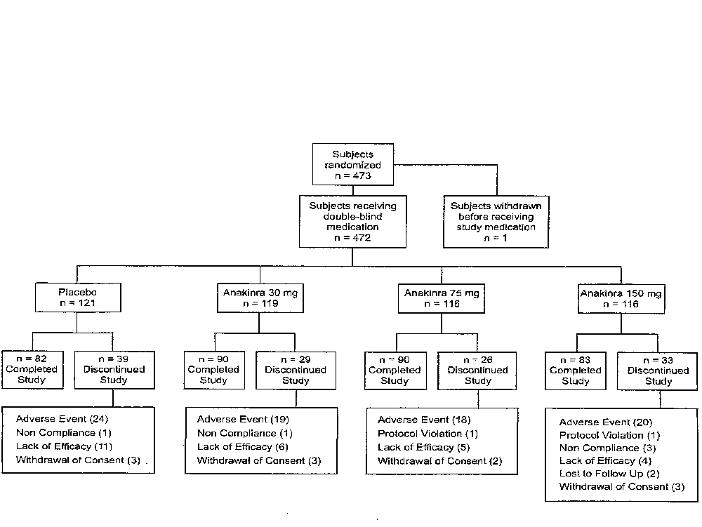
Figure 10. Study 560: Subject Disposition

Table 26, Study 560: Baseline Demographics
 | Placebo  N=121 | 30 mg  N=119 | 75 mg  N=116 | 150 mg  N=117 | All anakinra  N=352
Female | 85 (70%) | 85 (71%) | 92 (79%) | 92 (79%) | 269 (77%)
Age | 52 | 53 | 53 | 54 | 53
Caucasian | 118 (98%) | 118 (99%) | 114 (98%) | 116 (100%) | 348 (99%)
Steroid use | 48 (40%) | 58 (49%) | 47 (40%) | 48 (41%) | 153 (44%)
NSAID use | 106 (88%) | 95 (80%) | 97 (84%) | 96 (83%) | 288 (82%)
RF + | 84 (69%) | 84 (71%) | 80 (69%) | 80 (69%) | 244 (70%)
Duration of RA (yr) | 3.7 | 4.3 | 4.3 | 3.9 | 4.1
# of previous DMARDs | 1.3 | 1.3 | 1.3 | 1.2 | 1.3
Prior MTX | 42 (35%) | 48 (40%) | 38 (33%) | 42 (36%) | 128 (36%)
Erosions at BL | 90 (74%) | 91 (76%) | 86 (74%) | 80 (69%) | 257 (73%)

Table 27. Study 560: Baseline Disease Activity

 | Placebo  N=121 | 30 mg  N=119 | 75 mg  N=116 | 150 mg  N=117 | All anakinra  N=352
Tender jts | 33 | 33 | 36 | 35 | 35
Swollen jts | 26 | 26 | 26 | 27 | 26
MD global  (0-4) | 3.0 | 3.1 | 3.1 | 3.1 | 3.1
Patient global  (0-4) | 3.0 | 3.1 | 3.1 | 3.1 | 3.1
Pain VAS  (0-1) | 0.6 | 0.6 | 0.6 | 0.6 | 0.6
HAQ  (0-3) | 1.5 | 1.5 | 1.6 | 1.6 | 1.6
CRP | 4.2 | 4.1 | 4.2 | 4.0 | 4.1
ESR | 47 | 49 | 53 | 49 | 50
Larsen  (0-150) | 15 | 17 | 16 | 11 | 15
A.M. stiffness  (min/d) | 127 | 138 | 138 | 132 | 136

Study 960180
The subject disposition for study 960180 is shown in Figure 11. The proportion of subjects who completed 6 months of study drug was similar across arms with the exception of the highest dose anakinra arm. In the 2 mg anakinra arm, 74% (53/72) completed treatment, compared to 81% (60/74) in the placebo arm and between 78 and 84% in each of the other anakinra arms. The differences in completion rates were attributable to a dose-dependent increase in the proportion of subjects dropping out due to adverse events. In the placebo arm, 4% (3/74) subjects dropped out due to adverse events, compared to 6% (5/77) in the 0.4 mg, 14% (8/59) in the 1 mg and 15% (11/72) in the 2 mg anakinra arms.
The baseline demographics of the subjects is shown in Table 28. The sex and age range of the patients were similar to those of the general rheumatoid arthritis population. The patients as a group had long-standing rheumatoid arthritis, with a mean disease duration of approximately 7 and one-half years. The had previously been on an average of just under 2 DMARDs. A majority of subjects in both arms were on oral corticosteroids and NSAIDs. Approximately four-fifths of the subjects were rheumatoid factor-positive. No major imbalances were noted between treatment arms.
The baseline disease activity of the subjects is shown in Table 29. Overall, the subjects in study 960180, who were all receiving background methotrexate, had highly active disease, but not quite as active as in study 560. The average number of tender joints, 25, and the average number of swollen joints, 18, were somewhat lower than the comparable figures from study 560. The baseline mean CRP, 1.9, and ESR, 37, were also lower than in study 560. No major imbalances in baseline disease activity were seen between treatment arms in study 960180.

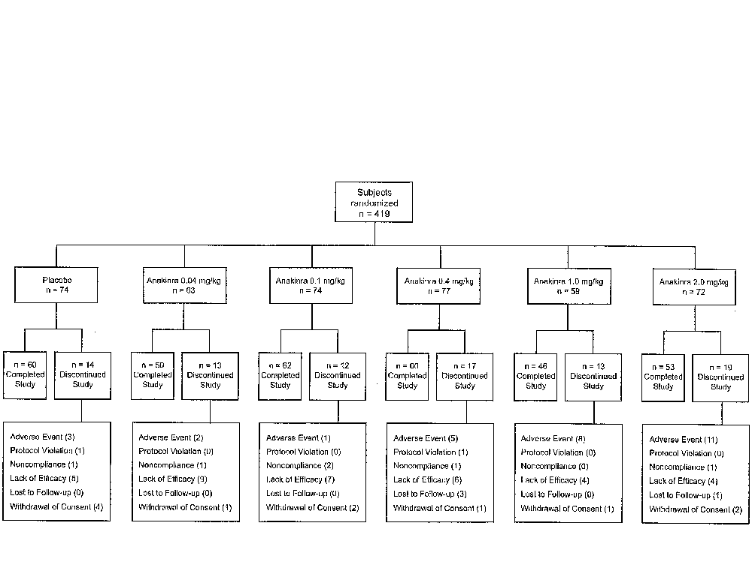
Figure 11. Subject Disposition: Study 960180

Table 28. Study 960180: Baseline Demographics (0.04, 0.1 mg/kg doses omitted)
 |  | Anakinra
 | Placebo  N=74 | 0.4 mg/kg  N=77 | 1 mg/kg  N=59 | 2 mg/kg  N=72 | All anakinra  N=345
Female | 63 (85%) | 59 (77%) | 50 (85%) | 45 (62%) | 262 (76%)
Age | 53 | 53 | 49 | 54 | 52
Caucasian | 67 (90%) | 64 (83%) | 51 (86%) | 66 (92%) | 304 (88%)
Steroid use | 49 (66%) | 45 (58%) | 37 (63%) | 47 (65%) | 220 (64%)
NSAID use | 50 (68%) | 52 (68%) | 38 (64%) | 47 (65%) | 239 (69%)
RF + | 55 (74%) | 60 (78%) | 43 (73%) | 60 (83%) | 272 (79%)
Duration of RA (yrs) | 7.8 | 7.0 | 6.5 | 8.0 | 7.4
MTX dose  (mg/wk) | 16.3 | 17.0 | 16.7 | 16.8 | 17.0
# of previous DMARDs | 2.1 | 1.4 | 1.8 | 1.9 | 1.8

Table 29. Study 960180: Baseline Disease Activity
 | Placebo  N=74 | 0.4 mg/kg  N=77 | 1.0 mg/kg  N=77 | 2.0 mg/kg  N=72 | All anakinra  N=345
Tender jts | 28 | 27 | 22 | 25 | 25
Swollen jts | 18 | 19 | 18 | 17 | 18
MD global  (0-100) | 57 | 60 | 54 | 56 | 58
Patient global  (0-100) | 53 | 50 | 48 | 51 | 50
Pain VAS  (0-100) | 52 | 51 | 48 | 55 | 50
HAQ  (0-3) | 1.4 | 1.5 | 1.3 | 1.3 | 1.4
CRP | 2.0 | 2.1 | 1.6 | 2.0 | 1.9
ESR | 36 | 37 | 37 | 35 | 37
A.M. stiffness  (min/d) | 140 | 120 | 134 | 143 | 128

Efficacy Analysis
The primary endpoint for study 560 was the proportion of subjects with an ACR20 response at month 6 (Table 30). The prespecified primary analysis was the Cochran-Mantel-Haenszel adjusting for country group. At 6 months, a greater proportion of subjects in the 30 mg and 150 mg/day anakinra groups had an ACR20 response compared to placebo. A higher proportion of subjects in the anakinra 75 mg arm also attained an ACR20, but the result did not reach statistical significance. A dose response was not clearly evident, as a similar proportion of subjects in the lowest and highest dose groups responded (40% and 43% in the 30 mg and 150 mg arms, respectively) and the proportion of responders in the intermediate dose group was lower (34%). Overall, the results at 3 months were similar, though numerically somewhat lower.
The primary analysis utilized last observation carried forward (LOCF) to account for missing data. As there are situations where LOCF can bias an analysis, a sensitivity analysis was carried out. When dropouts were classified as non-responders, the proportion of responders in the 30 and 150 mg anakinra arms were both 38%, compared to 25% responders among placebo-treated subjects. Both comparisons were statististically significant (p = 0.033 for both). A modified worst-case analysis showed no treatment effect.
The primary endpoint for study 960180 was the proportion of subjects achieving an ACR20 response at 3 months, using the Agresti Coull method to test for a dose –response. As shown in Table 31, a higher proportion of anakinra-treated subjects had an ACR20 response at 3 months at each dose level compared to placebo. A test for a dose response was statistically significant with a p-value of 0.001. Both the 1 mg/kg group and the 2 mg/kg anakinra groups showed responses that were significantly different from placebo in a pairwise comparison. At 6 months, a test for dose response was also statistically significant (p=0.004). At 6 months, the pairwise comparison was statistically significant for the 1 mg/kg group, but not for any of the other anakinra dose arms.
In contrast to study 560, where it was difficult to determine whether any dose was clearly less active than the highest dose, in study 960180, the subjects treated with 0.04 mg/kg had a response rate that was considerably below that seen with higher doses and was not clearly different from placebo at either 3 or 6 months. At the high end of anakinra dosing, the activity appeared to reach plateau as the proportion of ACR20 responders was not higher in the 2 mg/kg arm than the 1 mg/kg arm. However, the percent change from baseline for the most of the components of the ACR criteria was generally higher for the 2 mg/kg arm than the 1 mg/kg arm (see below).

Table 30. Study 560: ACR20 responses at 3 and 6 months, M-ITT population (LOCF)
 |  | Anakinra
 | Placebo  (N=119) | 30 mg  (N=119) | 75 mg  (N=116) | 150 mg  (N=117) | All  (N=352)
Week 12
Responders (%) | 27 (23%) | 41 (34%) | 38 (33%) | 38 (33%) | 117 (34%)
p-value |  | 0.053 | 0.075 | 0.103 | 0.029
Week 24
Responders (%) | 32 (27%) | 47 (40%) | 39 (34%) | 49 (43%) | 135 (39%)
p-value |  | 0.047 | 0.276 | 0.014 | 0.024

Table 31. Study 960180: Proportion of Subjects Achieving an ACR20 Response in the ITT Population Using Nonresponder Imputation

 | Placebo | Anakinra (mg/kg)
 | (N=74) | 0.04  (N=63) | 0.1  (N=74) | 0.4  (N=77) | 1.0  (N=59) | 2.0  (N=72)
Week 12
n | 74 | 63 | 74 | 77 | 59 | 72
No. of Responders (%) | 14 (19) | 16 (25) | 26 (35) | 19 (25) | 27 (46) | 27 (38)
Odds ratio |  | 1.3 | 2.6 | 1.4 | 3.8 | 2.9
95% C1 for Odds Ratio |  | (0.56, 3.1) | (1.2, 6.0) | (0.64, 3.3) | (1.7, 6.7) | (1.3, 6.5)
Week 24
n | 48 | 63 | 46 | 55 | 59 | 46
No. of Responders (%) | 11(23) | 12 (19) | 14 (30) | 20 (36) | 25 (42) | 16 (35)
Odds Ratio |  | 0.74 | 1.4 | 2.1 | 2.9 | 2.0
95% C1 for Odds Ratio |  | (0.28, 2.0) | (0.53, 3.7) | (0.83, 5.3) | (0.79, 5.4) | (0.79, 5.4)

The results of a completer analysis are shown in Table 32. The proportion of responders is higher in all groups than in the intent-to-treat analysis. When only the subjects who completed 6 months on blinded study drug are considered, the proportion of ACR20 responders at 6 months in study 560 was higher in all three anakinra-treated groups than with placebo, but only the results with the 150 mg group achieves a nominal p-value below 0.05. For study 960180, a 2-sided test for a dose response relationship showed statistical significance at both 3 and 6 months (p< 0.001 for both). The nominal p-values for the pairwise comparisons with placebo were also below 0.05 for the 2 highest anakinra doses, although the results with the lower doses were inconsistent.

Table 32. Study 560 (top) & study 960180 (bottom): ACR20 Responses in Completer Subset
 | Placebo | Anakinra
 | (N=121) | 30 mg  (N=119) | 75 mg  (N=116) | 150 mg  (N=117)
Week 12
n | 99 | 102 | 103 | 102
Number of Responders (%) | 27 (27) | 39 (38) | 38 (37) | 37 (36)
Relative Risk |  | 1.4 | 1.4 | 1.3
95% Confidence Interval |  | (0.97, 2.1) | (0.90, 2.0) | (0.87, 1.9)
Week 24
n | 82 | 91 | 90 | 84
Number of Responders (%) | 30 (37) | 45 (50) | 38 (42) | 44 (52)
Relative Risk |  | 1.3 | 1.1 | 1.4
95% Confidence Interval |  | (0.93, 1.8) | (0.77, 1.6) | (1.0, 2.0)

 | Placebo | Anakinra (mg.kg)
 | (N=74) | 0.04  (N=63) | 0.1  (N=74) | 0.4  (N=77) | 1.0  (N=59) | 2.0  (N=72)
Week 12
nª | 66 | 55 | 66 | 67 | 48 | 57
Number of Responders (%) | 14 (21) | 16 (29) | 26 (39) | 19 (28) | 27 (56) | 27 (47)
Odds Ratio^{c} |  | 1.4 | 2.8 | 1.5 | 7.9 | 3.7
95% C1 for Odds Ratio^{d} |  | (0.60, 3.5) | (1.2, 6.4) | (0.64, 3.5) | (1.6, 8.9) | (1.3, 5.1)
Week 24
N | 38 | 49 | 36 | 41 | 45 | 31
Number of Responders (%) | 11(29) | 12 (25) | 14 (39) | 20 (49) | 25 (56) | 16 (52)
Odds Ration^{c} |  | 0.72 | 1.4 | 2.5 | 3.9 | 3.2
95% C1 for Odds Ratio |  | (0.25, 2.1) | 0.50, 4.2) | (0.92, 7.1) | (1.4, 11.3) | (1.1, 9.8)

To assess the durability of ACR20 responses for individual patients, an analysis was carried out of the proportion of subjects who sustained an ACR20 response the majority of the time on trial. A sustained ACR20 was defined as a subject who had an ACR20 response for a minimum of 4 of the 6 study months, one of which was at the 3 or 6 month assessment. As shown in Figure 12, the number of subjects attaining a sustained ACR20 response in study 560 was lower than the number who met ACR20 response criteria in all groups. However, the proportion of sustained ACR20 responders was increased in each of the anakinra groups compared to placebo, with p-values below 0.01. An increase in the proportion of subjects experiencing a sustained ACR20 response was also seen in study 960180 (Figure 13).

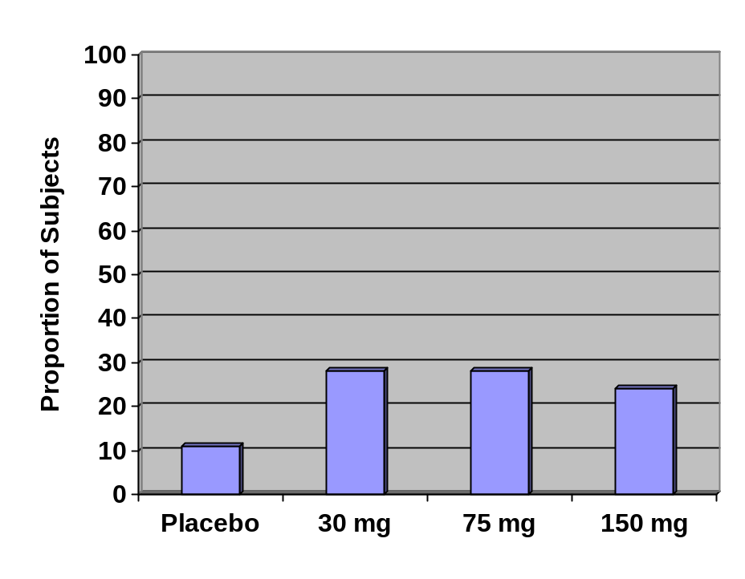
Figure 12. Study 0560: Sustained ACR20 Responders at 6 Months

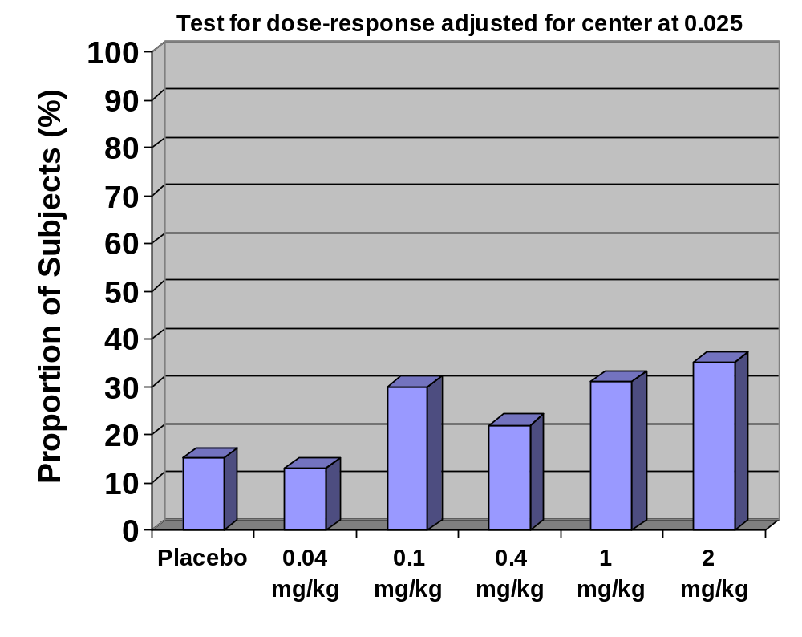
Figure 13. Study 960180: Sustained ACR20 Responders at 6 Months
The proportion of subjects attaining higher levels of ACR responses is shown in Table 33. In study 560, a higher proportion of anakinra-treated subjects attained an ACR50 than placebo-treated subjects. A test for a dose response showed statistical significance. However, ACR70 responses were distinctly uncommon and were not increased with anakinra compared to placebo. In study 960180, an increase in ACR50 responses was seen with anakinra treatment. ACR70 responses were distinctly uncommon, but were seen in 3 of 46, 6 of 59 and 1 of 55 subjects receiving 2.0, 1.0 and 0.4 mg/kg anakinra, respectively. The increase in ACR70 responses showed a statistically significant dose response.

Table 33: Proportion of Subjects with ACR20, 50 and 70 Responses at 24 weeks: ITT Population Using Non-responder Imputation
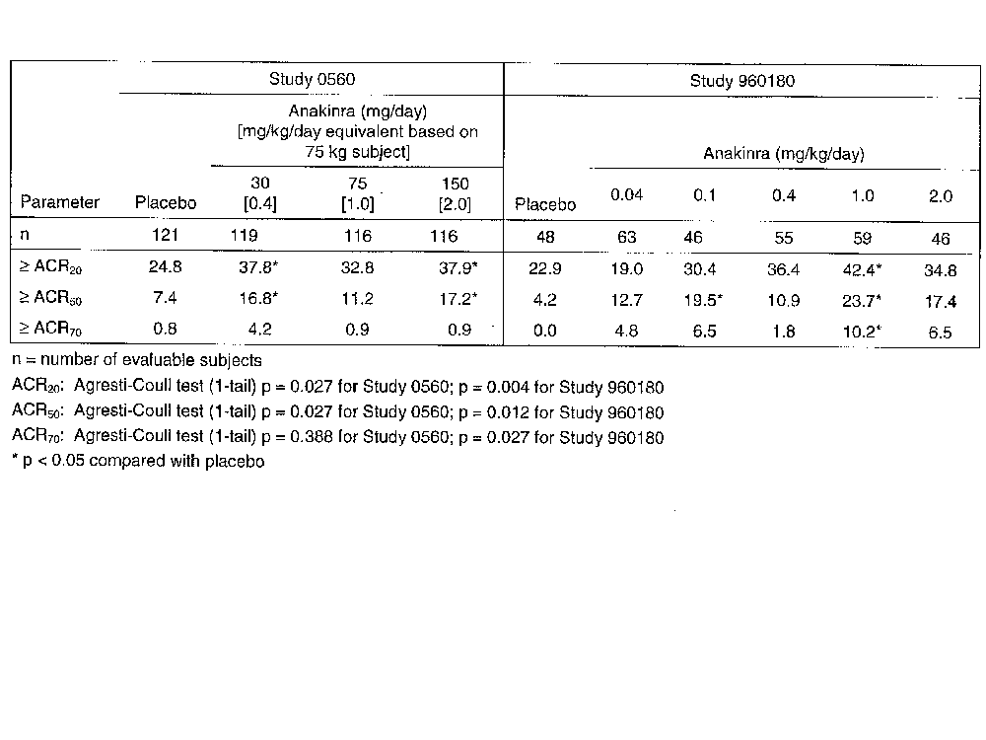
The time course of ACR20 responses is shown in Figure 14. In both studies, a higher proportion of subjects with ACR20 responses was seen as early as week 2. Although the increase in the percent of responders appeared to level off by week 12, the proportion of responders did continue to rise slowly between week 12 and week 25. Increase the dose from 75 mg to 150 mg in study 560, or from 1 mg/kg to 2 mg/kg did not appear to increase the rapidity of responses. The time course of the fall in ESR in study 560 (Figure 15) also showed a rapid fall, with decreases seen within 1 week and lasting through 24 weeks in all three anakinra doses.
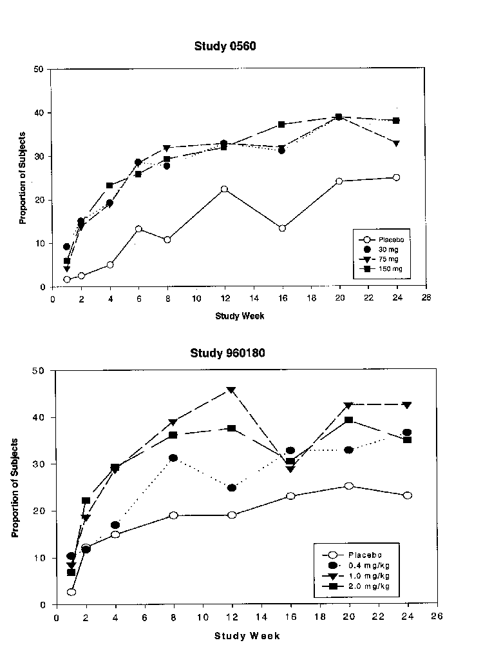
Figure 14. ACR20 responses by Visit Week (ITT Nonresponder Imputation)

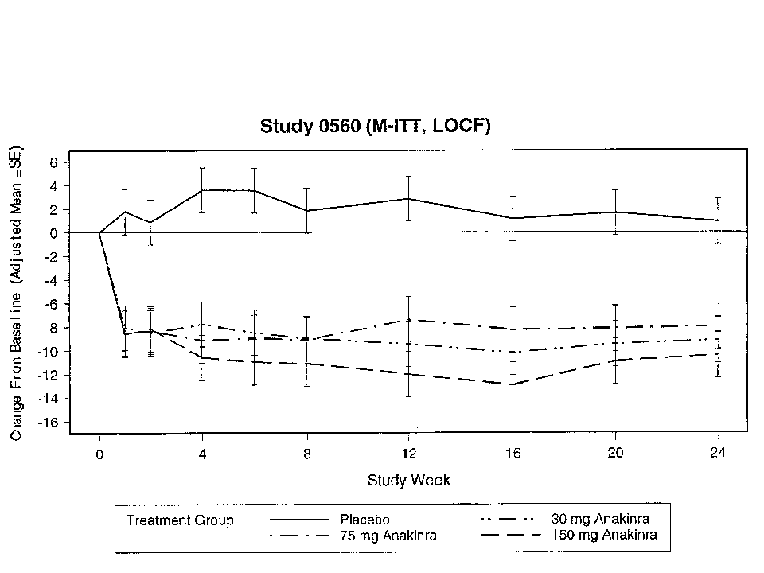
Figure 15. Study 0560: Change in ESR (mm/hr) by Study Visit

For a subject to attain an ACR20 response, they must have at least a 20% fall in tender and swollen joint count and a 20% fall in 3 of the following 5 parameters: physician global, patient global, pain, disability (HAQ) and acute phase reactants. The mean change from baseline in the components of the ACR criteria for the two highest anakinra doses are shown in Table 34 and Table 35. In study 560, the decrease in each of the components of the ACR response criteria in the higher dose anakinra group was statistically significant compared to placebo. For the 75 mg/d anakinra group, the decrease compared to baseline did not reach statistical significance for the swollen joint count, the pain score or the ESR, but in each case a trend toward improvement was seen compared to placebo. The percent change in the mean decline in each component is shown in Figure 16. It can be seen that the decreases from baseline in each component (with the exception of the CRP) were greater for the 150 mg anakinra dose than for the 75 mg dose.
For study 960180, the decreases in mean patient global assessment, pain score, HAQ and ESR were greater in each anakinra dose group compared to placebo. The falls in swollen joint counts, tender joint counts and physician global assessment were greater in the anakinra groups than placebo, but the differences did not reach statistical significance. The failure of the change in swollen joint count, tender joint count and physician global to reach statistical significance could have been due to either a smaller change from baseline compared to the other ACR components, or it could be due to a larger change in the placebo group. When the fall in mean swollen joint counts, tender joint counts and physician global assessment are expressed as the percent change from baseline (Figure 16), it can be seen that change from baseline in the anakinra-treated subjects is similar to, or greater than, for the other ACR components, but the fall from baseline was higher in the placebo arm. As with study 560, the fall in each component of the ACR criteria was greater for the highest dose arm (2 mg/kg) than for the next highest dose (1 mg/kg), again with the exception of the CRP.

Table 34. Study 560: ACR components: Mean change from baseline to 6 mo
 | Baseline | Placebo  N=116 | 75 mg/d  n=116 | 150 mg/d  n=116
Swollen joint count | 26 | -5.6 | -6.1 | -9.4*
Tender joint count | 34 | -5.2 | -9.0* | -12.0*
MD global  (0-4) | 3.1 | -.62 | -.87* | -1.0*
Patient global  (0-4) | 3.1 | -.51 | -.79* | -.96*
Pain VAS  (0-1) | 0.6 | -.04 | -.11 | -.18*
HAQ (0-3) | 1.6 | -.03 | -.19* | -.28*
ESR | 50 | .78 | -7.9 | -10*
CRP | 4.1 | -.36 | -1.0* | -.98*
*P<0.05

Table 35: Study 960180: Mean Change from Baseline to 6 Months in Components of ACR Response Criteria
 |  |  | Anakinra
 | Baseline | Placebo  N=74 | 1 mg/kg  N=59 | 2 mg/kg  N=72
Swollen jt | 18 | -4.2 | -6.3 | -7.6
Tender jt | 26 | -8.3 | -8.8 | -11
MD global  (0-100) | 57 | -14 | -22 | -24
Patient global  (0-100) | 50 | -3.6 | -13.8* | -20*
Pain VAS  (0-100) | 52 | -2.6 | -13* | -23*
HAQ (0-3) | 1.4 | -.15 | -.37* | -.51*
ESR | 36 | -4.2 | -12.4* | -14.4*
CRP | 1.9 | -.19 | -.77 | -.77
*P<0.05

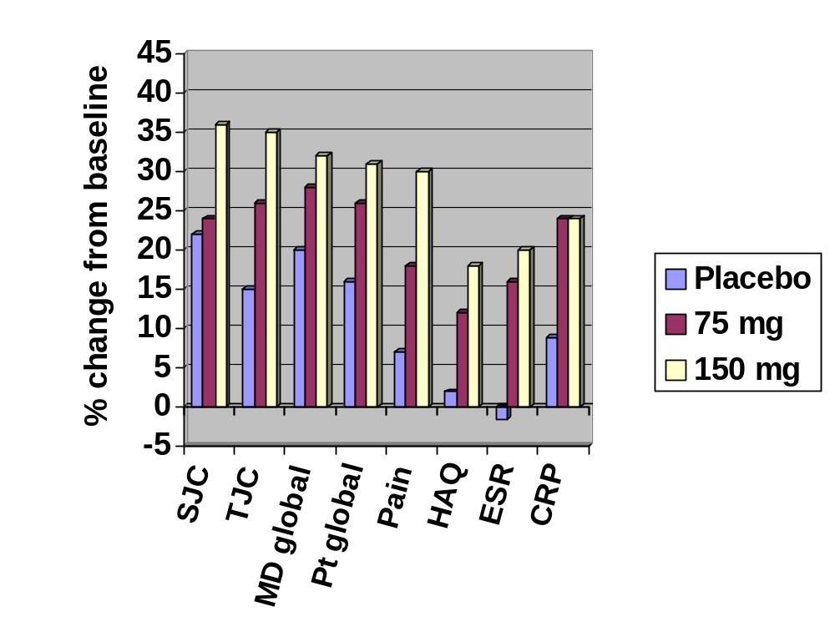
Figure 16. Study 560: Percent Change in Mean Change from Baseline in Components of ACR Response Criteria

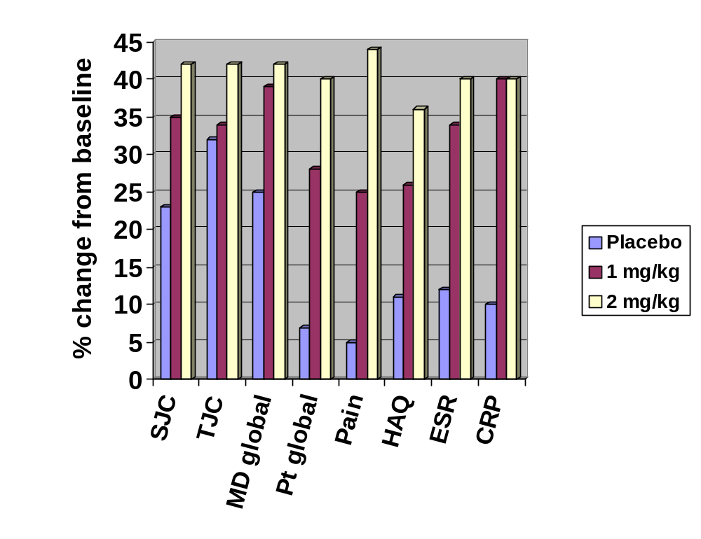
Figure 17. Study 960180: Percent Change in Mean Change from Baseline in Components of ACR Response Criteria

Sensitivity Analysis
Missing data can potentially give rise to bias the results of a study. For study 560, there were 26% dropouts prior to the 6-month primary endpoint. Somewhat fewer subjects completed 6 months of blinded study drug in the placebo arm (68%) compared to the anakinra arms (72-78%, see above). Sensitivity analysis was carried out to assess the effects of dropouts on the study results. When a non-responder imputation was substituted for the last-observation-carried-forward specified in the protocol, a 38% response rate was seen in the 30 mg arm and the 150 mg anakinra arm, compared to 25% for placebo (p=0.033 for both comparisons). A completer analysis showed results similar to that seen with the modified ITT analysis. When a modified worst-case scenario was used, where placebo dropouts who were not identified as dropping out due to lack of efficacy were reclassified as responders, no benefit was seen for the anakinra groups.
At the prespecified primary endpoint of 12 weeks, there were 14% missing data in study 960180. The primary analysis specified that dropouts in each study arm be classified non-responders (non-responder imputation). Sensitivity analysis to assess the contribution of the missing data revealed the following. A completer analysis showed similar results to the primary analysis, which used a modified intent-to-treat analysis. A compliant dropout analysis was carried out where subjects who discontinued blinded study drug but continued to come for follow-up assessments were classified responders or non-responders based on their 3-month response criteria without use of the non-responder imputation. The compliant dropout analysis showed similar results to the primary analysis. A modified worst-case scenario showed anakinra retaining a statistically significant effect at 3 months. Finally, the FDA carried out a Mantel-Hanszel chi-square analysis, which showed a p-value of 0.002 and 0.008 for the 1 mg/kg and 2 mg/kg anakinra groups, respectively.

Summary
The results of studies 0560 and 960180 are both consistent with a clinical benefit of anakinra given at doses of 1-2 mg/kg sc daily as measured by the proportion of subjects attaining an ACR20 response at 6 months. Overall, approximately 15% more subjects had a response at 6 months with anakinra than with placebo at doses of anakinra that are proposed for licensure (100 mg sc qd). However, there was considerable variation in the response rates. Similar results were seen whether anakinra was used as monotherapy (0560) or in combination with methotrexate (960180). The responses were rapid, occurring within weeks, and were sustained out to 6 months. Benefits were seen in most of the components of the ACR20. No subset of patients was identified who had a greater or lesser likelihood of responding to anakinra.

Radiographic Progression
In study 560, progression in structural damage was measured by assessing hand/wrist x-rays taken at baseline and at 6 months. The films were scored individually using the Larsen by two radiologists blinded to treatment group and to chronology. Disagreements between readers were resolved by consensus. The scoring system was defined as follows:
- 0 = normal
- 1 = ill-defined abnormality
- 2 = definite erosion on one side
- 3 = definite erosion on both sides
- 4 = marked derangement, but some surface preserved
- 5 = total destruction
- 6 = fused joint

Radiographs were available at baseline and at follow-up on 74% (347 of 472) of subjects. Similar proportions of subjects had baseline and follow-up x-rays in the different treatment arms. As shown in Table 36, there was some baseline imbalance in Larsen scores with the placebo scores similar to the scores for the 30 mg and 75 anakinra groups, but considerably higher than the mean of 12 in the 150 mg anakinra arm. The mean increase in Larsen score was lower in each of the anakinra groups than placebo. None of the individual comparisons of anakinra dose groups to placebo reached statistical significance, but the comparison of the pooled anakinra results to placebo had a nominal p value that was below 0.05 as measured by a comparison of means.
FDA analysis of the radiographic data revealed that the data were not normally distributed. The skewing of the data can be seen in the marked differences between the mean and median baseline scores and mean and median values for the 24 week change from baseline (Table 36 and Table 37). Therefore, the FDA used a non-parametric test, the Wilcoxon rank-sum test, to analyze the radiographic data (Table 37). The median increase in Larsen score in the placebo group was 6, compared to 2-3 in each of the anakinra groups. The nominal p-values for the pairwise comparisons with placebo showed statistical significance for the 30 mg and 75 mg anakinra groups and a trend toward improvement in the 150 mg group.

Table 36. Study 560: Larsen Scores
 | Placebo | 30 mg | 75 mg | 150 mg | All
Number Randomized | 121 | 119 | 116 | 117 | 352
M-ITT population | 83 | 89 | 89 | 86 | 265
Baseline
Mean | 15.4 | 16.7 | 14.9 | 12.1 | 14.6
Median | 11 | 13 | 12 | 7 | 10.5
Week 24 Change from Baseline
Mean | 6.5 | 3.5 | 4.2 | 3.9 | 3.8
p-value |  | 0.07 | 0.15 | 0.09 | 0.03

Table 37. Study 560: Larsen Score Change at Week 24 from Baseline (M-ITT Population) using Wilcoxon Test
 | Placebo | 30 mg | 75 mg | 150 mg | All Anakinra
N | 83 | 89 | 89 | 86 | 264
Mean | 6.42 | 3.61 | 3.85 | 4.01 | 3.82
SD | 10.13 | 7.47 | 10.41 | 8.75 | 8.93
Median | 6 | 3 | 2 | 2 | 2
Range | -26 – 37 | -26 – 27 | -30 – 66 | -25 – 30 | -30 – 66
P-valueª |  | <0.05 | <0.05 | 0.06 | <0.05
ª by Wilcoxon test

Reanalysis of the Data using a Modified Sharp Score
Amgen also submitted a reanalysis of the radiographic data using a modified Sharp score (Table 38). In its analysis of the data, the agency noted that:
- Unlike the original readings using the Larsen scoring system, in the reanalysis all films for a given subject were read simultaneously. It was also noted that a number of films had zero change from baseline that did have a change from baseline in the Larsen score. It is possible that the method of reading in the reanalysis may tend to minimize differences between films compared to the original method.
- Films were not read if only one timepoint was included in the reanalysis, while these films were scored in the original analysis.
- A total of 133 fewer subjects were scored in the reanalysis compared to the original analysis: 22 because films were lost; 111 because only 1 timepoint was available.
The reread of the data using the modified Sharp score produced statistically significant comparisons between each anakinra group and placebo for the total Sharp score and for joint space narrowing. For the erosion score, statistically significant comparisons were seen for the 30 and 150 mg dose arms and showed trends in the 75 mg group. These results must be interpreted in light of the large amount of missing data and other analytic concerns noted above.

Table 38. Study 0560: Sponsor’s Reanalysis of Radiographic Data using a Modified Sharp Score
 | Placebo | Anakinra (mg/day)
 | (N=121) | 30  (N=119) | 75  (N=115) | 150  (N=116) | All  (N=351)
Total
n | 78 | 87 | 85 | 79 | 251
Adjusted Mean | 3.6 | 1.8 | 2.0 | 1.8 | 1.9
SE | 0.52 | 0.48 | <1% | <1% | <1%
Median | 2.0 | 0.50 | 1.0 | 0.48 | 0.48
(Q1, Q3) | (0, 5.4) | (0, 2.5) | (0, 3.4) | (0, 2.4) | (0. 2.9)
p-value |  | <0.05 | <0.05 | <0.05 | <0.05
Joint space narrowing
n | 78 | 87 | 85 | 79 | 251
Adjusted Mean | 1.6 | 0.77 | 0.52 | 0.66 | 0.66
SE | 0.27 | 0.25 | 0.24 | 0.23 | 0.13
Median | 0.96 | 0 | 0 | 0 | 0
(Q1, Q3) | (0, 1.9 | (0,0.96) | (0, 0.96) | (0, 0.96) | (0, 0.96)
p-value |  | <0.05 | <0.05 | <0.05 | <0.05
Erosion
n | 78 | 87 | 85 | 79 | 251
Adjusted Mean | 2.0 | 1.0 | 1.4 | 1.1 | 1.2
SE | 0.32 | 0.30 | 0.28 | 0.28 | 0.15
Median | 0.77 | 0 | 0.51 | 0 | 0
(Q1, Q3) | (0, 3.1) | (0, 1.5) | (0, 2.0) | (0, 1.5) | (0, 2.0)
p-value |  | <0.05 | 0.171 | <0.05 | <0.05

Summary
Analysis of the radiographic data using the originally specified scoring system and analytic plan did not demonstrate statistical significance for any anakinra dose group. However, trends toward less radiographic progression were demonstrated for each anakinra dose group compared to placebo. These data suggest that anakinra is unlikely to worsen radiographic progression and may have activity in inhibiting radiographic progression. Post hoc analyses using a non-parametric test of significance and rereading of the data using a modified Sharp score represent additional exploratory analyses suggesting that anakinra may have activity in inhibition of radiographic progression. The lack of statistical significance of the primary analysis and the large amount of missing data (26% of subjects) limit the conclusions that can be made based on these data.

Safety
The total number of subjects exposed to anakinra in studies 560 and 960180, and their extension studies (0564 and 960181), is shown in Table 39. A total of 175 subjects were exposed to anakinra for 1 year or longer at doses equal to or greater than 75 mg/day and 318 subjects for 6 months or longer.

Deaths
A total of 13 deaths were seen in these two trials (Table 40). None of the deaths occurred during the placebo-controlled portions of the trials, that is, all occurred during the long-term, open-label extension phases of the trials. Overall, the ratio of exposure to anakinra vs. placebo was approximately 17 (1310 vs. 76 patient-years). Three of the deaths were infectious in nature. Three were due to malignancies. Four were the consequence of cardiovascular events.

Serious Adverse Events
The incidence of serious adverse events was similar in anakinra-treated and placebo-treated subjects. The cases of serious adverse events that were infectious in nature in study 960180 are shown in Table 41. Most were rated mild or moderate. Only one event led to premature withdrawal, a woman who received 1.0 mg/kg anakinra and who was ultimately hospitalized for pneumonia. For study 0560, 960180, their extensions and the earlier phase 1 studies, there were 18 serious infections: 17 among anakinra-treated subjects (17/1240 or 1%) and 1 subject receiving placebo (1 of 243, or <1%). Adjusting for the differing exposures to study drug (1310 patient-years with anakinra and 76 patient-years with placebo), the rate was 1.3 events/100 patient-years in both groups. There was no indication that serious infections were dose-dependent.
A total of 20 malignancies were observed during the controlled trials and their extensions. Six cases were breast cancer (Table 42), while the others were at various different sites (Table 43). No predominant type of malignancy was observed. Table 44 compares the observed rates of selected malignancies with the expected rates for the general population based on age- and sex-specific patient-years at risk using data derived from the SEER database. The observed numbers of all cancers, lymphomas and invasive breast cancers were all within the 95% confidence interval for expected incidence.

Table 39. Total Patient Exposure in Studies 0560, 960180 and Their Extensions
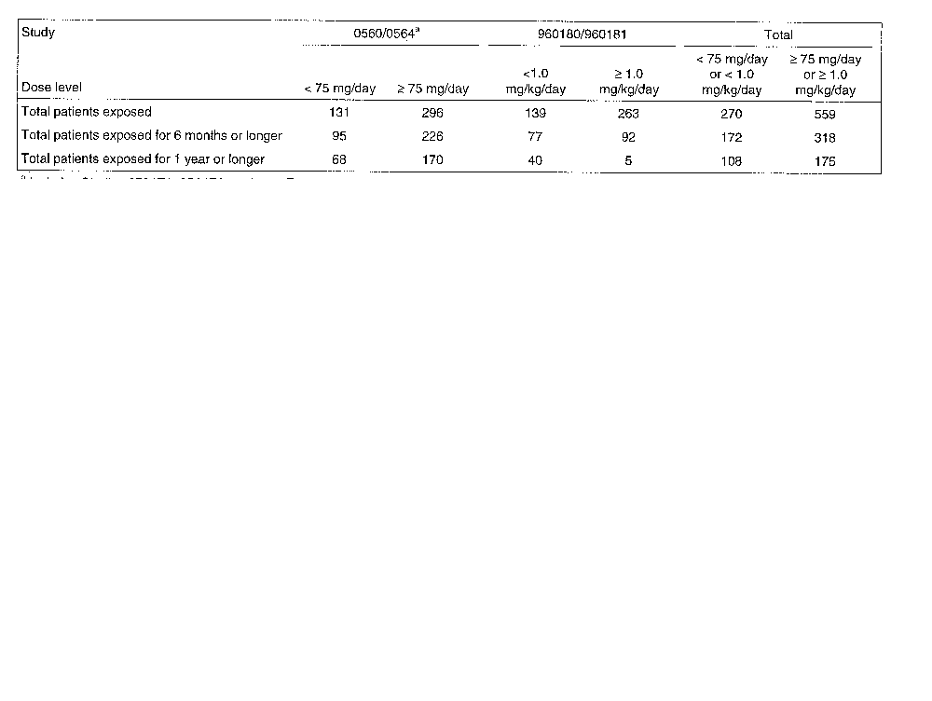

Table 40. Deaths in Studies 0560, 960180 and Their Extensions
Age | Sex | Dose | Days exposure | On/ post study | Cause of death
75 | M | 75 mg/d | 126 | >3 mo post | Resp failure/resp infection
73 | F | 150 mg/d | 71 | < 30 d post | Hemiparesis
55 | M | 30 mg/d | 168 | 3 mo post | Lung ca
68 | M | 75 mg/d | 454 | On study | V Fib
67 | M | 75 mg/d | 532 | 3 mo post | Stomach ca
51 | F | 70 mg/d | 180 | On study | Pneumonia sepsis
76 | F | 70 mg tiw | 150 | On study | CVA
58 | M | 70 mg qw | 60 | On study | Cardiac arrest
88 | F | 150 mg/d | 645 | >30 d post | CAD
72 | F | 30 mg/d | 776 | <30 d post | Endocarditis
79 | M | 30 mg/d | 984 | > 30 d post | Pancreatic ca
70 | F | 0.4 mg/kg/d | 151 | < 30 d post | MI
76 | F | 2 mg/kg/d | 550 | On study | Unknown

Table 41. Study 960180: Serious Infections
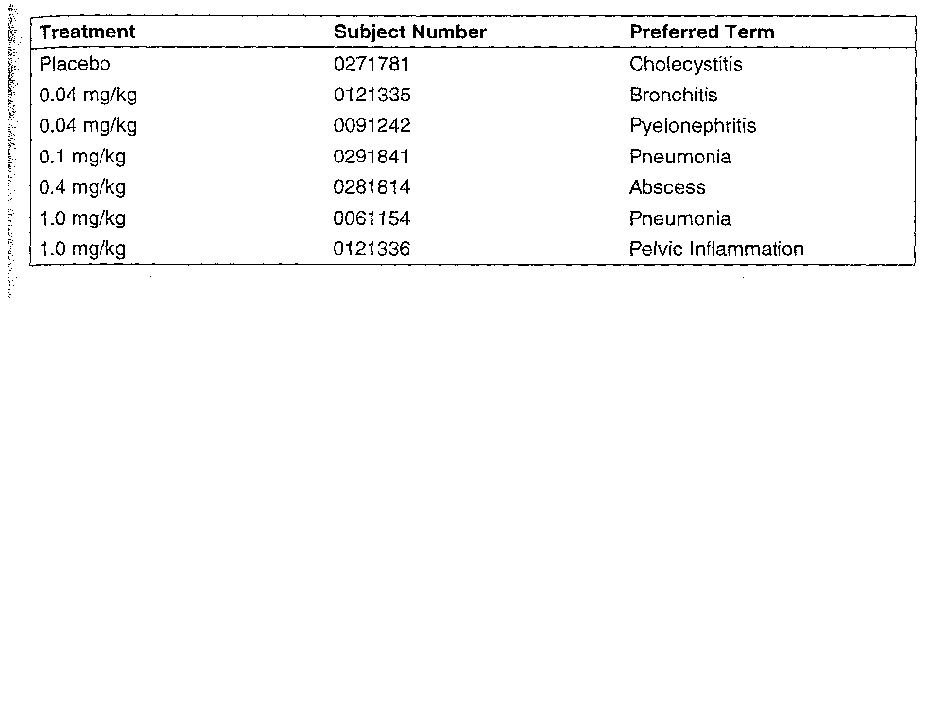

Table 42. Cases of Breast Cancer (Studies 0560, 960180)

Dose | Days exposure | Age
150 mg/d | 775 | 73
2 mg/kg/d | 60 | 69
0.4 mg/kg/d | 343 | 72
0.4 mg/kg/d | 165 | 67
0.4 mg/kg/d | 296 | 54
0.4 mg/kg/d | 274 | 67

Table 43. Other Malignancies
Dose | Days exposure | Age | Sex | Site
20 mg/d | 126 | N/A | M | Prostate
30 mg/d | 58 | 73 | M | Ca of mouth
30 mg/d | 183 | 55 | M | Lung ca
150 mg/d | 125 | 74 | F | Basal cell ca, recurrent
150 mg/d | 43 | 53 | F | Thyroid
30 mg/d | 157 | 75 | M | Lung
30 mg/d | 20 | 58 | F | Thyroid, undiff
75 mg/d | 498 | 67 | M | Stomach
75 mg/d | 1235 | 79 | M | Pancreas
0.4 mg/kg/d | 358 | 69 | M | Basal cell
0.4 mg/kg/d | 295 | 72 | M | Recurrent basal cell
30 mg/d | 303 | 81 | F | Bladder
150 mg/d | 126 | 51 | F | NHL

Table 44. Observed and Expected Incidence for Selected Malignancies
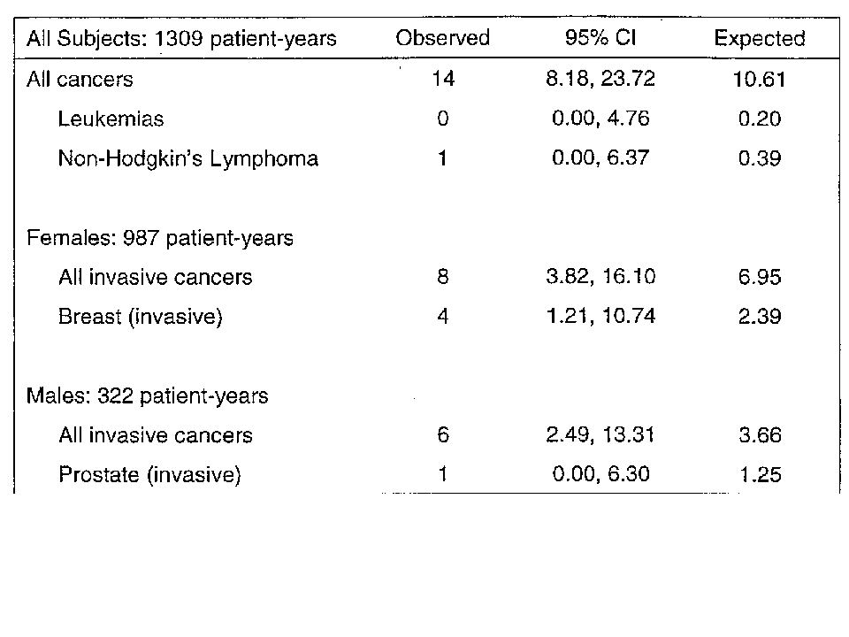

Discontinuations due to Adverse Events
The number of subjects who discontinued study medication due to adverse events in studies 560 and 960180 and their extensions is shown in Table 45. In study 0560, a higher proportion of subjects withdrew due to adverse events in the placebo arm than with anakinra. The major cause for discontinuation in the placebo arm was RA flare, which was seen in 14% of placebo-treated subjects and 9% of anakinra-treated subjects. Among anakinra-treated subjects, discontinuations were also seen because of ISRs, limb pain, arthralgia and leukopenia. Leukopenia, as well as ISRs, contributed to a higher proportion of discontinuations due to adverse events in the anakinra arm in study 960180.

Leukopenia and other Laboratory Abnormalities
Withdrawal due to leukopenia was seen at a variety of dose levels of anakinra, with no pattern of increasing incidence at higher doses (Table 46). The time since initiation of anakinra treatment varied, with about one-third developing in the first 100 days and one-third developing after 200 days of treatment. Study 560 required that subjects be withdrawn in the WBC fell below 3500/mm³ or the ANC below 1500/mm³, while study 960180 required withdrawal for a WBC below 3000/mm³ or an ANC below 1500/mm³. The ANC at the time of withdrawal varied, but all but two were above 1200/mm³. In all cases, the ANC recovered to above 1400/mm³. In only one case, the 67 year old woman in study 0564, was the leukopenia associated with an infection. That patient developed a urinary tract infection that was not considered serious and that resolved.
The occurrence of leukopenia in studies 0560 and 960180 is shown in Table 47 and Table 48. Overall, 12% (85 of 796) of anakinra-treated subjects experienced leukopenia, compared to 4% (10 of 195) of placebo controls. Leukopenia was defined as follows:
 | Study 0560 | Study 960180
Grade 1 | 3300-4400/mm³ | 3100-4100/mm³
Grade 2 | 2200-3300/mm³ | 2000-3100/mm³
Grade 3 | 1100-2200/mm³ | 1000-2000/mm³
Grade 4 | <1100/mm³ | < 1000/mm³

In study 0560, 5 of 121 placebo-treated subjects increased in grade of leukopenia by  1 grade. Of these, 2 increased by two grades. A higher proportion of subjects in the anakinra-treated groups increased in leukopenia grade of  1 grade. Of 351 anakinra-treated subjects, 55 (16%) developed leukopenia. The majority of these cases involved an increase of 1 grade, but 6 (2%) increased from the normal range to grade 2. In study 960180, 35 of 345 (10%) anakinra-treated subjects developed leukopenia. The majority of these involved a shift from the normal range to grade 1.

Table 45. Discontinuations due to Adverse Events in Studies 560 and 960180
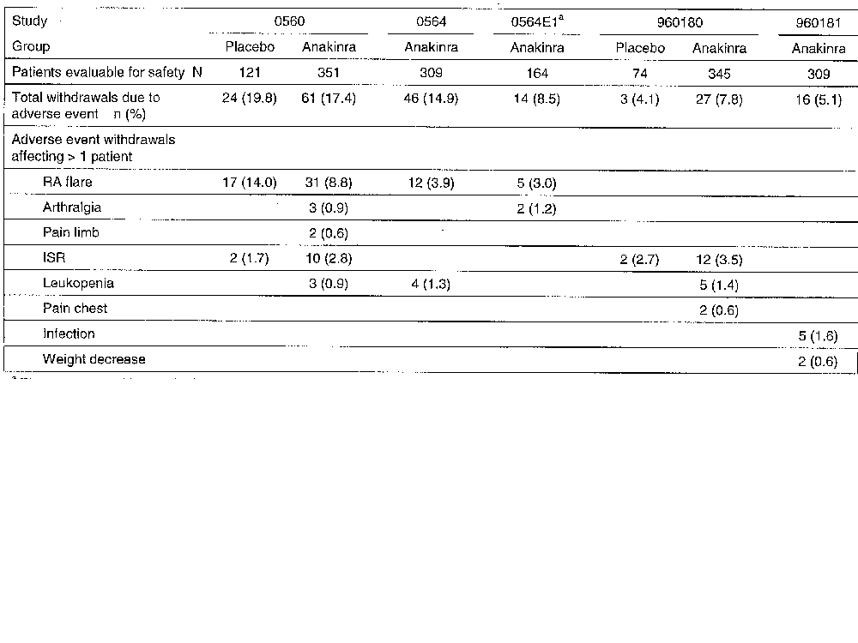

Table 46. Withdrawals due to Leukopenia
Study | Age, Sex | Dose | Days of Anakinra | ANC at Time of Withdrawal (cells/mm³)
0560 | 72, F | 150 mg/kg | 112 | 1.7
 | 68, F | 150 mg/kg | 7 | 1.1
 | 32, F | 30 mg/kg | 40 | 1.7
0564 | 83, M | 30 mg/kg | 353 | 1.4
 | 61, F | 75 mg/kg | 259 | 1.5
 | 50, M | 30 mg/kg | 353 | 2.0
 | 67, F | 150 mg/kg | 259 | 1.8
0564E1 | 62, F | 150 mg/kg | 568 | Unknown
960180 | 63, M | 0.4 mg/kg | 7 | 0.96
 | 35, F | 0.1 mg/kg | 115 | 2.2
 | 60, M | 2 mg/kg | 37 | 4.9
 | 63, F | 0.04 mg/kg | 112 | 0.90
 | 62, F | 1 mg/kg | 14 | 1.2
960181 | 58, F | Unknown | Unknown | 1.2

Table 47. Leukopenia in Study 0560
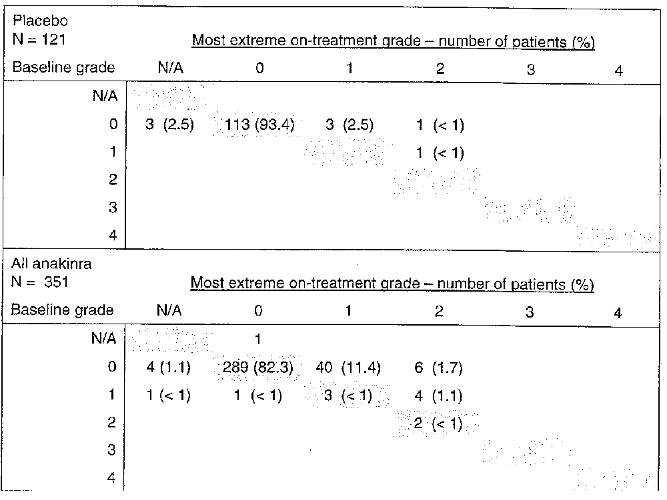

Table 48. Leukopenia in Study 960180
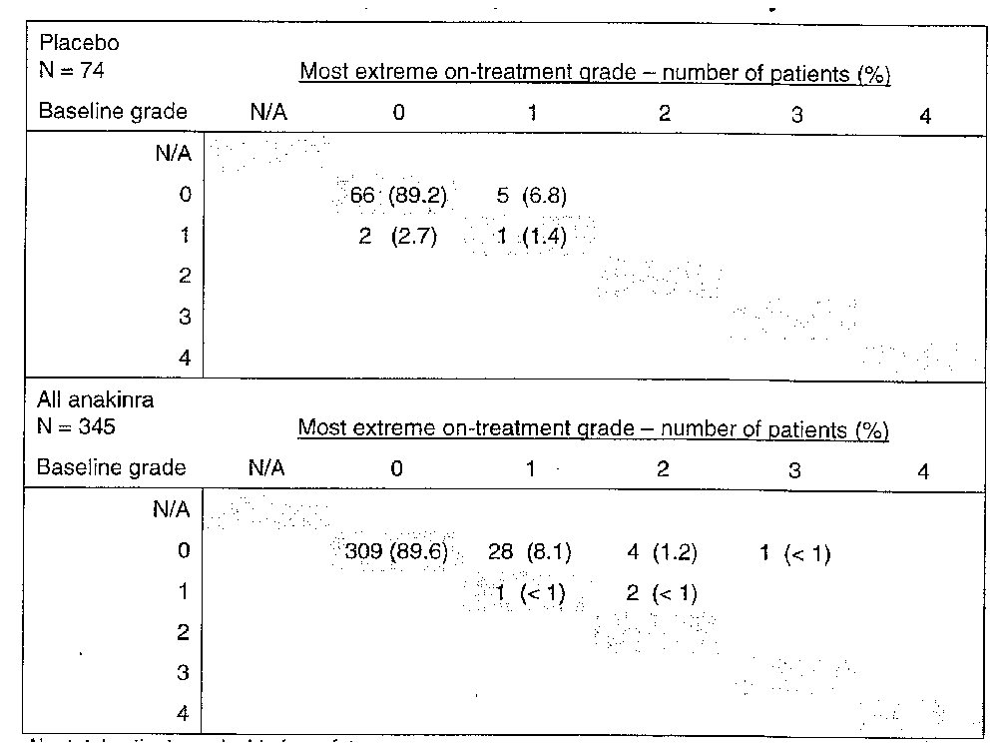
Apart from leukopenia, the only other laboratory abnormality associated with anakinra was an increase in eosinophil counts. As shown in Table 49, mean eosinophil counts rose somewhat during the course of studies 0560 and 960180 among anakinra-treated subjects while they stayed the same or fell in subjects receiving placebo. Using a modified WHO toxicity scale, the highest increase in eosinophilia grade was grade 2 and no subject increase by more than one grade.

Table 49. Mean Changes in Eosinophil Counts (SD)
 |  | Study 0560 |  | Study 960180
 |  | Placebo  (N=121) | All anakinra  (N=351) | Placebo  (N=74 | All anakinra  (N=345)
Eosinophils (%) | Baseline | 1.93 (1.87) | 1.92 (1.57) | 1.96(1.51) | 2.05 (1.71)
 | Week 24 | 1.93 (1.42) | 2.69 (2.17) | 2.10 (1.76) | 2.59 (2.26)

Other Adverse Events
The other adverse events reported in studies 0560 and 960180 are shown in Table 50. The most common adverse event in the anakinra-treated subjects was injection site reaction. Other events occurring at a higher incidence with anakinra than with placebo include headache, abdominal pain and rash.

Table 50. Other Adverse Events Occurring in 3% of all Anakinra-Treated Subjects
 | Placebo |  | All Anakinra
 | (N = 195) |  | (N = 696)
Number of Patients Reporting AEs | 164 | 84.1% | 653 | 93.8%
Preferred Term | n | % | n | %
Injection Site Reaction (Application Site) | 51 | 26 | 404 | 58
Arthritis Rheumatoid | 48 | 25 | 95 | 14
Headache | 12 | 6 | 86 | 12
Infection Upper Respiratory | 24 | 12 | 84 | 12
Arthralgia | 19 | 10 | 47 | 7
Diarrhea | 14 | 7 | 47 | 7
Pain Abdominal | 7 | 4 | 46 | 7
Nausea | 15 | 8 | 45 | 7
Influenza-Like Symptoms | 11 | 6 | 41 | 6
Rash | 5 | 3 | 34 | 5
Sinusitis | 13 | 7 | 32 | 5
Infection Urinary Tract | 11 | 6 | 30 | 4
Vomiting | 9 | 5 | 29 | 4
Pain Back | 9 | 5 | 26 | 4
Sore Throat | 8 | 4 | 26 | 4
Dyspepsia | 4 | 2 | 24 | 3
Fever | 4 | 2 | 24 | 3
Pruritus | 7 | 4 | 24 | 3
Cough | 4 | 2 | 23 | 3
Dizziness | 8 | 4 | 23 | 3
Edema Peripheral | 4 | 2 | 23 | 3
Injury | 2 | 1 | 23 | 3
Myalgia | 10 | 5 | 23 | 3
Joint Swelling | 3 | 2 | 22 | 3

Summary of Safety
No pattern of increased serious adverse events was observed in patients treated with anakinra monotherapy or combination therapy with methotrexate. A majority of subjects had injection site reactions, which were generally mild-moderate in intensity and a cause for discontinuation in a small percentage of patients. Leukopenia, defined as white blood cell counts below 3000 or 3500/mm³, were observed, with absolute neutrophil counts falling to approximately 1000/mm³ in some cases. In only one case was leukopenia associated with an infection.

Study 960182
Study 960182 was a randomized, double-blind, multicenter, European, 3-month, placebo-controlled study designed to determine the efficacy of lower doses of anakinra. A total of 141 subjects were randomized to receive 2.5, 10 or 30 mg of anakinra sc qd or placebo with no concomitant DMARDs allowed. The primary endpoint was the ACR20 response at 3 months. Although the study primarily investigated the effects of low dose anakinra, the highest dose was in the range of doses that have shown activity in other trials. The highest dose chosen in study 960182 showed an ACR20 response rate in trial 560 that was different from placebo. In addition, in study 960180, although the most similar dose, 0.4 mg/kg, was not different from placebo, both the doses closest to that dose were significantly different than placebo. As shown in Table 51, none of the anakinra doses studied showed a response rate higher than placebo. It should be noted that the placebo response rate in this trial, 43%, is quite high for rheumatoid arthritis trials and is higher than that seen in any of the other efficacy trials of anakinra.

Table 51. Study 960182: ACR20 Responses at 3 Months
 |  | Anakinra
 | Placebo  N=30 | 2.5 mg  N=42 | 10 mg  N=40 | 30 mg  N=29
Responders | 13 (43%) | 11 (26%) | 11 (28%) | 10 (34%)
95% CI | (26, 61) | (13, 40) | (14, 41) | (17, 52)

Study 20000125: Enbrel Combination
Study 20000125, hereafter called study 0125 for brevity, was carried out to assess the safety of anakinra given in combination with Enbrel. Study 0125 was a 6-month, open-label trial in 58 RA patients who were previously receiving Enbrel for at least 3 months, but were on no other DMARDs. Subjects were treated with anakinra 1 mg/kg sc qd. Subjects were required to have at least 6 tender and 6 swollen joints.
The enrolled subjects had a mean age of 49 years and had had RA for an average of 12 years. They had a mean tender joint count of 26 and a mean swollen joint count of 17 at baseline.
A total of 21 (21/58, 36%), subjects withdrew from the study before completing 6 months of anakinra therapy: 11 (19%) for AEs; and 8 (14%) due to withdrawal of consent. No deaths were reported during the study. There were a total of 7 serious adverse events. Four of the serious adverse events were infectious in nature. The other three were injury, withdrawal syndrome and hemorrhagic gastric ulcer. There were 4 serious infections (4/58 or 7% of subjects): 2 cases of pneumonia; 2 cases of cellulitis. Overall, the rate of serious infection was approximately 13.8 per 100 patient-years. The two cases of cellulitis are considered in more detail below:
A 57 year old woman with RA, who had been receiving Enbrel for 15 months, developed a cellulites after 6 weeks on anakinra at an abdominal injection site. She was treated with IV cefazolin and oral cephalexin and anakinra was discontinued. Aspiration from a site of fluid accumulation revealed by ultrasound grew Staphylococcus aureus. The abscess was treated by incision and drainage and oral antibiotics and the subjects recovered. She was withdrawn from the study.
A 56 year old man with RA, who had been receiving Enbrel for 6 months, developed a flu-like illness after 5 ½ months on anakinra. Study drug was held. The following day, the subject noted a red spot on his cheek that spread across his face and was diagnosed as a facial cellulitis. The cellulitis resolved with IV followed by oral antibiotics.
Of the 11 subjects who withdraw due to adverse events, 4 were related to infectious events. No other event was seen in more than one subject.
A total of 5 cases of laboratory toxicities were observed during the study, as defined by an increase in grade of 2. There were 2 cases of decreased neutrophils, 2 cases of decreased lymphocytes and 1 case of decreased white blood cell count. None were grade 4. Two of the cases of leukopenia occurred in subjects who also developed serious infections. The time course of neutropenia in these two cases is shown in Figure 18. The first subject had a neutrophil count of 1800/mm³ at screening and 1200/mm³ at baseline. The first neutrophil count on study was 680//mm³ after 1 month. The subject developed cellulitis 10 days later. The second subject had a neutrophil count of 2200/mm³ at baseline that fell to 1000/mm³ after 2 months on study. This subject developed pneumonia 15 days later.

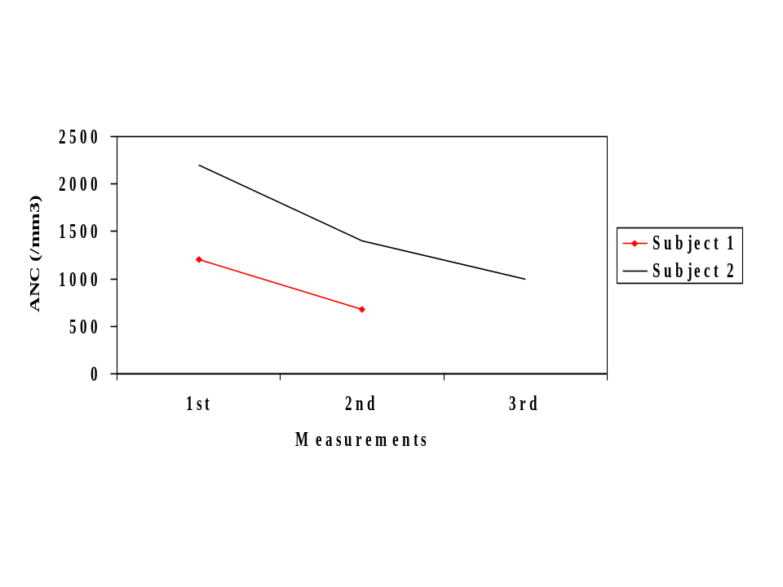
Figure 18. Subjects with neutropenia and serious infection in trial 0125. Measurement 1 was at baseline; measurement 2 and 3 at 1 and 2 months respectively. Subject 1 developed pneumonia and subject 2 cellulitis 15 days and 10 days after the 2nd and 3rd measurement, respectively

Summary
Study 0125 was a small, open-label study of the combination of anakinra with Enbrel. Serious infections and leukopenia, which were observed in other trials of anakinra, were more frequent in study 0125. Serious infection occurred in 4 subjects, a rate of 7% (95% CI 1.9-17%), compared to 2.1% (95% CI 1.3-3.1%) for study 990757, 0.8% (95% CI 0.2-2.0%) for study 990145 and 1.7% (95% CI 0.7-3.4%) for study 960180.
Five cases of cytopenia were seen among the 58 subjects. Two of the subjects who developed serious infection had developed decreased neutrophil counts of 1000/mm³ or below in the weeks before the infection. Although this is a small study and the lack of a control group makes conclusions difficult, study 0125 raises questions about whether the combination of anakinra with Enbrel may be associated with a higher incidence of serious infections and clinically significant leukopenia.

Overall Summary of Safety and Efficacy
The results of the three randomized efficacy studies (0560, 960180 and 990145) are consistent in showing therapy with anakinra to be helpful in reducing the signs and symptoms of rheumatoid arthritis as measured by the ACR20 response:
- In the largest study, 990145, 16% more anakinra-treated subjects attained an ACR20 response than patients receiving placebo.
- A similar effect size was seen with the other two studies at doses in the same range as the dose proposed for marketing (100 mg sc qd).
- Responses were seen within weeks and were maintained out to 6 months.
- Effects were seen on all components of the ACR response criteria.
Anakinra was generally well tolerated. A majority of patients, however, experienced injection site reactions (50-70%) and a minority of patients experienced low-grade leukopenia (12%). A higher incidence of serious infections was seen in anakinra-treated patients in study 990757, but was not apparent in the other studies, perhaps because of their smaller size. In study 990757, serious infections were more common in patients with asthma and in those who were taking concomitant corticosteroids. No pattern of increase in serious adverse events was observed in patients with other concomitant medical conditions or concomitant DMARDs.
Limited information is available of the safety and efficacy of anakinra use in combination with TNF antagonists. Anakinra use in combination with etanercept was studied in 58 patients in study 20000125. While the combination was well tolerated in most of the patients, serious infections were seen in 7%, a higher proportion than in the other studies. In addition, leukopenia was seen more frequently than in the other studies, and two subjects who developed neutrophil counts of 1000/mm³ or below developed concurrent serious infections.

Preliminary Questions for Advisory Committee
- In study 990757, a higher proportion of anakinra-treated subjects developed serious infections compared to subjects receiving placebo. Serious infections were more frequent in patients with asthma and in patients taking corticosteroids.
  - If anakinra is licensed, what warnings or precautions should be provided to health care providers regarding the risk of serious infections with anakinra?
  - Are there additional studies that should be considered to further assess the risk of serious infection in patients taking anakinra who have asthma or who are taking concomitant corticosteroids?
- Some patients in trials 0560 and 960180 developed grade 2 and 3 leukopenia and some subjects required discontinuation of anakinra because of leukopenia. What recommendations should be provided to health care providers about monitoring white blood cell counts for patients receiving anakinra?
- Study 20000125, although small, suggested that use of anakinra in combination with Enbrel may be associated with a higher risk of serious infection and leukopenia. If anakinra is licensed, what sorts of warnings or precautions should be provided to health care providers regarding the use of anakinra in combination with Enbrel?
- Based on the Pediatric Rule, the FDA requests that pharmaceutical company sponsors study their products in children if the product is likely to have a use in children. What studies should be done to evaluate its safety and efficacy in children?
- Do the overall safety and efficacy data for anakinra suggest that it has a favorable risk: benefit ratio in the treatment of rheumatoid arthritis?

Appendix

Study 990145: Inclusion and Exclusion Criteria
Inclusion criteria:
- Adult patients meeting ACR criteria for rheumatoid arthritis
- Disease duration of at least 24 weeks
- Radiographic evidence of at least one bone erosion in the hands, wrists or feet
- Active RA as defined by at least 6 swollen and 9 tender joints, based on 66/68 joint count AND one of the following: CRP ≥ 1.5 mg/dL or ESR ≥ 28 mm/hr
- Stable dose of MTX 10-25 mg/wk for at least 8 weeks, with a history of at least 24 consecutive weeks of MTX
- Stable NSAIDs or oral corticosteroids ( 10 mg/day of prednisone or its equivalent) for at least 4 weeks
Exclusion criteria
- Felty’s syndrome
- Any uncontrolled, clinically significant systemic disease
- Malignancy within 5 years
- Any other major chronic inflammatory disease
- Presence of a serious infection, defined as requiring hospitalization or frequent, acute or chronic infections during the 12 weeks before randomization
- Radiographic end stage disease
- WBC < 2000/μL, neutrophil count below 1000/μL, plt < 100,000/μL
- Elevated AST/ALT > 1.5 x ULN
- Elevated serum creatinine > 1.5 x ULN
- Intra-articular or systemic corticosteroid injections within 1 month
- Any DMARD besides MTX within 60 days
- Positive for hepatitis B, hepatitis C or HIV
- Previous receipt of IL-1ra

Study 990757: Inclusion and Exclusion Criteria
Inclusion criteria:
      - Met ACR criteria for rheumatoid arthritis
      - RA for  3 months
      - Minimum of 3 swollen and 3 tender/painful joints or morning stiffness or at least 45 min
      - Age 18 or older
      - Stable NSAIDs and oral corticosteroids for at least 1 month
      - Stable DMARDs for at least 2 months
Exclusion criteria:
      - History of Felty’s syndrome
      - Any significant and uncontrolled medical condition
      - Malignancy in past 5 years
      - Positive for hepatitis B, hepatitis C, HIV
      - WBC below 2,000/mm³, ANC below 1,000/mm³, platelet count below 100,000/mm³
      - ALT, AST or serum creatinine  1.5x upper limit of normal

