Note of Clarification, March 20, 2003

This research was conducted in 2001 when the Hospital Bed Safety Workgroup (HBSW) dimensional guidelines were under development. The dimensional guidelines and measurement methodology used here do not necessarily reflect current recommendations neither of the HBSW nor of the guidance document that will eventually be released by the FDA.

For current information on the HBSW work, refer to:
www.fda.gov/cdrh/beds <http://www.fda.gov/cdrh/beds>

For information about the availability of the toolkit, refer to:
www.ecri.org/bedsafety <http://www.ecri.org/bedsafety>

Hospital Bed Safety Evaluation in Hospitals and Nursing Homes
Investigators: G. Powell-Cope, A. Nelson¹, S. Hoffman¹, M. Tate, L. Rathvon¹, D. Bradham, S. Luther¹
Introduction: The Veterans Health Administration is committed to improving patient safety. The VHA-funded center based in Tampa FL, The VISN 8 Patient Safety Center of Inquiry, focuses on safe patient mobility for frail elderly and the disabled. In 2000, our center partnered with the Food and Drug Administration (FDA) and representatives from the medical bed industry, national health care organizations, patient advocacy groups, and other federal agencies (Health Care Finance Administration; Consumer Product Safety Commission) to improve the safety of hospital beds for patients who are most vulnerable to the risk of side rail entrapment.
Problem Statement: Hospital bed systems can contribute to significant injury or death. Today there are about 2.5 million hospital and nursing home beds in use in the United States. Between 1985 and 1999, 371 incidents of patients caught, trapped, entangled, or strangled in beds with rails were reported to the U.S. Food and Drug Administration. Of these reports, 228 people died, 87 had a nonfatal injury, and 56 were not injured because staff intervened. Most of these patients were frail, elderly, or confused. Generally, it is assumed that most of these “close calls” are not reported. The FDA Hospital Bed Safety Workgroup developed a set of proposed guidelines that specify dimensional criteria for bed systems based on 15 anthropometric data sources and a retrospective validation based on a survey of past entrapment events.
Research Objectives: The goal of this six-month study using prospective observational and survey methods is to minimize risk of death and injury due to bed-related entrapment of patients. The purpose of the study is to (1) evaluate a facility-based approach for bed safety assessment (2) determine evidence-based recommendations for intervention (3) determine relative risk and cost benefit comparison of interventions. An observational descriptive design will be used in the proposed study. The following immediate objectives (O) will be addressed:
O1: Determine the variability/frequency distribution/prevalence of bed systems (components of which include characteristics of rails, foot and head boards, beds and mattresses; models; manufacturers; bed modifications; bed rail alternatives) at six VA health care systems.
O2: Evaluate each bed according to proposed safety criteria in seven critical “bed-safety zones”.
O3: Empirically refine the process for measuring beds according to the proposed safety criteria in each of the seven critical areas.
O4: Estimate the incidence and etiology of bed-related adverse events including close calls, injuries, and deaths.
O5: Evaluate the attributable risk of each bed system and its sub-components for each outcome using a decision analytic model.
O6: Design a system for prioritizing interventions to improve bed safety based on risks, benefits (avoided cost of morbidity and mortality), and cost of interventions.
O7: Develop a strategic plan to mitigate the bed-related patient risks identified in VISN 8.
Methods: Overview. Initially a pilot study for Objectives 1 through 3 will be conducted at the Tampa VAMC to finalize data collection processes and evaluate the surveys. Once methods are standardized similar data will be collected all VAMCs in VISN 8. Observational and survey methods will be used to address objectives 1-3. Trained data collectors will measure seven predetermined critical areas including gaps within side rails, distances between mattresses and side rails and between mattresses and head/footboards. To address objective 4 and 5, patient specific administrative information will be collected using the VHA’s national Austin Automation Center (AAC) databases on all patients occupying a bed over the data collection period in long term care and medical/surgical units at Tampa VA only over a 45 day period. We will also review one year’s worth of incident reports of bed-related entrapment from each VAMC in VISN 8 and VISN 16. During this period a standardized instrument will be used to collect data on all falls from bed, entrapments, and close calls. To address objectives 6 and 7 an expert panel will review results of the VISN-level data and determine evidence-based priorities and a strategic plan to mitigate risks in VISN 8.
Anticipated Impact: The immediate outcome of this proposed Bed-Safety evaluation in VISN 8 pilot research is a reduction in patient risk of injury and entrapment related to bed systems. The result of this investigation will be an evidence-based decision making process on the replacement of bed systems. This process can be used to standardize purchasing through consolidated contracting based on an assessment of risk, benefit and cost. This proposed work extends the work of the FDA Bed Safety Working Group by validating and streamlining measurement procedures, providing the basis for training programs, and identifying processes for facilities to use in determining cost/benefits of mitigation strategies. Potential non-VHA users of data generated from this proposed study are the FDA, HCFA, JCAHO, and private industry.
Attachment 1. Seven Potential Entrapment Zones Related to Bedrails

Bedrail use is a practice issue of growing concern to clinicians and administrators. Based on 102 incidents of head and body entrapment resulting in sixty-eight deaths and twenty-two injuries, the Food and Drug Administration (FDA) issued a Safety Alert in 1995 concerning hazards related to bedrails. All deaths involved entrapment of the head, neck, or thorax while most injuries involved fractures or lacerations of the extremities. Drs. Parker and Miles (1997) analyzed 74 bedrail-related deaths form the Unites States Consumer Project Commission files and found that 70% of victims were asphyxiated between the bedrail and the side of the mattress. Also, many bedrails have wide gaps within the rails that can lead to entrapment injuries (Capezuti, 2000). Several recently published newspaper articles have reported the risks associated with bedrails and have prompted public attention to this issue (Braun and Capezuti, 2000a; a refers to IBJ v. b refers to DePaul Jl of HC Law). Figure 1 shows the areas where bed rail entrapment is most likely to occur.

Entrapment Zone 1 (H) Entrapment Zone 2 (I) Entrapment Zone 3 (A)
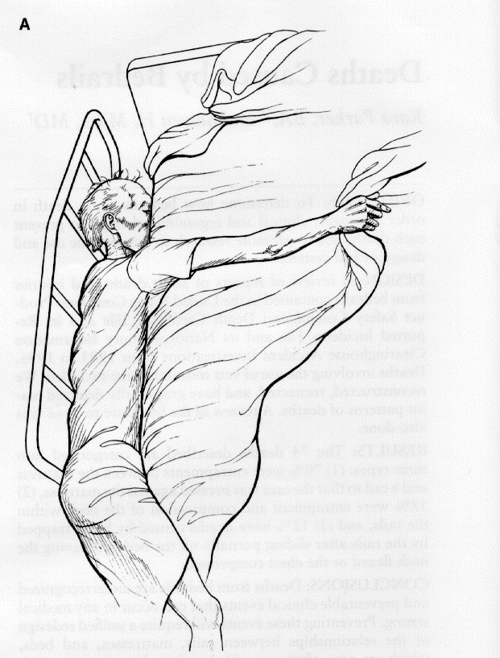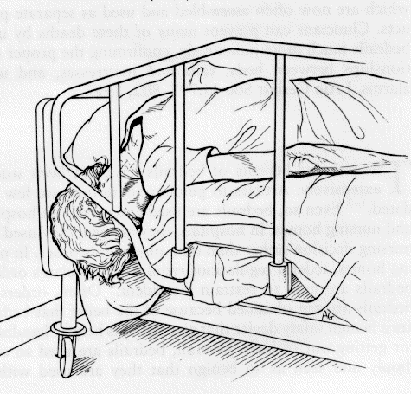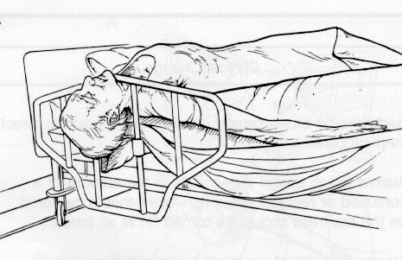

Entrapment Zone 4 (D) Entrapment Zone 5 (E) Entrapment Zone 6 (F)
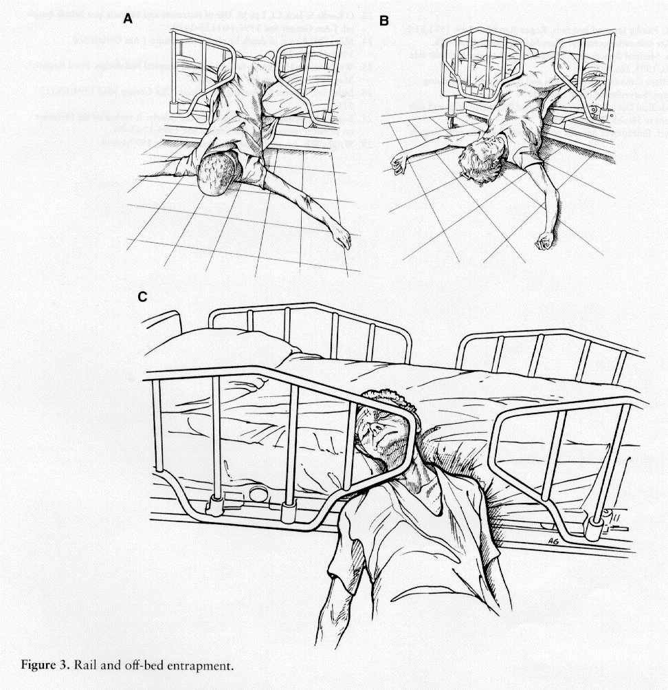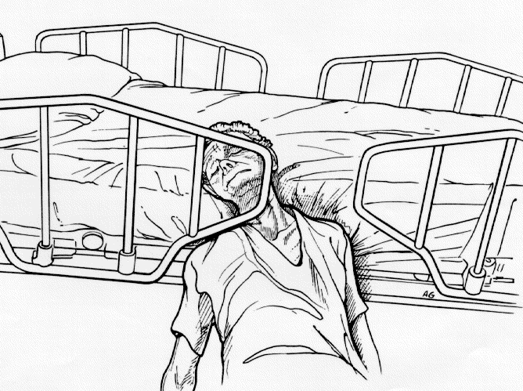

Entrapment Zone 7 (J)

Attachment II: Background Information: The Hospital Bed Safety Working Group

This workgroup was established in 1999 at the Department of Health and Human Services in Washington DC under the leadership of the Food and Drug Administration. The goal of the group is to reduce the risk of entrapment and injuries related to hospital beds, focusing on bed rails through standardization of definitions, standardization of the evaluation of beds, mattresses and side rails, and outreach to providers and patients. The working group is composed of representatives from government (including the VHA), professional and regulatory agencies (including HCFA, JCAHO), health care organizations, patient advocacy groups, and private industry. To date, the group has (1) reconciled regulatory definitions and requirements related to hospital beds; (2) authored “Universal Clinical Guidance for the Assessment for Use and Implementation of Hospital Bed Side rails in Hospitals, Long Term Care Facilities and Home Health Settings (not finalized as of April 2001); (3) developed a resident/family brochure on risks of side rails and alternatives to their use (posted on FDA website, (http://www.fda.gov/cdrh/beds/index.html) , and (4) proposed standards for seven bed system (bed/mattress/rail) measurements. These proposed measurement standards were systematically developed based on 1st and 5th percentiles for head, neck, chest measurements, then validated using actual entrapment data (Table 1).

It is expected that these measurement criteria will be submitted to the FDA in June 2001 for consideration as an FDA Guidance. The criteria were developed to be consistent with what the group believed will be international standards at a later date.

Table 1. Seven “Bed Safety Zones” and Recommended Measurement Criteria
BED-SAFETY ZONES | HEAD BREADTH  < 120 mm | NECK DIAMETER  < 60 mm | CHEST DEPTH  > 318 mm
- Rail to mattress, horizontal measurement (H) |  | ✓*
- Board to mattress, horizontal measurement (I) |  | ✓*
- Within rail (A) | ✓
- Rail to bed end (board), both ends, 60 > D > 318 (D) |  | ✓ | ✓
- Between split rails 60 > E > 318 (E) |  | ✓ | ✓
- Top of compressed Mattress to bottom of rail, at ends of rail** (F) |  | ✓
- Top of compressed Mattress to bottom of rail, between rail supports (J) | ✓
Note: All dimensions are measured with bed in typical patient care positions except for Zones 1 and 4 which are measured in the flat bed position only
* allows for mattress compression by head
** End of rail is defined as the length of rail that extends beyond the rail support / post

Attachment III: Procedure for Measurement of Entrapment Zones
A Bed System Evaluation Toolkit was developed by the FDA Bed Safety Working Group and includes a tape measure (to measure critical areas), a specially designed cone shaped device (to measure 2 1/3, 4 ¾, and 12 ½ inch spaces), a fish scale (to exert a predetermined force), and a weight to exert mattress compression that simulates the shoulder of a 170 pound adult.
Table 2. Evaluation Procedures for each Entrapment Zones
Entrapment Zone | Evaluation Procedures | Definition of “Pass”
- Rail to mattress, horizontal measurement (H) | Place bed in flat position, elevate side rails. (Elevate head end rails only for split rails.)  Push mattress against opposite side rails.  With tape measure, measure the horizontal distance between the side of the mattress and the inside surface of the side rail.  Repeat with head and knee elevated | Distance is less than 2 1/3 inches (60 mm)
- Board to mattress, horizontal measurement (I) | Place bed in flat position.  Ensure bed ends are properly installed.  Push mattress to opposite end for each measurement  With tape measure, measure the horizontal distance between the end of the mattress and the inside surface of the bed end at head and foot end. | Distance is less than 2 1/3 inches (60 mm)
- Within rail (A) | Place bed in flat position, elevate side rails  - Insert cone in the maximum space within each rail. Attempt to pull cone through rail with 12 lbs of force | Pass: Cone does not pull past 4 ¾” (120 mm)
- Rail to bed end (board), both ends, 60 > D > 318 (D) | Place bed in flat position, elevate side rails.  Insert cone between the side rail and bed end at the head and foot end.  Attempt to pull cone through the maximum space from the inside of the bed to the outside with 12 lbs. of force.  OR  Alternatively, turn cone sideways and attempt to pull through minimum space | Cone does not pull past 2 1/3 ” (60 mm)  Cone passes freely through > 12.5” (318 mm)
- Between split rails 60 > E > 318 (E) | Place bed in flat position, elevate side rails.  Insert cone at the maximum point between split rails.  Pull cone through from the inside of the bed to the outside with 12 lbs. of force.  OR  Alternatively, turn cone sideways and attempt to pull through the minimum space.  Repeat with head and knee elevated | Cone does not pull past 2 1/3” (60 mm)  Cone passes freely through > 12.5” (318 mm)
- Top of compressed Mattress to bottom of rail, at ends of rail** (F) | Place bed in flat position, elevate side rails, push mattress towards opposite side.  Have 170 lbs person lie on his/her side on mattress at edge of mattress. Have person’s shoulder positioned at end of rail.  With tape measure, measure the diagonal distance from the top of the compressed mattress to bottom of rail at the end of the rail.  - Repeat with head elevated. | Distance is less than 2 1/3” (60 mm)
- Top of compressed Mattress to bottom of rail, between rail supports (J) | Place bed in flat position, elevate side rails, push mattress towards opposite side.  Have 170 lbs person lie on his/her side on mattress at edge of mattress. Have person’s shoulder positioned between rail supports.  With tape measure, measure the diagonal distance from the top of the compressed mattress to bottom of rail between rail supports.  - Repeat with head elevated. | Distance is less than 4 ¾” (120 mm)

VISN 8 Patient Safety Center of Inquiry, Tampa VAMC, Tampa FL
VISN 16, Jackson, MS
Baltimore VAMC, Baltimore MD

