
Life Science
A curriculum and activity guide for Carlsbad Caverns National Park

Middle School Biology
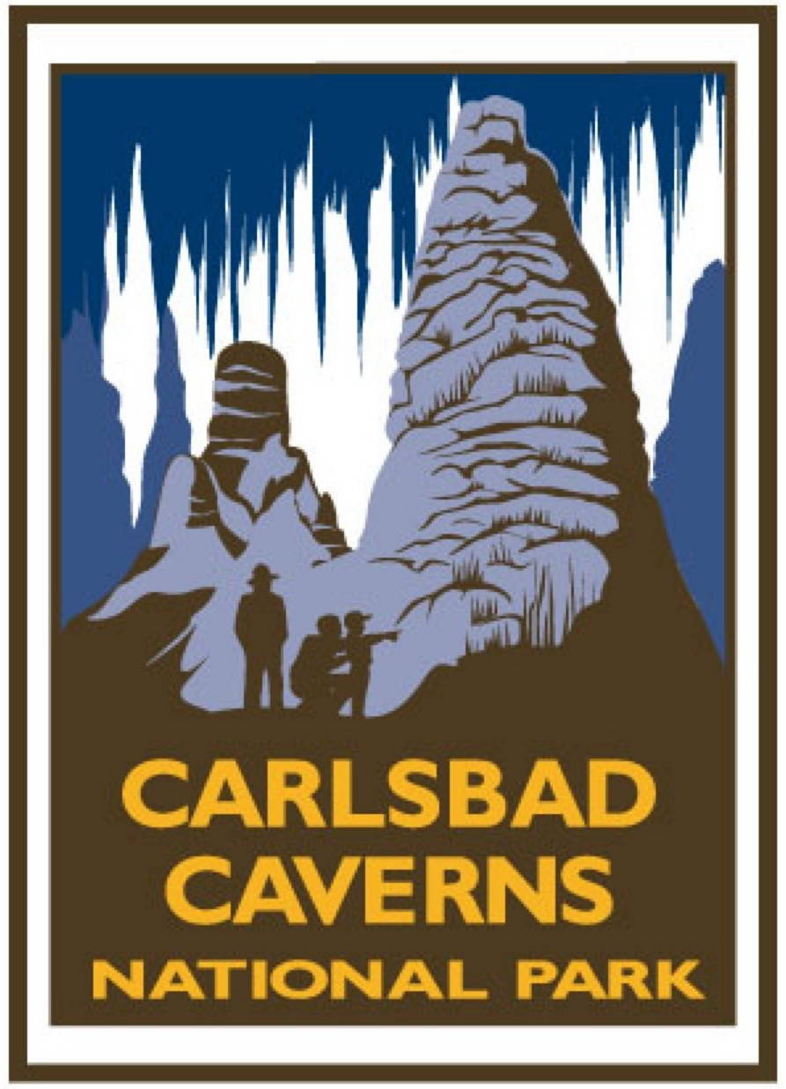
Life Science
Biology Curriculum
- Introduction 1
- Curriculum unit overview and activities

Characteristics of Life 2
- Wiggly Jiggly Cells? An introductory activity that allows students to build 3D cell models in order to have a concrete example of this concept. 3
- What Makes You Tick? Teaching portion of the unit focusing on the characteristics of plant and animal cells. 6
- Here’s Looking at You The lab portion of the unit where students collect and observe plant and animals cells under a microscope. 12
- What do You Really Look Like? A hands on activity that enhances the 3D characteristics of plant and animal cells. 17

Plant Life 24
- Structurally Sound Discuss and identify the basic parts and functions of plants, leaves, and flowers 25
- Don’t Leaf Out Photosynthesis Activity designed to increase the student awareness of photosynthesis and transpiration. 35
- Am I Leaking? Hands-on activity allowing students to witness the gas exchange in the atmosphere associated with the process of transpiration. 38
- One Tough Dude Activity designed to help students understand the plant adaptations needed to survive in the Chihuahuan Desert. 43
- To Be or Not to Be Activity designed to witness the plant adaptation of asexual reproduction, identify plants in the Chihuahuan Desert that reproduce asexually. 49
- Which is Which? An activity designed to differentiate between deciduous and coniferous trees through hands-on activities. 55
- Where in the World An activity to help students understand the importance of plants in the economy. 60

Animal Life 64
- The Taxonomic Shuffle
- Sorting out Species Activity designed to help students establish a criteria to separate items into groups. 65
- All in the Family Activity design to help students understand how scientists classify animals. 72
- Desert Animal Adaptations
- Why Do We Look the Way We Do? Activity to provide students with hands-on exploration of animal adaptations, specifically the different beaks and feet of common birds. 76
- Help! I’m Dehydrating activity designed to increase the students’ understanding of how desert animals conserve water. 84
- Designer Animal Adaptations Research of desert animal adaptations in order to discover how animals are designed to survive in the harsh desert climate. 88
- Animals That Live in the Dark Activity to help students understand the characteristics of different cave animal adaptations. 92
- Build an Animal Students design a hypothetical desert animal and classify it into its proper group. 97
- Nature Detective A day hike anywhere (Rattlesnake Springs, Carlsbad Caverns Nature Trail, school grounds, are all options) allowing students to observe and investigate plants and animals in the environment. 102
- Build a Desert Diorama Students will design a diorama to show desert animals in their natural habitat. 106
- Benchmarks and Standards 109
- Glossary 116
- Resources 121


Introduction
This curriculum guide was developed for middle school teachers to be used as a resource aid in the classroom. While it was designed as a project sponsored by Carlsbad Caverns National Park and written by local area teachers from the Carlsbad School District, Carlsbad, New Mexico, the information is applicable anywhere in the country. The curriculum guide follows a format that is intended to be user-friendly and resource-rich: a unit overview provides general information concerning the specific topic and follow-up activities supplement the lesson. Content standards and benchmarks (specific to New Mexico), a glossary, and additional resources are also provided.
The education office at Carlsbad Caverns National Park hopes you find this curriculum guide useful and beneficial. For additional information concerning other curriculum materials, contact the Education Specialist, Carlsbad Caverns National Park, 3225 National Parks Highway, Carlsbad, New Mexico 88220.

Characteristics of Life
In order to gain a basic understanding of all living things scientists must first understand the cellular structure of living organisms. All living things (plants, animals, and bacteria) are made up of cells. Living cells are divided into two basic types: prokaryotic and eukaryotic. The cells studied in this unit are eukaryotic. The eukaryotic cells of higher plants and animals are highly structured. These cells have developed internal organelles that help them survive. In addition, there is mention of on-going microbial research in Lechuguilla Cave in the Carlsbad Caverns National Park.
This unit focuses on the similarities and differences in plant and animal cells. In the first activity, students create 3D cell models in order to have a concrete example of this concept. The second activity is the teaching portion of the unit that focuses on the characteristics of plant and animal cells. The third activity is the lab portion of the unit where students collect and observe plant and animal cells under a microscope. The last activity is a hands-on activity that enhances the 3D characteristics of plant and animal cells.

Wiggly, Jiggly Cells?
3D cells are a hard concept for students to grasp. When viewed under
a microscope they appear 2D. We are going to create 3D cells.
Summary: Students will observe the 3D models of plant and animal cells and describe their appearance.
Duration: 2 class periods
Setting: Classroom
Vocabulary: cell, cell organelles, mitochondria, chloroplasts, cell membrane, cell wall, nucleus, ribosomes
Standards/Benchmarks Addressed: SC1-E2, SC2-E3, SC3-E1, SC6-E2, SC6-E6, SC6-E7, SC10-E1, SC10-E2

Objectives
Students will:
- create a 3D plant and a 3D animal cell following the directions given.
- describe the cell as a 3D object rather than a 2D object as observed under a microscope.
- describe the appearance and location of various cell organelles within a cell.
- compare and contrast the 3D plant cell and the 3D animal cell.
Background
A cell is the basic unit of life. All living things are made up of cells (plants, animals, and bacteria). These organisms can be either one-celled or multicellular. Most cells are so small that they cannot be seen without a microscope. In multicellular organisms, cells are specialized to carry out different functions to sustain life. In one-celled organisms the cell carries out all the functions to sustain life within itself.
Living cells are divided into two types: prokaryotic and eukaryotic. This division is based on internal complexity.
The eukaryotic cells of protozoa, higher plants, and animals are highly structured. These cells tend to be larger than cells of bacteria, and have developed specialized packaging and transport mechanisms that may be necessary to support their larger size.
Prokaryotic cells are simple in structure, with no recognizable organelles. They have an outer cell wall that gives them shape. Just under the rigid cell wall is the more fluid cell membrane. The cytoplasm enclosed within the cell membrane does not exhibit much structure when viewed by electron microscopy.
Animal and plant cells are eukaryotic. Every animal and plant cell has a nucleus that contains chromosomes. The nuclear envelope surrounding the nucleus separates the chromosomes from the cytoplasm. Chromosomes carry genes (these are bits of DNA, the heredity material).
Animal and plant cells also contain cytoplasm. Perhaps the most important things to be found in cytoplasm are mitochondria. A mitochondrion contains all the enzymes to obtain energy from glucose. They can be seen in detail with an electron microscope. Mitochondria also contain a bit of DNA, which controls how they work. Some people think that mitochondria look like bacteria.
Animal and plant cells also have a cell membrane around them. Cell membranes are very thin; nevertheless they are able to control what can get in or out of a cell.
Plant cells are surrounded by a cell wall made of cellulose. The cell wall is not living. The only thing the cell wall does is to allow very high pressure to build up inside the cell because of osmosis. Since cells have semi-permeable cell membranes, water can enter or leave by osmosis. When plant cells are put in distilled water they start to swell up, but they do not burst. Animal cells are different; they do not have cell walls. If one of your body cells is placed in distilled water it will swell up and burst. That means that animals have to excrete excess water. Some plant cells have an organelle called chloroplast that takes energy from the sun and converts it into sugar.
Materials
Plastic sacks
Twist ties
Lemon Jell-o
Boiling water
Large mixing bowls
Spoons
Square plastic food container
Plums
Mandarin oranges
Grapes
Refrigerator
Procedure
Warm up: Ask, “What is a cell and what do you think it looks like?” Make a list of the students’ answers and discuss. Discuss with students that cells are 3D objects but when we study them under microscopes we only see them as 2D objects. Before beginning our study of cells we will be creating 3D cells.

Activity
- Students, in groups or individually, will select 2 plastic sacks. They will put one plastic sack in a small square plastic container so that the plastic sack completely lines the container. The other plastic sack should be open on the desk.
- Each student or group should put the same amount of warm lemon Jell-o into the two plastic sacks so that they are nearly full. Then the required cell organelles should be put into the Jell-o: 1 plum representing the nucleus, 2-4 mandarin oranges representing the mitochondria, 2-4 grapes to represent chloroplasts (to be put only in the square plastic container). The plastic sacks represent cell membranes while the plastic container represents a cell wall. The cells should then be closed with a twist tie and refrigerated until the next day.
- The completed cells should be discussed in depth and compared for structure and appearance. Students should be able to differentiate between the plant cell (in the square container) and the animal cell. Be sure that the students understand that cell walls and chloroplasts are only found in plant cells.
Wrap Up: Student can draw a picture of both the cells being sure to draw everything that they see and labeling each part. Eat your cells and enjoy!
Assessment
Draw a picture of both the cells and label the parts of the cells accurately.
Extension
This lesson lends itself to discussions of tissue and how cells are grouped together to make tissue. You may want to stack the cells together and show how tissue is formed.

What Makes You Tick?
Cells are full of organelles. This lesson describes the location
and function of the organelles in plant and animal cells.
Summary: This lesson is designed to teach the students about cell organelles and their functions within plant and animal cells.
Duration: 1 class period
Setting: Classroom
Vocabulary: cell membrane, centrosome, cytoplasm, Golgi body, lysosome, mitochondrion, nuclear membrane, nucleolus, nucleus, ribosome, rough endoplasmic reticulum (rough ER), smooth endoplasmic reticulum (smooth ER), vacuole, chloroplast, cell wall, prokaryotic, eukaryotic
Standards/Benchmarks Addressed: SC1-E2, SC3-E1, SC5-E2, SC5-E3, SC6-E2, SC6-E3, SC6-E5, SC6-E6, SC10-E1, SC10-E2

Objectives
Students will:
- define vocabulary associated with cell structure.
- label the parts of plant and animal cells correctly.
Background
A cell is the basic unit of life. All living things are made up of cells (plants, animals, and bacteria). These organisms can be either one-celled or multicellular. Most cells are so small that they cannot be seen without a microscope. In multicellular organisms, cells are specialized to carry out different functions to sustain life. In one-celled organisms the cell carries out all the functions to sustain life within itself.
Living cells are divided into two types: prokaryotic and eukaryotic. This division is based on internal complexity.
The eukaryotic cells of protozoa, higher plants, and animals are highly structured. These cells tend to be larger than cells of bacteria, and have developed specialized packaging and transport mechanisms that may be necessary to support their larger size.
Prokaryotic cells are simple in structure, with no recognizable organelles. They have an outer cell wall that gives them shape. Just under the rigid cell wall is the more fluid cell membrane. The cytoplasm enclosed within the cell membrane does not exhibit much structure when viewed by electron microscopy.
Animal and plant cells are eukaryotic. Every animal and plant cell has a nucleus that contains chromosomes. The nuclear envelope surrounding the nucleus separates the chromosomes from the cytoplasm. Chromosomes carry genes (these are bits of DNA, the heredity material).
Animal and plant cells also contain cytoplasm. Perhaps the most important things to be found in cytoplasm are mitochondria. A mitochondrion contains all the enzymes to obtain energy from glucose. They can be seen in detail with an electron microscope. Mitochondria also contain a bit of DNA, which controls how they work. Some people think that mitochondria look like bacteria.
Animal and plant cells also have a cell membrane around them. Cell membranes are very thin; nevertheless they are able to control what can get in or out of a cell.
Plant cells are surrounded by a cell wall made of cellulose. The cell wall is not living. The only thing the cell wall does is to allow very high pressure to build up inside the cell because of osmosis. Since cells have semi-permeable cell membranes, water can enter or leave by osmosis. When plant cells are put in distilled water they start to swell up, but they do not burst. Animal cells are different; they do not have cell walls. If one of your body cells is placed in distilled water it will swell up and burst. That means that animals have to excrete excess water. Some plant cells have an organelle called chloroplast that takes energy from the sun and converts it into sugar.
Materials
Science textbook
Student handouts of plant and animal cells
Procedure
Warm up: Ask students to recall what they already know about cells and cell structure. Write the students’ responses on the board.

Activity
- Students will be given the vocabulary words to look up in their science textbook or other resource (dictionary, Internet, or encyclopedia). Students must write the definition of each word.
- Students will then work in pairs to complete the worksheets for plant and animal cells. Students should be allowed to use any resources needed to correctly label the worksheets.
- Discuss the cell organelles. Describe their location and function within the cell.
Wrap Up: Discuss the similarities and differences in plant and animal cells.
Assessment
Participation, completed worksheets and vocabulary words.
Name ____________________
What Makes You Tick?
Plant Cell Worksheet
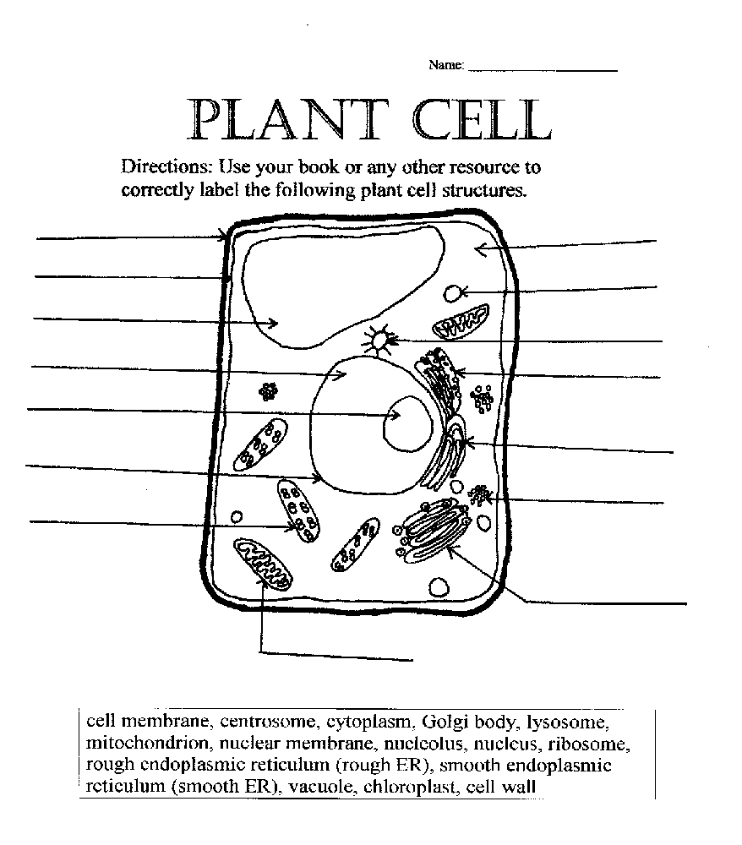

What Makes You Tick?
Plant Cell Answer Key
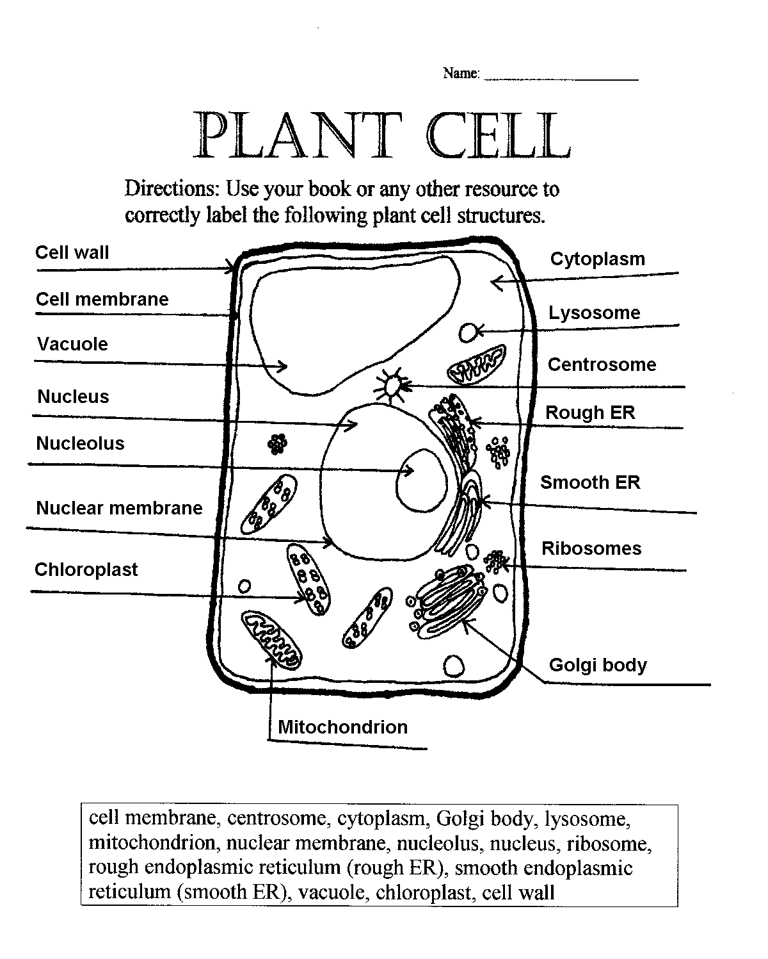
Name ____________________
What Makes You Tick?
Animal Cell Worksheet
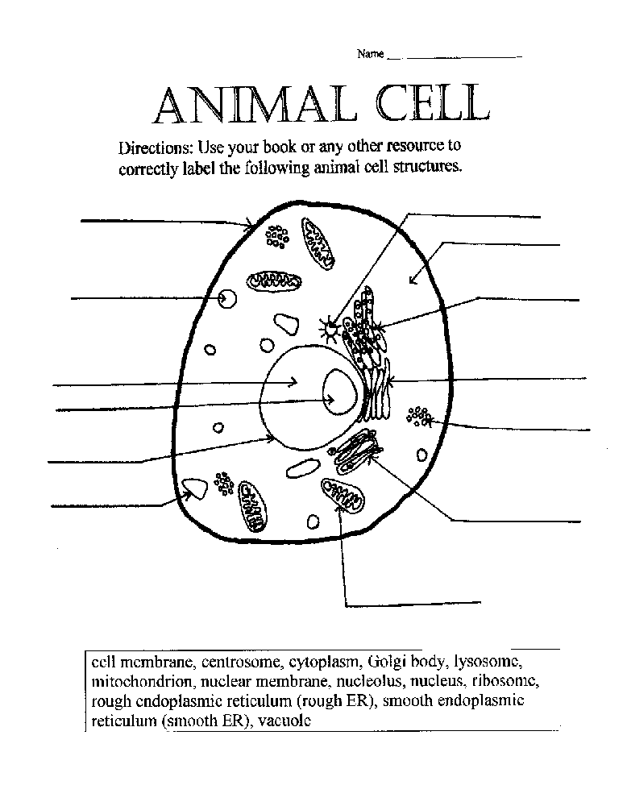
What Makes You Tick?
Animal Cell Answer Key
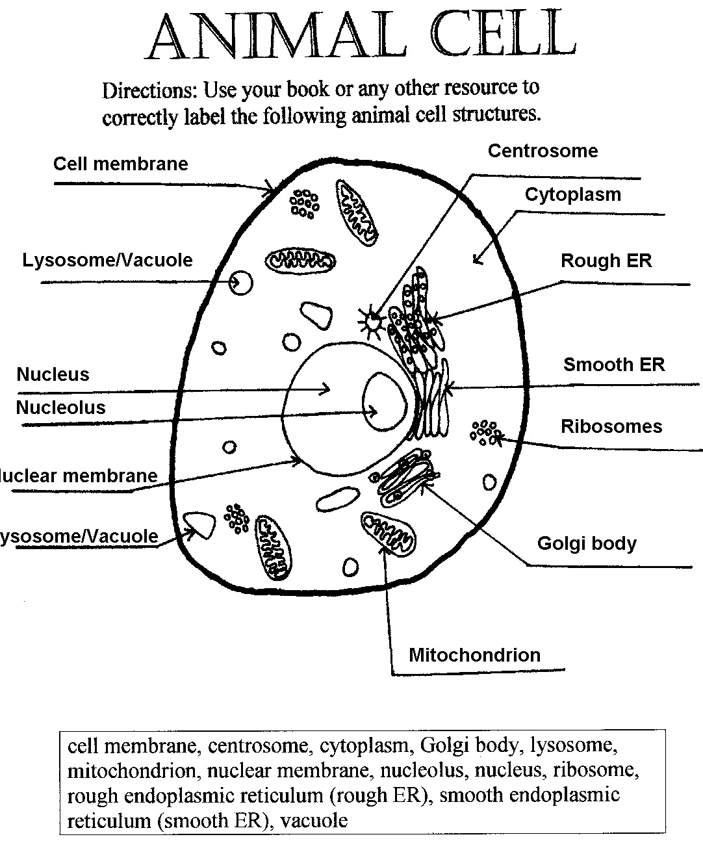

Here’s Looking At You!
Under the microscope you will be able to see the basic organelles in plant
and animal cells. However, these cells appear 2D but are actually 3D.
Summary: This lab is designed so that students can observe a real plant and animal cell under the microscope.
Duration: 1 class period
Setting: Lab
Vocabulary: bacteria, fungi, chemolithotrophs, biothems
Standards/Benchmarks Addressed: SC1-E2, SC3-E1, SC4-E3, SC5-E1, SC5-E2, SC5-E3, SC6-E1, SC6-E2, SC6-E3, SC6-E5, SC6-E6, SC6-E7, SC6-E8, SC10-E1, SC10-E2

Objectives
Students will:
- use a microscope to observe plant and animal cells.
- describe in writing what they observed about plant and animal cells.
Background
In April of 1989, an expedition went down to the deepest known cave pool in Lechuguilla Cave in the Carlsbad Caverns National Park. The team was going to check the hydrogen sulfide level of the cave pool. Cavers had reported smelling a rotten egg odor in the cave. The scientists thought this could mean they were nearing the water table, a first for a Guadalupe cave. A geologist, Kiym Cunningham, was on the expedition. When Cunningham submerged his hands into the cave pool he felt a loose piece of rock. He brought the rock out and took it to his lab to see what the areas of unusual staining were.
After looking at the stains for several hours, under the microscope, he noticed some fungi, which feed on bacteria. He questioned how something could be living so deep in the Earth with no organic food. When he went back to the cave for more research he started to think about rock-eating bacteria, called chemolithotrophs. These organisms are only found in deep aquifers where they form rich microbial ecosystems. Scientists have discovered a strong connection between geology and biology. Nowhere is it more noticeable than in limestone.
These bacteria live throughout Lechuguilla Cave in various cave pools. The bacteria that live in the cave today are direct descendants of the sulfur-loving ones in the oil fields when the cave was formed. That means that the bacteria in Lechuguilla are living relics of an ancient underground ecosystem. With further research scientists have discovered hundreds of types of bacteria in Lechuguilla’s cave pools. Many of these bacteria are still being studied.
The bacterial cells found in Lechuguilla’s cave pools have been extensively studied. Some of these organisms seemed to show the ability to kill cells associated with a particular type of breast cancer without harming healthy cells. How can these cave bugs be capable of this? It has been suggested that in order for these bacteria to protect its underground food source from invading fungi, the organisms have developed powerful toxins to attack an enzyme associated with a particular fungal growth phase. Like humans, fungi are highly evolved eukaryotes. It seems quite possible for some unicellular cave fungi to employ a growth mechanism similar to the ones that cause malignancies to blossom.
Cave bacteria have become adept at sticking tightly to surfaces in places where food will come to them. It turns out that sticking tightly to surfaces is an attribute that researchers look for in anti-cancer drugs. A few of the Lechuguilla samples are very proficient at killing any type of adjoining cell-- animal, plant, fungal, diseased, or healthy. Research has shown that three of the bacteria found in Lechuguilla cave target breast cancer cells.
There is continuing research on the bacteria and microbes found in cave pools. Scientists study microbes using a similar but more complex process than we are using in our lab today.
Materials
Iodine solution
Dropper bottles
Microscope slides
Cover slips
Onion
Tweezers
Microscope
Dropper
Pond water
Student lab worksheets
Prep
- Collect or order pond water for use in this lab.
- Make a diluted iodine solution mixing just enough iodine to color the water gold; put this solution into the dropper bottles.
- Cut the onion into squares.
- Have all lab supplies out and ready before the class starts.
Procedure
Warm up: Review with students the parts of the cells. What is the major difference between plant and animal cells? Today we are going to look at real plant and animal cells under the microscope.

Activity
- Detail all safety reminders: Iodine is toxic so do not drink it. Wear safety goggles at all times. Clean up any spills immediately. Wash your hands when you are finished.
- Show students how to make a wet mount: show them how to add a cover slip to the microscope slide by holding it over the specimen at an angle to the slide (Be sure the bottom is touching the slide) and gently drop the cover slip on top of the specimen.
- Students will be paired up and given the lab worksheets that detail the steps for the lab.
Wrap Up: Students will answer questions and do a lab write-up discussing what they did, why they did it, and how it connects to the unit of study.
Assessment
Completed worksheets and lab write-up.

Extension
You may want to collect water from other outdoor sources such as river water, rain water, and puddle water to compare with the pond water. You may also want to bring in a variety of other vegetable peelings such as potato and carrot peelings to be compared with the onion peeling.
Have students view materials from other living things under the microscope. Some suggestions include a strand of hair, a flower petal, and a piece of a leaf.
*For: pond water:
Carolina Biological Supply Co.
2700 York Road
Burlington, NC 27215
1-800-334-5551
Name ____________________
Here’s Looking at You
Lab Procedure
Materials:
Iodine solution in dropper bottle, 2 microscope slides, piece of onion, tweezers, 2 cover slips, microscope, dropper, pond water
Procedure:
- Use a dropper to put a drop of iodine solution in the middle of a microscope slide. Caution: Iodine will stain and can be harmful if swallowed.
- Bend a piece of onion back so that it breaks in two. Slowly pull the two halves apart. A thin layer of onion will peel off. Use tweezers to remove a piece of this layer.
- Float the layer of onion in the drop of iodine. Place a cover slip over the onion on the slide.
- Observe the onionskin under the low power of the microscope. Draw several of the cells you observe.
- Observe the onionskin under high power. Focus on one cell. Make a drawing of the cell and label the cell parts you can identify.
- Place a drop of pond water on another microscope slide. Place a cover slip over the drop.
- Observe the pond water under low power. Make drawings of any one-celled organisms you can see.
Name ____________________

Here’s Looking at You
Lab Results

Onion cells under low power Onion cell under high power

One-celled organisms in pond water

Write the answers to these questions using what you learned from the lab.
- What do onion cells look like?

- List the cell parts you observed. You may refer to your book for help.

- Did you observe any one-celled organisms in the pond water?

What Do You Really Look Like?
Cells may appear as 2D objects when viewed under the microscope;
however, they are actually 3D objects. We are going to be making 3D cells
that include the major components of cell structure.
Summary: This lesson is designed to extend the students’ knowledge of cellular structure, organelles, and their functions within plant and animal cells.
Duration: 1 class period
Setting: Classroom
Vocabulary: cell membrane, cytoplasm, lysosome, mitochondrion, nuclear membrane, nucleus, ribosome, rough endoplasmic reticulum (rough ER), smooth endoplasmic reticulum (smooth ER), vacuole, chloroplast, cell wall, chromosomes
Standards/Benchmarks Addressed: SC1-E2, SC2-E2, SC2-E3, SC3-E1, SC6-E1, SC6-E2, SC6-E3, SC6-E4, SC6-E5, SC6-E6, SC6-E7, SC10-E1, SC10-E2

Objectives
Students will:
- create 3D plant and animal cells.
- compare and contrast plant and animal cell structure.
- demonstrate and understand the 3 dimensional aspect of cell structure.
- identify the various parts of plant and animal cells.
Background
A cell is the basic unit of life. All living things are made up of cells (plants, animals, and bacteria). These organisms can be either one-celled or multicellular. Most cells are so small that they cannot be seen without a microscope. In multicellular organisms, cells are specialized to carry out different functions to sustain life. In one-celled organisms the cell carries out all the functions to sustain life within itself.
Living cells are divided into two types: prokaryotic and eukaryotic. This division is based on internal complexity.
The eukaryotic cells of protozoa, higher plants, and animals are highly structured. These cells tend to be larger than cells of bacteria, and have developed specialized packaging and transport mechanisms that may be necessary to support their larger size.
Prokaryotic cells are simple in structure, with no recognizable organelles. They have an outer cell wall that gives them shape. Just under the rigid cell wall is the more fluid cell membrane. The cytoplasm enclosed within the cell membrane does not exhibit much structure when viewed by electron microscopy.
Animal and plant cells are eukaryotic. Every animal and plant cell has a nucleus that contains chromosomes. The nuclear envelope surrounding the nucleus separates the chromosomes from the cytoplasm. Chromosomes carry genes (these are bits of DNA, the heredity material).
Animal and plant cells also contain cytoplasm. Perhaps the most important things to be found in cytoplasm are mitochondria. A mitochondrion contains all the enzymes to obtain energy from glucose. They can be seen in detail with an electron microscope. Mitochondria also contain a bit of DNA, which controls how they work. Some people think that mitochondria look like bacteria.
Animal and plant cells also have a cell membrane around them. Cell membranes are very thin; nevertheless they are able to control what can get in or out of a cell.
Plant cells are surrounded by a cell wall made of cellulose. The cell wall is not living. The only thing the cell wall does is to allow very high pressure to build up inside the cell because of osmosis. Since cells have semi-permeable cell membranes, water can enter or leave by osmosis. When plant cells are put in distilled water they start to swell up, but they do not burst. Animal cells are different; they do not have cell walls. If one of your body cells is placed in distilled water it will swell up and burst. That means that animals have to excrete excess water. Some plant cells have an organelle called chloroplast that takes energy from the sun and converts it into sugar.
Materials
Play-doh
Food coloring or tempura paint (red, purple, green, blue)
Disposable gloves
Yarn
Peppercorns
Plastic bubble packing
Aluminum foil
Plastic wrap
Pencil shavings
Scissors
Large knife
Glue
Prep
Make or buy play-doh in these colors—red, purple, green, blue
Recipe: makes enough for 3 groups
1 cup of baking soda
1 cup flour
1 cup corn starch
4 teaspoons cream of tartar
2 tablespoons oil
1 3/4 cup water
A few drops of food coloring (red, purple, green, blue)
Stovetop method: Mix and cook until dough leaves the sides of the pan. Cool on a plate with a wet cloth on top.
Oven method: Bake at 150⁰F overnight.
*** To color play-doh use either food coloring or tempura paint. This is where the disposable gloves would be handy.
Procedure
Warm up: Have students quickly write the major differences in plant and animal cells.

Activity
- Divide class into groups of 2-4 students.
- Have materials gathered and laid out according to the number of students. Hand out the materials and lists of cell structures to each group.
- Tell students they will be making two cells (one plant and one animal). The first portion of the lab will focus on creating the cell structures. Students are to fold, cut, and paste until the cell structure is simulated. The students should look at pictures and lists of the cell structures in order to make them as accurate as possible. Tell the students not to put the cells together until you give them directions to do so.
- Students are to cut the large piece of plastic in half and place each half on the table.
- Roll the plain play-doh into 2 equal balls. Lay 1 ball on each piece of plastic wrap and press each into a pancake about 6 inches around.
- Have the students designate one pancake “animal cell” and the other “plant cell.”
- Have the students place their finished cell structures (except the cell wall) in a pile on the center of the appropriate pancake.
- When all cell parts are in place gather up the pancake, carefully cupping it around its toppings, and seal all the edges together forming a ball of “cytoplasm.” Now wrap the plastic wrap around the cytoplasm of both cells to form the cell membrane. Then wrap the aluminum foil around the plant cell to form the cell wall.
- Cells may then be set aside for the next class period or each may be cut in half for observation right away.
Wrap Up: Ask the students:
- What did you do?
- What did you learn from this?
- How can you use this information again?
Assessment
Teacher observation, cell quiz.
List of Cell Structures
(What Do You Really Look Like? Activity)
Use the following chart to identify the material needed to create each cell structure. Refer to your book for cell appearance.
Cell Structure | Material needed
Cytoplasm | Plain play-doh about 260g
Endoplasmic reticulum | Yarn
Ribosomes | Whole Peppercorns
Mitochondria | Purple play-doh about 7g
Vacuole | Small piece of plastic bubble packing
Lysosome | Red play-doh about 5g
Chloroplasts | Green play-doh about 10g
Cell Wall | Aluminum foil 12”x7”
Cell Membrane | Plastic Wrap 12”x16”
Nucleus | Blue play-doh about 20g
Nuclear Membrane | Plastic Wrap 3”x6”
Chromosomes | Pencil shavings

Name ____________________

Plant and Animal Cell Quiz
(What Do You Really Look Like Activity)
Matching: use the words in the box below and write them next to the correct definition.
cell membrane, centrosome, cytoplasm, Golgi body, lysosome, mitochondrion, nuclear membrane, nucleolus, nucleus, ribosome, rough endoplasmic reticulum (rough ER), smooth endoplasmic reticulum (smooth ER), vacuole, chloroplast, cell wall
- This is a fluid-filled, membrane-surrounded cavity located inside a cell. It fills with food being digested and waste material that is on its way out of the cell. _________________
- This is a flattened, layered, sac-like organelle that looks like a stack of pancakes and is located near the nucleus. It produces the membranes that surround the lysosomes. It packages proteins and carbohydrates for “export” from the cell. ____________________
- This is an elongated or disc-shaped organelle containing chlorophyll. Photosynthesis takes place here. _____________________
- These are small organelles composed of RNA rich cytoplasmic granules that are sites of protein synthesis. _____________________
- This is an organelle within the nucleus. It is where ribosomal RNA is produced. ____________________
- This is the thin layer of protein and fat that surrounds the cell. It is semipermeable, allowing some substances to pass into the cell and blocking others. ____________________
- These are spherical organelles surrounded by a membrane; they contain digestive enzymes. This is where the digestion of cell nutrients takes place. ____________________
- This is a vast system of interconnected, membranous, infolded, and convoluted tubes that are located in the cell’s cytoplasm. It transports materials throughout the cell. It contains enzymes and produces and digests lipids (fats) and membrane proteins. It buds off the rough ER, moving the newly made proteins and lipids to the Golgi body, lysosomes, and membranes. ________________________
- This is a thick, rigid membrane that surrounds a plant cell. This layer of cellulose fiber gives the cell most of its support and structure. _____________________
- This is the membrane that surrounds the nucleus. _______________________
- This is a jelly-like material outside the cell nucleus in which the organelles are located. _____________________
- This is a vast system of interconnected, membranous, infolded, and convoluted sacks that are located in the cell’s cytoplasm. It is covered with ribosomes that give it a rough appearance. It transports materials through the cell and produces proteins in sacks called cisternae. ______________________
- This is a small body located near the nucleus. It has a dense center and radiating tubules. It is where microtubules are made. __________________________
- This is a spherical body containing many organelles, including the nucleolus. It controls many of the functions of the cell. _____________________
- This is a spherical to rod-shaped organelle with a double membrane. The inner membrane is infolded many times, forming a series of projections. It converts the energy stored in glucose into ATP (adenosine triphosphate) for the cell. It is often referred to as the powerhouse of the cell. _________________________
Essay: Please answer the following question in a paragraph using complete sentences. Compare and contrast a plant and animal cell. How are they alike and how are they different?
____________________________________________________________________________________________________________________________________________________________________________________________________________________________________________________________________________________________________________________________________________________________________________________________________________________________________________________________________________________________________________________________________________________________________________________________________________________________________________________________________________________________________________________________________________________________________________________________________________________________________________________________________________________________________________________________________________________________________________________________________________________________________________________________________________________________________________________________________________________________________________________________________________________________________________________________________________________________________________________________________________________________________________________________________________________________________________________________________________________________________________________________________________________________________________________________________________________________________________________________________________________________________________________________________________________________________________________________________________________________________________________________________________________________________________________________________________________________________________
Key for Matching: (5 points each)
- Vacuole
- Golgi body
- Chloroplast
- Ribosome
- Nucleolus
- Cell membrane
- Lysosome
- Smooth endoplasmic reticulum (smooth ER)
- Cell wall
- Nuclear membrane
- Cytoplasm
- Rough endoplasmic reticulum (rough ER)
- Centrosome
- Nucleus
- Mitochondrion
Essay: (25 points)
Answers will vary. Be sure that the students mention that plant cells are different from animal cells because plant cells have chloroplasts and cell walls.

Plant Life
With searing heat, dry air, and little rainfall, a desert hardly seems like a good spot for plant to grow. In many ways it’s not. Deserts can go for years without rain. When it does hit they can receive a year’s worth within hours. This deluge often washes away immediately with only a little water soaking into the ground where a plant’s roots can absorb it.
The hot sun can raise a plant’s internal temperature too high for photosynthesis to occur and even to the point where the plant’s tissues can literally cook. In a cold desert temperatures can dip to the point where a plant’s inner fluids expand as ice forms and results in rupturing the plant’s cell walls.
All in all, the desert is a challenging place for plant survival. Yet for thousands of years plant species have adapted and thrived in arid lands.
It is these adaptations that are the focus of this unit.
This unit will look at other aspects of plants, from their function to their importance. In the lesson, Structurally Sound, students will identify the basic parts and functions of plants, leaves, and flowers. The students will gain a greater understanding of the process of photosynthesis and transpiration in the lesson, Don’t Leaf Out Photosynthesis. Students will participate in experiments designed to encourage observation of various desert plant adaptations. In To Be or Not to Be students will start a plant by means of vegetative propagation. A field trip will be taken so students can identify trees through the use of a dichotomous key. In the last lesson, students will understand the importance of plants in the economy by identifying various plant byproducts.

Structurally Sound
Properties of leaves, plant, and flower
Summary: This lesson is an introduction to the properties of the parts of leaves, plants, and flowers.
Duration: 1 class period
Setting: classroom
Vocabulary: Leaf - lamina, leaf apex, axil, petiole, midrib, vein, stipule, stem; Flower-stigma, style, ovary, sepal, filament, anther, stamen, carpel (pistil), stem, petal, whorls; Plant - axillary bud, terminal bud, flower, flower stalk, axil, lateral shoot, leaf, petiole, root, root cap, tap root, stem, node, internode, angiosperms, dicotyledon, monocotyledon
Standards/Benchmarks Addressed: SC1-E1, SC3-E1, SC4-E6, SC6-E1, SC6-E2, SC6-E3, SC6-E6, SC10-E2, SC11-E4, SC11-E5, SC12-E2

Objectives
Students will:
- be able to label the parts of a flower.
- be able to label the parts of a plant.
- be able to label the parts of a leaf.
- be able to describe the plant-seed cycle.
Background

Plant Seed Cycle
Seed Dispersal – Plants have ways of scattering their seeds. A few plants burst open throwing their seeds out while others depend on the wind to spread them. Some rely on animals and people to disperse the seeds in a variety of ways. Some “hitchhikers” cling to clothing or fur. Animals that feed on the fruits disperse the seeds through their droppings.
Germination – Seeds need three things to germinate: warmth, moisture, and oxygen. Moisture works to soften the seed coat. Once softened it will swell and split, allowing the primary root to anchor the plant to the ground. As the root system develops, the epicotyl grows upward and the stem breaks through the soil. This growth carries the cotyledons above the ground. It is then that the seed coat falls off. The cotyledons open. This frees a bud called a plumule, which then produces the first leaves. Since the seedling now has its own developed roots and leaves and can make its own food, it no longer needs the cotyledon.
Pollination – When pollen grains are fully developed, the anther bursts open. Unable to move by themselves, the pollen grains must be carried or moved to the female parts of the flower before they can begin fertilization. One way pollen grains find their way to the pistil of another flower is by wind. The sweet scent or nectar of some flowers attracts insects or birds who will also carry the grains with them as they move from flower to flower. The transfer of pollen from the stamen to the pistil of the same flower is called self-pollination. When the pollen grain reaches the pistil of another flower, it is called cross-pollination.
Fertilization – As soon as the pollen lands on the pistil, a very thin tube begins to grow down to the ovary. It grows through the ovary wall and reaches the ovule inside. When the pollen tube touches the ovule, fertilization begins and a seed develops.

Flower Structure: Flowers vary in shape, size, and color. Fragrances of flowers range from sweet ones to those that smell like rotten meat. Flower shapes also vary among species. Flowers are the reproductive structures of angiosperms, plants whose seeds develop from fertilized ovules. Flowering plants are divided into two classes: Dicotyledon and Monocotyledon. Approximately seventy-five percent of flowering plants are dicots. This includes flowering trees, shrubs, annual, and perennial plants. Most flowers consist of four structural parts, which are attached to the flower base in whorls. The outer whorl consists of the sepals; followed by the petals, then the stamens, and the inner most whorl is the pistil. At the base of the pistil is the ovary which envelops the ovules, and this is where fertilization occurs. The outer two whorls, sepals and petals, serve to protect the inner parts of the flower and attract pollinators to the flowers. Flowers which contain all four whorls are considered “complete.” Flowers lacking one or more of the four whorls are termed “incomplete.”
Leaves: A leaf is a part of the plant where most of its food is made. Most leaves have two parts, the blade and the stalk. The lines or ridges on the leaf are veins. Veins hold tubes like those in the stems. Some of these tubes in the veins transport food from the leaves to the stems. Other tubes in the veins carry water and minerals from the stems to the leaves. Plants get air from openings on the underside of the leaf. These openings are called stomates. The stomates can be opened and closed. Air also moves in and out through tiny slits in stems. Plants with flat leaves like those found on flowering plants are called broad-leaved plants. There are two types of broad-leaved plants; those with simple leaves and those with compound leaves. A simple leaf has a single blade attached to a stalk. A compound leaf has one stalk with several blades attached. A conifer has leaves that look like needles, so they are called needle-leaved plants. These leaves have a tough outer covering that keeps the plant from losing a lot of water.
Materials
Different types of leaves
Several plants (flowering and non)
Flowers (preferably large flowers such as day lilies or tiger lilies)
Black construction paper
Flour
Celery stalk
Container
Water
Food coloring
Procedure
Warm up: Begin class by passing around different plants, leaves, and flowers for student observation. Have students examine the flower. Ask students to identify the feature of the flower that allows the pollen to attach to the stigmas. Next, ask students to name the different parts of the plants. Write their responses on the chalkboard. Show students a label list of all the different parts of the plants and explain to them that they will be participating in an activity that will allow them to identify the parts of a plant and a leaf. Explain that they will also be dissecting a flower in order to better understand the parts of a flower and their function.
Activity
- Students will work in pairs.
- Give each student copies of Label the Plant, Label the Flower, and Label the Leaf.
- Give each group a plant, a flower, and some leaves.
- Have students run their hands up the stem (also called the pedicel) until they reach the top portion of the stem. Here the students locate the outer whorl of three-petal-like structures or sepals. Instruct students to tear off the sepals carefully, keeping them intact.
- The next whorl of three parts is the petals. Have students tear off the petals.
- The reproductive parts are in the center of the flower. Have students locate the stamens. Have students tear them off and look at them through hand lenses. Direct students to locate the two parts of the stamen (filament and anther). What is produced in the anther?
- The last structure in the center is the pistil. Ask students to locate the three parts of the pistil (stigma, style, and ovary). The stigma is the top part of the pistil and receives the pollen during pollination.
- Have students remove the stigmas from the flowers and view them with a hand lens. Instruct students to lightly touch the tips of the stigmas. How do they feel?
- Students will then sprinkle some white flour onto pieces of black construction paper, then gently tap the stigmas into the flour.
- Students should then view the stigmas (with a hand lens) to determine which part of the stigma is capable of holding pollen grains. What is the purpose of the sticky area on the stigma?
- Students should then cut longitudinally through the pistil. The long, thin section below the stigma is the style. At the base of the pistil is the ovary which holds the ovules.
- Have students use the hand lenses to locate the ovules and count how many they find. Why are the ovules hidden in the base of the ovary?
- Students will then turn their attention to the plant structure.
- Students will remove the plants from the container. They should shake off excess soil in order to examine the root structure. The root is a plant structure that obtains food and water from the soil, stores energy, and provides support for the plant. Is it a taproot or is it fibrous? Students should note the ends of the roots and identify the root cap, which is the protective covering over the actively growing region.
- Students should then work their way up the stem, which is the part of the plant that supports the leaves, flowers, or cones. Students will cut a stem in order to examine the tubes that carry food, water, and minerals to all parts of the plant. Placing a celery stem in a container filled with water and food coloring can show this. After several hours the leaves of the celery should be the same color as the food coloring.
- Students should continue along the stem of the plant until they come to the first node. This is the part of the stem of a plant from which a leaf or branch grows. A plant has many nodes.
- The students will then follow the lateral shoot, an offshoot of the stem of a plant, to the petiole. The petiole is a leaf stalk that attaches the leaf to the plant. Students may identify a stipule in this area, which is the small, paired appendage that is found at the base of the petiole of leaves of many flowering plants.
- Students will identify the area between two nodes as the internode.
- Students should now locate the angle between the upper side of the stem and a leaf, branch, or petiole and identify it as the axil. Students should try to locate an axillary bud, which is one that develops in the axil.
- Students should identify the flower stalk, the structure that supports the flower. Students should also look for a terminal bud that would be located at the apex (tip) of the stem.
- Students will then turn their attention to the leaf. Students should understand that the blade of the leaf is also called the lamina.
- They should locate the petiole again and follow it up to the midrib, which is the central rib of the leaf.
- From there they should note the veins which provide support for the leaf and transport both water and food through the leaf.
- At the tip of the leaf the students will find the leaf apex with is the outer end of the leaf (opposite of the petiole).
Wrap Up: As a class, students should discuss what they have discovered about plants.
Assessment
Students will label the parts of a plant, flower, and leaf.
Name ____________________

Label the Plant
Directions: Correctly label the following plant parts:
axillary bud, terminal bud, flower, flower stalk, axil, lateral shoot, leaf, petiole, node (2), internode, stem, tap root, root, root cap
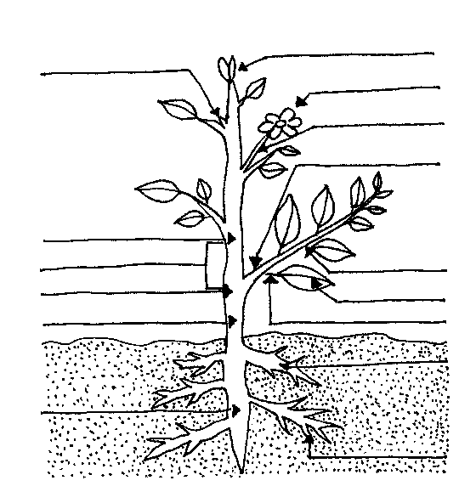
Label the Plant: Key
Directions: Correctly label the following plant parts:
axillary bud, terminal bud, flower, flower stalk, axil, lateral shoot, leaf, petiole, node (2), internode, stem, tap root, root, root cap

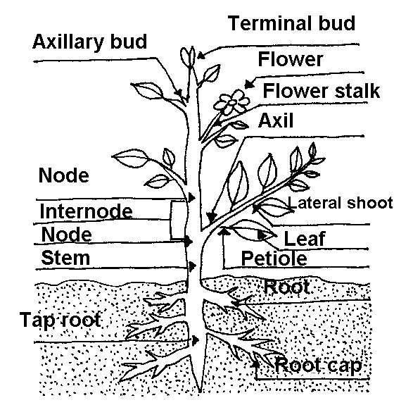
Name ____________________

Label the Flower
Directions: Correctly label the following flower parts:
anther, petal, filament, ovary, sepal, stem, stigma, style
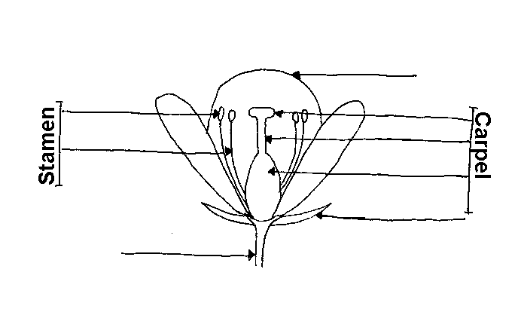

Label the Flower: Key
Directions: Correctly label the following flower parts:
anther, petal, filament, ovary, sepal, stem, stigma, style
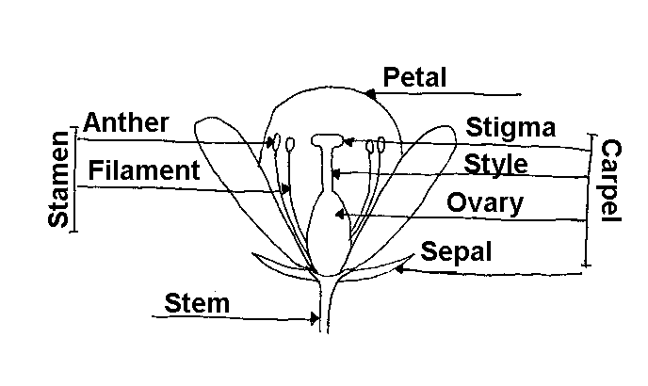

Name ____________________

Label the Leaf
Directions: Correctly label the following leaf parts:
axil, lamina, leaf apex, midrib, petiole, stipule, stem, vein

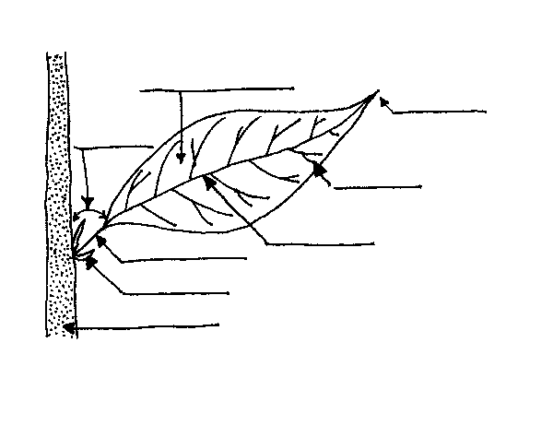

Label the Leaf: Key
Directions: Correctly label the following leaf parts:
axil, lamina, leaf apex, midrib, petiole, stipule, stem, vein

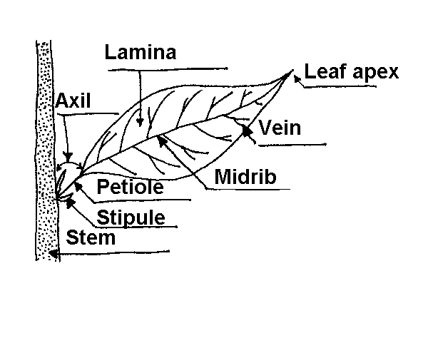

Don’t Leaf Out Photosynthesis
What exactly is photosynthesis?
Summary: Fall is a wonderful time of year to teach about the process that gives life to trees. In this lesson students will use hands-on methods to explore photosynthesis.
Duration: 1 class period
Setting: Classroom
Vocabulary: photosynthesis, chlorophyll, pigment
Standards/Benchmarks Addressed: SC1-E1, SC2-E1, SC3-E1, SC4-E1, SC4-E3, SC4-E5, SC5-E2, SC6-E1, SC6-E2, SC6-E3, SC6-E6, SC7-E2, SC7-E3, SC9-E1, SC11-E1, SC11-E2, SC11-E3, SC12-E2

Objectives
Students will:
- be able to identify the various pigments often found in leaves.
- be able to explain the process of photosynthesis.
Background
Producers obtain food (complex organic compounds) from inorganic materials and an energy source. Producers form the first level of an ecosystem. Producers most familiar to us are green plants. Their energy source is the sun, and they convert energy to food through reactions of photosynthesis. Less than 1% of the sunlight reaching the Earth’s atmosphere is transformed by photosynthesis. The rest is reflected back into space, absorbed by the atmosphere, or absorbed by the Earth.
Photosynthesis is the process by which plants, algae, and a few bacteria capture this tiny fraction of the sun’s energy and convert it into stored chemical energy for their biological processes. Photosynthesis is the process plants use to produce their own food. The chemical formula for photosynthesis is: 6CO₂ + 6H₂O + light → C₆H₁₂O₆ + 6O_{2.} What sustains life for all non-photosynthetic species is the ability to use that stored energy. The glucose and other food molecules produced by plants can be broken down by animals into water and carbon dioxide in a process called respiration. Respiration is photosynthesis in reverse. During respiration, the stored chemical energy captured originally by the plant is released for use by the plant eater. It is during this process that the leaves release oxygen, which become part of the air that we breathe.
Plants use photosynthetic pigments to capture radiant energy by converting carbon dioxide and water into glucose. Photosynthesis can take place only in the presence of chlorophyll, the green pigment that is found in all green plants. Chlorophyll absorbs the sunlight needed for photosynthesis. Plants contain several pigments, including chlorophyll. Chlorophyll is the most abundant pigment and causes most plant leaves to appear green. Did you know that most leaves are orange and yellow even in the summer? This is because most leaves include the pigments of all three colors. The other pigments, xanthophyll (yellow), carotene (orange), anthocyanin (red and/or purple) are present but in much smaller quantities. As winter nears plants receive less sunlight and less water. Soon the photosynthesis process shuts down until spring. It is this process that allows to experience the “turning of colors” in the fall.
SUN
CARBON DIOXIDE
OXYGEN

- Light strikes the leaf and is trapped by chlorophyll.
- Inside the leaf, light changes part of the water to hydrogen and oxygen.
- Carbon dioxide from the air enters the leaf through stomates located on the underside of the leaf.
- The hydrogen joins with carbon dioxide to make food for the plant.
- Oxygen is released through stomates.
Materials
Leaves
Small jars
Plastic wrap
Rubbing alcohol
Coffee filters
Shallow pan
Hot tap water
Tape
Pen
Plastic spoon
Procedure
Warm up: Ask students if they have ever been outside and picked up something that had been sitting in a grassy area for a few days. If so what had they noticed? If they saw an area of yellowish, wilted-looking grass, they have witnessed how light (or lack of light) affects color development. Explain that the activity for today will allow students to recreate this phenomenon and help them to better understand the process of photosynthesis.
Activity: Students will work in groups to complete this experiment.
Step 1 - Chop leaves into very small pieces and place them into small jars. Be sure to label the jar with the name of the leaf.
Step 2 – Add enough rubbing alcohol to cover the leaves. Use the plastic spoon to stir and grind the leaves in the alcohol.
Step 3 – Cover the jars and allow them to sit in a shallow tray filled with 1 inch of very hot tap water.
Step 4 – Allow the jars to sit for at least 30 minutes or until the alcohol has become colored. Replace the hot water if it cools off. Twirl the jars gently about every 5 minutes.
Step 5 – Using long strips of coffee filter paper, place one in each jar so that one end is in the alcohol and the other bends over the edge of the jar. Secure the lid.
Step 6 – After approximately 1 hour students should be able to see the various colors traveling up the paper.
Step 7 – Remove the strips and let them dry.
Wrap Up: Discuss the findings.
Assessment
Participation and discussion
Extensions
Students can complete the same activity using fall leaves that have already changed colors. Steps 4 and 6 will take longer. Have them compare the results.

Am I Leaking?
Where is the Water?
Summary: Using the scientific method, students will complete a hands-on experiment that will allow them to discover that cacti lose less water through transpiration than broad-leaf plants do.
Duration: 2 class periods
Setting: Classroom
Vocabulary: transpiration, stomata, photosynthesize
Standards/Benchmarks Addressed: SC1-E1, SC1-E2, SC2-E1, SC2-E2, SC2-E3, SC3-E1, SC4-E1, SC4-E3, SC4-E5, SC5-E1, SC5-E2, SC6-E1, SC6-E2, SC6-E3, SC6-E4, SC6-E5, SC6-E6, SC11-E1, SC11-E2, SC11-E3, SC12-E2

Objectives
Students will:
- design an investigation to answer questions about transpiration.
- compare the rate of transpiration of a cactus to that of a leafy plant.
Background
Photosynthesis is the process by which plants, algae, and a few bacteria capture a tiny fraction of the sun’s energy and convert it into stored chemical energy for their biological processes. Photosynthesis is the process plants use to produce their own food. The chemical formula for photosynthesis is: 6CO₂ + 6H₂O + light → C₆H₁₂O₆ + 6O_{2.}
What sustains life for all non-photosynthetic species is the ability to use that stored energy. Animals can break down the glucose and other food molecules produced by plants into water and carbon dioxide in a process called respiration. Respiration is photosynthesis in reverse. During respiration, the stored chemical energy captured originally by the plant is released for use by the plant eater.
During the respiration process, small pores (stomata) on a plant’s leaves and stems open to absorb CO₂ from the air and in return release oxygen (O₂). Each time the stomata open, some H₂O is lost. This water loss process is called transpiration. For some plants losing a large amount of water isn’t a problem. But, for desert plants, replacing this lost H₂O is not easy with so little annual moisture. If the H₂O can not be replaced, the desert plants will die. In order to survive some plants such as evergreens, cacti, and many plants that live in the dry climates have acquired special adaptations that limit the amount of water they give off.
Desert plants are unlike most plants that carry out photosynthesis during the day and lose a large amount of H₂O through transpiration. If transpiration occurs during daytime hours, high temperatures can cause water to evaporate quickly. If the process can occur at night, less H₂O is lost. One type of adaptation desert plants use is known as Crassulacean Acid Metabolism (CAM). In CAM plants, the stomata are only open at night, when the temperatures are much lower. Many plants in the desert environment have this method of photosynthesis, which is distinctly different.
Plants do not only lose H₂O through their pores; they also lose it through the cell walls on their leaves. The leaves and stems of many desert plants have a thick covering that is coated with a waxy substance, allowing them to open and absorb CO₂.
Desert plants have developed many adaptations in order to conserve the small amount of water they receive. The two adaptations discussed will be evident in the following experiment which shows how the waxy outer skin of a cactus helps it conserve water.
Materials
One plant (for each group of students)
One cactus (for each group of students)
1 clear plastic bag for each plant
String or tape
Mirror
Procedure
Warm up: Breathe on the mirror and then quickly hold it up and ask the students what they see. They should answer moisture. Explain to the students that in much the same manner, leaves give off moisture. How do we know this? How can we see this? Do all plants give off the same amount?
Activity: Review the background information with the class. Have students work in small groups of three or four. Each group should develop a step-by-step plan for trapping water vapor given off by their plants and for determining which plant lost the most water.
For example, some groups may decide to place their plants in direct sun while others may choose to place them in indirect sun or shade. The groups should identify the conditions that should be kept the same for both plants. Rather than sealing an entire plant in a bag, the groups may use intact limbs for the experiment. If so, they should tightly secure their plastic bags so that no water vapor can escape. Teachers should point out that this method is one of many desert survival techniques humans (hikers) use to extract water from plants.
Have the groups design and conduct their experiment. Students will keep a journal of their experiment. It should include such things as start and completion time of the experiment, observation notes, etc.
Wrap Up: Have each group explain their procedure and results. Discuss how this would help the desert plant save water.
Assessment
Scientific Procedure Project Report
Am I Leaking Rubric
Am I Leaking?
Scientific Procedure Project Report

Title: __________________________
Purpose: ____________________________________________________________________
________________________________________________________________________________________________________________________________________________________________________________________________________________________________________________________________________________________________________________
Hypothesis:_______________________________________________________________________________________________________________________________________________________________________________________________________________________________________________________________________________________________________
Materials:________________________________________________________________________________________________________________________________________________________________________________________________________________________________________________________________________________________________________
Procedure (Step-by-Step Directions):_______________________________________________
____________________________________________________________________________________________________________________________________________________________________________________________________________________________________________________________________________________________________________________________________________________________________________________________________________________________________________________________________________________________________________________________________________________________________________________________________________________________________________________________________________________________________________________________________________________________________________________________________________________________________________________________________
Each student is required to attach a copy of their journal, which will include dates and times of their observations, observation notes, etc. In addition to this record how else will you record your data?
Data:____________________________________________________________________________________________________________________________________________________________________________________________________________________________________________________________________________________________________________
Results:__________________________________________________________________________________________________________________________________________________________________________________________________________________________________________________________________________________________________________________________________________________________________________________________________________________________________________________________________________________________________________________________________________________________________________________________________________________________
Conclusion:_______________________________________________________________________________________________________________________________________________________________________________________________________________________________________________________________________________________________________________________________________________________________________________________________________________________________________________________________________________________________________________________________________________________________________________________________________________________________________________________________________________________________________________________________________________________________________________________________________________________________________________________________________________________________________________________________________________________________________________________________________________________________________________________________________________________________

Am I Leaking?
Scientific Method Rubric
Transpiration Project | Self  Evaluation | Teacher  Evaluation | Comments
Visual: |  | /12
Includes display of leaf samples to illustrate the type of plants tested.
Presentation board is visually attractive (fills the board, colorful, neat).
Display identifies each step of the scientific process (title, hypothesis, purpose, materials, procedure, conclusion, results).
Written: |  | /12
Students provide a completed Scientific Procedure Project Report.
Information is accurate.
Proper grammar, spelling, etc.
Presentation: |  | /8
Presenters followed appropriate speaking rules (eye contact, voice, enthusiasm).
Presentation quality, organization, information, appeal
Teamwork: |  | /4
Are the efforts of each team member clearly demonstrated, or did it appear to be the work of one or two
Responsibility: |  | /4
Turned in on due date and presented in class with visual.
4 – no mistakes 3 – few mistakes 2 – many mistakes 1 – incomplete (however is present) 0 – not evident or not included
Visual ______ Written ______ Presentation ______ Teamwork ______ Responsibility ______ Overall______

One Tough Dude
How does plant life survive such harsh desert conditions?
Summary: This lesson provides a discovery approach to learning about desert plant life. Students will complete three simple experiments in order to gain a greater knowledge of how plants adapt to desert life.
Duration: 1 class period
Setting: Classroom
Vocabulary: photosynthesis, transpiration, adaptation, drought-deciduous
Standards/Benchmarks Addressed: SC2-E1, SC3-E1, SC4-E1, SC4-E3, SC4-E5, SC5-E2, SC6-E1, SC6-E2, SC6-E3, SC6-E4, SC6-E5, SC10-E2, SC11-E1, SC11-E2, SC11-E3, SC11-E4, SC11-E5, SC12-E2

Objectives
Students will:
- explain how plants adapt to harsh desert environment.
- explain the concept of transpiration as it applies to desert plant life.
Background
For plants dependent on water for their basic life processes the dryness and heat of the desert make survival difficult. Unlike animals, plants cannot set out in search of water, they cannot retreat to a different location in order to avoid the intense heat of the sun. In response to these limitations, plants have developed several strategies for dealing with the harsh conditions of the desert. Plants use a variety of means to survive. Some have tough outer coatings while others depend on a rapid rate of growth after a rainfall. A large number of plants survive by their extensive shallow root systems. Other plants such as the mesquite tree have long taproots that may grow 100 feet deep to reach the water table. Some plants store water in their pulpy trunks or roots. Many desert plants have small, thick leaves with waxy coatings and will even shed their leaves during intense drought to further reduce water loss. Cacti carry out photosynthesis not in leaves, but in their thick stems. Thick stems are less likely to dry out. These stems have less surface area than broad, thin leaves. A cactus’s spines are actually modified leaves.
For a more detailed explanation of the various adaptations see Tricks of the Trade.

Materials
Station #1 – Aloe Vera plant, a cactus, and a cutting instrument
Station #2 – wax paper, water droppers
Station #3 – sponges, dishpans, and a measuring cup
Station #4 – plastic water bottles (One with holes in the bottom the size of pins. The other with holes in the bottom the size of a pencil.), tub of water
Procedure
Warm up: Students will be asked to brainstorm words they think of when we say the word desert. Discuss why these particular words come to mind.
Ask students to brainstorm various adaptations of desert plants. Explain to the students that they will be looking for similar adaptations as they complete the following series of activities.
Activity: Students will work in four groups and the groups will rotate from station to station.
Station #1 – The Pulpy Insides: At this station students will examine a desert plant (the Aloe Vera) and the cacti. Before they start the activity, students are asked to draw what they think a desert plant looks like on the inside (don’t forget to include the root system). As they cut open the plants students should be examining the amount of moisture, the look, and the feel of the plant.
Students should be prepared to discuss the following questions as a class.
- How would you describe the texture of the plant skin?
- Why do you feel the plant was able to hold the amount of moisture it held?
- Describe the stems (thick, thin, rounded, flat).
- Compare your drawing with the actual plant.
Station #2: How the Waxy Skin Works
- Students will use the water droppers to squeeze a few drops of water onto wax paper.
- Students should observe how the water reacts on the wax paper (does the paper absorb or resist the water?)
After completing this station, students should write a brief response to, “What type of adaptation does this activity represent?”
Station #3: The Spongy Roots
- Students will dip the sponge into the tub of water.
- Students should observe how the sponge soaks up the water.
- Students will then squeeze out the water into a measuring cup in order to determine the amount of liquid the sponge was able to hold.
After completing this station, students should write a brief response to, “What type of adaptation does this activity represent?”
Station #4: Pore Size Matters
- Students will fill the plastic containers with water (one container should have tiny holes poked in the bottom and the other should have larger holes poked in the bottom) by submerging the two bottles into a tub of water and then pulling them out by the neck of the bottle.
- Students should observe the different rate at which the bottles drain.
After completing this station, students should write a brief response to, “What type of adaptation does this activity represent?”
Wrap Up: Bring students back to the whole group. Group discussion should focus on the findings as a result of the previous experiments.
Students will then be asked to create a desert plant survival guide. This guide will consist of identifying six different Chihuahuan Desert plants, their specific adaptation(s), the way in which the adaptation helps the plant, and an illustration of each plant. Teachers may choose to have students research other types of plants depending on location or field of study.
Assessment
Evaluate the student’s survival guidebook by looking for a variety of adaptations. Students should also be able to explain how each adaptation helps the plant.
Students will receive three copies of the Desert Plant Survival Guide. A cover may be created with construction paper or may be computer generated.
Tricks of the Trade… How Desert Plants Survive
One Tough Dude Activity
How do desert plants save water?
Desert plants work hard to make use of what’s available. They use the sun’s energy to convert carbon dioxide (CO₂ ) and water (H₂O) into sugar, a process called photosynthesis. During this process, small pores (stomata) on a plant’s leaves and stems open to absorb CO₂ from the air and in return release oxygen (O₂). Each time a plant opens its pores, some H₂O is lost. This is called transpiration. Replacing this lost H₂O is not easy with so little annual moisture. If the H₂O cannot be replaced, the desert plants will die. Desert plants have acquired special adaptations that help them in reducing H₂O loss.
- Smaller, fewer, and deeper pores – Many desert plants have very small, fewer, and deeper pores. With such pores, hot and dry winds are inhibited from blowing directly across the pores and reducing H₂O loss.
- Waxy cover – Plants do not only lose H₂O through their pores, they also lose it through the cell walls on their leaves. The leaves and stems of many desert plants have a thick covering that is coated with a waxy substance, allowing them to still open and absorb CO₂.
- Nocturnal – Unlike most plants that carry out photosynthesis, plants lose a large amount of H₂O through transpiration, and if transpiration occurs during daytime hours, high temperatures can cause water to evaporate quickly. If the process can occur at night, less H₂O is lost. Many plants in the desert environment have a method of photosynthesis that is distinctly different. It is known as Crassulacean Acid Metabolism (CAM). In CAM plants, the stomata are only open at night, when the temperatures are much lower.
- Little leaves – Most desert plants have small leaves or no leaves at all. The smaller or fewer leaves a plant has, the less H₂O is lost during transpiration since it has less surface area exposed to the sun and wind. For desert plants with small leaves or none at all, the twigs and stems help carry out photosynthesis.
- Hide and rest-During the hottest part of the day many desert grasses and other plants “roll” their leaves to reduce the amount of surface area exposed to sun and wind. Some plants simply position themselves so they have less exposure to the climatic elements on a hot, sunny day. Some plants grow best if they sprout under a “nurse” plant. The “nurse” plant shades the young plants from damaging sun, drying winds, and animals that might trample it.
- Drop ‘em in drought – Some desert plants grow leaves during the high moisture period of the year and then shed them when it becomes dry and hot again, such plants are called drought-deciduous. These kinds of plants will carry out photosynthesis only during the moist period.
How do plants get water?
One way desert plants, trees, and shrubs suck up as much water as possible is by growing very deep taproots. Sometimes these roots can get to be more than 100 feet long. The above ground plant parts may remain small for years simply because the plant puts most of its energy into developing its taproot system. Desert plants may have a huge, tangled network of shallow roots that spread out from the plant in all directions. The roots can be as long as the plant is tall, and can quickly absorb water from the slightest rainfall.
Why do plants shrink and swell?
Desert plants can soak up water, store it, and prepare to use it during drought. For example, cacti and many other desert plants store water in their fleshy leaves and stems. Desert plants may also have other adaptations for water storage, such as pleats or folds that will allow the plant to swell with added water when it can. The pleats or folds can almost disappear if the plant soaks up a lot of water; then the plant can shrink, and its pleats or folds can become visible again as drought sets in and the plant makes use of water it has stored. Though many desert plants die to the ground during the hottest part of each year, the water they have stored in underground roots, tubers, and bulbs will sustain them until the next moist period.
Why do plants grow hairs and spines?
The hairs and spines that grow on desert plants help reduce moisture loss by breaking the effects of the wind. They also help cast minute shadows on desert plants, which can protect them from the sun. The light colored hairs and spines can even serve to reflect the sun’s rays away from the plant. Lastly, hairs and spines can help protect plants from hungry animal predators.
Why do plants produce special chemicals?
Scientists believe that desert plants may produce and give off chemicals from their leaves or roots that keep other plants from growing nearby. It is thought that plants do this to reduce competition, especially when water is scarce.
Why do seeds of plants sleep?
Some desert plants cope with the desert’s dryness by not coping at all. As a result, during drought they are present only as seeds in the soil. For months, years, or even decades these seeds “sleep” to wait out the dry spell in a dormant state. When the right amount of rain falls and soaks into the soil, they sprout and bloom. When this happens the desert’s dry brown landscape can quickly change into colorful fields of wildflowers, herbs, and grasses. Most of these fast-growing desert plants do not last very long. So aside from having seeds that are adapted to drought, they have few or no special adaptations to desert conditions. This is why desert plants of this kind sprout, flower, and leave behind a generation of seeds as quickly as possible. Short-lived desert plants are called ephemerals. With little water available to help them grow, dormant ephemerals are covered and protected by natural chemicals called inhibitors. The primary function of inhibitors is to keep seeds from germinating until enough moisture and specific temperatures are present. Once the inhibitor has been washed off, the seeds can sprout.
Desert Plant Survival Guide

Plant Name (common and scientific): __________________________________________________
Description (color, size, location, etc.): __________________________________________________
Adaptations: __________________________________________________
__________________________________________________

Plant Name (common and scientific): __________________________________________________
Description (color, size, location, etc.): __________________________________________________
Adaptations: __________________________________________________
__________________________________________________

Desert Plant Survival Guide Rubric
Desert Plants | Self  evaluation | Teacher  evaluation | Comments
Visual: |  | /4
Illustrations are accurate, colorful, and fill the page.
Written: |  | /12
Provides the common and scientific name of the plant.
Identifies an area in which each of these can be found.
Identifies the adaptations utilized by the various plants.
Presentation: |  | /8
Organization of information, quality, etc.
Presenter follows appropriate speaking rules (eye contact, voice, enthusiasm).
Responsibility: |  | /4
Turned in on due date and presented in class.
4 – no mistakes 3 – few mistakes 2 – many mistakes 1 – incomplete (however is present) 0 – not evident or not included
Visual ______ Written ______ Presentation ______ Responsibility ______ Overall______

To Be or Not to Be
What is asexual reproduction?
Summary: This activity introduces the concept of asexual reproduction. While utilizing the scientific method, students will choose a plant, research it, choose a method of propagation, and keep a scientific journal of its treatment.
Duration: Activity time approximately 6 weeks
Setting: Classroom
Vocabulary: vegetative propagation, alternation of generations, antheridia, archegonia, antheridium, marchegonium, dicotyledon, monocotyledon, dormant
Standards/Benchmarks Addressed: SC1-E1, SC1-E2, SC2-E1, SC2-E2, SC2-E3, SC3E1, SC4-E1, SC4-E3, SC4-E5, SC5-E1, SC5-E2, SC6-E1, SC6-E2, SC6-E3, SC6-E4, SC6-E5, SC10-E1, SC11-E1, SC11-E2, SC11-E3, SC11-E4, SC11-E5, SC12-E2

Objectives
Students will:
- understand the different methods of plant propagation.
- successfully start a new plant by any means of vegetative propagation.
- keep a laboratory journal on the progress of the plant.
- use the scientific process in order to complete an experiment on propagation.
Background
Whenever plants reproduce asexually by any means, either natural or induced, the term vegetative propagation applies. It simply means that vegetative tissues (non-reproductive tissues) are used to reproduce new plants. All members of the plant kingdom have some means of reproduction whether it produces sperm and eggs or spores. In the mosses and the ferns, the sexual structures are called antheridia and archegonia. The antheridium produces sperm and the marchegonium produces one or more eggs. These plants also have a spore-producing asexual phase.
Alternation of generations is a term that describes the life cycle of most plants and some algae. In most plants, meiosis and fertilization divide the life of the organism into two distinct phases or “generations.” The term generations is misleading since it refers to two different phases that make up a single life cycle. Sexual reproduction involves the two alternating processes of meiosis and fertilization. In one phase, the plant is known as a gametophyte or gamete-bearing plant and produces sex cells called gametes. Gametophytes can produce male sperm cells, female egg cells, or both. In fertilization, the nuclei of two gametes fuse, raising the chromosome number from haploid to diploid. When a sperm cell and an egg cell unite, they form a zygote (fertilized egg). The zygote develops into the next phase of the reproductive cycle. In this phase (meiosis) the plant is known as a sporophyte or spore-bearing plant and produces reproductive cells called spores. The chromosome number is reduced from the diploid to the haploid number. Then spores develop into gamete-producing plants, and the cycle begins again.

Alternation of Generations
Plant Life Cycle

multicellular
sporophyte
generation

Zygote

Diploid

Fertilization (2n) Meiosis

Haploid
(n)
Gametes Spores

multicellular
gametophyte
generation

In higher plants, the monocotyledon and the dicotyledon, flowers contain the sexual structures. The sperm are borne in pollen grains produced in the stamen of the flowers, and the eggs are held in ovules within the pistils. Some higher plants also have common means of asexual reproduction which do not involve floral parts. Strawberries, for example, send out runners, while many trees send up new shoots from their roots. Black cherry and quaking aspen both send up shoots.
Many plants that do not commonly reproduce asexually can be induced to do so. For example, stem cuttings of geraniums or jade plants will often root in water, and can then be planted in potting soil.

Types of propagation
Plant propagation can be completed by various means. One method is by seed. In the wild, seed germination is erratic by design, spanning the longest possible time in order to eventually strike upon a favorable set of conditions and there insure continuation of the species. In a controlled environment, good quality seed is the basis for successful seed production. Other key factors in successful propagation include; moisture, pollination, insect control, and temperature. In collecting seeds from the wild there are many things to consider. Timing of collection is critical. Seeds should be cleaned of debris. Often seeds need to be pretreated by means of an acid scarification or hot water soak. Scarification is the pretreatment used when the limiting factor is a hard seed coat that prevents water penetration and gas exchange or physically restricts the growth of the embryo.
Propagation by cuttings is another means of reproduction. The cuttings from some plants such as the cherry sage or four o’clocks root easily. Again correct timing and cutting material is essential. When selecting the plant to propagate it is important to remember that plant material that has had adequate moisture to produce healthy new growth will root and grow more rapidly than cuttings that have been dependent solely upon rainfall.
A third type of propagation is by root cuttings. This method can be used to propagate arid-land natives with fleshy root systems. Root cuttings should be taken when the plant is dormant. When using this method it may take several months for the cutting to form new terminal buds. It is important not to over-water them.
The layering method entails selecting a healthy lower branch of a plant and cutting a notch in the stem about ten inches from the tip just below the node (the point where a leaf is attached to the stem). Bend the stem down to the ground, loosen the soil where the notched stem touches, and push the stem into the soil so that the growing tip is exposed but the notched portion is buried. Pin the stem in place with wire. This method may take six months to one year to develop a root system.
Dividing established specimens can increase plants that have a matted growth habit or form offshoots from a central crown. Dig up the entire plant, split it into sections, and replant where desired. This method is most successful when the plant is in the dormant stage.
Materials
A variety of plants
Variety of potting soils
Pots
Procedure
Warm up: Bring in a piece of prickly pear cactus for students to examine. Ask students to consider whether or not this plant could form a new one. Write the term “vegetative propagation” on the board and ask students if they know what the term means. If none of them know the definition, write it on the board and then explain to the students that they will be completing an experiment in order to observe vegetative propagation.
Activity: Students will select a healthy plant to be propagated. The plant may be a house plant, a landscape plant, or a wild plant. Students will be required to research the plant paying specific attention to the proper propagation method for their plant. Once students have selected the method of propagation they will use the scientific process to complete their experiment.
Wrap Up: Six weeks after the initial set-up of this project students will take turns sharing their plant research, progress or lack thereof, and what they gained from this experience.
Assessment
Laboratory journals and project report using the attached rubric.
To Be or Not To Be
Project Report

Title: __________________________
Purpose: ____________________________________________________________________
________________________________________________________________________________________________________________________________________________________________________________________________________________________________________________________________________________________________________________
Hypothesis:_______________________________________________________________________________________________________________________________________________________________________________________________________________________________________________________________________________________________________
Materials:________________________________________________________________________________________________________________________________________________________________________________________________________________________________________________________________________________________________________
Research:____________________________________________________________________
____________________________________________________________________________________________________________________________________________________________________________________________________________________________________________________________________________________________________________________________________________________________________________________________________________________________________________________________________________________________________________________________________________________________________________________________________________________________________________________________________________________________________________________________________________________________________________________________________________________________________________________________________
Procedure (Step by Step Directions):_______________________________________________
____________________________________________________________________________________________________________________________________________________________________________________________________________________________________________________________________________________________________________________________________________________________________________________________________________________________________________________________________________________________________________________________________________________________________________________________________________________________________________________________________________________________________________________________________________________________________________________________________________________________________________________________________
Each student is required to attach a copy of their journal, which will include dates and times of their observations, observation notes, etc. In addition to this record how else will you record your data?
Data:____________________________________________________________________________________________________________________________________________________________________________________________________________________________________________________________________________________________________________
Results:__________________________________________________________________________________________________________________________________________________________________________________________________________________________________________________________________________________________________________________________________________________________________________________________________________________________________________________________________________________________________________________________________________________________________________________________________________________________
Conclusion:_______________________________________________________________________________________________________________________________________________________________________________________________________________________________________________________________________________________________________________________________________________________________________________________________________________________________________________________________________________________________________________________________________________________________________________________________________________________________________________________________________________________________________________________________________________________________________________________________________________________________________________________________________________________________________________________________________________________________________________________________________________________________________________________________________________________________
TO BE OR NOT TO BE
Scientific Method Rubric
Propagation Project | Self Evaluation | Teacher Evaluation | Comments
Visual: |  | /12
Include propagated plant.
Presentation board is visually attractive (fills the board, colorful, neat).
Display identifies each step of the scientific process (title, hypothesis, purpose, materials, procedure, conclusion, results).
Written: |  | /12
Students provide a completed Project Report.
Information is accurate.
Proper grammar, spelling, etc.
Presentation: |  | /8
Presenters followed appropriate speaking rules (eye contact, voice, enthusiasm).
Presentation quality, organization, information, appeal
Responsibility: |  | /4
Turned in on due date and presented in class with visual.
4 – no mistakes 3 – few mistakes 2 – many mistakes 1 – incomplete (however is present) 0 – not evident or not included
Visual ______ Written ______ Presentation ______ Teamwork ______ Responsibility ______ Overall______

Which is Which?
Deciduous or Coniferous – a lesson designed to differentiate between the two.
Summary: Through a hands-on approach students will be able to identify the distinguishing characteristics of the deciduous and coniferous tree.
Duration: 1 day
Setting: Outdoors-field trip, classroom
Vocabulary: deciduous, coniferous, simple, compound, dichotomous key
Standards/Benchmarks Addressed: SC1-E1, SC4-E3, SC5-E2, SC6-E1, SC6-E2, SC6-E3, SC6-E4, SC10-E2, SC11-E1, SC11-E4, SC11-E5, SC12-E2

Objectives
Students will:
- be able to explain the difference between deciduous and coniferous trees.
- use a dichotomous key to identify types of trees.
Background
What is a tree? Trees come in all shapes and sizes, from the bristlecone pines to saguaro cacti. In North America there are over 800 different species of trees. Some scientists use size as a way to help define trees. Yet, when you consider harsh environments such as the Arctic or deserts, trees can often be smaller than other plants. One way trees are defined is by the woody roots, trunks, and limbs that provide physical support. Trees also live longer than most other plants. They are a type of perennial. Although they become dormant during the winter, the stems, branches, and roots are still alive and will continue to grow taller and thicker each year.
Trees are classified according to how they reproduce, what types of flowers and seeds, how they grow, and how they are structured inside. Most trees fall into two main plant groups. Gymnosperms, which have seeds not enclosed in flowers. These seeds are produced on the surface of the scales of female cones. Conifers are the most common types of gymnosperms. Angiosperms are the types of plants that have true flowers and bear their seed in fruits.
Deciduous trees are those trees that shed their leaves at the end of the growing period, so they are bare for part of the year. This shedding typically occurs in the months of September and October. They rest during this part of the year. The trees grow new leaves when there is enough sun and rain for them to grow. Deciduous trees have two types of leaves, simple or compound. A simple leaf is one leaf that attaches to the stem. A compound leaf is two or more leaves, usually many, that connect to the stem. In North America, most broad-leaved trees are deciduous, while most needle-leaved trees are coniferous. Coniferous trees, often called evergreens, keep their leaves for several years and lose them gradually, while growing new ones, so they are never bare. Coniferous trees have leaves that look like needles.
From pine leaves to broad palm leaves, all leaves serve the same purpose: to make food for the tree. Leaves use carbon dioxide from the air, water from the roots, and the sun’s energy to make sugar. This food-making chemical reaction is called photosynthesis. Photosynthesis can only take place in the presence of chlorophyll. Chlorophyll is the green pigment that is found in all green plants. Chlorophyll absorbs the sunlight needed for photosynthesis. During photosynthesis the leaves release oxygen which becomes part of the air that we breathe.
Materials
Tree samples
Dichotomous key
Grab bag items (might include such things as pencil, magazine, wooden spoon,
aluminum foil, cork, plastic comb, etc.)
Procedure
Warm up: Begin by drawing the students’ attention to the classroom window. Ask, “What do you see when you look out the window?” Answers will vary. Next, ask, “How many of you look outside and say, “Hey, that’s an evergreen…, a Desert Willow…, a Mesquite …?” We don’t pay much attention to trees and yet they play an important part of our world. Today the students will be tying to “key” different leaves found on an outdoor hike (for example McKittrick Canyon).
Before the trip, make a transparency of Different Types of Leaves. Discuss the shape of each leaf and whether it is compound or simple and opposite or alternate. Hand out the dichotomous key, or make one of your own,* and explain that it is based on the idea of making a choice between two alternatives. As the student “keys” their leaf, they will need to decide which phrase applies to the particular leaf being “keyed.”
*Directions: Pick 6 trees you know you will encounter on your hike, separate the characteristics, and make a dichotomous key from those characteristics (see example).

Activity: Take a field trip (a suggested area is McKittrick Canyon). While there, students should practice using the dichotomous key to identify the various deciduous and coniferous trees.
Take students back to the classroom for the next activity. Divide the class into groups of five. Pass out small branches of leaves to each group. Students will work cooperatively in groups to identify which trees the leaves came from. Students will create a poster by illustrating the leaf sample and placing it on the deciduous side or the coniferous side.

When students are done they will share their findings with the group.
Wrap Up: As a closing activity, students can play a game of “Who Wants to be a Biologist?” “Who Wants to be a Biologist?” can be played with a variety of items in a grab bag. Have students choose an object out of the grab bag and decide whether or not it comes from a tree. Grab bag items might include such things as, pencil, magazine, wooden spoon, aluminum foil, cork, plastic comb, etc. Students may also choose to be asked a question. Examples are listed below.
- Name five trees that are commonly encountered in the area surrounding our school.
- Define the terms “Simple” and “Compound.”
- True or false: All broad-leaved trees are deciduous.
- What are deciduous trees?
- What gives plants their green color?
- True or false: Evergreen trees never shed their leaves.
- Show differences between the terms “Simple” and “Compound.”
- True or false: Gymnosperms do not produce true flowers or fruit.
- True or false: Pine needles are leaves.
- Why do many deciduous trees’ leaves change from green to other colors in the fall?
Assessment
Classroom participation
Which is Which? Activity
Dichotomous Key
Their shape, bark, buds, and leaves can identify trees. A key is a valuable tool that can be used to identify a tree by its characteristics.
1. a. The tree has leaves | go to 5
b. The tree has needles | go to 2
2. a. The needles are in clusters | go to 3
b. The needles are arranged singly on the twig | go to 4
3. a. If there are 2 or 3 needles ¾ to 1 ½ inch long | Pinyon Pine – Reddish barked tree that is small and many branched. Cones are about 2 inches long and contain wingless edible seeds, ½ inch in length.
b. If there are 2 or 3 needles approx. 5 inches long | Ponderosa Pine – Large tree with bark that is dark brown to black turning yellowish-red with age. Immature cones are green and tightly closed, changing to reddish-brown as they ripen.
4. If needles are scale-like | Juniper – Bark deeply furrowed and checkered with rectangular scales; branch tips usually stiff; green to reddish brown cones appear bluish.
5. a. If leaves are simple | go to 6
b. If leaves are compound | go to 9
6. a. If several main veins branch from one point | go to 7
b. If leaf has one main vein with smaller side branches | go to 8
7. If notches are lobed | Bigtooth Maple – Leaves are opposite and typically 2 ½ inches in diameter, with three broad, blunt lobes. Bark is gray to light brown and may be smooth or scaly.
8. a. If leaves are lanced-shaped and approx. 6 inches longwith wavy edges and coarse teeth | Chinquapin Oak – Bark is ash gray, rough and flaky. The fruit or acorn is small and half-enclosed in a cup.
b. If leaves are small, oval, smooth margined, and dusty blue-gray in color with star-shaped hairs on both sides of the leaf | Gray Oak – a common Shrubby oak of the Southwest that grows in dry rocky sites.
9. a. If leaves are bipinnate with 2 to 8 pinnae each with 12 to 60 leaflets | Honey Mesquite – A common desert shrub with sturdy branches that have straight thorns.
b. If leaves are compound with 5 to 7 leaflets up to 5 inches long with toothed margins | Mexican Buckeye – A small much-branched tree that grows in rocks and canyons. It is a member of the soapberry family.

Different Types of Leaves
(Which is Which? Activity)

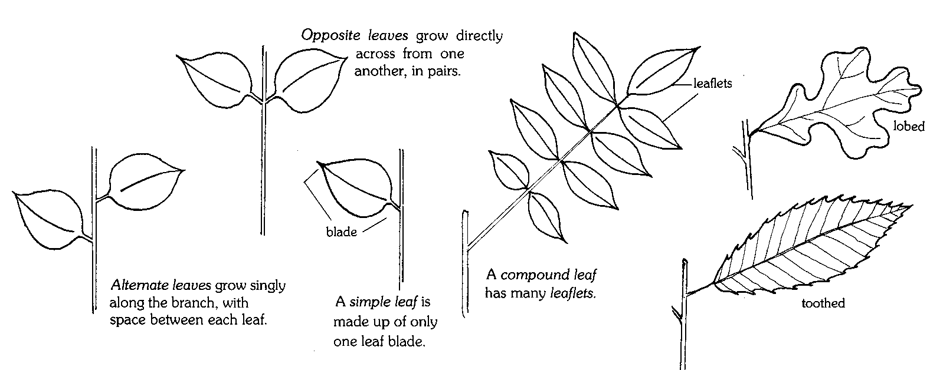

Where in the World?
What are the various uses of the plants we grow?
Summary: Students develop an understanding that plants are not just for food but that in fact are found in most everything we use daily. Students will explore the plant products that they use everyday.
Duration: 3 weeks
Setting: Classroom
Vocabulary: byproduct
Standards/Benchmarks Addressed: SC1-E1, SC3-E1, SC4-E5, SC5-E2, SC6-E2, SC6-E3, SC6-E4, SC6-E5, SC6-E6, SC6-E7, SC11-E5, SC12-E1

Objectives
Students will:
- identify various products that are a byproduct of plants.
- use research skills to gain information on various types of plants.
Background
The Southwest, or more specifically, the Chihuahuan Desert area, has been chosen for an example of research on byproducts of plants. This particular region has a rich history of Native American uses of plants. Although some still carry on their traditions, many desert natives no longer practice their traditional ways of life.
Medicines: Plants of the Southwest have long been valued for their medicinal uses. The Desert has a variety of plants that are being used, not only in traditional, but also in modern day medicines. One such plant is the Chihuahuan Desert’s Sangre De Drago, which contains a reddish juice traditionally used to treat eye and gum diseases. The Algerita plant contains the drug berberine, and has been used to treat toothaches. Native Americans used Creosote bush as a herbal medicine to cure colds, intestinal discomfort, and stomach and menstrual cramps. Today, researchers have a scientific basis for many of these traditional uses. They have identified compounds and resins in the creosote bush that act as painkillers and dissolve kidney stones. There is current investigation into its anti-aging effects and its ability to help control the growth of cancer cells.
Cosmetics: The juices of the desert plants aloe and jojoba are used in shampoos, burn remedies, lotions, and cosmetics. Jojoba also has potential uses in lubricants and wax for cars because it doesn’t spoil like other oils. Red chiles lend their fiery color to cosmetics, including lipstick. Soaptree yucca roots are still peeled and pounded or boiled to make a gentle soap for washing hair and for cleaning hand-woven rugs and blankets.
Beverages: Agave is best known for the sugary pulp that is mashed, fermented, and distilled to make mescal and tequila. Pinon-juniper berries are used to flavor gin. The red velvety berries of sumac have long been used to make a beverage similar to lemonade. Mormon tea is a plant long used by settlers and Indians to treat a variety of ills ranging from kidney infection to hayfever.
Clothing and Dyes: Agave supplied desert-dwellers in the Southwest with tough leaf fibers for use in hunting nets, baskets, mats, ropes, and sandals. Cotton was first cultivated by desert Southwesterners around 2,000 years ago. Today, New Mexico is the fourth-largest producer of cotton. Lichens, which are composed of fungi and algae, are used to furnish dyes for Southwest rug weavers. Algerita is used to produce a brilliant yellow dye. Brown and red dyes can be extracted from the netleaf hackberry. Indian paintbrush can produce yellow dye from its flower and black dye from its roots.
Other uses: Aspen can be used for building and is also shredded to make the excelsior for evaporative cooler pads. Mistletoe, the familiar Christmas “kissing ball” is one of the few truly parasitic plants that grow in the Southwest.
Although the Southwest no longer grows the bulk of the nation’s supply, corn remains a traditional Southwest crop. Corn has been a staple in the Southwest for at least 2,000 years. Corn is eaten fresh, ground into meal and flour, cooked into mush, or drunk as a creamy high-energy drink. Corn byproducts are found in the majority of our processed foods in the form of corn syrup, cornstarch, etc.
Mesquite wood is used today as barbecue flavoring, fuel, and fence posts.
This list is but a small sampling of the variety of uses of plants in the Southwest. With research, your students will be able to produce a comprehensive list of the many byproducts of plants in their chosen region.
Materials
Access to library and or Internet resources
Item(s) that are a byproduct of plants
Procedure
Warm up: Bring in an item (anything that is a byproduct of a plant), such as soda, ask students if they can name some of the ingredients of the item. Ask students if this item is a byproduct of plants. Explain that plant products are found in their everyday lives. Have students name some items that are a byproduct of plants (medicines, beverages, clothing and dyes, cosmetics and perfumes, snack foods, and cafeteria food).
Activity: Explain to the students that they have been hired to promote plant byproducts from various regions. To do this, students will break up into groups. Each group will choose a region to promote. The group will then identify plant byproducts from that region. They should consider the following categories as they research plant products.
- clothing and dyes
- beverages
- cosmetics and perfumes
- medicines
Within their groups, students will produce a list of products from their assigned region. Each student within the group will select a product from that list to research. The following questions should be addressed in that research. What plant does your product come from? What part of the plant does your product come from? Do/Did the native people use your product? Is your product processed? How is your product processed? How/When was your product discovered? Does your product grow anywhere else now?
Each group will create an advertisement for their region. The advertisement will highlight the researched products and should describe why consumers would want to use these items.
Wrap Up: Have each group present their advertisement to the class.
Assessment
Where in the World Rubric
Where in the World? Rubric
Regional plant products | Self Evaluation | Teacher Evaluation | Comments
Visual: |  | /8
Advertisement is visually attractive (fills the page, colorful, neat).
Advertisement contains interesting facts/information about the product (uses, medicinal purposes, etc.).
Written: |  | /16
Identifies uses of plants in each of the four categories (clothing and dyes, beverages, cosmetics and perfumes, medicines).
Information is accurate.
Proper grammar, spelling, etc.
Advertising techniques are evident (sells this region’s products).
Presentation: |  | /4
Organization of information, quality, etc.
Teamwork: |  | /4
Are the efforts of each team member clearly demonstrated, or did it appear to be the work of one or two?
Responsibility: |  | /4
Turned in on due date and presented in class with visual.

4 – no mistakes 3 – few mistakes 2 – many mistakes 1 – incomplete (however is present) 0 – not evident or not included

Visual ______ Written ______ Presentation ______ Teamwork ______ Responsibility ______ Overall______

Animal Life
Desert animals have some impressive ways of handling the challenges of desert life. These adaptations help the animals escape the harsh desert heat, retain water, and maintain their body temperature. Carlsbad Caverns National Park is a safe haven for many animals. It is said that the park is one of the richest areas in the state for insect life. There are three large native hoofed animals in the park. Mule deer are browsers preferring shrubs, such as catclaw acacia and desert willow, but are adapted for aridity with a flexible diet. The cave swallow is a very special summer resident in the park. Rattlesnake Springs is a hotspot for migratory birds. The area attracts 19 species of flycatchers, 35 species of warblers, and many other species of bird.
This unit will focus on animal classification and the adaptations desert animals utilize in order to survive in the harsh climate. In the first two activities, students will be learning about taxonomy or classification of animals. In the activity, Why Do We Look the Way We Do?, students will participate in a hands-on activity to explore the adaptations of different types of bird beaks and feet. In the activity, Help! I’m Dehydrating!, students will design experiments in develop an understanding of how desert animals conserve water. In the activity, Designer Animal Adaptations, students will discover how animals are designed to survive in the harsh desert climate. In the activity, Animals That Live in the Dark, students will study the special characteristics and adaptations of cave animals. In the activity, Build an Animal, students are free to design an animal that would survive in a given environment. The activity, Nature Detective, is an optional field trip opportunity for students to explore and investigate animals in their natural environment. The final activity, Build a Desert Diorama, allows students to design a diorama to show desert animals in their natural habitat.

Sorting Out Species?
How do we all fit together?
Summary: This lesson is designed to establish criteria to separate items into groups.
Duration: 1 class period
Setting: Classroom
Vocabulary: classification, taxonomy, evolution, kingdom, phylum, class, order, family, genus, species
Standards/Benchmarks Addressed: SC3-E1, SC6-E2, SC6-E3, SC6-E4, SC6-E6, SC6-E7, SC10-E2, SC11-E4, SC11-E5

Objectives
Students will:
- design and adhere to established criteria to sort items.
Background
Scientists are people who want to know how the world works. Biologists are people who study living things on our planet. They study how things evolved, how they are related, how they function, and how many different species there are. With the nearly 100 million species on Earth it is very complicated to organize species into their correct groups.
Biologists group animals together using relationships. This organization and classification of living things is called taxonomy. Karl von Linne developed this system of taxonomy in 1758. Using this system, every living thing is given a unique classification.
Taxonomists group similar kinds of creatures together based on their evolutionary relationships. This may sound simple, but it is not. The similarities and differences between species can be very subtle.
Taxonomy is a crucial part of our understanding of life on Earth; it reveals the order and diversity in the teeming life around us. The system that taxonomists use is based on the relationships of different groups of organisms to each other.
There are seven major levels of classification. These seven major levels from largest to smallest are: kingdom, phylum, class, order, family, genus, and species. Each level can be divided into clusters of organisms that are most closely related. These clusters form the next level of classification. For example, each kingdom is divided into a smaller phylum, each phylum into classes, each class into orders, and so on all the way down to species.
Another way to describe the different classifications is in terms of shared genetic material. It is for this reason that an understanding of species is so important: each species represents a unique and irreplaceable genetic resource. The concept of biodiversity cannot be properly understood without an appreciation of the species.
MATERIALS
Animal illustration cards
Double stick tape
Prep
Copy the animal illustration cards. Each group will need a complete set.
Procedure
Warm up: Each student will have a picture of a desert animal taped to his or her back. Students should not know what animal they are. Students are to go around the room and ask other students for clues as to what they are. Students may get only one clue from each person although they may ask as many people as necessary for clues. (Ex. Am I a mammal? Do I have horns or antlers?) Explain that scientists use groupings to sort animals into categories.
Activity
- Divide class into groups of 2-4 students.
- Hand out the sets of animal illustration cards.
- Tell students they will be sorting these animals into groups using any criteria they choose. They can focus on shape, size, pattern, etc. Have students be creative in the ways they sort these animals.
- When students are finished sorting their animals they are to share with the class the criteria they chose to sort the animals into groups.
- After all groups share their animal groupings, explain to them that scientists also sort animals into groups. They often sort animals based on teeth, tail, feet, coloring, skeletal structure, geographic region, and habitat. Emphasize that more and more weight is being placed on DNA similarities as a major criterion for classification. Be sure that the students understand that all the animals that they were given can all be grouped together, because they are all Chihuahuan Desert animals.
Wrap Up: Ask the students what other criteria they could use to classify or group animals. Ask students to tell you what they did, how they did it, and how can they use this information again.
Assessment
Teacher observation, participation
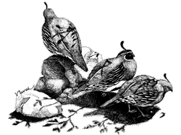  Gamble’s Quail |  | 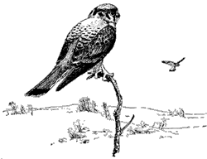  American Kestrel |  | 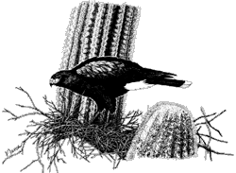  Harris’ Hawk
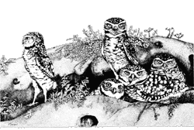  Burrowing Owl |  | 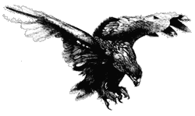  Golden Eagle |  | 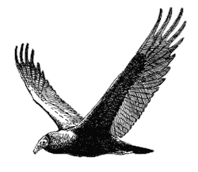  Turkey Vulture
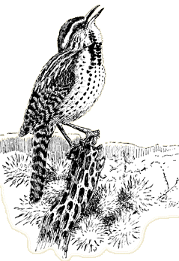  Cactus Wren |  | 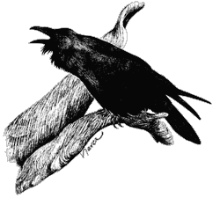  Common Raven |  | 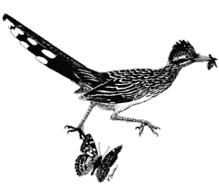  Greater Roadrunner
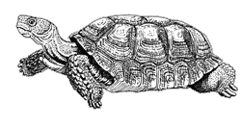  Desert Tortoise |  | 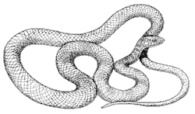  Western Coachwhip |  | 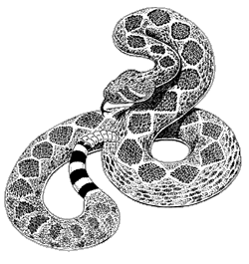  Western Diamondback Rattlesnake
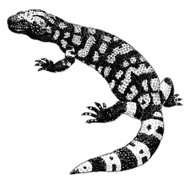  Gila Monster |  | 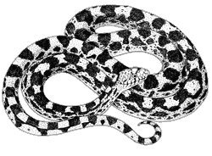  Gopher Snake |  | 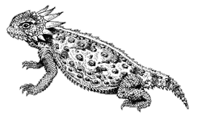  Horned Lizard
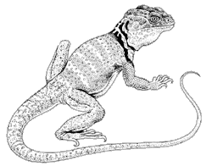  Collared Lizard |  | 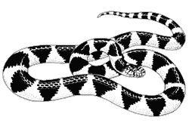  Desert Kingsnake |  | 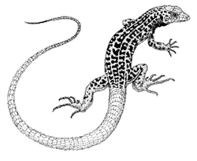  Checkered Whiptail Lizard
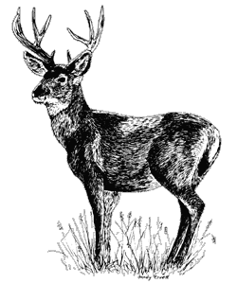  Mule Deer |  | 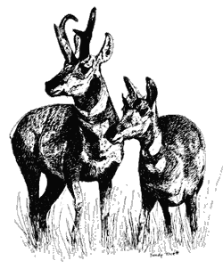  Pronghorn |  | 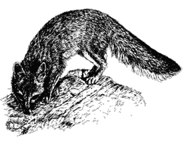  Grey Fox
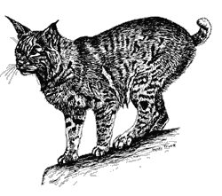  Bobcat |  | 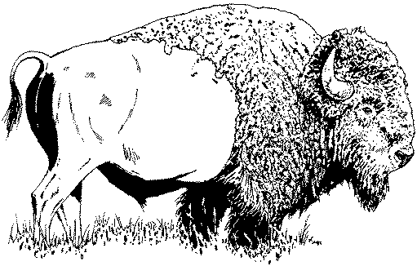  Bison |  | 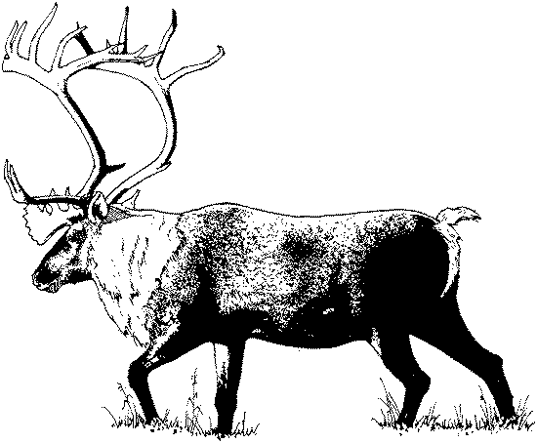  Elk
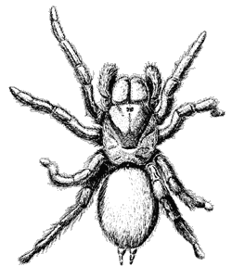  Desert Tarantula |  | 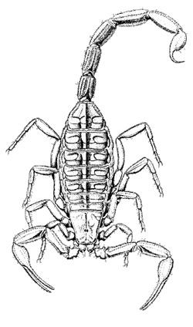  Bark Scorpion |  | 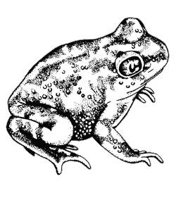  Couch’s Spadefoot
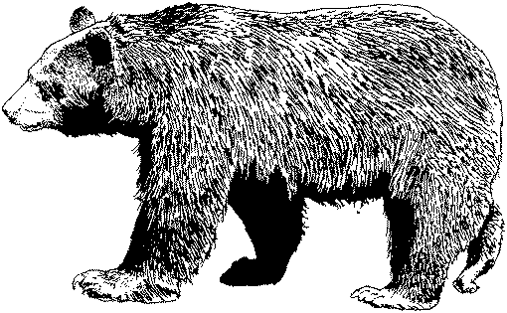  Black Bear |  | 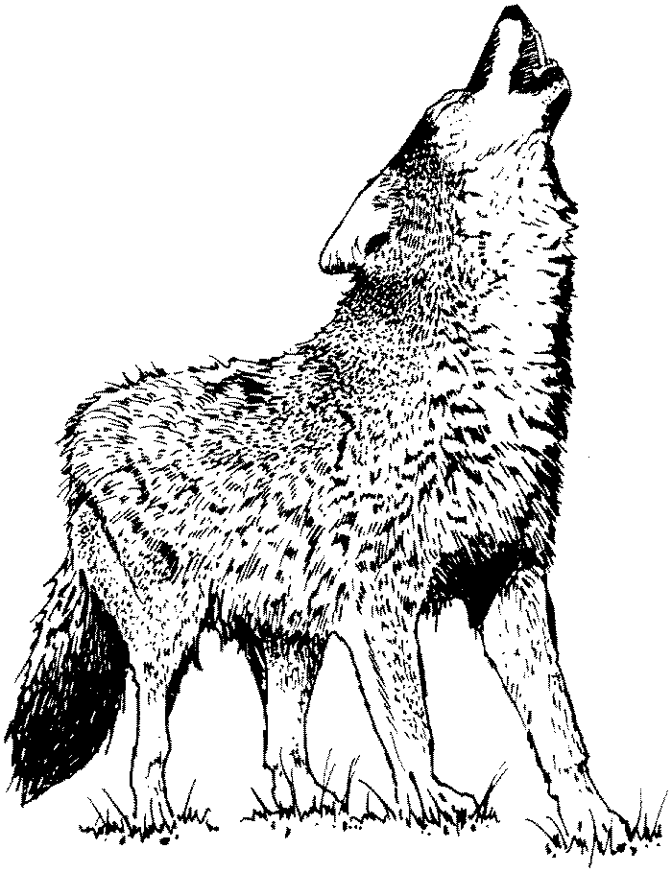  Mexican Gray Wolf |  | 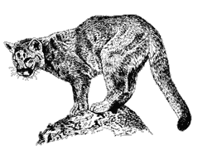  Mountain Lion
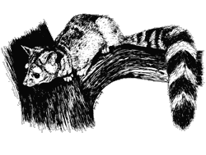  Ringtailed Cat |  | 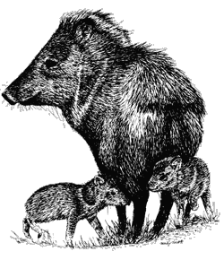  Javelina |  | 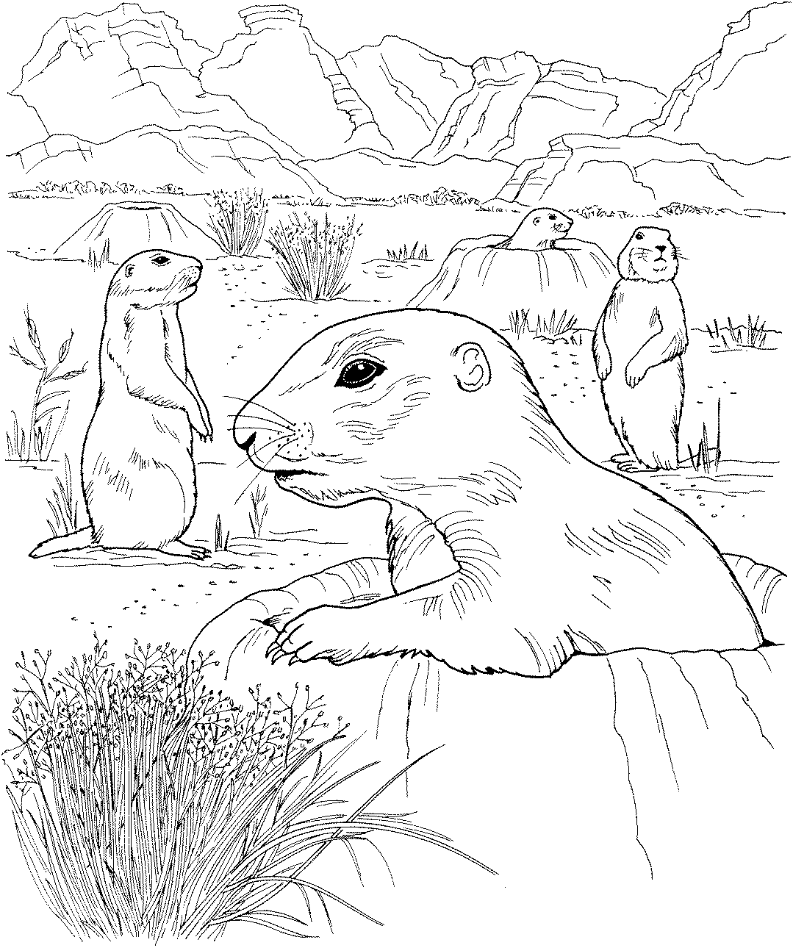  Black-tailed Prairie Dog
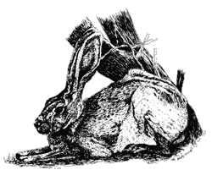
Black-tailed Jack Rabbit |  | 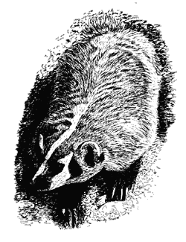  Badger |  | 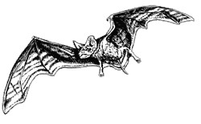  Mexican Free-tailed Bat
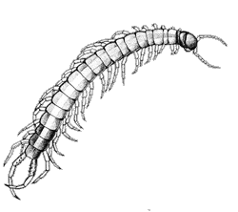  Centipede |  | 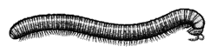  Millipede |  | 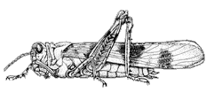  Banded Wing Grasshopper
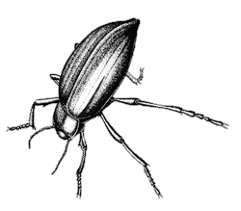  Pinacate Beetle |  | 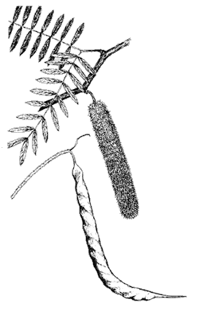  Honey Mesquite |  | 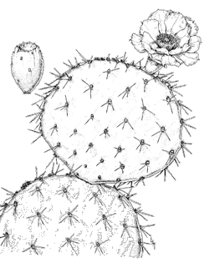  Engelmann Prickly Pear
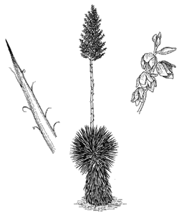  Soaptree Yucca |  | 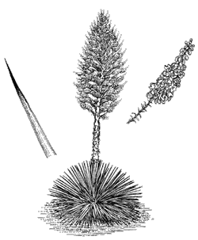  Spanish Bayonet |  | 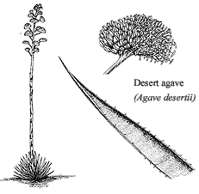  Desert Agave

All In the Family
Summary: Like all organisms, animals are named and classified into a hierarchy of relatedness. In this lesson students will learn the principles of classification in order to classify animals into their proper group.
Duration: 1 class period
Setting: Classroom
Vocabulary: class, kingdom, family, phylum, species, genus, order, animalia, chordata, mammalia, carnivora, canidae, canis
Standards/Benchmarks Addressed: SC1-E1, SC2-E2, SC3-E1, SC6-E1, SC6-E2, SC6-E3, SC10-E2, SC11-E1, SC11-E4, SC11-E5

Objectives
Students will:
- be able to define species.
- be able to order the taxonomic levels.
Background
Scientists are people who want to know how the world works. Biologists are people who study living things on our planet. They study how things evolved, how they are related, how they function, and how many different species there are. With the nearly 100 million species on Earth it is very complicated to organize species into their correct groups.
One way of making sense of the millions of species in the world is to organize them into groups based on their relationships. This system of uniform organization is called taxonomy: the classification of living things. This systematic organization and classification of living things was developed by Karl von Linne in 1758.
Taxonomists group similar kinds of creatures together based on their evolutionary relationships. Using this system, every living thing is given a unique classification.
This may sound simple, but it is not. The similarities and differences between species can be very subtle.
Taxonomy is a crucial part of our understanding of life on Earth; it reveals the order and diversity in the teeming life around us. The system that taxonomists use is based on the relationships of different groups of organisms to each other.
There are seven major levels of classification. These seven major levels from largest to smallest are: Kingdom, Phylum, Class, Order, Family, Genus, and Species. Each level can be divided into clusters of organisms that are most closely related. These clusters form the next level of classification. For example, each kingdom is divided into a smaller phyla, each phylum into classes, each class into order, and so on all the way down to species.
Another way to describe the different classifications is in terms of shared genetic material. The creatures at each level share a greater proportion of genetic material than those at the level below them. It is for this reason that an understanding of species is so important: each species represents a unique and irreplaceable genetic resource. The concept of biodiversity cannot be properly understood without an appreciation of the species.
Like all organisms, animals are named and classified into a hierarchy of relatedness. Organisms in the same species are more closely related than organisms in the same genus, and organisms in the same genus are more closely related than organisms in the same order, and so on.
Materials
Game pieces
Classification reference diagram
Procedure
Warm up: Students will be placed in groups of four and given a set of game cards. They will be asked to place these animals into groups. After a specified amount of time, ask each group to share how they grouped their cards. Introduce the concept of taxonomy and categorizing animals into groups. Refer to background information as needed.
Activity: Students will be given a classification reference diagram.
In the first column (address analogy) students are to write the country they live. In the next column (general scientific terms) they are to note the word kingdom. In the third column explain to the students that there are two major kingdoms, plants and animals. Ask the students to look at their game cards and determine which kingdom the pictured species are in (students should write, Animalia. Animalia are eukarotic, multicellular, and feed by ingesting other organisms or parts of other organisms).
In the first column, second row, students should write the state that they live in. In the second column, second row, students should note the word phylum (monophyletic assemblage derived from a single ancestor. Explain to the students that phyla can be sorted into arthropods (animals without backbones, invertebrates) and chordates(animals with backbones, vertebrates). Ask the students to sort their cards into the two categories. In the third column, second row, students should write chordata (members of this group are characterized by a notochord, pharyngeal gill slits, a dorsal tubular nerve cord, and a postanal tail). Students would retain only the animal cards in that category.
In the first column, third row, students should write the name of their city. In the second column, third row, students should note the term class. Explain to the students that in the phyla category there are four classes, amphibians, reptiles, birds, and mammals. Amphibians have moist skin, lay jellylike eggs and spend part of their life cycle in water. They are ectothermic (cold-blooded). Reptiles have scales or horny plates and usually lay leathery eggs. They are also ectothermic. Birds have feathers and wings. They lay hard-shelled eggs and have no teeth. Birds are endothermic (warm-blooded). Mammals are at least partially covered by hair, have specialized teeth, are endothermic, and young are nursed from mammary glands. Ask the students to sort their cards into these classes. In the third column, third row, students should write the word mammalia (members are at least partially covered by hair, have specialized teeth, are endothermic, and young are nursed from mammary glands). Students should retain only the cards from that class.
In the first column, fourth row, students should write their street name. In the second column, fourth row, students should note the term order. In the mammalia class there are five orders, rodents, primates, carnivores, omnivores, and herbivores. Rodents are usually small plant-eaters with gnawing teeth. Primates have five fingers with they can move separately and have flat fingernails instead of claws. Carnivores have sharp teeth, paws, claws, and eat meat. Have the students sort their cards into these categories. In the third column, fourth row, students will write the word carnivora (any organism that eats flesh). Students should retain only these cards.
In the first column, fifth row, students should write their street number. In the second column, fifth row, students should note the term family. Ask them to divide their cards into families. In the third column, fifth row, students will write the word canidae. Students should retain only the cards that fit this category.
In the first column, sixth row, students should write their last name. In the second column, sixth row, students should note the term genus. In the third column, sixth row, students should write Urocyon. What card do you have left?
In the first column, seventh row, students should write their first name. In the second column, seventh row, students should note the term species (a group of populations in which genes are actually, or potentially, exchanges through multiple generations). In the third column, seventh row, students have students write cinereoargenteus (scientific name for grey fox).
Wrap Up: Discuss the procedure just completed. Ask students to verbalize the analogy used with the address being compared to the classification system of animals. Students may play a game with the animal cards. Students should create an acronym in order for them to remember the classification order.
Assessment
Teacher can create a Classification Reference Diagram that has certain terms omitted. Students will fill in the missing words. Teachers can also name an animal and ask student to classify it.
All in the Family Activity
Classification Reference Diagram
Address Analogy | Classification | Name
 | Kingdom
 | Phylum
 | Class
 | Order
 | Family
 | Genus
 | Species

Why Do We Look the Way We Do?
How do animals adapt to their environment?
Summary: This hands-on lesson is designed to provide students with the opportunity to explore animal adaptations.
Duration: 2 class periods
Setting: Classroom/lab
Vocabulary: adaptation, flora, fauna, raptors, evolution, survival of the fittest, Charles Darwin, natural selection
Standards/Benchmarks Addressed: SC1-E1, SC1-E2, SC2-E2, SC2-E3, SC3-E1, SC4-E3, SC4-E4, SC4-E5, SC5-E2, SC6-E1, SC6-E2, SC6-E3, SC6-E6, SC11-E2, SC11-E4

Objectives
Students will:
- comprehend that birds physically adapt in relation to their food source.
- deduce what beaks are most efficient for given foods by experimenting with imitation beaks and hypothetical food sources.
- describe what would happen to a bird population if its environment could no longer support the bird’s food source.
- create a hypothetical bird for a desert environment.
Background
A change in physical appearance or behavior that allows an organism to survive in its natural environment is an adaptation. Animals change over time to fit the needs of their environment. If an environment changed the animals in that environment would have to change—adapt—in order to survive. Darwin’s theory of survival of the fittest implies the individuals with the best combination of inherited traits are most likely to survive. Darwin’s idea of natural selection implies that organisms best suited to the environment will survive and reproduce, therefore passing their genes to the next generation.
Animals change over a long period of time to fit their environment. Bird bills and tongues are modified for a variety of feeding habits and food sources. For example, the tongue of a woodpecker is barbed for extracting grubs from the bark of trees. Sapsuckers excavate holes in trees and use a brushlike tongue for licking the sap that accumulates in these holes. The tongues of hummingbirds and other nectar feeders are rolled into a tube and used for extracting nectar from flowers.
It is common practice to group birds by their feeding habits. This is somewhat artificial because birds may eat different kinds of food at different stages in their life history, or they may change diets simply because of changes in food availability. Robins, for example, feed largely on worms and other invertebrates when these foods are available. In the winter, however, robins feed on berries.
The appendages of birds have also been modified. Some bones in the front appendages have been lost or fused to serve as points of attachment for flight feathers. The rear appendages are used for hopping, walking, running, and perching. Perching tendons run from the toes across the back of the ankle joint to muscles of the lower leg. When the ankle joint is flexed, as in landing on a perch, tension on the perching tendons is increased, and the foot grips the perch. The automatic grasp helps the bird to perch even while sleeping. The muscles of the lower leg can increase the tension on these tendons, for example, when an eagle grasps a fish in its talons.
Materials
Beaks:
2 eyedroppers
1 pair of pliers
5 sets of chopsticks
4 tweezers
1 shoestring
1 sponge strip
1 straw
1 wrench
2 slotted spoons
1 strainer
3 tongs
1 envelope
1 bar-b-que fork
Food:
Colored water
Gummy worms
Sunflower seeds
Styrofoam
Popped popcorn
Rice
Marshmallows
Loose tea leaves
Other:
Potting soil
Shallow pans
8 boxes
8 cups
Graduated cylinder
Tree bark
Data sheets
Pictures of birds
Overhead of beaks and feet
Procedure
Warm up: Brainstorm ideas about what students know about birds. What makes a bird a bird? What do birds need to survive? What kind of foods do birds eat? Where do birds live? What kinds of birds can you find by your home or school?
Activity
- On the overhead, discuss the different bird beaks (cracker, shredder, chisel, probe, strainer, spear, tweezer, Swiss Army knife), what they look like, what they do, what kinds of birds have them; students should be taking notes and drawing the beaks. Do the same with the bird feet (grasping, scratching, swimming, perching, running, and climbing).
- Around the room have the following stations set up:
  - A graduated cylinder filled with colored water
  - A dish of potting soil with gummy worms buried throughout
  - Sunflower seeds spread throughout a pan
  - A shallow dish of water with Styrofoam floating in it
  - A dish of water with loose-leaf tea
  - Popped popcorn
  - Rice grains tucked into the bark of a log
  - Marshmallows hanging on strings
- These stations represent different food sources available. Students will visit each station and predict what type of beak and which type of feet that particular bird needs to posses in order to eat that food source. Have the students write their predictions down.
- Discuss the students’ predictions on the different stations to see if they are correct.
    - Nectar – probing beak, perching feet
    - Worms – Swiss Army knife beak, scratching feet
    - Seeds – cracker or Swiss Army knife beak, feet may vary
    - Fish – strainer or spear beak, swimming feet
    - Fine bits of vegetation – strainer beak, swimming feet
    - Flying insects – tweezer or Swiss Army knife beak, feet may vary
    - Small insects – chisel beak, climbing feet
    - Meat – shredder beak, grasping feet
- Divide students into groups (there are 8 challenges so divide accordingly). Each group will get a challenge. Pass out challenges and supplies to each group. After reading their challenge card the group should predict which beak (utensil) would work best for eating their specific food and write down their prediction on the data table. The group will then time (in seconds) how long it takes to obtain a given amount of food with each utensil (they must have three times for each utensil) and write the times on the data table. Then the students should average the three times and graph the results.
- Discuss the students’ predictions and results. Have them write an explanation next to their prediction. Was their prediction supported with evidence? How do you see things differently after this experiment?
- Discuss and/or research the following questions: What might happen to a bird population if its natural environment experienced a natural disaster where all the flora (plants) and fauna (animals) were wiped out? What would happen if a farmer used an insecticide that killed off all the insects? What would happen to the woodpeckers and other birds that eat insects? What would happen if the old trees were cut down? Where would eagles and other raptors watch for their meals?
Wrap Up: Students will create a bird that feeds on a particular food source. The students must include adaptations, other than beaks, that help the bird survive. For example: swimming feet for swimming animals like ducks and geese. The students will draw the bird and write a description of the adaptations needed for this bird to survive.
Assessment
Teacher observation, participation, notes, research, created birds with description, complete data table
Bird Feet Adaptations
Why Do We Look the Way We Do? Activity
Shape | Type | Adaptation | Example bird
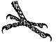 | Climbing | Enables the bird to climb without falling backwards | Woodpecker
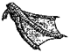 | Swimming | Web-lined feet; used like paddles for swimming. | Ducks and other web-lined swimming birds
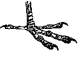 | Perching | Used to grab and perch tightly. | Robins
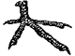 | Scratching | Used to scratch soil in search of food; have nail-like toes. | Pheasants
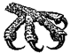 | Grasping | Have large curved claws used to snatch fish from the water and grab prey. | Raptors
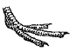 | Running | Have three toes rather than four; making them run faster. | Fast running birds
Pictures borrowed from: The Norman Bird Sanctuary
Bird Beak Adaptations
Why Do We Look the Way We Do? Activity
Shape | Type | Adaptation | Example bird
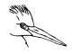 | Spear | Spear-like bill; adapted for fishing. | Herons, Kingfishers
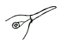 | Probe | Long and slender; used for probing flowers for nectar. | Hummingbirds
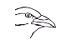 | Swiss Army Knife | A multipurpose bill; allows the bird to eat fruit, seeds, insects, fish, and other animals. | Crows
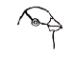 | Cracker | Short, thick conical bill; used for cracking seeds. | Sparrows, Cardinals
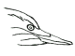 | Chisel | Long and chisel-like bills; used for boring into wood to eat insects. | Woodpeckers
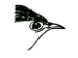 | Tweezer | Thin and pointed bills; used to eat insects. | Warblers
 | Shredder | Sharp curved bills; used for tearing meat. | Hawks, Owls
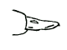 | Strainer | Long, flat bill; used to strain small plants and animals from the water. | Ducks
Pictures borrowed from: The Norman Bird Sanctuary

Why Do We Look the Way We Do? Challenges

Challenge #1
You have been given a graduated cylinder of water as a food source. You have also been given sample beaks: 1) a shoestring, 2) a medicine dropper, and 3) a sponge tip. Your challenge is to find out how many seconds it takes each “beak” to get 10mL of water from the graduated cylinder to the cup. Try several trials with each “beak.” Record the three times in the data table provided. Calculate the average time for each “beak.” Construct a bar graph of the averages.

Challenge #2
You have been given gummy worms as your food source. You have also been given sample beaks: 1) a straw, 2) chopsticks, and 3) a wrench. Your challenge is to find out how many seconds it takes to remove the gummy worms from the dirt using each “beak.” Use multiple trials, burying the worms after each trial. Record the times on the data table provided. Calculate the average time for each “beak.” Construct a bar graph of the averages.

Challenge #3
You have been given floating sunflower seeds as your food source. You have also been given sample beaks: 1) pliers, 2) chopsticks, and 3) tweezers. Your challenge is to find out how many seconds it takes each “beak” to crack the shell and remove the seed inside. Record the times on the data table provided. Calculate the average time for each “beak.” Construct a bar graph of the averages.

Challenge #4
You have been given Styrofoam squares as your food source. You have also been given sample beaks: 1) chopsticks, 2) tweezers, and 3) a slotted spoon. Your challenge is to find out how many seconds it takes each “beak” to remove all the Styrofoam squares from the water. Try several trials, returning the squares after each trial. Record the times on the data table provided. Calculate the average time for each “beak.” Construct a bar graph of the averages.

Challenge #5
You have been given tea leaves as your food source. You have also been given sample beaks: 1) a slotted spoon, 2) a strainer, and 3) tweezers. Your challenge is to find out how many seconds it takes each “beak” to get all the tea from the water. Try this several times, returning the materials each time. Record the times on the data table provided. Calculate the average time for each “beak.” Construct a bar graph of the averages.

Challenge #6
You have been given popped popcorn as your food source. You have also been given sample beaks: 1) tongs, 2) a medicine dropper, and 3) tweezers. A group member will gently toss some kernels into the air. Your challenge is to find out how many seconds it takes to capture 20 kernels with each “beak.” The kernels must be caught while they are still in the air. Try this several times with each “beak.” Record the times on the data table provided. Calculate the average time for each “beak.” Construct a bar graph of the averages.

Challenge #7
You have been given rice as your food source. You have also been given sample beaks: 1) a medicine dropper, 2) tongs, and 3) tweezers. Your challenge is to find out how many seconds it takes for each “beak” to remove thirty grains of rice from the tree bark. Try this several times, returning the rice to the tree bark after each time. Record the times on the data table provided. Calculate the average time for each “beak.” Construct a bar graph of the averages.

Challenge #8
You have been given marshmallows hanging from a string as your food source. You have also been given sample beaks: 1) chopsticks, 2) tongs, and 3) a bar-b-que fork. Your challenge is to find out how many seconds it takes for each “beak” to remove five marshmallows from the strings. Try this several times. Record the times on the data table provided. Calculate the average time for each “beak.” Construct a bar graph of the averages.

Name ____________________

Bird Beak Challenge Data Table
(Why Do We Look the Way We Do Activity)
Predict which beak (utensil) will work best for eating your specific food source.
Sample Beak Used | Trial 1 Time | Trial 2 Time | Trial 3 Time | Average

Was your prediction supported with evidence? Explain.
______________________________________________________________________________________________________________________________________________________________________________________________________________________________________________________________________________________________________________________________________________________________________________________________________________________________________________________________________________________________________________________________________________________________________________________________________________________________________________________

How do you see things differently now that you have completed this experiment? Explain.
______________________________________________________________________________________________________________________________________________________________________________________________________________________________________________________________________________________________________________________________________________________________________________________________________________________________________________________________________________________________________________________________________________________________________________________________________________________________________________________

Help! I’m Dehydrating!
How do animals conserve water?
Summary: This hands-on lesson is designed to help students understand how difficult it is for animals to conserve water in a desert environment.
Duration: 2 class periods
Setting: Classroom/lab
Vocabulary: conservation, nocturnal, adaptation, microhabitats
Standards/Benchmarks Addressed: SC1-E2, SC2-E1, SC2-E2, SC2-E3, SC3-E1, SC4-E3, SC4-E4, SC4-E5, SC5-E2, SC6-E1, SC6-E2, SC6-E4, SC6-E6, SC6-E7, SC11-E1, SC11-E2, SC11-E3, SC14-E3

Objectives
Students will:
- observe a model situation and make inferences about real organisms.
- communicate their observations relating to specialized organisms adapted to dry desert environments.
Background
A variety of organisms live in almost any habitat you could name. The desert, for example, is a challenging habitat for the plants and animals that live there. Yet for thousands of years plant and animal species have adapted and thrived in these arid lands. How? Because each organism has its own way of life which often requires a different environment from that of other organisms, plants and animals inhabit specific microhabitats within the environment of a general habitat. This microhabitat allows them to accommodate their needs and survive the harshness of the desert. A microhabitat is simply a small, distinctly specialized habitat.
For some animals their respite is the cool interior of a burrow. Rattlesnakes, kit foxes, and kangaroo rats spend most of the day resting in underground burrows. They choose the night for their active period to avoid the intense dehydrating heat of the daytime sun. During the day, the cool microclimate of their burrows helps protect them. How cool is it? While the soil surface up top may be 165 degrees Fahrenheit, their underground dens may be a livable 80 degrees Fahrenheit. In their cozy microhabitat, these animals can conserve their energy for nighttime hunting or seed gathering expeditions. Astonishingly, over half of all vertebrate animals, including those that live in caves and underground, are nocturnal.
During the dry times, animals such as the Spadefoot Toad, an amphibian that lives in the American Southwest, Can be found in a burrow dug with its spade-shaped back feet. It will continue to lie dormant until the sound of raindrops hitting the surface awakens the toad. At that point the race is on. Within approximately 8-10 days the cycle of finding a mate to laying the eggs to becoming a toad will be complete.
Some plants use combined strategies of dormancy and an accelerated life cycle. The seeds of the Sand Verbena will remain dormant (sometimes for years) until there is enough rain. When there is sufficient rain, they grow quickly, making their flowers and seeds and then dying all within a period of a few weeks. Some plants bloom at night in order to minimize water loss.
An arroyo, a ditch carved by water in desert regions, makes for the perfect microhabitat for Javelinas. When the steep banks erode, shallow cavities are created that provide warmth in the winter and cool in the summer. The Javelinas will hide in these shallow cavities to prevent water loss and stay cool on hot summer days.
Cave entrances can provide microhabitats for a variety of plant and animal species and provide growing conditions similar to a forest. It is not uncommon to find a fringe of green around the entrances to caves. Upon closer examination, evidence of animals such as birds, snakes, skunks, or mice living in the mouth of the cave can be found.
A variety of microhabitats can be found in any environment. Plants and animals find “their place” in logs, under boulders, in cacti, or even under a refuse can. Places such as a shady area under a tree or shrub are microhabitats because they provide a home for shade loving plants or respite for the desert lizards.
Materials
Sponges
Water
Natural desert materials (brush, vegetation, logs, etc…will be used as protection from the dry heat)
Balance scales
Desert animal profiles
Data sheet
Procedure
Warm up: Brainstorm ideas about what animals do to conserve water. Write a list of the students’ responses. What do desert animals do during the day? How do they escape from the desert heat? What adaptations have they made to survive in the harsh desert climate?
Activity
- Divide students into groups of 2 or 3. Each group will be given a sponge saturated with water. This sponge represents a desert animal with a very limited water supply. The students are to conserve as much of the animal’s water as possible. For a 24-hour period the group is to care for the “creature” in a way to achieve this goal using only natural materials. The creature must remain in the open for at least 4 hours (this represents feeding time).
- The students should weigh their sponge to get a baseline weight of the sponge. Write this weight down to compare to the ending weight of that same sponge. Students need to develop a strategy to conserve the water in their critter, write it down and make a prediction on what they think will happen. During the 24 hour observation time the students will make and write down observations as to what is happening with their animal. At the end of the time the students should weigh their sponges and compare beginning and ending weight. Students should make inferences about the results in relation to real organisms. (There should be a control sponge that is left out for the whole time for comparisons).
- Have the students share their plan, predictions, and results with the entire class. Have a class discussion on methods, results, and how it all relates to adaptations for desert survival of real living organisms.

Wrap Up: Students will invent a hypothetical desert animal. They may either draw or build the animal and write the adaptations the animal has that help it survive.
Assessment
Presentation of experiment results, animal presentation.
Name. ____________________
Help! I’m Dehydrating! Data Sheet
Sponge | Initial weight | Final Weight
Control Sponge
My Sponge

My strategy to conserve water:
________________________________________________________________________________________________________________________________________________________________________________________________________________________________________________________________________________________________________________

What I think will happen to my sponge:
________________________________________________________________________________________________________________________________________________________________________________________________________________________________________________________________________________________________________________

My observations:
________________________________________________________________________________________________________________________________________________________________________________________________________________________________________________________________________________________________________________

My results:
________________________________________________________________________________________________________________________________________________________________________________________________________________________________________________________________________________________________________________

How does this relate to real organisms?
________________________________________________________________________________________________________________________________________________________________________________________________________________________________________________________________________________________________________________

Designer Animals
Can you create an animal that could survive in a given environment?
Summary: This lesson is designed to extend the student’s knowledge of animal adaptations. This lesson could lead to the concept of the survival of the fittest (Darwinism).
Duration: 1 class period
Setting: Classroom/lab
Vocabulary: adaptations, global warming, habitat, ecosystem, climate, camouflage, mimicry
Standards/Benchmarks Addressed: SC1-E1, SC1-E2, SC2-E1, SC2-E2, SC2-E3, SC3-E1, SC4-E1, SC4-E5, SC6-E2, SC6-E3, SC6-E6, SC6-E7, SC11-E1, SC11-E2, SC11-E3, SC11-E4

Objectives
Students will:
- recognize animal adaptations.
- create an animal that would survive in a given environment.
Background
Sometimes little things can turn into big things. If global temperatures rise above normal levels for a few days, it’s no big deal—the Earth will stay more or less the same. But if temperatures continue to rise over a longer period of time, then the Earth may experience some problems.
The average global temperature has increased almost 1⁰ F over the past century; scientists expect the average global temperature to increase an additional 2 to 6⁰ F over the next hundred years. This may not sound like much, but it could change the Earth’s climate as never before. At the peak of the ice age (18,000 years ago), the temperature was only 7⁰ F colder than it is today, and glaciers covered most of North America.
Even a small increase in temperature over a long time can change the climate. When the climate changes, there may be big changes in the things that people and animals depend on. These things include the levels of the oceans and the places we plant crops. They also include the air we breathe and the water we drink.
Climate change may alter the world’s habitats and ecosystems—all living things are included in and rely on these places. Many of these places rely on a delicate balance of rainfall, temperature, and soil type. A rapid change in climate could upset this balance and endanger many living things.
Most past climate changes occurred slowly, allowing plants and animals to adapt to the new environment or move somewhere else. However, if future climate changes occur as rapidly as some scientist predict, plants and animals may not be able to react quickly enough to survive.
Materials
Drawing materials
Animal habitat cards
Procedure
Warm up: Brainstorm and list animal adaptations. Remind students that adaptations include camouflage, physical features, and behavioral features that help animals survive in their natural habitats. It is now the year 3000, humans are now able to design and create their own animals. The task is to develop an animal that would survive in a given environment.
Activity: Students will be given 1 animal habitat card. The students are going to draw an animal and label the adaptations that the animal has that help it survive in the given environment.
Criteria for animal:
Size
What does it eat?
How will it catch/get food and water?
How will it keep warm/cool?
Where will it take shelter?
What is the animal’s reproduction rate and gestation period?
How do the parents and infants interact?
How will it defend or protect itself from attackers?
Your animal cannot be a top predator (one that can eat everything else and survive).
All the above criteria must be labeled on the animal to receive credit.
Wrap Up: Students present and discuss the adaptations that their animal has in order to survive in the environment they were given.
Assessment
Rubric
Designer Animal Habitat Cards
This habitat is dark and cold most of the time. It is very mountainous. It rains almost all day. Because of the wet, dark conditions, the only plants that grow well are small mosses and fungi. The animals in this habitat include a type of mouse, a nocturnal large hunting cat, fish, and a variety of insects.

This habitat is dry and hot. Most of the surface is flat. Water is mostly found in underground streams, however there is a little water at the surface. Most of the terrain is covered in sand, although there are patches of dry grass. When plants are able to get their roots down into the water table, they grow into tall trees with leaves at the top but not along the trunk. Plants not connected to the water table are small and dry, but they are edible. The animals in this habitat include insects, a species of bird, which roosts in the high trees, a sand-colored lizard, and a type of rat.

This habitat is tropical: wet and hot. Most of the terrain is rainforest. The land is very flat. Water collects in large pools and lakes, which have water in them all year round. A species of poisonous plant grows thickly on the ground. The spines of this plant are poisonous; any animal that steps on one is sure to die. The vegetation is plentiful, and includes leaves, fruits, and nuts. Animals include carnivorous snakes, varieties of insects, monkeys, fish, and birds.

This habitat has a moderate climate. It never gets very hot or very cold, but stays mild all year long. It rains for part of the year and the water forms pools and lakes that dry up towards the end of the year, and then the habitat is very dry. The landscape is partly mountainous and partly flat. Vegetation includes tall trees with high leaves and fruit, and a smaller plant that bears nuts. However, these nuts are inside hard shells that need to be removed before the nut can be eaten. Animals include rats and mice which live underground, insects, birds that nest in the tall trees, slow moving mammals which also live in the trees, and a species of carnivorous nocturnal wolf.
Designer Animal Rubric
Designer Animal | Self evaluation | Teacher evaluation
Animal criteria: |  | /28
Size
What does it eat?
How will it catch/get food and water?
How will it keep warm/cool?
Where will it take shelter?
How will it defend or protect itself from attackers?
What is the animal’s reproduction rate and gestation period?
How do the parents and infants interact?
Overall: |  | /12
Has the student fulfilled all the parts of the task?
Has the student chosen appropriate adaptations to help the animal survive?
Is the picture neatly presented and labeled?
4 – no mistakes 3 – few mistakes 2 – many mistakes 1 – incomplete (however is present) 0 – not evident or not included

Percentage Animal Overall ________

Animals That Live in the Dark
Can you correctly place cave animals in their place in a cave?
Summary: This lesson is designed to extend the student’s knowledge of animal adaptations. This lesson will explore the life of cave animals and where they live in the cave system.
Duration: 1 class period
Setting: Classroom
Vocabulary: trogloxenes, troglophiles, troglobites, twilight zone, variable temperature zone, constant temperature zone, cave
Standards/Benchmarks Addressed: SC1-E1, SC2-E3, SC3-E1, SC4-E5, SC5-E2, SC6-E1, SC6-E2, SC6-E3, SC6-E4, SC6-E5, SC6-E6, SC6-E7, SC10-E2, SC11-E1, SC11-E2, SC11-E3, SC11-E4, SC11-E5

Objectives
Students will:
- place a group of cave animals into the correct placement within a cave system.
- identify the 3 zones of a cave.
- define the terms associated with cave life.
Background
There is an abundance of life within a cave. The characteristics and adaptations these animals have depend on the location within the cave that the animals live. There are three zones within a cave system.
The twilight zone is at the mouth of the cave, where the natural sunlight still enters the cave. The twilight zone is cooler than the outside temperature. Animals often take cover from the harsh outside temperatures in the cool twilight zone. For example, snakes, raccoons, packrats, skunks, birds, and some green plants grow. These animals are known as trogloxenes—they are animals that sometimes call caves their home.
The next is the variable temperature zone. The temperature here does not change much from the twilight zone. However, it is DARK! Mushrooms, molds, and fungi grow here. The animals that live in this zone include bats, crickets, and salamanders. These animals are known as troglophiles; they are animals that prefer to live in caves (they may also live other places like bats) most of their life; however, they leave the cave at night in order to eat. Green plants will not grow here because they need sunlight to grow.
The final life zone in the cave is the constant temperature zone. It is completely pitch-black. The air and water in this zone stay a constant temperature. Some bacteria and mold grow here. Some very strange cave dwellers live here as well. For example: blind crayfish, copepod, and blind shrimp. These animals are blind and colorless. They rely on touch, sound, and taste to find their food. These animals are called troglobites. They are animals who live only in caves and cannot survive anywhere else.
Materials
Paper
Pencils
Cave animal pictures
Procedure
Warm up: Brainstorm and list animals you may find in a cave, as well as information about caves.
Activity
- Discuss with students the three zones in a cave system. Discuss the characteristics and living organisms of each zone. As you go over the information students should take notes.
- Have the students draw a cave system and label the zones correctly. Then have the students place a list of organisms into the correct cave zones.
Wrap Up: Go over the adaptations that the cave animals have in order to survive in their special habitat. Make a list and discuss how these adaptations help the animals survive.
Assessment
Has the student fulfilled all the parts of the task?
Has the student correctly labeled the three zones?
Has the student correctly placed the living organisms in the correct place?
Is the picture neatly presented and labeled?
Name ____________________
Animals That Live In the Dark
Worksheet
Directions: Using another piece of paper, draw a cave system, and label the following cave zones and animals in the correct location.
- Twilight Zone
- Copepod
- Cave Cricket
- Snakes
- Cave salamander
- Constant Temperature Zone
- Cave swallows
- Barn owl
- Blind crayfish
- Bat
- Variable Temperature Zone
- Blind fish
- Spiders
- Isopod
- Skunks
- Ringtail
- Bacteria
Matching: Identify each animal as trogloxenes, troglophiles, or troglobites by circling the correct classification.
- Bats trogloxenes, troglophiles, or troglobites
- Ringtails trogloxenes, troglophiles, or troglobites
- Blind Crayfish trogloxenes, troglophiles, or troglobites
- Skunks trogloxenes, troglophiles, or troglobites
- Mountain lions trogloxenes, troglophiles, or troglobites
- Cave Crickets trogloxenes, troglophiles, or troglobites
- Isopods trogloxenes, troglophiles, or troglobites
- Cave swallows trogloxenes, troglophiles, or troglobites
- Blind fish trogloxenes, troglophiles, or troglobites
- Spiders trogloxenes, troglophiles, or troglobites
- Copepods trogloxenes, troglophiles, or troglobites
- Snakes trogloxenes, troglophiles, or troglobites
Animals that Live in the Dark
Worksheet Key
Matching: Identify each animal as trogloxenes, troglophiles, or troglobites by circling the correct classification.
- Bats trogloxenes, troglophiles, or troglobites
- Ringtails trogloxenes, troglophiles, or troglobites
- Blind Crayfish trogloxenes, troglophiles, or troglobites
- Skunks trogloxenes, troglophiles, or troglobites
- Mountain lions trogloxenes, troglophiles, or troglobites
- Cave Crickets trogloxenes, troglophiles, or troglobites
- Isopods trogloxenes, troglophiles, or troglobites
- Cave swallows trogloxenes, troglophiles, or troglobites
- Blind fish trogloxenes, troglophiles, or troglobites
- Spiders trogloxenes, troglophiles, or troglobites
- Copepods trogloxenes, troglophiles, or troglobites
- Snakes trogloxenes, troglophiles, or troglobite
Cave Animal Pictures
(Animals that Live in the Dark)
These are just some examples of animals you might find in a cave. Look carefully at the adaptations that these animals possess.

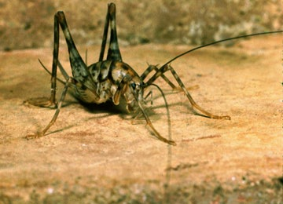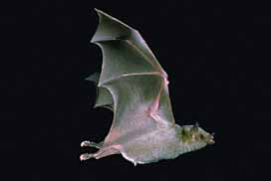
Camel “Cave” Cricket Mexican Long-Nosed Bat

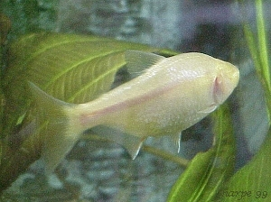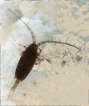
Blind Cave Fish Copepod

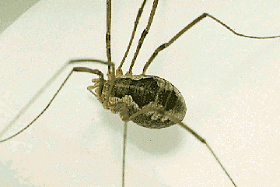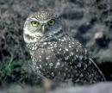
Harvestman Spider Burrowing Owl

Build An Animal
Will your animal survive the harsh desert environment?
Summary: This lesson is the culminating activity for the animal unit. It will bring together the ideas discussed throughout the unit and tie them together.
Duration: 1 to 2 weeks
Setting: Classroom
Vocabulary: phylum, hypothetical, theoretical, genus, species
Standards/Benchmarks Addressed: SC1-E2, SC2-E2, SC2-E3, SC3-E1, SC4-E5, SC5-E3, SC6-E1, SC6-E2, SC6-E3, SC6-E5, SC6-E6, SC6-E7, SC10-E2, SC11-E1, SC11-E2, SC11-E3, SC11-E4, SC11-E5

Objectives
Students will:
- design a hypothetical desert animal and construct a model of that animal.
- classify their animal into its correct phylum.
- infer which physical structures help the animal survive in the desert.
Background
Review background information on these following lessons:
- Why Do We Look The Way We Do?
- Help! I’m Dehydrating!
- Animals That Live in the Dark
- Sorting Out Species?
- All in the Family
- Make a Desert Diorama
Materials
Colored paper
String
Colored clay
Pins
Straws
Buttons
????, Be creative on material for the animals. Be sure not to include perishable items.
Procedure
Warm up: Review animal adaptations in reference to their environment.
Activity
- Review information on deserts, animal classification, and animal adaptations needed to survive in the desert.
- Decide what your hypothetical desert animal would look like (be creative – make it look strange and different from anything you have ever seen). What special adaptations would it have?
- Name the animal using proper genus and species format and classify it in a real (APPROPRIATE) phylum. Example: a person is a Homo sapien.
- Describe in writing the animal’s behavior, including the way it obtains food, the kind of dwelling it prefers, reproduction, its defensive behavior, and how it moves and gets oxygen.
- Use a variety of materials to create a model of the animal and answer the questions in the assessment section.
Wrap Up: Students create the model of their animal and review their writing. Both paper and animal will be turned in for a grade.
Assessment
Questions: (Due at the same time as the animal model)
- Describe the specific physical conditions that exist in your animal’s environment; include climate and landforms (temp, wind, rain, soil, and sunshine)
- For each condition above, describe a characteristic of your animal that makes it well-suited to the environment.
- State the characteristics that enable you to classify the animal in the phylum you selected.
Animal Grading Criteria
See rubric
Extensions
Create a story about the life of this animal and the future it may face.
Create a photo collage of animals dealing with dangers.
Make a short “documentary” video of an animal’s habits and behaviors.
Name ____________________
Build an Animal Assessment Questions
Due at the same time as the animal model!
1. Describe the specific physical conditions that exist in your animal’s environment, include climate and landforms (temp, wind, rain, soil, and sunshine).
____________________________________________________________________________________________________________________________________________________________________________________________________________________________________________________________________________________________________________________________________________________________________________________________

2. For each condition above, describe a characteristic of your animal that makes it well-suited to the environment.
____________________________________________________________________________________________________________________________________________________________________________________________________________________________________________________________________________________________________________________________________________________________________________________________

3. State the characteristics that enable you to classify the animal in the phylum you selected.
____________________________________________________________________________________________________________________________________________________________________________________________________________________________________________________________________________________________________________________________________________________________________________________________
Name ____________________
Classification Reference Diagram
(Build an Animal Activity)
Address Analogy | Classification | Name
 | Kingdom
 | Phylum
 | Class
 | Order
 | Family
 | Genus
 | Species

Name ____________________
Build an Animal Rubric
Build An Animal | Self evaluation | Teacher evaluation
Animal criteria: |  | /16
Animal created could survive in a desert environment.
Adaptations are appropriate for desert survival.
Animal is classified into an appropriate phylum.
Animal is named in the appropriate genus and species format.
Writing: |  | /8
Describe in writing the animal’s behavior, including the way it obtains food, the kind of dwelling it prefers, reproduction, its defensive behavior, and how it moves and gets oxygen.
Proper use of grammar
Overall: |  | /12
Has the student fulfilled all the parts of the task?
Has the student chosen appropriate adaptations to help the animal survive?
Has the student correctly answered the assessment questions?
4 – no mistakes 3 – few mistakes 2 many mistakes 1 – incomplete (however is present) 0 – not evident or not included

Percentage: Animal Writing Overall

The Nature Detective
What plants and animals live in this habitat?
Summary: This field trip is designed to help students become aware of their natural surroundings using keen observation skills.
Duration: 2-5 hours
Setting: Outdoors (nature hike at a National Park or on school grounds)
Vocabulary: riparian
Standards/Benchmarks Addressed: SC1-E1, SC2-E3, SC5-E2, SC6-E1, SC6-E2, SC6-E3, SC6-E4, SC6-E5, SC6-E6, SC10-E2, SC11-E1, SC11-E2, SC11-E4, SC11-E5

Objectives
Students will:
- discover and use clues to infer what plants and animals live in a certain habitat.
- take field notes about what is discovered.
- construct a plants and animals field guide.
Background
Nature hikes are a very important concept in developing students’ personal relationships with nature. Developing a nature journal as the students hike is a way for young explorers to observe, participate, sketch, count, reflect, and write as they interact with nature. Exploration activities, such as a desert scavenger hunt, encourage youngsters to see smell, hear, and touch nature in their own intimate way.
After a hike the students could research one plant and one animal to include in a nature guide. Below are two nature guide entries that include the appropriate information and layout (a nature guide would include a photograph of the plant and animal).
Mountain Lion – Puma concolor
Size: Total length about 78 inches, tail about 30 inches; weight, 100-200 pounds.
Habitat: Almost any habitat with sufficient topographic or vegetative stalking cover. In the Southwest, it favors edges of rimrock country, where scrub desert ends and forest begins.
Range: Throughout the western United States, Mexico, and southeastern Canada.
Also known as: cougar, catamount (short for “cat of the mountains”), puma, and panther
Similar species: Jaguar and ocelot have spots. Bobcat is much smaller, with a short, stubby tail.
Discussion: The mountain lion’s range once exceeded that of any other American mammal, extending from southeastern Alaska to southern South America and spanning the continental United States. Over hunting and habitat destruction have confined this secretive and solitary cat to large tracts of remote terrain.
The male’s territory averages a hundred square miles and may overlap with the smaller home ranges of several females. Mountain lions mark their territories with “scrapes”—visible mounds of dirt, needles, and twigs that are often scented with urine or feces.
Though the habits of mountain lions vary from high mountains to desert to tropical jungle, their appearance is similar. As indicated by the name concolor, the cat’s tawny coat is a monotone shade across most of its body, with lighter areas under the belly and inside the legs. It holds its tail—which is long, cylindrical, and may be tipped in black—close to the ground.
This highly efficient predator dines mainly on deer. It stalks its prey, pouncing with full weight from close range. After making the kill, the lion drags the carcass to a secluded spot to gorge. When satiated, it covers the remaining meat with leave and soil, bedding near the carcass by day and returning nightly to feed.
Banana Yucca – Yucca baccata, Agave Family (Agavaceae)
Description: As a group, yuccas are generally widespread in the northern Chihuahuan Desert and are often the most obvious large plant. In Yucca baccata, the leaves are very thick, and the trunk is usually stout but short. This species flowers from April to June and rarely at other times of the year when temperature and moisture are adequate.
Habitat: Also known as datil, the plants occur in rocky areas throughout our region. These plants can be found in Carlsbad Caverns National Park, Guadalupe Mountains National Park, and White Sands National Monument.
Discussion: The edible large fruits, which look something like bananas, were eaten by Native Americans. The fresh flowers are also edible, and leaf fibers are used to make baskets and similar items.
Rattlesnake Springs and Carlsbad Caverns Nature Trail, part of Carlsbad Caverns National Park, are great examples of places to take a hike. They are great examples of two different habitats. Rattlesnake Springs is a riparian area (an area with a water source) surrounded by lush vegetation and wildlife. Many of the animals you can see include aquatic life (crayfish, perch, and other fish species) and a variety of birds. The Carlsbad Caverns Nature Trail is a wonderful example of a desert environment. On the trail you can focus on the plant life of the Chihuahuan Desert and look for signs of animal life (tracks and scat).
Materials
Variety of desert plant and animal field guides
Pens and paper
Clipboards
Camera
Procedure
Warm up: Focus the students on the purpose of the trip. We are going to become Nature Detectives. We will have to closely observe our surroundings to find clues about the plants and animals that live here. With the information that we find we will be constructing a field guide. For instance, in the Chihuahuan Desert we would include rattlesnakes, Mexican Gray Wolf, Desert Agave, Soaptree Yucca, etc.
Activity
- Show the students the field guides and how to use them.
- Show the students how to set up their field notes and what information you want included (sketchings of plants, animals, tracks, and scat that you see, as well as descriptions on what they see, hear, feel, and smell).
- Divide the class into groups of 2. Have the pairs closely observe an area for a given amount of time and take notes, draw pictures, and take pictures of plants, animals, and things of interest that they see.
- Review with the students what they found.
Wrap Up: Discuss the information that should be present in a field guide. Have each student pick (or assign each student) a plant and animal to research and put into the field guide. When each student is finished with their research you should assemble them into one student-produced field guide.
Assessment
Research on assigned plant and animal for the field guide.
Extensions
Students graph the colors they see while on the trip.
Blindfold the students and take them to a tree. They are to use their senses of touch, smell, and hearing to learn as much about the tree as possible. They are returned to a central meeting point and asked to find their tree. Students can then describe the experience in a journal. What did they learn about the tree? What was the most difficult part of the experience?
Name ____________________
Nature Detective Field Guide Rubric
Nature Detective Field Guide | Self evaluation | Teacher evaluation
Animal criteria: |  | /12
Includes a picture
Includes both scientific and common names
Includes a detailed summary with a description of animal characteristics and adaptations
Plant criteria |  | /12
Includes a picture
Includes both scientific and common names
Includes a detailed summary with a description of plant characteristics and adaptations
Overall: |  | /12
Has the student fulfilled all the parts of the task?
Has the student chosen appropriate adaptations to help the plants and animals survive?
Has the student used proper grammar and sentence structure?
4 – no mistakes 3 – few mistakes 2 – many mistakes 1 – incomplete (however is present) 0 – not evident or not included

Percentage: Animal Plant Overall ________

Make a Desert Diorama
What plants and animals live in a desert habitat?
Summary: This activity helps the students share their knowledge of desert plants and animals and their natural habitat.
Duration: 2 class periods
Setting: Classroom
Vocabulary: microhabitat, desert
Standards/Benchmarks Addressed: SC1-E1, SC2-E2, SC2-E3, SC3-E1, SC4-E5, SC5-E2, SC5-E3, SC6-E2, SC6-E3, SC6-E4, SC6-E5, SC6-E6, SC11-E2, SC11-E3, SC11-E6

Objectives
Students will:
- design a diorama to show desert animals in their natural habitat.
Background
A diorama is a miniature scene with lifelike figures and objects set against a painted or colored background. The diorama is like a stage set that has all the props needed to represent the actual habitat (plants and animals).
Desert animals have some impressive ways of handling the challenges of desert life. Like plants, they need to beat the heat, get water, stay warm on cool nights, and stay unburned on sunny days. Unlike plants, they can’t send down a taproot for water or a web of roots to catch rain. They also do not make their own food using photosynthesis.
Animals do have one advantage: they can move around. Lizards waddle into the sun to warm up, and then shift into the shade to cool down. Bats migrate hundreds of miles so they can sip the nectar of many different plants. A vulture flies high, where the air temperature is cooler and it can get a better view of the ground.
Moving around is not the only way animals cope with desert conditions. For many desert animals a meal is both food and drink. Seeds can be 20-50 percent water, enough to quench the thirst of plant eaters. An animal’s body may be as much as 75 percent water, so meat eaters get water from their food, too. Some animals like the kangaroo rat actually make water in their bodies, as a by-product of the foods they eat. Others, like the desert cockroach can extract water directly from the air.
The big ears of desert hares, rabbits, and foxes help them to keep cool. Ears, long legs, and bare patches of skin where blood vessels are close to the surface act as natural radiators. Blood circulating through these spots radiates heat to the surrounding air. This cools the animal off.
Wet fur or skin can cool an animal even more. That’s why kangaroo rats lick their fur, foxes pant, and birds move their throats to evaporate water from their lungs and mouths. All these animals make use of evaporative cooling. The water on their skin absorbs their body heat. As it evaporates, it takes some of that heat away from their bodies and into the air.
To guard themselves against unpredictable desert food supplies, some animals stock up. Harvester ants and kangaroo rats store bushels of seeds in underground burrows for times of scarcity. Other animals go to sleep when food is scarce. Pocket mice, kangaroo rats, some ground squirrels, and some birds enter a state called torpor and may remain in that state for months. In torpor their breathing and other body processes slow down, saving energy. By saving energy, they need less food. Venom also helps desert predators subdue their prey quickly, with a minimum amount of energy.
Materials
Variety of desert plant and animal field guides
Cardboard boxes
Varity of art supplies (paints, markers, colored pencils, etc…)
A collection of natural objects (small rocks, plant material, leaves, grass, etc…)
Glue
Scissors
Procedure
Warm up: Review what the students know about desert plants and animals. They should have a good understanding of adaptations, and how these adaptations help the plants and animals survive in the desert. Students will build a diorama displaying what we have learned about desert plants and animals.
Activity
- Discuss what a diorama is and how to create one. Point out that in a diorama the background is the bottom of the box. It should be colored with a background that depicts the natural desert habitat. Then the animal and plant figures can be set in front of the background scene.
- Have each student pick an animal to research and learn about its natural environment.
- Give the students a box and have them begin making their dioramas. Each diorama must include at least one figure of the student’s animal. Students can draw the animal, cut out the animal from another resource, make modeling clay animals, or use any other material they can think of. Encourage the students to be creative. Use as many natural objects as possible to help set the appropriate tone for the desert environment. Suggest that the students glue the objects into the diorama so that the objects do not move or fall out when they are carried.
Wrap Up: Students share their dioramas with the class, explaining the features of their animal’s habitat.
Assessment
Rubric for diorama.
Name ____________________
Desert Diorama Rubric
Desert Diorama Rubric | Self evaluation | Teacher evaluation
Diorama criteria: |  | /24
Diorama depicts a desert habitat.
Background is neat and depicts a desert habitat.
Diorama includes at least one figure of the animal.
Diorama shows thorough knowledge of a variety of desert plants and animals.
Student has included mirohabitats (places the animal goes to escape the heat).
Student uses a variety of natural materials to depict the desert environment.
Presentation: |  | /8
Presenter followed appropriate speaking rules (eye contact, voice, appeal, enthusiasm)
Presentation quality, organization, appeal, and information
Overall: |  | /4
Has the student fulfilled all the parts of the task?
4 – no mistakes 3 – few mistakes 2 – many mistakes 1 – incomplete (however is present) 0 – not evident or not included

Percentage: Diorama Presentation Overall ________
CONTENT STANDARDS WITH BENCHMARKS

Science

Unifying Concepts and Processes
CONTENT STANDARD 1
Students will understand science concepts of order and organization.

SC1-E1
Students will apply information about the predictability and organization of the universe and its subsystems.

SC1-E2
Students will apply prediction to scientific problems and events.

CONTENT STANDARD 2
Students will use evidence, models, and explanations to explore the physical world.

SC2-E1
Students will identify and organize evidence needed to predict changes in natural and artificial systems.

SC2-E2
Students will organize phenomena into hypotheses, models, laws, theories, principles, and paradigms.

SC2-E3
Students will design and develop models.

CONTENT STANDARD 3
Students will use form and function to organize and understand the physical world.

SC3-E1
Students will explain function by referring to form and explain form by referring to function.

CONTENT STANDARD 4
Students will understand the physical world through the concepts of change, equilibrium, and measurement.

SC4-E1
Students will illustrate that constancy and change are properties of objects and processes.

SC4-E2
Students will illustrate that energy and matter can be transformed and changed but the sum remains the same.

SC4-E3
Students will use elementary scientific devices to measure objects and simple phenomena.

SC4-E4
Students will employ mathematics to quantify properties of objects and phenomena.

SC4-E5
Students will relate the contributions of external and internal forces to change in the form and function of objects, organisms, and natural systems.

Science as Inquiry
CONTENT STANDARD 5
Students will acquire the abilities to do scientific inquiry.

SC5-E1
Students will use the scientific method within the classroom and school environment.

SC5-E2
Students will employ equipment, tools, a variety of techniques, and information sources to gather, analyze, and interpret data.

SC5-E3
Students will explain that scientific theories emphasize evidence, have logically consistent arguments, and use scientific principles, models, and theories. Well-accepted scientific theories are formulations of apparent relationships or underlying principles of certain observed phenomena that have been verified to a very high degree.

CONTENT STANDARD 6
Students will understand the process of scientific inquiry.

SC6-E1
Students will use different kinds of methods, including observation, experiments, and theoretical and mathematical models to answer a variety of scientific questions.

SC6-E2
Students will use their own understanding of science to guide their scientific investigations.

SC6-E3
Students will use criteria for sound scientific investigations to verify the truth of the results of their own and others’ investigations.

SC6-E4
Students will choose appropriate methods and analytic techniques for specific science problems and investigations.

SC6-E5
Students will use technology and scientific methods to gather evidence to enhance the accuracy of their findings.

SC6-E6
Students will describe the results of investigations with teachers, peers, parents, and others.

SC6-E7
Students will explain that scientific investigations can result in new ideas, objects, methods, techniques, and procedures for investigation.

SC6-E8
Students will explain that in areas where there is not a great deal of experimental or observational evidence, it is typical for scientists to differ with one another about the theory, hypothesis, or evidence being investigated.

Physical Science
CONTENT STANDARD 7
Students will know and understand the properties of matter.

SC7-E1
Students will identify the characteristic properties of elements and compounds such as density, boiling point, and solubility.

SC7-E2
Students will explain that the characteristic properties of an element or compound are independent of the amount (size) of the sample.

SC7-E3
Students will discriminate between elements based on the characteristic ways in which they react with other elements to form compounds that are different substances with unique characteristic properties.

CONTENT STANDARD 8
Students will know and understand the properties of fields, forces, and motion.

SC8-E1
Students will explain that when an object is not being subjected to a force, the object will continue to move at a constant speed and in a straight line.

SC8-E2
Students will describe quantitatively how an object’s position, speed, and direction explain motion.

SC8-E3
Students will compare and contrast gravity to other forces in the world and universe.

CONTENT STANDARD 9
Students will know and understand the concepts of energy and the transformation of energy.

SC9-E1
Students will apply knowledge about energy and energy transformation to science problems.
SC9-E2
Students will explain how chemical reactions can take place in time periods ranging from less than a second to millions of years.

SC9-E3
Students will explain how chemical reactions involve concentration, pressure, temperature, and catalysts.

Life Science
CONTENT STANDARD 10
Students will know and understand the characteristics that are the basis for classifying organisms.

SC10-E1
Students will use information about living things including:
- The roles of structure and function as complementary in the organization of living systems.
- Cells as the fundamental unit of life.
- The functions of cells which sustain life.
- Cell division.
- The use of nutrients by cells.
- The role of heredity and environment in the characteristics of individual organisms.
- That small genetic differences between offspring and parents may accumulate in succeeding generations and may or may not be advantageous for the species.
- Disease as a breakdown in the structures or function of an organism.

SC10-E2
Students will categorize organisms according to reproductive and other characteristics.

CONTENT STANDARD 11
Students will know and understand the synergy among organisms and the environments of organisms.

SC11-E1
Students will distinguish among organisms based on the way an organism regulates its internal environment in relation to changes in its external environment.

SC11-E2
Students will describe how organisms obtain and use resources, grow, reproduce, and maintain a stable internal environment while living in a constantly changing external environment.

SC11-E3
Students will predict behavior in relation to changes in an organism’s internal and external environments.

SC11-E4
Students will use knowledge of population characteristics to distinguish specific populations.

SC11-E5
Students will categorize organisms based on the function they serve within their ecosystem.

SC11-E6
Students will examine the impact humans have had on other species and natural systems over time.

SC11-E7
Students will illustrate the impact that overpopulation might have on various regions of the world.

SC11-E8
Students will analyze consumption of nonrenewable resources based on population factors (birth rate, death rate, and density).

SC11-E9
Students will illustrate the role of personal control of basic needs on health outcomes.

SC11-E10
Students will model responsible health behaviors for peers and others.

SC11-E11
Students will demonstrate the impact of nutrition and exercise on personal health.

Earth and Space Science
CONTENT STANDARD 12
Students will know and understand properties of earth science.

SC12-E1
Students will explain how Earth’s materials can be transformed from one state to another.

SC12-E2
Students will experiment with the uses of Earth’s materials as resources.

SC12-E3
Students will model natural processes that shape the Earth’s surface.

SC12-E4
Students will observe, measure, and record weather changes that occur daily.

SC12-E5
Students will explain how fossils are formed and how fossils provide evidence of the complexity and diversity of life over time.

SC12-E6
Students will use a rectilinear coordinate system such as latitude and longitude to locate points on the surface of Earth.

SC12-E7
Students will describe the interaction between the Earth’s lithosphere, hydrosphere, atmosphere, and biosphere.

CONTENT STANDARD 13
Students will know and understand basic concepts of cosmology.

SC13-E1
Students will model the predictable patterns of the sun and planets in the solar system.

SC13-E2
Students will describe the elements of the universe including stars, galaxies, dust clouds, and nebulae.

SC13-E3
Students will explain various scientific theories for the origin of the universe.

SC13-E4
Students will explain how instruments and vehicles are used for space exploration work.

Technology and the History of Science
CONTENT STANDARD 14
Students will know and understand the differences between the interactions of science and technology.

SC14-E1
Students will design and conduct experiments that distinguish between natural and artificial objects and materials.

SC14-E2
Students will demonstrate trade-offs in safety, cost, efficiency, and appearance related to technological solutions provided through science.

SC14-E3
Students will compare and contrast a variety of scientific and technological solutions to problems.

SC14-E4
Students will examine the role of technology, particularly computers and other electronic advances, in the advancement of science.

CONTENT STANDARD 15
Students will know and understand the impact between science and technology in society.

SC15-E1
Students will illustrate the impact that work settings have on scientific investigations.

SC15-E2
Students will demonstrate how the direction for scientific investigations is related to social issues and challenges.

SC15-E3
Students will explain how the benefits of science and technology are enjoyed by some groups and not by other groups.

SC15-E4
Students will compare and contrast the science contributions of people with diverse interests, talents, qualities, and motivations from a variety of social and ethnic backgrounds.

SC15-E5
Students will predict new areas of scientific inquiry based on previous research.

SC15-E6
Students will analyze the impact of culture, gender, and other factors on an individual’s choice of science as a career.

SC15-E7
Students will differentiate between ethical and unethical scientific practices and research.

Science in Personal, Social and Environmental Perspectives
CONTENT STANDARD 16
Students will know and understand the relationship between natural hazards and environmental risks for organisms.

SC16-E1
Students will analyze environmental risks for personal and social costs.

SC16-E2
Students will determine options for reducing and eliminating environmental risks and for coping with natural catastrophic events.

SC16-E3
Students will predict the human and financial costs of slow natural events such as drought and rapid natural events such as earthquakes.

SC16-E4
Students will develop models for prevention of substance abuse including tobacco, alcohol, and other drugs, and to reduce the associated environmental risks.
Biology Glossary

A
Adaptations a behavior, physical feature, or other characteristic that helps an animal survive and make the most of its habitat; the way any living thing is fitted to the life it leads.
Alternation of generations life cycle in which haploid and diploid generations alternate with each other. The haploid-diploid life cycle is the most complex life cycle and thus has lots of variations. It is also the most common life cycle among plants since all land plants are haploid-diploid.
Animalia one of the 5 major kingdoms. Contains all animals.
Anther the tip of a flower’s stamen; contains the pollen.
Axil the angle between the upper side of the stem and the leaf or petiole.
Axillary bud a bud that develops in the axil.
B
Bacteria a unicellular microorganism associated with processes of putrefaction, fermentation, and causes diseases in plants and animals.
Biothems cave bacteria.
Byproduct something produced in the making of something else; a side effect.
C
Camouflage a means of concealment or a disguise that creates the effect of being part of the natural surroundings.
Carnivora typically flesh-eating animals.
Carpel (pistil) is the structure in a flower that consists of the stigma, a style, and an ovule-containing ovary; the ovule becomes the seed and the ovary becomes the fruit.
Cave a hollow or natural passage under or into the Earth with an opening to the surface.
Cell is a structural and functional unit of an organism; the small structure capable of performing all the functions necessary for life.
Cell membrane a thin layer of protein and fat that surrounds the cell, but is inside the cell wall, and is semi permeable.
Cell organelles small, often membranous, structure in the cytoplasm, having a specific structure and function.
Cell wall a thick, rigid membrane that surrounds a plant cell; gives a plant most of its support and structure.
Centrosome a small body located near the nucleus—it has a dense center and radiating tubules. The centrosome is where microtubules are made.
Charles Darwin wrote The Origin of Species, animals evolved through evolution.
Chemolithotrophs specialized prokaryotes that are able to oxidize inorganic chemicals as their sole source of energy and reducing power.
Chlorophyll green plant pigment that absorbs the sunlight needed for photosynthesis.
Chloroplasts elongated or disc-shaped organelles containing chlorophyll.
Chordata organisms with a backbone; vertebrates.
Cinereoargenteus scientific name for grey fox; based on the Greek words cinereus (ash-colored) and argenteus (silver), in reference to the color of the fox.
Class a taxonomic category ranking below a phylum and above an order.
Classification to sort into groups.
Climate weather condition of an area including prevailing temperature and average daily/yearly rainfall.
Compound substance having two or more different elements united chemically in a fixed ratio.
Coniferous a cone-bearing tree such as a pine or fir tree.
Conservation is a scientific discipline that seeks to understand the effects of human activities on species, communities, and ecosystems and to develop practical approaches to preventing the extinction of species and the destruction of ecosystems.
Constant temperature zone an area in a cave in which the temperature stays at 58 degrees regardless of weather on the surface.
Cytoplasm contents of a cell between the nucleus and the plasma membrane that contains the organelles.
D
Deciduous plants that shed their foliage at the end of the growing season.
Desert an area that receives less than 10 inches of rainfall a year and has a very high rate of evaporation.
Dichotomous key a way of identifying unknown organisms by constructing a series of couplets, each couplet consisting of two separate statements, by reading the statements from broad to narrower characteristics only a single choice will remain.
Drought a long period of low rainfall.
E
Ecosystem all the living organisms in a given area as well as their physical environment—usually made up of many complex interactions.
Eukaryotic an organism whose cells contain a distinct membrane-bound nucleus.
Evolution changes that occur in the members of a species with the passage of time, often resulting in increased adaptation of organisms to the environment.
F
Family the category ranking below an order and above a genus in the taxonomic classification.
Fauna animals, especially of a region or period.
Filament is the part of the flower that holds the anther.
Flora plants, especially of a specific region or period.
Flower the reproductive unit of angiosperm.
Flower stalk the structure that supports the flower.
Fungi any organism that lacks chlorophyll, includes yeast, molds, smut, and mushrooms. One of the 5 major kingdoms.
G
Genus category ranking below a family and above species in the hierarchy of taxonomic classifications.
Global warming predicted increase in the Earth’s temperature, due to the greenhouse effect, which will lead to the melting of polar ice and a rise in sea levels.
Golgi body a flattened, layered, sac-like organelle that looks like a stack of pancakes and is located near the nucleus. It produces the membranes that surround the lysosomes. The Golgi body packages proteins and carbohydrates into membrane-bound vesicles for “export” from the cell.
H
Habitat the place where an animal lives.
Hypothetical an answer to a question based on the best educated guess possible.
I
Internode the area of the stem between any two adjacent nodes.
K
Kingdom the highest taxonomic classification into which all organisms are grouped.
L
Lamina the blade of a leaf.
Lateral shoot an offshoot of the stem of a plant (branches).
Leaf an outgrowth of a plant that grows from a node in the stem. Most leaves are flat and contain chloroplasts; their main function is to convert energy from sunlight into chemical energy (food) through photosynthesis.
Leaf apex the outer end of a leaf; the end that is opposite the petiole.
Lysosome spherical organelles surrounded by a membrane; they contain digestive enzymes.
M
Mammalia mammals.
Midrib the central rib of a leaf—it is usually continuous with the petiole.
Microhabitat a small area where an organism lives that has different conditions from another small area that might be right next door.
Mimicry a superficial resemblance of two or more species; a mechanism that avoids predation by appearing to be dangerous.
Mitochondrion a microscopic structure in nearly all living cells, containing genetic material and enzymes important for cell metabolism. Plural Mitochondria.
N
Natural selection mechanism of evolution caused by environmental selection of organisms most fit to reproduce; results in adaptation to the environment.
Nocturnal most active at night, sleeps most of the day.
Node the part of the stem of a plant from which a leaf, branch, or aerial root grows; each plant has many nodes.
Nuclear membrane a membrane that surrounds the nucleus.
Nucleolus an organelle within the nucleus; it is where ribosomal RNA is produced.
Nucleus a spherical body containing many organelles, including the nucleolus; it also controls many of the functions of the cell and contains DNA.
Nucleus a membrane-bound organelle with a cell that contains chromosomes and controls the structure and function of the cell.
O
Order the category ranking below class and above family in the hierarchy of taxonomic classification.
Ovary is a female reproductive organ in plants that produces ovules.
P
Petal is one of the leafy structures that comprise a flower, they are usually brightly colored and have many different shapes.
Petiole a leaf stalk; it attaches the leaf to the plant.
Photosynthesis the process by which plants use the sun’s energy to convert carbon dioxide and water into sugar.
Phylum category below a kingdom and above a class in the hierarchy of taxonomic classifications.
Pigment a substance, such as chlorophyll, that produces a characteristic color in the plant and animal kingdom.
Prokaryotic cell lacking a membrane-bound nucleus and organelles, the cell type within the domain Bacteria and Archaea.
R
Raptor a bird of prey.
Ribosome small organelles composed of RNA-rich cytoplasmic granules that are sites of protein synthesis.
Riparian relating to the banks of a natural course of water.
Root is a plant structure that obtains food and water from the soil, stores energy, and provides support for the plant. Most roots grow underground.
Root cap a structure at the ends of the roots, it covers the growing end of the root.
Rough endoplasmic reticulum (rough ER) a vast system of interconnected, membranous, in-folded, and convoluted sacks that are located in the cell’s cytoplasm. Rough ER is covered with ribosomes that give it a rough appearance. Rough ER transport materials through the cell and produce proteins in sacks called cisternae.
S
Sepal small leaves located directly under a flower—they are the outermost part of a flower.
Simple leaves that are not divided into leaflets.
Smooth endoplasmic reticulum (smooth ER) a vast system of interconnected, membranous, in-folded, and convoluted tubes that are located in the cell’s cytoplasm. Smooth ER transports materials through the cell.
Species a group of similarly constructed organisms capable of interbreeding and producing fertile offspring; organisms that share a common gene pool.
Stamen in flowering plants, the portion of the flower that consists of a filament and an anther containing pollen sacs where pollen is produced.
Stem (also called the axis) the main support of the plant.
Stigma the uppermost part of the pistil, the female reproductive tissue of a flower, receives the male pollen grains during fertilization, when they travel through the style to the ovary.
Stipule the small, paired appendages (sometimes leaf-like) that are found at the base of the petiole of leaves of many flowering plants.
Stomata small pores in a tree’s leaves and stems that open to absorb carbon dioxide and release oxygen.
Style is part of the pistil, the female reproductive tissue of the flower; a long tube located on top of the ovary and below the stigma.
Survival of the fittest Darwin asserted that in order for a species to cope with the ever-changing environments and circumstances it is subjected to, it must not only adapt, but must also be capable of passing on those adapted characteristics to its offspring.
T
Taproot the main root of some plants; the taproot extends straight down under the plant.
Taxonomy a branch of biology concerned with identifying, describing, and naming organisms.
Terminal bud a bud located at the apex of the stem.
Theoretical answer based on a theory.
Transpiration the process by which a tree loses water through stomata on its leaves and stems.
Troglobites are animals that only live in caves. They can’t survive anywhere else.
Troglophiles are animals that like to live in caves but also can live elsewhere.
Trogloxenes are animals that sometimes choose caves as their homes.
Twilight zone the part of a cave in which some daylight penetrates (but not direct sun light) and gradually diminishes to zero light.
U
Urocyon the genus name based on the Greek words oura (tail) and kyon (dog).
V
Vacuole a large, membrane-bound space within a plant cell that is filled with fluid. Most plant cells have a single vacuole that takes up much of the cell.
Variable temperature zone the temperature inside fluctuates with the weather outside the cave.
Vegetative propagation the term given to any asexual means of starting new plants.
Vein one of the many vascular structures on a leaf; they provide support for the leaf and transport both water and food through the leaf.
W
Whorls a group of three or more leaves of the same kind, arising at the same level on a stem and arranged in a circle, the petals of a flower or the branches of a horsetail.

Biology Resources
ABC’s of Animal Taxonomy. Retrieved July 15, 2002, http://www.pcisys.net/~dlblanc/taxonomy.html
Alien Explorers. Retrieved July 17, 2002, http://www.alienexplorer.com/ecology/topic3.html
Anatomy and Physiology. Retrieved August 20, 2002, http://www.fi.edu/tfi/units/life/anatomy/anatomy.html
Audubon Society. Retrieved July 17, 2002, http://www.audubon.org/
Bigchalk Education Center. Retrieved July 12, 2002, http://www.bigchalk.com/cgi-bin/WebObjects/WOPortal.woa/wa/BCPageDA/sec~CAB~48410~~
Bigchalk: Homework Central Plant Structure and Growth. Retrieved July 10, 2002, http://www.bigchalk.com/cgi-bin/WebObjects/WOPortal.woa/wa/BCPageDA/sec~ga~10412~~
Biology Century. Retrieved July 7, 2002, http://mywebpages.comcast.net/biologycentury/pages/cell3.html
Bowers, J.E., (1989). 100 Desert Wildflowers of the Southwest. Tucson: Southwest Parks and Monuments Association.
Braus, J., (1989). Ranger Rick’s Nature Scope: Trees are Terrific. Washington DC: National Wildlife Federation.
Cave Animals. Retrieved August 6, 2002, http://www.expandtheworld.com/html/cave_animals.html
Cave Life. Retrieved July 10, 2002, http://www.ans.latech.edu/homes/wakeman/caves/cavelife.html
Cave Life. Retrieved July 20, 2002, http://www.nps.gov/maca/cavelife.htm
Cell Biology. Retrieved July 15, 2002, http://micro.magnet.fsu.edu/cells/
Cells Alive. Retrieved August 6, 2002, http://www.cellsalive.com
Cells and Cell Structure. Retrieved August 6, 2002, http://www.biology4kids.com/files/cell_main.html
Cells Are Us. Retrieved July 20, 2002, http://www.icnet.uk/kids/cellsrus/cellsrus.html
Crane, C. (2000). Carlsbad Caverns National Park: Worlds of Wonder. Korea: Carlsbad Caverns Guadalupe Mountains Association.
Cunningham, R.L., (1990). 50 Common Birds of the Southwest. Tucson: Southwest Parks and Monuments Association.
Desert Adaptation. Retrieved August 6, 2002, http://www.amphi.com/~ams/intpowers.html
Desert Biome: Plant and Animal Adaptations. Retrieved July 15, 2002, http://www1.enloe.wake.k12.nc.us/enloe/science/warner/desert/adaptations.htm
Desert Diary Desert Adaptations. Retrieved July 7, 2002, http://www.utep.edu/museum/desertdiary/archive/desertadapt/indexpage.htm
Desert Plant Survival. Retrieved July 12, 2002, http://www.desertusa.com/du_plantsurv.html
Desert USA. Retrieved July 20, 2002, http://www.desertusa.com/magdec97/psmuseums/dec_livedesert.htm
Desert Web Quest. Retrieved August 6, 2002, http://can-do.com/uci/lessons98/Desert.html
Ecosystems, Biomes, and Watersheds. Retrieved July 15, 2002, http://cnie.org/NLE/CRSreports/Biodiversity/biodv-6.cfm
EnchantedLearning.com. Retrieved August 5, 2002, http://www.enchantedlearning.com/biomes/
Encyclopedia Britannica. Retrieved July 12, 2002, http://www.britannica.com
Fischer, P.C., (1989). 70 Common Cacti of the Southwest. Tucson: Southwest Parks and Monuments Association.
Form and Photosynthesis in Vascular Plants. Retrieved July 10, 2002, http://fig.cox.miami.edu/Faculty/Tom/bil160sp98/plantform/13_plantform.html
Gander Academy’s Cave Theme Page. Retrieved July 10, 2002, http://www.stemnet.nf.ca/CITE/cave.htm
Gibbons, G., (1993). Caves and Caverns. San Diego: Voyager Books.
Gunzi, C. (1993). Cave Life: A Close-up Look At the Natural World of a Cave. New York: DK Publishing Inc.
Habitat Web Links. Retrieved July 7, 2002, http://www.lx.org/ewcave.html
I Can Do That – Cells. Retrieved July 15, 2002, http://www.eurekascience.com/ICanDoThat/bacteria_cells.htm
Miller, S.A., Harley J.P., (1996). Zoology. Dubuque: Wm. C. Brown Publishers.
Mohr, C. E. & Poulson, T. L., (1966). Our living world of nature: “The Life of the Cave”.
New York. McGraw-Hill, the World Book Encyclopedia and the U.S.Department of the Interior.
Murphy, D., (1984). The Guadalupes: Guadalupe Mountain National Park. Paragon Press Inc.
National Geographic.com. Retrieved July 12, 2002, http://www.nationalgeographic.com/wildworld/
NatureServe. Retrieved July 6, 2002, http://www.natureserve.org/
Olin, G. (2000). 50 Common Mammals of the Southwest. Tucson: Southwest Parks and Monuments Association.
Phillips, J. (1987). Southwestern Landscaping with Native Plants. Santa Fe, NM: Museum of New Mexico Press.
Photosynthesis. Retrieved July 10, 2002, http://www.biologie.uni-hamburg.de/b-online/e24/24.htm
Photosynthesis: Energy and Life. Retrieved July 17, 2002, http://www.ftexploring.com/photosyn/photosynth.html
Plant and Animal Adaptations. Retrieved August 6, 2002, http://www.earlham.edu/~biol/desert/adapt.htm
Plant and Animal Cells. Retrieved July 6, 2002, http://sun.menloschool.org/~cweaver/cells/
Plant Structure and Specialization. Retrieved August 5, 2002, http://www.biology4kids.com/files/plants_structure.html
Plant Structure: leaves, stems, and roots. Retrieved July 9, 2002, http://www.rbgkew.org.uk/ksheets/pdfs/plant.pdf
Taylor, M.R., (1999). Dark Life: Martian nanobacteria, rock-eating cave bugs, and other extreme organisms of the inner Earth and outer space. New York: Scribner.
The Cell. Retrieved August 20, 2002, http://web.jjay.cuny.edu/~acarpi/NSC/13-cells.htm
The Cell. Retrieved August 5, 2002, http://library.thinkquest.org/3564/
The Desert. Retrieved July 7, 2002, http://wilmette.nttc.org/wilmette/central/Gr4/worldregions/desert.html
The Electronic Zoo. Retrieved August 5, 2002, http://netvet.wustl.edu/e-zoo.htm
Tweit, S.J., (1995). The Great Southwest Nature Fact Book. Portland, OR: Alaskan Northwest Books.
US Fish and Wildlife Service. Retrieved July 8, 2002, http://www.fws.gov/
Virtual Cell. Retrieved July 6, 2002, http://ampere.scale.uiuc.edu/~m-lexa/cell/cell.html
Wallace M.D., (1996). America’s Deserts Guide to Plants and Animals. Golden, CO: Fulcrum Publishing.
West, S. (2000). Northern Chihuahuan Desert Wildflowers. Helena, MT: Falcon Publishing Inc.

