KOPIO EXPERIMENT

Introduction

Design Overview

Expected Signal

Expected Background

Enhancing Signal

Summary

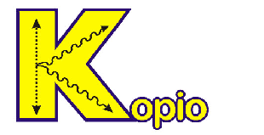

CKM MATRIX

Electroweak Interactions & CP Violation

CP violation in the Standard Model arises from the
complex phase in the CKM matrix

Unitarity of the CKM matrix, e.g. V_{ud}V_{ub}* + V_{cd}V_{cb}* +
V_{td}V_{tb}* = 0, allows one to draw the unitary triangle (shown below in the Wolfenstein representation)

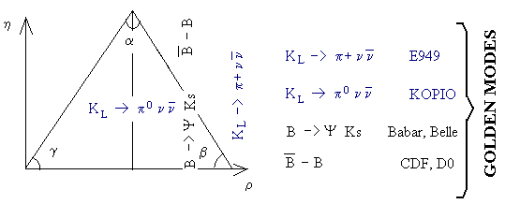

This triangle can be determined by measuring two rare K
decays or through measurements in the B system

Comparison of CP violation determined by K decays to
that measured in the B system provides a crucial test of the SM

RARE K DECAY

Predictions for the K_{L} → π⁰ ν ν decay:

The K_{L} → π⁰ ν ν decay is dominated by CP violating, one
loop diagrams involving s → d ν ν

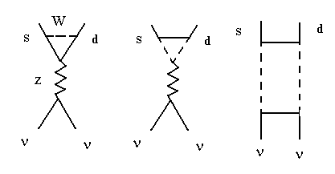

SM gives a precise (~ 2%) prediction for the branching
ratio of the K_{L} → π⁰ ν ν decay mode:

B(K⁺ → π⁰ e⁺ ν ) 3 α² τ(K_{L})
B(K_{L} → π⁰ ν ν ) = 9.44 • ———————— ————— ——— [X(x_{t}) ImV_{ts}* V_{td}]²
│V_{us}│² 2π² sin⁴θ_{w} τ(K⁺)

Using current values for CKM phenomenology and m_{t}
yields a branching ratio of (3.1 ± 1.3) • 10^{–11}

BASIC DESIGN CRITERIA

Beam design criteria:

Optimizing the number of usable decays per micro bunch
gives 14 million K_{L} decays / sec

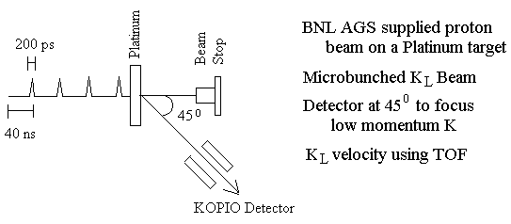

Detector design criteria:

Measurement of the photon energy Eγ

Reconstruction of π⁰ vertex

Measurement of E_{KL}

Hermetic vetoing

DESIGN OVERVIEW

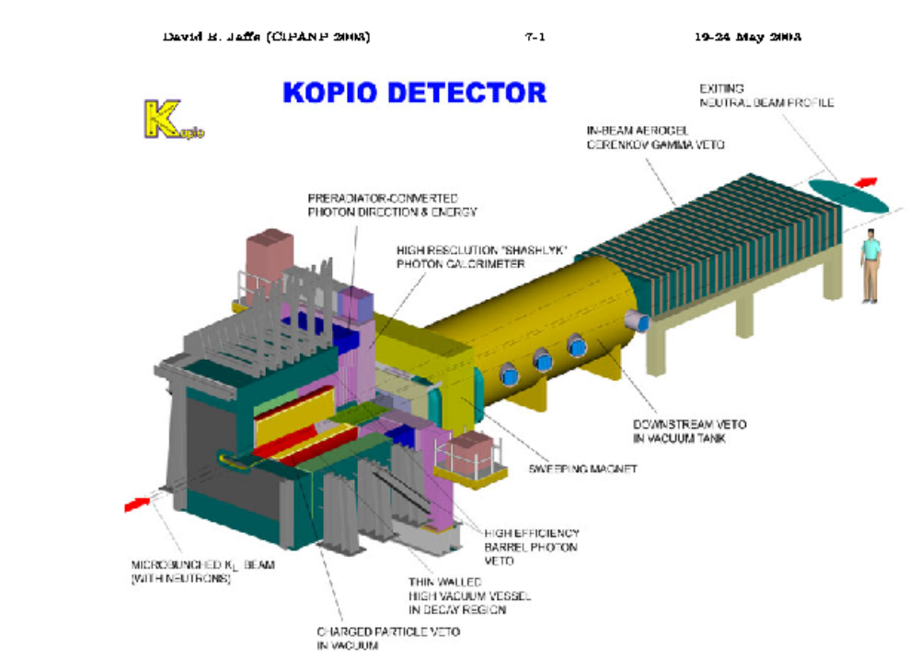

CANONICAL SIGNAL

A canonical signal event in the detector:

Canonical event: 2–γ’s from a signal π⁰ decay with
showers entering the Pre-Radiator (PR) < ±1.5m from the beam geometric center

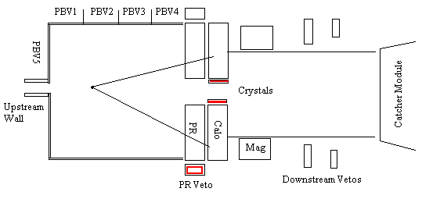

Reconstructed π⁰ vertex must be 50cm downstream of the
decay tank entrance and 50cm upstream of the PR, due to expected neutron background

Of the signal π⁰’s within the decay tank about ~ 24% have
both photons heading into the PR

K_{L}⁰ DECAY BACKGROUND

K_{L} background decay modes:

Several decay modes of the K_{L} tend to dominate the
trigger rate:
K_{L}⁰ → π⁰ π⁰ π⁰ ~ 21% decays
K_{L}⁰ → π⁰ π⁺ π – ~ 10% decays
K_{L}⁰ → π⁰ π⁰ ~ 0.09% decays
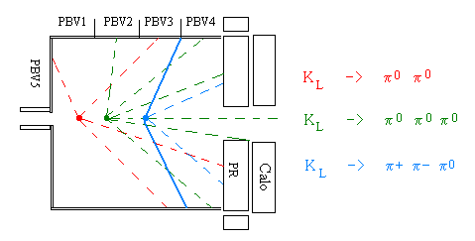
With competing K_{L} decay branching ratios of O(10¹⁰)
greater than what is predicted for the signal, much of the detector design focuses on background rejection

Fortunately, these modes involve additional gammas or
charged particles, that can also be detected

Other decay modes are of concern but not a triggering
issue

HERMETIC PHOTON VETO

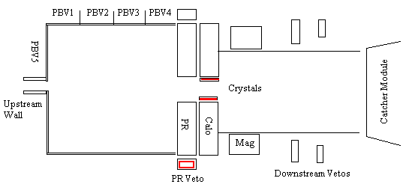

What must be detected?

Since the K_{L} can decay into several modes with multiple
π⁰’s and/or charged particles, one must effectively detect 2 gammas and no other particles in the detector

Photon and charged vetos surround the decay region

DOWNSTREAM REGION

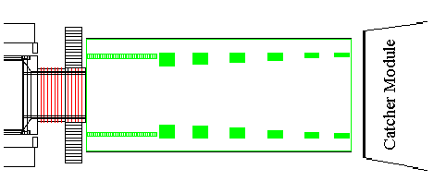

Particles entering the downstream volume:

A magnet just downstream of the calorimeter sweeps

charged particles from the beam for vetoing

The Downstream Photon Vetos (DPV) adjacent to the
beam are arranged to detect photons that escape from
the decay region

At the end of the beam, is a “neutron blind” photon veto,
the “catcher”

RECONSTRUCTED SIGNAL

MC predicted reconstructed signal events:

Using the TOF for the K_{L}, the momentum of the π⁰ in the
K_{L} rest frame can be reconstructed

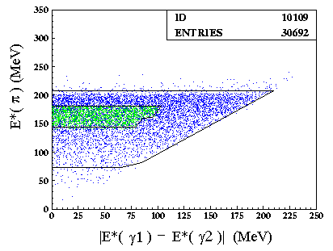

Plot shows MC signal distribution in Eπ⁰ versus
|Eγ1 – Eγ2| space

The events in green populate a low background region

RECONSTRUCTED BACKGROUND

MC predicted reconstructed background events:

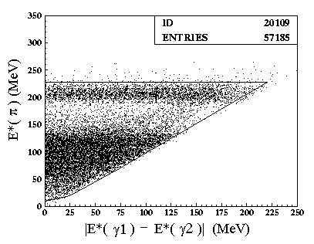

Kinematic constraints on the background give rise to the

sparsely populated band between Eπ⁰ 170 and 190 MeV

SIGNAL vs BACKGOUND

MC predicted signal vs background events:

Exploiting the background kinematics, the signal events

will be extracted from the region shown below in green

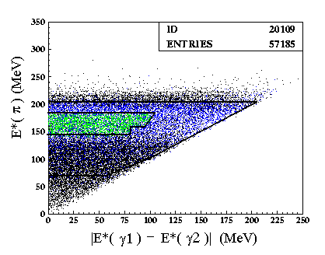

From this region we expect some 50 ± 10 signal events
with 25 ± 5 background events

LEVEL 0 TRIGGERING

Triggering and Background Rejection:

At the lowest level, KOPIO aims to suppress the
background trigger rates to around 25kHz

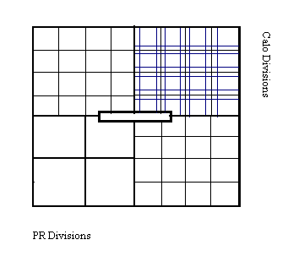

To keep the timing gates for each Photon Barrel Veto
(PBV) section as narrow as possible, it is necessary to use the natural divisions of both the PR and Calo for the L0 trigger

Using the PBV, PR, Calo and DPV elements together
allows KOPIO to effectively count gammas at L0

ENHANCING THE SIGNAL

Methods to enhance the signal rate include:

Improving the AGS
Investigating alternative aspect ratios
Modification of L0 trigger to use the photon veto
information for signal identification

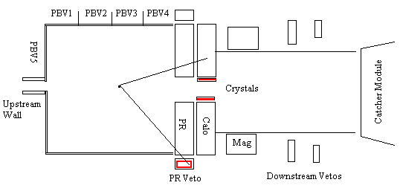

Using veto information to improve signal identification:
Predicted Signal: 2 PR tracks ~ 40-50 events
1 PR + 1PRV ~ 60-75 events
1 PR + 1PBV ~ 100-125 events

SUMMARY

KOPIO results in terms of the Standard Model:

The measured B(K_{L} → π⁰ ν ν ) can unambiguously be
interpreted in terms of SM

Any observed deviation from the predicted branching
ratio hints at new physics

KOPIO and the E787/E949 results allow an independent
determination of the Unitarity Triangle that can be
compared with that obtained from B measurements

