NORTHEAST FISHERIES SCIENCE CENTER

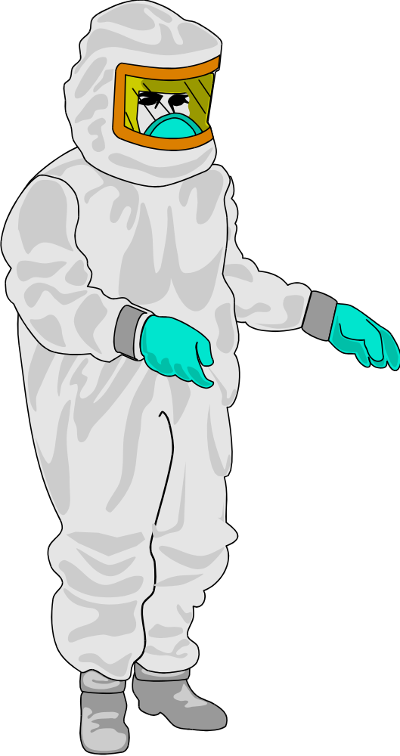
REFERENCE 29 CFR 1910.132

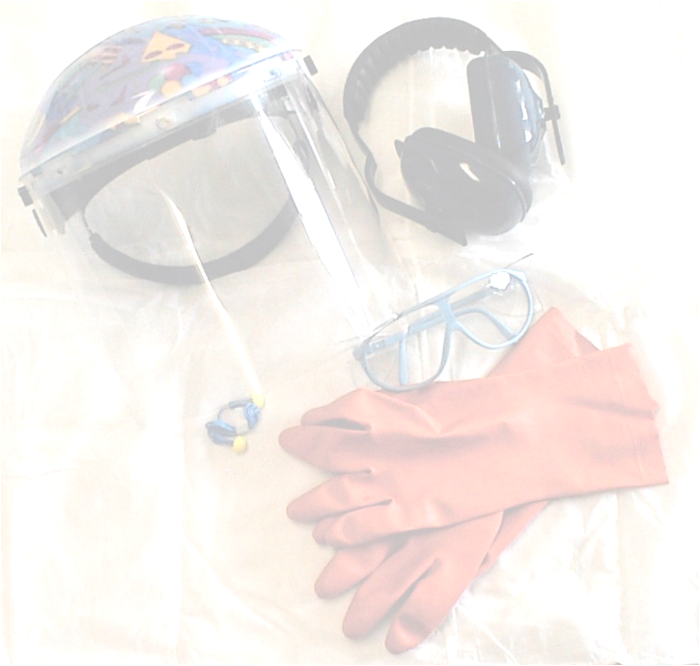
Table of Contents

- Introduction
- Responsibilities
  - Supervisors
  - Employees
  - Safety and Occupational Health Specialist
- Program Components
  - Hazard Assessment and Equipment Selection
  - Selection and Use of Protective Equipment
    - Eye and Face Protection
    - Head Protection
    - Foot Protection
    - Hand Protection
    - Laboratory Coat and Gowns
  - Cleaning and Maintenance
  - Inspection Practices
  - Storage Practices
- Training
- Recordkeeping

References
Appendix A - Job Hazard Analysis Certification Form
Appendix B - Glove Type and Chemical Use Chart
i

Personal Protective Equipment Program
1.0 Introduction
The objective of this Personal Protective Equipment (PPE) Program is to protect employees from the risk of injury by creating a barrier against workplace hazards. Personal protective equipment according to OSHA 29 CFR 1910.132 is not a substitute for good engineering, administrative controls, or good work practices, but should be used in conjunction with these controls to ensure the safety and health of employees. Personal protective equipment will be provided, used, and maintained when it has been determined that its use is required, and that such use will lessen the likelihood of occupational injury and/or illness.
This program addresses eye, face, head, foot, and hand protection. Separate programs exist for respiratory and hearing protection since the need for participation in these programs is established through industrial hygiene monitoring.
The NEFSC Personal Protective Equipment Program includes:
- Responsibilities of supervisors, employees, and Safety and Occupational Health Specialists
- Program components
- Employee training
- Recordkeeping requirements
2.0 Responsibilities
- 2.1 Supervisors
Supervisors have the primary responsibility for implementation of the PPE Program in their work area. This involves:
- Ensuring that a job hazard analysis (JHA) is performed for each work task.
- Seeking assistance from SOHS to evaluate hazards.
- Providing appropriate PPE and making it available to employees.
- Ensuring employees are trained on the proper use, care, and cleaning of PPE.
- Maintaining records on PPE assignments and training.
- Supervising staff to ensure that the PPE Program elements are followed and that employees properly use and care for PPE.
- Notifying SOHS when new hazards are introduced or when procedures are added or changed.
- Ensuring defective or damaged equipment is immediately replaced.

- 2.2 Employees
The PPE user is responsible for following the requirements of the PPE Program. This involves:
- Wearing PPE as required.
- Attending required training sessions.
- Caring for, cleaning, and maintaining PPE as required.
- Informing the supervisor of the need to repair or replace PPE.
- 2.3 Safety and Occupational Health Specialists
The Safety and Occupational Health Specialist (SOHS) is responsible for the development, implementation, and administration of the PPE Program. This involves:
- Assisting supervisors in conducting workplace hazard assessments to determine if the presence of hazards will necessitate the use of PPE.
- Assisting supervisors in conducting periodic workplace reassessments as requested by supervisors and/or as determined by the SOHS.
- Maintaining records on hazard assessments.
- Providing training, guidance, and technical assistance to supervisors on the proper selection, purchase, use, care, and cleaning of approved PPE.
- Periodically reevaluating the suitability of previously selected PPE.
- Reviewing, updating, and evaluating the overall effectiveness of the PPE Program.
3.0 Program Components
- 3.1 Hazard Assessment and Equipment Selection
OSHA requires employers to conduct evaluations of all workplaces to determine the need for personal protective equipment (PPE), and to help in selecting the proper PPE for each task performed. For each work task a job hazard analysis (evaluation) will detail the findings of the evaluation and the specific protective equipment needed. Supervisors and their employees will perform the job hazard analyses with the assistance, when necessary, of the SOHS.
Supervisors, assisted by the Safety and Occupational Health Specialist when required, will conduct a walk-through survey of each work area to identify sources of hazards, including impact, penetration, compression, exposure to chemicals, heat, dust, electrical sources, material handling, and injurious radiation, such as from laser use, ultraviolet and infrared lights. Each survey will be documented using the Job Hazard Analysis Certification Form (Appendix A).
Once the hazards of a workplace have been identified, the supervisor, with assistance of the SOHS as necessary, will determine the suitability of the PPE presently available and as, necessary select new or additional equipment. Care will be taken to recognize the possibility of multiple and simultaneous exposure to a variety of hazards. Adequate protection against the highest level of each of the hazards will be recommended for purchase.
- 3.2 Selection and Use of Protective Equipment
All personal protective clothing and equipment will be of safe design and construction for the work to be performed, and shall be maintained in a sanitary and reliable condition. Only those items of protective clothing and equipment that meet National Institute of Occupational Safety & Health (NIOSH) or American National Standards Institute (ANSI) standards will be procured or accepted for use. Newly purchased PPE must conform to the updated ANSI standards, which have been incorporated into the OSHA PPE regulations, as follows:
ANSI Design Specifications
Equipment | Specifications
Head Protection | ANSI Z89.1-1997, Industrial Head Protection
Eye and Face Protection | ANSI Z87.1-1989, Practice for Occupational and Educational Eye and Face Protection
Hearing Protectors | ANSI S12.6-1997, Methods for Measuring Real-Ear Attenuation of Hearing Protectors
Protective Footwear | ANSI Z41.1-1991, Personal Protection-Protective Footwear
Hand Protection | Selection based on performance characteristics of gloves in relation to tasks to be performed.
Hand Protection - There is no ANSI standard for gloves, however, selection must be based on the performance characteristics of the glove in relation to the tasks to be performed.
Careful consideration will be given to comfort and fit of PPE in order to ensure that it will be used. Protective devices are generally available in a variety of sizes. Care should be taken to ensure that the right size is selected.
- 3.2.1 Eye and Face Protection
Protective eye and face equipment is required when there is a reasonable probability of injury to the eyes or face that could be prevented by the use of such equipment. This includes employees, visitors, researchers, contractors, or others passing through an identified eye hazard area. To provide protection for these personnel, supervisors of such areas shall procure a sufficient quantity of safety eyewear.
Suitable protectors, such as the following, shall be used when employees are exposed to hazards from flying particles or objects; molten metal; chemical liquids, gases, or vapors; bioaerosols; or potentially injurious light radiation, such as ultraviolet:

Description and Use of Eye/Face Protectors

- Safety Glasses. Safety eyeglasses (spectacles) are made with safety frames, tempered glass or plastic lenses, temple and side shields. Safety glasses provide eye protection from hazardous chemicals, moderate impact and particles encountered in job tasks such as laboratory work, carpentry, woodworking, grinding, scaling, etc. Safety glasses are also available in prescription form for those persons who need corrective glasses.
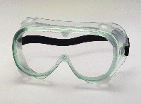
- Safety Goggles. Vinyl framed goggles of soft pliable body design provides adequate eye protection from many hazards. These goggles are available with clear or tinted lenses, and perforated, port vented or non-vented frames. Safety goggles provide superior protection to spectacles and may be worn in combination with spectacles or corrective lenses to insure protection along with proper vision.

Chippers/Grinders goggles provide eye protection from flying particles. The dual protective eyecups house impact resistant clear lenses with individual cover plates.

- Welding Goggles/Shields. Welding goggles provide protection from sparking, scaling, or splashing metals, and harmful light rays. These lenses are impact resistant and are available in graduated shades of filters, and in rigid and soft frames to accommodate single or dual eyepiece lenses.

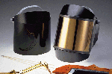
Welding shield assemblies consist of a vulcanized or glass fiber body, a ratchet/button type adjustable headgear or cap attachment, and a filter and cover plate holder. These shields will be provided to protect workers’ eyes and face from infrared or radiant light burns, flying sparks, metal spatter and slag chips encountered during welding, brazing, soldering, resistance welding, bare or shielded electric arc and oxyacetylene welding, and cutting operations.

- Face Shields. These normally consist of adjustable headgear and face shield of tinted/transparent acetate or polycarbonate materials. Face shields are available in various sizes, tensile strength, impact/heat resistance and injurious radiation filtering capacity. Face shields will be used in operations when the entire face needs protection and should be worn to protect eyes and face against flying particles, metal sparks, and chemical/biological splash. Face shields must always be worn over safety glasses or goggles. They must never be worn alone.
Eye and Face Protection Selection Chart
Source of Hazard | Assessment of Hazard | Protection Against Hazard
IMPACT - Chipping, grinding, machining, drilling, chiseling, riveting, sanding, woodworking, sawing, and masonry work | Flying fragments, objects, large chips, particles, sand, dirt, etc. | Spectacles with side protection, goggles, face shields  For severe exposure, use face shield over primary eye protection
CHEMICALS - Acid and chemical handling, degreasing, plating, and painting | Splash  Irritating mists | Safety glasses & goggles  For severe exposure, use face shield over primary eye protection;  Non-vented goggles
HEAT - Furnace operation and arc welding | Hot sparks | Faceshields, spectacles with side shield. For severe exposure use face shield
DUST - Woodworking, buffing, general dusty conditions | Nuisance dust | Goggles
LIGHT and/or RADIATION  Welding - electric arc  Welding - gas  Cutting, torch brazing, torch soldering  Glare | Optical radiation  Optical radiation  Optical radiation  Poor vision | Welding helmets or welding shields  Welding goggles or shield  Welding goggles or shield  Tinted lenses
Prescription Safety Eyewear
OSHA regulations require that each affected employee who wears non-safety prescription eyewear (glasses or spectacles) while engaged in operations that involve eye hazards wear eye protection that has the prescription incorporated into the make-up of the safety glasses/goggles, or shall wear eye protection that can be worn over the prescription lenses (goggles, face shields) without disturbing the proper position of the prescription or the protective lenses.
Emergency Eyewash Facilities
Emergency eyewash facilities meeting the requirements of ANSI Z358.1 are provided in all areas where the eyes of any employee may be exposed to hazardous chemicals or corrosive materials. All such emergency facilities will be located where they are easily accessible in an emergency.
Additional Eye Protection Issues
- Wearers of contact lenses must also wear additional appropriate eye and face protection devices in a hazardous environment. Contact lenses alone are not adequate protection.
- Side shields shall be used on all safety glasses.
- Face shields shall only be worn over primary eye protection (safety glasses or goggles).
- Goggles and face shields shall be used when there is a hazard from chemical splash.
- If a procedure has a high potential of creating aerosols with organisms of Biological Safety Level One (BSL1) or above, face shields should be worn over safety glasses or goggles. BSL1 is suitable for work with microorganisms not known to cause disease in healthy adult humans. Work is generally performed on open bench tops. Special containment equipment and devices are not usually needed.
- All safety eyewear must pass the High-Velocity and High Mass Impact Tests as required by the American National Standards Institute (ANSI). In addition, they must also have lenses that are 3 millimeters thick, with the lenses and frames marked to identify the manufacturer and the appropriate ANSI standard. In order to promote business, many manufacturers have improved styles and colors. Employees who wear prescription glasses or contact lenses can wear their protective goggles over their prescription glasses.
- Selection of laser protective eyewear depends on the wavelength and power density of the laser in use. Goggles are recommended to protect against back reflection or side entrance of a stray beam. Lightweight laser protective spectacles, when properly fitted with side shields of the same material as the lenses provide a good alternative to goggles. The optical density and wavelength for which the eyewear is designed must be imprinted on the lens or frame. Plain tinted and shaded lenses are not filter lenses.
- 3.2.2 Head Protection

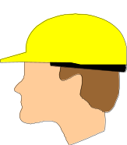Head protection has been designed and manufactured to provide workers protection from impact, heat, electrical, and fire hazards. Head injuries can be caused by falling or flying objects, or by bumping the head against a fixed object. Safety hats and caps must be of nonconductive, fire, and water resistant materials. Head protectors must resist penetration and absorb the shock of a blow.
Some examples of occupations for which head protection should be routinely considered are: carpenters, electricians, linemen, mechanics and repairers, plumbers and pipe fitters, assemblers, packers, wrappers, sawyers, welders, laborers, freight handlers, timber cutters and loggers, stock handlers, and warehouse laborers.

It is important to make a distinction between protective helmets (more commonly known as hard hats) and bump caps. Bump caps do not comply with the ANSI guidelines, and are not acceptable for occupations or applications where OSHA requires an ANSI-compliant hard hat. Bump caps or skull guards are constructed of lightweight materials and are designed to provide minimal protection against hazards when working in congested areas. They shall not be worn as substitutes for safety caps/hats because they do not afford protection from high impact forces or penetration by falling objects.

Most "hard hats" consist of a shell and suspension combined as a protective system. The shell of a protective hat is hard enough to resist a blow, and the shock-absorbing liner consists of headband and crown straps to keep the shell away from the wearer's skull.
Head protection of the types and classes below will be furnished to, and used by, all employees, engineers, inspectors, visitors, contractors and others engaged in construction and other miscellaneous work in head-hazard areas. Head protection will also be required to be worn on NOAA vessels when machinery is operating.

Protective hats are made in the following types and classes:
- Type 1 –Helmets provide protection strictly from blows to the top of the head
- Type 2 –Helmets provide protection from blows to both the top and sides of the head
- Class C (Conductive) helmets - Designed for lightweight comfort - provide impact and penetration resistance - should not be used around electrical hazards - no voltage protection - (usually made of aluminum which conducts electricity) - used in certain construction, manufacturing and refineries, and where there is a possibility of bumping the head against a fixed object.
- Class E (Electrical) helmets - Good impact protection - protect against high-voltage shocks and burns (they are proof tested to 20,000 volts) - used in utility service by electrical workers
- Class G (General) helmets – Good impact and penetration resistance - provide electrical protection from low-voltage conductors (they are proof tested to 2,200 volts)
Note: The voltages stated in Classes E and G are not intended to be an indication of the voltage at which the headgear protects the wearer.
In addition to electrical protection, hard hats are also tested for impact and penetration resistance, and water absorption. The rigorous testing requirements are described in detail within the standard.
Every hard hat conforming to the requirements of ANSI Z89.1-1997 must be appropriately marked to verify its compliance. The following information must be marked inside the hat:
- The manufacturer’s name
- The legend, “ANSI Z89.1-1997”
- The class designation (C, E, or G)
- Must contain user information.
- Must be marked with the date of manufacture.
- Instructions pertaining to sizing, care and service life guidelines must also accompany the hard hat.
One common misconception is that hard hats have a predetermined service life—this is not the case. The standards state that all hard hat components should be inspected daily for signs of dents, cracks, penetration, and any damage due to impact, rough treatment, or wear, any hard hat that fails the visual inspection should be removed from service until the problem is corrected.
In addition to everyday wear and tear, ultra violet (UV) radiation can pose a problem for hats constructed of plastic materials. Damage caused by UV radiation is easy to spot: the hat will lose its glossy finish and eventually take on a chalky appearance. Further degradation could cause the shell to actually start flaking away. Once the effects of UV radiation are detected, the hardhat shell should be immediately replaced.
3.2.3 Foot Protection

Employees shall wear protective footwear when working in areas where there is a danger of foot injuries due to falling or rolling objects, or objects piercing the sole, and where such employee’s feet are exposed to electrical hazards
Safety footwear with impact protection is required to be worn in work areas where carrying or handling materials such as packages, objects, parts or heavy tools, which could be dropped, and for other activities where objects might fall onto the feet. Safety footwear with compression protection is required for work activities involving skid trucks (manual material handling carts), around bulk rolls (such as paper rolls), around heavy pipes, or other activities in which materials or equipment could potentially roll over an employee’s feet. Safety footwear with puncture protection is required to prevent foot injuries from occurring where sharp objects such as nails, wire, tacks, screws, large staples, scrap metal, etc., could be stepped on by employees.
An important point to remember is that the ANSI standard Z41.1-1991 does not allow for the use of add-on type devices (strap-on foot, toe, or metatarsal guards) as a substitute for protective footwear. The toe box shall be incorporated into the footwear during construction and shall be an integral part of the footwear. However OSHA states that the footwear shall comply with ANSI or shall be demonstrated by the employer to be equally effective. Most manufacturers of add-on devices have submitted their products to independent laboratories for testing. This data and its results can be obtained upon request.
Protective footwear can either meet all the requirements of the ANSI standard, or specific elements of it. A steel-toed work boot that meets the impact and compression requirements of the ANSI standard may not provide protection for metatarsal, electrical or penetration hazards. The ANSI standard incorporates a coding system that manufacturers use to identify the portions of the standard with which the footwear complies. All footwear manufactured to ANSI specifications will be marked with the specific portion of the standard with which it complies. The following is an example of an ANSI code that could be found on protective footwear:
ANSI Z41 PT 91
F I/75 C/75 MT/75
Cd 1 EH
PR
Line #1: ANSI Z41 PT 91
This line identifies the ANSI standard. The letters PT indicate the protective toe section of the standard. This is followed by the last two digits of the year of the standard with which the footwear meets compliance (1991).
Line #2: F I/75 C/75 t/75
This line identifies the applicable gender (M or F) for which the footwear is intended. It also identifies the existence of impact resistance (I), the impact resistance rating (75, 50, or 30 foot-pounds), compression resistance (C) and the compression resistance rating (75, 50, or 30 which correlates to 2500 lbs., 1750 lbs., and 1000 lbs. of compression respectively). This line can also include a metatarsal designation (MT) and rating (75, 50, or 30 foot-pounds).
Lines #3 &#4: Cd 1 EH & PR
This area of the code designates conductive properties (Cd) and type (1 or 2), electrical hazard (EH) and puncture resistance (PR), if applicable.
The identification code must be legible (printed, stamped, stitched, etc.) on one shoe of each pair of protective footwear.
An occasional point of confusion when selecting protective footwear is the difference between steel shanks and steel midsoles. These terms are not interchangeable. A steel shank is a relatively narrow piece of metal that’s inserted into the arch area, strictly for support purposes. Steel midsoles, on the other hand, provide puncture protection on the soles of the footwear. According to the ANSI standard, protective steel midsoles, “shall cover the maximum area of the insole allowed by the construction of the footwear and shall at least extend from the toe to overlap the breast of the heel.”
Protective footwear with steel midsoles can be easily distinguished by the PR marking in the ANSI compliance code. The ANSI standard does not contain a marking to distinguish footwear that incorporates steel shanks.
Selecting protective footwear can be a tedious task. The ANSI standard separates safety footwear into six categories:
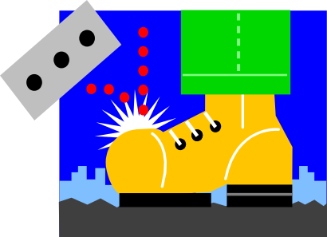
- Impact-resistant and compression-resistant footwear (I) makes use of a steel or nonmetallic toecap to protect against falling objects or crushing from heavy, rolling objects.
- Metatarsal shoe (MT) design prevents or reduces injuries when the metatarsal (upper foot) and toe areas are exposed to “drop” hazards. These guards can be internal or external.

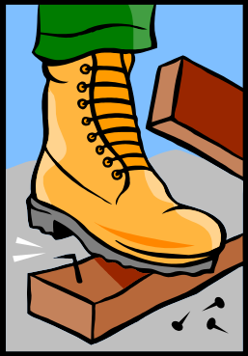
- Puncture-resistant footwear (PR) must conform to ANSI standards that reduce the possibility of puncture wounds to the soles of the feet by objects. This footwear should have reinforced, flexible metal soles or inner soles, assuming there is no risk of electrical contact.
- Electrical hazard (EH) shoes are nonconductive and are designed to reduce the potential for electric shock when the soles are exposed to open circuits of 600 volts or less under dry conditions.
- Electrostatic dissipative (ED) footwear is used to reduce static electricity by conducting a charge from the body to the ground, maintaining 106 to 109 ohms level of electrical resistance under test procedures. The primary protection provided by these shoes is from electrical hazards due to excessively low footwear resistance.
- Conductive footwear (Cd) is designed to minimize static electricity, which also reduces the possibility of ignition of volatile chemicals or explosives.
There are many types and styles of protective footwear and it is important to realize that a particular job may require additional protection other than listed here.
a. Steel-Reinforced Safety Shoes. These shoes are designed to protect feet from common machinery hazards such as falling or rolling objects, cuts, and punctures. The entire toe box and insole are reinforced with steel. Steel, aluminum, or plastic materials protect the instep. Safety shoes are also designed to insulate against temperature extremes, and may be equipped with special soles to guard against slips, chemicals, and/or electrical hazards.
- Safety Boots. Safety boots offer more protection when splash or spark hazards (chemicals and molten materials) are present:
- When working with corrosives, caustics, cutting oils, and petroleum products, neoprene or nitrile boots are often required to prevent penetration by these dangerous liquids.
- Foundry or "Gaiter" style boots feature quick-release fasteners or elasticized insets to allow speedy removal should any hazardous substances get into the boot itself.
- When working with electricity, special electrical hazard boots are available, and are designed with no conductive materials other than the steel toe (which is properly insulated).
There is no federal regulation specifically dealing with slip-resistant soles, and there is no federal testing to ensure slip resistance. Sole compounds for slip-resistant footwear include rubber-based, polyurethane and polyvinyl chloride (PVC). Rubber soles are normally best for slip resistance.
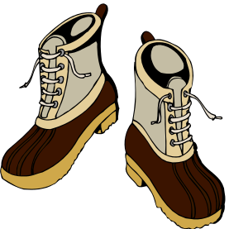
Additional types of footwear include arctic, cold-weather, ice-traction, and heat-resistant footwear. When working in conditions colder than minus 10 degrees, employees should wear arctic or cold-weather footwear and not typical steel-toe safety shoes. When selecting footwear for ice traction, look for shoes with a sandpaper-like grit texture. This surface increases traction better than rubber soles and can be worn in normal conditions also. In terms of heat resistant footwear, select shoes with a leather material, which provides the best protection against heat. In order to maintain resistance to slips, heat, and chemicals, the outsoles of the shoes should be made of a durable rubber combination or a similar product. It is also important to ensure the boots have a heat-resistant thread and laces.
The most important factor in footwear selection is proper fit. Use the following guidelines to ensure proper fit.
- Ensure the shoe fits the foot’s arch from heel to ball, which helps provide appropriate toe room.
- Check for quality materials and construction.
- Make sure there is sufficient foot clearance at the steel toe.
- Use the fitting process to determine correct size, remembering to measure both feet.
- Walk in the shoe and make sure it fits comfortably and adjusts to the foot, with little “break-in” time needed.
All footwear requires routine inspection for cuts, holes, tears, cracks, worn soles and other damage that could compromise the footwear’s protective qualities. Outsoles should be kept free of stones, tacks, nails and other debris. Footwear should be cleaned according to the manufacturer’s instructions.
3.2.4 Hand Protection
Skin contact is a potential source of exposure to toxic materials and it is important that the proper steps be taken to prevent such contact. Most accidents involving hands and arms can be classified under four main hazard categories: chemicals, abrasions, cutting, and harmful temperature extremes. There are gloves available that can protect workers from any of these individual hazards or any combination thereof. One type of glove may not work in all situations. Gloves will only protect if they are used properly.
The first consideration in the selection of gloves for use against chemicals is to determine, if possible, the exact nature of the chemicals to be used. Read instructions and warnings on chemical container labels and MSDSs before working with any chemical.
- The best way to select a glove is to have it tested against the chemical(s) you use under the conditions you use them.
- Gloves may appear alike in material and color, but manufacturing procedures greatly affect performance.
- If you double the thickness, you quadruple the breakthrough time.
- No single glove gives absolute protection against all chemicals.
- A glove can perform well against one chemical and poorly against a closely related chemical.
- Some gloves can be very resistant and still be permeated by a chemical.
- When a glove degrades, it is much too late to use.
- A higher temperature usually makes gloves fail sooner.
- Remove gloves correctly. Never touch the outside of the gloves.
- Wash your hands before putting on and after taking off gloves.
- Wash your hands before visits to the rest room.
- Wash your hands before eating or smoking.
Gloves should be replaced periodically, depending on frequency of use and permeability to the substance(s) handled. Gloves overtly contaminated should be rinsed, then carefully removed after use and thrown away. Chemicals eventually permeate all glove materials. However, they can be used safely for limited time periods if specific use and other characteristics (i.e., thickness and permeation rate and time) are known. The Safety and Occupational Health Specialist can assist in determining the specific type of glove material that should be worn for a particular chemical. For more information on types of gloves and their use with specific chemicals refer to Appendix B - "Glove Type and Chemical Use" and the following chart “Chemical Protective Clothing Resistance Chart”.
Chemical Protective Clothing Resistance Chart
Breakthrough Times for Common Laboratory Chemicals Against Select Materials

PROTECTIVE  MATERIAL | CHEMICAL  Methylene Nitric Hydrochloric  Chloride Hexane Acid ¹ Acetone Acid ² Sulfuric Acid²
Butyl rubber | < 1 hr | < 1 hr | > 8 hrs | > 8 hrs | > 8 hrs | > 8 hrs
Neoprene | < 1 hr | < 1 hr | > 8 hrs | < 1 hr | 1 to 4 hrs | > 8 hrs
Nitrile | < 1 hr | > 8 hrs | > 8 hrs | < 1 hr | < 1 hr | 1 to 4 hrs
Polyvinyl  alcohol | > 8 hrs | > 8 hrs | < 1 hr | < 1 hr | < 1 hr | < 1 hr
Polyvinyl  chloride | < 1 hr | < 1 hr | > 8 hrs | < 1 hr | < 1 hr | > 8 hrs
Telfon™ | 1 to 4 hrs | > 8 hrs | No Data | > 8 hrs | No Data | > 8 hrs
Vitron™ | < 1 hr | > 8 hrs | No Data | < 1 hr | No Data | > 8 hrs
Saranex™ | < 1 hr | < 1 hr | > 8 hrs | < 1 hr | > 8 hrs | > 4 hrs
4H & Silvershield™ | > 8 hrs | > 8 hrs | > 4 hrs | > 8 hrs | 1 to 4 hrs | > 4 hrs

¹ Data based on a concentration of <30%
² Data based on a concentration of 30 to 70%

IMPORTANT NOTES:
- This table is based ONLY on permeation data. Additional factors must be considered in the selection process, such as the physical characteristics required (e.g., need for cut resistance, temperature resistance, etc.), and the human factors required (e.g., need for dexterity, flexibility, etc.).
- Data are based on generic protective materials, with the exception of a few specific trade names, and represents average breakthrough times. Specific manufacturer's information must be used to supplement this data.

Careful attention must be given to protecting your hands when working with tools and machinery. The type of glove materials to be used in these situations includes leather, welders' gloves, aluminum-backed gloves, and other types of insulated glove materials. Power tools and machinery must have guards installed or incorporated into their design that prevent the gloved hands from contacting the point of operation, power train, or other moving parts.
However, do not wear gloves around moving machinery, such as drill presses, mills, lathes, and grinders. To protect hands from injury due to contact with moving parts, it is important to:
- Ensure that guards are always in place and used.
- Always lockout machines or tools and disconnect the power before making repairs.
- Treat a machine without a guard as inoperative.
The following is a guide to the most common types of protective work gloves and the types of hazards they can guard against:
Hazard | Type of Glove
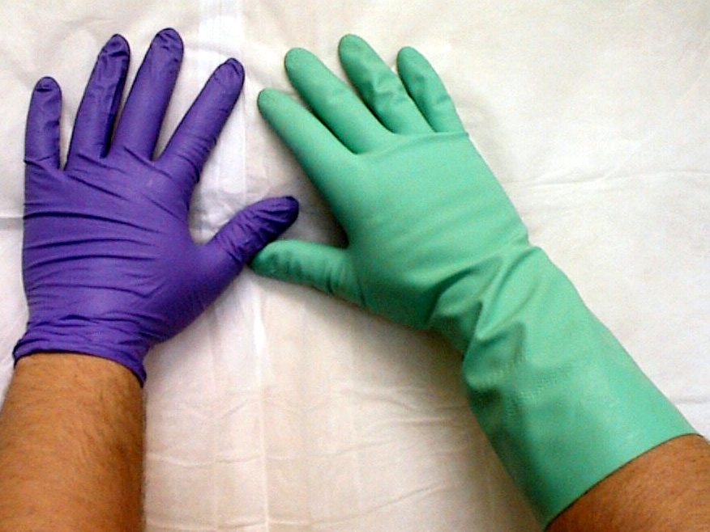  Contact with biological or chemicals other than oils, solvents, corrosives or toxic material | Impervious disposable gloves: Disposable gloves, usually made of lightweight rubber, latex, or nitrile can help guard against mild irritants.
Contact with oils, solvents, corrosives, or toxic material | Chemical-resistant utility gloves: Chemical resistant gloves may be made of rubber, nitrile, neoprene, polyvinyl alcohol, or vinyl, etc. These gloves protect hands from corrosives, oils, and solvents. When selecting chemical resistant gloves, be sure to consult the manufacturers’ recommendations, especially if the gloved hand will be immersed in the chemical. | 
Laceration | Cut-resistant material (e.g. KevlarTM): Metal mesh gloves are used to protect hands from accidental cuts and scratches. Persons working with cutting tools, scapels, scissors, or other sharp instruments use them most commonly. | 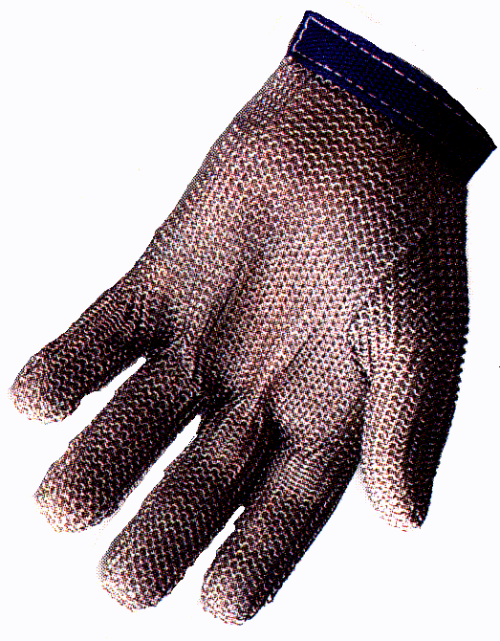
Abrasion, cut, or puncture | Canvas or leather work gloves: (1) Fabric gloves are made of cotton or fabric blends and are generally used to improve grip when handling slippery objects. They also help insulate hands from mild heat or cold. (2) Leather gloves are used to guard against injuries from sparks or scraping against rough surfaces. They are also used in combination with an insulated liner when working with electricity. | 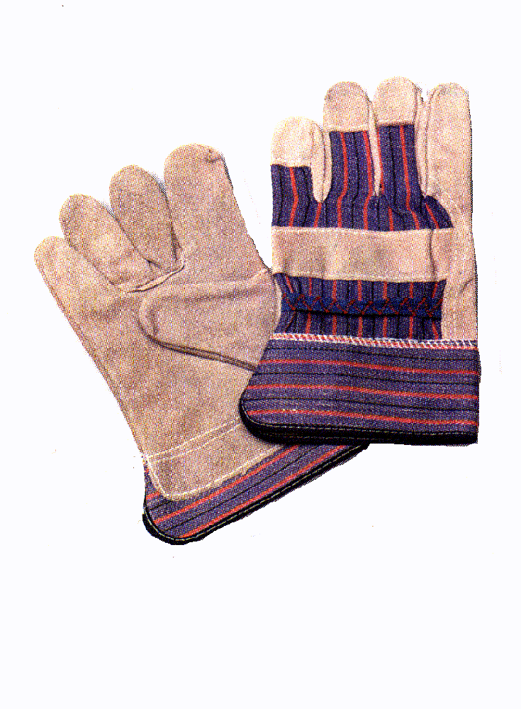
Contact with hot or cold objects | Welders', aluminized, insulated, cryo, and freezer gloves are a few of the types of gloves used to insulate hands from intense heat or cold. | 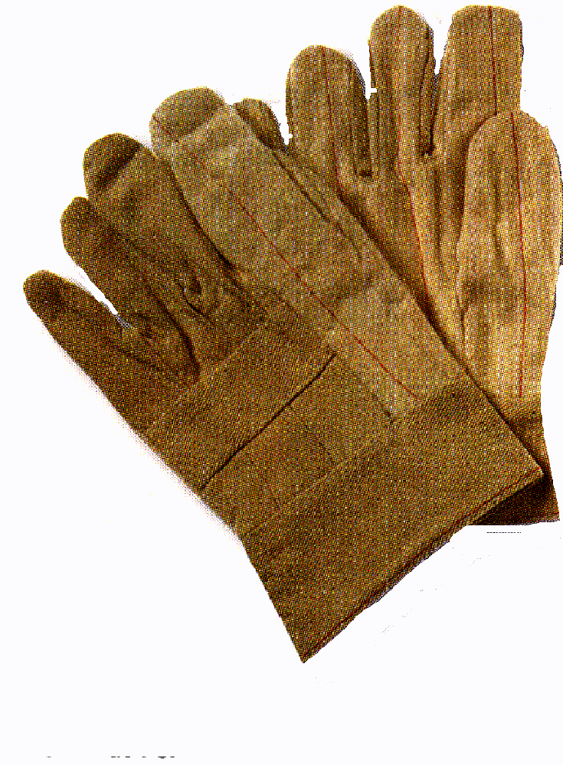
The following table is provided as a guide to the different types of glove materials and the chemicals they can be used against:

Glove Chart
Type | Advantages | Disadvantages | Use Against
Natural rubber and latex | Low cost, good physical properties, dexterity | Poor vs. oils, greases, organics. Frequently imported; may be poor quality | Bases, alcohols, dilute water solutions; fair vs. aldehydes, ketones
Natural rubber blends | Low cost, dexterity, better chemical resistance than natural rubber vs. some chemicals | Physical properties frequently inferior to natural rubber | Same as natural rubber
Polyvinyl chloride (PVC) | Low cost, very good physical properties, medium cost, medium chemical resistance | Plasticizers can be stripped; frequently imported may be poor quality | Strong acids and bases, salts, other water solutions, alcohols
Neoprene | Medium cost, medium chemical resistance, medium physical properties | NA | Oxidizing acids, anilines, phenol, glycol ethers
Nitrile | Low cost, excellent physical properties, dexterity | Poor vs. benzene, methylene chloride, trichloroethylene, many ketones | Oils, greases, aliphatic chemicals, xylene, perchloroethylene, trichloroethane; fair vs. toluene
Butyl | Specialty glove, polar organics | Expensive, poor vs. hydrocarbons, chlorinated solvents | Glycol ethers, ketones, esters
Polyvinyl alcohol (PVA) | Specialty glove, resists a very broad range of organics, good physical properties | Very expensive, water sensitive, poor vs. light, alcohols | Aliphatics, aromatics, chlorinated solvents, ketones (except acetone), esters, ethers
Fluoro-elastomer (Viton) | Specialty glove, organic solvents | Extremely expensive, poor physical properties, poor vs. some ketones, esters, amines | Aromatics, chlorinated solvents, also aliphatics and alcohols
Norfoil (Silver Shield) | Excellent chemical resistance. For better dexterity wear latex gloves over the Silver Shield | Poor fit, easily punctures, poor grip | Use for Hazmat work, especially methylene chloride
- 3.2.5 Laboratory Coats and Gowns
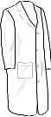
A lab coat can be used to protect street clothing against biological or chemical spills, as well as provide some additional body protection. The specific hazard(s) and the degree of protection required must be known before selecting coats for lab personnel.
- 3.3 Cleaning and Maintenance
It is important that all PPE be kept clean and properly maintained at regular intervals so that the PPE provides the requisite protection. Cleaning is particularly important for eye and face protection where dirty or fogged lenses could impair vision. Most consumer cleaning products are adequate for washing PPE. However, dishwasher soap solutions are specifically not recommended by PPE manufacturers. Personal protective equipment shall not be shared between employees until it has been properly cleaned and sanitized. PPE will be distributed for individual use whenever possible.
It is also important to ensure that contaminated PPE (such as by radiation or with extremely toxic chemicals, for example, dimethyl mercury), that cannot be decontaminated, be disposed of in a manner that protects all employees including janitorial staff from exposure to hazards.
- 3.4 Inspection Practices
A general inspection of PPE should be conducted before each use and include a check for the following:
- Abrasions, cuts, holes, or tears
- Signs of chemical contamination, such as discoloration, rough surfaces, gummy feeling, or cracks
- Missing, damaged, or defective components
Supervisors and staff must be trained in inspection practices. The manufacturer's recommendations for inspection should always be referenced.

Damaged or defective PPE must never be used!

- 3.5 Storage Practices
PPE must be stored properly in protective containers within a designated area. Some examples of containers that may be used are plastic bags or cardboard boxes. Some suggested areas are cabinets, wall hooks, shelves, etc. If equipment will be exposed to dust, dirt, or the elements, it should be placed in a plastic bag for protection. Stored equipment may be damaged or malfunction due to the conditions listed in the following table:
Factors Affecting PPE in Storage
Factor | Hazard
Damaging Chemicals | Contaminates and breaks down material
Moisture | Can cause mold or break down material
Sunlight | Damages materials and accelerates aging
Dust | Contaminates material
Extreme Temperatures | Can alter configurations of material; melt (hot) or crack (cold)
Impact | Can damage, break, or tear material

4.0 Training
Any worker required to wear PPE shall receive training in the proper use and care of PPE. Periodic retraining shall be offered by the SOHS to both the employees and the supervisors, as needed. The training shall include, but not necessarily be limited to, the following subjects:
- When PPE is necessary.
- What PPE is necessary?
- How to properly don, remove, adjust, and wear PPE.
- The limitations of the PPE.
- The proper care, maintenance, useful life and disposal of the PPE.
After the training, the employees shall demonstrate that they understand the components of the PPE Program and how to use PPE properly, or they shall be retrained.
5.0 Recordkeeping
OSHA requires certification of training for PPE. Written records shall be kept of the names of persons trained, the type of training provided, and the dates when training occurred. The Safety and Occupational Health Specialist shall maintain the employees’ training records and Hazard Assessment Certification Forms for each work site for at least 3 years.

REFERENCES
American National Standards Institute, ANSI Z41-1991, "Personal Protection - Protective Footwear".
American National Standards Institute, ANSI Z87.1-1989, "Practice for Occupational and Educational Eye and Face Protection".
American National Standards Institute, ANSI Z89.1-1997, "Safety Requirements for Industrial Head Protection".
American National Standards Institute, ANSI S12.6-1997, "Methods for Measuring Real-Ear Attenuation of Hearing Protectors".
OSHA Safety and Health Standards (29 CFR 1910.132-.138), United States Department of Labor, OSHA, Government Printing Office: Washington, D.C., (latest edition).
Office of Health and Safety, Centers for Disease Control and Prevention, " Personal Protective Equipment Program" Last Modified: 1/2/97
US Environmental Protection Agency, EPA-202-B-98-001 June 1998, SHEMP Operations Manual for Laboratories.
Lab Safety Supply, EZ Facts Safety Info

Appendix A

Job Hazard Analysis Certification Form

APPENDIX B

Glove Type and Chemical Use
*Limited service | VG= Very Good | G= Good | F=Fair | P=Poor (not recommended)

Chemical | Neoprene | Natural Latex  or Rubber | Butyl | Nitrile Latex
*Acetaldehyde | VG | G | VG | G
Acetic acid | VG | VG | VG | VG
*Acetone | G | VG | VG | P
Ammonium hydroxide | VG | VG | VG | VG
*Amyl acetate | F | P | F | P
Aniline | G | F | F | P
*Benzaldehyde | F | F | G | G
*Benzene | F | F | F | P
Butyl acetate | G | F | F | P
Butyl alcohol | VG | VG | VG | VG
Carbon disulfide | F | F | F | F
*Carbon tetrachloride | F | P | P | G
Castor oil | F | P | F | VG
*Chlorobenzene | F | P | F | P
*Chloroform | G | P | P | E
Chloronaphthalene | F | P | F | F
Chemical | Neoprene | Natural Latex  or Rubber | Butyl | Nitrile
Chromic Acid (50%) | F | P | F | F
Citric acid (10%) | VG | VG | VG | VG
Cyclohexanol | G | F | G | VG
*Dibutyl phthalate | G | P | G | G
Diesel fuel | G | P | P | VG
Diisobutyl ketone | P | F | G | P
Dimethylformamide | F | F | G | G
Dioctyl phthalate | G | P | F | VG
Dioxane | VG | G | G | G
Epoxy resins, dry | VG | VG | VG | VG
*Ethyl acetate | G | F | G | F
Ethyl alcohol | VG | VG | VG | VG
Ethyl ether | VG | G | VG | G
*Ethylene dichloride | F | P | F | P
Ethylene glycol | VG | VG | VG | VG
Formaldehyde | VG | VG | VG | VG
Formic acid | VG | VG | VG | VG
Freon 11 | G | P | F | G
Freon 12 | G | P | F | G
Freon 21 | G | P | F | G
Freon 22 | G | P | F | G
Chemical | Neoprene | Natural Latex  or Rubber | Butyl | Nitrile
*Furfural | G | G | G | G
Gasoline, leaded | G | P | F | VG
Gasoline, unleaded | G | P | F | VG
Glycerine | VG | VG | VG | VG
Hexane | F | P | P | G
Hydrochloric acid | VG | G | G | G
Hydrofluoric acid (48%) | VG | G | G | G
Hydrogen peroxide (30%) | G | G | G | G
Hydroquinone | G | G | G | F
Isooctane | F | P | P | VG
Isopropyl alcohol | VG | VG | VG | VG
Kerosene | VG | F | F | VG
Ketones | G | VG | VG | P
Lacquer thinners | G | F | F | P
Lactic acid (85%) | VG | VG | VG | VG
Lauric acid (36%) | VG | F | VG | VG
Lineoleic acid | VG | P | F | G
Linseed oil | VG | P | F | VG
Maleic acid | VG | VG | VG | VG
Methyl alcohol | VG | VG | VG | VG
Methylamine | F | F | G | G
Chemical | Neoprene | Natural Latex  or Rubber | Butyl | Nitrile
Methyl bromide | G | F | G | F
*Methyl chloride | P | P | P | P
*Methyl ethyl ketone | G | G | VG | P
*Methyl isobutyl ketone | F | F | VG | P
Methyl methacrylate | G | G | VG | F
Monoethanolamine | VG | G | VG | VG
Morpholine | VG | VG | VG | G
Naphthalene | G | F | F | G
Naphthas, aromatic | G | P | P | G
*Nitric acid | G | F | F | F
Nitromethane (95.5%) | F | P | F | F
Nitropropane (95.5%) | F | P | F | F
Octyl alcohol | VG | VG | VG | VG
Oleic acid | VG | F | G | VG
Oxalic acid | VG | VG | VG | VG
Palmitic acid | VG | VG | VG | VG
Perchloric acid (60%) | VG | F | G | G
Perchloroethylene | F | P | P | G
Petroleum distillates (naphtha) | G | P | P | VG
Phenol | VG | F | G | F
Chemical | Neoprene | Natural Latex  or Rubber | Butyl | Nitrile
Phosphoric acid | VG | G | VG | VG
Potassium hydroxide | VG | VG | VG | VG
Propyl acetate | G | F | G | F
Propyl alcohol | VG | VG | VG | VG
Propyl alcohol (iso) | VG | VG | VG | VG
Sodium hydroxide | VG | VG | VG | VG
Styrene | P | P | P | F
Stryene (100%) | P | P | P | F
Sulfuric acid | G | G | G | G
Tannic acid (65%) | VG | VG | VG | VG
Tetrahydrofuran | P | F | F | F
*Toluene | F | P | P | F
Toluene diisocyanate | F | G | G | F
*Trichloroethylene | F | F | P | G
Triethanolamine | VG | G | G | VG
Tung oil | VG | P | F | VG
Turpentine | G | F | F | VG
*Xylene | P | P | P | F
<!--END GLOVE TYPES-->
VG= Very Good | G= Good | F=Fair | P=Poor (not recommended) | *Limited service

