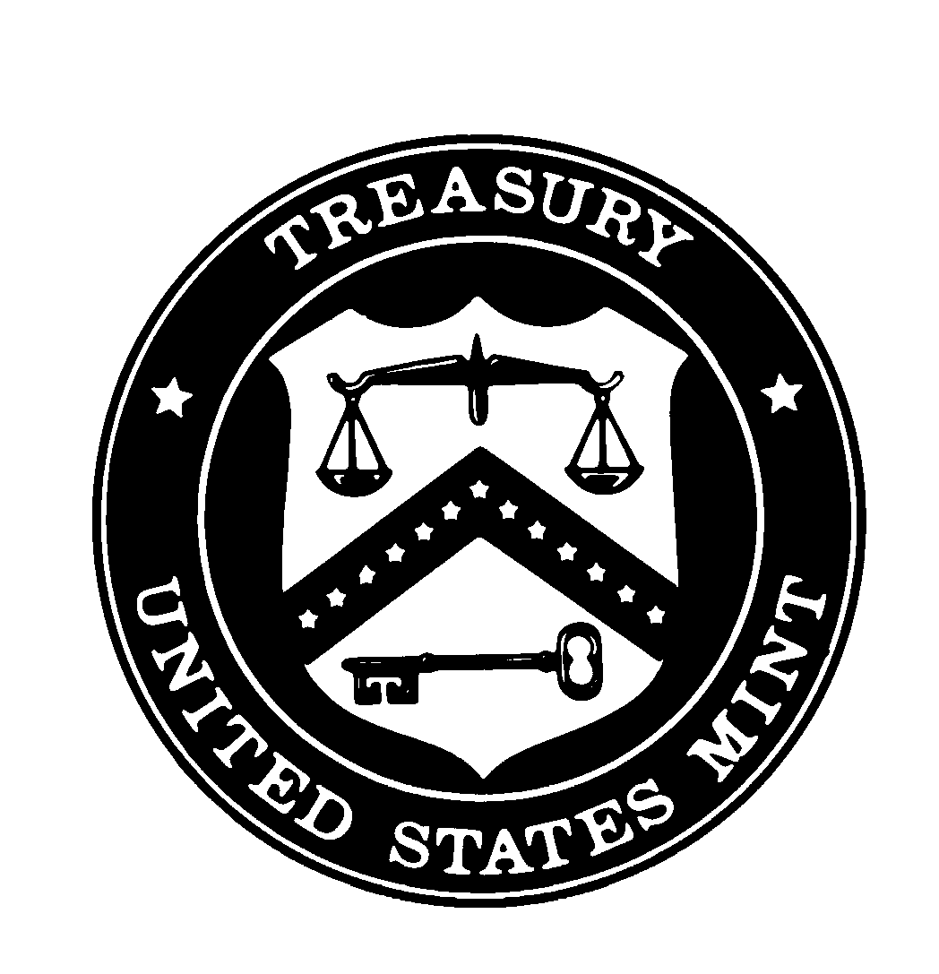
United States Mint

Commemorative Coin
FY 2002 1st Quarter Update

(For the quarter ending December 31, 2001)

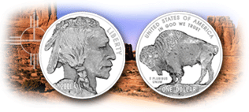

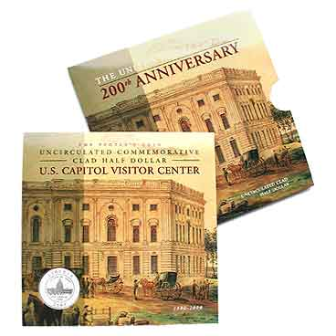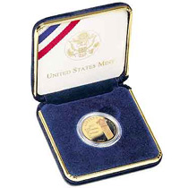
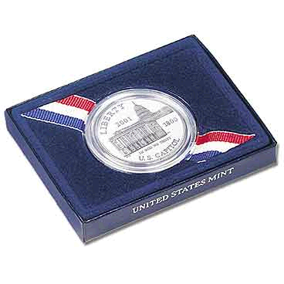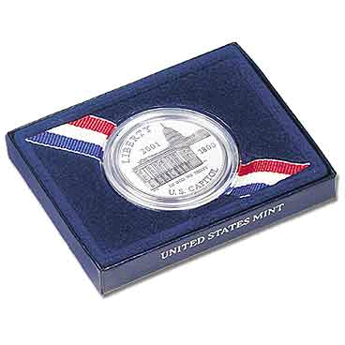

PROGRAM-WIDE SUMMARY

Modern commemorative coins authorized by Congress and produced by the U.S. Mint date from the introduction of the George Washington 250th Anniversary Half Dollar in 1982. Congress authorized a total of 39 commemorative coin programs between 1982-2001, honoring American people, places, events, and institutions. Surcharges from the sales of these coins helped fund a variety of organizations and projects that benefit the community at large. Profits generated through the sale of modern commemorative coins are placed in the Mint’s Public Enterprise Fund, which returns gains exceeding the Mint’s operating requirements to the Department of the Treasury’s General Fund. These profits then benefit the American people by reducing the amount of new Federal debt issued. U.S. Mint commemorative coins have generated nearly $417 million in surcharges over the past 19 years for many worthy foundations.

America’s commemorative coin program links public funding of special projects to demonstrated private support. The Commemorative Coin Reform Act of 1996 makes coin program beneficiaries partners in bearing the risks of commemorative coin programs, and it assures that the U.S. Mint recovers its costs of operating coin programs. Commemorative coins are a benefit, not only to numismatic enthusiasts and the recipient organizations, but also by reaffirming our history to the Nation as a whole. While the commemorative coin programs currently are increasing in their popularity following the 1996 reforms, the program’s well being remains fragile. To ensure that commemorative coin programs continue to reap the benefits of the reforms, the U.S. Mint must continue to execute and oversee these coin programs in a conscientious, prudent, and businesslike manner.

As of December 31, 2001, cumulative sales for the Capitol Visitor Center (CVC) and Buffalo Commemorative Coin Programs generated revenues of $29.7 million. The U.S. Capitol Visitor Center coin program has generated $13.1 million in sales revenue since the program began. The most recent program, the American Buffalo Silver Dollar, generated $16.7 million in cumulative sales revenue for total orders shipped.

There were no surcharge payments disbursed for FY2002 as of the 1st quarter ended December 31, 2001.

The Central Bank of Iceland chose to add a $10.00 “surcharge” to the price of their coin in order to make its price consistent with the U.S. version authorized by Public Law 106-126. While the payment of surcharges to the Leifur Eirkicson foundation are covered by the CCRA requirements, the payment of the monies raised, as the result of the sale of the Icelandic coins were not. Accordingly, the “surcharge” payment reported in the FY 2001 Fourth Quarter CCRA Report, reflects monies paid to the Central Bank of Iceland from the sale of their coins, which the Mint had agreed to produce and sell in tandem with the U.S. version of the coin. To date, the Mint has not disbursed surcharge payments to the Leifur Eirkicson Foundation as they have yet to fulfill all the requirements outlined under the CCRA.

FINANCIAL REPORTING

The attached financial statements provide quarterly and cumulative active program data.

U.S. CAPITOL VISITORS CENTER – FY 2002
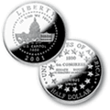
Program Highlights

The first commemorative coin program of 2001, Public Law 106-126, the U.S. Capitol Visitor Center (CVC) Commemorative Coin Program was authorized to commemorate the first convening of Congress in the Capitol building. Congress established mintages of 100,000 gold coins; 500,000 silver dollar coins; and 750,000 clad half-dollar coins. Surcharges from the sale of the coins are authorized to go toward the construction, maintenance and preservation of the U.S. Capitol Visitor Center. Production for this program ended December 31, 2001, with sales throughout the one year anniversary, March 7, 2002, while inventories last.

Marketing Activities

The CVC Program is featured in the Mint’s Holiday Catalog and on the Mint’s website home page with a special permanent banner to help purchasers find the CVC coins easily.

Customized four-color CVC buck slips designed to create awareness for and sales of the CVC Program continue to be distributed to Mint customers via the Mint’s product fulfillment center.

A follow-on direct response print advertising campaign was launched in the Numismatic Trade Press during the third quarter, 2001, and ads continued until December. Also, in an effort to generate additional sales, the CVC coins were advertised in the Reserve Officers Association Magazine’s December 2001 issue.

Additional ads in Numismatic News and Coin World are planned for February 2002.

Analysis of Financial Position

As of December 31, 2001, the Mint shipped nearly 354,000 coins, generating total program revenues of more than $13.1 million, including surcharges of nearly $3.3 million. Estimated profits of $1.3 million covered the potential unrecovered expenses of $255,000. Cost of goods sold totaled $4.6 million. Selling, general and administrative expenses were $3.9 million. First quarter revenues posted a profit of nearly $0.3 As of this report, the U.S. Capitol Preservation Commission has not met the matching funds criterion established by the Commemorative Coin Reform Act of 1996. That requirement stipulates that the U.S. Mint must withhold surcharges until it recovers all program operating costs, and until the designated beneficiary has raised other monies from private sources equal to the maximum potential program surcharges.

Manufacturing/Packaging Operations

The Philadelphia Mint produced 11,590 acceptable silver proof coins and 1,730 acceptable silver uncirculated coins during the quarter ending December 31, representing a reject rate of 2% and 1%, respectively.

AMERICAN BUFFALO COMMEMORATIVE COIN - FY 2002

Program Highlights
Authorized by Public Law 106-375, the American Buffalo Coin Commemorative Coin Act of 2000 commemorates the opening of the Smithsonian Institution’s National Museum of the American Indian. Congress established a mintage limit of 500,000 silver dollar coins. The second commemorative coin program of 2001, the American Buffalo Silver Dollar features a reproduction of one of the most famous and beloved designs among coin collectors – the James Earle Fraser Buffalo nickel.

Surcharges from sales of this coin program are authorized for payment to the National Museum of the American Indian (NMAI) to commemorate the opening of the museum and to supplement the museum’s endowment and educational outreach funds.

Coins were released to the public in June. The program was so popular that all 50,000 of the American Buffalo Coin and Currency sets sold out in just five days, and the entire authorized mintage of 500,000 Buffalo Silver Dollars sold out in just two weeks.

After numerous requests to strike additional coins, the Secretary of the Treasury decided not to authorize an increase in the mintage of the American Buffalo coin because all the requirements contained in the relevant statute, 31 U.S.C. § 5112(m)(2)(B), were not met. Furthermore, it was noted that increasing mintage levels would be unfair to the many customers who based their decisions to purchase these coins on the advertised mintage levels.

Also, the United States Mint has received, and continues on occasion to receive inquiries regarding replicas of the new American Buffalo Commemorative Silver Dollar now flooding the numismatic and collectors markets. The replicas are not authentic U.S. coins and are not sponsored or endorsed by the United States Government. The American public was informed they may be entitled to a refund or redress from the firm that sold the replica if they were bought with the understanding that the replica purchased was a genuine U.S. Mint product.

Marketing Activities

There were no marketing activities during the first quarter ending December 31, 2001. due to sell-out of the program.

Analysis of Financial Position

As of December 31, 2001, the Mint shipped over 499,000 coins, generating total program revenues of nearly $16.6 million, including surcharges of nearly $5.0 million. Cost of goods sold totaled $6.1 million. Selling, general and administrative expenses were $2.9 million. The Mint posted first quarter loss of $4,500 for this program. The loss is a reflection of limited sales revenue realized during the first quarter, which, in turn resulted in an unrealized breakeven point. The majority of sales were captured in the prior three quarters of FY 2001; and as a whole the program was profitable. As of this report, NMAI has not met the matching funds criterion established by the Commemorative Coin Reform Act of 1996. That requirement specifies that the U.S. Mint must withhold surcharges until it has recovered all program operating costs, and until the designated beneficiary has raised other monies from private sources equal to the maximum potential program surcharges.

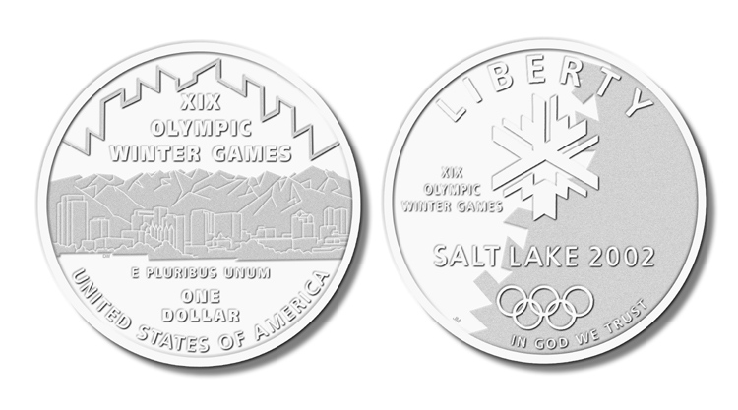2002 WINTER OLYMPIC GAMES

The 2002 Winter Olympic Commemorative Coin Act, P.L. 106-435, authorizes the production of 400,000 silver dollar coins and 80,000 gold five-dollar coins. In the spirit of the 1996 commemorative coin reform legislation to curb proliferation of commemorative coin programs, the U.S. Olympic Committee has been very responsive to past concerns, and the 2002 Games will feature a single coin design for the obverse and reverse of each silver dollar and gold five-dollar coins.

Congress directed the Mint to divide the surcharges from the sale of the coins equally between the Salt Lake Organizing Committee for the Olympic Winter Games of 2002 and the U.S. Olympic Committee. Issuance of the coin is targeted for early January 2002. Previous U.S. Mint Commemorative coin programs honoring the Olympics have raised over $130 million for our Olympic athletes and programs.

Marketing Activities

The 2002 Olympic Winter Games Commemorative Coins were formally put on sale in the Mint’s 2001 Holiday Catalog. The program was prominently featured in a premium position within the catalog.

Also, the Mint was provided the opportunity to promote the program during the Olympic Torch Run ceremony that was held in Old Towne Alexandria, Virginia on December 21, 2001. Promotional materials containing ordering information were distributed to event attendees.

The 2002 Olympic Winter Games Commemorative Coin Program’s direct mail brochure is scheduled to mail to over one million customers on January 9, 2002.

Analysis of Financial Position
Although sales began through the 2001 holiday catalog, no product shipment has occurred in the first quarter. As of December 31, 2001, the Mint has processed orders amounting to 86,255 coins for total revenue of over $5 million. Shipments will begin before January 2002.

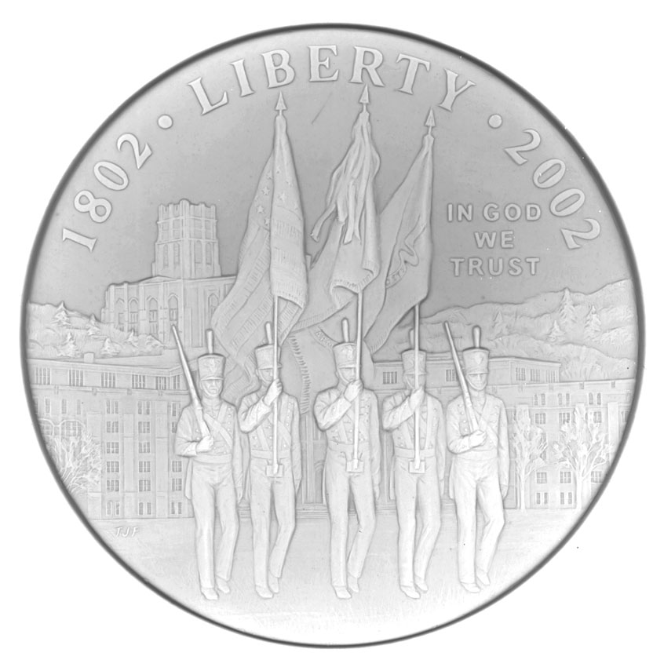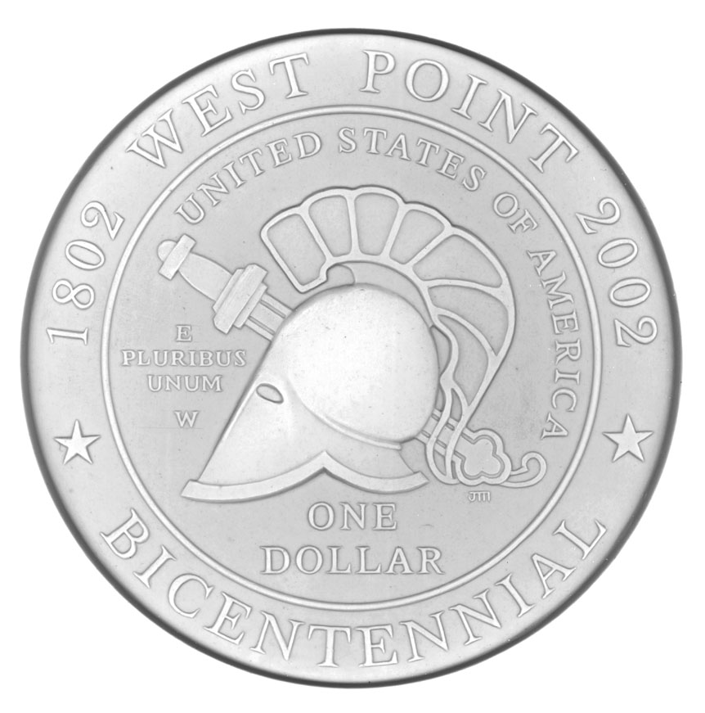U.S. MILITARY ACADEMY BICENTENNIAL

The U.S. Military Academy Bicentennial Commemorative Coin Act, P.L. 103-328, authorizes the production of 500,000 silver dollar coins. Surcharges from the sale of the coins will go to the Association of Graduates, U.S. Military Academy, to assist efforts to provide direct support to the academic, military, physical, moral, and ethical development programs of the Corps of Cadets, U.S. Military Academy. The U.S. Bullion Depository at West Point will strike the coins. Issuance of the coin is targeted for March 16, 2002. The Secretary of the Treasury approved final designs for the U.S. Military Academy Bicentennial Commemorative Coin Program on May 30, 2001.

The trial and test strikes have been completed for both proof and uncirculated versions of the coins. Production began in the last weeks of the first quarter of 2002.

New Consumer and Business Awareness Website

On October 29, 2001 the U.S. Mint launched a new Consumer and Business Awareness website -- www.usmint.gov/consumer -- that explains the variety of replicas and coin-related products in the market that are easily confused with authentic U.S. Mint coins and medals. This new site explains the differences between an authentic U.S. Mint American Buffalo Commemorative Coin and a replica, which is not authentic and is not sponsored or endorsed by the United States Government. The site informs consumers that the authentic U.S. Mint American Buffalo Commemorative Coin features the year 2001 and the artist’s initial “F” for “Fraser” on the obverse, and the denomination and the mint mark on the reverse.

Future Commemorative Coin Programs

2003 First Flight Centennial Commemorative Coins Program (Gold, Silver, Clad)

This gold, silver and clad series will commemorate the 100th anniversary of the Wright brothers’ first flight on December 17, 1903 in Kitty Hawk, NC. The Mint engraving staff was provided with source materials and began the initial design process in December 2001.

Program surcharges will go to the First Flight Foundation for the purposes of repairing, refurbishing, and maintaining the Wright Brothers Monument on the Outer Banks of North Carolina and, expanding or, if necessary, replacing and maintaining the visitor center and other facilities at the Wright Brothers National Memorial Park.

2004 Thomas Alva Edison Commemorative Coins Program (Silver)

This commemorative silver dollar will commemorate the 125th anniversary of the invention of the light bulb. Design concepts for this coin will be provided at a later date.

Program surcharges will be shared as follows:
(1) MUSEUM OF ARTS AND HISTORY- Up to 1/8 to the Museum of Arts and History, in the city of Port Huron, Michigan, for the endowment and construction of a special museum on the life of Thomas A. Edison in Port Huron.
(2) EDISON BIRTHPLACE ASSOCIATION- Up to 1/8 to the Edison Birthplace Association, Incorporated, in Milan, Ohio, to assist in the efforts of the association to raise an endowment as a permanent source of support for the repair and maintenance of the Thomas A. Edison birthplace, a national historic landmark.

(3) NATIONAL PARK SERVICE- Up to 1/8 to the National Park Service, for use in protecting, restoring, and cataloguing historic documents and objects at the `invention factory' of Thomas A. Edison in West Orange, New Jersey.

(4) EDISON PLAZA MUSEUM- Up to 1/8 to the Edison Plaza Museum in Beaumont, Texas, for expanding educational programs on Thomas A. Edison and for the repair and maintenance of the museum.

(5) EDISON WINTER HOME AND MUSEUM- Up to 1/8 to the Edison Winter Home and Museum in Fort Myers, Florida, for historic preservation, restoration, and maintenance of the historic home and chemical laboratory of Thomas A. Edison.

(6) EDISON INSTITUTE- Up to 1/8 to the Edison Institute, otherwise known as `Greenfield Village,' in Dearborn, Michigan, for use in maintaining and expanding displays and educational programs associated with Thomas A. Edison.

(7) EDISON MEMORIAL TOWER- Up to 1/8 to the Edison Memorial Tower in Edison, New Jersey, for the preservation, restoration, and expansion of the tower and museum.

(8) HALL OF ELECTRICAL HISTORY- Up to 1/8 to the Schenectady Museum Association in Schenectady, New York, for the historic preservation of materials of Thomas A. Edison and for the development of educational programs associated with Thomas A. Edison

2004 Lewis and Clark Commemorative Coins Program (Silver)

The commemorative silver dollar will commemorate the bicentennial of the incredible expedition conducted by the Corps of Discovery. The expedition departed St. Louis, Missouri on May 14, 1804. The Mint engraving staff was provided with source materials and began the initial design process in December 2001.

Program surcharges will go to the Lewis and Clark Bicentennial Council (2/3), and the National Park Service (1/3), for activities associated with commemorating the bicentennial of the Lewis and Clark Expedition.

CONCLUSION

Of the two commemorative programs authorized for 2001, only the CVC Program remained on sale through the first quarter of FY 2002. The 2002 Olympic Winter Games Commemorative Coin Program – the first of two programs authorized for 2002, began program pre-sales in the Mint’s Holiday catalog during the first quarter.

As of this report, neither the Capitol Visitor Center nor the National Museum of the American Indian has submitted the appropriate audited statements attesting to their compliance with the CCRA requirements. Consequently, no surcharge payments were made to either organization.

COMMEMORATIVE COIN PROGRAMS
FINANCIAL SUMMARY
FROM INCEPTION THROUGH DECEMBER 31, 2001

 | CAPITOL
 | VISITOR CENTER | BUFFALO | Description
REVENUE | $13,086,834 | $16,668,212 | Receipts
COST OF GOODS SOLD
Proceeds on Silver | $447,177 | $1,405,850 | Payments to DLA for silver
Proceeds on Gold | $1,769,683 | $0 | Payments to Treasury's General Fund for profit on gold
Other Material | $498,581 | $0 | Precious Metal Cost
Manufacturing and Assembling | $1,822,498 | $4,666,207 | Includes fabrication cost
Total Cost of Goods Sold | $4,615,536 | $6,072,057
RESULTS BEFORE SELLING, GENERAL & ADMINISTRATIVE | $8,471,298 | $10,596,155
SELLING, GENERAL & ADMINISTRATIVE
Promotional | $1,277,640 | $712,907 | Promotional includes advertising, printing & postage
Shipping | $799,621 | $750,808 | Product delivery
General & Administrative & Marketing | $1,781,930 | $1,483,671 | Fixed overhead allocated to program
Total Selling, General & Administrative | $3,859,191 | $2,947,386
PROFIT BEFORE SURCHARGES | $4,612,107 | $7,648,769
SURCHARGE ON REVENUE | $3,287,827 | $4,998,730 | Proceeds collected for Benefiting Organizations
ESTIMATED PROGRAM PROFIT (LOSS) | $1,324,280 | $2,650,039 | (Note 2)
POTENTIAL UNRECOVERED MINT INVESTMENT (Note 1)
Melting | $2,311 | $515 | Cost to melt ending inventory and condemned coins
Manufacturing and Assembling | $180,641 | $42,601 | Manufacturing and assembling costs (includes fabrication cost)
Packaging Material | $54,437 | $2,553 | Packaging material that has not been used in mfg. & assembly.
Die Manufacturing | $17,542 | $17,192 | Cost of unused dies
TOTAL | $254,931 | $62,861
SURCHARGES FORWARDED TO BENEFITING ORGANIZATIONS | $0 | $0 | (Note 3)

COMMEMORATIVE COIN PROGRAMS
FINANCIAL SUMMARY
FROM INCEPTION THROUGH SEPTEMBER 30, 2001

(NOTES AND COMMENTS)

This report summarizes the unaudited financial activities of the U.S. Mint’s Commemorative Programs and is intended for the sole use of the Banking and Appropriations Subcommittees and should not be used for any other purposes.
This Interim Profit and Loss analysis was prepared using the modified accrual basis of accounting.
Note 1 – The Mint’s unrecovered investment has been displayed in accordance with the requirements of Sec. 529 of P.L 104-208, and represents the costs associated with the Mint’s inventory of coins, packaging material, and dies on hand. If no additional sales were made, these amounts would be charged as expenses of the associated programs.
Note 2 – P.L. 104-208 requires the Mint to recover all allocable operation and program costs prior to the release of surcharge funds.
Note 3 – Neither the Capitol Visitor Center nor the National Museum of the American Indian has met the matching funds criterion established by the commemorative Coin Reform Act of 1996. Consequently, no surcharge payments were made.

COMMEMORATIVE COIN PROGRAMS
FINANCIAL SUMMARY
OCTOBER 1, 2001 THROUGH DECEMBER 31, 2001

 | CAPITOL
 | VISITOR CENTER | BUFFALO | Description
REVENUE | $1,248,679 | $89,384 | Receipts
COST OF GOODS SOLD
Proceeds on Silver | $50,597 | $10,371 | Payments to DLA for silver
Proceeds on Gold | $138,805 | $0 | Payments to Treasury's General Fund for profit on gold
Other Material | $42,732 | $0 | Metal Cost
Manufacturing and Assembling | $164,034 | $34,023 | Includes fabrication cost
Total Cost of Goods Sold | $396,168 | $44,394
RESULTS BEFORE SELLING, GENERAL & ADMINISTRATIVE | $852,511 | $44,990
SELLING, GENERAL & ADMINISTRATIVE
Promotional | $0 | $0 | Promotional includes advertising, printing & postage
Shipping | $72,883 | $4,040 | Product delivery
General & Administrative & Marketing | $156,626 | $8,611 | Fixed overhead allocated to program
Total Selling, General & Administrative | $229,509 | $12,651
PROFIT BEFORE SURCHARGES | $623,002 | $32,339
SURCHARGE ON REVENUE | $305,329 | $36,850 | Proceeds collected for Benefiting Organizations
ESTIMATED PROGRAM PROFIT (LOSS) | $317,673 | ($4,511)

This report summarizes the unaudited financial activities of the U.S. Mint’s Commemorative Programs and is intended for the sole use of the Banking and Appropriations Subcommittees and should not be used for any other purposes.

This Interim Profit and Loss analysis was prepared using the modified accrual basis of accounting.

The variance between program mintage of 500,000 coins and the 499,000 coins shipped as of December 31, 2001 is due to one of two situations: 1) a small number of shipments were made after the close of the fourth quarter, or 2) a small number of returns received at the Customer Care Center had not yet been processed for possible sale.

