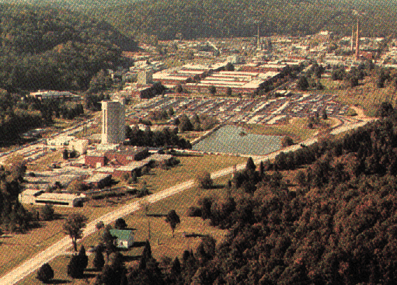
1. Quick Summary
Total Building Space (gross ft²):……………. | 3,544,562*
# of Buildings:…………………………………. | 464 (129 non-SC)
Largest Occupied Building (gross ft²):  Bldg 4500S Central Research & Administration …………………………………. | 347,346
Trailers:………………………………………….. | 137
Wooden Buildings:……………………………. | 31
Excess Facilities: Uncontaminated ……….  Contaminated …………... | 11  19
Excess Space To Be Removed in FY 02…… | 54,000
Replacement Plant Value¹:…………………… | $3.68 Billion*
Landlord Program:…………………………….. | SC Basic Energy Sciences
¹Includes buildings and other structures and facilities, but not excess facilities.
* Excludes SC buildings at Y-12. All 16 buildings (921,000 sf) are to be excessed.

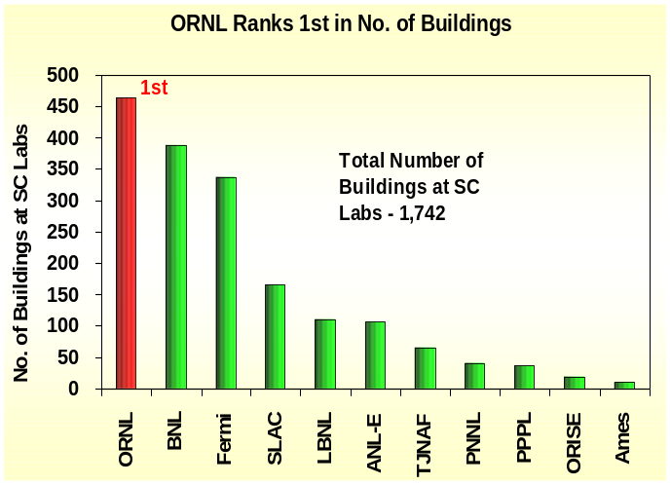2. Rank in Space and No. of Buildings Against Other SC Labs
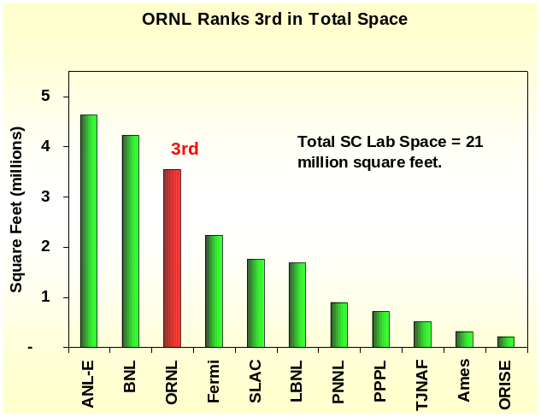
- Programmatic Funding
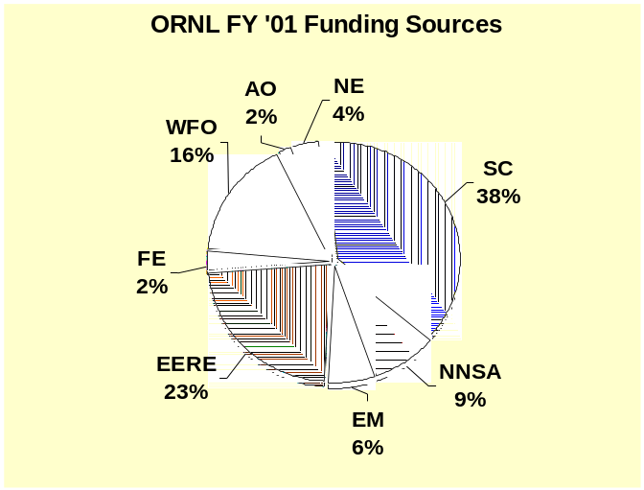
SC – Office of Science
EERE – Energy Efficiency and Renewable Energy
EM – Environmental Management
FE – Fossil Energy
NE – Nuclear Energy

NNSA – Nonproliferation and National Security
WFO – Work for Others
AO – All Others

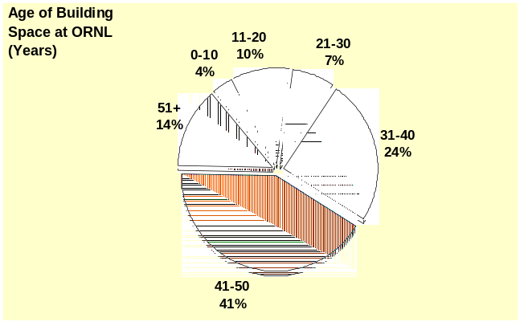4. Age of Space–is the age of building space by gross square feet (gsf). Seventy-nine percent of the ORNL building space is over 30 years old with fifty-five percent being over 40 years of age.

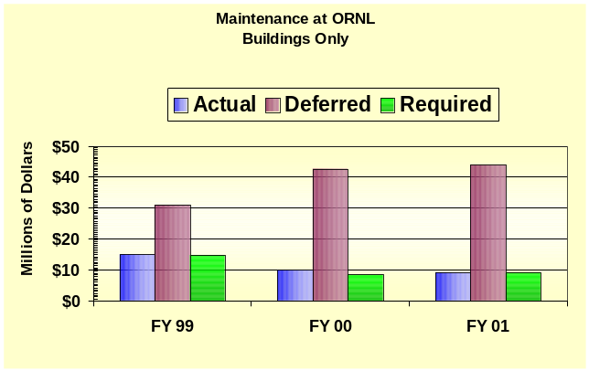5. Real Property Maintenance – Actual maintenance is all real property maintenance activities regardless of funding source (indirect, operating or capital funding). Required maintenance is the estimate of all costs to perform maintenance activities deemed necessary by engineering and life-cycle studies. Actual and Required maintenance have declined from FY 99 to FY 01. The Maintenance Investment Index (total maintenance divided by replacement plant value) based on FY 2001 FIMS Actual Maintenance data is .28%; the corporate benchmark is 2% to 4%. Deferred maintenance is maintenance that was planned but was postponed to a future period due to lack of funds. Deferred maintenance is increasing, reflecting lack of maintenance and capital investment however, the deferred maintenance is substantially less than the $389M of GPP/GPE and line items identified in the FY 2002 Strategic Facilities Plan as needed for modernization.

6. Building Condition Index (BCI) – indicates the condition of space in buildings. BCI is calculated on a building-by-building basis, as Total Deferred Maintenance as a percentage of Replacement Plant Value (RPV). Buildings with a low BCI (i.e., low deferred maintenance) are rated in better condition than those with higher BCI (i.e., high deferred maintenance) – see chart below for quality rating for the BCI percentages. Summary conditions are defined as follows:

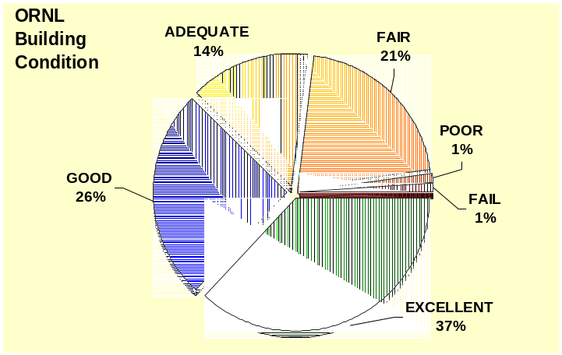Quality Rating: Building Condition Index Range:
- Excellent BCI < 2%
- Good 2% ≤ BCI < 5%
- Adequate 5% ≤ BCI <10%
- Fair 10% ≤ BCI <25%
- Poor 25% ≤ BCI <60%
- Fail BCI ≥ 60%

ORNL’s Facility Condition Index for all facilities is 1.3%, which would indicate that the facilities are in Excellent overall condition. Based on the large number of infrastructure upgrade projects planned ($379M), the deferred maintenance may be underestimated.

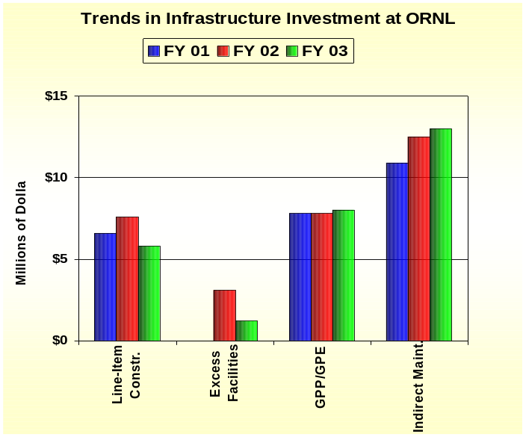7. Infrastructure Investment–is composed of funding for line-items, GPP/GPE, excess facilities, and indirect funded maintenance. Line-items (LI) fund construction of general purpose infrastructure, such as roads, utility systems, and general purpose buildings. Excess facilities funding provides for clean-up and removal of excess buildings. General Plant Project (GPP) and General Purpose Equipment (GPE) are funds for equipment and infrastructure that are shared by facilities across the site. The SC Basic Energy Sciences program provides GPP/GPE funds while the SC Science Lab Infrastructure program funds infrastructure line items and excess facilities. Indirect Maintenance is real property maintenance that is funded by laboratory overhead. It does not include housekeeping or grounds keeping.

Most Recent Line-Item Project: Research Support Bldg, FY 2003, Total Estimated Cost - $16.1M
Summary of Project s Identified in 2002 Strategic Facilities Plan:
Line Item Construction | $ 217M
GPP/GPE | $ 171M

8. Recapitalization Period–is the number of years needed to fully maintain infrastructure as it ages. It is calculated by dividing Total Replacement Plant Value by the total amount spent on construction (the sum of line-items and GPP/GPE).
Recapitalization Periods
FY ‘01 | 214 years
FY ‘02 | 200 years
FY ‘03 | 223 years

- Third Party Facilities – In addition to the DOE owned buildings, ORNL is currently in the process of design/build for over 370,000 sf of new research and office space financed by private sector funds, and over 50,000 sf of office, research and distance learning space financed by the State of Tennessee as part of a university-collaboration Joint Institute. These facilities will be built in the new East Campus area at ORNL, adjacent to the DOE’s new Research Support Center. There are two future State funded facilities that have been committed to by the State legislature to be built in the FY05 and FY06 timeframe –Joint Institutes for Biological Science and Neutron Science respectively.

Sources: Facilities Information Management System (FIMS) Database, April 2002
FY ’04 Budget Crosscut
Lab Strategic Facilities Plan
Institutional Plans and other documentation

Contact: John Yates, SC-82
Tel: 301-903-8435
Fax: 301-903-8442
E-mail: John.Yates@science.doe.gov

