Visiting Washington, D.C., Our Nation's Capital
From California’s 42nd District
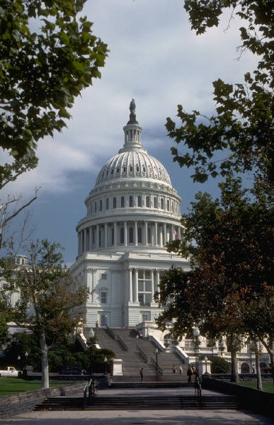
Getting to Congressman Joe Baca’s D.C. Office
Located at 1133 Longworth House Building,
Corner of Independence Ave. & South Capitol Street

From Baltimore-Washington

International (BWI) Airport

Visit online at www.airport.com

• By CAR
- Exit Airport and Take I-195 WEST
- Take the MD-295 SOUTH/BALT/ WASH PKWY exit, exit number 2B, towards WASHINGTON
- Merge onto MD-295 SOUTH
- Take the EAST CAPITOL STREET exit
- TURN LEFT on FIRST STREET
- TURN RIGHT on INDEPENDENCE AVENUE
- TURN LEFT at corner of SOUTH CAPITOL STREET

• BWI SUPERSHUTTLE SERVICE
- Provides door-to-door service to most homes, offices, or hotels in the D.C. area. To make reservations, call 1-800-BLUE-VAN at least 24 hours in advance. Rates range from $26 to $32 each way; additional passengers $8 each way; and children under six ride free.

• TAXI/CAB SERVICE: Average Fare to DC $55

• TRAIN SERVICE
Amtrak and Maryland Rail Commuter (MARC) trains run between the BWI Rail Station and Washington's
Union Station.
- MARC trains (800-325-7245) -- 35 minutes from BWI to Union Station -- depart Monday through Friday every 30 minutes during peak hours and hourly at other times; no weekend service. Service from BWI is 5 a.m. to 9 p.m.; from Union Station, 6 a.m. to 10 p.m. One-way adult fare is $5; seniors 65 and older pay $2.50; and children under 6 ride free. Please go to www.mtamaryland.com for more information.
- Amtrak trains (800-872-7245) run 5 a.m. to 10:45 p.m., with more than 30 trains making the 25- to 29-minute trip daily. One-way adult fares range from $19 to $30 (depending on time and train type); children 2-15 pay half fare. Seniors 62 and older get a 15 percent discount on some trains during the weekends. For more information, go to www.amtrak.com.

an article. Hold down Shift, and click each additional text boxes you want to copy. On the Edit menu, click Copy. Click where you want to copy the text boxes and then click Paste.
To copy some of the text from an article, select the text you want to copy from the article and then copy it. Do not select the text box. You can paste text you’ve copied directly into your document, into another location within the same article, or into another article.

From Washington

Reagan National (DCA)

Airport
Visit online at www.mwaa.com/national

• By CAR
- Exit Airport and stay straight on I-395 NORTH
- Take the C STREET, HOUSE exit and
stay straight
- TURN LEFT onto SOUTH CAPITOL STREET

• TAXI/CAB SERVICE
Average Fare to DC $15

• TRAIN SERVICE
- The Metro runs from Reagan National Airport -- a stop on the Blue or Yellow lines, at the concourse (Level 2) of terminal B/C. Monday-Thursday, 5:30 a.m. to midnight; Friday, 5:30 a.m.-2 a.m.; Saturday, 8 a.m. to 2 a.m.; Sunday, 8 a.m.-midnight.

From Washington-Dulles

International (IAD) Airport
Visit online at www.mwaa.com/dulles

• By CAR
- Exit Airport and stay straight on DULLES AIRPORT ACCESS RD
- Take I-66 EAST
- Take the INDEPENDENCE AVE exit and stay straight
- TURN RIGHT onto SOUTH CAPITOL STREET

• TAXI/CAB SERVICE
Average Fare to DC $45

• TRAIN SERVICE
- Washington Flyer express bus service (1-888-WASH-FLY), operated by the Metropolitan Washington Airports Authority, travels from Dulles to the West Falls Church Metro station every 30 minutes Monday-Friday and Saturday-Sunday afternoons, and every hour on weekend mornings. The first bus leaves at 5:45 a.m., the last at 10:15 p.m. Cost: $8 one way, $14 round trip. For more details, visit online at www.washfly.com.

Getting Around the District

Metro Rail System

The Washington DC metro is the main mode of transportation for many of the residents of Washington, D.C. and the surrounding communities. It’s convenient, safe, clean, easy to use and inexpensive! Getting familiar with the metro system and the way it works might be the first thing you consider before you visit the district. An excellent online map and other helpful information are available at www.wmata.com. Farecards are needed to ride the Metro and can be purchased at every station. Note: Bring small bills because there are no change machines in the stations; credit cards may also be used to purchase farecards.

Parking

On most of the city's major thoroughfares, parking is restricted (and towing strictly enforced) between the hours of 7 and 9:30 a.m. and/or 4 and 6:30 p.m. on weekdays. Make certain that you check the entire street for signs before leaving your car in the afternoon or overnight. The city's neighborhoods are governed by restrictions that allow residents to park all day, but limit all others to two hours maximum from 7 a.m. to 6:30 p.m. Parking meters cost a quarter for fifteen minutes, with two hours maximum. Unlike many U.S. cities, there are no central municipal parking garages in Washington. In downtown, several office buildings and hotels have private garages; rates range from $5 for an hour to up to $20 for a full day, and more for an overnight stay.
Please note: the Metro serves most of the major tourist attractions well, enabling you to leave your vehicle stationary during your visit and to still see the sights.

Taxis In Washington, D.C.

Fares for the DC taxi system are calculated according to zone maps, not by the meter system. No matter how far you travel within a zone, the fares are the same. When traveling by taxi, you can calculate your fare before you get into the taxi, by calling the D.C. Taxicab Commission at (202) 645-6010. Verify the fare with the driver before getting in the taxi. Carry small bills, as most drivers cannot make change for anything over $20. All area taxis are required to post a taxicab zone map and the driver's photo ID; if you don't see these prominently displayed, hail another taxi. Note the company's name and the number of the taxi in case you need to file a complaint. And remember to tip the driver, the going rate is between 15 and 20 percent - tip more for especially good service.

Additional charges may apply. A rush hour surcharge will be added if you travel between 7 and 9:30 a.m. or 4 and 6:30 p.m. An extra $1.50 is charged for each additional passenger. Zone charges are doubled during snow emergencies. A luggage charge may apply on trips to and from the airport.

