
10 Things You Can Do To Save Water

Action:
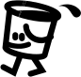
1. Use left over cooking water to water plants.

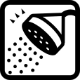
2. Take quick showers. Install low-flow showerheads.

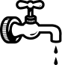
3. Fix leaky faucets.

4. Only run the dishwasher when full.
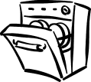

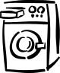
5. Only run the washing machine when full.

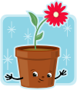
6. Collect shower water while the shower warms up and use it to water plants.

7. Don’t use the toilet as a garbage can!
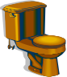

8. Put plastic bottles filled with rocks in your toilet tank.
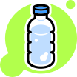

9. Put water bottles in the fridge.

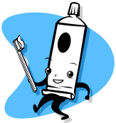
10. Turn off faucet when brushing your teeth.

Reason:
Allows you to reuse water that would be dumped down the drain.

A quick, low flow shower uses only 12 gallons of water.

A tiny leak can waste up to 70 gallons per day.

Running appliances with a full load saves loads of water!

Running appliances with a full load saves loads of water!

Allows you to use otherwise wasted water for a good purpose.

Each flush can waste up to 5 gallons of water.

Bottles may displace and save ten or more gallons of water a day.

Running the tap until the water is cold wastes a large amount of water.

You could save over 1 ^{1/2} gallons of water each time you brush.

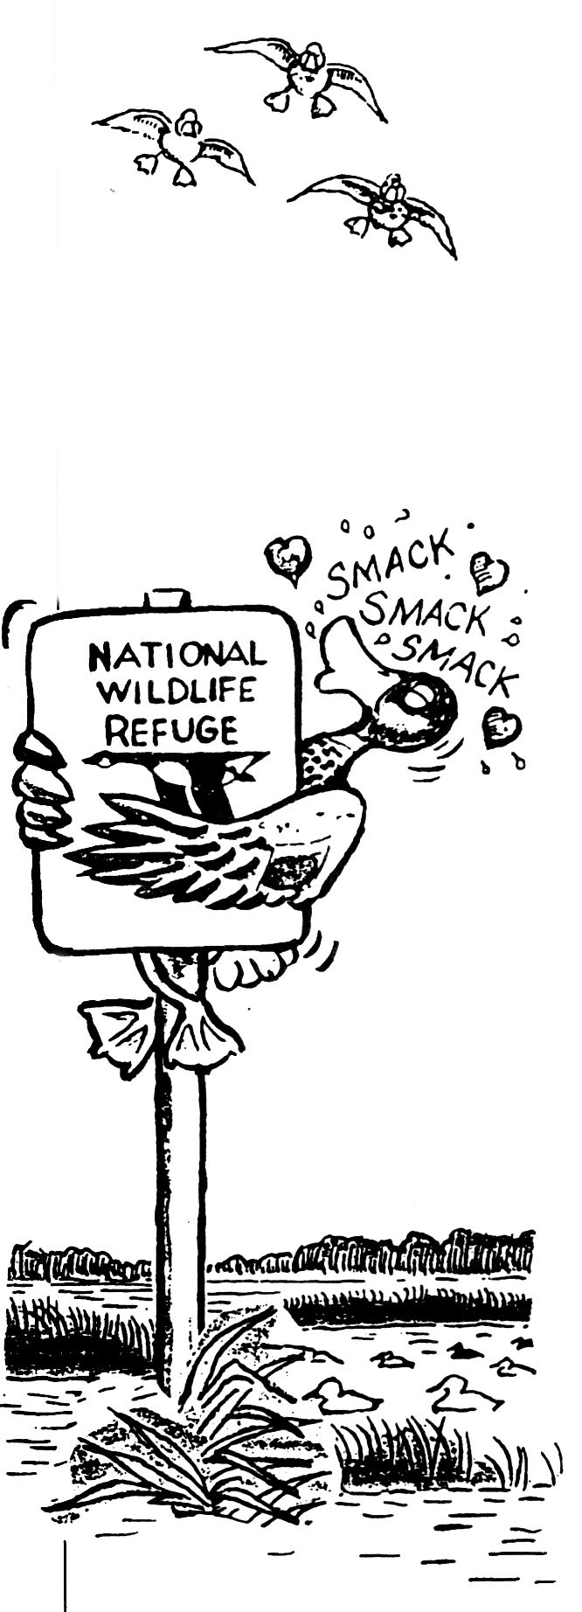
Come Visit us at the Environmental Education Center!!!

Contact information:
Phone: 408-262-5513
Saturday and Sunday open 10:00-5:00
Monday- Friday open 7:30-4:30 by reservation only

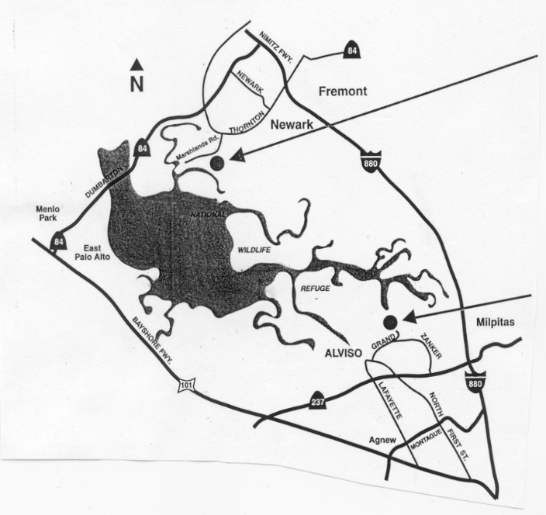

Visitor Center
Directions to the Don Edwards San Francisco Bay National Wildlife Refuge Environmental Education Center in Alviso:
From I-880 or Highway 101, exit on Highway 237 toward Alviso. Turn north onto Zanker Rd. to the Environmental Environmental Education Center Education entrance road (a sharp right turn at Center Grand Blvd). The distance from 237 to the entrance is 2.1 miles. (see map to right)

mark your calendar for South Bay Bird

