“Houston, We May Have a Problem… in 27 Hours or so…”

An early warning protocol for satellites owners

By

Francesca Alexandra Bassa
St. Agnes Academy
Houston, TX

I. Background

From http://www.magazine.noaa.gov/stories/mag131.htm (passim)

SOLAR STORMS CAUSE SIGNIFICANT ECONOMIC AND OTHER IMPACTS ON EARTH
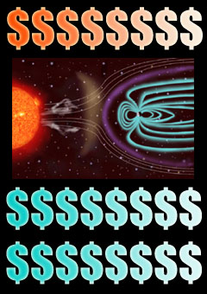
April 5, 2004 — The impacts and costs associated with meteorological storms occurring on the Earth’s surface are obvious, but what about those associated with space weather? Solar or geomagnetic storms — just like hurricanes, tornadoes, hail and floods — can cause damage resulting in hundreds of millions of dollars in economic losses each year.

Impacts of Solar Storms
…Solar storms have been known to knock out satellites, some power supplies, communications and navigation systems. Many of these effects are transitory, but they can be very disruptive and potentially dangerous — both to the systems themselves and the nation’s economy. Damage to these systems can also result in secondary effects that can disrupt virtually every major infrastructure dependant on them, including transportation, security and emergency response systems, telecommunications and other wireless networks and electronic equipment.

Increased Vulnerability with Advanced Technologies
“…it is more important now (than ever) to have the capabilities and resources necessary to monitor, predict and understand space weather,” says retired Navy Vice Adm. Conrad C. Lautenbacher, Ph.D., undersecretary of commerce for oceans and atmosphere and NOAA administrator. “NOAA’s research and operational capabilities enable it to help the nation (and the world) prepare for these storms."

… space weather data [are collected] from satellites and ground-based sensors, including:

- The geostationary satellites provide real-time measurements of solar flares, radiation storms, and geomagnetic disturbances…
- The polar-orbiting satellites carry solar environmental monitors and instruments to measure ultraviolet radiation in space.

NOAA collects additional space weather data through cooperation with NASA and the U.S. Department of Defense. The NOAA space weather scales [see Appendix A] were created to communicate to the public the current and future space weather conditions and their possible impacts on people and systems. All of these activities help power companies, the airline industry, spacecraft operators, the communications industry and emergency officials predict and prepare for the potential damage of solar events well before they hit the Earth.

Value of Space Weather Observation
NOAA Chief Economist Rodney F. Weiher and Dr. Thomas J. Teisberg recently estimated that the economic benefits of providing reliable warnings of geomagnetic storms to the electric power industry (alone) would be approximately $450 million over three years (note that this doesn't include any other impacted industries). This is well above the $100 million cost of a new operational satellite that would provide such warnings (Teisberg and Weiher, 2000).

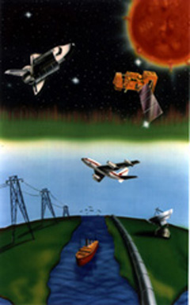
Economic Impacts on Power Grids and Satellite Systems
The satellite industry and electric power producers have experienced major financial losses attributed to space weather since the 1980s (Quinn, 2000).

Power Grids
…The HydroQuebec Power Grid blackout in Quebec, Canada, in March of 1989 … [showed] the extent to which solar storms can impact the economy. The solar storm induced a nine-hour blackout which affected 6 million customers and ultimately cost this power company more than $10 million — putting the cost of this disaster in the same category as hurricanes and earthquakes…

Comprehensive real-time protective space weather prediction services could have significantly reduced damages and costs. Hydro-Quebec’s solution to the blackout was to install devices that block solar storms created geomagnetically-induced currents from traveling through its transmission lines. Unfortunately, this solution is extremely complex and expensive ($1.2 billion) (Quinn, 2000).

It was soon realized that the key to protecting vulnerable high tech systems is the ability to forecast solar storms and to take appropriate measures to avoid (or at least minimize) potential damage before they strike the Earth.
…

Satellites
Scientists point out that satellites are even more vulnerable to solar storms than power grids. Engineers have been forced to use much lighter shielding materials in order to keep costs down (it costs between $5,000 to $10,000 per pound to launch material into space) (Odenwald, 1999). Space storms don't even have to make a direct hit to harm a satellite, especially the many new low Earth orbit (LEO) commercial satellites (orbiting only a few hundred miles above the Earth’s surface). During heightened solar activity, the atmosphere thickens, increasing atmospheric friction on LEO objects. In fact, $500 million in satellite insurance claims from 1994 to 1999 were the direct or indirect result of space weather (Kunstadter, 2002). Despite this, LEO satellites remain prime orbital real estate for the latest generations of communication satellite networks. Although astronauts can minimize radiation storm impacts by retreating into the shielded chambers of their space station, many other satellites must be switched to safe mode to survive solar storms…

- The U.S. Department of Defense has estimated that disruptions to government satellites from space weather cost about $100 million a year (Rodgers, et. al., 2000).
- The loss of telephone pager service to 45 million customers in May of 1998 and military reports of interruptions to high frequency radio communications during the Gulf War in 1991 have also been attributed to solar storms (NOAA Hearing, 2003).
- Society is becoming extremely reliant on global positioning systems. A one percent gain in continuity and availability of GPS would be worth $180 million per year (Rodgers, et. al., 2000).

October-November 2003 Solar Storm
The solar storms that impacted the Earth between Oct.19 to Nov.7, 2003… Larry Combs, one of the NOAA Space Environment Center forecasters [commented] “… there were two distinct, very intense geomagnetic storms, which both arrived in just 19 hours from the sun to the Earth. This ranks them as some of the fastest traveling solar storms on record and both produced the strongest activity this solar cycle — reaching extreme or G5 on the NOAA space weather scales." Because the NOAA Space Environment Center released advanced warnings about an unusually large solar storm, electrical utilities, airlines and spacecraft managers were able to take preventive action to minimize disruption of service — and the economy — due to the storm.

II. This Project

The idea originated when I read that NASA and JAXSA (Japan Space Agency) had launched in September 2006 the Hinode (Solar-B) program and satellite (http://solarb.msfc.nasa.gov/) to study the effects of solar weather on communication satellites and other phenomena. My initial desire was to establish a simple early warning system similar to the tsunami warning system in the Pacific Ocean, when/if a major solar disturbance is aimed at the Earth.

I wrote to JAXSA and NASA and was put in touch with Dr. Sten Odenwald at NASA. After several exchanges he suggested that I do a data mining and statistical analysis which if successful could become part of a larger project he is working on to create a sophisticated mathematical model of what happens to communication satellites during a severe solar storm. These storms have many components to them and to make the model accurate all the statistically meaningful correlations which can be deduced from past solar storms and what they did to satellites need to be incorporated. Dr. Odenwald will present the results at the Space Weather Conference in Boulder, CO, in April 2007.

The scope of this project is to provide the owners of satellites in orbit with a statistically valid protocol of early warning for a specific type of solar disturbances which can damage satellites, namely Solar Proton Emissions (SPE) which are suspected to be related to certain types of Corona Mass Ejections (CMEs) called Halo CME and Partial Halo CME.

Solar storms may produce spectacular Solar Flares because the magnetic fields near the surface of the sun are forced to “reconnect” rapidly. Other times, this process is slower and larger regions become buoyant and launch CMEs into space. Some CMEs have a period near the sun when particles are accelerated to high energy in an outward traveling shock front. When this shock front arrives at Earth with the CME, Solar Proton “storm” occurs which we see as an SPE. Other times, the shock front does not accelerate so clearly and all we see is the CME and its associated magnetic effects near earth (auroras).

Solar Storm
│
┌──────────┴──────────────┐
Solar Flares CME
│
┌──────────┴───────┐
No Shock Shock Acceleration
│ │
│ ┌────┴──────┐
Magnetic Storm Magnetic Storm No Magnetic Storm
│ │ │
Aurora Aurora & SPE SPE

Source: communication from Dr. Odenwald
1. Methodology

(a) Gathering of the raw data

The first step was to select the CME-SPE pairs that were close to each other in time.

- Generally, CME happen first and are followed by SPE. Solar Proton Emissions are caused by protons that are accelerated within the shock front of the CME as it gets close to Earth, so the SPE date and time will be 1-3 days after the first sighting of the CME eruption on the sun.

The starting point was the catalog of all SPE created by NOAA from 1976 to present:

ftp://ftp.ngdc.noaa.gov/STP/SOLAR_DATA/Satellite_ENVIRONMENT/PARTICLES/p_events.lst

and the catalog of all CMEs from 1996 to present compiled by NASA:

http://cdaw.gsfc.nasa.gov/CME_list/UNIVERSAL/text_ver/univ_all.txt

The next step was to make these two lists cover the same period from January 1996 to June 2006 since CMEs data are available only from 1996 when SOHO was launched and became operational. The SPE list then became document 002-SPE [Appendix B].

The CME Catalog (document 003-SOHO-LASCO CME catalog 2007-01-23 [Appendix C]) was changed into a new catalog (document 004-CME catalog 2007-01-23-working set [Appendix D]), without the columns with measurements deemed not reliable (acceleration, mass, and kinetic energy).

Note: Since these two documents (003 & 004) contain over 11,000 data entries each, only the first page of each is included in the appendix for the purpose of illustration only.

Now two compatible sets of data were available from which to select the CME-SPE pairs that were close to each other in time.

- For the CME events, the two qualities of interested are the “Halo” and “Partial Halo” description. A Halo CME has a symmetrical appearance around the sun, a Partial Halo CME is more lob sided.
- A “Halo CME” is a CME which is either headed directly towards Earth, or in the opposite direction. Both eruptions look like haloes but only the one on this side of the sun is directed towards earth.

The scope of this project is to “prove” that earthbound Halo (or Partial Halo) CME are those events that correlate with SPE events.

(b) Collating the data

This was the major part of the work, i.e., to build a table with the data side by side, starting from the two catalogs, of CMEs and SPE which are related in time, and to separate and order in the right time sequence Halo CME from Partial Halo CME with their associated SPE events. The result, after several iterations is the Excel spreadsheet 005-Table 5 [Appendix E].

005-CME-SPE Table 5

- Each row represents a pair of Halo (or Partial Halo) CME-SPE events with the data from the original catalogs.

- CME data (to the left of the red column – columns B through G)

- Date, time, speed measurements (columns B through G). Column M indicates whether the CME is categorized as Halo or Partial Halo (HaloP).

- Columns N through U tag all CMEs with linear speed >1000 km/s or >1500 km/s (3.6 million km/hr and 5.4 million km/hr respectively).

- SPE data (to the right of the red column)

- Date, time, and strength of SPE measured in particle flux units (Pfu) or particles per square centimeter per second. The energy of the particle is measured in MeV. Only events with energy >10 MeV are considered (columns I through K).

- Column L indicates the time delay in hours between a CME event observed on the sun and the associated SPE event observed near Earth.

- Columns V, W, and X tag all SPE events with energy >10^2 Mev, 10^3 MeV, and 10^4 MeV respectively.

- This is repeated for the Partial Halo CMEs.

- At the bottom of each list there is a tally of all tagged events in each column and the frequency of occurrence of each.

- The lower half of the spreadsheet asks the question whether earthbound Halo (or Partial Halo) CMEs are related to SPE with energy >10^2 MeV, and presents the data for the interpretation.

Note: Appendix E (Table 5) shows only the results of the data analyses. The Excel spreadsheet contains numerous tabs with the original and elaborated data to produce these results.

2. Summary of the results

Question: Are SPE and CME statistically related?

- SPE (the independent variable) are caused by solar events: solar flares, CME, etc.

- CME (their characteristics like speed etc., are the dependent variables) are
  - Halo CME (total halo)
  - HaloP CME (partial halo)
  - Non-halo CME

- All Halo and HaloP CME are either
  - earthbound (towards the earth) or
  - in the opposite direction.

Data extracted and collated over the period January 1, 1996 to June 30, 2006

SPE ( > 10 MeV) (independent variables):

total # of SPE events over the period: 90

SPE “associated with” Halo CME: 45 out of 90 (50.0%)
SPE “associated with” HaloP CME: 16 out of 90 (17.8%)
SPE “associated with” Halo or HaloP CME: 61 out of 90 (67.8%)
SPE “not associated with” Halo or HaloP CME: 29 out of 90 (32.2%)

All SPE are characterized by energy > 10 MeV

CME and their characteristics (dependent variables):

total # of all CME events over the period: 11031

Halo CME: total # of events: 384 out of 11031 (3.5%)
HaloP CME: total # of events: 803 out of 11031 (7.3%)
Halo or HaloP CME: total # of events: 1187 out of 11031 (10.8%)
Non Halo CME: total # of events: 9844 out of 11031 (89.2%)

All CME have linear speed measurements and other measurements associated with them (dependent variables).

1st assumption: CME linear speed (l.s.) “relates to” SPE energy

(a) Halo & HaloP CME with l.s. > 1000 km/s "relate to" SPE with energy > 10 MeV

Halo CME (l.s.>1000) “related to” SPE (>10 MeV): 36 out of 45 (80.0%)
HaloP CME (l.s.>1000) “related to” SPE (>10 MeV): 11 out of 16 (68.8%)

(b) Halo & HaloP CME with l.s. > 1500 km/s "relate to" SPE with energy >10 MeV

Halo CME (l.s.>1500) “related to” SPE (>10 MeV): 21 out of 45 (46.7%)
HaloP CME (l.s.>1500) “related to” SPE (>10 MeV): 6 out of 16 (37.5%)

2nd assumption: SPE ( >10^2 MeV) are associated with CME (Halo & HaloP) l.s.

SPE (>10^2 MeV) (independent variables):

total # of SPE (>10^2 MeV) events over the period: 30 out of 90 (33.3%)

SPE (>10^2 MeV) “associated with” Halo CME: 23 out of 30 (76.7%)
SPE (>10^2 MeV) “associated with” HaloP CME: 7 out of 30 (23.3%)
SPE (>10^2 MeV) “associated with” Halo or HaloP CME: 30 out of 30 (100%)

(c) Halo & HaloP CME with l.s. > 1000 km/s "relate to" SPE with energy > 10^2 MeV

Halo CME (>1000 l.s.) “related to” SPE (>10^2 MeV): 22 out of 23 (95.7%)
HaloP CME (>1000 l.s.) “related to” SPE (>10^2 MeV): 7 out of 7 (100%)

(d) Halo & HaloP CME with l.s. > 1500 km/s "relate to" SPE with energy >10^2 MeV

Halo CME (>1500 l.s.) “related to” SPE (>10^2 MeV): 15 out of 23 (65.2%)
HaloP CME (>1500 l.s.) “related to” SPE (>10^2 MeV): 4 out of 7 (57.1%)

Note: Plots of these results, pie charts and Venn diagrams are in Appendix F

3. Conclusions

- There is a fair correlation between
  - SPE with energy >10 MeV and
    - Halo CME (50%)
    - HaloP CME (18%)

- There is a very good correlation between
  - SPE with energy >10 MeV and
    - Halo CME with l.s.>1000 km/s (80%)
    - HaloP CME with l.s.>1000 km/s (69%)

- There is a fair correlation between
  - SPE with energy >10 MeV and
    - Halo CME with l.s.>1500 km/s (47%)
    - HaloP CME with l.s.>1500 km/s (38%)

- There is an excellent correlation between
  - SPE with energy >10^2 MeV and
    - Halo CME with l.s.>1000 km/s (96%)
    - HaloP CME with l.s.>1000 km/s (100%)

- There is a good correlation between
  - SPE with energy >10^2 MeV and
    - Halo with l.s.>1500 km/s (65%)
    - HaloP CME with l.s.>1500 km/s (57%)

From these analyses it is statistically reasonable to conclude that fast-moving (>1000 km/s or 3.6 million km/hr or 2.2 million miles/hr) Halo (or Partial Halo) CMEs headed towards Earth are the most likely origins for “strong” Solar Proton Events (energy > 100 MeV).

4. Practical application

There are hundreds of satellites in space and most are affected in one way or another by these events, sometimes in a minor way, other times more severely. The most vulnerable are the geostationary communication satellites. There are over 280 of them and they generate about $100 billion a year in revenue from TV/radio programming.

During the most severe storms in the past some satellites were damaged or suffered temporary malfunction during intense periods of operating anomalies. The actual information of which satellites were affected is confidential because their owners worry that their stocks may drop if consumers become skeptical of their reliability.

This project now offers for the first time a statistically valid protocol for satellite owners in the case of special events known as Halo and Partial Halo Corona Mass Ejections and their relation with Solar Proton Emissions. If a satellite owner determines that a Halo (or Partial Halo) CME is directed towards Earth and is moving faster than 1000 km/s (3.6 million km/hr or 2.2 million miles/hr), he now knows that it could produce conditions capable of disrupting satellite operations.

Earth is about 148 million km from the sun and a CME traveling at a speed of 1500 km/s (5.4 million km/hr or 3.4 million miles/hr) would take a little more than a day, about 27 hrs and 24 minutes, to reach a satellite in orbit and the associated SPE could damage/ disrupt the satellite and its operation. A satellite owner has now a statistically valid warning of about 27 hours on average to take actions to protect his investment.

What practical actions can a satellite owner take within this warning period?

Satellites maintenance is a very complex operation. Periodically, satellites are put through tests, or have their operating modes changed or optimized. This requires sending complicated commands to the satellite. It is these commands that can be corrupted by these and other radiation “glitches.” If it is known that a storm will soon hit, these changes would be scheduled for later times, after the disturbance has passed.

Acknowledgment

I am extremely grateful to Dr. Sten Odenwald of NASA for guiding me and yet let me struggle on my own how to gather and analyze lots of raw data and for giving me the opportunity to collaborate with him in what he called “a serious project.”

I also want to thank Mr. Woong Lim, a colleague fencer and a math teacher at my school, St. Agnes Academy in Houston, TX, for spending time in showing me many statistical tricks and Excel manipulations I had never used before.

Lastly, I want to thank my St. Agnes Academy Science Advisor, Ms. Madeline Contreras, and the counselor for the Science Fair, Ms. Jean Flanders, for letting me work on this project which involved a lot of data mining, statistical manipulations, and analyses of data generated by experiments and measurements conducted by NASA scientists.

Francesca Alexandra Bassa

10th grade

St. Agnes Academy
Houston, TX

APPENDIX A

NOAA SPACE WEATHER SCALES

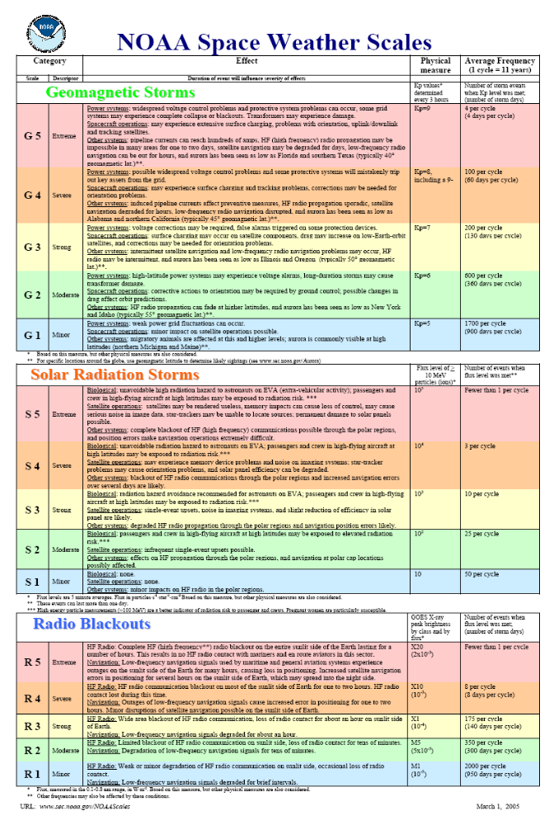

APPENDIX B

002-SPE

SPE, ASSOCIATED CME, FLARE AND ACTIVE REGION

SPE, ASSOCIATED CME, FLARE AND ACTIVE REGION
(passim 1996-2006)

ftp://ftp.ngdc.noaa.gov/STP/SOLAR_DATA/Satellite_ENVIRONMENT/PARTICLES/p_events.lst

PARTICLE EVENT ASSOCIATED CME, FLARE AND ACTIVE REGION

Start Maximum Proton Flux CME Flare Max.ImportancLocationRegion #
(Day/UT) (pfu @ >10 Me(Loc./ Day UT) (X ray/Opt.) (SWO)

1996

1997
Nov 04/0830 Nov 04/1120 72 W/04 0610 Nov 04/055 X2/2B S14W33 8100
Nov 06/1305 Nov 07/0255 490 W/06 >1300 Nov 06/115 X9/2B S18W63 8100

1998
Apr 20/1400 Apr 21/1205 1,700 W/20 1007 Apr 20/102 M1/EPL S43W90 8194
May 02/1420 May 02/1650 150 Halo/02 1406 May 02/134 X1/3B S15W15 8210
May 06/0845 May 06/0945 210 W/06 0829 May 06/080 X2/1N S11W65 8210
Aug 24/2355 Aug 26/1055 670 NA Aug 24/221 X1/3B N30E07 8307
Sep 25/0010 Sep 25/0130 44 NA Sep 23/071 M7/3B N18E09 8340
Sep 30/1520 Oct 01/0025 1,200 NA Sep 30/135 M2/2N N23W81 8340
Nov 08/0245 Nov 08/0300 11 ?
Nov 14/0810 Nov 14/1240 310 NA Nov 14/051 C1/BSL N28W90 8375?

1999
Jan 23/1105 Jan 23/1135 14 NA Jan 20/200 M5 N27E90
Apr 24/1804 Apr 25/0055 32 Halo/24 1331 NW limb 8517?
May 05/1820 May 05/1955 14 Halo/ 03 0606 May 03/060 M4/2N N15E32 8525
Jun 02/0245 Jun 02/1010 48 Halo/ 01 <1937 Jun 01/~1930
Jun 04/0925 Jun 04/1055 64 NW/ 04 0726 Jun 04/070 M3/2B N17W69 8552

2000
Feb 18/1130 Feb 18/1215 13 W/ 18 0954 Feb 17/203 M1/2N S29E07 8872
Apr 04/2055 Apr 05/0930 55 W/ 04 1632 Apr 4/1541 C9/2F N16W66 8933
Jun 07/1335 Jun 08/0940 84 halo/ 06 1554 Jun 06/1525 X2/3B N20E18 9026
Jun 10/1805 Jun 10/2045 46 halo/ 10 1708 Jun 10/1702 M5/3B N22W38 9026
Jul 14/1045 Jul 15/1230 24,000 halo/ 14 1054 Jul 14/1024 X5/3B N22W07 9077
Jul 22/1320 Jul 22/1405 17 NW/ 22 1230 Jul 22/1134 M3/2N N14W56 9085
Jul 28/1050 Jul 28/1130 18
Aug 11/1650 Aug 11/1655 17
Sep 12/1555 Sep 13/0340 320 halo/ 12 1331 Sep 12/1213 M1/2N S17W09 Filament
Oct 16/1125 Oct 16/1840 15 halo/ 16 0727 Oct 16/0728 M2 N04W90 9182?
Oct 26/0040 Oct 26/0340 15 halo/ 25 0826 Oct 25/1125 C4 N00W90
Nov 08/2350 Nov 09/1555 14,800 halo/ 08 2306 Nov 8/2328 M7 (multiple)
N00-10W75-80 Regions 9212, 9213, 9218
Nov 24/1520 Nov 26/2030 940 halo/ 24 0530 Nov 24/0502 X2/3B N20W05 9236

2001
Jan 28/2025 Jan 29/0655 49 halo/ 28 1554 Jan 28/1600 M1/1N S04W59 9313
Mar 29/1635 Mar 30/0610 35 halo/ 29 1026 Feb 29/1015 X1/1N N24W12 9393
Apr 02/2340 Apr 03/0745 1,100 NW/ 02~2200 Apr 02/2215 X20/? N14W82 9393
Apr 10/0850 Apr 11/2055 355 halo/ 10 0530 Apr 10/0526 X2/3B S23W09 9415
Apr 15/1410 Apr 15/1920 951 W/ 15/1430 Apr 15/1350 X14/2B S20W85 9415
Apr 18/0315 Apr 18/1045 321 SW/ 18/0230 Apr 18/0214 C2/ S20W-Limb 9415
Apr 28/0430 Apr 28/0500 57 halo/ 26/1230 Apr 26/1312 M7/2B N17W31 9433
May 07/1915 May 08/0755 30 NW ~07/1000 NW Limb
Jun 15/1750 Jun 16/0005 26 CME W/15/1648 W Limb
Aug 10/1020 Aug 10/1155 17 CME W/09/1122 Aug 09/1122 C3/ Center Disk
Aug 16/0135 Aug 16/0355 493 halo 15/2330 Far backside
Sep 15/1435 Sep 15/1455 11 CMEsw/15/1154 Sep 15/1128 M1/1N S21W49 9608
Sep 24/1215 Sep 25/2235 12,900 halo 24/1030 Sep 24/1038 X2/2B S16E23 9632
Oct 01/1145 Oct 02/0810 2,360 CMEsw/01/0530 Oct 01/0515 M9 S22W91 9628
Oct 19/2225 Oct 19/2235 11 halo 19/1650 Oct 19/1630 X1/2B N15W29 9661
Oct 22/1910 Oct 22/2130 24 CMEse/22/1826 Oct 22/1759 X1/2B S18E16 9672
Nov 04/1705 Nov 06/0215 31,700 halo/ 04/1620 Nov 04/1620 X1/3B N06W18 9684
Nov 19/1230 Nov 20/0010 34 halo/ 17/0530 Nov 17/0525 M2/1N S13E42 9704
Nov 22/2320 Nov 24/0555 18,900 halo/ 22/2330 Nov 22/2330 M9/2N S15W34 9704
Dec 26/0605 Dec 26/1115 779 CME W 26/0540 Dec 26/0540 M7/1B N08W54 9742
Dec 29/0510 Dec 29/0815 76 CME E 29/2006 Dec 28/0815 X3 S26E90 9767
Dec 30/0245 Dec 31/1620 108

2002
Jan 10/2045 Jan 11/0530 91 CME E 08/1754 Jan 08/2025 C9 E Limb
Jan 15/1435 Jan 15/2000 15 halo 14/0525 Jan 14/0627 M4 W Limb
Feb 20/0730 Feb 20/0755 13 CME W 20/0630 Feb 20/0612 M5/1N N12W73 9825
Mar 17/0820 Mar 17/0850 13 hal0/ 15/2306 Mar 15/2310 M2/1F S08W03 9866
Mar 18/1300 Mar 19/0650 53
Mar 20/1510 Mar 20/1525 19 CME W 18/0254 Mar 18/0231 M1 S09W46 near 9866
Mar 22/2020 Mar 23/1320 16 halo/ 22/1106 Mar 22/1114 M1 W limb 9866
Apr 17/1540 Apr 17/1540 24 halo/ 17/0824 Apr 17/0824 M2/2N S14W34 9906
Apr 21/0225 Apr 21/2320 2,520 halo/ 21/0127 Apr 21/0151 X1/1F S14W84 9906
May 22/1755 May 23/1055 820 halo/ 22/0354 May 22/0354 C5/DSF S19W56
Jul 07/1830 Jul 07/1955 22 CME W 07/1106 Jul 07/1143 M1 W limb
Jul 16/1750 Jul 17/1600 234 halo 15/2008 Jul 15/2008 X3/3B N19W01 10030
Jul 19/1050 Jul 19/1515 13
Jul 22/0655 Jul 23/1025 28 halo 20/2130 Jul 20/2130 X3 SE limb
Aug 14/0900 Aug 14/1620 24 CME NW14/0206 Aug 14/0212 M2/1N N09W54
Aug 22/0440 Aug 22/0940 36 CME SW22/0200 Aug 22/0157 M5/2B S07W62 10069
Aug 24/0140 Aug 24/0835 317 Aug 24/0112 X3/1F S08W90 10069
Sep 07/0440 Sep 07/1650 208 halo 05/1654 Sep 05/1706 C5/DSF N09E28 10102
Nov 09/1920 Nov 10/0540 404 CME SW09/1331 Nov 09/1323 M4/2B S12W29 10180

2003
May 28/2335 May 29/1530 121 halo 28/0050 May 28/0027 X3/2B S07W17 10365
May 31/0040 May 31/0645 27 CME W 31/0230 May 31/0224 M9/2B S07W65 10365
Jun 18/2050 Jun 19/0450 24 halo 17/2255 Jun 17/2255 M6 S08E61 10386
Oct 26/1825 Oct 26/2235 466 halo 26/1819 Oct 26/1819 X1/1N N02W38 10484
Nov 02/1105 Nov 03/0815 1,570 halo 02/0954
Nov 04/2225 Nov 05/0600 353 halo 04/1929 Nov 04/1929 X28/3B S19W83 10486
Nov 21/2355 Nov 22/0230 13 CME SW21/0026 Nov 20/2353 M5/2B N02W17 10501
Dec 02/1505 Dec 02/1730 86 halo 02/1026 Dec 02/0948 C7 W limb

2004
Apr 11/1135 Apr 11/1845 35 SW/11 0430 Apr 11/0419 C9/1F S14W47 10588
Jul 25/1855 Jul 26/2250 2,086 Halo/25 1530 Jul 25/1514 M1/1F N08W33 10652
Sep 13/2105 Sep 14/0005 273 Halo/12 0036 Sep 12/0056 M4/2N N04E42 10672
Sep 19/1925 Sep 20/0100 57 W/19 2224 Sep 19/1712 M1 N03W58 10672
Nov 01/0655 Nov 01/0805 63 CME W01/0606 Backside
Nov 07/1910 Nov 08/0155 495 Halo/07/1706 Nov 07/1606 X2 N09W17 10696

2005
Jan 16/0210 Jan 17/1750 5040 Halo/15/2306 Jan 15/2302 X2 N15W05 10720
May 14/1525 May 15/1120 3140 Halo/13/1722 May 13/1657 M8 N12E11 10759
Jun 16/2200 Jun 17/0500 44 W/16 2003 Jun 16/2002 M4 N09W87 10775
Jul 14/0245 Jul 15/0345 134 Halo/13/1430 Jul 13/1449 M5 N10W80 10786
Jul 27/2300 Jul 29/1715 41 Halo/27/0454 Jul 17/0502 M3 N11E90 10792
Aug 22/2040 Aug 23/1045 330 Halo/22/1730 Aug 22/1727 M5/1N S12W60 10798
Sep 08/0215 Sep 11/0425 1880 E/07 1723 Sep 07/1740 X17/3B S06E89 10808

2006

Dec 06/1555 Dec 07/1930 1980 Halo Dec 05/1035 X9/2N S07E79 10930
Dec 13/0310 Dec 13/0925 698 Halo/13/0254 Dec 13/0240 X3/4B S05W23 10930

=========================================================================================

Please Note:

Proton fluxes are integral 5-minute averages for energies > 10 MeV, given in Particle Flux Units (pfu), measured by GOES spacecraft at Geosynchronous orbit: 1 pfu = 1 p/sq. cm-s-sr.

SWO defines the start of a proton event to be the first of 3 consecutive data points with fluxes greater than or equal to 10 pfu. The end of an event is the last time the flux was greater than or equal to 10 pfu. This definition, motivated by SWO customer needs, allows multiple proton flares and/or interplanetary shock proton increases to occur within one SWO proton event. Additional data may be necessary to more completely resolve any individual proton event.

Different detectors, onboard various GOES spacecraft, have taken the data since 1976. These proton data were processed using various algorithms. To date, no attempt has been made to cross-normalize the resulting proton fluxes.

Flare associations are given, although data about individual Coronal Mass Ejections (CMEs), available from SOHO since 1996 only, are necessary to fully characterize each event.

APPENDIX C

003-SOHO-LASCO CME catalog 2007-01-23

(first page only for illustration)

APPENDIX D

004-SOHO-LASCO CME catalog 2007-01-23-working set

(first page only for illustration)

APPENDIX E

005-CME-SPE-Table 5

(results only)

APPENDIX F

Pie charts and Venn diagrams of the results

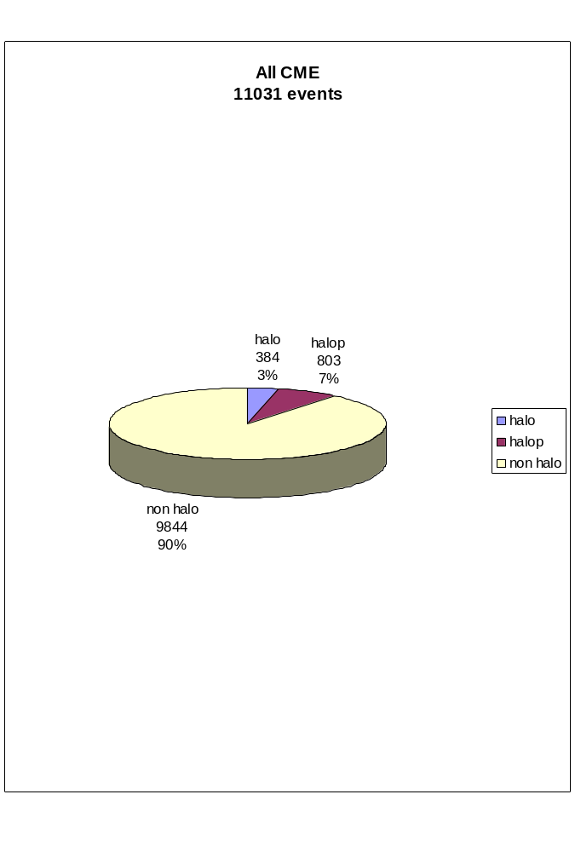

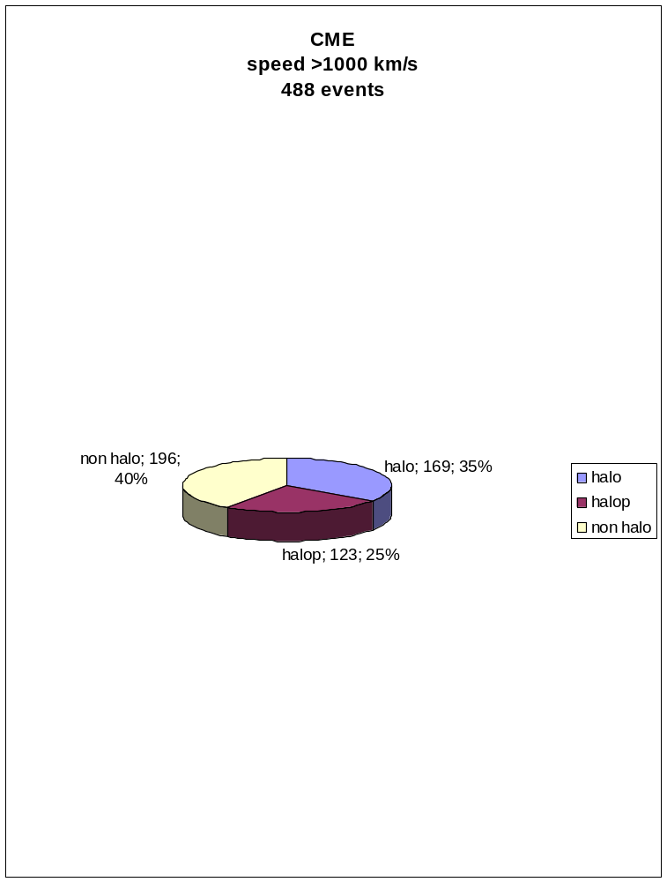

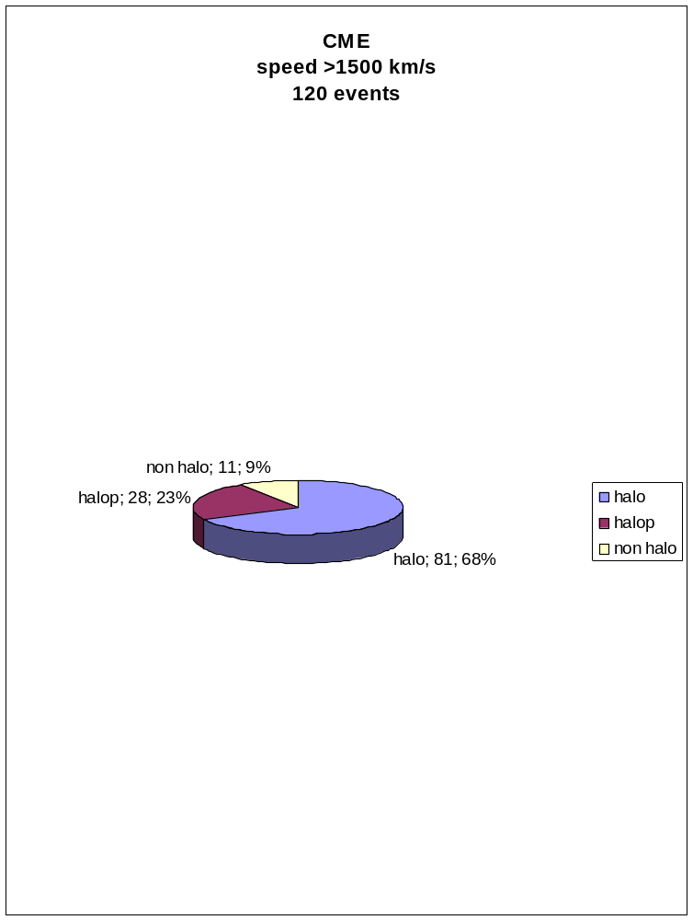

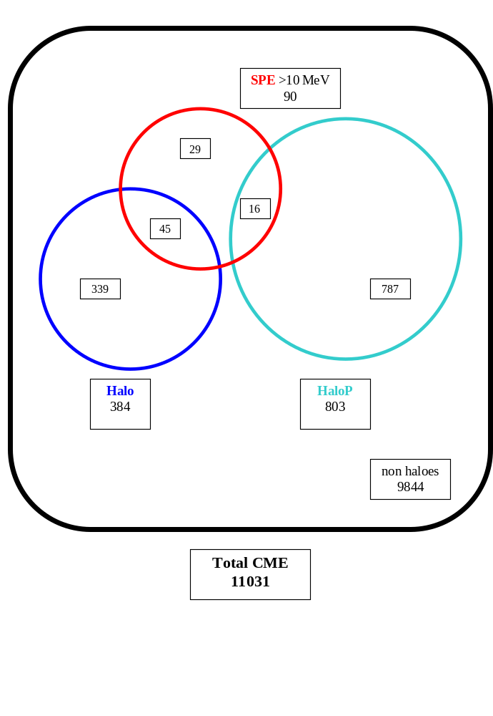

Total CME
11031
non haloes 9844
Halo
384
HaloP
803
SPE >100 MeV
30
0
23
7
796
361

CME
speed > 1000 km/s
488
non haloes 196
Halo
169
HaloP
123
SPE >10 MeV
90
43
36
11
112
133

CME
speed >1000 km/s
488
non haloes 196
Halo
169
HaloP
123
SPE >100 MeV
30
1
22
7
116
147

CME
speed >1500 km/s
120
non haloes 11
Halo
81
HaloP
28
SPE >10 MeV
90
63
21
6
22
60

CME
speed >1500 km/s
120
non haloes 11
Halo
81
HaloP
28
SPE >100 MeV
30
11
15
4
24
66

APPENDIX G

Feedback from Dr. Sten Odenwald, NASA

2/8/2007
Francesca,
You made a great start by selecting the CME-SPE pairs that were close to each other in time.
Generally, the CME happens first followed by the SPE.
Solar proton Events are caused by protons that are accelerated within the shock front of the CME as it gets close to Earth, so the SPE date and time will be 1-3 days after the first sighting of the CME eruption on the sun.
Part of the art of science is to work with data in its raw form, and recast it in a way that lets you more clearly see or examine the correlations you are interested in studying.
...
I really need to see the final results to your study very soon. This is not a 'goofy' project, but one in which you are really helping me with an important part of my research. I could do this work myself and spend a few days doing it efficiently, but I have other things that I need to do in this project and this is only a piece of the puzzle.
For the last two years I have been creating a sophisticated mathematical model of what happens to our communication satellites during a severe solar storm. These storms have many components to them (SPEs, magnetic disturbances, clouds of high-energy particles) and to make the models accurate I need to incorporate all the statistically meaningful correlations I can deduce from past solar storms and what they did to satellites.
Your contribution will be to help me understand one small part of this big picture, and if you do it well, I will be more than happy to acknowledge your efforts in the paper I will be giving at the Space Weather Conference in Boulder Colorado this April...so that’s a bit of motivation for you should you need it.
I am just delighted to have a high school student working with me on this project. I have two other high school students helping me with other aspects of this problem and we are having quite a lot of fun with it.
Dr. Odenwald
NASA

3/12/2007
Francesca,
WOW! This is fantastic work and exactly what I was looking for, without doing this hard work myself ;>)
To test for significance … Take each of your findings and evaluate their probability (odds). This will help us assess whether it is more likely that the findings are more consistent with randomness or with some valid correlation.
Dr. Odenwald

3/14/2007
Francesca,

I think you have done a fantastic job with the data, and your statements in section III are quite sufficient to make the cases that you did. Based on your highest confidence statements, you have made the case that fast-moving Halo CMEs headed towards earth are the most likely origins for solar proton events. Practically speaking, this means that if a satellite owner determines that a CME is directed towards earth and is moving faster than about 1000 km/sec, it could produce the conditions needed for disrupting satellite operations. Last question to you…at a speed of 1500 km/sec, how many days will it take the CME to reach earth located 148 million km from the sun? That’s the amount of time the satellite owner will have to take some kind of action to protest their satellites.

I look forward to reading your final report…and please do take some pictures of the poster when you are done!

Dr. Odenwald

3/19/2007
Francesca,
What a great job...and an Olympic Fencer too. What an incredible schedule of work/study you must have to keep it all going!!
... let me know what the reactions are to your work. It is an impressive piece of research for a high school student.
Dr. Odenwald
NASA

