5022.1TA

BELOW-THE-HOOK LIFTING DEVICE

Engineering Note Cover Page of #MD-ENG-066

Lifting Device Numbers:
FNAL Site No/ |  | Div. Specific No. | 151 | Asset No.
 | If applicable |  | If applicable |  | If applicable
ASME B30.20 Group: [X ] Group I Structural and Mechanical Lifting Devices
(check one) [ ] Group II Vacuum Lifting Devices
[ ] Group III Magnets, Close Proximity Operated
[ ] Group IV Magnets, Remote Operated

Device Name or Description | Spreader Bar for SM3 Disassembly & VM Assembly

Device was | [ ] Purchased from a Commercial Lifting  Device Manufacturer. Mfg Name
(check all applicable) | [ X] Designed and Built at Fermilab | See eng. drawing ME – 407814 for details.
[ ] Designed by Fermilab and Built by a
Vendor. Assy drawing number
 | [ ] Provided by a User or other Laboratory
 | [ ] Other: Describe

Engineering Note Prepared by | James Kilmer, Edward Chi | Date | Dec. 20, 2004
Engineering Note Reviewed by | Dave Pushka | Date | Dec. 22, 2004
Lifting Device Data:
Capacity | 16,600 lbs.
Fixture Weight | 1,400 lbs.
Service: [ X] normal [ ] heavy [ ] severe (refer to B30.20 for definitions)
Duty Cycle | _______ 8, 16 or 24 hour rating (applicable to groups III, and IV)
Inspections Frequency
Rated Load Test by FNAL (if applicable) |  |  | Date |  |  | Load
[ ] Check if Load Test was by Vendor and attach the certificate
Satisfactory Load Test Witnessed by:
Signature (of Load Test Witness)
Notes or Special Information:
- The spreader bar was originally designed for Mino project. It was modified to retrofit the applications of the SM3 disassembly and VM assembly.
2. See pages 13, 14 & 15 for load test.

 | Fermilab

Particle Physics Division
Mechanical Department Engineering Note

Number: MD-ENG- 066 Date: Dec. 20, 2004

Project Internal Reference:

Project: BTeV, SMTF

Title: Spreader Bar for SM3 Disassembly and Vertex Magnet Assembly

Author(s): James Kilmer, Edward Chi

Reviewer(s): Dave Pushka

Key Words: Spreader Bar, Lifting, Allowable stress, Eccentric, Torsional
Shear, Primary shear, Bolt, Weld size, torque.

Abstract Summary: The spreader bar was originally designed for the
application of the Mino project. It was modified to
retrofit the applications for handling the different coils
in multiple positions. The working stresses, welding
sizes and bolt selections subject the different
applications have been presented for discussion per
related specifications codes.

Applicable Codes:
ASME B30.20, “Below the Hook Lifting Devices”
(#5022, ES&H manual, FermiLab)
“Allowable Stress Design”, AISC, 9th edition
ANSI/AWS D1.1-90, “Structural Welding Code-Steel”
Analysis and Calculations of Spreader Bar for Coil Handling During SM3 disassembly and VM assembly

Background:
Reuse the existing spreader bar of the Mino project to modified it, to retrofit the
multiple coil handling applications during SM3 disassembly and VM assembly
process. It is not only a design approach, but also it is a budgetary and environmental
approach. Figure 1 shows an isometric view of one of the application of the spreader
bar.

Reference Drawings and Others:
1. ME – 397459, ME – 397326;
MD – 397452,
2. “Steel Structure Design and Behavior” by C. Salmon & J. Johnson, 3rd edition.
3. “Fastening & Joining”, by Robert Parmley, 2nd edition
4. “Allowable Stress Design”, AISC, 9th edition
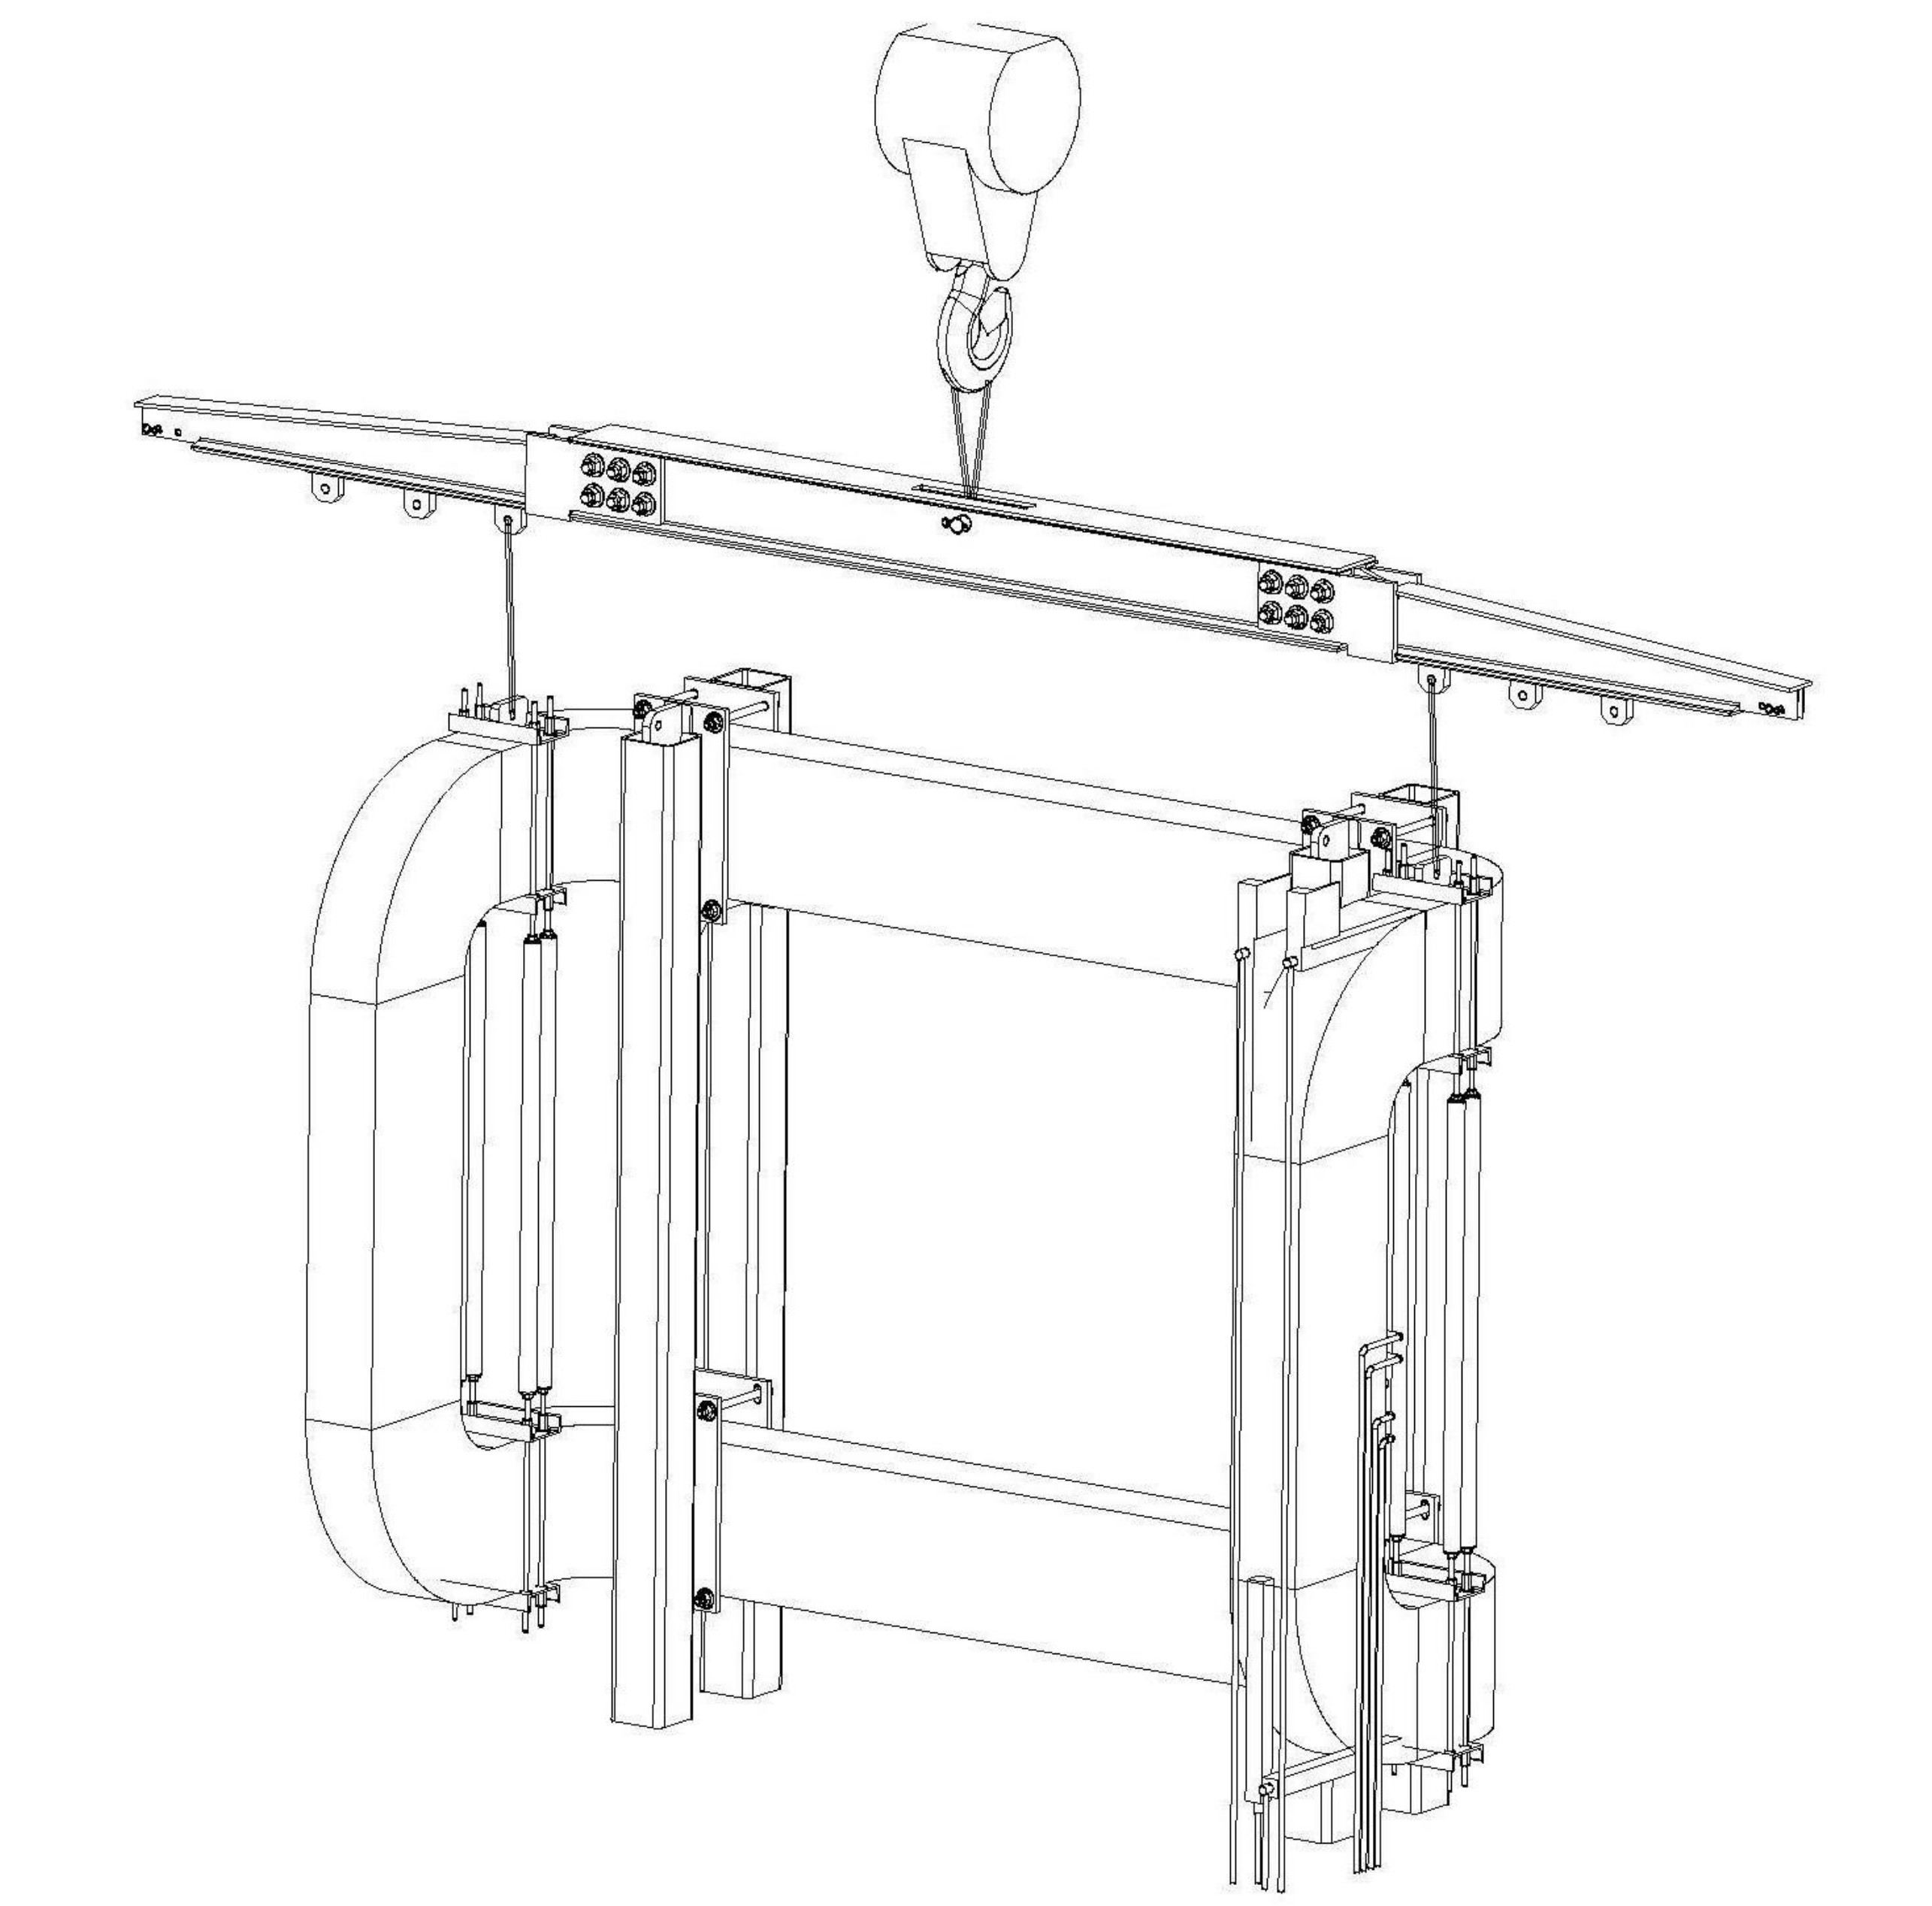

Figure 1, The isometric view of the application of the Spreader bar
Allowable Stresses:

The materials of all Plates, channels are:
ASTM A36, where F_{y} = 36 ksi, so F_{v} = F_{b} = 12 ksi
Welds are E70, where F_{u} = 70 ksi, F_{wv} = 0.30 x 70 ksi = 21ksi
Bolts for A490, where F_{u} = 150 ksi, F_{t} = 54 ksi, F_{v} = 21 ksi

Applying Load P_{a} and Others:

Figure 2 showed the force distribution diagram of the spreader bar,

Where W_{inner} _{coil} = 13,000 lbs.
W_{spre}. _{bar} = 1,360 lbs.
W_{coil} _{turning} _{fix.} = 3,200 lbs
W_{coil} _{lift. Fix}. = 370 lbs.
P_{at} = W_{inner} _{coil} + W_{spre}. _{bar} + W_{coil} _{turning} _{fix} + W_{coil} _{lift. Fix}
= 17,930 lbs.

a
P
L
R1
R2
Figure 2. The force distribution diagram of the spreader bar

From figure 2 and drawing ME - 407814, it is found that:

L = 201 inch (the span distance for the largest coil – inner coil)
P = P_{at} =17,930 lbs.
a_{c} = 0.5 L = 100.50 in (@ the center of the spreader bar)
R₁ = R₂ =0.5P = 8,965 lbs.

1. Calculate the working stresses at different locations.

1.1. The working stresses in the center of the spreader bar:

The sectional modulus S_{xc} at the center of the spreader bar of the strong axis x-x
Per Figure 3 on page 4, it was conservatively simplified and calculated as:

I_{xx1} = (78.9 x 2) in⁴ = 157.80 in⁴ for 2 channels
A₁ = 5.88 in² x 2 = 11.76 in²
I_{xx2} =((0.75 x 10³ x 2) ÷ 12) in⁴ = 125 in⁴ for 2 vertical plates
A₂ = ( 0.75 x 10 x 2) in² = 15 in²
I_{xx3} = ((8.50 – 2.50) x (11³- 10³) ÷ 12) in⁴ = 165.5 in⁴
for 2 horizontal plates which assumed that both have 2.50 central cut out.
A₃ = ((8.50 – 2.50) x 0.50 x 2) in² = 6 in²
I_{total} = I_{xx1} + I_{xx2} + I_{xx3}
= 448.30 in⁴
A_{total} = A₁ + A₂ + A₃ = 32.76 in²
S_{xc} = I_{total} ÷ 5.50 in = 81.5 in³
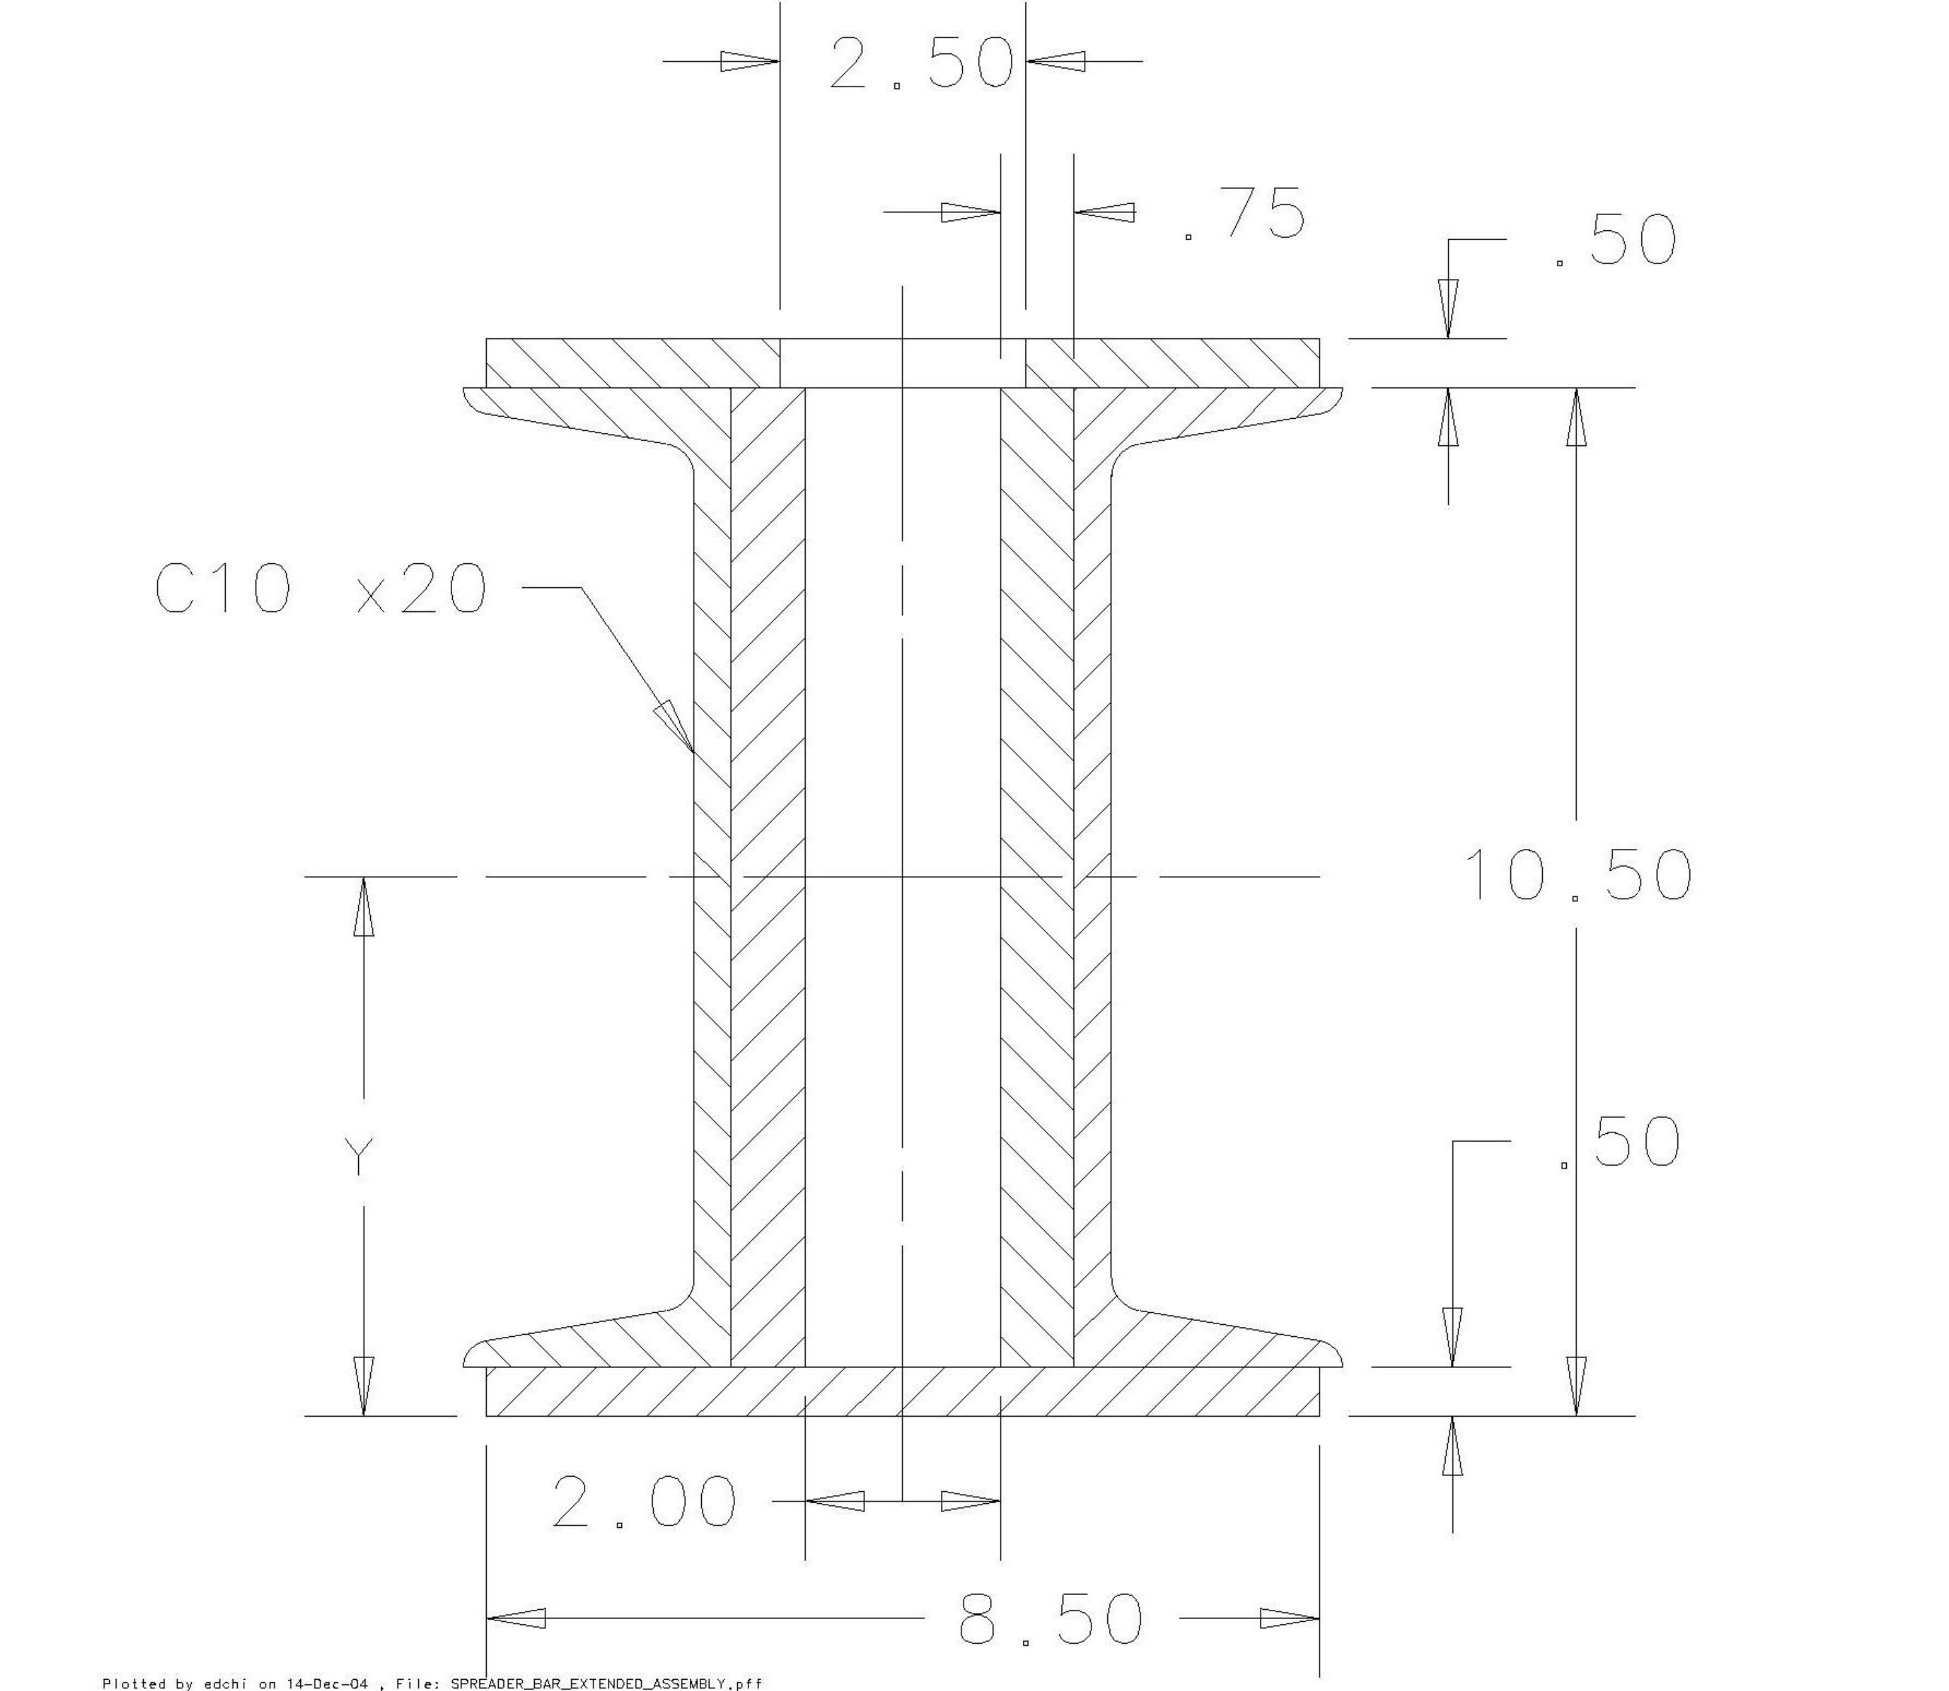

Figure 3. The cross-section view of the spreader bar in the center location

The moment at the center location subject to the force application:

M_{max} = PL/4
= (17,930 lbs. x 201 in) ÷ 4
= 900,983 lbs-in

The max. working bending stress f_{b}:
f_{b} = M_{max} / S_{xc}
= 900,983 lbs-in ÷ 81.5 in³
= 11.06 ksi < F_{b} = 12 ksi,

The working shear stress fv:
Fv = P_{at} / A_{total} = 548 psi < F_{v} = 12 ksi

The design in this location is satisfactory.

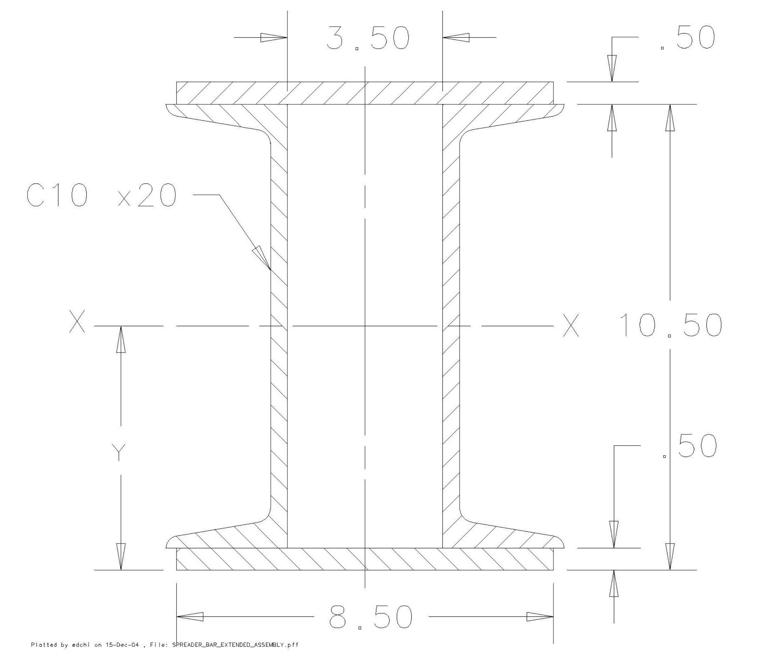

Figure 4, The cross-section view of the spreader bar in the location of 12” away from the
center.

1.2. The working stresses in the location 12 inches away from the center of the spreader
bar:

Find out the sectional modulus S_{x12} in the location of 12” away from the center of
spreader bar about the strong axis x-x:

Per Figure 4 on page 5, it was found that:

I_{xx1} = (78.9 x 2) in⁴ = 157.80 in⁴ for 2 channels
A₁ = 5.88 in² x 2 = 11.76 in²
I_{xx2} = (8.50 x (11³- 10³) ÷ 12) in⁴ = 234.45 in⁴ for 2 horizontal plates
A₂ = (8.50 x 0.50 x 2) in² = 8.50 in²
I_{total} = I_{xx1} + I_{xx2}
= 392.25 in⁴
A_{total} = A₁ + A₂ = 20.26 in²
S_{x12} = I_{total} ÷ 5.50 in = 71.31 in³

The applying moment in this location subject to the force application:

M₁₂ = R₂ x (100.5 -12) lbs.-in
= 8,965 lbs. x 88.5 in
= 793,403 lbs-in

The max. work bending stress f_{b}:
f_{b} = M₁₂ / S_{x12}
= 793,403 lbs-in ÷ 71.31 in³
= 11.13 ksi < F_{b} = 12 ksi,

The max. work shear stress fv:
Fv = R₂ / A_{total} = 443 psi < F_{v} = 12 ksi

The design in this location is satisfactory.

1.3. The working stresses in the location of 60 inches away from the center of the the
spreader bar:

Find out the sectional modulus S_{x60} in the location of 60” away from the center of
spreader bar about the strong axis x-x:

Per Figure 5 on page 7, it was found that:

I_{xx1} = ((1 x 9.94³) ÷12)in⁴ = 81.84 in⁴ for one vertical central plate
A₁ = (1 x 9.94) in² = 9.94 in²
I_{xx2} = (1 x 8.50³ x 2) ÷ 12) in⁴ = 102.35 in⁴ for 2 vertical side plates
A₂ = (8.50 x 1.0 x 2) in² = 17 in²
I_{total} = I_{xx1} + I_{xx2}
= 184.19 in⁴
A_{total} = A₁ + A₂ = 26.94 in²
S_{x12} = I_{total} ÷ 4.97 in = 37.06 in³

The applying moment in the location subject to the force application:

M₁₂ = R₂ x (100.5 -60) lbs.-in
= 8,965 lbs. x 40.5 in
= 363,083 lbs-in

The max. work bending stress f_{b}:
f_{b} = M₁₂ / S_{x12}
= 363,083 lbs-in ÷ 37.06 in³
= 9.80 ksi < F_{b} = 12 ksi,

The max. work shear stress fv:
Fv = R₂ / A_{total} = 333 psi < F_{v} = 12 ksi

The design in this location is satisfactory

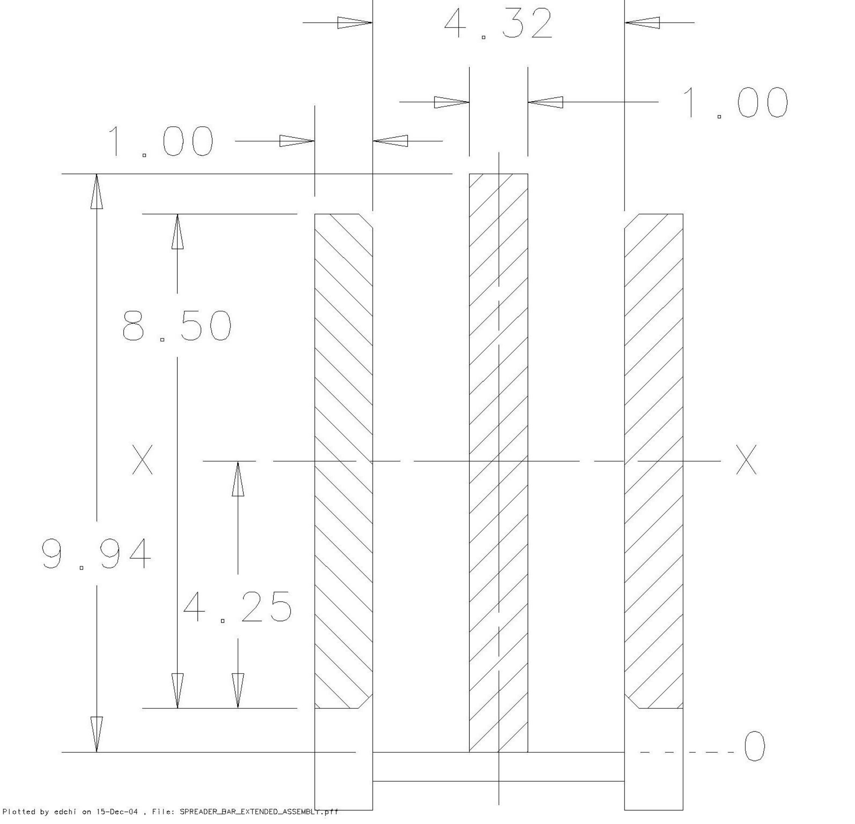

Figure 5. The cross-section view of the spreader bar in the location of 12” away from the
center.

2. The Calculation and discussion of the fastener group of the spreader bar:

Background:
Try to re-use (or to modify) the existing Mino project spreader bar for the SM3
disassembly project. the capacity of the spreader bar for the SM3 project is:
Overall load P_{at} = 17,930 lbs = 9 tons with max. span distance L_{s} = 201 in

Assumptions:
Slip critical connection, single shear

2.1 The selection of the fastening group and the others

Figure 6 is showing that when the applying load P is eccentric to the centroid of the bolt group. This physical configuration is represented by the design of the spread bar using for the SM3 project, which is also shown pictorially in figure 1 on page 3.
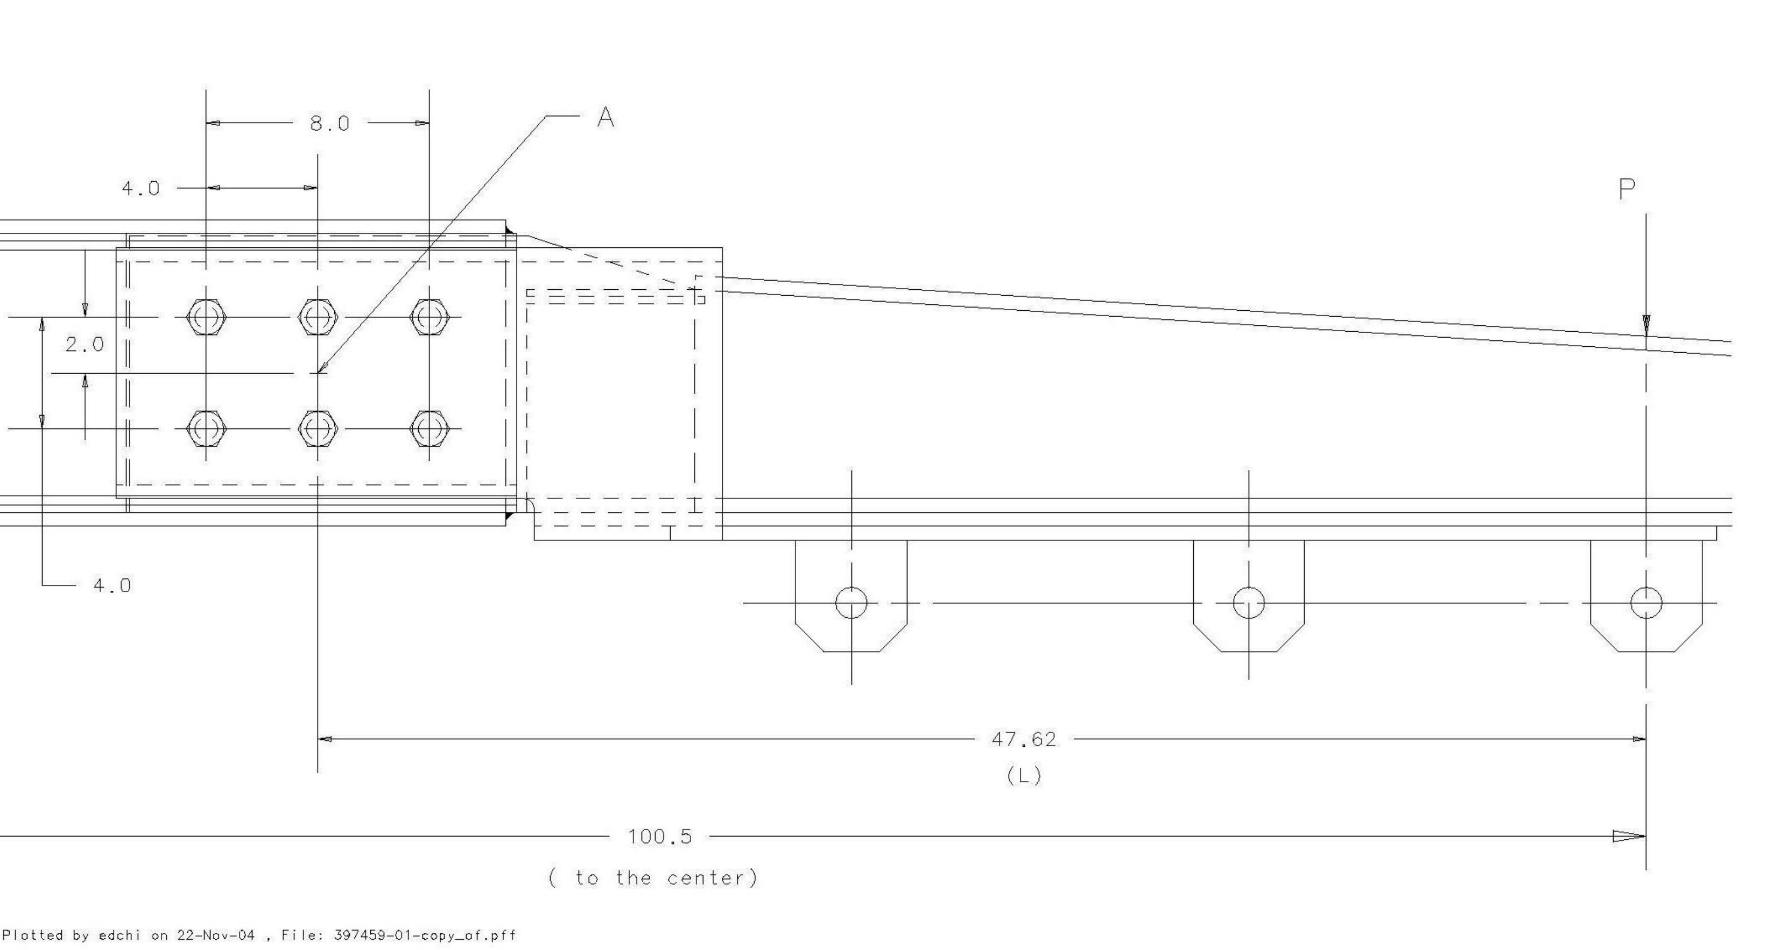

Figure 6. Eccentric load P and the group of bolt (6 bolts) of the spreader bar

Where:
P = R1 = R2 = 8,965 lbs, applying load
L = 47.625 in
Location A is the geometrical centroid of the bolt group, 6 bolts are located as
showing in Figure 6. currently, the spec. of bolt is assuming:
A490, 1 1/4 - 7, UNC
n = 6 (number of bolts)

Per Table I –D, part 4 of ASD, it is found that:
R_{av} = 25.8 kip (allowable shear load for the bolt)

Find out the local properties of the fastener group:

∑x² = 4 (4)² = 64 in²
∑y² = 6 (2)² = 24 in²
∑x² + ∑y² = 88 in²

The primary shear load f_{v1} of each bolt subject to the applying load P:

R_{v1} = P/n = 8,965 lbs / 6
= 1,494 lbs ↓

The secondary torsional shear load of the bolt is subjected to the moment PL:
Pick the bolt of the most right top one as shown in figure 1,
(which is subjected by the largest 2nd shear force)

Where: R_{vx} = PLy ÷ (∑x² + ∑y²)
= (8,965 lbs) x (47.625 in) x (2 in) ÷ 88 in²
= 9,704 lbs. →

R_{vy} = PLx ÷ (∑x² + ∑y²)
= (8,965 lbs) x (47.625 in) x (4 in) ÷ 88 in²
= 19,407 lbs ↓

The resultant force applying to the most right top bolt:

R = [(R_{v} + R_{y})² + R_{x}² ]^{1/2}
= [(1,494 + 19,407)² + (9,704)² ]^{1/2} lbs
= 23.044 kip < R_{av} = 25.8 kip

Using (6) A490 (or grade 8) high strength structural bolts with specification of 1 ¼ -7, UNC – 2B can be meet the current applications.

2.2. The Assembly Torque Value for Two Arms of the Spreader Bar

There are (12) A490 structural bolts for connecting the center piece to the arms (2) of the spreader bar as shown on drawing ME – 407814 and on figure 6.

The suggested tightening torque value T can be calculated as:
F_{t} = 150 ksi Min. tensile strength of A490 bolt.
F_{p} = 120 ksi, proof strength of A490 bolt.
P_{c} = 0.75 As F_{p} Clamp load, where
A_{s} = 0.969 in², stress area for 1 ¼ -7, UNC bolt
P_{c} = 0.75 x 0.969 x 120 ksi
= 87,210 lbs
T = K D_{b} P_{c} where K = 0.2, torque coefficient,
D_{b} = 1.25 in, nominal bolt diameter
T = 0.2 x 1.25 in x 87,210 lbs
= 21,803 lbs–in = 1,817 lbs-ft
(Per table 4.1.1, page 107 of ref. 2, also table 1-2, Page 1-25 of ref.3)

3. Weld Calculations and Discussions:

Per figure 1 on page 3, design drawings of ME – 407814 and MD – 407915, it is found that the welds on 3 plates (MD-397452, MD-407815) are subjected:
Stress due to direct load P_{y}
Stress due to torsional moment T

Figure 7 is based on the design weld configuration to treat it as line with unit thickness.

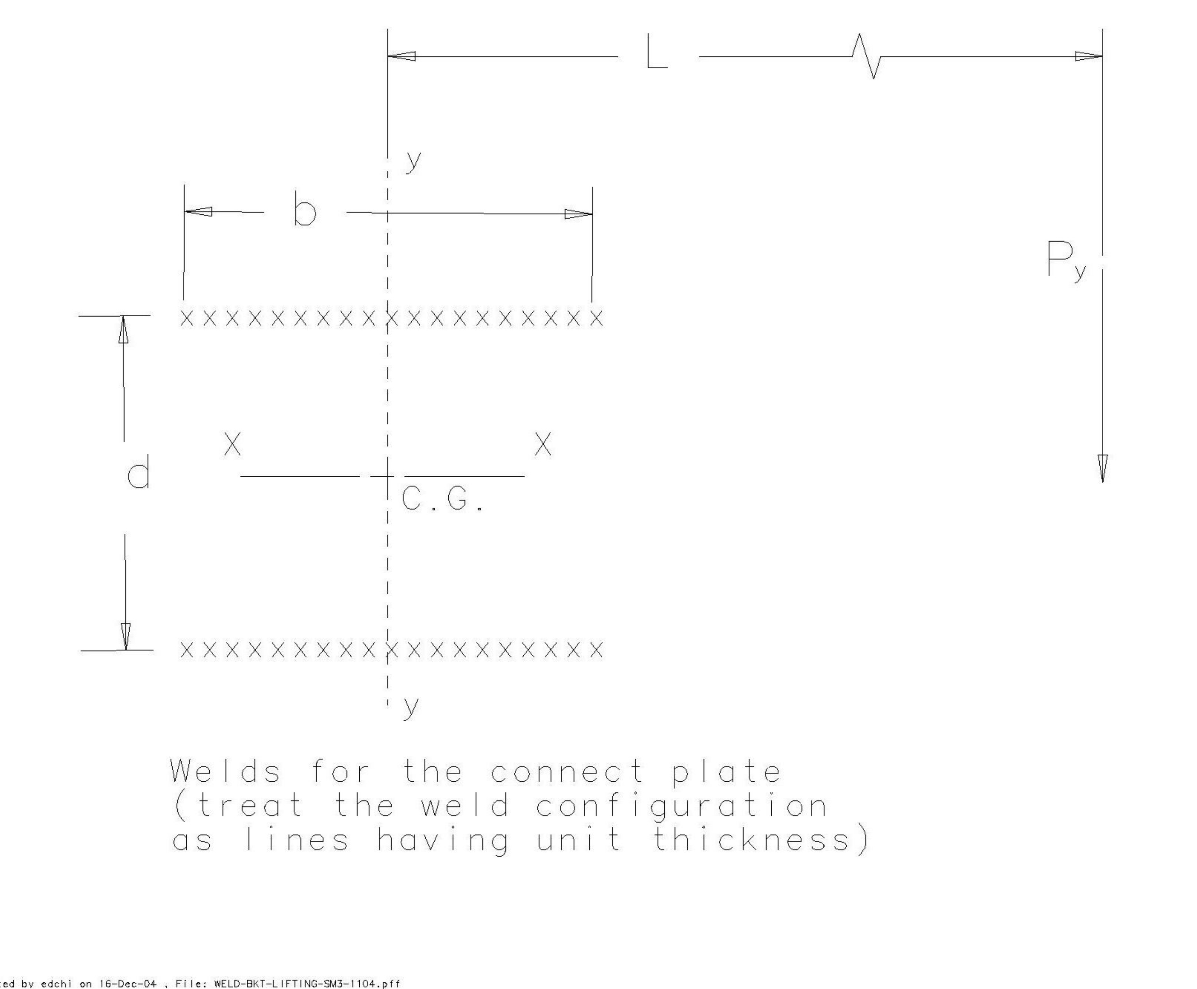

Figure 7. The weld configuration of the connect plate to treat as lines

Find the geometric properties of the welds (treated as lines):

Length l = 2b = 16.50 in where b = 8.25 in, d = 7 in
I_{p} = b(3d² + b²) ÷ 6 (Per table 5.18.1, section 5.18 of reference 2)
= (8.25 x (3 x 7² + 8.25²) ÷ 6) in³
= 295.7 in³ Where I_{p} is the polar moment of inertia about C.G.

Compute the components of the force on the weld at the maximum area:
Per figure 7, the locations to subject the maximum force are 4 corners .

T = P_{y} *L Where T is torsional moment,
P_{y} = 0.5 R₁ =0.5 R₂ = 4,483 lbs, assuming 2 plates (conservative)
L = 36.56 in

= 4,483 lbs x 36.56 in
= 163,899 lbs-in

The primary shear R_{v1}:
R_{v1} = Py ÷ weld length
= 4,483 lbs ÷ 16.50 in
= 272 lbs/in ↓

The secondary torsional shear about the centroid of the welds:

R_{vx} = (T y)/ I_{p}
= ((163,899 x 3.50) ÷ 295.7) lbs/in
= 1,940 lbs/in →
R_{vx} = (T x)/ I_{p}
= ((163,899 x 4.125) ÷ 295.7) lbs/in
= 2,287 lbs/in ↓
The resultant force R_{t}
R_{t} = [(R_{v1} + R_{vy})² + R_{vx}² ]^{1/2}
= ((272 + 2,287)² + 1,940²)^{1/2} lbs/in
= 3,212 lbs/in

Find the fillet weld size C, assuming all are fillet welds with E70 weld metal:
Allowable stress of the weld metal F_{wv}:

F_{wv} = 0.30 x 70 ksi = 21ksi, for E70 weld metal
C = R_{t} / (0.707 x F_{wv} ) ( Per section 5.18, reference 2)
= 3,212 lbs/in ÷ (0.707 x 21,000) lbs/in²
= 0.217 in

Per drawing MD-407815, it was found that the weld sizes are 0.25”, so the design is satisfactory.

Conclusions:
The engineering note was presented by discussing and analyzing several of the most critical structural areas and locations. The calculations have been shown that the modified reused spreader bar has been designed per the related applicable codes.

Rated Load Test Layout and Procedures

Step 1. Review the test setup layout as shown on figure 8.

Step 2. Move B blocks (2) and E blocks (4) to the designated area, lay them out per
figure 8 (the center line of E block should be lined up the ctr. line of the B block
on top view). The distance of the two B blocks will depend on the distance
between AA, BB, CC & DD lifting lugs respectively.

Step 3. Select designated rated slings, anchor shackles (1” dia. alloy/carbon steel) and
scale, install them per figure 8.

Step 4. Gradually, slowly apply load through crane until the scale reading reaches
22,150 lbs, sustain the load up to 10 minutes, take pictures if it is possible.

Step 5. Release the loads and relocate the bottom 2 slings and anchor shackles to the
next 2 lifting lugs.

Step 6. Repeat steps 4 & 5 until all lifting lugs (AA, BB, CC & DD) are been tested.

Step 7. Fill out and sign form 5022.1TA (page 1) as Load Test Witness.

Step 8. Mark the spreader bar as:
Number 151
Lifting Capacity: 16,600 lbs.
Fixture Weight: 1,400 lbs.

Step 9. Remove every item back in order. Thanks for finish the project safely and
Successfully!

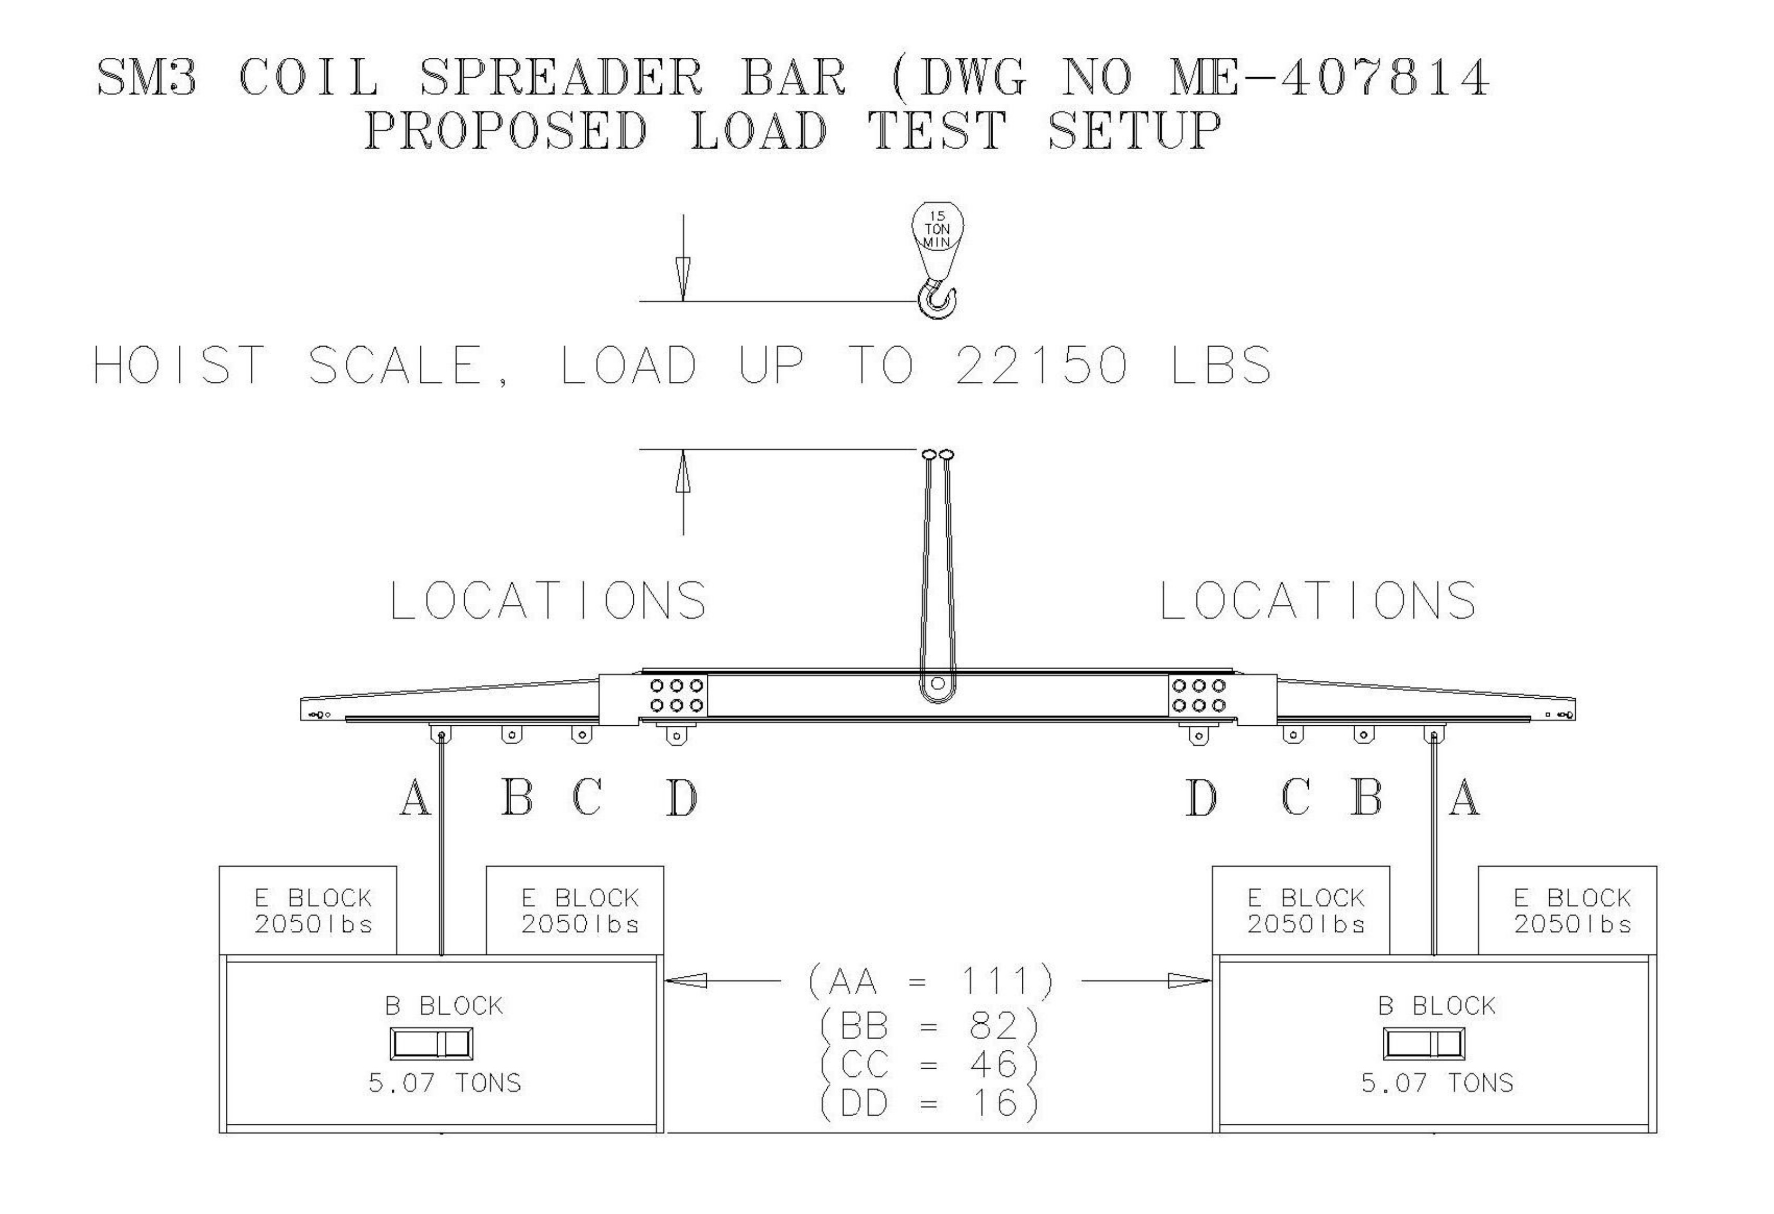

Figure 8. SM3 Coil Spreader Bar Load Test Setup

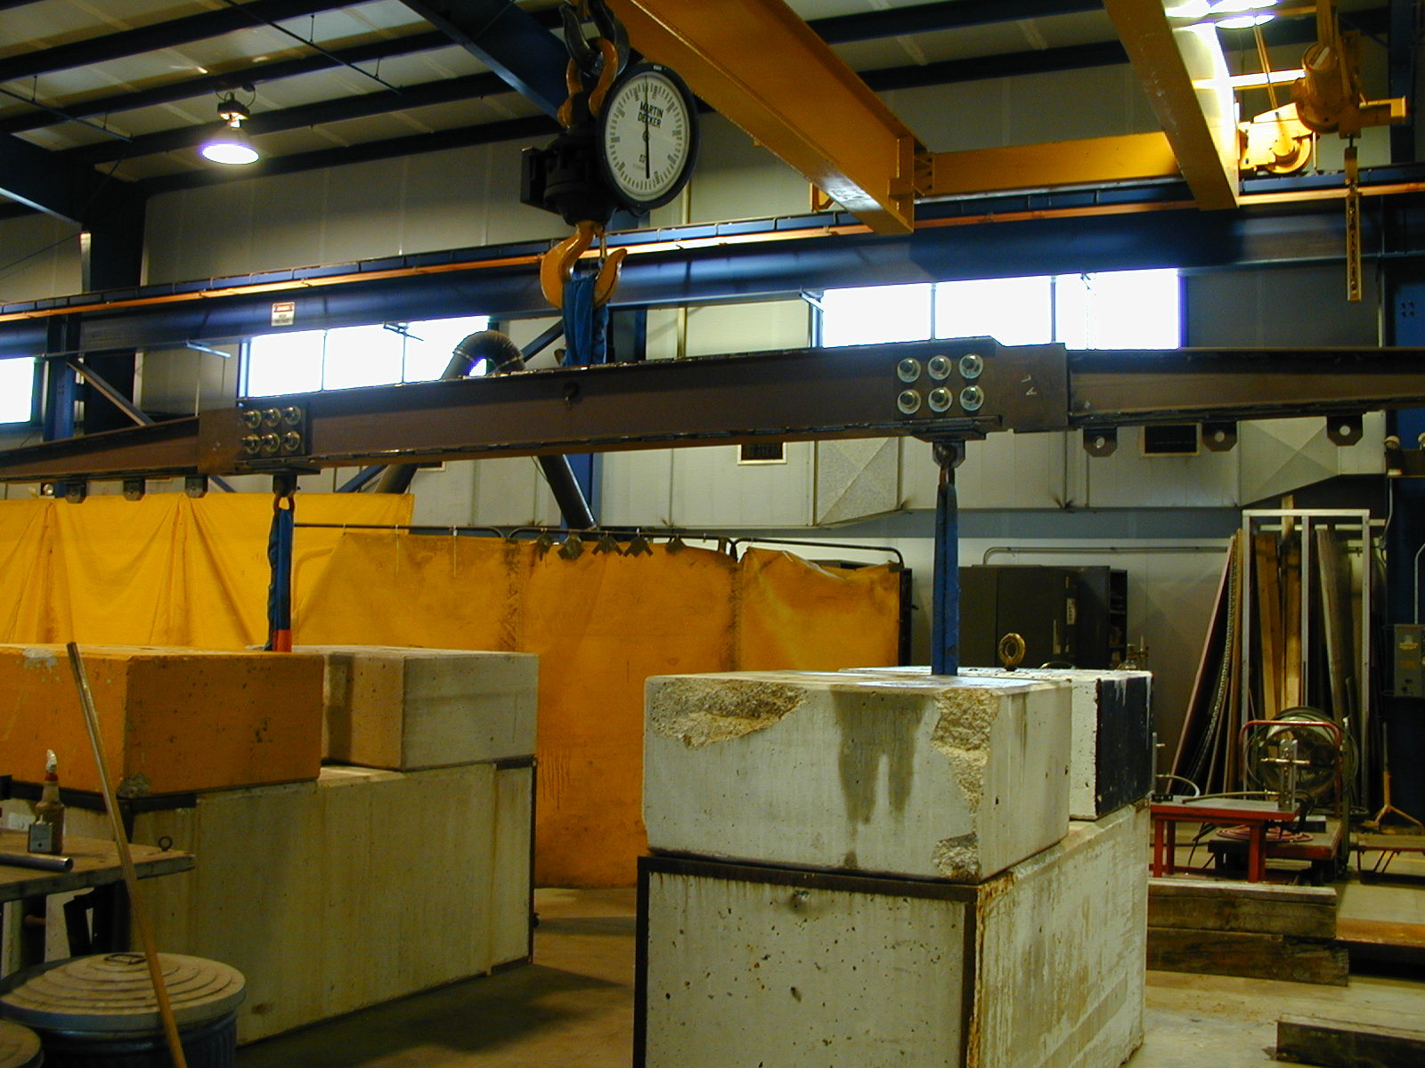_{Ll}

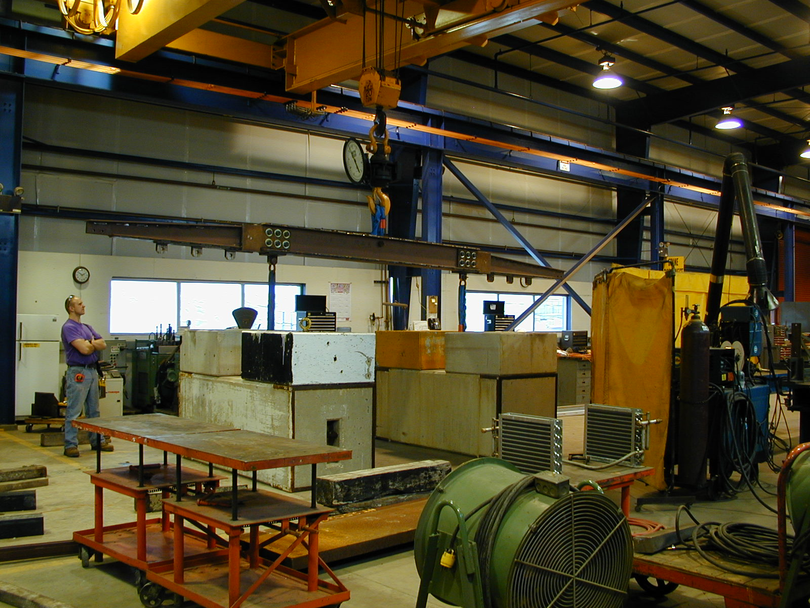

Figure 9. The Load Test for SM3 Coil Spreader @ MAB Building

