6 June 2005

To: Paul Philp, DOE Project Manager, Run IIb D-Zero Detector Project

From: Vivian O’Dell, Project Manager, Run IIb D-Zero Detector Project

Subject: Run IIb D-Zero Detector Project Report for April 2005

Attached is the monthly report summarizing the April 2005 activities and progress for the Fermilab RunIIb D-Zero Detector Project.

cc:
M. Abolins
J. Appel
E. Arroyo
L. Bagby
E. Barberis
A. Bean
J. Blazey
A. Bross
J. Butler
W. Cooper
M. Demarteau
D. Edmunds
T. Erickson
H. Evans
S. Fuess
G. Ginther
U. Heintz
M. Hildreth
R. Hirosky
D. Hoffer
K. Johns
M. Johnson
- Knapp
R. Lipton
J. Livengood
P. Lukens
R. McCarthy
H. Montgomery
M. Narain
A. Nomerotski
V. O’Dell
P. Oddone
P. Padley
R. Partridge
V. Pavlicek
TJ Sarlina
R. Sidwell
P. Slattery
K. Stanfield
RP Smith
J. Strait
L. Stutte
E. Temple
C. Trimby
V. White
M. Witherell
D. Wood
T. Wyatt
C. Yoshikawa
Fermi National Accelerator Laboratory
Run IIb D-Zero Detector Project
Fermilab Experiment Number E925

Progress Report No. 29
April 2005

- Project Description

The Tevatron Collider at Fermilab offers a unique capability to elucidate many of the major issues currently facing particle physics. Its high center-of-mass energy and recently upgraded luminosity offer us the capability of shedding light on the Higgs mechanism - which has the potential of offering insight into the origin of mass - and pushing the boundaries of searches for supersymmetry and other new phenomena beyond the Standard Model. It also makes accessible improved precision measurements of the W boson and top quark properties that, by further constraining the Standard Model, provide increasingly stringent tests of its precepts. The Tevatron offers the most cogent experimental probes of Standard Model physics, and beyond, during the coming 3+ years.

The Run IIb D-Zero Detector Project has been designed to allow the D-Zero Experiment to continue operating in the high intensity Tevatron environment for the remainder of the coming decade. The integrated exposure of the D-Zero Detector to colliding beam will result in radiation damage to the silicon detector that will compromise its efficiency. Adequate b-tagging is an essential ingredient of the Run II physics program. In order to maintain adequate b-tagging, D-Zero is adding an inner layer detector of radiation-hard silicon to enhance tracking efficiency as the Run IIa detector ages. In addition, the trigger system must be upgraded in order to provide sufficient rejection and to limit the dead time at the higher instantaneous rates that will be delivered by the Tevatron as the run progresses. The Run IIb D-Zero Detector Project provides for the additional D-Zero Layer 0 silicon detector and the upgrade of the D-Zero trigger, DAQ, and online systems in order to enable the continued efficient running of the experiment, and the acquisition of forefront physics data, for the foreseeable lifetime of the Tevatron collider program.

- Overview of Project Status

Module production completed in April, although there are still parts to build more modules, The plan is to build a few more during module assembly. Plans and fixturing for installing modules onto the support structure are being finalized.

Production adaptor cards from KSU are being used to read out the electrical prototype structure with 10 mounted modules. The goal is to have the electrical prototype read out through the 1% test stand in May. Work continues debugging the firmware for the SVX4 string readout at DZero.

The L1 Calorimeter Trigger ADF board production completed in March and bench testing of all 100 boards was completed during April. Only 3 boards needed some minor rework. All boards for the L1 Calorimeter Trigger have now been produced and bench tested. Firmware for the TAB and GAB boards is being optimized and tested. Design of the paddle card for the BLS->ADF cabling was completed, and layout will begin in May. The test area (sidewalk) was heavily utilized and great progress has been made in sending data from the calorimeter through the new L1 Cal Trigger and onto tape. Problems in the Calorimeter Track-Match MTCM continue to be debugged. Bench testing of the production UFB and MTCxx continued.

The production PCBs for the DFEA2 were received from the vendor in April and sent out for assembly. 7 boards were received back and tested. Four boards had no problems and the remaining three had various recoverable problems. Progress was made in software issues, both in interfacing the DFEA2 to EPICS and in testing software for testing the production DFEA2 boards at FNAL.

The production readiness review was help in April for the L2 Beta upgrade. The reviewers with the upgrade scope of 9 additional processors and these boards will be ordered. In addition, work continues on the L2 b-tagging algorithm. The L2 STT is progressing, and all production boards are undergoing tests. In addition, firmware on the Track Fit Cards is being modified to include Layer 0.

The L1 Calorimeter simulation is now interfaced properly to the overall trigger framework. Work is ongoing to modify the level 2 simulation to read the new L1 Cal trigger output. The run IIa L1CTT simulator was cleaned up and is being prepared to read run IIb equations Work is continuing to develop a “strawman” 2b trigger list using the trigger rate tool.

Purchasing of the new 96 nodes for the L3 upgrade is going smoothly. An RFP was distributed to 5 vendors in April and it is anticipated that the proposals will be received in May. Six server machines to augment the four online clusters (DAQ, Database, Fileserver and Online) were received and will be commissioned during May. All of the single board computers for the control systems have been received and will be installed/commissioned during May.

- Project Milestone Summary (as of 30 April 2005)

The DOE baseline milestones are shown in Figure 1 as solid diamonds. These fixed milestones are defined in the modified DOE Project Execution Plan approved in December 2003. Open diamonds on the same line are the Project’s forecast dates for achieving the milestones. Actual dates of achieving milestones are shown as solid stars. The Trigger, Online, and Layer 0 Silicon milestones are shown separately and sorted by current forecast date.

Table 1 shows the difference in the current forecast and last month’s forecast for achieving the DOE milestones. This table lists approved DOE milestone dates along with the project’s current (and previous month’s) forecast for achieving them. The list is sorted by DOE Milestone date. Milestones with forecast dates that have changed significantly in the last month are discussed in Section X of this report.

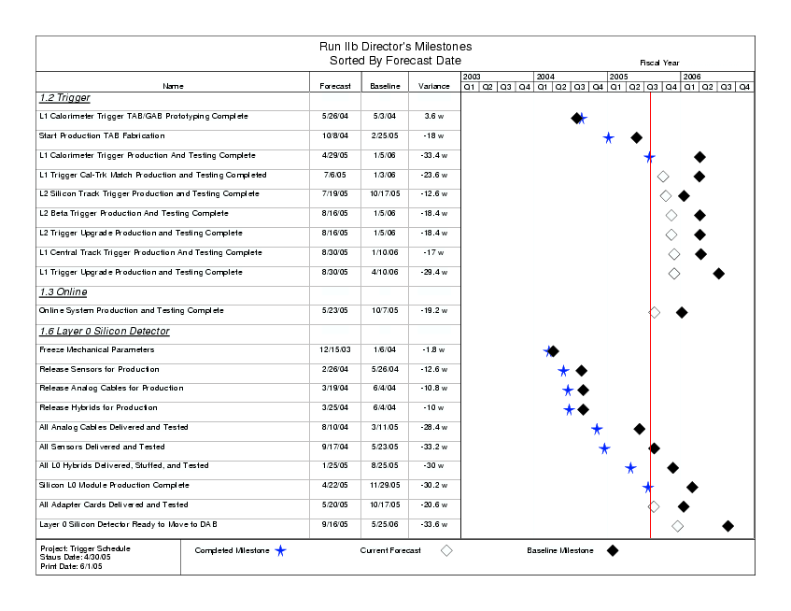

Figure 1: Run IIb D-Zero Detector Project DOE Level 2/Director’s Milestones. Closed (open) diamonds represent baseline (current forecast) dates. Closed stars represent completed milestones.

L2/Director's Milestones vs Current Forecast
(Sorted by L2/Director's Baseline Date)
Milestone Description | L2/Director's Baseline (4/05) | Last Month's Forecast (3/05) | This Month's Forecast (4/05) | L2/Director's Variance (work days) | Monthly Variance (work days) | Notes
WBS 1.2 Trigger
L1 Calorimeter Trigger TAB/GAB Prototyping Complete | 05/03/04 | 05/26/04 | 05/26/04 | 18 | 0 | Complete
Start Production TAB Fabrication | 02/25/05 | 10/08/04 | 10/08/04 | (90) | 0 | Complete
L2 Silicon Track Trigger Production and Testing Complete | 10/17/05 | 06/21/05 | 07/19/05 | (63) | 19
L1 Trigger Cal-Trk Match Production and Testing Completed | 01/03/06 | 06/01/05 | 07/06/05 | (118) | 24
L1 Calorimeter Trigger Production And Testing Complete | 01/05/06 | 05/04/05 | 04/29/05 | (167) | (3) | Complete
L2 Beta Trigger Production And Testing Complete | 01/05/06 | 08/08/05 | 08/16/05 | (92) | 6
L2 Trigger Upgrade Production and Testing Complete | 01/05/06 | 08/08/05 | 08/16/05 | (92) | 6
L1 Central Track Trigger Production And Testing Complete | 01/10/06 | 09/08/05 | 08/30/05 | (85) | (6)
L1 Trigger Upgrade Production and Testing Complete | 04/10/06 | 09/08/05 | 08/30/05 | (147) | (6)
WBS 1.3 Online/DAQ
Online System Production and Testing Complete | 10/07/05 | 05/23/05 | 05/23/05 | (96) | 0
WBS 1.6 Layer 0 Silicon Detector
Freeze Mechanical Parameters | 01/06/04 | 12/15/03 | 12/15/03 | (9) | 0 | Complete
Release Sensors for Production | 05/26/04 | 02/26/04 | 02/26/04 | (63) | 0 | Complete
Release Hybrids for Production | 06/04/04 | 03/25/04 | 03/25/04 | (50) | 0 | Complete
Release Analog Cables for Production | 06/04/04 | 03/19/04 | 03/19/04 | (54) | 0 | Complete
All Analog Cables Delivered and Tested | 03/11/05 | 08/10/04 | 08/10/04 | (141) | 0 | Complete
All Sensors Delivered and Tested | 05/23/05 | 09/28/04 | 09/28/04 | (159) | 0 | Complete
All L0 Hybrids Delivered, Stuffed, and Tested | 08/25/05 | 01/25/05 | 01/25/05 | (150) | 0 | Complete
All Adapter Cards Delivered and Tested | 10/17/05 | 05/27/05 | 05/20/05 | (98) | (5)
Silicon L0 Module Production Complete | 11/29/05 | 04/22/05 | 04/22/05 | (151) | 0 | Complete
Layer 0 Silicon Detector Ready to Move to DAB | 05/25/06 | 09/09/05 | 09/16/05 | (168) | 5
 |  |  |  |  | status date: | 4/30/2005

Table 1: Run IIb D-Zero Detector Project DOE Level 2/Director’s Milestones vs. Current Month forecast. Monthly variances are also provided.

- Management Highlights – V. O’Dell

A director’s review of the AFEII-t project was held April 13-14, and the AFEII-t project was approved as a level 2 subproject at the end of April. The review committee had concerns about the cost and schedule of the AFEII-t project, and these concerns were addressed by the project. For more details see http://d0server1.fnal.gov/AFEII_April_2005/Review_web.htm This month’s CPR reflects the new cost of the AFEII-t subproject. Director’s review and the narrative reporting is done with the new management structure.

Also in April, a lab review of the cost of the RunIIb upgrade was done with the aim of reevaluating the total cost to go and contingency. Preliminary results show a contingency excess in the project. This will be reviewed again by the DOE in May with an aim to return excess contingency to the DOE for reprogramming. Several change requests were processed in conjunction with this exercise and are reflected in this month’s CPR.

- Procurement Highlights – V. O’Dell

An RFP for the RunIIb 96 node addition to the online Level 3 processing farm was distributed to vendors and responses are expected in May.

Preparations are underway for submitting the TripT chip for production in May. A Production Readiness Review of the TripT has been scheduled and the documentation is being assembled. This is about a $200k cost to the AFEII-t project. The submission is shared with FPIX.

- Trigger Highlights (WBS 1.2) – B. P. Padley, D. Wood

The ADC Digital Filter board (ADF) for the Level 1 Calorimeter Upgrade, with demanding requirements in both analog and digital sections, was perhaps the most technically challenging board of the Trigger upgrade. Thus, it is particularly notable that as of the end of April, 100 of production ADF's completed their testing at Michigan State University, with only three requiring any reworking. The great care put into the design and layout paid off with this very high yield (80 boards are needed for the final system) and a schedule gain of several weeks in the production and testing phase.

We also note the very encouraging results from the first batch of production DFEA2 boards received for the L1CTT upgrade. After the ADF, the DFEA2 is the largest board production of the upgrade.

The L2beta system had a successful Production Readiness Review in April, which now means that all systems have had PRR's. The remaining PRR's in the schedule involve reviews of system level tests that are underway now at Fermilab.

  - Level 1 Calorimeter Trigger (WBS 1.2.1) – M. Abolins, H. Evans
Bench testing of the full complement of production ADF v2 boards was completed in April. Of the 100 boards tested, none had major problems and only three required minor reworking. With the completion of this testing, the last major hardware component of the project is finished.

At Nevis, studies of the new EM algorithm as implemented in firmware continued. Improvements to the implementation are being made to reduce the number of pathologies produced by the algorithm. The improvements are now being tested using simulated data samples. Testing of the new firmware for creation of trigger terms in the GAB also began in April. By the end of the month, most of this testing has been completed.

At Fermilab, the design of the paddle card used to ease cabling at the back of the ADF crate was finalized in April. We are now performing cross-checks to insure that channel mapping has been done correctly in the design, with layout to begin in early May.

Finally, work in the Test Area at Fermilab continued on several fronts. Data transfer between the ADF v2 cards and TABs was established as was data transfer from the TABs to the D0 Level-2 and Level-3 trigger systems. Real data from the calorimeter (using the splitter cards) was recorded to disk as well and will be used to study digitization and digital filtering in the ADFs.

  - Level 1 Calorimeter/Track Matching (WBS 1.2.2) – K. Johns
We continue to debug a problem with the production MTCM sending L2 and L3 messages at D0. Limited test opportunities at D0 and perfect bench testing performance have slowed progress. Bench testing of the production UFB and MTCxx cards continued. All parts for the splitter cards are now in hand and assembly will start next month.

  - Level 1 Track Trigger (WBS 1.2.3) – D. Lincoln, M. Narain
DFEA2 - 60 production version PCBs were received from the vendor on 4/22/05. PCBs were sent for assembly on 4/23/05. On 4/26/05 BU received 7 assembled boards. By 4/28/05 all 7 boards were checked by Shouxaing Wu. Out of 7 boards, 4 boards were working fine and 3 had problems of various kinds. 2 of the 3 boards have assembly defects – but could be recovered by changing the routings in firmware. The third had problems with the orientation of the Samtech connectors and could be recovered.

Work also continued to enhance the functionalities of the DFEA2 test software. Hardware status: Backplanes (DFEB2) are ready for installation in the sub-racks. All DFE documentation has been moved to http://www-d0.fnal.gov/hardware/dfe.

EPICS Interface/Download Software – Geoff Savage worked on EPICS software. We can now:
- read / write one 16-bit word to a DFEA2
- read / write up to 744 16-bit words to a DFEA2
- download a firmware file to all four FPGAs by sending the filename, up to 250 characters (this can be increased)

Commissioning Software Status – A new program (incapture.c) was written by Jamieson Olsen to test DFEA2 boards on the test stand. This program is working and Norik is using it to send events through the prototype boards. The DFEA2 board was checked by using test vector to DFEA2 input buffer and comparing with prediction. The test vectors were taken from D0 platform readout. The output from DFEA2 and prediction were compared and the differences are understood.

  - Level 2 Beta (WBS 1.2.4) – R. Hirosky
The Production Readiness Review of the L2beta upgrade was held in April. The review panel, chaired by Reinhard Schwienhorst of MSU, reviewed hardware compatibility, power and cooling requirements, CPU power need projections, numbers of processors and spares, and testing plans. The committee's conclusions are repeated here: "Bob [Hirosky] presented a very strong and convincing case for the L2 Beta upgrade. After having received additional information about power consumption and timing profiles, we conclude that there are no issues with the new Betas, that they have been well tested and can operate with the power and cooling provided by the L2 crates. There is a clear path for the L2 Beta upgrade. The timing simulations demonstrate the necessity to implement multiple-Beta crates, in particular in light of possible instantaneous Tevatron luminosities exceeding 2E32, going maybe as high as 3E32. Thus, the request for nine additional Betas is well-justified. We recommend the purchase of nine additional L2Beta processors."

Work is in progress to convert a L2 b-tagging algorithm into a software tool for the online trigger system. The L2beta prototype testing is now complete. The faster prototype is observed to perform exactly as the original Betas in the D0 DAQ.

  - Silicon Track Trigger (WBS 1.2.5) – U. Heintz
In April, testing of motherboards and Silicon Track Cards (STCs) took place at BU. Some STC firmware modifications were made to make them less sensitive to faulty inputs. At Columbia, two Buffer Controllers (BC) were assembled and testing started. A misrouted trace was discovered on the boards that will be rerouted using a wire soldered to the boards. Otherwise, the boards tested fine. At Stony Brook, work was done on adapting Track Fit Card (TFC) code to include Layer 0.

  - Trigger Simulation (WBS 1.2.6) – E. Barberis, M. Hildreth
The L1Cal simulator, tsim_l1cal2b, is integrated with the trigger simulator framework, tsim_l1l2. It fills IOgen objects with output to tsim_l1caltrack and to Level2 (ADC counts and trigger masks). All three objects (electrons, taus, jets) can be identified in a single job. The new version is released in the code repository. The IIa version of the L1CTT simulator is working and being tested. We’re also working on the equation handling for IIb. Work is ongoing on the L1Caltrack simulator, tsim_l1caltrack, on the piece of the code which reads the output of L1Caltrack, i.e., the analyze package. Work is also progressing on the modifications to the Level 2 code for the reading of the new L1Cal output (i.e. the output of tsim_l1cal2b).

Work on the Trigger Rate Tool has concentrated on the insertion of TRT trigger objects into the Common Analysis Data Format, so that trigger studies can be performed as a function of the selection on the offline reconstructed objects. A modified version of the chosen electron algorithm has been implemented in the firmware (due to some pathologies observed with the original version) and we are testing it both with the Trigger Rate Tool and the L1Cal simulator, tsim_l1cal2b.

- DAQ/Online Highlights (WBS 1.3) – S. Fuess

  - Level 3 Systems (WBS 1.3.1) D. Chapin, G. Watts
The requisition process for a 96-node upgrade of the Level 3 processing farm continued. A Request for Pricing (RFP) was distributed to five vendors in early April. Competitive bids were received from two vendors, and a purchase order was awarded in late May. We expect delivery at the end of June.

The new nodes being purchased are 64-bit EM64T Intel Xeon processor based. We borrowed a similar system from the Computing Division, and have successfully demonstrated that the Level 3 DAQ and filter code runs correctly on these systems.

Requisitions for two additional 48-port network switch modules were submitted in March, and slowly moved through the approval process. This purchase is currently in the hands of a buyer. The Fermilab Computing Division Network Group is managing the purchase of these components.

Electrical infrastructure improvements to the D0 Assembly Building 2nd floor area that will house the Level 3 farm nodes were completed in March. Network trunk cables for these nodes have been acquired from Computing Division surplus.

  - Network and Host Systems (WBS 1.3.2) – J. Fitzmaurice, S. Krzywdzinski
Online/DAQ Network: 1.3.2.1
During March a change order (with a net decrease in expenses) was processed to reallocate funds within WBS 1.3.2, specifically to upgrade the Online Cisco 6509 switch. A requisition, managed by the Computing Division Network Group, for a new Supervisor module and a 48-port Gigabit module has been submitted.

Control and Monitoring systems: 1.3.2.2, 1.3.2.3
The upgrade of the interactive control room and the event monitoring systems is a DØ operations task, and is part of the operations budget. The evaluation of appropriate systems naturally follows the investigation of potential Level 3 and host server systems; we expect to add ~8 new nodes, or ~15% of the current control and monitoring systems, during Summer 2005.

Storage, DAQ Host, ORACLE, & File Server Systems: 1.3.2.4, 1.3.2.6, 1.3.2.7, 1.3.2.8
The complete RunIIb plan calls for an augmentation of the minimal central system configuration now in operation. Six servers are being added to the four operational clusters (DAQ, Database, File Server, and Online functions). The new servers will provide the computing capacity needed for the duration of RunIIb, plus give much-needed configuration flexibility. These six systems and peripherals were delivered in April and are being commissioned.

The RunIIb plan calls for a single additional quad-processor system to be purchased as a principal node in the DAQ event data-logging chain. We plan to evaluate the performance of the six systems noted above to determine whether a dual-processor system is adequate. The result will dictate the final DAQ server purchase. This remains as the only outstanding purchase to be made for the Online/DAQ portion of the RunIIb upgrade.

We completed the investigation of options for completing the disk storage requirements and created requisitions in April. A JBOD array for event data buffers was delivered in early May; the requisition for an additional RAID array is in the hands of a purchasing agent.

  - Control Systems (WBS 1.3.3) – F. Bartlett, G. Savage, V. Sirotenko
The remaining MVME5500 processors for the control system upgrade were delivered in April, completing that order. A few adaptor board components for those processors that are used in the muon system are outstanding, but expected in May. We have begun the process of installing the new processors. There are no outstanding issues.

- Silicon Detector Layer 0 Highlights (WBS 1.6) – A. Bean, R. Lipton

Module production of the 48 needed modules was completed and additional spare modules are being produced. The overall yield continues to be good, with ~90% passing specifications and ~80% with zero or 1 bad channel. Fixturing for module installation was set up and testing begun. Design of fixturing for installation at D0 is nearing completion and prototypes of carbon fiber installation tools have been produced. Preparation of the support structure for module installation has begun

  - Readout (WBS 1.6.2) – A. Nomerotski, R. Sidwell
Two more Adapter Cards have been received from KSU and used to read out the electrical prototype structure with 10 mounted modules. 100 mV oscillations have been found on the regulated SVX4 power coming from the Adapter Card. The problem has been solved by using local regulation at AC. The goal for the electrical prototype is to have 10 modules read out
through the 1% stand in May.
First production jumper cables have been received from KU and successfully tested. The cables do not have stiffener at the hybrid end. 0ne cable has been plugged/unplugged 20 times with no damage observed to check its longevity.
SVX4 readout in DAB: we had problems to have reliable readout with SVX4 chains in the test-stand "crate 79" and with the modules installed in the collision hall. The debugging of the firmware is in progress. A difficulty that should be addressed there is that the stands are
available only a small fraction of time between the stores since the data taking with stands interferes with the operations.

  - Mechanical Design and Fabrication (WBS 1.6.3) – W. Cooper
Evaluation of geometric, electrical, and mechanical properties of the two completed L0 support structures led to the selection of the second structure for use in fabricating Layer 0. That structure is sufficiently accurate geometrically, has been leak checked, is leak tight, and has improved mesh ground circuits. A minor restriction at the end of one cooling passage was repaired.

A plan for mounting sensor – hybrid modules on the support structure was proposed and is being reviewed. The procedure compensates for gravitational deflection of the structure based upon finite element analysis and measured deflections of the structure under load. A spreadsheet was developed which specifies coordinates of all sensors based upon the measured shape of the support structure.

Wheels for the ends of a fixture to hold and rotate the support structure during module installation were received from the University of Washington and are acceptable. Spacers to position hybrids from the support structure were received. Fixturing for positioning the spacers was designed and submitted for fabrication. All fixturing to install modules on the support structure was received.

Copper on kapton flex cables, to connect the RTD’s monitoring Layer 0 temperatures were received from Rice. Detailed paths for the cables were proposed and are under evaluation.

  - Detector Modules and Final Detector Integration (WBS 1.6.4, 1.6.5) – L. Bagby
The 1% test stand is being expanded to accommodate the readout of the entire Layer 0 detector. The LV system has been connected and tested for the additional 20 readout channels. Integration of the HV Control into the EPICS system is underway. A detector cooling interlock system is being developed. The Adapter Card mounting panel has been reviewed and is being expanded to accommodate 12 cards.

- Analog Front End Highlights (WBS 1.7) – A. Bross

During April we finished the first pass testing of the AFE II prototype boards. Sixteen (16) boards will go into channel-by-channel testing. Additional testing of the TriPt prototypes was also done in April. No new issues have been identified. The TriPt redesign was completed and verification is in the final stages. We are on schedule for a joint TriPt/FPIX submission on 5/24. The schematic for the AFE IIt prototype board is progressing and layout should start in early May.

- TripT (WBS 1.7.4) – L. Bellantoni
Prototype measurements and documentation for the Directors' Review were completed.

- AFEII-t board (WBS 1.7.5) – P. Rubinov
Phases A1 to A126 (visual inspection), B1 to B20 (preliminary power and programming), C1 to C9 (functional testing of slow control and monitoring) and D1 to D8 (functional testing of FPGAs and TriP chips) of AFEII prototype testing is done for all boards. Tests E1 and E2 completed on one board (temperature control). D9 to D11 (charge injection for every channel) and temperature control testing for every board require modifications for which parts must be ordered. The parts have been ordered and this testing is expected to be completed during May. The goal of the testing is a minimum of 4 fully working boards.

Conceptual design of the AFEIIt is complete, schematic capture is progressing, and layout of reusable blocks is starting.

- Code Development (WBS 1.7.6)
No activity in this area occurred during April.

- Schedule Variance Analysis (as of 30 April 2005)

Schedule variances are reported against director’s milestones in section III. Nine milestones have been successfully achieved. All remaining milestones are projected ahead of the DOE baseline dates.

  - D-Zero Run IIb Trigger Upgrade (WBS 1.2)

The L1 Calorimeter Trigger Production and Testing Complete milestone was achieved at the end of April. All boards have been produced and bench tested.

The L1 Calorimeter Track-Match trigger lost 24 days in the last month. This is due to problems debugging the production MTCM. The boards tested fine on the bench but have some problems sending L2/3 messages to D0. The L2STT lost 19 days in the last month. However, production boards are now in hand and being tested. In addition, the L2STT is not a critical path item for the L2 trigger upgrade. The L2 Beta lost 6 days, which drove out the final L2 completion milestone by 6 days. There is very little risk in this, however, as the processors being purchased are commercial CPUs and have been tested with the existing boards.

  - D-Zero Run IIb Online (WBS 1.3)

There is no unfavorable schedule variance for this subproject.

  - D-Zero Run IIb Layer 0 Upgrade (WBS 1.6)

The milestone for Silicon Layer 0 ready to move to DAB slipped 5 days in April due to slippages in module installation preparation. We are watching this carefully and continue to look for ways to keep to the schedule and at the same time generate more schedule contingency for the layer 0 work.

- Department of Energy Milestones (as of 30 April 2005)

No DOE milestones were predicted or achieved during the month of April. Table 2 (below) shows the status of all DOE Milestones.

L1 DOE Milestones vs Current Forecast
(Sorted by L1 Baseline Date)
Milestone Description | L1 Milestone (4/05) | Last Month's Forecast (3/05) | This Month's Forecast (4/05) | L2/Director's Variance (work days) | Monthly Variance (work days) | Notes
WBS 1.2 Trigger
L2 Trigger Upgrade Production and Testing Complete | 01/05/06 | 08/08/2005 | 08/16/2005 | (92) | 6
L1 Trigger Upgrade Production and Testing Complete | 04/10/06 | 09/08/2005 | 08/30/2005 | (147) | (6)
WBS 1.3 Online/DAQ
Online System Production and Testing Complete | 10/07/05 | 05/23/05 | 05/23/05 | (96) | 0
WBS 1.6 Layer 0 Silicon Detector
Layer 0 Silicon Detector Ready to Move to DAB | 05/25/06 | 9/09/2005 | 9/16/2005 | (168) | 5
 |  |  |  |  | status date: | 4/30/2005

Table 2: Run IIb D-Zero Detector Project DOE Level 1 Milestones vs. Current Month and Previous Month’s forecast. Entries are sorted by DOE L1 Milestone date. Monthly variances are also provided.

- Cost Performance Report (as of 30 April 2005)

This report is generated from COBRA and provides a summary of the WBS 1.2-1.4 costs of the Project down to Level 3 of the Work Breakdown Structure. Silicon detector subproject closeout costs are not tracked here. Input data originates with the status (% Complete) of the Project schedules as reported by the Level 2 managers and actual costs extracted from the Fermilab accounting system. Where possible, costs are accrued for items that have been delivered, but not yet invoiced. Financial summaries are shown for this reporting period (columns 2-6) as well as the project to date (columns 7-11). Column 12 contains our baseline BAC, and will only be changed after the formal implementation of the Change Control process. Column 13 is the projected BAC, based on the current month’s schedule.

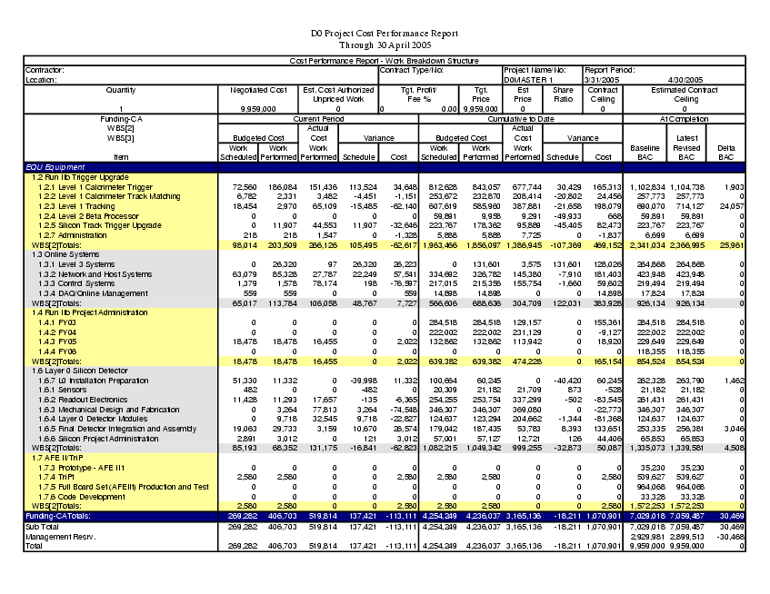

- Obligation Reports (as of 30 April 2005)

The DZero Obligation Reports can be found below. The first report shows total obligations without the cost of the original Run IIb Silicon and related closeout costs. The second report shows all obligations.

