Title
SOHO Gyroless
- User’s Manual -

 | Name and Function | Date | Signature
Prepared by : | L. BRETT Operations  M. CHALOUPY Operations  F.TERRON Dependability Eng.  M. JANVIER AOCS design Mgr | 16/07/99
Verified by : | M. JANVIER AOCS design Mgr | 16/07/99
Approved by : | B. POUZET Product Assurance | 16/07/99
Authorised by : | E. BEAUFUME Gyroless Project. Manager | 16/07/99
Application  authorised by : | B. ANDRAU DSO/Engineering & Ops department Manager | 16/07/99

Document type | Nb WBS | Keywords :

The copyright in this document is the property of Matra Marconi Space France and the contents may not be
reproduced or revealed to third parties without prior permission of that company in writing.

SUMMARY

The aim of the SOHO gyroless user’s manual is to describes the new operational concept related to gyroless operations for the SOHO satellite.

Document controlled by : E. BEAUFUME

DOCUMENT CHANGE LOG

Issue/  Revision | Date | Modification Nb | Modified pages | Observations
1 | 25/6/99 | - | All | Document creation
2 | 16/07/99 | - | All | Refer to rev bars / rev marks

TABLE OF CONTENTS

1 GLOSSARY OF ABBREVIATIONS 10
2 OVERVIEW 19
2.1 Reference Documentation 19
2.2 Applicable documentation 20
2.3 Applicability of the ORIGINAL SOHO user’s manual (SH-MAT-UM-13687) 21
2.3.1 Part 1 - System user's manual 21
2.3.2 Part 2- AOCS subsystem user's manual 22
2.3.3 Part 3 - PROS subsystem user's manual 23
2.3.4 Part 4 - PTCS subsystem user's manual 23
2.3.5 Part 5 - STCS subsystem user's manual 23
2.3.6 Part 6 - EPSS and SGSS user's manual 23
2.3.7 Part 7 - DHSS and COBS users manual 24
2.3.8 Part 8 - ANTS subsystem user's manual 25
2.3.9 Part 9 - Contingency operations 25
2.3.10 Part 10 - Annexes 25
2.3.11 Part 11 Experiments User's manuals 25
2.3.12 Part 12 Procedures 26
3 Gyroless modes 37
3.1 Introduction 37
3.2 Gyroless modes 38
3.3 ESR mode 41
3.3.1 Presentation 41
3.3.2 ESR divergence and Roll rate control in ESR 41
3.3.3 Pitch or yaw braking in ESR 46
3.3.4 ESR operational constraints 49
3.4 Stand-by mode 50
3.4.1 Presentation 50
3.4.2 Transition to CRP 50
3.4.2.1 The CRP entry principle 50
3.4.2.2 Roll Rate Measurement and trim principle 51
3.4.2.2.1 Case of nominal subset and 1/3/4 subset : measurement with pitch momentum 52
3.4.2.2.2 Case of 2/3/4 subset and 1/2/4 subset: measurement with yaw momentum 55
3.4.2.2.3 The roll rate trim 58
3.4.2.3 Pitch and Yaw rate measurement and trim principle 59
3.4.2.4 Initial Roll Rate and timing of the operations 60
3.4.3 Stand-by mode operational constraints 60
3.5 CRP mode 62
3.5.1 Presentation 62
3.5.2 The CRS sensor 62
3.5.2.1 The CRS principle 62
3.5.2.2 The CRS algorithms 65
3.5.2.3 The reaction wheels filter algorithms 65
3.5.2.4 The CRS drift estimation algorithms 70
3.5.2.5 The CRS performance 71
3.5.3 The CRP control laws 72
3.5.3.1 Pitch and yaw control laws 73
3.5.3.2 Roll control in CRP 74
3.5.4 Attitude profiles in CRP 77
3.5.4.1 Roll Manoeuvres 77
3.5.4.2 Pitch and yaw attitude trims 77
3.5.5 Transitions into CRP 80
3.5.5.1 Initialisations for control 80
3.5.5.2 Others initialisations 80
3.5.6 Transition to RMW 81
3.5.7 Control performances in CRP 82
3.5.7.1 Pitch and yaw performances 82
3.5.7.2 Roll steady state performances 82
3.5.7.3 Roll performances during pitch and yaw attitude trims 82
3.5.7.4 Roll performances in roll manoeuvres 83
3.5.7.5 Miscellaneous performances 84
3.5.8 CRS and CRP operational constraints 87
3.5.8.1 CRP constraints 87
3.5.8.2 CRP to RMW transition 88
3.5.8.3 CRS constraints 88
3.5.8.4 Various notes : 89
3.6 RMW mode 90
3.6.1 Presentation 90
3.6.2 Maneuvers using thrusters in RMW 91
3.6.2.1 Presentation and general items 91
3.6.2.2 The momentum management phase 92
3.6.2.3 RW4 maintenance phase 96
3.6.2.4 The station keeping phase 96
3.6.3 The RMW control algorithms 100
3.6.3.1 Pitch and Yaw control in RMW 100
3.6.3.2 Roll control in RMW 101
3.6.4 Attitude profile in RMW 102
3.6.4.1 Roll trims 102
3.6.4.2 Pitch and yaw attitude trims 102
3.6.5 Transitions into RMW 102
3.6.6 Transition to Normal Mode 103
3.6.7 RMW operational constraints 103
3.6.7.1 RMW mode operations 103
3.6.7.2 Thruster manoeuvres in RMW 103
3.7 Normal Mode, NM 106
3.7.1 Presentation 106
3.7.2 The PCPG algorithm 106
3.7.3 The Roll Steering Law 107
3.7.4 The experiment off pointing warning function 109
3.7.5 The NM control algorithms 109
3.7.5.1 Pitch and Yaw control in NM 110
3.7.5.2 Roll control in NM 111
3.7.6 Attitude profile in NM 111
3.7.6.1 Roll trims 111
3.7.6.2 Pitch and yaw attitude trims 111
3.7.7 NM operational constraints 111
3.8 AOCS additional features 113
3.8.1 The attitude profile algorithm 113
3.8.1.1 Presentation 113
3.8.1.2 Algorithms 114
3.8.1.3 Performance and interference with monitoring functions 115
3.8.2 Protection against SEU's and SSU outages 118
3.8.2.1 Presentation of selected principles 118
3.8.2.2 The staircase filter and tuning 118
3.8.2.3 The Z spike filter and tuning 119
3.8.2.4 Initialisations at modes transition and at star swaps 120
3.8.3 The star swap, star eligibility, and implications in algorithms and operations 121
3.8.3.1 The star swap principle 121
3.8.3.2 The star swap implementation in software 122
3.8.3.2.1 The control reference in RMW and NM modes for the roll axis 122
3.8.3.2.2 Handling of eligibility 128
3.8.3.2.3 Initialisation of RSL offsets 130
3.8.3.2.4 Initialisations at mode transitions and at change of control star 130
3.8.3.3 Implication of spacecraft dynamics 131
3.8.3.4 Implication in operations and principles for star selection. 134
3.8.3.5 The searching / tracking restricted mode 135
3.8.4 The roll attitude telemetry 135
3.8.4.1 The roll attitude telemetry principle 135
3.8.4.2 Implication of spacecraft dynamics 136
3.8.5 The Hx monitoring 138
3.8.6 The RW speed monitoring 141
3.8.7 Operational constraints stemming from AOCS additional features 141
3.8.7.1 Attitude profiles 141
3.8.7.2 SEU protection 142
3.8.7.3 Hx monitoring and RW speed monitoring 142
3.8.7.4 Star handling and associated items 143
3.9 AOCS configuration 145
3.9.1 FDE 145
3.9.1.1 ESR status 145
3.9.1.2 FDE power 145
3.9.1.3 Roll criteria 145
3.9.1.4 Pressure criteria 146
3.9.1.5 Sun pointing criteria 146
3.9.2 AOCS units 146
3.9.3 AOCS monitorings 147
3.9.4 Others 147
3.9.4.1 Old IRU's 147
3.9.4.2 Miscellaneous 148
3.10 COBS gyroless functions 149
3.10.1 Unused functions 150
3.10.2 Warm start-up / Chilly start-up 150
3.10.3 Thruster on-time monitoring 150
3.10.4 ESR detection 150
3.10.5 ACU reset monitoring 151
3.10.6 Hx flag monitoring 152
3.10.7 RW speed monitoring 154
3.10.8 CRP flag monitoring 156
3.10.9 Experiments off-pointing warning message 158
3.11 Gyroless FDIR principles 160
3.12 Gyroless contingency analysis 161
3.13 Ground constraints – Satellite autonomy 162
4 GROUND SUPPORT SOFTWARE 165
4.1 ESR and ESR exit 165
4.2 CRP / CRS 165
4.3 Attitude maneuvers 166
4.4 Station keeping and momentum management maneuvers 166
4.5 Others 167
5 Gyroless database 168
5.1 Introduction 168
5.2 TM summary 169
5.3 Calibration curves 175
5.4 Monitoring limits 178
5.5 Updated limits - Miscellaneous 181
5.6 TC summary 184
5.7 Gyroless Expected TM states 193
5.8 TC to be deleted 204
6 Gyroless PROCEDURES 205
6.1 Introduction 205
6.2 ESR_RECOVERY_GYROLESS 206
6.2.1 Introduction 206
6.2.2 Constraints 206
6.2.3 Procedure 206
6.3 PROFILE_IN_CRP_GYROLESS 208
6.3.1 Introduction 208
6.3.2 Constraints 208
6.3.3 Procedure 208
6.4 CRP_TO_RMW_GYROLESS 210
6.4.1 Introduction 210
6.4.2 Constraints 210
6.4.3 Procedure 210
6.5 RMW_TO_CRP_GYROLESS 211
6.5.1 Introduction 211
6.5.2 Constraints 211
6.5.3 Procedure 211
6.6 MM_SK_RMW_GYROLESS 212
6.6.1 Introduction 212
6.6.2 Constraints 212
6.6.3 Procedure 212
6.7 PROFILE_IN_RMW_NM_GYROLESS 214
6.7.1 Introduction 214
6.7.2 Constraints 214
6.7.3 Procedure 214
6.8 RMW_TO_NM_GYROLESS 215
6.8.1 Introduction 215
6.8.2 Constraints 215
6.8.3 Procedure 215
6.9 NM_TO_ RMW _GYROLESS 216
6.9.1 Introduction 216
6.9.2 Constraints 216
6.9.3 Procedure 216
6.10 ROUTINE_OPERATIONS_GYROLESS 217
6.10.1 Introduction 217
6.10.2 Constraints 217
6.10.3 Procedure 217
6.11 ACU_SW_LOAD_IN_NM_GYROLESS 218
6.12 CRP_RECOVERY_GYROLESS 219
6.12.1 Introduction 219
6.12.2 Constraints 219
6.12.3 Procedure 219
7 Annex 1. – COBS Gyroless Functions – Software user’s manual 220
8 Annex 2. – AOCS TM and TC INPUTS 221
9 ANNEX 3. - GYROLESS PROCEDURES / STEPS 222
10 ANNEX 4. - SOHO GYROLESS – FDIR ANALYSIS 223
11 ANNEX 5. - SOHO GYROLESS – CONTINGENCY ANALYSIS 224
12 ANNEX 6. - Complements to SSU user's manual 225
13 ANNEX 7. - ERRORS IN ROLL MANOEUVRES IN CRP 230
14 ANNEX 8. - SOHO GYROLESS AOCS ACU SOFTWARE user's manual 235
15 ANNEX 9. - SOHO AOCS ACU SOFTWARE GYROLESS UPDATE TECHNICAL NOTE 236
16 ANNEX 10. - SOHO AOCS ACU TELECOMMAND REQUIREMENTS DEFINITION 237
17 ANNEX 11. - SOHO AOCS ACU TELEMETRY PACKET REQUIREMENTS DEFINITION 238

GLOSSARY OF ABBREVIATIONS
Acronym Signification
AAD Attitude Anomaly Detector
ACQ BUS Acquisition Bus
ACSW Attitude Control SOFTWARE
ACU Attitude Control Unit
ADC Analog to Digital Converter
AGC Automatic Gain Control
AIT Assembly, Integration and Test
AIV Assembly, Integration and Verification
ANA Analog Acquisition
ANTS Antenna Subsystem
AOCS Attitude and Orbit Control Subsystem
AOS Acquisition Of Signal
APA Antenna Pointing Assembly (i.e. HGA + APMM)
APDU AOCS PDU
APM Antenna Pointing Mechanism (overall, i.e. HGA + APMM + APME)
APME Antenna Pointing Mechanism Electronics
APMM Antenna Pointing Mechanism
ARO Automatic Reconfiguration Order
ARTU AOCS RTU
ASW Address and Synchronization Word
ASW Application Software
BCP Broadcast Pulse
BCR Battery Charge Regulator
BDR Battery Discharge Regulator
BER Bit Error Rate
BOL Beginning Of Life
BPS Bit Per Second
BRU Battery Regulator Unit
BW Bandwidth
CA or C.A. Corrective Action
CAE Control Actuation Electronic
CBH Catalyst Bed Heater
CCD Charge Coupled Device
CCS Central Check-out System
CDHF Central Data Handling Facility
CDMU Central Data Management Unit
CDS Coronal Diagnostics Spectrometer
CELIAS Charge ELement and Isotope Analysis System
CEPAC COSTEP-ERNE Particle Analyser Collaboration
CMD CoMmand
COBS Central On Board Software
COG Center Of Gravity
COI Center Of Inertia
COMS SOHO Telecommunication subsystem
COSTEP Comprehensive SupraThermal and Energetic Particle analyser
COSTR Collaborative Solar-Terrestrial Research
CPM or CPMS Command Pulse Module Soho
CRP Coarse Roll Pointing mode
CRS Coarse Roll Sensor
CSP Coarse Sun Pointing Mode
CSPAAD Coarse Sun Pointing Attitude Anomaly Detector
CTU Central Terminal Unit
CUM Cluster User Manual
DB Digital Bilevel acquisition
DC Direct Command
DEC DECoder
DEM or DEMS DEModulator Soho
DFS Demodulator Frame Synchronizer
DH Data Handling
DHSS Data Handling Sub-System
DOD Depth Of Discharge
DP Daily Pulse
DR Digital Relay acquisition
DS Digital Serial acquisition
DS8 8 bit Digital Serial acquisition
DS16 16 bits Digital Serial acquisition
DSM Data System Manager (at GSFC)
DSN Deep Space Network
e.g. Exempli Gratia, for example
EAA Earth Aspect Angle
EDAC Error Detection And Correction
EDB Engineering Data Base
EEEOF European Extension of EOF
EGSE Electrical Ground Support Equipment
EHP Extended High Power Command
EICD Electrical Interface Control Document
EID Experiment Interface Document
EIDR Experiment Intermediate Design Review
EIT Extreme ultraviolet Imaging Telescope
EM Engineering Model
EMC ElectroMagnetic Compatibility
EOF Experiment Operation Facility
EOL End Of Life
EPD External Power Dumper
EPSS Electrical Power Sub-System
ERNE Energetic and Relative Nuclei and Electron experiment
ESA European Space Agency
ESD ElectroStatic Discharge
ESOC European Space Operation Center
ESR Emergency Sun Re-acquisition mode
ESTEC European Space research & Technology Center
EV EnVironnement
FCL Foldback Current Limiter
FCV Flow Control Valve
FDE Failure Detection ELectronic
FDF Flight Dynamics Facility
FDIR Failure Detection Isolation & Recovery
FDV Fill & Drain Valve
FM Flight Model
FMECA Failure Mode Effects and Critical Analysis
FOT Filght Operation Team
FOV Field Of View
FPSS Fine Pointing Sun Sensor
FPSSE or FSE FPSS Electronics
FPSSH FPSS Head
FSA Fine Sun pointing Acquisition mode
FSM or FSMS Frame Synchronizer Module Soho
FSPAAD Fine Sun Pointing Attitude Anomaly Detector
GDCF General Data Capture Facility
GEU Gyro Electronic Unit (= GME)
GME Gyroscope Management Electronics (= GEU)
GMU Gyro Mechanical Unit (= GYP)
GOLF Global Oscillation at Low Frequencies
G/S Ground Segment
GSFC Goddard Space Flight Center
GSID-A Ground/Spacecraft Interface Document Part A
GYP GYroscope Package (= GMU)
H/W Hardware
HF High Frequency Clock
HGA High Gain Antenna
HK Housekeeping
HLBP High Level Broadcast Pulse
HLBS High Level and Broadcast module Soho
HOI Halo Orbit Injection
HOP Halo Orbit Phase
HP High Power
HPA High Power Amplifier
HPRTC High Priority Real Time Command
HR High Rate
i.e. Id Est, that is
I/F InterFace
I/O Input/Output
IIA Illegal I/O Access
IIH Instrument Interface Hardware (FPSS, Tape Recorder, SSPA)
IMA Illegal Memory Access
IMT or IMTS Input Multiplexer and Thermistor module Soho
IRU Inertial Reference Unit
ISA Initial Sun Acquisition mode
ISTP International Solar & Terrestrial Program
IUB Internal User Bus
IVT Integrated Verification Test
KAL Keep Alive Line
KRCG Kernel Reconfiguration Command Group
KSC Kenedy Spce Center
L1 1st Libration point between Sun and Earth
LASCO Large Angle and Spectometric COronograph
LCL (switchable) Latchable Current Limiter
LEOP Launch and Early Orbit Phase
LGA Low Gain Antenna
LHC Left Hand Circular polarization
LOBT Local OBT
LPM Low Power Mode
LR Low Rate
LSB Least Significant Bit
LV Latch Valve
MACS Modular Attitude Control System data bus
MB Main Bus
MBH MACS Bus Head
MBRS Mother Board RTU Soho
MBT MACS Bus Terminator
MCC1 1st Mid-Course Correction manoeuvre
MDI Michelson Doppler Imager
MEA Main Error Amplifier
MECO1 1st centaur Main Engine Cut Off
MECO2 2nd centaur Main Engine Cut Off
MEOP Maximum Expected Operating Pressure
MES1 1st centaur Main Engine Start
MES2 2nd centaur Main Engine Start
MF Major Frame
ML Memory Load
ML10 Memory Load with 10 drivers
MLC or MLCS Memory Load and Clock module Soho
MLI Multi Layer Insulation (thermal blanket)
MM Momentum Management
MO&DSD Mission Operation & Data Systems Directorate
MOPC Mode of Operation Code
MPE Memory Parity Error
MR Medium Rate
MSB Most Significant Bit
MVL Majority Voting Logic
NASA National Aeronautics and Space Administration
NM Normal Mode
NPU Normal Power Up
OBDH On-Board Data Handling
OBT On-Board Time
OBTC On Board Time Check
OS Operating System
OSR Optical Surface Reflector
P/L PayLoad
PACOR PACket processOR facility
PAD Pressure Anomaly Detection
PCCS Power Converter CDMU Soho
PCPG Payload Calibration Profile Generator
PCM Pulse Code Modulation
PCRS Power Converter RTU Soho
PCU Power Control Unit
PDU Power Distribution Unit
PHAS Payload HARness Subsystem
PI (experiment) Principal Investigator
PLL Phase Lock Loop
PLM PayLoad Module
PM or PMS Processor Module Soho
POCC Payload Operations Control Center
PRCG Peripheral Reconfiguration Command Group
PROS PROpulsion Subsytem
PRTC Priority Real Time Command
PRTU PLM RTU
PSK Phase Shift Keying
PSR Power Supply part of RTU
PSTS PLM Structure Subsytem
PT Pressure Transducer
PTCS PLM Thermal Control Subsytem
PVT Pressure-Volume-Temperature
PWM Pulse Width Modulation
RAAD Roll Attitude Anomaly Detection
RAM Random Access Memory
RAO Roll Attitude Offset
RCC or RCCS Remote Control Core Soho
RD Reference Document
RF Radio Frequency
RFD Request For Deviation
RFDU RF distribution Unit
RHC Right Hand Circular polarization
RM or RMS
or RME Reconfiguration Module Soho
RMS Root Mean Square
RMW Roll Maneuvre Wheels mode
RRAD Roll Rate Anomaly Detection
RS Relay Status acquisition
RSL Roll Steering Law
RTU Remote Terminal Unit
RW Reaction Wheel
RWU Reaction Wheel Unit
S/C SpaceCraft
S/L SateLlite
S/N Signal/noise ratio
S/S Subsystem
S/W Software
SA Solar Array
SA Serial Acquisition
SAD Solar Array Deployment
SAS Sun Acquisition Sensor
SB Stand-By mode
SCI Science
SDB Satellite Data Base
SEU Single Event Upset
SGSS Solar Generator Sub-System
SHAS Service module HArness Subsystem
SIRD System Instrumentation Requirement Document
SIWG SOHO Investigators Working Group
SK Station Keeping
SMIP SOHO Mission Implementation Plan
SMIRD Soho Mission Implementation Requirement Document
SMOCC Soho Mission Operation Control Center
SOHO SOlar and Helioscopic Observatory
SORD System Operations Requirement Document
SP Sun Presence
SPDU SVM PDU
SRTU SVM RTU
SPF Single Point of Failure
SSPA Solid State Power Amplifier
SSR Solid State Recorder
SSTS SVM Structure Sub-System
SSU Star Sensor Unit
SSUE SSU Electronics
SSUH SSU Head
STCS SVM Thermal Control Sub-System
STSP Solar-Terrestrial Science Programme
SUM Soho Users Manual
SUMER Solar Ultraviolet Measurement of Emitted Radiation
SVM SerVice Module
S/W Software
SWAN Solar Wind ANisotropies
TBC To Be Confirmed
TBD To Be Defined
TBR To Be Reviewed
TC Telecommand
TCM Telecommand
TFG or TFGS Transfer Frame Generator Soho
TH Thermistor acquisition
TM TeleMetry
TM Bus Telemetry Bus
TOD Time Out Detection
TPOCC Transportable Payload Operations Control Center
TR or TRC Tape Recorder
TRP Temperature Reference Point
TRSP Transponder
TRX Tansponder
TSTOL TPOCC System Test and Operations Language
TTI Transfer Trajectory Injection
TTP Transfer Trajectory Phase
USO Ultra Stable Oscillator
UVCS UltraViolet Coronograph Spectrometer
VC Virtual Channel
VF Virtual Frame
VFC Virtual Frame Counter
VIRGO Variability of solar IRradiance and Gravity Oscillations
WCA Worst Case Analysis
WD Watch Dog
WDE Wheel Drive Electronics

OVERVIEW
The SOHO GYROLESS User's Manual purpose is to provide to the users (ESA and NASA) all the necessary information related to the SOHO Satellite operations without gyros, in a self contained document. This user’s manual is a complementary documentation to the SOHO user’s manual (SH-MAT-UM-13687), and the information presented in the gyroless user’s manual takes precedence over information given in SOHO user’s manual (SH-MAT-UM-13687).
The SOHO GYROLESS User's Manual consists in 17 sections:
1 GLOSSARY OF ABBREVIATIONS
2 OVERVIEW
3 Gyroless modes
4 GROUND SUPPORT SOFTWARE
5 Gyroless database
6 Gyroless PROCEDURES
7 Annex 1. – COBS Gyroless Functions – Software user’s manual
8 Annex 2. – AOCS TM and TC INPUTS
9 ANNEX 3. - GYROLESS PROCEDURES / STEPS
10 ANNEX 4. - SOHO GYROLESS – FDIR ANALYSIS
11 ANNEX 5. - SOHO GYROLESS – CONTINGENCY ANALYSIS
12 ANNEX 6. - Complements to SSU user's manual
13 ANNEX 7. - ERRORS IN ROLL MANOEUVRES IN CRP
14 ANNEX 8. - SOHO GYROLESS AOCS ACU SOFTWARE user's manual
15 ANNEX 9. - SOHO AOCS ACU SOFTWARE GYROLESS UPDATE TECHNICAL NOTE
16 ANNEX 10. - SOHO AOCS ACU TELECOMMAND REQUIREMENTS DEFINITION
17 ANNEX 11. - SOHO AOCS ACU TELEMTRY PACKET REQUIREMENTS DEFINITION

Reference Documentation
RD1: AOCS Design and Justification report
SH-MAT-DS-37925
RD2: GYROLESS ACU SOFTWARE FUNCTIONAL REQUIREMENTS
SH-MAT-NT-37919
RD3: SOHO GYROLESS AOCS ACU SOFTWARE USER REQUIREMENTS
SH-MMB-RS-7014

Applicable documentation
AD1: SOHO User’s Manual + Annexes
SH-MAT-UM-13687 refer to the applicability section 2.3
AD2: COBS Gyroless Functions – Software User's Manual
SH-SAG-NT-TP007
AD3: AOCS TM and TC INPUTS
SH-MAT-NT-37928
AD4: SOHO Gyroless – FDIR Analysis
SH-MAT-NT-37923
AD5: SOHO Gyroless – Contingency Analysis
SH-MAT-NT-37932
AD6: SOHO Gyroless AOCS ACU software User Manual
SH-BAe-MA-4041
AD7: SOHO AOCS ACU Gyroless Update Technical Note
SH-MMB-TN-7017
AD8: SOHO AOCS ACU Telecommand Requirements definition
SH-BAe-DS-637
AD9: SOHO AOCS ACU Telemetry Packet Requirements definition
SH-BAe-DS-638

Applicability of the ORIGINAL SOHO user’s manual (SH-MAT-UM-13687)
The SOHO user’s manual (SH-MAT-UM-13687) document is constituted of 12 parts, and this section gives a detailed definition of the applicability to the original documentation.

Part 1 - System user's manual
The following tables presents the applicability of the original documentation:
Section | Applicability | Comments
1 | Yes
2 | Yes
3 | Yes * | 3.2 : new gyroless COBS monitoring are used – refer to Gyroless user’s manual  3.2 : no more gyros are used
4 | Yes * | Refer to Gyroless user’s manual for new AOCS modes and usage, COBS monitorings  - No more gyros are used  - New AOCS modes used for Station Keeping, Momentum Mgt, Roll acquisition in CRP  - New Gyroless COBS monitorings
5 | Yes * | Refer to Gyroless user’s manual for new flight operations description:  - Orbital manœuvres (in RMW – no gyros)  - Station keeping along X axis only  - New routine operations  - New system constraints (ground reaction time, Satellite autonomy)  - New AOCS and PROS constraints  - New COBS constraints
6 | Yes * | Refer to Gyroless user’s manual for new FDIR and CONTINGENCY analysis  - Satellite autonomy (in ESR, CRP)  - Failure recovery (ESR recovery, CRP recovery)  - Failure protection, Gyroless COBS monitoring
Yes * : Refer to comments.

Part 2- AOCS subsystem user's manual
The following tables presents the applicability of the original documentation:
Section | Applicability | Comments
1 | Yes * | Refer to Gyroless user’s manual for gyroless AOCS description:  - New gyroless AOCS modes, new ACU software  - Orbital manœuvres (in RMW – no gyros – Station keeping along X axis only)  - AOCS units / architecture : no gyro used  - New AOCS TM packet definition / new set of commands  - AOCS gyroless software (in RAM : impact in case of ACU reset / initialisation)  - FDE usage limited to FSPAAD, CSPAAD  - No roll control in ESR (ESR roll controller disabled)  - New COBS monitorings (ESR triggering : ACU reset, Hx mon)  Note: Hardware units / architecture description are applicable (1.1.2.1)
2 | Yes * | Refer to Gyroless user’s manual for gyroless AOCS description:  - New gyroless TM/TC interface  - New COBS monitorings
3 | Yes * | Refer to Gyroless user’s manual for gyroless AOCS operations description:  - New modes and transitions  - New COBS monitorings – On board protections  - SK and MM maneuvres in RMW  - Attitude profile  - Automatic switch over of guide star  - AOCS units usage / modes  - New operational constraints
4 | Yes * | Refer to Gyroless user’s manual for gyroless contingency operations description:  - New ESR recovery procedure  - New CRP recovery
5 | Yes * | Refer to Gyroless user’s manual for gyroless ground support software requirements
6 | Yes | Unchanged
7 | Yes | Unchanged
Appendix A1 | Yes * | Refer to Gyroless user’s manual for new AOCS S/W definition
Appendix A2 | Yes | Unchanged
Appendix B1 | Yes * | Refer to Gyroless user’s manual
Appendix B2 | Yes | Unchanged
Appendix B3 | Yes | Unchanged
Appendix B4 | Yes | Unchanged
Appendix B5 | Yes | Unchanged
Appendix B6 | Yes | Unchanged – unused
Appendix B7 | Yes | Unchanged
Appendix B8 | Yes * | Refer to Gyroless user’s manual for new AOCS TC definition
Appendix B9 | Yes * | Refer to Gyroless user’s manual for new AOCS TM definition
Appendix B10 | Yes * | Refer to Gyroless user’s manual for new AOCS TC definition
Appendix B11 | Yes * | Refer to Gyroless user’s manual for new AOCS TM definition
Appendix C | No | Refer to Gyroless user’s manual for new nominal operations
Appendix D | No | Refer to Gyroless user’s manual for new contingency operations
Yes * : Refer to comments.

Part 3 - PROS subsystem user's manual
Unchanged, fully applicable.

Part 4 - PTCS subsystem user's manual
Unchanged, fully applicable

Part 5 - STCS subsystem user's manual
Unchanged, fully applicable.
Note: Thermal control / monitoring setting for gyros has been changed in order to preserve the thermal balance of the area (Thermal loops : 22, 23, 26)

Part 6 - EPSS and SGSS user's manual
Unchanged, fully applicable

Part 7 - DHSS and COBS users manual
The following tables presents the applicability of the original documentation:
Section | Applicability | Comments
1 | Yes * | Refer to Gyroless user’s manual and AD2  - Gyroless COBS functions lost in case of warm / chilly start-up
2 | Yes * | Refer to Gyroless user’s manual and AD2  - New TC for gyroless monitorings
3 | Yes | Unchanged – note: in case of warm / chilly start-up, COBS patches must be reloaded (including gyroless functions) and reactivated.
4 | Yes | Unchanged
5 | Yes | Unchanged
6 | Yes | Unchanged
Appendix 1 | Yes | Unchanged
Appendix 2 | Yes | Unchanged
Appendix 3A | Yes | Unchanged
Appendix 3B | Yes | Unchanged
Appendix 4 | Yes | Unchanged
Appendix 5 | Yes * | Addendum to existing COBS user’s manual provided through AD2 (COBS Gyroless Functions – Software User's Manual)
Appendix 6 | Yes | Addendum to existing Application function user’s manual provided through AD2 (COBS Gyroless Functions – Software User's Manual) :  Section 1.5 Standard mon entries 24 and 25 are no more used (free entries)  Section 1.6 No more available  Section 7.3 No more available  Section 7.5 Available for any AOCS mode  Section 7.6 No more available  Section 7.7 No more available  Section 7.8 No more used (replaced by CRP monitoring)
Yes * : Refer to comments.

Part 8 - ANTS subsystem user's manual
Unchanged, fully applicable

Part 9 - Contingency operations
Refer to AD5: SOHO Gyroless – Contingency Analysis for more.

Part 10 - Annexes
Unchanged, fully applicable except new Database items (refer to gyroless user’s manual).

Part 11 Experiments User's manuals
Unchanged, fully applicable

Part 12 Procedures
The following table presents the list of all original SUM procedures and applicability
CODE | PROCEDURE NAME | Applicability
ABS_ROLL | Absolute Roll Attitude Determination | Old product
ACUA_ACUB | Swap ACUs ( A to B ) | Old product
ACUA_REBOOT | Reboot ACU A | Old product
APM_STD_MONIT | APM standard monitoring | -
BATT1CONSRECH | Battery 1 recharge via BCR 1 ON/OFF commands | -
BATT1MLMNG | Battery 1 ground management via Memory Load. | -
BATT2CONSRECH | Battery 2 recharge via BCR 2 ON/OFF commands | -
BATT2MLMNG | Battery 2 ground management via Memory Load | -
BCR1ONRETRY | BCR 1 module switch-on retry | -
BCR1OSCOFF | BCR 1 module switch-off (oscillating failure case) | -
BCR2ONRETRY | BCR 2 module switch-on retry | -
BCR2OSCOFF | BCR 2 module switch-off (oscillating failure case) | -
BDR11OSCOFF | BDR 11 switch-off (oscillating failure case) | -
BDR12OSCOFF | BDR 12 switch-off (oscillating failure case) | -
BDR21OSCOFF | BDR 21 switch-off (oscillating failure case) | -
BDR22OSCOFF | BDR 22 switch-off (oscillating failure case) | -
CAE_SWAP | Swap CAEs (A to B), Contingency. | Old product : refer to CAE_SWAP_Gyroless
CAL_SENS | Switch on IRU"s and Calibrate Sensors | Old product
CH_APME | Check all TMs of APME/APMM | -
DAILY | Daily Maintenance | Old product : refer to ROUTINE_OPERATIONS_Gyroless
DAY_BEF_MAN | Day-before-the-manoeuvre Preparation | Old product: refer to MM_SK_IN_RMW_Gyroless
DELTA_V | Delta-V Burn. | Old product: refer to MM_SK_IN_RMW_Gyroless
DELTA_V_TRIM | Delta-V Trims. | Old product: refer to MM_SK_IN_RMW_Gyroless
DISCBATT1 | Disconnection of battery 1 section | -
DISCBATT2 | Disconnection of battery 2 section | -
END_MAN | End of an orbital manoeuvre | Old product: refer to MM_SK_RMW_Gyroless
ESR_MAIN | ESR Recovery, MAIN procedure. | Old product: refer to ESR_RECOVERY_Gyroless
ESR_REC | ESR Recovery | Old product: refer to ESR_RECOVERY_Gyroless
EXP_SWITCH_OFF | EXPERIMENTS SWITCH OFF | -
EXP_SWITCH_ON | EXPERIMENTS SWITCH ON | -
FAST_MCC1 | Advanced X delta-V for MCC1 | Old product
FPSS_RAA | FPSS/Roll Attitude Acquisition | Old product
FPSS_SWAP | Swap FPSSs | Old product: refer to UNIT_SWAP_Gyroless
FP_RA_CK | FPSS/Roll Attitude Acquisition Checkout | Old product: ESR_RECOVERY_Gyroless
HALO_ROUTINE_DAILY_SCENAR | CHANGE TM MODES IN THE DAILY SCENARIO | -
HALO_ROUTINE_DAILY_SCEN_S | Change TM modes in the daily scenario [SSR] | -
HGA_STUC | HGA Stuck. | Applicable: SG_DHSS will cause the lost of COBS gyroless functions.
IRU_SWITCH | Switch IRU channels | Old product
KC1OVIDETECT | Detection of KC 1 internal overcurrent | -
KC1RELAYONFAIL | Recovery of KC1 relay constantly closed | -
KC2OVIDETECT | Detection of KC 2 internal overcurrent | -
KC2RELAYONFAIL | Recovery of KC2 relay constantly closed | -
LOSS_TM_ISA | Loss of Telemetry during ISA. | Old product
LOSTM_HR | Recovery action in case of loss of High Rate TM | applicable
LOSTM_LR | Recovery action in case of loss of Low Rate TM | -
MAN_PREP | Manoeuvre preparation (incl. momentum management) | Old product: refer to MM_SK_IN_RMW_Gyroless
MOM_MAN | Momentum Management (in CSP mode) | Old product: refer to MM_SK_IN_RMW_Gyroless
NO_TM_AT_SEP | No telemetry at separation | Old product
PDUBUSREC | PDU Power Bus reconfiguration | -
POST_SAD_AOCS | Post SAD early preparation of the AOCS | Old product
POST_SAD_HGA | Post SAD operations related to HGA | Old product
POST_SAD_THERMAL | Thermal control activation after SAD | Old product
RMW_F_NM | RMW mode from Normal mode Transition | Old product: refer to NM_TO_RMW_Gyroless
RMW_T_NM | RMW mode to Normal mode Transition | Old product: refer to RMW_TO_NM_Gyroless
RM_F_RMW | Roll Manoeuvre from RMW Mode. | Old product: refer to PROFILE_IN_RMW_NM_Gyroless and PROFILE_IN_CRP_Gyroless
ROL_MAN | Roll Manoeuvre of an orbital manoeuvre | Old product: PROFILE_IN_RMW_NM_Gyroless
ROUTINE_OBT_CORRECTION | OBT Correction | -
RWU_SWAP | Swap RWU Channels | Old product: refer to UNIT_SWAP_Gyroless
SLEW_ABORT | Abort a slew | Old product: refer to PROFILE_IN_RMW_NM_Gyroless and PROFILE_IN_CRP_Gyroless
SSR_LOGICAL_RECONF | Logical reconfiguration of the SSR Memory Stack | -
SSU_SWAP | Swap SSUs | Old product: refer to UNIT_SWAP_Gyroless
The following table presents the list of all original SUM steps and applicability
STEP CODE | STEP NAME | Applicability
ABS_POINT_VERIF | Absolute Pointing verification | -
ACUASW_SET | ACU A Software Set-up | Old product: no ACU A reboot allowed
ACUA_CK | ACU A Checkout | Old product: refer to ACUA_ON_BOFF_Gyroless
ACUA_OFF | Power OFF ACU A | Old product: no ACU A reboot allowed
ACUA_ON | To power on ACU A (contingency) | Old product: no ACU A reboot allowed
ACUBSW_SET | ACU B Software Set-up | Old product: no ACU swap allowed
ACUB_START | To start ACU B (contingency) | Old product: no ACU swap allowed
ACUSW_SET | ACU Software Set-up | Old product: refer to ACUSW_SET_Gyroless
ACU_DUMP | Dump ACU RAM | -
ACU_PATCH | Patch ACU S/W (Generic step) | -
ANOM_SET | Anomaly Detection Mechanisms Set-up | Old product: refer to ESR_RECOVERY_Gyroless
ANTS_GOOD_HEALTH | Antenna good health test | -
AOCS_GOOD_HEALTH | AOCS good health test | Old product
APDU_SWN | Reconfigure APDU switchable channels to Nominal | -
APME_INIT | Initialize APME Y and Z axis | -
APME_ON | Power ON nominal APME | -
APM_LOAD_NORMAL_TABLE | LOAD A NEW TABLE FOR APME NORMAL MODE CONTROL | -
APM_LOAD_ROLL_TABLE | Load APM roll table & settings for roll manoeuvre | -
APM_NORMAL_MODE | SET OR RETURN HGA APME REPOINTING IN NORMAL MODE | -
APM_PREPARE_ROLL | Prepare HGA APM repointing for roll manoeuver | -
AROESR_CK | ARO/ESR Check | Old product
ARTU_N_R | Reconfigure ARTU to Redundant side. | -
ARTU_R_N | Reconfigure ARTU to Nominal side. | -
BATT1ML | BATT1 ML enabling and battery management | -
BATT1RECHOFF | BATT 1 recharge via BCR ON/OFF management | -
BATT1RECHON | BATT 1 recharge via BCR ON/OFF management | -
BATT2ML | BATT2 ML enabling and battery management | -
BATT2RECHOFF | BATT 2 recharge via BCR ON/OFF management | -
BATT2RECHON | BATT 2 recharge via BCR ON/OFF management | -
BCR11OFF | BCR11 switch-off | -
BCR12OFF | BCR12 switch-off | -
BCR1ON | BCR 1 switch-on | -
BCR1OSCDETECT | BCR1 anomaly detection and recovery | -
BCR2ON | BCR 2 switch-on | -
BCR2OSCDETECT | BCR2 anomaly detection and recovery | -
BDR11OFF | BDR11 switch-off | -
BDR11OSCDETECT | BDR11 anomaly detection and recovery | -
BDR12OFF | BDR12 switch-off. | -
BDR12OSCDETECT | BDR12 anomaly detection and recovery | -
BDR21OFF | BDR21 switch-off | -
BDR21OSCDETECT | BDR21 anomaly detection and recovery | -
BDR22OFF | BDR22 switch-off | -
BDR22OSCDETECT | BDR22 anomaly detection and recovery | -
BURN_MON | Burn (Delta-v Manoeuvre) Monitor | Old product: refer to MM_SK_Gyroless
BURN_SET | Delta-V Burn Set-up | Old product: refer to MM_SK_Gyroless
CAEA_CK | CAE A Checkout | Old product: refer to CAEA_CHECK_Gyroless
CAEA_OFF | CAE A Power Off (contingency) | -
CAEB_ON | CAE B Power On (contingency) | -
CALC_BURN | Calculate Delta-v Burn Parameters | Old product: refer to MM_SK_Gyroless
CALC_MOM | Calculate Momentum Mangement Parameters | Old product: refer to MM_SK_Gyroless
CALC_TRIM | Calculate Delta-vs Trims Parameters | Old product: refer to MM_SK_Gyroless
CBHA_OFF | Switch Off CBH A | Old product: refer to CBHA_OFF_Gyroless
CBHA_ON | Switch On CBH A | Old product: refer to CBHA_ON_Gyroless
CHK_THERMAL_SETTINGS | Check COBS thermal settings | -
CH_ANAP | Check APME/APMM analog and Digital Serial TMs. | -
CH_ISA | Check-out of the position in the ISA sequence. | Old product: ISA mode
CH_POAP | Check Position TMs. | -
CH_SAD | Check-out of the status of the SAD sequence | Old product: ISA mode
CH_TEAP | Check APME/APMM temperatures | -
CH_TSAP | Functional check of heater channel of APMM | -
COMBU_RC | Coms Back-Up recovery | -
CONFIG_1 | Configuration Set-up 1 for IRU Calibration | Old product: no gyros
CONFIG_2 | Configuration Set-up 2 for IRU Calibration | Old product: no gyros
CONFIG_N | Configuration Set-up for IRU Nominal Operation | Old product: no gyros
CSPAAD_DIS | Disable the CSPAAD mechanism | -
CSPAAD_ENABLE | Enable the CSPAAD mechanism | -
CSP_RMW | CSP Mode to RMW Mode Transition | Old product: Gyroless modes
DAILY_PULSE | Daily pulse for experiments synchronisation | -
DEFAULT_THR_PARAM | Restore default thruster parameters | Old product: no thruster based mode
DHSSA_TO_B | Spacecraft DHSS reconfiguration (A to B) | COBS Gyroless functions to be checked
DHSS_GOOD_HEALTH | DHSS good health check | COBS Gyroless functions to be uploaded
DH_WM_RC | Spacecraft recovery after DHSS Warm Start-up | COBS Gyroless functions to be uploaded
DUMP_CDMU_MEMORY | Dump CDMU RAM or PROM Memory | -
DUMP_CTXT_MEMORY | Dump Context Memory | -
DUMP_CTXT_MEMORY_SP | Dump Context Memory specific addresses | -
DUMP_ONE_GROUP | Dump one software programmable TM part group | -
DUMP_TO_IDLE_FORM_1_OPT | CHANGE TM MODE DUMP TO IDLE, ACQ FORMAT 1 (OPTION) | -
DUMP_TO_MDI-M_FORM_1 | CHANGE TM MODE FROM DUMP TO MDI-M, FORMAT 1 | -
DUMP_TO_MDI-M_FORM_1_S | Change TM mode: Dump to MDI-M,. form 1 [SSR] | -
ESR_ISA | ESR to ISA mode transition | Old product: Gyroless modes - refer to ESR_RECOVERY_Gyroless
EXP_ELEC_BUS_SW_ON | SWITCH ON OF PLM PDU 1 BUS 2 & PLM PDU 2 BUS 2 | -
EXP_LCL_MONIT_DIS | DISABLE EXPERIMENTS LCL MONITORING | -
EXP_LCL_MONIT_ENA | DEFINE AND ENABLE EXPERIMENTS LCL MONITORING | -
EXP_LCL_SW_OFF | EXPERIMENT LCL SWITCH OFF | -
EXP_LCL_SW_ON | EXPERIMENT LCL SWITCH ON | -
EXP_SW_CH_SELECT | SELECT SWITCHABLE CHANNELS FOR EXPERIMENTS | -
EXT_TORQUE_CAL | External disturbing torque calibration | -
FAST_TH_RECONF_REC_NOSUB | FAST THERMAL RECONF RECOVERY (NO SUB HEATER) | -
FAST_TH_RECONF_REC_SUB | FAST THERMAL RECONF RECOVERY (SUB HEATER) | -
FCVA_OFF | Power Off FCV A LCL | Old product: refer to FCVA_OFF_Gyroless
FCVA_ON | Power On FCV A LCL | Old product: refer to FCVA_ON_Gyroless
FPSSA_CK | FPSS A Checkout | Old product: refer to FPSSA_CHECK_Gyroless
FPSSA_OFF | FPSS A Power Off (contingency) | -
FPSSA_ON | FPSS A Power On | -
FPSSB_ON | FPSS B Power On | -
FPSS_COMPARE | compare FPSS A and B for commissioning test SSA7 | Old product: commissioning
FPSS_REF | FPSS Reference Update | Old product: refer to PROFILE_IN_RMW_NM_Gyroless and PROFILE_IN_CRP_Gyroless
FPSS_SSU_COREL | FPSS / SSU corellation (pitch axis) | -
FPSS_SWITCH | Switch FPSSs | Old product: refer to FPSS_SWAP_Gyroless
FSA_RMW | FSA Mode to RMW Mode Transition | Old product: Gyroless modes
FSA_RMW_C | FSA Mode to RMW Mode Transition - contingency step | Old product: Gyroless modes
FUEL_CHECK | Fuel Budget Verification (Commissioning test S4) | Old product: commissioning
GND_CHK | Ground checkout. | -
GY_MON_SET | GYRO monitoring SET. | Old product: no COBS gyro mon - Gyroless
HGA_CABLES_NOM_CUT | Cut HGA cables through nominal chain | -
HGA_CABLES_RED_CUT | Cut HGA cables through redundant chain | -
HGA_CENTERING | HGA centering test (commissioning SSR1) | Old product: commissioning
HGA_DEPOINTING | HGA depointing test (commissioning SSR2) | Old product: commissioning
HGA_ORIENT | Orient HGA after deployment | -
HGA_SAFE_ZONE | Move HGA from launch position to safe zone | -
HR_TO_MR_FORM_1 | CHANGE TELEMETRY MODE FROM HR TO MR FORMAT 1 | -
IAMB_SET | Set ACU B Mode Relays to Inactive Mode. | -
IAM_SET | Set ACU A Mode Relays to Inactive Mode. | -
IDLE_TO_DUMP_FORM_1_OPT | CHANGE TM MODE IDLE TO DUMP, ACQ FORMAT 1 (OPTION) | -
IDLE_TO_MDI-H_FORM_1_OPT | CHANGE TM MODE IDLE TO MDI-H, ACQ FORMAT1 (OPTION) | -
IDLE_TO_MDI-M_FORM_1_OPT | CHANGE TM MODE FROM IDLE TO MDI-M FORMAT1 (OPTION) | -
IDLE_TO_RECORD_FORM_1_OPT | CHANGE TM MODE IDLE TO REC, ACQ FORMAT 1 (OPTION) | -
IIDE | Inter Instrument Data Exchange | -
IIDE_DIS | Disable Inter Instrument Data Exchange | -
IRUB_CK | IRU Channel B Checkout | Old product: no gyro
IRUC_CK | IRU Channel C Checkout | Old product: no gyro
IRU_BIAS | Correct IRU Bias | Old product: no gyro
IRU_CAL1 | IRU Constant Drift Calibration 1 | Old product: no gyro
IRU_CAL2 | IRU Constant Drift Calibration 2 | Old product: no gyro
IRU_EXCHANGE | Exchange IRU"s | Old product: no gyro
IRU_REST | IRU Resting status | Old product: no gyro
IRU_SWAP | Reconfigure IRU channels | Old product: no gyro
IRU_USE1 | Define nominal IRU usage for the COBS | Old product: no gyro
IRU_WAKE | IRU Wake-up | Old product: no gyro
ISA_FSA | ISA Mode to FSA Mode Transition | Old product: Gyroless modes
ISA_SAD_MON | ISA and SAD monitoring | Old product
ISA_SET | Set ACU B Relays to ISA mode | Old product
ISA_STOPPED | Interruption of the ISA sequence. | Old product
KC1OUTRELAYOFF | Tentative of KC 1 relay switch-off | -
KC1OVIRESET | Reset of KC 1 internal overcurrent protection | -
KC2OUTRELAYOFF | Tentative of KC 2 relay switch-off | -
KC2OVIRESET | Reset of KC 2 internal overcurrent protection | -
KC_OVERSAMPLING | KC current oversampling | -
LOAD_CMD_LIST | Load a command list in COBS | -
LOAD_MACRO | Load a Macrocommand in COBS | -
LR_TO_MR_FORM_1234 | CHANGE TM MODE FROM LR TO MR FORMAT 1, 2,3 OR 4 | -
LVA_CLOSE | Latch Valve A Close | Old product: refer to LVA_CLOSE_Gyroless
LVA_OPEN | Latch Valve A Open | Old product: refer to LVA_OPEN_Gyroless
LVB_CLOSURE | Close LV B, and set up a monitoring | Old product : refer to LVAB_CLOSURE_Gyroless
MDI-H_TO_IDLE_FORM_1_OPT | CHANGE TM MODE MDI-H TO IDLE,ACQ FORMAT 1 (OPTION) | -
MDI-H_TO_RECORD_FORM_1 | CHANGE MDI-H MODE TO REC, ACQUISITION FORMAT 1 | -
MDI-H_TO_RECORD_FORM_1_S | Change TM mode: MDI-H to Record, form 1 [SSR] | -
MDI-M_TO_IDLE_FORM_1_OPT | CHANGE TM MODE MDI-M TO IDLE,ACQ FORMAT 1,(OPTION) | -
MDI-M_TO_MDI-H_FORM_1 | CHANGE TM MODE MDI-M TO MDI-H,ACQUISITION FORMAT 1 | -
MDI-M_TO_RECORD_FORM_1 | CHANGE MDI-M MODE TO REC, ACQUISITION FORMAT 1 | -
MDI-M_TO_RECORD_FORM_1_S | Change TM mode: MDI-M to Record, form 1 [SSR] | -
MID_TERM_POINT_VERIF | Medium term Pointing verification | -
MINMAX_MONIT_I_DIS | Disable one Min/Max monitoring channel | -
MINMAX_MONIT_I_ENA | Define and enable one Min/Max monitoring channel | -
MOM_ADJUST | Momentum Adjust. - RW4 maintenance/commissioning. | Old product: refer to MM_SK_Gyroless
MOM_SET | Momentum Adjustment Set-up | Old product: refer to MM_SK_Gyroless
MR_TO_IDLE_FORM_1_OPT | CHANGE TM MODE FROM MR TO HR IDLE,FORMAT1 (OPTION) | -
MR_TO_MDI-H_FORM_1 | CHANGE TM MODE MEDIUM RATE TO MDI-H, ACQ FORMAT 1 | -
NEW_STAR | New Guide Star Selection | Old product: refer to SSU_NEW_STAR_Gyroless
NM_RMW | Normal Mode to RMW Mode Transition | Old product: refer to NM_TO_RMW_Gyroless
NOINITRW | No initialisation of 1 or several Reaction Wheels. | Old product
NULL_SLEW | Execute a null slew | Old product
OBT_COR1 | OBT_COR1 | -
OBT_COR2 | OBT_COR2 | -
OBT_INIT | Initialize the OBT | -
PAD_DIS | Disable the PAD | Old product
PAD_SET | Set PAD Threshold and enable criteria | Old product
PATCH | Patch memory | -
PCPG_OPN | PCPG operation | Old product: refer to PCPG_OPN_Gyroless
PDUBUSCH | PCU to PDU power bus change, N to R | -
PLM_NOM_HEATER_BUS_ON | Switch ON PLM nominal (substitution) heater bus | -
PNTG_FLAGS | Maintain Off-pointing Flags | Old product: refer to PNTG_FLAGS_Gyroless
POINT_STAB_DUR_EXP_MOT | Pointing Stablility During Experiment Motion - S9 | Old product: commissioning
POINT_STAB_OUT_EXP_MOT | Pointing Stablility Outside Experiment Motion - S8 | Old product: commissioning
POST_SAD_EPSS | Post SAD EPSS settings | Old product
POST_SAD_SET | Post SAD AOCS settings | Old product
POST_SAD_TH_START | Post SAD Thermal Control & Monitoring Start | Old product
POWER_BUDGET | Power Budget verification | Applicable : No Gyro…
POWER_GOOD_HEALTH | Power Subsystem good health test - SSE1 | Applicable : No Gyro…
POWER_UB | Verify ACU B power and power up CAE B. | Applicable
PRCG_SET | SET WARM START-UP PRCG SEQUENCE | -
PROS_B_SURVEY | Survey PROS B branch against hammer effect risks. | Old product : refer to PROS_AB_SURVEY_GYROLESS
PRTU_N_R | Reconfigure PRTU to Redundant side. | -
PRTU_R_N | Reconfigure PRTU to Nominal side. | -
PTCS_CHECK | PTCS prediction check - Commissioning SSP1 | Old product: commissioning
RAAD_DV | RAAD set for a Delta-V Burn | Old product
RAAD_MM | RAAD set for Momentum Management | Old product
RC_APME | Reconfiguration from nominal to redundant APME | -
RC_CBU_HR | Coms Back-Up in HR | -
RC_CBU_LR | Coms Back-Up recovery (LR) | -
RC_TRXP | Reconfiguration TRSP from nominal to redundant | -
RECORD_TO_DUMP_FORM_1 | CHANGE TM MODE REC TO DUMP ,ACQUISITION FORMAT 1 | -
RECORD_TO_DUMP_FORM_1_S | Change TM mode: Record to Dump, form 1 [SSR] | -
RECORD_TO_IDLE_FORM_1_OPT | CHANGE TM MODE REC TO IDLE, ACQ FORMAT 1, (OPTION) | -
RF_BG_HGA | RF Budget with HGA (Commissioning S3) | Old product: commissioning
RF_BG_LGA | RF Budget with LGA (Commissioning S2) | Old product: commissioning
RF_HGA_TO_TX1 | Move RF switches in order to route HGA to TX1 | -
RMS_SET1 | SET RMS MASK AND KRCG SEQUENCE | -
RMW_CSP | RMW Mode to CSP Mode Transition | Old product: Gyroless modes
RMW_NM | RMW Mode to Normal Mode Transition | Old product: refer to RMW_TO_NM_Gyroless
ROLLTM_SET | Roll Telemetry Set-up. | Old product: refer to ESR_RECOVERY_Gyroless, PROFILE_IN_CRP_Gyroless and CRP_TO_RMW_Gyroless
ROLL_IDENT | Roll Attitude Identification | Applicable
ROLL_TRIM | Roll Attitude Trimming | Old product: refer to PROFILE_IN_RMW_NM_Gyroless and PROFILE_IN_CRP_Gyroless
RRAD_INIT | RRAD Initialise | Old product
RRAD_SET | RRAD Set | Old product
RWU_CK | RWU Checkout | Old product: refer to RW123_CHECK_Gyroless
RWU_EXCHANGE | Exchange Reaction Wheels | Old product: refer to RWU_SWAP _Gyroless
RWU_INIT | RWU Initialisation | Old product
R_STR_DIS | Roll Steering Law Disable | Old product: refer to R_STR_DIS_Gyroless
R_STR_EN | Roll Steering Law Enable | Old product: refer to R_STR_EN_Gyroless
R_STR_SET | Roll Steering Law Set-up | Old product: refer to R_STR_SET_Gyroless
R_STR_UPD | Roll Steering Law Table Update | Old product: refer to R_STR_SET_Gyroless (Daily)
SAD_FAIL | No deployment of Solar Panels. | Old product
SAD_ROCKNROLL_1 | SAD under spin/shocks condition (part 1) | Old product
SAD_ROCKNROLL_2 | SAD under spin/shocks condition (part 2) | Old product
SAD_ROCKNROLL_3 | SAD under spin/shocks condition (part 3) | Old product
SAD_ROCKNROLL_4 | SAD under spin/shocks condition (part 4) | Old product
SAD_ROCKNROLL_5 | SAD under spin/shocks condition (part 5) | Old product
SAD_ROCKNROLL_6 | SAD under spin/shocks condition (part 6) | Old product
SAS1A_CAL | SAS 1A Bias Calibration. | Old product
SAS1B_CAL | SAS 1B Bias Calibration. | Old product
SAS_CAL | SAS 1 (A AND B) CALIBRATION | Old product
SBM_ISA | Standby Mode to ISA Mode Transition | Old product
SBM_ISA_B | Standby Mode to ISA Mode Transition - ACUB | Old product
SBM_SET | Set ACU B to Standby Mode. | Applicable
SET_ESR_W | Set-up and enable ESR Warning flag function | -
SEU_ENABLE | Enable the SSU SEU monitor | -
SG_APME | Switch OFF APME and initialize COMS back-up. | -
SG_DHSS | Initiate an automatic reconfiguration of the DHSS | -
SG_ESR | Initiate Emergency Sun Reacquisition. | -
SG_SAD | Solar Array Deployment using ground commands. | -
SG_TM_ISA_1 | Switch OFF TX/HPA 2 and switch ON TX/HPA1 | -
SG_TM_ISA_2 | Trigg COMS BACK-UP | -
SLEW_EXEC | Execute a roll slew manoeuvre | Old product
SLEW_KILL | Kill a slew | Old product
SLEW_SET | Slew (Roll Manoeuvre) Parameters Set-up | Old product
SRTU_N_R | Reconfigure SRTU to Redundant side. | -
SRTU_R_N | Reconfigure SRTU to Nominal. | -
SSA10 | Thruster calibration | Old product: commissioning
SSA6 | FPSS Offsetting and PCPG verifications | Old product: commissioning
SSD1 | VERIFY DUMP OF SW PKT PROGRAMMABLE PART | Old product: commissioning
SSD11 | VERIFY BER OF TR AND SSR | Old product: commissioning
SSD12 | CDMU SINGLE EVENT UPSET SURVEY | Old product: commissioning
SSD7 | TRANSITION FROM SSR TO TR | Old product: commissioning
SSD8 | VERIFY TC FRAME SENDING AND RECEPTION WITH ASW2 | Old product: commissioning
SSP2 | PTCS calibration (fine tuned areas) | Old product: commissioning
SSP3 | PTCS calibration (upper pannel) | Old product: commissioning
SSR4 | UPLINK AND DOWNLINK PERFORMANCE VERIFICATION | Old product: commissioning
SSR5 | UPLINK PERFORMANCE VERIFICATION | Old product: commissioning
SSR_CHECKLIST_S | Perform the SSR checklist [SSR] | -
SSR_CHECK_MU_TABLE | Check the Memory Unit table | -
SSR_DAILY_MONITORING_S | Monitor SSR errors (if any) on a daily basis | -
SSR_DATA_DUMP | Dump SSR data | -
SSR_DUMP_S/W_DATA | Dump software data from the SSR processor RAM | -
SSR_FAILURES | Manage the SSR failures | -
SSR_LOAD_S/W_DATA | Load software data in the SSR processor RAM | -
SSR_OFF_S | Switch Off the SSR [SSR] | -
SSR_ON_S | Switch On and initialize the SSR [SSR] | -
SSR_RESET_CTRL | Reset the SSR controller | -
SSR_RESET_ML_COMMAND | Reset the ML command rejection flag | -
SSR_SWAP_TWO_MU | Swap two Memory Units | -
SSR_SWITCH_OFF_ONE_MU | Switch Off one Memory Unit | -
SSR_SWITCH_ON_ONE_MU | Switch On one Memory Unit | -
SSUA_CK | SSU A Checkout | Old product: refer to SSUA_CK_gyroless
SSUA_DOWN | SSU A Power Down (contingency) | Old product: refer to SSU_star_down_gyroless
SSUA_ON | early SSU A Power On | Old product
SSUA_ON_C | SSU A Power On | Old product
SSUB_ON | SSU B Power On | Old product
SSUB_ON_C | SSU B Power On | Old product: refer to ssu_swap_gyroless
SSUSEU_CK | SSU SEU Monitor Function Check and Recovery | Old product
SSU_CCD | SSU CCD performance degradation assessment | Old product: refer to ssu_ccd_gyroless
SSU_COMPARE | Compare SSU A and B for commissioning test SSA8 | Old product: commissioning
SSU_RESET | Reset SSU | old product
SSU_SEU_STDMONIT_ENA | Enable the Standard Monitorings for SSU SEU | old product
SSU_STARMAP | Command an extra star mapping | old product: refer to ssu_map_gyroless
SSU_ST_SET | SSU Search/Track Mode Set. | old product refer to ssu_st_gyroless
SSU_TEST | Test of SSU A (Commissioning SSA3) | Old product: commissioning
SSU_TH_SET | SSU Star Magnitude Threshold Set-up | old product
SSU_UPDATE_CONSTANTS | Update constants inside SSU RAM | old product: refer to ssu_update_constants_gyroless
STAR_DOWN | Download SSU star data | old product: refer to ssu star down_gyroless
STAR_TRACK | Verify star tracking | Old product
STCS_APMM_TRANSIENT | STCS APMM transient check - Commissioning SSS4 | -
STCS_MOM_DUMP | STCS momentum dumping check - Commissioning SSS3 | -
STCS_STATIC | STCS static prediction check - Commissioning SSS1 | -
STCS_TRC_TRANSIENT | STCS TRC transient check - Commissioning SSS2 | -
STD_MONIT_I_DIS | Disable one Standard Monitoring | -
STD_MONIT_I_ENA | Define and enable one Standard Monitoring | -
SUBFORM1 | TRANSITION TO TM SUBFORMAT 1 | -
SUBFORM2 | TRANSITION TO TM SUBFORMAT 2 | -
SUBFORM3 | TRANSITION TO TM SUBFORMAT 3 | -
SUBFORM4 | TRANSITION TO TM SUBFORMAT 4 | -
SUB_HEAT_LCL_MONIT_DIS | DISABLE SUBSTITUTION HEATERS LCL MONITORING | -
SUB_HEAT_LCL_MONIT_ENA | DEFINE AND ENABLE SUB HEAT LCL MONIT | -
SWAP_LGA | Switch from one LGA to the other. | -
THC_DC_ADJUST | Adjust duty cycle of a heater channel | -
THC_DIS | Thermal Control Disable on one channel | -
THC_ENA | Thermal Control Enable on one channel | -
THC_TR_DIS | Disable Thermal Control on TR or SSR | -
THC_TR_ENA | Enable Thermal Control on TR or SSR | -
THM_DIS | Thermal Monitoring Disable on one channel | -
THM_ENA | Thermal Monitoring Enable on one channel | -
THM_TR_DIS | Disable Thermal Monitoring on TR or SSR | -
THM_TR_ENA | Enable Thermal Monitoring on TR or SSR | -
THR_FF_CAL | Thruster Feedforward Torque Calibration | -
THR_MONIT_START | Start COBS thruster monitoring | Old product: refer to THR_MON_START_Gyroless
THR_MONIT_STOP | Stop COBS thruster monitoring | Old product: refer to THR_MON_STOP_Gyroless
THR_OPEN | Thruster failure in open positon during a delta-V | Old product
THR_TQ_CAL | Thruster Torque Calib. - AOCS TM type 3.3 verif. | Old product
TOD_DISABLE | Disable the TOD. | Old product: (TOD shall always be forced)
TOD_ENABLE | Enable the TOD. | Old product: (TOD shall always be forced)
TOD_SET | Set the TOD Threshold | Old product: (TOD shall always be forced)
TOD_START | Start the TOD | Old product: (TOD shall always be forced)
TRIM_SET | Second Delta-V Trim Set-up | Old product
TRSP1_1 | Set TRSP 1 in mode 1 (TM only) | -
TRSP23_1 | Set TRSP 1 in mode 2 or 3 (uplink + TM) | -
TRSP46_1 | Set TRSP 1 in mode 4 or 6 (uplink + ranging) | -
TRSP57_1 | Set TRSP 1 in mode 5 or 7 (uplink + TM + ranging) | -
TR_SBY | Put TR1 in standby mode | -
TX_TM_ON | TM ON for both transponders. | -
USER_SYNCHRO | SYNCHRONIZE USER LOBT WITH MAIN OBT | -
USO_STABILITY | USO STABILITY VERIFICATION | -
WDE_OFF | Power OFF the WDE (contingency) | -
WHEEL_MON | Reaction Wheel Momenta Monitor | -

Gyroless modes

Introduction
Three gyros were nominally used on the SOHO satellite for roll attitude control and failure detection in the different modes:
- Gyro C for ACU control laws (ISA, FSA, RMW, CSP)
- Gyro B for failure detection (ISA, FSA, RMW, CSP)
- Gyro A for ESR control

Since all three gyros are now declared failed, it is presently proposed to perform open loop roll control from ground when possible and necessary, i.e. for survival mode (ESR mode), or closed loop on board otherwise.
In that respect, major design modifications are introduced in order to avoid use of a gyro for the attitude roll control in Roll Maneuver Wheels mode (RMW mode). A new ultimate Coarse Roll Pointing mode (CRP mode) based on monitoring the reaction wheel momentum is now proposed when the Star Sensor Unit (SSU) is not available (e.g. during solar flares). The Normal mode (NM mode), as well as RMW, will keep the Star Sensor for roll attitude control, but some modification are proposed to increase the robustness to SSU Single Event Upset (SSU SEU) in these modes as well as automatic switch over of guide star when the SSU is tracking more than one star.
In addition, the development of new on board surveillances restores the safety of the spacecraft. These are achieved by the COBS.
It must be pointed out that no longer thruster based modes are considered for SOHO attitude control, increasing the safety of the satellite (except for ESR mode).

Gyroless modes
The following diagram presents the new Gyroless AOCS modes:
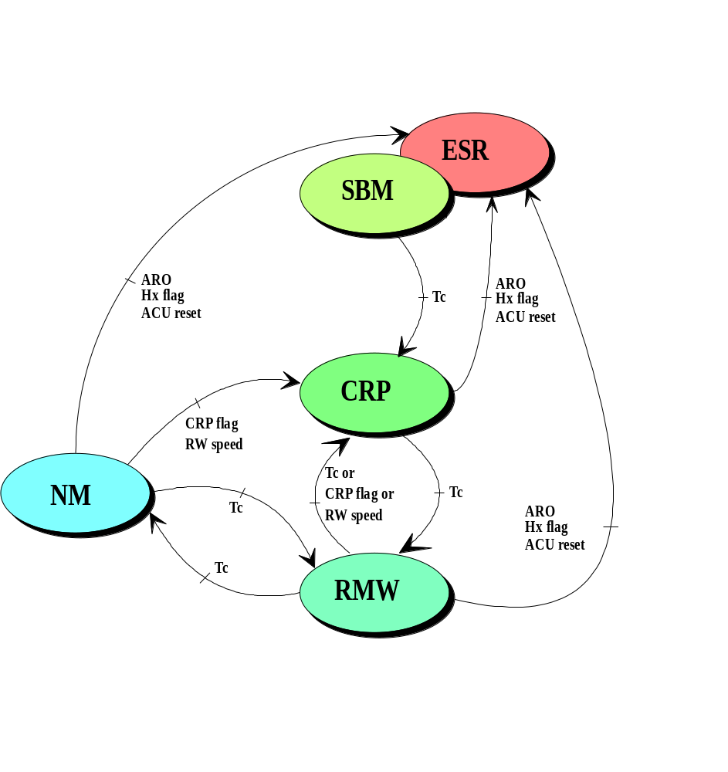
Figure 3.2/1 : Gyroless modes and transitions

The CRP mode is a new AOCS mode. This mode uses only the FPSS and the reaction wheels.
It will be used to recover from ESR and as a recovery mode in case of SSU SEU outages or RW speed anomaly for both RMW & NM. This CRP mode allows performing roll manoeuvres and enables HGA operations for medium or high rate telemetry.

The RMW mode will be used for both Station keeping and Momentum management.
The Normal mode will be used for science.

The nominal or permitted transitions between these modes are :
- ESR to CRP (through ACU Inactive, then Standby mode), for ESR recovery
- CRP to RMW, to restore the nominal mission modes using the SSU after ESR recovery
- RMW to CRP, for roll adjustment in CRP
- RMW to NM, to restore science operations
- NM to RMW, for performing manoeuvres with thrusters (station keeping and momentum management)

In addition to the permitted mode transitions, the following transitions are commanded in case of anomalies:
- From NM or RMW modes : transition to CRP mode in case of SSU outage or RW speed anomaly (both commanded by a dedicated COBS function). This replaces the old fallback to RMW with gyroscope in case of SEU declared on the control star.
- From any ACU mode : transition to ESR mode (in case of FDE anomaly detection : FSPAAD criterion, or commanded by a dedicated COBS function in case of ACU reset or Hx momentum anomaly)

The old ISA, FSA, and CSP modes are no longer required. Transition from any mode to ISA, FSA and CSP are now declared as being invalid transitions in the gyroless AOCS software. The CRP to Stand-By transition is not allowed in the new software definition.
Transitions from on mode on itself are also still possible, as implemented in the initial design solution. This performs initialisation of some of the mode variables, using default values.

The CRP mode is implemented as being ACU mode 5, making the AOCS new mode tables as follows :
- Inactive : mode 0, used at power up
- Stand-By : mode 1, used at ESR recovery
- ISA : mode 2, unused
- FSA : mode 3, unused
- RMW : mode 4, operational mode
- CRP : mode 5, operational mode
- CSP : mode 6, unused
- NM : mode 7, operational mode

ESR mode

Presentation
The ESR mode is still being used as an ultimate back up mode after an on board anomaly detection.
The ESR mode being a hardware mode, no change to this mode occurs. The ESR performs an independent control using SAS B analogue channel and the propulsion B branch. The only restriction is that the ESR roll controller will be kept inhibited and the roll rate of the satellite will be controlled from ground through regular open loop thruster actuations (direct commands through the ACU & CAE B).
The main technique used to control the roll rate is described in section 3.3.2. It uses the SAS outputs.

ESR divergence and Roll rate control in ESR
The need for a roll rate control in ESR is linked to a gradual spin of the roll rate each time pitch thrusters 1B/2B (and to a lesser extent from the yaw thrusters 3B/4B) are actuated. For all these actuations, the roll rate builds up to negative values.
At high rates, the capability to maintain the sun pointing control is no more granted. This is linked to the inertia cross products terms, and forms a diverging phenomenon at high negative rates : the more the roll rate, the more the parasitic torques on the pitch and yaw axes, hence the more the pitch and yaw actuation and the more the roll rate becomes negative. This phenomenon was illustrated by the June 98 mission interruption.
The loss of control occurs at -4.5 °/s at EOL worst case (-5.12°/s worst case for 13 bar pressure), and did occur at -7.2°/s in June 98 conditions. The dynamics of the ESR divergence on the negative rate side (current worst case and EOL worst case) is illustrated Figure 3.3/1 : ESR divergence dynamics (13 bar worst case) and Figure 3.3/2 : ESR divergence dynamics (EOL worst case).
It should be also noted that the loss of ESR control can also occur at positive rates at the same order of rates magnitude : although the negative braking delivered by the 1B to 4B thrusters, if the initial roll rate is too high for maintaining the SAS 1 control, the dynamics will generate large angles and a subsequent entry into the SAS 2/SAS 3 logic, which does not recover the sun pointing.
The roll rate increase is a smooth phenomenon at beginning, when experienced at low rate conditions. This has been verified in flight from various opportunities.
The daily rate increase is somewhere between -0.1°/s and -0.2°/s per day at low roll rates (around or below 0.1°/s). It goes up to -0.7°/s per day when the roll rate is around 0.7°/s, and increases rapidly at the end.
At -0.7°/s, when the wheels have despun and the ESR steady state is set, the order of magnitude to reach the ESR divergence is about one day.
If kept above -0.1°/s, the autonomy of the ESR before the divergence is the matter of several days.
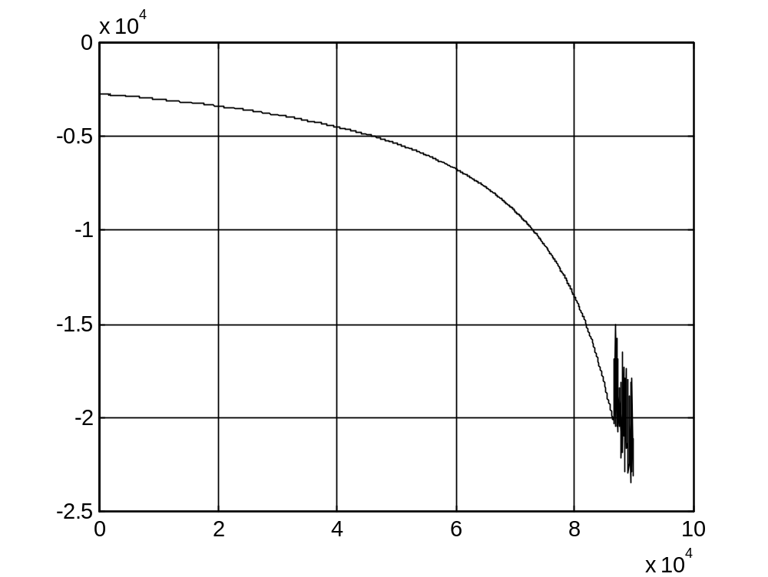
Roll rate (104 "/s, full scale at -6.94°/s) vs time (104 s, full scale at 27h45')
Initial rate = -0.75°/s
Divergence at -5.12°/s in 23h30'

Figure 3.3/1 : ESR divergence dynamics (13 bar worst case)
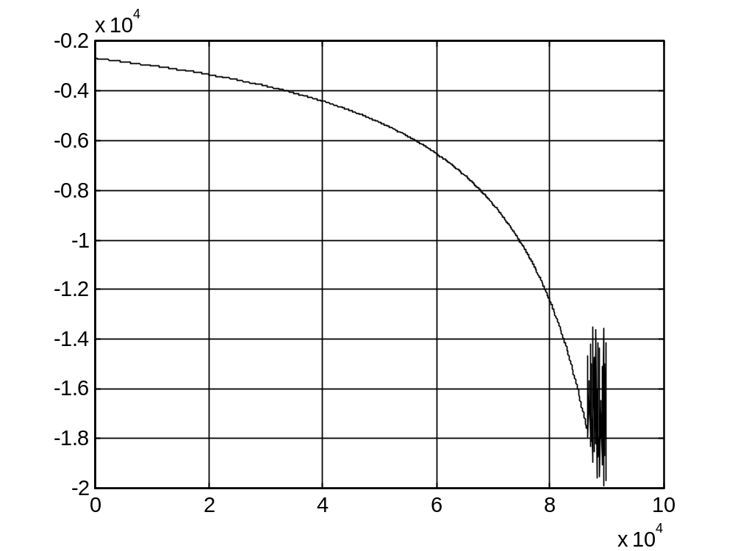
Roll rate (104 "/s, full scale at -5.55°/s) vs time (104 s, full scale at 27h45')
Initial rate = -0.75°/s
Divergence at -4. 5°/s in 23h30'

Figure 3.3/2 : ESR divergence dynamics (EOL worst case)
Amongst the candidate roll rate measurement techniques experimented on SOHO, the roll rate reduction from SAS-1B has been retained. The roll rate (ω_{x}) can be monitored on ground from the plots of the SAS-1 α and β angles, plotted in polar as follows :
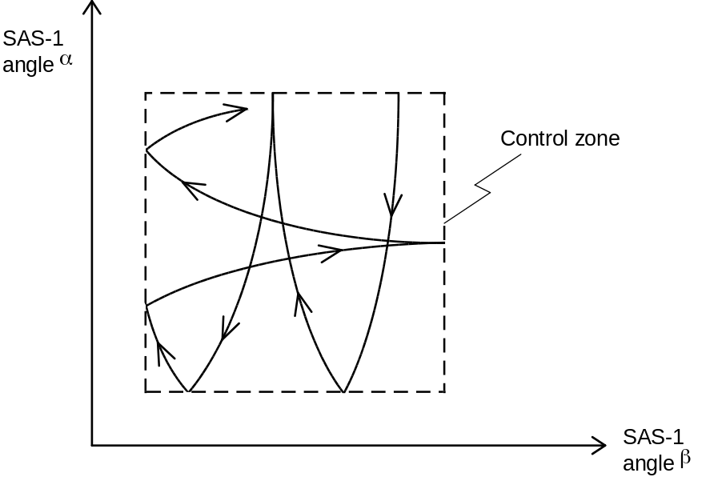
Inside the control zone, the spacecraft exhibits free body motion. If there is no roll rate, the α, β trajectories are straight lines. However, if there is a roll rate, the α, β trajectories are curved. In addition, if ω_{x} < 0, the curves are in a clockwise direction. If ω_{x} > 0, the curves are anticlockwise.
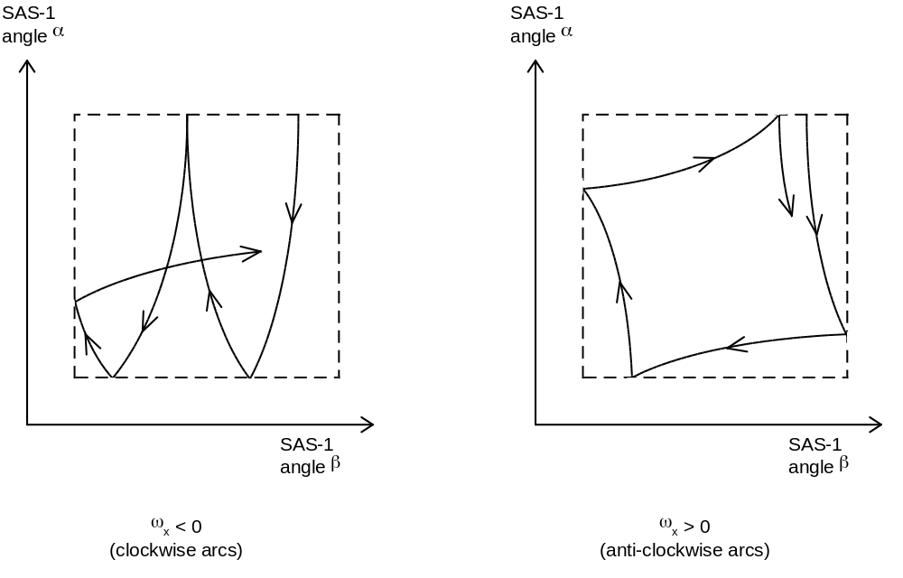
The curves represent a combination of nutation and spin, as seen from the equations for the dynamics and kinematics. The magnitude of the curvature in the α, β plots is hence indicative of the roll rate magnitude. Rather than attempting to estimate the roll rate from the free body motion equations, it is proposed to fire elementary 5B or 6B 0.05°/s equivalent pulses, until SAS curves becomes visually straight lines on the polar plots or prove to indicate a barely positive roll rate. Indeed, curvatures can easily be seen above 0.1°/s. Typical curvatures at 0.1°/s are depicted on Figure 3.3/3 : typical SAS curvatures at -0.1°/s (flight data, one point per 15s). Their actual shape depend on the pitch/yaw rates experienced on the free dynamics arcs.
This operational strategy has been performed successfully in flight since September 98.

Pitch or yaw braking in ESR
Upon request from the orbit maintenance experts, the braking of the pitch or yaw cycles can be performed by thrusting open loop pulses through ACU-B and CAE-B, up to the date when ACU-A is switched ON.
The braking of the yaw (respectively the pitch) cycle is understood as the reduction of the cycle rate to a low value on one of its edge, and reduces the orbital perturbation on the +X axis (respectively on the - X axis).
The pitch or yaw rate trim is achieved once the roll rate control is established using a derivation the SAS measurements.
Owing to the shape of the limit cycling with no roll rate (refer to Figure 3.3/4 : ESR steady state limit cycling (pitch/yaw) at low roll rates (flight data)), the good repetitivity of the limit cycling and its fast cycles allows to time out in advance the date at which the pitch or yaw rate will be performed. If the correction is not accurate enough, a fine tuning will be performed, and made more easy by the resulting lengthening of the pitch and yaw cycling frequencies.

The principle used to damp the residual pitch and yaw momentum is as follows :
- The spacecraft Hy and Hz is computed using the rates estimation from the SAS and the spacecraft inertia (Iyy estimated at 3270 kgm² for 130 kg fuel left and at 3190 kgm² for a dry spacecraft / Izz estimated at 3650 kgm² for 130 kg fuel left and at 3570 kgm² for a dry spacecraft, linear interpolation in between)
- The current thruster torque matrix is used to compute the required on time. This makes the on time dependant on the pressure. Thruster 1B is used to generate + pitch rate (2B for negative), thruster 3B is used to generate -yaw rate (4B for positive).
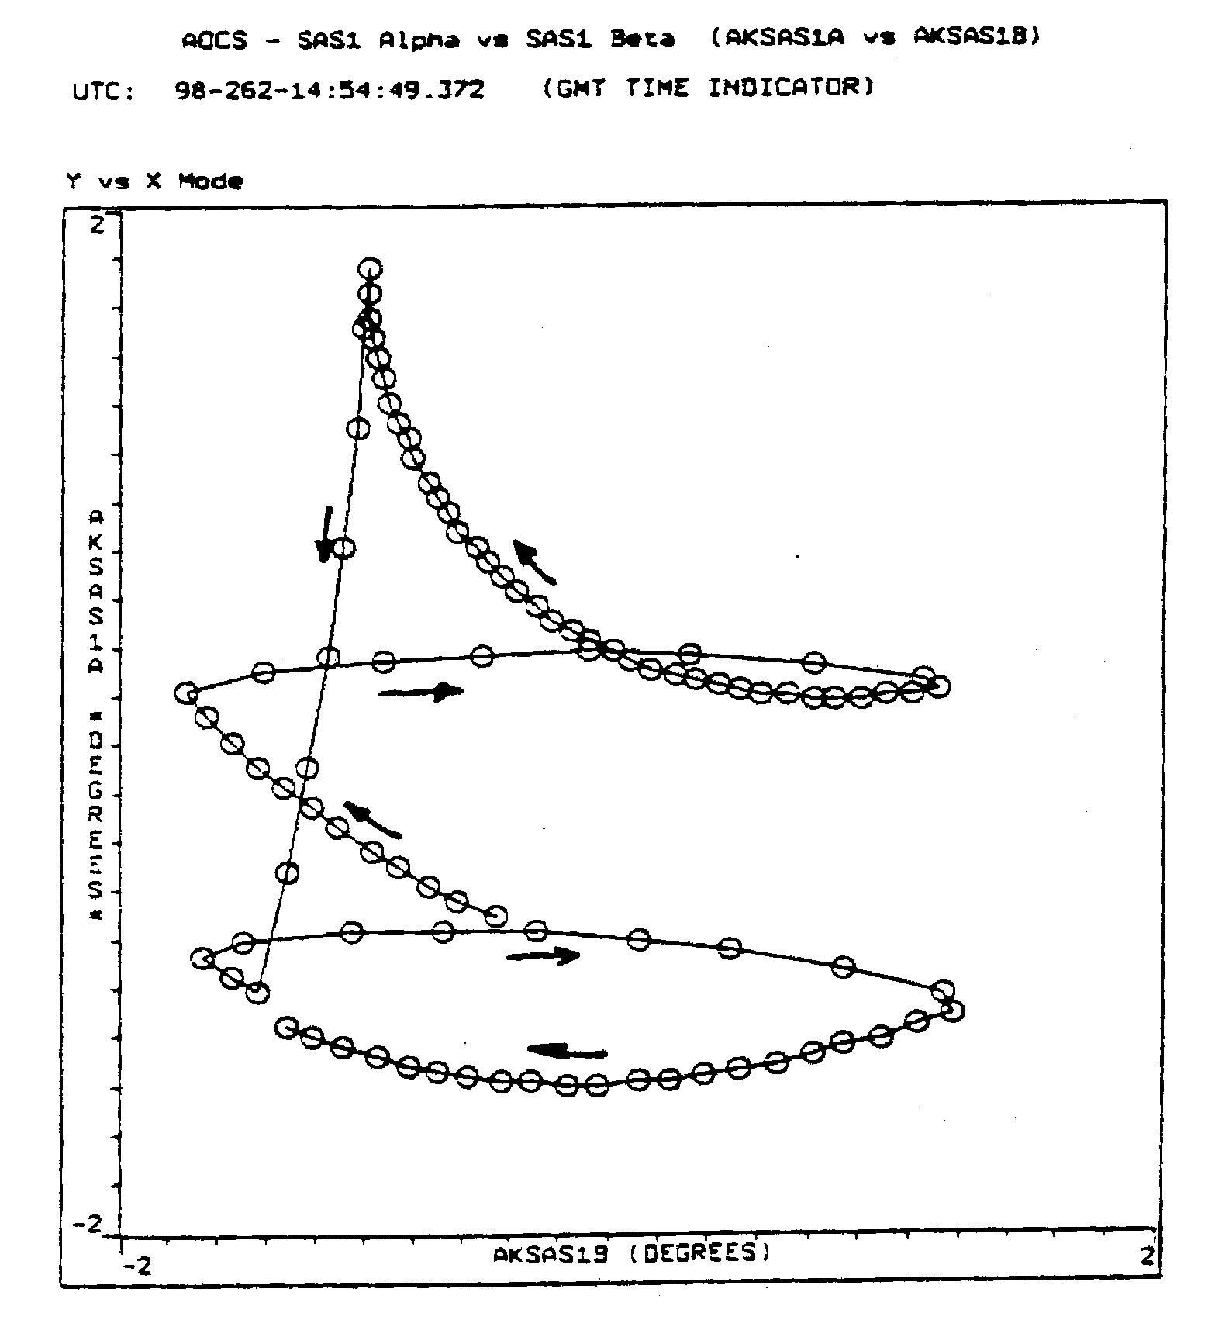
Figure 3.3/3 : typical SAS curvatures at -0.1°/s (flight data, one point per 15s)
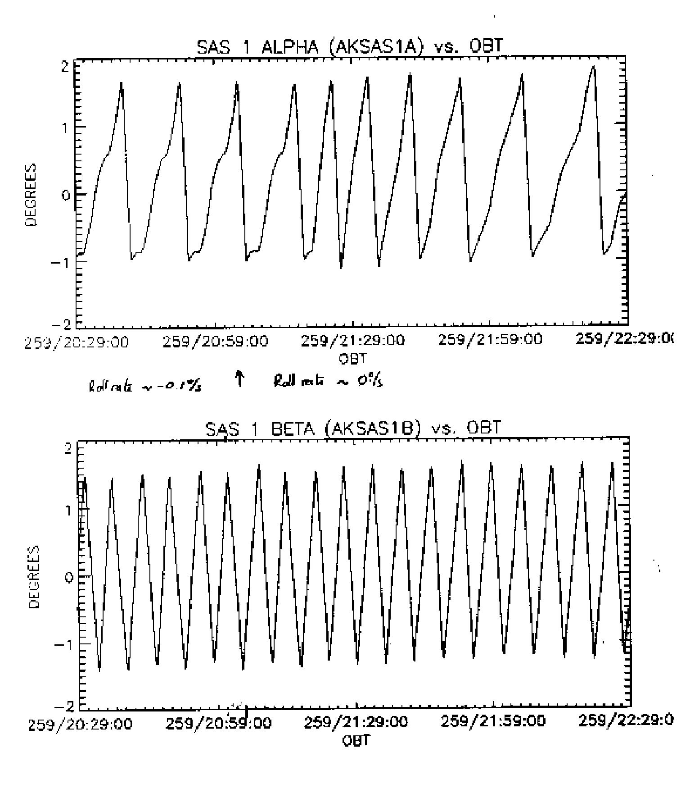
Figure 3.3/4 : ESR steady state limit cycling (pitch/yaw) at low roll rates (flight data)

ESR operational constraints
- The ESR roll rate control shall always be disabled, and checked at the ESR entry
- It is not allowed to let large positive or negative roll rates in ESR.
- The axis convention of the SAS plots and curvatures shall be respected for roll rate control in ESR.
- As a safeguard mean, the roll rate shall be monitored on ground by alternative means (Doppler).
- The ESR shall not be left without contact until the reaction wheels have spun down (1 hour into ESR) and the roll rate has been controlled by the ground
- Once the roll rate control is established and the wheels have spun down (1 hour into ESR), the spacecraft shall not be left out of contact for more than 24 hours.
- The reaction time to perform control in ESR (once low rate telemetry is established and ESR reported) shall be less than 1 hour.
- In order to grant large ESR autonomy, the ESR roll rate control shall be performed above -0.1°/s, and shall target roll rate control within +/- 0.1°/s.
- The orbit perturbations generated by the ESR control pulses shall be monitored on ground by Doppler. If required by the orbit dynamics, pitch braking or yaw braking can be performed to help maintaining the orbit.
- Roll rate control shall be performed from ACU-B and CAE-B. SAS 1B plots can either be from digital and analog measurements. Other units than SAS 1B can be used to establish roll rate with the same principle if they are proved worthy versus SAS 1B.
- Would thrusters be used from an unhealthy ACU in ESR (ex ESR from an ACU B control, if ACU A failed), their actuation shall be : timed tagged, limited to 1s per actuation, followed 1s after by a CAE execute send by direct MACS command (to clear the FCV command register located within CAE).

Stand-by mode

Presentation
The Stand-By mode is the first ACU mode used to support ESR exit operations. A transition to CRP mode is used afterwards while the ESR controller is switched OFF.
The Stand-By mode now implements :
- the reaction wheels speed controller, to support open loop rate reduction techniques with reaction wheels, exercised to prepare for CRP transition.
- the reaction wheels speed filter, to anticipate filter convergence for CRP mode, and to enhance the reaction wheel speeds observability.

Transition to CRP

The CRP entry principle
Several constraints have been taken into account to design the ESR to CRP transition :
- The Stand-By mode to CRP mode transition is not made conditional, within the ACU software, on the sun being present within the FPSS field of view.
- The operational entry conditions set for CRP are exceeded by the ESR control performances.
- Adequate failure identification shall be performed before using hardware for the ESR to CRP transition.
- Adequate protections (the Hx monitoring function) shall be installed in CRP as soon as possible after the ESR exit.
- A minimum request for CRP autonomy (few days) is anticipated, for operational robustness.

The selected principle of operations to tackle these constraints is as follows :
- The failure identification activities are performed in ESR. This failure identification starts at ACU A level. It allows to upload the gyroless software, and uses the ACU A in stand by mode to support the investigations associated to the other remaining AOCS hardware (mostly FPSS and reaction wheels).
The logic and the rationale for these operations are described in the contingency analysis. The scheme of investigation gives an appraisal of the health of the ACU A, FPSS A, and RW's good enough to perform the CRP entry with these hardware pieces. On the other hand, although if proved globally healthy, the ACU A can not be tested sufficiently at MACS level to allow for thruster actuation (CAE A and even CAE B) without protection.
- A rate reduction technique is set on all the axes to grant the CRP operational entry conditions. This rate reduction technique is performed with the reaction wheels, under ACU control.
The method for performing the roll, then the pitch and yaw rate reduction is described in the following paragraphs. The reaction wheels are used to damp the rates according to the choice not to use thrusters commanded by ACU A. A specific initial momentum configuration is set to allow for roll rate measurement correction, as formerly done in the frame of the first gyroless ESR exit solution (Januark 99). The roll rate is thereafter damped by trimming the reaction wheels speeds. Thereafter the remaining pitch and yaw rates are identified from the SAS measurements, and damped the same way, just before the transition into CRP.
- The FPSS sun presence check is part of the final verification.
This does not really calls for a timed out exit, since the FPSS has always been proved largely in the ESR field of view so far in flight.
- The possibility to set the Hx monitoring in CRP and the CRP autonomy is granted by an adequate initial roll rate trim in ESR, executed as part of the end of the roll ground based control before the ACU A operations, and adequate reaction wheels speeds.
This timeline and its implications are described in section 3.4.2.2. The reaction wheels initial speeds are presented in section 3.4.2.2, for any reaction wheels subset. It shall be noted that the value of the embedded momentum nevertheless differs from the solution used at the date of the early gyroless solution (first gyroless exit of ESR), making the computation routines used at that date slightly obsolete.

Roll Rate Measurement and trim principle
Two roll rate trims are performed as part of the ESR exit procedure :
- The first one applies before the start of the operations with ACU A.
It is achieved by thrusters as part of the last ground based control actions. There is no roll rate measurement and verification principle performed at that stage. The trim of the roll rate to the required positive value is only performed using calibration knowledge of thruster 5B. To get accuracy, the requested procedure set in place is to trim down to zero the negative roll rate, and thereafter to trim to the requested positive value the roll rate.
- The second one applies before the CRP entry.
It is performed with reaction wheels for both the achievement of the measurement and of the trim.
The principle stands as embedding a pure +Hy (case of reaction wheels 1/2/3 or 1/3/4) or a pure -Hz (case of reaction wheels 1/2/4 or 2/3/4) momentum on the wheels, while evaluating the perturbation observed on the other axis : yaw axis for the case when an Hy is set, pitch axis for the case when the Hz is set.

Case of nominal subset and 1/3/4 subset : measurement with pitch momentum
For these two reaction wheels subset, it is possible to embed a pure Hy momentum. The selected momentum solution is :
h_{x} = 0
h_{y} = + 11.39 Nms
h_{z} = 0

This corresponds to the following wheel speeds for the nominal 1/2/3 subset :
h₁ = 6.5 Nms (≡ 650 rpm)
h₂ = -13 Nms (≡ -1300 rpm)
h₃ = 6.5 Nms (≡ 650 rpm)

This corresponds to the following wheel speeds for the redundant 1/3/4 subset (usage in case of reaction wheel 2 failure) :
h₁ = -6.5 Nms (≡ -650 rpm)
h₃ = -6.5 Nms (≡ -650 rpm)
h₄ = 13 Nms (≡1300 rpm)

Following the wheel spin up, in both cases, the presence of the wheel pitch momentum, coupled with the residual roll rate, will give rise to a yaw disturbance torque.
The yaw dynamics are approximately Izz dωz/dt + ωx hy = 0, so that Izz dωz/dt = - ωx hy

If the rate is nearly null, a double sided steady state is always experienced on the yaw axis :

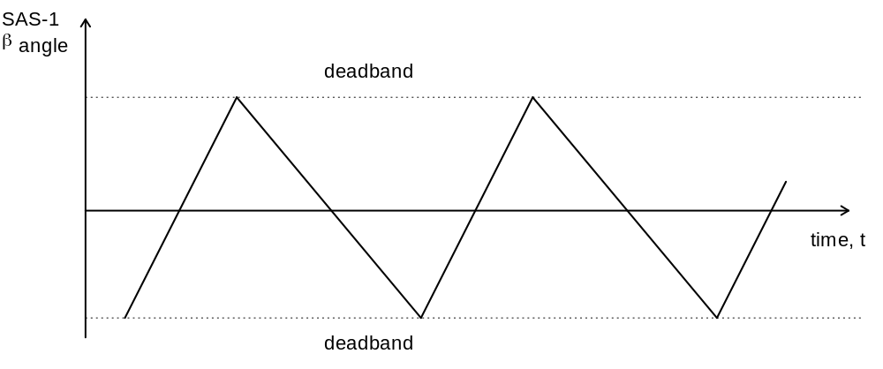

In this situation, there is no need to measure the residual roll rate : the roll rate is low enough to proceed with the CRP entry.
If it does not, then there is a residual roll rate which may be identified using the following method :

- As h_{y} > 0, then if ω_{x} > 0, there is a negative disturbance torque, i.e. the SAS-1 β angle or the FPSS yaw angle, will exhibit the following limit cycle behaviour:

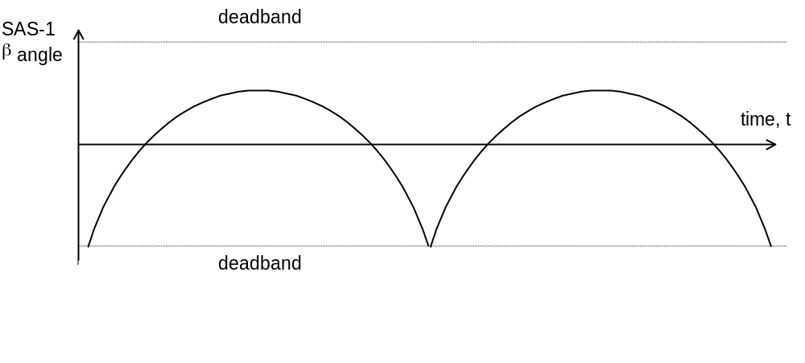
Positive roll rate on yaw axis for 1/2/3 and 1/3/4 subset

- Similarly, if ω_{x} < 0, there is a positive disturbance torque, i.e. the SAS-1 β angle or the FPSS yaw angle, will exhibit the following limit cycle behaviour:
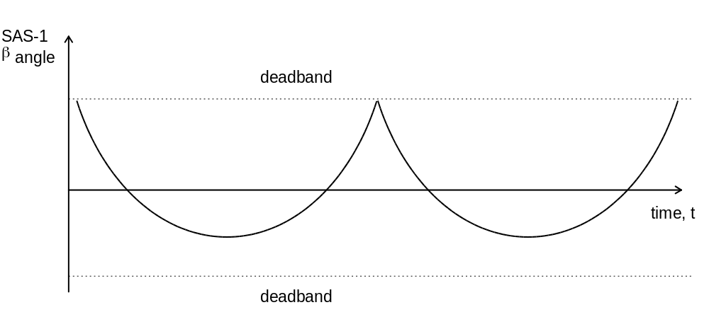

Negative roll rate on yaw axis for 1/2/3 and 1/3/4 subset

- The roll rate may be evaluated from any arc of this profile as follows, measuring the ΔT half period and Δθ peak angle variation as follows, and picking up the sign of the rate by the shape of the profile :

Positive case :
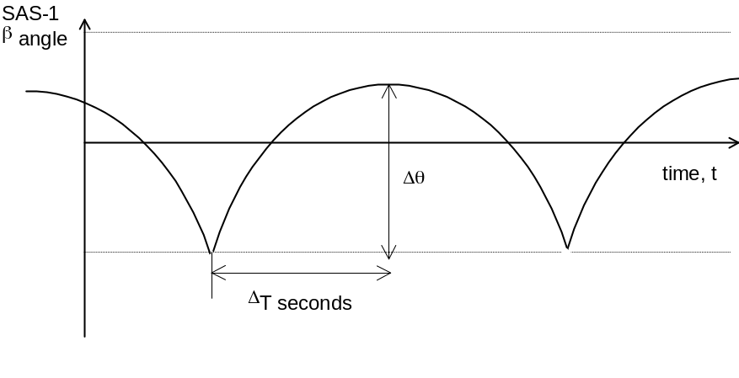
Negative case :
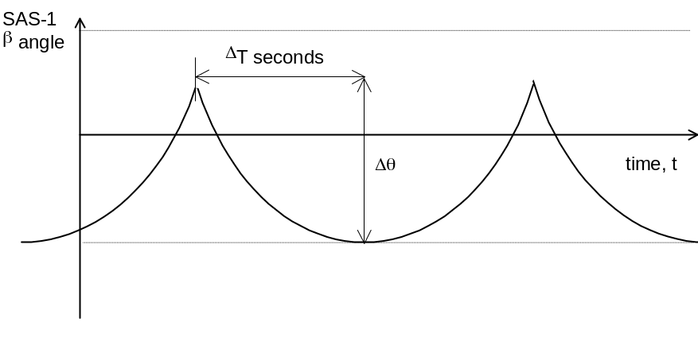

- During any of these arcs, experienced in free dynamics under a nearly constant yaw disturbance, the yaw acceleration can be appraised by : 2 Δθ / ΔT². This gives access to the following estimate of the rate (in absolute values) :

ω_{x} = 2 * Izz * Δθ / (ΔT² * hy)

The best knowledge of Izz is 3650 kgm² with 130 kg fuel left on board, and 3570 kgm² with no fuel left on board. Linear interpolation can be used in between.

The table below gives a rough approximation of half the single sided limit cycle period for a given roll rate. The number of data points from the telemetry is also given. The period of the limit cycle and hence the number of data points is sufficient to calculate the roll rate to a reasonable level of accuracy for roll rates up to 300 “/s to 400 “/s. Moreover, as the roll rate is reduced, the accuracy increases.

Roll Rate (“/s) | Half Cycle Period (s) | Telemetry points per Half Cycle
50 | 384 | 26
100 | 192 | 13
150 | 128 | 9
200 | 96 | 6
250 | 77 | 5
300 | 64 | 4
350 | 55 | 4
400 | 48 | 3

Table 3.4/1 : Observability of yaw sine waves

Case of 2/3/4 subset and 1/2/4 subset: measurement with yaw momentum
For these two reaction wheels subset, it is not possible to embed a pure Hy momentum. Therefore a pure yaw momentum is selected :
h_{x} = 0
h_{y} = 0
h_{z} = -11.39 Nms

This corresponds to the following wheel speeds for the redundant 2/3/4 subset (usage in case of reaction wheel 1 failure):
h₂ = -6.5 Nms (≡ -650 rpm)
h₃ = -6.5 Nms (≡ -650 rpm)
h₄ = 13 Nms (≡ 1300 rpm)

This corresponds to the following wheel speeds for the redundant 1/2/4 subset (usage in case of reaction wheel 3 failure) :
h₁ = -13 Nms (≡-1300 rpm)
h₂ = 6.5 Nms (≡ 650 rpm)
h₄ = 6.5 Nms (≡ 650 rpm)

Following the wheel spin up, in both cases, the presence of the wheel yaw momentum, coupled with the residual roll rate, will give rise to a pitch disturbance torque.
The pitch dynamics are approximately Iyy dωy/dt - ωx hz = 0, so Iyy dωy/dt = + ωx hz

If the rate is nearly null, a double sided steady state is always experienced on the pitch axis :

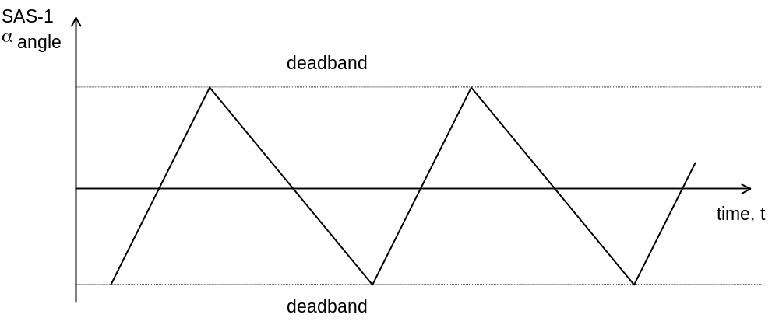

In this situation, there is no need to measure the residual roll rate : the roll rate is low enough to proceed with the CRP entry.
If it does not, then there is a residual roll rate which may be identified using the following method.

- As h_{z} < 0, then if ω_{x} > 0, there is a negative disturbance torque, i.e. the SAS-1 α angle or the FPSS pitch angle, will exhibit the following limit cycle behaviour:

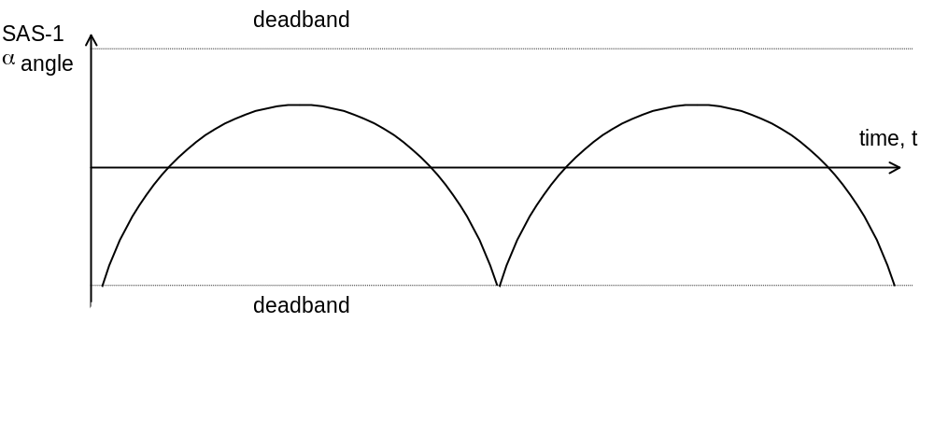
Positive roll rate on pitch axis for 1/2/4 and 2/3/4 subset

- Similarly, if ω_{x} < 0, there is a positive disturbance torque, i.e. the SAS-1 α angle or the FPSS pitch angle, will exhibit the following limit cycle behaviour:
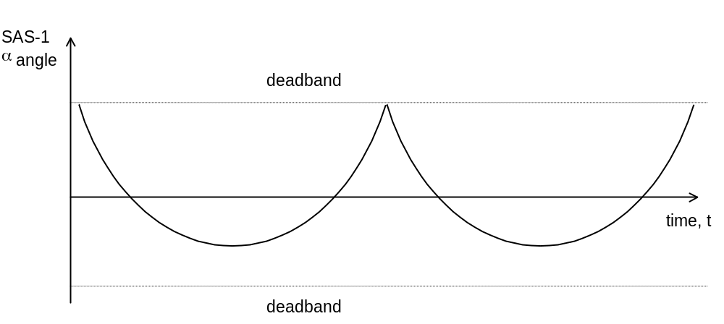

Negative roll rate on pitch axis for 1/2/4 and 2/3/4 subset
- The roll rate may be evaluated from any arc of this profile as follows, measuring the ΔT half period and Δθ peak angle variation as follows, and picking up the sign of the rate by the shape of the profile :
Positive case :
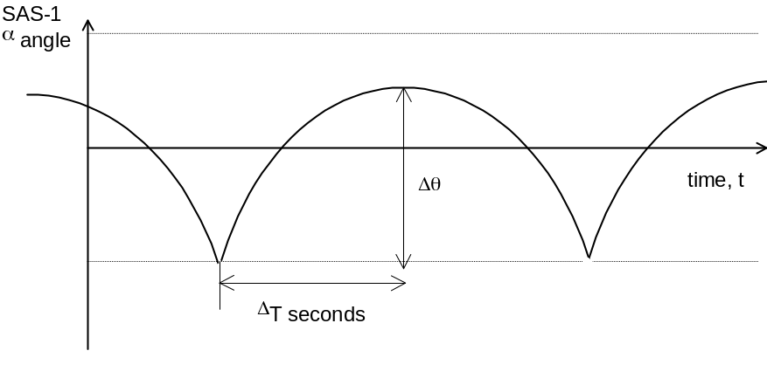
Negative case :
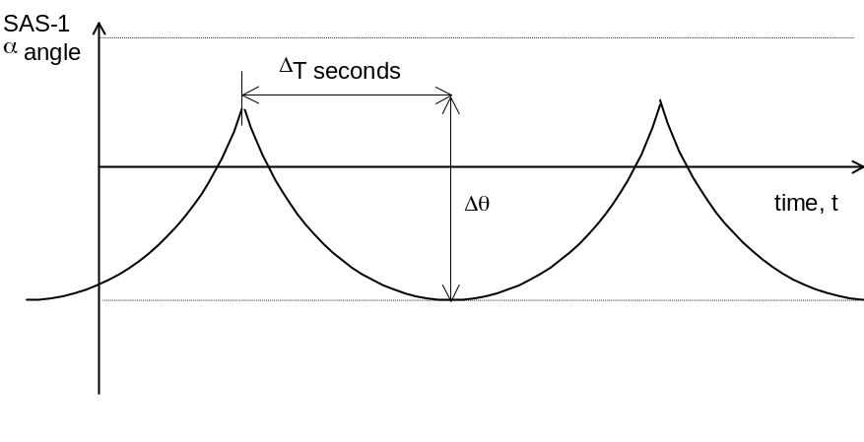

- During any of these arcs, experienced in free dynamics under a nearly constant pitch disturbance, the pitch acceleration can be appraised by : 2 Δθ / ΔT². This gives access to the following estimate of the rate (in absolute value) :

ω_{x} = 2 * Iyy * Δθ / (ΔT² * hz)

The best knowledge of Iyy is 3270 kgm² with 130 kg fuel left on board, and 3190 kgm² with no fuel left on board. Linear interpolation can be used in between.

The table below gives a rough approximation of half the single sided limit cycle period for a given roll rate. The number of data points from the telemetry is also given. The period of the limit cycle and hence the number of data points is sufficient to calculate the roll rate to a reasonable level of accuracy for roll rates up to 300 “/s to 400 “/s. Moreover, as the roll rate is reduced, the accuracy increases.

Roll Rate (“/s) | Half Cycle Period (s) | Telemetry points per Half Cycle
50 | 384 | 26
100 | 192 | 13
150 | 128 | 9
200 | 96 | 6
250 | 77 | 5
300 | 64 | 4
350 | 55 | 4
400 | 48 | 3

Table 3.4/1 : Observability of pitch sine waves

The roll rate trim
The roll rate trim is achieved by increasing or decreasing the speed of the two reaction wheels of the subset acting on the Hx spacecraft momentum.
To kill a positive roll rate, the Hx momentum of the reaction wheels shall be increased towards the positive direction. On the other hand, to kill a negative roll rate, the Hx momentum of the reaction wheels shall be increased towards the negative direction.

The value of which both wheels shall be trimmed is given by :
x = int (Ixx * roll rate absolute value / 2 / reaction wheel speed quantum / cos 61.2°)
that is x ( rpm) = int (694.666* roll rate absolute value (in deg/s))

Pending on the wheels subset used, this translates into :
- For subset 1/2/3 (nominal) and a positive roll rate, evolution of RW1 and RW3 speeds from + 650 rpm to 650 + x rpm
- For subset 1/2/3 (nominal) and a negative roll rate, evolution of RW1 and RW3 speeds from + 650 rpm to 650 - x rpm
- For subset 1/2/4 (redundant) and a positive roll rate, evolution of RW2 and RW4 speeds from + 650 rpm to 650 + x rpm
- For subset 1/2/4 (redundant) and a negative roll rate, evolution of RW2 and RW4 speeds from + 650 rpm to 650 - x rpm
- For subset 1/3/4 (redundant) and a positive roll rate, evolution of RW3 and RW4 speeds from - 650 rpm to - 650 + x rpm
- For subset 1/3/4 (redundant) and a negative roll rate, evolution of RW3 and RW4 speeds from - 650 rpm to - 650 - x rpm
- For subset 2/3/4 (redundant) and a positive roll rate, evolution of RW2 and RW3 speeds from - 650 rpm to - 650 + x rpm
- For subset 2/3/4 (redundant) and a negative roll rate, evolution of RW2 and RW3 speeds from - 650 rpm to - 650 - x rpm

Pitch and Yaw rate measurement and trim principle
The pitch and yaw rate trim is achieved after the roll rate trim by increasing or decreasing the speed of the reactions wheels to damp the residual Hy and Hz spacecraft momentum. The measurement technique is simply based on the use of a derivation the SAS or FPSS measurements.
Owing to the shape of the limit cycling with no roll rate (refer to Figure 3.3/4 : ESR steady state limit cycling (pitch/yaw) at low roll rates (flight data) in section 3.3), the good repetitivity of the limit cycling and its fast cycles allows to time out in advance the date at which the pitch and yaw rate will be performed. If the correction is not accurate enough, a fine tuning will be performed, and made more easy by the resulting lengthening of the pitch and yaw cycling frequencies.

The principle used to damp the residual pitch and yaw momentum is as follows :
- The spacecraft Hy and Hz is computed using the rates estimation from the SAS or FPSS, and the spacecraft inertia (Iyy estimated at 3270 kgm² for 130 kg fuel left and at 3190 kgm² for a dry spacecraft / Izz estimated at 3650 kgm² for 130 kg fuel left and at 3570 kgm² for a dry spacecraft, linear interpolation can be used in between)
- The momentum increase to apply of the reaction wheels is derived using the wheels to spacecraft transformation matrix : H(RWijk, SC) for wheels subset ijk
(Hi , Hj, Hk) = H(RW, SC) (0, Hy, Hz)
- Each of the wheels speed reference is modified accordingly.

Initial Roll Rate and timing of the operations
The maintain operational robustness, the procedure for exiting ESR requires that no thruster commands are sent once ACU-A is patched and operational, until the adequate protections are set in RMW to perform momentum management operations.
On the other hand, at CRP entry, it is desired to set in place the Hx protection as soon as possible (this allows to set the basic protection for spacecraft safety) and a minimum autonomy is aimed in CRP wrt the first momentum management request.
The solution selected to comply with these two requests has been to trim the roll rate prior to patch and use ACU A, and set in place a rough timeline of operations associated with initial reaction wheels speeds, such that no thrusters actuations are needed in the first two days in CRP mode.
A number of factors influence the final value of Hx:
- When in ESR, the roll rate evolves at a rate between 0.1°/s per day and 0.2°/s per day.
- When in CRP mode, the environment torque on the roll axis has a worst case value of 1.0E-06 Nm
- When in CRP mode, the spacecraft will rotate about an axis orthogonal to the roll axis at 1° per day.
- When in CRP mode, the disturbance torques on the pitch and yaw axis result in a drift of the CRS, resulting in a non-zero rate on the roll axis.
The recommended initial rate for the roll axis is + 408 “/s (ie + 0.11°/s). It is coherent with getting a positive Hx in CRP (largely above the lowest edge Hx limit) even if the length of the operations is up to 6 hours from the date of the roll rate rim up to the date of transition into CRP. The theoretical maximal length which can be accepted is in fact longer (about 1 day), since the operational Hx lowest edge limit is set at -0.14°/s (-5 Nms).

Stand-by mode operational constraints
- The stand by mode has only to be used as part of the ESR exit operations from a boot up software configuration, while the ESR controller is still active. This mode does not perform attitude control on any of the axes.
- The stand by mode shall always be entered with reaction wheels speed references coherent with actual reaction wheels speeds, in order not to generate a rate kick on the three axes. This imposes that the reaction wheels have spun down before the ESR exit where default references are at zero : the duration of any ESR shall be higher than 2 hours.
- During the ESR exit operations, the stand by mode to CRP transition shall be performed while the sun is present inside the FPSS field of view. This check is performed under ground responsibility, and might impose a timed ESR to CRP exit.
- The ESR exit procedure starts with a roll rate trimmed to +0.1°/s as part of the last actions performed for the ESR roll rate control with thrusters. The pitch and yaw braking actions are stopped at during the ESR exit procedure.
- Thrusters actuation (CAE A and CAE B) from ACU A are NOT allowed as part of the ESR exit procedure while the spacecraft remains unprotected on all the axes.
- The ESR exit procedure duration shall be limited to less than 1 day.
- After CRP entry, the Hx computation shall be performed from the reaction wheels speeds before enabling both the AOCS computation and the COBS monitoring function. If the computed Hx appears lower than -8 Nms, the contact with the spacecraft shall not be released until a momentum management is performed and the Hx protection is set.

CRP mode

Presentation
This new AOCS mode is ultimately proposed to cope with SSU outages, i.e. during high solar activity and solar flares. The primary objective of this mode is to avoid a rapid transition from NM or RMW to ESR in case of unavailability of the SSU sensor. As a secondary objective, the roll angle is maintained close to the position experienced at mode entry, in the aim of keeping the HGA orientation for medium / high rate TM communication.
The CRP mode is a gyroless and SSU less mode, using only the FPSS and the reaction wheels for three axis attitude control. This mode can then support SSU troubleshooting and operations related to uploading of SSU software.
The roll angle control is based on the direction of the transverse reaction wheel momentum in spacecraft axes to measure the roll attitude. This principle, the CRS sensor, is detailed in section 3.5.2. It appears accurate enough for maintaining a pertinent roll angle pointing on a daily basis. On a longer-term basis, roll attitude information from MDI or EIT experiments, available in the medium / high rate telemetry, will be used to maintain a correct absolute roll attitude, hence HGA orientation.
The pitch and yaw control is performed with the FPSS, as per RMW mode.
The CRP mode is also used for the ESR recovery and closed loop roll maneuvers, including HGA Station Keeping operations.
The Hx monitoring function is run in CRP to grant the spacecraft safety. It is the only spacecraft protection set in CRP, together with the FSPAAD/CSPAAD channels from the FDE.

The CRS sensor

The CRS principle
The CRS is based on the conservation of the spacecraft angular momentum, and the observation of that momentum vector via the reaction wheels. Its principle is broadly explained hereafter and illustrated in Figure 3.5/1 : the CRS principle :
- The spacecraft rates being controlled to virtually zero on the pitch and yaw axes by the AOCS, the total spacecraft momentum transverse to the spacecraft to sun line is directly embedded on the wheels. Therefore, the evolution of this momentum vector can be observed by measuring the wheel speeds and having an accurate knowledge of the wheel inertias and the wheels to spacecraft decoupling matrix.
- If control is released on the sole roll axis, the external disturbance torque will be stored as body momentum, i.e. the roll axis will have a non zero rate, causing the body to rotate about this axis with respect to the inertial reference frame.
- The conservation of angular momentum requires that the momentum in the orthogonal reference pitch and yaw axes remains constant. At low roll rates, the pitch and yaw attitude control being still able to maintain the rates to virtually zero, the momentum in the orthogonal body axes must change in the spacecraft axes, manifested as the inverse of the rotation of the spacecraft.
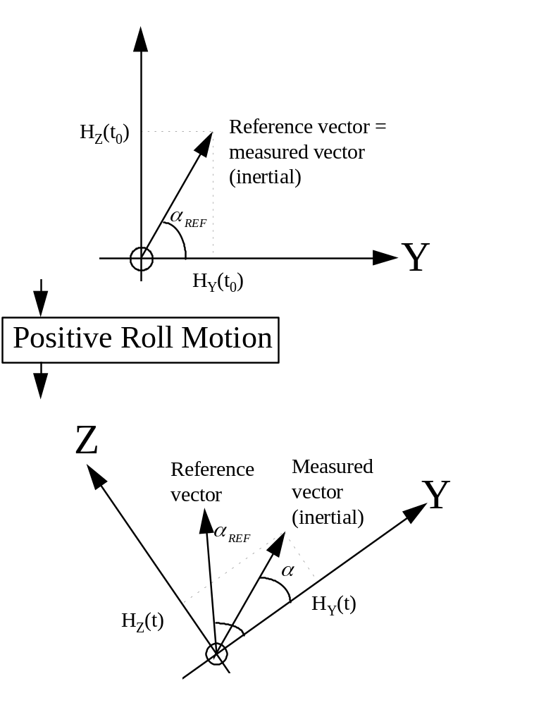

Figure 3.5/1 : the CRS principle

A number of assumptions are made in this explanation :
- There are no disturbance torques acting on the pitch and yaw (Y and Z) axes of the spacecraft.
- The pitch and yaw attitudes of the spacecraft remain fixed in inertial space.
- There is no transient activity on the pitch and yaw axes.
- The wheels speed quantum is low enough not to pollute the measurement.

In practice these assumptions are contravened, and the implications of this are discussed below :
- The spacecraft momentum is not fixed in inertial space, linked to the presence of a long term build up from the solar pressure torque. Furthermore, the geometry of SOHO orbit and its commanded attitude makes the transverse momentum nominally evolving in the spacecraft axes.
Incorporating a CRS drift compensation to correct for the natural CRS drift solves this problem. This drift is estimated by an on board function (the CRS drift estimator, consisting into a linear interpolation), regularly activated by the ground. This solution offers a suitable CRS accuracy over the typical time frame the CRS has to be used (1 day). On a longer term, a calibration from the experiments might be required, if no SSU measurement is still valid.
- Transient activity on the pitch and yaw axes might take place, exchanging transverse momentum with body rates, and thus corrupting the measurement principle.
To cope with that fact, the CRS algorithms are started 40s after the switch over to the mode using that sensor, and the pitch and yaw attitude transients are minimised at this mode entry (rate reduction at ESR exit, and freezing the references to the measured values at CRP entry). This is suitable to damp the major transients. The only remaining transient activities, namely the FPSS offsets, corrupt the sensor measurements to an acceptable level, and are avoided it that mode when the high gain antenna is used.
- The wheel speed quantum of 5.33 rpm could generate an attitude noise up to more than 1°
To increase the CRS performance to a far better value (33" at 1 sigma), a filtering technique of the wheels speeds is set in place before the usage in the CRS algorithm. This filter has been designed in conjunction with the CRP roll control loop, and is described in section 3.5.2.3.

The momentum stored in each wheel is estimated using the measured wheel speed already available, and multiplying by the wheel inertia. The estimate of the wheel inertia uses the most accurate estimate of the wheel inertia possible, as errors in this estimate results in errors when performing large slew manoeuvres about the roll axis. The inertia values currently proposed stem from flight wheels EIDP :
- I₁ = 0.095700 kgm²
- I₂ = 0.095273 kgm²
- I₃ = 0.097310 kgm²
- I₄ = 0.096450 kgm²

At last, it should be noted that a CRS deadband has been introduced. This deadband avoids the divide by zero problem and very noisy CRS behaviour if the transverse momentum appears too small. In the deadband, entered if both the absolute value of Hy and Hz are below 0.5 Nms.

The CRS algorithms
The CRS algorithms are depicted in detail in RD2 : “ GYROLESS ACU SOFTWARE FUNCTIONAL REQUIREMENTS”. These include also the CRS implementation inside the CRP, related to :
- the handling of the CRS dead band (CRS_angle_valid)
- the associated setting the CRS reference for the CRP control (Set_ ref)
- the associated slew abort function
These algorithms are synthesised in Figure 3.5/2 : the CRS algorithms in the CRP mode.
The CRS angle computation, including the quadrant definition and correction is depicted in Figure 3.5/3 : the CRS quadrant definition and Figure 3.5/4 : computation of the CRS angle.

The reaction wheels filter algorithms
The wheel speed filter is designed to filter out the quantisation noise introduced by the measurement process. This filter was designed in conjunction with the roll controller, in order to avoid introducing a significant phase lag near the pass band of the open loop transfer function. The highest frequency quantisation noise is 20 Hz, and the bandwidth of the controller is approximately 0.006 Hz.
A second order filter has been chosen:
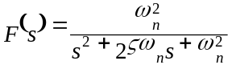
ω = 0.5 Hz chosen as the minimum frequency that can be tolerated
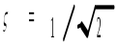 optimal damping
The delay from the measured to the filtered wheel speeds introduced by the filter is approximately 2 seconds, and the residual noise is in the order of ±0.4 rpm; an improvement by an order of magnitude.
Figure 3.5/5 : RW speed filter shows simulations of the measured wheel speed and filtered wheel speed for a particular wheel.
The reaction wheels filter algorithms are run in all modes. This improves the observability of the transient perturbations experienced by the spacecraft.
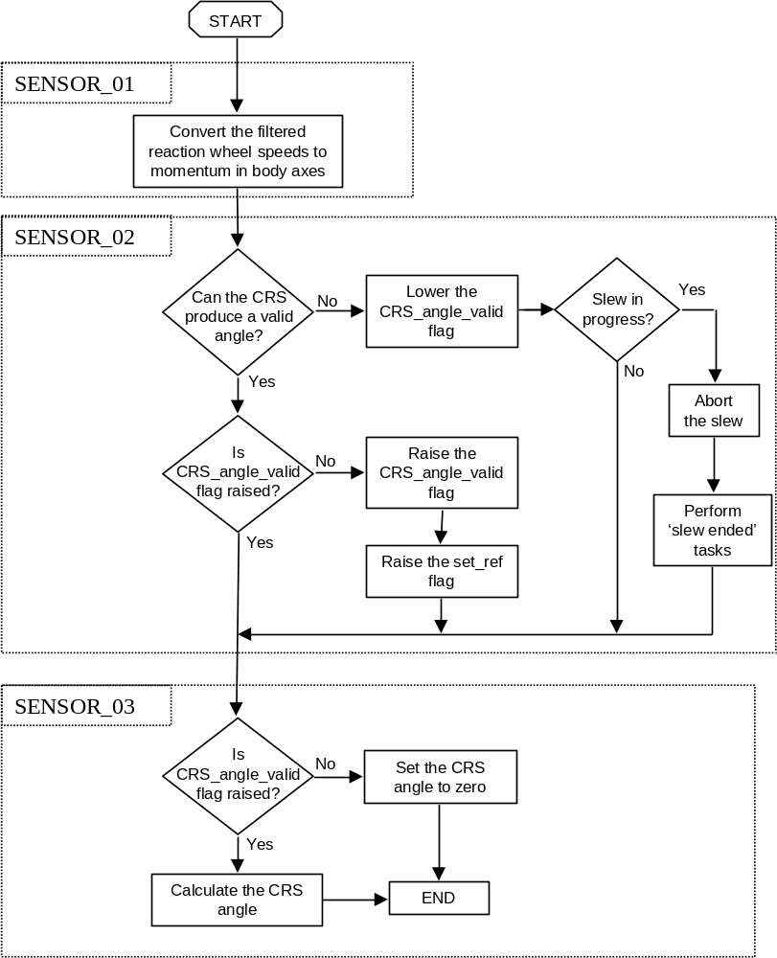

Figure 3.5/2 : the CRS algorithms in the CRP mode

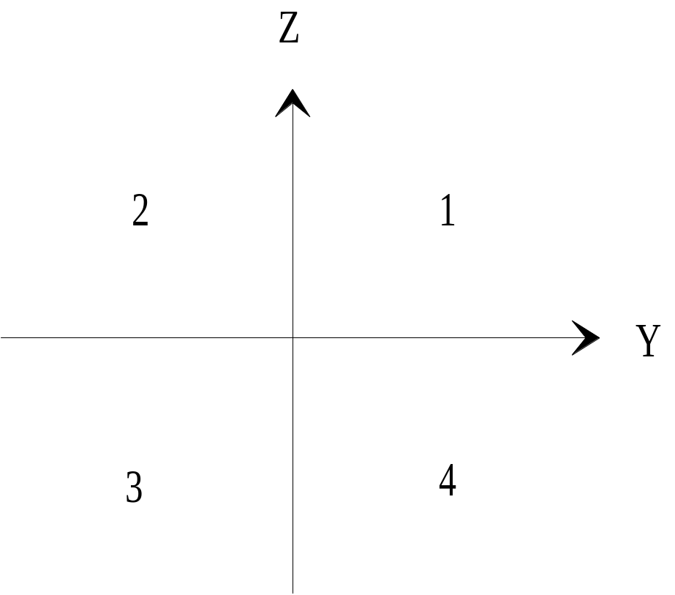
Figure 3.5/3 : the CRS quadrant definition

IF CRS_angle_valid
IF abs_H_{Y} ≥ abs_H_{Z}
alpha = arctan [abs_H_{Z} / abs_H_{Y}]
ELSE
alpha = π/2 - arctan [abs_H_{Y} / abs_H_{Z}]
END

Determine the quadrant the vector is actually in:
IF H_{Y} is ≥ 0.0
IF H_{Z} is ≥ 0.0
quadrant = 1
ELSE
quadrant = 4
END
ELSE IF H_{Z} is ≥ 0.0
quadrant = 2
ELSE
quadrant = 3
END
Calculate the actual estimate of phi according to the quadrant
IF quadrant = 1 CRS_roll_angle = alpha
IF quadrant = 2 CRS_roll_angle = π - alpha
IF quadrant = 3 CRS_roll_angle = -π + alpha
IF quadrant = 4 CRS_roll_angle = - alpha
ELSE
CRS_roll_angle = 0
END

Figure 3.5/4 : computation of the CRS angle
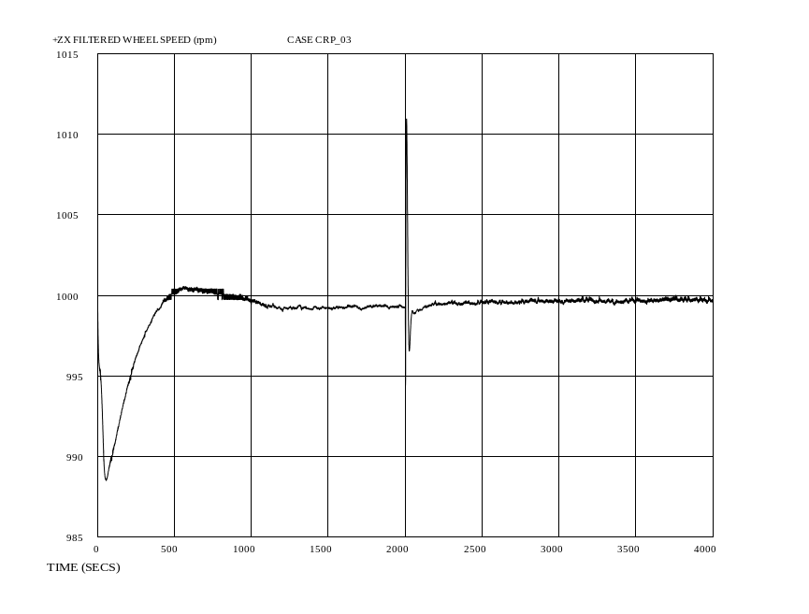
Raw wheel speed
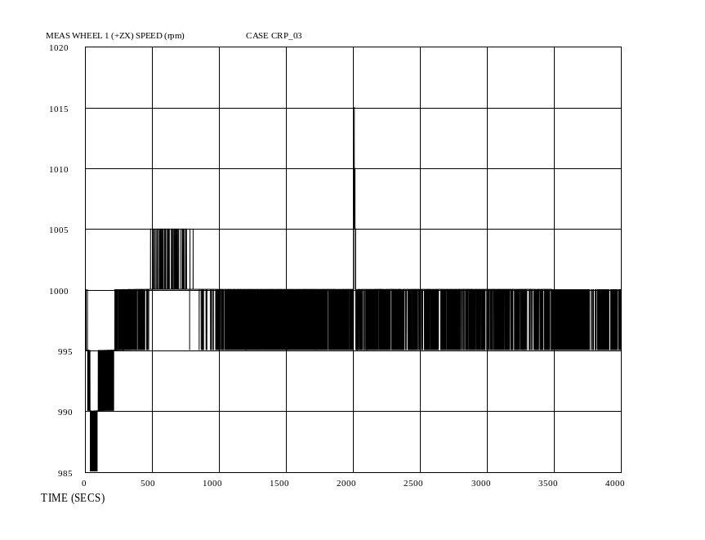
Filtered wheel speed
Figure 3.5/5 : RW speed filter

The CRS drift estimation algorithms
When the spacecraft is in either Normal mode or RMW mode, the effect of external torques and the orbit can be observed directly in the evolution of the wheel momenta. Hence the CRS drift can be estimated on a regular basis and used on any subsequent entry into CRP mode. The drift rate of the CRS will be reasonably constant over short time periods, say one week, hence such a method will be sufficient to maintain the roll attitude to within ±0.5° of the initial roll angle for the majority of the time spent in CRP.
The drift of the CRS is estimated and stored on-board, on approximately a daily basis, in both Normal Mode and RMW mode. This stored value is used if CRP mode is entered. When CRP is entered from ESR, the CRS drift estimate is zero unless configured otherwise from ground.
The drift of the CRS is a delta angle in radians, and is added to the reference angle once per compensation period when in CRP mode. The compensation period is set at 500s in the AOCS software to get observable compensations.
The logic associated to the CRS drift estimation on board is depicted in Figure 3.5/6 : CRS drift estimation algorithms. It uses the CRS algorithm and an arming logic (the Drift_estimator_initialised flag). This logic is activated by a single telecommand.
The following on board actions are associated to that logic :
- the default value of the CRS drift is zero, and the default arming status is "not initialised"
This means that in the first CRP exercised after ESR exit, no compensation will be applied by default, and two telecommands shall be received in subsequent RMW or NM modes before the first drift compensation is computed on board. This takes approximately 12 hours to 24 hours to get a valuable compensation estimate.
- Whenever the thrusters are used, be it for momentum management or a delta-V manoeuvre, the compensation term is invalidated and the Drift_estimator_initialised flag is set to false.
This is linked to the risk of evolution of the momentum during thruster operations. This means that in the phase after momentum management or delta V manoeuvre, no compensation will be applied by default, and two telecommands shall be received in subsequent RMW or NM modes before the first drift compensation is computed on board.
- Whenever an attitude manoeuvre is performed in any mode (CRP, NM, RMW), or at exit of CRP mode, the Drift_estimator_initialised flag is set to false, and the CRS drift compensation value is not reset (kept unchanged). On the other hand, if a roll manoeuvre greater than 10° has to occur, the CRS drift compensation value has to be reset prior the manoeuvre.
This is linked to the fact that after an attitude manoeuvre (whichever the axis), the vectorisation of the wheels speeds is changed, then corrupting the computation of CRS drift estimation. On the other hand, the momentum evolution being more driven by the orbit than from the constant torques in body axes, the compensation existing is deemed more accurate than a null value. This appears true, except if a large angle variation occurs in roll.
The commanding period for the on-board drift compensation must be greater than 12 hours and less than 36 hours, in order to get accurate drift estimation.
In any case, ground can override the value used for compensation at any time, either when in CRP mode or in RMW or Normal mode. In particular, computation of a more accurate compensation term can be performed using an orbital dynamics/torque model. This will be applied to all the mission phase when the drift compensation is forced to zero by the on board logic or by ground actions.

IF Drift_estimator_initialised = false
Drift_estimator_initialised = true
initial_time = Current_time,
initial_angle = CRS_roll_angle
ELSE
Delta_angle = CRS_roll_angle – initial_angle
IF Delta_angle > pi
Delta_angle = Delta_angle – (2*pi)
ELSE IF Delta_angle < -pi
Delta_angle = Delta_angle + (2*pi)
END
Delta_time = Current_time – initial_time
CRS_drift_delta = (Delta_angle / Delta_time) * Compensation_period
Initial_angle = CRS_roll_angle
Initial_time = Current_time
END

Figure 3.5/6 : CRS drift estimation algorithms

The CRS performance
The CRS performance is highly linked to the size of the momentum embedded on the reaction wheels :
- The worst case CRS noise, if performed by on ground by algorithms not using filtered wheels speeds, is at 1.15°, from the 5.33 rpm lsb.
- The worst case CRS noise is at 0.092° = 331". This corresponds to an equivalent quantisation error after filtering of 0.4 rpm.
- The CRS noise is appraised at 33" (1 sigma)
- The delay from the measured to the filtered wheel speeds, and hence from the actual angle to the measured angle, introduced by the RW speed filter is approximately 2 seconds.
At CRP entry, the roll angle evaluated by the CRS is corrupted by the 40s phase, where no integration and control takes place. The associated error depends on the CRP entry rate.
The CRS drift rate is about 1° per day if uncompensated and about 0.1° per day if compensated.

The CRP control laws
The CRP mode control tasks are for pitch and yaw axes :
- Acquire the FPSS data.
- Compute the error angles for the pitch and yaw axes using the FPSS data
- Compute the required torque demands for the pitch and yaw axes
These tasks are run at 20 Hz, straight after entry into CRP mode.

The CRP mode control tasks are for roll axis :
- Run the wheel speed filter
This task is run at 20 Hz, straight after entry into CRP mode.
- Perform the Coarse Roll Sensor (CRS) algorithm
- Compute the error angle for the roll axis
- Compute the required torque demand for the roll axis
These tasks are run at 2 Hz. A delay of 40 seconds is applied after the transition into the mode before the first execution of these tasks.

An overview of the CRP control laws is given in Figure 3.5/7 : overview of the CRP control algorithms.

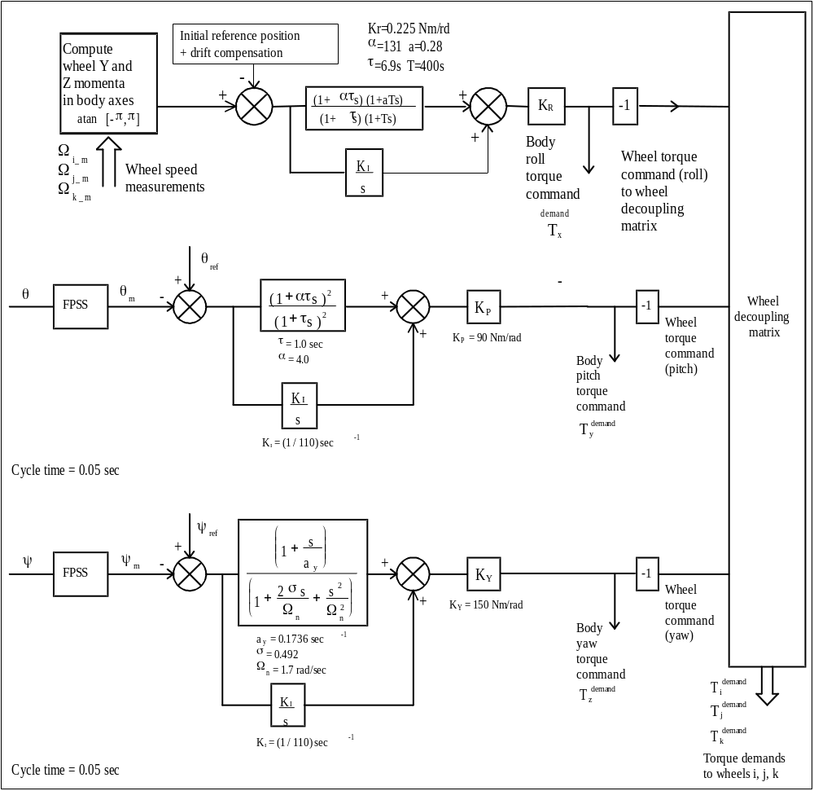
Figure 3.5/7 : overview of the CRP control algorithms

Pitch and yaw control laws
The pitch and yaw control is performed with algorithms almost identical to the ones used in the RMW mode :
- The FPSS data acquisition and error angle computation are unchanged from the ones used in the original NM and RMW modes, except that the FPSS reference is set at the CRP mode entry at the measured FPSS value.
- The pitch and yaw control algorithms in CRP mode are the same as for the old RMW mode, except that the algorithms linked to the pitch and yaw feedforward terms are now deleted.
- A separate set of parameters is nevertheless used for the CRP pitch and yaw controller, to cope with the CRP to CRP initialisation functions
Profiled attitude demands may be commanded in pitch and yaw : they directly act on the FPSS references. They are basically used to trim down to zero the large FPSS references taken at ESR exit.

Roll control in CRP
The CRP roll control algorithms are summarised on Figure 3.5/8 : The CRP roll control algorithms.
When CRP mode is entered, the pitch and yaw controllers are started, but start-up of the roll controller is delayed for 40 seconds. This gives the pitch and yaw controllers time to converge on their steady state before the CRS is used.
The predominant design driver for the roll control law is the decoupling of the roll axis from the pitch and yaw axes. Indeed, any transient activity on the pitch or yaw axes will result in a temporary change in the measurement of the roll angle due to the wheel momentum transients induced by the pitch/yaw control laws.
The roll control law has been designed with a very low bandwidth, such that the coupling of these transients into the roll axis is minimised. The settling time on the roll axis is approximately 250 to 300 seconds.
If the CRS output is not valid, the roll error angle is directly set to zero, and the calculation of the control torques directly takes place. At the first measurement where the CRS output becomes valid, the "set reference" flag is raised and the initial reference is set to the CRS measured angle, and the CRS compensation is reset to zero.
From that status, the CRS drift compensation algorithm is started, and takes place every 500s. Roll slew manoeuvres can also take place.
The current reference angle is calculated by subtracting the cumulative slew angle (see specific paragraph for roll manoeuvres) from the drift compensation angle, and adding the result to the initial roll reference angle. The roll error angle is computed thereafter. Both the reference angle and the roll error angle are scaled to -π to +π, to allow for large roll angle rotations.
The computation of the roll error logic is summarized on Figure 3.5/9 : The CRP roll error algorithms.

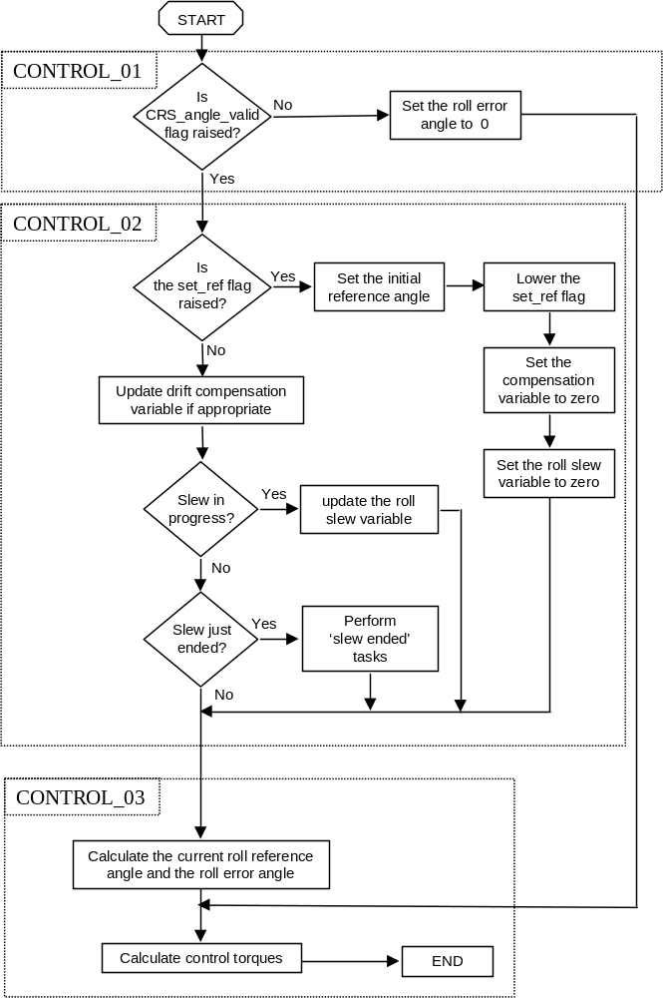
Figure 3.5/8 : The CRP roll control algorithms
IF the CRP mode time is (n * Compensation_period) + Roll_delay
(Roll_delay is the time that the roll controller delayed from the beginning of CRP mode. Compensation_period is the period between update of the drift compensation variable. N is an integer between 0 and ∞)
CRS_drift_comp = CRS_drift_comp + CRS_drift_delta
END
IF a roll slew is in progress
Roll_slew = cumulative delta angle from reference generator
ELSE IF a roll slew has just ended
Perform the associated variable transfers (refer to specific paragraph) on the roll axis.
END
Current_reference_angle = Initial_reference_angle + (CRS_drift_comp – Roll_slew)
IF Current_reference_angle > π
Current_reference_angle = Current_reference_angle – (2×π)
Initial_reference_angle = Initial_reference_angle – (2×π)
ELSE IF Current_reference_angle < -π
Current_reference_angle = Current_reference_angle + (2×π)
Initial_reference_angle = Initial_reference_angle + (2×π)
END
Roll_error_angle = CRS_roll_angle – Current_reference_angle
IF Roll_error_angle > π
Roll_error_angle = Roll_error_angle – (2×π)
ELSE IF Roll_error_angle < -π
Roll_error_angle = Roll_error_angle + (2×π)
END

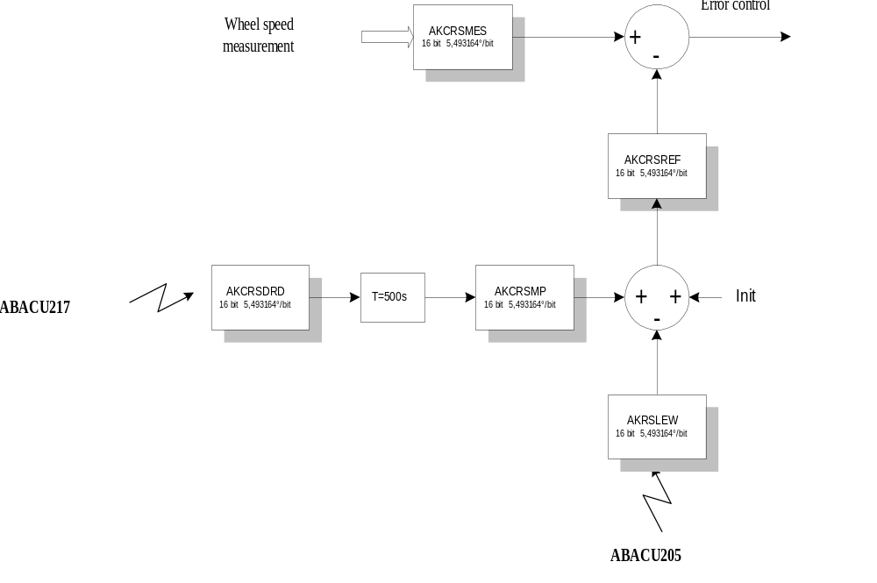
Figure 3.5/9 : The CRP roll error algorithms

Attitude profiles in CRP

Roll Manoeuvres
Roll attitude trim manoeuvres are performed by changing the reference angle to the required position in the body axis. The reference angle is modified using the Attitude Profile Algorithm (refer to section 3.8 : AOCS additional features) on a dedicated software variable : roll_slew angle (AKRSLEW in telemetry). This variable acts in the establishment of the current CRS reference computation as a trim of the CRS reference. The steady state rate is at 30"/s, achieved after a 180s acceleration period. This is illustrated on Figure 3.5/10 : 60° roll manoeuvre in CRP. At end of the manoeuvre, the CRS reference is reinitialised appropriately and this variable is reset to zero.
The following initialisations then take place to ensure continuity of the CRS reference and the roll telemetry.
- Roll_TM_offset = Roll_TM_offset + Roll_slew
- Roll_slew = 0
- CRS_drift_comp = 0
- Initial_reference_angle = Current_reference_angle
There is no limit to the magnitude of a profiled trim manoeuvre.
For large manoeuvres, the error in the wheel inertia and wheel alignment knowledge can result in significant errors in the actual angle that the spacecraft is rotated through. This is developed in section 3.5.7. This calls for large angle manoeuvres done in low rate telemetry.
During a roll slew, the SSU may be set into Mapping mode, thus providing star positions to ground so that the absolute roll attitude can be tracked. If so the stars shall be released before they exit the SSU field of view, in order to avoid overlapping problems on SSU (and hence an SSU reset).

Pitch and yaw attitude trims
The pitch and yaw trim manoeuvres are performed in the same way as in RMW and Normal mode. The FPSS reference angle is modified using the Attitude Profile Algorithm (see dedicated chapter). The steady state rate is at 20"/s, achieved after a 180s acceleration period.
The pitch and yaw attitude trims corrupt the roll angle measurement from the CRS. This comes from two different facts :
- Due to the rotation of the spacecraft, the transverse momentum changes slightly in the spacecraft axes, yielding to a roll angle steady state offset.
- Due to exchange of momentum between the wheels and the spacecraft during the rotation, the transverse momentum changes slightly in the spacecraft axes, yielding to a roll angle transient corruption during the manoeuvre
The steady state offset is easily predicted to a high degree of accuracy by multiplying the initial wheel momentum vector by the relevant rotation matrix, and calculating the relative change in the CRS angle.

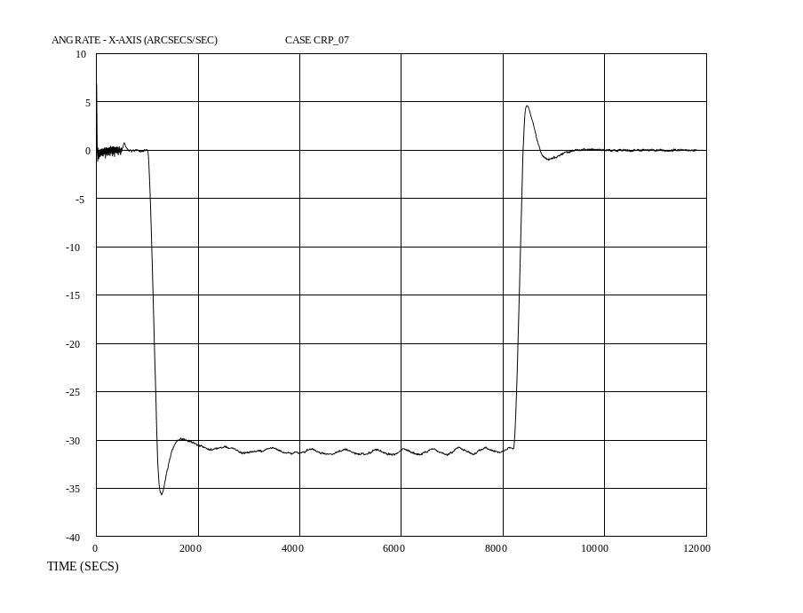
roll rate
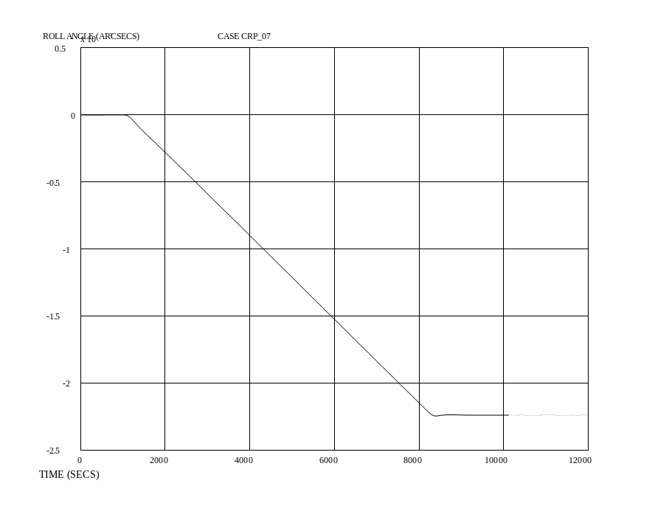
roll angle

Figure 3.5/10 : 60° roll manoeuvre in CRP
Hence, this resultant offset in roll can be known and corrected immediately following an FPSS trim manoeuvre.
The transient motion of the roll axis is dependant on the position of the momentum vector in the body axes, and the coast rate of the trim manoeuvre. Transients corrupting an HGA required pointing accuracy for medium / high rate telemetry can take place with the baseline 20"/s rate. Therefore, the following strategy is proposed :
- When entering CRP from ESR, the trim manoeuvres on the pitch and yaw axes will be performed prior to acquisition of medium / high rate telemetry via the HGA.
- When entering from Normal mode or RMW mode, no correction of FPSS reference will be allowed, until transition is performed in RMW.
The roll performance during pitch and yaw attitude trims is developed in section 3.5.7.

Transitions into CRP

Initialisations for control
At CRP mode entry from any mode (including the CRP mode itself), the current FPSS pitch and yaw attitude measurements become the new pitch and yaw attitude references, and the attitude profile manoeuvres are aborted.
The CRS reference logic is initialised, and 40s after the mode entry, the CRS reference is taken at the measured CRS angle, and the CRS compensation starts.
The CRP mode roll, pitch and yaw integrators are initialised as follows :
- from a Stand-By mode or an CRP entry condition, the integrators are initialised at zero
- from a RMW or NM mode entry conditions, the integrators are initialised from the former mode integrators, on all the axes
At CRP mode entry from any mode, all the second order filters are set equal to zero.

Others initialisations
Appropriate initialisations are made to ensure roll attitude telemetry continuity at CRP entry :
- The roll attitude telemetry is held constant and the source of attitude telemetry (SSU or CRS) is left unchanged during the CRP phase when the roll control is not yet started.
- After that phase, the roll attitude telemetry is forced to a “CRS based” telemetry, and the roll telemetry is initialised with pseudo – continuity with respect to the last frozen value :
new TM offset for CRP = last roll TM value
As part of the CRP mode initialisation, any remaining actuation demands from the execution of on going ABACU201 telecommand are cleared.

Transition to RMW
The transition to RMW is made conditional on board on two items :
- the SSU, as reported by the mode status word, is in the searching / tracking mode or in the searching / tracking restricted mode and the currently defined control star, at least, is tracked valid, and is “eligible” (see dedicated chapter)
- no attitudes manoeuvres are on going roll pitch or yaw axes.

For that purpose, an SSU mapping will be commanded in CRP before the transition to RMW. This mapping will select and initialise automatically a default control star for RMW. Then ground will be in charge of :
- establishing the SSU in the searching / tracking mode while keeping this star, using the maximum search track window in the aim of acquiring as many stars as possible.
- setting all the tracked stars eligible, if they stay valid.
If the star already identified as the candidate control star can be made eligible, and is not at the border of the SSU field of view, it is proposed to perform the transition to RMW using this star. Otherwise it has to be released and one amongst the other has to be selected. Acquisition of more stars using the searching tracking restricted mode is the matter of RMW operations (refer to the Note presented at end of this section).
The selection of the new control star resets the staircase filter counts and the Z spike coordinate filter (old patch 6), and prepares for a smooth transition in RMW. Anyway, adequate initialisations are done at the level of the CRP exit, regarding the SEU protection strategy :
- The staircase filter counter is cleared as part of the CRP to RMW modes transition
- Adequate initialisations are performed at RMW entry from CRP such that the patch 6 logic is effective at RMW mode start, without interfering with the control error.
- The CRP flag is set to "false", as part of the CRP to RMW mode transition
Appropriate initialisations are made at the level of the mode transition to ensure roll attitude telemetry continuity at CRP exit to RMW :
- As part to the transition into RMW, the roll attitude telemetry is forced to a “SSU based” telemetry.
- The roll telemetry is initialised with pseudo – continuity with respect to the last “CRS telemetry” value
new TM offset for RMW = old TM offset for CRP - current RSL value
Appropriate initialisations are made at the level of the mode transition to ensure correct initialisations for the RSL offsets :
- All the RSL offsets for eligible stars being tracked and valid are initialised to measured values
- At that stage, if any of the eligible stars is at a non valid condition, its "eligibility" flag is set to false
The Compensation level of the CRS is not changed by the CRP to RMW mode transition. On the other hand, the CRS drift initialisation logic is reset, requiring thus two telecommands (separated by 12 hours) before the CRS drift compensation can be recomputed on board.

Note :
It is not intended to acquire in CRP more stars than can be acquired by the searching tracking mode. These activities might be left, if desirable, to the RMW phase.
Indeed, the residual slow drift in CRP makes the usage of the searching tracking mode possible (the ST maximum search window is ±0.34° in Y and ±0.25° in Z, yielding to a valid star centre prediction valid over 6 hours for the maximum CRP uncompensated drift) and the usage of the searching tracking restricted mode impossible (the uncertainty for using the STR mode is ±0.011° = 40" = 1 pixel on the star position, yielding to a valid star centre prediction valid over 13 minutes for the maximum CRP drift).

Control performances in CRP

Pitch and yaw performances
The CRP control sharing the same pitch and yaw controllers with the RMW mode, the CRP pitch and yaw performances are as per RMW.

Roll steady state performances
Outside experiment perturbation, the roll rate noise in steady state (including in steady coasting phases of roll manoeuvres) is better than 6"/s, and the roll torque noise is smaller than 0.015 Nm.
Outside experiment perturbation, the roll angle noise is steady state is better than 50" peak.
When experiencing perturbations from experiments motion or attitude glitches from reaction wheels (worst case envelope of 0.04 Nms in roll, 0.02 Nm in pitch or yaw), the roll performance depends on the size and position of the momentum embedded on the reaction wheels, as can be in worst case :
- 135" roll excursion and 4.4"/s peak roll rate, for roll perturbation
- 1237" transient roll excursion with 1000" roll steady state offset and 35"/s peak roll rate, for pitch or yaw perturbation.

Roll performances during pitch and yaw attitude trims
The generic roll behaviour for a manoeuvre on either the pitch or yaw axis can be described qualitatively as follows:
- At the start of the manoeuvre, the roll axis will respond with a rate transient due to the application of momentum onto the ‘manoeuvre’ axis.
- The rate will then typically settle down to a non zero value. This is due to the rotation of the inertial angular momentum vector in body axes.
- At the end of the slew, the roll axis will exhibit another rate transient as the ‘manoeuvre momentum’ is removed and the motion of the inertial angular momentum vector in the body axes comes to a stop.
- After the manoeuvre is complete, the roll axis will reach a steady state roll angle that is not the same as the initial roll angle; a direct result of the rotation of the spacecraft body.
Of course, there are always exceptions to generic behaviour:
- If the initial momentum vector is perfectly aligned with the manoeuvre axis, there will be no transient or steady-state offset on the roll axis.
- If the initial momentum vector is in the plane orthogonal to the manoeuvre axis (a zero manoeuvre axis component), the roll axis will experience the transient motion, but there will be no steady state offset from the initial roll angle.

The worst case steady state error occurs when the initial momentum vector has a very small component on the manoeuvre axis, a large component on the roll axis, and zero on the other axis. It can grow up to 3.6° for 0.5° sun pointing trims.
The roll steady state offset prediction can be performed as per ANNEX 7 - ERRORS IN ROLL MANOEUVRES IN CRP.
The worst case transient error occurs when the momentum vector is orthogonal to the manoeuvre axis, and has small components in the orthogonal axes. It can go up to a transient angle on the CRS of 4.62°.

Roll performances in roll manoeuvres
The accuracy to which the slew is performed is determined entirely by the assumed characteristics of the wheels used in the CRS. The prediction of the accuracy depends principally on the wheels inertia knowledge and on wheels misalignments. It can be performed as, follows :
- If 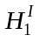, 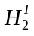, and 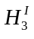 are the initial wheel momenta, and 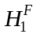, 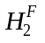, and 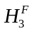 the final wheel momenta, in the roll, pitch and yaw axes respectively, the angle between the intial CRS vector and the final CRS vector, , can be found using the vector dot product; hence:
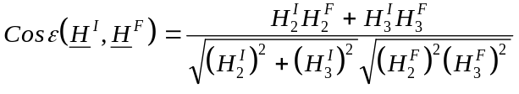
- Given a pitch rotation of 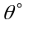, the final components of the wheel momentum can be expressed in terms of the initial components, hence:
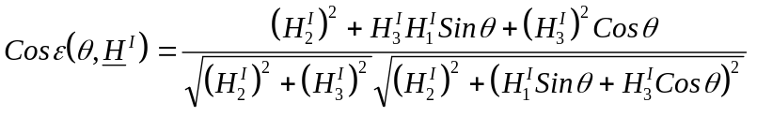
- The equivalent expression for a yaw rotation is:
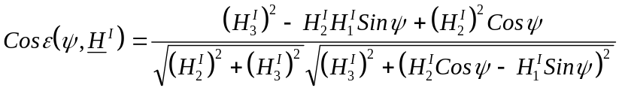 8.1.3-2

The roll error at end of manoeuvre can grow up to 8.7° for a 180° rotation, assuming an inertia knowledge of the wheels by 2% and 0.25° alignment errors.
The maximum roll manoeuvre which can be performed in CRP with the possibility to maintain performance with medium / high rate telemetry from HGA is 8°.

Miscellaneous performances
The maximum step which can be applied in roll to CRP without generating wheels saturation is about 1°, and is damped in 800s.
The CRS/CRP response to steps in pitch or yaw attitude depend largely form the size of the embedded momentum, and can be as high as transient 1.4° errors on the CRS and 0.14° on the roll angle if 20" steps are applied.
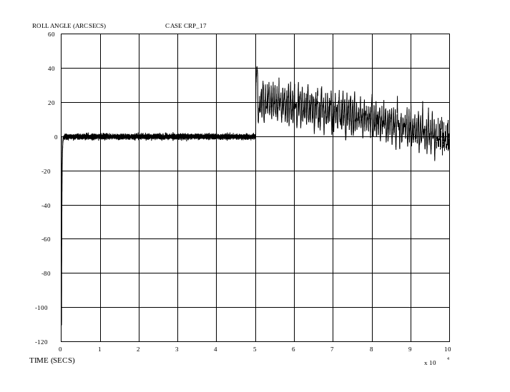
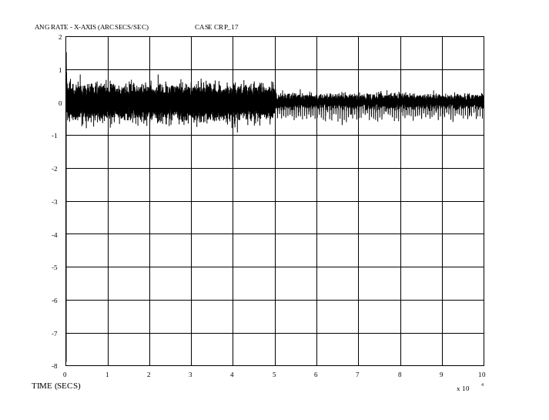
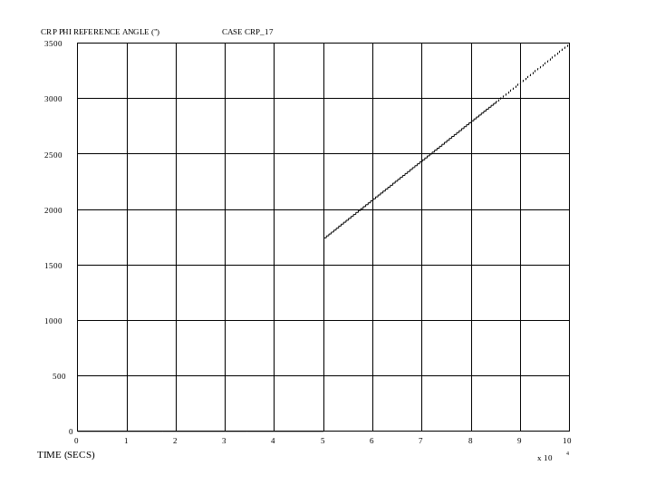
Figure 3.5/11 : Steady state CRP (NM then CRP)
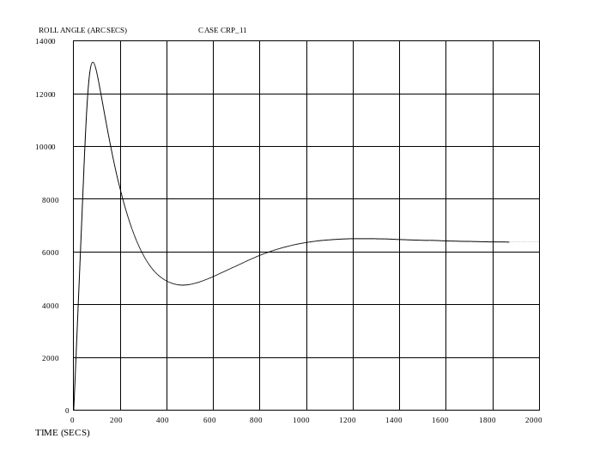
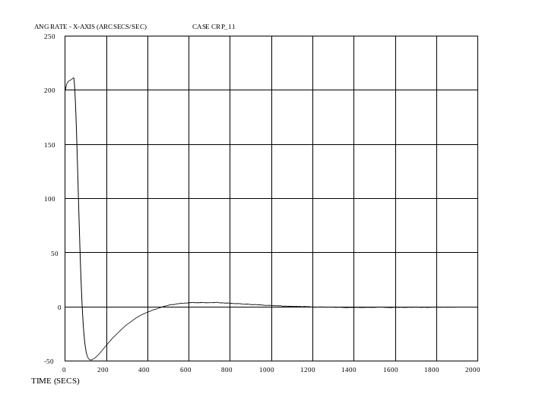
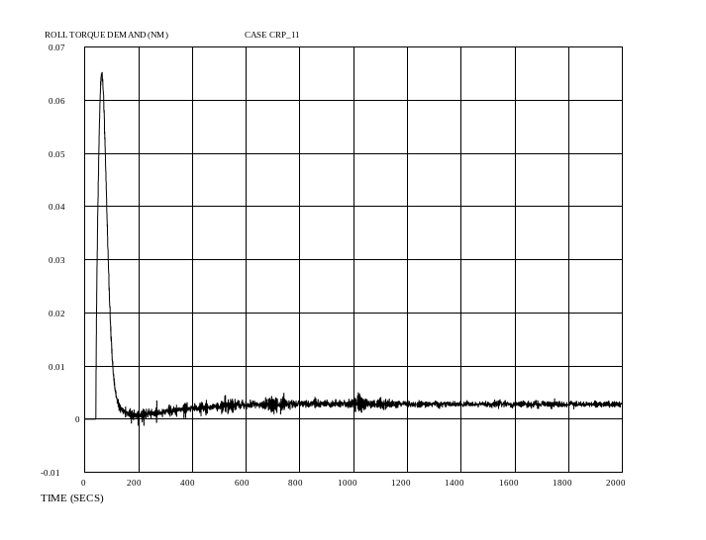
Figure 3.5/12 : ESR entry transient
The roll attitude excursion from the initial roll reference at start if roll control at CRP entry from ESR can be up to 2°, and is damped in 1000s worst case. The roll rate is reduced below 5"/s after 400s.
The CRP can control roll entry rates up to 0.05°/s while maintaining sun pointing. The capacity for CRP to control higher rates depends on the momentum configuration on the wheels.
The CRP roll control performance close to the CRS deadband is better than 50" roll angle noise, 10"/s roll rate noise, 0.08 Nm peak roll torque demand.

CRS and CRP operational constraints

CRP constraints
- ABACU201 TC (open loop thruster block telecommand) shall not be sent if the current active mode is the CRP mode. This TC is rejected otherwise.
- When entering CRP mode from ESR, the pitch and yaw rates must be less than or equal to ±40”/s.
- When entering CRP mode from ESR, the roll rate must be less than ±100”/s.
- The usage of pitch and yaw attitude trims in CRP do not comply with the capability to maintain the High Gain Antenna medium / high rate telemetry. This would also apply to direct FPSS offset (by direct write to memory). Attitude trimming on FPSS shall therefore be performed only in low rate telemetry, with the attitude profile manoeuvre. They will provoke both CRS transients and steady state errors.
- The proposed strategy is to trim FPSS references to zero at ESR exit, and to leave other FPSS trim activities to RMW, if CRP is entered from NM or RMW conditions.
- When entering CRP mode from ESR, 15' shall be elapsed before the attitude trims are performed on FPSS. In between the two trims, 15' shall also be elapsed. This is to grant the CRP roll control convergence.
- Before any manoeuvre is attempted, the ground shall verify that during the complete manoeuvre no overspeed condition will occur, at that any of the reaction wheels speed goes above the operational limit of 3000 rpm. The reaction wheels speed at stop of the manoeuvre shall not be below 500 rpm.
- The magnitude of roll manoeuvres must be less than or equal to 8 degrees if it is desired to ensure that the medium / high rate telemetry can be maintained all through the manoeuvre. This applies if no particular wheel speed subset is used.
- The FPSS offsets shall be lower than 0.3° before attempting any roll manoeuvres with telemetry from HGA
- In TM low rate condition, any size of roll manoeuvre can be commanded.
- Attitude profile manoeuvres will not be performed by the AOCS software (on any axis) if the CRS is within its deadband.
- Would CRP be entered with CRS in its deadband, the CRP exit activities can be performed up to the point of SSU mapping. If SSU A can be made available, the transition to RMW can take place. If any of the two SSU can not be made available, the natural exit of the CRS deadband shall take place before SSU operations are retried on A or B unit. This can take days.
- At CRP entry from RMW or NM, any real time roll angle from the experiments shall be recorded
- After one day in CRP (if applicable) :
- the roll angle evolution shall be checked by the experiments
- the CRS drift can be tuned according to the predicted torque / orbit evolution and crossed checked with the experiment observations. The trim of the drift is proposed to be done if the update is higher than 20%.
- the roll TM offset shall be modified according to the experiment observed roll angle
- the spacecraft shall be rolled back to its nominal position
- As soon as the roll absolute attitude is identified in CRP, whichever the means, the roll telemetry offset shall be modified accordingly to allow suitable roll angle telemetry.

CRP to RMW transition
- At the level of the CRP to RMW transition, for performing the transition :
- It is the ground responsibility to acquire and track at least a star using the SSU searching tracking mode
- As many stars as possible shall be acquired using the maximum SSU searching / tracking window, in the respect of the star selection criteria applied in NM and RMW.
- It is the ground responsibility to make these star eligible
- All the roll, pitch and yaw manoeuvres shall be completed
- Once in RMW, the roll telemetry offset shall be fine trimmed to the actual attitude value, pending the actual stars position in the SSU. Roll attitude shall be trimmed to the desired position afterwards, using an attitude profile. This is to compensate for the small CRS drift experienced in CRP since last roll attitude determination and roll TM offset trim.
- In RMW, after CRP exit to RMW, the FPSS references shall always be trimmed to the desired values, using an attitude profile.

CRS constraints
- In RMW, the value used for drift compensation is automatically set to zero whenever a thruster telecommand is sent.
- In CRP, when large slews are attempted (>10°), the CRS drift compensation has to be set to zero before the manoeuvre. In addition, at end of manoeuvre, ground will upload a compensation value, derived from new ground predictions of wheel speeds evolution, that can be used by the CRP algorithm.
- In RMW or NM, this value becomes invalidated if the desired cumulated roll angle manoeuvres appears to be larger than 10° from the attitude at which the last CRS drift value was estimated.
- In these two cases (thruster / roll), once the manoeuvres are completed, the ground is required to re-initiate the on-board measurement process. This will be performed straight after the manoeuvre, and between 12 and 24 hours after. In addition, ground will upload a temporary compensation value, derived from new ground predictions of wheel speeds evolution, that can be used by the CRP algorithm. This value can also be uploaded if the current mode appears already CRP before the value has been uploaded.
- During either NM or RMW, outside momentum management, station keeping manoeuvres or attitude manoeuvres, the commanding of the CRS drift compensation update shall be done between 12 and 36 hours. No commanding shall be performed before 12 hours. A daily activity is recommended.
- In NM and RMW modes, the commanding of the CRS drift compensation update shall be performed by procedure straight after any attitude or thruster manoeuvres and CRP mode exit, and 12 hours after these events.
- If applicable, upon changing the RW H/W configuration word (ON status or wheel subset selection) outside procedures using thrusters, the CRS drift compensation would have to be set to zero by procedure. In that case, the ground would have also to predict from models the new anticipated CRS drift evolution once the activity is completed.

Various notes :
- SSU trouble shooting operations shall be performed in CRP.
- There is no limitation on the number of revolutions which can be performed in CRP on the roll axis
- The principle of operations shall always grant a transverse momentum higher than 1 Nms, even during momentum management and RW4 maintenance (baby sitting) activities. In order to get good performances in CRP, it is recommended to optimise the periods when this transverse momentum is higher than 10 Nms.
- The maximum change that is allowed to be made to the CRP roll reference is 1 degree, or 0.01745 radians, separated by 800s.

RMW mode

Presentation
The new RMW mode is derived from the original RMW mode. The SSU is used to determine the satellite roll attitude, and FPSS is used as pitch and yaw attitude sensor. The reaction wheels are used as control actuator.
The major change is linked to the fact that the SSU becomes the sole RMW roll sensor, which simplifies the original RMW software :
- No more software logic is used to perform swapping from the original gyro based control to the SSU and gyro based control. Instead, the roll control is a direct replica from the normal mode roll control.
- The roll attitude telemetry is forced to a "SSU based" status
- No more feedforward terms are input to the pitch and yaw RMW controller, which remains unchanged otherwise.
On the other hand :
- a complementary AOCS functionality is applied in this mode to authorize an automatic switch over to a new control star in case of star outage. This functionality is only made possible when the SSU is tracking more than one star. The number of stars (up to 5) and the eligible stars which can participate to that process are left to ground control and responsibility. Ultimately, if no eligible and valid star is available within the SSU field of view, transition to CRP is commanded by a dedicated COBS monitoring function (refer to section 3.10).
- The old "patch 6" Z spike filter logic is applied in RMW, as a complement to the old "patch 5" staircase filter for protection against corrupted SSU measurements. Both protections are exclusively applied on the current control star.
In RMW mode, the roll steering law is not active and attitude profiles may be executed on all the axes. As for CRP, the FDE FSPAAD & CSPAAD failure criteria and the Hx COBS monitoring function are enabled in RMW mode. A monitoring of the wheels speeds is also performed by the COBS.

Open loop thruster actuations can be performed in RMW under the normal FPSS/SSU/RW control to perform Station Keeping maneuvers (delta V's), Momentum Management or RW4 maintenance maneuvers. In these phases :
- The LVA is opened, then closed at maneuver completion.
- The star swap logic is inhibited by the on board software by appropriate initializations, and the staircase filter count threshold is verified to be at a small value. (note: star swap logic is also inhibited through ground commands prior to thruster operations).
- The Hx monitoring function is disabled during both momentum management and station keeping phases
- A constraint is set to get fast ground reaction times in case of anomaly or loss of contact.
- Additional services are provided by the COBS software thruster on time monitoring.
- The boundaries for the RW speed monitoring are extended to the full operational range.

Maneuvers using thrusters in RMW

Presentation and general items
In the initial design, the rationale to use the gyroscope as a roll sensor was the inability for the SSU to track stars at rates above than 40"/s.
Given the tight planning allowed to design an early gyroless mission in January 99, including the momentum management and delta V capability, the only achievable solution was to design momentum management and delta V manoeuvres by open loop pulsing while under reaction wheels control.
This solution, which has been operated several times in flight with satisfaction, has been fully reconducted for the final gyroless operations.
The delta V capability has been restricted to the +X and -X axes. This latter point is not constraining, and linked to the following rationales :
- At mission analysis level the transverse delta V are not necessary to maintain the Halo orbit, even after major orbit perturbations such as experienced after the recovery of the spacecraft.
- At operational level, the achievement of a transverse delta V necessitates a potential spacecraft roll alignment.
At spacecraft level, the achievement of delta V pulse trains on the Z axis while keeping the rates under 40"/s is slightly more difficult than on the other axes. This is linked to the smallest roll inertia and to the largest uncertainties for the achievement of a well balanced OFF modulation.
The momentum management principle has been restricted to single axis management at a time. This latter point allows a better control of the restitution of the thrusters efficiency, and is a better safeguard for granting rates on the roll and pitch axes adequate for the SSU.
The open loop thrusting service is directly available on board with the ABACU201 telecommand. This one provides the capability to generate pulse trains of up to four thrusters, with full programmability of ON & OFF times.

For thruster based manoeuvres, the pulse trains respect several major issues :
- They do not impart rates above 40"/s on the SSU (roll and pitch axes on the spacecraft). The design goal used is 25"/s.
- They do not generate excessive power dissipation in reaction wheels
- Each pulse effect is damped by the reaction wheel control before the next pulse is exercised
- The repetition frequency and the pulse amplitudes is close to the highest bound acceptable to minimise the duration of the operations to an acceptable level
- The pulses trains comply with the vapour lock constraints
- Pulses start dates are synchronized when more than one thruster is used

The star swapping logic is inhibited by the ACU software on receipt of an ABACU201 open loop thruster block telecommand. This is achieved by setting all the stars to a “not eligible” status, automatically on board, upon the reception of the ABACU201 header. (note: star swap logic is also inhibited through ground commands prior to thruster operations by setting all stars to “not eligible).
The ground must re-authorise the star swapping function on completion of the ABACU201 telecommand. This is done when the LVA is closed. The SEU protection logic on the current guide star, however, is not affected. The objective is to minimise the time needed to raise the “CRP flag” (the AOCS flag send to the COBS requesting a transition to CRP mode) once the LVA is open and thrusts are about to start.
Once thrusters are used, the CRS drift estimator logic is reset and the estimated CRS drift correction is cleared. The ground will be in charge of reinitialising this functionality after each manoeuvres.
The thruster on time monitoring thresholds are set to common values for delta V and momentum management. The protection mostly cope with clearing errors in pulse trains commands. The train is cleared once the first pulse is executed and found of excessive size. The thresholds are set on 1/2/3/4 at 1.1 s to allow for delta V's and OFF modulation. The thresholds are set on 5/6 to 0.3 sec to allow for momentum management. The thresholds are set to 0 on 7/8 (not used).

The momentum management phase
The overall momentum management is achieved by pulsing several series of pulse trains while performing RMW control under reaction wheels and SSU.
Each pulse train corresponds to the firing of one single thruster, delivering a torque mostly on one of the spacecraft axes (the torque matrix at 13.6 bar, current flight pressure, is given in Figure 3.6/1 : Thruster torques (theoretical values at current flight pressure) :
- Thruster 1 : generates a positive pitch torque
- Thruster 2 : generates a negative pitch torque
- Thruster 3 : generates a negative yaw torque
- Thruster 4 : generates a positive yaw torque
- Thruster 5 : generates a positive roll torque
- Thruster 6 : generates a negative roll torque
Thrusters 7 and 8 are not anticipated to be used in the frame of the momentum management. This is to allow longer pulses to be performed on thrusters 5 and 6. This is also linked to the fact that thrusters 7 and 8 can not be used during the delta V operations (the ABACU201 command has a limitation to operate only 4 thrusters). A common protection against unforeseen commands can therefore be established for both mission phases.
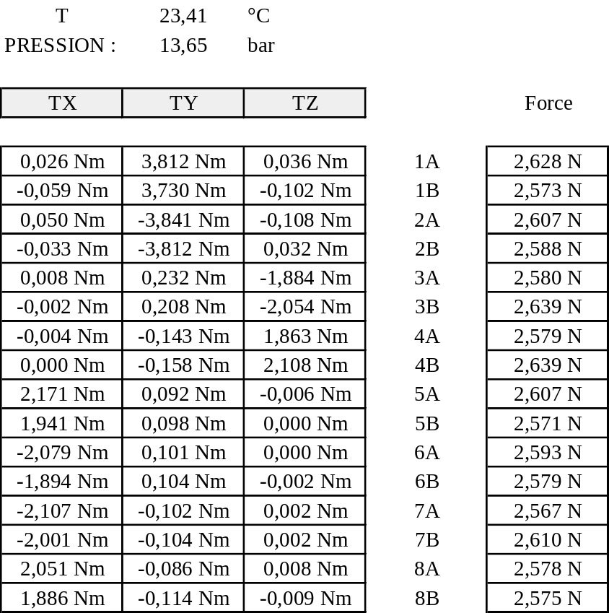
Figure 3.6/1 : Thruster torques (theoretical values at current flight pressure)

In most of the cases, three pulse trains are sufficient to allow for the change of the three reaction wheels speeds from an initial set of three values to a targeted set of final speeds.
The amounts of Nms to be delivered by each of the three pulse trains are to be derived from the difference, directly expressed in the spacecraft axes, between the final wheels momenta and the initial wheels momenta. This value allows selecting the three thrusters that shall be used, looking at the roll, pitch and yaw requested momentum signs. The on time to be delivered is finally derived using the inverted torque matrix for the three used thrusters.
The computation of each wheel speed to be achieved at the end of each of the three segments has to be performed. The order of the execution of the segments will be selected such as :
- At each intermediate stop condition, any of the reaction wheels speed is not over 3000 rpm or not under 500 rpm in absolute value
- During the overall momentum evolution on the reaction wheels, a residual 1 Nms transverse momentum stays.
If any of these two conditions is not fulfilled, a fourth segment is to be introduced. The simplest way is in that case to split a segment on one axis on two (equal) segments, not performed in a row. This artefact always allows finding a workable solution.
The sizing of the pulse trains related to the roll, pitch, yaw is linked to targeting both a maximum rate at 25"/s per axis, and an average torque of 0.007 Nm on the reaction wheels. The associated boundaries at 40"/s in roll and pitch, and 0.014 Nm if all the wheels are braking simultaneously.
The maximum rate is verified by designing the elementary impulses of each pulse of the train to deliver a value of 25"/s on a free body dynamics :
- Thruster 5 or 6 (Roll axis) at 0.25 Nms, which correspond typically to 120 ms at current 13.5 bar pressure, and typically to 150 ms at 10 bar
- Thruster 1 or 2 (Pitch axis) at 0.39 Nms, which correspond typically to 100 ms at current 13.5 bar pressure, and typically to 130 ms at 10 bar
- Thruster 3 or 4 (Yaw axis) at 0.44 Nms, which correspond typically to 235 ms at current 13.5 bar pressure, and typically to 310 ms at 10 bar
The average torque constraint is verified by computing for the three axes the required maximum Nms level to be stored on one of the wheels, each time a pulse is executed, and scaling it by the 0.007 Nm average torque value to find the pulse repetition frequency :
- 35 second on the roll axis, whichever the wheel configuration is used
- 60 seconds on the pitch axis, if wheels 1/2/3 or wheels 1/3/4 are used, and 35 seconds otherwise
- 35 seconds on the yaw axis, if wheels 1/2/3 or wheels 1/3/4 are used, and 60 seconds otherwise
This latter constraint is always sufficient to damp the attitude and rates transient by the control for performing series of pulses.
Although the length of the roll and pitch thruster pulses are below the recommendation associated for the vapour lock problem (ie 160 ms at 14 bar and 240 ms at 10 bar), there is no concern anticipated. Indeed the high settling time between pulses yield to duty cycles well decoupled from the 1% critical duty cycles (less than 0.3 to 0.4 %). If vapour lock problem were to be experienced in flight in that phase, an increase of the settling time would be recommended.
A typical momentum management (flight data) is illustrated in Figure 3.6/2 : Thruster actuation (roll segment, then pitch segment), Figure 3.6/3 : RW speed evolution (roll segment, then pitch segment) and Figure 3.6/4 : Attitude evolution (roll segment, then pitch segment).

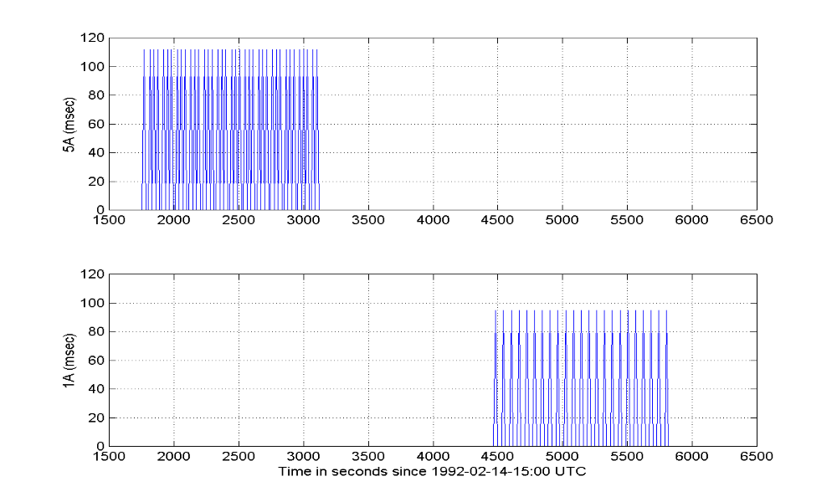
Figure 3.6/2 : Thruster actuation (roll segment, then pitch segment)

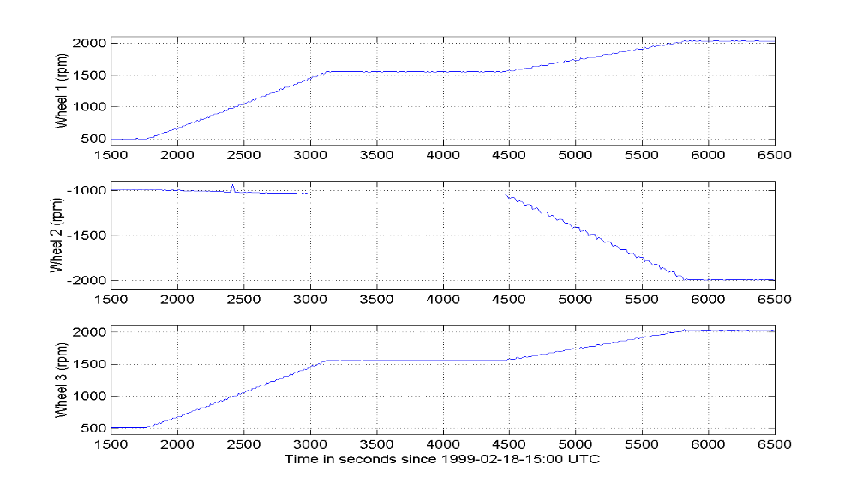
Figure 3.6/3 : RW speed evolution (roll segment, then pitch segment)

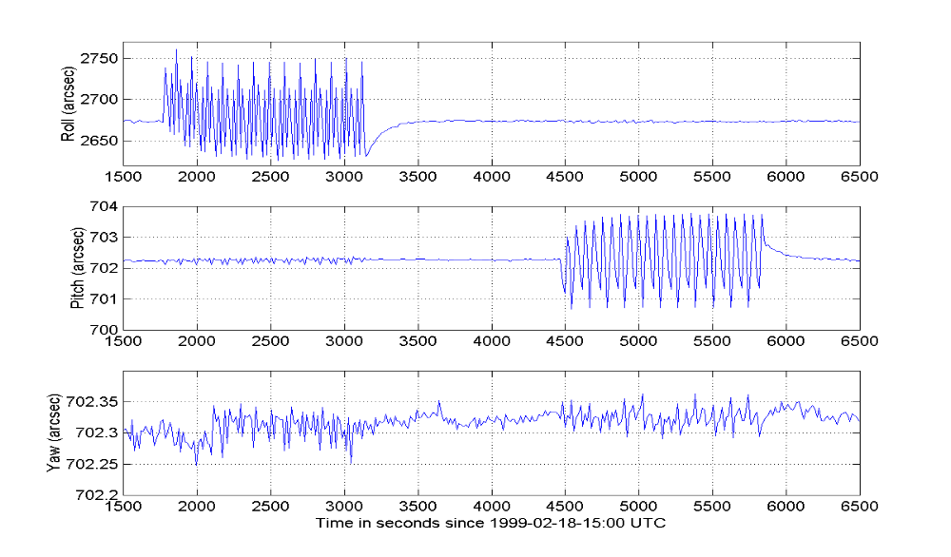
Figure 3.6/4 : Attitude evolution (roll segment, then pitch segment)

RW4 maintenance phase
The RW4 maintenance phase (or baby sitting) is performed with the momentum management procedure, using a strategy as follows :
- rw 2 is driven to zero within 50 rpm by a pitch pulse train,
- rw 4 is switched ON, and declared ON in the hardware configuration word
- subset 1,3,4 is declared to hardware configuration word
- rw 2 is removed from hardware configuration word and switched OFF
- rw 4 is driven to the 1000 rpm speed by a pitch pulse train
- reverse operations afterwards at end of the run in phase

The station keeping phase
The overall delta V manoeuvre is achieved by pulsing an OFF modulated pulse train on the delta V axis, while performing two ON modulated pulse train on the two other axes. These actuations are performed in open loop by an ABACU201 telecommand while RMW controls under reaction wheels and SSU.
The OFF modulated pulse train corresponds to the balanced firing of two thrusters, in the aim of delivering a pure force on the X-axis. Thrusters 1 and 2 are used to perform - X delta V manoeuvres, whereas thrusters 3 and 4 are used to perform + X delta V manoeuvres.
The objective of the balancing is to avoid the wheels speed evolutions during the delta V's. It hence increases the length of the maximum possible delta V's without getting out of the operational wheels speed range, and minimises the need for momentum management.
The balanced OFF modulation avoids a momentum build up around the pitch axis for the -X delta V, and around the yaw axis for the + X delta V. The transverse ON modulation avoids a momentum build up on the two others axes. The definition of the ON and OFF modulation pulses are derived from the thruster torque matrix presented in Figure 3.6/1 : Thruster torques (theoretical values at current flight pressure).
Thrusters 7 and 8 are not anticipated to be used in the frame of the delta V compensation. This is linked to the fact that the ABACU201 command has a limitation to operate only 4 thrusters, leaving only one thruster available for compensation per ON modulated axis.
As for momentum management, the sizing of the delta V pulse train related to the + X and -X axes is linked to targeting both a maximum rate at 25"/s per axis, and an average torque of 0.007 Nm on the reaction wheels. The associated boundaries at 40"/s in roll and pitch, and 0.014 Nm if all the wheels are braking simultaneously.
The maximum expected rate caused by the OFF modulation is verified by designing the impulses of each delta V pulses of the train to deliver a value of 25"/s on a free body dynamics if the OFF modulation residual unbalance is 5% per thruster :
- Thruster 1 or 2 (-X delta V and Pitch axis perturbation) is nominally set at 1s. This imparts (at current pressure level) a pitch perturbation less than 0.39 Nms equivalent to the one used for momentum management. The roll and yaw perturbations are on their side kept well within the ones experienced for momentum management at less than 0.1 Nms for current pressure level.
- Thruster 3 or 4 (+X delta V and Yaw axis perturbation) is nominally set at 1s by similarity, although the equivalent perturbations could have been increased to reach the ones used during momentum management.

The average torque constraint caused by the OFF modulation is verified the same way as done for momentum management. For the two delta V axes, the required maximum Nms level to be stored on one of the wheels, each time a pulse is executed, is computed, and scaled by the 0.007 Nm average torque value to find the pulse repetition frequency. The major assumption taken is that the 5% error is mostly peak noise, hence the finding for the momentum management could be reduced by a factor 3 to really get an average value :
- 20 seconds on the -X axis, as a worst case envelope other the wheels configuration
- 20 seconds on the +X axis, by similarity, although less could be tolerated.
This latter constraint is always sufficient to damp the attitude and rates transient by the control for performing series of pulses. It has to be noted that this scheme yields to a delta V performed in pulsed mode at a 5% duty cycle. The length of the pulses and the duty cycle does not cause concern with respect to the vapour lock concern.
The actual level of torque experienced when pulsing the OFF modulated delta V pulse imposes the level of the ON modulation. That has to be predicted from the thruster torque matrix. The only degree of freedom left is how often the ON modulation shall occur. The ABACU201 commanding principle and the CAE design (a common execute) imposing the ON and OFF modulation pulses to be synchronised, the trade off is to be performed on firing every 20s short pulses or firing less often higher pulses.
Short pulses help to limit the rates, but appear detrimental at the level of the vapour lock concern, and at the level of the predictability and repeatability. On the other hand, the grouping of the pulses to respect the vapour lock recommendation (160 ms at 14 bar and 240 ms at 10 bar) generates roll or pitch rates between 36"/s and 44"/s rates on the roll and pitch axes. These rates are not acceptable with respect to the SSU limits.
Given the foreseen duty cycles necessary to perform the ON modulation, namely less than 0.2% for each manoeuvre - well decoupled from the 1% critical duty cycles -, the retained solution has been to size the maximum pulses not to exceed 100 ms at 14 bar and 150 ms at 10 bar. This correspond to rates imparted on the roll or pitch axes less than 25"/s, and makes the on modulation as follows :
- During -X delta V's, approximately 75 ms every 40s for roll and yaw in current situation, and 120 ms every 60s for yaw associated to 140 ms every 80s for roll at end of life.
- During + X delta V's, 90 ms every 80s for pitch in current situation, and 140 ms every 120s for pitch at end of life, and virtually no compensation on roll (i.e. one 100 to 150 ms pulse on long manoeuvres)
This causes no concern with respect to the average torque and settling times constraints.
The coherency between the anticipated delta V and the will speed will be analysed before the manoeuvre from the current wheels speeds to check if a specific momentum management as to be performed before the delta V. In the frame of the coupled station keeping and momentum management operations, it is recommended to perform the momentum management after the station keeping, anticipating on the momentum management perturbations in the delta V, rather than the other way round.
A typical delta V (flight data, 32 cm/s on + X axis) is illustrated in Figure 3.6/5 : Thruster + X actuation in + X delta V , Figure 3.6/6 : Attitude in + X delta V and Figure 3.6/7 : RW speeds in + X delta V.

Commands to clear the propulsion lines are executed prior any delta V's : 10 times two pulses of 100 ms on 3/4 thrusters and two pulses of 115 ms on 1/2 thrusters, with a repetition frequency of 20s. This provides at least a 1s equivalent pulse on all the thrusters that can be OFF modulated. The delta V impact is nominally null, and the delta H impact very low. The objective is to avoid to generate pitch or yaw attitude spikes and rates at start of manoeuvres.
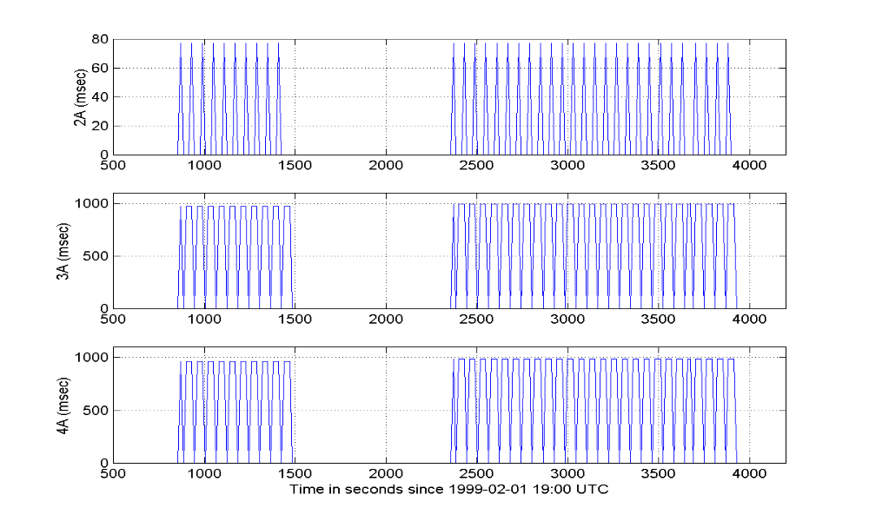
Figure 3.6/5 : Thruster + X actuation in + X delta V
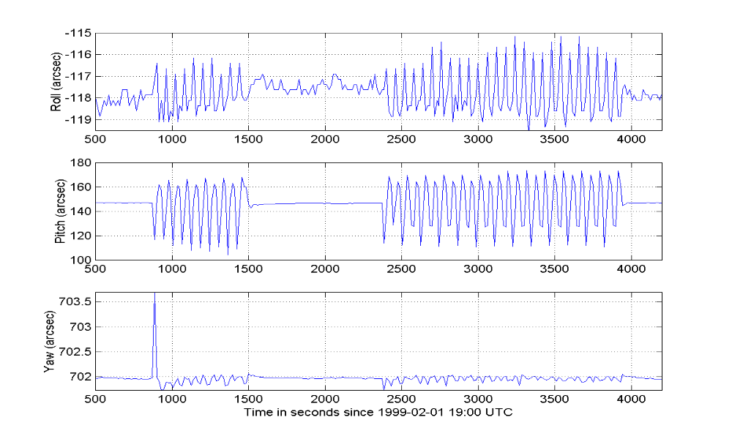
Figure 3.6/6 : Attitude in + X delta V
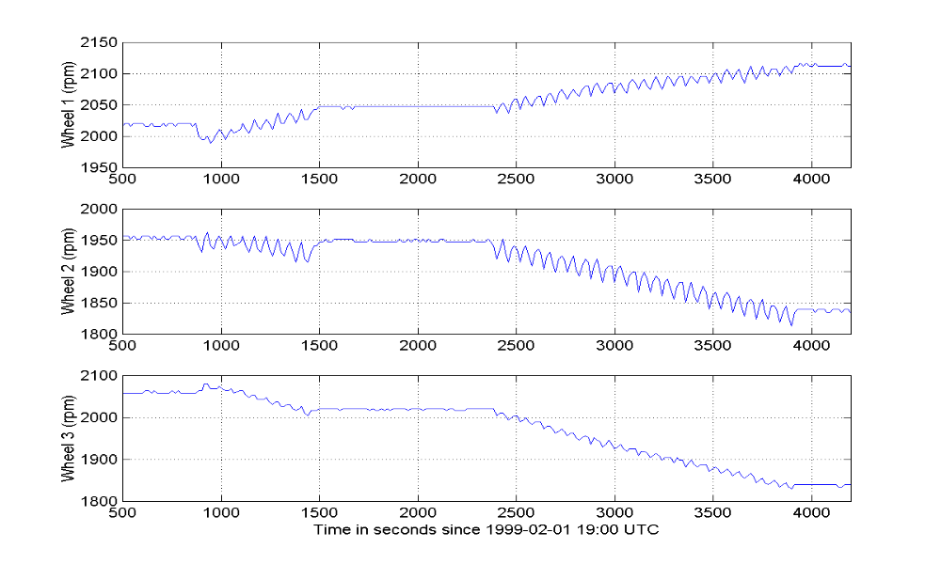
Figure 3.6/7 : RW speeds in + X delta V

The RMW control algorithms
An overview of the RMW control laws is given in Figure 3.6/8 : the RMW control algorithms.

Pitch and Yaw control in RMW
The pitch and yaw control is performed with algorithms almost identical to the ones used in the old RMW mode. They are almost the same than in CRP :
- The FPSS data acquisition and error angle computation are unchanged from the ones used in the original NM and RMW modes
- The pitch and yaw control algorithms in RMW mode are the same as for the old RMW mode, except that the algorithms linked to the pitch and yaw feedforward terms are now deleted.
The RMW pitch and yaw integrators are initialised from the CRP or NM pitch and yaw integrators at RMW entry.
Profiled attitude demands may be commanded in pitch and yaw : they directly act on the FPSS references. They are basically used to trim back the pointing to the operational level, clearing any change of references performed at CRP entry.

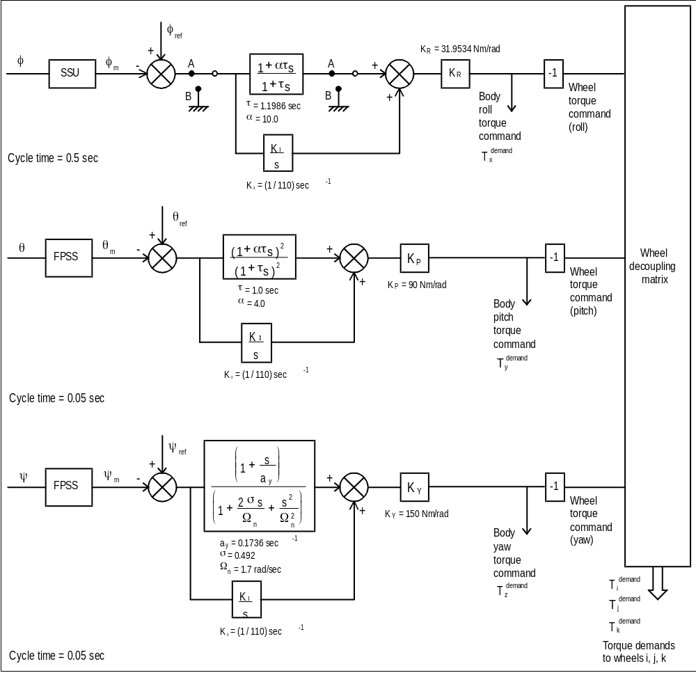
Figure 3.6/8 : the RMW control algorithms

Roll control in RMW
The roll control is performed with algorithms identical to the ones used in Normal Mode. This commonality goes up to the usage of RSL and PCPG values in the definition of the control references, although these functions are not used in RMW.
A separate set of parameters is nevertheless used, to cope with the RMW to RMW initialisation functions.
As per Normal Mode, a filtering logic (old patch 5 and now old patch 6, modified to allow its use in RMW mode) is applied to the control star, and a star swap strategy is included. This star swap is made transparent to the control algorithms.
In case the control star is temporarily not valid, the roll control error signal is set to zero.
The RMW roll integrator is initialised from the CRP or NM roll integrator at RMW entry.
Profiled attitude demands may be commanded in roll. They are basically used to trim back the pointing to the operational level, clearing any CRP residual drift.

Attitude profile in RMW

Roll trims
Roll attitude trim manoeuvres are performed by changing the control star reference angle to the required position in the body axis. The reference angle is modified using the Attitude Profile Algorithm Algorithm (refer to section 3.8 : AOCS additional features) on a dedicated software variable : Roll_Attitude_Offset angle (AKRAO in telemetry). The RAO variable is at a non zero value only during the roll manoeuvre. The steady state rate is at 20"/s, achieved after a 180s acceleration period.
At end of a roll attitude profile, the following operations are done at the level of the last profile cycle :
- Roll_Angle_Ref (Control_Star) = Roll_Angle_Ref (Control_Star) + RAO
- RSLOffset (all stars)= RSLOffset (all stars) + RAO
- Roll_TM_Offset = Roll_TM_Offset + RAO
- RAO = 0.
The Roll_Attitude_Offset angle being independent of the control star, the star swap algorithm is made possible in the attitude trim manoeuvre. The only limitation set to the magnitude of a profiled trim manoeuvre in RMW is that the control star shall not leave the field of view of the SSU.

Pitch and yaw attitude trims
The pitch and yaw trim manoeuvres are performed in the same way in RMW and Normal mode. The FPSS reference angle is modified using the Attitude Profile Algorithm (see chapter 3.8.1). The steady state rate is at 20"/s, achieved after a 180s acceleration period.
A 2° per axis limitation is set to the magnitude of a profiled trim manoeuvre in RMW on Sun pointing, together with the constraint that the control star shall not exceed the field of view of the SSU.

Transitions into RMW
The FPSS pitch and yaw references are maintained to their current values at entry to RMW mode from any mode (Normal Mode or CRP mode).
At entry from CRP mode, the roll control is initialised on the designed control star (valid and eligible) : the initial roll reference position is set equal to the first measured star position through an appropriate initialisation of the RSL offset. No automatic mapping is demanded by the software.
At entry from Normal Mode :
- the roll reference position is kept and the same control star are kept (except if stated otherwise by the star swap logic)
- the same stars are tracked.

Transition to Normal Mode
There is no check of the control star validity or coordinate positions to enable the transition towards normal mode. On the other hand, the transition to NM is made conditional on :
- No ABACU201 open loop thruster block telecommand is programmed to execute
- No ABACU201 open loop thruster block telecommand is in execution

RMW operational constraints

RMW mode operations
- The roll steering law shall not be active in RMW mode.
- The transitions from RMW mode to Normal Mode and from Normal mode to RMW mode shall be performed with no roll steering law active and no attitude manoeuvres in progress.
- The transition from RMW mode to Normal Mode shall be performed with no ABACU201 TC under execution.
- The roll axis step which can be tolerated in RMW mode is as per Normal Mode
Note : constraints for star acquisition and handling, outside thruster operations are addressed in section 3.8.7.4.

Thruster manoeuvres in RMW
- LVA shall be open and closed for manoeuvres only.
- Commanding of thrusters shall always take place with :
- Hx monitoring function disabled at COBS level, at Hx computation enabled at AOCS level
- No attitude profile in execution, or programmed to execute
- Extended RW monitoring boundaries from -3000 rpm to +3000 rpm
- Thruster monitoring function enabled
- Specific ground reaction time (refer to section 3.13)
- Synchronized pulses if more than one thruster is to operate at a time
- No actuations on thrusters 7/8, limited actuations to 1.1s per 15s for thrusters 1/2/3/4 and 0.3s per 15s for thrusters 5/6
- CBH On and CBT temperatures stabilised
- LV open
- Usage of PVT method and thruster torque/force calibration to compute appropriate on times
- Torque/force level feedback analyses
- The Hx sliding limits will be reinitialised in AOCS after the delta V or momentum management manoeuvre, prior re-enabling the Hx monitoring function in COBS
- The star eligibility table will be automatically set to "false" upon the assertion of an ABACU201 TC (thruster actuations for manoeuvres). In addition, the star eligibility will be forced to “not eligible” from ground procedure prior to thruster operations. It is forbidden to restore any eligibility status to true during the manoeuvre. On the other hand, it will be demanded that the ground either checks that all the stars are set to "not eligible" at TC assertion or sets himself the stars at non eligible before sending the TC. The re -setting to the eligibility condition shall ONLY be done for all the tracked and valid stars after the end of the burn when the latching valve is closed, upon monitoring of stable wheel speeds. This also applies for the control star.
- To minimise the risk of such an erroneous command, it will be forbidden to acquire new stars during momentum management and delta V scripts
- The staircase filter threshold shall be brought back to the default value of 5 before the opening of the LVA. This will have to be verified at both the level of the LVA opening and the thruster commanding. The setting of an increased value can only be used if the LVA is closed.
- The Z spike (old patch 6) threshold shall be brought back to the default value of 125 before commanding the thrusters. This will have to be verified by procedure.
- The time delay used inside an ABACU201 TC shall be limited to less than 15 minutes
- It is recommended to check that the SSU attitude is not frozen on the control star channel, before attempting a momentum dumping or a station keeping manoeuvre, and during the manoeuvre. The corrective action would be to postpone the coming manoeuvre or abort the on going manoeuvre and change of control star. If all SSU telemetry appears to be frozen, CRP mode shall be triggered to avoid ESR.
- During delta V operations, the ground shall abort the manoeuvre if the wheels speed trend show that the -500 to +500 rpm region is entered for one wheel speed
- During momentum management operations, the RW speeds shall be managed by the ground such that a residual transverse momentum exists, greater than 1 Nms
- Given the order of magnitudes of the compensation accuracy, a station keeping will be allowed without a preliminary momentum management, if the reaction wheels speeds comply with the following rules :
- For + X delta V's, to allow 10 cm/s, each of the reaction wheels shall be away from the 500 rpm & 3000 rpm boundaries by 150 rpm.
- For - X delta V's, to allow 10 cm/s, each of the reaction wheels shall be away from the 500 rpm & 3000 rpm boundaries by 300 rpm
- Linear extrapolation shall be used on both axis to trim the constraint to the size on the demanded delta V.
- Commands to clear the propulsion lines shall be executed prior any delta V's : 10 times two pulses of 100 ms on 3/4 thrusters and two pulses of 115 ms on 1/2 thrusters, with a repetition frequency of 20s.
- Momentum management shall be performed axis by axis, with pulses complying to :
- Thruster 5 or 6 (Roll axis) impulses at 0.25 Nms
- Thruster 1 or 2 (Pitch axis) impulses at 0.39 Nms
- Thruster 3 or 4 (Yaw axis) impulses at 0.44 Nms
- 35 second repetition on the roll axis, whichever the wheel configuration is used
- 60 seconds repetition on the pitch axis, if wheels 1/2/3 or wheels 1/3/4 are used, and 35 seconds otherwise
- 35 seconds repetition on the yaw axis, if wheels 1/2/3 or wheels 1/3/4 are used, and 60 seconds otherwise
- Delta V's shall only be performed on -X and + X axes, with pulsing complying to :
- Off modulation on the delta V axis, using 1s per 20s pulses
- On modulation on the other axes, while grouping and synchronizing the pulses to get on times just lower than 100 ms (14 bar) and 150 ms (10 bar)
- The RW4 maintenance procedure shall be performed with the momentum management principle, driving back the RW2 to within +/- 50 rpm before swapping the RW's, and backwards. The frequency of this maintenance shall be as per RW user's manual.

Normal Mode, NM

Presentation
The basis of Normal Mode is unchanged at AOCS level:
- The SSU is used to determine the satellite roll attitude
- The FPSS is used as pitch and yaw attitude sensor.
- The reaction wheels are used as control actuator.
- The control laws are unchanged.
- The performances are unchanged.
On the other hand, improvements are performed :
- As per RMW, a complementary AOCS functionality is applied in this mode to authorize an automatic switch over to a new control star in case of star outage. This functionality is only made possible when the SSU is tracking more than one star. The number of stars (up to 5) and the eligible stars which can participate to that process are left to ground control and responsibility. Ultimately, if no eligible and valid star is available within the SSU field of view, transition to CRP is commanded by a dedicated COBS monitoring function.
- As per RMW, the old "patch 6" Z spike filter logic is applied, as a complement to the old "patch 5" staircase filter for protection against corrupted SSU measurements. Both protections are exclusively applied on the current control star.
- As per RMW, attitude profiles may be executed on all axes.
In Normal Mode, the roll steering law can be active. The PCPG function can also be executed in Normal Mode.
As for RMW, the FDE FSPAAD & CSPAAD failure criteria, the Hx and RW COBS monitoring function are enabled in RMW mode.
The experiment OFF pointing monitoring function can be executed in normal mode.
Open loop thruster actuations can not be performed in NM.

The PCPG algorithm
The PCPG algorithm is still effective in Normal Mode, unchanged from its original design. Its application is subject (by procedure) to :
- No attitude profile is on going
- No RSL active
This is to ensure that acceptable rates are granted for the SSU.
The PCPG function is still subject to maximum FPSS or SSU offset size.
In case of transition to CRP in the middle of a PCPG function, adequate initialisations are done by the software at re-entry into NM for the clearing of the residual PCPG variables : the task will not restart.
As a consequence to the experiment off pointing monitoring function, the sun off pointing flag is now raised during the execution of a pitch or yaw PCPG function.

The Roll Steering Law
The RSL algorithm is still effective in Normal Mode, with a software implementation basically unchanged from its original design, and the same interfaces for execution (note : the current value of the roll steering law table, applicable to the control algorithms in RMW and NM has been put in telemetry under the mnemonic AKRSLVAL).
On the other hand, the physical meaning of the variables handled by the roll steering law are changed to cope with the star swapping, and a new notion - the RSL offset - is introduced :
- In order to be dissociated from the control star, the roll steering law is now related to a sliding roll reference in the field of view of the SSU. This sliding reference can be materialised as a line along the Y axis.
- The coordinates of all the candidate control stars are referred to the position of this line when they are allowed to participate to the swapping process (the star being made eligible), or at upload of a new roll steering law.
- These differences are held quasi - constant along the execution of the Roll Steering Law. They are named the RSL offsets (AKRSLOFi, i = 1 to 5, valid only if the star is eligible).
This principle is illustrated in Figure 3.7/1 : the RSL evolution and the RSL offsets.
The initialisation of the RSL offsets are done automatically on board from SSU measurements. This is detailed in section 3.8.3.2.3. Nevertheless, in some opportunities, these offsets shall be trimmed by ground for few arcsec to reach their theoretical value. This applies particularely on the control star, and allows to avoid accumulation of SSU measurement and pointing errors if a star swap is to occur (refer to section 3.8.3.3), which will cause a pointing error. The associated trim strategy is detailed in section 3.8.3.4.
In order not to change the principle of operations and of computation of the roll steering law, it is proposed to define and optimise the roll steering law sliding reference from the current control star theoretical position, each time the RSL is uploaded. This current control star is defined as the anticipated "nominal" control star for the time frame of validity of the RSL table. This solution will force the control star RSL offset to zero, and optimise the pointing performances (refer to section 3.8.3.3 discussing the effects of the orbit evolution around the sun).
The enabling of the roll steering law is only possible if the current control star is valid and eligible. If not, a software anomaly is reported and the RSL start is aborted. In the mean time, if the initialisation succeeds, all the star channels not being the control star and not being valid at that time will be set to "not eligible".
These design solutions allows to initialise the tracked stars (including the control star) RSL offset properly, avoiding to use potentially corrupted data, at the expense of very little probability of interference on the operations.
As a lesson learnt from flight experience, the RSL steps can be increased to 10" to 15", and shall avoid star being positioned on both pixel boundaries and pixel centers.

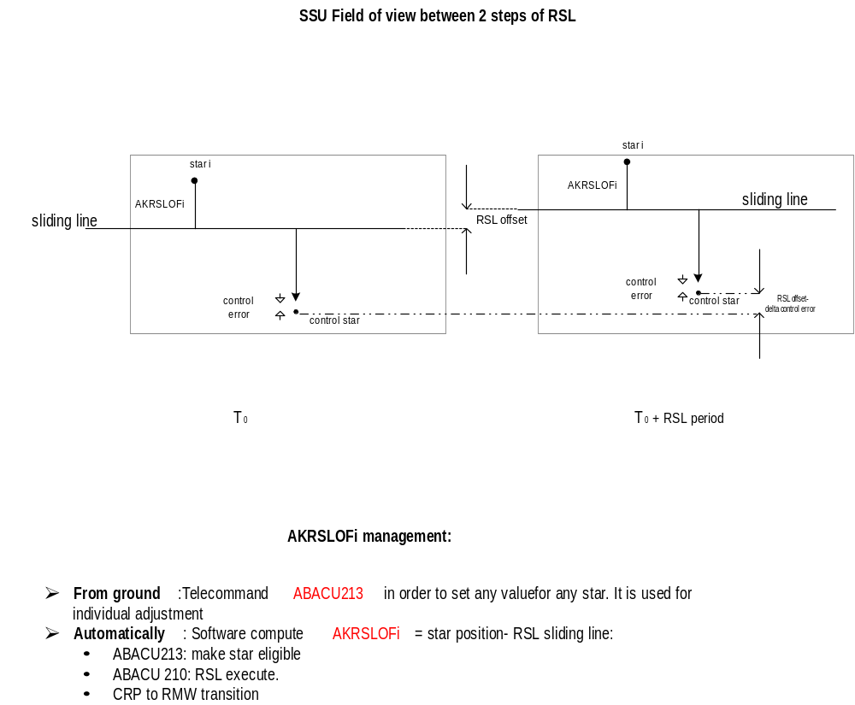

Figure 3.7/1 : the RSL evolution and the RSL offsets

The experiment off pointing warning function
The experiment off pointing warning function has been designed to warn the experiments in case of depointing from the Sun. This function is only run in normal mode. Its detailed description can be found in section 3.10.9.
The flag monitored by the COBS is set by AOCS in case :
- the root sum square of the AOCS pitch and yaw control errors (depointing - pointing reference) exceeds 10", that is (pitch - pitch_ref)² + (yaw - yaw_ref)² > 100 arcsec²
- PCPG profiles are attempted on the pitch and yaw axes
- Attitude profiles are attempted on the pitch and yaw axes
In the two latter cases, the operational procedure to perform these activities in normal mode could therefore be (to be decided on a case by case basis with the experimenters) :
- Verify the experiments are safed or the profile attempted is coherent with the experiment configuration
- Disable the COBS function
- Perform the AOCS activity
- Clear the AOCS flag at end of activity
- Enable the COBS function
If so, during these activities the experiments are not protected, hence the usage of the attitude profiles and PCPG on the pitch and yaw axes shall be limited to their minimum.
The setting of the AOCS threshold shall be performed at function initialisation.
In case of fallback to CRP, this monitoring function is not disabled. If so, it should be noted that the most stringent experiment perturbations in CRP might trigger this monitoring.

The NM control algorithms
An overview of the NM control laws is given in Figure 3.7/2 : the NM control algorithms.
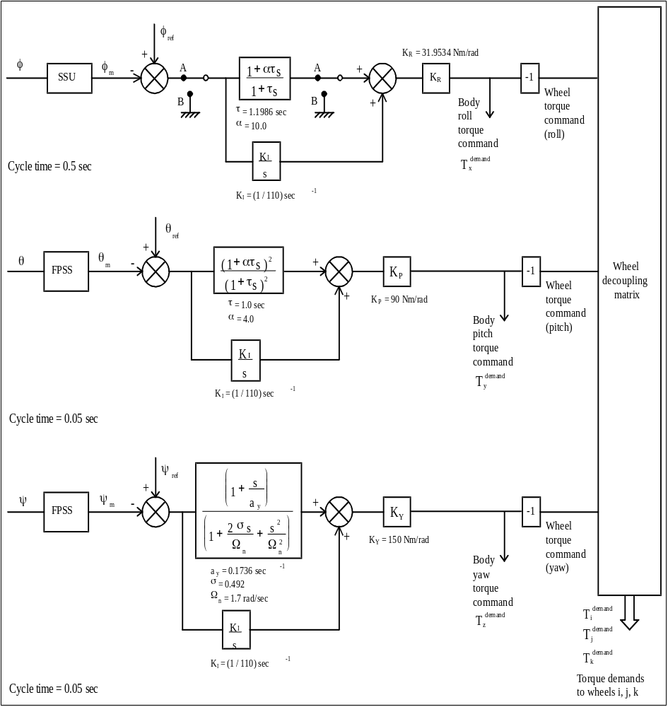

Figure 3.7/2 : the NM control algorithms

Pitch and Yaw control in NM
The pitch and yaw control is performed with algorithms identical to the ones used in the old NM mode.
The NM pitch and yaw integrators are initialised from the RMW pitch and yaw integrators at NM entry.
As for RMW, profiled attitude demands may be commanded in pitch and yaw : they directly act on the FPSS references. They are basically used to trim the operational offset upon experiment request.

Roll control in NM
The roll control is with algorithms identical to the ones used in the old NM mode.
A separate set of parameters is nevertheless used, to cope with the RMW to RMW initialisation functions.
As per Normal Mode, a filtering logic (old patch 5 and now old patch 6, modified to allow its use in RMW mode) is applied to the control star, and a star swap strategy is included. This star swap is made transparent to the control algorithms.
In case the control star is temporarily not valid, the roll control error signal is set to zero.
The RMW roll integrator is initialised from the RMW roll integrator at NM entry.
As for RMW, profiled attitude demands may be commanded in roll.

Attitude profile in NM

Roll trims
As per RMW mode, refer to section 3.6.4.1.

Pitch and yaw attitude trims
As per RMW mode, refer to section 3.6.4.2.

NM operational constraints
- The execution of the roll steering law, the PCPG functions, the attitude profiles shall be mutually exclusive.
- Each time a RSL start is demanded, the telemetry shall be checked to confirm the success of the action. If not, a retry shall be attempted.
- The roll steering law sliding reference will be defined from the current control star theoretical position, each time the RSL is uploaded. This solution will force the control star RSL offset to zero.
- The roll steering law step size shall be computed such that on the foreseen nominal control star, the reference star position avoids both pixel centers and pixel boundaries.
- The roll steering law steps size can be increased to 10" (nominal) and up to 15" (for avoiding boundaries or centers)
- The operational threshold for the off pointing flag shall be set or verified to the desired threshold (baseline at 100"²) each time the COBS function is activated, and the AOCS flag cleared.
- The execution of the PCPG or attitude profile functions in NM on the pitch and yaw axes shall be performed in accordance with the experiments and the COBS experiment warning flag function. The AOCS off pointing flag shall be cleared after these activities.
- The NM step constraint is increased to 135" on the roll axis (can generate up to 30"/s) and stays unchanged on the pitch and yaw axes (can generate up to 20"/s).
Note : constraints for star acquisition and handling are addressed in section 3.8.7.4.

AOCS additional features

The attitude profile algorithm

Presentation
A new AOCS service providing on-board repointing capabilities has been developed for all AOCS modes (CRP, RMW, NM) and for all satellite axes. This is performed trough a continuous attitude reference profile : the software commands automatically an attitude reference adjustment to reach the specified final position.
These profiles are performed under ground request, and functionally replace the possibility to perform either old roll manoeuvres with gyros, or direct offsets of FPSS references. As such, the same kind of interfaces are used :
- the roll attitude profiles are commanded by an update of the ABACU205 block telecommand, which specifies a requested slew magnitude (delta roll angle to be performed) and an execute order.
- the pitch or yaw profiles are commanded by an update of the ABACU214 block telecommand, which specifies the new desired pitch or yaw angle references. They are executed only if the commanded reference is lower than 2°.
An abort procedure is possible from any mode by one of these two telecommands (ABACU205 for roll, ABACU214 for pitch or yaw). The abort freezes the pointing reference of the profiled axis to the current commanded reference value.
One single software procedure is used to trim the roll, pitch and yaw attitudes, in all modes, allowing one single axis trim at a time. This procedure uses a flag representing the "attitude manoeuvre in progress" status : attitude_man_flag. This flag is raised at start of attitude trims on any axis, and cleared upon manoeuvre completion (AKGLPROF).
For roll angle, the attitude manoeuvres (CRP) or trims (RMW, NM) use specific variables, which are reset to zero at manoeuvre completion :
- the Roll Attitude Offset (AKRAO) in RMW an NM modes (SSU),
- the Roll slew angle (AKRSLEW) in CRP mode (CRS)
For pitch and yaw angles (FPSS), the variables to be trimmed are directly the FPSS references :
- pitch_angle_ref for CRP, RMW, NM modes
- yaw_angle_ref for CRP, RMW, NM modes

As a consequence of the experiment off pointing requirements, the sun off pointing flag is raised upon the start of a pitch or yaw attitude profile in CRP/RMW/NM modes.
Note : this remark is also true now for the PCPG function.

The only means left to perform pure offsets without the use of this function stands now as :
- using the PCPG profile, but at the expense of completion of a pure sine wave (no steady offset is commanded)
- a trim of the RSL offset of the control star on the roll axis in RMW, NM. If performed, the RSL offsets of the other stars have also to be reinitialised in coherence, and the execution shall be decoupled from attitude profiles and PCPG operations. Herealso, care has to be taken on the maximum offset size.
- a direct write to memory of the FPSS references for pitch or yaw axes in CRP, RMW, NM. These are not recommended, particularly in CRP due to the interference with the CRS. If performed, they have to be decoupled from the attitude profile execution function, and care has to be taken with respect to the experiment pointing limitation and the maximum offset size.
- A trim of the CRS reference, achieved by a direct write to memory on the CRS initial reference (rather than a trim on the compensation value). Herealso, care has to be taken on the maximum offset size.
The two last alternatives are not recommended in the frame of nominal actions.

Algorithms
The execution of the attitude profile algorithms is performed at :
- 20 Hz in all modes and all axes, except for the roll axis in CRP
- 2 Hz for the roll axis in CRP
The attitude profile consists of :
- an acceleration phase, where the rate of change of the trimmed reference is gradually increased up to a steady state value
- a coast phase, if needed, where the rate of change of the trimmed reference is fixed
- a deceleration phase, where the rate of change of the trimmed reference is gradually trimmed down to zero.

The way to establish the actual profile, pending the demanded attitude excursion stems to the following principles :
- The acceleration and deceleration phases duration are kept equal and constant whichever the profile commanded. For all modes and all axes it is selected at 180s.
- The steady state rate is only reached if the size of the profile permits, otherwise, the acceleration is computed such that the end of the acceleration phase, the resulting motion corresponds to half of the desired motion. The deceleration phase completes then the end of the resulting motion.

The maximum rate of evolution of reference is set at 20"/s = 9.6962736 e-5 rad/s for all axes all modes, except in CRP where the roll axis uses 30"/s = 1.4544410 e-4 rad/s. This choice is linked to getting peak rates largely compatible with the SSU tracking capability in all axes and to get accelerations small enough to get smooth control actions.
The 30"/s is slightly increased in roll for CRP linked to the fact that the SSU is not part in the control loop, and according to the amplitude of the possible manoeuvres, and the resulting duration (30°/h yields to 6 hours at ESR exit in worst case). This value allows still a monitoring of the manoeuvre by the SSU, if deemed necessary.

The illustration of the attitude profile algorithms is done in Figure 3.8/1 : the attitude trim algorithms, μ being the variable to trim, and t1 the acceleration period.

Performance and interference with monitoring functions
The selection of the fixed 180s acceleration and the default rates yields to the following remarks :
- The coast rate (or maximum trim rate) is achieved only if the angular variation commanded is higher than 1° (1.5° on roll axis in CRP)
- If not, the profile will be completed
- in 360s.
- with a triangular shape.
- At the end of the acceleration period, the maximum rate will be the demanded delta angle / 180.

Given the selected threshold for reaction wheel speed monitoring in RMW and NM mode (1.35 Nms), and given the selected threshold for the Hx monitoring function (7 Nms) the following interference's apply between the attitude profiles and these monitoring functions (computed for nominal wheels configuration, axis substitution otherwise) :
- The Hx level taken in CRP (0.3 Nms) and in RMW or NM (0.2 Nms) will not trigger the Hx monitoring function by itself.
- For a roll manoeuvre in RMW or NM, if the yaw momentum is the highest possible, the RW2 speed boundary is exceeded for a 1.2° roll manoeuvre.
- For a pitch manoeuvre, if the roll momentum is the highest possible (3 wheels at 30 Nms, yielding to Hx = 43.35 Nms), the RW2 speed boundary is exceeded for a 1.5° pitch manoeuvre.
- For a pitch manoeuvre, if the pitch momentum is the highest possible, the Hx variation can be as high as 0.91 Nms for a 2° manoeuvre.
- For a yaw manoeuvre, if the roll momentum is the highest possible (3 wheels at 30 Nms, yielding to Hx = 43.35 Nms), the RW1/3 speed boundary is exceeded for a 1.72° yaw manoeuvre
- For a yaw manoeuvre, if the yaw momentum is the highest possible, the Hx variation can be as high as 1.83 Nms for a 2° manoeuvre.
There is then no stringent interference with the Hx monitoring function. Any manoeuvre will not exceed the 7 Nms sliding boundary, nor challenge the margin taken between the -5 Nms operational limit and the -10 Nms default value in software. It is therefore proposed simply to (applicable in all modes) :
- Reinitialise the Hx sliding boundary before the execution of the profile (to be sure not to trigger during the manoeuvre), and after the manoeuvre (to get the autonomy after the manoeuvre).
- Verify the lowest Hx value is always greater than -8 Nms
On the contrary, for the reaction wheels speed monitoring, it is proposed to (applicable in RMW and NM) :
- Verify than the anticipated profile does not violate any RW speed monitoring function, while granting sufficient autonomy (this appears always to be the case if the targeted attitude is lower than 500" from the nominal attitude on any axis)
- If not, disable the monitoring during the profile, and re-establish it after the profile.

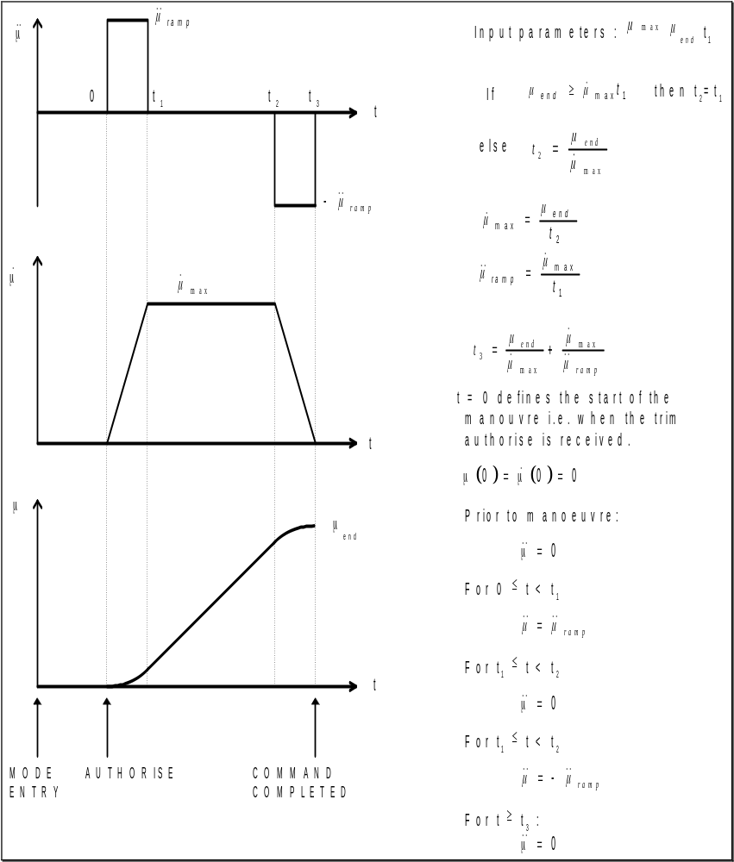

Figure 3.8/1 : the attitude trim algorithms

Protection against SEU's and SSU outages

Presentation of selected principles
The protection against outages of SSU outputs addresses the effect of SEU's, but also any commanding of the SSU in an undesired mode, or SSU failures.
The principle is based on two separate items :
- A star swapping logic, described in the following paragraph, which makes the RMW and NM modes more robust to the loss of the control star, and allows to carry on these modes with "back-up" control stars.
- A protection logic, applied on the current control star, based on the existing staircase filter (old patch 5), and the Z spike coordinate filter (old patch 6). This logic is common to the RMW and the NM modes, meaning that the Z spike coordinate filter is now also run in RMW mode.
Note : there does not remain in the gyroless software any test linked to star position in the SSU field of view to assess condition on star validity.

The staircase filter and tuning
The staircase filter principle is unchanged, and is applied only to the control star.
This filter counts up when either the control star is not "valid - full accuracy" or the SSU mode is not "mapping" or "searching / tracking" or "searching / tracking restricted". The result of this test is indicated in the "control star valid" telemetry AKSSUCSV. The default for the rate of increase of the staircase is 1 (meaning each SSU cycle). It is not anticipated to change that value.
As soon as the control star is not indicated as being valid in the sense of the staircase condition, the roll error angle input to the RMW or NM roll control laws is set at zero.
If the condition on star validity appears to be re-established before the upper acceptable limit of the staircase counts is achieved, the filter count is decreased, while the control is resumed (there is no change in star position reference). The default for rate of decrease of the staircase is 1 (meaning each SSU cycle). It is not anticipated to change that value.

The current count status of the staircase filter is reflected in the AKSEUCNT telemetry. If the upper acceptable limit of the staircase counts is achieved (the so-called staircase threshold, reflected in AKSEUTH telemetry), a control star swap is demanded (refer to paragraph 3.8.3.1), and the eligibility condition of the former control star is set to false (refer to paragraph 3.8.2.1). The roll error angle is maintained to zero up to the point when a new valid control star is selected for the AOCS roll control, or up to the point the CRP mode is commanded if no more valid and eligible stars remains amongst the currently tracked stars (refer to refer to paragraph 3.10.8 for CRP flag monitoring).
A global count of the control star invalidity condition (ie integration of the staircase counts) is reported in the AKSSUTSU telemetry.
The default value of the staircase threshold is set at 5 (meaning 5 SSU consecutive measurement cycles, or 2.5 seconds).
For safety purposes, this value shall not be extended during phases when thrusters are used. Indeed, the principle for reaction times (on board and on ground) to shut down an open thruster do rely on an on board reaction within 2.5 second of SSU tracking rates being exceeded.
Now than the star swap principle and the CRP mode are implemented, it is not desirable to extend this value to very high levels, outside thruster operations, as was done formerly. Indeed there is far less need to let the AOCS a chance to reacquire an unvalid control star, in the objective of maintaining normal mode. On the other hand, the integration in the free dynamics no roll control phase of any small error on the friction estimated on board by the RMW or NM roll integrator (including the ramp-down contribution from the phase advance) will yield rapidly to potential high roll angle offsets. Those might not be sustained by the RMW/NM roll controller when the control is reestabished.
As an example, a misestimation of 10-4 Nm on the roll axis (typical 1/100th of the expected value, matching well with registered data at 1.5 E-4 Nm on 20/5/99) causes the maximum RMW/NM roll offset to be exceeded in 160 seconds. In any case, given the expected roll offsets at star swap (see paragraph 3.8.3.3 ), would the default value of 5 be increased, it is not desirable to go above an expected additional offset source of 100", that is a duration of the order of 100s (or 200 for the threshold).
Note : The allowance of the new searching / tracking restricted mode, declared as a valid mode for the staircase filter, is linked to its possible use in the frame of selecting more stars for the star swapping process (refer to § 3.8.3.4)

The Z spike filter and tuning
The Z spike filter principle is unchanged, and is applied only to the control star.
This filter rejects the control star Z coordinate if the difference between the current measured coordinate and the measured coordinate at previous cycle is higher than a threshold, and performs the control from the old Z coordinate measurement.
This threshold, expressed in CCD units, is reflected in the AKZFILTH telemetry. The default value is 125 CCD units. It corresponds to maximum variation between two consecutive SSU measurements at 30.6".
A cumulated number of occurrence of the Z spike filtering is maintained in the AKZSPIKE telemetry.
This threshold has been slightly decreased from the initial tuning, flown until the gyroless software is uploaded. This is made in order to increase the global filter efficiency, and to maximise the chance to remain in the tracking window of the control star if the measurement is corrupted and not reported as an SEU by the SSU.
The proposed threshold translates into a maximum rate of 61.25"/s, given the 0.5s SSU measurement frequency. This is largely above the maximum anticipated rates on the SSU during station keeping and momentum management operations (at around 35"/s). It is not intended to decrease more that threshold, since the principle of the filter will force no control action if the rate on the spacecraft exceeds the acceptable limit. This particularly applies to the phases when the experienced rates are anticipated high, namely the operations with thrusters.
Note : the proposed tuning also corresponds to the typical SSU tracking limit over several cycles, as seen during flight operations with SSU patch 2 (first ESR exit in FSA). It is therefore not useful to run this filter with higher thresholds.

Initialisations at modes transition and at star swaps
The cumulated number of SEU's (AKSSUTSU telemetry) is never reset on board neither if a star swap occurs or at any mode transition, and scrolls automatically to zero at 65536. This telemetry allows therefore a trend on the SEU rates on the SSU. This trend might have to be correlated to the magnitude of the used control stars.
On the other hand, the cumulated number of Z spike filter occurrence (AKZSPIKE telemetry) is related to the current control star and is reset at CRP to RMW mode transition and each time a star swap is performed (either from ground demand by telecommand, or by the on board star swap logic).
No specific actions have to be done on ground on the SEU protection logic when a control star change is performed by telecommand, or to recover a fallback in CRP after outages of the SSU measurements. This is all handled at software level, and detailed in section 3.8.2.4.
On the other hand :
- The staircase and Z spike filter counters are not affected by the RMW to NM and NM to RMW mode transitions.
- The staircase and Z spike filter thresholds are not affected by any mode transition or change of control star.

The star swap, star eligibility, and implications in algorithms and operations

The star swap principle
The star swapping logic is a new RMW and NM modes common feature which makes these modes robust to the loss of the "nominal" control star, and allows to carry on these modes with "back-up" control stars, until the "nominal" control star is reacquired or changed.
The notion of "nominal" and "back up" control stars is explained in the section 3.8.3.3, and is purely linked to pointing and telemetry fine performance.
In that sense, the star swapping logic is an answer to outages of SSU measurements, in the attempt to maintain the on going AOCS mode with reasonable performances. This avoids to go to the CRP mode (the SSU-less AOCS mode) where the AOCS performance is further degraded, and where more lengthy operations will take place to recover the nominal AOCS mode.
The star swap logic has been included in the AOCS software with the aim of minimising both the on board software changes (functions and CPU budget), and the ways to operate the spacecraft (interfaces with ground, and programmation of the roll steering law). It is based on the following items :
- The ground is responsible to make the SSU tracking several stars, one of which being defined as the "nominal" control star for the control laws. This star is related to the computation of the roll steering law.
- The roll control is based only on the measurements of one star. Initially, the "nominal" control star is used.
- Amongst the other tracked stars, the ground is responsible to design the candidate "back-up" control stars. For that purpose, each star channel of the SSU (channel 1 to channel 5) is associated to a logical condition : the "eligibility" flag. In case of outage of measurement on the current control star, a control star swap on a "back-up" control star can only occur on a star already tracked by the SSU, which channel has been declared "eligible" by the ground.
- Any star being tracked by the SSU while not being "eligible" is in fact kept off-line of the AOCS algorithms : its measurements are made available in telemetry.
- The control reference for the "back-up" control stars is identified from the roll steering law reference with bias, initialised from measured values when the star is declared "eligible". These bias are named the RSL offsets (AKRSLOF1 to AKRSLOF5 in telemetry). They are regularly updated on board (hourly basis) to cope with the orbital motion distorting the roll measurement from the SSU (refer to section 3.8.3.3).
- The staircase filter, presented in the previous section, identifies the outages on the measurements of the control star. If its threshold is exceeded, the current control star is declared "not eligible" and a star swap is generated by the software. The software will select as the new control star the one in the first channel (the channel with the lowest number) which is both "eligible" and "valid".
- Various initialisations performed in the software, principally done on the RSL offsets and for setting the eligibility condition to false, in the general objective of ensuring to get appropriate RSL offset initialisations.
The star swar logic exit will be when the last valid and eligible tracked star is identified as faulty by the staircase filter. In that case, the AOCS software will raise the "CRP flag" (AKMDSCRP telemetry) used by the COBS to set the ACU in CRP mode (refer to section 3.10.8).
The number of star swaps is reported in telemetry (AKNSWAPS telemetry). This number is not cleared until the ground decides to do so by telecommand .

The star swap implementation in software

The control reference in RMW and NM modes for the roll axis
The star swap implementation in the software for deriving the control references is derived from the initial RMW and NM software. The control reference is derived from a single control star, and copes for the RSL, PCPG functions, and the roll trims in RMW and NM modes.
In order to be independent of the control star during swapping, the roll scan law is now related to a sliding roll reference in the field of view of the SSU. The reference position of the control star (used to determine the roll error) will account for the evolution of this line :
- Basically the roll offsets from this line, for all the tracked stars, can be known and initialised at star acquisition. The assumption is made that they will remain fixed on a short term basis (refer to section 3.8.3.3 for the actual impact of the orbital motion contravening slightly this assumption). They will be in fact regularly refreshed on board with measurements (hourly basis).
- When a new star is used for control, the control error is derived by evaluating the difference between the CCD Z coordinate (expressed in angle) and a new reference derived from the known offset + the RSL sliding reference.
- When a new roll scan law is executed, all these offsets are re-initialised.

For that purpose, the following equations and variable definition are used (in the equations, the new variables are underlined) :

- Roll_Angle_Ref (Control_Star) = RSLTable (RSLindex) + RSLOffset (Control_Star)
This can be understood as follows :
"control star offset from the SSU centre" = "offset (from SSU centre) of the RSL sliding line" + "offset between the control star and RSL the sliding line"
This equation is performed on each roll control cycle, only for the control star. The RSL routine updates on a long terms the RSL table.

- Roll_Angle_Error_S = Roll_Angle_Ref (Control_Star) + PCPG_Angle (Roll) + RAO
- Measured_angle (Control_Star)
This can be understood as follows :
"roll control error in RMW and NM" = "desired star position from the SSU centre"
- " measured star position from the SSU centre "
The "desired star position from the SSU centre" being made of the "control star offset from the SSU centre" adjusted with two secondary attitude offset (generally set at zero in normal operations) :
- the "PCPG offset", generated in the course of the PCPG function operations
- the "Roll Attitude Offset", used to perform the roll attitude trims (this variable will evolve only during roll attitude trims in RMW and NM, and will be reset at zero at manoeuvre completion), updated by the attitude profile algorithms.
This equation is performed on each roll control cycle, and is illustrated on Figure 3.8/2 : roll control with SSU in RMW and NM modes.

- ROLL TM (SSU based) =
Roll_TM_Offset
+ Roll_Angle_Ref (Control_Star) - RSLOffset (Control_Star)
- Roll_Angle_Error_S + PCPG_Angle (Roll) + RAO
This can be understood as follows :
"roll attitude of SSU field of view centre" =
"roll attitude of the spacecraft, if the RSL sliding line was at the SSU centre" +
"offset (from SSU centre) of the RSL sliding line" +
"measured star position - reference star position (control star) from the RSL"
This equation is performed on each roll control cycle, and is illustrated on Figure 3.8/3 : roll telemetry with SSU in RMW and NM modes.

This latter equation can be reduced in :

- ROLL TM (SSU based) =
Roll_TM_Offset
- RSLOffset (Control_Star)
+ Measured_angle (Control_Star)
This can be understood as follows :
"roll attitude of SSU field of view centre" =
"roll attitude of the spacecraft, if the RSL sliding line was at the SSU centre"
- "offset (from SSU centre) of the RSL sliding line"
+ "measured star position"

The drawing of Figure 3.8/4 : variables for roll control with SSU in RMW and NM modes illustrates these variables.

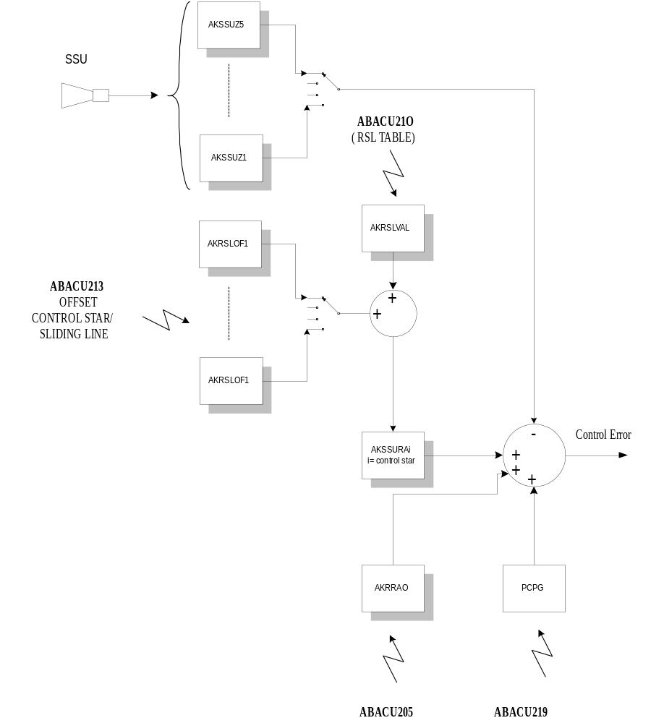
Figure 3.8/2 : roll control with SSU in RMW and NM modes

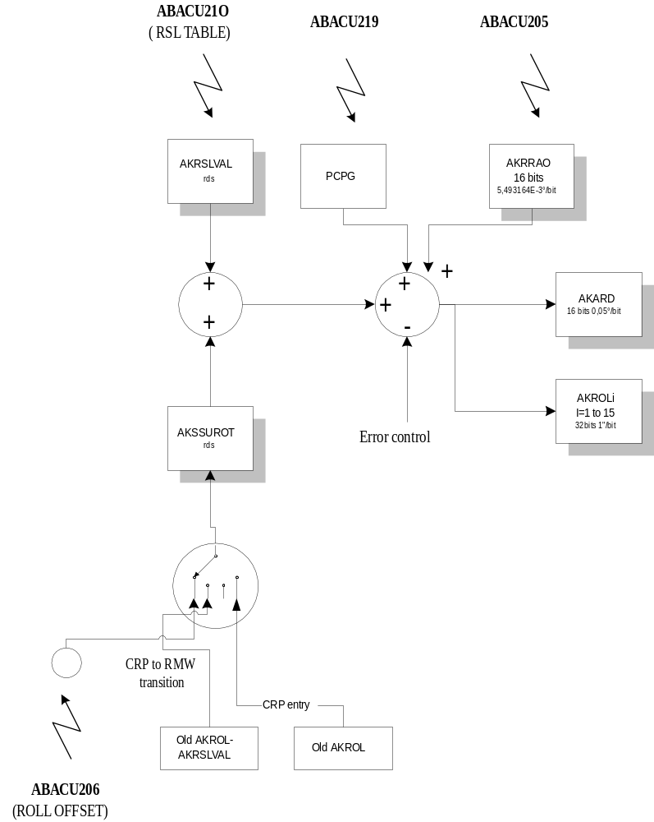
Figure 3.8/3 : roll telemetry with SSU in RMW and NM modes

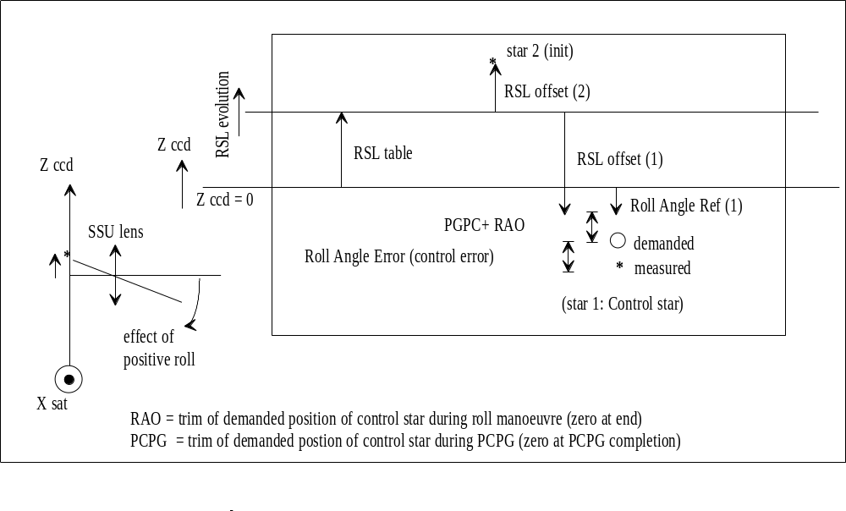
Figure 3.8/4 : variables for roll control with SSU in RMW and NM modes

Handling of eligibility
A table of five “eligibility” status for the five star channels is stored in memory to determine if a star is suitable for inclusion in the star swapping process. These status are reflected in the AKGLEL1 to AKGLEL5 telemetries.
When a star channel is made eligible, if the star tracked in that channel is valid at the date of the action, the RSL offset of the star is initialised as per the following section.
The setting (and resetting) of the eligibility condition can be performed by telecommand.
As a principle, the on board software never sets these status to "eligible". On the other hand, the on board software forces some of these status to non "eligible" in the following conditions :
- The setting of the eligibility condition of a star channel by telecommand is only possible if the star tracked in that channel is valid at the date of the action. If not, the action is rejected and a block telecommand error is reported
- The eligibility condition of the current control star is set to "false" if a change of control star is demanded by the star swap logic
- The eligibility table is set to "false" for all stars not valid, as part of the CRP to RMW modes transition.
- Upon the assertion of an ABACU201 thruster telecommand, all the star (including the guide star) eligibility table is set to "false"
- Upon the assertion of mapping commanded to the SSU, all the star (including the guide star) eligibility table is set to "false"
- At the start (execute order) of a new roll steering law, or when their RSL offset is refreshed every hour, the eligibility condition is set to "false" for all the "back-up" control stars (the tracked and eligible stars not being the control star) if they appear not to be at a valid condition.
The synthesis and the objectives of all the actions linked to handling the eligibility are summarised in Figure 3.8/5 : Synthesis for eligibility handling.

WHEN | WHO | WHAT | WHY
In CRP before exit to RMW (after mapping being commanded) | Ground by TC | Setting eligibility to "true" on valid stars | - Necessary on the first control star for RMW for allowing transition,  - At transition, initialise RMW and RSL offsets on all the eligible and valid stars
At transition to RMW. | On board S/W | Setting eligibility to "false" on all stars channels not valid | - Avoidance of inappropriate RSL offset initialisation
After acquisition of new stars in RMW and NM | Ground by TC | Setting eligibility to "true" on new stars | - Inclusion of stars in the star swap process  - Initialise RSL offset for new stars
When setting the eligibility to "true" by TC (all modes) | On board S/W | Setting eligibility to "false" on the stars channel if not valid | - Avoidance of inappropriate RSL offset initialisation
At release of stars in RMW and NM | Ground by TC | Setting eligibility to "false" on released stars | - Avoidance of later situations where valid stars can be acquired in these channels, with eligibility status and RSL offsets not initialised properly
Before ABACU201 being executed, when the LVA is still closed. | Ground by TC | Setting eligibility to "false" on all stars channels | - Inhibition of the star swap process during thruster manoeuvres
At ABACU201 assertion in S/W. | On board S/W | Setting eligibility to "false" on all stars channels | - Inhibition of the star swap process during thruster manoeuvres (back-up)
After ABACU201 being executed, once the LVA is closed. | Ground by TC | Setting eligibility to "true" on all valid stars | - Reauthorisation of the star swap process  (will Initialise RSL offset for these stars)
At mapping command assertion in S/W in any AOCS mode | On board S/W | Setting eligibility to "false" on all stars channels | - avoidance of situations where several valid stars can be acquired automatically, with eligibility status and RSL offsets not initialised properly
After mapping command being executed in RMW and NM modes | Ground by TC | Setting eligibility to "true" on all valid stars | - Reauthorisation of the star swap process  (will Initialise RSL offset for these stars)
When a star swap is commanded by the staircase filter | On board S/W | Setting eligibility to "false" on the control star | -Design solution to avoid endless swaps  -Allows eventually to go to CRP
At execute of a new RSL or during regular refresh of RSL offset | On board S/W | Setting eligibility to "false" on the stars not being the control star, if not valid | - Avoidance of inappropriate RSL offset initialisation

Figure 3.8/5 : Synthesis for eligibility handling

Initialisation of RSL offsets
The on board software initialises automatically the RSL offsets from the SSU measurements :
- Each time a star, including the control star, is made eligible, that is :
- after new star is acquired, when the ground authorises its participation into the star swap process,
- after delta -v or momentum management operations, when the ground reauthorizes the star swapping
- after a mapping in RMW or NM
- In the frame of the CRP to RMW transition, for all the stars eligible (including the control star)
- When a new roll scan law is uploaded, for all the stars eligible (including the control star), at the level of the ground demand for the Enable_roll_steering_law flag change from "false" to "true" status
- On an hourly basis for the "back-up" control stars (the ones eligible and not being the current control star) to cope with the distortions induced by the orbital motion (refer to section 3.8.3.4)
In all these opportunities, the objective is to get for the concerned star its RSL offset coherent with all the variables handled on board, making either the "nominal" control star or the "back-up" control star (and in some cases both) reference position initialised from measured position of the star in the SSU field of view. For that purpose, the initialisation can always take place if the star channel is valid, and causes the interference with the eligibility as described in section 3.8.3.2.2.
The initialisation is derived as follows :
Measured_angle (N) - RSLTable (RSLindex) - RAO - PCPG_Angle (roll)
A specific possibility to trim the RSL offset table is provided by the ABACU213 block telecommand.

Initialisations at mode transitions and at change of control star
The ground still have the ability to change the guide star, while being in NM and in RMW mode. If a change of control star is requested directly by ground, the current eligibility status of this star is not affected. In that case :
- no checks are performed by the software on the eligibility and validity status of the new control star requested by the ground
- no RSL offset initialisation takes place
Appropriate checks will therefor be requested for such an operation.
If a star is released by the ground at the level of the SSU by an ABACU211 TC, no action to set its "eligibility" status to "false" is undergone by the software.
The eligibility flag and control star number are not affected by the RMW to NM transition or NM to RMW transition.
The various other initialisations are performed by the software :
- The CRP flag (AKMDSCRP telemetry) is cleared as part of the CRP to RMW mode transition
- The staircase filter counter (AKSEUCNT telemetry) is cleared as part of the CRP to RMW modes transition and each time a star swap is performed (either from ground demand by telecommand, or by the on board star swap logic).
- The Z spike filter logic is reinitialised as part of the CRP to RMW modes transition and each time a star swap is performed (either from ground demand by telecommand, or by the on board star swap logic).
As a last reminder about initialisations, the ground has always the possibility to force, by telecommand, the star swap and the CRP flag, and the staircase filter monitoring function shall never be disabled.

Implication of spacecraft dynamics
The design solution taken for the star swap has been to define fixed RSL offsets in the software. This assumes that the RSL reference is not dependant on the star position in the field of view of the SSU, meaning that the displacement of the stars is always the same on the Z axis of the CCD wherever in the SSU field of view, due to the roll motion.
This point is not exactly true as SOHO orbits around the sun. On top of that Z translation, a rotation of about 1° per day (360° in 365 days) occurs around a point on the SSU CCD Z axis, separated from the center by the actual commanded roll angle (the roll angle derived from the sun poles).
This behaviour is illustrated on the Figure 3.8/6 : Evolution of stars in SSU field of view (24h for DOY 183) (day of year 183, evolutions of all stars which can be tracked over 24 hours) and Figure 3.8/7 : Zoom on star 19040068 at border of SSU field of view (24h for DOY 183) (zoom on one star evolution at the border of the field of view in Y) :
- At that date the roll angle of the spacecraft is initially 6,598° and will decrease by 0,052° in a day. This basically explains the amplitude of the projections of the evolutions on the Z coordinate of the CCD, which globally appear similar.
- The magnitude of the evolution of the Y coordinate is dependant on the initial position of the star on the CCD, from the average rotation point. The typical evolution is about 6.6° * sin 1° = 0.11°, as expected. But the evolution of the coordinate is the highest when Y is close to zero and the farthest from the rotation center : the component of the Y motion is purely tangential to the circle, while the circle is the largest.
- On the other hand, at the extremes of the CCD field of view in Y, the tangent of the circle couples with both the Y and the Z coordinates. This makes the Y evolution smaller, but has the drawback to induce a perturbation on the Z axis, hence on the roll angle.
This latter fact corrupts the roll angle measurement, as defined on board from the SSU Z measurement.
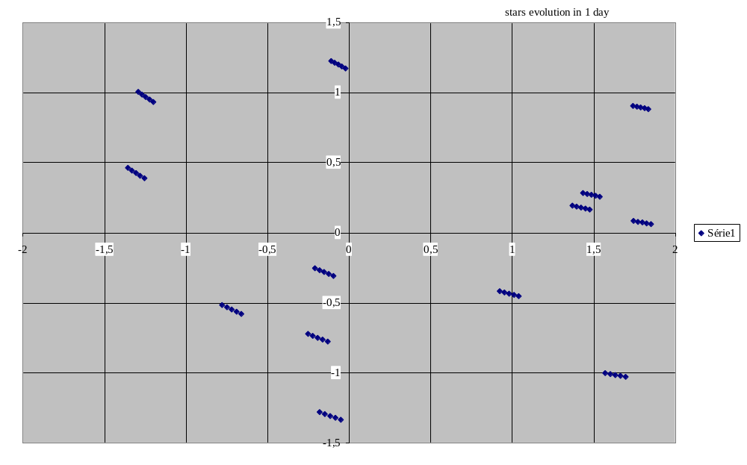
Figure 3.8/6 : Evolution of stars in SSU field of view (24h for DOY 183)
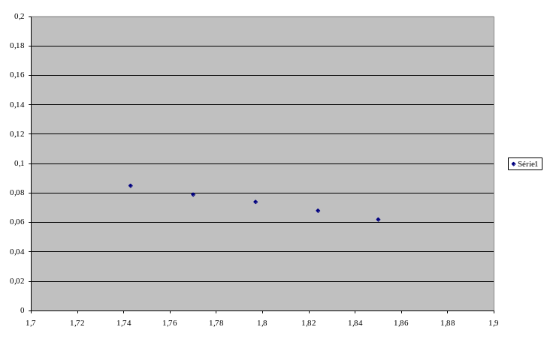
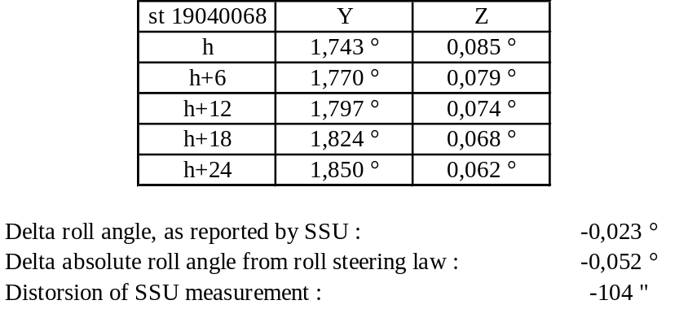
Figure 3.8/7 : Zoom on star 19040068 at border of SSU field of view (24h for DOY 183)
With a first order approximation, neglecting magnitude of the commanded roll angle (assuming that X SSU is at the north of ecliptic), the roll angle perturbation is directly dependant on the Y coordinate of the tracked star : pollution of the roll angle = pitch angle * sin (duration in days*360°/365.25). This evaluation remains also valid with a complete model of the position and evolution of the roll angle on few days : the maximum corruption is at 127" / day and 260" / 2 days at 2° in pitch.
When applied to the baseline SOHO concept, this effect manifests itself as :
- A corruption of the roll attitude telemetry, when the control star is not on the Y axis of CCD. The proposed handling of this point is addressed in section 3.8.4.2. It is based on ground post processing to allow for the best attitude reconstitution in the definitive attitude files for the experimenters, merged with correction of the roll TM offset each time the RSL is uploaded. This corruption impacts the raw unprocessed spacecraft telemetry by 0.1° at worst and does not interfere with the antenna pointing interface on board.
- The requirement to compute the roll steering law table, anticipating this circular motion for the control star. This is not a new requirement, and has always been done by FDF.
- Since the circular motion correction is dependant on the position in the SSU field of view, the roll steering law can only be optimised on one star. This star is defined as the "nominal" control star, and it is not anticipated nominally to change from this star as being the control star, unless the roll steering law is re-optimised. For this star, the RSL offset is fixed at zero by convention, in order to keep the same interface with the ground.
- On the other hand, if a swap occurs on a star for which the RSL has not been optimised, a roll pointing error might grow up. This is basically why the "back-up" control stars are indeed only back-up solutions... The control will then not have to remain too long in such a situation to respect the experiment roll absolute pointing requirements. The rate of increase of the roll pointing error could be as high as 250" per day if the back-up star is 4° away from the "nominal" star (one edge to the other in pitch).
- If no regular update is done, a corruption of the RSL offsets for the other potential control stars (named as "back-up" stars), which will generate a roll attitude step at star swap. Given the adaptation of the roll steering law for the "nominal" control star, this corruption will manifest itself roughly as sin1° * the delta pitch angle measured from the "nominal" control star.
In order to keep the experienced rates very low below 30"/s during such a swap, the corruption of the RSL offset from the nominal control star to one back up control star shall be kept less than 135". The same would apply on the differential corruption of the RSL offset for a second swap.
The proposed solution for that is to update regularly on board the RSL offsets for "back-up" stars : stars eligible and not currently being the control star. This will force their reference to be initialise very close to the current roll attitude if a swap is done. The anticipated roll offset is restricted to 10" at worst after 1 hour for a jump from one side to the other in the SSU field of view. This places no autonomy restriction on the star swapping principle, nor any constraint for selecting all the tracked stars in a cluster grouped around pitch.

Implication in operations and principles for star selection.
The proposed principles for star selection and operations are as follows :
- The "nominal" guide star will, be selected as before. It will use feedback from flight experience on the behaviour of the SSU (magnitude...). The purpose is to ensure nominally a star remaining up to 4 days in the field of view. When desired, the change of the "nominal" control star will take place, with RSL disabled.
- For roll telemetry purpose, this star will be selected as close as possible from the Yccd axis.
- When started, the RSL will be optimised for that star, and the resulting RSL offset will be trimmed to zero after start of RSL, to clear for measurement errors at initialisation. The roll TM ofsset will also be trimmed on ground. This performs no change from the old design definition.
- On a daily basis, a revisit of the other stars to be acquired and release will take place. The stars exiting the field of view in the coming day will be released properly before, with their eligibility set to false appropriately afterwards. At that stage, the RSL offsets will be have to be reinitialised by toggling the eligibility for the stars not being the control star.
- At that stage, the "back up" control stars will be selected in the field of view such that :
- The desired stars number to be acquired is 3. This corresponds to operation performed with the searching tracking mode. If desirable and possible from the selection criteria, the stars number could be increased to 5, using potentially the tracking restricted mode.
- They stay in the field of view for more than 1 day,
- They comply to in flight experience acquire on the SSU (maximise robustness of the measurement : any criteria on magnitude, ...)
- If more than 3 stars can be acquired :
- select the ones which will stay in the field of view for more than 3 to 4 days, and get a back-up RSL table prepared for them. This table might be used in case of selection on of these stars as the next "nominal" control star
- if more than 3 or 5 stars comply, amongst the brightest (or other similar criteria from flight experience) select the ones the closest to the Yccd axis for telemetry accuracy purpose.
- If the control logic gives up on the "nominal" control star is recommended (within a day) :
- Either to make the current control star the new "nominal" control star, that is to change the RSL table for fitting with the current star, and when done, trim its RSL offset to zero for retrieving the right orientation. This will also require a consistent trim (or reinitialisation) of the RSL offset of all the other "back-up" control stars.
- Or to reacquire it, make it eligible, redeclare it as the control star, and trim its RSL offset to zero to recover the right orientation. This will also require a consistent trim (or reinitialisation) of the RSL offset of all the other "back-up" control stars.
The roll rates induced by the RSL 10" to 15" steps is low enough to accept any swap or change of control stars, with RSL offsets maintained with the previously described strategy.

The searching / tracking restricted mode
As explained above, the usage of the searching / tracking restricted mode is not strictly mandatory to acquire the desired numbed of stars (3) for the star swap logic. Its use is now authorised in the ACU software in nominal operations. If wished by the ground, pending the result of the in-flight commissioning phase, its use can allow to go up to 5 stars for the star swap logic.
The description and usage of the searching / tracking restricted mode is detailed in
ANNEX 6 - Complements to SSU user's manual

The roll attitude telemetry

The roll attitude telemetry principle
The roll attitude telemetry refers to either the AKARD mnemonic, or the AKROLL00 to AKROLL15 mnemonics.
The definition of the roll attitude telemetry when based on SSU measurements (ie in RMW and NM modes) is provided in section 3.8.3.2.1. There is no interference on roll telemetry during RMW to NM and NM to RMW transitions.
The definition of the roll attitude telemetry when based on CRS measurements (ie in CRP mode) is designed to compensate for any transverse momentum reference position evolution during roll manoeuvres. It can be expressed as follows :

- Roll TM = Roll_TM_offset + Roll_slew – Roll_error_angle
This equation can be understood as follows :
“ roll attitude of SSU centre ” = “roll attitude of SSU centre at CRP entry corrected by all the completed slews in CRP and any requested error adjustments” + “current slew angle (if in progress, zero otherwise)” - “CRP control error, defined though the delta between the CRS measurement and the reference, after CRS drift compensation “
The telemetry is made continuous at CRP to RMW and RMW or NM to CRP mode transition by appropriate software initialisations on the last computed variables. This makes the roll TM offset (AKSSUROT) being changed at the transitions, as follows :
- At CRP entry : new TM offset for CRP = last roll TM value
- At RMW entry : Roll_TM_Offset = old ROLL TM (CRS based) - RSLTable (RSLindex)
The change of the telemetry source is reported in the AKSSUATM telemetry.

At entry into CRP, this initialisation occurs at star of the roll control, that is 40s into CRP.
To compensate for these errors done during the initial CRP phase when the CRS is not active, but also for any residual errors into drift compensation of CRS, the TM offset shall be trimmed operationally in CRP, each time a roll absolute measurement source is acquired. This is the meaning of the “any requested error adjustments” statement into the explanation of variable definition.
The illustration of the telemetry behaviour at CRP entry is given in Figure 3.8/8 : the roll telemetry at RMW or NM to CRP transition.

Implication of spacecraft dynamics
The explanation of the corruption of the roll attitude measurement, as derived from the SSU is explained in section 3.8.3.3. The motion of the spacecraft around the sun makes the derivation of the roll angle from any SSU star measurement inaccurate if the star is not on the Y axis of the SSU CCD. The pollution sign and amplitude depends on the place of the star in the field of view, and of the time since the last roll TM offset correction. This can be explained as follows :
- The circular motion around the sun, manifests itself as a modulation of the Z star coordinate, pending on the amplitude from the center of the rotation : towards +Zccd if the star is in the +Yccd domain, and towards -Zccd if the star is in the -Yccd domain.
- This modulation is not sensed by the on board error algorithms and translates itself as an error reporting of roll angle of sign positive if +Yccd, negative if -Yccd. Its daily rate of increase can be evaluated from the Y coordinate of the control star with the simplified formula : pollution of the roll angle = pitch angle * sin (duration in days*360°/365.25)
The roll telemetry being used for two purposes the HGA pointing and the experimenter, the following solution is proposed to cope with this effect :
- Regularly trim the roll TM offset, at worst each time the RSL is uploaded, with the objective to maintain the error below 0.1°, that is less frequently than every 4 days in any case.
- Select as far as possible control stars close to the Y part of the field of view, to minimise the rate of distortion
- Post process the attitude telemetry data on ground from the Y coordinate of the current control star, to remove the distortion.
The solution of post processing appear far more efficient for performance than the solution to trim daily or more frequently the TM offset, owing to the experimenters requirements.

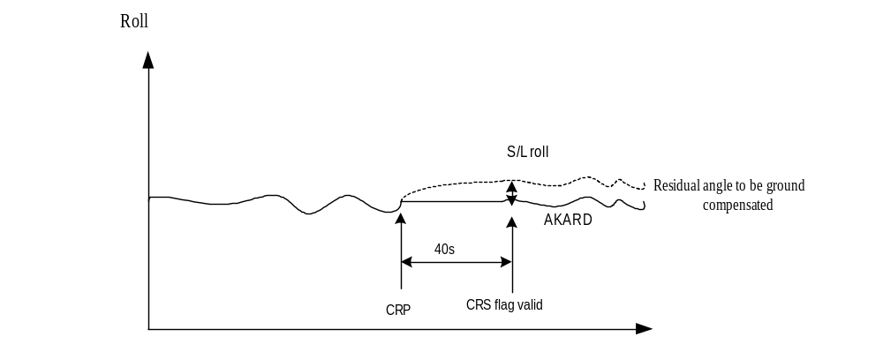

Figure 3.8/8 : the roll telemetry at RMW or NM to CRP transition

The Hx monitoring
The definition of the Hx monitoring is illustrated in Figure 3.8/9 : the Hx monitoring principle. The Hx monitoring function enables the computation of the Hx telemetry at AOCS level, and raises an Hx flag if the current Hx value evolves outside specific criteria. The Hx flag is monitored by the COBS Hx monitoring function (refer to paragraph 3.10.6) used in all modes, except during SK / MM. The purpose of this function is to ensure the spacecraft safety, by triggering the ESR safe mode before the ESR autonomy or control capability starts to be challenged by its entry condition.
At AOCS level, the Hx flag is raised in AOCS if :
- the Hx monitoring function is enabled (it is not at initialisation). This can be seen in AKGLHXFN telemetry.
- The Hx value (AKHXVAL telemetry) is lower than the Hx lowest edge (AKHXLOW telemetry). This lowest edge limit the ESR negative roll rate after the wheels have spun down.
- The Hx value (AKHXVAL telemetry) is inside two limits, namely the Hx minimum limit (AKHXMIN) and the Hx maximum limit (AKHXMAX). Although proved by analysis not strictly mandatory, theses min & max limits helps to minimises ESR transient, and ensures controllability of ESR during transient.

The Hx minimum and maximum limits have to be updated regularly in order not to get interference with the natural Hx evolution from the external disturbances and the orbit. It is performed quite infrequently, by sending a single ABACU217 TC. At that date, the Hx minimum and maximum limits are initialised given the current Hx value and the value of the Hx threshold, and the Hx flag is cleared :
Hx minimum limit (AKHXMIN) = current Hx value (date of TC) - Hx threshold (AKHXTH)
Hx maximum limit (AKHXMAX) = current Hx value (date of TC) + Hx threshold (AKHXTH)

The threshold tuning and the interference with the natural orbit evolution is as follows :
- Lowest edge is -10 Nms in S/W. This places operationally a yellow limit at -5 Nms on the Hx value, and a red limit red set at -8 Nms. This will always grant an ESR rate higher than -0.75°/s after ESR transient, hence at least 24 hours of autonomy.
- The -5 Nms yellow limit grants two months in between station keepings.
- The value of the threshold is at 7 Nms. At date of the update of the Hx minimum and maximum limits, the triggering of the ESR will therefore occur before the natural Hx evolution is below that threshold. Given the natural rates of Hx evolution, this gives a duration of 2 weeks worst case, and 4 weeks expected.
It is therefore recommended to perform this operation not less frequently than weekly. This provides a 1 to 3 weeks autonomy margin.
Note : the Hx monitoring function (COBS part for corrective action) will not be effective in station keeping and momentum management phase. This is related to the following facts :
- ground support is present in these phases, compatible with sufficient reaction time in case of problems,
- the Hx monitoring is less reactive than the CRP flag for the cases of open thruster failures
- this places less constraints on intermediate momentum condition for momentum management, and does not places constraints on the efficiency of the roll compensation in delta V.
Obviously, the values of the Hx min and max limits have to be reinitialised after operations with thrusters, owing to the risk of change into the spacecraft embedded roll momentum.

Note : the Hx monitoring function has to be has to be enabled in AOCS to get Hx telemetry in AOCS. This is why the AOCS part of the monitoring function is never disabled after initialisation (it is not enabled as a default state to avoid risks of fallback at ESR exit if the momentum is not adequate). This initialisation updates automatically the Hx minimum and maximum bounds and clears the Hx flag.

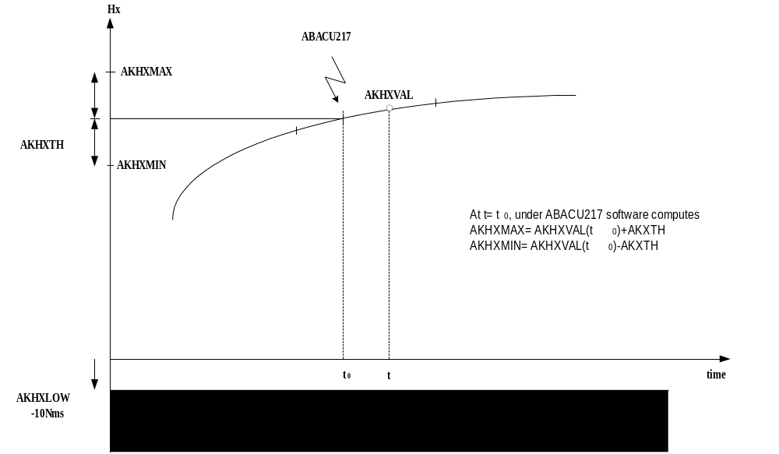

Figure 3.8/9 : the Hx monitoring principle

The RW speed monitoring
The principle of the RW speed monitoring is broadly similar to the one of the Hx monitoring, with the following exceptions :
- There is no lowest edge limits. Two maximum and minimum limits are only used.
- There are no automatic initialisations on board. The monitoring is based directly in COBS on the comparison between the reaction wheel speeds and two fixed limits.
The detailed definition of the COBS monitoring is performed in section 3.10.7. This monitoring is run in RMW and NM modes. Its purpose is twofold :
- To guarantee the reaction wheels speeds operational range in operations with thrusters. For that purpose the reaction wheels limits are set to -3000 rpm, +3000 rpm in these phases.
- Outside these phases, to attempt a CRP mode when the RW speeds evolution is abnormal. For that purpose, the evolution of the reaction wheels speed is allowed in a range of 1.35 Nms from a fixed reference, updated regularly according to the natural wheel speeds evolution. If none of the wheels speeds variation evolve beyond this threshold, the entry rate in CRP will be limited to 0.05°/s. This ensures in any case the convergence into CRP.
In normal operations, as for the Hx monitoring function, the upper and lower limits for the RW speed evolutions are to be updated regularly according to the natural evolution from the orbit and the external torques. According to the anticipated orders of magnitude, this activity is required daily, and consists in (for each of the reaction wheels) :
- Setting the lowest limit to the current wheel speeds (algebraic) - 135 rpm
- Setting the highest limit to the current wheel speeds (algebraic) + 135 rpm
Given the size of the 1.35 Nms threshold and the anticipated natural wheel speeds evolution, the daily update allows a 1.5 to 3.5 days margin before interference with the limits occur.
During attitude profiles, the RW speeds evolutions have to be predicted, to check that no interference occur with the limits. If so, the monitoring function can be disabled, and reinitialised once the manoeuvre is done.

Operational constraints stemming from AOCS additional features

Attitude profiles
- The attitude profiles shall be executed axes by axes. The attitude excursion is limited such as to stay within 2° off the FPSS reference on the pitch and yaw axes.
- The targeted delta roll angle might be checked by memory dump, before the execute of the roll manoeuvre is performed.
- The attitude profiles shall be sized in RMW and NM not to loose the control star. If other stars are to exit the field of view, they shall be released before the profile is executed.
- The verification of the RW speed evolution shall be done in CRP, RMW and NM before an attitude profile.
- Adequate margin versus the lowest Hx edge exists
- During any profile, the reaction wheels shall not go above 3000 rpm
- At the end of a profile, all wheels shall be above 500 rpm
- In RMW or NM, if the foreseen speed evolution enters in conflict with the RW speed monitoring limits, the RW speed monitoring shall be inhibited and reinitialised after the profile is performed.
- The Hx sliding limits shall be reinitialised before and after the profile is attempted.
- The sun off pointing flag shall be cleared after each attitude profile in pitch and yaw axes generated by an ABACU214, and the programmation on the COBS experiment off pointing warning message function shall be handled accordingly.
- Although the software allows to handle RSL initialisation and change of eligibility status in the course of roll attitude trims and PCPG roll operations (initialisations of RSL offsets account for that), it is intended to make these operations exclusive.

SEU protection
- It is not desirable to extend the staircase filter when LVA is closed. When LVA is open, this is forbidden.
- It is not desirable to decrease the Z spike coordinate filter when LVA is closed. When LVA is open, this is forbidden.
- Outside thruster operations, it is not desirable to extend the staircase filter threshold above 200.

Hx monitoring and RW speed monitoring
- The ground is not allowed to release the contact with the spacecraft if the Hx monitoring function is not operational.
- The revisit time, with the Hx monitoring function enabled, shall be less than 12 hours.
- The reaction time to a loss of contact when using the thrusters shall be less than 3 hours to retrieve telemetry.
- The Hx sliding min and max limits shall be updated not less frequently than 1 week.
- The Hx sliding min and max limits shall be reinitialised before the execution of the profile (to be sure not to trigger during the manoeuvre), and straight after the manoeuvre (to get the autonomy after the manoeuvre).
- The Hx function monitoring function will be disabled at COBS level during thruster manoeuvres.
- The Hx sliding min and max limits will be reinitialised in AOCS after the delta V or momentum management manoeuvre, prior re-enabling the Hx monitoring function in COBS. At that stage the Hx flag might have to be cleared in AOCS.
- Any attitude profile shall not be attempted if the Hx value goes below -5 Nms (nominal) or -8 Nms (contingency).
- The RW speed monitoring limits shall be updated daily if the spacecraft is in RMW or NM modes.
- If an attitude profile is attempted in RMW or NM modes, it is the ground responsibility to verify that the anticipated profile does not violate any RW speed monitoring function, while the resulting speeds grant sufficient autonomy (this appears always to be the case if the targeted attitude is lower than 500" from the nominal attitude on any axis). If not, disable the monitoring during the profile, and re-establish it after the profile with appropriate updated limits.

Star handling and associated items
- In RMW and NM modes, the current control star shall never be released by the ground by an SSU command
- In any case, in RMW and NM modes, the changeover of control star shall be done by the ground before the star exits the field of view, and the other stars shall be released before they exit the SSU field of view (also applicable in CRP).
- In NM and RMW, if a star is released by the ground by an ABACU211 TC, it is requested to set its associated eligibility status to false.
- After a mapping and operations with thrusters, the eligibility of all the tracked and valid stars shall be re - established. This includes the one for the current control star to be able to restart the RSL.
- A star can be made eligible only if the star is valid at the date of the execution of the telecommand. An associated verification is always requested to confirm the eligibility operation.
- The SSU stars shall be selected in NM and RMW according to the following rules of section 3.8.3.4
- In RMW and NM, if a star, which is not the control star becomes invalid on more than 40 consecutive TM packets (when applicable TM packets are set), that is 10 minutes, this star shall be declared "not eligible" and released. On the other hand, transients invalidity status can be accepted.
- When a star is first acquired, the following items should be verified, before the star can be declared eligible. If the items are not fulfilled, the star shall be released :
- In 30 minutes, if the star becomes invalid on more than 40 consecutive TM packets (when applicable TM packets are set), that is 10 minutes, this star shall be declared "not eligible" and released.
- If the difference between the measured and the expected magnitude is more than the SSU typical magnitude error (from in flight experience, threshold at FDF discretion)
- Other criteria, at ground discretion, from flight experience
- In RMW and NM modes, it is not allowed to release the control star by an ABACU211 TC or to change it to an invalid star channel, if the control star is the sole valid star tracked. If a NM to CRP transition is desired, the direct transition shall be used through ACU mode relays.
- In NM and RMW, it is not allowed to perform (under ground request) a control star change on a "non eligible" star, even if this star is valid. This associated risk is a fallback in CRP. This is linked to an inappropriate RSL offset and star reference initialisation.
- For the "nominal" control star, on which the RSL has been computed with the objective to get a null RSL offset, the RSL offset shall be trimmed back to zero once at the date of RSL start, after delta V operations, after mapping operations. In that case the RSL offsets of the others stars might have to be trimmed accordingly, if the delta is higher than 10".
- If the control star for which the RSL has been computed is flagged out by the SEU logic, the recovery of the pointing shall be performed with either of the strategies presented in section 3.8.3.4.
- If the spacecraft attitude is to be trimmed with a step on the RSL offset on the control star, the RSL offsets of all the other eligible stars shall be trimmed accordingly if the trim exceeds 10". The trim shall respect the 135" limit, while being decoupled from attitude profiles and PCPG operations. On the other hand, it is not necessary to stop RSL for that activity.
- The eligibility status of the control star itself is meaningless, since it makes no sense to swap from one star to itself. It has nevertheless to remain eligible (action needed after a delta V and a mapping) to avoid interference with later start of RSL.
- Setting eligibility is always ground action and responsibility. If a star is tracked and not made eligible, it is only for investigation or at acquisition.
- The ground has to set the star channel to "not eligible" when a star is released, otherwise when a new star is acquired on that channel the RSL offset can be not yet initialised and the star can be made the control star, risking thus an offset.
- There is no requirement to disable RSL when changing the control star from a on ground demand.
- The roll TM offset shall be trimmed regularly, not less frequently than each time the RSL is updated.

AOCS configuration

FDE
The FDE configuration shall be as follows:

ESR status
- ARO/ESR is enabled
- ARO power is enabled
- ARO/ESR ground initiate arming is at "not armed"

FDE power
- Except relay which has been open during recovery ( ASFD12=OPEN), all others relays shall stay closed and not be commanded by ground.

Roll criteria
- ESR roll control disabled.
- The gain used for gyro set at low. The purpose is not to force gyro compensation to zero.
- Roll rate criteria is disabled and threshold is set at maximum value = 1,5°/sec.
The commands to set the RRAD threshold are:
Send AZFD02, ‘7FF’h
Verify ASFD52 : raw value =’7FF’
1,5°/sec
It shall be noted that in case of CDMU chilly start up, the RRAD will be re-enabled.
- Roll attitude anomaly criteria disabled and threshold is set at maximum value = 157,4°
The commands to set the RAAD threshold are:
Send AZFD01, ‘7FF’
Verify ASFD51 : raw value =’7FF’
157,4°
The gyro drift correction shall be ASFD57 = 0000, since FDE is in low gain.
Yellows limits have to be set on roll attitude accumulator at 50° typical value. When this value is reached, the accumulator shall be reset:
Send telecommand AZFD01, ‘8000’h the verification is got with telemetry ASFD58.

Pressure criteria
- Pressure anomaly detection disabled with threshold set at 25 bars.
The commands to set threshold are:
Send AZFD03, ‘FF’
Verify ASFD53 : raw value =’FF’
25 bar

Sun pointing criteria
- FSPAAD and CSPAAD are always enabled.
- Time out detection (TOD) is always forced in order not to use timer.

AOCS units
The nominal AOCS configuration of AOCS units is as follows :

 | CRP | RMW | RMW manoeuvre | NM
ACU | A | A | A | A
CAE | A | A | A | A
FDE | See & 3.9.1 | See & 3.9.1 | See & 3.9.1 | See & 3.9.1
SSU | A ( not in control loop) | A | A | A
IRU | All OFF | All OFF | All OFF | All OFF
WDE | 1,2,3 | 1,2,3 | 1,2,3 | 1,2,3
FPSS | A | A | A | A
FCV drivers | OFF | OFF | A | OFF
LV drivers | OFF | OFF | OFF  (ON only for LV OPEN and CLOSE) | OFF
LV | A CLOSED,  B CLOSED | A CLOSED,  B CLOSED | A OPEN,  B CLOSED | A CLOSED, B CLOSED
CBH | B | B | AB | B

AOCS monitorings
The nominal AOCS configuration of AOCS monitorings is as follows :

 | CRP | RMW | RMW manoeuvre | NM
CSPAAD | Enabled | enabled | enabled | enabled
FSPAAD | Enabled | enabled | enabled | enabled
Hx flag | Enabled | enabled | disabled | enabled
CRP flag | Disabled | enabled | enabled | enabled
RW speed monitoring | Disabled | enabled | enabled | enabled
ACU reset monitoring | Enabled | enabled | enabled | enabled
Thruster monitoring | Disabled | disabled | enabled | Disabled
Experiment off pointing monitoring | As desired | As desired | As desired | As desired, recommended

Others

Old IRU's
The Three failed gyro's shall be left unpowered, out of the ACU hardware configuration word, and with their MACS bus head disabled
The assignation of gyros for FDE/ESR shall never be changed

Miscellaneous
The relay 5 of ACU shall always be left open after mode transition activities
Any of the possible hardware configuration words shall now be derived from the following definition :

0 | 0 |  |  | CAE B  1= activ | CAE A  1= activ | 0 |  | 0 |  | FPSS B  1= activ |  | FPSS A  1= activ |  |  |  | SSU B  1= activ |  | SSU A  1= activ |  |  | WDE 4  0=activ |  | WDE 3  0=activ |  | WDE 2  0=activ | WDE 1  0=activ
 |  | 0 | 0 | Wheels 2,3,4
 |  | 0 | 1 | Wheels 1,3,4
 |  | 1 | 0 | Wheels 1,2,4
 |  | 1 | 1 | Wheels 1,2,3

The nominal configuration is :
AKHWCNF = 3457h
0 | 0 | 1 | 1 | 0 | 1  CAE A | 0 | 0 | 0 | 1  FPSS A | 0 | 1  SSU A | 0 | 1  WDE 3 | 1  WDE 2 | 1  WDE 1

3 | 4 | 5 | 7

COBS gyroless functions
Several new COBS functions have been developed, mainly to provide adequate on board monitoring in order to ensure the satellite safety. Five new COBS functions are used:
- ACU reset monitoring (force ESR mode in case of ACU reset detection)
- Hx flag monitoring (force ESR mode in case of unexpected Hx momentum evolution – satellite autonomy in ESR)
- RW speed monitoring in RMW mode (inhibit PROS and command transition to CRP mode in case of unexpected RW speed evolution)
- CRP flag monitoring in both RMW or NM (inhibit PROS and command transition to CRP mode in case of SSU star loss)
- Depointing message for experiments (a warning message will be broadcast to experiments in case of excessive depointing)

This last function is not directly related to the Gyroless operations, but is used to prevent experiments damages in case of satellite depointing, and before ESR fallback upon FSPAAD criteria detection.
These new gyroless COBS functions replace the following unused application functions:
- ESR gyro setting (no more used – no more gyros)
- Trouble shooting function (used for ACU reset detection – replaced by ACU reset monitoring)
- Gyro monitoring (no more used – no more gyros)
- ISA / SAD function (used after separation for initial acquisition)
- RAAD monitoring (never used)

In addition to the new gyroless COBS functions, some modifications have been developed on the following functions
- Thruster on-time monitoring (running in any AOCS mode)
- ESR detection (to disable all Gyroless monitoring in case of ESR detection)

The Table 3.13/1 : Gyroless COBS functions usage presents a summary of the COBS gyroless function, the associated usage and routine operations:

Unused functions
The existent functions ESR Gyro Setting, Trouble-Shooting Function, Gyro Monitoring, ISA and SAD Function and RAAD Monitoring have been disconnected from COBS scheduler. In addition, the corrective actions have been disabled (no effect, even if the C.A. execution is commanded through the dedicated TCM).
The ESR Gyro Setting, Trouble-Shooting Function, Gyro Monitoring, ISA and SAD Function and RAAD Monitoring status at warm start-up shall always be INHIBITED.

Warm start-up / Chilly start-up
The new gyroless monitoring functions are discarded in case of warm or chilly star-up. These function shall be uploaded to the CDMU as a part of the DHSS recovery, in addition to the existing patches (TM packet).
Note: In case of chilly start-up, the FDE RRAD criteria will be enabled as a part of the start-up sequence. As soon as a chilly start-up has been detected, the FDE RRAD criteria shall be inhibited by ground command.

Thruster on-time monitoring
The existent function Thruster Monitoring runs in all AOCS modes. No other modification have been introduced for that function.
This function shall be used during thruster operations, for both Momentum Management and Station Keeping, as a protection against ground command errors (excessive thruster actuation duration). The Thruster (open) failure detection is achieved by both the CRP monitoring for roll thrusters failure and FSPAAD for pitch and yaw thrusters failure.

ESR detection
The existent function ESR Monitoring inhibits the five new Gyroless functions when triggered. No other modification have been introduced for that function.

ACU reset monitoring
A new function have been developed to replace the existing Trouble Shooting Function (TSF or Free Process) in order to monitor any occurrence of a reinitialisation of the AOCS computer. In case of ACU reset, all AOCS gyroless software is discarded during the boot of the AOCS computer. The COBS is used to monitor any occurrence of the ACU reset, and force ESR mode in case of detection, according to the following definition:

ACU reset monitoring (“ACU reset monitoring” function = ENA)
If (“ACU reset” = detected) then
Report COBS Anomaly message “ACU reset detected” (ANO Id = 93h)
If (“ACU reset monitoring ” CA = ENA) then
AOCS RTU reconfiguration (as per PRCG definition)
Disable Gyroless function “CRP flag monitoring”
Disable Gyroless function “RW speed monitoring”
Disable Gyroless function “Hx flag monitoring”
Disable Gyroless function “Experiments off-pointing warning message”
Arm and Initiate ARO / ESR : ACFD19, ACFD09
Disable “ACU reset monitoring” function
Disable “ACU reset monitoring” CA
Set “ACU reset monitoring” CA triggered flag
End if
End if

Note: this function is able to monitor ACU A or ACU B reset occurrence (according to the switchable channels definition)
The ACU reset detection is based on ASAC53 word (ACU watchdog):
ACU reset detected if
(ASAC53[bit_0] and ASAC53[bit_12]) or (ASAC53[bit_8] and ASAC53[bit_13])

Refer to AD2: COBS Gyroless Functions – Software User's Manual for more.

Hx flag monitoring
A new monitoring has been introduced in order to guarantee the satellite autonomy, in particular the Hx momentum value at ESR entry. In case of unexpected evolution of the Hx momentum, the ACU software will report an anomaly through Hx flag within the AOCS telemetry. This flag is used by the COBS Hx flag monitoring function to force the ESR mode with a minimum Hx momentum at ESR entry, in order to guarantee a maximum autonomy.
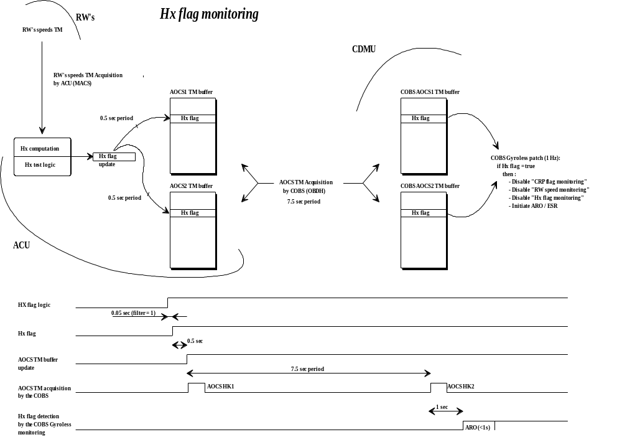

The COBS Hx flag monitoring function process the AOCS Hx flag (two words: word_10 & word_405), according to the following process:

Hx flag monitoring (Hx flag monitoring = ENA)
If (AOCS TM packet = new) and [Hx flag = true] then
Report COBS Anomaly message “Hx flag detected” (ANO Id = 96h)
If CA “Hx flag monitoring ”= ENA then
AOCS RTU reconfiguration (as per PRCG definition)
Disable Gyroless function “ACU reset monitoring”
Disable Gyroless function “CRP flag monitoring”
Disable Gyroless function “RW speed monitoring”
Disable Gyroless function “Experiments off-pointing warning message”
Set function “Hx flag monitoring” CA triggered flag
Disable function “Hx flag monitoring” and associated CA
Arm and Initiate ARO / ESR : ACFD19 , ACFD09
End if
End if

Refer to AD2: COBS Gyroless Functions – Software User's Manual for more.
Note: this function can be used with any AOCS TM packets selection.

RW speed monitoring
A new monitoring has been introduced in order to monitor the Reaction Wheels speeds. In case of unexpected evolution of the RW speed, the COBS RW speed monitoring function will force a transition to CRP mode and will disable the PROS.
The COBS RW speed monitoring function process the AOCS telemetry (word_111 to word_114), according to the following process:

RW Speed monitoring (RW speed monitoring = ENA)
If (AOCS TM packet = gyroless) and [(RW i speed < RW i min) or (RW i speed > RW i max)] ∀ i ∈ [1..4] then
Report COBS Anomaly message “RW Speed outside limits” (ANO Id = 95h + ANA data =
RW number that causes the anomaly)
If CA “RW Speed monitoring ”= ENA then
Disable Gyroless function “CRP flag monitoring”
AOCS RTU reconfiguration (as per PRCG definition) + PDU Command
registers reconf
Switch OFF FCV A (AZFVAOFR+PZAPEXER)
Switch ON LV A (AZLVAONR+PZAPEXER)
Minimum Delay 1 sec
Close LV A (ACCA21A)
Minimum Delay 1 sec
Switch OFF LV A (AZLVAOFR+PZAPEXER)
Command AOCS mode relay 5 OFF (ACAC25A - ACAC25B if ACU B is used)
Command AOCS mode to CRP (ACAC24A+ACAC03A+ACAC22A+ACAC01A)
(ACAC24B+ACAC03B+ACAC22B+ACAC01B if ACU B is used)
Minimum Delay 1 sec
Command AOCS mode relay 5 ON (ACAC05A – ACAC05B if ACU B is used)
Minimum Delay 1 sec
Command AOCS mode relay 5 OFF (ACAC25A - ACAC25B if ACU B is used)
Set function “ RW Speed monitoring” CA triggered flag
Disable function “ RW Speed monitoring” and associated CA
End if
End if

Since the RW speed TM are available only for AOCS packet type 2 and 3.2, the function shall be disabled when another packet type is commanded.
The RW speed TM (words 111 to 114) have the following definition (bit_0 = MSB):
bit_0 = sign bit
bit_0 =1 => CW (+)
bit_0 = 0 => CCW (-)
[bit_4.. bit_15] = speed (12 bits, lsb = 5.333 rpm) AKWDSPi

Refer to AD2: COBS Gyroless Functions – Software User's Manual for more.
Note: this function reads both ACU A or ACU B telemetry and command ACU A or B mode relays upon the current switchable channels definition.

CRP flag monitoring
A new monitoring has been introduced in order to monitor the so-called CRP flag, elaborated at ACU software level. When no more valid and eligible star is available for roll control in both NM and RMW, the ACU S/W will set the CRP flag and the CRP flag monitoring COBS function will force a transition to CRP mode and will disable the PROS.
This monitoring is particularly important during manoeuvres in RMW (Station Keeping and Momentum Management) since the SSU is used for both roll control and as a Roll Rate Anomaly Detector. For the manoeuvres, only one star is used for the control (all other stars being forced to a ‘not eligible’ status). In case of excessive (roll) rate, the SSU will report an anomaly to the ACU (i.e. SEU / Star loss) and the ACU will provide to COBS the CRP flag to abort the manoeuvre and initiate the transition to CRP mode, as presented in the following figure:

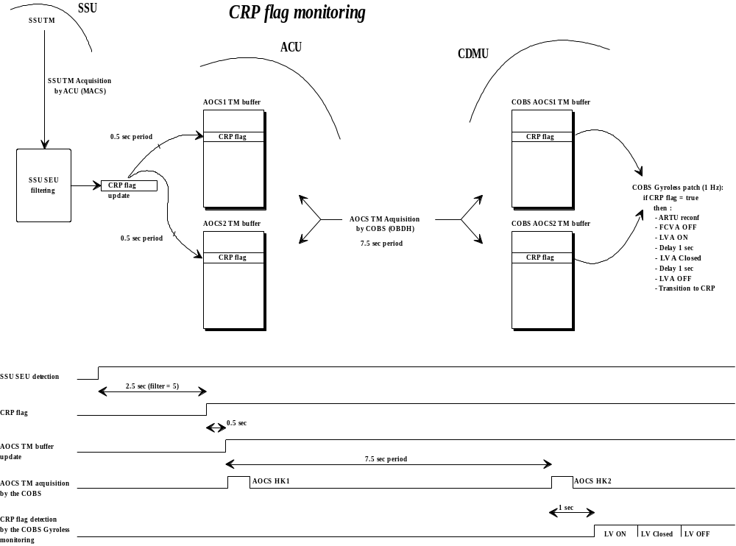

The COBS CRP flag monitoring function process two words within the AOCS telemetry (word_10 and word_405), according to the following process:
CRP flag monitoring (CRP flag monitoring = ENA)
If (CRP flag = detected) and (AOCS TM packet = new) and
[(AOCS active mode = NM) or (AOCS active mode = RMW)] then
Report COBS Anomaly message “ CRP flag detected” (ANO Id = 94h,
ANO data = AOCS mode)
If CA “ CRP flag monitoring ” = ENA then
Disable Gyroless function “RW speed monitoring”
AOCS RTU reconfiguration (as per PRCG definition) + PDU Command
registers reconf
Switch OFF FCV A (AZFVAOFR+PZAPEXER)
Switch ON LV A (AZLVAONR+PZAPEXER)
Minimum Delay 1 sec
Close LV A (ACCA21A)
Minimum Delay 1 sec
Switch OFF LV A (AZLVAOFR+PZAPEXER)
Command AOCS mode relay 5 OFF (ACAC25A - ACAC25B if ACU B is used)
Command AOCS mode to CRP (ACAC24A+ACAC03A+ACAC22A+ACAC01A)
(ACAC24B+ACAC03B+ACAC22B+ACAC01B if ACU B is used)
Minimum Delay 1 sec
Command AOCS mode relay 5 ON (ACAC05A - ACAC05B if ACU B is used)
Minimum Delay 1 sec
Command AOCS mode relay 5 OFF (ACAC25A - ACAC25B if ACU B is used)
Set function “ CRP flag monitoring” CA triggered flag
Disable function “ CRP flag monitoring” and associated CA
End if
End if

Refer to AD2: COBS Gyroless Functions – Software User's Manual for more.
Note: this function can be used with any AOCS TM packets selection.
Note: this function reads both ACU A or ACU B telemetry and command ACU A or B mode relays upon the current switchable channels definition.

Experiments off-pointing warning message
This new monitoring function is not exactly linked to gyroless operations, since it is used to prevent experiments damages in case of large depointing (transient period from nominal pointing to ESR detection by FDE - FSPAAD criteria). In order to avoid the damages at experiments levels, the AOCS off-pointing flags are monitored by this specific COBS function in order to command a safe configuration in case of pointing anomaly for LASCO, MDI, SUMER and UVCS.
This monitoring function is based on the existing AOCS off-pointing flags, provided within the AOCS TM (word 6), according to the following processing:
Experiment off-pointing warning message (“Experiment off-pointing” function = ENA)
If (AOCS off-pointing flag = true) then
Report COBS Anomaly message “Experiment Off-pointing warning ”
Disable “Experiment Off-pointing warning” COBS function
If (UVCS “Experiment Off-pointing warning” flag = AUTHORISE) then
Execute CA (UVCS):
Direct High Power Command : UCMDSFN (“UVCS Enter safe mode prim”)
Hexa code: 0008, 8000, 0048, 023D
Direct High Power Command: UCMDSFR (“UVCS Enter safe mode red ”)
Hexa code: 0008, 8001, 0050, 02BD
If (LASCO/EIT “Experiment Off-pointing warning” flag = AUTHORISE) then
Execute CA (LASCO):
OBDH block command : LBSESR (“LASCO ESR warning message”)
Hexa code: 000A, 4482, 24A2, CCCC, F16E
If (MDI “Experiment Off-pointing warning” flag = AUTHORISE) then
Execute CA (MDI):
OBDH block command : MBLTOPNL “Limb tracker open loop”
Hexa code: 000C, 4503, 2B03, 0007, 0001, 2B0B
If (SUMER “Experiment Off-pointing warning” flag = AUTHORISE) then
Execute CA (SUMER):
Disable ESR Warning flag distribution for SUMER (COBS “ESR warning
flag” function)
OBDH block command : SBSESR (“SUMER ESR warning message ”)
Hexa code: 000A, 4584, 2CA2, CCCC, F96E

End if
End if

The configuration of the experiments concerned by this monitoring are defined by a specific register.

Refer to AD2: COBS Gyroless Functions – Software User's Manual for more.
Note: this function can be used with any AOCS TM packets selection.

Gyroless FDIR principles
The FDIR principles are described within AD4: SOHO Gyroless – FDIR Analysis, reference SH.MAT.NT.37923) provided in ANNEX 4 - SOHO GYROLESS – FDIR ANALYSIS.

Gyroless contingency analysis
The gyroless contingency analysis (AD5: SOHO Gyroless – Contingency Analysis), reference SH.MAT.NT.37932) is provided in ANNEX 5 - SOHO GYROLESS – CONTINGENCY ANALYSIS

Ground constraints – Satellite autonomy
The ESR autonomy, in worst case outside thruster maneuvers, is established at nearly 24 hours. The ESR autonomy, if the failure occurs during thruster manoeuvres, is appraised at 8 hours.
The ground reaction times and the operational scheme proposed to comply with this autonomy, and hence grant the spacecraft safety, is therefore determined the following way :
- a revisit time of 12 hours, the purpose of it being nominally to verify that both telemetry can be acquired and no ESR has triggered. If not, appropriate contingency operations have to take place : reacquire at least low rate TM and if ESR, perform roll rate control.
- A reaction time to acquire TM in less than 3 hours, if the TM is lost
- A reaction time to perform roll rate control in less than 1 hour once ESR is notified and low rate linked is established
This strategy allows a contingency margin always more than 4 hours.
Once in ESR with roll rate control, the revisit time (ie the time without roll rate control) can be extended to 24 hours.
The following constraints apply to grant maximal ESR entry rates, and hence spacecraft autonomy :
- In any case, the contact with the spacecraft shall not be released until the Hx protection is set in AOCS and COBS
- In any case, the enabling of the SSU_SEU monitoring in AOCS & of the CRP flag in COBS shall be performed, specially when using thrusters. If a reconfiguration of the data handling takes place during a thruster manoeuvre, the manoeuvre shall be aborted as soon as possible.
- In any case, the default value of the staircase filter shall be brought back to a value lower or equal to 5 when latching valve A is open.
- The lowest Hx which can be accepted nominally is -5 Nms, and for contingency -8 Nms. If the value becomes lower than -5 Nms, a momentum management has to take place within a week. If the value becomes lower than -8 Nms, a momentum management has to take place immediately.

The autonomy provided by the RW speed monitoring limits is several days (2.5 to 4.5). In order not to trigger intempestively a reconfiguration to CRP, the update of these limits is requested daily.
The autonomy provided by the Hx monitoring sliding limits is several weeks (2 to 4). In order not to trigger intempestively a reconfiguration to ESR, the update of the sliding limits is requested weekly.
The Hx lowest edge can allow more than two months in between momentum management. The operational yellow limit at -5 Nms allows more than 1 week autonomy before the COBS action takes place.
The operational red limit at -8 Nms allows several days autonomy before the COBS action takes place.

The Table 3.13/1 : Gyroless COBS functions usage presents a summary of the COBS gyroless function, the associated usage and routine operations:

 |  |  | Related Ops | Modes
 | HX Mon | COBS function | - | CRP, RMW, NM
 |  | AOCS function | Routine: Weekly update | (inhibited during SK and MM)
 | RW speed Mon | COBS function | Routine: Daily update  (Setting –3000 / +3000 during SK and MM) | RMW, NM  Disabled in CRP
 |  | AOCS function | -
 | CRP flag Mon | COBS function | - | RMW, NM
 |  | AOCS function | - | Disabled in CRP
 | ACU reset Mon | COBS function | - | CRP, RMW, NM
 |  | AOCS function | -
 | Off-pointing Mon | COBS function | - | NM
 |  | AOCS function | - | (Upon exp. Requirement)

Table 3.13/1 : Gyroless COBS functions usage

GROUND SUPPORT SOFTWARE
The following items are required as ground processing to operate the AOCS. They are sorted out by mission phases. A brief explanation of the desired processing is performed. In some cases, the user's manual section is identified for a better definition the detailed processing requirements.

ESR and ESR exit
- SAS polar plots : the existing TM page of AKSAS1A (on Y axis, -2° to +2°) plotted versus AKSAS1B (on X axis, -2° to +2°), completed with a back-up page for the analog SAS outputs AXFD05 versus AXFD06 (same axes, same scales). This will be used to perform the roll rate control in ESR.
- FPSS polar plot : a TM page from AKFPITCH versus AKFYAW, as for SAS plots, to be used to monitor ESR roll behaviour during the ESR exit phase.
- TSTOL roll rate : update of the ground Tstol procedure, as run during the ESR exit operation of 1/99, customized to the size and axis of the selected ESR exit momentum, depending on the selescted wheel subset. Refer to section 3.4.2.2. Will support the ESR exit operations.
- SAS / FPSS pitch and yaw rate : new ground Tstol procedure to evaluate the pitch and yaw rates from the SAS digital coordinates (AKSAS1A, AKSAS1B) or the new processed FPSS data (AKFPITCH, AKFYAW) evolution in time (every TM packet). Will support the ESR exit operations. Refer to 3.4.2.3.
- Derivation of momentum exchange with the reaction wheels : refer to section 3.4.2.2.3. Will be used to reduce the roll rate before entering CRP.
- Open loop thruster torque computation (any thruster) : as per computations done for momentum management and station keeping. Will be used in ESR steady state, at least for open loop roll rate control.
- Yaw and pitch braking (option) : translation of the pitch or yaw rate to damp with thruster into commanded on times with the open loop thruster torque computation. Refer to section 3.3.3. Might be used in ESR steady state.

CRP / CRS
- MDI / experiment data : elaboration of absolute roll attitude from experiments measurements available in (at least) medium rate telemetry. Will allow to maintain roll attitude on a long term in CRP.
- Attitude reconstitution algorithm from SSU : no change into processing from the current situation (already provided by FDF since launch). Will allow to identify accurately roll absolute attitude.
- CRS drift estimation from wheels transverse momentum evolution in NM and RMW : post processing of the RW speed evolution along time in NM or RMW (with or without roll steering law active, pending on the estimated solar perturbation torques and on the orbital geometry) to derive the size of the transverse momentum embedded on the wheels and its angular position in the Y/Z spacecraft axes. The CRS drift estimation is derived taking the average angular evolution of the transverse momentum over 500s in the coming day. Refer to 3.5.2.4. Will allow to provide a CRS drift estimation in the phases when the CRS on board drift estimation logic is not yet able to identify a valuable estimation.
- Roll angle monitoring in CRP from SSU (option) : ground Tstol procedure, as run during the roll in FSA operation of 3/99. Option for commissionning of CRS accuracy in roll large angle manoeuvres.

Attitude maneuvers
- Prediction of RW speeds all through the profile (roll) : as formerly done for roll manoeuvres with gyros, neglecting the momentum taken by the spacecraft rates (ie at each position, equivalent to the stop RW speeds if manoeuvre was to end in that position). Will allow to verify the feasability of a roll manoeuvre versus RW speed monitoring in RMW / NM and versus RW operational range in all modes.
- Stop RW speeds at end of manoeuvre (pitch/yaw) : as formerly done for roll manoeuvres with gyros, but extended with rotations matrixes on pitch and yaw axes of up to 2°. Will allow to verify the feasability of a pitch / yaw manoeuvre versus RW speed monitoring in RMW / NM and versus RW operational range in all modes.
- Hx evolution at end of manoeuvre (pitch/yaw) : post processing of "Stop RW speeds at end of manoeuvre". Will allow to verify the feasability of a pitch / yaw manoeuvre versus the Hx monitoring function (lowest Hx edge in particular).

Station keeping and momentum management maneuvers
- Torque and efficiency matrix : no change into processing from the current situation (already provided by FDF since early gyroless operations). Will allow to make accurate prediction for open loop activities with thrusters.
- Intermediate speeds for momentum management : no change into processing from the current situation (already provided by FDF since early gyroless operations). Will allow to make the definition of the segments order for momentum management.
- Open loop compensation in delta V (OFF and ON) : no change into processing from the current situation (already provided by FDF since early gyroless operations). Allows to perform delta-V's while not being at RW'w speed mid range.
- Manoeuvre calibration report : as currently performed after each manoeuvre, analysis of the thrusters accuracy and of the compensation accuracy for the delta V's.

Others
- PVT analysis : no change into processing from the current situation, is used to evaluate the remaining fuel mass. Will allow to make the evaluation of the position of the center of mass for the thruster torque matrix.
- Hx evolution : no change into processing from the current situation (already provided by FDF since early gyroless operations). Will allow to make the evaluation of the dates at which a momentum management will have to be performed, and when interference with the parameters of the Hx monitoring function takes place.
- RW evolution : no change into processing from the current situation (already provided by FDF since launch). Will allow to make the evaluation of the dates at which a momentum management will have to be performed, and when interference with the parameters of the RW monitoring function takes place.
- RW speed monitoring thresholds : It is proposed to create a new ground tstol procedure, wich will generate automatically the RW speeds limits for the COBS monitoring from the current wheels speeds and the 1.35 Nms threshold. Will be used daily in NM to update the COBS monotoring limits to cope with natural RW speed evolution.
- RSL : no change into processing from the current situation (already provided by FDF since launch). The RSL still fits with the reference Z coordinate of the "nominal" control star (RSLoffset is intended at zero for this star). It is advised to compute "back-up" RSL tables for the "back-up" control strars, prepared on ground for a potential upload in the course of the operations.
- Definitive attitude for experiments : new item, based on the roll telemetry, the current control star Y coordinate, the roll TM offset, and the date of upload of the roll TM offset. Used to remove distorsion on roll attitude telemetry for elaboration of definitive attitude files for the experiments. Refer to paragraph 3.8.4.2 for processing.

Gyroless database

Introduction
The SOHO gyroless Telecommand / Telemetry interface are described in the following documents:
- AD2: COBS Gyroless Functions – Software User's Manual
- AD3: AOCS TM and TC INPUTS

TM summary
The following table presents the COBS gyroless Telemetry summary
Note: bit 0 = MSB, "n.a." means not applicable, "n.c." means no change
Mnemo | short text description | Type | Packet | offset | bits /code | calibration | Validity
KKGYRLES | Gyroless COBS functions Installed | Digital | §0 | 17..18 (32b) | bit 31 | 0=GYLES.OF / 1=GYLES.ON | allways
KKAFES16 | ACU Reset Monitoring ENA/INH | Digital | §0 | 17..18 (32b) | bit 22 | 0=ACUR.IN / 1=ACUR.EN | KKGYRLES=1
KKAFES17 | CRP Flag Monitoring ENA/INH | Digital | §0 | 17..18 (32b) | bit 23 | 0=CRP.EN / 1=CRP.IN | KKGYRLES=1
KKAFES18 | RW Speed Monitoring ENA/INH | Digital | §0 | 17..18 (32b) | bit 24 | 0=RWS.IN / 1=RWS.EN | KKGYRLES=1
KKAFES19 | Hx Flag Monitoring ENA/INH | Digital | §0 | 17..18 (32b) | bit 25 | 0=HX.IN / 1=HX.EN | KKGYRLES=1
KKAFES1A | Experiment Off-pointing Warning Message ENA/INH | Digital | §0 | 17..18 (32b) | bit 26 | 0=OFFP.IN / 1=OFFP.EN | KKGYRLES=1
KK01XACU | EXEC PROFILE OF ACU Reset MONIT | Digital (3FF hex) | §1 | 4 | 10bits : 0..9 | 0: MSB, 1: lsb | KKGYRLES=1 and  KKGROIDT=1
KK01XOFP | EXEC PROFILE OF Off-pointing MONIT | Digital (3FF hex) | §1 | 7 | 10bits : 0..9 | 0: MSB, 1: lsb | KKGYRLES=1 and  KKGROIDT=1
KK01XCRP | EXEC PROFILE OF CRP MONIT | Digital (3FF hex) | §1 | 8 | 10bits : 0..9 | 0: MSB, 1: lsb | KKGYRLES=1 and  KKGROIDT=1
KK01XRWS | EXEC PROFILE OF RW Speed MONIT | Digital (3FF hex) | §1 | 13 | 10bits : 0..9 | 0: MSB, 1: lsb | KKGYRLES=1 and  KKGROIDT=1
KK01XHX | EXEC PROFILE OF HX MONIT | Digital (3FF hex) | §1 | 14 | 10bits : 0..9 | 0: MSB, 1: lsb | KKGYRLES=1 and  KKGROIDT=1
KK01WACU | ACU Reset Monitoring E/I STATUS AT WARM | Digital | §1 | 1..2 (32b) | bit 22 | 0=INHIBIT / 1=ENABLE (shall always be INHIBIT) | KKGYRLES=1 and  KKGROIDT=1
KK01WCRP | CRP Flag Monitoring E/I STATUS AT WARM | Digital | §1 | 1..2 (32b) | bit 23 | 0=INHIBIT / 1=ENABLE (shall always be INHIBIT) | KKGYRLES=1 and  KKGROIDT=1
KK01WRWS | RW Speed Monitoring E/I STATUS AT WARM | Digital | §1 | 1..2 (32b) | bit 24 | 0=INHIBIT / 1=ENABLE (shall always be INHIBIT) | KKGYRLES=1 and  KKGROIDT=1
KK01WHX | Hx Flag Monitoring E/I STATUS AT WARM | Digital | §1 | 1..2 (32b) | bit 25 | 0=INHIBIT / 1=ENABLE (shall always be INHIBIT) | KKGYRLES=1 and  KKGROIDT=1
KK01WOFP | Experiment Off-pointing E/I STATUS AT WARM | Digital | §1 | 1..2 (32b) | bit 26 | 0=INHIBIT / 1=ENABLE (shall always be INHIBIT) | KKGYRLES=1 and  KKGROIDT=1
KKCAEI2A | ACU Reset Monitoring C.A. ENA/INH | Digital | §0 | 101..103 (48b) | bit 42 | 0=ACUR.CA.IN / 1=ACUR.CA.EN | KKGYRLES=1
KKCAEI2B | CRP Flag Monitoring C.A. ENA/INH | Digital | §0 | 101..103 (48b) | bit 43 | 0=CRP.CA.IN / 1=CRP.CA.EN | KKGYRLES=1
KKCAEI2C | RW Speed Monitoring C.A. ENA/INH | Digital | §0 | 101..103 (48b) | bit 44 | 0=RWS.CA.IN / 1=RWS.CA.EN | KKGYRLES=1
KKCAEI2D | Hx Flag Monitoring C.A. ENA/INH | Digital | §0 | 101..103 (48b) | bit 45 | 0=HX.CA.IN / 1=HX.CA.EN | KKGYRLES=1
KKCATR2A | ACU Reset Monitoring CA TRIG FLAG | Digital | §0 | 104..106 (48b) | bit 42 | 0=ACUR.NOTRIG / 1=ACUR.TRIGG | KKGYRLES=1
KKCATR2B | CRP Flag Monitoring CA TRIG FLAG | Digital | §0 | 104..106 (48b) | bit 43 | 0=CRP. NOTRIG / 1=CRP. TRIGG | KKGYRLES=1
KKCATR2C | RW Speed Monitoring CA TRIG FLAG | Digital | §0 | 104..106 (48b) | bit 44 | 0=RWS.NOTRIG / 1=RWS.TRIGG | KKGYRLES=1
KKCATR2D | Hx Flag Monitoring CA TRIG FLAG | Digital | §0 | 104..106 (48b) | bit 45 | 0=HX.NOTRIG / 1=HX.TRIGG | KKGYRLES=1
KKGLFACU | FILTER Value for ACU Reset MONIT | Integer (16b) | @FC05h | n.a. | 16bits | Curve 1 | Dump valid only when KKGYRLES=1
KKGLFOFP | FILTER Value for Off-pointing MONIT | Integer (16b) | @FC11h | n.a. | 16bits | Curve 1 | Dump valid only when KKGYRLES=1
KKGLFCRP | FILTER Value for CRP MONIT | Integer (16b) | @FC06h | n.a. | 16bits | Curve 1 | Dump valid only when KKGYRLES=1
KKGLFRWS | FILTER Value for RW Speed MONIT | Integer (16b) | @FC07h | n.a. | 16bits | Curve 1 | Dump valid only when KKGYRLES=1
KKGLFHX | FILTER Value for HX MONIT | Integer (16b) | @FC10h | n.a. | 16bits | Curve 1 | Dump valid only when KKGYRLES=1
KKGLRMI1 | RW 1 Speed Minimum Threshold | Rwspeed (16b) | @FC08h | n.a. | mask=8FFF | Curve 2 | Dump valid only when KKGYRLES=1
KKGLRMI2 | RW 2 Speed Minimum Threshold | Rwspeed (16b) | @FC09h | n.a. | mask=8FFF | Curve 2 | Dump valid only when KKGYRLES=1
KKGLRMI3 | RW 3 Speed Minimum Threshold | Rwspeed (16b) | @FC0Ah | n.a. | mask=8FFF | Curve 2 | Dump valid only when KKGYRLES=1
KKGLRMI4 | RW 4 Speed Minimum Threshold | Rwspeed (16b) | @FC0Bh | n.a. | mask=8FFF | Curve 2 | Dump valid only when KKGYRLES=1
KKGLRMA1 | RW 1 Speed Maximum Threshold | Rwspeed (16b) | @FC0Ch | n.a. | mask=8FFF | Curve 2 | Dump valid only when KKGYRLES=1
KKGLRMA2 | RW 2 Speed Maximum Threshold | Rwspeed (16b) | @FC0Dh | n.a. | mask=8FFF | Curve 2 | Dump valid only when KKGYRLES=1
KKGLRMA3 | RW 3 Speed Maximum Threshold | Rwspeed (16b) | @FC0Eh | n.a. | mask=8FFF | Curve 2 | Dump valid only when KKGYRLES=1
KKGLRMA4 | RW 4 Speed Maximum Threshold | Rwspeed (16b) | @FC0Fh | n.a. | mask=8FFF | Curve 2 | Dump valid only when KKGYRLES=1
KKGLOFES | Off-pointing Experiment set | Status word | @FC12h | n.a. | 16bits | bit 6 : LASCO (1= ENA ; 0=INH)  bit 7 : MDI (1= ENA ; 0=INH)  bit 8 : SUMER (1= ENA ; 0=INH)  bit 10 : UVCS (1= ENA ; 0=INH) | Dump valid only when KKGYRLES=1
KKAFES02 | GYRO setting at ESR ENA/INH | n.c. | n.c. | n.c. | n.c. | n.c. | KKGYRLES=0
KK01WGYS | GYRO setting ENA/INH status at warm start | n.c. | n.c. | n.c. | n.c. | n.c. | KKGYRLES=0
KK01XGYS | Exec profile of GYRO setting | n.c. | n.c. | n.c. | n.c. | n.c. | KKGYRLES=0
KKAFES06 | Gyro monitoring ENA/INH | n.c. | n.c. | n.c. | n.c. | n.c. | KKGYRLES=0
KKCAEI01 | GYRO monitoring C.A. ENA/INH | n.c. | n.c. | n.c. | n.c. | n.c. | KKGYRLES=0
KKCATR01 | GYRO monitoring CA TRIG FLAG | n.c. | n.c. | n.c. | n.c. | n.c. | KKGYRLES=0
KK01WGYM | GYRO monitoring ENA/INH status at warm start | n.c. | n.c. | n.c. | n.c. | n.c. | KKGYRLES=0 and KKGROIDT=1
KK01XGYM | Exec profile of GYRO monitoring | n.c. | n.c. | n.c. | n.c. | n.c. | KKGYRLES=0 and KKGROIDT=1
KK17A1E | GYRO monitoring E/I st. of GYRO A thr 1 | n.c. | n.c. | n.c. | n.c. | n.c. | KKGYRLES=0 and KKGROIDT=17
KK17A2E | GYRO monitoring E/I st. of GYRO A thr 2 | n.c. | n.c. | n.c. | n.c. | n.c. | KKGYRLES=0 and KKGROIDT=17
KK17B1E | GYRO monitoring E/I st. of GYRO B thr 1 | n.c. | n.c. | n.c. | n.c. | n.c. | KKGYRLES=0 and KKGROIDT=17
KK17B2E | GYRO monitoring E/I st. of GYRO B thr 2 | n.c. | n.c. | n.c. | n.c. | n.c. | KKGYRLES=0 and KKGROIDT=17
KK17C1E | GYRO monitoring E/I st. of GYRO C thr 1 | n.c. | n.c. | n.c. | n.c. | n.c. | KKGYRLES=0 and KKGROIDT=17
KK17C2E | GYRO monitoring E/I st. of GYRO C thr 2 | n.c. | n.c. | n.c. | n.c. | n.c. | KKGYRLES=0 and KKGROIDT=17
KKAFES0A | ISA and SAD ENA/INH | n.c. | n.c. | n.c. | n.c. | n.c. | KKGYRLES=0
KKISADEL | ISA - SAD current delay | n.c. | n.c. | n.c. | n.c. | n.c. | KKGYRLES=0
KKISAPHA | ISA - SAD current phase | n.c. | n.c. | n.c. | n.c. | n.c. | KKGYRLES=0
KK01WISA | ISA and SAD seq. ENA/INH status at warm start | n.c. | n.c. | n.c. | n.c. | n.c. | KKGYRLES=0 and KKGROIDT=1
KK01XISA | Exec profile of ISA and SAD seq. | n.c. | n.c. | n.c. | n.c. | n.c. | KKGYRLES=0 and KKGROIDT=1
KKAFES0C | RAAD monitoring ENA/INH | n.c. | n.c. | n.c. | n.c. | n.c. | KKGYRLES=0
KK01WRAA | RAAD monitoring ENA/INH status at warm start | n.c. | n.c. | n.c. | n.c. | n.c. | KKGYRLES=0 and KKGROIDT=1
KK01XRAA | Exec profile of RAAD monitoring | n.c. | n.c. | n.c. | n.c. | n.c. | KKGYRLES=0 and KKGROIDT=1
KKAFES05 | Free process ENA/INH | n.c. | n.c. | n.c. | n.c. | n.c. | KKGYRLES=0

The following table presents the AOCS gyroless Telemetry summary (TM packet type 2)

Mnemo | short text descrition | type | words | bits /code | calibration | limits | validity
AKMODEST | ACU mode status word | status word | 10 and 405 | (all) | n.a. | n.a. | allways
AKMDSCRP | CRP flag | digital | 10 and 405 | 9 | 0=NOT DETECT / 1=DETECT | n.a. | AKMDSTMF = 1
AKMDSTMP | TM packet type/subtype | digital | 10 and 405 | 10,13-15 | 0xx000=type 2, 1xx001=3.1, 1xx010=3.2, 1xx011=3.3, 1xx100=3.4 | n.a. | AKMDSTMF = 1
AKMDSHXF | Hx flag | digital | 10 and 405 | 11 | 0=NOT DETECT, 1=DETECT | n.a. | AKMDSTMF = 1
AKMDSTMF | gyroless telemetry flag | digital | 10 and 405 | 12 | 0=ORIGINAL TM, 1=GYROLESS TM | n.a. | allways
AKWDFSP1 | Wheel 1 filtered speed | analog | 91 | signed 16 bit | Curve 3 | Limit 1 | AKMDSTMF = 1
AKWDFSP2 | Wheel 2 filtered speed | analog | 92 | signed 16 bit | Curve 3 | Limit 1 | AKMDSTMF = 1
AKWDFSP3 | Wheel 3 filtered speed | analog | 93 | signed 16 bit | Curve 3 | Limit 1 | AKMDSTMF = 1
AKWDFSP4 | Wheel 4 filtered speed | analog | 94 | signed 16 bit | Curve 3 | Limit 1 | AKMDSTMF = 1
AKCRSMES | CRS measured angle | analog | 95 | signed 16 bit | Curve 4 | Limit 2 | AKMDSTMF = 1
AKCRSREF | CRS reference angle | analog | 96 | signed 16 bit | Curve 4 | Limit 2 | AKMDSTMF = 1
AKCRSCMP | CRS compensation angle | analog | 97 | signed 16 bit | Curve 5 | n.a. | AKMDSTMF = 1
AKCRSDRD | CRS drift delta | analog | 98-99 | float 32 bit | float = rad (calibrate to display in deg) | Limit 3 | AKMDSTMF = 1
AKCRSDRT | Time of last CRS drift estimate | analog | 100 | unsigned 16 bit | Curve 6 | n.a. | AKMDSTMF = 1
AKRSLVAL | Current value of RSL | analog | 292-293 | float 32 bit | float = rad (calibrate to display in deg) | n.a. | AKMDSTMF = 1
AKRSLOF1 | RSL offset for star 1 | analog | 294-295 | float 32 bit | float = rad (calibrate to display in deg) | n.a. | AKMDSTMF = 1
AKRSLOF2 | RSL offset for star 2 | analog | 296-297 | float 32 bit | float = rad (calibrate to display in deg) | n.a. | AKMDSTMF = 1
AKRSLOF3 | RSL offset for star 3 | analog | 298-299 | float 32 bit | float = rad (calibrate to display in deg) | n.a. | AKMDSTMF = 1
AKRSLOF4 | RSL offset for star 4 | analog | 300-301 | float 32 bit | float = rad (calibrate to display in deg) | n.a. | AKMDSTMF = 1
AKRSLOF5 | RSL offset for star 5 | analog | 302-303 | float 32 bit | float = rad (calibrate to display in deg) | n.a. | AKMDSTMF = 1
AKGLWORD | Gyroless status word | status word | 304 | (all) | n.a. | n.a. | AKMDSTMF = 1
AKGLEL1 | Eligibility status for star 1 | digital | 304 | 7 | 0=NOT ELIGIBLE, 1=ELIGIBLE | n.a. | AKMDSTMF = 1
AKGLEL2 | Eligibility status for star 2 | digital | 304 | 8 | 0=NOT ELIGIBLE, 1=ELIGIBLE | n.a. | AKMDSTMF = 1
AKGLEL3 | Eligibility status for star 3 | digital | 304 | 9 | 0=NOT ELIGIBLE, 1=ELIGIBLE | n.a. | AKMDSTMF = 1
AKGLEL4 | Eligibility status for star 4 | digital | 304 | 10 | 0=NOT ELIGIBLE, 1=ELIGIBLE | n.a. | AKMDSTMF = 1
AKGLEL5 | Eligibility status for star 5 | digital | 304 | 11 | 0=NOT ELIGIBLE, 1=ELIGIBLE | n.a. | AKMDSTMF = 1
AKGLHXFN | Hx function status | digital | 304 | 12 | 0=DISAB, 1=ENAB | n.a. | AKMDSTMF = 1
AKGLPROF | Attitude profile status | digital | 304 | 13 | 0=NO, 1=YES | n.a. | AKMDSTMF = 1
AKGLRRVF | CRP Roll Reference validity flag | digital | 304 | 14 | 0=NOT VALID, 1=VALID | n.a. | AKMDSTMF = 1
AKGLRAVF | CRS Roll Angle validity flag | digital | 304 | 15 | 0=NOT VALID, 1=VALID | n.a. | AKMDSTMF = 1
AKRSLEW | Roll slew angle (CRP) | analog | 305 | signed 16 bit | Curve 4 | Limit 4 | AKMDSTMF = 1
AKRAO | Roll Attitude Offset | analog | 306 | signed 16 bit | Curve 4 | Limit 4 | AKMDSTMF = 1
AKSEUMAX | Max. staircase count over the TM format | analog | 307 | unsigned 16 bit | Curve 7 | Limit 5 | AKMDSTMF = 1
AKSEUTH | SEU staircase filter threshold | analog | 308 | unsigned 16 bit | Curve 7 | Limit 4 | AKMDSTMF = 1
AKSEUCNT | SEU staircase count | analog | 309 | unsigned 16 bit | Curve 7 | Limit 4 | AKMDSTMF = 1
AKNSWAPS | Number of star swaps | analog | 310 | unsigned 16 bit | Curve 7 | n.a. | AKMDSTMF = 1
AKZFILTH | SSU Z coordinate filter threshold | analog | 311 | unsigned 16 bit | Curve 8 | Limit 6 | AKMDSTMF = 1
AKZSPIKE | Number of filtered spikes on SSU Z coordinate | analog | 312 | unsigned 16 bit | Curve 7 | n.a. | AKMDSTMF = 1
AKHXTH | Hx threshold | analog | 313 | signed 16 bit | Curve 9 | Limit 7 | AKMDSTMF = 1
AKHXLOW | Hx lowest edge | analog | 314 | signed 16 bit | Curve 9 | Limit 8 | AKMDSTMF = 1
AKHXMAX | Hx maximum bound | analog | 315 | signed 16 bit | Curve 9 | n.a. | AKMDSTMF = 1
AKHXMIN | Hx minimum bound | analog | 316 | signed 16 bit | Curve 9 | n.a. | AKMDSTMF = 1
AKHXVAL | Hx value | analog | 317 | signed 16 bit | Curve 9 | Limit 9 | AKMDSTMF = 1
AKSSUPST | SSU process status word | status word | 364 | (all) | n.a. | n.a.
AKSSUATM | SSU attitude TM flag | digital | 364 | 7 | 0=CRS, 1=SSU | n.a. | AKMDSTMF = 1
AKSSUCSV | Control star validity flag | digital | 364 | 12 | 0=NOT VALID, 1=VALID | n.a. | AKMDSTMF = 1
AKFPITCH | processed FPSS pitch attitude | analog | 403 | signed 16 bit | Curve 10 | Limit 10 | AKMDSTMF = 1
AKFYAW | processed FPSS yaw attitude | analog | 404 | signed 16 bit | Curve 10 | Limit 10 | AKMDSTMF = 1

Note : the defilition of the TM packet type 2 results in a new mnemonic in packet 3.5
AKS34CSV | Control star validity flag | digital | 121 | 12 | 0=NOT VALID, 1=VALID | n.a. | AKMDSTMF = 1

Calibration curves
Curve 1
applies to filter values: KKGLFACU, KKGLFOFP, KKGLFCRP, KKGLFRWS, KKGLFHX
format : 16 bit signed integer

raw (hex) | processed unit = counts
0000 | 0
7FFF | 32767
8000 | -32768
FFFF | -1

Curve 2
applies to RW speed thresholds: KKGLRMI1, KKGLRMI2, KKGLRMI3, KKGLRMI4, KKGLRMA1, KKGLRMA2, KKGLRMA3, KKGLRMA4
format :
bit 0 : sign bit (1 = positive / 0 = negative)
bit 1..3 : don't care (mask = 8FFF h)
bit 4..15 : absolute value of wheel speed (12 bits unsigned, LSB = 5.333 rpm)

raw (hex) | processed unit = RPM
0000 | 0
0FFF | -21838.63
7FFF | -21838.63
8000 | 0
8FFF | +21838.63
FFFF | +21838.63

Curve 3
applies to filtered RW speeds: AKWDFSP1, AKWDFSP2, AKWDFSP3, AKWDFSP4
format : 16 bit signed integer (LSB = 0.122 RPM)

raw (hex) | processed unit = RPM
0000 | 0
7FFF | 3997.574
8000 | -3997.696
FFFF | -0.122

Curve 4
applies to : AKCRSMES, AKCRSREF, AKRSLEW, AKRAO
format : 16 bit signed integer (LSB = 5.493164e-3 deg)

raw (hex) | processed unit = deg
0000 | 0
7FFF | 179.9945
8000 | 179.9999
FFFF | -0.00549

Curve 5
applies to : AKCRSCMP (CRS compensation angle)
format : 16 bit signed integer (LSB = 2,750197e-3 deg)

raw (hex) | processed unit = deg
0000 | 0
7FFF | 90.1157
8000 | -90.1184
FFFF | -0.00275

Curve 6
applies to: AKCRSDRT (Time of last CRS drift estimate)
format : 16 bit unsigned integer (LSB = 0.5688833 hour)

raw (hex) | processed unit = hour
0000 | 0
FFFF | 37281.77

Curve 7
applies to: AKSEUTH, AKSEUCNT, AKSEUMAX, AKNSWAPS, AKZSPIKE
format : 16 bit unsigned integer (LSB = 1 count)

raw (hex) | processed unit = count
0000 | 0
FFFF | 65535

Curve 8
applies to: AKZFILTH
format : 16 bit unsigned integer (LSB = 0.245 arcsec = 1 CCD unit)

raw (hex) | processed unit = arcsec
0000 | 0
FFFF | 16056.075

Curve 9
applies to : AKHXTH, AKHXLOW, AKHXMAX, AKHXMIN, AKHXVAL
format : 16 bit signed integer (LSB=0,01Nms)

raw (hex) | processed unit = Nms
0000 | 0
7FFF | 327.67
8000 | -327.68
FFFF | -0.01

Curve 10
applies to : AKFPITCH, AKFYAW (processed FPSS angles)
format : 16 bit signed integer (LSB = 0,3 arcsec = 8.3333e-5 deg)

raw (hex) | processed unit = deg
0000 | 0
7FFF | 2.73058
8000 | 2.73066
FFFF | -8.3333e-5

Monitoring limits

Limit 1
applies to filtered RW speeds: AKWDFSP1, AKWDFSP2, AKWDFSP3, AKWDFSP4
Limit | min | max
Yellow | -3000 rpm | +3000 rpm
Red | -4100 rpm | +4100 rpm

Limit 2
applies to : AKCRSMES, AKCRSREF
Limit | min | max
Yellow | -180 deg | +180 deg
Red | n.a. | n.a.

Limit 3
applies to : AKCRSDRD
Limit | min | max
Yellow | -3e-4 rad | +3e-4 rad
Red | n.a. | n.a.

Limit 4
applies to : AKRSLEW, AKRAO, AKSEUCNT, AKSEUTH
Yellow if ≠ 0
Limit | min | max
Yellow | 0 | 0
Red | n.a. | n.a.

Limit 5
applies to : AKSEUMAX
Yellow if ≠ 5
Limit | min | max
Yellow | 5 | 5
Red | n.a. | n.a.

Limit 6
applies to : AKZFILTH
Yellow if ≠ 125
Limit | min | max
Yellow | 125 | 125
Red | n.a. | n.a.

Limit 7
applies to : AKHXTH
Yellow if ≠ 7 Nms
Limit | min | max
Yellow | 7 | 7
Red | n.a. | n.a.

Limit 8
applies to : AKHXLOW
Yellow if ≠ -10 Nms
Limit | min | max
Yellow | -10 | -10
Red | n.a. | n.a.

Limit 9
applies to : AKHXVAL
Limit | min | Max
Yellow | -5 | None
Red | -8 | None

Limit 10
applies to : AKFPITCH, AKFYAW
Limit | min | Max
Yellow | -2 deg | +2 deg
Red | n.a. | n.a.

Updated limits - Miscellaneous
The following table presents additional database modification (limits) for AOCS telemetry:

 | TM_CODE | TM_NAME | LIMIT CRITERIA | LIMIT TYPE
 | AKIRUST | IRU status |  | N
 | AKIRURA | IRU angular increment |  | N
 | AKWDSP1 | Wheel 1 speed | Rpm> 3000 (Y) Rpm>4100 (R) | Y / R
 | AKWDSP2 | Wheel 2 speed | Rpm> 3000 (Y) Rpm>4100 (R) | Y / R
 | AKWDSP3 | Wheel 3 speed | Rpm> 3000 (Y) Rpm>4100 (R) | Y / R
 | AKWDSP4 | Wheel 4 speed | Rpm> 3000 (Y) Rpm>4100 (R) | Y / R
 | AKWDERF1 | Wheel 1 speed reference | If value >= 314,16 rad/s ( 3000 rpm) | RED
 | AKWDERF2 | Wheel 2 speed reference | as per wheel 1 | RED
 | AKWDERF3 | Wheel 3 speed reference | as per wheel 1 | RED
 | AKWDERF4 | Wheel speed reference | as per wheel 1 | RED
 | AKFSS00A | FPSS fine attitudes |  | N
 | AKFSS00B | FPSS fine attitudes |  | N
 | AKFSS14A | FPSS fine attitudes |  | N
 | AKFSS14B | FPSS fine attitudes |  | N
 | AKTH1OTI | Thruster 1 ON time/format. | ON-Time > 1.1s => Y | Y
 | AKTH2OTI | Thruster 2 ON time/format. | ON-Time > 1.1s => Y | Y
 | AKTH3OTI | Thruster 3 ON time/format. | ON-Time > 1.1s => Y | Y
 | AKTH4OTI | Thruster 4 ON time/format. | ON-Time > 1.1s => Y | Y
 | AKTH5OTI | Thruster 5 ON time/format. | ON-Time > 0.3s => Y | Y
 | AKTH6OTI | Thruster 6 ON time/format. | ON-Time > 0.3s => Y | Y
 | AKTH7OTI | Thruster 7 ON time/format. | ON-Time # 0 => Y | Y
 | AKTH8OTI | Thruster 8 ON time/format. | ON-Time # 0 => Y | Y
 | AKFSSPAR | FPSS angle ref. | 0.1° = (Y) 2° = (R) | Y / R
 | AKFSSYAR | FPSS angle ref. | 0.1° = (Y) 2° = (R) | Y / R
 | AKSSUCST | Star selection |  | N
 | AKFSS15A | FPSS fine attitudes |  | N
 | AKFSS15B | FPSS fine attitudes |  | N
 | AKFSS29A | FPSS fine attitudes |  | N
 | AKFSS29B | FPSS fine attitudes |  | N
 | AKRSLADR | Roll steering law address | If outside range (0 to 399) | Y
 | packet 3.2
 | AYSSUBFC | SSU data block counter | If outside range (0 to 7) | Y
 | packet 3.3
 | AKTH1OT3 | Thruster 1 ON time/format. | ON-Time > 1.1s => Y | Y
 | AKTH2OT3 | Thruster 2 ON time/format. | ON-Time > 1.1s => Y | Y
 | AKTH3OT3 | Thruster 3 ON time/format. | ON-Time > 1.1s => Y | Y
 | AKTH4OT3 | Thruster 4 ON time/format. | ON-Time > 1.1s => Y | Y
 | AKTH5OT3 | Thruster 5 ON time/format. | ON-Time > 0.3s => Y | Y
 | AKTH6OT3 | Thruster 6 ON time/format. | ON-Time > 0.3s => Y | Y
 | AKTH7OT3 | Thruster 7 ON time/format. | ON-Time # 0 => Y | Y
 | packet 3.4
 | AK1WDS34 | Wheel 1 speed | Rpm> 3000 (Y) Rpm>4100 (R) | Y / R
 | AK2WDS34 | Wheel 2 speed | Rpm> 3000 (Y) Rpm>4100 (R) | Y / R
 | AK3WDS34 | Wheel 3 speed | Rpm> 3000 (Y) Rpm>4100 (R) | Y / R
 | AK4WDS34 | Wheel 4 speed | Rpm> 3000 (Y) Rpm>4100 (R) | Y / R
 | AKF34PAR | FPSS angle ref. | 0.1° = (Y) 2° = (R) | Y / R
 | AKF34YAR | FPSS angle ref. | 0.1° = (Y) 2° = (R) | Y / R
 | AYSSUBFN | SSUdata block counter | If outside range (0 to 19) | Y
 | CAE
 | ASFD51L | RAAD THRESHOLD (LOW GAIN) | 157,4 deg (R) | R
 | ASFD52L | RRAD THRESHOLD (LOW GAIN) | 1,5°/s (R) | R
 | ASFD53 | Pressure Anomaly Threshold | 25 bar (R) | R
 | ASFD54 | TIMEOUT DETECTOR THRESHOLD | 228 sec (Y) | Y
 | ASFD55L | ROLLRATE FDE (LOW GAIN) | 0 °/s (Y) | Y
 | ASFD57 | Gyro drift correction | 0 °/s (Y) | Y
 | ASFD58L | ROLL ATTITUDE (LOW GAIN) | 50° (Y) | Y
 | AXFD11 | IRU A analogue output | 0 °/s (Y) | Y
 | AXFD12 | IRU B ANALOGUE OUTPUT | 0 °/s (Y) | Y
 | IRU
 | AIGYA | IRU A CURRENT LINE 1 | 0A | R
 | AIGYB | IRU B CURRENT LINE 1 | 0A | R
 | AIGYC | IRU A CURRENT LINE 2 | 0A | R
 | AIGYD | IRU B CURRENT LINE 2 | 0A | R
 | AIGYE | IRU C CURRENT | 0A | R
 | AIGYG | IRU C CURRENT | 0A | R

The following mnemonics are only attached to the definition of the old TM packets (AKMDSTMF = "ORIGINAL TM") :
- Packet type 2 mnemonics (plus extension of validity as appropriate in other packets) :
- General : AKMDSSOP, AKMDSTMP (bits of word 10), AKNULL (words 403 to 405)
- SSU : AKSSUSLM, AKSSUAUT, AKSSUST1 (bits of word 364)
- IRU : AKIRURAA, AKIRURAR, AKIRURRR, AKIRUWD, AKIRUDK (words 91 to 100)
- PROS : AKPRSST, AKPRSBDT, AKPRSRT, AKPRSRS, AKPRSDUR, AKPRSBT, AKPRSRFF, AKPRSPFF, AKPRSYFF, AKPRSMPR, AKPRSMNR, AKPRSMPP, AKPRSMNP, AKPRSMPY, AKPRSMNY (words 292 to 317)
- Packet type 3.1 mnemonics :
- AKNULL31 (word 536)
- Packet type 3.3 mnemonics :
- AKTH80T3 (word 405)
- Packet type 3.4 mnemonics :
- AKSSLA34, AKS34AUT, AKS34STV (bits of word 121)
The following status text shall be created :
- "CRP" when the AKMDSACT mnemonics reflect the commanding of mode 5
- "COM CRP" when the AKMDSCOM mnemonics reflect the commanding of mode 5
- "RST END", when AKSSUMST reflect the execution of the searching tracking restricted mode (F181 Hex)

TC summary
The following section presents a summary of the COBS gyroless Telecommand. Refer to
AD2: COBS Gyroless Functions – Software User's Manual ref: SH-SAG-NT-TP007 for more.

KNK0A000 This telecommand (and its variants KNK0AAUT / KNK0AINH) is used to enable / disable the COBS gyroless monitoring functions execution (entries 22 to 26):
22 ACU reset monitoring
23 CRP flag monitoring
24 RW speeds monitoring
25 Hx flag monitoring
26 Experiment off-pointing monitoring

KNK0B000 This telecommand is used to define the COBS functions status at warm start-up. Since gyroless functions are lost in case of warm start-up, this telecommand shall not be used only (except to force all gyroless functions, and unused application functions status at warm to INHIBIT)

KNK0C000 This telecommand is used to define the gyroless COBS functions execution profile, (i.e. the frequency of execution) according to the following definition:
2 ACU reset monitoring
5 CRP flag monitoring
6 RW speeds monitoring
11 Hx flag monitoring
12 Experiment off-pointing monitoring

KNK24000 This telecommand is used to clear the triggered status for all COBS application functions including gyroless COBS monitorings:

KNK51000 This telecommand, originally designed to trigger the corrective action for “Gyro monitoring” has been discarded (i.e. no effect).

KNK2C000 This generic memory load command is used to directly write in CDMU memory, and is particularly used to control the execution of the gyroless COBS monitorings:
- Initialise the gyroless functions,
- Enable / Disable C.A. for gyroless function,
- Define filter value for gyroless functions,
- Define RW speeds monitoring thresholds (min / max)
- Define the experiment off-pointing setting (set of experiments to receive the warning message in case of off pointing.

The following table presents the memory interface for gyroless functions:
Address (hex) | Label | Command
FC00 | InitGyroless | Initialize Gyroless Functions
FC01 | CAS_ACU_Reset | Enable/Disable CA for ACU Reset Monitoring
FC02 | CAS_CRP_Flag | Enable/Disable CA for CRP Flag Monitoring
FC03 | CAS_RW_Speed | Enable/Disable CA for RW Speed Monitoring
FC04 | CAS_HxFlag | Enable/Disable CA for Hx Flag Monitoring
FC05 | ACU_ResetFilter | Filter value for ACU Reset Monitoring
FC06 | CRP_FlagFilter | Filter value for CRP Flag Monitoring
FC07 | RW_SpeedFilter | Filter value for RW Speed Monitoring
FC08 | RW_SpeedMin (1) | RW1 minimim speed threshold
FC09 | RW_SpeedMin (2) | RW2 minimim speed threshold
FC0A | RW_SpeedMin (3) | RW3 minimim speed threshold
FC0B | RW_SpeedMin (4) | RW4 minimim speed threshold
FC0C | RW_SpeedMax (1) | RW1 maximum speed threshold
FC0D | RW_SpeedMax (2) | RW2 maximum speed threshold
FC0E | RW_SpeedMax (3) | RW3 maximum speed threshold
FC0F | RW_SpeedMax (4) | RW4 maximum speed threshold
FC10 | HxFlagFilter | Filter value for Hx Flag Monitoring
FC11 | OffPointingFilter | Filter value for Experiment Off-pointing
FC12 | OffPointingExpSet | Set of experiments to receive off-pointing warning message

The following table presents the AOCS gyroless Telecommand summary :
 | NAME | DESCRIPTION
 | ABACU001 | Unchecked i/o write
 | ABACU002 | Unchecked memory write
 | ABACU003 | Write to telemetry packet
 | ABACU004 | Dummy telecommand
 | ABACU101 | MACS bus command
 | ABACU102 | Change task parameters
 | ABACU103 | Checked memory write
 | ABACU104 | Set telemetry packet type
 | ABACU105 | Set memory dump parameters
 | ABACU106 | I/o read
 | ABACU107 | not defined
 | ABACU108 | On board time transmission
 | ABACU201 | Thruster command
 | ABACU202 | Unused
 | ABACU203 | SAS bias
 | ABACU204 | Unused
 | ABACU205 | Roll Manoeuvre command
 | ABACU206 | Roll Attitude Telemetry command
 | ABACU207 | Unused
 | ABACU208 | Unused
 | ABACU209 | Modify h/w config. parameter
 | ABACU210 | Roll Steering Law Command
 | ABACU211 | SSU command
 | ABACU212 | Unused
 | ABACU213 | SSU Common Function Command
 | ABACU214 | FPSS Common Function Command
 | ABACU215 | General Mode command
 | ABACU216 | Unused
 | ABACU217 | WDE Common Function Command
 | ABACU218 | General Common Function Command
 | ABACU219 | Set PCPG task parameters

The evolutions of these telecommands, as part of the AOCS software modification, are detailed hereafter.
As per the synthesis provided in the old SOHO User's manual, the definition of a telecommand identifier in the following text is often followed by a backslash and another number. This refers to the instance of the telecommand corresponding to the identifier but with the Data Description Word defined by the number following the backslash.
The unchanged telecommands are not detailed. The formerly unused and unchanged telecommands are not reprinted.
For further details of the ACU software telecommands, see Section 3.5 of the ACU Software User Manual in Appendix of this document.

Level 0 telecommands :
ABACU001 Unchecked i/o write Unchanged.
ABACU002 Unchecked memory write Unchanged.
ABACU003 Write to telemetry packet Unchanged.
ABACU004 Dummy telecommand Unchanged.

Level 1 telecommands :
ABACU101 MACS bus command Unchanged.
ABACU102 Change task parameters Unchanged.
ABACU103 Checked memory write Unchanged.
ABACU104 This block telecommand is used to set the telemetry packet type.
The pre-defined types available are still being Type 2, Type 3.1, Type 3.2, Type 3.3, and Type 3.4. The change in the telecommand occurs at the level of the definition of the interface word used to command the packet types.
ABACU105 Set memory dump parameters Unchanged.
ABACU106 I/o read Unchanged.
ABACU108 On board time transmission Unchanged.

Level 2 telecommands :
ABACU201 This block telecommand is used to command open loop thruster firings.
There is no change into the definition, but this telecommand is now rejected in CRP mode and in Normal Mode. Note that if more than one thruster has to be commanded at a time with this telecommand, the start times of the pulses have to be synchronized. Upon assertion of this telecommand, the CRS drift estimation and estimation logic are reset and the stars are set to non eligible
ABACU203 SAS bias (new name) Unchanged (except the updated name)
ABACU205 Roll Manoeuvre command
ABACU205/0 This block telecommand is now made invalid. Its use has been superseded by ABACU205/4
ABACU205/1 This block telecommand is now made invalid. The Jrc term is no more used in the roll algorithms.
ABACU205/2 This block telecommand is now made invalid. The SSU mapping threshold is directly handled by the ABACU211/6 mapping command sent to the SSU.
ABACU205/3 This block telecommand is now made invalid. There is no more IRU to SSU swapping logic.
ABACU205/4 This block telecommand is used to set up the requested roll slew angle used to define a slew manoeuvre in CRP or in RMW and NM modes. The telecommand sets the parameters as defined, and they can be verified in ACU through a memory dump, if required, prior to the manoeuvre being initiated (using ABACU205/5).
ABACU205/5 This block telecommand is used to initiate a roll slew manoeuvre after the required slew parameters have been uplinked using ABACU205/4 and verified by memory dump.
ABACU205/6 This block telecommand can be used to abort a roll slew manoeuvre. Upon the execution of this abort, in either CRP, RMW or NM modes, the roll angle reference will be kept to the current commanded reference at the date of the abort.
ABACU206 Roll Attitude Telemetry command
ABACU206/0 This block telecommand is now made invalid. The source of telemetry selection is made mode dependant.
ABACU206/1 This block telecommand is used to set the roll attitude telemetry offset. This telecommand definition is unchanged. It is possible to set the roll attitude telemetry reference point to any position around the roll axis. It is a ground operations responsibility to set and trim this variable to an appropriate value that meets the end-users needs. The physical interpretation of this value is mode dependant. The roll attitude telemetry offset is automatically initialised from the roll telemetry value at modes transitions from/to the CRP mode.
ABACU209 Modify h/w config. parameter Unchanged.
ABACU210 Roll Steering Law Command
ABACU210/0 This block telecommand is used to set the roll steering law function control parameters. There is no change in the definition of that telecommand, except that the start of the roll scan law is now made conditional to the SSU being in a valid mode (mapping, searching tracking, searching tracking restricted), and control star being valid and eligible.
ABACU210/1-400 This block telecommand is used to set the contents of the roll steering law data table. The physical definition of the loaded parameters changes if the roll steering law is not related to the position of the control star at date of upload. Otherwise, there is no change of interface.
ABACU211 SSU commands Unchanged, with clarifications.
The reset command (ABACU211/0), the CCD test command (ABACU211/1), the memory test mode command (ABACU211/2), the stand-by mode command (ABACU211/3), the program uploading mode (ABACU211/7), the SSU downloading mode (ABACU211/8) shall not be used if the operation mode is either RMW or NM modes. These modes can only be used in CRP mode form SSU trouble shooting.
Note that upon commanding of the SSU reset (ABACU211/0), the SSU patches are not lost. This occurs only if the SSU resets itself.
The SSU Search/Track mode (ABACU211/4) and mapping mode (ABACU211/6) are to be operated while retaining no more than 2 stars.
The SSU to Search/Track Restricted mode (ABACU211/5) is now a valid mode. The level of roll angle drift experienced in CRP mode makes its used only suitable in RMW and NM modes.
ABACU212 The former IRU common function commands are now made unvalid. The block telecommand is renamed unused.
ABACU213 SSU Common Function Command
ABACU213/0 Unchanged. This block telecommand is used to update the value of the variable Control_Star in the SSU processing function. It is essential to check that the star data is valid and the star has been declared eligible (and the RSL offset has been adequately updated) for the value of control star to be selected. This telecommand resets the SEU staircase counts.
ABACU213/1 This block telecommand, which was used to update the roll reference angle of star 1, is now made invalid. Its use has been superseded by ABACU213/A, which updates the RSL offset of star 1.
ABACU213/2 This block telecommand, which was used to update the roll reference angle of star 2, is now made invalid. Its use has been superseded by ABACU213/B, which updates the RSL offset of star 2.
ABACU213/3 This block telecommand, which was used to update the roll reference angle of star 3, is now made invalid. Its use has been superseded by ABACU213/C, which updates the RSL offset of star 3.
ABACU213/4 This block telecommand, which was used to update the roll reference angle of star 4, is now made invalid. Its use has been superseded by ABACU213/D, which updates the RSL offset of star 4.
ABACU213/5 This block telecommand, which was used to update the roll reference angle of star 5, is now made invalid. Its use has been superseded by ABACU213/E, which updates the RSL offset of star 5.
ABACU213/6 There is no change associated to that telecommand. This block telecommand is used to update the state of the Roll_Off_Pointing flag.
ABACU213/7 There is no change associated to that telecommand This block telecommand is used to set the threshold for the Roll_Off_Pointing flag.
ABACU213/8 This block telecommand is now used to force a star swap.
ABACU213/9 This block telecommand, which was used to enable/disable the SSU_SEU monitor, is now made unvalid. The SSU_SEU monitor is now always enabled.
ABACU213/A This new block telecommand is used to trim the RSL offset of star 1. The trim shall respect the roll offset constraints.
ABACU213/B This new block telecommand is used to trim the RSL offset of star 2. The trim shall respect the roll offset constraints.
ABACU213/C This new block telecommand is used to trim the RSL offset of star 3. The trim shall respect the roll offset constraints.
ABACU213/D This new block telecommand is used to trim the RSL offset of star 4. The trim shall respect the roll offset constraints.
ABACU213/E This new block telecommand is used to trim the RSL offset of star 5. The trim shall respect the roll offset constraints.
ABACU213/F This new block telecommand is used to force the CRP flag.
ABACU213/10 This new block telecommand is used to set the star eligibility flag. The telecommand consists in one star selection word (1 to 5) and the associated star eligibility status. If the is SSU in a valid mode (mapping, searching tracking, searching tracking restricted), and the selected star is valid, its RSL offset is initialised to a measured value.
ABACU213/11 This new block telecommand is used to set the staircase filter threshold. Its is forbidden to increase the staircase filter threshold from its default value when the LVA is opened.
ABACU213/12 This new block telecommand is used to force the CRP flag.
ABACU214 FPSS Common Function Command
ABACU214/0 There is no change associated to that telecommand. This block telecommand is used to update the upper and lower thresholds for the pitch axis FPSS consistency check.
ABACU214/1 There is no change associated to that telecommand. This block telecommand is used to update the upper and lower thresholds for the yaw axis FPSS consistency check.
ABACU214/2 There is no change associated to that telecommand. This block telecommand is used to update the scale factor for the pitch and yaw axis FPSS processing function.
ABACU214/3 This block telecommand, which was used to trim the pitch and yaw angles references, is made unvalid. It is superseded by the use of ABACU214/6 for the pitch angle and ABACU214/7 for the yaw angle.
ABACU214/4 There is no change associated to that telecommand. This block telecommand is used to update the threshold for the Xaxis_Off_Pointing flag. This flag is set true (and latched) if the pitch and/or yaw controller error (sum of squares) exceeds a threshold, or at start of PCPG or attitude profiles on the pitch or yaw axis.
ABACU214/5 This block telecommand is used to set or reset the Xaxis_Off_Pointing flag (see above). Note that the default threshold is zero, hence this flag is set until the threshold is set to an appropriate level, and this telecommand is used to clear the flag.
ABACU214/6 This new block telecommand is used to generate a pitch attitude profile. This profile is executed if the targeted pitch reference is below 2°, and no attitude profile is currently on going.
ABACU214/7 This new block telecommand is used to generate a yaw attitude profile. This profile is executed if the targeted yaw reference is below 2°, and no attitude profile is currently on going.
ABACU215 General Mode command Unchanged, with clarifications.
This block telecommand is used to update mode specific "infrequent" variables. The mode word has been extended to mode 5 (new CRP mode).
ABACU216 The former PROS common function commands are now made unvalid. The block telecommand is renamed unused.
ABACU217 WDE Common Function Command
ABACU217/0 There is no change associated to that telecommand. This block telecommand is used to update the speed references for the reaction wheel speed loops. The main purpose of this telecommand is to assign required speeds (and hence required momentum) to the reaction wheels at ESR exit.
ABACU217/1 There is no change associated to that telecommand. This block telecommand is used to update the maximum torque level that the reaction wheel speed control loops use to decelerate the wheels.
ABACU217/2 This new block telecommand is used to execute the CRS drift estimation algorithms. This command is only relevant to RMW and NM modes.
ABACU217/3 This new block telecommand is used to update the CRS drift compensation delta value. This command can be send in CRP, RMW, NM modes.
ABACU217/4 This new block telecommand is used to authorise the Hx computation and monitoring functions inside the AOCS S/W. This command can be send in CRP, RMW, NM modes. This command can not be send in stand-by mode.
ABACU218 General Common Function Command Unchanged, with clarifications
This block telecommand is used to update common function specific "infrequent" variables. The telecommand updates the current values so the effect is immediate. Common functions now includes the attitude profile and the momentum (Hx, CRS) common functions.
ABACU219 Set PCPG task parameter Unchanged

Gyroless Expected TM states
This section presents the expected states for many gyroless digital telemetries (not the one found useless), so as to enable FOT to monitor these TM efficiently. Note that analog TM, being covered by SDB limits, are not treated here.
Of course, only nominal scenario is envisaged here. Many of these states would have to be reviewed in case of reconfiguration on back-up equipments.
For each listed TM, the expected value is given in upper case. Lower case indications shall be interpreted as guideline for knowing what value is expected.
A column labeled "CRIT" gives a criticity flag. One star flags critical TM's and two stars flag very critical TM's. These criticity levels mean that the more critical the TM is, the more severe the anomaly (affecting this TM) can be.

Note: this section supersedes the user’s manual AOCS expected TM states definition (Part 12 - section 3 – AOCS expected TM).

The TM state is defined for following modes: CRP, RMW and NM. The list of all "AOCS related" telemetries has been divided into 4 TM sets named AOCS_always, AOCS_CRP, AOCS_RMW and AOCS_NM.
The following table indicates for each mode which version of the four sets shall be considered.
AOCS MODE | TM expected states
CRP | AOCS_CRP + AOCS_Always
RMW | AOCS_RMW + AOCS_Always
NM | AOCS_NM + AOCS_Always

EXPECTED TELEMETRY STATUS
TM set: | AOCS_Always
USAGE: | ALWAYS, for any gyroless modes
MNEMONIC | NAME | EXPECTED VALUE | CRIT | COMMENT
ACU A status:
ASACA | ACU A STATUS | ON | **
AAACSNRE | NON REC ERROR COUNTER | Counter shouldn't increase nor wrap-around | *
AAACSREC | RECOVERABLE ERROR COUNTER | Counter shouldn't increase nor wrap-around | *
AAACSRST | CAUSE OF COMPUTER RESET | POWER RST
AAASWRST | RESET DETECT | NO RESET
AAERR1CD to  AAERR8CD | ACU ERROR i CODE | 0000h | *
AAERR1DT to  AAERR8DT | ACU ERROR i DATE | 0
AAFTBITE | 1750 BITE STATUS | NO BITE ERR | *
AAFTDT | FAULT REGISTER DATATION | 0
AAFTILAD | ILLEGAL ADDRESS FAULT | NO ILAD ERR | *
AAFTILIN | ILLEGAL INSTRUCTION FAULT | NO ILINS ERR | *
AAFTMPAR | MEMORY PARITY ERROR | PARITY OK
AAFTWDOG | WATCHDOG TIMER STATUS | NO WDOG ERR | *
AAMERRDT | MACS ERROR DATATION | 0
AAMERRN | MACS ERROR COUNT | 0 | *
AAMPARDT | PARITY ERROR DATATION | 0
AAMPARN | MEMORY PARITY ERROR COUNT | 0
AARAMFAI | RAM FAILURE COUNT | 0
AATCEDT | TC FAIL DATATION | 0
AATCEN | TC ERROR COUNT | 0 | *
AATCERR1 to  AATCERRA | n-th LAST TC ERROR CODE | shouldn't change |  | compare with previous  value
AAWDOGDT | WATCHD ERR DATATION | 0
AAWDOGN | WATCHDOG TIMEOUT COUNT | 0 | *
ASACCPCA | ACU A:PAR. ERR. FLAG LATCH CLEAR | MPE LATCH
ASACCTCA | ACU A:WATCHDOG ERR LATCH FLAG | WTO LATCH
ASACDMAA | ACU A:PROC. DMA FLAG | DMA NOT ACK. |  | may be transiently  DMA ACK.
ASACMPAA | ACU A:MEM PARITY ERR ADDRESS | 0
ASACMPSA | ACU A:MEM PARITY ERR/SEU FLAG | NO MPE/SEU | *
ASACNPUA | ACU A:PROC. NORMAL POWER UP FLAG | NPU OK
ASACSURA | ACU A:PROC. START UP ROM FLAG | SURE OFF
ASACTCPA | ACU A:PROC RESET UPON SEU EVENT | RES(MPE) ENA
ASACTCTA | ACU A:PROC RESET UPON TIME-OUT | RES(WTO) ENA
ASACWTEA | ACU A:WATCHDOG TIMER ERR FLAG | NO WTO ERR | *
AKPCMST or  AKPCM34 | PAYLOAD CALIB MANOEUVRE ST | ENDED |  | Except if the ground  has initiated a PCPG.  Valid TM depend on  TM type (A MDSTMP)
AKMDSTRP | MODE TRANSITION STATE | NO TRANSIT |  | Except during mode  transition
ASAC05A | Mode Relay 5 A | OFF | * | To reboot in IAM in case of ACU reset
AKMDSTMP | ACU TM Packet Type | 2 |  | Unless another TM packet is selected
AKHWCNF | Hardware Configuration Word | 3458 hex | **
AKMDSTMF | TELEMETRY PACKET TYPE | GYROLESS TM |  | Gyroless Telemetry

MNEMONIC | NAME | EXPECTED VALUE | CRIT | COMMENT
ACU B status:
ASACB | ACU B STATUS | OFF | *
ASAC01B | Mode Relay 1 B | OFF | *
ASAC02B | Mode Relay 2 B | OFF | *
ASAC03B | Mode Relay 3 B | OFF | *
ASAC04B | Mode Relay 4 B | OFF | *
ASAC05B | Mode Relay 5 B | ON | *
ASACCPCB | ACU B:PAR. ERR. FLAG LATCH CLEAR | don't care |  | since ACU B is off
ASACCTCB | ACU B:WATCHDOG ERROR LATCH FLAG | don't care |  | since ACU B is off
ASACDMAB | ACU B:PROC. DMA FLAG | don't care |  | since ACU B is off
ASACMPAB | ACU B:MEM PARITY ERR/ADDRESS | don't care |  | since ACU B is off
ASACMPSB | ACU B:MEM PARITY ERR/SEU FLAG | don't care |  | since ACU B is off
ASACNPUB | ACU B:PROC. NORMAL POWER UP FLAG | don't care |  | since ACU B is off
ASACSURB | ACU B:PROC. START UP ROM FLAG | don't care |  | since ACU B is off
ASACTCPB | ACU B:PROC. RESET UPON SEU EVENT | don't care |  | since ACU B is off
ASACTCTB | ACU B:PROC. RESET UPON TIME-OUT | don't care |  | since ACU B is off
ASACWTEB | ACU B:WATCHDOG TIMER ERR FLAG | don't care |  | since ACU B is off
CAE status:
ASCAA | CAE A STATUS | ON
ASCAB | CAE B STATUS | OFF | *
IRU powering
ASGYA | IRU A STATUS LINE 1 | OFF | * | No gyro used
ASGYC | IRU A STATUS LINE 2 | OFF | * | No gyro used
ASGYB | IRU B STATUS LINE 1 | OFF | * | No gyro used
ASGYD | IRU B STATUS LINE 2 | OFF | * | No gyro used
ASGYE | IRU C STATUS LINE 1 | OFF | * | No gyro used
ASGYG | IRU C STATUS LINE 2 | OFF | * | No gyro used
AKIRUST | IRU STATUS | Don't care |  | No gyro used
ASIR01A | IRUA MACS bus enabled/disabled | DISAB |  | No gyro used
ASIR01B | IRUB MACS bus enabled/disabled | DISAB |  | No gyro used
ASIR01C | IRUC MACS bus enabled/disabled | DISAB |  | No gyro used
COBS Settings
KK01CM01 | AOCS TM PACKET ACQ.CHANNEL | APACOIA
KK0lCM42 | TOGGLE BIT OF AOCS.BC ACQ.CHAN | ASACG1A
KK0lML03 | BLOCK HEADER FOR ACU CMD.CHAN | AZAC01A
KK0lML04 | BLOCK DATA FOR ACU CMD.CHAN | AZAC02A
KK01WGYS | GYRO SETTING E/ I STATUS AT WARM | INHIBIT | *
KK01WTSF | TROUBLE-SHOOT E/ I STATUS AT WARM | INHIBIT | *
KK01WGYM | GYRO MON E/I STATUS AT WARM | INHIBIT | *
KK01WISA | ISA & SAD SEQ E/I STAT. AT WARM | INHIBIT | *
KK01WRAA | RAAD MONIT E/ I STATUS AT WARM | INHIBIT | *
KK01WESR | ESR DETECTION E/I STATUS AT WARM | INHIBIT
KK01WHN0 | HGA NOM CTRL E/I STATUS AT WARM | INHIBIT
KK01WHSK | HGA STAT.KEEP E/I STATUS AT WARM | INHIBIT
KK01WTHR | THRUSTERS MON E/I STATUS AT WARM | INHIBIT
KK01XESR | EXEC PROFILE OF ESR DETECTION | 3FF hex |  | runs every second
KK01XHNO | EXEC PROFILE OF HGA NOM CTRL | Not null
KK01XHSK | EXEC PROFILE OF HGA STAT-KEEP. | 3FF hex |  | runs every second
KK01XTHR | EXEC PROFILE OF THRUSTERS MONIT | Not null
KIK01XGYS | EXEC PROFILE OF GYRO SETTING | Don’t care |  | To be deleted
KK01XTSF | EXEC PROFILE OF TROUBLE-SHOOT | Don’t care |  | To be deleted
KK01XGYM | EXEC PROFILE OF GYRO MONIT | Don’t care |  | To be deleted
KK01XISA | EXEC PROFILE OF ISA AND SAD SEQ. | Don’t care |  | To be deleted
KK01XRAA | EXEC PROFILE OF RAAD MONIT | Don’t care |  | To be deleted
KK17A1E | GYRO MON:E/I ST. OF GYRO A THR 1 | INHIBIT
KK17A2E | GYRO MON:E/I ST. OF GYRO A THR 2 | INHIBIT
KK17B1E | GYRO MON: E/I ST. OF GYRO B THR 1 | INHIBIT
KK17B2E | GYRO MON: E/I ST. OF GYRO B THR 2 | INHIBIT
KK17C1E | GYRO MON: E/I ST. OF GYRO C THR 1 | INHIBIT
KK17C2E | GYRO MON: E/I ST. OF GYRO C THR 2 | INHIBIT
KK17FA1 | GYRO MON:FILTER FOR GYRO A THR 1 | 3
KK17FA2 | GYRO MON:FILTER FOR GYRO A THR 2 | 3
KK17FB1 | GYRO MON:FILTER FOR GYRO B THR 1 | 3
KK17FB2 | GYRO MON:FILTER FOR GYRO B THR 2 | 3
KK17FC1 | GYRO MON:FILTER FOR GYRO C THR 1 | 3
KK17FC2 | GYRO MON:FILTER FOR GYRO C THR 2 | 3
KK17TA1 | GYRO MON:MAX THRESH.GYRO A THR | 123 hex
KK17TA2 | GYRO MON:MAX THRESH.GYRO A THR 2 | 1D hex
KK17TB1 | GYRO MON:MAX THRESH.GYRO B THR 1 | 123 hex
KK17TB2 | GYRO MON:MAX THRESH.GYRO B THR 2 | 1D hex
KK17TC1 | GYRO MON:MAX THRESH.GYRO C THR 1 | 123 hex
KK17TC2 | GYRO MON:MAX THRESH.GYRO C THR 2 | 1D hex
KKAFES00 | HGA STATION-KEEPING ENA/INH | HG.ST.IN |  | Except during wide roll maneuvers
KKAFES01 | ESR WARNING FLAG ENA/INH | ESR.W.EN | *
KKAFES02 | GYRO SETTING AT ESR ENA/INH | GY.ST.IN | *
KKAFES03 | ESR DETECTON ENAIINH | ESR.D.EN | *
KKAFES05 | FREE PROCSS ENA/INH | FRE.P.IN | *
KKAFES06 | GYRO MONITORING ENA/INH | GY.MO.IN | *
KKAFES08 | HGA NOMINAL CONTROL ENA/INH | HG.NO.EN |  | Except during wide roll maneuvers
KKAFES0A | ISA AND SAD ENA/INH | ISA.INH | *
KKAFES0C | RAAD MONITORING ENA/INH | RAAD.INH | *
KKAFES0D | FDE STARTUP FUNCTION ENA/INH | FDE.INH
KKAFES0E | STANDARD MONITORING ENA/INH | ST.MO.EN | *
KKBKRA0C | OBDH B.C. REJECT COUNTER (AOCS) | 0
KKAFES15 | THRUSTER MONITORING ENA/INH | THRUS.IN |  | Enabled during Station Keeping / Momentum Management operations
KKCAEI01 | GYRO MONIT C.A. EN/INH | Don't care |  | TM point has been deleted
KKCATR01 | GYRO. MONIT C.A. TRIG FLAG | GYR NOT TRIG | *
KKCAEI03 | STD MONIT: TT59 CA EN/INH | TT59 CA EN |  | CAE temp. monitoring
KKCATR03 | STD MONIT: TT59 CA TRIG FLAG | TT59 NOTRIG | * | CAE temp. monitoring
KKCAE129 | THRUSTER MONIT CA EN/INH | THRUST CA IN |  | Enabled during Station Keeping / Momentum Management operations
KKCATR29 | THRUSTER MONIT CA TRIG FLAG | THRUST NOTRI | *

MNEMONIC | NAME | EXPECTED VALUE | CRIT | COMMENT
FDE
ASFD01 | Roll Attitude Anomaly enabled | DISAB
ASFD02 | Roll Rate Anomaly enabled | DISAB
ASFD03 | Pressure Anomaly enabled | DISAB
ASFD04 | FSPAAD and TOD enabled | ENAB | *
ASFD05 | TOD MANUAL FORCING | FORCED | **
ASFD06 | CSPAAD enabled | ENAB
ASFD07 | SELECTED IRU | don't care
ASFD08 | ARO / ESR enabled | ENAB | *
ASFD09 | ARO / ESR initiated | NOT INIT
ASFD10 | Power 1 overridden | OVRD1 ON
ASFD11 | Power 2 overridden | OVRD2 ON
ASFD12 | Power(Sep Switchl) enabled | OFF
ASFD13 | Power(Sep Switch2) enabled | ON | ***
ASFD14 | SELECTED IRU GAIN | LOW | **
ASFD17 | ESR Roll Control enabled | DISAB | **
ASFD18 | ARO power enabled | ENAB | *
ASFD19 | ARO / ESR Arm initiated | NOT ARMED
ASFD51L | RAAD THRESHOLD (LOW GAIN) | 157,4° | * | RAAD not used
ASFD51H | RAAD THRESHOLD (HIGH GAIN) | don't care |  | RAAD not used
ASFD52L | RRAD THRESHOLD (LOW GAIN) | 1,5°/sec |  | RRAD not used
ASFD52H | RRAD THRESHOLD (HIGH GAIN) | don't care |  | RRAD not used
ASFD56 | Anomaly type detector | NO ANOMALY | **
ASFD61 | Roll Attitude Anomaly detected | NOT DETECT |  | RAAD not used - RAAD shall be cleared upon Yellow limit detection on ASFD58
ASFD62 | Roll Rate Anomaly detected | NOT DETECT |  | RRAD not used
ASFD63 | Pressure Anomaly detected | NOT DETECT |  | PAD not used
ASFD64 | FSPAA detected | NOT DETECT | **
ASFD65 | TOD COUNTER STATUS | TIME OUT | **
ASFD66 | CSPAA detected | NOT DETECT
ASFD67 | ESR activated | NO ESR | **
ASFD68 | ARO activated | NO ARO | **
ASFD69 | SAS 1 Sun Presence detected | DETECTED | *
ASFD70 | FCV drive monitor | OFF
Reaction Wheels
ASWD1 | WDE1 STATUS | ON
ASWD2 | WDE2 STATUS | ON
ASWD3 | WDE3 STATUS | ON
ASWD4 | WDE4 STATUS | OFF
AKWDST1 or  AKlWDV34 | WHEEL 1 STATUS | CW or ACW | * | Valid TM depends on  TM type( KMDSTMP)
AKWDST2 or  AK2WDV34 | WHEEL 2 STATUS | CW or ACW | * | Valid TM depends on  TM type( KMDSTMP)
AKWDST3 or  AK3WDV34 | WHEEL 3 STATUS | CW or ACW | * | Valid TM depends on  TM type( KMDSTMP)
AKWDST4 or  AK4WDV34 | WHEEL 4 STATUS | CW or ACW | * | Valid TM depends on  TM type( KMDSTMP)
ASWD61 | Overspeed Trip Status Channell | NORMAL | *
ASWD62 | Overspeed Trip Status Channel2 | NORMAL | *
ASWD63 | Overspeed Trip Status Channe13 | NORMAL | *
ASWD64 | Overspeed Trip Status Channel4 | NORMAL
KKCAEI04 | STD MONIT: TT63 CA EN/INH | TT63 CA EN |  | WDE temp. monitoring
KKCAEI0D | STD MONIT: ATWD01 CA EN/INH | ATWD01 CA EN | * | WDE temp. monitoring
KKCAEI0E | STD MONIT: ATWD02 CA EN/INH | ATWD02 CA EN | * | WDE temp. monitoring
KKCAEI0F | STD MONIT: ATWD03 CA EN/INH | ATWD03 CA EN | * | WDE temp. monitoring
KKCAEI10 | STD MONIT: ATWD04 CA EN/INH | ATWD04 CA EN | * | WDE temp. monitoring
KKCATR04 | STD MONIT: TT63 CA TRIG FLAG | TT63 NOTRIG |  | WDE temp. monitoring
KKCATR0D | STD MONIT: ATWD01 CA TRIG FLAG | ATWD01 NOTRG |  | WDE temp. monitoring
KKCATR0E | STD MONIT: ATWD02 CA TRIG FLAG | ATWD02 NOTRG |  | WDE temp. monitoring
KKCATR0F | STD MONIT: ATWD03 CA TRIG FLAG | ATWD03 NOTRG |  | WDE temp. monitoring
KKCATR10 | STD MONIT: ATWD04 CA TRIG FLAG | ATWD04 NOTRG |  | WDE temp. monitoring

MNEMONIC | NAME | EXPECTED VALUE | CRIT | COMMENT
FPSS
ASFPA | FPSS1 STATUS | ON | **
ASFPB | FPSS2 STATUS | OFF
AKFSSVL1 | FPSS VALIDITY WORD 1 | 1 |  | Not observable if TM is  in Low Rate
AKFSSVL2 | FPSS VALIDITY WORD 2 | 1 or 3 |  | Not observable if TM is  in Low Rate
AKFSYSP | FPSS SUN PRESENCE Y | SUN PRESENT | **
AKFSZSP | FPSS SUN PRESENCE Z | SUN PRESENT | **
KKCAEI16 | STD MONIT: QTR24 CA EN/INH | QTR24 CA EN |  | FPSS temp. monitoring
KKCAEI17 | STD MONIT: QTR25 CA EN/INH | QTR25 CA EN |  | FPSS temp. monitoring
KKCATR16 | STD MONIT: QTR24 CA TRIG FLAG | QTR24 NOTRIG | * | FPSS temp. monitoring
KKCATR17 | STCLMONIT: QTR25 CA TRIG FLAG | QTR25 NOTRIG | * | FPSS temp. Monitoring
AAACSFPA | FPSS ANOMALY | NO FPSS ANOM
SSU
ASSSA | SSU A STATUS | ON | **
ASSSB | SSU B STATUS | OFF
AKSSUHCS or  AKS34HCS | SSU HEALTH STAT | 0000h | * | Valid TM depends on  TM type (AKMDSTMP)
AKSSUERR or  AKS34ERR | SSU ERROR STATUS | 00xxh  NO ERROR | * | Valid TM depends on  TM type (AKMDSTMP)
AKMDSSOP | SSU SEU DETECT | NO SEU | **
AKSSUTSU or  AKSSUS34 | T SEU COUNT | increasing |  | Valid TM depends on  TM type (AKMDSTMP)
KKCAEI18 | STD MONIT: TT20 CA EN/INH | TT20 CA EN |  | SSU temp. monitoring
KKCAEI19 | STD MONIT: TT21 CA EN/INH | TT21 CA EN |  | SSU temp. monitoring
KKCATR18 | STD MONIT: TT20 CA TRIG FLAG | TT20 NOTRIG | * | SSU temp. monitoring
KKCATR19 | STD MONIT: TT21 CA TRIG FLAG | TT21 NOTRIG | * | SSU temp. monitoring
KKCAEI1A | STD MONIT: AKMDSSOP CA EN/INH | SSUSEU CA EN
KKCAEI1B | STD MONIT: AKMDSSOP CA EN/INH | SSUSEU CA EN
KKCATR1A | STD MONIT: AKMDSSOP CA TRIG FLAG | SSUSEU NOTRG | *
KKCATR1B | STD MONIT: AKMDSSOP CA TRIG FLAG | SSUSEU NOTRG | *
AKSSUMST or  AKS34MST | SSU MODE STATUS | FOxx hex |  | Mode is Search/track.  Valid TM depends on  TM type (AKMDSTMP)
AKSSUINi or  AKS34INi | STAR i STATUS | VALID | * | where i=guide star  number, as per  AKSSUCSTor  AKS34CTS.  Valid TM depends on  TM type (AKMDSTMP)
AKSSUINj or  AKS34INj | STAR j STATUS | VALID or FREE |  | where j#i.  Valid TM depends on  TM type (AKMDSTMP)
AKSSURSL or  AKRSL34 | ENABLE ROLL STEERING LAW | ENABLED |  | Valid TM depends on  TM type (AKMDSTMP)
AKSSUMON or  AKS34MON | SSU SEU MONITOR | ENABLED |  | Valid TM depends on  TM type (AKMDSTMP)
AKSSUMAP or  AKS34MAP | MAPPING ENDED | ENDED |  | Valid TM depends on  TM type( KMDSTMP)
AKSSUSLM or  AKSLA34 | SLEW AUTHORIZED | DISABLE |  | Valid TM depends on  TM type (AKMDSTMP)
AKSSUAUT or  AKS34AUT | SSU AUTHORIZED | don't care |  | Valid TM depends on  TM type (AKMDSTMP)
AAACSRLA | ROLL ANOMALY | NO ROLL ANOM

MNEMONIC | NAME | EXPECTED VALUE | CRIT | COMMENT
PROS
ASFVA | FCV A STATUS | OFF |  | ON during Station Keeping / Momentum Management operations
ASFVB | FCV B STATUS | OFF
ASCHA | RCS HEAT. A STATUS | OFF |  | ON during Station Keeping / Momentum Management operations
ASCHB | RCS HEAT. B STATUS | ON | * | Needed in case of ESR
ASLVA | LV A STATUS | OFF |  | Except transiently
ASLVB | LV B STATUS | OFF
ASLVAPOS | LATCHING VALVE A STATUS | CLOSED |  | LVA is closed outside MM or SK operations
ASLVBPOS | LATCHING VALVE B STATUS | CLOSED
AKPRSST | PROS STATUS WORD | 0

EXPECTED TELEMETRY STATUS
TM set: | AOCS-CRP
USAGE: | CRP MODE
MNEMONIC | NAME | EXPECTED VALUE | CRIT | COMMENT
Mode & HW conf
AKMDSACT | ACTIVE MODE NUMBER | CRP
AKMDSCOM | COMMANDED MODE NUMBER | COM CRP
ASAC01A | Mode Relay 1 A | ON
ASAC02A | Mode Relay 2A | OFF
ASAC03A | Mode Relay 3A | ON
ASAC04A | Mode Relay 4A | OFF
Gyroless Telemetry
AKMDSCRP | CRP flag | NOT DETECT
AKMDSHXF | HX flag | NOT DETECT
AKGLEL1 | Eligibility status for star 1 | ELIGIBLE |  | or not depending on desired setting
AKGLEL2 | Eligibility status for star 2 | ELIGIBLE |  | or not depending on desired setting
AKGLEL3 | Eligibility status for star 3 | ELIGIBLE |  | or not depending on desired setting
AKGLEL4 | Eligibility status for star 4 | ELIGIBLE |  | or not depending on desired setting
AKGLEL5 | Eligibility status for star 5 | ELIGIBLE |  | or not depending on desired setting
AKGLHXFN | Hx function status | ENAB
AKGLPROF | Attitude profile status | NO |  | Except during attitude profile in CRP
AKGLRRVF | CRP Roll Reference validity flag | VALID
AKGLRAVF | CRS Roll Angle validity flag | VALID
AKSSUATM | SSU ATT-TELEM-FLAG | CRS
AKSSUCSV | Control star validity flag | VALID
KKGYRLES | Gyroless COBS functions Installed | GYLES.ON
KKAFES16 | ACU Reset Monitoring ENA/INH | ACUR.EN
KKAFES17 | CRP Flag Monitoring ENA/INH | CRP.IN
KKAFES18 | RW Speed Monitoring ENA/INH | RWS.IN
KKAFES19 | Hx Flag Monitoring ENA/INH | HX.EN
KKAFES1A | Experiment Off-pointing Warning Message ENA/INH | OFFP.IN
KK01XACU | EXEC PROFILE OF ACU Reset MONIT | 3FF hex |  |  | runs every second
KK01XOFF | EXEC PROFILE OF Off-pointing MONIT | 3FF hex |  |  | runs every second
KK01XCRP | EXEC PROFILE OF CRP MONIT | 3FF hex |  |  | runs every second
KK01XRWS | EXEC PROFILE OF RW Speed MONIT | 3FF hex |  |  | runs every second
KK01XHX | EXEC PROFILE OF HX MONIT | 3FF hex |  |  | runs every second
KKCAEI2A | ACU Reset Monitoring C.A. ENA/INH | ACUR.CA.EN
KKCAEI2B | CRP Flag Monitoring C.A. ENA/INH | CRP.CA.IN
KKCAEI2C | RW Speed Monitoring C.A. ENA/INH | RWS.CA.IN
KKCAEI2D | Hx Flag Monitoring C.A. ENA/INH | HX.CA.EN
KKCATR2A | ACU Reset Monitoring CA TRIG FLAG | ACUR.NOTRIG
KKCATR2B | CRP Flag Monitoring CA TRIG FLAG | CRP. NOTRIG
KKCATR2C | RW Speed Monitoring CA TRIG FLAG | RWS. NOTRIG
KKCATR2D | Hx Flag Monitoring CA TRIG FLAG | HX. NOTRIG

EXPECTED TELEMETRY STATUS
TM set: | AOCS-RMW
USAGE: | RMW MODE
MNEMONIC | NAME | EXPECTED VALUE | CRIT | COMMENT
Mode & HW conf
AKMDSACT | ACTIVE MODE NUMBER | RMW
AKMDSCOM | COMMANDED MODE NUMBER | COM RMW
ASAC01A | Mode Relay 1 A | OFF
ASAC02A | Mode Relay 2A | OFF
ASAC03A | Mode Relay 3A | ON
ASAC04A | Mode Relay 4A | OFF
Gyroless Telemetry
AKMDSCRP | CRP flag | NOT DETECT
AKMDSHXF | HX flag | NOT DETECT
AKGLEL1 | Eligibility status for star 1 | ELIGIBLE |  | or not during MM or SK manoeuvres
AKGLEL2 | Eligibility status for star 2 | ELIGIBLE |  | or not during MM or SK manoeuvres
AKGLEL3 | Eligibility status for star 3 | ELIGIBLE |  | or not during MM or SK manoeuvres
AKGLEL4 | Eligibility status for star 4 | ELIGIBLE |  | or not during MM or SK manoeuvres
AKGLEL5 | Eligibility status for star 5 | ELIGIBLE |  | or not during MM or SK manœuvres
AKGLHXFN | Hx function status | ENAB
AKGLPROF | Attitude profile status | NO |  | Except during attitude profile in CRP
AKGLRRVF | CRP Roll Reference validity flag | Don't care
AKGLRAVF | CRS Roll Angle validity flag | Don't care
AKSSUATM | SSU ATT-TELEM-FLAG | SSU
AKSSUCSV | Control star validity flag | VALID
KKGYRLES | Gyroless COBS functions Installed | GYLES.ON
KKAFES16 | ACU Reset Monitoring ENA/INH | ACUR.EN
KKAFES17 | CRP Flag Monitoring ENA/INH | CRP.EN
KKAFES18 | RW Speed Monitoring ENA/INH | RWS.EN
KKAFES19 | Hx Flag Monitoring ENA/INH | HX.EN
KKAFES1A | Experiment Off-pointing Warning Message ENA/INH | OFFP.IN |  |  | Or EN depending on experiments requiremts
KK01XACU | EXEC PROFILE OF ACU Reset MONIT | 3FF hex |  |  | runs every second
KK01XOFF | EXEC PROFILE OF Off-pointing MONIT | 3FF hex |  |  | runs every second
KK01XCRP | EXEC PROFILE OF CRP MONIT | 3FF hex |  |  | runs every second
KK01XRWS | EXEC PROFILE OF RW Speed MONIT | 3FF hex |  |  | runs every second
KK01XHX | EXEC PROFILE OF HX MONIT | 3FF hex |  |  | runs every second
KKCAEI2A | ACU Reset Monitoring C.A. ENA/INH | ACUR.CA.EN
KKCAEI2B | CRP Flag Monitoring C.A. ENA/INH | CRP.CA.EN
KKCAEI2C | RW Speed Monitoring C.A. ENA/INH | RWS.CA.EN
KKCAEI2D | Hx Flag Monitoring C.A. ENA/INH | HX.CA.EN
KKCATR2A | ACU Reset Monitoring CA TRIG FLAG | ACUR.NOTRIG
KKCATR2B | CRP Flag Monitoring CA TRIG FLAG | CRP. NOTRIG
KKCATR2C | RW Speed Monitoring CA TRIG FLAG | RWS. NOTRIG
KKCATR2D | Hx Flag Monitoring CA TRIG FLAG | HX. NOTRIG

EXPECTED TELEMETRY STATUS
TM set: | AOCS-NM
USAGE: | NM MODE
MNEMONIC | NAME | EXPECTED VALUE | CRIT | COMMENT
Mode & HW conf
AKMDSACT | ACTIVE MODE NUMBER | NM
AKMDSCOM | COMMANDED MODE NUMBER | COM NM
ASAC01A | Mode Relay 1 A | ON
ASAC02A | Mode Relay 2A | ON
ASAC03A | Mode Relay 3A | ON
ASAC04A | Mode Relay 4A | OFF
Gyroless Telemetry
AKMDSCRP | CRP flag | NOT DETECT
AKMDSHXF | HX flag | NOT DETECT
AKGLEL1 | Eligibility status for star 1 | ELIGIBLE |  | or not depending on desired setting
AKGLEL2 | Eligibility status for star 2 | ELIGIBLE |  | or not depending on desired setting
AKGLEL3 | Eligibility status for star 3 | ELIGIBLE |  | or not depending on desired setting
AKGLEL4 | Eligibility status for star 4 | ELIGIBLE |  | or not depending on desired setting
AKGLEL5 | Eligibility status for star 5 | ELIGIBLE |  | or not depending on desired setting
AKGLHXFN | Hx function status | ENAB
AKGLPROF | Attitude profile status | NO |  | Except during attitude profile in CRP
AKGLRRVF | CRP Roll Reference validity flag | Don't care
AKGLRAVF | CRS Roll Angle validity flag | Don't care
AKSSUATM | SSU ATT-TELEM-FLAG | SSU
AKSSUCSV | Control star validity flag | VALID
KKGYRLES | Gyroless COBS functions Installed | GYLES.ON
KKAFES16 | ACU Reset Monitoring ENA/INH | ACUR.EN
KKAFES17 | CRP Flag Monitoring ENA/INH | CRP.EN
KKAFES18 | RW Speed Monitoring ENA/INH | RWS.EN
KKAFES19 | Hx Flag Monitoring ENA/INH | HX.EN
KKAFES1A | Experiment Off-pointing Warning Message ENA/INH | OFFP.EN
KK01XACU | EXEC PROFILE OF ACU Reset MONIT | 3FF hex |  |  | runs every second
KK01XOFF | EXEC PROFILE OF Off-pointing MONIT | 3FF hex |  |  | runs every second
KK01XCRP | EXEC PROFILE OF CRP MONIT | 3FF hex |  |  | runs every second
KK01XRWS | EXEC PROFILE OF RW Speed MONIT | 3FF hex |  |  | runs every second
KK01XHX | EXEC PROFILE OF HX MONIT | 3FF hex |  |  | runs every second
KKCAEI2A | ACU Reset Monitoring C.A. ENA/INH | ACUR.CA.EN
KKCAEI2B | CRP Flag Monitoring C.A. ENA/INH | CRP.CA.EN
KKCAEI2C | RW Speed Monitoring C.A. ENA/INH | RWS.CA.EN
KKCAEI2D | Hx Flag Monitoring C.A. ENA/INH | HX.CA.EN
KKCATR2A | ACU Reset Monitoring CA TRIG FLAG | ACUR.NOTRIG
KKCATR2B | CRP Flag Monitoring CA TRIG FLAG | CRP. NOTRIG
KKCATR2C | RW Speed Monitoring CA TRIG FLAG | RWS. NOTRIG
KKCATR2D | Hx Flag Monitoring CA TRIG FLAG | HX. NOTRIG

TC to be deleted
The following section presents the TC considered critical for the satellite or no more used for gyroless operations that shall be deleted from the operational database:
- ACFD01 Enable RAAD
- ACFD02 Enable RRAD
- ACFD03 Enable PAD
- ACFD17 Enable ESR roll controller
- ABACU212 IRU common function
- ABACU216 PROS common function
- ACIR01A Enable MACS bus head Gyro A
- ACIR01B Enable MACS bus head Gyro B
- ACIR01C Enable MACS bus head Gyro C
- KNAGYANN IRU A LCL 1 ON
- KNAGYBNN IRU B LCL 1 ON
- KNAGYENN IRU C LCL 1 ON
- KNAGYCNN IRU A LCL 2 ON
- KNAGYDNN IRU B LCL 2 ON
- KNAGYGNN IRU C LCL 2 ON

Gyroless PROCEDURES

Introduction
The SOHO gyroless procedures consist in the following nominal procedures:
ACU_SW_LOAD_IN_NM_GYROLESS (Refer to 6.11)
PROFILE_IN_CRP_GYROLESS (Refer to 6.3)
CRP_TO_RMW_GYROLESS (Refer to 6.4)
RMW_TO_CRP_GYROLESS (Refer to 6.5)
MM_SK_RMW_GYROLESS (Refer to 6.6)
PROFILE_IN_RMW_NM_GYROLESS (Refer to 6.7)
RMW_TO_ NM _GYROLESS (Refer to 6.8)
NM_TO_ RMW _GYROLESS (Refer to 6.9)
ROUTINE_OPERATIONS_GYROLESS (Refer to 6.10)

In addition to these nominal procedures, the following contingency procedures are provided:
ESR_RECOVERY_GYROLESS (Refer to 6.2)
CRP_RECOVERY_GYROLESS (Refer to 6.12)

ESR_RECOVERY_GYROLESS

Introduction
The ESR recovery procedure allows the initiation of ground based roll control, identification of the origin of the reconfiguration, and describes the transition from ESR mode back to CRP mode, including SSU operations, COMS backup recovery, and HGA operations.
The main principle is to switch ON ACU A in SBM and check all necessary units in ESR mode prior the transition back to CRP. After transition to CRP mode, complementary operations such as SSU operations, COMS backup recovery, ARTU reconfiguration are commanded.

Constraints
Refer to section 3.3.4 for ESR constraints and sections 3.4.3 for ACU Standby mode constraints.

Procedure
The main phases of the procedure are:
In ESR mode, configuration check
Initial fault identification
Configure transponder 2 for ranging
Command ACU A mode relays to IAM
Command ACU B mode relays to SBM
Switch ON ACU B
Switch ON CAE B + CAE B in H/W configuration word
Ground roll control and yaw/pitch braking through ACU B - CAE B – (ABACU201)
Switch ON FPSS A, FPSS A in H/W configuration word, check FPSS A (ground TM verification – MACS bus verification – check SAS analog + digital v.s. FPSS output)
Verify / Upload COBS gyroless software to CDMU A
TM collection – fault identification
Re-authorize standard monitoring
Experiment safing
Set roll rate to +0.1 °/sec
Remove CAE B and FPSS A from H/W configuration word + switch OFF ACU B
Command ACU A mode relays to SBM
Configure COBS switchable channels for ACU A
Switch ON ACU A, in SBM + synchronize LOBT
Put FPSS A in H/W configuration word
Upload ACU gyroless software to ACU A, in SBM – no CAE in H/W configuration word
Check ACU A (ground TM verification)
Command ACU B mode relays to IAM
Switch ON CAE A + check (note: LVA closed, CBH A OFF) + CAE A in H/W configuration word; check against FPSS A plot
Switch OFF CAE B
Switch ON RWs (1, 2, 3), RWs in H/W configuration word, spin up RWs and check RWs (TM verification – MACS bus verification)
Determine Roll rate (RobTM) & compensate roll rate to less than 100 arcsec/sec and pitch and yaw rates to less than 40 arcsec / sec (RW speed modification)
Transition to CRP mode + reactivate ESR detection
Verify / set COBS gyroless monitoring in CRP (ACU reset monitoring = ENA, CRP flag monitoring = DIS, Hx flag monitoring = ENA, RW speeds monitoring = DIS, Experiments off-pointing = DIS)
Close LV B and switch OFF FCV B
Switch ON CBH A
Switch ON SSUA, SSU A in H/W configuration word, SSU cooling, check SSU A (TM verification)
Upload SSU patch
Pitch & Yaw FPSS off-pointing commanded to zero (see PROFILE_IN_CRP_GYROLESS)
Command star mapping, download SSU data
Roll determination
Nominal roll attitude recovery (probable momentum management required)
ARTU, AOCS PDU reconfiguration to nominal
COMS back-up recovery, HGA orientation, HGA nominal operations, transition to MR TM
CRP roll attitude daily drift compensation (if required)
Recovery to normal operations (CRP to RMW to NM)

PROFILE_IN_CRP_GYROLESS

Introduction
The profile in CRP procedure allows to perform either roll, pitch or yaw attitude trims, and large angle roll manoeuvres while being in CRP mode.
This procedure handles the interference with the roll attitude and the telemetry source, if a large roll angle manoeuvre is commanded. For all possible manoeuvres, the interference with the Hx monitoring function and the RW speeds is also addressed.

Constraints
Refer to section 3.5.8.

Procedure
The main phases of the procedure are:
Verify ACU Hx flag enabled
Verify / set COBS gyroless monitoring in CRP (ACU reset monitoring = ENA, CRP flag monitoring = DIS, Hx flag monitoring = ENA, RW speeds monitoring = DIS, Experiments off-pointing monitoring = DIS)
If telemetry in low rate, leave in low rate
If telemetry is in high rate
Ensure RF budget sufficient to maintain high/medium rate telemetry
Load HGA station keeping table to maintain pointing during roll (for roll > 1°)
Transition to medium rate telemetry (for roll > 1°)
Release stars that will leave the field of view during maneuvre
Update Hx min and max monitoring limits
Verify RW speeds / allowed range compatible with profile
Pitch or yaw:
Command profile in CRP
Roll:
Uplink delta angle for roll profile (max roll adjustment magnitude: 8 deg)
Check delta angle by ACU memory dump (optional)
Execute roll profile
Update Hx min and max monitoring limits
Command Star mapping, Download SSU data
Roll determination
Initialize roll TM offset
If more than 10° cumulative roll profile, send estimated drift from FDF.

CRP_TO_RMW_GYROLESS

Introduction
The CRP to RMW procedure allows to perform the nominal CRP to RMW mode transition.
This procedure cheks that the SSU patch is still active before exiting CRP mode. Then stars are acquired and the transition to RMW takes place. The RMW configuration is set and checked afterwards (monitoring, roll attitude telemetry trim, ...).

Constraints
Refer to section 3.5.8.

Procedure
The main phases of the procedure are:
Verify ACU gyroless patch present and AOCS in CRP mode
Verify ACU Hx flag is enabled
Verify / set COBS gyroless monitoring (ACU reset monitoring = ENA, CRP flag monitoring = DIS, Hx flag monitoring = ENA, RW speeds monitoring = DIS, Experiments off-pointing monitoring = DIS)
Check SSU patch
SSU operations (mapping / new star acquisition / old star release / eligibility)
Transition to RMW mode
Initialize roll TM offset
Verify / set COBS gyroless monitoring in RMW (ACU reset monitoring = ENA, CRP flag monitoring = ENA, Hx flag monitoring = ENA, RW speeds monitoring = ENA, Experiments off-pointing monitoring = DIS)
Initialize CRS drift
Restore FPSS pitch and yaw offsets
SSU operation (track many stars as possible, eligibility, trim RSL offsets)
If telemetry is medium rate and no further large roll adjustments are required:
Configure HGA for nominal operations (nominal table)
Transition to HR TM

RMW_TO_CRP_GYROLESS

Introduction
The RMW to CRP procedure allows to perform the nominal RMW to CRP mode transition.
This procedure cheks that the CRS will not operate in its dead band before the CRP mode is commanded. The CRP monitoring configuration is set and checked, then the transition to CRP takes place.

Constraints
Refer to section 3.6.7.

Procedure
The main phases of the procedure are:
Verify ACU gyroless patch present and AOCS in RMW mode
Verify ACU Hx flag is enabled
Verify / set COBS gyroless monitoring in CRP (ACU reset monitoring = ENA, CRP flag monitoring = ENA, Hx flag monitoring = ENA, RW speeds monitoring = ENA, Experiments off-pointing warning message monitoring = DIS)
Update Hx limits (if required)
Verify RW speeds are sufficient to avoid CRS deadband
Disable CRP flag and RW speed monitoring
Transition to CRP mode
CRP routine operations (as required)

MM_SK_RMW_GYROLESS

Introduction
This procedure allows to perform momentum management and delta V manoeuvres. An option allows also to perform the maintenance operation of the redundant reaction wheel.
This procedure sets and verify the necessary surveillances and thresholds for the coming manoeuvre (identical for both manoeuvres), and switches on the PROS catalyst bed heaters. When achieved, the star swap is inhibited and the PROS is configured for actuaction. The Hx monitoring function is disabled and the thrurster operations take place. Reverse operations are performed at end of procedure. The order of these action ensures security against thruster open failures.

Constraints
Refer to section 3.6.7.

Procedure
The main phases of the procedure are:
Verify ACU Hx flag and CRP flag are enabled
Verify / set COBS gyroless monitoring in RMW (ACU reset monitoring = ENA, CRP flag monitoring = ENA, Hx flag monitoring = ENA, RW speeds monitoring = ENA, Experiments off-pointing monitoring = DIS)
Enable Thruster on-time monitoring (= ENA)
Set adequate RW speed monitoring boundaries
Verify SSU telemetry is alive
Verify/switch ON CBH A
Set/verify staircase filter set to 5 and Z spike threshold is set to 125
Set all stars flagged “not eligible” for control (automatic switch over of guide star disabled)
Switch ON FCV A
Check PROS A pressure + Verify / Open LV A
Disable Hx flag monitoring
Set/verify staircase filter set to 5 and Z spike threshold is set to 125
Momentum Management – Station Keeping (ABACU201 commands)
Verify CRP flag and RW speed monitoring functions (not triggered)
Ground monitoring : Thruster actuations, RWs speeds evolution
RW4 management (option):
- RW4 switch ON
- Momentum management (RW2 to 0 rpm +/- 50 rpm)
- RW4 swapped with RW2 in H/W configuration word
- RW2 switch OFF
- Momentum Management (ABACU201 command) to spin-up RW4 to 2000 rpm
- Monitor RW4 (30 minutes)
- Momentum Management (ABACU201 command) to despin RW4 to 0 rpm +/- 50 rpm
- RW2 switch ON
- RW2 swapped with RW4 in H/W configuration word, RW4 switch OFF
- Momentum Management (ABACU201 command) to restore nominal RW speeds
Enable Hx monitoring
Close LV A
Manoeuvre end (FCV A OFF, CBH A OFF)
SSU operation (eligibility)
Change RW speed monitoring boundaries
Disable Thruster on-time monitoring
Reinitialize CRS drift compensation
Verify / set COBS gyroless monitoring in RMW (ACU reset monitoring = ENA, CRP flag monitoring = ENA, Hx flag monitoring = ENA, RW speeds monitoring = ENA, Experiments off-pointing warning message monitoring = DIS)

PROFILE_IN_RMW_NM_GYROLESS

Introduction
The profile in RMW / NM procedure allows to perform either roll, pitch or yaw attitude trims in both modes.
This procedure handles the interference with stars exiting the SSU field of view, the RSL (if normal mode), and the experiment off pointing monitoring function. The interference with the Hx monitoring function and the RW speeds is also addressed.

Constraints
Refer to section 3.6.7, 3.7.7 and 3.8.7.

Procedure
The main phases of the procedure are:
Verify NO maneuver or profile in progress
Verify / set COBS gyroless monitoring in RMW / NM (ACU reset monitoring = ENA, CRP flag monitoring = ENA, Hx flag monitoring = ENA, RW speeds monitoring = ENA)
Verify / Disable Experiments off-pointing monitoring (= DIS) and experiments prepared for maneuvre
Verify / Disable RSL
Optional: TM to MR (if required)
Optional: Select new guide star to remain in FOV during maneuver
Release SSU stars likely to exit the SSU FOV
Reinitialize Hx limits
Roll, pitch and yaw attitude profile manoeuvre in RMW (new ACU telecommand)
Reinitialize Hx limits
Enable RSL (= ENA) if required in NM
Track additional stars (as required)
Enable Experiments off-pointing monitoring (= ENA) if required by experiments

RMW_TO_NM_GYROLESS

Introduction
The RMW to NM procedure allows to perform the nominal RMW to NM mode transition. The RSL is activated, and the experiment off pointing monitoring function might be started.

Constraints
Refer to section 3.6.7.

Procedure
The main phases of the procedure are:
Verify / set COBS gyroless monitoring in RMW (ACU reset monitoring = ENA, CRP flag monitoring = ENA, Hx flag monitoring = ENA, RW speeds monitoring = ENA, Experiments off-pointing warning message monitoring = DIS [TBC by experiment teams])
If required, SSU operation (new star acquisition / old star release / eligibility)
Transition to NM mode
Activate RSL
If required, SSU operation (new star acquisition / old star release / eligibility)
Reset off- pointing flags

NM_TO_ RMW _GYROLESS

Introduction
The NM to RMW procedure allows to perform the nominal NM to RMW mode transition. The RSL is stopped, and the experiments might be safed.

Constraints
Refer to section 3.7.7.

Procedure
The main phases of the procedure are:
Verify / set COBS gyroless monitoring in NM (ACU reset monitoring = ENA, CRP flag monitoring = ENA, Hx flag monitoring = ENA, RW speeds monitoring = ENA, Experiments off-pointing warning message monitoring = ENA as required by experiments)
If transition for thruster maneuver, switch CBH A ON
If required, SSU operation (new star acquisition / old star release / eligibility)
Experiment safing
Deactivate RSL, Experiments off-pointing warning message (TBC by experiment teams)
Transition to RMW mode

ROUTINE_OPERATIONS_GYROLESS

Introduction
The routine operations allows to address all the actions to be performed regularly (part linked to the activities impacted by the gyroless operations), such as :
- Handling of stars, asociated RSL activities
- Update of CRS drift estimation
- Hx and RW speed monitorings limits update

Constraints
Refer to section 3.8.7.

Procedure
The main phases of the procedure are:
SSU operations:
New star (search / track restricted)
Star release
Eligibility
Attitude trimming (ground)
RSL (NM), RSL offset, Roll TM offset
Hx limits : weekly basis
RW speeds limits : daily basis
CRS drift estimation.

ESR warning / Experiment off-pointing flag… upon experiment reactivation

ACU_SW_LOAD_IN_NM_GYROLESS
Refer to AD7: SOHO AOCS ACU Gyroless Update Technical Note (attached in ANNEX 9 - SOHO AOCS ACU SOFTWARE GYROLESS UPDATE TECHNICAL NOTE).

CRP_RECOVERY_GYROLESS

Introduction
The CRP recovery procedure allows to check that the CRP is working well if a contingency fallback to CRP has been commanded by on board protection, and the cause of the anomaly is investigated. The SSU sensor is in particular trouble shooted. Upon SSU A check, the transition to RMW is performed.

Constraints
Refer to section 3.5.8.

Procedure
The main phases of the procedure are:
Verify AOCS mode = CRP, LV A and B closed
Verify ACU Hx flag enabled
Verify COBS gyroless monitoring disabled (ACU reset monitoring = ENA, CRP flag monitoring = DIS, Hx flag monitoring = ENA, RW speeds monitoring = DIS, Experiments off-pointing warning message monitoring = DIS)
Verify CRP convergence
Verify CRS compensation angle increases by the value of the CRS drift delta value every 500 seconds
Identification of the origin of the CRP transition (CRP flag : no star valid / RW speed) – TM collection / analysis
Verify ARTU OK and reconfigure to nominal
Check SSU A
Verify SSU patches still present
Perform star mapping, dump star data, and determine absolute roll angle
Set guide star eligible
Transition to RMW

Annex 1 – COBS Gyroless Functions – Software user’s manual

Annex 2 – AOCS TM and TC INPUTS

ANNEX 3 - GYROLESS PROCEDURES / STEPS
1 |  | ESR RECOVERY | 1
2 |  | ESR OPERATIONS | 2
3 |  | CRP RECOVERY | 3
4 |  | PROFILE IN CRP | 4
5 |  | CRP TO RMW | 5
6 |  | RMW TO CRP | 6
7 |  | MM - SK IN RMW | 7
8 |  | PROFILE IN RMW OR NM | 8
9 |  | RMW TO NM | 9
10 |  | NM TO RMW | 10
11 |  | ROUTINE OPERATIONS | 11
12 |  | UNIT SWAP | 12
13 |  |  | 13
14 |  |  | 14
15 |  |  | 15
16 |  |  | 16
17 |  |  | 17
18 |  |  | 18

ANNEX 4 - SOHO GYROLESS – FDIR ANALYSIS

ANNEX 5 - SOHO GYROLESS – CONTINGENCY ANALYSIS

ANNEX 6 - Complements to SSU user's manual

The following text applies as a complement to the "SSU OPERATIONAL MANUAL", reference SH-GEO-MA-002, Issue 2, Aug 94. This document was an annex to the initial SOHO User's manual. It replaces the section 5.4, deleted in that document. The paragraphs numbering refer to that document.
The following text is also in coherence with the "STAR TRACKER SOFTWARE USER MANUAL" , reference SH-GEO-MA-001, issue 4.1, AUG 94, named as "AD1" in the text of the "SSU OPERATIONAL MANUAL"
5.4 SEARCHING / TRACKING RESTRICTED
In this operative mode, only one star has to be detected and tracked in a STR cycle (0.5 sec) while j stars, commanded by the ACC, shall be tracked with full accuracy.
A fixed tracking window is addressed in this mode (8x8 pixels). Details on restricted search/tracking mode are reported in sect. 5.5 of AD1.
5.4.1 Initialization conditions
The following conditions must be met to allow a nominal execution of the operations:

AOCS level
• the STR must be powered,
• the AOCS broadcast synchronization pulse RC_BRD must be sent to the STR MACS I/F,
• to allow the STR to track the star with full accuracy the slew speed of the spacecraft must be lower than 5 arcsec/sec.

Unit Level
• the unit must be healthy (see sect. 8.1),
• if the STR is already tracking 5 stars then at least one star must be released during the initialization using word STR*THRLO (see sect. 5.1.1 of AD1),
• the CCD temperature must be within the defined range. In particular, when the sensor is in STAND_BY after initialization, the searching/tracking restricted command will be rejected as long as the CCD temperature is not in the operative range. The CCD temperature is available via STR*CCDT word (see sect. 8.1.2).
The time necessary to cool the CCD at the operating temperature is 40 minutes in the worst case of external temperature +30 °C.
5.4.2 Operational constraints
The following operational constraints are valid:
• the STR must be within its operational temperature range,
• see sect. 8.5 for constraints during Earth radiation belts crossing.
5.4.3 Procedure description
The detailed operational procedure (DOP) is reported in the following.
Step | Commands | Monitor | Description
1 | STR*YCOO  STR*ZCOO  STR*THRLO  STR*FUNC |  | Command sequence containing search window position, threshold level, star(s) released and searching/tracking restricted mode command
2 |  | STR*ERR | Indicates within 0.5 sec detection of error in the received command.
 |  |  | - In nominal case the field "ERROR" must be "0000Hex".
 |  |  | If 1. not true then go to section 8.3.1.
3 |  |  | The STR starts searching in the commanded search window for stars above the commanded threshold
 |  | STR*STAT1 | - Must indicate within 0.5 a after entrance in S/T restricted mode :  - mode: S/T restricted,  - state: active.
 |  |  | If 1. not true (incorrect mode entrance) then go to sect. 8.3.2.
 |  | STR*HK1 | - Must indicate within 0.5 s: data valid full accuracy for at least one i- star.
 |  |  | If 2. not true (star not found) then go to sect. 8.3.3.
4 |  |  | The STR will provide the position and magnitude of the detected star in the search window above the threshold and of the tracked j stars (if any).
 |  | STR*YOUTi | - Indicates y-coordinate of the star i (i≤5)
 |  | STR*ZOUTi | - Indicates z-coordinate of the star i (i≤5)
 |  | STR*MAGi | - Indicates magnitude of star i (i≤5)
 |  |  | (See sect. 5.4 of AD1 for detailed description of STR behavior during S/T restricted mode).
5 |  | STR*HK2 | - Indicates the focal length: this data shall be used to evaluate the angular position of the stars.
 |  |  | If 1. not true then go to sect. 8.1.3
 |  |  | Note : The focal length expressed in µm is evaluated mutliplying by 5 the value contained in STR*HK2.
6 |  | STR*STAT1 | - Check completation of S/T procedure on the commanded window. When STATE assumes "n000 0001 bin" (where n=star detected identif.) the procedure has been completed.
 |  |  | If 1. not true (incorrect mode execution) then go to sect. 8.3.2.
 |  |  | After completation of S/T restricted procedure the STR continues tracking the j stars and the last detected star.
7 |  |  | Using provided data, ACC can compute the angular position of the detected star (See sec. 9.1).
8 |  |  | The procedure is now completed; the STR can be set in any other operative mode. See relevant sections for procedure entrance into desired mode.
5.4.4 Specific tasks and required tools

Preparatory tasks
The following tasks are required before starting the DOP:
- Verify the position of the tracked stars in the STR Field of View (FOV) (if the sensor is already in tracking),
- Select the position of the window to be commanded
- to avoid overlapping of the commanded window and tracking window(s)
- to avoid that part of teh commanded window lies out of the STR FOV,
- to avoid that the 8x8 addressed window overlaps a CCD bad pixel:
- select the required star magnitude threshold for star detection,
- check the number of stars which are presently tracked (if any).
If:
number of star already under tracking = 5
Then:
select at least one star to be released.

(Post-) processing tasks
The following tasks are required during/after the DOP execution:
• proceed step by step through the procedure: send the indicated commands and verify via the indicated monitors that the STR behavior is nominal,
• compute angular position of the star starting from the output data provided by the STR (See sect. 9.1),
• compute STR focal length in µm.

Required tools
The following S/W tools are required for this DOP:
• tool to calculate the position of the window in the CCD coordinate frame (1/7 of µm) as function of the angular position,
• tool to calculate if the commanded window overlaps other tracked windows or lies outside the FOV,
• tool to calculate the star angular position based on the STR output,
• tool to calculate focal length,
• tool to verify via the monitors that the procedure is proceeding successfully or to perform recovery sequence (if possible) if one of the monitor fails.

ANNEX 7 - ERRORS IN ROLL MANOEUVRES IN CRP

When a roll manoeuvre is performed using the CRS, there are two sources of steady state error. One is the difference between the measured wheel inertias used to compute the wheel momenta, and the actual wheel inertias. The other is the wheel alignment assumed for the wheel to body transformation matrix compared to the actual wheel alignment.
Wheel Inertia Error :
The following tables gives the measured wheel inertias, to be used for conversion from wheel speed to wheel momenta, and the associated anticipated error.
Wheel | Inertia (kgm²) | Error (%)
1 (ZX) | 0.0957 | 2
2 (-YX) | 0.095273 | 2
3 (-ZX) | 0.09731 | 2
4 (YX) | 0.09645 | 2

The error generated is that between the magnitude of a commanded slew and the actual angle that the spacecraft has rolled through, i.e. the roll error for a given CRS rotation.
This error cannot be directly calculated from a commanded roll angle, as it is not possible to recover the actual wheel momenta or wheel speeds from the CRS after a rotation has been performed. Instead, the CRS error is computed for a given spacecraft roll rotation; the error for the same CRS rotation can then be derived by itteration.
The following shows the derivation of the CRS error arising from a true rotation about the spacecraft roll (X) axis.
is the angle through which the body is rotated
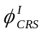 is the initial CRS angle
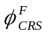 if the CRS angle after a rotation about the roll axis
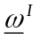 is the vector of the intial wheel speeds
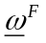 is the vector of the final wheel speeds
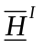 is the initial estimated wheel momentum vector expressed in spacecraft body axes
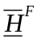 is the final estimated wheel momentum vector expressed in spacecraft body axes (after roll rotation)
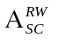 is the direction cosine matrix for transforming from the spacecraft body axes to the wheel axes
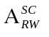 is the direction cosine matrix for transforming from the wheel axes to the spacecraft body axes
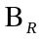 is the transformation matrix for performing a rotation about the spacecraft roll axis.
is the diagonal matrices of the real wheel inertias
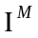 is the diagonal matrix of the estimated wheel inertias
For the purpose of the wheel inertia error analysis, it is assumed that the wheel speeds are known without error.

The two wheel inertia matrices are defined as follows:
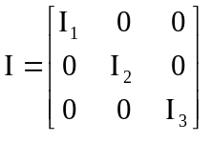, 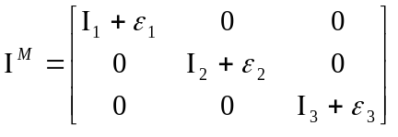
The initial angle measured by the CRS for a given set of initial wheel speeds is established as follows:
Obtain the initial wheel momenta in body axes:
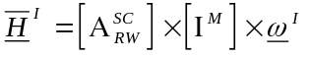 (1)
The initial CRS angle is given by:
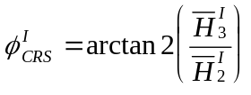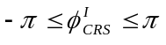
The final true wheel speeds after a given rotation about the roll axis are given by:
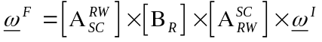 (2)
The final angle measured by the CRS using the final true wheel speeds is established as follows:
Obtain the final estimated wheel momenta in body axes:
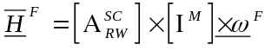 (3)
Substituting equation (2) into (3) gives:
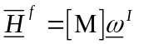
where
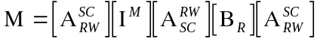.
The final CRS angle is given by:
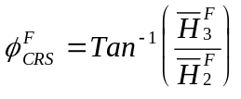
Hence the angular rotation as measured by the CRS is given by:
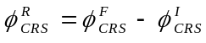
The absolute CRS error is given by:
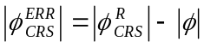

Wheel Alignment Error :
The transformation matrix to convert from the wheel axes to the spacecraft axes is as follows:
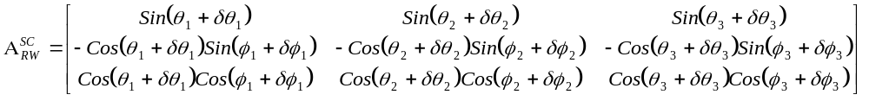
Where:
is the angular displacement about the wheel X axis
is the angular displacement about the wheel Y axis after having been displaced through
Nominally, and as assumed in the matrix used for the CRS, these angular displacements are:
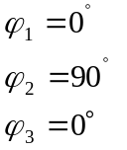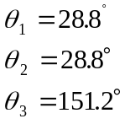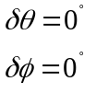
This defines the estimated transformation matrix, denoted by 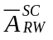.
The maximum deltas are:
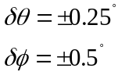
The actual transormation matrix includes these non zero delta angles, and is denoted by 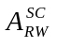.

Given an initial wheel momentum vector, 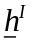, the estimated momentum vector in body axes is:
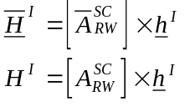
It follows that the CRS angle of the initial wheel momentum vector in body axes is given by:
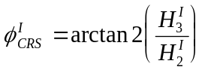
For a given rotation, , about the roll axis, the final body wheel momentum in body axes is:
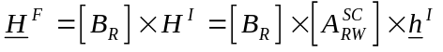
Hence the final wheel momentum in wheel axes is given by:
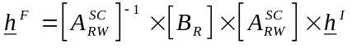
Finally, the CRS angle after the roll slew is given by:
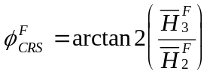
where
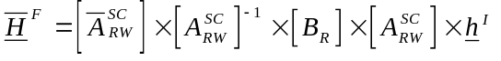
The angular rotation as measured by the CRS is given by:
It follows that error of the CRS sensor for a rotation of degrees about the roll axis is:
As for the error arising from the wheel inertia mismatch, the error arising from a commanded roll rotation in the CRS can only be derived by itteration.

ANNEX 8 - SOHO GYROLESS AOCS ACU SOFTWARE user's manual

ANNEX 9 - SOHO AOCS ACU SOFTWARE GYROLESS UPDATE TECHNICAL NOTE

ANNEX 10 - SOHO AOCS ACU TELECOMMAND REQUIREMENTS DEFINITION

ANNEX 11 - SOHO AOCS ACU TELEMETRY PACKET REQUIREMENTS DEFINITION

DISTRIBUTION LIST

 | Overall document |  | Summary
 | Action | Information
ESA
MM. F. Vandenbussche |  | x
T. Van Overbeek | x
MMS Toulouse
Mme. M. Hervieux |  | x
MM. E. Beaufumé | x
M. Janvier | x
F. Terron | x
M. Chaloupy | x
F. Dufrechou | x
B. Pouzet | x
MMS Bristol
MM. R. Harris |  | x
J. Stevens | x
G. Johnson | x
P. Singh | x
MMS Stevenage
A. Holt | x
SAAB Götteborg
L. Börjesson | x
S. Lernvall | x
B. Enoksson | x
NASA / ESA GSFC
J. Bruner | x
M. Verdant | x
H. Schweitzer | x
J. P. Olive | x
H. Benefield | x

