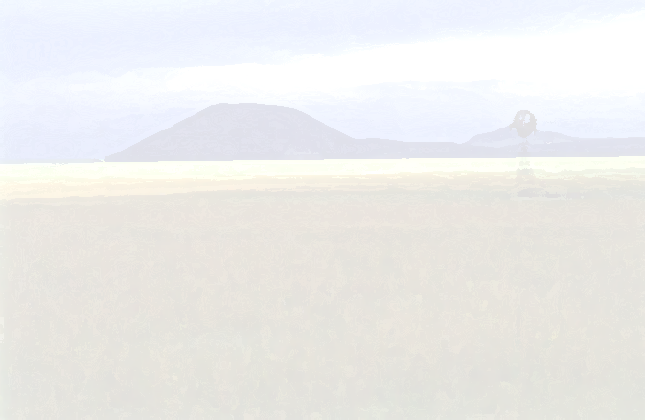

Pre-Site Activities

Lesson One

Title: The NPS at work

Goals: The students will be able to explain why the National Park Service was created. They will be able to discuss the diversity that exists in America and what they can do to protect the resources. They will be able to explain why it is important to protect America's resources.

Objectives: The student will be able to:
- state three purposes of the NPS
- list a different activity that can be done in 3 different parks
- list at least 3 ways to conserve our parks

Materials Needed:
Internet Access
Books about National Parks
Presentation Sheet
11 x 17 in sheets
Colored pencils
Rulers
Popsicle sticks
4 ft long string/rope for every student

Background Information:
On August 25, 1916, President Woodrow Wilson signed the act creating the National Park Service. This new branch of the Department of Interior was responsible for protecting the present and future National Parks and Monuments.

This "Organic Act" of August 25, 1916, states that "the Service thus established shall promote and regulate the use of Federal areas known as national parks, monuments and reservations . . . by such means and measures as conform to the fundamental purpose of the said parks, monuments and reservations, which purpose is to conserve the scenery and the natural and historic objects and the wild life therein and to provide for the enjoyment of the same in such manner and by such means as will leave them unimpaired for the enjoyment of future generations."

The National Park System currently comprises of 384 areas. Congress has designated all of these areas in some way. Through the Antiquities Act of 1906, the President has the authority to establish national monuments. The first official national park is located in Yellowstone National Park.

Activity:
Session One:
*This activity will take more than one class session. Small group activity.
1. Familiarize the class with the history of the National Park Service.
(You may want to have a map of all of the National Parks available for the students to use.)
2. Explain to them that they will be doing research of a park of their choice. Provide them with as much material as possible. You can have the students write a letter to the park requesting information about the park.
3. Once they have enough information, they can present their park to the class. The presentation sheet will guide them to a successful presentation
Session Two:
*This can be done while the students are waiting for the information on the park of their choice.
*The students will create their own park.
*To successfully complete this activity, they will need to follow the guidelines set forth in the "My Park" activity sheet.

*You can choose to do this activity outside or inside the classroom
- If you haven’t already done so, familiarize the students with the history of the NPS.
- Compile a list, with the class, some of the features they think belong in a National Park.
- Discuss the importance of having national parks. Why should we have them? What is the purpose of having one? Who should be able to go to a national park? What can the students do to protect their local park?
- After the discussion, distribute the ‘My Park’ sheet. Review it and gage comprehension before going outside. You may want to set guidelines for rules of behavior while they are doing this activity.
- Allow the students, in their groups, to find their own park area.
- After twenty minutes, tell the students they will split up and visit the parks.
- Each member will have ten minutes to visit the other parks.
- When the twenty minutes is up, have the students get back together and fill out the questionnaire.
- Back in the classroom, discuss the questionnaire with the students.

Assessment:
Successful completion of the activities.
Participation during the discussions.
*Adapted from "Children are the Future of the Everglades" Parks As Classrooms program.

Presentation Sheet

This sheet will help you to present the research that you have obtained about your park. Remember, when you give your presentation, speak clearly and concisely, make eye contact, and be enthusiastic.

Name of park: ____________________________________ Location of park: ______________________

I picked this park because ________________________________________________________________
______________________________________________________________________________________
______________________________________________________________________________________

This park was made a park because _________________________________________________________
____________________________________________________________________________________________________________________________________________________________________________

Some of the activities that the park provides are: ______________________________________________
____________________________________________________________________________________________________________________________________________________________________________

This park has ____________________ visitors a year.
This park was established in ____________________.

Two things that make this park special are ___________________________________________________
______________________________________________________________________________________

Other people should visit this park because __________________________________________________
____________________________________________________________________________________________________________________________________________________________________________

This park protects many different habitats, such as: ____________________________________________.

Two types of animals that live in the park are _______________________________________________. They are protected because ______________________________________________________________.

If I were to go to this park I would ask the park ranger these questions (at least two) __________________
________________________________________________________________________________________________________________________________________________________________________________________________________________________________________________________________________________________________________________________________________________________

Directions:
My Park

- With a partner, find an area that you think would make a good park. Your area should feature at least one recognizable landmark. This will be the main focus of the park. The landmark could be a rock or just a hole in the ground. Using the four popsicle sticks and one of the ropes, mark out your territory. Using the other rope, make trails for your visitors to use.
- When you have finished roping off your park and making your trails, you will need to make a brochure for your park. Use the paper provided.
Your brochure should include:
    - The parks name
    - Entrance fee cost
    - Park hours
    - Distance from the nearest town
    - A map of the park
    - What activities visitors can do at the park
    - Location of the visitor’s center, picnic area, parking lots, trails, the landmark. (All of these should be included in the map of the park.)
    - Park history
    - Local animals and plant life
- When the class is ready, one member of your team will stay with the park, while the other goes to look at your classmates parks. (After ten minutes switch with your partner). The person that stays with the park will need to share information with the ‘visitors’. The other member will go to the other parks and learn about each park. If it sounds like a park you would like to visit, you must sign the registration on the back of the park brochure.
- When both members of the team have had a chance to look at the parks, discuss which parks you liked and didn’t like and why. Fill out the questionnaire below.

Questionnaire:

Which park was your favorite park? __________________________________
Why did you pick this park as your favorite? _________________________________________________
____________________________________________________________________________________________________________________________________________________________________________

If your were the president of the United States and it was up to you to make a new park, would you pick this park? _________________________Why? _______________________________________________
____________________________________________________________________________________________________________________________________________________________________________

What resources/features does this park protect? _______________________________________________
____________________________________________________________________________________________________________________________________________________________________________

Did the map provide enough information? _________________ If not, what could have been included to make it better? _________________________________________________________________________
______________________________________________________________________________________

Additional comments/suggestions:

Map and Guide

______________________________ National Park Service
(PARK NAME HERE)

Lesson Two

Title: Volcanology 101

Goals: The students will be able to identify the four layers that make up the earth. They will understand that the crust is the thinnest layer, which allows volcanology to occur.

Objectives: The student will be able to
- name the 4 layers of the earth
- draw connections and discrepancies between plate tectonics and Capulin Volcano
- re-create how a cinder cone is formed

Materials Needed:
Activity One:
Four different colored clay/playdough
Activity Two:
16-oz soda bottle
large baking pan
2 measuring cups
1 tablespoon flour
1 tablespoon baking soda
spoon
funnel
red food coloring
1 cup white vinegar
tap water

Background Information:
The Earth is made up of four layers. The inner core, outer core, the mantle and the crust.
The inner core is made up of dense iron, while the outer core is made up of molten iron. Above the outer core is the plastic mantle. The crust, or lithosphere, is made up of plates. These plates follow the theory of plate tectonics. The crust is a very thin layer of rock, whose thickness can vary anywhere from a few miles to 60 miles in length.
It is in this thin layer of the crust that volcanic eruptions can occur. Most volcanic eruptions occur in the Pacific Ring of Fire. Volcanoes that occur in the Ring of Fire include the Cascade Range and the Alaskan Mountain Range.
Capulin Volcano does not occur in the Pacific Ring of Fire. The volcano lies in a volcanic field that begins in Raton and ends in Clayton, NM. Capulin is one of the youngest in a 9 million-year-old field of activity. Geologists are uncertain as to why there are volcanoes this far east of the Ring of Fire. It is likely that the outward spreading of the Rio Grande Rift has caused friction to occur beneath the surface. Unlike the Hawaiian Volcanoes or Yellowstone, there is not hotspot underneath the ground in the Raton-Clayton Volcanic Field. When there isn't a hot spot, friction between the rocks causes magma to form beneath the surface. Too much pressure builds up and explodes out of the ground, creating a volcano.
Cinder cones, like Capulin, are monogenetic; they only erupt once. The eruption can be likened to the explosion of a soda can that has been shaken up and then opened. Cinder cones average a height of 700 feet. Capulin was originally over a thousand feet in height. This indicates that the eruption of Capulin lasted a little longer than most cinder cone eruptions last. It is estimated that the eruption lasted between five and fifteen years. The volcano is between 56,000 and 62,000 years old.

Activity One:
*This is a simple activity. It will reinforce the concept of the four layers of the Earth. You may want to pair the students together. Use red clay to represent the inner core, orange clay for the outer core, black clay for the mantle, and green clay for the crust. Depending on the size of the class and the amount of supplies, you make want to make the models small.
*As you can see from the model below, the inner core is slightly smaller than the outer core. The mantle is a lot thicker than any of the other layers. The crust is a very thin layer.
*When the models are assembled, have the students cut them in half. They will be able to see what the inside of the earth looks like.
*Discuss the layers of the earth. The students should realize through this discussion that most of the magma (usually along the plate boundaries) comes from the mantle and not the core of the Earth. To reinforce the thinness of the crust, make the students aware that scientists have only been able to drill to a depth of five miles before hot temperatures and pressure takes over.
*If you can, let the students keep their half of the model. You may want to use the models in another lesson.
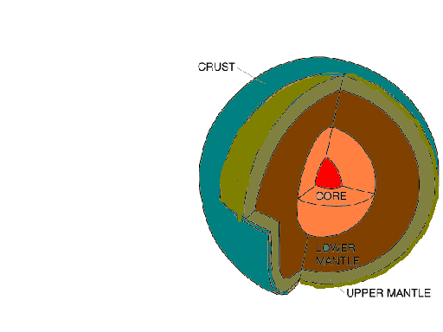

Activity Two:
(Modified from Janice VanCleave’s Volcanoes, John Wiley & Sons, Inc, 1994.)
*Whole group activity.
*This activity will help to demonstrate the volcanic eruption once it reaches the crust of the Earth.
*Have all materials ready before the lesson.
*To get the student more involved, allow them to do the mixing and the pouring.
*Before beginning, show the students the materials. Have them hypothesize what would happen if all of the materials were to be mixed together. What would happen? Write this on the board so that all of the students can see it and be thinking about the hypothesis while the experiment is occurring. For those that don’t get a chance to add materials to the bottle, have them write down their observations.
Procedure:
- Place the bottle in the pan.
- In one of the measuring cups, combine the flour and baking soda.
- Pour the mixture through the funnel into the soda bottle.
- Add 20 drops of red food coloring What does the color red represent?
- Pour ½ cup of vinegar into the bottle
- When it stops foaming, add the other ½ cup of vinegar into the bottle
(You may want to experiment with different amounts of the ingredients to determine how each one effects the explosion.)
Questions:
What occurs when vinegar is combined with the flour and baking soda?
How can this be likened to a volcanic explosion?
What observations were made during the process?
Assessment:
Correct identification of each layer of the Earth.
Able to answer questions correctly.
Observations during Activity Two coincided with what occurred during experiment.

Volcanoes

Identify all four layers of the Earth:

1. What layer is the thickest? ________________________________________________________

2. What layer is the thinnest? ________________________________________________________

- 3. What layer does the magma come from? _____________________________________________

- The crust is made of ________________________.

- What caused Capulin Volcano to erupt so far east from the Pacific Ring of Fire? ________________________________________________________________________________________________________________________________________________________________________________________________________________________________________________________________________________________________________________________________________

- Capulin Volcano is a __________ cone volcano.

- Capulin is between ___________ and ___________ thousand years old.

- How long did the eruption of Capulin last? _______________________________________________

- Most cinder cones are 700 - 900 feet tall. How tall is Capulin? _______________________________

- Capulin Volcano sits in the __________-__________ Volcanic Field.

Lesson Three

Title: Erosion, Is It A Problem?

Goals: The students will be able to recognize and understand the effects of erosion on Capulin Volcano.

Objectives: The student will be able to
- describe the process of erosion
- relate erosion to Capulin
- demonstrate how people can effect erosion

Materials Needed:
Method One:
Large baking pan
Sand
Watering can or can with holes punched in the bottom
Water
Method Two:
Trough made of wood
Dirt
Sand
Various rocks, twigs, and grass

Background Information:
Over the many thousands of years that Capulin has been in existence, it has had to face many erosional factors that have impacted its classic cinder cone shape. The road and trails on the volcano have increased erosion greatly since 1925. They have allowed access to the volcano to thousands of people every year. Natural factors have also contributed to the erosion on the volcano. Every year, wind, rain and snow have caused cinders to wash down the side of volcano. One of the only things that has prevented massive erosion is the pinyon and juniper trees that have attached themselves to the cinder cone.
Erosion of the volcano has become a major issue over the years. At Capulin, we are trying to find ways to prevent, or slow down, erosion. Through this activity, the students will have an understanding of how water affects landforms and creates erosion. It would be ideal to have a discussion prior to the activity about how people, wind, rain , and snow have an effect on the erosion at Capulin Volcano. It would also be good to brainstorm, as a group, about different ways erosion could be prevented on the volcano.

Activity:

Discussion:
*Discuss with the class how erosion can affect any and all landforms. Using such examples as Capulin Volcano, Shiprock, NM and Devil's Tower, Wyoming the students will begin to understand the effect that erosion can have on natural landforms.
*Below, you will find two different methods that can be used to do this activity. Method one can be done in small groups. Method two can be done as a whole class activity. Pick one that will be fit into your time limit.
*It would be good to have the students write down their hypothesis of what will happen when the water is poured onto the soil, before beginning the activity.
*After completing the activities, discuss what the students observed. This would be a good time to come up with some ideas on how to prevent erosion at Capulin Volcano.

Method One:
Using a large baking pan, place moist sand at one end of the pan. Gradually pat the sand down towards the end of the pan, making a slope.
Add water to the water can and, at the high end of the sand, begin to pour the water onto the sand.
Have the students write down their observations.
*If time allows, have the students reform the soil to its original flat form and then add small rocks and pour more water onto the high end of the pan. Have them record their answers.
*It might be interesting to add the rocks to the original trial and see how the rocks will affect the already formed gully's.

Method Two:
Using 2x4's, build a trough. Make sure that the sides are high enough to prevent over flow and that one end is lower than the other, to ensure the water flows "down stream". Fill the trough with sand. Make sure there is more sand on the higher side, than the lower side. Have each of the children place a rock in the sand. You may want to include other natural objects, such as twigs and grass. Standing at the higher side, pour water down onto the sand. Have the students observe the routes the water decides to take. They can make their observations on the hypothesis page. *Have a discussion afterwards about what the students observed.
*You may want to have an in-depth discussion on how people can effect the erosion process.

Assessment:

This activity is best assessed through the discussion after the initial activity. Some questions to fuel discussion and gage students understanding: 1. What happens during the erosional process? 2. What causes erosion? 3. What are some land forms that have been significantly eroded away? 4. Is it possible to prevent erosion? If so, how? 5. How could we prevent erosion on Capulin Volcano? (You may want to compile a list)

*Adapted from "Work House" a Glacier NP Environmental Education Guide
*Silver Burdett Ginn, Discovery Works. Teaching Guide., Parsippany, NJ pA6, 7

Erosion Activity

State your hypothesis: ______________________________________________________________________________________

______________________________________________________________________________________

______________________________________________________________________________________

______________________________________________________________________________________

Observations during activity: ______________________________________________________________________________________

______________________________________________________________________________________

______________________________________________________________________________________

______________________________________________________________________________________

______________________________________________________________________________________

Ideas on how to prevent erosion at Capulin Volcano: ______________________________________________________________________________________

______________________________________________________________________________________

______________________________________________________________________________________

______________________________________________________________________________________

Lesson Four

Title: How Many Rocks Does It Take To Get To The Center Of A Volcano?

Goals: The students will understand how important it is to preserve Capulin Volcano. They will understand that if everyone takes a rock, there won't be a volcano left for them to visit.

Objectives: The student will be able to
- demonstrate numerically how Capulin could "disappear"
- relate the lab to true examples of eroded cinder cones
- create solutions to preserve Capulin Volcano

Materials Needed:
M&M's
Bowls
Index cards

Background Information:
Over 65,000 people come to Capulin Volcano each year. If every single person took a rock from the volcano, eventually, there wouldn't be anything left. It is important for the students who visit here to realize that it is everyone's job to protect the resource. The activity in this lesson will help them to realize the impact people have on natural resources.
For students to grasp the concept of how much of an impact rock collecting has on a resources, you may want to have a discussion about something that the students can relate to, before beginning the activity. Example: If every person in their neighborhood (or town) came to their house and took one toy from their room, what would they have left?

Activity:
- Divide the students up into groups of three. Assign a recorder and a reporter.
- Pass out the bowls, which will have 25 M&M's in each bowl.
- Pass out the index cards face down. One card will say Parents, one will say Children, and one will say Grandchildren. Below will be listed the number of people in that group. (For example, on the Children card you may put that there are 4 people in that generation group.) (It may be a good idea to discuss what a generation group is, if they don't already know.)
- Make sure the students understand that the M&M's represent one cinder on the volcano.
- Have each group member pick a card. They will represent that generation group.
- Starting with the Parent group, the student will remove 3 M&M's for every person in their generation group. Continue until each generation group has had a turn.
- The students will need to record their thoughts on what happens when each person takes 3 M&Ms from the bowl.
- Have a post-activity discussion about protecting the resource and how it can effect the volcano.
Post-activity discussion questions:
- What other natural resources could the M&M's represent?
- What resources are people using too much of?
- How can we prevent people from overusing natural resources?
- Is there something you can do at the school or in your neighborhood to try to save natural reources? *Challenge them to take action.

Assessment:
*Were the students able to record the data correctly and in a manner that fits into the activity?
*Through the discussion, where the students able to grasp the concept of protecting resources?
*The student's should be able to hypothesize that if everyone was able to take a rock from the volcano, there would, eventually, be nothing left for others to enjoy.

*Silver Burdett Ginn, Discovery Works. Teaching Guide., Parsippany, NJ pA6, 7

Protect the Resource

Make a hypothesis about what you think is going to happen to the pile of M&M's in the bowl. ______________________________________________________________________________________

______________________________________________________________________________________

How many M&M's did the Parent group take? ____________________
How many M&M's did the Children group take? __________________
How many M&M's did the Grandchildren group take? ______________

If generation after generation were to take at least 3 M&M's, what would happen to the supply of M&M's? ______________________________________________________________________________________

______________________________________________________________________________________

What would happen if generation after generation were to take at least one rock from Capulin Volcano? ______________________________________________________________________________________

______________________________________________________________________________________

What can you do to prevent Capulin Volcano from disappearing? ______________________________________________________________________________________

______________________________________________________________________________________

Is there anything that you can do at your school or in your neighborhood to help protect the resources in your community? ______________________________________________________________________________________

______________________________________________________________________________________

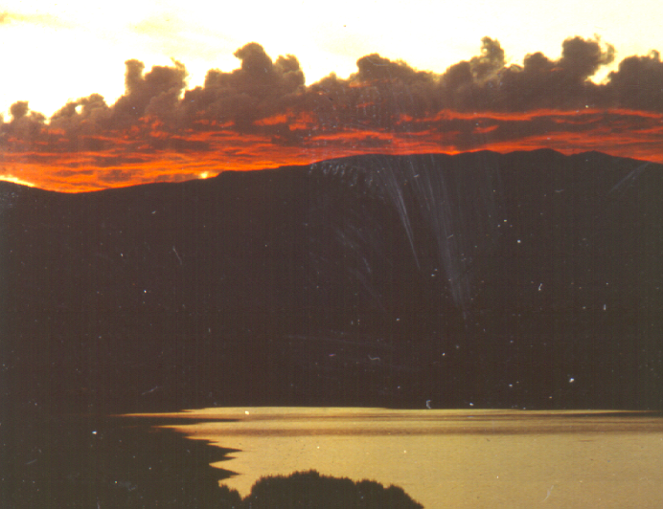
Bus Ride Activities

Bus Ride Activities

No matter which direction you come from, there are a lot of interesting things to see on your way to Capulin Volcano. The questions below test your observation skills. Determine the route you are taking, find it listed below, and answer the questions that pertain to your trip.

Clayton to Capulin (Hwy 64/87):

How far is it to Capulin from Clayton, NM?

Just north of Clayton is a place called Clayton Lake. Name two things that make Clayton Lake special.

Between the towns of Clayton and Des Moines, there are two volcanoes that are visible from the highway. Can you name them?

Des Moines is located at the base of what volcano?

Is Capulin Volcano large or small in comparison to the surrounding landscape?

How can you tell which volcano is Capulin?

How far is it to Capulin from Des Moines, NM?

What trail crosses the highway, near the town of Grenville?

Raton to Capulin (Hwy 64/87):

How far is it from Raton to Capulin?

How many volcanoes do you see from the road?

What is the name of the ranch along the highway? What color are the roofs?

How many signs are there along the road that say Capulin?

Name three different types of animals you are most likely to see along this road.

Las Vegas to Capulin (Hwy 25 & 64/87):

How far is it from Las Vegas to Capulin?

How far is it from Raton to Capulin?

How many volcanoes do you see from the road?

What is the name of the ranch along highway 64/87? What color are the roofs?

How many signs are there along the road say Capulin?

Name three different types of animals you are most likely to see along this road.

How many towns do you pass along the highway?

Just north of the town of Maxwell, the highway cuts through a fissure. What is the name of the town where this fissure is cut through?

How many billboards do you see along the road?

There are remnants of volcanoes in Wagon Mound. How many do you see? Why is the town called Wagon Mound? Why was Wagon Mound an important place along the Santa Fe Trail?

How many National Monuments do you pass on the way?

What river do you cross on Hwy 25?

Cimarron to Capulin:

How many highways do you have to travel to get to the volcano?

How many miles is it from Cimarron to Capulin?

How far is it from Raton to Capulin?

How many volcanoes do you see from the road?

What is the name of the ranch along the highway? What color are the roofs?

How many signs are there along the road say Capulin?

Name three different types of animals you are most likely to see along this road.

What river do you cross on Hwy 25?

Bus Ride Activity

THIS LAND IS YOUR LAND
words and music by Woody Guthrie

Chorus:
This land is your land, this land is my land
From California, to the New York Island
From the redwood forest, to the gulf stream waters
This land was made for you and me

As I was walking a ribbon of highway
I saw above me an endless skyway
I saw below me a golden valley
This land was made for you and me

Chorus

I've roamed and rambled and I've followed my footsteps
To the sparkling sands of her diamond deserts
And all around me a voice was sounding
This land was made for you and me

Chorus

The sun comes shining as I was strolling
The wheat fields waving and the dust clouds rolling
The fog was lifting a voice come chanting
This land was made for you and me

Chorus

As I was walkin' - I saw a sign there
And that sign said - no tress passin'
But on the other side .... it didn't say nothin!
Now that side was made for you and me!

Chorus

In the squares of the city - In the shadow of the steeple
Near the relief office - I see my people
And some are grumblin' and some are wonderin'
If this land's still made for you and me.

Chorus (2x)

©1956 (renewed 1984), 1958 (renewed 1986) and 1970 TRO-Ludlow Music, Inc. (BMI)

