Preassessment Data Report #5:

Persistence rates of bird carcasses on beaches of Unalaska Island, Alaska, following the wreck of the M/V Selendang Ayu

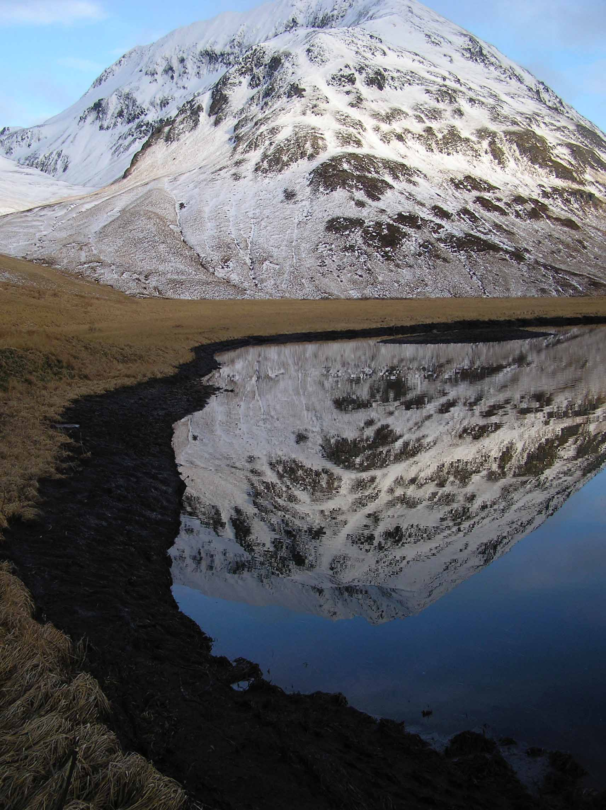

G. V. Byrd¹
J. H. Reynolds²

¹U. S. Fish and Wildlife Service, Alaska Maritime National Wildlife Refuge, 95 Sterling Highway, Suite 1, Homer, AK 99603
²U. S. Fish and Wildlife Service, Division of Natural Resources, MS-221, 1011 E. Tudor Road, Anchorage, AK 99503

This document should be referenced as:

Byrd, G.V., and J.H. Reynolds. 2006b. Persistence rates of bird carcasses on beaches of Unalaska Island, Alaska, following the wreck of the M/V Selendang Ayu. U.S. Fish and Wildlife Service, Alaska Maritime National Wildlife Refuge, Homer, AK.

cover photo:
A salmon stream in Skan Bay oiled following the wreck of the M/V Selendang Ayu, Unalaska Island (on beach segment SKN14; 17 December 2004, Art Sowls, Alaska Maritime National Wildlife Refuge).

ABSTRACT

Bird carcass surveys were conducted as part of the pre-assessment phase of response to the M/V Selendang Ayu oil spill off the coast of Unalaska Island. Deposited carcasses were not expected to persist on a beach for more than a few days due to scavenging and tidal rewash. Carcass persistence rate was estimated approximately 1.5 months following the original spill event by experimentally depositing unoiled carcasses in the field and monitoring their state (intact / scavenged) and persistence (present / absent) through repeated visits. Daily scavenging and persistence rates were estimated using standard mark-recapture models. The probability that an intact unoiled carcass remained unscavenged for 24 hours was 0.0%. The probability that an intact unoiled carcass persisted overnight (though scavenged) was 14.6%. The probability that a scavenged carcass persisted overnight was 79%. These persistence rates and the relatively low detection probabilities (Byrd and Reynolds 2006a) suggest that only a very small proportion of all deposited carcasses were found and recorded during beach searches on Unalaska Island.

INTRODUCTION

On 8 December 2004, the M/V Selendang Ayu ran aground and broke in half in rough seas off Unalaska Island, Alaska (53°38'N, 167° 07'W). An estimated 354,218 gallons of oil (339,538 gallons of bunker oil [IFO 380] and 14,680 gallons of marine diesel and miscellaneous oils) were discharged. Numerous bird carcasses were recovered during beach searches in the months following the spill as part of the typical pre-assessment phase of response to an oil spill, which includes collecting data from which to estimate the total number of animals affected by the event (Ford et al., 1987; Page et al., 1990; Piatt et al., 1990; Burger, 1992a, Flint et al. 1999). Recovered carcasses represent only a fraction of the total number deposited on beaches (Flint et al. 1999). Recovered carcasses represent only a fraction of the total number deposited on beaches (Flint et al. 1999), including both mortality related to the event and “natural background mortality.”

Carcasses found by observers on a specific beach at any given time after a mortality event are a result of three processes: (1) the rate at which carcasses are deposited on beaches, (2) their persistence once on the beach, and (3) the probability of observers detecting them when surveying the beach (Flint et al. 1999). These components vary depending on site and environmental characteristics present in each specific mortality event. For example, carcass deposition rate can vary with factors such as beach type (Bodkin and Jameson, 1991, Flint et al. 1999), persistence rates can vary with factors such as beach type, time since deposition, weather, tidal activity, carcass size and scavenger activity (Bodkin and Jameson, 1991; Burger, 1992b, 1993; Van Pelt and Piatt, 1995, Ford et al. 1996, Fowler and Flint 1997, Ford in press), and detection probabilities can vary with factors such as beach type and weather conditions like presence or absence of snow (Fowler and Flint 1997).

Persistence rate is defined as the probability that a carcass will remain on the study area for a given period of time. A combination of factors at Unalaska Island suggests that persistence rates for carcasses on beaches are likely to be very low in most instances. For instance, many beaches are exposed to direct wave action, exacerbated by storm surges, which might reduce persistence rates by rewashing carcasses. Additionally, resident populations of scavenger populations occur commonly in much of the affected area, including red foxes (Vulpes vulpes), common ravens (Corvus corax), bald eagles (Haliaeetus leucocephalus), and glaucous-winged gulls (Larus glaucescens), and some of these scavengers removed carcasses quickly.

Persistence rates can be estimated using mark-recapture analyses techniques (Pollock et al. 1990). In this application, the usual survival rate estimate is, functionally, a persistence rate.

This report summarizes carcass persistence rate estimates for beach surveys on Unalaska Island, Alaska in January 2005. Results are discussed in the context of scavenger satiation. Detection probability estimates are reported in a companion document (Byrd and Reynolds 2006a).

Methods

Study Design

Following a reconnaissance, all beaches in the oil spill core area were classified to one of four types: exposed – high impact beaches normally exposed to waves, often with steep angles indicating frequent impacts; catchment – beaches with areas where large amounts of debris had accumulated; protected – beaches not normally exposed to waves from the open sea; unavailable – segments that were either too short (< 100m) or not safely accessible by the Tiglax-based crew. The spill area was comprised of 18% exposed beaches, 6% catchment, 31% protected, and 45% non-accessible coast (cliffs or other unwalkable segments of coastline). Beach segments were defined based on physical shore zone character following Owens and Sergy (2000).

Persistence studies require conducting repeated searches on the study beach segments. Previous studies suggested a revisitation frequency of every other day (Van Pelt and Piatt 1995, Fowler and Flint 1997). The persistence study beaches were thus selected from that subset of (i) the stratified random sample of exposed, catchment, and protected beaches selected for the Tiglax-based beached animal surveys (Byrd et al. 2005) that (ii) supported regular repeated access from the ship. This design constraint eliminated consideration of any exposed beach segments due to (i) the difficulty of regularly accessing such open areas from a ship and (ii) the expected high rate of re-wash. Four beaches were purposively selected for the carcass persistence rate study, three protected (CNB 10, NGW 2, PTN10) and one catchment (CNB 19) (Figure 1).

Longstanding U.S. Fish and Wildlife Service practice in Alaska prevented leaving any oiled carcasses on beaches because of a desire to remove sources for secondary oiling of scavengers as quickly possible, therefore carcass persistence was estimated using previously frozen carcasses of marine birds of species present in the spill area. The 112 carcasses available for the study included auklets, murres, puffins, cormorants, eiders, kittiwakes and gulls (Table 1). The size class distribution of deployed carcasses was 37 % large, 19 % medium and 44% small. Each carcass was marked by placing a numbered, metal tag through the gap between the radius and ulna bones of each wing.

A total of 112 carcasses were distributed across the four beaches in samples of 22, 26, 32, and 32 carcasses, respectively, on beaches CNB 19, NGW 2, PTN10, and CNB10. Carcasses were deposited along the beach in a fashion similar to that of natural carcasses as observed earlier in the response. Each carcass’ position was recorded relative to the mean low tide line (above, below) to assess the effect of tide (i.e., rewash) on carcass persistence. Fifty percent of carcasses were deposited at the mean low water line with the remainder deposited at the higher high water line.

On the three protected beaches a small numbered board of plain plywood (approximately 10 cm x 18 cm) was placed directly under each carcass to assess tidal rewash. If a board remained but the carcass was missing, the carcass was assumed lost due to scavenging rather than tidal action. When both the carcass and the board were missing, loss was assumed due to tidal action.

The study was first implemented at beach CNB 19 and rechecked 48 hours later, at which time all carcasses had been scavenged. All other implementations of the study were therefore rechecked at least every 24 hours (sometimes within 8-12 hr). During each revisit observers searched until they were certain they had detected all deployed carcasses that remained on the beach, recorded the presence of carcasses and numbered boards as well the condition of the carcass with regards to scavenging. Thus each visit to each carcass placement location resulted in one of four carcass outcomes:

- intact (with board)
- scavenged in place (with board),
- removed by scavengers (carcass missing but board present)
- re-washed (carcass and board both missing)

Further scavenging of an already scavenged carcass was not recorded.

Analysis of Persistence Rates

There were three rates of interest: (i) persistence rate of an intact carcass (intact → intact), (ii) persistence rate of scavenged carcass (scavenged → scavenged), and (iii) transition rate from intact to scavenged, but not removed, carcass (intact → scavenged). The time scale of interest was daily rates rather than hourly or weekly rates. When a study site had received multiple visits within a day, observations from visits that were as close to 24 hours apart as possible were used for the daily rate estimation; observations made within less than 24 hours of each other were used to estimate diurnal scavenging probabilities.

Interval censored survival models were used to account for variation in the length of time between observations (Johnson 1979). Let s be constant daily persistence rate and t the number of days between carcass visits (here t = 1 or 2). Let n_{t} be the total number of carcass-events of revisit interval t, i.e., the sum across all but the last revisit of the number of carcasses remaining deployed at each revisit. Let r_{t} be the total number the n_{t} carcass-events where the carcasses persisted to the next revisit. For example, if there were three daily visits with 100 carcasses deployed at the first day, 50 remaining the second day, and 5 remaining the last day, n_{t}=100+50=150 carcass-events, of which r_{t}=50+5=55 persisted to the next interval.

The likelihood for the sample persistence data is given by Equation 1, assuming that all carcasses were detected if present on every search (‘known fate’ analysis). The resulting maximum likelihood estimator (Equation 2) was solved via an iterative procedure using Excel (Microsoft, Inc., Redmond, WA.). Standard error estimates were obtained by substituting the estimated daily persistence rate s and the other data into Equation 3 and taking the reciprocal. Confidence intervals were estimated by assuming an asymptotic normal sampling distribution for the maximum likelihood estimates.

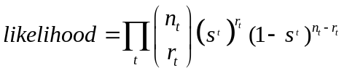

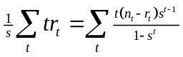
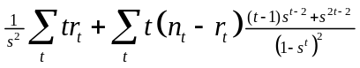

Diurnal Probabilities of loss, Probability of Re-wash

The proportion of carcasses lost during the day versus the night was estimated using observations from beaches surveyed multiple times within a 24 hour period. The proportion of carcasses lost due to tidal re-wash was estimated using observations from the three beaches with numbered boards. Both proportions were estimated following the usual binomial model (Zar 1996). Confidence intervals were calculated following Agresti and Coull (1998) using the function binconf in the Hmisc package (Harrell 2004) for the statistical freeware package R (R Development core team 2005).

Assessment of the assumption regarding detection probability

Two deployed carcasses, both LEAU, were not found on later persistence searches but then located much later on regular beach surveys. In both cases, the carcasses were moved by scavengers during the first evening following initial deployment as the associated board was present the next morning but the carcass was not detected. In both cases, two (three, respectively) further persistence searches were conducted on the relevant beaches and the scavenged carcass was not found. No carcasses were detected on the subsequent persistence searches, thus these searches ceased. Carcass NGW2-2783/2792 was encountered eleven days after the cessation during a regular beach survey; all that remained was the wing tags and some primaries and contour feathers. Carcass CNB10-2152/2151 was encountered three days after cessation during a regular beach survey. The detection rate for numbered boards placed with carcasses was 1, implying that searchers were effectively covering the beaches.

There were insufficient data to directly estimate a detection rate using maximum likelihood approaches and a standard Cormack-Jolly-Seber Model (Pollock et al. 1990). As an alternative, persistence rates for scavenged carcasses were calculated under three different scenarios regarding the fate of the two relocated carcasses and persistence searcher detection rates: (i) the carcasses were assumed to have remained present on the study beach the full time and a true detection rate of 1.0 for study carcasses was attained by treating the two carcasses in question as if they had actually been detected on all intervening persistence searches (Table 2a); (ii) the carcasses were assumed to have been initially removed from the study area by scavengers then returned to the study area later, and thus were not available for detection during the intervening searches (i.e., temporary immigration) (Table 2b); and (iii) the detection probability was estimated using an ad hoc approach that mimicked the logic of the detection probability estimate from a C-J-S model. That is, detection probability is defined as the proportion of carcasses marked before time i and were known to be present after time i, that were observed at time i. Given that the estimated persistence rate is functionally the product of the persistence rate and the detection rate, we divided the estimate of persistence by this detection probability to predict true persistence rates.

Results

Intact Carcasses

Of the 112 carcasses, eleven (scenario 1) / ten (scenario 2) persisted to the second survey by which time they had all been scavenged (Tables 2a, b). The daily persistence rate for an intact carcass remaining in an intact state was thus 0.0 (Table 3). The estimated daily persistence rate for an intact carcass remaining as a scavenged carcass was 0.146 with a standard error of 0.034 (Table 3).

Scavenged Carcasses

The eleven (ten) scavenged carcasses remaining to the second visit served as the initial sample for estimating persistence of scavenged carcasses. There were five recheck interval lengths (Table 2). The estimated daily persistence rate for a scavenged carcass remaining on a beach was 0.791 with standard error of 0.066 under scenario 1; 0.622 with a standard error of 0.113 under scenario 2 (Table 3). Under scenario 3, the estimated detection probability was 0.714 (5 of 7 carcasses detected) with a binomial standard error of 0.171. Dividing the estimated persistence rate from scenario 1 by this estimated detection probability yields an adjusted estimated persistence rate >1. The approximate lower 95% CI for this estimate is 0.63.
Thus the probability that an intact carcass remains after the first day is 0.146, at which point it is a scavenged carcass, and the probability it continues to persist on day t is 0.146 (0.791)^{t-1} (Figure 2). For example, the probability that a carcass remained present ten days after deposition is estimated to be 0.146 (0.791)⁹ = 0.018.

Diurnal Scavenging Probabilities

Fifty eight carcasses were placed on beaches in the morning, rechecked in the evening of the same day, and then checked the following morning (protected beaches NGW2, CNB10, and PTN10). On the evening search of the placement day 1 carcass was missing and 5 were scavenged. On the following morning search only 3 remained, each scavenged.

Thus probability of daylight removal or scavenging was 0.103 (6/58, 95% confidence interval of (0.048, 0.208)). The probability of being removed during the night given that the carcass was intact in the evening was 0.947 (54/57, 95% confidence interval of (0.856, 0.982)). Of all carcasses ultimately lost over a 24 hour period, the probability that they were removed at night was 98.2% (54/55, 95% confidence interval of (0.904, 0.999)). Some daylight scavenging occurred with probability 0.086 (5/58, 95% confidence interval of (0.037, 0.186)), though all of these carcasses were subsequently removed by scavengers overnight.

Rewash Probability

Marked boards were placed under 90 carcasses, of which 3 showed evidence of flotation and removal by tidal action within the first 24 hours following placement (0.033, 95% confidence interval of (0.011, 0.093)). Only one tagged carcass was subsequently found on a beach other than where it was marked, demonstrating that scavengers could remove carcasses from the study beaches to areas not generally searched. Thus it is feasible, though improbable, that some of the 3 carcasses attributed to rewash could have been removed by scavengers and their boards subsequently removed by tide. The rewash probability estimate could thus feasibly be biased slightly upwards.

DISCUSSION

Intact carcasses had very low rates of persistence on the Unalaska Island study beaches during the period of our study, approximately 48 days after the M/V Selendang Ayu oil spill. All intact carcasses were either removed or scavenged within 24 hours. For carcasses that remained on the beach after scavenging, the estimated carcass persistence probability increased substantially (Table 3). Similar almost exponential declines in carcass persistence (Figure 2) have been observed in auklets on Naked Island, Prince William Sound, Alaska, following the Exxon M/V Valdez oil spill (Ford et al. 1996) and in common murres in Resurrection Bay, Alaska, following a natural die-off event (Van Pelt and Piatt 1995).

The minimal evidence of tidal re-wash and the removal of carcasses almost exclusively during night strongly suggest that most carcasses were removed by nocturnal scavengers such as red foxes. While degree of scavenging was not recorded on searches, we suspect that the carcasses with the highest persistence were heavily scavenged carcasses, probably by birds, with little remaining food value.

The rates of persistence observed here, while comparable to those found in Prince William sound and northern Washington (Ford et al. 1996), were considerably lower than those from some previous studies (see Van Pelt and Piatt 1995 for review, Fowler and Flint 1997). They are also considerably lower than estimates of bird carcass persistence in terrestrial habitats (Tobin and Dolbeer 1990, Linz et al. 1991, Kostecke et al. 2001, Rivera-Milan et al. 2004).

The very low rates of persistence imply that scavengers were not satiated 48 days after the initial spill, contrary to the suggestion of Fowler and Flint (1997) following a spill in the Pribilof Islands. Carcass persistence rates have been hypothesized to vary with carcass density as carcasses at higher densities would cause scavengers to focus on specific areas, thus resulting in lower rates of persistence for those areas (Linz et al. 1991), though we know of no data that demonstrates this effect on ocean beaches. By the time of the study the deposition rate of carcasses from the M/V Selendang Ayu was apparently insufficient to satiate or overwhelm scavengers.

The very low rewash rate estimate likely underestimates the actual rewash rate averaged across all relevant beaches during the event. Firstly, rewash rate was only estimated on protected beaches, which are the type expected to have the lowest rewash rates. Secondly, rewash rates during and immediately following the spill event were likely much higher due to the larger waves associated with the much higher wind velocities during and immediately after the spill compared to during the persistence study (V. Byrd, unpubl. data).

As required by current policy, all of the persistence study carcasses were completely un-oiled. It is possible that degree of carcass oiling could affect the probability of scavenging and hence persistence, in which case oiled carcasses may persist at higher rates than reported here. However, neither Ford et al. (1996) nor Wiese (2002) found evidence for this effect in either Alaska subsequent to the Exxon Valdez or in Newfoundland. Since most carcasses found in the beach surveys were heavily scavenged and consisted of only a few fragments, such as a wing, any difference in probability of scavenging between oiled and unoiled carcasses is at most slight.

Although relevant data were collected, too few intact carcasses persisted to support estimating variation in persistence rates across beaches, by carcass size, or relative to tide level on the beach. Previous studies demonstrated variation in persistence rates across habitat types (Kostecke et al. 2001), beach types (Fowler and Flint 1997), carcass ages (VanPelt and Piatt 1995), carcass size (Ford in press) and carcass condition (Fowler and Flint 1997). Kostecke et al. (2001) concluded that carcass persistence rates did not differ by species, implying that scavengers were neither satiated nor selective. We conclude that scavenger density on protected and catchment beaches in the affected area (31% and 5% of the beach segments, respectively) is uniformly high resulting in consistently low persistence rates.

Assumptions of estimation models

While many of the standard assumptions of mark-recapture estimation are irrelevant when applied to carcass persistence, some do apply. First, the models used here assume no tag loss. Three untagged scavenged murre carcasses were found during beach revisits. As the wings of these carcasses were damaged or missing, it is probable that they were tagged carcasses from which scavengers had removed the tags. If so, failure to include these carcasses as recaptures would slightly underestimate persistence rates. As a conservative approach, all three carcasses were assumed to have been originally tagged and utilized accordingly in these analyses.

The persistence model used is a “known fates” model which assumes perfect carcass detection probabilities at every revisit – that is, all carcasses present on the beach during a survey were detected. All numbered boards placed under carcasses were relocated implying that detection probability for intact carcasses was 1.0. However, of the 11 scavenged carcasses used in the study, two were moved by scavengers and not encountered during multiple persistence searches but then encountered on subsequent regular beach carcass surveys. Less than perfect detection would cause underestimation of the persistence rate. Given that (i) this was an experimental study where carcasses were purposively placed on the beach, hence the initial number and locations of carcasses were known by the searchers, (ii) the crews were instructed to search at each visit until they were confident that all carcasses present were located, and (iii) all numbered boards placed under carcasses were relocated, the relocations suggest two possible scenarios. Scenario A: the two scavenged carcasses were present and not detected on the two or three intervening persistence searches yet relocated on subsequent regular searches. Scenario B: they were moved off of the study beach, like all other carcasses, and thus not available for detection (at which point they are no longer considered part of the persistence study, by definition) and later were returned to the study beach.

Scenario A assumes that even though the persistence study crew(s) explicitly searched until they were fully confident that no deployed study carcasses remained anywhere on the beach segment, these two carcasses were both missed in at least two persistence searches yet relocated during subsequent regular beach searches which have an associated detection probability of roughly 40% (Byrd and Reynolds 2006a).

Scenario B assumes that carcasses initially removed from the study beach by scavengers could later be returned to the beach (by scavengers, winds, or other means). Within the first night of deployment, approximately 86% of all intact carcasses were removed from the study beaches; ultimately over 99% of all deployed carcasses were removed from the study beaches (Table 2). Other scavenged carcasses were found that had been moved from their initial deployment location to either other locations within the study segment, off the study segment and onto other nearby segments, or off the study segment and onto the nearby grass (persistence study field notes). Thus scavengers can move carcasses and not all movements involve removal from beaches. Unfortunately the exact location of subsequent re-encounter of the two relocated carcasses were not recorded, i.e., whether near the grass, and thus there is little contextual information for determining the likelihood of these carcasses being re-deposited back onto the study beach.

Given that the estimated persistence rate is functionally the product of the true persistence rate and the true detection probability, the appropriate estimated detection probability cannot be less than the estimated persistence rate as this would require true persistence rates in excess of 1.0. Therefore, the logical bounds for the point estimate of the detection probability are from 0.791 to 1.0. All estimates of detection probability from other studies fall below this level making it clear that detection rates during this controlled experiment exceeded those for other searches. Unfortunately, the small sample size resulted in an ad hoc estimate of detection probability with such high variance that its was uninformative. We have no additional data that can be used to estimate a detection probability appropriate for these data. Therefore, we assumed that detection probability was 1.0 but we acknowledge this may result in underestimation of the persistence rate by an unknown degree.

Conclusions and Recommendations

The combination of extremely low persistence rates and relatively low detection probabilities (Byrd and Reynolds 2006a) suggests only a very small proportion of total carcasses deposited on the Unalaska beaches by the event were actually found during beach searches.

ACKNOWLEDGEMENTS

Paul Flint made essential contributions to this report. Tremendous thanks to the following individuals for the their assistance in implementing this study and in reviewing the report: the crew of the R/V Tiglax - Kevin Bell, Dan McNulty, Dennis Haunschild, John Faris, Dan Erickson, Joe Isenhour, Bob Ward, Eric Nelson; Jeff Williams, Leslie Slater, Becky Howard, Bill Schaff, Greg McClelland, Ty Wyatt, Janis Krukof, Kent Sundseth, Jeff Lewis, Cris Dippel, Andy Aderman, Don Dragoo, Arthur Kettle, Greg Thomson, Steve Kendall, Gary Wheeler, Pat Walsh, Fred Broerman, Ken Gates, Kristine Sowl, Thomas Siekaniec, Clay McDermott, Delia Person, Michael Winfree, Suzann Speckman, Merban Cebrian, Jennie Wetzel, Ingrid Harrald, R. Glenn Ford, and those individuals and agencies who provided frozen carcasses at short notice to allow this study to occur.
REFERENCES

Agresti, A., and B.A. Coull. 1998. Approximate is better than "exact" for interval estimation of binomial proportions. American Statistician, 52:119–126.

Bodkin, J. L., and R. J. Jameson. 1991. Patterns of seabird and marine mammal carcass deposition along the central California coast, 1980-1986. Canadian Journal of Zoology 69:1149-1155.

Burger, A. E. 1992a. The effects of oil pollution on seabirds off the west coast of Vancouver Island. In The Ecology, Status, and Conservation of Marine and Shoreline Birds on the West Coast of Vancouver Island (K. Vermeer, R. W. Butler & K. H. Morgan, eds.), pp. 120-128. Occasional Paper No. 75, Canadian Wildlife Service, Ottawa, Canada.

Burger, A. E. 1992b. Beached bird surveys in British Columbia, annual report, March 1992. Unpubl. rep., Emergency Services Branch, British Columbia Environment, Victoria, BC, Canada, 27 pp.

Burger, A. E. 1993. Beached bird surveys in British Columbia, annual report, March 1993. Unpubl. rep., Emergency Services Branch, British Columbia Environment, Victoria, BC, Canada, 19 pp.

Burnham, K. P., and D. R. Anderson. 2002 . Model Selection and multimodel inference: a practical information-theoretic approach. Second edition. Springer-Verlag, New York Inc., New York, New York.

Byrd, G.V., J. H. Reynolds, R. G. Ford, J. F. Piatt, and P. L. Flint. 2005. Beached animal surveys near the wreck of the Selendang Ayu on Unalaska Island, Alaska: a pre-assessment plan. U.S. Fish and Wildlife Service, Alaska Maritime National Wildlife Refuge, Homer, Alaska.

Byrd, G. V., and J. H. Reynolds. 2006a. Detection probabilities of bird carcasses on beaches of Unalaska Island, Alaska, following the wreck of the M/V Selendang Ayu. U. S. Fish and Wildlife Service, Alaska Maritime National Wildlife Refuge, Homer, Alaska.

Flint, P. L., A. C. Fowler, and R. F. Rockwell. 1999. Modeling losses of birds associated with the oil spill from the M/V Citrus off St. Paul Island, Alaska. Ecological Modeling 117:261-267.

Ford, R. G., G. W. Page, and H. R. Carter. 1987. Estimating mortality of seabirds from oil spills. In Proceedings of the 1987 Oil Spill Conference, pp. 747-751. American Petroleum Institute, Washington, DC, USA.

Ford, R. G., M. L. Bonnell, D. H. Varoujean, G. W. Page, H. R. Carter, B. E. Sharp, D. Heinemann, and J. L. Casey. 1996. Total direct mortality of seabirds from the Exxon Valdez oil spill. Pages 684-711 in S. D. Rice, R. B. Spies, D. A. Wolfe, and B. A. Wright, editors. Proceedings of the Exxon Valdez Oil Spill Symposium. American Fisheries Society Symposium 18.

Ford, R. G. In Press. Using beached bird monitoring program data for seabird damage assessment: the importance of search interval. Marine Ornithology.

Fowler, A. C., and P. L. Flint. 1997. Persistence rates and detection probabilities of oiled King Eider carcasses on beaches of St. Paul Island, Alaska. Marine Pollution Bulletin 34:522-526.

Harrel, F. E. 2004. Hmisc S function library. Programs available from http://biostat.mc.vanderbilt.edu/s/Hmisc (5 July 2006).

Linz, G. M., J. E. Davis, R. M Engeman, D. L. Otis, and M. L. Avery. 1991. Estimating survival of bird carcasses in cattail marshes. Wildlife Society Bulletin 19:195-199.

Nichols, J. D., J. E. Hines, J. R. Sauer, F. W. Fallon, J. E. Fallon, and P. J. Heglund. 2000. A double-observer approach for estimating detection probability and abundance from point counts. The Auk 117: 393-408.

Owens, E.H. and Sergy, G.A., 2000. The SCAT Manual - A Field Guide to the Documentation and Description of Oiled Shorelines (Second Edition). Environment Canada, Edmonton AB, 108 pp.

Page, G. W., H. R. Carter, and R. G. Ford. 1990. Numbers of seabirds killed or debilitated in the 1986 Apex Houston oil spill in central California. Studies in Avian Biology 14:164-174.

Philibert, H., G. Wobeser, and R. G. Clark. 1993. Counting dead birds: examination of methods. Journal of Wildlife Diseases 29:284-289.

Piatt, J. F., C. J. Lensink, W. Butler, M. Kendziorek, and D. R. Nysewander. 1990. Immediate impact of the Exxon Valdez oil spill on marine birds. Auk 107:387-397.

Pollock, K. H., J. D. Nichols, J. E. Hines, and C. Brownie. 1990. Statistical inference for capture-recapture experiments. Wildlife Monographs 107:1-97.

R Development Core Team (online). 2005. R: a language and environment for statistical computing. Version 2.2.0. R Foundation for Statistical Computing, Vienna, Austria. http://www.R-project.org (1 June 2005).

Tobin, M. E., and R. A. Dolbeer. 1990. Disappearance and recoverability of songbird carcasses in fruit orchards. Journal of Field Ornithology 61:237-242.

Van Pelt, T. I., and J. F. Piatt. 1995. Deposition and persistence of beachcast seabird carcasses. Marine Pollution Bulletin 30:794-801.White, G. S., and K. P. Burnham. 1999. Program MARK: survival estimation from populations of marked birds. Bird Study (supplement):120-138.

Wiese, Francis K. 2002. Estimation and impacts of seabird mortality from chronic marine pollution off the coast of Newfoundland. Ph.D. Thesis, Department of Biology, Memorial University of Newfoundland, St. John’s, Newfoundland, Canada.

Zar, J. 1996. Biostatistical Analysis (3rd ed). Prentice Hall, Upper Saddle River, New Jersey.

Table 1. Species and size of carcasses used for estimating persistence rates. ‘Beach Strata’ refers to the type of beaches where the carcasses were deposited for the study.
Species ID | Common Name | Carcass Size | Beach Strata
PECO | pelagic cormorant | Large | Protected
COEI | common eider | Large | Protected
KIEI | king eider | Large | Protected
GWGU | glaucous-winged gull | Large | Protected
COMU | common murre | Large | Protected, Catchment
TBMU | thick-billed murre | Large | Protected, Catchment
Murre | unidentified murre | Large | Protected
TUPU | tufted puffin | Large | Protected, Catchment
HOPU | horned puffin | Medium | Protected, Catchment
BLKI | black-legged kittiwake | Medium | Protected
RLKI | red-legged kittiwake | Medium | Protected
LEAU | least auklet | Small | Protected, Catchment
WHAU | whiskered auklet | Small | Protected
CRAU | crested auklet | Small | Protected, Catchment
MAMU | marbled murrelet | Small | Protected

Table 2a. Carcass persistence summary data, by beach (row), number of days between visits (columns) and initial carcass state (left - intact; right - scavenged), assuming the two relocated carcasses were present and detected the whole time. For example, 22 intact carcasses were deposited on beach CNB 19 and revisited two days later, at which time only four scavenged carcasses remained (Intact t₂ = 4 = Scavenged t₀). Those were revisited one day later (Scavenged t₁), at which time three remained, then revisited after another seven days (Scavenged t₈), at which time no carcasses remained. Of the 112 intact carcasses originally deposited, 11 remained at the first revisit, all scavenged..
Initial State | Intact |  |  | Scavenged
Beach, Type | t_{o} | t₁ | t₂ | t_{o} | t₁ | t₂ | t₃ | t₄ | t₅ | t₈ | t₁₂
CNB 19, C | 22 |  | 4 | 4 | 3 |  |  |  |  | 0
NGW 2, P | 26 | 2 |  | 2 | 2 |  |  |  |  |  | 1
CNB10, P | 32 | 4 |  | 4 | 1 |  |  | 1 | 0
PTN 10, P | 32 | 1 |  | 1 | 1 |  | 1 | 1

Table 2b. Carcass persistence summary data, by beach (row), number of days between visits (columns) and initial carcass state (left - intact; right - scavenged), assuming the two relocated carcasses were removed by scavengers and thus unavailable for detection until being returned to the beach.
Initial State | Intact |  |  | Scavenged
Beach, Type | t_{o} | t₁ | t₂ | t_{o} | t₁ | t₂ | t₃ | t₄ | t₅ | t₈ | t₁₂
CNB 19, C | 22 |  | 4 | 4 | 3 |  |  |  |  | 0
NGW 2, P | 26 | 1 |  | 1 | 1 |  |  |  |  |  | 0
CNB10, P | 32 | 3 |  | 3 | 0
PTN 10, P | 32 | 1 |  | 1 | 1 |  | 1 | 1

Table 3. Daily persistence rate estimates, aka transition probabilities, with 95% confidence intervals. The estimates for the transitions Intact → Intact and Intact → Rewashed are the usual binomial estimates; their intervals follow Agresti and Coull (1998). The estimates for the transitions Intact → Scavenged and Scavenged → Scavenged are from interval censored survival model (Equation 1); their intervals assume asymptotic normality of the estimates.
 | State Tomorrow
 | Persisting |  | Disappearing
State Today | Intact | Scavenged | Rewashed | Removed
Intact | 0.0  (0,0.041) | 0.146  (0.079, 0.213) | 0.033  (0.011, 0.093) | 0.821ª
Scavenged |  | 0.79  (0.662, 0.920) | 0.0 | 0.21
a. Daily probability of Intact → Removed = 1 – 0.0 - 0.146 – 0.033; similarly Scavenged → Removed = 1 – 0.79.

Figures
1. (a) Area of western Unalaska Island, Alaska, surrounding spill zone; (b – d) detail maps identifying beach segment labels. The current study was conducted on beach segments CNB 10, CNB 19, NGW 2, and PTN10 within Makushin Bay (see 1 d).

2. Persistence probability for initially intact carcasses on beaches at Unalaska Island, Alaska in January 2005: Prob(persist t days after deposition)=0.1460.791^{(t-1)}. After the initial day of deposition, all carcasses persist only as scavenged carcasses. Dashed lines mark upper and lower 95% confidence intervals.

Figure 1 a
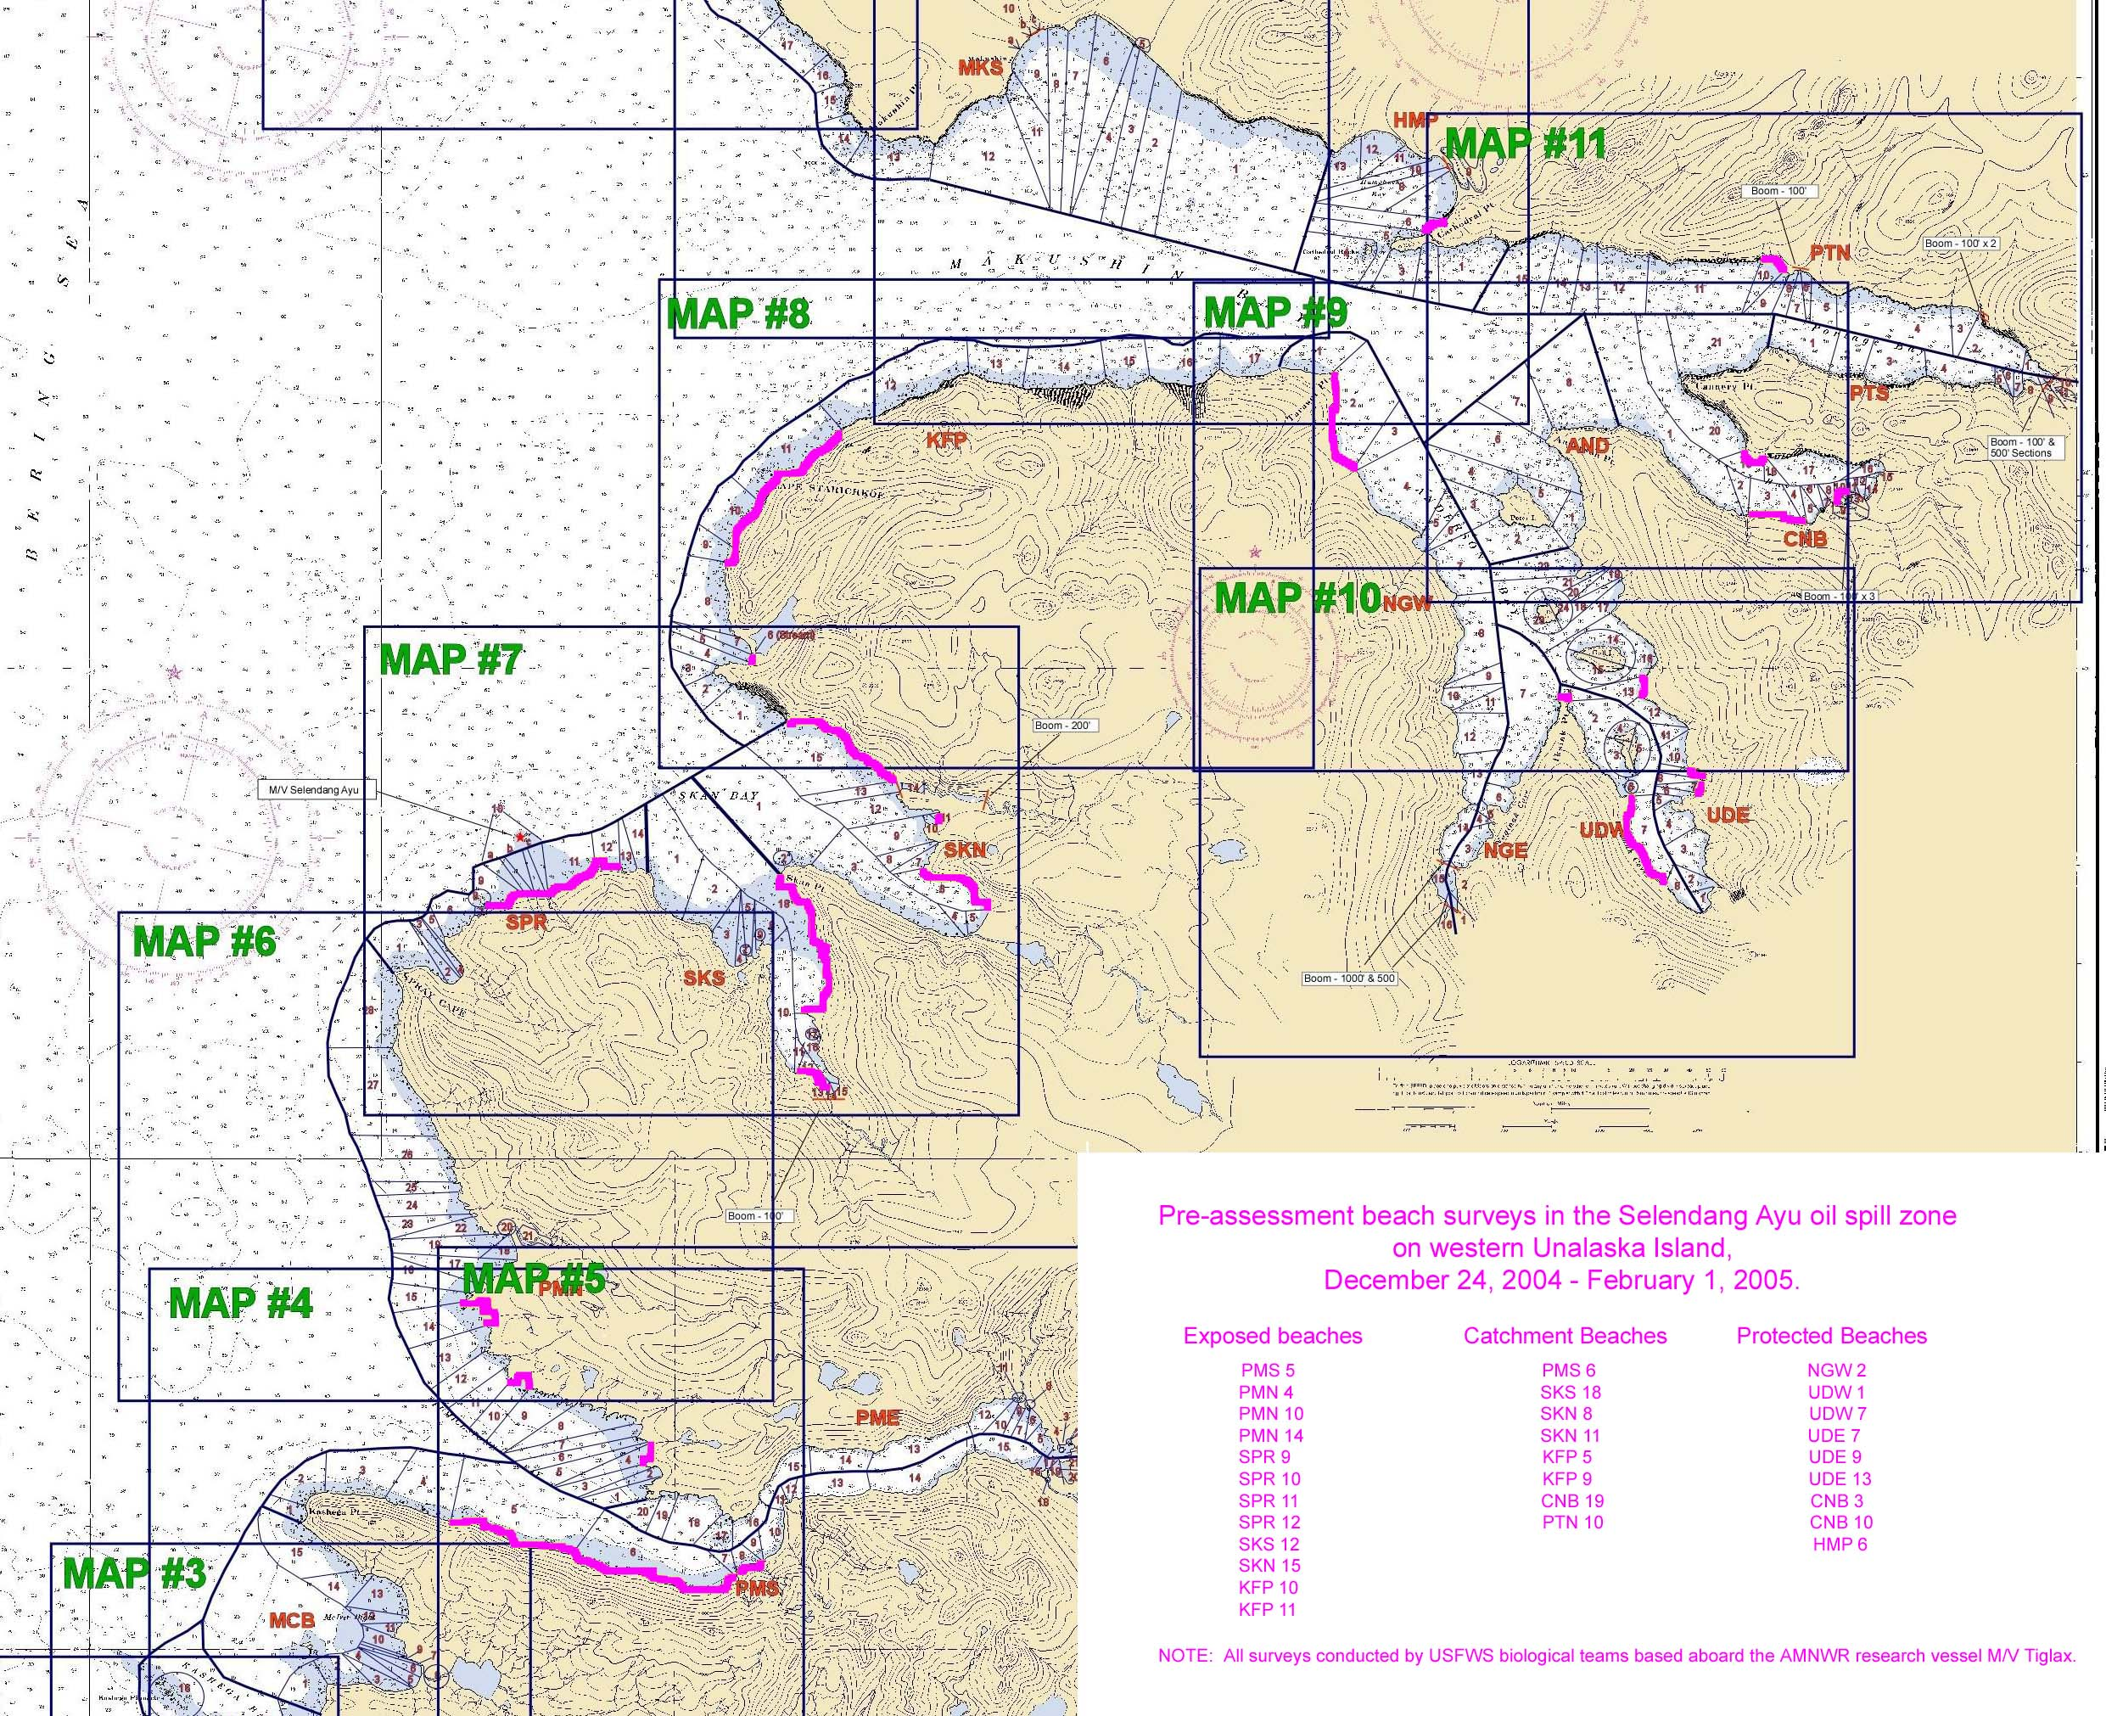
Figure 1 b

Figure 1 c
Figure 1 d
Figure 2.


