Design of SHM-Embedded Structures for Space Operation Vehicles

Fu-Kuo Chang, Johannes F.C. Markmiller, Jinkyu Yang, Yujun Kim
Department of Aeronautics and Astronautics
Stanford University, Stanford CA

ABSTRACT
Structural health monitoring plays an essential role in the integrated vehicle health management system for space transportation vehicles. Due to the natural characteristics of space structures, the requirements for SHM can be quite different from aircraft structures. This paper examines the potential impact of SHM on the space structures and their requirements for such applications. Attention is focused on diagnosing damage autonomously in a space environment and the technology needs for developing such a system at the vehicle design stage.

INTRODUCTION
Integrity, reliability and safety are critical for space operation vehicles (SOV), particularly when human beings are involved. Knowledge of the health condition of the vehicle in orbit and on the ground is crucial for maintaining safe operation of the vehicle. As lessons learned from the shuttles, traditional tear-down inspection techniques would make the new vehicle not only too costly to maintain and operate, but most importantly, they would be very difficult, if not impossible, to perform while the vehicle is in orbit. Accordingly, traditional inspection techniques could hardly ensure the integrity, reliability, or safety of the vehicles while they are in orbit.

Recent advances in structural health monitoring (SHM) technology have resulted in significant promising techniques to offer autonomous solutions for detecting and assessing the health condition of structures, providing a real-time early warning capability to mitigate damage, and reducing considerably downtime and maintenance cost. SHM has been demonstrated potentially for a wide range of applications from civil infrastructures to transportation systems. It is obviously well suited to applications for space operation vehicles.

However, there exist significant discrepancies in performance among these structures as well as their operation environments, so the requirements of SHM techniques for each application can be quite different in order to accommodate their unique demands and needs. For instance, an SOV experiences a much harsher environment than traditional aircraft during ascent and decent. While SOV vehicles fly less often, they are remote and inaccessible during each flight. Furthermore, there will be only a few SOV to be produced compared to aircraft in the hundreds. The loss of a vehicle can be detrimental to the entire space operation.

Table 1 lists a survey by Boeing Company which identified the top five high payoff areas for SHM application in SOV and characterized 10 common damage types in space vehicles [1]. High on the list are thermal protection panels and fuel tanks. Unlike aircraft structures, which produce well-known “hot-spot” areas due to fatigue/cyclic loads resulting from frequent operations, SOV is prone more to encountering unexpected events such as foreign object impacts and a harsh environment during its operation. To detect foreign-object impact, the exposed surface of the entire SOV under consideration must be monitored (for instance, the 2003 shuttle disaster); however, to prevent the attack of harsh environment such as elevated temperatures, knowledge of the integrity of joints and connectors where material property mismatch is the highest is critically important (for instance, the 1986 shuttle disaster). For SHM to be effective for space application, it must not only be able to identify the location of damage and quantify it; but also it shall interface with an appropriate failure analysis to estimate the effect of such damage on the integrity of the vehicle for its remaining operation in space.

Identified Top 5  High Payoff Areas | Rankings by Area
Identified Top 5  High Payoff Areas | Area | Rank
Identified Top 5  High Payoff Areas | TPS | 1
Identified Top 5  High Payoff Areas | Tank | 2
Identified Top 5  High Payoff Areas | Wing Structures | 3
Identified Top 5  High Payoff Areas | Leading Edges | 4
Identified Top 5  High Payoff Areas | Thrust Structures | 5
Identified Top 10  Damage/Data Types | Rankings by Damage/Data Types
Identified Top 10  Damage/Data Types | Damage/Data Types | Rank
Identified Top 10  Damage/Data Types | Crack Growth | 1
Identified Top 10  Damage/Data Types | Fuel Leak | 2
Identified Top 10  Damage/Data Types | Over Temperature | 3
Identified Top 10  Damage/Data Types | Impact Damage | 4
Identified Top 10  Damage/Data Types | Bondline Failure | 5
Identified Top 10  Damage/Data Types | Composite Delamination | 6
Identified Top 10  Damage/Data Types | Load Monitoring | 7
Identified Top 10  Damage/Data Types | Temperature Monitoring | 8
Identified Top 10  Damage/Data Types | Leading Edge Mass Loss | 9
Identified Top 10  Damage/Data Types | Corrosion | 10
Note: The ranking shown in the tables may vary depending on the
engineering judgement, but basically with the range
Table 1: Ranking of critical areas and common damage types in SOV for SHM applications

In this paper, the framework of an SHM-embedded system is proposed for diagnosing impact events and for detecting joint failure in thermal protection panels for SOV applications.

Impact Monitoring
For an SOV to be capable of diagnosing an impact event, the SHM system shall use the embedded sensor measurements to detect the impact and then determine the effect of such an impact on the integrity of the structures for their remaining operation. Numerous sensor-based impact identification techniques have been developed in the literature [2-8], which can be classified into two types typically: a neural network-based approach and a model-based approach. The former is good for identifying impact location but is not efficient for assessing the impact force. It requires collecting exhausted impact data set through training tests throughout the external surface of the vehicle, which may not be feasible practically to perform. The latter uses a model of the structure to estimate the impact force. While it is straightforward to calculate local strains for a given impact force with an accurate physical model, the inverse solution cannot be obtained easily. Iterative methods have been proposed by some researchers [9] to solve this problem but such an approach is slow and difficult to use for complicated structures.

Recently, a mixed approach based on system identification was proposed which requires only limited training data on the actual structure [9]. This approach produces a system model, which then could be used to effectively estimate the impact force and location in nearly real time. This approach has been demonstrated successfully on various types of structures from stiffened panels to TPS panels [9-10].

For an SOV application, the number of impact training data on actual vehicles should be minimal or eliminated because of the delicateness of the structures, which can also be quite complicated in geometry and material properties. In order to further minimize the number of training data, it is proposed to utilize finite element analysis to generate the system model from a mixed approach instead of using training data from physical tests. If the same finite element analysis that is used for the vehicle structure design could be utilized to develop the SHM model, then a linkage between traditional damage tolerance analysis and SHM prediction could be established. Accordingly, a schematic of the proposed SHM-embedded design for impact detection and diagnosis is illustrated in Figure 1.

As shown in Figure 1, a transient dynamic FEM model, which can simulate the strains at sensor locations upon impact is used to train a system model required for the SHM system. In the first step arbitrary impact forces are applied to the structure and the sensor signals are calculated using the FEM model. The force and the signals of the sensors are then used to obtain a transfer function (the system model) as described in [9].

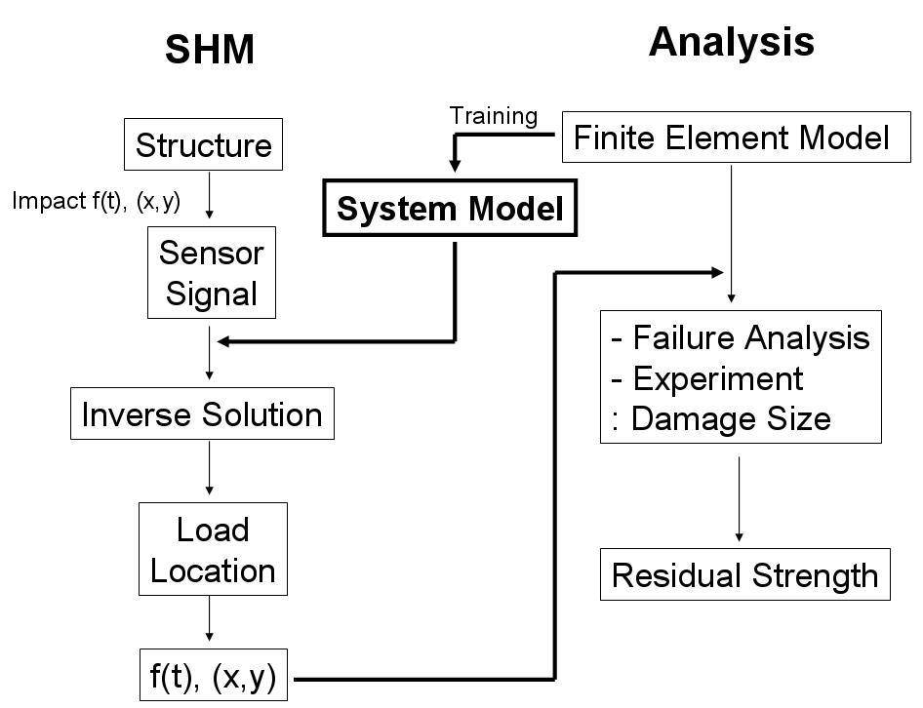
Figure 1: The proposed SHM-embedded design for impact diagnosis in space operation vehicles

In the second step, if an actual impact occurs, the impact force is estimated from the system model with the actual sensor data. The estimated impact event is then fed back to the FEM model, and the stresses during the impact event can be calculated. Finally, the stresses allow an estimate of the damage size and of the residual strength of the structure using appropriate failure criteria from a traditional damage tolerance analysis.

To verify the approach tests have been performed with a plate made of unidirectional graphite/epoxy composites. The dimension of the [0₄/90₄]_{s} plate is 12 inches by 12 inches with a surface-mounted sensor network of eight piezoelectric sensors made by Acellent Technologies (SMART layer) [11]. The plate was subjected to a drop-weight test with a weight of 3.5 lbs dropped from a height of 8.2 feet. A drawing of the plate showing the sensor location, the boundary conditions and the impact location can be seen in Figure 2. An X-radiograph was used to examine impact damage induced by the impactor, along with visual inspection.

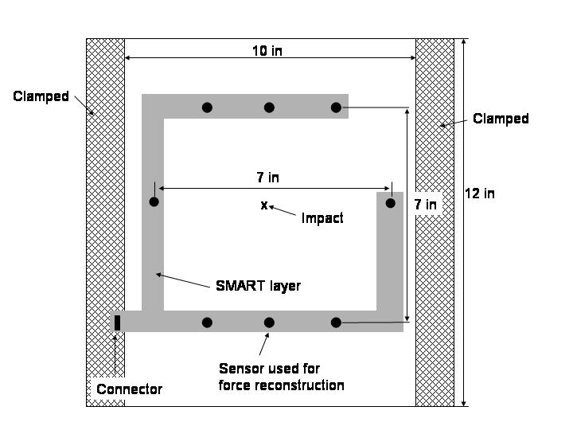
Figure2: Plate with SMART layer

The commercial ABAQUS code was utilized to simulate the impact dynamics of the plate. Figure 3 shows the finite element mesh used in the simulations of an arbitrary impact by the impactor. The code calculated the responses of the piezoelectric sensors, which were used to determine the system model of the plate based on the mixed impact identification approach [9].

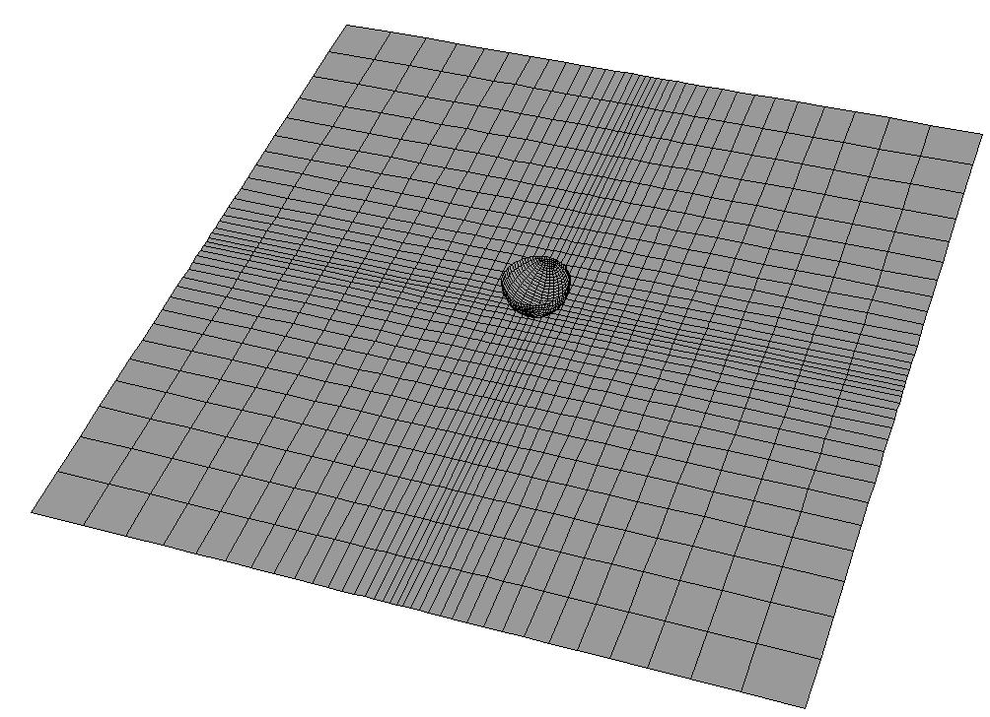
Figure 3: FEM model of the plate and the impactor
Once the system model was determined independently, the actual impact signals generated from the impact tests were used within the system model to estimate the impact force from the actual steel impactor. The signal measured during the drop test from one of the sensors can be seen in Figure 4. The location of this sensor can be found in Figure 2. Figure 4 also shows the impact force estimated from the system model and this measured signal.

Measured sensor signal | Calculated impact force
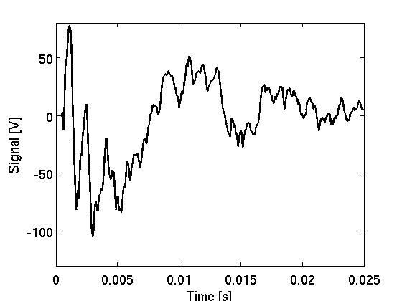 | 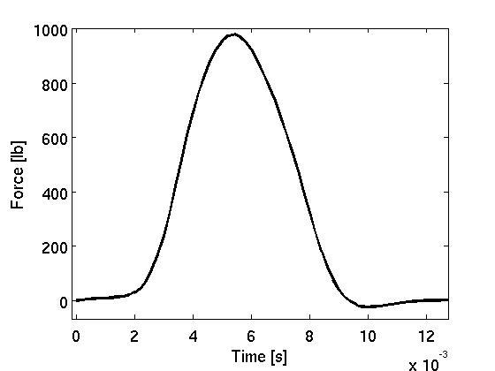

Figure 4: Measured sensor signal and calculated impact force

The reconstructed impact force-time history was then fed back as an input to the FEM model to estimate potential impact damage induced by the impactor on the plate. In the study, an impact-induced delamination criterion proposed by Choi and Chang [12] was selected because of its simplicity. Figure 5 shows a comparison of the predicted damage size and the X-ray picture taken from the specimen. It can be seen that the damage size could be estimated with good accuracy by combining the SHM system model with the traditional FEM analysis. More studies are being performed to further verify this approach in much more complicated structures.

 | 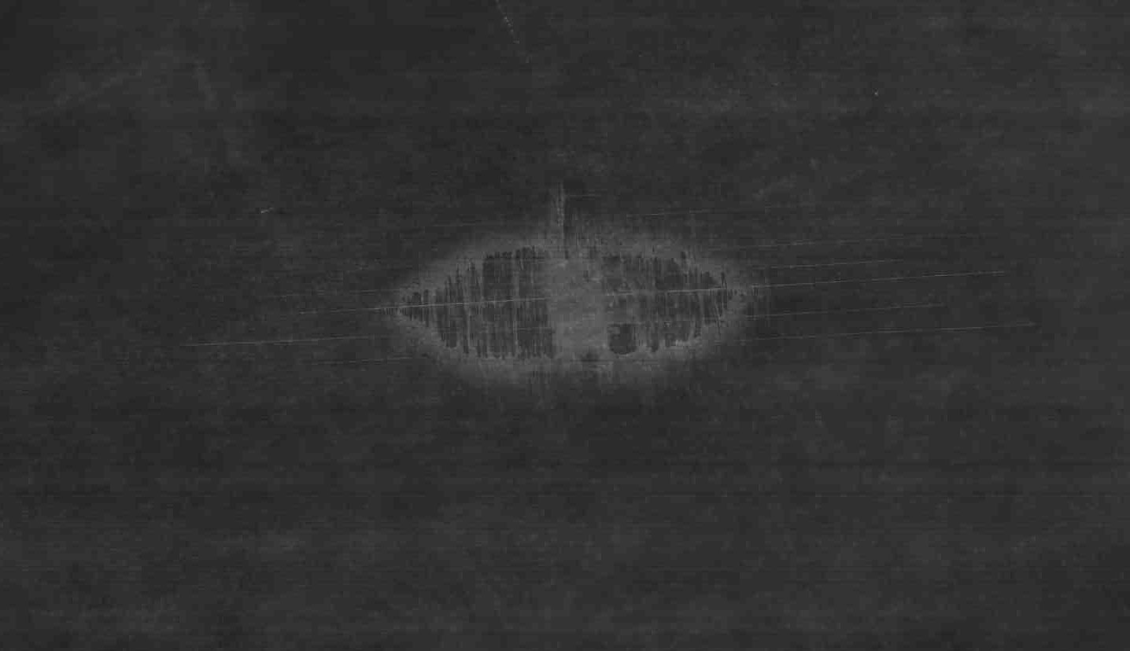
Calculated damage size | X-ray

Figure 5: Calculated damage size and X-ray

Detection of Bolt Loosening in TPS
Loosening of bolts in mechanically fastened thermal protection panels can be detrimental to the integrity of the entire vehicle due to harsh environments. Hot air can enter the gap at joints and destroy the vehicle. Therefore, the ability to early detect bolt loosening or damage such as cracks at joints is critically important for an SHM system.

Detection of bolt loosening/damage is very much different from monitoring an impact event. The former (referred to as active SHM) requires input excitation from transducers or actuators in order to produce diagnostic sensor signals, while the latter (passive SHM) uses the signals generated automatically through the external impact energy. There are numerous bolt loosening/damage techniques proposed in the literature, most of which are based on the impedance method or wave propagation techniques [13 - 18].

Recently, Yang and Chang developed a built-in bolt-loosening detection technique by analyzing signal attenuation of sensors based on propagation stress waves generated by an actuator located inside a washer [19]. Figure 6 shows a schematic description of a smart washer which was designed specifically for this application. The washer contains a piezoelectric transducer to generate propagating waves as well as to receive signals. The washers were then used to replace the existing washers without altering the original design and configuration of the TPS structures. The washer is placed at the bottom of each leg of the supporting bracket as shown in Figure 7 to be as far away from the surface TPS panels as possible to minimize temperature effect but still be effective for monitoring when the panels are exposed to extreme high temperatures. One smart washer is used to generate diagnostic propagating waves and the washer at the other leg of the bracket is to collect the signals. By comparing the signals generated from the same actuator at different times, an algorithm was developed based on the stress wave attenuation to estimate the degree of bolt loosening at the base bracket or at the top TPS panel.
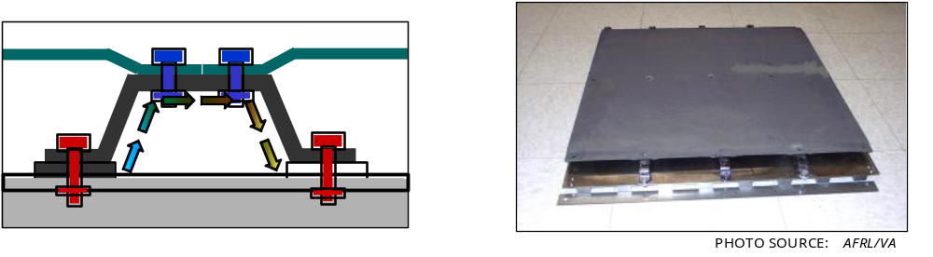
Figure 6: (left) a schematic of the bolt-loosening detection technique based on built-in wave propagation technique. (right) a photo of the TPS panel with the supporting brackets.

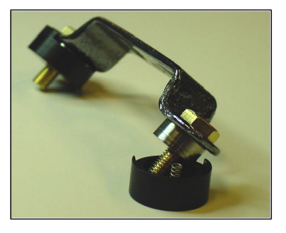

Figure 7: Smart washer design

The technique has been demonstrated successfully to identify the bolt loosening in the TPS panel [19]. A closer view of the smart washer design is shown in Figure 7. Clearly, the success of an active SHM system depends not only on the diagnostic algorithms, but also on the design of the sensor/actuator network system where the diagnostic signals are generated. The detectability of bolt loosening can be very much dependent upon the location and configuration of the sensors and the actuators, particularly as most mechanical joints and connectors may involve multiple materials with various thermal expansion coefficients and can be complicated in configuration.

Therefore, a retrofit of an active SHM system to an existing space structure can be quite challenging if not impossible because the detectability of the sensor/actuator network could be severely compromised in the existing configuration since any major modification to the existing components is normally prohibited. It is therefore necessary for space structures that the installation of an active SHM system must be considered at the initial design phase in order to be effective in detection and to be properly protected from harsh environments.

Accordingly, for SHM integration, it is proposed here to integrate the active SHM technique with a proper analysis in the initial design phase to maximize the system detectability. The result of the SHM predictions will then be fed back to the failure analysis to determine the residual strength and remaining life of the structures. A schematic description of the proposed approach is illustrated in Figure 8.

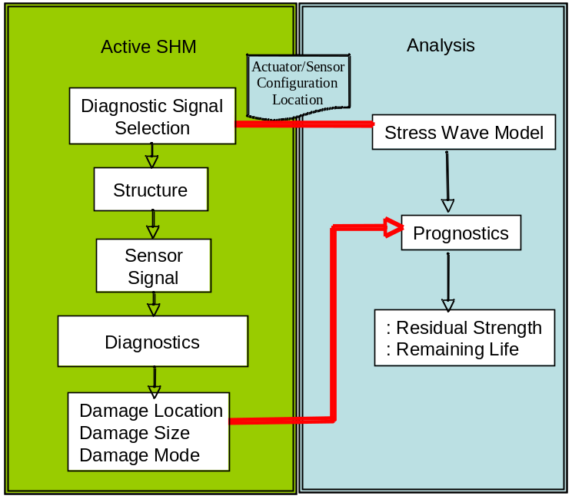
Figure 8: A proposed active SHM-embedded design for detection of joint integrity for SOV.
Design of built-in SHM system
The success of a built-in SHM system that deduces in-situ “health” through active sensors and real-time data processing relies heavily on sensor network design. In addition, the durable integration of sensors with structures needs to enhance the integrity of the system. In order to establish a fundamental understanding of the interactions not only between diagnostic wave and damage, but also between sensor and structure, numerical approaches in design and analysis are necessary. There exist numerous numerical techniques such as finite element method (FEM), finite difference method (FDM) and boundary element method (BEM) for modeling the dynamic response of structures [20-24].

However, none of these methods are effective in analyzing stress wave propagations in complex structures with built-in sensors and actuators. Most of them would require excessive computational resources such as computing time and memory, which would preclude them from being utilized in the initial design phase.

Recently, Kim and Chang [25] have demonstrated that the spectral element method (SEM) could be a powerful alternative to the existing numerical methods for analyzing structures with built-in sensor and actuator networks. The SEM first developed in the mid 1980s [26] is a weighted residual method like FEM. Main features of the SEM are a subdivided whole domain, called elements, and high-order interpolation with particular quadrature rules (see Figure 9). Therefore, the SEM conserves advantages of FEM such as geometric flexibility and interface modeling in addition to an exponential rate of the solution convergence that means drastic reduction of the required computational resource [25].

With the SEM as a computational engine, the traditional computer-aided design/engineering (CAD/CAE) can be utilized more rapidly and less expensively to analyze and characterize sensor and actuator responses in the SHM-embedded structures. Such simulations are crucial for understanding fundamentally the detectability of the SHM system and for optimal design of the system with minimal trial and error from the laboratory, which is presently the common practice. Through a standard design iteration, the sensor/actuator network configuration could be constructed to be effective for the particular structures. Figure 10 describes the proposed essential design flowchart for constructing SHM-embedded structures. With the SEM analysis, the SHM techniques could potentially be integrated and interfaced with the traditional design process. The diagnostic algorithms such as digital imaging analyses and a damage index for estimating damage could be integrated with SEM analysis to simulate SHM detectability without physically constructing the system in the laboratory [27 – 31]. This process will significantly improve the reliability and accuracy of the SHM system in practice and expedite the implementation process.

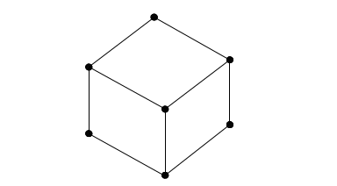
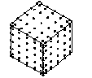

(a) 3D linear finite element (b) 3D 6-th order spectral element
Figure 9: Comparison between finite element and spectral element

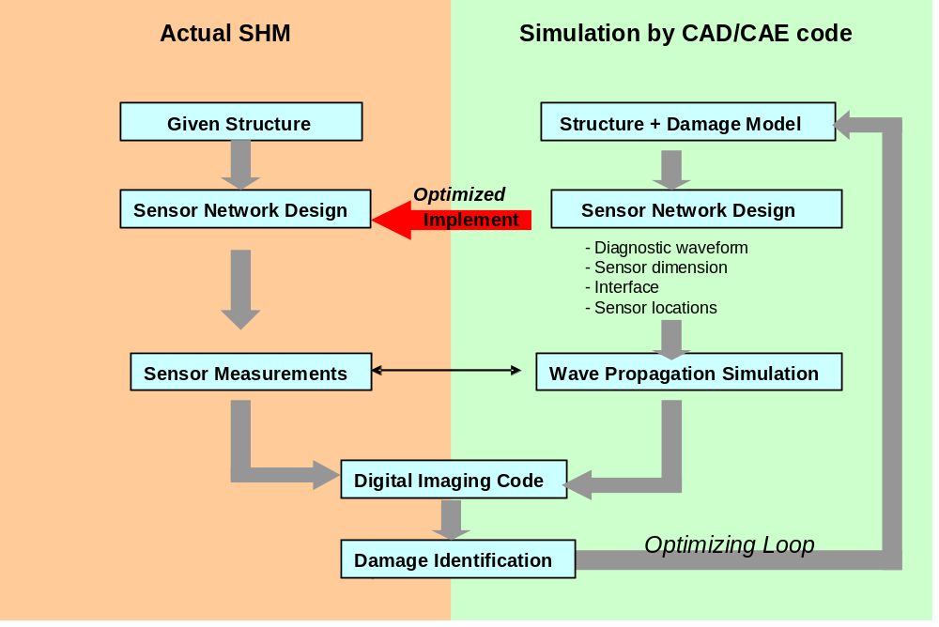
Figure 10: Simulation and optimization by CAD/CAE interfaced with digital imaging method

CONCLUSION
SHM techniques can have a significant impact on the safety and reliability of space operation vehicles. Concerns about the design of SHM systems for the detection of foreign-object impact and monitoring the integrity of thermal protection panels were discussed. The SHM systems for space applications must not only be capable of detecting impact and monitoring damage, but must also be able to predict the integrity of the structures with estimated damage in a timely manner. It is recommended that the integration of SHM techniques into space operation vehicles shall be performed at the initial design phase to maximize its effectiveness in detection and to provide proper protection to the system. New techniques and innovative tools that are still fundamentally lacking need to be developed for implementing the SHM system in structures.

ACKNOWLEDGEMENT
The authors are grateful for the support of Boeing Commercial Airplane Group, Lockheed Martin, and the National Science Foundation for this research. Eric Haugse, Suraj Rawal, and S.C. Liu are the program monitors, respectively.

REFERENCES

- C. Allen, 2005. “ISHM Conference Keynote,” Integrated Systems Health Management Conference, Air Force Wright Patterson.
- M.F. Gunther, A. Wang, B.R. Fogg, S.E. Starr, K.A. Murphy, and R.O. Claus, 1993. “Fiber optic impact detection and location system embedded in a composite material,” Proceedings of the SPIE, Vol. 1798, pp. 262-269.
- J.F. Doyle, 1987. “Experimentally determining the contact force during the transverse impact of an orthotropic plate,” Journal of Sound and Vibration, Vol. 118, pp. 441-448.
- E. Wu, J.-C. Yeh, and C.-S. Yen, 1994. “Identification of impact forces at multiple locations laminated plates,” AIAA Journal, Vol. 32, pp. 2433-2439.
- R. Seydel and F.K. Chang, 2001. “Impact identification of stiffened composite panels: I. system development,” Smart Mater. Struct., Vol. 10, pp. 354-369.
- K. Chandrashekara, A.C. Okafor, and Y. P. Jiang, 1996. “Estimation of contact force on composite plates using impact induced strain and neural network,” Proceedings of the SPIE, Vol. 218, pp. 320-330.
- F. Akhavan, S.E. Watkins, and K. Chandrashekara, 1996. “Recovery of impact contact forces of composite plates using fiber optic sensors and neural networks,” Proceedings of the SPIE, Vol. 2839, pp. 277-288.
- R.T. Jones, J.S. Sirkis, and E.J. Friebele, 1997. “Detection of impact location and magnitude for isotropic plates using neural networks,” Journal of Intelligent Material Systems and Structures, Vol. 7, pp. 90-99.
- J. Park, F.-K. Chang, 2005. “System identification method for monitoring impact events,” Smart Structures and Materials 2005: Modeling, Signal Processing, and Control. Edited by Smith, Ralph C. Proceedings of the SPIE, Vol. 5758, pp. 189-200.
- F.-K. Chang, J. Markmiller, 2005. “Composite Design with SHM,” Proceedings of the 5th International Workshop on Structural Health Monitoring, Stanford University.
- www.acellent.com
- H. Choi, F.-K Chang, 1992. “A Model for Predicting Damage in Graphite/Epoxy Laminated Composites Resulting from Low-Velocity Point Impact,” J. Composite Materials, Vol. 26(14): 2134-2169.
- M.M. Derriso, W. Braisted, J. Rosenstengel, M. DeSimio, 2004. “The structural health monitoring of a mechanically attached thermal protection system,” Journal of the Minerals, Metals & Materials (JOM), Vol. 53, pp. 36-39.
- D.M. Peairs, G. Park and D.I. Inman, 2004. “Practical issues of activating self-repairing bolted joints,” Smart Mater. Struct., Vol. 13, pp. 1414-1423.
- S. Basava and D.P. Hess, 1998. “Bolted joint clamping force variation due to axial vibration,” Journal of Sound and Vibration, Vol. 210, pp. 255-265.
- C. Liang, F.P. Sun and C.A. Rogers, 1996. “Electro-mechanical impedance modeling of active material system,” Smart Mater. Struct., Vol. 5, pp. 171-186.
- G. Park, H.H. Cudney and D.J. Inman, 2000. “An integrated health monitoring technique using structural impedance sensors,” Journal of Intelligent Material Systems and Structures, Vol. 11, pp. 448-455.
- D.M. Peairs, G. Park and D.I. Inman, 2004. “Improving accessibility of the impedance-based structural health monitoring method,” Journal of Intelligent Material Systems and Structures, Vol. 15, pp. 129-140.
- J. Yang and F.-K. Chang, 2005. “Verification of a built-in health monitoring system for bolted thermal protection panels,” 12th SPIE Annual International Symp. Smart Materials and Structures.
- M. Kehlenbach, B. Kohler, X. Cao and H. Hanselka, 2003. “Numerical and experimental investigation of Lamb wave interaction with discontinuities,” Proceedings of the 4th International Workshop on Structural Health Monitoring, Stanford University, pp. 15-17.
- J. Mackerle, 2004. “Finite-element modeling of non-destructive material evaluation, an addendum: a bibliography (1997-2003),” Modelling and Simulation in Material Science and Engineering, Vol. 12, pp. 799-834.
- Z. Su, 2004. “Fundamental Lamb mode-based delamination detection for CF/EP composite laminates using distributed piezoelectrics,” Structural Health Monitoring, Vol. 3, pp. 43-68.
- B.C. Lee and W.J. Staszewski, 2003. “Modeling of Lamb waves for damage detection in metallic structures: Part I wave propagation; Part II Wave interactions with damage,” Smart Mater. Struct., Vol. 12, pp. 804-824.
- Y. Cho, D.D. Hongerholt and J.L. Rose, 1997. “Lamb wave scattering analysis for reflector characterization,” IEEE Transactions on Ultrasonics, Ferroelectrics and Frequency Control, Vol. 44, pp. 44-52.
- Y. Kim and F.-K. Chang, 2005. “Computational tool for the design of structures with built-in piezoelectric-based sensor networks,” Proceedings of the SPIE, 5765, pp. 8-18.
- A.T. Patera, 1984. ”A spectral element method for fluid dynamics: lamina flow in a channel expansion,” J. Comput. Phys., Vol. 54, pp. 468-488.
- J.-B. Ihn, F.-K. Chang, 2005. “Active sensing methods in structural health monitoring for aircraft structures”, International Journal of Structural Health Monitoring,” to be submitted.
- C. Wang, J. Rose, F.-K. Chang, 2004. “A Synthetic time-reversal imaging method for structural health monitoring,” J. of Smart Materials Structures, Vol. 13, 2004, pp. 413-423.
- J.-B. Ihn, F.-K. Chang, 2005. “Development of smart layer technologies for advanced aerospace vehicles- baseline and phase I study,” A final report to Boeing Commercial Company under contract No. SY-ADA-98-003153.
- J.-B. Ihn, F.-K. Chang, 2004. “Detection and monitoring of hidden fatigue crack growth using a built-In pizoelectric sensor/actuator network: Part I. Diagnostics,” Smart Materials and Structures, Vol. 13, pp. 609-620.
- J.-B. Ihn, F.-K. Chang, 2004. “Detection and monitoring of hidden fatigue crack growth using a built-in piezoelectric sensor/actuator network: Part II. Validation through riveted joints and repair patches,” Smart Materials and Structures, Vol. 13, pp. 621-630.

